

# Elements of a 5-year implementation plan

*GOOS Exec 2018 working document*

*25 February 2018*

## Introduction

The *GOOS 2030 Strategy* identifies long-term strategic objectives aligned with the Framework for Ocean Observing; the need to step up our engagement in three different axes: with observing system stakeholders, with GOOS funders, and with major users of GOOS data; and the need to align our structures and the work of partners to achieve these objectives.

At present, the work plans of each of the GOOS structures: Steering Committee, the three panels, the JCOMM Observation Coordination Group, the GRA Council, and each GOOS project, are loosely coordinated, and it is not clear how they deliver to a larger whole.

This document serves largely as a reference document to the work plans of the different GOOS structures, to start the work of aligning them in the framing of the strategic objectives.

One step along the way of the development of the GOOS Strategy was an [early draft of a GOOS Five Year Implementation Plan](http://goosocean.org/index.php?option=com_oe&task=viewDocumentRecord&docID=17354), which focused on the FOO's core areas of defining requirements, coordinating and expanding observations in GOOS, and delivery of data and information products. It started from a summary of the present status, developed a SWOT analysis and summary of resources available, and identified some 1-, 3-, and 5-year actions. It is now necessary to revisit this plan and revise it based on our objectives and capacity, identifying the needed interfaces and partners along the way.

Estimates of full-time equivalent (FTE) human resources devoted to each set of forward plans are drawn from the accompanying document on GOOS staffing in the distributed office.

## GOOS structures forward plans

### Steering Committee

The Steering Committee's major ongoing and new actions for 2017 - 2018 are captured in the [summary of actions from the GOOS SC-6 meeting](http://goosocean.org/index.php?option=com_oe&task=viewDocumentRecord&docID=20120) (September 2017):

1. Adopting GOOS's high-level Strategy
2. Rewriting an Implementation Plan
3. Publishing a paper on the GOOS requirements process and the definition of EOVs
4. Improving the GCOS-GOOS interface (with a task team)
5. Resolution of Argo and EEZ issues with the IOC Executive Council, and identification of other EEZ-related issues from other observing networks (with a task team)
6. Stepping up fundraising efforts for the GOOS office
7. Develop and document the GOOS role in Capacity Development (with a task team)
8. Formulate an overall process for GOOS in the area of standards and best practice (with a task team)
9. Engage in OceanObs'19 development

*FTE resources available: about 1.75, including outreach, communications, management activities, and development of the Strategic Mapping*

### Physics panel / OOPC

In addition to playing the interface role from GOOS into the Global Climate Observing System, the Ocean Observations Panel for Climate has identified these four major areas of work, centered on projects and reviews. Details can be found in Appendix II of the [OOPC-20 report](http://goosocean.org/goos-222).

1. Heat and freshwater content review: review of the ocean observation system for quantifying global and regional heat and freshwater changes
2. Air sea fluxes: understand the sensitivity of flux estimating systems to sources of ocean data (together with TPOS 2020)
3. Observations for near term climate prediction (decadal prediction)
4. Boundary currents: to provide observing advice for this important ocean process

*FTE resources available: about 0.45*

### Biogeochemistry panel / IOCCP

The IOCCP leadership is meeting just prior to the GOOS Exec and so this information may be out of date.

The [report of the IOCCP SSG 12th session](http://www.ioccp.org/images/D3meetingReports/IOCCP-SSG-XIIth-Session-Report_FINAL.pdf) (February 2017, pages 38-43 in particular) identify some specific actions related to GOOS, as well as the updated Terms of Reference of the IOCCP, broadly identifying activities in their role as the GOOS Biogeochemistry Panel.

Specific actions in this context include:

1. Engagement with GRAs on standards and best practice, where appropriate,
2. working with GESAMP to develop a scope and initial specification sheet for a Contaminants / Pollution EOV
3. Further work on the requirements, observations coordination, and data related to the Oxygen EOV

within the framework of its ToRs which include two that are specific to GOOS, and many others related to the core IOCCP mission of coordinating observing networks, promoting standards and best practices in observations and data systems, developing training, and engaging the scientific user community:

* Identify priority measurements for implementation of GOOS observations of ocean carbon and biogeochemistry, and promote development and adoption of necessary measurements and measurement technology.
* Develop and maintain a set of specifications, implementation goals, and progress metrics for EOVs for ocean carbon and biogeochemistry parameters for GOOS and corresponding Essential Climate Variables for the Global Climate Observing System (GCOS).

The BGC panel secretariat has also led the preparation for the GOOS cross-panel meeting.

*FTE resources available: about 1.0 (not counting resources dedicated to specific projects)*

### Biology and Ecosystems Panel

The broad context of the Biology and Ecosystem's panel work plan is identified in the diagram on the following page.

Specific plans for 2018 were identified in the [2017 panel report](http://goosocean.org/index.php?option=com_oe&task=viewDocumentRecord&docID=21004):

* Across panel (with physics and biogeochemistry) integration on “phenomena”
* Deliver the coral EOV IP
* Submission of a white paper to OceanObs’19 on implementation of plankton observations
* Hold the plankton EOV IP workshop
* Submit a Working Group proposal to POGO to support a workshop to advance the Macroalgal Canopy EOV IP
* Prepare papers related to the implementation of the EOVs and how to develop the required capacity to support implementation
* Contribute to IOC capacity development strategy
* Contribute to GOOS theme on Ocean Health
* Continue to engage with the scientific community through targeted meetings (e.g. with the Southern Ocean Observing System through the Marine Ecosystem Assessment for the Southern Ocean – MEASO-2018 conference)
* Full Panel meeting – date TBD
* Special session at 4th WCMB – (papers potentially to be published in a special issue in Frontiers of Marine Science)
* Contribute to preparations for Ocean Obs’19
* Contribute to developing focal areas of the UN Decade of Ocean Science for Sustainable Development (2021-2030)
* Contribute to G7 Future of the Seas and Oceans

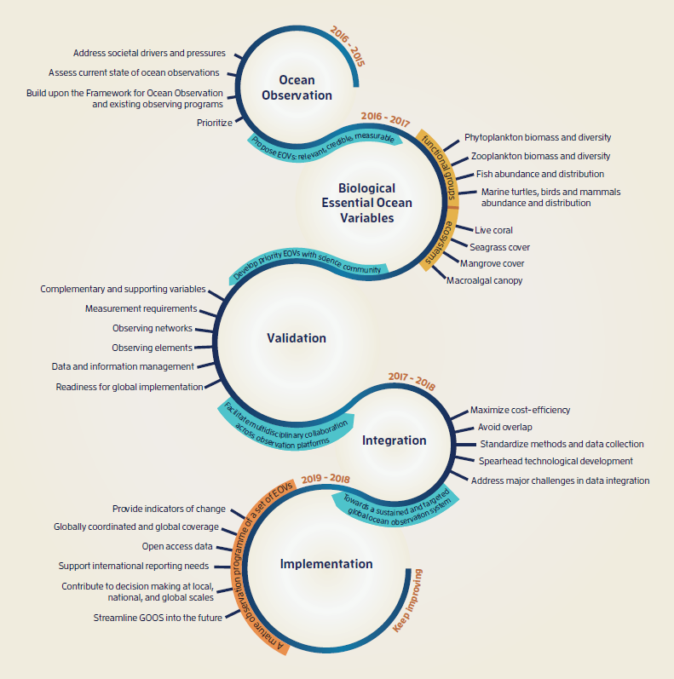

*FTE resources available: about 1.45*

### JCOMM Observations Coordination Group

Having a main reporting line through JCOMM, the JCOMM OCG work plan was adopted formally by the JCOMM-5 Session in October 2017 in [JCOMM-5/Doc. 7.1](http://meetings.wmo.int/JCOMM-5/_layouts/15/WopiFrame.aspx?sourcedoc=/JCOMM-5/English/2.%20PROVISIONAL%20REPORT%20(Approved%20documents)/JCOMM-5-d07-1-OCG-VISION-GOVERNANCE-AND-WORKPLAN-approved_en.docx&action=default).

The six strategic focii of its work plan for 2017-2021 are:

1. Improving the fit for purpose of the observing system against numerous requirements and the needs of JCOMM sponsors and stakeholders;
2. Encouraging technical development of existing observing networks and engaging emerging networks and communities of practice that are the key to addressing new requirements and needs; including the availability, completeness and timeliness of instrumental metadata;
3. Developing metrics and targets to assess and report observing system performance and progress over time;
4. Advancing exchange of international data and metadata and system-wide monitoring capabilities through JCOMMOPS;
5. Encouraging system-wide integration and quality standards through development of community best practices and standards;
6. Improving integration of data and information through data management standards and integration pilot projects.

The JCOMM OCG is now formally co-sponsored by GOOS. It will operate with vice-chairs dedicated to looking after: (1) the link to the WMO Integrated Global Observing System (WIGOS), (2) Standards and best practices, and (3) Data and information.

*FTE resources available: about 1.3 FTEs from the GOOS perspective, including support to JCOMM overall from IOC, the OCG itself (0.3 FTE), and some OCG networks. This is supplemented by support from the WMO side (about 0.8 FTE) with a focus on delivery for WIGOS.*

*JCOMMOPS additional FTE resources available: about 4 FTEs for technical coordination, metadata curation, and ensuring data flow*

### GOOS Regional Alliances

The major elements of the collective work of the GRAs are identified in the report of the [2017 GOOS Regional Council meeting](http://goosocean.org/goos-227).

* Update analysis of networks operated by GRAs and asset mapping to improve visibility of networks, including willing national programs that meet GRA criteria
* Update the GRA modeling inventory in cooperation with GODAE OV COSS-TT
* Encourage engagement in Ocean Gliders
* Work with GOA-ON to support the development of standard methods for ocean acidification observation in regional nodes
* Provide feedback on the GOOS Strategy and a watching brief on G7 opportunity for GRA pilot projects
* Explore potential for GOOS-Africa to evolve, and support the Canadian Integrated Ocean Observing System in its development
* A series of actions related to developing and funding GRA pilot projects
* Support the BioEco Panel in advocating for capacity building for sustained observing and monitoring
* Engage with the JCOMM OCG Standards and best practices activity with information on existing BPs and advice on priorities
* Encourage engagement in the Global HF Radar team
* Provide input into the OOPC Boundary Current / Shelf Sea interaction task

*FTE resources available: about 0.3 FTEs for central coordination*

### GOOS Projects

Both the TPOS 2020 project and the Deep Ocean Observing Strategy development project have clear timelines for activity and deliverables for consideration by GOOS and JCOMM. How exactly to incorporate their input into the ongoing activities of GOOS will be trialed by a Transition and Implementation Task Team for TPOS 2020 under JCOMM.

TPOS 2020 will issue a Second Report in mid-2018, and a Final Design in 2020, with handover of responsibility, in a joint context of meteorological and oceanographic sustained observations.

### Other considerations

The EU AtlantOS project, designed around the FOO and as a contribution to GOOS and GEO, will produce in 2019 a final report on requirements in the Atlantic, as well as a broader Atlantic Blueprint that will begin to address the regional governance requirement. The AtlantOS project contributes 2 FTEs to GOOS, on balance using about 1.25 FTEs purely for AtlantOS deliverables.

The OceanObs'19 Conference, its processes and outcomes, need to be fully incorporated into our 1- and 3-year actions.

The UN Decade of Ocean Science for Sustainable Development can be a vehicle for innovation actions under GOOS, that leave a permanent legacy for the observing system. These can be related to the obvious area of observing technology innovation, but also to the innovation required to generate stronger feedback loops between users and implementers of GOOS.

Other UN processes such as the targets for the Sustainable Development Goals, reporting against Aichi targets for the Convention on Biodiversity, and the development of a legal mechanism for the protection of biodiversity in areas beyond national jurisdiction (BBNJ), have specific entry points for engagement.

In general, the engagement strategy focused on stakeholders (scientific users and often the operators of the observing system), funders, and users (primarily intermediate modeling users, as well as scientific assessments), will need to be segmented. Our natural partners and messages related to climate, operational services, and ocean health will have common elements but also many specificities that need to be identified and worked.