Intergovernmental Oceanographic Commission
Technical Series | 105


User’s Guide
for the Pacific Tsunami Warning Center Enhanced Products for the Pacific Tsunami Warning System

August 2014
UNESCO
Intergovernmental Oceanographic Commission
Technical Series | 105

User’s Guide
for the Pacific Tsunami Warning Center Enhanced Products for the Pacific Tsunami Warning System

August 2014
Revised Edition

UNESCO 2014
IOC Technical Series, 105, Revised Edition
Honolulu and Paris, August 2014
English

Official tsunami warning messages are sent out by governmental authorities through the designated national authorities. UNESCO does not warrant, guarantee, or make any representations regarding the timeliness, currency, correctness, accuracy, reliability, or other aspect of the characteristics or use of the information available through the Pacific Tsunami Warning System.

The designations employed and the presentation
of the material in this publication do not imply the expression of any opinion whatsoever on the part
of the Secretariats of UNESCO and IOC concerning the legal status of any country or territory, or its authorities, or concerning the delimitation of the frontiers of any country or territory.

For bibliographic purposes, this document should be cited as follows:

Users Guide for the Pacific Tsunami Warning Center Enhanced Products for the Pacific Tsunami Warning System. IOC Technical Series No 105, Revised edition. UNESCO/IOC 2014 (English; Spanish)

Guide prepared by: Pacific Tsunami Warning Center
International Tsunami Information Center
PTWS Task Team on Enhanced Products
Published in 2014
by United Nations Educational, Scientific
and Cultural Organization
7, Place de Fontenoy, 75352 Paris 07 SP
© UNESCO 2014
Printed in France

(IOC/2013/TS/105 rev.3)
Table of Contents
page
Executive Summary (iii)
1. OVERVIEW 1
1.1 Introduction 1
1.2 Governance and Approval Process 1
1.3 Implementation Timeline 2
1.4 New Enhanced Products 3
1.5 New Enhanced Products Limitations 4
1.6 Dissemination of Products 4
2. PTWC CAPABILITIES AND PROCEDURES – TIMELINE FOR PRODUCT ISSUANCE 4
3. RIFT FORECAST MODEL DESCRIPTION AND LIMITATIONS 6
3.1 RIFT Description 6
3.2 Limitations of RIFT Model 7
3.3 Limitations Due to Source Uncertainties. 7
3.4 Key Assumptions of Green's Law 8
3.5 RIFT References 8
4. DESCRIPTION OF NEW PRODUCTS 9
4.1 Threat Levels 9
4.2 Text Products 9
4.3 Coastal Tsunami Amplitude Forecast Polygons Map 10
4.4 Table of Forecast Statistics for Regional Polygons 10
4.5 Deep-Ocean Tsunami Amplitude Forecast Map 11
4.6 Coastal Tsunami Amplitude Forecast Map 11
4.7 Coastal Tsunami Amplitude Forecast KMZ File 11
5. NATIONAL TSUNAMI WARNING ALERT GUIDANCE 12
6. GENERAL EMERGENCY RESPONSE GUIDANCE 13
APPENDIX I. BACKGROUND MOTIVATION AND IMPLEMENTATION 15
APPENDIX II. EXAMPLES OF PTWC NEW ENHANCED PRODUCTS
FOR THE PTWS 18
A. Tsunami Information Statement (no tsunami threat) 18
B. Tsunami Information Statement (minor sea level changes only) 19
C. Initial Tsunami Threat Message (no forecast) 20
D. Supplemental Tsunami Threat Message (with amplitude forecast) 23
E. Supplemental Threat Message (with tsunami observations) 47
F. Final Threat Product (text only) 51
APPENDIX III. LIST OF COUNTRIES OR PLACES NAMED IN THE NEW PRODUCTS 54
APPENDIX IV. LIST OF PTWS PTWC FORECAST POLYGONS 55
APPENDIX V. LIST OF PTWS PTWC FORECAST POINTS FOR ETAS 57
APPENDIX VI. NATIONAL TSUNAMI WARNING CENTER GUIDANCE 62
APPENDIX VII. NATIONAL TSUNAMI WARNING CENTER MESSAGE PRODUCTS 68
APPENDIX VIII. EMERGENCY RESPONSE GUIDANCE 76

ACRONYMS 79

Executive Summary
The Pacific Tsunami Warning Center (PTWC), of the IOC-coordinated Intergovernmental Coordination Group for the Pacific Tsunami Warning and Mitigation System (ICG/PTWS), has provided international tsunami alerts to countries of the Pacific since 1965. In order to provide timely services, alerts (warnings and watches) have been based primarily on seismic data and the rapid determination of an earthquake’s hypocenter and magnitude, followed by the monitoring of coastal sea level gauges to confirm a tsunami and its severity. Over the last 5-10 years, however, seismic and sea level data availability, analysis methods, computational capabilities, and communications have improved significantly. Additionally, better and faster numerical models, and specifically models that can incorporate the actual earthquake source, are now able to provide much more accurate forecasts of tsunami impacts along different coasts. Accordingly, and since 2007 with the guidance and approval of Member States of the ICG/PTWS, the PTWC enhanced and evolved its existing products in 2013–2014 in order to provide countries with more useful tsunami forecast products that will give detailed tsunami threat assessments for their coasts.

The PTWC began the issuance of its enhanced tsunami products in an experimental phase to Member States of the ICG/PTWS on 15 April 2013. The experimental enhanced products were sent by email to IOC officially-designated Tsunami Warning Focal Points (TWFP) in parallel with PTWC’s existing products. This introduction and familiarization period was also used for training on the new products and for countries to incorporate the necessary changes to their TWFP and National Tsunami Warning Center (NTWC) Standard Operating Procedures (SOPs). The IOC and International Tsunami Information Center (ITIC) worked together to meet the training requests of PTWS countries. At the Twenty-fifth Session of the ICG/PTWS (September, 2013), Member States were asked to review and discuss the new products, and they agreed on a target changeover date of 1 October 2014. Member States further decided that the public text product will continue, and that additional forecast guidance products be only sent to country Tsunami Warning Focal Points to assist them in assessing their national threat. The PTWS Steering Committee provided the final approval in July 2014. Starting 0000Z on 1 October 2014, the PTWC will retire its existing products and start issuance of its new enhanced products.

The User’s Guide provides a description and examples of the PTWC new enhanced products, and guidance to National Tsunami Warning Centers. Both improved text and additional graphical products will be available. The text products include improvements in the order and type of information provided, and in its readability. The graphical products are expected to provide more information and at a much greater level of detail than will be possible using only text products. These include maps that show the forecast directionality of the tsunami energy, the forecast position of the initial wave through time, as well as the expected maximum wave amplitudes offshore and at the coast.

- OVERVIEW
1.1 Introduction
The Pacific Tsunami Warning Center (PTWC), operated by the United States National Oceanic and Atmospheric Administration’s National Weather Service (NOAA/NWS), has served since 1965 as the operational tsunami warning center for Member States of the Intergovernmental Coordination Group for the Pacific Tsunami Warning and Mitigation System (ICG/PTWS). The ICG/PTWS is a subsidiary body of UNESCO’s Intergovernmental Oceanographic Commission (IOC), and the IOC’s Tsunami Unit oversees the coordination of the global tsunami warning and mitigation system. The ICG/PTWS, begun as an international response after the 1960 M9.5 Chile earthquake and tsunami, is the oldest of the four regional tsunami systems. Systems in the Indian Ocean, Caribbean and Adjacent Seas, and Northeastern Atlantic and Mediterranean were established after the 2004 Indian Ocean Tsunami.
The suite of text tsunami products issued by PTWC to countries around the Pacific in support of this mission has evolved over time as seismic and sea level data, analysis methods, computational capabilities, and communications have all improved. With order of magnitude increases in data availability and quality over the last 10 years enabling reliable real-time earthquake source characterization and more timely, detailed tsunami monitoring, and with better numerical models providing more accurate forecasts of tsunami impacts in real time, it is now time to enhance and evolve the existing PTWC products to provide countries with more informative and useful tsunami threat assessments to their coasts (Appendix I).
PTWC’s New Enhanced Product suite, as described in this Users Guide with examples given in Appendix II, was first issued in an experimental phase starting 15 April 2013, in parallel with PTWC’s existing products in order to familiarize recipients – the designated national Tsunami Warning Focal Points (TWFPs) -- with the new products’ timing and content. This introduction and familiarization period also provided lead time for training on the new products and for countries to incorporate the necessary changes to their TWFP and National Tsunami Warning Center (NTWC) Standard Operating Procedures (SOPs).
1.2 Governance and Approval Process
At its Twenty-second Session, the ICG/PTWS (2007) started the process of improving the PTWS international alert products, starting first with the products of the PTWC. At its Twenty-fourth Session, the ICG/PTWS (May 2011) approved PTWC’s Enhanced Tsunami Products proposal and asked them to proceed with their development. Exercise Pacific Wave 2011 (November) introduced those products and the ICG/PTWS Steering Committee (SC) met in May 2012 to review the feedback and approve the final implementation timeline. Exercise Pacific Wave 2013 (April) was conducted to validate the products. At the Twenty-fifth Session of the ICG/PTWS (September 2013), Member States approved the final products and agreed on the target changeover date of 1 October 2014 proposed by the PTWS SC. Member States further decided that the public text product will continue, and that additional forecast guidance products be only sent to country Tsunami Warning Focal Points to assist them in assessing their national threat. In July 2014, the PTWS SC met to perform the final readiness review and satisfied, approved the full operation start date. Starting 0000Z on 1 October 2014, the PTWC will retire its existing products and start issuance of its new enhanced products. A detailed background and summary is provided in Appendix I.

Further, at the Forty-seventh Session of the IOC Executive Council (EC-XLVII, Dec.3.2.1, July 2014), upon the recommendation of the Working Group on Tsunamis and Other Hazards Related to Sea-Level Warning and Mitigation Systems (TOWS-WG), Member States approved revised terminology to emphasize the critical importance that tsunami bulletins be sent to the appropriate country points of contact. The updated definitions for TWFP and NTWC are:
- National Tsunami Warning Center (NTWC): A center officially designated by the government to monitor and issue tsunami warnings and other related statements within their country according to established National Standard Operation Procedures.
- Tsunami Warning Focal Point (TWFP). A 24 x 7 point of contact (office, operational unit or position, not a person) officially designated by the NTWC or the government to receive and disseminate tsunami information from an ICG Tsunami Service Provider according to established National Standard Operation Procedures. The TWFP may or not be the NTWC.
Definitions of additional key terms used with the PTWC new enhanced products are:
- Tsunami Forecast: A prediction of certain future characteristics of an ongoing tsunami based upon the study and analysis of available pertinent geophysical and oceanographic principles, observational data and models.
- Tsunami Alert: An actionable pre-defined status level, typically a single word or phrase, which indicates the severity and/or imminence of a tsunami threat. Examples are tsunami warnings, watches, and advisories.
- Tsunami Threat: A tsunami that could cause trouble, harm, or danger.
1.3 Implementation Timeline
The PTWC New Products familiarization phase began on April 15, 2013, and continued until the enhanced products were fully implemented on October 1, 2014.
To support the transition to the new products, the PTWS conducted two international exercises in 2011 and 2013. Exercise Pacific Wave 2011 (November) introduced the new products and asked for feedback on the format, staging, and contents of the proposed products. These requests were considered in the development of the final products. PacWave11 information can be found at:
http://itic.ioc-unesco.org/index.php?option=com_content&view=category&layout=blog&id=2016&Itemid=2331. Exercise Pacific Wave 2013 (PacWave13) was conducted in May 2013 to validate the products, provide further feedback, and assess country readiness. PacWave13 information can be found at http://www.pacwave.info.

The PTWS PacWave11 and PacWave13 Task Teams oversaw the planning, conduct, and post-exercise evaluation of the new products, and worked with the PTWS Enhancing Tsunami Products Task Team for the successful implementation. ITIC and the IOC worked with the PTWC to provide the necessary training in 2013 and 2014 for the successful transition and changeover. A list of trainings conducted can be found at http://itic.ioc-unesco.org/index.php?option=com_content&view=category&layout=blog&id=1117&Itemid=2257.
At the Twenty-Fifth Session of the Intergovernmental Coordination Group (ICG) of the Pacific Tsunami Warning and Mitigation System, held 11-13 September 2013, Member States approved use of and agreed on a timeline for full implementation of the PTWC New Products suite. A target date of October 1, 2014 was set to officially retire the existing products and changeover fully to the new products. The date was officially confirmed by the PTWS SC in July 2014.
1.4 New Enhanced Products
There are important differences between PTWC’s former and its new enhanced products. Existing products use terminology that describes a level of alert for each country. Specifically, a country is currently designated by PTWC as being in a Tsunami Watch or a Tsunami Warning depending upon the tsunami threat presented by the event, as well as the time remaining until tsunami impact. Over the last several years, however, use of the Warning and Watch terms have caused confusion when the PTWC-designated levels of alert conflict with a country’s independently-derived levels of alert. As each country is sovereign and thus responsible for the safety of its own population, the PTWC new products will now change to avoid using the Warning and Watch terms, and instead provide forecast levels of impact along coasts.
The levels of expected impact will be provided as expected maximum tsunami wave amplitudes relative to the tide within four categories which are: i) less than 0.3 m, ii) 0.3 to less than 1 m, iii) 1 m to 3 m, and iv) greater than 3 m. A fifth category will be ‘no threat computed’ to reflect locations where a forecast has not been made. Examples of the new products are provided in Appendix II. With this change, the designation of alert levels, such as a Tsunami Warning, will then become the sole responsibility of the NTWCs.
A list of countries and country sub-jurisdictions for which PTWC will provide forecasts is given in Appendix III, and the list of PTWC forecast polygons that divide extended coasts into segments or that surround particular island groups is given in Appendix IV. The list of points where estimated initial tsunami wave arrival times are given, when the point is in a threatened area, are in Appendix V. Countries are asked to review these lists and recommend changes if needed. NTWC guidance for using the new products for national threat assessment and warning is described in Appendices VI. Example NTWC message templates are provided in Appendix VII. Tsunami Emergency Response guidance is provided in Appendix VIII.
Further, the PTWC procedures for designating levels of alert in the former products are extremely conservative and most places that come under a warning alert usually do not finally experience a destructive tsunami. This was in large part due to PTWC’s reliance on limited historical data and, at the time the criteria were conceived and approved by the ICG/PTWS, the lack of numerical model forecasting for tsunamis in real time.
While numerical forecasts provided in the new product suite continue to be conservative, the provision of forecast information should nonetheless significantly reduce over-warning. In addition, by providing an expected level of impact, it is expected that national and local authorities will now be able to determine and enable more appropriate levels of response. For example, the distribution of forecast values along a coast may provide justification for national or local authorities to evacuate only a part of the coast, or to only clear beaches and harbors because only a relatively small tsunami is expected. (see Appendix VI.)
The PTWC new products will consist of both improved text products, and graphical products (examples in Appendix II). The text products include improvements in the order and type of information provided, and in its readability. The graphical products provide more information at a much greater level of detail than is possible using only text products. They include maps that show the forecast directionality of the tsunami energy, the forecast position of the initial wave through time, as well as the expected maximum wave amplitudes offshore and at the coast. The graphical products may also be helpful for communicating the threat quickly and clearly when time is of the essence. Further NTWC guidance on the use of these products is given in section 5 and in Appendix VI.

1.5 New Enhanced Products Limitations
It is important to note that while the new products and the procedures behind them represent a significant improvement over the current ones, there will still be limitations that need to be recognized and understood by every country, and especially by their National Tsunami Warning Centers. The science of accurately forecasting tsunamis is still in its infancy.
The greatest unknown about the tsunami in real-time (and even later) is its source. Specifically, as most tsunamis are generated by earthquakes, how did the seafloor deform when the earthquake occurred? How much was the seafloor displaced up or down, over what areas, and over what time period? The tsunami forecast models that PTWC uses must make assumptions about the source based upon the best available seismic analysis, or later, based upon the available nearby sea level gauge readings. But this only permits an approximation of the real source, and that approximation can evolve from the first few minutes after an earthquake to several hours after the earthquake when more data and analysis results become available.
The second greatest unknown is how the tsunami will interact with the coast. In most situations, a general approximation (Green’s Law) must be used. Unfortunately, even when detailed bathymetry and coastal inundation models are available, properly and accurately capturing coastal resonances, trapped wave energy, and multiple wave interactions after even a few wave cycles, and in real-time as the tsunami is approaching, is not currently possible. For these reasons, the forecast model information provided in the PTWC New Products should be viewed and interpreted with care by persons trained in their meaning, and taking into consideration the limitations that are explained later in this document.
1.6 Dissemination of Products
Per Recommendation ICG/PTWS-XXV.2, PTWC Enhanced Products for the PTWS, Member States decided that the text bulletins will be made available to the public, and the scientifically more complex graphical products should only be disseminated via secure channels to Tsunami Warning Focal Points (TWFPs) for use by National Tsunami Warning Centres (NTWCs) in order to minimize potential confusion and misinterpretation by the public.
Accordingly, the Text Product (Section 4.2) will be a public product disseminated through the existing PTWC message communication channels, and the Coastal Tsunami Amplitude Forecast Polygons Map (4.3), Table of Forecast Statistics for Regional Polygons (4.4), Deep-Ocean Tsunami Amplitude Forecast Map (4.5), Coastal Tsunami Amplitude Forecast Map (4.6), Coastal Tsunami Amplitude Forecast KMZ File (4.7) will only be sent by email to designated IOC Tsunami Warning Focal Points.

- PTWC CAPABILITIES AND PROCEDURES
– TIMELINE FOR PRODUCT ISSUANCE
The new product suite is tied closely to PTWC’s new capabilities and procedures. This section of the User’s Guide provides an overview of those capabilities and procedures and how they will drive the new products. The overview is presented in terms of a timeline of events that occur as an event unfolds. Times indicated are only approximate and conservative, but are typical.

00h00m | A large earthquake occurs in the Pacific region.
00h02m | Vibrations from the earthquake reach seismic stations near the earthquake epicenter, triggering event alarms at PTWC. PTWC duty analysts respond to the operations center and begin to analyze the event. [PTWC currently monitors close to 500 seismic stations from around the world, with data collected at most of those stations reaching PTWC within a minute of when it is collected.]
00h08m | Using a combination of automatic and interactive analyses, duty analysts complete their preliminary determination of the earthquake epicenter, depth, and magnitude.
00h10m | Based on the preliminary earthquake parameters, for any Pacific-region earthquake with a magnitude of 6.5 or above, initial text products are generated and issued according to the following general procedures that are similar to procedures used prior to the enhanced products. Some deviation from these procedures may occur based upon the scientific judgments of the duty staff. A quantitative forecast is not issued at this early time due to having too little information to be able properly constrain such a forecast.  - If the earthquake is too deep within the earth (≥100 km depth) or is located too far inland to significantly displace the seafloor, then a Tsunami Information Statement will be issued indicating no tsunami threat.  - If the earthquake is shallow (<100 km depth) and undersea and has a magnitude of 6.5 to 7.0, then a Tsunami Information Statement will be issued indicating no tsunami threat but with minor sea level fluctuations possible.  - If the earthquake is shallow (<100 km depth) and undersea and has a magnitude of 7.1 to 7.5, then a Tsunami Threat Message will be issued indicating a possible tsunami threat to coasts located within 300 km of the epicenter.  - If the earthquake is shallow (<100 km depth) and undersea and has a magnitude of 7.6 to 7.8, then a Tsunami Threat Message will be issued indicating a possible tsunami threat to coasts located within 1000 km of the epicenter.  - If the earthquake is shallow (<100 km depth) and undersea and has a magnitude of 7.9 or greater, then a Tsunami Threat Message will be issued indicating a possible tsunami threat to coasts located within 3 hours tsunami travel time.
00h20m | Seismic analyses continue as data from additional seismic stations arrive and are processed. If the earthquake parameters change significantly based on these analyses then the appropriate supplemental text product will be issued, using the procedures described above.
00h25m | For earthquakes with a tsunami threat, the W-phase Centroid Moment Tensor (WCMT) analysis is triggered with results typically available about 25 minutes after the earthquake. The WCMT analysis not only gives a more accurate estimate of the earthquake’s location, depth and magnitude, but also an estimate of the earthquake’s faulting mechanism – the strike angle of the fault, the dip angle of the fault, and the direction and amount of slip along the fault. These parameters are critical to constrain the estimate of seafloor deformation that is the tsunami source. They are used to drive a run of the tsunami forecast model covering part or all of the entire Pacific.
00h35m | The forecast model run completes providing a tsunami forecast. The model will be run for the entire Pacific region unless it is necessary or appropriate to run it over a smaller domain, possibly with a smaller grid spacing. This would be the case for enclosed or semi-enclosed shallow basins or seas.
00h40m | For events with forecast coastal amplitudes greater than 0.3 m anywhere within the PTWC area of responsibility, a Tsunami Threat Message is issued along with accompanying maps, statistics table, and KMZ file that covers the affected region.
00h15m  to  02h00m | Sea level gauges are monitored for tsunami signals. Within the first 30 minutes to an hour the tsunami may arrive on the nearest one or two coastal gauges and one or two deep-ocean gauges. Tsunami amplitudes are measured and compared, when possible, with forecast amplitudes produced by the models. The model forecast may be adjusted to be more consistent with observations. [PTWC currently monitors more than 600 sea level stations from around the world, with data collected reaching PTWC within a few minutes of when it is transmitted.]
Beyond  2h | The process of refining the earthquake parameters and collecting additional sea level observations continues, with that information used to constrain the forecast if necessary. The tsunami is monitored as it advances. When it is likely that there is no longer a significant continuing tsunami threat for most areas then a final product is issued. Due to resonances in enclosed bays, and to tsunami energy that gets trapped around islands and along continental shelves or is re-energized by reflections, some areas may continue to experience hazardous sea level oscillations. It is up to local officials to determine when coasts are safe, persons can return to evacuated areas, and normal activities may resume.

- RIFT FORECAST MODEL DESCRIPTION AND LIMITATIONS
The PTWC will use the Real-time Inundation Forecast of Tsunamis (RIFT) model as the basis for its international forecast products for the PTWS. Developed by PTWC, RIFT is currently a tsunami forecast model of NOAA that is based on the linear shallow water equations. Studies of its accuracy for a wide variety of sources and coasts are continuing. Its general success in forecasting impacts from several recent tsunamis, including the February 2010 Chile tsunami and the March 2011 Japan tsunami, its unique capability to use real-time estimates of the actual earthquake fault geometry as the primary source constraint, and its capability to produce comprehensive forecast for all coasts around the world in real time have made RIFT the foundation of PTWC’s international tsunami forecast operations. It should be noted PTWC also uses several other forecast models during an event, including NOAA’s SIFT (Short-term Inundation Forecasting for Tsunamis) and ATFM (Alaska Tsunami Forecast Model), but these models are primarily for U.S. coasts -- they do not cover all coasts and countries around the Pacific.
3.1 RIFT Description
The primary outputs of the RIFT model are wave amplitudes at grid points in the ocean. Deep-ocean and coastal maximum tsunami wave amplitudes shown in the Enhanced Products are calculated using the following definitions and formulas.

Definitions: z2p=maximum absolute value of RIFT zero to peak wave amplitude
z2t=maximum absolute value of RIFT zero to trough wave amplitude

RIFT Deep-Ocean Maximum Tsunami Wave Amplitudes
At each model grid point in the ocean, RIFT produces a time series of the sea level fluctuations caused by the passing tsunami waves. Shown on the deep-ocean tsunami amplitude forecast map is the maximum amplitude of those fluctuations, A_{max}, defined by:
A_{max} = 0.5 * (z2p + z2t) in meters

at every point in the deep ocean. These are the maximum deep-ocean tsunami amplitudes. Maximum coastal amplitudes can be much larger.

RIFT Coastal Maximum Tsunami Wave Amplitudes
For each model grid point near the coast, the tsunami amplitude at the coast can be estimated based upon Green's Law.

Green's Law: A_{coast}=A_{offshore} * ( D_{offshore} / D_{coast} )^{¼}

where A_{coast} is the tsunami amplitude at the coast
A_{offshore} is the tsunami amplitude at the offshore grid point
D_{offshore} is the depth of the ocean at the offshore grid point, and
D_{coast} is the depth of the ocean at the coast

The offshore ocean depth can vary from about 15 m to 1000 m, depending upon the resolution at which RIFT is run - 30 arc-sec, 1 arc-min, 2 arc-min or 4 arc-min. The coastal ocean depth is set to be 1 m.

The offshore grid point is the closest model grid point with a water depth greater than the offshore water depth of the model coastal point. If the distance from the coastal point to the offshore point is greater than 100 km, then no forecast is made for the coastal point. There is reduced confidence in the quality of the coastal forecast if Green's Law is applied over distances > 100 km. Consequently, there might not be a forecast for coasts with wide continental shelves at 4-arc-min. resolution. In those cases, a RIFT run at finer than 4 arc-min resolution is required for RIFT to produce a Green's Law coastal forecast.

3.2 Limitations of RIFT Model
The following are overall known limitations of RIFT:
- Initial results can vary easily by a factor of two, because of uncertainties in the preliminary magnitude, depth and assumed mechanism of the earthquake. Later results, constrained by the earthquake W-phase Centroid Moment Tensor (WCMT), as well as by deep-ocean observations, are typically more reliable.
- For small islands (e.g., islands less than 30 km in diameter) and atolls, Green's Law can overestimate the coastal amplitude. In those cases, a forecast amplitude between the offshore (Deep-Ocean) and Green's Law (Coastal) amplitude may be more appropriate.
- For resonant harbors, the Green's Law amplitude (Coastal) can underestimate the actual wave amplitude. The Green's Law amplitude should be interpreted as average wave amplitude at the open coast, not necessarily the maximum amplitude inside a harbor or at a sea-level gauge.
- The RIFT forecast coastal amplitude is not necessarily indicative of inundation depth, which is a function of the local topography. A 10-meter coastal amplitude from Green's Law does not mean the inundation depth will reach 10 meters. But it does indicate a major tsunami impact.
- In the near field, Green’s Law (Coastal) amplitude does not necessarily take into account wave propagation and dissipation. Thus, a coastal amplitude of 20-30 meters can be misleading - it should also simply be interpreted as a major tsunami.

3.3 Limitations Due to Source Uncertainties.
Additionally, there can be significant uncertainties in the RIFT forecast because of its assumptions and uncertainties of the earthquake source parameters. These include:
- The forecast is sensitive to the earthquake magnitude. A difference of 0.2 in the earthquake magnitude results in factor of two in the RIFT wave amplitude forecasts.
- The forecast is sensitive to the earthquake focal mechanism. For example, two earthquakes of magnitude 7.5 with different focal mechanisms can give vastly different results, easily by a factor of two or more. This is why a forecast is not disseminated until the earthquake mechanism (WCMT) has been computed.
- Experience shows that when RIFT is initiated using the computed centroid moment tensor (WCMT) of the earthquake, it tends to give a much better result. However, the WCMT is typically not available until 25-30 minutes after the earthquake occurs. Further, the initial WCMT can be off by 0.2 or more in magnitude for great earthquakes, resulting in a factor of two difference in the RIFT tsunami wave forecast.

3.4 Key Assumptions of Green's Law
In order to provide a real-time coastal forecast, Green’s Law is utilized. Green’s Law makes the following assumptions:

- The coastline in question is linear and exposed to the open ocean.
- Tsunami waves near the coast behave as one-dimensional plane waves.
- There are no significant wave reflections and no dissipation by turbulence.
- The bathymetry varies slowly compared to the wavelength of the tsunami waves. Thus, for steep bathymetry, the Green's Law forecast can overestimate the tsunami wave amplitudes.
- Cliff boundary conditions are used. In other words, the coast is assumed to be a vertical wall.

Therefore, where coastlines consist of bays, inlets, or are hidden by offshore islands, or where the sea bottom rises steeply to the shore, Green’s Law coastal wave forecasts will be in error.

  - RIFT References
Foster, J. H., B. A. Brooks, D. Wang, G. S. Carter, and M. A. Merrifield, Improving tsunami warning using commercial ships, Geophys. Res. Lett., 39, L09603, doi:10.1029/ 2012GL051367, 2012.

Fryer, G., Holschuh, N., Becker, N., and Wang, D., 2010, Improving Tsunami Warning with a Rapid Linear Model, Paper NH33A-1378, Amer Geophysi Union, Fall Meeting, 2010 (abstract).

Fryer, G. J.; Wang, D.; Becker, N. C.; Weinstein, S. A.; Walsh, D., Fast Simulation of Tsunamis in Real Time, Paper NH21C-1525, Amer Geophys Union, Fall Meeting, 2011 (abstract)

Duputel, Z., L. Rivera, H. Kanamori, G. P. Hayes, B. Hirsorn, and S. Weinstein, Real-time W-phase inversions during the 2011 Tohoku-oki earthquake, Earth Planets Space, 63(7), 535–539, doi:10.5047/eps.2011.05.032., 2011

Duputel, Z., L. Rivera, H. Kanamori, and G. H. Hayes, W phase source inversion for moderate to large earthquakes (1990–2010), Geophys. J. Int., 189, 1125–1147, doi:10.1111/j.1365-246X.2012.05419.x, 2012.

Wang, D., Walsh, D.; Becker, N. C., Fryer, G. J., A Methodology for Tsunami Wave Propagation Forecast in Real Time, Paper OS43A-1367, Amer Geophys Union, Fall Meeting, 2009 (abstract).

Wang, D., Becker, N.C,, Walsh, D., Fryer, G., Weinstein, S. A., McCreery, C. S., Sardiña, V., Hsu, V., Hirshorn, B.F., Hayes, G.P., Duputel, Z., Rivera, L., Kanamori, H., Koyanagi, K.K., and Shiro, B., Real-time Forecasting of the April 11, 2012 Sumatra Tsunami, Geophys. Res. Lett, 39, L19601, doi:10.1029/2012GL053081, 2012

Whitmore, P., Weinstein, S., Knight, W, Wang, D., McCreery, C., and Gately, K., Real-time tsunami forecasting for the Caribbean Region, Paper 25-6, Southeastern Section - 62nd Annual Meeting (20-21 March 2013), Geol Soc Amer, 2013 (abstract).

- DESCRIPTION OF NEW PRODUCTS
This section describes the PTWC new product and includes recommendations on how to use and interpret the information. Examples of the PTWC New Products are provided in Appendix II. The list of countries and country sub-jurisdictions that PTWC will forecast products for is provided in Appendix III, and the coastal forecast polygons that PTWC will use are listed in Appendix IV. Points where estimated arrival times of the initial tsunami wave may be given are listed in Appendix V. Guidance on NTWC and emergency management response to the new products is provided in Sections 5 and 6, and in detail in Appendix VI and Appendix VIII, and example NTWC message templates are provided in Appendix VII.

4.1 Threat Levels
The New Products will provide forecasts of maximum tsunami wave amplitudes that are grouped into one of five forecast bins. These are ‘less than 0.3 meters’, ‘0.3 meters up to less than 1 meter’, ‘1 meter to 3 meters’, and ‘greater than 3 meters’ above the normal tide level. A fifth bin corresponding to ‘threat not computed’ is assigned when a forecast has not been calculated for a forecast polygon or region.

4.2 Text Products
The enhanced text products are public products that will contain threat assessments for countries and country sub-jurisdictions (Appendix III), estimated tsunami arrival times at forecast points (Appendix V), and tsunami observations. Country NTWCs may base their tsunami alert level decision-making solely on these public text products, or may supplement their decision-making by utilizing the graphical and statistical products sent to Country TWFPs by email.
The enhanced text products replace the former text products issued under the World Meteorological Organization (WMO) headers WEPA42 PHEB for “Tsunami Information Bulletins” and WEPA40 PHEB for “Tsunami Warnings”. The corresponding enhanced text products have the names “Tsunami Information Statement” and “Tsunami Threat Message”. They are organized into the following discrete sections.
Headers
At the top of each text product are some header lines that include the World Meteorological Organization Product ID and issue date/time, an AWIPS ID, a product type line, an issuing office line, and an issuance date/time line.
Headline
Immediately below the header lines is a brief headline, leading and trailing with an ellipsis (…). The headline indicates either an information statement or a tsunami threat message.
Target Area
Below the headline is a statement indicating the geographic area that the product is intended for. The products are for most of the Pacific except those parts exclusively covered by other centers. This statement is to help avoid confusion in areas not covered by the product.
Evaluation
The evaluation section always includes a narrative statement describing the key earthquake parameters. It may also include one or two short statements about the tsunami threat.
Tsunami Threat Forecast
Within this section, the countries or places with a possible tsunami threat are initially listed. Once a forecast is available, maximum forecast coastal tsunami amplitudes are given in ranges of less than 0.3 meters, 0.3 to less than 1 meter, 1 to 3 meters, and greater than 3 meters, all relative to the tide.
Preliminary Earthquake Parameters
The earthquake parameters, origin time, epicenter coordinates, depth, magnitude, and descriptive location are provided here in bulleted form.Recommended Actions
This section gives brief statements about recommended actions. Since the product is intended primarily for government agencies and not the public, the recommended actions are left very general to avoid conflicting with actions directed by the local authoritative government agencies.
Estimated Times of Arrival
Within this section are listed, in table form, estimated first tsunami wave arrival times for specific points within or near areas identified with a tsunami threat of at least 0.3 meters above the tide. These times should only be viewed as approximate. For a long-duration event, estimated arrival times more than an hour in the past will be removed from the list.
Potential Impacts
This section contains brief statements about tsunami behavior and the hazard presented by each level of threat.
Tsunami Observations
Within this section are readings of the maximum tsunami height recorded so far on certain coastal and/or deep-ocean sea-level gauges.Next Update and Additional Information
This final section indicates when the next product, if any, can be expected. It is usually within an hour. It also tells where additional information about the event may be found.
4.3 Coastal Tsunami Amplitude Forecast Polygons Map
The forecast polygons map provides a quick and general view of the tsunami threat. All coastal areas of the Pacific covered by the product are enclosed within a set of polygons (Appendix IV). Some countries or places are covered by a single polygon and some by multiple polygons. Each polygon is shaded with a color depending upon its maximum level of threat. Some polygons are uncolored because either i) the forecast model domain did not include those areas, or ii) the forecast model could not make a forecast because its resolution was insufficient in areas of shallow water.
The forecast polygons that divide extended coasts into segments or that surround particular island groups were chosen and named somewhat arbitrarily based upon geological and political boundaries. Member States are encouraged to review the polygons and recommend changes in boundaries or names to make the polygons more useful for their purposes.
4.4 Table of Forecast Statistics for Regional Polygons
The forecast polygon table shows, for each polygon with a threat, the maximum, mean, and median forecast maximum Coastal Tsunami Amplitude Forecast, as well as the maximum, mean, and median offshore Deep-Ocean Tsunami Amplitude Forecast. Offshore amplitudes are translated to coastal amplitudes using Green’s Law. Rows are ordered by the maximum Green’s Law value, from largest to smallest. For places like small islands and atolls that have dimensions much smaller than the tsunami wavelength, Green’s Law overestimates and the offshore amplitude may be more appropriate. In all cases, amplitude is measured relative to the tide level. Also provided are the standard deviation of the values, the total number of forecast points within each polygon, and a descriptive name for each polygon. Polygons shown in the Forecast Polygon Map are colored according to the maximum coastal amplitude as given in this table.
4.5 Deep-Ocean Tsunami Amplitude Forecast Map
The energy map shows the maximum tsunami amplitude at each place in the deep ocean. It shows how the tsunami is directed away from the earthquake, how it is focused and defocused by the shape of the seafloor, and how it diminishes by spreading. It is useful for understanding why some areas may be more threatened because they are in a “beam” of directed tsunami energy. The color scale is chosen to best depict the range of expected forecasts, with the maximum forecast amplitude indicated as the largest value on the scale.
4.6 Coastal Tsunami Amplitude Forecast Map
This map shows the individual coastal forecast points colored according to the forecast tsunami amplitude at each point. It provides significantly more spatial detail than the polygons. This can be useful for identifying when only part of a coast within a polygon is under threat. The accuracy of individual points, however, is less than points as a group. The color scale is according to the threat level ranges, with the maximum forecast indicated as the largest value on the scale.
4.7 Coastal Tsunami Amplitude Forecast KMZ File
Also provided with each forecast is a KMZ file containing the individual tsunami forecast amplitude values (with and without Green’s Law) for each forecast point. When combined with a program like Google Earth, the user can drill down into the forecast to examine individual forecast points. Again, however, it is important to note that the accuracy of individual points is less than the group value.
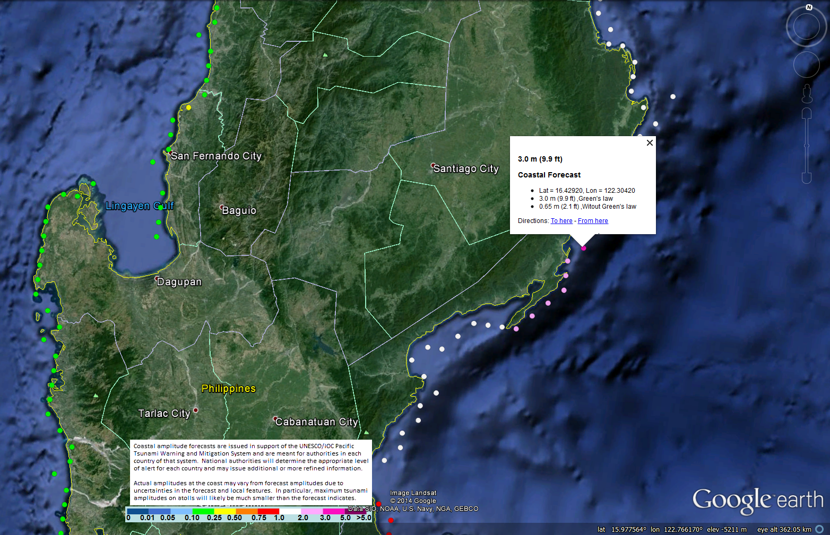

GoogleEarth screenshot of coastal tsunami forecast points from the KMZ file around Luzon Island in the Philippines for a tsunami generated near the Mariana Islands. By mousing over and clicking on a forecast point, the metadata for that point is shown.
- NATIONAL TSUNAMI WARNING ALERT GUIDANCE
This section provides guidance to National Tsunami Warning Centers on how to use the PTWC New Enhanced Products for national tsunami threat assessment and warning. Further details, criteria tables, and warning center guidance are described in Appendix VI. Sample NTWC message templates are given in Appendix VII.
In the prior products, PTWC based their warning and watch decisions on earthquake magnitude and distance from the source (or tsunami arrival time) to the threatened coast. A warning was issued for a particular country if there was an imminent possibility of dangerous tsunami waves, and the criterion for dangerous waves was taken to be one meter or more above the tide level. A watch was issued when dangerous waves were still far away, and upgraded to a warning when the tsunami was close.
With the New Enhanced Products, PTWC will provide a quantitative tsunami forecast 30 minutes to one hour after a large Pacific earthquake with a tsunamigenic potential. This information will be most useful for assessing a country’s tsunami threat from a regional and distant tsunami (e.g., three or more hours away).
For shallow, undersea earthquakes M7.1 or greater, and after the W-phase Centroid Moment Tensor solution constrains the earthquake source, PTWC will issue a Tsunami Threat Message containing tsunami wave amplitude forecasts. NTWC should then use the forecasts, in conjunction with other national or local information, to assess whether any or all of their coasts are threatened, and act accordingly to issue a warning if necessary.
Before this time, and especially for local tsunami threat assessment, countries should continue to use earthquake size (magnitude, or macroscopic intensity scales if instrumental estimates are unavailable) as their initial warning alert criteria. Due to uncertainties in the earthquake source early on, the initial PTWC product, typically issued within 10 minutes of any large Pacific earthquake, will not include quantitative tsunami wave amplitude forecasts.
Based on the experience of the PTWC in providing interim advisory services for the Indian Ocean from 2005-2012, and its current services for the wider Caribbean since 2006, a conservative recommendation is for NTWCs to issue a tsunami warning for local earthquakes M7.1 to M7.5 (less than one hour tsunami travel time), and regional earthquakes M7.6 or greater (less than three-hour time).
- GENERAL EMERGENCY RESPONSE GUIDANCE
This section provides guidance to emergency response agencies on how to interpret and use the PTWC New Enhanced Products. Criteria tables, including Emergency Response Action, are provided in Appendix VI. Further emergency response guidance is provided in Appendix VIII.
In the prior products, a warning for a particular coast means that there is a possibility of tsunami waves that will be one meter or more above the tide level. Without additional information, the conservative response to a PTWC warning should be the maximum evacuation of entire coastal areas.
In the PTWC New Products, there are four categories of forecast tsunami threat that are based on the forecast of the maximum wave amplitude relative to the tide. These categories are: less than 0.3 meters, 0.3 to less than 1 meter, 1 to 3 meters, and greater than 3 meters. The categories are intended to generally correspond, respectively, to no threat, a marine threat, a coastal flooding threat, and a major tsunami, with a corresponding response for public safety. However, each country or area may assign different threshold ranges based upon their own coastal morphology and vulnerabilities.
A tsunami that is forecast to have less than 0.3 meter fluctuations from the tide level is generally not a hazard, and the tsunami would usually not be observed except in places where there is still water, or on sea level gauges.
A tsunami that is forecast to have sea level fluctuations of 0.3 to 1 meter above and below mean sea level is usually a hazard only for ocean recreation activities, such as swimming, diving, and leisure boating, due to strong and unusual near-shore ocean currents, and to minor flooding of beaches and harbors immediately adjacent to the coast. It does not necessarily require a full evacuation of coastal areas, but may require safety actions that recommend swimmers and divers to exit the ocean and persons in low-lying areas of beaches, and harbors and shipping ports to be aware of the anomalous ocean behavior or to evacuate.
A tsunami that is forecast to have sea level fluctuations of 1 to 3 meters above or below mean sea level is a much more dangerous hazard and in most cases would require a significant evacuation of the coast to protect lives. However, in places with elevated coastlines, or places where multiple evacuation zones have been designated, a public safety action that is less than the maximum evacuation may be appropriate.
A tsunami that is forecast to reach more than 3 meters above mean sea level is a very serious threat that would require a maximum evacuation.
Standard response procedures for the PTWC forecast threat levels should be developed nationally and/or locally, taking into consideration the character of the coast, the range and state of the tides, the various vulnerabilities at the coast, and the capability of emergency officials to issue evacuation notices to vulnerable communities in a timely manner.
Further definitions and guidance on warning centers and their products, threat levels, and other terms used in tsunami warning and emergency response can be found in Section 5 (Tsunami Warning System, Acronyms, & Organizations) of the 2014 Tsunami Glossary (Intergovernmental Oceanographic Commission. Revised Edition 2014. Tsunami Glossary,
2014. Paris, UNESCO. IOC Technical Series, 85. (Arabic, English, French, Spanish.) (IOC/2008/TS/85rev2)). The 2013 Tsunami Glossary was updated to reflect the establishment of warning centers in the Indian Ocean and North Atlantic and Mediterranean region, and to reflect that PTWS PTWC New Products. The 2014 edition was revised to include the revised definition of TWFP and the new term NTWC. PTWC’s prior products (with Tsunami Warnings, Watches, and Information Bulletins) are described in Section 5 Acronyms & Organizations of the 2008 Tsunami Glossary.
Both documents can be downloaded in low-resolution from the ITIC web site at: http://itic.ioc-unesco.org/index.php?option=com_content&view=article&id=1328&Itemid=2305&lang=en

APPENDIX I. BACKGROUND MOTIVATION AND IMPLEMENTATION
This Appendix provides background and summarizes the implementation of the New Enhanced Products for the PTWS. A summary timeline of activities and milestones is found at the end of this Appendix.
Over the past fifteen years, PTWC has gone from ingesting data from only about 10 seismic stations outside of Hawaii to over 400 stations now. In addition, its seismic data processing capabilities have become faster and more accurate due to a combination of a better information technology and communications infrastructure, as well as improved science and techniques of its implementation. Within the past five years, and especially since the 2004 Indian Ocean tsunami, the quantity, quality, and timeliness of sea level observations available to PTWC have also increased dramatically. Notably, data are now being received from 39 deep-ocean tsunami gauges in the Pacific that provide measurements of tsunami waveforms unaltered by non-linear effects near the coast, and over 600 sea level stations along country coasts. Lastly, numerical forecast models implemented into PTWC’s operations over the past several years have demonstrated that they are capable of providing much more detailed and precise guidance on the expected level of tsunami impacts than was previously possible using PTWC’s current PTWS warning procedures based only on limited historical data and general properties of tsunami generation, propagation and impact. While the predictive capabilities of the forecast models are not perfect, it is felt that they are now accurate enough to provide reliable guidance on the expected levels of impact to areas that are threatened, and thus should greatly reduce the number of areas warned unnecessarily.
During the Twenty-second and Twenty-third sessions of the ICG/PTWS (2007, 2009), the PTWC reported on operational enhancements that are now permitting the PTWC to provide more timely and accurate assessments of tsunami threat, and asked Member States for input on how PTWC can improve its services. In response, Recommendation ICG/PTWS-XXIII.1 established a Task Team on Enhancing Tsunami Warning Products under the PTWS Working Group on Detection, Warning and Dissemination (WG 2) to review current capabilities, obtain customer feedback, consider best practices, and develop recommendations to improve existing or create new products, and improve dissemination for more effective, functional, and timely delivery.
At the Twenty-fourth session of the ICG/PTWS (May, 2011), Recommendation ICG/PTWS-XXIV.1 asked PTWC to proceed with its development of improved tsunami procedures and products with the Task Team on Enhancing Products guiding and providing feedback and related documentation to PTWC and the ICG/PTWS regarding these changes and the proposed implementation timeline. Any new products and procedures should be exercised in an experimental mode as they are developed and until they are approved for official use by the ICG/PTWS-XXV or later. Recommendation ICG/PTWS-XXIV.3 on PTWS Exercises asked the Working Group Two Task Team on PacWave11 to oversee the conduct of Exercise Pacific Wave 2011 (PacWave11); PacWave11 took place in November 2011 as an international exercise aimed at improving local and regional tsunami response and additionally, introduced the new products to Member States. Through the post-exercise evaluation, comments were received on the staging, format, and contents of the new products.
In May 2012, the Task Teams on PacWave11 and Enhanced Products met to review the feedback on the new products from PacWave11 and other tsunami meetings, and provided recommendations to the following PTWS Steering Committee (PTWS-SC). The PTWS-SC endorsed the recommendations, approved a revised timeline for implementation, and asked the Task Team on PacWave11 to continue and organize Exercise Pacific Wave 2013 to further validate the new products. Since 2009, the Task Teams on Enhanced Products and Exercise Pacific Wave have worked closely to develop, exercise, and obtain feedback from Member States for the implementation and changeover to the new products.
Exercise Pacific Wave 2013 (PacWave13) took place 1-14 May 2013, as a recommended tabletop exercise enabling countries to provide final feedback on the new products and to report on their readiness for the changeover to the new products. At the 25th Session of the ICG/PTWS, based on the findings in the PacWave13 Summary Report and the Report of the PTWS Enhancing Products Task Team, Member States approved Recommendation ICG/PTWS-XXV.2 setting the target start date of the new PTWC Enhanced Products to be 1 October 2014.
In July 2014, the Task Teams on Enhancing Products and PacWave15 met to review the final decisions on the staging, format, and content of the PTWC New Enhanced Products, and decide on the format and schedule for Exercise Pacific Wave 2015 to test the products. Having received confirmation from the USA that their internal processes for the completion by the U.S. National Weather Service of the operational baseline process for the PTWC tsunami forecasting models and arrangements for U.S. National alerting products were on track, the PTWS SC confirmed the changeover to PTWC Enhanced Tsunami Products for the PTWS will commence on 1st October 2014 UTC. At that time, PTWC will cease issuing Alert products containing Warning or Watch and commence issuing Information products containing wave height forecasts. By necessity, each Country will then be required to decide on their national Alert Level using guidance from the PTWC, national, and other sources.
Following the same process, the JMA Northwest Pacific Tsunami Advisory Center (NWPTAC) is starting its analysis to identify enhancements to its existing products. At the 26th Session of the ICG/PTWS (22-24 April 2015), Member States will consider the proposal of the NWPTAC for its new enhanced products, and with approval, the PTWS and JMA will commence the process of finalization, training, and implementation in 2015 to 2018.

For the PTWC Enhanced Products, substantial resources for regional and country trainings were made available to ensure a successful transition to the New Products, and a similar effort is expected for the NWPTAC New Products. The transition has required the consensus approval of all Member States, collaboration and cooperation with and between countries to work together to seamlessly implement coordinated international and national systems, and the full assistance of countries, regional governmental and non-governmental organizations, and donors to support PTWS technical meetings and training to ensure the dissemination and country receipt of timely and helpful tsunami products that are correctly interpreted and used to assess national tsunami threats.

PTWS NEW PRODUCTS IMPLEMENTATION PLAN
SUMMARY OF ACTIVITIES AND MILESTONES
July 2014

Activity | Date | Calendar Year
1. ICG/PTWS-XXIV: Approve PTWC Proposal New Products | May-11 | 2011
2. Prepare for PacWave 2011 - Introduce PTWC New Products | Jun-Oct 2011 | 2011
3. Conduct PacWave 2011 | Nov-11 | 2011
4. Evaluate PacWave 2011, Feedback on PTWC New Products | Dec 2011 - May 2012 | 2011-2012
5. PacWave11 Summary Report | Jun-12, published 2013 | 2012-2013
6. Tsunami SOP Training / Feedback on PTWC New Products | Feb 2012 – Aug 2013 | 2012-2013
7. Prepare for PacWave 2013 - Validate PTWC New Products | Oct 2012 - Apr 2013 | 2012-2013
8. Conduct PacWave 2013 | May 2013 | 2013
9. Evaluate PacWave 2013, Validate PTWC New Products | Jun 2013 | 2013
10. PacWave13 Summary Report | Jul 2013 | 2013
11. ICG/PTWS-XXV: Approve PTWC New Products | Sept 2013 | 2013
12. Train on PTWC New Products | Oct 2013 - Sept 2014 | 2013-2014
13. PTWS Steering Committee approves Start Date | July 11, 2014 | 2014
14. PTWC New Products implemented | Oct 1, 2014 | 2014
15. Prepare for PacWave 2015 | Nov 2014-2015 | 2015
16. Conduct PacWave 2015 | Feb 2015 | 2015
17. Evaluate PacWave 2015 | Mar 2015 | 2015
18. PacWave15 Summary Report | Apr 2015 | 2015
19. ICG/PTWS-XXVI: Evaluate Use of PTWC New Products;  Approve JMA Proposal NWPTAC New Products for Implementation | Apr 22-24, 2015 | 2015
20. Prepare for PacWave 2016 - Introduce NWPTAC New Products |  | 2015-2016
21. Conduct PacWave 2016 | Feb 2016 | 2016
22. Evaluate PacWave 2016, Feedback on NWPTAC New Products |  | 2016
23. PacWave16 Summary Report | May 2016 | 2016
24. PTWS Steering Committee Meeting, PTWS-SC5 | July 2016 | 2016
25. Prepare for PacWave 2017 - Validate NWPTAC New Products |  | 2016-2017
26. Conduct PacWave 2017 | Feb 2017 | 2017
27. Evaluate PacWave 2017, Feedback on NWPTAC New Products |  | 2017
28. PacWave17 Summary Report | May 2017 | 2017
29. ICG/PTWS-XXVII: Approve NWPTAC New Products | 2017 | 2017
30. Train on NWPTAC New Products | 2017-2018 | 2017-2018
31. NWPTAC New Products implemented | 2018 | 2018

APPENDIX II. EXAMPLES OF PTWC NEW ENHANCED PRODUCTS FOR THE PTWS

- Tsunami Information Statement (no tsunami threat)

  - Initial Product (text only)

    - Text Product

ZCZC
WEPA42 PHEB 010008
TIBPAC

TSUNAMI INFORMATION STATEMENT NUMBER 1
NWS PACIFIC TSUNAMI WARNING CENTER EWA BEACH HI
0008 UTC WED OCT 1 2014

...TSUNAMI INFORMATION STATEMENT...

**** NOTICE **** NOTICE **** NOTICE **** NOTICE **** NOTICE *****

THIS STATEMENT IS ISSUED FOR INFORMATION ONLY IN SUPPORT OF THE
UNESCO/IOC PACIFIC TSUNAMI WARNING AND MITIGATION SYSTEM AND IS
MEANT FOR NATIONAL AUTHORITIES IN EACH COUNTRY OF THAT SYSTEM.

NATIONAL AUTHORITIES WILL DETERMINE THE APPROPRIATE LEVEL OF
ALERT FOR EACH COUNTRY AND MAY ISSUE ADDITIONAL OR MORE REFINED
INFORMATION.

**** NOTICE **** NOTICE **** NOTICE **** NOTICE **** NOTICE *****

PRELIMINARY EARTHQUAKE PARAMETERS
---------------------------------

* MAGNITUDE 6.7
* ORIGIN TIME 0000 UTC OCT 1 2014
* COORDINATES 20.0 SOUTH 173.4 WEST
* DEPTH 178 KM / 111 MILES
* LOCATION TONGA

EVALUATION
----------

* AN EARTHQUAKE WITH A PRELIMINARY MAGNITUDE OF 6.7 OCCURRED
IN THE TONGA ISLANDS AT 0000 UTC ON WEDNESDAY OCTOBER 1 2014.

* BASED ON ALL AVAILABLE DATA... THERE IS NO TSUNAMI THREAT
FROM THIS EARTHQUAKE.

RECOMMENDED ACTIONS
-------------------

* NO ACTION IS REQUIRED.

NEXT UPDATE AND ADDITIONAL INFORMATION
--------------------------------------

* THIS WILL BE THE ONLY STATEMENT ISSUED FOR THIS EVENT UNLESS
ADDITIONAL DATA ARE RECEIVED OR THE SITUATION CHANGES.

* AUTHORITATIVE INFORMATION ABOUT THE EARTHQUAKE FROM THE U.S.
GEOLOGICAL SURVEY CAN BE FOUND ON THE INTERNET AT
EARTHQUAKE.USGS.GOV/EARTHQUAKES -ALL IN LOWER CASE-.

* FURTHER INFORMATION ABOUT THIS EVENT MAY BE FOUND AT
PTWC.WEATHER.GOV AND AT WWW.TSUNAMI.GOV.

* COASTAL REGIONS OF HAWAII... AMERICAN SAMOA... GUAM... AND
CNMI SHOULD REFER TO PACIFIC TSUNAMI WARNING CENTER DOMESTIC
MESSAGES FOR THOSE PLACES THAT CAN BE FOUND AT
PTWC.WEATHER.GOV.

* COASTAL REGIONS OF CALIFORNIA... OREGON... WASHINGTON...
BRITISH COLUMBIA AND ALASKA SHOULD REFER TO U.S. NATIONAL
TSUNAMI WARNING CENTER MESSAGES THAT CAN BE FOUND AT
NTWC.ARH.NOAA.GOV.

$$

- Tsunami Information Statement (minor sea level changes only)

  - Initial Product (text only)

    - Text Product

ZCZC
WEPA42 PHEB 010008
TIBPAC

TSUNAMI INFORMATION STATEMENT NUMBER 1
NWS PACIFIC TSUNAMI WARNING CENTER EWA BEACH HI
0008 UTC WED OCT 1 2014

...TSUNAMI INFORMATION STATEMENT...

**** NOTICE **** NOTICE **** NOTICE **** NOTICE **** NOTICE *****

THIS STATEMENT IS ISSUED FOR INFORMATION ONLY IN SUPPORT OF THE
UNESCO/IOC PACIFIC TSUNAMI WARNING AND MITIGATION SYSTEM AND IS
MEANT FOR NATIONAL AUTHORITIES IN EACH COUNTRY OF THAT SYSTEM.

NATIONAL AUTHORITIES WILL DETERMINE THE APPROPRIATE LEVEL OF
ALERT FOR EACH COUNTRY AND MAY ISSUE ADDITIONAL OR MORE REFINED
INFORMATION.

**** NOTICE **** NOTICE **** NOTICE **** NOTICE **** NOTICE *****

PRELIMINARY EARTHQUAKE PARAMETERS
---------------------------------

* MAGNITUDE 6.7
* ORIGIN TIME 0000 UTC OCT 1 2014
* COORDINATES 20.0 SOUTH 173.4 WEST
* DEPTH 28 KM / 17 MILES
* LOCATION TONGA

EVALUATION
----------

* AN EARTHQUAKE WITH A PRELIMINARY MAGNITUDE OF 6.7 OCCURRED IN
THE TONGA ISLANDS AT 0000 UTC ON WEDNESDAY OCTOBER 1 2014.

* BASED ON ALL AVAILABLE DATA... THERE IS NO TSUNAMI THREAT
FROM THIS EARTHQUAKE ALTHOUGH SOME MINOR SEA LEVEL
FLUCTUATIONS MAY OCCUR.

RECOMMENDED ACTIONS
-------------------

* PERSONS ALONG COASTAL AREAS NEAR THE EARTHQUAKE SHOULD BE
OBSERVANT AND EXERCISE NORMAL CAUTION. OTHERWISE... NO ACTION
IS REQUIRED.

POTENTIAL IMPACTS
-----------------

* MINOR SEA LEVEL FLUCTUATIONS MAY OCCUR IN COASTAL AREAS NEAR
THE EARTHQUAKE OVER THE NEXT FEW HOURS.

NEXT UPDATE AND ADDITIONAL INFORMATION
--------------------------------------

* THIS WILL BE THE ONLY STATEMENT ISSUED FOR THIS EVENT UNLESS
ADDITIONAL DATA ARE RECEIVED OR THE SITUATION CHANGES.

* AUTHORITATIVE INFORMATION ABOUT THE EARTHQUAKE FROM THE U.S.
GEOLOGICAL SURVEY CAN BE FOUND ON THE INTERNET AT
EARTHQUAKE.USGS.GOV/EARTHQUAKES -ALL IN LOWER CASE-.

* FURTHER INFORMATION ABOUT THIS EVENT MAY BE FOUND AT
PTWC.WEATHER.GOV AND AT WWW.TSUNAMI.GOV.

* COASTAL REGIONS OF HAWAII... AMERICAN SAMOA... GUAM... AND
CNMI SHOULD REFER TO PACIFIC TSUNAMI WARNING CENTER DOMESTIC
MESSAGES FOR THOSE PLACES THAT CAN BE FOUND AT
PTWC.WEATHER.GOV.

* COASTAL REGIONS OF CALIFORNIA... OREGON... WASHINGTON...
BRITISH COLUMBIA AND ALASKA SHOULD REFER TO U.S. NATIONAL
TSUNAMI WARNING CENTER MESSAGES THAT CAN BE FOUND AT
NTWC.ARH.NOAA.GOV.

$$

- Initial Tsunami Threat Message (no forecast)

  - Initial Product (text only)

    - Text Product

ZCZC
WEPA40 PHEB 010008
TSUPAC

TSUNAMI MESSAGE NUMBER 1
NWS PACIFIC TSUNAMI WARNING CENTER EWA BEACH HI
0008 UTC WED OCT 1 2014

...TSUNAMI THREAT MESSAGE...

**** NOTICE **** NOTICE **** NOTICE **** NOTICE **** NOTICE *****

THIS MESSAGE IS ISSUED FOR INFORMATION ONLY IN SUPPORT OF THE
UNESCO/IOC PACIFIC TSUNAMI WARNING AND MITIGATION SYSTEM AND IS
MEANT FOR NATIONAL AUTHORITIES IN EACH COUNTRY OF THAT SYSTEM.

NATIONAL AUTHORITIES WILL DETERMINE THE APPROPRIATE LEVEL OF
ALERT FOR EACH COUNTRY AND MAY ISSUE ADDITIONAL OR MORE REFINED
INFORMATION.

**** NOTICE **** NOTICE **** NOTICE **** NOTICE **** NOTICE *****

PRELIMINARY EARTHQUAKE PARAMETERS
---------------------------------

* MAGNITUDE 8.6
* ORIGIN TIME 0000 UTC OCT 1 2014
* COORDINATES 20.0 SOUTH 173.4 WEST
* DEPTH 20 KM / 12 MILES
* LOCATION TONGA

EVALUATION
----------

* AN EARTHQUAKE WITH A PRELIMINARY MAGNITUDE OF 9.0 OCCURRED IN
THE TONGA ISLANDS AT 0000 UTC ON WEDNESDAY OCTOBER 1 2014.

* BASED ON THE PRELIMINARY EARTHQUAKE PARAMETERS... HAZARDOUS
TSUNAMI WAVES ARE POSSIBLE FOR SOME COASTS.

TSUNAMI THREAT FORECAST...UPDATED
---------------------------------

* HAZARDOUS TSUNAMI WAVES ARE POSSIBLE WITHIN THE NEXT THREE
HOURS ALONG SOME COASTS OF

NIUE... TONGA... AMERICAN SAMOA... SAMOA... WALLIS AND
FUTUNA... TOKELAU... COOK ISLANDS... FIJI... TUVALU...
KIRIBATI... HOWLAND AND BAKER... AND NEW ZEALAND.

* OTHER AREAS NOT MENTIONED ABOVE SHOULD REMAIN ALERT IN CASE
THE TSUNAMI THREAT IS EXTENDED TO THEIR COAST.

* A MORE QUANTITATIVE TSUNAMI FORECAST IS NOT YET AVAILABLE
DUE TO INSUFFFICIENT INFORMATION ABOUT THE EARTHQUAKE AND
TSUNAMI. THE SITUATION IS STILL BEING ANALYZED AND A MORE
QUANTITATIVE FORECAST WILL BE PROVIDED AS SOON AS POSSIBLE.

RECOMMENDED ACTIONS
-------------------

* GOVERNMENT AGENCIES RESPONSIBLE FOR THREATENED COASTAL AREAS
SHOULD TAKE ACTION TO INFORM AND INSTRUCT ANY COASTAL
POPULATIONS AT RISK IN ACCORDANCE WITH THEIR OWN EVALUATION...
PROCEDURES AND THE LEVEL OF THREAT.

* PERSONS LOCATED IN THREATENED COASTAL AREAS SHOULD STAY ALERT
FOR INFORMATION AND FOLLOW INSTRUCTIONS FROM NATIONAL AND
LOCAL AUTHORITIES.

ESTIMATED TIMES OF ARRIVAL
--------------------------

* ESTIMATED TIMES OF ARRIVAL -ETA- OF THE INITIAL TSUNAMI WAVE
OVER THE NEXT SIX HOURS. OBSERVED ARRIVAL TIMES MAY DIFFER
AND THE INITIAL WAVE MAY NOT BE THE LARGEST.

LOCATION REGION COORDINATES ETA(UTC)
------------------------------------------------------------
NIUE ISLAND NIUE 19.0S 170.0W 0026 10/01
NUKUALOFA TONGA 21.0S 175.2W 0033 10/01
PAGO PAGO AMERICAN SAMOA 14.3S 170.7W 0050 10/01
APIA SAMOA 13.8S 171.8W 0100 10/01
WALLIS ISLAND WALLIS AND FUTUN 13.3S 176.3W 0110 10/01
NUKUNONU ISLAND TOKELAU 9.2S 171.8W 0130 10/01
FUTUNA ISLAND WALLIS AND FUTUN 14.3S 178.2W 0132 10/01
PUKAPUKA ISLAND COOK ISLANDS 10.8S 165.9W 0133 10/01
RAROTONGA COOK ISLANDS 21.2S 159.8W 0144 10/01
SUVA FIJI 18.1S 178.4E 0151 10/01
FUNAFUTI ISLAND TUVALU 7.9S 178.5E 0216 10/01
KANTON ISLAND KIRIBATI 2.8S 171.7W 0222 10/01
PENRYN ISLAND COOK ISLANDS 8.9S 157.8W 0239 10/01
HOWLAND ISLAND HOWLAND AND BAKE 0.6N 176.6W 0249 10/01
EAST CAPE NEW ZEALAND 37.7S 178.5E 0251 10/01
NORTH CAPE NEW ZEALAND 34.4S 173.3E 0253 10/01
GISBORNE NEW ZEALAND 38.7S 178.0E 0257 10/01
FLINT ISLAND KIRIBATI 11.4S 151.8W 0303 10/01
ANATOM ISLAND VANUATU 20.2S 169.9E 0307 10/01
PAPEETE FRENCH POLYNESIA 17.5S 149.6W 0314 10/01
JARVIS ISLAND JARVIS ISLAND 0.4S 160.1W 0317 10/01
WELLINGTON NEW ZEALAND 41.3S 174.8E 0322 10/01
MALDEN ISLAND KIRIBATI 3.9S 154.9W 0324 10/01
NAPIER NEW ZEALAND 39.5S 176.9E 0345 10/01
CHRISTMAS ISLAN KIRIBATI 2.0N 157.5W 0348 10/01
PALMYRA ISLAND PALMYRA ISLAND 5.9N 162.1W 0349 10/01
ESPERITU SANTO VANUATU 15.1S 167.3E 0354 10/01
NOUMEA NEW CALEDONIA 22.3S 166.5E 0356 10/01
AUCKLAND EAST NEW ZEALAND 36.7S 175.0E 0358 10/01
TARAWA ISLAND KIRIBATI 1.5N 173.0E 0407 10/01
SANTA CRUZ ISLA SOLOMON ISLANDS 10.9S 165.9E 0413 10/01
NAURU NAURU 0.5S 166.9E 0418 10/01
AUCKLAND WEST NEW ZEALAND 37.1S 174.2E 0422 10/01
MAJURO MARSHALL ISLANDS 7.1N 171.4E 0433 10/01
KIRAKIRA SOLOMON ISLANDS 10.4S 161.9E 0438 10/01
HIVA OA FRENCH POLYNESIA 10.0S 139.0W 0453 10/01
DUNEDIN NEW ZEALAND 45.9S 170.5E 0457 10/01
KWAJALEIN MARSHALL ISLANDS 8.7N 167.7E 0459 10/01
RIKITEA FRENCH POLYNESIA 23.1S 135.0W 0505 10/01
AUKI SOLOMON ISLANDS 8.8S 160.6E 0506 10/01
NEW PLYMOUTH NEW ZEALAND 39.1S 174.1E 0509 10/01
GHATERE SOLOMON ISLANDS 7.8S 159.2E 0511 10/01
KOSRAE ISLAND KOSRAE 5.5N 163.0E 0511 10/01
HONIARA SOLOMON ISLANDS 9.3S 160.0E 0525 10/01
PANGGOE SOLOMON ISLANDS 6.9S 157.2E 0529 10/01
LYTTELTON NEW ZEALAND 43.6S 172.7E 0532 10/01
MUNDA SOLOMON ISLANDS 8.4S 157.2E 0536 10/01
PITCAIRN ISLAND PITCAIRN 25.1S 130.1W 0546 10/01
KIETA PAPUA NEW GUINEA 6.1S 155.6E 0548 10/01
WESTPORT NEW ZEALAND 41.8S 171.6E 0551 10/01
MILFORD SOUND NEW ZEALAND 44.6S 167.9E 0556 10/01
FALAMAE SOLOMON ISLANDS 7.4S 155.6E 0556 10/01
ENIWETOK MARSHALL ISLANDS 11.4N 162.3E 0600 10/01
WAKE ISLAND WAKE ISLAND 19.3N 166.6E 0602 10/01
POHNPEI ISLAND POHNPEI 7.0N 158.2E 0608 10/01

POTENTIAL IMPACTS
-----------------

* A TSUNAMI IS A SERIES OF WAVES. THE TIME BETWEEN WAVE CRESTS
CAN VARY FROM 5 MINUTES TO AN HOUR. THE HAZARD MAY PERSIST FOR
MANY HOURS OR LONGER AFTER THE INITIAL WAVE.

* IMPACTS CAN VARY SIGNIFICANTLY FROM ONE SECTION OF COAST TO
THE NEXT DUE TO LOCAL BATHYMETRY AND THE SHAPE AND ELEVATION
OF THE SHORELINE.

* IMPACTS CAN ALSO VARY DEPENDING UPON THE STATE OF THE TIDE AT
THE TIME OF THE MAXIMUM TSUNAMI WAVES.

* PERSONS CAUGHT IN THE WATER OF A TSUNAMI MAY DROWN... BE
CRUSHED BY DEBRIS IN THE WATER... OR BE SWEPT OUT TO SEA.

NEXT UPDATE AND ADDITIONAL INFORMATION
--------------------------------------

* THE NEXT MESSAGE WILL BE ISSUED IN ONE HOUR... OR SOONER IF
THE SITUATION WARRANTS.

* AUTHORITATIVE INFORMATION ABOUT THE EARTHQUAKE FROM THE U.S.
GEOLOGICAL SURVEY CAN BE FOUND ON THE INTERNET AT
EARTHQUAKE.USGS.GOV/EARTHQUAKES -ALL IN LOWER CASE-.

* FURTHER INFORMATION ABOUT THIS EVENT MAY BE FOUND AT
PTWC.WEATHER.GOV AND AT WWW.TSUNAMI.GOV.

* COASTAL REGIONS OF HAWAII... AMERICAN SAMOA... GUAM... AND
CNMI SHOULD REFER TO PACIFIC TSUNAMI WARNING CENTER MESSAGES
FOR THOSE PLACES THAT CAN BE FOUND AT PTWC.WEATHER.GOV.

* COASTAL REGIONS OF CALIFORNIA... OREGON... WASHINGTON...
BRITISH COLUMBIA AND ALASKA SHOULD REFER TO U.S. NATIONAL
TSUNAMI WARNING CENTER MESSAGES THAT CAN BE FOUND AT
NTWC.ARH.NOAA.GOV.

$$

- Supplemental Tsunami Threat Message (with amplitude forecast)

  - Text Product

ZCZC
WEPA40 PHEB 010040
TSUPAC

TSUNAMI MESSAGE NUMBER 2
NWS PACIFIC TSUNAMI WARNING CENTER EWA BEACH HI
0040 UTC WED OCT 1 2014

...TSUNAMI THREAT MESSAGE...

**** NOTICE **** NOTICE **** NOTICE **** NOTICE **** NOTICE *****

THIS MESSAGE IS ISSUED FOR INFORMATION ONLY IN SUPPORT OF THE
UNESCO/IOC PACIFIC TSUNAMI WARNING AND MITIGATION SYSTEM AND IS
MEANT FOR NATIONAL AUTHORITIES IN EACH COUNTRY OF THAT SYSTEM.

NATIONAL AUTHORITIES WILL DETERMINE THE APPROPRIATE LEVEL OF
ALERT FOR EACH COUNTRY AND MAY ISSUE ADDITIONAL OR MORE REFINED
INFORMATION.

**** NOTICE **** NOTICE **** NOTICE **** NOTICE **** NOTICE *****

UPDATES
-------

* THE PRELIMINARY EARTHQUAKE PARAMETERS ARE UPDATED IN THIS
MESSAGE.

* THE TSUNAMI THREAT FORECAST IS UPDATED IN THIS MESSAGE.

* THE ESTIMATED TIMES OF ARRIVAL ARE UPDATED IN THIS MESSAGE.

PRELIMINARY EARTHQUAKE PARAMETERS... UPDATED
--------------------------------------------

* MAGNITUDE 9.0
* ORIGIN TIME 0000 UTC OCT 1 2014
* COORDINATES 20.0 SOUTH 173.4 WEST
* DEPTH 20 KM / 12 MILES
* LOCATION TONGA

EVALUATION
----------

* AN EARTHQUAKE WITH A PRELIMINARY MAGNITUDE OF 9.0 OCCURRED IN
THE TONGA ISLANDS AT 0000 UTC ON WEDNESDAY OCTOBER 1 2014.

* BASED ON THE PRELIMINARY EARTHQUAKE PARAMETERS... HAZARDOUS
TSUNAMI WAVES ARE FORECAST FOR SOME COASTS.

TSUNAMI THREAT FORECAST... UPDATED
----------------------------------

* TSUNAMI WAVES REACHING MORE THAN 3 METERS ABOVE THE TIDE
LEVEL ARE POSSIBLE ALONG SOME COASTS OF

ECUADOR... PERU... CHILE... NEW ZEALAND... FIJI... SAMOA...
AMERICAN SAMOA... COOK ISLANDS... VANUATU... FRENCH POLYNESIA...
TONGA... WALLIS AND FUTUNA... PITCAIRN ISLANDS... AND NIUE.

* TSUNAMI WAVES REACHING 1 TO 3 METERS ABOVE THE TIDE LEVEL ARE
POSSIBLE ALONG SOME COASTS OF

MEXICO... EL SALVADOR... GUATEMALA... COSTA RICA...
NICARAGUA... PANAMA... COLOMBIA... ANTARCTICA... AUSTRALIA...
NEW CALEDONIA... POHNPEI... TOKELAU... KIRIBATI... NAURU...
TUVALU... SOLOMON ISLANDS... PAPUA NEW GUINEA... HAWAII... AND
NW HAWAIIAN ISLANDS.

* TSUNAMI WAVES REACHING 0.3 TO 1 METERS ABOVE THE TIDE LEVEL
ARE POSSIBLE FOR SOME COASTS OF

HONDURAS... JAPAN... PHILIPPINES... TAIWAN... NORTHERN
MARIANAS... GUAM... PALAU... YAP... CHUUK... KOSRAE... MARSHALL
ISLANDS... WAKE ISLAND... MIDWAY ISLAND... JOHNSTON ISLAND...
JARVIS ISLAND... PALMYRA ISLAND... HOWLAND AND BAKER...
INDONESIA... AND RUSSIA.

* TSUNAMI WAVES LESS THAN 0.3 METERS ABOVE THE TIDE LEVEL ARE
POSSIBLE FOR SOME COASTS OF

CHINA... REPUBLIC OF KOREA... DPR OF KOREA... VIETNAM...
MALAYSIA... AND BRUNEI.

* ACTUAL AMPLITUDES AT THE COAST MAY VARY FROM FORECAST
AMPLITUDES DUE TO UNCERTAINTIES IN THE FORECAST AND LOCAL
FEATURES. IN PARTICULAR MAXIMUM TSUNAMI AMPLITUDES ON ATOLLS
WILL LIKELY BE MUCH SMALLER THAN THE FORECAST INDICATES.

* FOR OTHER AREAS COVERED BY THIS PRODUCT A FORECAST HAS NOT
YET BEEN COMPUTED. THE FORECAST WILL BE EXPANDED AS NECESSARY
IN SUBSEQUENT PRODUCTS.

RECOMMENDED ACTIONS
-------------------

* GOVERNMENT AGENCIES RESPONSIBLE FOR THREATENED COASTAL AREAS
SHOULD TAKE ACTION TO INFORM AND INSTRUCT ANY COASTAL
POPULATIONS AT RISK IN ACCORDANCE WITH THEIR OWN EVALUATION...
PROCEDURES AND THE LEVEL OF THREAT.

* PERSONS LOCATED IN THREATENED COASTAL AREAS SHOULD STAY ALERT
FOR INFORMATION AND FOLLOW INSTRUCTIONS FROM NATIONAL AND
LOCAL AUTHORITIES.

ESTIMATED TIMES OF ARRIVAL... UPDATED
-------------------------------------

* ESTIMATED TIMES OF ARRIVAL -ETA- OF THE INITIAL TSUNAMI WAVE
FOR POINTS WITHIN THREATENED REGIONS ARE GIVEN BELOW. ACTUAL
ARRIVAL TIMES MAY DIFFER AND THE INITIAL WAVE MAY NOT BE THE
LARGEST.

LOCATION REGION COORDINATES ETA(UTC)
------------------------------------------------------------
NIUE ISLAND NIUE 19.0S 170.0W 0026 10/01
NUKUALOFA TONGA 21.0S 175.2W 0033 10/01
PAGO PAGO AMERICAN SAMOA 14.3S 170.7W 0050 10/01
APIA SAMOA 13.8S 171.8W 0100 10/01
WALLIS ISLAND WALLIS AND FUTUN 13.3S 176.3W 0110 10/01
NUKUNONU ISLAND TOKELAU 9.2S 171.8W 0130 10/01
FUTUNA ISLAND WALLIS AND FUTUN 14.3S 178.2W 0132 10/01
PUKAPUKA ISLAND COOK ISLANDS 10.8S 165.9W 0133 10/01
RAROTONGA COOK ISLANDS 21.2S 159.8W 0144 10/01
SUVA FIJI 18.1S 178.4E 0151 10/01
FUNAFUTI ISLAND TUVALU 7.9S 178.5E 0216 10/01
KANTON ISLAND KIRIBATI 2.8S 171.7W 0222 10/01
PENRYN ISLAND COOK ISLANDS 8.9S 157.8W 0239 10/01
HOWLAND ISLAND HOWLAND AND BAKE 0.6N 176.6W 0249 10/01
EAST CAPE NEW ZEALAND 37.7S 178.5E 0251 10/01
NORTH CAPE NEW ZEALAND 34.4S 173.3E 0253 10/01
GISBORNE NEW ZEALAND 38.7S 178.0E 0257 10/01
FLINT ISLAND KIRIBATI 11.4S 151.8W 0303 10/01
ANATOM ISLAND VANUATU 20.2S 169.9E 0307 10/01
PAPEETE FRENCH POLYNESIA 17.5S 149.6W 0314 10/01
JARVIS ISLAND JARVIS ISLAND 0.4S 160.1W 0317 10/01
WELLINGTON NEW ZEALAND 41.3S 174.8E 0322 10/01
MALDEN ISLAND KIRIBATI 3.9S 154.9W 0324 10/01
NAPIER NEW ZEALAND 39.5S 176.9E 0345 10/01
CHRISTMAS ISLAN KIRIBATI 2.0N 157.5W 0348 10/01
PALMYRA ISLAND PALMYRA ISLAND 5.9N 162.1W 0349 10/01
ESPERITU SANTO VANUATU 15.1S 167.3E 0354 10/01
NOUMEA NEW CALEDONIA 22.3S 166.5E 0356 10/01
AUCKLAND EAST NEW ZEALAND 36.7S 175.0E 0358 10/01
TARAWA ISLAND KIRIBATI 1.5N 173.0E 0407 10/01
SANTA CRUZ ISLA SOLOMON ISLANDS 10.9S 165.9E 0413 10/01
NAURU NAURU 0.5S 166.9E 0418 10/01
AUCKLAND WEST NEW ZEALAND 37.1S 174.2E 0422 10/01
MAJURO MARSHALL ISLANDS 7.1N 171.4E 0433 10/01
KIRAKIRA SOLOMON ISLANDS 10.4S 161.9E 0438 10/01
HIVA OA FRENCH POLYNESIA 10.0S 139.0W 0453 10/01
DUNEDIN NEW ZEALAND 45.9S 170.5E 0457 10/01
KWAJALEIN MARSHALL ISLANDS 8.7N 167.7E 0459 10/01
RIKITEA FRENCH POLYNESIA 23.1S 135.0W 0505 10/01
AUKI SOLOMON ISLANDS 8.8S 160.6E 0506 10/01
NEW PLYMOUTH NEW ZEALAND 39.1S 174.1E 0509 10/01
GHATERE SOLOMON ISLANDS 7.8S 159.2E 0511 10/01
KOSRAE ISLAND KOSRAE 5.5N 163.0E 0511 10/01
HONIARA SOLOMON ISLANDS 9.3S 160.0E 0525 10/01
PANGGOE SOLOMON ISLANDS 6.9S 157.2E 0529 10/01
LYTTELTON NEW ZEALAND 43.6S 172.7E 0532 10/01
MUNDA SOLOMON ISLANDS 8.4S 157.2E 0536 10/01
PITCAIRN ISLAND PITCAIRN 25.1S 130.1W 0546 10/01
KIETA PAPUA NEW GUINEA 6.1S 155.6E 0548 10/01
WESTPORT NEW ZEALAND 41.8S 171.6E 0551 10/01
MILFORD SOUND NEW ZEALAND 44.6S 167.9E 0556 10/01
FALAMAE SOLOMON ISLANDS 7.4S 155.6E 0556 10/01
ENIWETOK MARSHALL ISLANDS 11.4N 162.3E 0600 10/01
WAKE ISLAND WAKE ISLAND 19.3N 166.6E 0602 10/01
POHNPEI ISLAND POHNPEI 7.0N 158.2E 0608 10/01
WOODLARK ISLAND PAPUA NEW GUINEA 9.0S 152.9E 0609 10/01
AMUN PAPUA NEW GUINEA 6.0S 154.7E 0610 10/01
SYDNEY AUSTRALIA 33.9S 151.4E 0625 10/01
BRISBANE AUSTRALIA 27.2S 153.3E 0632 10/01
RABAUL PAPUA NEW GUINEA 4.2S 152.3E 0634 10/01
MIDWAY ISLAND MIDWAY ISLAND 28.2N 177.4W 0636 10/01
NELSON NEW ZEALAND 41.3S 173.3E 0645 10/01
KAVIENG PAPUA NEW GUINEA 2.5S 150.7E 0704 10/01
PORT MORESBY PAPUA NEW GUINEA 9.3S 146.9E 0705 10/01
LAE PAPUA NEW GUINEA 6.8S 147.0E 0705 10/01
ULAMONA PAPUA NEW GUINEA 5.0S 151.3E 0707 10/01
HOBART AUSTRALIA 43.3S 147.6E 0711 10/01
BLUFF NEW ZEALAND 46.6S 168.3E 0712 10/01
MADANG PAPUA NEW GUINEA 5.2S 145.8E 0731 10/01
CAPE ADARE ANTARCTICA 71.0S 170.0E 0732 10/01
CHUUK ISLAND CHUUK 7.4N 151.8E 0739 10/01
MINAMITORISHIMA MINAMITORISHIMA 24.3N 154.0E 0739 10/01
MANUS ISLAND PAPUA NEW GUINEA 2.0S 147.5E 0740 10/01
CAIRNS AUSTRALIA 16.7S 145.8E 0751 10/01
SAIPAN NORTHERN MARIANA 15.3N 145.8E 0752 10/01
GUAM GUAM 13.4N 144.7E 0758 10/01
GLADSTONE AUSTRALIA 23.8S 151.4E 0810 10/01
WEWAK PAPUA NEW GUINEA 3.5S 143.6E 0813 10/01
VANIMO PAPUA NEW GUINEA 2.6S 141.3E 0825 10/01
JAYAPURA INDONESIA 2.4S 140.8E 0829 10/01
YAP ISLAND YAP 9.5N 138.1E 0840 10/01
EASTER ISLAND CHILE 27.1S 109.4W 0844 10/01
CHICHI JIMA JAPAN 27.0N 142.3E 0911 10/01
WARSA INDONESIA 0.6S 135.8E 0913 10/01
MALAKAL PALAU 7.3N 134.5E 0926 10/01
MANOKWARI INDONESIA 0.8S 134.2E 0933 10/01
KATSUURA JAPAN 35.1N 140.3E 0948 10/01
HACHIJO JIMA JAPAN 33.1N 139.8E 0949 10/01
MACKAY AUSTRALIA 21.1S 149.3E 0951 10/01
THURSTON ISLAND ANTARCTICA 72.0S 100.0W 0959 10/01
SORONG INDONESIA 0.8S 131.1E 1002 10/01
KUSHIRO JAPAN 42.9N 144.3E 1011 10/01
BEREBERE INDONESIA 2.5N 128.7E 1019 10/01
GEME INDONESIA 4.6N 126.8E 1026 10/01
PATANI INDONESIA 0.4N 128.8E 1031 10/01
DAVAO PHILIPPINES 6.8N 125.7E 1035 10/01
HACHINOHE JAPAN 40.5N 141.5E 1038 10/01
MEDNNY ISLAND RUSSIA 54.7N 167.4E 1042 10/01
UST KAMCHATSK RUSSIA 56.1N 162.6E 1045 10/01
LEGASPI PHILIPPINES 13.2N 123.8E 1045 10/01
PETROPAVLOVSK RUSSIA 53.2N 159.6E 1047 10/01
ENSENADA MEXICO 31.8N 116.8W 1049 10/01
PALANAN PHILIPPINES 17.1N 122.6E 1051 10/01
PUNTA ABREOJOS MEXICO 26.7N 113.6W 1053 10/01
SHIMIZU JAPAN 32.8N 133.0E 1053 10/01
TABUKAN TENGAH INDONESIA 3.6N 125.6E 1054 10/01
NOBEOKA JAPAN 32.5N 131.8E 1056 10/01
CABO SAN LUCAS MEXICO 22.8N 110.0W 1056 10/01
SEVERO KURILSK RUSSIA 50.8N 156.1E 1108 10/01
OSTROV KARAGINS RUSSIA 58.8N 164.5E 1111 10/01
HUALIEN TAIWAN 24.0N 121.7E 1115 10/01
TAITUNG TAIWAN 22.7N 121.2E 1117 10/01
OKINAWA JAPAN 26.2N 127.8E 1117 10/01
PUERTO VALLARTA MEXICO 20.6N 105.3W 1135 10/01
MANZANILLO MEXICO 19.1N 104.3W 1137 10/01
MAZATLAN MEXICO 23.2N 106.4W 1142 10/01
LAZARO CARDENAS MEXICO 17.9N 102.2W 1148 10/01
CHILUNG TAIWAN 25.2N 121.8E 1148 10/01
ACAPULCO MEXICO 16.9N 99.9W 1157 10/01
GOLFO DE PENAS CHILE 47.1S 74.9W 1158 10/01
SAN BLAS MEXICO 21.5N 105.3W 1204 10/01
SAPPORO JAPAN 43.5N 141.0E 1209 10/01
GUAYMAS MEXICO 27.9N 110.9W 1218 10/01
NAGASAKI JAPAN 32.7N 129.7E 1221 10/01
NIIGATA JAPAN 38.0N 139.0E 1228 10/01
CORRAL CHILE 39.8S 73.5W 1241 10/01
TALCAHUANO CHILE 36.7S 73.1W 1250 10/01
VALPARAISO CHILE 33.0S 71.6W 1306 10/01
BALTRA ISLAND ECUADOR 0.5S 90.3W 1313 10/01
SALINA CRUZ MEXICO 16.5N 95.2W 1316 10/01
COQUIMBO CHILE 29.9S 71.4W 1321 10/01
PUERTO MADERO MEXICO 14.8N 92.5W 1323 10/01
COCOS ISLAND COSTA RICA 5.5N 87.1W 1325 10/01
SHIMANE JAPAN 35.8N 133.0E 1326 10/01
CALDERA CHILE 27.1S 70.8W 1335 10/01
SIPICATE GUATEMALA 13.9N 91.2W 1335 10/01
ACAJUTLA EL SALVADOR 13.6N 89.8W 1340 10/01
TALARA PERU 4.6S 81.5W 1344 10/01
CABO SAN ELENA COSTA RICA 10.9N 86.0W 1353 10/01
ANTOFAGASTA CHILE 23.3S 70.4W 1354 10/01
LA LIBERTAD ECUADOR 2.2S 81.2W 1358 10/01
SAN JUAN PERU 15.3S 75.2W 1400 10/01
CORINTO NICARAGUA 12.5N 87.2W 1401 10/01
LA PUNTA PERU 12.1S 77.2W 1402 10/01
PUERTO SANDINO NICARAGUA 12.2N 86.8W 1407 10/01
PUERTO QUEPOS COSTA RICA 9.4N 84.2W 1414 10/01
CABO MATAPALO COSTA RICA 8.4N 83.3W 1415 10/01
SAN JUAN DL SUR NICARAGUA 11.2N 85.9W 1417 10/01
MOLLENDO PERU 17.1S 72.0W 1420 10/01
IQUIQUE CHILE 20.2S 70.1W 1420 10/01
PUNTA BURICA PANAMA 8.0N 82.9W 1425 10/01
ARICA CHILE 18.5S 70.3W 1426 10/01
CHIMBOTE PERU 9.0S 78.8W 1429 10/01
PUERTO MONTT CHILE 41.5S 73.0W 1437 10/01
ESMERELDAS ECUADOR 1.2N 79.8W 1437 10/01
AMAPALA HONDURAS 13.2N 87.6W 1437 10/01
PIMENTAL PERU 6.9S 80.0W 1440 10/01
SAN FELIPE MEXICO 31.0N 114.8W 1450 10/01
TUMACO COLOMBIA 1.8N 78.9W 1455 10/01
PUNTA MALA PANAMA 7.5N 80.0W 1505 10/01
BAHIA SOLANO COLOMBIA 6.3N 77.4W 1513 10/01
PUERTO PINA PANAMA 7.4N 78.0W 1514 10/01
UST KAHYRYUZOVO RUSSIA 57.1N 156.7E 1522 10/01
BUENAVENTURA COLOMBIA 3.8N 77.2W 1539 10/01
BALBOA HEIGHTS PANAMA 9.0N 79.6W 1725 10/01

POTENTIAL IMPACTS
-----------------

* A TSUNAMI IS A SERIES OF WAVES. THE TIME BETWEEN WAVE CRESTS
CAN VARY FROM 5 MINUTES TO AN HOUR. THE HAZARD MAY PERSIST FOR
MANY HOURS OR LONGER AFTER THE INITIAL WAVE.

* IMPACTS CAN VARY SIGNIFICANTLY FROM ONE SECTION OF COAST TO
THE NEXT DUE TO LOCAL BATHYMETRY AND THE SHAPE AND ELEVATION
OF THE SHORELINE.

* IMPACTS CAN ALSO VARY DEPENDING UPON THE STATE OF THE TIDE AT
THE TIME OF THE MAXIMUM TSUNAMI WAVES.

* PERSONS CAUGHT IN THE WATER OF A TSUNAMI MAY DROWN... BE
CRUSHED BY DEBRIS IN THE WATER... OR BE SWEPT OUT TO SEA.

NEXT UPDATE AND ADDITIONAL INFORMATION
--------------------------------------

* THE NEXT MESSAGE WILL BE ISSUED IN ONE HOUR... OR SOONER IF
THE SITUATION WARRANTS.

* AUTHORITATIVE INFORMATION ABOUT THE EARTHQUAKE FROM THE U.S.
GEOLOGICAL SURVEY CAN BE FOUND ON THE INTERNET AT
EARTHQUAKE.USGS.GOV/EARTHQUAKES -ALL IN LOWER CASE-.

* FURTHER INFORMATION ABOUT THIS EVENT MAY BE FOUND AT
PTWC.WEATHER.GOV AND AT WWW.TSUNAMI.GOV.

* COASTAL REGIONS OF HAWAII... AMERICAN SAMOA... GUAM... AND
CNMI SHOULD REFER TO PACIFIC TSUNAMI WARNING CENTER MESSAGES
FOR THOSE PLACES THAT CAN BE FOUND AT PTWC.WEATHER.GOV.

* COASTAL REGIONS OF CALIFORNIA... OREGON... WASHINGTON...
BRITISH COLUMBIA AND ALASKA SHOULD REFER TO U.S. NATIONAL
TSUNAMI WARNING CENTER MESSAGES THAT CAN BE FOUND AT
NTWC.ARH.NOAA.GOV.

$$

  - Forecast Polygons Map

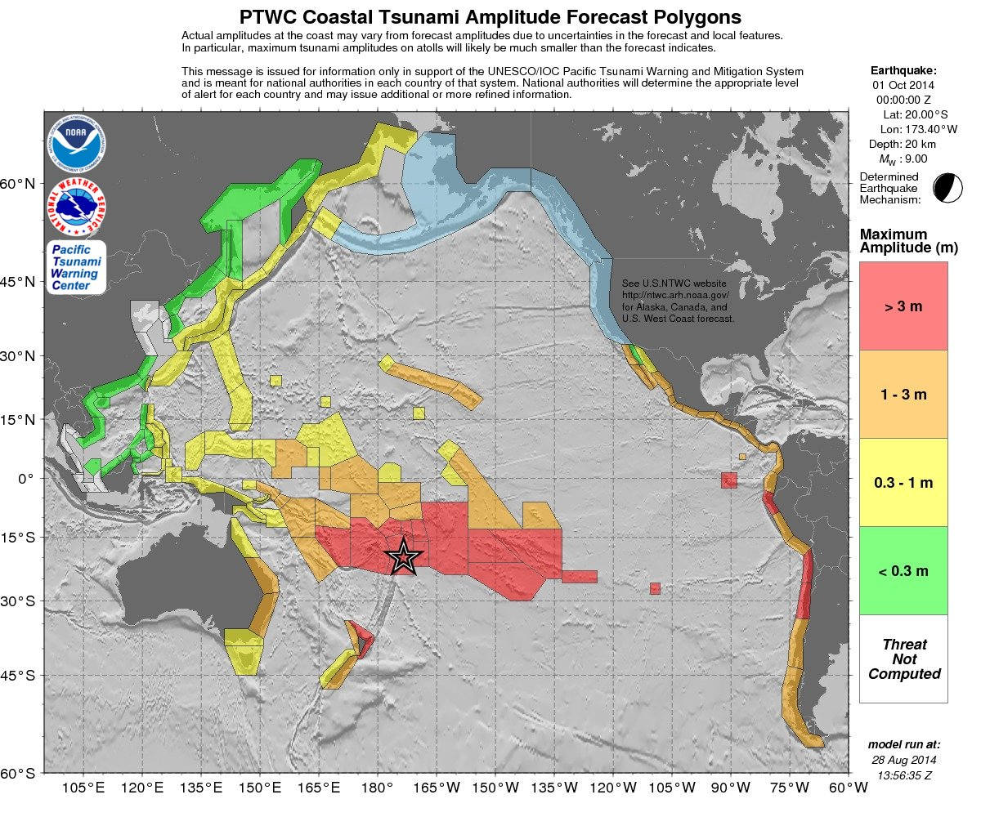

  - Forecast Polygons Table of Statistics
This table provides some statistics on the coastal forecast values provided within each polygon. “Region Name” (Appendix IV) is a name that should unambiguously describe the location of the polygon. There are two categories of coastal point values for which statistics are given. The first, “Coastal Forecast,” represents the Green’s Law coastal forecast values depicted on the coastal forecast maps and in the KML file. The second, “Offshore Forecast,” represents the model values without Green’s Law applied that can be individually viewed using the KML file. “Total Points” are the total number of coastal points computed within the polygon for the model run over the domain and at the grid resolution that was used.

PTWC TABLE OF FORECAST STATISTICS FOR REGIONAL POLYGONS - RUN ID 20140828135635
(for internal use only - not for distribution)

Earthquake - Origin: 10/01/2014 00:00:00 UTC Coordinates: 20.0S 173.4W Depth: 020km Magnitude: 9.0

This table is issued for information only in support the UNESCO/IOC Pacific Tsunami Warning and Mitigation System and is
meant for national authorities in each country of that system. National authorities will determine the appropriate
level of alert for each country and may issue additional or more refined information.

Actual amplitudes at the coast may vary from forecast amplitudes due to uncertainties in the forecast and local
features. In particular, maximum tsunami amplitudes on atolls will likely be much smaller than the forecast indicates.

Coastal Forecast (meters) Offshore Forecast (meters) Total
Region_Name Maximum Mean Median STD Maximum Mean Median STD Points
Tonga 14. 7.31 5.21 3.96 7.0 5.50 5.66 1.17 4
Niue 14. 13.55 13.55 0.00 1.8 1.76 1.76 0.00 1
Austral_Islands 8.3 7.36 7.20 0.59 1.4 1.33 1.34 0.03 4
Cook_Islands 8.1 3.73 1.60 3.12 1.2 0.54 0.20 0.47 3
Wallis_and_Futuna 7.0 4.13 3.80 1.51 2.1 1.44 1.21 0.38 5
Easter_Island 5.4 5.38 5.38 0.00 1.2 1.18 1.18 0.00 1
Fiji 5.3 3.07 3.06 1.06 3.6 1.31 1.21 0.58 151
Society_Islands 4.9 2.92 2.68 0.87 2.2 0.78 0.77 0.37 35
Samoa 4.7 2.86 2.55 1.04 1.7 0.78 0.69 0.36 40
Tuamotu_Archipelago 4.1 4.09 4.09 0.00 0.78 0.78 0.78 0.00 1
North_Central_Chile 3.9 2.57 2.54 0.50 4.0 1.49 1.31 0.66 120
Northern_Peru 3.9 2.80 2.58 0.64 3.0 1.67 1.64 0.47 100
Northern_Chile 3.7 2.60 2.71 0.65 3.7 1.06 0.98 0.52 119
American_Samoa 3.5 2.42 2.23 0.69 1.1 0.71 0.79 0.26 18
Galapagos_Islands 3.4 2.10 1.82 0.72 1.7 0.71 0.60 0.37 94
North_Side_of_North_Island_New_Zealand 3.2 1.99 1.89 0.37 3.5 1.50 1.51 0.43 114
Pitcairn_Islands 3.2 3.16 3.16 0.00 0.53 0.53 0.53 0.00 1
East_Side_of_North_Island_New_Zealand 3.2 1.32 1.18 0.38 2.0 0.79 0.71 0.37 88
Vanuatu 3.0 1.69 1.73 0.38 1.8 0.60 0.52 0.32 189
South_Central_Chile 2.9 1.86 1.77 0.39 2.2 1.11 1.04 0.36 167
Central_Peru 2.8 1.85 1.77 0.40 2.3 1.37 1.40 0.38 104
Southern_Chile 2.7 1.42 1.35 0.50 1.7 0.72 0.67 0.28 382
Southern_Peru 2.6 2.09 2.10 0.22 2.4 1.24 1.15 0.45 76
Ecuador 2.6 1.20 1.59 0.87 1.8 0.68 0.86 0.52 151
Santa_Cruz_Islands 2.4 1.84 1.83 0.30 1.4 0.66 0.61 0.28 18
Pacific_Coast_of_Costa_Rica 2.3 1.57 1.54 0.22 1.5 0.89 0.90 0.22 79
Pacific_Coast_of_Panama 2.3 1.44 1.56 0.37 1.5 0.72 0.68 0.28 91
New_Caledonia 1.9 1.19 1.21 0.29 1.4 0.74 0.72 0.27 153
Gilbert_Islands_Kiribati 1.9 1.91 1.91 0.00 0.45 0.45 0.45 0.00 1
Marie_Byrd_Land_Coast_of_Antarctica 1.8 1.25 1.18 0.24 3.1 0.67 0.56 0.35 570
Hawaii 1.7 1.11 1.11 0.22 1.2 0.43 0.35 0.21 147
Oaxaca_Mexico 1.6 1.26 1.24 0.15 1.3 0.74 0.70 0.23 68
Pohnpei_State_Micronesia 1.6 1.26 1.27 0.23 1.1 0.46 0.33 0.28 10
Michoacan_Mexico 1.6 1.26 1.25 0.16 1.4 0.63 0.59 0.23 27
Jalisco_Mexico 1.5 1.31 1.28 0.15 1.5 0.79 0.79 0.31 33
Guerrero_Mexico 1.5 1.31 1.29 0.12 1.5 0.87 0.88 0.23 56
Marquesas_Islands 1.5 1.25 1.22 0.16 0.76 0.34 0.31 0.15 24
West_Side_of_North_Island_New_Zealand 1.5 0.78 0.77 0.15 1.1 0.70 0.66 0.17 76
Nayarit_Mexico 1.5 1.20 1.19 0.16 1.1 0.68 0.73 0.26 32
New_Ireland 1.5 0.88 0.83 0.22 0.96 0.28 0.22 0.16 127
Pacific_Coast_of_Colombia 1.5 1.16 1.14 0.12 1.1 0.71 0.73 0.19 98
Pacific_Side_of_Baja_Mexico 1.5 1.20 1.19 0.12 1.2 0.71 0.70 0.17 75
Line_Islands_Kiribati 1.4 1.24 1.18 0.14 0.33 0.23 0.20 0.07 3
Cocos_Island_Costa_Rica 1.4 1.42 1.42 0.00 0.29 0.29 0.29 0.00 1
Pacific_Side_of_Baja_Sud_Mexico 1.4 1.18 1.15 0.11 1.3 0.78 0.78 0.21 110
Choisel_to_Philip_Solomon_Islands 1.4 0.86 0.83 0.21 1.2 0.36 0.32 0.19 339
Pacific_Coast_of_Nicaragua 1.4 1.15 1.15 0.10 1.1 0.87 0.90 0.15 35
Colima_Mexico 1.4 1.21 1.21 0.07 1.3 0.83 0.75 0.25 12
Tokelau 1.3 1.31 1.31 0.00 0.33 0.33 0.33 0.00 1
Chiapas_Mexico 1.3 1.17 1.26 0.14 0.95 0.72 0.69 0.12 28
Gulf_Side_of_Baja_Sud_Mexico 1.3 0.54 0.43 0.23 1.0 0.21 0.19 0.15 99
Ellsworth_Land_Coast_of_Antarctica 1.2 0.92 0.87 0.16 1.8 0.57 0.53 0.25 274
Pacific_Coast_of_Guatemala 1.2 1.14 1.10 0.07 0.99 0.72 0.74 0.14 33
El_Salvador 1.2 1.11 1.12 0.09 1.2 0.81 0.81 0.17 37
Sinaloa_Mexico 1.2 0.79 0.77 0.24 1.3 0.51 0.49 0.25 77
NW_Hawaiian_Islands 1.2 0.96 1.03 0.17 0.74 0.53 0.56 0.18 5
Tuvalu 1.2 1.16 1.16 0.00 0.15 0.15 0.15 0.00 1
Nauru 1.1 1.14 1.14 0.00 0.17 0.17 0.17 0.00 1
Northeast_Side_of_the_Antarctic_Peninsula 1.1 0.88 0.89 0.14 1.5 0.40 0.36 0.18 436
Phoenix_Islands_Kiribati 1.1 1.10 1.10 0.00 0.29 0.29 0.29 0.00 1
East_Side_of_South_Island_New_Zealand 1.1 0.84 0.85 0.13 1.0 0.58 0.56 0.14 158
Southern_Queensland_Australia 1.1 0.68 0.61 0.21 0.85 0.39 0.36 0.14 142
Bougainville_Papua_New_Guinea 1.1 0.76 0.79 0.16 0.83 0.42 0.41 0.16 75
New_South_Wales_Australia 1.0 0.82 0.80 0.08 1.4 0.72 0.71 0.14 150
Pacific_Coast_of_Honduras 0.98 0.98 0.98 0.00 0.75 0.65 0.61 0.08 3
East_Coast_of_Japanese_Main_Islands 0.98 0.62 0.61 0.10 0.85 0.40 0.39 0.15 407
West_Side_of_South_Island_New_Zealand 0.96 0.81 0.83 0.11 1.2 0.54 0.56 0.24 139
Marshall_Islands 0.93 0.74 0.74 0.13 0.77 0.42 0.38 0.27 4
Guam 0.92 0.68 0.68 0.10 0.41 0.23 0.21 0.09 12
Jarvis_Island 0.89 0.89 0.89 0.00 0.13 0.13 0.13 0.00 1
Johnston_Island 0.88 0.88 0.88 0.00 0.14 0.14 0.14 0.00 1
Manus_Island_Papua_New_Guinea 0.87 0.78 0.81 0.09 0.77 0.43 0.43 0.11 23
Trobriand_Woodlark_and_Louisiade_Islands 0.87 0.69 0.71 0.11 0.86 0.40 0.41 0.17 71
Bismarck_Sea_Coast_of_Papua_New_Guinea 0.87 0.63 0.62 0.09 0.81 0.24 0.21 0.12 152
Pacific_Side_of_Papua_Indonesia 0.87 0.55 0.55 0.10 0.68 0.26 0.25 0.11 266
Palmyra_Island 0.86 0.86 0.86 0.00 0.13 0.13 0.13 0.00 1
Victoria_Oates_and_George_V_Coast_of_Antarctica 0.86 0.65 0.68 0.11 1.2 0.35 0.32 0.15 548
Chuuk_State_Micronesia 0.86 0.86 0.86 0.00 0.73 0.73 0.73 0.00 1
Talaud_Islands_Indonesia 0.83 0.51 0.52 0.17 0.46 0.21 0.20 0.09 19
New_Britain-Solomon_Sea_Coast_of_New_Britain 0.80 0.55 0.54 0.10 0.52 0.22 0.20 0.09 82
New_Britain-Bismarck_Sea_Coast_of_New_Britain 0.80 0.60 0.60 0.05 0.57 0.29 0.29 0.10 86
Howland_and_Baker 0.79 0.79 0.79 0.00 0.09 0.09 0.09 0.00 1
Coral_Sea_Coast_of_Papua_New_Guinea 0.79 0.41 0.37 0.10 0.61 0.27 0.22 0.12 164
Kuril_Islands_Russia 0.79 0.47 0.46 0.14 0.73 0.23 0.20 0.15 95
Tasmania 0.78 0.51 0.56 0.18 0.62 0.35 0.36 0.13 167
Solomon_Sea_Coast_of_Papua_New_Guinea 0.77 0.51 0.50 0.09 0.55 0.19 0.17 0.09 141
Urup_Etorofu_Kunashiri_Shikotan_and_Habomai_Islands 0.76 0.42 0.37 0.16 0.69 0.21 0.16 0.14 101
Pacific_Coast_of_Kamchatka_Russia 0.75 0.64 0.65 0.07 0.83 0.45 0.46 0.14 157
Kosrae_State_Micronesia 0.75 0.75 0.75 0.00 0.09 0.09 0.09 0.00 1
Victoria_Australia 0.72 0.40 0.28 0.16 0.81 0.29 0.23 0.16 130
Northern_Marianas 0.72 0.55 0.55 0.08 0.52 0.15 0.10 0.10 19
Palau 0.70 0.51 0.49 0.08 0.47 0.24 0.25 0.10 15
Midway_Island 0.68 0.63 0.60 0.04 0.64 0.55 0.51 0.06 3
West_Coast_of_Japanese_Main_Islands 0.68 0.13 0.05 0.17 0.49 0.07 0.03 0.09 465
Halmahera_Indonesia 0.66 0.38 0.37 0.11 0.55 0.19 0.17 0.09 190
Pacific_Coast_of_the_Philippines 0.66 0.46 0.47 0.09 0.61 0.23 0.22 0.10 350
Izu_and_Ogasawara_Islands_Japan 0.63 0.61 0.61 0.02 0.32 0.25 0.25 0.07 2
Komandorsky_Islands_Russia 0.61 0.50 0.49 0.07 0.75 0.37 0.32 0.19 38
Northern_Queensland_Australia 0.61 0.44 0.44 0.07 0.44 0.23 0.22 0.08 211
Nansei_Islands_Japan 0.60 0.47 0.49 0.08 0.50 0.29 0.29 0.10 81
Bering_Sea_Coast_of_Eastern_Russia 0.58 0.38 0.38 0.08 0.74 0.26 0.26 0.08 328
Wake_Island 0.57 0.54 0.53 0.02 0.10 0.09 0.08 0.01 3
Interior_Seas_of_the_Philippines 0.53 0.08 0.05 0.09 0.27 0.03 0.02 0.04 264
Eastern_Coast_of_Taiwan 0.51 0.44 0.45 0.07 0.32 0.16 0.14 0.06 49
Yap_State_Micronesia 0.47 0.47 0.47 0.00 0.47 0.47 0.47 0.00 1
Sonora_Mexico 0.46 0.30 0.29 0.05 0.22 0.11 0.11 0.05 97
Minamitorishima_Japan 0.43 0.43 0.43 0.00 0.06 0.06 0.06 0.00 1
Celebes_Sea_Coast_of_Sulawesi_Indonesia 0.39 0.24 0.23 0.05 0.28 0.13 0.12 0.05 87
Sangihe_Islands_Indonesia 0.38 0.30 0.29 0.04 0.28 0.12 0.09 0.07 13
Celebes_Sea_Coast_of_the_Philippines 0.35 0.21 0.21 0.03 0.20 0.09 0.09 0.04 67
Gulf_Side_of_Baja_Mexico 0.30 0.27 0.26 0.01 0.08 0.06 0.06 0.01 40
Western_Coast_of_Kamchatka_Russia 0.30 0.16 0.13 0.06 0.32 0.17 0.15 0.05 54
Western_Coast_of_Taiwan 0.29 0.24 0.22 0.03 0.22 0.11 0.10 0.04 32
Southeastern_Coast_of_China 0.29 0.28 0.28 0.02 0.17 0.11 0.11 0.03 30
Western_Coast_of_the_Northern_Philippines 0.29 0.13 0.10 0.07 0.38 0.07 0.05 0.07 125
Sea_of_Okhotsk_Coast_of_Sakhalin_Russia 0.26 0.20 0.21 0.04 0.27 0.16 0.16 0.05 150
Sulu_Archipelago_Philippines 0.26 0.20 0.21 0.05 0.14 0.09 0.08 0.03 52
Southern_Coast_of_China 0.22 0.15 0.17 0.04 0.13 0.08 0.09 0.02 130
Celebes_Sea_Coast_of_Borneo_Indonesia 0.20 0.17 0.17 0.02 0.12 0.07 0.07 0.02 57
Celebes_Sea_Coast_of_Sabah_Malaysia 0.18 0.17 0.17 0.01 0.11 0.07 0.07 0.01 27
Sulu_Sea_Coast_of_the_Philippines 0.13 0.04 0.03 0.02 0.04 0.01 0.01 0.01 120
East_Coast_of_Russia_on_the_Sea_of_Okhotsk 0.13 0.13 0.13 0.00 0.10 0.07 0.06 0.02 61
Palawan_Island_Philippines 0.11 0.05 0.05 0.03 0.05 0.03 0.03 0.01 130
Southern_Coast_of_Vietnam 0.07 0.05 0.05 0.01 0.06 0.03 0.03 0.01 112
East_Coast_of_Russia_on_the_Tatarskiy_Straight 0.07 0.05 0.05 0.01 0.05 0.03 0.02 0.01 43
Hainan_Island_China 0.07 0.06 0.06 0.00 0.05 0.03 0.03 0.01 46
Tatarskiy_Straight_Coast_of_Sakhalin_Russia 0.07 0.06 0.07 0.01 0.10 0.05 0.04 0.02 47
East_Coast_of_Russia_north_of_the_Korean_Peninsula 0.06 0.03 0.03 0.01 0.04 0.02 0.02 0.01 148
Northern_Coast_of_Vietnam 0.06 0.05 0.06 0.01 0.05 0.03 0.03 0.01 33
Sulu_Sea_Coast_of_Sabah_Malaysia 0.06 0.04 0.03 0.01 0.07 0.03 0.02 0.01 54
Northwest_Coast_of_Sabah_Malaysia 0.04 0.04 0.04 0.00 0.03 0.02 0.02 0.00 51
Brunei 0.04 0.03 0.03 0.00 0.02 0.02 0.02 0.00 16
Southwest_Coast_of_Sabah_Malaysia 0.04 0.04 0.03 0.00 0.02 0.02 0.02 0.00 42
Eastern_Coast_of_DPR_of_Korea 0.04 0.02 0.03 0.00 0.03 0.02 0.01 0.01 89
Eastern_Coast_of_the_Republic_of_Korea 0.03 0.03 0.03 0.00 0.07 0.02 0.02 0.01 59
Natuna_Islands_Indonesia 0.03 0.03 0.03 0.00 0.02 0.01 0.01 0.00 6
  - Energy Forecast Map

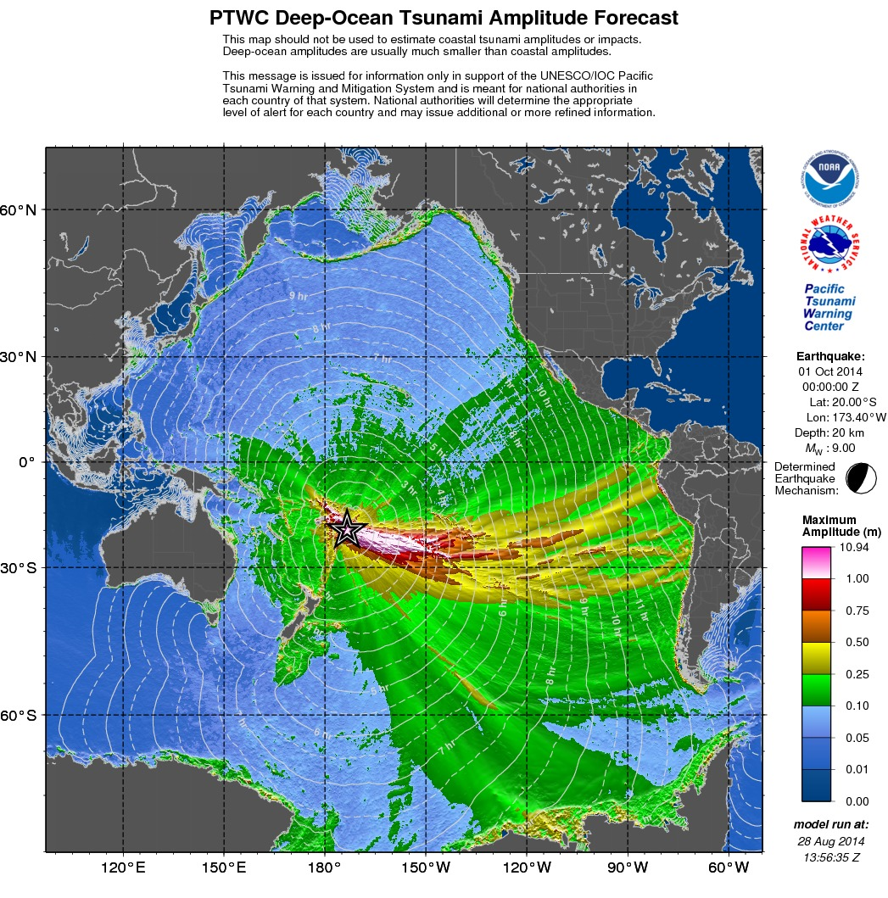

  - Pacific-Wide Coastal Forecast Map

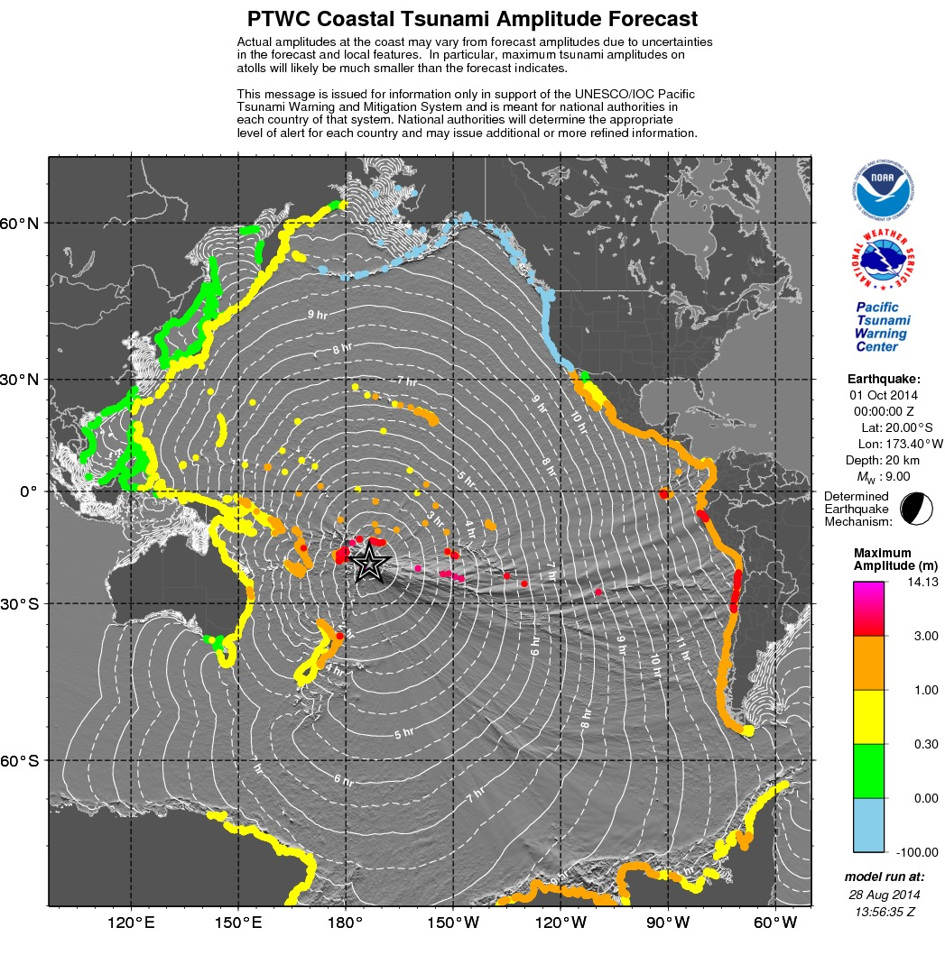
The light blue dots along the U.S. West Coast, British Columbia, Canada, and Alaska are not actual forecast values but instead show locations where forecast values will be shown if they are published during events by the U.S. NTWC.
  - Northwest Pacific Coastal Forecast Map

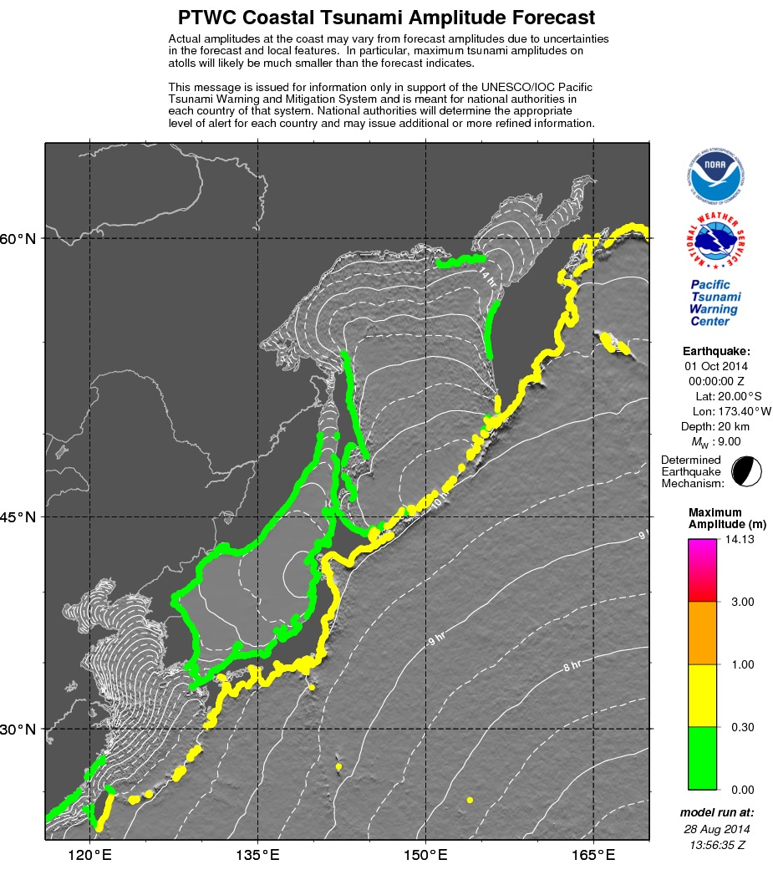
Forecast values are not available for coasts such as those bordering the Bohai Sea, Yellow Sea, and Sea of Okhotsk that are far from deep water where the model is valid at the 4-minute grid resolution used. For cases where a forecast is needed for those coasts, the model can be run again at a higher resolution but over a smaller domain.
  - South China Sea Coastal Forecast Map

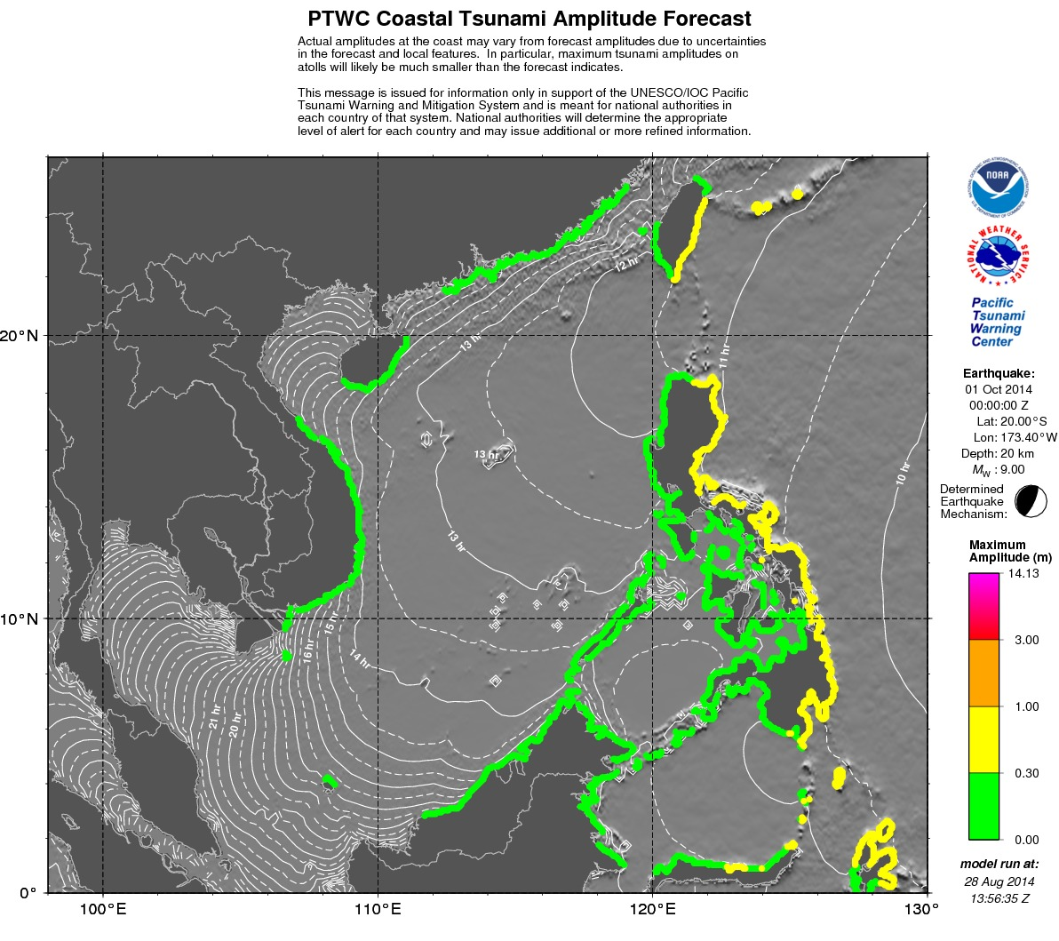
Forecast values are not available for coasts such as those bordering the Gulf of Thailand that are far from deep water where the model is valid at the 4-minute grid resolution used. For cases where a forecast is needed for those coast, the model will be run at a higher resolution to be valid much closer to the coast. .
  - Southwest Pacific Coastal Forecast Map

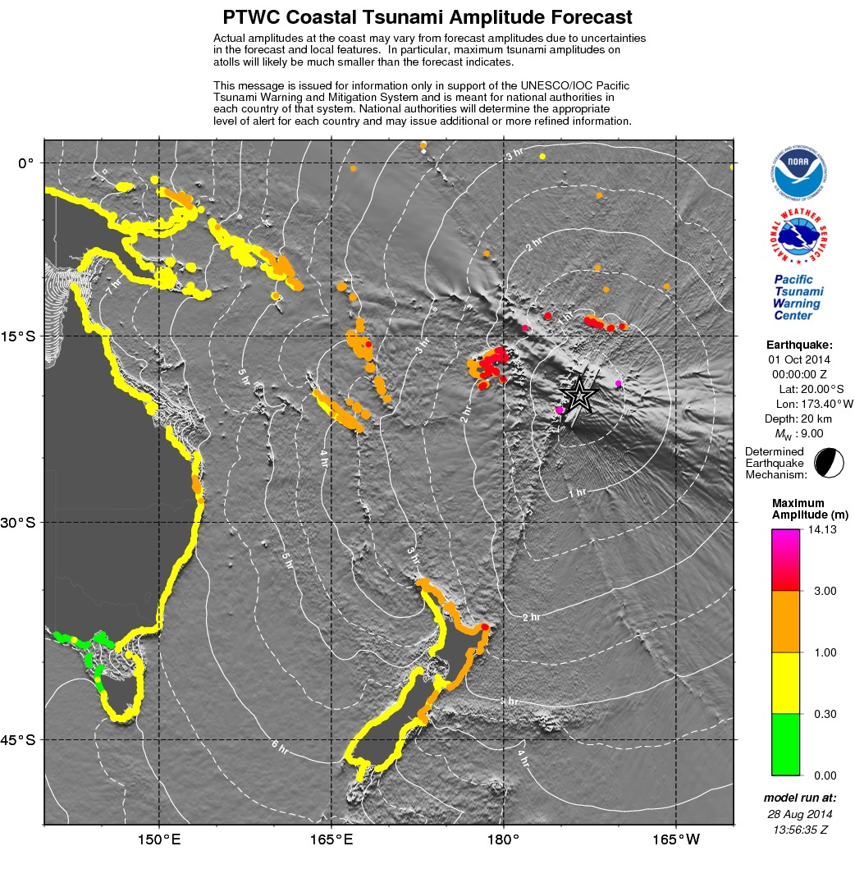

  - West Central Pacific Coastal Forecast Map

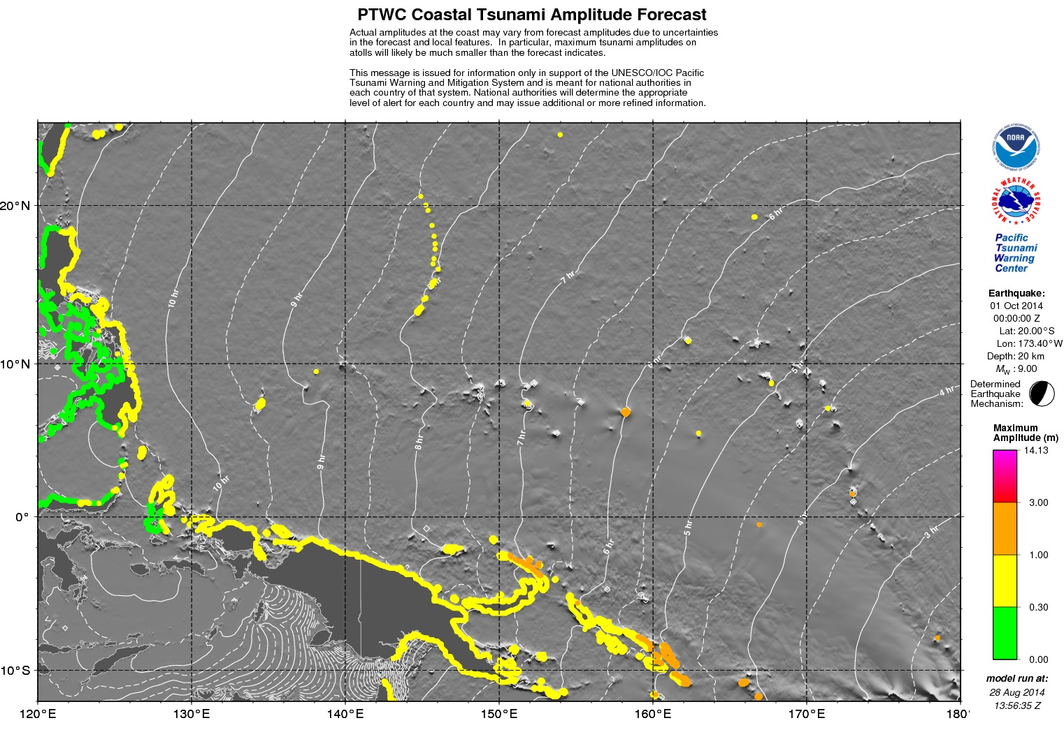

  - Central South Pacific Coastal Forecast Map

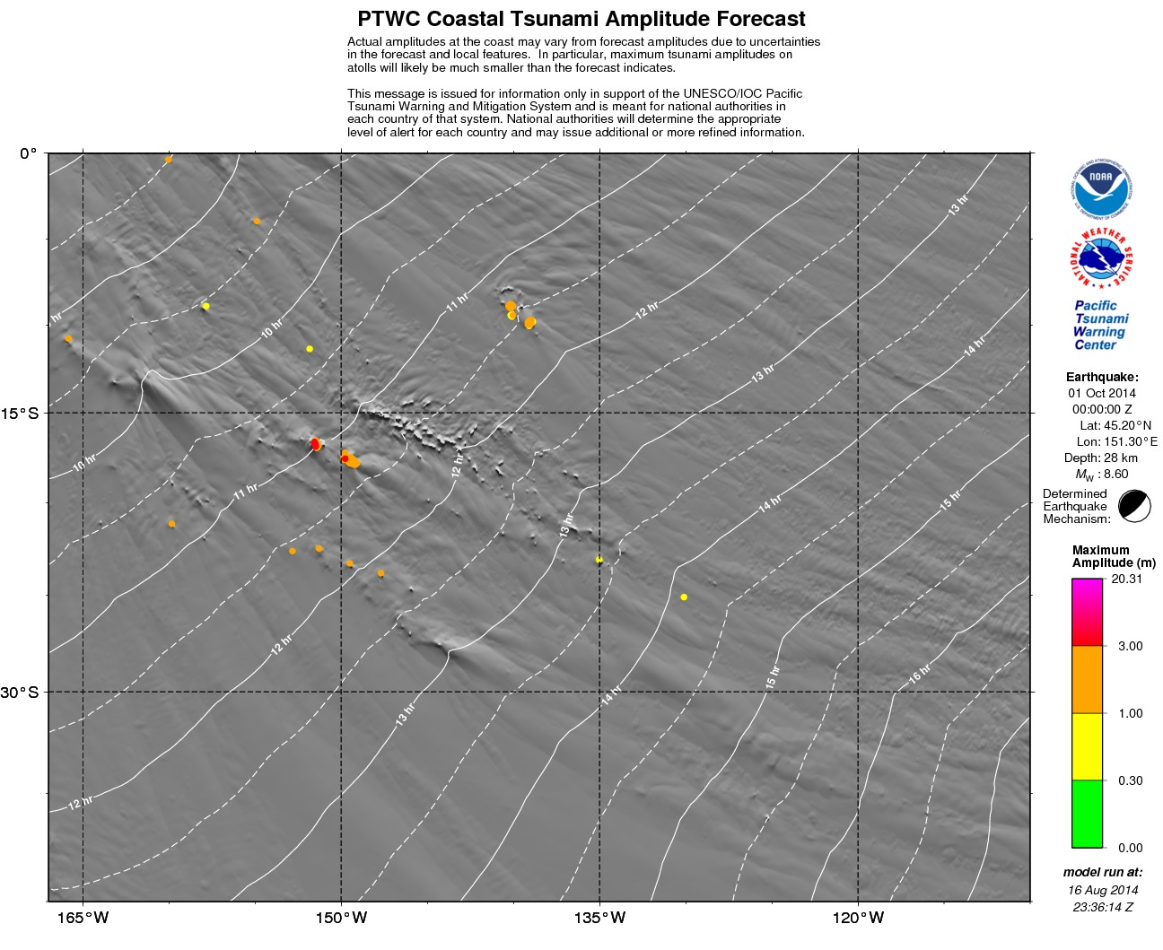

  - Southeast Pacific Coastal Forecast Map

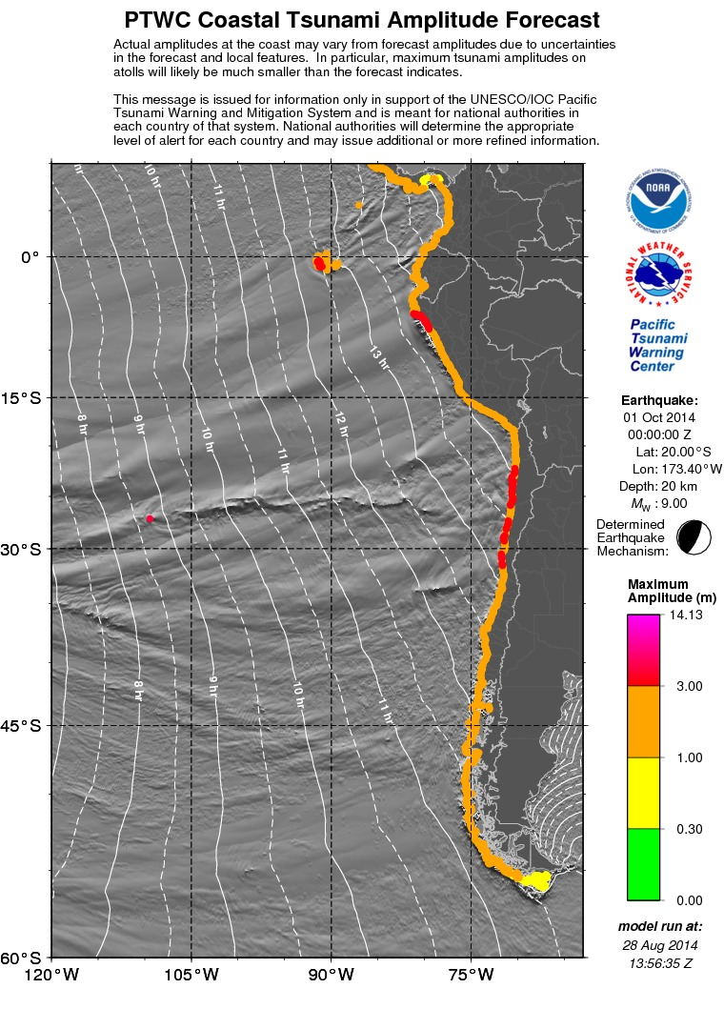

  - Central Eastern Pacific Coastal Forecast Map

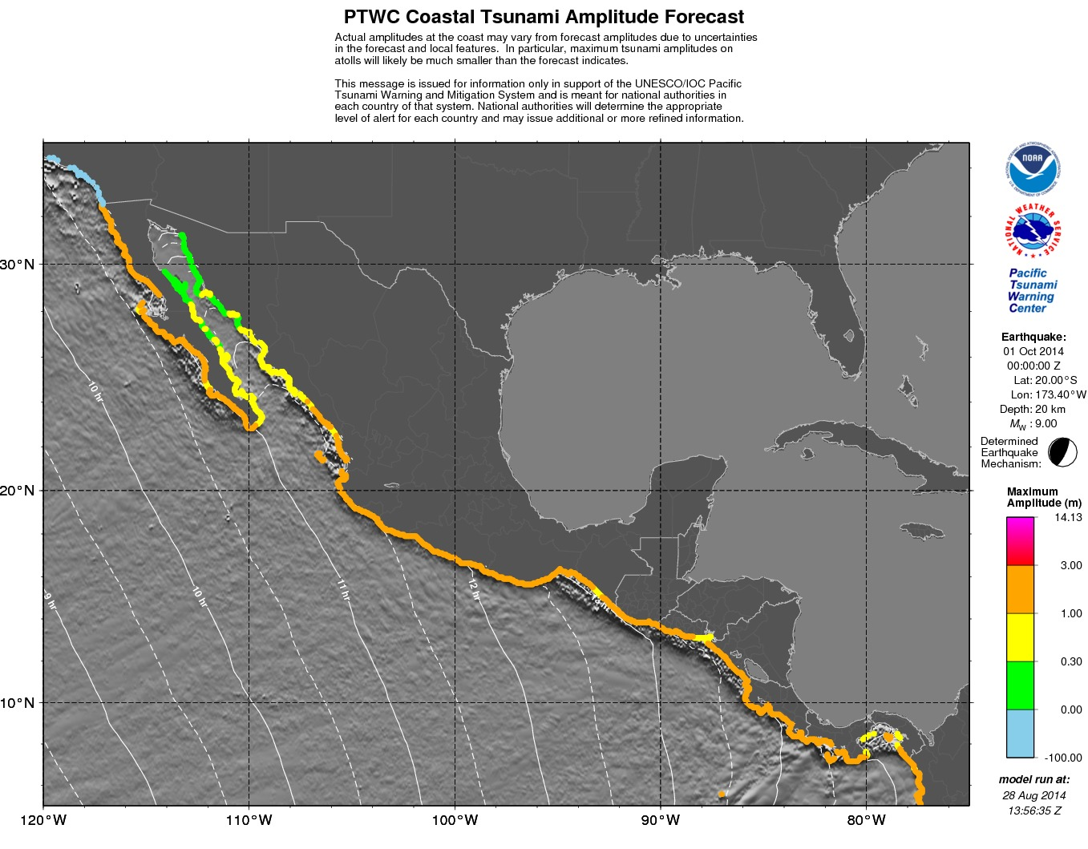
The light blue dots north of the Mexico-California border are not actual forecast values but instead show locations where forecast values will be shown if they are published during events by the U.S. NTWC.
  - Northeast Pacific Coastal Forecast Map

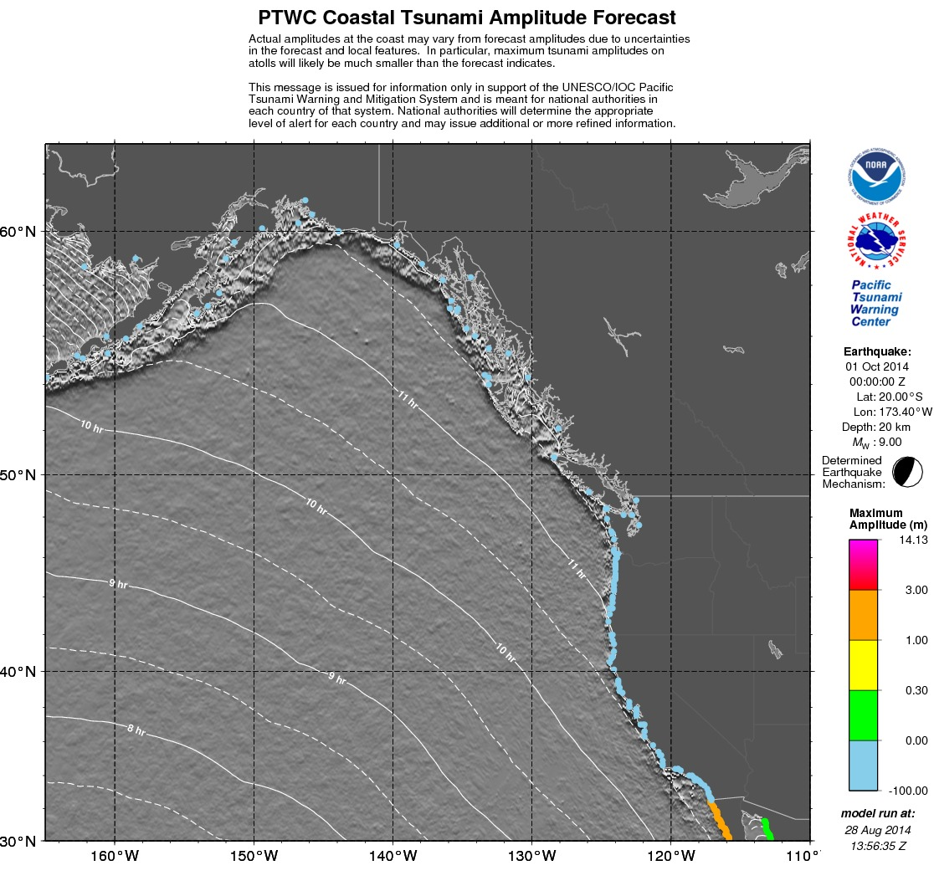
The light blue dots are not actual forecast values but instead show locations where forecast values will be shown if they are published during events by the U.S. NTWC.

  - North Central Pacific Coastal Forecast Map

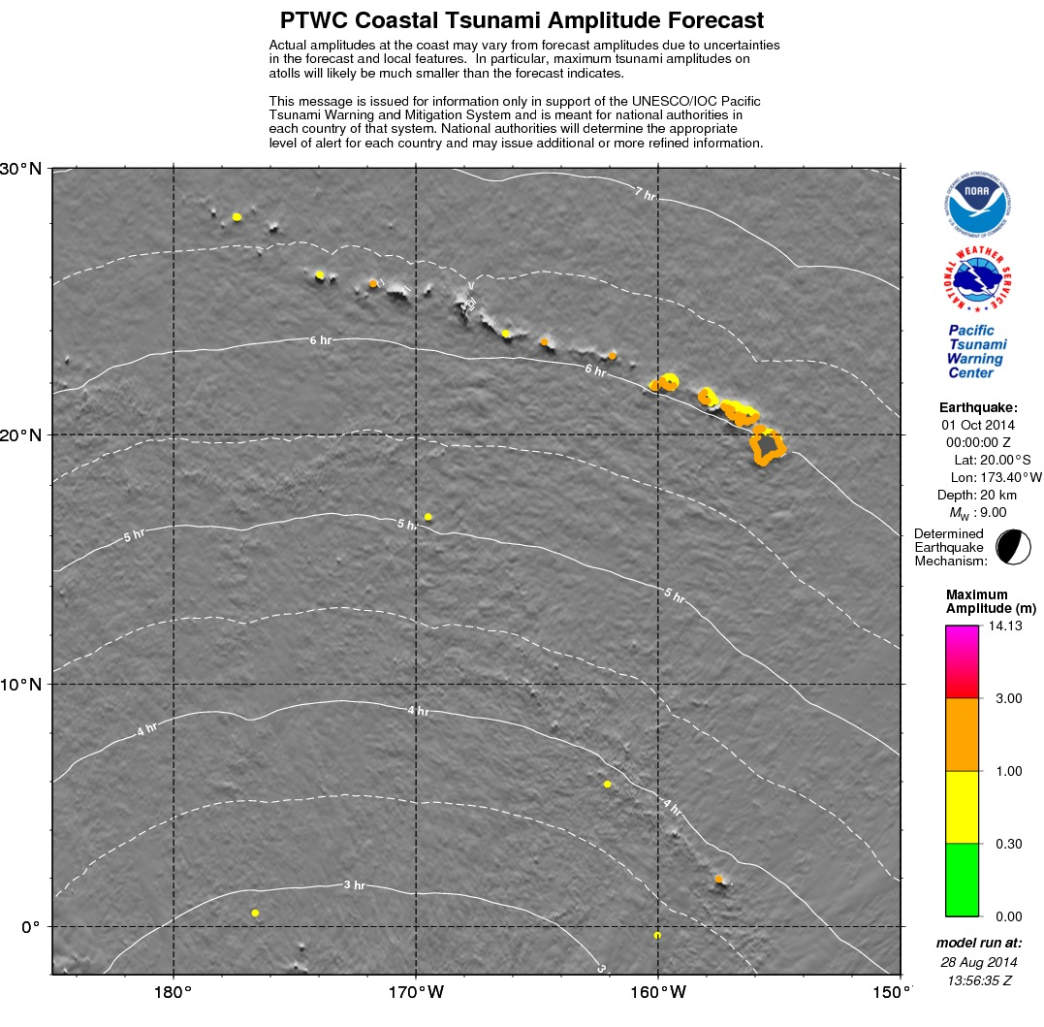

  - Bering Sea Coastal Forecast Map

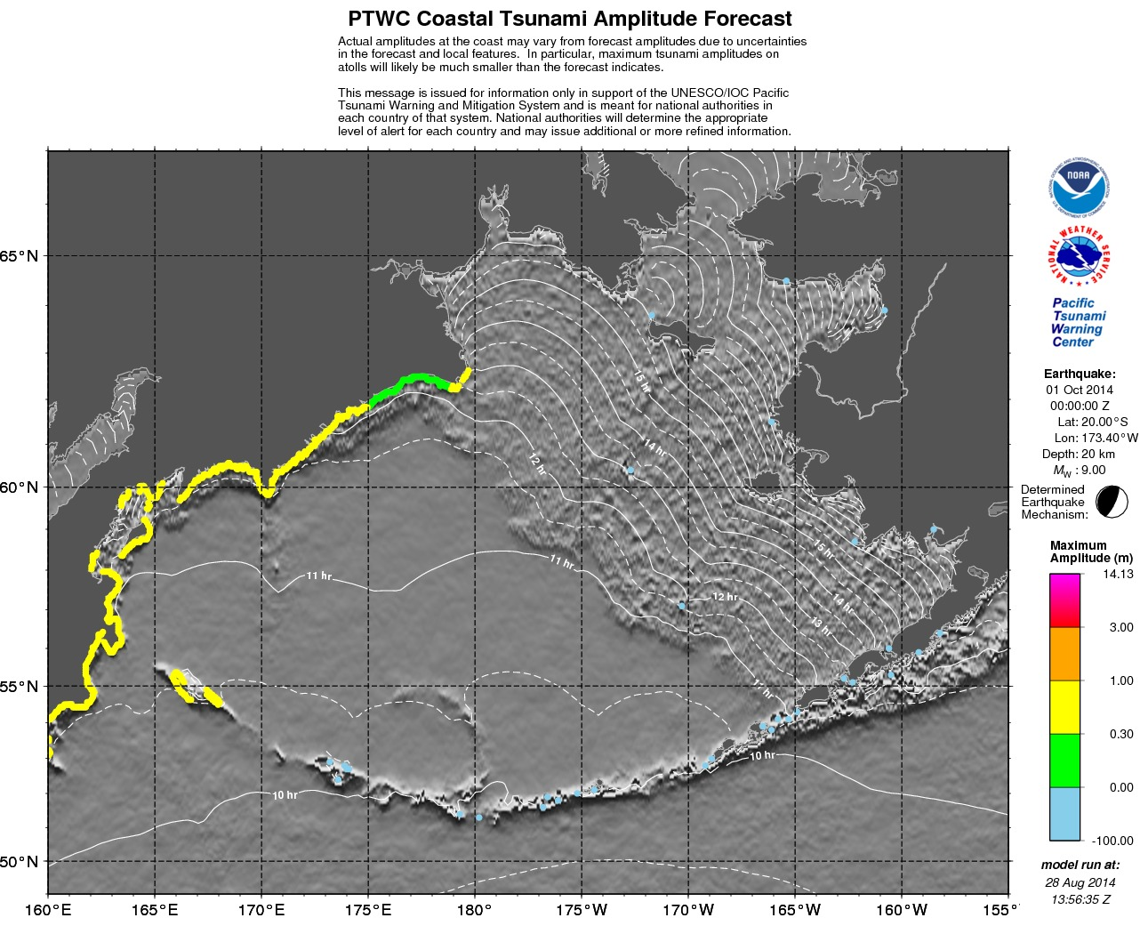
The light blue dots are not actual forecast values but instead show locations where forecast values will be shown if they are published during events by the U.S. NTWC.
  - Antarctica Coastal Forecast Map

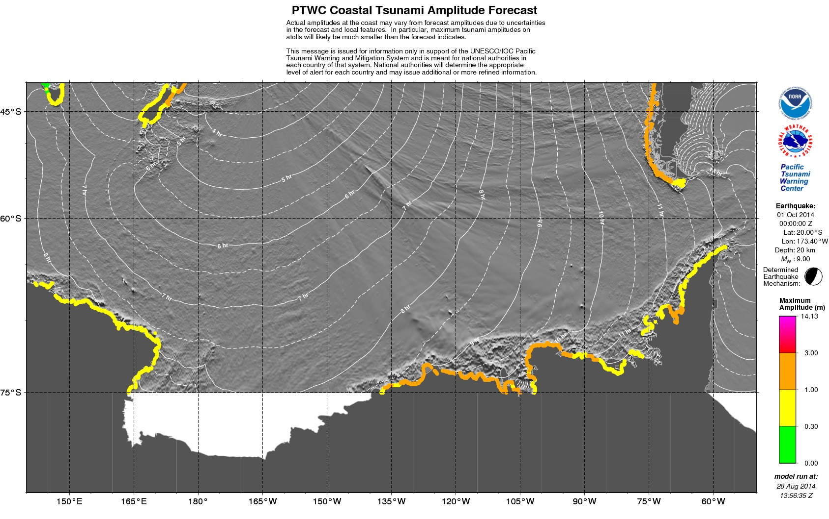
The domain over which the RIFT forecast model was run in this case stops at 75°S and as a consequence no coastal forecast points are available south of that limit.
  - KMZ File (displayed for a particular region with Google Earth)

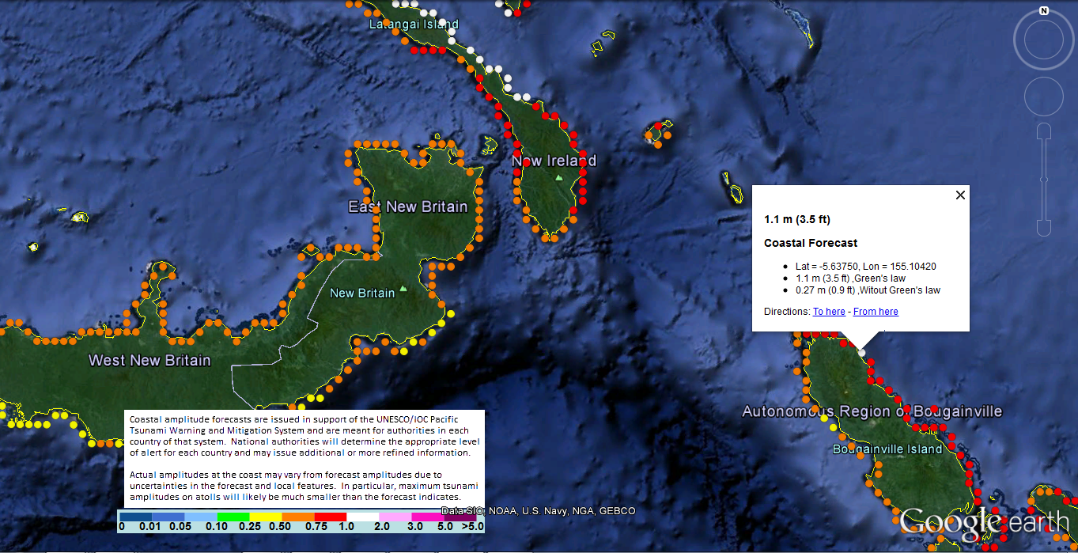
The KMZ file, when used in combination with a program like Google Earth, allows users to zoom in to areas of interest and to display individual forecast points and their values.

- Supplemental Threat Message (with tsunami observations)

  - Text Product Only (unless the forecast changes)

ZCZC
WEPA40 PHEB 010440
TSUPAC

TSUNAMI MESSAGE NUMBER 6
NWS PACIFIC TSUNAMI WARNING CENTER EWA BEACH HI
0440 UTC WED OCT 1 2014

...TSUNAMI THREAT MESSAGE...

**** NOTICE **** NOTICE **** NOTICE **** NOTICE **** NOTICE *****

THIS MESSAGE IS ISSUED FOR INFORMATION ONLY IN SUPPORT OF THE
UNESCO/IOC PACIFIC TSUNAMI WARNING AND MITIGATION SYSTEM AND IS
MEANT FOR NATIONAL AUTHORITIES IN EACH COUNTRY OF THAT SYSTEM.

NATIONAL AUTHORITIES WILL DETERMINE THE APPROPRIATE LEVEL OF
ALERT FOR EACH COUNTRY AND MAY ISSUE ADDITIONAL OR MORE REFINED
INFORMATION.

**** NOTICE **** NOTICE **** NOTICE **** NOTICE **** NOTICE *****

UPDATES
-------

* TSUNAMI OBSERVATIONS ARE UPDATED IN THIS MESSAGE.

PRELIMINARY EARTHQUAKE PARAMETERS
---------------------------------

* MAGNITUDE 9.0
* ORIGIN TIME 0000 UTC OCT 1 2014
* COORDINATES 20.0 SOUTH 173.4 WEST
* DEPTH 20 KM / 12 MILES
* LOCATION TONGA

EVALUATION
----------

* AN EARTHQUAKE WITH A PRELIMINARY MAGNITUDE OF 9.0 OCCURRED IN
THE TONGA ISLANDS AT 0000 UTC ON WEDNESDAY OCTOBER 1 2014.

* BASED ON THE PRELIMINARY EARTHQUAKE PARAMETERS... HAZARDOUS
TSUNAMI WAVES ARE FORECAST FOR SOME COASTS.

TSUNAMI THREAT FORECAST
-----------------------

* TSUNAMI WAVES REACHING MORE THAN 3 METERS ABOVE THE TIDE
LEVEL ARE POSSIBLE ALONG SOME COASTS OF

ECUADOR... PERU... CHILE... NEW ZEALAND... FIJI... SAMOA...
AMERICAN SAMOA... COOK ISLANDS... VANUATU... FRENCH POLYNESIA...
TONGA... WALLIS AND FUTUNA... PITCAIRN ISLANDS... AND NIUE.

* TSUNAMI WAVES REACHING 1 TO 3 METERS ABOVE THE TIDE LEVEL ARE
POSSIBLE ALONG SOME COASTS OF

MEXICO... EL SALVADOR... GUATEMALA... COSTA RICA...
NICARAGUA... PANAMA... COLOMBIA... ANTARCTICA... AUSTRALIA...
NEW CALEDONIA... POHNPEI... TOKELAU... KIRIBATI... NAURU...
TUVALU... SOLOMON ISLANDS... PAPUA NEW GUINEA... HAWAII... AND
NW HAWAIIAN ISLANDS.

* TSUNAMI WAVES REACHING 0.3 TO 1 METERS ABOVE THE TIDE LEVEL
ARE POSSIBLE FOR SOME COASTS OF

HONDURAS... JAPAN... PHILIPPINES... TAIWAN... NORTHERN
MARIANAS... GUAM... PALAU... YAP... CHUUK... KOSRAE... MARSHALL
ISLANDS... WAKE ISLAND... MIDWAY ISLAND... JOHNSTON ISLAND...
JARVIS ISLAND... PALMYRA ISLAND... HOWLAND AND BAKER...
INDONESIA... AND RUSSIA.

* TSUNAMI WAVES LESS THAN 0.3 METERS ABOVE THE TIDE LEVEL ARE
POSSIBLE FOR SOME COASTS OF

CHINA... REPUBLIC OF KOREA... DPR OF KOREA... VIETNAM...
MALAYSIA... AND BRUNEI.

* ACTUAL AMPLITUDES AT THE COAST MAY VARY FROM FORECAST
AMPLITUDES DUE TO UNCERTAINTIES IN THE FORECAST AND LOCAL
FEATURES. IN PARTICULAR MAXIMUM TSUNAMI AMPLITUDES ON ATOLLS
WILL LIKELY BE MUCH SMALLER THAN THE FORECAST INDICATES.

* FOR OTHER AREAS COVERED BY THIS PRODUCT A FORECAST HAS NOT
YET BEEN COMPUTED. THE FORECAST WILL BE EXPANDED AS NECESSARY
IN SUBSEQUENT PRODUCTS.

RECOMMENDED ACTIONS
-------------------

* GOVERNMENT AGENCIES RESPONSIBLE FOR THREATENED COASTAL AREAS
SHOULD TAKE ACTION TO INFORM AND INSTRUCT ANY COASTAL
POPULATIONS AT RISK IN ACCORDANCE WITH THEIR OWN EVALUATION...
PROCEDURES AND THE LEVEL OF THREAT.

* PERSONS LOCATED IN THREATENED COASTAL AREAS SHOULD STAY ALERT
FOR INFORMATION AND FOLLOW INSTRUCTIONS FROM NATIONAL AND
LOCAL AUTHORITIES.

ESTIMATED TIMES OF ARRIVAL
--------------------------

* ESTIMATED TIMES OF ARRIVAL -ETA- OF THE INITIAL TSUNAMI WAVE
FOR POINTS WITHIN THREATENED REGIONS ARE GIVEN BELOW. ACTUAL
ARRIVAL TIMES MAY DIFFER AND THE INITIAL WAVE MAY NOT BE THE
LARGEST. A TSUNAMI IS A SERIES OF WAVES AND THE TIME BETWEEN
WAVES CAN BE FIVE MINUTES TO ONE HOUR.

LOCATION REGION COORDINATES ETA(UTC)
------------------------------------------------------------
NAPIER NEW ZEALAND 39.5S 176.9E 0345 10/01
CHRISTMAS ISLAN KIRIBATI 2.0N 157.5W 0348 10/01
PALMYRA ISLAND PALMYRA ISLAND 5.9N 162.1W 0349 10/01
ESPERITU SANTO VANUATU 15.1S 167.3E 0354 10/01
NOUMEA NEW CALEDONIA 22.3S 166.5E 0356 10/01
AUCKLAND EAST NEW ZEALAND 36.7S 175.0E 0358 10/01
TARAWA ISLAND KIRIBATI 1.5N 173.0E 0407 10/01
SANTA CRUZ ISLA SOLOMON ISLANDS 10.9S 165.9E 0413 10/01
NAURU NAURU 0.5S 166.9E 0418 10/01
AUCKLAND WEST NEW ZEALAND 37.1S 174.2E 0422 10/01
MAJURO MARSHALL ISLANDS 7.1N 171.4E 0433 10/01
KIRAKIRA SOLOMON ISLANDS 10.4S 161.9E 0438 10/01
HIVA OA FRENCH POLYNESIA 10.0S 139.0W 0453 10/01
DUNEDIN NEW ZEALAND 45.9S 170.5E 0457 10/01
KWAJALEIN MARSHALL ISLANDS 8.7N 167.7E 0459 10/01
RIKITEA FRENCH POLYNESIA 23.1S 135.0W 0505 10/01
AUKI SOLOMON ISLANDS 8.8S 160.6E 0506 10/01
NEW PLYMOUTH NEW ZEALAND 39.1S 174.1E 0509 10/01
GHATERE SOLOMON ISLANDS 7.8S 159.2E 0511 10/01
KOSRAE ISLAND KOSRAE 5.5N 163.0E 0511 10/01
HONIARA SOLOMON ISLANDS 9.3S 160.0E 0525 10/01
PANGGOE SOLOMON ISLANDS 6.9S 157.2E 0529 10/01
LYTTELTON NEW ZEALAND 43.6S 172.7E 0532 10/01
MUNDA SOLOMON ISLANDS 8.4S 157.2E 0536 10/01
PITCAIRN ISLAND PITCAIRN 25.1S 130.1W 0546 10/01
KIETA PAPUA NEW GUINEA 6.1S 155.6E 0548 10/01
WESTPORT NEW ZEALAND 41.8S 171.6E 0551 10/01
MILFORD SOUND NEW ZEALAND 44.6S 167.9E 0556 10/01
FALAMAE SOLOMON ISLANDS 7.4S 155.6E 0556 10/01
ENIWETOK MARSHALL ISLANDS 11.4N 162.3E 0600 10/01
WAKE ISLAND WAKE ISLAND 19.3N 166.6E 0602 10/01
POHNPEI ISLAND POHNPEI 7.0N 158.2E 0608 10/01
WOODLARK ISLAND PAPUA NEW GUINEA 9.0S 152.9E 0609 10/01
AMUN PAPUA NEW GUINEA 6.0S 154.7E 0610 10/01
SYDNEY AUSTRALIA 33.9S 151.4E 0625 10/01
BRISBANE AUSTRALIA 27.2S 153.3E 0632 10/01
RABAUL PAPUA NEW GUINEA 4.2S 152.3E 0634 10/01
MIDWAY ISLAND MIDWAY ISLAND 28.2N 177.4W 0636 10/01
NELSON NEW ZEALAND 41.3S 173.3E 0645 10/01
KAVIENG PAPUA NEW GUINEA 2.5S 150.7E 0704 10/01
PORT MORESBY PAPUA NEW GUINEA 9.3S 146.9E 0705 10/01
LAE PAPUA NEW GUINEA 6.8S 147.0E 0705 10/01
ULAMONA PAPUA NEW GUINEA 5.0S 151.3E 0707 10/01
HOBART AUSTRALIA 43.3S 147.6E 0711 10/01
BLUFF NEW ZEALAND 46.6S 168.3E 0712 10/01
MADANG PAPUA NEW GUINEA 5.2S 145.8E 0731 10/01
CAPE ADARE ANTARCTICA 71.0S 170.0E 0732 10/01
CHUUK ISLAND CHUUK 7.4N 151.8E 0739 10/01
MINAMITORISHIMA MINAMITORISHIMA 24.3N 154.0E 0739 10/01
MANUS ISLAND PAPUA NEW GUINEA 2.0S 147.5E 0740 10/01
CAIRNS AUSTRALIA 16.7S 145.8E 0751 10/01
SAIPAN NORTHERN MARIANA 15.3N 145.8E 0752 10/01
GUAM GUAM 13.4N 144.7E 0758 10/01
GLADSTONE AUSTRALIA 23.8S 151.4E 0810 10/01
WEWAK PAPUA NEW GUINEA 3.5S 143.6E 0813 10/01
VANIMO PAPUA NEW GUINEA 2.6S 141.3E 0825 10/01
JAYAPURA INDONESIA 2.4S 140.8E 0829 10/01
YAP ISLAND YAP 9.5N 138.1E 0840 10/01
EASTER ISLAND CHILE 27.1S 109.4W 0844 10/01
CHICHI JIMA JAPAN 27.0N 142.3E 0911 10/01
WARSA INDONESIA 0.6S 135.8E 0913 10/01
MALAKAL PALAU 7.3N 134.5E 0926 10/01
MANOKWARI INDONESIA 0.8S 134.2E 0933 10/01
KATSUURA JAPAN 35.1N 140.3E 0948 10/01
HACHIJO JIMA JAPAN 33.1N 139.8E 0949 10/01
MACKAY AUSTRALIA 21.1S 149.3E 0951 10/01
THURSTON ISLAND ANTARCTICA 72.0S 100.0W 0959 10/01
SORONG INDONESIA 0.8S 131.1E 1002 10/01
KUSHIRO JAPAN 42.9N 144.3E 1011 10/01
BEREBERE INDONESIA 2.5N 128.7E 1019 10/01
GEME INDONESIA 4.6N 126.8E 1026 10/01
PATANI INDONESIA 0.4N 128.8E 1031 10/01
DAVAO PHILIPPINES 6.8N 125.7E 1035 10/01
HACHINOHE JAPAN 40.5N 141.5E 1038 10/01
MEDNNY ISLAND RUSSIA 54.7N 167.4E 1042 10/01
UST KAMCHATSK RUSSIA 56.1N 162.6E 1045 10/01
LEGASPI PHILIPPINES 13.2N 123.8E 1045 10/01
PETROPAVLOVSK RUSSIA 53.2N 159.6E 1047 10/01
ENSENADA MEXICO 31.8N 116.8W 1049 10/01
PALANAN PHILIPPINES 17.1N 122.6E 1051 10/01
PUNTA ABREOJOS MEXICO 26.7N 113.6W 1053 10/01
SHIMIZU JAPAN 32.8N 133.0E 1053 10/01
TABUKAN TENGAH INDONESIA 3.6N 125.6E 1054 10/01
NOBEOKA JAPAN 32.5N 131.8E 1056 10/01
CABO SAN LUCAS MEXICO 22.8N 110.0W 1056 10/01
SEVERO KURILSK RUSSIA 50.8N 156.1E 1108 10/01
OSTROV KARAGINS RUSSIA 58.8N 164.5E 1111 10/01
HUALIEN TAIWAN 24.0N 121.7E 1115 10/01
TAITUNG TAIWAN 22.7N 121.2E 1117 10/01
OKINAWA JAPAN 26.2N 127.8E 1117 10/01
PUERTO VALLARTA MEXICO 20.6N 105.3W 1135 10/01
MANZANILLO MEXICO 19.1N 104.3W 1137 10/01
MAZATLAN MEXICO 23.2N 106.4W 1142 10/01
LAZARO CARDENAS MEXICO 17.9N 102.2W 1148 10/01
CHILUNG TAIWAN 25.2N 121.8E 1148 10/01
ACAPULCO MEXICO 16.9N 99.9W 1157 10/01
GOLFO DE PENAS CHILE 47.1S 74.9W 1158 10/01
SAN BLAS MEXICO 21.5N 105.3W 1204 10/01
SAPPORO JAPAN 43.5N 141.0E 1209 10/01
GUAYMAS MEXICO 27.9N 110.9W 1218 10/01
NAGASAKI JAPAN 32.7N 129.7E 1221 10/01
NIIGATA JAPAN 38.0N 139.0E 1228 10/01
CORRAL CHILE 39.8S 73.5W 1241 10/01
TALCAHUANO CHILE 36.7S 73.1W 1250 10/01
VALPARAISO CHILE 33.0S 71.6W 1306 10/01
BALTRA ISLAND ECUADOR 0.5S 90.3W 1313 10/01
SALINA CRUZ MEXICO 16.5N 95.2W 1316 10/01
COQUIMBO CHILE 29.9S 71.4W 1321 10/01
PUERTO MADERO MEXICO 14.8N 92.5W 1323 10/01
COCOS ISLAND COSTA RICA 5.5N 87.1W 1325 10/01
SHIMANE JAPAN 35.8N 133.0E 1326 10/01
CALDERA CHILE 27.1S 70.8W 1335 10/01
SIPICATE GUATEMALA 13.9N 91.2W 1335 10/01
ACAJUTLA EL SALVADOR 13.6N 89.8W 1340 10/01
TALARA PERU 4.6S 81.5W 1344 10/01
CABO SAN ELENA COSTA RICA 10.9N 86.0W 1353 10/01
ANTOFAGASTA CHILE 23.3S 70.4W 1354 10/01
LA LIBERTAD ECUADOR 2.2S 81.2W 1358 10/01
SAN JUAN PERU 15.3S 75.2W 1400 10/01
CORINTO NICARAGUA 12.5N 87.2W 1401 10/01
LA PUNTA PERU 12.1S 77.2W 1402 10/01
PUERTO SANDINO NICARAGUA 12.2N 86.8W 1407 10/01
PUERTO QUEPOS COSTA RICA 9.4N 84.2W 1414 10/01
CABO MATAPALO COSTA RICA 8.4N 83.3W 1415 10/01
SAN JUAN DL SUR NICARAGUA 11.2N 85.9W 1417 10/01
MOLLENDO PERU 17.1S 72.0W 1420 10/01
IQUIQUE CHILE 20.2S 70.1W 1420 10/01
PUNTA BURICA PANAMA 8.0N 82.9W 1425 10/01
ARICA CHILE 18.5S 70.3W 1426 10/01
CHIMBOTE PERU 9.0S 78.8W 1429 10/01
PUERTO MONTT CHILE 41.5S 73.0W 1437 10/01
ESMERELDAS ECUADOR 1.2N 79.8W 1437 10/01
AMAPALA HONDURAS 13.2N 87.6W 1437 10/01
PIMENTAL PERU 6.9S 80.0W 1440 10/01
SAN FELIPE MEXICO 31.0N 114.8W 1450 10/01
TUMACO COLOMBIA 1.8N 78.9W 1455 10/01
PUNTA MALA PANAMA 7.5N 80.0W 1505 10/01
BAHIA SOLANO COLOMBIA 6.3N 77.4W 1513 10/01
PUERTO PINA PANAMA 7.4N 78.0W 1514 10/01
UST KAHYRYUZOVO RUSSIA 57.1N 156.7E 1522 10/01
BUENAVENTURA COLOMBIA 3.8N 77.2W 1539 10/01
BALBOA HEIGHTS PANAMA 9.0N 79.6W 1725 10/01

POTENTIAL IMPACTS
-----------------

* A TSUNAMI IS A SERIES OF WAVES. THE TIME BETWEEN WAVE CRESTS
CAN VARY FROM 5 MINUTES TO AN HOUR. THE HAZARD MAY PERSIST FOR
MANY HOURS OR LONGER AFTER THE INITIAL WAVE.

* IMPACTS CAN VARY SIGNIFICANTLY FROM ONE SECTION OF COAST TO
THE NEXT DUE TO LOCAL BATHYMETRY AND THE SHAPE AND ELEVATION
OF THE SHORELINE.

* IMPACTS CAN ALSO VARY DEPENDING UPON THE STATE OF THE TIDE AT
THE TIME OF THE MAXIMUM TSUNAMI WAVES.

* PERSONS CAUGHT IN THE WATER OF A TSUNAMI MAY DROWN... BE
CRUSHED BY DEBRIS IN THE WATER... OR BE SWEPT OUT TO SEA.

TSUNAMI OBSERVATIONS... UPDATED
-------------------------------

* THE FOLLOWING ARE TSUNAMI WAVE OBSERVATIONS FROM COASTAL
AND/OR DEEP-OCEAN SEA LEVEL GAUGES AT THE INDICATED LOCATIONS.
THE MAXIMUM TSUNAMI HEIGHT IS MEASURED WITH RESPECT TO THE
TIDE LEVEL.

GAUGE TIME OF MAXIMUM WAVE
COORDINATES MEASURE TSUNAMI PERIOD
GAUGE LOCATION LAT LON (UTC) HEIGHT (MIN)
-------------------------------------------------------------
NIUE 19.1S 169.9W 0042 GAUGE FAILED --
NUKUALOFA TO 21.1S 175.2W 0053 4.70M/15.4FT 16
DART 51426 23.3S 168.3W 0059 1.53M/ 5.0FT 28
PAGO PAGO AS 14.3S 170.7W 0105 1.81M/ 5.9FT 22
APIA WS 13.8S 171.8W 0113 1.60M/ 5.2FT 24
BOAT COVE RAOUL IS 29.3S 177.9W 0140 2.35M/ 7.7FT 18
FUTUNA IS FR 14.3S 178.2W 0147 GAUGE FAILED --
DART 51425 9.5S 176.2W 0149 0.16M/ 0.5FT 26
DART 54401 33.0S 173.0W 0152 0.20M/ 0.6FT 26
RAROTONGA CK 21.2S 159.8W 0200 GAUGE FAILED --
SUVA VITI LEVU FJ 18.1S 178.4E 0206 2.92M/ 9.6FT 21
DART 55016 26.1S 176.0E 0222 0.17M/ 0.6FT 23
FUNAFUTI TV 8.5S 179.2E 0229 1.70M/ 5.6FT 29
KANTON KI 2.8S 171.7W 0237 1.10M/ 3.6FT 15
LOTTIN PT NZ 37.6S 178.2E 0238 2.88M/ 9.5FT 15
GISBORNE EASTLAND N 38.7S 178.0E 0312 1.57M/ 5.1FT 24
NORTH CAPE NZ 34.4S 173.0E 0314 1.41M/ 4.6FT 26
PORT TAURANGA NZ 37.6S 176.2E 0317 1.81M/ 5.9FT 14
GREAT BARRIER IS NZ 36.2S 175.5E 0318 1.66M/ 5.4FT 21
HUAHINE PF 16.7S 151.0W 0319 1.99M/ 6.5FT 15
CASTLE POINT NZ 40.9S 176.2E 0322 1.19M/ 3.9FT 22
TUBUAI PF 23.3S 149.5W 0323 GAUGE FAILED --
PAPEETE TAHITI 17.5S 149.6W 0329 2.89M/ 9.5FT 25
MARE NEW CALEDONIA 21.5S 167.9E 0331 1.30M/ 4.2FT 31
LIFOU NEW CALEDONIA 20.9S 167.3E 0335 1.93M/ 6.3FT 29
OUINNE NEW CALEDONI 22.0S 166.7E 0346 1.52M/ 5.0FT 23
PORT VILA VU 17.8S 168.3E 0349 1.50M/ 4.9FT 16
RANGIROA PF 14.9S 147.7W 0357 2.26M/ 7.4FT 26
PORT NAPIER NZ 39.5S 176.9E 0400 1.07M/ 3.5FT 21
HIENGHENE NEW CALED 20.7S 164.9E 0402 1.30M/ 4.3FT 27
CHRISTMAS KI 2.0N 157.5W 0403 1.18M/ 3.9FT 30
KAIKOURA NZ 42.4S 173.7E 0404 1.01M/ 3.3FT 28
PALMYRA ISLAND US 5.9N 162.1W 0404 0.86M/ 2.8FT 19

NEXT UPDATE AND ADDITIONAL INFORMATION
--------------------------------------

* THE NEXT MESSAGE WILL BE ISSUED IN ONE HOUR... OR SOONER IF
THE SITUATION WARRANTS.

* AUTHORITATIVE INFORMATION ABOUT THE EARTHQUAKE FROM THE U.S.
GEOLOGICAL SURVEY CAN BE FOUND ON THE INTERNET AT
EARTHQUAKE.USGS.GOV/EARTHQUAKES -ALL IN LOWER CASE-.

* FURTHER INFORMATION ABOUT THIS EVENT MAY BE FOUND AT
PTWC.WEATHER.GOV AND AT WWW.TSUNAMI.GOV.

* COASTAL REGIONS OF HAWAII... AMERICAN SAMOA... GUAM... AND
CNMI SHOULD REFER TO PACIFIC TSUNAMI WARNING CENTER MESSAGES
FOR THOSE PLACES THAT CAN BE FOUND AT PTWC.WEATHER.GOV.

* COASTAL REGIONS OF CALIFORNIA... OREGON... WASHINGTON...
BRITISH COLUMBIA AND ALASKA SHOULD REFER TO U.S. NATIONAL
TSUNAMI WARNING CENTER MESSAGES THAT CAN BE FOUND AT
NTWC.ARH.NOAA.GOV.

$$

- Final Threat Product (text only)

  - Text Product Only

ZCZC
WEPA40 PHEB 012040
TSUPAC

TSUNAMI MESSAGE NUMBER 22
NWS PACIFIC TSUNAMI WARNING CENTER EWA BEACH HI
2040 UTC WED OCT 1 2014

...FINAL TSUNAMI THREAT MESSAGE...

**** NOTICE **** NOTICE **** NOTICE **** NOTICE **** NOTICE *****

THIS MESSAGE IS ISSUED FOR INFORMATION ONLY IN SUPPORT OF THE
UNESCO/IOC PACIFIC TSUNAMI WARNING AND MITIGATION SYSTEM AND IS
MEANT FOR NATIONAL AUTHORITIES IN EACH COUNTRY OF THAT SYSTEM.

NATIONAL AUTHORITIES WILL DETERMINE THE APPROPRIATE LEVEL OF
ALERT FOR EACH COUNTRY AND MAY ISSUE ADDITIONAL OR MORE REFINED
INFORMATION.

**** NOTICE **** NOTICE **** NOTICE **** NOTICE **** NOTICE *****

PRELIMINARY EARTHQUAKE PARAMETERS
---------------------------------

* MAGNITUDE 9.0
* ORIGIN TIME 0000 UTC OCT 1 2014
* COORDINATES 20.0 SOUTH 173.4 WEST
* DEPTH 20 KM / 12 MILES
* LOCATION TONGA

EVALUATION
----------

* AN EARTHQUAKE WITH A PRELIMINARY MAGNITUDE OF 1.0 OCCURRED IN
THE TONGA ISLANDS AT 0000 UTC ON WEDNESDAY OCTOBER 1 2014.

* BASED ON ALL AVAILABLE DATA... THE TSUNAMI THREAT FROM THIS
EARTHQUAKE HAS PASSED AND THERE IS NO FURTHER THREAT.

TSUNAMI THREAT FORECAST...UPDATED
---------------------------------

* THE TSUNAMI THREAT HAS NOW LARGELY PASSED.

RECOMMENDED ACTIONS
-------------------

* GOVERNMENT AGENCIES RESPONSIBLE FOR ANY IMPACTED COASTAL
AREAS SHOULD MONITOR CONDITIONS AT THE COAST TO DETERMINE IF
AND WHEN IT IS SAFE TO RESUME NORMAL ACTIVITIES.

* PERSONS LOCATED NEAR IMPACTED COASTAL AREAS SHOULD STAY ALERT
FOR INFORMATION AND FOLLOW INSTRUCTIONS FROM LOCAL
AUTHORITIES.

* REMAIN OBSERVANT AND EXERCISE NORMAL CAUTION NEAR THE SEA.

POTENTIAL IMPACTS
-----------------

* SEA LEVEL FLUCTUATIONS MAY CONTINUE TO OCCUR IN AFFECTED
COASTAL AREAS OVER THE NEXT FEW HOURS... AND SOMETIMES FOR
MUCH LONGER IN RESONANT BAYS AND HARBORS.

NEXT UPDATE AND ADDITIONAL INFORMATION
--------------------------------------

* THIS WILL BE THE FINAL STATEMENT ISSUED FOR THIS EVENT UNLESS
NEW INFORMATION IS RECEIVED OR THE SITUATION CHANGES.

* AUTHORITATIVE INFORMATION ABOUT THE EARTHQUAKE FROM THE U.S.
GEOLOGICAL SURVEY CAN BE FOUND ON THE INTERNET AT
EARTHQUAKE.USGS.GOV/EARTHQUAKES -ALL IN LOWER CASE-.

* FURTHER INFORMATION ABOUT THIS EVENT MAY BE FOUND AT
PTWC.WEATHER.GOV AND AT WWW.TSUNAMI.GOV.

* COASTAL REGIONS OF HAWAII... AMERICAN SAMOA... GUAM... AND
CNMI SHOULD REFER TO PACIFIC TSUNAMI WARNING CENTER MESSAGES
FOR THOSE PLACES THAT CAN BE FOUND AT PTWC.WEATHER.GOV.

* COASTAL REGIONS OF CALIFORNIA... OREGON... WASHINGTON...
BRITISH COLUMBIA AND ALASKA SHOULD REFER TO U.S. NATIONAL
TSUNAMI WARNING CENTER MESSAGES THAT CAN BE FOUND AT
NTWC.ARH.NOAA.GOV.

$$

APPENDIX III. LIST OF COUNTRIES OR PLACES NAMED IN THE NEW PRODUCTS
The countries and country sub-jurisdictions where the PTWC will provide forecasts are listed below. Member States are asked to review the places and recommend changes as needed.

- AMERICAN_SAMOA
- ANTARCTICA
- AUSTRALIA
- BRUNEI
- CAMBODIA
- CHILE
- CHINA
- CHUUK
- COLOMBIA
- COOK_ISLANDS
- COSTA_RICA
- DPR_OF_KOREA
- ECUADOR
- EL_SALVADOR
- FIJI
- FRENCH_POLYNESIA
- GUAM
- GUATEMALA
- HAWAII
- HONDURAS
- HOWLAND_AND_BAKER
- INDONESIA
- JAPAN
- JARVIS_ISLAND
- JOHNSTON_ISLAND
- KIRIBATI
- KOSRAE
- MALAYSIA
- MARSHALL_ISLANDS
- MEXICO
- MIDWAY_ISLAND
- NAURU
- NEW_CALEDONIA
- NEW_ZEALAND
- NICARAGUA
- NIUE
- NORTHERN_MARIANAS
- NW_HAWAIIAN_ISLANDS
- PALAU
- PALMYRA_ISLAND
- PANAMA
- PAPUA_NEW_GUINEA
- PERU
- PHILIPPINES
- PITCAIRN_ISLANDS
- POHNPEI
- REPUBLIC_OF_KOREA
- RUSSIA
- SAMOA
- SINGAPORE
- SOLOMON_ISLANDS
- TAIWAN
- THAILAND
- TOKELAU
- TONGA
- TUVALU
- VANUATU
- VIETNAM
- WAKE_ISLAND
- WALLIS_AND_FUTUNA
- YAP

APPENDIX IV. LIST OF PTWS PTWC FORECAST POLYGONS
The forecast polygons that divide extended coasts into segments or that surround particular island groups are listed below. These were chosen and named somewhat arbitrarily based upon geological, geographic, and/or political boundaries. Member States are asked to review the polygons and recommend changes in boundaries or names as needed.

- American Samoa
- Ellsworth Land Coast of Antarctica
- Marie Byrd Land Coast of Antarctica
- Northeast Side of the Antarctic Peninsula
- Victoria Oates and George V Coast of Antarctica
- New South Wales Australia
- Northern Queensland Australia
- Southern Queensland Australia
- Tasmania
- Victoria Australia
- Brunei
- Cambodia
- Easter Island
- North Central Chile
- Northern Chile
- South Central Chile
- Southern Chile
- Eastern Coast of China
- Hainan Island China
- Northeastern Coast of China
- Southeastern Coast of China
- Southern Coast of China
- Chuuk State Micronesia
- Pacific Coast of Colombia
- Cook Islands
- Cocos Island Costa Rica
- Pacific Coast of Costa Rica
- Eastern Coast of DPR of Korea
- Western Coast of DPR of Korea
- Ecuador
- Galapagos Islands
- El Salvador
- Fiji
- Austral Islands
- Marquesas Islands
- Society Islands
- Tuamotu Archipelago
- Guam
- Pacific Coast of Guatemala
- Hawaii
- Pacific Coast of Honduras
- Howland and Baker
- Bangka Islands Belitung Indonesia
- Celebes Sea Coast of Borneo Indonesia
- Celebes Sea Coast of Sulawesi Indonesia
- Halmahera Indonesia
- Natuna Islands Indonesia
- Pacific Side of Papua Indonesia
- Sangihe Islands Indonesia
- Southeast Coast of Sumatra Indonesia
- Talaud Islands Indonesia
- Western Borneo Indonesia
- East Coast of Japanese Main Islands
- Izu and Ogasawara Islands Japan
- Minamitorishima Japan
- Nansei Islands Japan
- Urup Etorofu Kunashiri Shikotan and Habomai Islands
- West Coast of Japanese Main Islands
- Jarvis Island
- Johnston Island
- Gilbert Islands Kiribati
- Line Islands Kiribati
- Phoenix Islands Kiribati
- Kosrae State Micronesia
- Celebes Sea Coast of Sabah Malaysia
- Northwest Coast of Sabah Malaysia
- Southwest Coast of Sabah Malaysia
- Sulu Sea Coast of Sabah Malaysia
- Western Coast of the Malay Peninsula Malaysia
- Marshall Islands
- Chiapas Mexico
- Colima Mexico
- Guerrero Mexico
- Gulf Side of Baja Mexico
- Gulf Side of Baja Sud Mexico
- Jalisco Mexico
- Michoacan Mexico
- Nayarit Mexico
- Oaxaca Mexico
- Pacific Side of Baja Mexico
- Pacific Side of Baja Sud Mexico
- Sinaloa Mexico
- Sonora Mexico
- Midway Island
- Nauru
- New Caledonia
- East Side of North Island New Zealand
- East Side of South Island New Zealand
- North Side of North Island New Zealand
- West Side of North Island New Zealand
- West Side of South Island New Zealand
- Pacific Coast of Nicaragua
- Niue
- Northern Marianas
- Northwestern Hawaiian Islands
- Palau
- Palmyra Island
- Pacific Coast of Panama
- Bismarck Sea Coast of Papua New Guinea
- Bougainville Papua New Guinea
- Coral Sea Coast of Papua New Guinea
- Manus Island Papua New Guinea
- Bismarck Sea Coast of New Britain
- Solomon Sea Coast of New Britain
- New Ireland
- Solomon Sea Coast of Papua New Guinea
- Trobriand Woodlark and Louisiade Islands
- Central Peru
- Northern Peru
- Southern Peru
- Celebes Sea Coast of the Philippines
- Interior Seas of the Philippines
- Pacific Coast of the Philippines
- Palawan Island Philippines
- Sulu Archipelago Philippines
- Sulu Sea Coast of the Philippines
- Western Coast of the Northern Philippines
- Pitcairn Islands
- Pohnpei State Micronesia
- Eastern Coast of the Republic of Korea
- Jeju Island Republic of Korea
- Western Coast of the Republic of Korea
- Bering Sea Coast of Eastern Russia
- East Coast of Russia north of the Korean Peninsula
- East Coast of Russia on the Sea of Okhotsk
- East Coast of Russia on the Tatarskiy Straight
- Komandorsky Islands Russia
- Kuril Islands Russia
- Pacific Coast of Kamchatka Russia
- Sea of Okhotsk Coast of Sakhalin Russia
- Tatarskiy Straight Coast of Sakhalin Russia
- Urup Etorofu Kunashir Shikotan and Habomai Islands
- Western Coast of Kamchatka Russia
- Samoa
- Singapore
- Choisel to Philip Solomon Islands
- Santa Cruz Islands
- Eastern Coast of Taiwan
- Western Coast of Taiwan
- Eastern Gulf Coast of Thailand
- Western Gulf Coast of Thailand
- Tokelau
- Tonga
- Tuvalu
- Vanuatu
- Northern Coast of Vietnam
- Southern Coast of Vietnam
- Wake Island
- Wallis and Futuna
- Yap State Micronesia
APPENDIX V. LIST OF PTWS PTWC FORECAST POINTS FOR ETAs
Member States are asked to review the forecast points for ETAs and recommend changes or additions as needed.

COUNTRY / PLACE | ETA LOCATION | LATITUDE | LONGITUDE
AMERICAN SAMOA | PAGO PAGO | 14.3°S | 170.7°W
ANTARCTICA | THURSTON ISLAND | 72.0°S | 100.0°W
ANTARCTICA | CAPE ADARE | 71.0°S | 170.0°E
AUSTRALIA | HOBART | 43.3°S | 147.7°E
AUSTRALIA | SYDNEY | 33.9°S | 151.5°E
AUSTRALIA | BRISBANE | 27.2°S | 153.3°E
AUSTRALIA | GLADSTONE | 23.8°S | 151.4°E
AUSTRALIA | MACKAY | 21.1°S | 149.3°E
AUSTRALIA | CAIRNS | 16.7°S | 145.8°E
BRUNEI | MUARA | 5.0°N | 115.1°E
CAMBODIA | SIHANOUKVILLE | 10.6°N | 103.6°E
CHILE | ARICA | 18.5°S | 70.3°W
CHILE | IQUIQUE | 20.2°S | 70.1°W
CHILE | ANTOFAGASTA | 23.3°S | 70.4°W
CHILE | CALDERA | 27.1°S | 70.8°W
CHILE | COQUIMBO | 29.9°S | 71.4°W
CHILE | VALPARAISO | 33.0°S | 71.6°W
CHILE | TALCAHUANO | 36.7°S | 73.1°W
CHILE | PUERTO MONTT | 41.5°S | 73.0°W
CHILE | PUNTA ARENAS | 53.2°S | 70.9°W
CHILE | PUERTO WILLIAMS | 54.9°S | 67.6°W
CHILE | EASTER ISLAND | 27.2°S | 109.5°W
CHILE | CORRAL | 39.8°S | 73.5°W
CHILE | GOLFO DE PENAS | 47.1°S | 74.9°W
CHINA | QINGDAO | 36.0°N | 120.4°E
CHINA | SHANGHAI | 31.2°N | 122.3°E
CHINA | WENZHOU | 27.8°N | 121.2°E
CHINA | QUANZHOU | 24.8°N | 118.8°E
CHINA | HONG KONG | 22.3°N | 114.2°E
CHINA | HAINAN ISLAND | 18.8°N | 110.5°E
CHUUK | CHUUK ISLAND | 7.4°N | 151.8°E
COLOMBIA | BAHIA SOLANO | 6.3°N | 77.4°W
COLOMBIA | BUENAVENTURA | 3.8°N | 77.2°W
COLOMBIA | TUMACO | 1.8°N | 78.9°W
COOK ISLANDS | RAROTONGA | 21.2°S | 159.8°W
COOK ISLANDS | PENRYN ISLAND | 8.9°S | 157.8°W
COOK ISLANDS | PUKAPUKA ISLAND | 10.8°S | 165.9°W
COSTA RICA | CABO SAN ELENA | 10.9°N | 86.0°W
COSTA RICA | PUERTO QUEPOS | 9.4°N | 84.2°W
COSTA RICA | CABO MATAPALO | 8.4°N | 83.3°W
COSTA RICA | COCOS ISLAND | 5.5°N | 87.1°W
DPR OF KOREA | SINCHANG | 40.1°N | 128.5°E
DPR OF KOREA | NAMPHO | 38.8°N | 125.0°E
ECUADOR | BALTRA ISLAND | 0.5°S | 90.3°W
ECUADOR | ESMERELDAS | 1.2°N | 79.8°W
ECUADOR | LA LIBERTAD | 2.2°S | 81.2°W
EL SALVADOR | ACAJUTLA | 13.6°N | 89.8°W
FIJI | SUVA | 18.1°S | 178.4°E
FRENCH POLYNESIA | PAPEETE | 17.5°S | 149.6°W
FRENCH POLYNESIA | RIKITEA | 23.1°S | 135.0°W
FRENCH POLYNESIA | HIVA OA | 10.0°S | 139.0°W
GUAM | GUAM | 13.4°N | 144.7°E
GUATEMALA | SIPICATE | 13.9°N | 91.2°W
HAWAII | NAWILIWILI | 22.0°N | 159.4°W
HAWAII | HONOLULU | 21.3°N | 157.9°W
HAWAII | HILO | 19.7°N | 155.1°W
HAWAII | KAHULUI | 20.9°N | 156.5°W
HONDURAS | AMAPALA | 13.2°N | 87.6°W
HOWLAND AND BAKER | HOWLAND ISLAND | 0.6°N | 176.6°W
INDONESIA | JAYAPURA | 2.4°S | 140.8°E
INDONESIA | WARSA | 0.6°S | 135.8°E
INDONESIA | MANOKWARI | 0.8°S | 134.2°E
INDONESIA | SORONG | 0.8°S | 131.1°E
INDONESIA | PATANI | 0.4°N | 128.8°E
INDONESIA | BEREBERE | 2.5°N | 128.7°E
INDONESIA | GEME | 4.6°N | 126.8°E
INDONESIA | TABUKAN TENGAH | 3.6°N | 125.6°E
INDONESIA | PANGKALPINANG | 2.1°S | 106.1°E
INDONESIA | KEPULAUAN RIAU | 4.0°N | 108.5°E
INDONESIA | KUALA INDRAGIRI | 0.5°S | 103.8°E
INDONESIA | SINGKAWANG | 1.0°N | 109.0°E
INDONESIA | TARAKAN | 3.3°N | 117.6°E
INDONESIA | MANADO | 1.6°N | 124.9°E
JAPAN | HACHINOHE | 40.5°N | 141.5°E
JAPAN | OKINAWA | 26.2°N | 127.8°E
JAPAN | SHIMIZU | 32.8°N | 133.0°E
JAPAN | KATSUURA | 35.1°N | 140.3°E
JAPAN | KUSHIRO | 42.9°N | 144.3°E
JAPAN | NAGASAKI | 32.7°N | 129.7°E
JAPAN | NOBEOKA | 32.5°N | 131.8°E
JAPAN | SHIMANE | 35.8°N | 133.0°E
JAPAN | NIIGATA | 38.0°N | 139.0°E
JAPAN | SAPPORO | 43.5°N | 141.0°E
JAPAN | HACHIJO JIMA | 33.1°N | 139.8°E
JAPAN | CHICHI JIMA | 27.1°N | 142.3°E
JARVIS ISLAND | JARVIS ISLAND | 0.4°S | 160.1°W
JOHNSTON ISLAND | JOHNSTON ISLAND | 16.7°N | 169.5°W
KERMADEC ISLANDS | RAOUL ISLAND | 29.2°S | 177.9°W
KIRIBATI | CHRISTMAS ISLAND | 2.0°N | 157.5°W
KIRIBATI | MALDEN ISLAND | 3.9°S | 154.9°W
KIRIBATI | FLINT ISLAND | 11.4°S | 151.8°W
KIRIBATI | KANTON ISLAND | 2.8°S | 171.7°W
KIRIBATI | TARAWA ISLAND | 1.5°N | 173.0°E
KOSRAE | KOSRAE ISLAND | 5.5°N | 163.0°E
MALAYSIA | K TERENGGANU | 5.3°N | 103.2°E
MALAYSIA | BINTULU | 3.2°N | 113.0°E
MALAYSIA | KOTA KINABALU | 6.0°N | 116.0°E
MALAYSIA | LAHAD DATU | 4.9°N | 118.4°E
MALAYSIA | SANDAKAN | 5.9°N | 118.1°E
MARSHALL ISLANDS | ENIWETOK | 11.4°N | 162.3°E
MARSHALL ISLANDS | KWAJALEIN | 8.7°N | 167.7°E
MARSHALL ISLANDS | MAJURO | 7.1°N | 171.4°E
MEXICO | ENSENADA | 31.8°N | 116.8°W
MEXICO | CABO SAN LUCAS | 22.8°N | 110.0°W
MEXICO | PUNTA ABREOJOS | 26.7°N | 113.6°W
MEXICO | MAZATLAN | 23.2°N | 106.4°W
MEXICO | PUERTO MADERO | 14.8°N | 92.5°W
MEXICO | MANZANILLO | 19.1°N | 104.3°W
MEXICO | SOCORRO | 18.8°N | 111.0°W
MEXICO | ACAPULCO | 16.9°N | 99.9°W
MEXICO | SALINA CRUZ | 16.5°N | 95.2°W
MEXICO | LAZARO CARDENAS | 17.9°N | 102.2°W
MEXICO | PUERTO VALLARTA | 20.7°N | 105.3°W
MEXICO | SAN BLAS | 21.5°N | 105.3°W
MEXICO | GUAYMAS | 27.9°N | 110.9°W
MEXICO | SAN FELIPE | 31.0°N | 114.8°W
MIDWAY ISLAND | MIDWAY ISLAND | 28.2°N | 177.4°W
MINAMITORISHIMA | MINAMITORISHIMA | 24.3°N | 154.0°E
NAURU | NAURU | 0.5°S | 166.9°E
NEW CALEDONIA | NOUMEA | 22.3°S | 166.5°E
NEW ZEALAND | NEW PLYMOUTH | 39.1°S | 174.1°E
NEW ZEALAND | NORTH CAPE | 34.4°S | 173.3°E
NEW ZEALAND | AUCKLAND EAST | 36.7°S | 175.0°E
NEW ZEALAND | AUCKLAND WEST | 37.1°S | 174.2°E
NEW ZEALAND | EAST CAPE | 37.7°S | 178.5°E
NEW ZEALAND | GISBORNE | 38.7°S | 178.0°E
NEW ZEALAND | NAPIER | 39.5°S | 176.9°E
NEW ZEALAND | WELLINGTON | 41.3°S | 174.8°E
NEW ZEALAND | LYTTELTON | 43.6°S | 172.7°E
NEW ZEALAND | DUNEDIN | 45.9°S | 170.5°E
NEW ZEALAND | BLUFF | 46.6°S | 168.3°E
NEW ZEALAND | MILFORD SOUND | 44.6°S | 167.9°E
NEW ZEALAND | WESTPORT | 41.8°S | 171.6°E
NEW ZEALAND | NELSON | 41.3°S | 173.3°E
NICARAGUA | CORINTO | 12.5°N | 87.2°W
NICARAGUA | PUERTO SANDINO | 12.2°N | 86.8°W
NICARAGUA | SAN JUAN DL SUR | 11.2°N | 85.9°W
NIUE | NIUE ISLAND | 19.0°S | 170.0°W
NORTHERN MARIANAS | SAIPAN | 15.3°N | 145.8°E
PALAU | MALAKAL | 7.3°N | 134.5°E
PALMYRA ISLAND | PALMYRA ISLAND | 5.9°N | 162.1°W
PANAMA | BALBOA HEIGHTS | 9.0°N | 79.6°W
PANAMA | PUNTA BURICA | 8.0°N | 82.9°W
PANAMA | PUNTA MALA | 7.5°N | 80.0°W
PANAMA | PUERTO PINA | 7.4°N | 78.1°W
PAPUA NEW GUINEA | VANIMO | 2.6°S | 141.3°E
PAPUA NEW GUINEA | WEWAK | 3.5°S | 143.7°E
PAPUA NEW GUINEA | MADANG | 5.2°S | 145.8°E
PAPUA NEW GUINEA | LAE | 6.8°S | 147.0°E
PAPUA NEW GUINEA | RABAUL | 4.2°S | 152.3°E
PAPUA NEW GUINEA | PORT MORESBY | 9.3°S | 146.9°E
PAPUA NEW GUINEA | KAVIENG | 2.5°S | 150.7°E
PAPUA NEW GUINEA | MANUS ISLAND | 2.0°S | 147.5°E
PAPUA NEW GUINEA | KIETA | 6.1°S | 155.6°E
PAPUA NEW GUINEA | AMUN | 6.0°S | 154.7°E
PAPUA NEW GUINEA | WOODLARK ISLAND | 9.0°S | 152.9°E
PAPUA NEW GUINEA | ULAMONA | 5.0°S | 151.3°E
PERU | LA PUNTA | 12.1°S | 77.2°W
PERU | TALARA | 4.6°S | 81.5°W
PERU | PIMENTAL | 6.9°S | 80.0°W
PERU | CHIMBOTE | 9.0°S | 78.8°W
PERU | MOLLENDO | 17.1°S | 72.0°W
PERU | SAN JUAN | 15.3°S | 75.2°W
PHILIPPINES | LEGASPI | 13.2°N | 123.8°E
PHILIPPINES | PALANAN | 17.2°N | 122.6°E
PHILIPPINES | DAVAO | 6.9°N | 125.7°E
PHILIPPINES | LAOAG | 18.2°N | 120.6°E
PHILIPPINES | SAN FERNANDO | 16.6°N | 120.3°E
PHILIPPINES | MANILA | 14.6°N | 121.0°E
PHILIPPINES | ILOILO | 10.7°N | 122.5°E
PHILIPPINES | PUERTO PRINCESA | 9.8°N | 118.8°E
PHILIPPINES | ZAMBOANGA | 7.0°N | 122.3°E
PHILIPPINES | MAIMBUNG | 5.9°N | 121.0°E
PHILIPPINES | COTABUTO CITY | 7.3°N | 124.2°E
PITCAIRN | PITCAIRN ISLAND | 25.1°S | 130.1°W
POHNPEI | POHNPEI ISLAND | 7.0°N | 158.2°E
REPUBLIC OF KOREA | CHEJU ISLAND | 33.5°N | 127.0°E
REPUBLIC OF KOREA | BUSAN | 35.1°N | 129.1°E
REPUBLIC OF KOREA | INCHON | 37.3°N | 126.4°E
RUSSIA | MEDNNY ISLAND | 54.7°N | 167.4°E
RUSSIA | UST KAMCHATSK | 56.1°N | 162.6°E
RUSSIA | PETROPAVLOVSK | 53.2°N | 159.6°E
RUSSIA | SEVERO KURILSK | 50.8°N | 156.1°E
RUSSIA | VLADIVOSTOK | 42.8°N | 132.0°E
RUSSIA | VANINO | 49.1°N | 140.4°E
RUSSIA | ALEXANDROVSK SAK | 50.9°N | 142.1°E
RUSSIA | GASTELLO | 49.1°N | 143.0°E
RUSSIA | OKHOTSK | 59.3°N | 143.3°E
RUSSIA | UST KAHYRYUZOVO | 57.1°N | 156.7°E
RUSSIA | OSTROV KARAGINSKIY | 58.8°N | 164.5°E
SAMOA | APIA | 13.8°S | 171.8°W
SINGAPORE | SINGAPORE | 1.2°N | 103.8°E
SOLOMON ISLANDS | FALAMAE | 7.4°S | 155.6°E
SOLOMON ISLANDS | MUNDA | 8.4°S | 157.2°E
SOLOMON ISLANDS | HONIARA | 9.3°S | 160.0°E
SOLOMON ISLANDS | KIRAKIRA | 10.4°S | 161.9°E
SOLOMON ISLANDS | PANGGOE | 6.9°S | 157.2°E
SOLOMON ISLANDS | GHATERE | 7.8°S | 159.2°E
SOLOMON ISLANDS | AUKI | 8.8°S | 160.6°E
SOLOMON ISLANDS | SANTA CRUZ ISLAND | 10.9°S | 166.0°E
TAIWAN | CHILUNG | 25.2°N | 121.8°E
TAIWAN | HUALIEN | 24.0°N | 121.7°E
TAIWAN | TAITUNG | 22.7°N | 121.2°E
TAIWAN | KAOHSIUNG | 22.5°N | 120.3°E
TAIWAN | HOMEL | 24.2°N | 120.4°E
THAILAND | PRA KHIRI KHAN | 11.8°N | 99.8°E
THAILAND | PATTAYA | 12.8°N | 100.9°E
THAILAND | NK SI THAMMARAT | 8.4°N | 100.0°E
TOKELAU | NUKUNONU ISLAND | 9.2°S | 171.8°W
TONGA | NUKUALOFA | 21.0°S | 175.2°W
TUVALU | FUNAFUTI ISLAND | 7.9°S | 178.5°E
VANUATU | ESPERITU SANTO | 15.1°S | 167.3°E
VANUATU | ANATOM ISLAND | 20.2°S | 169.9°E
VIETNAM | VINH | 18.6°N | 105.7°E
VIETNAM | QUI NHON | 13.7°N | 109.2°E
VIETNAM | BAC LIEU | 9.3°N | 105.8°E
WAKE ISLAND | WAKE ISLAND | 19.3°N | 166.6°E
WALLIS AND FUTUNA | WALLIS ISLAND | 13.3°S | 176.3°W
WALLIS AND FUTUNA | FUTUNA ISLAND | 14.3°S | 178.2°W
YAP | YAP ISLAND | 9.5°N | 138.1°E

APPENDIX VI. NATIONAL TSUNAMI WARNING CENTER GUIDANCE
This Appendix provides guidance on Standard Operating Procedures (SOPs) for utilizing the PTWC new enhanced products for national tsunami threat assessment and warning. The guidance was developed by the ITIC and PTWC, with assistance from the U.S. Guam Weather Forecast Office.
On 1 October 2014, PTWC will cease the issuance of Warning, Watch, and Information alert levels to Pacific countries when it changes over to its new enhanced products. The new products are either Threat Messages or Information Statements that instead respectively indicate only whether there is or is not a tsunami threat. If there is a tsunami threat and information exists to sufficiently constrain a numerical tsunami forecast, then the products will also contain a forecast of maximum tsunami wave amplitudes. A new text product will replace the retired one and will continue to be publicly available and sent through the same communication channels. In addition, PTWC will issue graphical and statistical threat information that will only be sent by email to a country’s designated Tsunami Warning Focal Point (TWFP) to support decision-making by that country’s National Tsunami Warning Center (NTWC). The NTWC may use the PTWC information as primary or supplemental guidance for determining their level of alert. Each country’s NTWC is responsible for issuing applicable alert levels such as warnings and watches to its own emergency management and stakeholder agencies, and/or the public.

A country’s NTWC tsunami event SOPs should include the following:
  - Alert Criteria Table showing the alert thresholds and actions;
  - Message templates (Appendix VII) to facilitate quick standard responses, and Checklists to remind Duty Staff during an event;
  - High-level communication flow chart showing the primary agencies or stakeholders involved in the warning chain from the international tsunami advisory centers to national and local warning and emergency response authorities and to the public;
  - Planning efforts to develop timeline-driven SOPs describing time, who, what, how, and to whom, followed by exercises to practice and improve procedures.

- ALERT CRITERIA TABLE

National decisions should be based on criteria decided upon beforehand, such that:
- Thresholds are used to assign Alert Levels (Warning, Advisory, Watch, Information)
- Alert Levels correspond to country’s Forecast Maximum Coastal Wave Amplitude and/or earthquake magnitude
- Emergency Response Actions correspond to Alert Level

The following simple Criteria Tables provide guidance to NTWCs and Emergency Response Agencies. Countries may wish to further customize these tables by assigning different thresholds for different source regions. The simple Tables are divided into two situations, namely when there is a PTWC quantitative forecast, and where there is not:
- NO QUANTITATIVE PTWC FORECAST. PTWC Information Statement or Threat Message typically issued within 10 minutes after M6.5+ earthquake.

- QUANTITATIVE PTWC FORECAST PRODUCT. PTWC Threat Message typically issued 30 minutes to 1 hour after a large earthquake with tsunamigenic potential.

- Warning / Watch Alerts (1.0 m threshold)
- Warning / Advisory Watch Alerts (0.3 / 1.0 m thresholds)

1. CRITERIA TABLE - NO QUANTITATIVE PTWC FORECAST PRODUCT
Criteria Table for NTWC tsunami alerts and emergency response actions based upon the initial PTWC product, typically issued within 10 minutes of any large Pacific earthquake, prior to the computation of a quantitative tsunami forecast. Key criteria for each situation are indicated in bold red letters.

PTWC Product Type | Earthquake Parameters | Potential Tsunami Type | Are Possible Hazardous Tsunami Waves Indicated for Your Country or Area | Threatened Coast | Time left to Initial Wave Arrival (ETA) | NTWC Alert Level for Threatened Coast | Emergency Response Action
Tsunami Information Statement | Magnitude of 6.5-7.0,  or on land,  or ≥ 100 km depth | None  or  Very Minor | No | None | Not applicable | INFORMATION | No action required
Tsunami Threat Message | Magnitude of 7.1-7.5, undersea or very near the sea, and < 100 km depth | Local Tsunami | Yes | < 300 km from earthquake | < 1 hr typical | WARNING | Evacuate threatened coast
Tsunami Threat Message |  | Local Tsunami | No | ≥ 300 km  from earthquake | Not given | INFORMATION | Monitor subsequent messages
Tsunami Threat Message | Magnitude of 7.6-7.8, undersea or very near the sea, and < 100 km depth | Regional Tsunami | Yes | < 1000 km from earthquake | < 3 hrs typical | WARNING | Evacuate threatened coast
Tsunami Threat Message |  | Regional Tsunami | No | ≥ 1000 km  from earthquake | Not given | INFORMATION | Monitor subsequent messages
Tsunami Threat Message | Magnitude of 7.9 and greater, undersea or very near the sea, and  < 100 km depth | Basin-wide Tsunami | Yes | Potential for a basin-wide tsunami | < 3 hours | WARNING | Evacuate coast within 3 hours of ETA
Tsunami Threat Message |  | Basin-wide Tsunami | No | Potential for a basin-wide tsunami | 3 to 6 hours | WATCH | Prepare to evacuate
Tsunami Threat Message |  | Basin-wide Tsunami | No | Potential for a basin-wide tsunami | > 6 hours | INFORMATION | Monitor subsequent messages

NOTES:
- In a local tsunami situation, in order to provide the fastest alert, earthquake magnitude criteria should be used. Issuance of a Warning, Watch, or Information is dependent and the size of the earthquake and its closeness to coastlines. Smaller magnitude earthquakes that are closer to the coast may warrant issuance of a Warning.
- Local tsunami criteria based solely on magnitude should be determined after examining a country historical earthquake tsunami hazard. In some places, the local tsunami magnitude threshold may need to be lower than M7.1. The M7.1 threshold is used by PTWC for its Caribbean Tsunami Watch Service and was used by the PTWC for its Indian Ocean Tsunami Watch Service.
- The 3-hour time criteria is based on the amount of time required for a country to safely complete a coastal evacuation. The 3-hr threshold used by PTWC is considered a conservative, but reasonable time criteria. Historically, the value is from a requirement from Hawaii State Emergency Management Agency as the time required to safely evacuate all coasts of the State of Hawaii. Each country should consider their situation.

LOCAL TSUNAMI SITUATION
This situation is for a tsunami that will take less than one hour tsunami travel time to reach the impact area, and when there is no PTWC wave amplitude forecast provided in the first product. Countries with a local tsunami threat should engage in outreach and education as its highest priority. Outreach should emphasize the recognition of a tsunami’s natural warning signs, followed by immediate self-evacuation by those in threatened coastal zones.

NTWC Duty Staff who feel unusually strong and/or long earthquake shaking should immediately start to prepare for a tsunami warning alert situation. If the earthquake is extremely big (such as a Modified Mercalli Scale IX or greater), the Country may not want to wait for PTWC’s first message, and instead immediately issue a Warning.

Upon receipt of the PTWC Message confirming a great earthquake, a NTWC should issue a Warning based only on the earthquake’s magnitude. Later incoming seismic and sea level data will enable PTWC to calculate a tsunami wave amplitude forecast for inclusion in its second forecast message, and at that time, the Country may choose to continue, upgrade, or downgrade a warning.

2.A. CRITERIA TABLE – QUANTITATIVE PTWC FORECAST PRODUCT:
Warning / Watch Alerts (1.0 m threshold)

Criteria Table for NTWC tsunami alerts and emergency response actions based upon PTWC threat messages that include a quantitative tsunami forecast typically issued 30 minutes to one hour after a large Pacific earthquake with a tsunami-genic potential. Key criteria for each situation are indicated in bold red letters. This uses the same criteria (> 1 m) used by PTWC until September 30, 2014 to designate Warning/Watch alert levels.

PTWC Product Type | Earthquake Parameters | Maximum Tsunami Wave Amplitude Indicated for Your Country or Area | Threatened Coast | Time left to Initial Wave Arrival | NTWC Alert Level for Threatened Coast | Emergency Response Action
Tsunami Threat Message | Magnitude of 7.1 or greater, undersea or very near the sea, and < 100 km depth | ≥ 1 m | Sections of coast with forecast amplitudes  ≥ 1 m | < 3 hrs | WARNING | Evacuate threatened coast
 |  |  |  | 3 to 6 hrs | WATCH | Prepare to evacuate
 |  |  |  | > 6 hrs | INFORMATION | Monitor for subsequent forecasts
Tsunami Threat Message |  | < 1 m | None |  | INFORMATION | Monitor for subsequent forecasts

NOTES:
- Threatened coast information can be gotten from the public text message, coastal forecast amplitude maps or the KMZ file. If only the Public Text message is used, then the entire country should be placed in a Warning.
- The 3-hour time criteria is based on the amount of time required for a country to safely complete a coastal evacuation. The 3-hr threshold used by PTWC is considered a conservative, but reasonable time criteria. Historically, the value is from a requirement from Hawaii State Emergency Management Agency as the time required to safely evacuate all coasts of the State of Hawaii. Each country should consider their situation.

2.B. CRITERIA TABLE – QUANTITATIVE PTWC FORECAST PRODUCT:
Warning / Advisory Watch Alerts (0.3 / 1.0 m thresholds)

Criteria Table for NTWC tsunami alerts and emergency response actions based upon PTWC threat messages that include a quantitative tsunami forecast typically issued 30 minutes to an hour after a large Pacific earthquake with a tsunamigenic potential. Key criteria for each situation are indicated in bold red letters. This adds another NTWC alert level; the Advisory corresponds to a lower level of Warning, and calls for evacuating the beaches and harbors only.
Laboratory studies complementing empirical structural damage and casualty data collected from recent tsunamis show that tsunami inundation or flow depths of less than one meter, and as small as tens of centimeters, can be dangerous and destructive (e.g., Arikawa et al., 2006; Suppasri et al., 2013),. The data suggest that a lower level of warning for a marine threat may be desirable. The response to this lower level of warning would be for people to avoid beaches and low-lying coastal areas, and for vessels in harbors and waterways to take precaution against unusually strong water currents. This lower level of warning is used in the United States, and is termed an Advisory. In an Advisory status, a full scale land evacuation is not necessary.

PTWC Product Type | Earthquake Parameters | Maximum Tsunami Wave Amplitude Indicated for Your Country or Area | Threatened Coast | Time left to Initial Wave Arrival | NTWC Alert Level for Threatened Coast | Emergency Response Action
Tsunami Threat Message | Magnitude 7.1 or greater,  undersea or very near the sea, and  < 100 km depth | ≥ 1 m | Sections of coast with forecast amplitudes  ≥ 1 m | < 3 hrs | WARNING | Evacuate threatened coast
 |  |  |  | 3 to 6 hrs | WATCH | Prepare to evacuate
 |  |  |  | > 6 hrs | INFORMATION | Monitor for subsequent forecasts
Tsunami Threat Message |  | 0.3 to 1 m | Sections of coast with forecast amplitudes 0.3 to 1 m | < 3 hrs | ADVISORY | Evacuate beaches and harbors
 |  |  |  | 3-6 hrs | WATCH | Prepare to evacuate
 |  |  |  | > 6 hrs | INFORMATION | Monitor for subsequent forecasts
Tsunami Threat Message |  | < 0.3 m | None |  | INFORMATION | Monitor for subsequent forecasts

NOTES:
- Threatened coast information from public text message, coastal forecast amplitude maps or the KMZ file. If only the Public Text message is used, then the entire country should be placed in a Warning.
- The 3-hour time criteria is based on the amount of time required for a country to safely complete a coastal evacuation. The 3-hr threshold used by PTWC is considered a conservative, but reasonable time criteria. Historically, the value is from a requirement from Hawaii State Emergency Management Agency as the time required to safely evacuate all coasts of the State of Hawaii. Each country should consider their situation.

- FURTHER DISTRIBUTION OF PTWC GRAPHICAL
AND STATISTICAL FORECAST PRODUCTS

As instructed by Recommendation ICG/PTWS-XXV.2, PTWC will send these products only to Country TWFPs due to their scientific complexity. Countries may decide whether they will further share the products internally. Specifically:
- Which, if any, Products will be shared, and with Whom;
- Whether the PTWC products need to be adjusted and/or customized before sharing.
- Further dissemination will require socialization and training on these New Products beforehand to ensure that recipients understand how to use and interpret the products, and are aware of the model’s forecast limitations and uncertainties.

- BASIC CHARACTERISTICS OF TWC OPERATIONS
In order to provide timely warning services, tsunami warning centers (TWC) should have the capability to monitor and detect, analyse, and inform stakeholders of impending tsunami threats. Particularly:
- TWC operations must be reliable, robust, and redundant (have backups)
- Have two ways of knowing when a large earthquake has occurred (such as through the CISN, PTWC message, Country monitoring, etc.)
- Have two ways of knowing when a dangerous tsunami has occurred (such as through Tide Tool, PTWC message, IOC Sea Level Monitoring Site, Country monitoring, etc.)
- Have immediate knowledge of how much time it will take the tsunami to impact from various sources (such as through PTWC message, calculation using Tsunami Travel Time software (P. Wessel, http://www.geoware-online.com/tsunami.html), or quickly referring to a pre-calculated reverse tsunami travel map with the country at the source (‘bullseye’ map)
- Have redundant communication methods for issuing alerts, communicating with Emergency Operations Centers (EOC) and/or other important officials (methods could include commercial, land-line, mobile, VHF radio, satellite phone, etc.)
- Have astronomical tidal charts for use in determining whether the wave forecast will increase or decrease the danger (whether arrives at low or high tide). Have knowledge of other pre-existing weather phenomena (king or spring tides, storm surge, heavy swells, etc.) in warning decisions.
- Configure web browser URLs to directly access tsunami- and earthquake related, or other monitoring or notification, web sites (bookmarks)
- Ensure there is a method (ideally, automatic) to log time of action during events (message issuance, phone calls, etc.)
- Have redundant power through a backup generator (for operations, including for message receipt and dissemination)

- TIMELINE-DRIVEN STANDARD OPERATING PROCEDURES
To ensure realistic decision-making and seamless response from detection to evacuation, countries are encouraged to engage in planning efforts with stakeholders to share and agree on plans and protocols for tsunami warning and emergency response (TWC, TER) for different tsunami scenarios. Tsunami exercises are recommended activities to assist in determining when decisions need to be made, and by whom, and what information will be available at that time to use in the decision-making. The TWC – TER SOPs include a number of written documents that:
- Identify Stakeholders involved, and their role and responsibilities
- Describe the end-to-end (detection to evacuation) process and the stakeholders involved by a high-level flow chart for each alert level
- Include time by creating a Timeline-Driven SOP (Time, Who, What, How, To whom). An example template is provided below. Guidance and considerations are:
    - TWC operations should consider local and distant tsunami, and customize according to whether in-center seismic processing capability exists;
- TER operations should clearly identify all response stakeholders, and document their different roles in the warning, evacuation, and response process. A list of Stakeholder and Other Emergency Numbers for key actors, include Telecommunication providers, Utilities, Air and Harbor Ports, Hotels, Special Needs populations (old, young, gender, disability, language, etc.)
  - Countries need to agree on its Warning Decision Time (WDT). This is the Minimum Time needed for safe evacuation. The NTWC must issue its Warning by this time (or it will be too late to evacuate). Depending on how big the jurisdiction, this could typically vary from 30 minutes to 3-6 hours.
  - NTWC must decide beforehand what methods and techniques, or data, it will use to assess its Country Threat in the time available before the WDT.
  - National Disaster Management Offices (NDMO) / DMO must decide what actions it must do, and how much time to allot for each action given the time available before the tsunami attacks.
  - SOPs need to consider whether there is time for high-level consultation and approval or Committee decision-making. For a local tsunami, there may not be enough time, so a Delegation of Authority is required (which should be codified into Law or other legal Administrative document). The Delegation should be clear (who, when, what), and in writing.
  - NTWC and NDMO/ DMO together must decide and agree on what information is conveyed to Public, When, and By Whom. This should include public information updates (by whom, how, when).

These TWC and TER SOPs should be well-practiced through drills both inside their organizations, and between and among their and other stakeholders. A regular, continual, annual program of exercising ensures operational readiness for the next tsunami.

The IOC and ITIC have developed SOP templates and conducted training courses over the past 10 years to support these country tasks. Further information can be accessed at http://itic.ioc-unesco.org/index.php?option=com_content&view=category&layout=blog&id=1062&Itemid=2256

TIMELINE-DRIVEN SOP CHART

EVENT | TIME (When) | ACTIVITY  (What actions) | AUTHORITY (Who) | MEDIUM (How) | TO (Target audience)
EQ Occurs
Assess Threat - Tsunami might come
Evacuate
Tsunami comes
Safe to return / Declare “All Clear”

APPENDIX VII. NATIONAL TSUNAMI WARNING CENTER MESSAGE PRODUCTS
This Appendix provides sample country message templates based on the prior PTWC Warning/Watch/Information Bulletins. The templates can be further customized to meet country needs.

The following guidance is provided on tsunami text products:

- Country National Tsunami Text Messages should include basic important information on the tsunami threat so that customers know who is the source, what information is being given, and when it is being issued

- Standard national messages may want to mimic the prior PTWC Text Bulletins (Warning, Watch, Information), and additionally include appropriate PTWC Enhanced Text Product content (see following pages for templates)

- Messages should include a standard set of information.
Messages may want to adopt the following structure, in order:
Header, EQ Information, Evaluation, Forecast (if applicable), Recommended Actions (depending on Threat Level), Estimated Time of Tsunami Arrival (ETA), Potential Impacts, Tsunami Observations, Next Update and Additional Information

- Message should be customized for each country. Specific customizations to a PTWC message are:
  - Replace PTWC with Country’s NTWC
  - Use Local Time
  - Retain only country locations (for threat, ETA). Delete others.
  - Specify Local Authority (NDMO, DMO, etc.) responsible for deciding and enabling Public Safety Action (e.g., Evacuation), and Contact Information. If applicable, include information on how public can obtain evacuation status
  - Specify update schedule
  - Emphasize that NTWC and NDMO/DMO are authorities, not PTWC or other international TWCs.

- Messages should be pre-scripted to enable immediate and efficient creation. Templates, in which the basic text does not change, allow easy fill-in of just event information by Duty Staff. (or that can automatically be filled in with incoming PTWC message parameters). If an automated process or graphical user interface (GUI) is used, there should be options to ‘REVIEW BEFORE SEND’ and ‘MANUAL ENTRY’.

Use: This message is to be disseminated by a Country’s National Tsunami Warning Center (e.g., National Meteorological Service) to its Emergency Management Stakeholder Agencies (e.g., National Disaster Management Office) based on the interpretation of the PTWC New Enhanced Products. Depending on the method of transmission, font formats may need to be adjusted

Sample Message Text Template: INFORMATION

Date and Time of Message Issuance
Header

< insert country message header >

TSUNAMI INFORMATION STATEMENT

EVALUATION

An earthquake has occurred…but there is no tsunami threat from this earthquake to < insert country > based on available data at this time.

PRELIMINARY EARTHQUAKE PARAMETERS

An earthquake has occurred with the following preliminary parameters reported by the Pacific Tsunami Warning Center.

< copy earthquake parameters from PTWC message. Convert UTC time to local time. >

Origin Time –
Coordinates –
Depth –
Location –
Magnitude –

RECOMMENDED ACTIONS

- No action is required.

NEXT UPDATE AND ADDITIONAL INFORMATION

- This will be the only statement issued for this event.
- Authoritative information about this event can be found at XXX <web site>

Use: This message is to be disseminated by a Country’s National Tsunami Warning Center (e.g., National Meteorological Service) to its Emergency Management Stakeholder Agencies (e.g., National Disaster Management Office) based on the interpretation of the PTWC New Enhanced Products. Depending on the method of transmission, font formats may need to be adjusted

Sample Message Text Template: WATCH

Date and Time of Message Issuance
Header

< insert country message header >

TSUNAMI THREAT MESSAGE

A TSUNAMI WATCH IS IN EFFECT FOR xxxxxx < insert country name and section of country if appropriate >

Repeat

A TSUNAMI WATCH IS IN EFFECT FOR xxxxxx < insert country name and section of country if appropriate >

PRELIMINARY EARTHQUAKE PARAMETERS

An earthquake has occurred with the following preliminary parameters reported by the Pacific Tsunami Warning Center.

< copy earthquake parameters from PTWC message. Convert UTC time to local time. >

Origin Time –
Coordinates –
Depth –
Location –
Magnitude –

EVALUATION

A major earthquake has occurred which may have generated a destructive tsunami. The tsunami threat to <country> is still under evaluation. If there is a tsunami threat then the earliest impacts would occur around <earliest ETA for country>. Appropriate action should be taken to prepare in case there is a threat. A decision regarding the threat will be made no later than <country decides this time based upon the minimum lead time needed for a beach or full evacuation>.

TSUNAMI THREAT FORECAST

< copy PTWC sections applicable to a country’s coastal tsunami amplitude wave forecasts in meters above the tide level. View kmz file to determine if the threat is for all coasts or can be limited to certain sections of coast.>

ESTIMATED TIMES OF ARRIVAL

Estimated times of arrival (ETA) of the initial tsunami wave for points within threatened regions are given below. Actual arrival times may differ and the initial wave may not be the largest.

Location Region Coordinates ETA (local time)

< copy PTWC wave arrival time sections applicable to a country’s coastline. Convert UTC time to local time. >

RECOMMENDED ACTIONS

- This message is issued as guidance to government agencies responsible for public safety alerts.
- Persons located in threatened coasts should stay alert for instructions from national and local authorities.

POTENTIAL IMPACTS

- A tsunami is a series of waves and the time between wave crests can vary between five minutes to one hour. The hazard may persist for many hours after initial wave arrival.
- The first wave may not be the largest.
- A coastal tsunami of only 1-meter amplitude above tide level can cause strong currents in a harbor, be dangerous to swimmers in the water and be hazardous to persons along inland waterways.
- Flooding impacts can vary significantly from one section of coast to the next due to local bathymetry and the shape and elevation of the shoreline.

TSUNAMI OBSERVATIONS

The following are tsunami wave observations from coastal and/or deep-ocean sea level gauges at the indicated locations. The maximum tsunami amplitude is measured with respect to normal tide level.

Gauge Location
Coordinates Time of Measure Max Tsunami Amplitude Wave Period

< copy PTWC tsunami observation section. >

NEXT UPDATE AND ADDITIONAL INFORMATION

- The next NTWC message will be issued hourly or sooner if the situation warrants.
- The Tsunami Watch will remain in effect until further notice.
- Authoritative information about this event can be found at XXX <web site>

Use: This message is to be disseminated by a Country’s National Tsunami Warning Center (e.g., National Meteorological Service) to its Emergency Management Stakeholder Agencies (e.g., National Disaster Management Office) based on the interpretation of the PTWC New Enhanced Products. Depending on the method of transmission, font formats may need to be adjusted

Sample Message Text Template: WARNING

Date and Time of Message Issuance
Header

< insert country message header >

TSUNAMI THREAT MESSAGE

A TSUNAMI WARNING IS IN EFFECT FOR xxxxxx < insert country name and section of country if appropriate >

Repeat

A TSUNAMI WARNING IS IN EFFECT FOR xxxxxx < insert country name and section of country if appropriate >

PRELIMINARY EARTHQUAKE PARAMETERS

An earthquake has occurred with the following preliminary parameters reported by the Pacific Tsunami Warning Center.

< copy earthquake parameters from PTWC message. Convert UTC time to local time. >

Origin Time –
Coordinates –
Depth –
Location –
Magnitude –

EVALUATION

A major earthquake has generated a tsunami that could be destructive to coasts in <country>. The earliest estimated time that the first impacts may occur is <earliest ETA for your country from the PTWC bulletin, converted to local time>. Authorities should take appropriate action to save lives and reduce property damage for this threat.

TSUNAMI THREAT FORECAST

< copy PTWC sections applicable to a country’s coastal tsunami amplitude wave forecasts in meters above the tide level. >

ESTIMATED TIMES OF ARRIVAL

Estimated times of arrival (ETA) of the initial tsunami wave for points within threatened regions are given below. Actual arrival times may differ and the initial wave may not be the largest.

Location Region Coordinates ETA (local time)

< copy PTWC wave arrival time sections applicable to a country’s coastline. Convert UTC time to local time. >

RECOMMENDED ACTIONS

- This message is intended to trigger appropriate actions by <agencies responsible for carrying out evacuations, etc.> in accordance with their tsunami warning standard operating procedures.
- Persons located in or near threatened coasts should stay alert for instructions from national and local authorities.

POTENTIAL IMPACTS

- A tsunami is a series of waves and the time between wave crests can vary between five minutes to one hour. The hazard may persist for many hours after initial wave arrival.
- The first wave may not be the largest.
- A coastal tsunami of only 1-meter amplitude above tide level can cause strong currents in a harbor, be dangerous to swimmers in the water and be hazardous to persons along inland waterways.
- Flooding impacts can vary significantly from one section of coast to the next due to local bathymetry and the shape and elevation of the shoreline.

TSUNAMI OBSERVATIONS

The following are tsunami wave observations from coastal and/or deep-ocean sea level gauges at the indicated locations. The maximum tsunami amplitude is measured with respect to normal tide level.

Gauge
Location Coordinates Time of Measure Max Tsunami Amplitude Wave Period

- < copy PTWC tsunami observation section. >

NEXT UPDATE AND ADDITIONAL INFORMATION

- The next NTWC message will be issued hourly or sooner if the situation warrants.
- The Tsunami Warning will remain in effect until further notice.
- Authoritative information about this event can be found at XXX <web site>

Use: This message is to be disseminated by a Country’s National Tsunami Warning Center (e.g., National Meteorological Service) to its Emergency Management Stakeholder Agencies (e.g., National Disaster Management Office) based on the interpretation of the PTWC New Enhanced Products. Depending on the method of transmission, font formats may need to be adjusted

Sample Message Text Template: CANCELLATION

Date and Time of Message Issuance
Header

< insert country message header >

TSUNAMI WARNING CANCELLATION MESSAGE

THE TSUNAMI WARNING AND/OR WATCH IS CANCELLED FOR xxxxxx < insert country name and section of country if appropriate >

Repeat

THE TSUNAMI WARNING AND/OR WATCH IS CANCELLED FOR xxxxxx < insert country name and section of country if appropriate >

PRELIMINARY EARTHQUAKE PARAMETERS

An earthquake has occurred with the following preliminary parameters reported by the Pacific Tsunami Warning Center.

< copy earthquake parameters from PTWC message. Convert UTC time to local time. >

Origin Time –
Coordinates –
Depth –
Location –
Magnitude –

EVALUATION

[after destructive tsunami waves]

Based on all available data, the destructive tsunami waves from this earthquake have now passed and there is no further threat. However, some coasts may still experience small sea level fluctuations lasting for several more hours.

[or, if cancelled before wave arrival]

Based on the analysis of additional data it has now been determined that there is no tsunami threat to <country> and a warning is no longer warranted. However, some coasts may still experience small sea level changes beginning around <earliest ETA> and continuing for several hours.

[or, if cancelled because the waves arrived and were too small]

Based on measurements of the tsunami waves now impacting the coasts of <country> a tsunami warning is no longer warranted. However, some coasts may continue to experience small sea level changes for several more hours.

RECOMMENDED ACTIONS

- This message is issued as guidance to government agencies responsible for public safety alerts.
- Persons located in threatened coasts should stay alert for instructions from national and local authorities.

POTENTIAL IMPACTS

< copy PTWC section on potential impacts >

TSUNAMI OBSERVATIONS

The following are tsunami wave observations from coastal and/or deep-ocean sea level gauges at the indicated locations. The maximum tsunami amplitude is measured with respect to normal tide level.

Gauge Location
Coordinates Time of Measure Max Tsunami Amplitude Wave Period

< copy PTWC tsunami observation section. >

NEXT UPDATE AND ADDITIONAL INFORMATION

- This will be the final NTWC message.
- Authoritative information about this event can be found at XXX <web site>

APPENDIX VIII. EMERGENCY RESPONSE GUIDANCE
This Appendix provides tsunami response guidance to emergency agencies. It is based on Annex III of the Operational Users Guide for the Pacific Tsunami Warning and Mitigation System (PTWS) (IOC Technical Series No 87, Second Edition. UNESCO/IOC 2011).

It is the responsibility of the Tsunami Warning Focal Point (TWFP) and the National Tsunami Warning Center (NTWC) for each country where PTWC products are received to assess the level of threat to country coastlines, and then to inform disaster management offices so they make take action to save lives and reduce property damage.

To respond quickly: tsunami emergency response plans and standard operating procedures should be prepared and practiced by stakeholders in order to familiarize the response prior to a real event. The procedures are advised to take into account and include:
- Rapid enactment of emergency response procedures
- Delegated decision-making regarding the ordering of evacuations and other protective measures, notification of authorities and recall of disaster response personnel
- If warranted, rapid and comprehensive notification of the public at risk
- Emergency procedures for evacuations including establishment of tsunami or multi-hazard coastal evacuation zones, routes, and public shelters
- Pre- and Post-Emergency procedures in case of a tsunami disaster impact

Procedures can include pre-determined decisions, such as automatically notifying the public and media for nearby local tsunami events when time is very limited.

The following are alert level definitions and associated emergency response actions.

TSUNAMI WARNING
Definition
The highest level of tsunami alert. Warnings are issued to particular areas i) when there is an imminent threat (usually within the next three hours) of a tsunami from a large, shallow, undersea earthquake; or ii) following confirmation that a potentially destructive tsunami is crossing the Pacific that may destructively impact coasts along part or all of the named areas. They may initially be based only on seismic information as a means of providing the earliest possible alert. Warnings advise that appropriate actions be taken in response to the tsunami threat. Warnings are updated at least hourly (or regularly) or as conditions warrant to continue, expand, restrict, or end the warning.
Action
A TSUNAMI WARNING MEANS... ALL COASTAL RESIDENTS IN THE WARNING AREA WHO ARE NEAR THE BEACH OR IN LOW-LYING REGIONS SHOULD MOVE IMMEDIATELY INLAND TO HIGHER GROUND AND AWAY FROM ALL HARBORS AND INLETS INCLUDING THOSE SHELTERED DIRECTLY FROM THE SEA. THOSE
FEELING THE EARTH SHAKE... SEEING UNUSUAL WAVE ACTION... OR THE
WATER LEVEL RISING OR RECEDING MAY HAVE ONLY A FEW MINUTES BEFORE THE TSUNAMI ARRIVAL AND SHOULD EVACUATE IMMEDIATELY. HOMES AND SMALL BUILDINGS ARE NOT DESIGNED TO WITHSTAND TSUNAMI IMPACTS. DO NOT STAY IN THESE STRUCTURES.
A TSUNAMI WARNING MEANS EMERGENCY RESPONSE AGENCIES WITHIN THE DESIGNATED WARNING REGIONS SHOULD IMMEDIATELY ENACT PRE-DETERMINED EVACUATION PROCEDURES, SUCH AS AUTOMATICALLY NOTIFYING THE PUBLIC AND MEDIA, AND RECALL THEIR STAFFS FOR POTENTIAL 24 X 7 DUTY.

ALL RESIDENTS WITHIN THE WARNED AREA SHOULD BE ALERT FOR INSTRUCTIONS BROADCAST FROM THEIR LOCAL CIVIL AUTHORITIES. DO NOT RETURN TO EVACUATED AREAS UNTIL AN ALL CLEAR IS GIVEN BY LOCAL CIVIL AUTHORITIES. AN INITIAL TSUNAMI WARNING NEAR AN EARTHQUAKE EPICENTER IS BASED SOLELY ON EARTHQUAKE INFORMATION – THE TSUNAMI HAS NOT YET BEEN CONFIRMED.

TSUNAMIS CAN BE DANGEROUS WAVES THAT ARE NOT SURVIVABLE. WAVE
HEIGHTS ARE AMPLIFIED BY IRREGULAR SHORELINE AND ARE DIFFICULT TO
PREDICT. TSUNAMIS OFTEN APPEAR AS A STRONG SURGE AND MAY BE
PRECEDED BY A RECEDING WATER LEVEL. WAVE HEIGHTS
WILL INCREASE RAPIDLY AS WATER SHALLOWS. TSUNAMIS ARE A SERIES OF
OCEAN WAVES WHICH CAN BE DANGEROUS FOR SEVERAL HOURS AFTER THE
INITIAL WAVE ARRIVAL.

TSUNAMI WATCH
Definition
The second highest level of tsunami alert. Watches are issued by the TWCs based on seismic information without confirmation that a destructive tsunami is underway. It is issued as a means of providing an advance alert to areas that could be impacted by destructive tsunami waves. Watches are updated at least hourly (or regularly) to continue them, expand their coverage, upgrade them to a Warning, or end the alert. A Watch for a particular area may be included in the text of the message that disseminates a Warning for another area.
Action
A TSUNAMI WATCH MEANS... ALL COASTAL RESIDENTS IN THE WATCH AREA
SHOULD PREPARE FOR POSSIBLE EVACUATION. A TSUNAMI WATCH IS INITIALY ISSUED TO AREAS WHICH WILL NOT BE IMPACTED BY THE TSUNAMI FOR LESS THAN THREE HOURS. WATCH AREAS WILL EITHER BE UPGRADED TO WARNING STATUS OR CANCELED.

A TSUNAMI WATCH MEANS EMERGENCY RESPONSE AGENCIES WITHIN THE DESIGNATED WATCH REGION SHOULD NOTIFY AND RECALL THEIR STAFFS FOR THE POSSIBILITY OF THE WATCH BEING UPGRADED TO A WARNING IN THE NEAR FUTURE.

TSUNAMI INFORMATION
Definition
A message issued to advise customers of the occurrence of a major earthquake in the Pacific or near the country, with an evaluation that there is either: i) no widespread tsunami threat but the small possibility of a local tsunami or ii) there is no tsunami threat at all because the earthquake is located inland or deep inside the earth. A supplement or higher level of alert will be issued if tsunami waves are observed on nearby gauges.
A message is issued to inform that an earthquake has occurred and to advise regarding its potential to generate a tsunami. In most cases, a Tsunami Information Bulletin indicates there is no threat of a destructive tsunami, and are used to prevent unnecessary evacuations as the earthquake may have been felt in coastal areas.
A supplemental Tsunami Information Bulletin may be issued if important additional information is received such as a sea level reading showing a tsunami signal. A Tsunami Information Bulletin may also be upgraded to a watch or warning if appropriate.
Action
A TSUNAMI INFORMATION BULLETIN MEANS EMERGENCY RESPONSE AGENCIES NEAR THE EPICENTER SHOULD ENSURE THAT THE PUBLIC IS NOTIFIED THAT AN EARTHQUAKE HAS OCCURRED, BUT BASED ON THE EARTHQUAKE MAGNITUDE AND HISTORIC TSUNAMI INFORMATION A DAMAGING TSUNAMI IS NOT EXPECTED ALONG THE COASTS. HOWEVER, AT COASTAL LOCATIONS WHICH HAVE EXPERIENCED STRONG GROUND SHAKING LOCAL TSUNAMIS ARE POSSIBLE. MODERATE EARTHQUAKE MAY CAUSE UNDERWATER LANDSLIDES THAT GENERATE TSUNAMIS.

NOTE TO MARINERS:
Mariners in water deeper than 100 meters (or a water depth specified by local or national officials) should not be affected by a tsunami. Do not return to port if you are at sea and a tsunami warning or watch has been issued for your coastal area. For a distant tsunami, listen for official tsunami wave arrival times. Consider how much time you have to possibly remove or deploy vessels to deep water if a tsunami warning is declared. If time allows, remove or deploy vessels to deep water. However, for a locally-generated tsunami, there will be no time to deploy a vessel because waves can come ashore within minutes. Leave your boat at the pier and physically move to higher ground.

ACRONYMS
ATFM | Alaska Tsunami Forecast Model
AWIPS ID | US National Weather Service product Identifier (communication header)
CISN | California Integrated Seismic Network
EOC | Emergency Operations Center
ETA | Estimated Time of Tsunami Arrival
GUI | Graphical user interface
ICG | Intergovernmental Coordination Group (for regional tsunami warning systems) [IOC-UNESCO]
IOC | Intergovernmental Oceanographic Commission [UNESCO]
ITIC | International Tsunami Information Center
JMA | Japan Meteorological Agency
KMZ | Keyhole Markup Language
NDMO | National Disaster Management Office
NOAA | US National Oceanic and Atmospheric Administration
NTWC | National Tsunami Warning Centre
NWPTAC | Northwest Pacific Tsunami Advisory Center [JMA]
NWS | US National Weather Service
PacWave | Pacific large-scale exercise
PTWC | Pacific Tsunami Warning Center
PTWS | Pacific Tsunami Warning System
RIFT | Real-time Inundation Forecast of Tsunamis
SC | Steering Committee
SIFT | Short-term Inundation Forecasting for Tsunamis [NOAA]
SOP | Standard Operating Procedure
TOWS-WG | Working Group on Tsunamis and Other Hazards related to Sea-Level Warning and Mitigation Systems [IOC-UNESCO]
TWC–TER | Tsunami warning and emergency response
TWFP | Tsunami Warning Focal Points
UNESCO | United Nations Educational, Scientific and Cultural Organization
URL | Uniform Resource Locator
US | United States of America
UTC | Universal Time Coordinated
WCMT | W-phase Centroid Moment Tensor
WDT | Warning Decision Time
WG | Working Group
WMO | World Meteorological Organization

Arikawa, T., Imamura, F., Matsutomi, H., Nakano, F., Otsubo, D., Shimosako, K., and Takahashi, S. Large Scale Experiment on the Impact Force due to Surge Front Tsunami. Annual Journal of Coastal Engineering, JSCE, 2006, 53: 796-800, (in Japanese)
Suppasri, A., Mas, E., Charvet, I., Gunasekera R., Imai, K., Fukutani, Y., Abe, Y, Imamura, F. Building damage characteristics based on surveyed data and fragility curves of the 2011 Great East Japan tsunami. Nat. Hazards Earth Syst. Sci. 2013, 66 (2): 319–341

