**9th Session of the JCOMM Observations Coordination Group**

**14 - 17th May 2018, Brest, France**

**Report Title: Global High Frequency Radar Network report to OCG-9**

**Authors: Enrique Alvarez Fanjul, Simone Cosoli, Jack Harlan, Lisa Hazard*, Hugh Roarty, Lucy Wyatt *(in alphabetical order)***

**Agenda Item Reference: 4.2.2**

**Date: 15 May 2018**

**Draft: Version 1**

**1. SUMMARY**

This document summarises the status of the work of the Global High Frequency Radar Network and issues/actions to be noted by OCG.

**2. REPORT CONTENT**

The Network had its 5th meeting in December 2016 that coincided with the American Geophysical Union annual meeting in San Francisco, California, USA. Updates were given on HF radar activity in Europe, China, Saudi Arabia, United States and Australia. This past year, the HF Radar network has been adopted by JCOMM OCG as an operational observation and the community continues to maintain global standards and further global relationships. Opportunities for global partnerships and collaborations will be available during the Ocean Radar Conference for Asia-Pacific (ORCA) June 2-4, 2018.

*Development Since OCG-8, 2017*

The growth of the network remains steady with approximately 400 stations currently operating and collecting real-time surface current information. There are approximately 281 sites reporting to the GEO list as of 2018. The United States and Europe have tracked the growth of this sensor technology versus time. See Figure 1 and Figure 2 for a plot of number of operating stations versus time for the United States and Europe respectively. In Australia, the HFR network is undergoing an optimisation process which includes an asset relocation across the Country aimed at maximising HFR coverage at a regional scale, increase data uptake, and optimise the operational resources. A new node was added in 2017 to the network and interest is increasing along the northwest shelf region in support to the oil-and-gas operations. Approximately 140 installations are active in the Asia-Pacific region, and this number is expected to grow with new installations in the Philippines and Vietnam. HFR systems have also been recently installed in South Africa.

The number of organizations displaying surface current information on the Global Network page has also increased from 7 in November 2016 to 13 in May 2017. The organizations currently providing surface current information to the Global Network are shown in Table 1 and remain the same from the 2016 report.

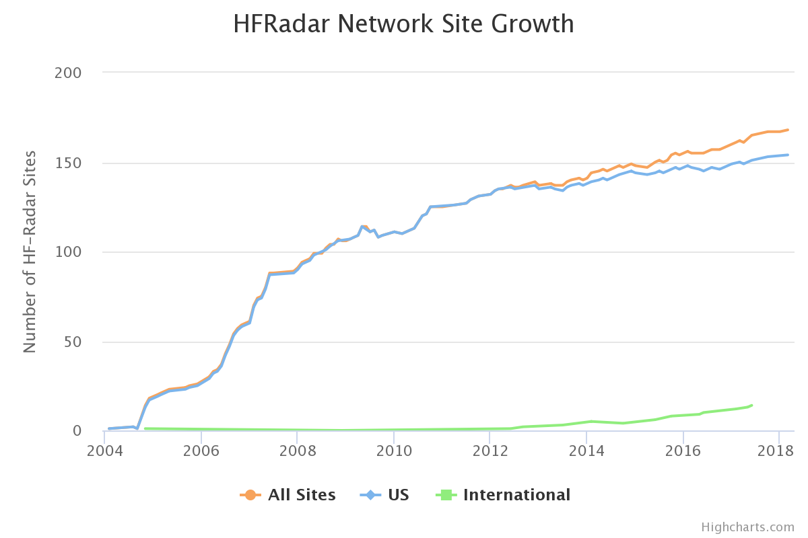

U.S. – 154

Canada/Mexico* - 14

*Mexico plans to install qty. 14 radars in 2018/2019

Figure : Number of radar stations reporting to the United States National Network (black) and Canada/Mexico (orange) from 2005 to 2018.



Figure 2: Number of radar stations reporting to the European network from 2005 to 2018.

|  |  |  |
| --- | --- | --- |
| Number | Country | Organization |
| 1 | Australia | Integrated Marine Observing System (IMOS) |
| 2 | Canada | Ocean Networks |
| 3 | Croatia | Institute of Oceanography and Fisheries |
| 4 | Germany | Helmholtz-Zentrum Geesthacht Centre for Materials and Coastal Research |
| 5 | Italy | CNR, Consiglio Nazionale delle Ricerche |
|  |  | OGS, Istituto Nazionale di Oceanografia e di Geofisica Sperimentale |
| 6 | Malta | University of Malta, Physical Oceanography Unit (PO-Unit), International Ocean Institute-Malta Operational Centre (IOI-MOC) |
| 7 | Mexico | Observatorio de Corrientes Oceánicas MEXicanas (OCOMEX) |
| 8 | Spain | Puertos del Estado |
|  |  | SOCIB, Balearic Islands Coastal Observing and Forecasting System |
|  |  | Meteorological Agency (Euskalmet) |
| 9 | United States | Integrated Ocean Observing System (IOOS) |

Table : List of countries and organizations providing surface current information to the Global HF Radar Network.

*Goals, Challenges, Opportunities and Risk*

Decentralized surface current data enables the aggregation of national surface current grids and allows for ingestion into displays, management tools, and models. HF radar derived surface currents have been used in several societal applications including coastal search and rescue, oil spill response, water quality monitoring and marine navigation.

The use of a short term prediction system numbers (STPS) calculated from near real-time HFR in the U.S. Coast Guard Search and Rescue Optimal Planning System has increased by over 85% from 2016.

*Coordination between Networks*

Meetings and conferences offer opportunities to collaborate and coordinate. The following are examples of recent meetings and topics.

2017 24-26 January, in Plymouth, United Kingdom – Partnership for Observation of the Global Oceans sponsored by Plymouth Marine Laboratory (PML)

2017 26 February – 3 March in Honolulu, Hawaii, USA – Association for the Sciences of Limnology and Oceanography

2017 18 September, in Lisbon, Portugal – Oceans Meeting sponsored by the Portuguese Minister of the Sea

2017 4-6 October, in Malta – Our Ocean

2018 23-25 January, in La Jolla, California, USA – Partnership for Observation of the Global Oceans sponsored by Scripps Institution of Oceanography (SIO)

2018 11–16 February, in Portland, Oregon - 2018 Ocean Sciences Meeting (OSM), co-sponsored by the American Geophysical Union (AGU), the Association for the Sciences of Limnology and Oceanography (ASLO), and The Oceanography Society (TOS)

**3. DECISIONS, ACTIONS and RECOMMENDATIONS**

***Developments in Technologies***

Developments in technologies can be reviewed by the recent presentations held at Ocean Sciences, 2018. Examples of technology efforts include, but are not limited to the following:

- Design and Implementation of a Compact Low-power Controller for High Frequency Doppler Radars

- Estimates of the Uncertainty in the High Frequency Radar-derived Surface Radial Velocity Observations off the Korean Coast.

- Spectral Kinetic Energy Fluxes in the Lower St. Lawrence Estuary from HF Radar Observations

- Uncertainty Estimates for Coastal Ocean Currents Measured with HF Radar

- Data Quality Assessment for HF Radar Systems Along the West Coast of Canada

- Inter-annual Variability in Surface Currents Over the California Shelf Measured by High Frequency Radar- General Patterns of Transport and Specific Features

- Compact WERA HF-Radar Installations at Cape Hatteras Contributing to Glider Control, Feature Tracking and examination of Cross-shelf Exchange Processes

- Observations of Coastal Trapped Waves from High-Frequency Radar Velocity Data

HF Radar derived wave data and meteotsunami warning products are being evaluated within the community. Several countries such as Australia, Spain, United Kingdom, and the United states are testing operational wave products for distribution, but these efforts are not currently coordinated. Similarly, the United States and Canada are reviewing the use of HF radar data for meteotsunami warning capabilities. Similarly, these efforts are not coordinated at a global scale, but are ongoing research areas.

***Data Flow and Data Quality***

A new method employing small drone aircraft for antenna pattern measurements (APMs) of high frequency (HF) oceanographic radars is being used for observing ocean surface currents. Previous studies have shown that accurate surface current measurements using HF radar require APMs. In the absence of APMs so-called "ideal" antenna patterns are assumed and these can differ substantially from measured patterns. Typically APMs are obtained using small research vessels carrying radio signal sources or transponders in circular arcs around individual radar sites. Circular arcs are necessary to avoid distortion of the transmitted calibration signals caused by radial movements of the signal source. This procedure is expensive because it requires sea-going technicians, a vessel, and other equipment necessary to support small boat operations. Furthermore adverse sea conditions and obstacles in the water can limit the ability of small vessels to conduct APMs.  In contrast, it is shown that drone aircraft can successfully conduct APMs at much lower cost and in a broader range of sea states with comparable accuracy. Drone-based patterns can extend farther shoreward since they are not affected by the surf zone and thereby expand the range of bearings over which APMs are determined. This simplified process for obtaining APMs can lead to more frequent calibrations and improved surface current measurements. Developed originally at the UC Santa Barbara, it is now operationally used in Australia to calibrate the existing Codar Seasonde systems, where it has contributed so far to a significant reduction in operational costs and increased safety of the technical staff, with plans to extend the drone calibration procedure to the WERA phased array systems. – *Libe Washburn, Eduardo Romero, Cyril Johnson, Brian Emery, and Chris Gotschalk, UC Santa Barbara*

An overview of the high frequency radar community’s recent efforts to implement real-time quality can be viewed in Version 1.0 of the QARTOD Manual for Real-Time Quality Control of High Frequency Radar Surface Current Data, a task which is also implemented as part of EU-funded projects (INCREASE; Jerico-NEXT). The document describes several QC tests that may be performed at different levels of radar data processing including tests for the spectra, radial component and total vector processing stages. Each of these tests also has a designation: required, strongly recommended, and suggested or in development. This is an ongoing effort within the community, which include both the extension and the development of new tests for phased-array radars *Teresa Updyke, Old Dominion University; Hugh Roarty, Rutgers University; Larry Atkinson, CCPO; Simone Cosoli, UWA – ACORN IMOS*

The goals of the global ocean currents database (GOCD) at NOAA’s National Centers for Environmental Information (NCEI) are to: 1) to integrate global ocean currents observations from a variety of instruments into a uniform network common data form (NetCDF) format and 2) to provide a dedicated online data discovery, access to NCEI-hosted and distributed ocean currents data. The data sets in the GOCD contain near-surface ocean currents derived from high frequency radar systems and drifting platforms. The portal is available at <https://www.nodc.noaa.gov/gocd/index.html>. *Leangchwan Sun, National Centers for Environmental Information*

***Areas of concern***

Frequency sharing and interference - The increasing number of HFR systems is requiring the development of platform-independent frequency-sharing techniques that allow for an efficient use of the radio bands in which the HFR systems operate.