Draft Guidelines for the organization of Regional/Thematic Workshops in the framework of the preparatory phase of the UN Decade

- Principles for the design of the implementation plan of the UN Decade
The Decade offers the ocean community a once-in-a-life-time opportunity to join efforts, mobilize resources, create partnerships with private sector and public at large, and engage governments in moving towards the Ocean We Need for the Future We Want.
Building on the several decades of international cooperation in ocean research and observations, as well as the policy-relevant goals defined by the 2030 Agenda and other ocean frameworks, it is desirable to specify a number of higher level scientific and technological breakthroughs, which are linked to the achievement of desired societal outcomes that the Decade will deliver.
The Decade Roadmap document considered by the IOC Executive Council, offers such a preliminary set of globally defined objectives and R&D Priority Areas, which should guide the development of activities and new programmes.
In addition, the Roadmap defines a bottom-up process which is very much needed so as to allow for the regional or even local definition of these outcomes and objectives, with the formulation of scientific products, activities and partnerships that could be proposed in the context of the Decade.
Consultation will therefore be essential throughout the Preparation Phase (2018–2020) and through the Decade itself, to guide the development and evolution of the Decade’s activities and to ensure that outcomes respond to specified plans, and are in harmony with other UN, non-UN and non-governmental initiatives, as well as respond to regional priorities.
This document provides a set of guidelines for interested parties that wish to organize consultation workshops either at the regional level or on a theme which is relevant to the objectives of the Decade. These are still draft form until these are formally considered by the Executive Planning Group (EPG) established to advise on the development of the overall implementation plan of the Decade.
- Purpose of Regional / thematic workshops
Regional and thematic workshops are an integral part of the Decade design process to achieve the above-mentioned objective and to engage various communities through a multi-stakeholder process.

The aims of these workshops are therefore to:
(i) communicate the purpose and expected results of the Decade to all stakeholders;
(ii) brief the participants on proposed arrangements for the Decade, including structure and governance, and solicit feedbacks;
(iii) engage and consult the ocean community concerning the implementation plan for the Decade (for example, identifying priorities in research or in capacity development and training);
(iv) workshop possible themes or topics that may be part of the Decade;
(v) draft plans for such initiatives, as appropriate, including scope, objectives, expected results, participation and possible schedule;
(vi) identify opportunities (but not necessarily commitments) for investment and resource mobilization for the Decade.

These workshops should provide a platform for advancing dialogue amongst scientists, academia, policy makers, civil society organizations and ocean businesses towards the identification and development of solution-oriented approaches to ocean sustainability.

Workshops can also be used to report to primary national and regional stakeholders on the preparation of the Implementation Plan. Self-organization and reporting within constituencies of partners is strongly encouraged.

Regional workshops organized in the framework of the Decade’s preparation phase will need to follow a common structure and format and deliver a number agreed outputs that will inform the design process, and feed into the work of the Executive Planning Group, as well as the two Global Workshops foreseen in 2019-2020. These will therefore need to be organized in close collaboration with IOC/UNESCO Secretariat as coordinator of the preparation phase.

- Geographical coverage of Workshops and timing

Regional workshops:
At least five regional consultative and planning workshops will be organized to cover the following ocean basins:
- The North Pacific,
- The South Pacific,
- The Indian Ocean and marginal seas,
- The North Atlantic, the Baltic Sea, the Mediterranean Sea and the Black Sea, and
- The South Atlantic (between the African and American coasts) and the wider Caribbean.

Coverage for sub-regions, as well as marginal seas and polar regions may also be considered in context of these regional workshops and/or through additional workshop that may be offered by interested parties.

Thematic workshops:
Thematic workshops addressing one or more core areas of work of the Decade (for eg. ocean observation, ocean data, ocean literacy) may be organized depending on the interest of various communities and partners, these will not be bind to a specific location or region.

IOC Member States, relevant organizations, intergovernmental regional organizations and institutional partners have been invited to express interest in hosting these workshops in 2019 through a widely disseminated call of expression.

Once dates and venue will be confirmed, an overall schedule of consultative workshops will be circulated by the IOC Secretariat.
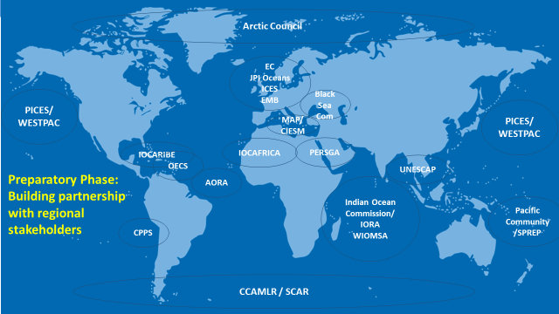

Scheduling workshops within the preparation phase

Ideally, workshops should take place after the first global planning meeting which will aim at assessing the status of ocean research vis-à-vis the 2030 Agenda requirements, tentatively scheduled for March 2019, and at the latest by December 2019. In early 2020, the second global planning meeting would aim at consolidating inputs from various consultations, including regional workshops referred to above, into a draft Implementation Plan, as well as the drafting of an integrated Science Plan, and the formulation of capacity development action.

- Who should participate?

Representative of Member States of IOC/UNESCO or the United Nations, members of United Nations specialized agencies and relevant organizations, bodies, funds or programmes within the United Nations system, shall be entitled to participate in any workshop that they consider relevant to them, up to the number of available places.

Relevant regional intergovernmental organizations in the region are encouraged to participate, including regional seas organizations, regional fisheries management organizations and arrangements, relevant regional intergovernmental marine science organizations and intergovernmental organizations and arrangements undertaking work in relation to large marine ecosystems.

Relevant regional marine scientific institutions and organizations as well as non-governmental organizations are particularly encouraged to participate. The IOC Secretariat may reserve a number of seats in the workshop to be filled by such invitations, covering different type of scientific expertise.

Each workshop should include at least one member of the Executive Planning Group (EPG). The number of participants for each workshop should remain within the 50-80 pax range in order to ensure sufficient interactions amongst experts.

For practical reasons, the logistics and the number of invitees will need to be managed by the host in consultation with the IOC Secretariat (or IOC relevant Sub-Commission).

Registration process

Registration to the workshops should be opened at least two months before the events and closed two weeks prior the workshop. [OPTION 1: Registration form should be submitted and processed online, via the Decade website or OPTION 2: Host Country will manage the registration process.

A two-step system will be established, participant will send their application through an online system. The workshop host together with the IOC Secretariat will confirm the registration and notify each participant formally.

Gender and balanced geographical representation will be encouraged. A particular attention will be paid to youth and early carrier scientists (in terms of how to engage them in the regional workshops).

Travel support
Depending on the availability of resources, Travel support/grants may be provided to representative of developing countries experts and stakeholders (especially from SIDS/LDCs). The host and IOC Secretariat will then establish a process for participants to apply to travel grants.

- Workshop format and expected outputs

The duration of a consultative workshop should be between 2 and 3 working days.

Workshop format

The local host/partner organization will enjoy some degree of flexibility and ownership regarding the conceptualization of the potential decade projects/initiatives and side-events. Particularly for regional workshops, these should follow a common format in order to generate information that are comparable and that can be integrated in the Implementation Plan and Decade design process.

The following Expected outputs are envisaged:

- Knowledge gaps identification and list of the regional scientific priorities vis-à-vis the 2030 Agenda requirements and more globally shared expectations vis-à-vis the Decade
- List of existing partnerships/networks/initiatives in Ocean Observing Systems, data and information systems and list of desired ones;
- Priorities in capacity-development/training;
- List of themes or topics identified as priority area;
- Identification of interested partners clustered around themes/potential initiatives to be developed under the Decade ;
- Follow-up arrangements (timeline for the development of individual partnerships/initiatives; responsibilities of various partners, identification of potential resources, identification of expert that will represent the region in the global planning meeting, communication/reporting mechanisms).

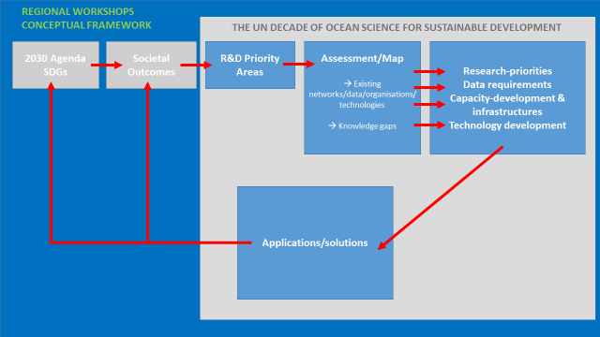
Conceptual approach to organize regional workshops

Regional Workshop structure
The workshop structure will be organized around 2 plenary sessions (Day 1 and Day 3) and a series of Working Group Sessions (Day 1 and 2). At any time, no more than 2 Working Groups will run in parallel. In order to promote the development of scientific solutions and application that are responsive to the sustainable development agenda (Agenda 2030 and other frameworks, for eg SIDS, UNFCCC, Sendai), the Working Groups will be organized around the six societal outcome that have been defined in the Decade Roadmap document. These outcomes are considered to be highly transformative, because they are expected to trigger environmental, societal, and policy changes.
The Working Groups will address both deep disciplinary understanding of ocean processes and solution-oriented research to generate new knowledge needed to achieve a given societal outcome. They will map existing networks and science initiatives that can contribute, identify major knowledge gaps that are hindering sustainable development, and prioritize research priorities and data requirements. They will delineate a number of potential partnerships with concrete deliverables in terms of ocean sustainability that should be further developed in the framework of the Decade. Aspects related to marine technology and capacity development will also be addressed. Specific terms of reference will be developed for the working groups.

The following table provides a possible structure for the regional workshops.

DAY 1 | DAY 2 | DAY 3
PLENARY  Opening  Presentation of the Decade and its Preparatory Phase  Regional Stakeholder Interventions  Working Group Objectives | WORKING GROUPS III & IV  WG III: A predicted Ocean (3h)  //  WG IV: A safe Ocean (3h) | PLENARY SESSION  WG Reporting  Cross cutting issues  Capacity development requirements
Lunch | Lunch | Lunch
WORKING GROUPS I & II  WG I: A clean Ocean (3h)  //  WG II: A healthy & resilient Ocean (3h) | WORKING GROUPS V & VI  WG V: A sustainable productive Ocean (3h)  //  WG VI: A transparent & accessible Ocean (3h) | Resource Mobilization  Participation in Global process (Global Planning Workshop/ Stakeholder Forum)  Workplan & responsibilities  Closure

Chairing arrangements:
In consultation with the IOC Secretariat, the Hosting institutions, two co-chairs will be appointed from the region. Co-chairs should be national representatives from two different countries, affiliated respectively with institutions with an ocean science perspective and ocean management/policy perspective.

Side-events showcasing/displaying specific and successful regional initiatives/programs/networks may be organized during lunch breaks and at the end of the working days, depending on the availability of rooms.

- Sharing of responsibilities:

- Local host responsibility:

The local host will be responsible for:
- Provide venue for the workshop (Meeting Rooms, secretariat offices and other spaces (e.g. meeting secretariat, pressroom, exhibition area, wifi network) and related equipment (audio system, microphones, headset, podium, screens, LCD projector, nameplates), as well as local staff (meeting clerks, technicians)
- inviting high-level representatives for the opening of the workshop and with appointing chairs for the various sessions;
- assist with the identification of regional experts;
- liaise with public and private institutions to raise funds for activities in relation to the meeting, in cooperation with IOC/UNESCO.
- the cost of interpretation in working languages depending on requirements,
- facilitate the application and granting of visas free of charge for meeting participants,
- the provision of tea/coffee/refreshments and welcome reception for the participants;
- assistance with the negotiation of reduced hotel rates and the booking of accommodation for the experts;

- IOC Secretariat responsibility:

The IOC will be responsible for:
- the identification and invitations of participants;
- the registration of attendees (including those experts willing to follow the workshop via live broadcast);
- the identification of facilitators and panelists who will facilitate and participate in working groups and stakeholders meetings;
- the documentation supporting the workshops;
- the communication tools supporting the workshop;
- the international aspect related to communication of the workshop;

- Workshops funding and organization:

The local host/partner organization is expected to support logistical costs.
The experts/participants travel expenses are expected to be on a self-sponsoring basis, unless identified support is provided.

Travel grants for experts from SIDS/LDCs to participate in the workshop as well as for regional experts to participate in the second global meetings that will aim at consolidating inputs from the regional workshops should be encouraged.

The workshops logistics funding and support will be detailed in the local host proposal/specifications note.

- Green workshops:

IOC, the local host/partner organisation and the IOC regional Commission (where it does exist) in charge of organizing the event will apply best practices ensuring green events and reducing carbon footprint.

IOC, the local host/partner organisation and the IOC regional Commission (where it does exist) in charge of organizing the event will also assist attendees and participants in their own individual efforts to contribute to the event’s ecological footprint reduction.

After the workshops, IOC will communicate the results to the venue’s managers, institutional partners and participants and the efforts put into this event, spreading the message that organizing greener events is possible;

The shared responsibilities regarding the organization of green workshops are listed in Annex IV.

- Workshops specifications note:

The logistics, funding support and responsibilities of the shared responsibilities between the local host/partner organisation, the IOC Secreterariat will be detailed in a meeting specifications note.

- Workshops preparation timeline:
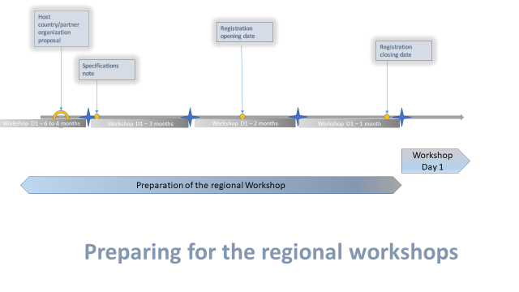

- Workshops’ follow-up activities:

The final version of the regional plan will be available on the Decade website.

Designated regional experts will present the regional plan during the global planning meeting that will take place in 2019 to consolidate inputs from various consultations (including the regional workshops).

A regional network will be established gathering scientific experts/institutions, regional Ocean managers and decision-makers, regional NGOs, regional representatives of businesses and industries in order to prepare the Decade activities and liaise with the Stakeholder Forum.

- Workshops communication strategy:

The workshop will be as much interactive as possible, using public engagement tools such as online live streaming and Slido.

Communication will be key:
- Before the workshops: to inform and engage stakeholders. The IOC regional commissions will have a key role in that communication;
- During the workshop: communication tools will be developed (interviews, videos, pictures, etc.);
- After the workshops: the communication materials elaborated during the workshop will be used to prepare the next workshops and to communicate the results of the regional consultation.

Communications materials produced in the context of the regional workshops will serve to:
- Promote the role of specific individuals in the Decade process through story-telling techniques
- Create links between region-specific experiences/activities
- Translate regional activities and experiences to the Decade’s global planning framework and communications plan

Workshop host countries and institutions will be encouraged to provide human and in-kind resources for communication activities, such as:
- Video and photographic coverage of the workshop
- Support to craft and disseminate communications materials on mainstream and social media (before, during, after workshops)
- Audio-visual equipment such as large screens and video projectors
- Editorial support to design and print workshop materials (brochures, flyers, etc.)
- Liaison with journalists and other members of the national media

The Decade Communications Team based in the IOC Secretariat will work closely with the host country and partner institutions organizing the regional workshops to coordinate activities in the most coherent and effective manner.

Decade Roadmap : http://ioc-unesco.org/components/com_oe/oe.php?task=download&id=38665&version=1.0&lang=1&format=1

