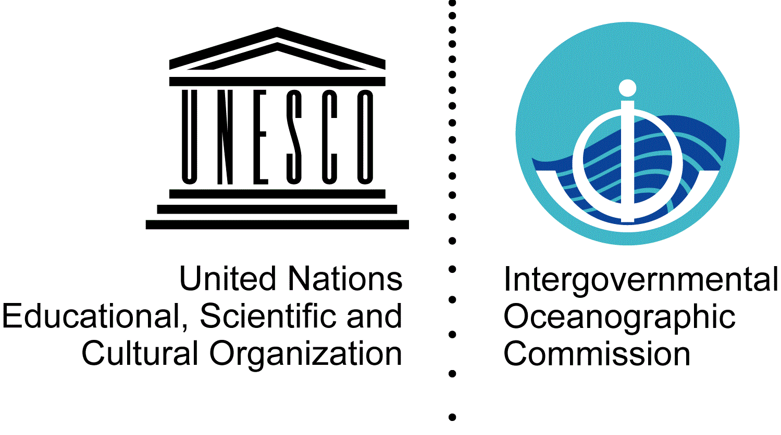  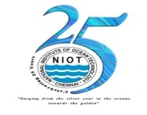 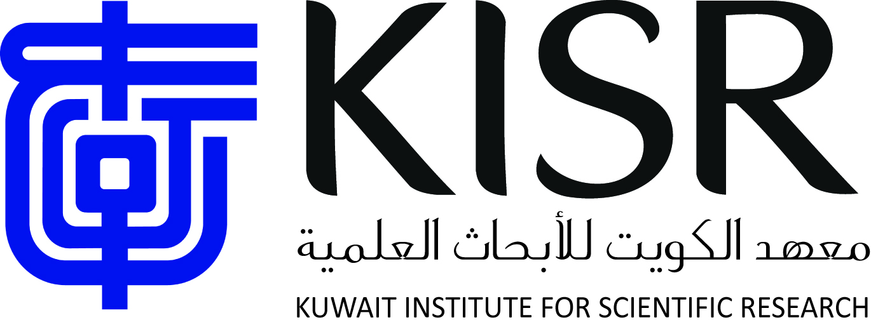 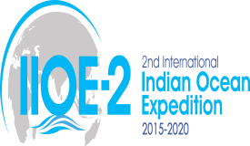 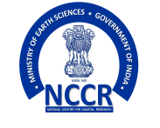

**IOC Regional Committee for the Central Indian Ocean (IOCINDIO)**

**Scientific, Technical and Institutional Innovations Workshop for National and Regional Framework on Coastal Vulnerability Assessment and Monitoring for Sea-Level Rise and Storm Surges in the Indian Ocean Region**

**Under the patronage of the Ministry of Earth Sciences, Government of India**

**Venue:** The Kick off Workshop will be kindly hosted at the newly established International Training Centre on Operational Oceanography (ITCOocean) as a Centre under the auspices of UNESCO (category 2) and the Indian National Centre for Ocean Information Services (INCOIS), Ocean Valley” Pragati Nagar, Nizampet P.O.; Hyderabad - 500 090, India

**Dates**

**Workshop:** 27-30 May 2019

**7th Session of the IOCINDIO (IOCINDIO-VII**): 31 May–1 June 2019.

**Sponsors**

Intergovernmental Oceanographic Commission of UNESCO **(**IOC of UNESCO)

International Training Centre on Operational Oceanography (ITCOocean) as a Centre under the auspices of UNESCO (category 2), India

Indian National Centre for Ocean Information Services (INCOIS), India

National Institute of Ocean Technology, (NIOT), India

Kuwait Institute for Scientific Research (KISR), Kuwait

**Geographical scope/benefiting countries:** All the nineteen (19) IOCINDIO Member States:

Australia, Bangladesh, France, India, Indonesia, Iraq, Iran, Kuwait, Malaysia, Maldives, Myanmar, Oman, Pakistan, Qatar, Saudi Arabia, Sri Lanka, Thailand, United Arab Emirates, United Kingdom of Britain and Northern Ireland and partners.

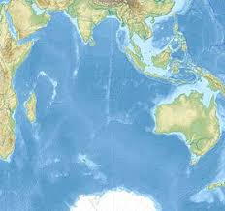

***Brief justification and rationale of the project***

**Goal:** The goal is to have all the countries in the region becoming ready for the anticipated sea level rise by developing their own coastal vulnerability index and early warning systems for storm surges. Countries in the region need to develop their codes and standards for the preparedness in face of consequences of storm surges and sea level rise.

**The Challenge:** The global climate change and the threat of accelerated sea-level rise exacerbate the already existing high risks of storm surges, severe waves and tsunamis in coastal areas. Climate change may not only enhance the most threatening extreme events causing loss of life of vulnerable coastal population and properties, but also aggravate long-term bio-geophysical effects, such as sea-level rise, shoreline erosion, sediment deficits, saltwater intrusion into coastal aquifers and the loss of coastal wetlands. In light of these existing hazards and increasing risks in coastal regions, there is a great need to gain as much insight as possible into the exact nature and extent of possible risk increases related to future climate trends.

***The IPCC predictions*** provide a strong background justification for the regional project:

* Scenario 1: If the whole world goes for renewable energy, the sea level will rise up to 25 cm by 2100.
* Scenario 2: If 50 % of the world power generated from renewable and the rest is from conventional power sources, then the sea level rise will be up to 50 cm by 2100.
* Scenario 3: Status quo, sea level rise will be up to 1 m by 2100.

For all the above scenarios, all the countries in the region should know the inundation and erosion threats and should be invited to take responsive remedial actions; for storm surges will increase the vulnerability to the those countries which are prone to cyclones.

**The project activities include the following.**

* Identify the list of countries, which already have the coastal vulnerability index and those in needs.
* Identify the list of countries, which have developed or adopted early warning systems for storm surges and those in needs.
* North Indian Ocean area requires a specific focus because storm surges associated with severe tropical cyclones stand out as by far the most damaging among natural disasters. The South Asian countries bordering the Bay of Bengal and the Arabian Sea are frequently affected by cyclonic storms. About 9,000 km of coastal zones from Oman to Thailand and about 300 million people are exposed to cyclone induced storm surges, (http://unesdoc.unesco.org/images/0011/001133/113310Eo.pdf). Storm surges due to cyclone in 1977 November that made landfall along Andhra Pradesh coast that killed around 10,000 lives. About 15,000 people lost their lives due to the storm surge generated by Odisha Super cyclone in October 1999 (Dube et al., 2009). Storm surge due to Bhola cyclone (November 1970) that made land fall along Bangladesh coast that took around 3,00,000 lives (Das PK, 1994). Although storm surges are less frequent in Arabian Sea than in the Bay of Bengal, major destructive surges occasionally have occurred along the countries bordering Arabian Sea. Cyclonic storm Gonu that struck Oman which causing about $4 billion in damage and 49 deaths (Dube et al., 2009). The high and increasing population density along the coastal stretch necessitates a dedicated operational storm surge warning system in order to mitigate the loss due to storm surges. Considering the same, the Earth System Science Organization (ESSO) - Indian National Centre for Ocean Information Services (INCOIS), Government of India initiates the setting up the Storm Surge Early Warning System (SSEWS) for the Indian coasts. ESSO-INCOIS is mandate to storm surge warnings to disaster management offices and coastal authorities of the coastal regions of India. Timely issuance of surge bulletins from INCOIS during recent very severe cyclonic storms ‘Hudhud’ and ‘Phailin’, could helped coastal authorities in their successful evacuation processes and in turn lessen the human loss.

**The workshop will**:

* Highlight the importance of studies, research and technology applications by each country for sustainable national coastal development.
* Promote the development of scientific investigations and technology by interested countries.
* Determine the economic and financial impacts of coastal vulnerability in terms of What if? (in terms of loss of human life, Economic and Financial damages and lost if NO Actions?). Local social and societal impacts on populations, stakeholders and businesses versus responsibilities of Municipalities.
* In view of the looming threats due to climate change and the ever increasing need to mitigate and manage coastal hazards it is imperative to develop expertise among the coastal stakeholders and especially the government officials on the tools and techniques available to model and map the coastal vulnerability arising out of hazards such as sea level rise, storm surges, urban flooding, tsunamis etc.
* Thus, this Workshop is conceived as a mixture of theory, practical and field sessions wherein participants are encouraged to work independently on GIS, Image Processing software, design field data collection programmes and run numerical models on coastal hazards. Both open source and commercial GIS and Image Processing software are used in the practical sessions.

**Participants** will exchange experiences and best practices about field data collection using GPS, satellite image processing and development of a spatial database in GIS, spatial analysis and interpretations of results for preparation of hazard maps for management purpose using case studies.

**Workshop programme**

1. Climate change, projections and impacts
2. Coastal Risk & Vulnerability – Introduction
3. Sea Level Rise and its impact
4. Storm surge modelling and mapping
5. Coastal urban flooding
6. Coastal Inundation mapping
7. Tools, Instrumentations for field data collection
8. Coastal Vulnerability indices
9. Climate database and its utilization

**Practical (10 sessions)**

1. Field Data Collection
2. Basics of GIS and Remote Sensing – 1
3. Field data collection and mapping – 1
4. Storm Surge Modelling – 1
5. Coastal Flooding -1
6. Generation of Coastal Vulnerability Index - 2

**Group Discussion (2 sessions)**

Climate Change protocols – impact-based solutions

**Targeted audience**

Scientists/experts in different fields from member countries of IOCINDIO along with experts from the premier Institutes of the host country including NIOT, NCCR and INCOIS.

**The tentative schedule of the programme**

|  |  |
| --- | --- |
| Module 1 | 1. Introduction of participants 2. Presentation by the representatives of member states 3. Discussion on the needs of member states |
| Module 2 | 1. Coastal vulnerability index calculation |
| Module 3 | 1. Coastal observations necessary to be set up 2. Tools, Instrumentations for field data collection |
| Module 4 | 1. Feedback from participants |
| Module 5 | Climate change, projections and impacts |
| Module 6 | Coastal Risk & Vulnerability – Introduction |
| Module 7 | Sea Level Rise and its impact |
| Module 8 | Storm surge modelling and mapping |
| Module 9 | Coastal urban flooding & Inundation mapping |
| Module 10 | Coastal Vulnerability indices |
| Module 11 | Climate database and its utilization |
| Module 12 | Basics of GIS and Remote Sensing  Field data collection and mapping |
| Module 13 |
| Module 14 | Storm Surge Modelling  Coastal Flooding |
| Module 15 |
| Module 16 | Concluding Marks |