Ocean Observing Governance Workshop
30 April 2019, GEOMAR, Kiel, Germany
goosocean.org/gov-workshop

Context
The Global Ocean Observing System (GOOS) has developed an ambitious 2030 Strategy (link), with a vision for a fully integrated ocean observing system delivering to a broader range of users, through strong partnerships and expanded participation. A governance system needs to be envisioned with the strategy that supports the evolution and maintenance of the integrated and responsive observing system, that our ocean, governments and society need.

The present governance of ocean observing systems has functioned well in tapping into a strong observing community, and is a functioning patchwork of global, regional and local level initiatives. At a global level, GOOS, as an intergovernmental programme, harnesses input from Member States, and connection to other parts of the UN system including WMO, UN Environment, UNCLOS, and global environmental conventions; while building on the patchwork of community-driven initiatives.

However, the present governance arrangements will not be sufficient to realize the ambition of the 2030 Strategy, as they do not connect the different communities, networks, and partners in fully achieving their potential; and generally ignore private sector partnership. They do not allow for a full implementation of the concepts identified in the Framework for Ocean Observing. Better governance will ensure good observing system delivery, responsiveness and sustainability.

The 2030 Strategy and OceanObs'19 Conference (16-20 September 2019) provides an opportunity to develop an expanded common vision for ocean observing system governance, and to work towards implementing it in the coming UN Decade of Ocean Science for Sustainable Development. In order to gain community input to shape the questions and composition for such a governance system, GOOS is organizing several workshops for independent input on the process, calling on leaders of observing system partners, and regional and national observing systems. This workshop will be the initial touch point for developing the ideas around partnership and national structures needed to improve the ocean observing system, with a focus on the governance that will enable this partnership to be responsive and effective.

Initial work in identifying the impediments and considering some different models for the future are a starting point for the discussion (Tanhua et al. OceanObs'19 Community White Paper, submitted). This one day workshop, and a second in summer 2019, aim to assist in framing ideas around governance support the evolution of a new fit for purpose governance system to be discussed with the observing community at OO19.

The workshop Agenda is framed around four discussion areas, it would be useful to review the background to these discussion areas, provided below, before the meeting. The workshop will be interactive and encompass many opportunities for discussion so please come ready to contribute and to help shape the outcomes.

Agenda
09:00
Introduction - Toste Tanhua (20 min)
- GOOS 2030 Strategy and present status
- goals of the workshop and the discussion process
- scope (e.g. governance vs. management)

9:20
- Global ocean observing governance: Shared Principles - Brad de Young (1 hr)
- procedural principles (e.g. transparency)
- basic principles (e.g. equity)
Outline and discussion, vote on outcomes at coffee break

10:00-10:30 coffee break

10:30
(continuation of item 1)

10:50
- GOOS Governance - present status - Albert Fischer (40 min )
- Review of structure
- what is working, what is not?
- what is not covered or not well connected?
Outline, discussion and SWOT on present status GOOS governance

11:30
- Theory and models of governance, from hierarchical to polycentric multilevel models of governance - Robin Mahon (1 h)
a. polycentric governance enabling conditions (15 min presentation and questions)
b. How to take a structured approach towards implementation of a polycentric multilevel model, including an example from the wider Caribbean region on ocean governance (15 min presentation and questions - how much is applicable in this case? What lessons can be learnt?)

12:30-13:30 Lunch
13:30
- Models/modes of Governance in the observing system: national to global / roles and responsibilities - Albert Fischer, Emma Heslop, Toste Tanhua and Robin Mahon (2 h)
a) review of the components and stakeholders of the global ocean observing system
b) discussion around 3 key areas, 1) cycles and what this means in the context of ocean observing system, 2) multi-level characterization of components, 3) implications for governance structure and components;

15:30-16:00 coffee break

16:00
- Effective governance attributes - John Gunn and Robin Mahon (1 hr)
- How to move towards more effective governance?
- How to measure progress / successful governance?
- Outline of some next steps?
- Messages for the next workshop?

17:00
Wrap up
Close meeting

19:30
Workshop Dinner - traditional May Day’s Eve food in local restaurant
- details provided on the day
- optional and self-funded

Background to the 4 areas of discussion are outlined below to provide context with links to further reading if anyone interested in more depth on the topics outlined.

1. Global Ocean Governance: Shared Principles

Some of the desired principles expressed through Tanhua et al.(2019, OceanObs'19 Community White Paper, submitted) include:

- Responsiveness. Governance must respond to the needs of stakeholders and participants, from local, regional to global, across all relevant sectors, and include governmental and non- governmental aspects.
- Purposeful. Governance must be purposeful for, and on behalf of the community.
- Clear objectives. Good governance relies on clear and purposeful (relevant) objectives and strategy.
- Transparency. Transparency and openness must be a priority, to ensure public access to and benefit from the system. While private networks may be warranted on the grounds of security or because of the narrowness of the target audience, in general information should be public and governance arranged accordingly.
- Efficiency and Effectiveness. Governance must ensure that maximum value is derived from invested resources and must have enough flexibility and nimbleness to ensure guidance/decisions are provided in a timely way.

AtlantOS noted similar principles (deYoung, B., Visbeck, M. et al., 2019). Stewardship/ethics in the governance principles have also been highlighted by some authors, for example Barbier et. al. 2018.

Some attributes of desirable governance were also noted by Tanhua et al. (2019) and include:

- Adaptive. Governance must support innovation and openness to change, to ensure that benefits accrue for new solutions and improved practices.
- Sustainability. Governance must have a long-term orientation, taking account of the broad- range of existing and likely future drivers, and the need for dependability and robustness.
- Authoritative. The individuals and teams contributing to governance must have the appropriate capability, skills, and respect of the community to act on their behalf.
- Performance and accountability. The governance must include monitoring and measures of success and performance.

2. GOOS Governance: Present Status
In response to expanded requirements, GOOS governance has changed significantly in the ten years following the OceanObs’09 conference. Among many changes, a three-tiered governance model was implemented: a multinational steering committee was established to provide oversight; scientific expert panels were formed to guide system requirements; and efforts were also made to connect with and reinvigorate observation coordination groups involved in implementation at global and regional scales.

Today, GOOS has four key components:
- expert panels for physics, biogeochemistry, and biology and ecosystems that synthesize across requirements and provide guidance on observing system design;
- the Observations Coordination Group and the GOOS Regional Alliances that implement observing systems and ensure the flow of observations across the global networks and regional observing structures;
- GOOS Projects that advance innovation and expand into new areas for the observing system; and
- core coordination through the GOOS Steering Committee and GOOS Office

Through these components GOOS supports a community encompassing all those playing a role in the observing system: international, regional, and national observing programs, governments, UN agencies, research organizations, and individual scientists.

What works and what does not in this current structure? Are some components not well enough connected to the decision making process? As GOOS continues to mature and partners, such as WMO restructure, how can we best use what we have to build what we need? What does this tell us about the partnership required to deliver on the strategy?

3. Governance theory

The situation of multiple centres of responsibility for GOOS components and the lack of an entity or mechanisms with responsibility for overall for coordination of the system described by Tanhua et al. (2018) is not uncommon in the world of natural resources governance. There is a significant body of literature on the characteristics of such systems and how to make them effective, that may be useful in understanding and coping with GOOS. Ostrom termed such systems as polycentric, defined by the existence of multiple centers of influence or decision-making that address a particular problem area.

Several terms and concepts have sprung up in relation to these ideas. These systems are variously referred to as: fragmented systems, when there is little interaction among their parts; bricolages, when there are attempts to coordinate and facilitate interaction of what is there; complex self-organizing systems, which takes note of the often organic nature of their evolution; network systems, when there are linkages that may have evolved or been facilitated. These are not mutually exclusive. Knowing that others have recognized and tackled these problems before may help the GOOS community to reflect on the current situation, how to determine the desired situation, and how to get from here to there. Figure 1 may help in visualizing the situation and some of the approaches in moving from one state to another.

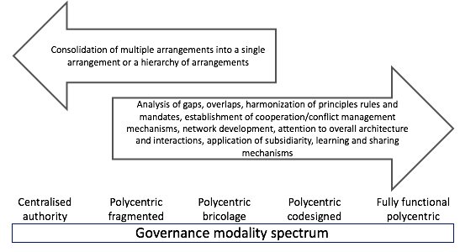

Figure 1. A governance modality spectrum indicating the relationship among some key stages and processes for moving between them (Mahon and Fanning, submitted to Marine Policy). A fully functional polycentric system includes: analysis of gaps, harmonization of principles rules and mandates, establishment of cooperation / conflict management mechanisms, network development, attention to overall architecture and interactions, application of subsidiarity, learning and sharing mechanisms.

Fully functional polycentric governance systems have some theoretical advantages, including adaptive capacity, fit to institutions, and mitigating risk. Some potential disadvantages are the transactional cost of coordination across structures, dispersion and accountability.

Importantly, the polycentric system that is GOOS is also multilevel, with global regional, subregional, national, and subnational levels. In addressing the multilevel, polycentric ocean governance situation in the Wider Caribbean Region, a symbolic characterization of the system that, while an oversimplification, allowed structured discussion, was adopted (Figure 2). The key features of the framework were policy / decision-making processes at multiple organizational and geographical levels, with the propositions that: (1) the policy cycles / decision-making processes should be structured so as to be effective, (2) they should connect with other cycles at the same level, and (3) they should connect with relevant cycles above and below.

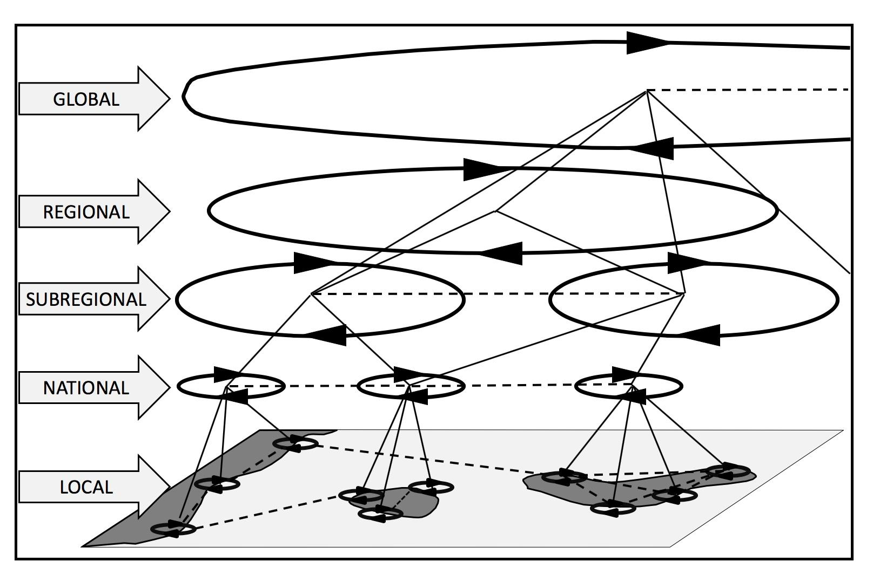

Figure 2: A multilevel governance framework with policy cycles and
lateral (between arrangements) and vertical (between global, regional, subregional, national, and local levels) interactions

This simplified perspective allows one to break the entire system into manageable parts and to ask a variety of questions about the parts as well as the entire system.

4. Models/modes of Governance in the observing system: national to global / roles and responsibilities

While nations mostly oversee their own local observing networks, the degree to which these are coordinated nationally varies widely and often cross-nation coordination is also lacking. A recent positive development has been the emergence of coordination at the scale of complete ocean basins. The basin-scale focus provides a new and potentially effective vehicle for collaboration on ocean observation requirements, observing strategies, data sharing, capacity building, and resourcing. However, there is currently no single model for integrating regional efforts. Improvements in the way we coordinate through national, regional to global systems, across the range of models is needed. The variety of differently focused observing systems makes it challenging to find a model for coordination. What role does a governance model play in this?

In addition, there is a current lack of clarity within the global ocean observing community structure about roles and responsibilities. This confusion results in missed opportunities, potential duplication of effort, and underfunding, among other challenges. Improvement to the governance system should also focus on finding common ground and building strong partnerships across the growing observing system. To achieve this, it will be helpful to have developed a common understanding of roles and responsibilities. Finally processes around the setting of requirements, assessing technology choices, standards for data management and sharing, coordinating the suite of public products, and cooperating in global capacity development on all levels could be better addressed,

The following questions are set out across 3 areas to foster some analysis of the observing system components, their function and the influences on direction. Taken from the multilevel polycentric system thinking/approach (Mahon et al), it assumes that the system envisaged is probably going to need to be both multilevel and polycentric, as concluded by Tanhua et al. (2019).

Policy / decision-making cycles
- What do we mean by a policy cycle (encompassing decision-making / implementing processes) in the context of ocean observing?
- What are the policy cycles at various levels?
- How do different cycles compare/contrast? IMOS/EOOS/U.S.IOOS, AtlantOS/TPOS, GOOS Regional Alliances?
- Is there a typology of policy cycles? Can we group characteristics? National cycles will likely have more centralized characteristics, what about basin-scale, international etc.
- What are desired characteristics for various types?
- What is needed to build capacity towards those characteristics?

Interactions amongst cycles (multi-level and lateral)
- What kinds of interactions are needed among policy cycles and where?
- Is there a typology of interactions (sharing information, co-production of outputs, planning and strategizing together, making joint decisions)?
- Are there differences in modes of interaction at the national, regional, global levels?
- What decisions that are best made at each level - national, regional, basin, global, system, network?
- How do cross-cutting dimensions (observing platforms, themes) define a model or interface?
- Who decides on priorities (enhancements/innovation vs. additional platforms), around basins? do we need to integrate to a global view? Is design negotiated at the basin scale? Global scale? National scale? co-negotiated?
- What is needed to build capacity towards effective interactions?

Overall
- What type of mechanism is needed to provide overarching guidance and monitoring?
- or example: an MoU between the partners, stakeholders. Strategy as a statement of common objectives? What processes of coordination, conflict resolution, representation, learning/sharing mechanisms?
- Is it possible to envisage a multi-level governance where regions and stakeholders are represented at the global level, rather than having all included?

Addressing these questions will be an ongoing initiative, not a one-time discussion, and will likely require quite a bit of analysis, however it is worth bearing in mind what Albert Einstein said “If I had an hour to solve a problem I'd spend 55 minutes thinking about the problem and 5 minutes thinking about solutions.”

Additional Reading

Ocean observing and governance:
- 'Governance' CWP Tanhua et al. 2019
- 'GOOS Regional Alliances' CWP Moltmann et al. 2019
- FOO 2.0 Summary Report - key findings about implementation of the Framework for Ocean Observing McCurdy
- An Integrated All-Atlantic Ocean Observing System in 2030
- Barbier et al.: Ethical recommendations for ocean observing
- Larkin and Heynmans: Strategic foresight paper on AtlantOS in the European context

Governance models:

  - Ostrom 2010 Polycentric systems
  - Jordan et al 2018 Promise and limits of Polycentric Governance
  - Vousden 2015 ASLME local-regional polycentric governance
  - Mahon et al 2014 Emerging regional ocean governance arrangements
  - Carlisle 2017: Polycentric Systems: a theoretical model

