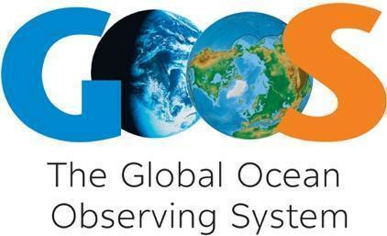

GOOS Implementation Plan

INTERNAL DRAFT
April 17 2019
For GOOS SC-8
Version 2

1. Introduction

Scope
This initial draft of a GOOS Implementation Plan is a working document for the GOOS Steering Committee. Taking a Strategy that has a vision for a broad ocean observing community, includes objectives on the development of partnerships, and the championing of ocean observing governance at all levels—it nonetheless as an initial starting point focuses on the structures of GOOS as seen from a global level, as a practical first step.
We envision this document to evolve over time:
- In an initial phase through September 2019 with input from GOOS structures. This targets the OceanObs’19 conference as an initial starting point to engage with partners about a co-designed contribution to the broad ocean observing Strategic Objectives; and
- On an annual basis as actions move forward, the pieces of GOOS work more closely together and with partners in designing actions around objectives, and as priorities and inputs change.

Review of objectives
The Global Ocean Observing System 2030 Strategy defines the following objectives:
Deepening engagement and impact
Deepen engagement and partnership from observations to end users to advance the use and impact of the observations and demonstrate its benefits

1. Strengthen partnerships to improve delivery of forecasts, services, and scientific assessments.
2. Build advocacy and visibility with stakeholders through communicating with key users and national funders.
3. Regularly evaluate system impact to assess fit for purpose.
4. Strengthen knowledge and exchange around services and products, to boost local uptake.

System integration and delivery
Deliver an integrated, ‘fit for purpose’ observing system built on the systems approach outlined in the Framework for Ocean Observing.

5. Provide authoritative guidance on integrated observing system design, synthesizing across evolving requirements and identifying gaps.
6. Sustain, strengthen and expand observing system implementation through GOOS and partner communities, promoting standards and best practice, and developing metrics to measure success.
7. Ensure GOOS ocean observing data and information are findable, accessible, interoperable, and reusable, with appropriate quality and latency.

Building for the future
Building for the future through innovation, capacity development, and evolving good governance.

8. Support innovation in observing technologies and networks.
9. Develop capacity to ensure a broader range of beneficial stakeholders participation.
10. Extend systematic observations to understand human impacts on the ocean.
11. Champion effective governance for global in situ and satellite observing, together with partners and stakeholders.

Status now
[section to be completed]
Combined overview
Integrated
Major gaps
Draw from Strategy Nov 2018 version

Priorities
GOOS, given its history, structures, staffing and level of financing, would struggle at present to fully address each of the 11 Strategic Objectives outlined above in the short term with equal priority.
During the stakeholder review of the Global Ocean Observing System 2030 Strategy (mid-2018), commenters were asked to identify the most important Strategic Objectives from their perspective. The results are visualized below, and the GOOS Steering Committee Executive agreed to five priorities Strategic Objectives:
SO1. Partnerships for delivery
SO2. Advocacy and communication
SO6. Implement and promote best practice
SO7. Open data (FAIR data)
SO9. Guide capacity development
Those five priority Strategic Objectives are the most developed in this Implementation Plan, along with ongoing strong activity areas in SO3 evaluating impact, SO5 providing authoritative guidance on design, and SO11 championing effective governance.

2. Implementation by Strategic Objective

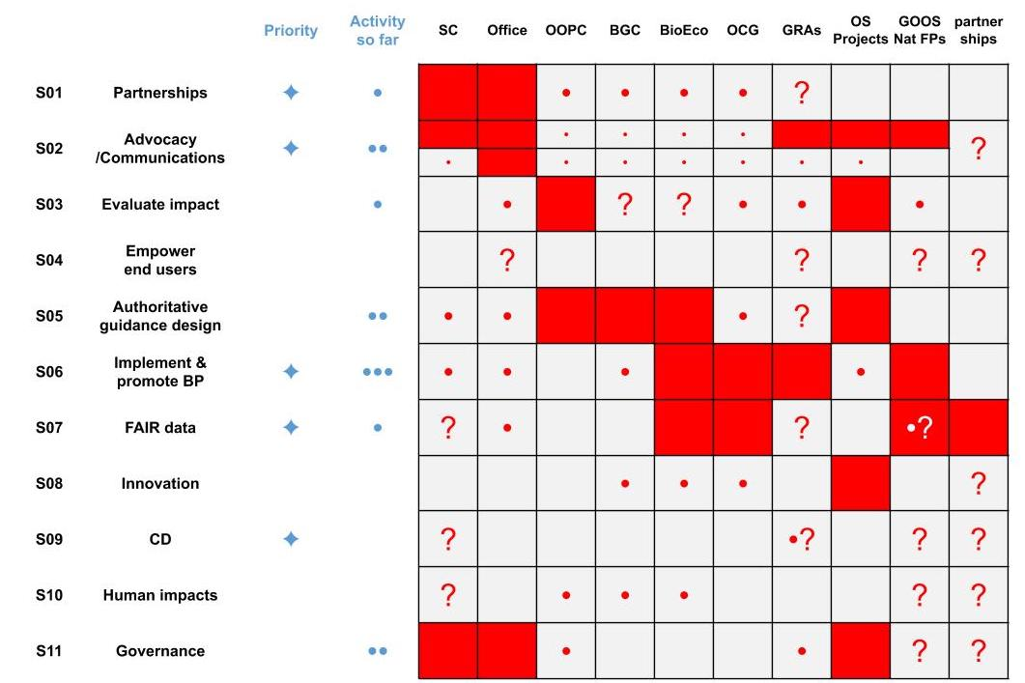

Figure 1: Notional matrix of Strategic Objective and GOOS components. At present this shows where each component of GOOS (columns) focuses its effort with respect to the Strategic Objectives (rows). A red square notes a primary effort, a dot a supporting effort, and a question mark identifies areas where further discussion is needed. The five priority SOs are marked with the blue diamonds, and an initial assessment of where GOOS as a programme has put its primary effort so far is noted with the small blue dots (• some effort, •• strong effort, ••• major effort)

Goal: Deepening engagement and impact
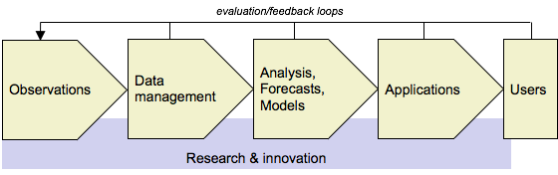
Figure 2: Observations generate value for science or end users making decisions through a value chain, where each steps add value to the basic observations. These run from observations through data management, analysis forecasts or models, services and applications, which are providing information of value to end users in making short or long-term decisions of societal importance. Science is an important intermediate user, and research and innovation actions underpin the development of stronger value chains.
Deepen engagement and partnership through the value chain from observations to end users, in order to advance the impact and use of the observations, and to improve visibility of the work of the observing system. There are 4 strategic objectives under this goal:

SO1. Strengthen partnerships to improve delivery of forecasts, services, and scientific assessments
Issue: There is a fundamental lack of connection across the value chain from observations to end use and therefore in our ability to implement end-to-end design and ensure fit for purpose delivery of information and the ability for the system to be responsive to users.
Implementation: Building on a strong base of partnership with the global climate research community, the GOOS will work on building strengthened engagement with new and existing partners that improve the interface from ocean observing networks and data systems to key intermediate users across climate, operational services and marine ecosystem health service. Our initial target will be to establish partnerships with key ‘super’ or ‘intermediary’ users (organisations that serve a broad range of end-users) as the first step in enhancing the value chain from observations to end use. As an urgent priority, GOOS will aim to make a major leap forward in establishing partnerships to link sustained observations and scientific assessment for sustaining threatened ocean ecosystem services.
Across the range of the GOOS identified delivery areas there are a number of key potential partners that exits, some fulfill one part of the value chain (data), others fulfill multiple roles or delivery to multiple areas, some are more focused. Using the expertise within the GOOS Exec, especially the GOOS panels and office, and to leverage existing connections, key partners for delivery will be identified and a GOOS exec responsible be selected to lead on the partnership for GOOS. The partnerships may take different forms, informal, transactional, or integrated under an MOU or board membership for example, depending on partner and the objectives of both organisations from the partnership. Some large and complex ‘global’ partners will likely need specific central office management, all partnerships will have some central office support for harmonisation of agreements, activities across partners and the two way flow of information (requirements, response, advocacy…)

Outcomes:
- An increase in fit-for-purpose ocean information products (forecasts, indicators, coastal warning) based on sustained observations;
- A strengthened, responsive and delivery-focused observing system;
- Strong partnerships for delivery.

Benefits:
- This will help to ensure the adequacy of the system to meet societal needs, to enhance delivery to end users and to provide evaluation mechanisms.
- Improve the sustainability of the observing system through increased use and visibility of how data is used in critical services
Actions:
Medium-term (1-3 years)
- Map priority delivery partners
  - Starting with: WMO service delivery, IOC early warning, indicator, and assessment programmes, UN Environment indicators and regional governance users, climate delivery partners through GCOS, OceanPredict, Biodiversity and ecosystem services assessment and governance partners
- Create a common method to engage partners, identify shared objectives and plan
- Identify GOOS leads for management of individual partners
- Resource a designated secretariat to provide consistency and a dedicated co-chair for this action
- Set up initial system, reporting, engagement, measurements, assessment
- Set up channels of communication, partners to components of GOOS - panels/implementation, and or method of developing co-work/projects
- Set up methodologies to use partner information for fit-for-purpose assessment
- BGC is producing products (SOCAT, GLODAP) and BioEco aspires to – around EOVs and or action areas

Long-term (3-5 years)
- Employ someone to manage this partnership area for delivery activity across GOOS, coordinating communications and GOOS response, maybe setting up the channels for this information for assessments of system, system responsiveness and measurement of success
- Develop relationships with key end users/potential end users in the commercial sector, identify a mechanism for the observing system to gain support beyond government and what we might expect the nature of that support to be, regional sponsorship of specific observing components, advocacy for the need for ocean observations (GOOS Office)
SWOT
Strengths  - GOOS recognised role as focal point for global ocean observing system  - GOOS networks of people, experts, many of whom already regularly engage with identified key partners  - Some key partners are already sponsors of GOOS and so cognizant and supportive  - Ability to measure success through application of methodology  - Focus on intermediate users keep manageable | Weaknesses  - Relationship management a new area to develop for GOOS and some people  - Time of individuals to engage and add to/adjust existing roles  - Capacity of central office to support and develop the channels of communication
Opportunities  - Tune the system to fundamentally deliver what society is asking for  - Support sustainability of the system through increased interdependence along the value chain to users  - Creating advocates for the observing system  - Increasing internal knowledge on key drives of design | Threats  - Partners are not interested in implementing GOOS vision  - We do not gain support/resources to expand the activity to the level required to fully implement  - External partners confused by number of ‘global observing system’ players and their roles  - Ability to implement responsiveness, design implications, results of any assessment (advisory role)  - Balance between delivery areas, with some large and powerful partners in certain spaces

Flip side:
- Communicate unique role as implementer
- Ability to implement - governance/authoritative advice

SO2. Build advocacy and visibility for the observing system with stakeholders, communicating with key users and national funders
Issue: The ocean observing system is predominantly funded through national investment, which is often fragmented across a variety of different funding sources, and dependent on successive short-term research projects. Knowledge of the economic value of the services it enables is scattered and not well defined. Major satellite and in situ observing networks depend on funding from a very small number of countries..There is a growing need for: more nations to step up and support the system, and for politicians to better understand the value of ocean observing and its contribution to sustainable economies, human health and safety..There is a need to advocate for long term thinking around funding mechanisms to support ocean observing.
Implementation: GOOS will work towards ensuring greater visibility for the vital work undertaken by the observing community and the value it provides, in particular targeting policy makers and funders. One component if this will be to gain a better understanding of the economic and socioeconomic value of ocean observations, through quantifying the impact of services at the end of the value chain.. Through IOC, GOOS is in a unique position to be an advocate into international processes for sustaining essential observations, and to strengthen our vocal advocates within national agencies and organisations. We will seek to understand and reduce the risk to the sustainability of the observing system from dependency on large individual and short-term national contributions through all levers possible, including advocacy and capacity development. GOOS should also provide the observing community with support to help make the case at the appropriate funding levels.
Outcomes [Measures of success]:
- Significant step-up in the external recognition of value of the global ocean observing system in climate, operational services, and marine ecosystem health areas, and the role of GOOS in leading and supporting the global development of this system
- A vocal community external to GOOS who are advocates for the need for funding an evolving and sustained observing system;

Benefits:
- Increase in longer-term sustained funding for ocean observations,
- More nations participating in the observing system.

Actions:

1-3 year

- Secure resource for communications effort and initiate a more integrated communications planning capability, including targets, events
- Develop the work with OECD on value of ocean observations; defining the value of observations and flow of data in national economies for dialogue with funders/public/users/partners, to support decision making around funding and observing system design.
- Develop greater understanding on the funding of the observing system, recognizing individual national strengths and identify means to support greater participation. Develop initial understanding on risk to sustainability using indicators readily available from JCOMMOPS metadata on the national contributions to the global observing networks and identify knowledge gaps on funding
- Strengthen targeted participation in UN conventions and SDG process to advocate for the relevance of GOOS in their work (need a key link to SO1 partnership work, partnership managers)
- Launch Strategic Mapping overview diagram to communicate on utility of GOOS and its integrated nature
- Develop core resource or forum for engagement with major observing system funders (top 14 identified), integrated with GOOS national focal point contacts
- Survey GOOS National Focal Points on what they expect and need from GOOS
- Communicate to IOC Member States, GRAs, and GOOS National Focal Points on how they can support the implementation of the GOOS Strategy
- Explore how GOOS partners can be advocates for ocean observations, particularly delivery partners (linked to SO2)
- Use and support the UN Decade of ocean science for sustainable development, to advocate for ocean observing and to deliver step change on societal objectives

3-5 year
- Create a comprehensive communications strategy and support our advocates to take this out
- Leverage learning in GRAs (IMOS, EUROGOOS) to develop dialogue with industry end users (and as data providers - if appropriate SO6/7), perhaps through associations and leading to a body or forum or strengthened feedback through partners
- Develop a core resource to manage GOOS input to and support of UN agency objectives where ocean observations are fundamental, UNFCCC, EN Environment

SWOT

Strengths  - GOOS has some visibility and recognition within the community and beyond for its work (but not sufficient)  - Groundwork in developing GOOS 2030 Strategy and incrementally-developed goodwill  - Initial work and relationship with OECD on value of ocean observations  - Connection to intergovernmental system | Weaknesses  - Lack of GOOS resource to focus on communications  - Inability to express value of ocean observations succinctly
Opportunities  - Gain funding to reach the Strategy goals  - Oceans have growing political visibility and public awareness | Threats  - Oceans have growing visibility, GOOS will be unable to scale in time to take advantage  - GOOS can be seen as irrelevant, particularly at regional and national level

SO3. Regularly evaluate the system to assess fitness-for-purpose
Issue: The Framework for Ocean Observing identifies the need for regular cycles of evaluation, at different levels: to ensure the data products coming out of the observing system meet the designed requirements, and to ensure that the information generated is having the impact on the societal issues the observing system is designed for. At present, one framework for evaluation of global ocean observations for climate exists through the Global Climate Observing System and another through the World Meteorological Organization's Rolling Review of Requirements. However, we have little guidance to evaluate the observing system against other objectives, as a whole, or at regional and local levels.
Implementation: Working through the Framework process and with value chain partners, GOOS will support regular evaluations of how the observing system is delivering fit-for-purpose information for societal benefit areas and applications.
This assessment process will be guided by the requirements expressed against applications and knowledge challenges. The work GOOS has undertaken to develop the Essential Ocean Variable specification sheets and scientific community input forms a solid base and starting point for this effort. This is further supported by the work done at a regional level in GOOS projects. Leveraging the work in SO1 with value chain partners and feedback along the value chain, and joint OECD work in SO2 on the value of ocean observations and the flow of data in economies, GOOS will develop both in depth system design analyses, through the GOOS panels and projects focused on resolving knowledge gaps for all delivery areas and on pilots that check fit-for-purpose of the delivery. Ultimately we aim to have measurable metrics to evaluate the performance towards delivering on high level global mandates, and to provide guidance on evaluations that are performed for regional, national, or local objectives. These metrics should capture the status of the observing networks, data flow to science users and models, the impact of the data, and governance. We are some distance from having a comprehensive set of metrics and as this work is dependant on other strategic objectives, the delivery will be more oriented to 3-5 year timeframe and beyond.It is also anticipated that the design will be flexible, these evaluations and metrics will evolve, as the GOOS projects and other innovation activities improve the capabilities of the system.

Outcomes:
- Provision of operational tracking of the adequacy of the observing system against targets for climate, operational services, and marine ecosystem health;
- Identification of global observing system status and gaps across the observing system (disciplines and domains) and at global, regional, and local scales;
- Ultimately a view of the status of the observing system to meet a range of societal goals, including real-time view of status for short term response
- Guidance on how to evaluate observing systems from a regional and national perspective

Benefits:
- Increased efficiency in use of observing resources to meet requirements
- Guide targeted investment to meet observing objectives or new requirements
- Understanding of fall or drop in capability, quality and impact

Actions:

1-3 year
- Initiate pilots in design and evaluation: OOPC has 3 such underway in fluxes, heat and freshwater budgets and boundary current observations - maybe as a final component look at what an integrated output from 3 projects is - test system along all these design lines
- Use the evaluations done at the basin scale in AtlantOS, TPOS 2020, and integrate lessons learned
- Initiate at least one pilot to evaluate from an end use perspective through value chain partners, one integrating the operational focused WMO RRR process/output and in support of climate
- Identify relevant national efforts and learn
- Use GCOS connections to IPCC, in dialogue, to evaluate gaps to policy-relevant assessment in climate
- Evaluate the utility of all of the above approaches
- Develop global coverage maps for major ocean EOVs with intention of initiating dialogues with GOOS panels and operational users regarding observing gaps and opportunities/priorities

3-5 year
- Develop clear ideas on how to integrate different fit-for-purpose evaluations, e.g. scientific (often forward looking, led by panels) with end use (now) needs into an overall evaluation of GOOS
- Develop clear ideas on useful global metrics
- Secure resource/capability (JCOMMOPS and other metadata sources) for managing the metric monitoring
- Test the system
- Integrate real time capability for specific applications - can this be automated using algorithms
[two streams, panels more connected to scientific use. Need to develop the operational and end user evaluations through partnerships primarily. And learn how to integrate the two]

SWOT

Strengths  - Work underway through GCOS and panels for climate  - Project work in this area  - JCOMMOPS metadata on its participating networks, and network-based metrics  - OECD work on valuation which may guide some metrics | Weaknesses  - Needs dedicated intellectual power and resource to learn from individual evaluation activities and work towards common framework and view  - Unified tracking of metadata aross GOOS  - Depends on the development of partnerships and value proposition (SO1 & 2)
Opportunities  - National observing systems are interested in this topic: opportunities for common work, funding, leveraging of national work | Threats  - It is a complex problem, we may not be aware of technologies from other areas that can assist  - Identifying meaningful and limited number of metrics may not be possible across the multiple uses of the system

SO4. Strengthen knowledge and exchange around value creation from ocean observation, empowering the spread of end user applications at a local level
Issue: Multiple national and regional investments have been made towards the development of products and services using ocean observations and forecasts. Although there are many successes they are scattered across sectors, regions and stakeholders. Outside of weather forecast systems, there is no collective knowledge base regarding what ensures successful and value creating implementation of ocean data products and services.
Implementation: GOOS will strengthen knowledge about the value of ocean data by employing external economic expertise, such as OECD, to increase understanding the end-to-end value chain, from observation to end users. In order to help seed successful implementations ocean products and services, GOOS will also work through the GRAs and other bodies to identify successful implementations, understand the nature of that success, and share this knowledge as examples of best practice within product and service development.
Outcome:

- Increased use of ocean data
- Increased innovation in ocean data services
- Building capacity and strengthening partnerships for delivery

Benefits:
- Broader access to valuable end user applications
- Development of a new commercial sectors providing ocean/earth system data services
- Improved decision making in the marine environment
- Enhanced impact of observing system at local/regional level

Actions:

1-3 year
- Work with GRAs to identify key applications, consider methods of cross transference - communication, exchange, papers
- Identify where data flows in nations economies (from GOOS/OECD project SO2) , are there gaps in high impact areas that need to be addressed?
- Develop partnerships in this area
- Scope a GOOS approach to this objective

3-5 year
- Attract sustainable blue economy funding for a the development of ocean data service incubation - skills, advice, business support, data support.
- Support application area development forums - regional, sector

SWOT

Strengths  - Knowledge within national systems and GRAs on applications | Weaknesses  - Lack of experience in the area of stimulating new innovation
Opportunities  - Partnership development with forecasting and applications partners, GEO Blue Planet (SO1)  - Seeding new services growth for the Blue economy | Threats  - Failing to do this reduces GOOS relevance to coasts and to a greater number of countries and communities

Goal 2: Supporting Integration & Delivery
Deliver an integrated observing system that is fit for purpose and built on a systems approach as outlined in the Framework for Ocean Observing. There are 3 Strategic Objectives under this goal:

SO5. Provide authoritative guidance on integrated observing system design, synthesizing across evolving requirements and identifying gaps
Issue: The requirements for the ocean observing system are expanding rapidly and exponentially, with users in different economic sectors requiring information at different levels of quality and latency. Creating a individual observing systems focused on the needs of each delivery area is clearly not sustainable nor economic. An integrated global system needs a guidance on design to maximize impact, balanced with the feasibility (technical and funding-wise) of building different components. The only clearly-stated global GOOS design responds to climate and is not fully integrated.

Implementation: GOOS undertakes multidisciplinary assessment and synthesis across a range of evolving requirements , to guide and support implementation decisions from global to regional, and across platforms, networks and technologies. This starts with an understanding the needs for ocean information for public policy, individual and private sector decision-making, and the information products that serve those applications. Requirements then are expressed against scientific or operational applications, and the ocean phenomena, EOVs, and time and space scales, that need to be sustainably observed to inform those applications defined. Also taking into account the complementary design of satellite and in situ observing networks. Through cycles of assessment, defining requirements, providing implementation planning/guidance, and tracking, the design of the system is evolved.

Panels:
- Global view: scientific, foresight, knowledge in panel of key policy drivers for observations
- Horizon-scanning
- Synthesis of requirements: EOVs and phenomena are way of expressing these
Projects:
- Key focus on improving design
Outcome:
- A refined design for essential global observations needed for global issues that maximises return on investment;
- Testing of a modular design approach to guide and support implementation decisions at the national level.
Benefits:
- This guidance delivers a global focus in achieving goals for society through the complexity of individual observing system decisions and investments, that enabling nations to understand where and why investment is needed, in order to leverage that investment and gain maximum the utility from the observing system.

Actions:
1-3 years
- Input into GCOS Implemetation Plan [year?],
- Communicate on phenomena and EOV specification sheets, and the design guidance they provide
- Complete OOPC reviews: boundary currents, air-sea fluxes, heat and freshwater storage
- Set phenomena-based targets for networks measuring biogeochemistry EOV
- Publish best practices on observing system review: including evaluation and design
- [operational requirements: using partnership]
- capturing and learning from design legacy of projects; and GRAs

3-5 years
- Develop capability to incorporate regional recommendations identified by GOOS projects
- [SO 3] A GOOS capability to individually assess the integrated system for its delivery to operational services, climate, ocean health.
- Guidance on an evolving integrated design for operational services, climate, ocean health
- Facilitate exchange of knowledge on design of more coastal systems? [through GRAs?]

SWOT

Strengths  - Three strong and enthusiastic disciplinary panels with scientific expertise  - Projects have garnered new expertise and focus in specific areas  - The Framework for Ocean Observing provides guidance for observing system implementation  - GOOS has learned from experience in the application of the FOO | Weaknesses  - All three GOOS panels secretariats funded on short-term annual contracts  - Present GOOS and panel structure lacks expertise on operational requirements for observations  - Lack of internal structure to focus on requirements related to GOOS themes (operational services, climate, ocean health)  - Projects end, lack of clear mechanism to broker legacy  - Have not published EOVs methodology  - Lack of transparency in identifying requirements and design guidance
Opportunities  - Build on partnerships to improve requirements and design: operational, regional, SDG indicators, ...  - Better communicate on the requirements work done by GOOS  - Build consensus on goals for global parts of GOOS | Threats  - Not seen as authoritative  - Guidance seen as serving science above all  - Design/requirements noise/competition from specific quarters: SDG indicators, GCOS if not aligned with GOOS, etc.

SO6. Sustain, strengthen and expand observations coordination through GOOS and partner communities, promoting standards and best practice, and developing metrics to measure success
Issue: GOOS's core of observations is made up of many different observing platforms, sensors, techniques and communities. Together they have to respond to global, regional, and national requirements, and together deliver common data streams. Without coordination, opportunities for efficiency and knowledge-sharing between parts of GOOS are lost.

Implementation: This is a core activity for GOOS and covers many areas. GOOS will build on coordination activity in the JCOMM OCG, GOOS Regional Alliances, GOOS Projects, emerging observing networks and national systems. This coordination will include global tracking of observing system status, platforms for coordination of national activity at global and regional levels, the development and promotion of standards and best practices, tracking of data flow from platforms to data management systems, and the promotion of increasing readiness of new observing technologies and networks.
Implementers:
The observing system implementation components of GOOS are: [need to describe]
- the JCOMM Observation Coordination Group,
- GOOS Regional Alliances,
- GOOS BioEco Panel EOV networks,
- Ocean Best Practice System project (IODE-GOOS)
- [SO8] Projects may also develop future implementation components (e.g. DOOS); or these may be more fully integrated into the elements above.
Outcomes:
- Adoption of common approaches;
- Efficient use of resources through opportunities for integration and sharing of knowledge
- A system for identifying and sharing of ocean best practices;
- Increasing observing networks, sensors and platforms with Technology Readiness Level of 7 or more (mature)
- Expansion and evolution into new areas, identified through requirements and supporting emerging communities focused on solving global needs

Benefits:
- Greater availability of interoperable ocean data
- Components gain support for sustainability through role in global integrated system
- Ability to track data and metadata flow, latency, and delivery across an integrated system
- All can learn from sharing knowledge
- increasing integration will provide opportunities to serve more uses.

Actions:
1-3 year
- [pull from OCG and BioEco IP sheets to put this in]
- [ask Glenn re: GRAs for a development plan that includes:]
  - cross-GRA project development
  - S. America and Africa
  - Review of GRAs? Reconfiguration? Connection to national systems?
- Creating metrics
- Implement a best practice system
- Apply the recommendation of the JCOMMOPS review
- Continued metadata tracking and development through JCOMMOPS and BioEco
- Identifying impediments to observing in EEZs
- Incorporate emerging global observing networks
- Brokering recommendations from projects for the global networks
- Support development of GRAs
3-5 year
- SC will review GRAs in consultation with regional communities, and recommend new configurations to IOC Assembly
SWOT

Strengths  - Thought leadership from the OCG and the strong voluntary participation of the networks  - Specific guidance  - Support for emerging networks  - JCOMMOPS and the thought leadership in this area of metadata tracking and service to networks, network management tools, system visibility  - Strong operationally-focused and research-oriented ocean and marine meteorological observing networks, with strong core teams focused on continuous delivery, improvement, and innovation  - Some amazingly strong GRAs  - Some emerging networks BioEco EOV networks with global community buy-in  - GOOS has successfully created a global community | Weaknesses  - Coordination funding is limited  - OCG needs to expand beyond original climate focus  - OCG relationship to coastal networks  - Some non-functioning GRAs  - Overlap and lack of clarity between regional projects and GRAs  - Poor central support to GRAs  - GRAs hard to evolve due to intergovernmental approval (high barrier)  - Intergovernmental status of some GRAs does not actually add legitimacy or support  - Lack of central resources to support development of BioEco networks  - Ocean Best Practice System project unclear pathway to full system
Opportunities  - Reform of JCOMM can streamline OCG looking across requirements, and for GOOS to strengthen implementation arm and improve OCG-GRA-projects coordination  - OCG and JCOMMOPS mission expansion serving more networks and delivery areas  - Ocean Best Practice System can help deliver functional community-driven best practice | Threats  - Clarity in roles in ocean health GOOS BioEco and MBON?  - Competition from UN Environment in developing ecosystems-based observing networks  - OCG and JCOMMOPS mission creep and expansion beyond resourcing

SO7. Ensure GOOS ocean observing data and information are findable, accessible, interoperable, and reusable, with appropriate quality and latency
Issue: The ocean sustained data system architecture, from acquisition to dissemination, is incomplete and fragmented. Some ocean data are incorporated into the meteorological WMO Information System for coupled ocean-atmosphere forecast systems, and the IOC and ocean community are developing the concept for an Ocean Data Information System. The cultural revolution of free and open data sharing that has been achieved for most platforms measuring open ocean physical variables is not universal to biogeochemical and biological variables, and to certain areas under national jurisdiction. In this fragmented landscape users can find it difficult to encounter the data they need. To ensure a data system that is fit for purpose and responsive, there needs to be a clear connection from observations to users that can be refined via evaluation cycles, to ensure that data can be found and is of appropriate quality and latency.
Implementation: Building on GOOS principles and IOC oceanographic data exchange policy, we will promote that ocean observations are made available to users on a free and unrestricted basis, ensuring full and open exchange of data, metadata and products at minimum time delay and need to be preserved and remain accessible indefinitely.
GOOS will track compliance of in situ observing networks to these principles, through specified data assembly centres (often platform specific). We will engage with data aggregators to bring these data streams together, ensuring timely data submission and mechanisms to provide credit, relevant information on data provenance and processing (metadata), interoperability between data systems (including satellite), ensuring availability for each EOV.
We will support the flow of data by promoting the use of modern information and communication technology, ensuring that data and associated metadata are discoverable. Data flow will be brought into the evaluation cycle for end-to-end delivery, with an understanding of quality and latency appropriate for users, to ensure end-to-end responsiveness.
GOOS will work with partners on all levels to encourage the adherence to the FAIR principles - findable, accessible, interoperable, and reusable - from observations to information products.
Outcome:
- An identified and tracked global observing system data architecture as part of broader oceanographic, atmospheric, and earth system data architectures;
- Data products based on EOVs available in a timely manner, with appropriate quality.

Benefits:
- More data, more appropriately, to more users
- Strengthens the development of meaningful metrics
- The opportunity is vast,sound and effective (frictionless) data flow is fundamental to delivery of a functioning system - the vision

Actions:

1-3 year
- GOOS analysis/review, horizon scanning of what is required, what is practical given the structure of observations and data management systems today - identify or develop DM Roadmap - with short cycle projects to deliver (Agile methodologies)
- Liaise with key data management partners for delivery
- Support creation of DACs and GDACs
- Resource OBIS to support BioEco observing networks
- Coordinating and harmonizing metadata
- ERDAPP implementation
- Set up Biogeochemistry GDAC
3-5 year

SWOT

Strengths  - OCG is beginning to connect data across networks using technology solutions, focused on access for users (expert) | Weaknesses  - Data experts are scattered across the observing system and networks
Opportunities  - Just Vast | Threats  - Focus required, pilot projects to develop workable solutions  - Data world moves fast, and is full of well intentioned white elephants

Goal 3: Building for the future
Building for the future with innovation, capacity development, and evolving good governance. There are 4 strategic objectives under this goal:

SO8. Support innovation in observing technologies and networks
Issue: Observing technology evolves rapidly, while a sustained observing system has to balance continuity and responsiveness.
Implementation: GOOS will encourage increased partnerships across the ocean research, commercial and operational communities to assess and improve the readiness levels and encouraging the speedy deployment of observation technology, platforms and techniques, including citizen science, to measure each EOV. GOOS will also seek to capture the observing innovation outcomes of the UN Decade of Ocean Science for Sustainable Development and GOOS Projects into the sustained observing system.
Outcomes:

- Increase efficiency and observational capability in observing system
- Faster adoption of new technology

Benefits:
- Speeding of technological development for the observing system
- Meet new observing challenges faster

Actions:

1-3 year
- OCG to develop with networks and sensor/equipment/technology producers how practically OCG can support innovation and adoption of promising new technology
- Develop methodology to identify key gaps that it is believed technology can fill, how can technology be accelerated by leveraging global need - is it enough
- Encourage product life cycle thinking (sustainability/plastics) in product design
3-5 year
- Identify ways to support the fast track technology from other sectors

SWOT

Strengths | Weaknesses
Opportunities | Threats

SO9. Develop capacity to ensure a broader range of beneficial stakeholder participation
Issue: There are profound gaps in our ocean observing coverage. This is not a matter simply of one-off investment, but of sustained capacity development in the techniques of observation, the design of responsive regional, multi-platform observing systems, that take advantage of global satellite and in situ observations, and applications or data use for regional societal benefit. This involves the use of the data flowing from the system for science and specific applications, including meeting national reporting requirements under global agreements. Without this pull it is difficult to conceive of sustained new observing capacity.
Implementation: GOOS will partner in a broader context of the IOC and other programmes to implement actions that sustainably develop capacity in ocean observations, data systems, and other elements of the value chain to deliver local benefit. This will require strong engagement with GOOS Regional Alliances and national ocean observing programmes.
Development will focus both on human capacities, as well as the transfer of marine technology, including knowledge on observing techniques and best practices. Certain contexts may require the development of observing tools and best practice guides adapted to local conditions for deployment and maintenance of observing networks, and the strengthening of local monitoring systems.
The engagement of countries that already have a strong marine science community can be achieved with the modest use of new resources that link existing GOOS global and regional structures. But, in order to have any lasting impact, developing the sustained ocean observing capacity of least developed countries and small island developing states has to be done in the context of broader end-to-end initiatives that are linked to development-targeted environmental processes, like the Sustainable Development Goals, climate adaptation, the Large Marine Ecosystem programmes, or Regional Seas Conventions.
GOOS will also seek to leverage bilateral programmes between nations and regions.
[POGO and GRAs and networks]
Outcome:
- a greater number of countries actively participating in GOOS and benefiting from information products;
- new best practices and data products addressing the needs of a larger and more diverse participating countries.
- [gender sensitivity/diversity]

Actions:

1-3 year
- ID key interested parts of GOOS (SC) and support them in making a cross-GOOS – IOC Plan (GRAs, Regional leaders, OCG, IOC….)
- BGC summer school on sensors
- BioEco guidance on CD strategy, and organized training in biodiversity observing techniques
- OCG network activity (particularly DBCP)

SO10. Extend systematic observations to understand human impact on the ocean
Issue: A need to integrate the pressures from human activity with observation and modelling of climate and marine ecosystem health, combined with advances in observing system technology, strongly suggests that the time could be right to extend ocean observing capacity to monitor human pressure variables.
Implementation: GOOS will develop knowledge of the requirements landscape around human pressures and assess elements or variables that it would be suitable to integrate within an integrated global observing system. GOOS will identify and implement pilots to assess the viability and value of this approach, considering delivery channels from observations to end users. Possible pilots could focus on ocean noise, marine plastics, and harmful algal blooms. Engagement with regional ocean assessment activities will be important to implementation and feedback on the relevance of global coordination.
Outcome:
- A pilot project around a variable related to human pressure
- Recommendations for the implementation of the monitoring of human pressures within GOOS

Benefits:

Actions:

1-3 year
- Set up a Task Team to identify partners and develop a plan
3-5 year

SWOT

Strengths | Weaknesses
Opportunities | Threats

SO11. Play a leading role in establishing effective governance for global in situ and satellite observing, together with partners and stakeholders
Issue: As the global ocean observing system grows from a focus on serving climate science and policy, to serve a broader suite of users across operational services and ocean health, encompassing open ocean and coastal applications, the complexity of the “system” (as defined by the Framework for Ocean Observing) multiplies. We operate now with a historical accretion of organizations and networks, working on different links in the value chain from observations to end users; at a global, regional, and national level; and focused on different segments of users. The present governance arrangements are not sufficient to realize the ambition of the 2030 Strategy, as they do not optimally connect the different communities, networks, and partners in fully achieving their potential; and generally ignore private sector partnership. They do not allow for a full implementation of the concepts identified in the Framework for Ocean Observing. An inclusive and global governance architecture is needed to enable direction setting, coordination, and the responsiveness of ocean observing within this complex landscape. This architecture needs to mesh with appropriate governance arrangements for the management of ocean-related risk, climate mitigation and adaptation, fisheries, pollution, and biodiversity issues.

Implementation: Building on engagement with stakeholders, key users, and funders, we will foster a discussion with the ocean observing community on the characteristics of good governance, which can set global directions and design for observations that respond to global issues. This will also help to ensure global approaches that ease local implementation of ocean observations.
We will help to develop a community understanding of a governance architecture that is designed for decisions about ocean observations at the appropriate level (global, basin-scale, regional, national, or local), and identifies principles, institutions and processes of this governance through a best practices and consensus-building approach, building on and connecting existing structures wherever possible.

Outcomes:
- A governance architecture for GOOS and related regional and national programmes, with clarity in roles and processes; a cycle of evaluation of governance; and a clearer single voice for ocean observations.

Benefits:
- Improved observing system delivery, responsiveness and sustainability.
- National systems supported in their goals to be responsive and sustained.

Actions:
Medium-term (1-3 years)
- Use the OceanObs’19 conference and followup engagement to foster an expanded common vision for ocean observing system governance, across the observing system community, partners, and funders (SC and partners, projects, IOC, WMO)
- Identify and highlight good examples of governance of national or regional observing systems, integrated into larger policy or management frameworks (HQ, GRAs)
- Identify priority opportunities to reduce fragmentation (who? And how?)
- Develop a transformative process (SC and partners, sponsors)
Longer-term (3-5 years)
- Develop some techniques (surveys, analysis) to review and measure characteristics of the governance of the observing system, to track progress (SC and partners), and supporting development an adaptive governance

SWOT
Strengths  - GOOS is leading a process of discussion on governance of ocean observations for a larger community through the OceanObs’19 conference  - TPOS 2020, AtlantOS are considering the governance of regional and basin-scale observing systems  - GRAs have analysed their own governance strengths and weaknesses | Weaknesses  - GOOS at present is missing critical thinking ability in this area  - Communication with national ocean observing systems (including through GOOS national contacts) is poor
Opportunities  - The sponsors of OceanObs’19 (major funders and international coordinating organizations) are focused on improved observing system governance as an outcome  - The Decade of Ocean Science can be a period of action to improve governance for better delivery out of the observing system | Threats  - Sponsors of GOOS may have different view of governance than the broader ocean observing community  - Potential partners and stakeholders

3. How are we going to do it, what do we need to do it
Integrated view of which components will do it and with what resources
Human resourcing table and graphics
Budget table and graphics
Caveat on OCG and JCOMMOPS subject to governance reform; also have an eye on ETOOFS
SWOT overall
- JCOMM reform
- Resourcing (Plan A / Plan B)
- Ambition
- Partial control of elements
Plan A Plan B? Based on resources?

Annex: Structure of GOOS

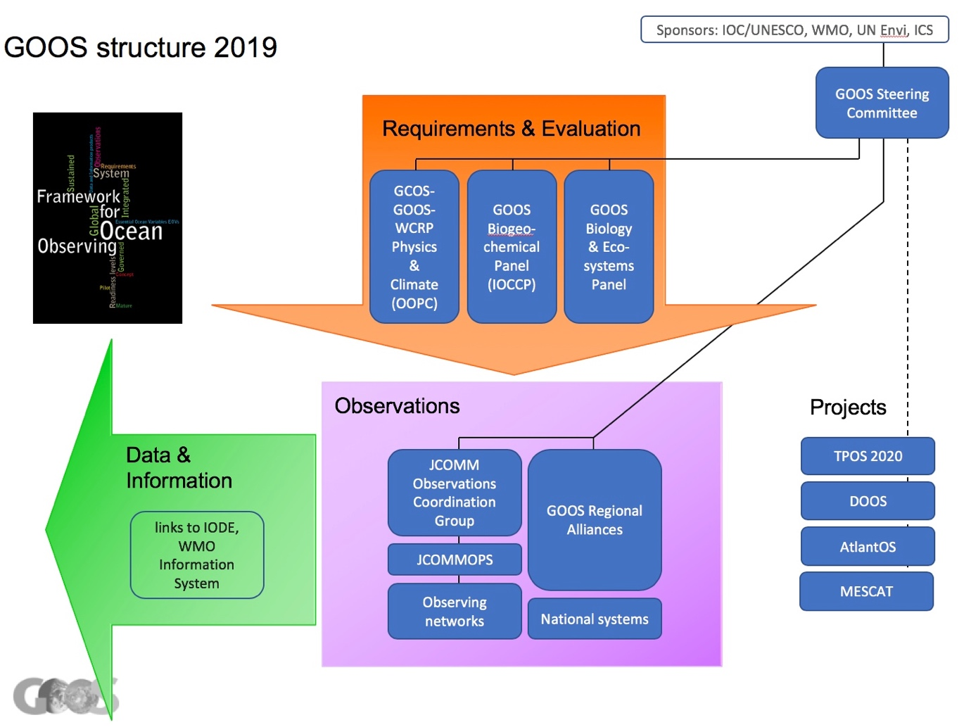

[later] Separate documents
Individual component plans, HQ plan [incl Comms plan, overall partnership management]
Partnership plans

A Framework for Ocean Observing. By the Task Team for an Integrated Framework for Sustained Ocean Observing, UNESCO 2012, IOC/INF-1284, doi: 10.5270/OceanObs09-FOO
FAIR principles: Wilkinson et al., 2016

