Limited Distribution IOC/IODE-XXV/7.1.1b
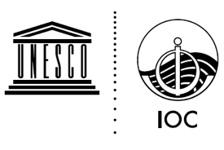
Oostende, 5 December 2018
Original: English

INTERGOVERNMENTAL OCEANOGRAPHIC COMMISSION
(of UNESCO)

Twenty-fifth Session of the IOC Committee on International Oceanographic Data and Information Exchange (IODE-XXV) and Scientific Conference
Tokyo, Japan, 18-22 February 2019

Ocean Best Practices System
a sustained system
for promoting and supporting ocean best practices
across observation, data management and applications communities

Project Proposal
Working Document
Version 7

December 2018

http://www.oceanbestpractices.net/
http://www.oceanbestpractices.org/

Project Information
Project Identifier | OBPS
Project Title | Ocean Best Practices System: a sustained system for promoting and supporting ocean best practices across observation, data management and applications communities .
Start Date | Mar 2019
Project Manager
Contact email | psimpson@reefresearch.org
Project Webpage URL | https://iode.org/index.php?option=com_content&view=article&id=560:iode-ocean-best-practices-project-obp&catid=14&Itemid=100363 (to be edited when Project Doc approved by IODE/GOOS/IOC)
Document Information
Author(s) |  |  | Pauline Simpson
Project Role(s) |  |  | Repository Project Manager
Date |  |  | 30 Sep 2017 |  |  | Filename | OBPS_Project_Proposal
Access |  |  | CC-BY-NC-SA 4.0
Document History
Version |  | Date |  | Comments
V.0.1 |  | 30 Sep 2017
V.0.2 |  | 20 Nov 2017 |  | Incorporate AtlantOS Workshop feedback
V.0.3 |  | 21 Nov 2017 |  | SG-OBP & Pier Luigi Buttigieg discussions
V.1 |  | 19 Dec 2017 |  | Tech Implementation Plan added
V.2 |  | 01 Oct 2018 |  | Repurposed as OBPS
V.3 |  | 01 Oct 2018 |  | Peter Pissierssens review
V.4 |  | 16 Oct 2018 |  | Peter Pissierssens review
V.5 |  | 17 Oct 2018 |  | OBPWG
V.6 |  | 07 Nov 2018 |  | OBPWG
V.7 |  | 05 Dec 2018 |  | OBPWG
Except where otherwise noted content is licensed under a Creative Commons Attribution-NonCommercial-ShareAlike 4.0

Bibliographic Citation
Ocean Best Practices Working Group (2018) Ocean Best Practices System: a sustained system for promoting and supporting ocean best practices across observation, data management and applications communities. Project Proposal. Oostende, Belgium, International Oceanographic Data and Information Exchange (IODE)
of the Intergovernmental Oceanographic Commission of UNESCO, 20pp.

EXECUTIVE SUMMARY

The Ocean Best Practices System (OBPS) provides the ocean research, observing and application communities with a mechanism to discover, review, agree upon, adopt and support the widest possible dissemination of ocean best practices.

In addition to a permanent repository (OBPS Repository) offering the scientific community the possibility to add their ocean-related best practices to a comprehensive database including the full-text documents, OBPS will provide a peer review process (including a peer review journal publishing outlet as well as a user community forum enabling users to “rate” documents - “seal of quality”). The system will also use innovative search technology to optimize discovery of practices relevant to the end user.

In this project document, we present the proposed way forward to developing the Ocean Best Practices System (OBPS) including governance as an IOC Project.. We identify future directions for OBPS acknowledging the lead work of the AtlantOS Project Work Package 6.4. Best Practices that developed the system concept through active interaction with the relevant communities.
All previous documents concerning the OceanBestPractices Repository (including those issued under its previous names) are superseded by this project document.

1. CHALLENGES IN OCEAN BEST PRACTICES

Often, best practices may not be formally documented, residing solely within the minds of individuals who pass the information along through direct instruction and through oral traditions. In the academic tradition, publication of processes is not as highly regarded as publication of original research. Even with publication in a scientific journal, wide distribution of best practices is not assured because even with the advent of open access, many journals are still behind subscription barriers. The World Wide Web has radically changed the way information is curated and shared. Best practices are now available through websites or through publication of web-based (html) documents. But, it is not unusual for web pages to disappear forever. It is also possible that the information held within these web pages is not, in fact, an accepted, community approved best practice. It is thus important to identify and leverage the immense corpus of well-tested methodology in ocean observing that has been and is being amassed by national, regional, and international observatory networks. However, despite the quality of these efforts, the documentation, discoverability and sustainability of high-quality methodology is still limited by fragmented reporting and archiving.
To eliminate possible issues, contemporary document handling technologies need to be adopted to make best practices discoverable, accessible, and interlinked, echoing the logic of the FAIR data principles, from a central curated source. Meeting this need, the OceanBestPractices System has adopted a mission “to provide a sustained system which fosters collaboration, consensus building, and innovation by providing coordinated and global access to best practices across ocean sciences.”
Ocean observing systems rely on robust and stable instrumentation integrated into an equally robust observatory infrastructure, generating raw data for conversion into information and knowledge products. The methodologies associated with large-scale ocean observing are an integral part of an elaborate, end-to-end process that ranges from observatory design and sensor handling, to the quality control, deposition, and management of data in repositories. Over time, experience gathered within organizations (e.g. universities, private and public research institutions) will show whether these methodologies can be treated as BP, suitable for adoption by the broader community. Should this be the case, dissemination and community engagement become vital.
Consistent use of ocean best practices leads to many benefits including interoperability of data, system efficiency, traceability and transparency of methods, reproducibility of observations, support of capacity development and a foundation for further innovation.
The landscape of ocean best practice production is complex and involves many players (industry, academia, research labs, citizen science, environmentalists, etc) and many different types of best practice documents (standard operating procedures, manuals, guidelines, handbooks, cookbooks etc).

2. BENEFITS OF A GLOBAL OCEAN BEST PRACTICE SYSTEM

A new system, centred around the OceanBestPractices repository of IOC/UNESCO IODE, is addressing these challenges and offers many benefits to the community. The global ocean observing system will find support for interoperability of datasets; a secure, sustained, and curated repository within IOC IODE; and more efficient development and transmission of key best practices.
Those seeking best practices for their own use will see a global repository of full text ocean best practices identified by key metadata, indexed by all major search engines. They will enjoy using semantic technology to enhance discovery, and knowledge-based connections between best practices. The Searches can be focused on a particular EOV, SDG, sensor or other parameters, and a specific search capability for key best practices will return BPs endorsed by the GOOS and JCOMM communities of experts.
Those endeavouring to create best practices will obtain visibility and a place to share their work. The OBPS will facilitate the creation and submission of their best practice, perhaps utilizing one of the standardized templates and the automated submission option. A DOI persistent identifier for each version of their best practice will be generated. They may choose to obtain recognition through optional publication in a linked peer reviewed journal dedicated to ocean best practices. And they will find a permanent archive with ease of curation, version control, automated checking of links, and logging changes through time.

3. BACKGROUND: DEVELOPMENT OF THE PILOT OCEAN BEST

PRACTICE SYSTEM

A growing need for global and sustainable ocean best practice management has been recognized by many national and international organizations and projects. The AtlantOS Project (whose partners currently include: EuroGOOS/GOOS, GEOMAR, Ifremer, IO PAS, Marum, PML, UPMC, NERSC, etc) has a Best Practices Work Package 6.4 that is working in diverse ocean disciplines to populate a Best Practice repository and to address the utility of the BP process for their communities. This work has also been supported by ODIP (Ocean Data Interoperability Platform) and the NSF Ocean Observation Research Coordination Network.

The existing OceanDataPractices repository (main partners IODE/WMO/JCOMM/ICES) established through Recommendation IODE-XXII.19 as a deliverable of the IODE Steering Group for Ocean Data Standards and Best Practices Project (ODSBP) http://www.oceandatastandards.org/ was identified as a permanent, sustainable repository option and IODE agreed (2017) to join with the AtlantOS and ODIP BP Working Group (BPWG) to work towards an enhanced global best practices repository. The name of the repository was changed to OceanBestPractices to reflect the ‘ all ocean-related’ best practices broader remit.
From Repository to System
The AtlantOS BPWG commenced their work in 2017 and held the first Best Practices Workshop in Paris in Nov 2017. From the workshop recommendations the OceanBestPractices Repository has been tailored to articulated community needs and forms the hub of an evolving system that addresses many of the issues that underlie the propagation and use of best practices. It includes: 1. a permanent repository (OBPS-R) offering the scientific community a platform to publish their ocean-related best practices and and find practices of others using innovative search and access technology; 2. a peer review journal publishing outlet; 3. a community forum; 4. a training resource leveraging community capabilities. The elements of the system are described in separate sections below.
Definition of a community Ocean Best Practice in the context of the Ocean Best Practice System
- as developed at the BP Workshop Paris 2017 -

A community best practice is a methodology that has repeatedly produced superior results relative to other methodologies with the same objective.
To be fully elevated to a best practice, a promising method will have been adopted and employed by multiple organizations. Best Practices may come in any of a number of formats types – standard operating procedures, manuals, operating instructions, etc. – with the understanding that the document content is put forth by the provider as a community best practice.

4. The OBP SYSTEM

4.1 Vision, mission, and strategic objectives

Vision

To have agreed methods for every activity in ocean observing research, operations and applications that are broadly adopted : a cross-cutting vision that will serve the needs for broad interoperability and sustainable observations complemented with modelling and applications capabilities.

Thus, with the above statement, our vision is to increase efficiency, reproducibility, and interoperability of the entire ocean observing value chain by providing the ocean observing community with a unified, sustained, and readily accessible knowledge base of interdisciplinary best practices. We will accomplish this vision by engaging ocean observing communities in a joint and coordinated effort in producing, reviewing, adopting and sustaining BP documents.

Mission

To provide a sustained system which fosters collaboration, consensus building, and innovation by providing coordinated and global access to best practices across ocean sciences and applications.
Consistent with this mission, our objective is to provide coordinated and sustained global access to best practices in the end-to-end value chain to foster innovation and excellence.
This activity will be centred on the UNESCO/IOC IODE best practice repository, the peer-reviewed BP journal and the IODE OceanTeacher Global Academy leading the BP training support, which will be integrated into a system that provides increased discoverability and access to BP documents. We believe this will promote community dialogue, consensus and agreement of BPs.

Strategic Objectives

This project has the following five strategic objectives:

- Enhance the functionality and search capabilities of the existing IODE OceanBestPractices repository and provide tools to promote and increase the BP content, including advanced user interfaces and easy means to submit best practices.
- Establish the Frontiers in Marine Science “Best Practices in Ocean Observing” research topic as the media to describe and understand robust and high quality methodologies over the entire range of ocean observing and addressing the challenges of improving observation capabilities, data management and user applications) and interoperability and linked/referenced to the OBP repository.
- Ensure visibility and relevance of the repository/system through community engagement activities.
- Provide a framework for training of best practices and facilitate such training of best practice
- Establish funding of the BP system by the global and regional ocean observation and information organizations as well as community practitioners.

4.2 OBPS - Elements of a global system
The OBPS is composed of 6 key elements, which integrate to deliver a global service:

- A trusted repository
- Advanced Technology: including text mining, natural language processing and semantic search
- Web interface bridging 1 and 2 with users in a user-friendly manner
- Peer-reviewed journal linked to the repository
- Training materials supporting the users and their experience with the OBPS
- A community of users and providers of best practices

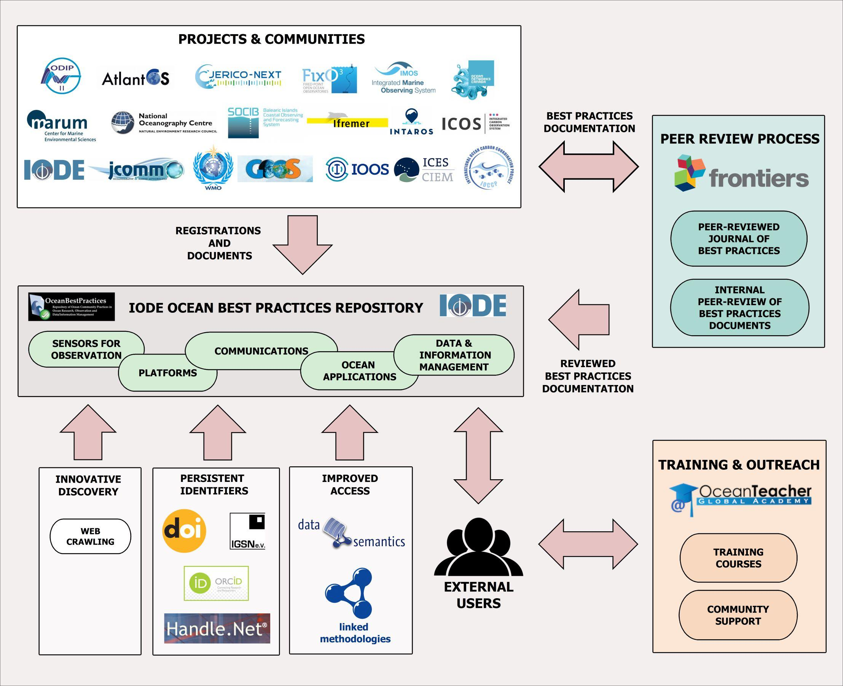

Figure 1. Shows the OBPS elements working together; each element is described in more detail below

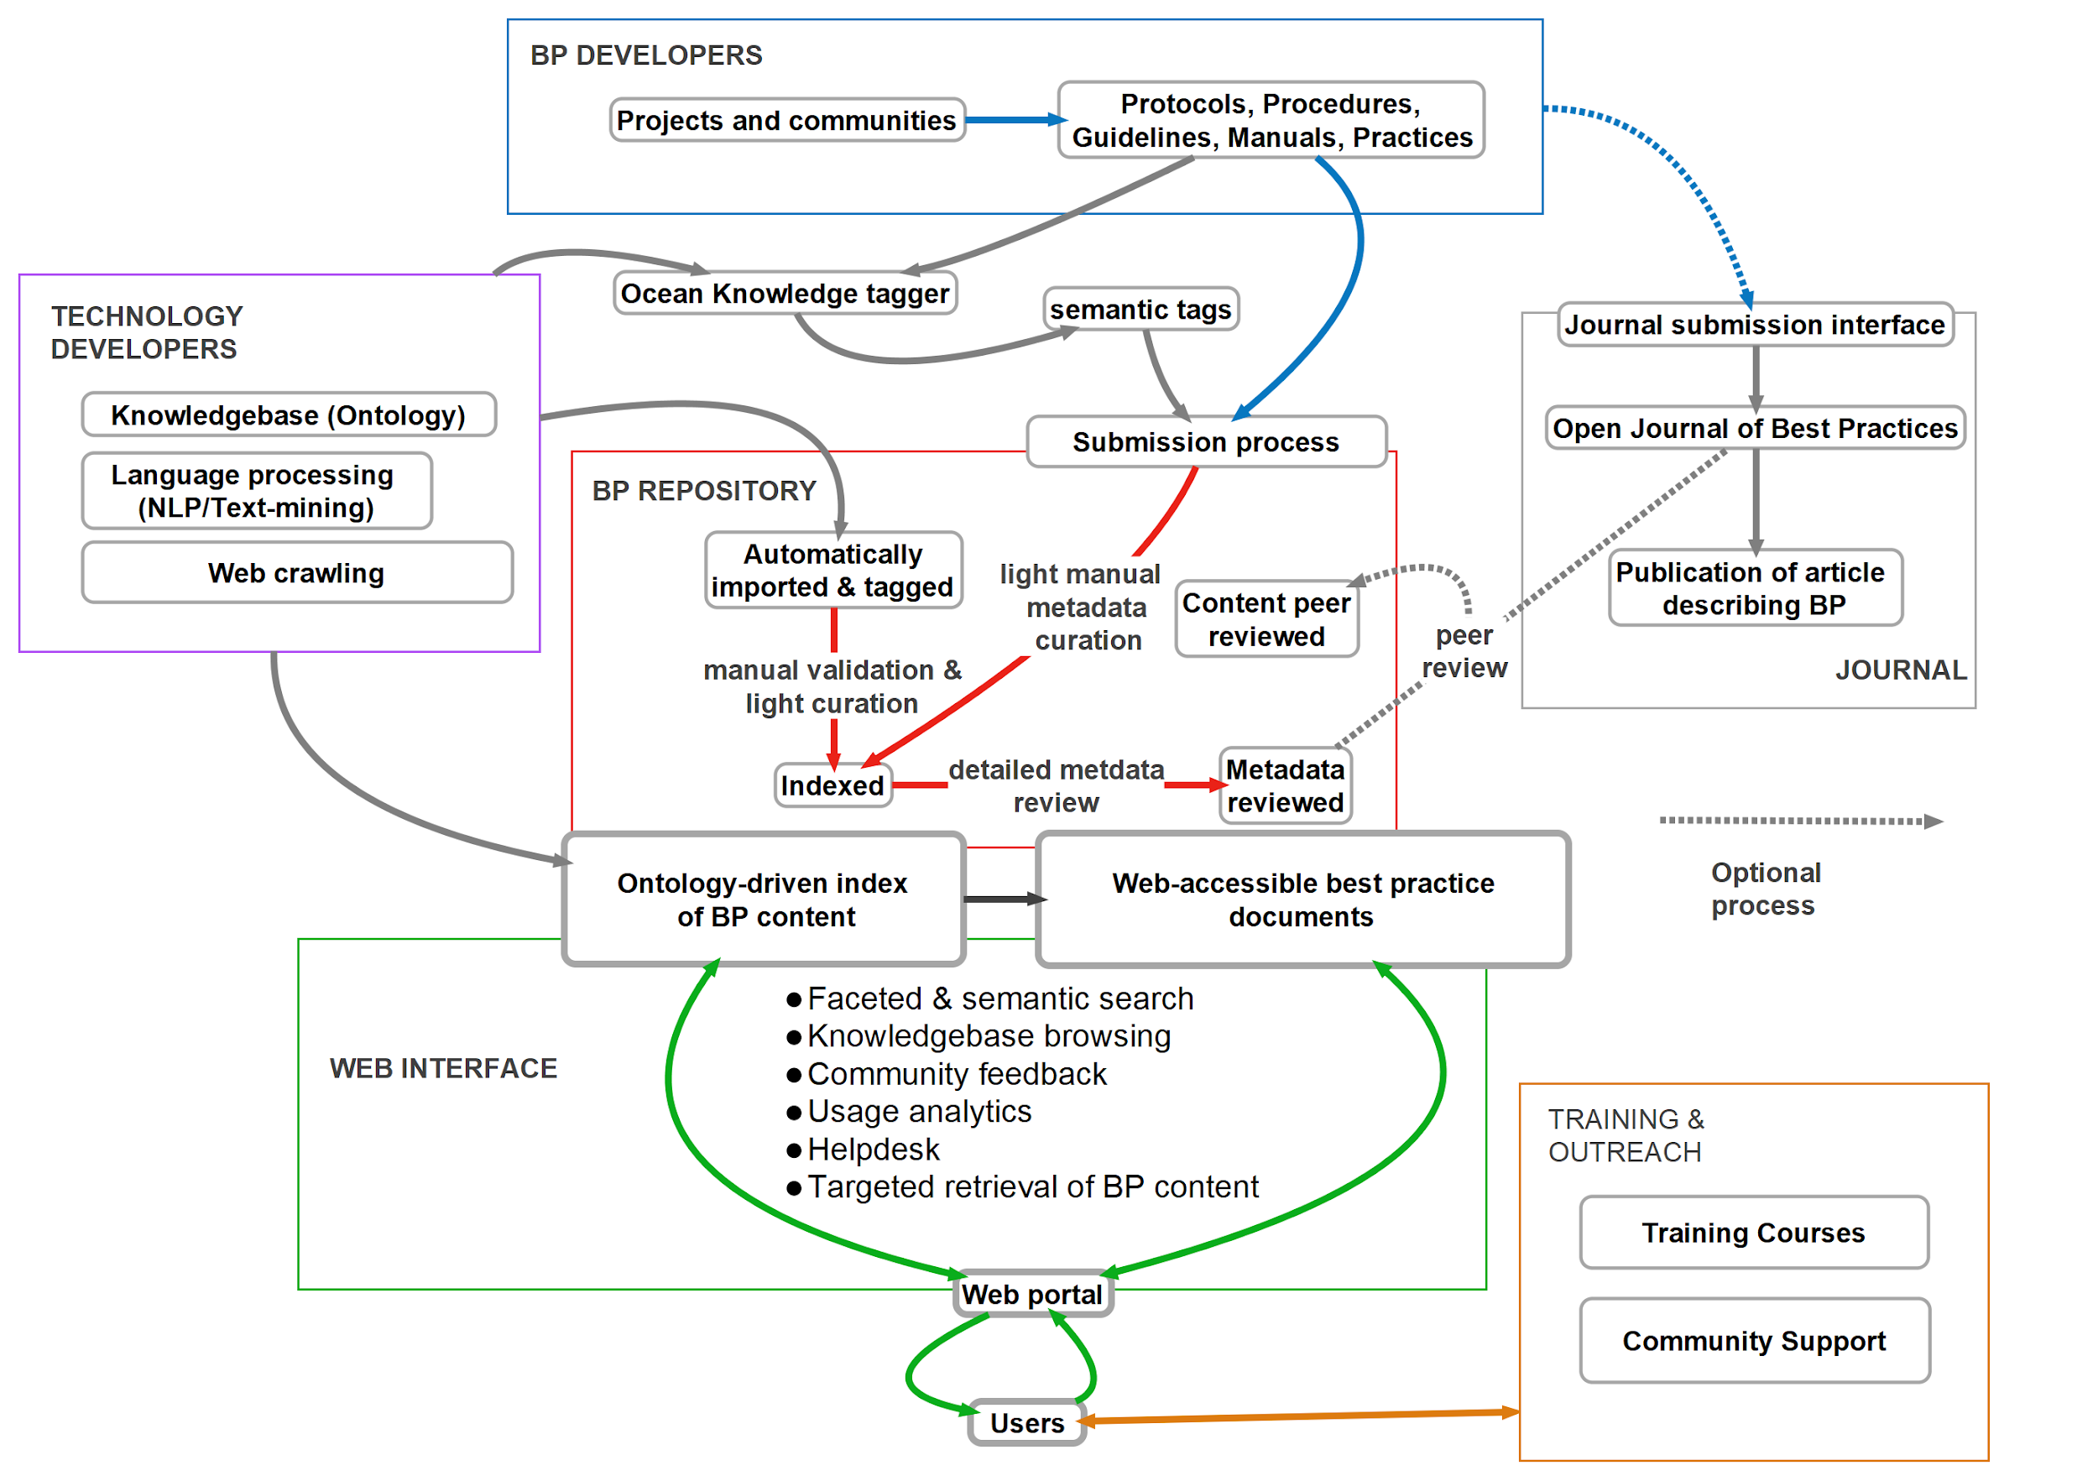
Figure 2: OBPS End-to-End Flow diagram

4.2.1 A Trusted Repository
The OceanBestPractices System Repository will be the main resource that allows for collection, discovery and access of best practices. To achieve the FAIR Principles (Findable, Accessible, Interoperable, Re-Usable), functionality has been enhanced, funded by EC AtlantOS, ODIP and NSF OceanObs RCN. Particularly, advanced technologies like semantic indexing and natural language processing are being utilized to increase the discoverability of the OBPS Repository content via a sophisticated new User Interface. It is also intended that the semantic tagging module will eventually be available as a standalone tool for the community to use for all ocean publications. Best Practice documents on ocean-related topics can be in the form of Standard Operating Procedures, Manuals, Handbooks, Guides, Cookbooks etc. The Repository’s exemplary UNESCO/IOC provenance encourages the community to trust its permanence and sustainability. In addition the repository will be seeking Certified Trusted Repository accreditation during 2019. The OBPS will be an integral part of the proposed Ocean Data Information System (ODIS).

When best practices are added to the repository, the submitter will submit not only the digital document file but also a set of metadata that describe the item. A Digital Object Identifier (DOI) will be issued for each best practice document submitted. Each subsequent version of a best practice will be issued a new DOI to ensure that citations to different versions of a document are uniquely identified.

Document templates - understanding that a researcher may not want to spend precious research time making submissions to the OBPS repository, the Ocean Best Practices Working Group (OBPWG) have made available BP document templates (at present for sensors, applications and data management). If these templates are used to create the best practice document including a Document (meta)Data Sheet, it is planned that submitting to the repository will entail only uploading the full text file and the system will automatically ingest the full text and populate the repository metadata fields. As a vision, it is also planned to provide the technology to create a new BP via the OBPS User Interface (a la Wikipedia); automatic ingest would follow.

Peer Review - OBPS is a community-based system and it relies on the expertise of the members of its content provider and user community. The OBPS Repository hosts do not attach a value statement for submitted content. Members of the community have 3 ways to support and use high quality content in the repository:

- Support work in the GOOS community creating ‘endorsed’ best practices within the teams of community experts, around EOVs, networks, and from deployment to delayed mode QC
- They can participate as a reviewer, either in the peer review process of the Frontiers Best Practice Research Topic, or in a documented review process as experts within their community.
- They can attach a rating to a BP within the Repository based on experience in using the practice or based on other properties of the practice. The life history of each best practice may evolve to a “Recommended Best Practice” by submission in the repository and receiving positive ratings from the relevant community. This will make it easier for community users to identify the most relevant practice for their use.

4.2.2 Advanced Technology

Technology innovation will be used to maintain the repository as a state-of-the-art capability to

fully support current, new and expanding best practices in ocean science, engineering and

application initiatives.

Advanced technology deployed in the OBPS is of two forms:

- Externally hosted community resources, such as the ontologies used to tag documents and link them to knowledge representations, are maintained by organisations such as the OBO Foundry and Library and others. In selecting which of these resources is used for the OBPS, we ensure that they are active and have been maintained for several years, with a track record of addressing user needs. We will also look at their relevance to marine applications as well as items of overlap that may not give optimal tagging results.
- Locally hosted, custom software components, developed by companies contracted by the OPBWG have been thoroughly documented and modularised to ease maintenance by third parties. Popular programming languages, platforms, and applications have been used for each module. Adaptations, maintenance, or extensions of each module may thus be done by most qualified software and web-interface developers. Note, however, that the semantic tagging modules (i.e. importing and managing ontologies) require skills that may not be commonly available. All custom software has been developed and released based on open software practices and is available to the community.

4.2.3 Web interface
A new, semantically enhanced ocean best practices portal https://www.oceanbestpractices.org,has been incrementally implemented since April 2018 and is progressing through beta testing. In the next year, we aim to integrate ontologies and thesauri covering more ocean-relevant themes, including sensors and societal goals such as the UN Sustainable Development Goals. We will develop closer technical ties to the academic journal associated with the OBPS, ensuring that best practice developers are not only discoverable, but also accredited and recognised in the literature. Further, we will expose the open source code driving each of the system’s modules, inviting the community to offer new or revised modules to further pursue a future of FAIRness for ocean best practices.

4.2.4 Peer-reviewed journal linked to the repository
One of the elements of the OBPS is the Research Topic (RT) aka “Special Issue” Best Practices In Ocean Observation in the journal Frontiers in Marine Science - Ocean Observing. The Editorial Board for the RT is comprised of members of the BPWG. The Frontier journal was selected as publication media because it offers open access (via paid Gold OA) to the published articles, a timely review and publication process, and the possibility for commenting on published research through a commentary tool available at the publishers website. Note, printable and archivable article copies are available as well.
The editorial team of the RT “Best Practices In Ocean Observation” solicit papers describing robust and high quality methodologies over the entire range of the ocean observing value chain, addressing the challenges of improving observation capabilities (including data management) and interoperability. Papers can be linked to one or more fully documented protocols archived in the OPBS Repository and may provide a summary of archived BP. Likewise concepts for BP from requirements, via the scientific approach, the observing strategy, the data flow and data integration, and up to the product generation and the final dissemination strategy, are welcome.
A selection of different publication formats from full review articles to commentaries is available to authors - further specifics can be found at the publishers website. Publication fees for this RT are negotiated with the Frontiers publisher and eventually other special arrangements may apply that allow virtually all researchers, independent of their financial status, to publish. Note, an application prior to submitting the manuscript submission is required.
A synergy is anticipated, when possible, between the Frontiers Research Topic and the OBPS repository, meaning a copy of the article will also be deposited into the repository and both BP and article records will be linked.
The RT opens a way to expose BP documentation and concepts to an independent group of specialists and thus provides an opportunity for wider exposure and improvement of BP documentation. Moreover, BP creator groups have the opportunity to publish their results in peer reviewed literature, thus making it recognizable for standard research performance metrics (JIF).
So far the published articles cover a surprisingly wide spectrum of the BP on ocean observation value chain topics, from observing design concepts (Mueller-Karger et al 2018), capacity building, views on elements of observing value chain subsystem (...Alessandro), data management (...), real-time QC (U.S. IOOS/QARTOD), and standard operating procedures.

4.2.5 Training materials supporting the users and their experience of the OBPS
The emphasis for training is the diffusion of best practices to those with emerging interests. This includes students, professionals working in cross-disciplinary collaborations, educators, etc. The approach is to draw upon ocean observation experts (working with educators) to formulate and provide focused courses on selected best practices. However, issues to be addressed in OBPS training are broader than focusing on the best of the best. There is so much information, so much missed experience, so much poor technology that is not published or even known, but this information is valuable and could save time. Thus, the training includes the rationale for the best practice methodology and what alternatives are not recommended.

Training is fundamental to transferring knowledge from one individual to another. This element will promote the organization and implementation of training efforts on Best Practices by the provider communities. The project will assist by harmonizing the training content and building a suite of training courses (eg. through the IOC OceanTeacher Global Academy, POGO Summer Schools etc) in collaboration with provider experts.

There are many discussions of best practices that are not occuring in a formal training environment. An example is the workshop on interoperability and best practices held at Ifremer in October 2018. This and other events, if video recorded, could be part of a training video channel on Youtube (OTGA already uses this channel). A similar effort for summer schools would provide a long term community resource. Thus the training will look for innovative solutions to being a global resource for best practice dissemination and adoption.

4.2.6 A community of users and providers of best practices
Engagement with the ocean community is a major work component and will be the responsibility of the SG but with activities directed and led by a designated SG member. It is essential that all members of the SG maintain communication with BP coordination efforts, including, for example, work done by JCOMM, AtlantOS, IMOS, IOOS etc. Where possible these groupings will be represented at the annual workshop or as part of the SG.

Through advocacy material, journal contributions. participation in ocean related conferences and project workshops/meetings, webinars, the Good, Better, Best monthly newsletter, community listserv (obpcommunity@oceanbestpractices.org) etc, the ocean observing communities are engaged in a joint and coordinated effort in producing, reviewing and sustaining BP documents. The System has responded already to such community requests as the repository includes recording where appropriate, in addition to traditional bibliographic metadata, such information as Maturity Level (Technology Readiness); Essential Ocean Variables (EOV) and UN Sustainable Development Goals (SDG). This active requirements dialogue with the community will continue.

5. NEXT STEPS: THE OCEAN BEST PRACTICE SYSTEM AS AN IOC PROJECT

At the Ocean Best Practice Workshop in Paris last years (2017) GOOS, JCOMM and IODE agreed to support the development of the OBPS. The proposal is for the Ocean Best Practice System to be formally adopted as an IOC (GOOS/IODE) Project, to assist the evolution of the OBP System develop and in defining a pathway to sustained funding and operations. The structure of this project and the timeline is outlined below and in the following section the work plan and budget is outlined.

This is a positive step and provides the following:
- governance structure
- some core funding
- secure IODE hosting
- budgets to find funding against
- stability beyond existing project resources and pathway towards sustainability
- framework to support the ongoing development of this emerging global system

Details on work plan requirements and costing are in Annexes 2 and 3, and support the proposed governance system (see section 5.2) and the future work plans (subject to funding). The OBPS supports key areas (details below) for IODE, GOOS and JCOMM Observations Coordination Group Programmes.

5.1 The IODE/GOOS/(JCOMM) Partnership for OBP project
Following the initial GOOS, JCOMM and IODE agreement to support the development of the OBPS at the Ocean Best Practice Workshop (2017), the three organisations will continue to support the development of this system through a joint GOOS/IODE (IOC) project.

- Relevance to IODE
The Ocean Best Practices System supports two major elements of the IODE Strategic Plan http://www.oceanbestpractices.net/handle/11329/345
- Ensure the long-term archival, management and services of oceanographic data and information;
- Recommended standards and best practice for management and exchange of oceanographic data;

- Relevance to GOOS
The GOOS 2030 Strategy (Final Draft) makes direct reference to promoting and supporting ocean observing best practices, under the Strategic Objective 6:
- Sustain, strengthen and expand observing system implementation through GOOS and partner communities, promoting standards and best practice, and developing metrics to measure success;
In the Seventh GOOS Steering Committees (2018), actions are noted with regard to best practices and mention support for the OBP System, including a more formalised governance model.

Action 20: A GOOS S&BP Task Team, to interface with the OBPWG and develop the following lines of activity:
- GOOS to develop an internal process for SC endorsement/approval of GOOS community best practices from OBPWG system
- GOOS TT to provide engage in the testing and provide feedback to the OBPWG on the repository interface and new OBP System
- OBPS requested to enable endorsed Best Practices to be highlighted/branded(?) and to be easily discoverable in the system
- GOOS-SC to ask OBPWG to work with GOOS, IODE and JCOMM to consider a more formalized governance model/processes for a sustained OBP System
The partnership with IODE to support the OBP System as a IOC Project is fully inline with the approved GOOS Actions, providing a central location to for the GOOS endorsed and community submitted best practices for EOV measurements, across the measurement lifecycle from deployments to post mission data processing and quality control.

- Relevance to JCOMM
Ocean Best Practices System supports the JCOMM OCG Best Practices strategic plan, which includes
a direct link to the work being done by the SG. The repository has been highlighted as a place in
which to ‘host’ JCOMM programme area best practices, whilst still allowing them to remain on the
program areas webage. The observing networks have and will continue to be encouraged to publish
in the Frontiers journal. As such, JCOMM is represented on the SG and the interactions between the
workloads are continuous.

JCOMM OCG-9 action 23, has the following relevant points:
- Continue working with the chairs/designated program best practice leaders to collate and review best practices, recommend these are then uploaded to the repository and issued a DOI, encourage publication in Frontiers.
- Work with GOOS and GOOS TT to facilitate method of endorsement of BP, implement some initial pilots

This support will now be strengthened and formalised through the evolution of the OBPS to becoming a recognised IOC project

5.2 Establishment of the Project
In order to establish this as an IOC Project, endorsed jointly by IODE and GOOS, a Decision will be needed of the IOC Assembly. The proposal will need to be approved by both the IODE Committee (February 2019) and the GOOS Steering Committee (April 2019). Taking into account that IODE is a primary subsidiary body with a Technical Committee (the IODE Committee) that can submit recommendations and draft decisions to the IOC Assembly, it is proposed that the IODE Committee will submit a Draft Decision or Recommendation to the 30th Session of the IOC Assembly (June 2019). For the Draft Decision of Recommendation see ANNEX 1

5.3. Governance of the OBP Project
The project will be managed by a Steering Group that will report to the IODE and GOOS governing bodies (IODE Committee and GOOS Steering Committee respectively).

Initially, face-to-face sessions of the SG-OBPS will be arranged annually. Virtual OBPS Project Steering Group meetings may be agreed upon and scheduled by the Steering Group on a monthly and/or as necessary basis.

5.3.1 Terms of Reference of the Steering Group
The IOC Steering Group for the Ocean Best Practices shall:

● Propose the vision, strategy, work plan and timetable for the Ocean Best Practices System
Project, for submission to, and approval by the relevant IOC bodies;
● Provide guidance to the project manager/chief editor and technical manager
● Oversee the work of the project and the project manager/chief editor and technical manager
● Establish task teams to deal with specific tasks;
● Report to the relevant IOC bodies and to other partners on the progress of the project; and
● Identify funding sources to further develop the project.

5.3.2 Membership of the Steering Group
The IOC Steering Group for the Ocean Best Practices shall have the following initial membership:

(i) Representatives from IOC Programmes and JCOMM;

(ii) Project Manager/Chief Editor;

(iii) Project Technical Manager;

(iv) Invited Experts from the full value chain of the ocean observing community;
(v) Representative of the IODE and GOOS Secretariat.
The Steering Group shall elect its own (Co-) Chair(s).

6. PROJECT PLAN AND BUDGET OUTLINE

6.1. Outline
The preparatory work for this Project Proposal was funded mainly by (1) the EC Horizon 2020 AtlantOS project; (2) the ODIP Project; and the NSF OceanObs Research Coordination Network project. IODE has provided hosting and IT support for the “proof of concept” repository on http://www.oceanbestpractices.org and http://www.oceanbextpractices.net

There are two major categories of activity and therefore budget categories: operations and development/innovation. Operational activities will cover the basic functioning of the OBPS and the development and innovation will include development of new elements to enhance the user experience, search capabilities and/or linking to other system with enhanced functionality as identified.

Operational activities include:
Repository hosting and IT support
Limited development of interface and functionality
Repository management and administration
Submission of ocean best practices
Curation and QC of deposited OBP
Help desk
Integration of new developments
Outreach and advocacy activities

Development and innovation include:
Community Review
New ontologies
Additional Workshops around particular themes
Additional support for training

6.2. Infrastructure and Technical Support
Infrastructure and IT support for the Ocean Best Practices System will be provided and managed by the UNESCO/IOC Project Office for IODE, Oostende, Belgium, under the direction of the Project Steering Group and as agreed to in the annually reviewed Project Plan.

6.3 OBPS Project Development Plan (2019 - 2021) (see ANNEX 2)
The two-year plan falls into 4 work packages
WP1: Project Management will oversee the system administration, reporting and progress of the OBPS project and be the responsibility of the OBPS Project Manager.
WP2: Administration, Operations and Technical Maintenance which will ensure the efficient day-to-day management, administration and development of the Repository. The technical support for the Search User Interface and Repository will be the responsibility of the Project Technical Manager who will be the prime liaison with the technology contractor/s.
WP3: Technical Development covers the introduction of new user-facing functionality based on the Search User Interface and Repository as well as technology enhancements of the underlying system. Working with the E84 Technology Contractor or another as appropriate, new developments will build on the present service and introduce automated processes to enhance the best practice creator and user experience.
WP4: Community engagement: This is key to the success of the OBPS that needs Community commitment to sustain it. This work package will be the responsibility of the whole SG but led by a designated member of the SG. Activities will include the production of promotional material and dynamic dissemination of the OBPS to the community via workshops, webinars, conference papers/presentations and journal articles and a community newsletter. Under this WP the Frontiers journal will be supported as the main vehicle for BP article publications. Community engagement also includes engaging with funding organizations to support development and implementation of advanced technologies.

6.4 Budget Summary (see ANNEX 3 for details)
IODE and GOOS will share the funding of the operational cost; additional funding will be sought from other Projects. The development and innovation will be supported by specific grants targeted at innovation components.

The cost estimated for operations/service level delivery of OBPS including repository/user interface/user support is US$72k over two years which includes system management and administration, technical maintenance, advocacy and steering group meetings. This budget does not include the introduction of any technology advancements.

The grant-based financial support for further advanced technology development, project management support, annual workshops and additional support to SG membership, is dependent on the availability of grant and partnering opportunities.

The high profile and developing success of the IOC Ocean Best Practices System will attract existing projects and new projects now being proposed to include its functionality, particularly its support to EOV, SDG and UN Decade of Ocean Science. Annex 3 highlights activities that will require additional external funding. Plans for such activities are part of the SG mandate.

7. A SUSTAINED SERVICE

The use of best practices for the entire scientific community is as important as the fundamental concept of data sharing.

The OBPS development has been under a project umbrella, but its’ future is as a unique sustained service for the ocean observing community, sharing a corpus of richly discoverable best practices.

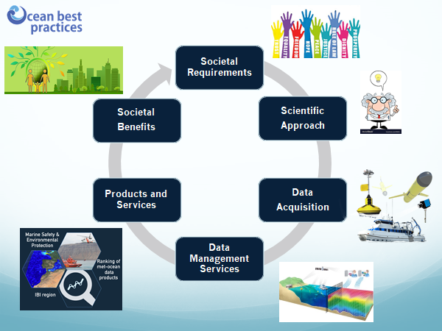
Best practices are created by the community for the community - the Ocean Best Practices System under the auspices of the IOC will support the end-to-end best practices value chain.

ANNEX 1: OBPS DRAFT DECISION OF RECOMMENDATION

Draft Decision of the 30th Session of the IOC Assembly

ESTABLISHMENT OF THE IOC OCEAN BEST PRACTICES SYSTEM PROJECT (OBPS)

The Intergovernmental Oceanographic Commission,

Recalling Recommendation IODE-XXII.19 for the establishment of the IODE Clearing House Service for Data/Information Management Practices Project, which replaced the JCOMM Catalogue of Best Practices;

Recognizing that:

(i) the dissemination and use of rigorously tested best practice methods in ocean observing promote and facilitate activity within and across disciplinary boundaries of ocean science;

(ii) IODE has successful established a permanent repository offering the scientific community a platform to publish their ocean-related best practices and find practices of others using innovative search and access technology, a peer review journal publishing outlet and community forum, and a training resource leveraging community capabilities;

(iii) IOC and JCOMM have established close, efficient and effective collaboration in ocean best practices;

Noting the system of best practices will support all IOC programmes and contribute to the UN Decade of the Ocean and UN Sustainable Development Goals by a providing permanent curated archive of best practices in ocean sciences;

Decides to:

(i) establish the IOC OceanBestPractices System project (OPBS) with the terms of reference as attached in Annex A of this Decision;

(ii) establish the IOC Steering Group for the OceanBestPractices System (OPBS) with the terms of reference as attached in Annex B of this Decision;

Invites all IOC Programmes to contribute to the OBPS;

Invites JCOMM and other relevant organizations to contribute to and collaborate with OBPS.

Annex A

Terms of Reference of the IOC OceanBestPractices System Project (OBPS)

Objectives

The objectives of this project are to:

(i) Increase efficiency, reproducibility and interoperability of the entire ocean observing value chain by providing the community with a unified, sustained and readily accessible knowledge base of interdisciplinary best practices;

(ii) Provide coordinated and sustained global access to best practices in ocean observing to foster innovation and excellence by developing a system and engaging ocean observing communities in a joint and coordinated effort in producing, reviewing and sustaining BP documents.

Annex B

Terms of Reference of the IOC Steering Group for OceanBestPractices System (SG-OBPS)

Objectives

The SG-OBPS will have the following Terms of Reference:

(i) Propose the vision, strategy, work plan and timetable for the Ocean Best Practices System Project;

(ii) Report to the IOC and to other partners on the progress of the Ocean Best Practices System Project;

(iii) Provide guidance to the project manager and project technical manager;

(iv) Advise on technical aspects such as user interface, back office, etc. to the project technical task team;

(v) Identify funding sources to further develop the OBP System.

Membership

The Steering Group will be composed, inter alia, of:

(i) Representatives from IOC Programmes and JCOMM;

(ii) Project Manager/Chief Editor;

(iii) Project Technical Manager;

(iv) Invited Experts from the ocean observing community;

(v) Representative of the IODE Secretariat.

Financial and other resource implications

Budget table (expressed in US Dollars)
Item | 2019 (39C/5) | 2020 (40C/5) | 2021 (40C/5)

$.... from IOC Regular Programme ($xx from IODE, $xx from GOOS)

$... requested from IOC Member States through extra-budgetary financial contributions

ANNEX 2: OBPS WORK PLAN 2019-2021

WORK PACKAGES | 2019/2020
WP 1: Project Management | Finalise the Project Document;  Establish Steering Group;  Organize SG Meetings (annual/monhly-virtual);  Create a project webpage;  Monitor project progress;  Prepare reports for IODE and GOOS Committees;
WP2.1: Repository Manager/Chief Editor | Management, administration, policies, development;  User registration, permissions  Record submission  Record curation/quality control  Help Desk  Trusted Repository certification
WP 2.2 : Technical Operations and Maintenance | Day-to day operations and maintenance; response to urgent maintenance immediately; maintain maintenance logs. Limited development of interface and functionality
WP 3: Technical Development – Contractor - FUTURE - Contingent on additional funding | Natural Language Processing/Queries;  Web Crawling Content;  Expert Panels Peer Review Process;  Community Review;  Creation Of BP Document on UI Interface;  Automatic Ingest of Metadata And Content;  Upload Additional Ontologies;  Linked Data;  Version Control;  Statistics/Metrics Upgrade
WP4: Community engagement/ Advocacy/Promotion | Create advocacy material;  Conference. webinars, articles etc  Community Newsletter

ANNEX 3: PROJECT BUDGET 2019 AND 2020
20 Nov 2017

Operational budget funded by IODE & GOOS - US$72000

 | Activity | 2019 | 2020 | Total in US$ | In-Kind
1 | SG Meeting (4 members?) | 5000  (Mar 2019 (5k funding from AtlantOS?) | 10000 | 15000
2 | IT person at IOC/IODE Secretariat to maintain the current system | 7000 | 7000 |  | 14000
3 | OBPS Repository  Manager/Chief Editor.  Project Manager and  member of  contributing project  teams ... | 15000  (1 week/month x 12) | 15000  (1 week/month x 12) | 30000
4 | Software optimization and enhancements from feedback | 10000 | 10000 | 20000
5 | Advocacy  material (poster etc) | 2000 | - | 2000
6 | Advocacy Newsletter | 4000  1 day/month | 4000  1 day/month |  | 8000
7 | Certified Trusted Repository Certification |  | 1000 | 1000
8 | Contingency | 2000 | 2000 | 4000
 | TOTAL | 34000 | 38000 | 72000 | 22000

Continuous Deployment Modules budget Items contingent on funds from other sources
 | Activity | 1 2019 | 2020 | Funds from  other sources  in US$
9 | S SG attendance for additional  members from BPWG. And  an ad- hoc Support  staff/postdoc -  ontologies, submission  assistance | 20000  (SG meeting  10k) | 20000  (SG meeting  10k) | 40000
10 | Advanced  Technology  Development of  OBPS – E84 tbd | 20000 | 25000 | 45000
11 | Advocacy - Annual  Workshop (Nov) | 15000 | 15000 | 30000
 | TOTAL |  |  | US$115000

Simpson, P., Pearlman, F. and Pearlman J. (eds) (2017) Evolving and Sustaining Ocean Best Practices Workshop, 15 – 17 November 2017, Intergovernmental Oceanographic Commission, Paris, France: Proceedings. AtlantOS/ODIP/OORCN Ocean Best Practices Working Group, 74pp. DOI: http://dx.doi.org/10.25607/OBP-3
https://www.frontiersin.org/research-topics/7173/best-practices-in-ocean-observing)
http://emso.eu/wp-content/uploads/2018/10/Colloque_reseaux_observation_ocean_EN_DEF.pdf

