Eighth Meeting, 1-3 May 2019
goosocean.org/goos-sc-8

How to capture the legacy of GOOS Projects?
Agenda item: 7 Projects Legacy
26 April 2019
Prepared by: Hill and Palacz

- Introduction: GOOS projects and the Framework for Ocean Observing
GOOS Projects are aimed at filling identified gaps in the system. They may be Development Projects with a broad scope covering requirements, observations, and data systems universally relevant to GOOS, with a geographic or thematic focus; or Pilot Projects focused on specific areas or systems to improve readiness for sustained observations. (see GOOS Projects principles for affiliation).
For GOOS to capture the legacy of GOOS projects, Outcomes/advances can be considered in all steps of the Framework for Ocean Observing (FOO), as well as the approach taken to exercising the FOO process. In addition, some guidance can be identified in areas not covered by the FOO; including governance, prioritisation and facilitating change.
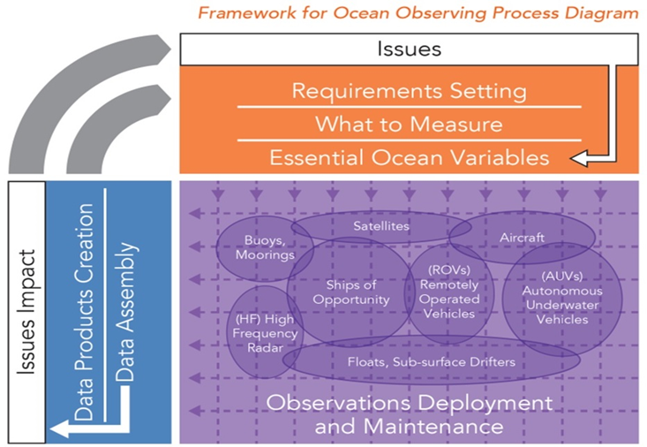
Figure 1. The Framework for Ocean Observing.

2. Outcomes from GOOS Projects - Steps of the FOO.
2.1. User and Stakeholder needs.
Projects need to engage strongly with the stakeholder community to understand users, uses, and their information needs. This information can be useful for understanding the uses and users of GOOS more broadly, and also enables us to engage potentially new stakeholders in championing the need for ocean observations. Project outcomes could be vital to reconciling the national and regional user and stakeholder needs to those considered globally by GOOS.
In order to adapt to changing societal needs, priorities should be given to actions that enable iterative and regular stakeholder and user consultations. Monitoring of changing user needs and their evaluation of information products delivered by the observing system is critical to the closure of the blue value chain.
Example - AtlantOS Project
Analysis of the societal requirements for Atlantic Ocean observations can be found in this report, currently being revised. The project also analyzed the adequacy of selected information products to meet the user requirements (e.g. deliverable reports 8.9, 8.11 and 8.16).
The European Strategy for All-Atlantic Ocean Observing System, produced by the AtlantOS project, points at the need to map the requirements of European users “on a biannual basis via dedicated user meetings focussing specifically on delivering information for operational services, climate and marine ecosystem health applications.”
The goal could be realized through actions proposed by the European Ocean Observing System (EOOS) as specified in the 2018-2022 Strategy and Implementation Plan.
Example - TPOS 2020.
In depth analysis of user requirements is included in the TPOS 2020 First and Second Reports, with a strong evidence backed assesment of how to meet these requirements.
Questions/recommendations for the SC:
- How does GOOS entrain project outcomes in engaging with users and stakeholders?
- Which element/structure of GOOS should be responsible for engaging the stakeholder and user community?
- Can Projects establish/strengthen partnerships that help reconcile regional user and stakeholder needs with those considered globally by GOOS?
Related to GOOS Strategic Objective #1: ”Strengthen partnerships to improve delivery of forecasts, services, and scientific assessments”

2.2. Requirements for Essential Ocean Variables (EOVs)
Evolving and emerging requirements for ocean observations can be taken up by GOOS Panels through updates to the EOVs/Specifications, panels can broker discussions between projects with common requirements, synergies. The requirements for EOV measurement have multiple dimensions (scale, frequency, accuracy, etc.) and can be specific to a region (e.g Tropical Pacific) or system (e.g. deep sea, boundary currents). When relevant, GOOS projects can recommend additional requirements for observations in these regions/systems, but within the globally accepted set of requirements.
Example - TPOS2020
Ocean surface stress and air-sea fluxes was raised with OOPC as a global issue.
Example - DOOS Project
DOOS EOVs developed using GOOS EOV Specification Sheet templates and in close communication with GOOS Panels. Need to identify which DOOS EOVs can be integrated into existing EOVs, which should form new EOVs, and which not (based on impact vs feasibility assessment).
Example - AtlantOS
AtlantOS workshop on setting phenomena-based targets for biogeochemical observations in the Atlantic Ocean. See workshop report HERE. Generated interest in the PICES community to repeat such an exercise in the North Pacific Ocean basin.

Questions/recommendations for the SC:
- Formalize the concept of “emerging EOVs” and agree on a common process for accepting new EOVs based on project outcomes and recommendations.
- Describe the impact vs feasibility assessment for EOVs, document the process and communicate to relevant observing system actors.
Related to GOOS Strategic Objective #5: “Provide authoritative guidance on integrated observing system design, synthesizing across evolving requirements and identifying gaps.”

2.3. Observing system design.
Evolving the design of regional observing systems can be brokered through the JCOMM OCG to evolve global network targets, engaging with relevant regional alliances. Lessons learnt from one regional observing system may be globally applicable.
Due to a relatively lower readiness level of the biological and ecosystem component of the observing system, multidisciplinary considerations of the design are challenging and might require different structure than OCG to coordinate the design of the biological observations.
Questions/recommendations for the SC:
- How is GOOS to support regional observing system designs based on project outcomes?
- Do GOOS projects propose how to enable a flexible observing system design in response to changing user needs?
- How to strengthen the interaction between OCG and the regional alliances, to agree on and implement the design across the coastal and open ocean interface?
- How to better engage (low readiness level) observing communities or emerging networks in the observing system co-design, especially for biological networks?

2.4. New technologies and approaches
Pilot deployments in projects at the regional level can then be discussed with OCG. New sensors may be taken up by global network, and for new platforms, potential to evolve to global pilot, global coordination. Priorities for technology development in observing system components need to be based on current readiness levels and critical gaps identified. Projects are ideally fit for testing and inter-comparing new technology before it is being adopted by networks.
Example - AtlantOS
A ten year roadmap for strategic development of sensor and instrument technology for Integrated Atlantic Ocean Observing Systems and GOOS - AtlantOS Sensors and Instrumentation Roadmap.
Assessment of networks and gap analysis that highlights opportunities for development over three and ten year timescales - AtlantOS Emerging Networks Roadmap.
Example - TPOS2020
Current state of emerging technologies and an evaluation mechanism to guide integration of new observation platforms in TPOS observational arrays of the future.
Assessment of FOO readiness levels and Technical readiness levels.
Chapter 9 in the 2nd TPOS2020 Report.

Questions for the SC:
- How does GOOS/OCG use the project roadmaps and assessments to advise observing networks on implementing new technologies to increase the FOO readiness levels of the global system?
Related to GOOS Strategic Objective #8: “ Support innovation in observing technologies and networks.”

2.5. Data Management and information product delivery.
Data management
Some projects might develop pilots to improve delivery of data, or be looking for a forum to engage with.
Example - AtlantOS
An integrated data system that harmonizes work flows, data processing and distribution across in-situ observing network systems, and integrates in-situ observations into existing European and international data infrastructures, named Integrators (e.g. Copernicus INS TAC, SeaDataNet, NODCs, EMODnet, EurOBIS, GEOSS). - AtlantOS Data Services Report.
Example - TPOS 2020
Prioritising capability to bring data into a single environment, using ERRDAP, and encouraging regional sharing/archival of experimental data (e.g. in the western Pacific) Consideration of a WIS 2.0 Demonstrator focussed on the Tropical Pacific (See Chapter 8 - Data Flow and Access…)

Product delivery
Delivery of essential ocean information products and downstream services relies on close partnership with the modelling and forecasting community. GOOS aims to enhance product delivery for applications related to weather and operational ocean forecasting, climate prediction and projection, as well as climate analysis and assessment, hazard response and early warning systems, sustainable fisheries and aquaculture management, marine spatial planning, biodiversity and environmental assessments, and other. By partnering with the modelling and forecasting community, GOOS can help transfer information product ideas and solutions to other regions; turn pilot projects into operational products; engage with the private sector to advance the delivery of adequate ocean observations.
Example - AtlantOS products for end-users
The following targeted products benefited from the use of forecasts and reanalyses made available by the European Centre for Medium-range Weather Forecast (ECMWF) and Copernicus Marine Environment Monitoring Service (CMEMS), among other.
North West European Shelf Seas Reanalysis and Forecasting
Ship routing hazard mapping
Harmful algal bloom warning bulletins
Operational forecast system for Atlantic albacore tuna
POGO-AtlantOS collaboration on ocean products
Example - VOICE (www.ioccp.org/voice)
One of the goals of the VOICE initiative is to enable the development of forecasts for improved fisheries management with respect to changes in marine habitats due to oxycline and oxygen minimum zone core variability. In an OceanObs’19 Community White Paper, VOICE points at the need for and challenges of performing regional readiness level assessments of all three components of the FOO: (i) requirement setting, (ii) observation coordination, and (iii) data management and information product delivery.

Questions/recommendations for the SC:
- How does GOOS guide and support project-based data management and product delivery aspirations?
- How can GOOS facilitate/provide incentives for basin-wide FAIR data and information product delivery?
- How to effectively bridge the gap between the national data management approach and the global data management approach?
- Endorse and promote further development and operational use of selected pilot/demonstration products, and help transfer product ideas and solutions between regions.
Related to GOOS Strategic Objectives:
#1: “Strengthen partnerships, to improve delivery to end users from observations through forecasts, services, and scientific assessments”,
#7: “Ensure GOOS ocean observing data and information are findable, accessible, interoperable, and reusable, with appropriate quality and latency”

3. Outcomes from GOOS Projects - Not covered by the FOO.
3.1. Specifics of design, Implementation: managing change, prioritisation.
We need to improve guidance on how we evolve the observing system, and prioritise developments: in a time of flat budgets, particularly how we decide when to shut things down to enable new investment to meet user needs; and how this process is managed.
TPOS 2020 and AtlantOS have taken very different approaches to design recommendations, with TPOS developing a detail design and evidence based set of recommendations, including transition plan (see Chapter 7 of the Second Report). AtlantOS has stopped short of providing specific guidance on observing system design, rather focussed on encouraging integration.
3.2. Governance….
Recommendations around ongoing governance, lessons learnt for the global observing system to be discussed with the GOOS SC. Many projects energise new partners to contribute; how do we ensure they are enabled to engage in GOOS in the longer term? How do we recognise national partners/contributions? This does not feature in the FOO, but is part of a broader discussion on the governance of the observing system for the future.
TPOS 2020 established a ‘transition and implementation Task Team under JCOMM, which was also identified as a WIGOS Pre-Operational Regional Pilot; this has enabled greater engagement from regional met services; key stakeholders in TPOS. The 3rd Report of TPOS will focus on governance transition.

Others?

