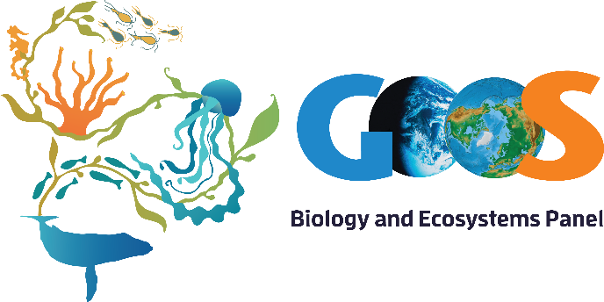
GOOS BioEco – Partnerships
GOOS SC-8, Kiel-Germany
BACKGROUND
The Biology and Ecosystems Panel of GOOS (GOOS BioEco) was established in 2015 with the goal of developing and coordinating efforts to implement a global ocean observation system for measuring essential biological and ecosystem variables. This will enhance global ocean observations and inform policy development and management decisions on ocean and coastal resource sustainability and health.
From the beginning, GOOS BioEco has interacted with a variety of institutions, organizations, programs, projects, and groups to advance the understanding and acceptance of the newly defined biological EOVs. It is clear that in the area of ocean health, despite there being no single best set of EOVs, community acceptance is and continues to be a prerequisite to their adoption. In consequence, the panel approach has been to communicate widely through the academic peer-reviewed literature and through formal and informal interactions with many different groups. The nature of these interactions has included: formal collaboration and support /funding, discussions on how to establish such formal ways of collaboration, participation and reporting on BioEco activities in meetings, and working with groups to understand and communicate how monitoring can meet some of their strategic needs.
This process has a considerable overhead and has only been achieved through taking advantage of panel members existing engagements with different groups. The BioEco panel has now reached a point where partnership support and development needs greater focus at the panel level on the most strategically valuable partnerships, and improved coordination as greater emphasis falls on the development and implementation of the individual EOVs, led by individual panel members. This agenda item is our first step in developing a suitable approach that might also have relevance to other GOOS panels.
Our existing and developing relationships are listed below using the UN Decade stakeholder 5 level classification as a convenient option. Some advice on developing partnerships is provided at the end to stimulate discussion.

PARTNERSHIPS following 5 level UN Decade stakeholder classification (acronyms spelled at the end of document)
- Science and technology
PARTNER | NATURE OF PARTNERSHIP
RCN/NSF | Co-developed and supported IMSOO Cross-panel workshop (Feb 2017) and the plankton EOV implementation plan workshop (June 2018) and provided support for the BioEco IPO to travel and represent GOOS to relevant events (e.g. the Ocean Sciences meeting in Portland and the RCN workshop).
MBON | Signed collaboration agreement with GOOS BioEco and OBIS to support collaboration and reduce potential competitive practices. At least 3 panel members sit on both BioEco and MBON. Pole to Pole project of MBON has supported airfares and/or accommodation for IPO to provide training in MBON-P2P workshops in Latin America that uses GOOS EOVs. MBON of IOOS provided funding for the plankton EOV implementation workshop (June 2018). Represented in the panel by Frank Muller-Karger.
GACs | Collaboration to develop and implement the zooplankton EOV (represented in the panel by Sonia Batten)
GCRMN | Worked closely with GCMRN to revitalize this group and develop and implement the coral EOV (represented in the panel by David Obura)
GlobalHABs | Collaboration to develop and implement the phytoplankton EOV (represented in the panel by Raphael Kudela)
GLOMICON | Collaboration to develop and implement the microbial EOV (represented in the panel by Pier Luigi Buttigieg)
IGMETS | Collaboration to develop and implement the plankton EOVs – data contribution model (non-panel contributor Peter Thompson)
IMBER | Collaboration to develop and implement the turtle-bird-mammal EOV (through Karen Evans from CLIOTOP, a project under IMBER)
IndiSeas | Collaboration to develop and implement the fish EOV (represented in the panel by Yunne Shin)
IQOE | Collaboration to develop and implement the sound EOV (through Peter Tyack)
MarineGEO | Collaboration to develop and implement the seagrass EOV (represented in the panel by Emmett Duffy)
OBIS | Signed collaboration agreement. OBIS participates in all EOV implementation workshops to provide guidance and encourage biological monitoring data to be uploaded into the database (through Ward Appeltans)
SCOR | BioEco progress is reported to the SCOR Executive Committee through the IABO representative – the Panel IPO. The SCOR WG platform is being used to help build global networks around the biological EOVs. SCOR is mainly funded by the National Science Foundation (NSF) and by country memberships. It provides funding to three-year duration Working Groups, to three large scale research projects (the IOCCP, SOOS and GlobalHABs), it sponsors five other research projects (IMBER, SOLAS, GEOTRACES, IQOE and the IIOE-2), and has several affiliated programs which are not funded by, but still report to SCOR. One of the current working groups, P-OBS is directly linked to GOOS BioEco.
POGO | Collaboration to develop and implement the macroalgal EOV (through Craig Johnson from IMAS/UTAS)  Collaboration with the POGO WG in Biological Observations (through Patricia Miloslavich, member of the WG chaired by Margaret Leinen)
GCOS | Collaboration to develop ECVs and support biological reporting in AR6.
DOOS | Ongoing discussions to develop deep sea EOVs and identify their relationship to the BioEco Panel. DOOS provided airfare and accommodation to BioEco IPO to attend strategic planning workshop (December 2016)
SOOS | Ongoing discussions (with Louise Newman and Andrew Constable)

- Policy and sustainable development
PARTNER | NATURE OF PARTNERSHIP
CBD | Discussions on collaboration with parties to the CBD including two monitoring workshops bringing together parties, marine monitoring and reporting groups (Nic Bax through Jihyun Lee now replaced with Joseph Appiott)
Future Earth | Funder of PEGASuS project (at NCEAS) with potential for future collaborations. (Craig Starger)
UN BBNJ | Regular representation of GOOS activities at BBNJ meetings through side events (Daniel Dunn)
CBD SOI | Sustainable Oceans Initiative brings together UNEP Regional Sea Programs, Regional Fishery Management Bodies, and other policy groups. (Nic Bax sites on advisory group)
IOC CDWG | Member of IOC Capacity development working group with particular emphasis on P-SIDS. (Nic Bax represents Australia)
UN-WOA2 | TBM panel member (Karen Evans) is on scientific oversight team for WOA2. IPO is contributing to one of the WOA-2 chapters (Chapter 7c on intertidal zones).
IPBES | IPO is one of the Coordinating Leading Authors (CLAs) for the IPBES global assessment (securing that information from the oceans is included in the assessment). The global assessment will be discussed at the General Assembly in April 2019. IPBES has supported all travel of the IPO for IPBES related activities.
FAO | Engage FAO in scientific meetings and reports especially given their experience in capacity development (Kim Freedman). Developing new proposal for Indian Ocean with CSIRO and FAO through GOBI and IKI (German Government climate funding)
LME | Discussions on potential collaboration (Ken Sherman), and through UNEP/LME regional meeting. Relationship with IOC oversight of LME program not clear. (Nic Bax)
ISA | Developing new integrated deep sea biogeography and monitoring package (Nic Bax through Jihyun Lee)

- Business and industry
PARTNER | NATURE OF PARTNERSHIP

- Civil society and NGOs
PARTNER | NATURE OF PARTNERSHIP
ICRI | Contributed to support the Coral EOV workshop in Tanzania (November 2017)
WCMC | Discussions on potential collaboration (with Lauren Weatherdon)
WWF | Discussions on potential collaboration (Alistair Graham)

- Funders and donors
PARTNER | NATURE OF PARTNERSHIP
AIMS | Contributed AUD 50 K/year since 2015 and committed until 2021 to support salary of IPO.
CSIRO | Contributed AUD 25k/yr from 2015-2019 and 50k/yr till 2021 to support salary for IPO. Contributes salary and airfare for Nic Bax to attend BioEco Panel meetings
MMC | Contributed US$ 25 k for the 2017-2019 period to support salary for the IPO. Sam Simmons was co-chair of the panel from 2015-2017 and the MMC contributed with her salary, airfares and accommodation to attend BioEco panel meetings
UWA | Contributed AUD 100 K for the 2015-2017 period to support salary of IPO.
IOC | Contributed US$ 65k in 2015 and US$ 50k in 2019 to support salary of IPO  Co-supported the coral and macroalgal EOV implementation workshops (airfare and accommodation of some participants). Major funder for the 3 BioEco Panel meetings (February 2016 in New Orleans; November 2016 in Oostende, and November 2018 in St. Petersburg, Florida)
NCEAS /  PEGASuS | Contributing US$ 111,490 in 2019 to support two workshops plus 40% salary of a Postdoc to support project activities
UNEP | Contributed to support the Coral EOV workshop in Tanzania (November 2017)
Lounsbery  Foundation | Contributing US$ 100k in 2019 to support training workshops in Latin America on marine biodiversity monitoring methods (Colombia and Argentina)
NASA | Contributed US$ 10k to organize special session on biological observations at the 4th WCMB (2018) and is contributing US$50k to organize the seagrass/mangrove implementation plan workshop in June 2019
POGO | Contributed €10k to support the macroalgal EOV implementation workshop (Hobart, September 2018)
NESP-MBH | Contributed AUD 1k to support the macroalgal EOV implementation workshop (Hobart, September 2018)
IMAS/UTAS | Provides office space for IPO. Contributed AUD 2k to support the macroalgal EOV implementation workshop (Hobart, September 2018)
IMOS | Provides organisational support for IPO
IOOS | Co- supported the plankton EOV implementation plan workshop (June 2018)
NIPPON FOUNDATION | Potential longer term funder (to be approached directly by Daniel Dunn and potentially through ISA )

PARTNERSHIP CONSIDERATIONS
How partners shape strategy
- In a fast-changing environment, it’s crucial to be at the centre of a hub-and-spoke network so that you’re constantly exposed to new ideas.
- Highly diversified firms gain a lot from being hubs, because employees with different backgrounds can see more opportunities in diverse ideas coming in from the spokes.
- On the other hand, Integrated networks can be particularly beneficial for companies whose small size leaves them vulnerable to shocks
- With either type of network, a company must ensure that information about partners flows freely so that an executive managing a relationship with one partner knows what others are learning from different partners.
- Many companies fail to look beyond their own partner relationships to consider whether their partners are interacting with one another. This prevents them from gaining the greatest possible competitive advantage from their alliances.
(Greve et al. 2013. HBR. How partners shape strategy)

How to Strike Effective Alliances and Partnerships
- Individual excellence. Both parties must have strengths on their own, because weak players cannot prop each other up.
- Importance. The relationship must have strategic significance. If it is just casual, don’t bother.
- Interdependence. The strongest and most enduring alliances occur when the parties are different in some respects and need each other to carry out an activity they would not otherwise do.
- Investment. One sign of commitment is a willingness to invest something in the partner’s success, such as equities or personnel swaps (business “hostages for peace”).
- Information. Transparency aids relationship formation. If you don’t want a partner to know too much about you, why are you in the alliance?
- Integration. There must be many points of contact that tie the organizations together in joint activities.
- Institutionalization. A formal structure and governing board ensures objectivity, and that alliance interests are considered, not just each company’s interests.
- Integrity. Trust is essential. Alliances fall apart in conflict and lawsuits when partners do not act ethically toward one another nor strive to contribute to the other’s success.
(Kanter, R.M. 2009. How to Strike Effective Alliances and Partnerships. HBR)

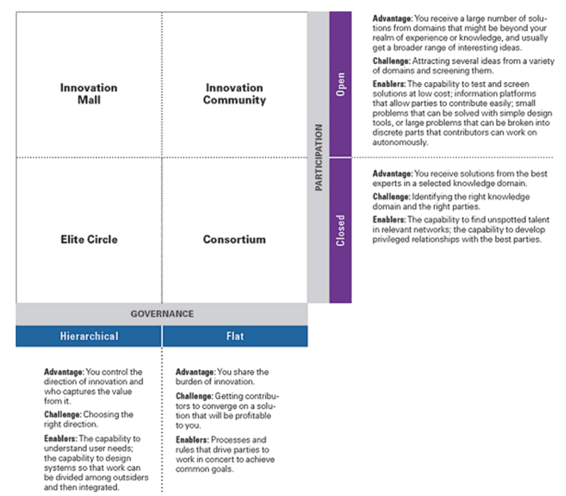
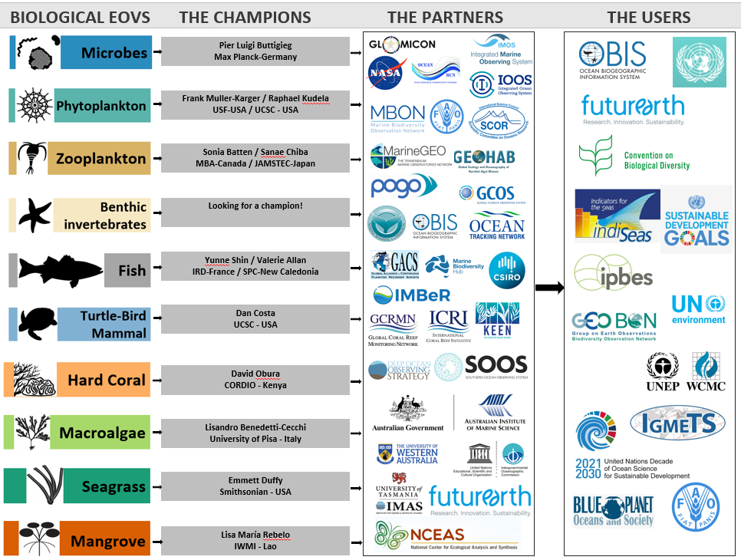

ACRONYMS
AIMS (Australian Institute of Marine Science), GOOS BioEco (GOOS Biology and Ecosystems Panel), CBD (Convention on Biological Diversity), DOOS (Deep Ocean Observing Strategy), EOVs (Essential Ocean Variables), FAO (Fisheries and Agriculture Organization), GACs (Global Alliance of Continuous Plankton Recorders), GCOS (Global Climate Observing System), GCRMN (Global Coral Reef Monitoring Network), GEOTRACES (International Study of Marine Biogeochemical Cycles of Trace Elements and their Isotopes), GlobalHABs (Global Harmful Algal Blooms project), GOOS (Global Ocean Observing System), IABO (International Association for Biological Oceanography), ICRI (International Coral Reef Initiative), IGMETS (International Group for Marine Ecological Time Series), IIOE-2 (International Indian Ocean Expedition-2), IMAS (Institute for Marine and Antarctic Studies), IMBER (Integrated Marine Biosphere Research Project), IMOS (Integrated Marine Observing System), IOC (Intergovernmental Oceanographic Commission), IOCCP (International Ocean Carbon Coordination Project), IOOS (Integrated Ocean Observing System), IPO (International Project Officer), IQOE (International Quiet Ocean Experiment), ISA (International Seabed Authority), LME (Large Marine Ecosystem), MarineGEO (Marine Global Earth Observatory - Smithsonian's Tennenbaum Marine Observatories Network), MBON (Marine Biodiversity Observation Network), MMC (Marine Mammal Commission), NCEAS (National Center for Ecological Analysis and Synthesis), NESP-MBH (National Environmental Science Programme – Marine Biodiversity Hub/Australia), NGOs (Non-Governmental Organizations), NSF (National Science Foundation / USA), OBIS (Ocean Biogeographic Information System), P-OBS (Integration of Plankton-Observing Sensor Systems to Existing Global Sampling Programs), POGO (Partnership for the Observation of the Global Ocean), RCN (Research Coordination Network), SCOR (Scientific Committee on Oceanic Research), SOLAS (International Surface Ocean - Lower Atmosphere Study), SOOS (Southern Ocean Observing System), UTAS (University of Tasmania), UNEP (United Nations Environment Program), UWA (University of Western Australia), WMO (World Meteorological Organization), WCMB (World Conference on Marine Biodiversity), WCMC (World Conservation Monitoring Center).

