

**The Ninth GOOS Regional Alliance Forum (GRA Forum -9)**

**Tokyo, Japan, 5-7 August 2019**

Information for Participants

**1. Visa**

A number of countries have a Visa Exemption Arrangement with Japan, and do not require a visa. This list is available here:

<https://www.mofa.go.jp/j_info/visit/visa/short/novisa.html>

All other participants will require a visa to enter Japan: **if you require a visa, please inform Denis Chang Seng (d.chang-seng@unesco.org) by Friday 14 June 2019**, so that JAMSTEC can issue an invitation letter to support your visa application.

**2. Venue**

GRA Forum-9 will be held at the JAMSPEC Tokyo Office. The Tokyo Office is conveniently located at a building directly connected to Uchisaiwaicho on the Toei-Mita Line, and near JR Shimbashi as well as Kasumigaseki on the Tokyo Metro Chiyoda Line. The Tokyo Office has 5 meeting rooms with sufficient work space.

[Address]

Fukokuseimei Bld. 23F

2-2-2 Uchisaiwaicho, Chiyoda City, Tokyo, 100-0011, Japan

Phone: +81-3-5157-3900

Fax: +81-3-5157-3903

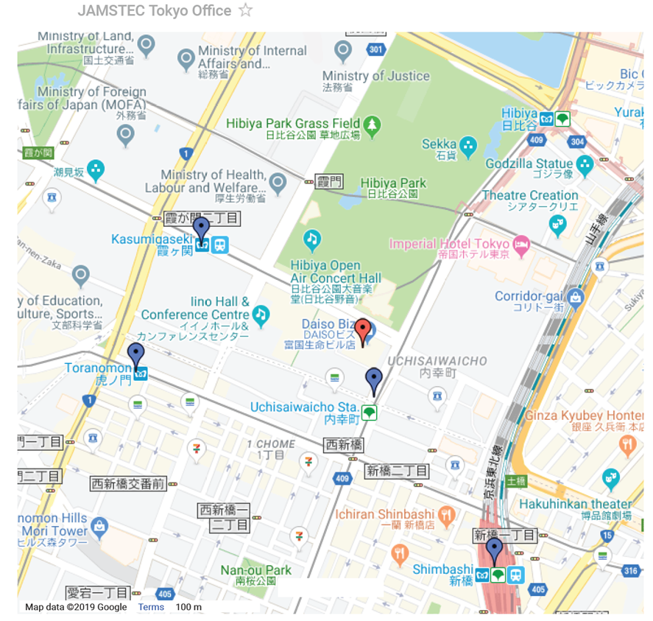

(View larger map: https://www.jamstec.go.jp/e/about/access/tokyo.html)

Tokyo Office can be reached from 4 stations. The walk to Tokyo Office is a few minutes from Exit A6 of Uchisaiwai-cho Station on Toei Mita Line, 3 minutes from Exit C4 of Kasumigaseki Station on Tokyo Metro Chiyoda Line, 6 minutes from Hibiya Exit of Shimbashi Station on JR and subway lines, and 8 minutes from Exit No. 9 of Toranomon Station on Tokyo Metro Ginza Line.

**3. List of the Hotels**

|  |  |  |  |
| --- | --- | --- | --- |
| **Hotel** | **Rate** | **Booking inclusions** | **Information on Google map (The links to some hotel booking sites are shown on google map)** |
|
| [the b shimbashi](https://www.ishinhotels.com/en/theb/shimbashi/) | \16,434~ | Breakfast Free wi-fi | [Information on Google map](https://www.google.com/maps/place/%E3%82%B6%E3%83%BB%E3%83%93%E3%83%BC+%E6%9D%B1%E4%BA%AC+%E6%96%B0%E6%A9%8B/@35.6709123,139.7485334,16z/data=!4m22!1m11!2m10!1sIino+Building,+2+Chome-1-%E7%95%AA1%E5%8F%B7++hotels!5m7!5m4!1s2019-07-30!2i3!4m1!1i1!9i16200!10e3!6e3!3m9!1s0x60188bea4d24ffff:0x1f023fb5521e51fa!5m4!1s2019-07-30!2i3!4m1!1i1!8m2!3d35.6675124!4d139.7535664?hl=en) |
| [Dai-ichi Hotel Annex](https://global.hankyu-hotel.com/daiichi-hotel-annex/) | \16,195~ | Free wi-fi | [Information on Google map](https://www.google.com/maps/place/Daiichi+Hotel+Annex/@35.6695215,139.7558314,17z/data=!3m1!4b1!4m5!3m4!1s0x60188beea5978f21:0xd70ae6cdbe7c9be9!8m2!3d35.6695215!4d139.7580201?hl=en) |
| [remm Hibiya](https://global.hankyu-hotel.com/remm-hibiya/) | \15,985~ | Breakfast Free wi-fi | [Information on Google map](https://www.google.com/maps/place/Remm+Hibiya/@35.6709123,139.7485334,16z/data=!3m1!5s0x60188bee4e372011:0xa230d50a9d9dbf30!4m22!1m11!2m10!1sIino+Building,+2+Chome-1-%E7%95%AA1%E5%8F%B7++hotels!5m7!5m4!1s2019-07-30!2i3!4m1!1i1!9i16200!10e3!6e3!3m9!1s0x60188bee4efaf6bb:0xc7bab07b43127cbf!5m4!1s2019-07-30!2i3!4m1!1i1!8m2!3d35.6726058!4d139.7596711?hl=en) |
| [Shinbashi Atagoyama Tokyu Rei Hotel](https://www.tokyuhotelsjapan.com/global/atagoyama-r/) | \15,008~ | Breakfast Free wi-fi | [Information on Google map](https://www.google.com/maps/place/Shinbashi+Atagoyama+Tokyu+REI+Hotel/@35.6709123,139.7485334,16z/data=!3m1!5s0x60188b9479fa812f:0xb01df47da79040b0!4m22!1m11!2m10!1sIino+Building,+2+Chome-1-%E7%95%AA1%E5%8F%B7++hotels!5m7!5m4!1s2019-07-30!2i3!4m1!1i1!9i16200!10e3!6e3!3m9!1s0x60188b947a41c003:0x9476b4fba9d8aff9!5m4!1s2019-07-30!2i3!4m1!1i1!8m2!3d35.6653169!4d139.7494197?hl=en) |
| [Ginza International Hotel](http://www.ginkoku.co.jp/eng/index.html) | \14,200~ | Free wi-fi Breakfast | [Information on Google map](https://www.google.com/maps/place/Ginza+Kokusai+Hotel/@35.6687566,139.7547584,16.79z/data=!4m22!1m11!2m10!1sIino+Building,+2+Chome-1-%E7%95%AA1%E5%8F%B7++hotels!5m7!5m4!1s2019-07-30!2i3!4m1!1i1!9i16200!10e3!6e3!3m9!1s0x0:0xb4a701469006f16b!5m4!1s2019-07-30!2i3!4m1!1i1!8m2!3d35.6680016!4d139.7604194?hl=en) |
| [HOTEL UNIZO Tokyo Shimbashi](https://www.unizo-hotel.co.jp/en/shimbashi/) | \13,238~ | Breakfast Free wi-fi | [Information on Google map](https://www.google.com/maps/place/Hotel+Unizo+Shinbashi/@35.6709123,139.7485334,16z/data=!4m22!1m11!2m10!1sIino+Building,+2+Chome-1-%E7%95%AA1%E5%8F%B7++hotels!5m7!5m4!1s2019-07-30!2i3!4m1!1i1!9i16200!10e3!6e3!3m9!1s0x60188beba0874689:0x60c49becae469df1!5m4!1s2019-07-30!2i3!4m1!1i1!8m2!3d35.6664751!4d139.7550094?hl=en) |
| [TOKYU STAY Shimbashi](https://www.tokyustay.co.jp/e/hotel/SHI/) | \12,820~ | Breakfast Free wi-fi | [Information on Google map](https://www.google.com/maps/place/Tokyu+Stay+Shimbashi/@35.6709123,139.7485334,16z/data=!4m22!1m11!2m10!1sIino+Building,+2+Chome-1-%E7%95%AA1%E5%8F%B7++hotels!5m7!5m4!1s2019-07-30!2i3!4m1!1i1!9i16200!10e3!6e3!3m9!1s0x60188bc1faad425d:0xa2e866bcc364d9f7!5m4!1s2019-07-30!2i3!4m1!1i1!8m2!3d35.6635028!4d139.7570063?hl=en) |
| [APA Hotel Shimbashi Toranomon](https://www.apahotel.com/hotel/shutoken/35_shimbashi-toranomon/) | \12,560~ | Breakfast Free wi-fi | [Information on Google map](https://www.google.com/maps/place/APA+HOTEL+SHIMBASHI-TORANOMON/@35.6709123,139.7485334,16z/data=!3m1!5s0x60188beb59a4a03d:0x9302872189126060!4m22!1m11!2m10!1sIino+Building,+2+Chome-1-%E7%95%AA1%E5%8F%B7++hotels!5m7!5m4!1s2019-07-30!2i3!4m1!1i1!9i16200!10e3!6e3!3m9!1s0x60188beb5906514d:0x96044dcf42d3872a!5m4!1s2019-07-30!2i3!4m1!1i1!8m2!3d35.6668641!4d139.7532351?hl=en) |
| [Sotetsu Fresa Inn Shimbashi-Hibiyaguchi](https://fresa-inn.jp/en/shinbashi/) | \12,204~ | Breakfast Free wi-fi | [Information on Google map](https://www.google.com/maps/place/Sotetsu+Fresa+Inn+Shimbashi+Hibiyaguchi/@35.6709123,139.7485334,16z/data=!4m22!1m11!2m10!1sIino+Building,+2+Chome-1-%E7%95%AA1%E5%8F%B7++hotels!5m7!5m4!1s2019-07-30!2i3!4m1!1i1!9i16200!10e3!6e3!3m9!1s0x60188be957f46d83:0x1e088bea01c72ef1!5m4!1s2019-07-30!2i3!4m1!1i1!8m2!3d35.6682641!4d139.7576635?hl=en) |
| [Ginza Bellevue Hotel](https://www.ginza-bellevue.com/en/index.html) | \11,980~ | Breakfast Free wi-fi | [Information on Google map](https://www.google.com/maps/place/%E9%8A%80%E5%BA%A7%E3%83%99%E3%83%AB%E3%83%93%E3%83%A5%E3%83%BC%E3%83%9B%E3%83%86%E3%83%AB/@35.6709123,139.7485334,16z/data=!4m22!1m11!2m10!1sIino+Building,+2+Chome-1-%E7%95%AA1%E5%8F%B7++hotels!5m7!5m4!1s2019-07-30!2i3!4m1!1i1!9i16200!10e3!6e3!3m9!1s0x60188bef3ee7890f:0x76ad88a5a372bfba!5m4!1s2019-07-30!2i3!4m1!1i1!8m2!3d35.6711775!4d139.7612214?hl=en) |
| [GINZA GRAND HOTEL](http://www.ginzagrand.com/english/) | \11,143~ | Free wi-fi | [Information on Google map](https://www.google.com/maps/place/Ginza+Grand+Hotel/@35.6709123,139.7485334,16z/data=!4m22!1m11!2m10!1sIino+Building,+2+Chome-1-%E7%95%AA1%E5%8F%B7++hotels!5m7!5m4!1s2019-07-30!2i3!4m1!1i1!9i16200!10e3!6e3!3m9!1s0x60188be8e2efa533:0x8df62a573d80db6e!5m4!1s2019-07-30!2i3!4m1!1i1!8m2!3d35.6682336!4d139.7602089?hl=en) |
| [Shimbashi Urban Hotel](http://tokyowest-hotel.co.jp/sb-urban/) | \9,820~ | Free wi-fi | [Information on Google map](https://www.google.com/maps/place/Shimbashi+Urban+Hotel/@35.6689765,139.7528894,17z/data=!4m22!1m11!2m10!1sIino+Building,+2+Chome-1-%E7%95%AA1%E5%8F%B7++hotels!5m7!5m4!1s2019-07-30!2i3!4m1!1i1!9i16200!10e3!6e3!3m9!1s0x60188beb9cce0b03:0x38b0b71defd5fdd!5m4!1s2019-07-30!2i3!4m1!1i1!8m2!3d35.6672498!4d139.7551905?hl=en) |
| [Hotel Check In Shimbashi](http://www.checkin.co.jp/shinbashi/) | \9,660~ | Free wi-fi Breakfast | [Information on Google map](https://www.google.com/maps/place/Hotel+Check+In+Shimbashi/@35.6709123,139.7485334,16z/data=!4m22!1m11!2m10!1sIino+Building,+2+Chome-1-%E7%95%AA1%E5%8F%B7++hotels!5m7!5m4!1s2019-07-30!2i3!4m1!1i1!9i16200!10e3!6e3!3m9!1s0x60188bebb9d26e97:0xbcd5af31b3e6b619!5m4!1s2019-07-30!2i3!4m1!1i1!8m2!3d35.6664577!4d139.7561587?hl=en) |

**\*You may find the hotels at an affordable price in the areas which are 2 or 3 stations away from the meeting venue.**

**4. Local Climate in August**

Mean temperature : 26.4°C

Mean maximum temperature : 30.8°C

Mean minimum temperature : 23.0°C

Mean precipitation : 168.2 mm/month

Humidity : 73%

Mean duration of sunshine : 169 hours/month = 5.45 hours/day