Local Logistics - OOPC 23 Meeting
Version 1 (10 Jan 2020)

The OOPC 23 meeting in Cape Town will run concurrently with the Nansen-Tutu Center 10th anniversary symposium on “Ocean, weather and climate, science to the service of society”. Information about Cape Town and symposium logistics can be found at: https://www.nansentutusymposium.com.

Preliminary Agenda summary:
Tuesday 10th March: Breakwater lodge
- OOPC activities in conjunction with the Nansen Tutu Science Symposium. See Day 1 Agenda https://www.nansentutusymposium.com/schedule
- Ice breaker and poster session between 17:30-19:30.
Wednesday 11th March: Breakwater lodge
- OOPC activities
Thursday 12th March: Breakwater lodge
- OOPC activities
- Dinner funded by Department of Environment, Forestry and Fisheries (DEFF) (to be confirmed)
Friday 13th March: RV S.A Agulhas II (to be confirmed)
- OOPC activities and short visit of the S.A Agulhas II by DEFF.
Venue:
The meeting will be held at the Breakwater Lodge (http://www.breakwaterlodge.co.za/) at the V/A Cape Town waterfront, also called the “Protea Hotel Cape Town Waterfront Breakwater Lodge” (see map below).
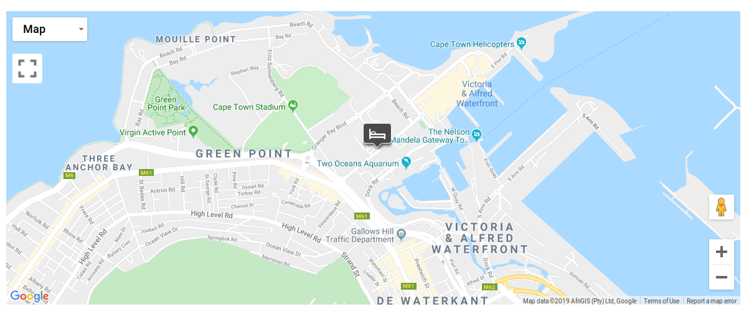
Local Connections and Transportation:
Getting around:
Uber is a very popular way to get around the city and it is very affordable. You can also make use of the MyCiti bus system around the city (https://www.myciti.org.za/en/home/).
Airport Transfer:
Bus:
The MyCiti Airport Shuttle (0800 65 64 63; myciti.org.za) is the cheapest option at about R 90 (6 USD) if you include the activation fee for your card (2.5 USD). However, there is no direct route from the airport and you’ll need to change buses or catch a cab from its drop off point at the Civic Centre in town. Tickets are on sale at the kiosks in both the Civic Centre and Airport bus stations. Buses leave every 20 minutes from both destinations; the trip takes about 20 minutes; 45-55 minutes during rush hour.
Shuttle:
It is often best to book your shuttle prior to flying. I advise centurion shuttles (www.centuriontours.co.za). They are very good and also very affordable. A transfer from the airport to the venue will cost you about R 190 (13 USD) for one person and then R 30 ( 2 USD) extra for additional passengers (http://www.centuriontours.co.za/transfers.html). You can book by sending an email to info@centuriontours.co.za, Central Reservations: Daily 07h00 – 23h00, 24/7 assistance: 27 (0)82 472 6216. They have a kiosk in the airport and you can also just arrive and ask for a shuttle, you might just need to wait a bit longer.
Hotel shuttles:
Most hotels will offer you a shuttle service at a cost superior to that of the airport shuttle service.
Accomodation:
Please find below a list of hotel suggestions close to the meeting venue.
Hotel | Website | Breakfast included | Walking distance to venue (Km) | Rate per night (ZAR / USD)
Protea Hotel Cape Town Waterfront Breakwater Lodge  (Venue) | https://www.marriott.com/hotels/travel/cptca-protea-hotel-cape-town-cape-castle/ | No | 0 | R 2000 / $ 137
Sugar Hotel | http://www.sugarhotel.co.za/ | Yes | 0.7 | R 2000 / $ 137
The greenhouse Boutique Hotel | https://www.thegreenhousect.com | No | 0.8 | R 1400 / $ 96
Protea Hotel by Marriott Cape Town Victoria Junction | https://www.marriott.com/hotels/travel/cptvi-protea-hotel-cape-town-victoria-junction/?scid=bb1a189a-fec3-4d19-a255-54ba596febe2 | No | 0.9 | R 2000 / $ 137
The grey Hotel | https://thegreyhotel.co.za | No | 1.3 | R 1600 / $ 110
Signature Lux Hotel | https://signatureluxhotels.com/ctcc/ | Yes | 1.6 | R1100 / $ 75
City Lodge Hotel Victoria and Alfred | https://clhg.com/hotels/180/City-Lodge-Hotel-Victoria-&-Alfred-Waterfront | No | 1.6 | R1700 / $117
Dolphin Inn guesthouse | https://www.dolphin-inn.co.za | Yes | 1.8 | R1500 / $ 103
Please consult https://www.nansentutusymposium.com/logistics for more information.

