|  |
| --- |
| Summary  Part I of this report provides an overview with regard to the implementation of the 2018–2019 IOC budget as at 31 December 2019, including an update on resource mobilisation.  Part II gives an outline of the approved 2020–2021 budget and a brief overview of the financial situation of the IOC Special Account at year-end 2019, including an updated forecast for the period 2020–2021. The Financial Report of the IOC Special Account for the period 1 January 2018 to 31 December 2019 is included in Appendix I.  Proposed decision: This document is part of the report of the Executive Secretary to the Executive Council. It will be further examined by the statutory sessional open-ended Financial Committee and the decision reflected in the Draft Resolution that the Financial Committee will submit for adoption by the Assembly under item 5.2 in accordance with paragraph 15 of the *Revised* [*guidelines for the preparation and consideration of draft resolutions*](http://www.ioc-unesco.org/index.php?option=com_oe&task=viewDocumentRecord&docID=9281) ([IOC/INF-1315](https://unesdoc.unesco.org/ark:/48223/pf0000265307.locale=fr)). |

**This report covers three types of funding that compose the IOC budget:**

1. Regular Programme allocation (UNESCO budget–39 C/5 for 2018–2019 + Additional Appropriations (voluntary contributions intended to directly reinforce an existing budget line), if applicable).
2. Voluntary (Extrabudgetary) Contributions to the IOC Special Account:

**B1.** Programme Activities (191-series accounts)

**B2.** Earmarked Activities (193-series accounts)

1. Voluntary (Extrabudgetary) Contributions for specific projects under the funds-in-trust modality.

**PART I – IMPLEMENTATION OF THE IOC BUDGET IN 2018–2019**

1. In compliance with UNESCO Member States’ decisions, the 2018–2019 budget was based on an Integrated Budgetary Framework (IBF), allowing greater transparency of resources and helping to align resources with the collectively decided priorities.
2. Following the approval of the Organization’s Programme and budget for 2018–2019 by the UNESCO General Conference at its 39th session, the actual working budget of the Commission was set in accordance with the Assembly-adopted scenario of US$ 10,681,300 for the IOC from UNESCO’s regular programme budget, plus US$ 4,800,000 of Voluntary Contributions (VC) secured at the moment of the budget adoption, plus US$ 12,776,400 resource mobilisation target (gap), or total IBF budget of US$ 28,257,700.

Table 1. IOC IBF 2018–2019 (US$ 518M Expenditure plan) at function level, as per [Resolution XXIX-2](http://ioc-unesco.org/index.php?option=com_oe&task=viewDocumentRecord&docID=19662).

|  |  |  |  |
| --- | --- | --- | --- |
| **Title** | **Regular Programme allocation** | **Voluntary Contributions target** | **Total** |
|
| $ | $ | $ |
| **FUNCTION A (Ocean Research)** | **185,000** | **1,094,000** | **1,279,000** |
| **FUNCTION B (Observing Systems/Data Management)** | **567,000** | **2,745,200** | **3,312,200** |
| **FUNCTION C (Early Warning & Services)** | **450,000** | **3,582,000** | **4,032,000** |
| **FUNCTION D (Assessment & Information for Policy)** | **287,000** | **1,877,200** | **2,164,200** |
| **FUNCTION E (Sustainable Management & Governance)** | **527,700** | **4,443,000** | **4,970,700** |
| **FUNCTION F (Capacity Development)** | **391,300** | **3,835,000** | **4,226,300** |
| **COMMON COSTS** | **251,100** |  | **251,100** |
| Evaluations | 20,000 |  | 20,000 |
| IOC Operating costs | 50,000 |  | 50,000 |
| IOC Contribution to common costs | 181,100 |  | 181,100 |
| **TOTAL OPERATIONS** | **2,659,100** |  | **2,659,100** |
| **STAFF ALLOCATION** | **8,022,200** |  | **8,022,200** |
| **TOTAL** | **10,681,300** | **17,576,400** | **28,257,700** |

Table 2. IOC IBF 2018–2019 (US$ 518M Expenditure plan) at function level, as at 31 December 2019.

|  |  |  |  |
| --- | --- | --- | --- |
| **Title** | **Regular Programme allocation\*** | **Voluntary Contributions target** | **Total** |
|
| $ | $ | $ |
| **FUNCTION A (Ocean Research)** | **185,000** | **1,094,000** | **1,279,000** |
| **FUNCTION B (Observing Systems/Data Management)** | **657,763** | **2,745,200** | **3,402,963** |
| **FUNCTION C (Early Warning & Services)** | **450,000** | **3,582,000** | **4,032,000** |
| **FUNCTION D (Assessment & Information for Policy)** | **287,000** | **1,877,200** | **2,164,200** |
| **FUNCTION E (Sustainable Management & Governance)** | **527,700** | **4,443,000** | **4,970,700** |
| **FUNCTION F (Capacity Development)** | **405,229** | **3,835,000** | **4,240,229** |
| **COMMON COSTS** | **261,825** |  | **261,825** |
| Evaluations | 18,725 |  | 18,725 |
| IOC Operating costs | 62,000 |  | 62,000 |
| IOC Contribution to common costs | 181,100 |  | 181,100 |
| **TOTAL OPERATIONS** | **2,774,517** |  | **2,774,517** |
| **STAFF ALLOCATION** | **8,022,962** |  | **8,022,962** |
| **TOTAL** | **10,797,479** | **17,576,400** | **28,373,879** |
| *Regular programme budget figure adjusted for additional appropriations (US$ 60.7K under Function B) and comparative transfers from Part V of UNESCO budget | | | |

Table 3. Consolidated Report on 2018–2019 Expenditure as at 31 December 2019.

|  |  |  |  |  |
| --- | --- | --- | --- | --- |
| **Title** | **Regular programme budget** | **Special Account** | **Funds-in-Trust** | **Total** |
| $ | $ | $ | $ |
| **FUNCTION A (Ocean Research)** | **184,986** | **238,180** | **154,362** | **577,528** |
| **FUNCTION B (Observing Systems/Data Management)** | **657,628** | **1,063,800** | **910,810** | **2,632,238** |
| **FUNCTION C (Early Warning & Services)** | **447,332** | **984,286** | **857,069** | **2,288,687** |
| **FUNCTION D (Assessment & Information for Policy)** | **286,588** | **111,064** | **96,227** | **493,880** |
| **FUNCTION E (Sustainable Management & Governance)** | **527,503** | **733,584** | **5,600,233** | **6,861,320** |
| **FUNCTION F (Capacity Development)** | **405,066** | **475,725** | **2,548,098** | **3,428,888** |
| **COMMON COSTS** | **261,797** |  |  | **261,797** |
| Evaluations | 18,724 |  |  | 18,724 |
| IOC Operating costs | 61,973 |  |  | 61,973 |
| IOC Contribution to common costs | 181,100 |  |  | 181,100 |
| **TOTAL OPERATIONS** | **2,770,899** | **3,606,639** | **10,166,798** | **16,544,336** |
| **STAFF ALLOCATION** | **8,003,589** |  |  | **8,003,589** |
| **TOTAL** | **10,774,489** | **3,606,639** | **10,166,798** | **24,547,926** |

Chart 1. 2018–2019 Expenditure by source of funding (Total of US$ 24,547,926).

Chart 2. 2018–2019 Expenditure on Operations by Function – all sources (total of US$ 16,544,336).

Table 4. 2018–2019 Expenditure analysis by main categories.

|  |  |  |  |  |  |
| --- | --- | --- | --- | --- | --- |
| **IPSAS category** | **IPSAS sub category** | **Regular Programme** | **Special Account** | **Funds-in-Trust** | **Total** |
|
| $ | $ | $ | $ |
| **Consultants, Experts & Mission Costs** | | **1,281,761** | **742,444** | **2,314,686** | **4,338,891** |
|  | Consultants | 341,034 | 335,799 | 1,793,046 | 2,469,879 |
|  | Delegates & External Experts | 181,080 | 113,983 | 110,457 | 405,520 |
|  | Other Contracts | 48,519 | 79,133 | 5,640 | 133,292 |
|  | Staff Mission Costs | 711,128 | 213,529 | 405,543 | 1,330,200 |
| **Contracted Services** | | **541,939** | **328,493** | **3,288,338** | **4,158,770** |
|  | Contracted Seminars | 3,416 | 6,000 | 197,774 | 207,190 |
|  | Other Contracted Services | 538,523 | 322,493 | 3,090,564 | 3,951,580 |
| **Employee Benefits** | | **7,710,221** | **1,871,458** | **2,503,882** | **12,085,561** |
|  | International & National Staff | 7,552,420 | 1,677,782 | 2,070,190 | 11,300,392 |
|  | Other Personnel Costs | 24,608 | 59,670 | 91,609 | 175,887 |
|  | Temporary Staff | 133,193 | 134,006 | 342,083 | 609,282 |
| **External Training, Grants & Other Transfers** | | **528,916** | **222,676** | **758,528** | **1,510,120** |
|  | External Training & Seminars | 476,297 | 222,636 | 748,341 | 1,447,274 |
|  | Financial Contribution | 51,182 | 0 | 5,461 | 56,643 |
|  | Grants and Fellowship | 1,437 | 40 | 4,726 | 6,203 |
| **Finance Costs** | | **7,648** | **1,370** | **3,090** | **12,108** |
| **Other Expenses/Interfund Transfers** | | **208,571** | **261,857** | **1,014,618** | **1,485,046** |
| **Supplies, Consumable, Equipment & Maintenance** | | **495,434** | **178,340** | **283,657** | **957,431** |
|  | Communications | 51,689 | 16,505 | 30,468 | 98,662 |
|  | Equipment | 65,566 | 11,795 | 49,771 | 127,132 |
|  | Leases | 36,050 | 6,808 | 264 | 43,122 |
|  | Other Supplies | 259,524 | 143,232 | 198,786 | 601,542 |
|  | Maintenance & Utilities | 82,605 | 0 | 4,368 | 86,973 |
| **TOTAL** | | **10,774,489** | **3,606,639** | **10,166,798** | **24,547,926** |

Table 5. 2018–2019 Expenditure analysis by operations and staff.

|  |  |  |  |  |
| --- | --- | --- | --- | --- |
|  | **Regular Programme** | **Special Accounts** | **Funds-in-Trust** | **Total** |
|
| Operations | 28% | 48% | 75% | 51% |
| Staff | 72% | 52% | 25% | 49% |

Chart 3. 2018–2019 Expenditure analysis by operations and staff.

Table 6. Overview of the IOC staffing situation.

|  |  |  |  |  |  |  |  |  |  |  |  |  |
| --- | --- | --- | --- | --- | --- | --- | --- | --- | --- | --- | --- | --- |
|  | Budgeted | | Actual | | Budgeted | | Actual | | Budgeted | | Actual | |
|
| FTE | % | FTE | % | FTE | % | FTE | % | FTE | % | FTE | % |
| **REGULAR BUDGET** | | | | | **EXTRABUDGETARY** | | | | **TOTAL** | | | |
| Function A | 3.18 | 12% | 3.18 | 12% | 1.00 | 4% | 0.83 | 4% | 4.18 | 8% | 4.02 | 9% |
| Function B | 5.78 | 21% | 4.93 | 22% | 3.00 | 13% | 3.60 | 17% | 8.78 | 17% | 8.52 | 19% |
| Function C | 4.99 | 18% | 4.59 | 16% | 4.50 | 20% | 3.51 | 17% | 9.49 | 19% | 8.10 | 18% |
| Function D | 2.03 | 7% | 1.63 | 8% | 1.00 | 4% | 1.00 | 5% | 3.03 | 6% | 2.63 | 6% |
| Function E | 6.06 | 22% | 5.75 | 24% | 7.50 | 33% | 7.67 | 37% | 13.56 | 27% | 13.42 | 29% |
| Function F | 5.58 | 20% | 4.76 | 17% | 6.00 | 26% | 4.35 | 21% | 11.58 | 23% | 9.11 | 20% |
| **TOTAL** | **27.62** | **100%** | **24.84** | **100%** | **23.00** | **100%** | **20.96** | **100%** | **50.62** | **100%** | **45.81** | **100%** |

Chart 4a. Overview of the IOC staffing situation by location.

Chart 4b. Overview of the IOC staffing situation by category of personnel.

**A.**

**REGULAR PROGRAMME ALLOCATION   
(UNESCO BUDGET – 39 C/5 FOR 2018–2019)**

Table 7. IOC 2018–2019 regular budget allocations and expenditure as at 31 December 2019.

|  |  |  |  |  |  |
| --- | --- | --- | --- | --- | --- |
| **IOC Function/Activity** | **Allocation** | **Expenditure** | | | **Impl. Rate** |
| **2018-2019** | **2018** | **2019** | **Total** | **%** |
|  | $ | $ | $ | $ |  |
| **FUNCTION A (Ocean Research)** | | | | | |
| WCRP | 50,000.00 | 28,818.50 | 21,181.50 | 50,000.00 | 100.0% |
| Ocean Carbon & Acidification | 75,000.00 | 28,019.95 | 46,966.21 | 74,986.16 | 100.0% |
| CC impact on ocean & coastal ecosystems | 60,000.00 | 29,748.08 | 30,251.92 | 60,000.00 | 100.0% |
| ***Sub-total*** | ***185,000.00*** | ***86,586.53*** | ***98,399.63*** | ***184,986.16*** | **100.0%** |
| **FUNCTION B (Observing Systems/Data Management)** | | | | | |
| GOOS Work Plan | 320,000.00 | 177,834.55 | 142,164.50 | 319,999.05 | 100.0% |
| GOOS projects through IOCAFRICA | 40,000.00 | 19,905.91 | 20,093.88 | 39,999.79 | 100.0% |
| GOOS Pacific Ocean projects through Perth Project Office (PPO) | 20,000.00 | 5,159.57 | 14,840.10 | 19,999.67 | 100.0% |
| GOOS Indian Ocean projects through PPO | 20,000.00 | 18,257.43 | 1,742.50 | 19,999.93 | 100.0% |
| IIOE-2 | 35,000.00 | 12,770.20 | 22,228.81 | 34,999.01 | 100.0% |
| JCOMM Observations* | 88,193.00 | 38,782.80 | 49,409.64 | 88,192.44 | 100.0% |
| IODE & OBIS core systems* | 134,570.00 | 37,822.72 | 96,615.14 | 134,437.86 | 99.9% |
| ***Sub-total*** | ***657,763.00*** | ***310,533.18*** | ***347,094.57*** | ***657,627.75*** | **100.0%** |
| **FUNCTION C (Early Warning & Services)** | | | | | |
| Promote integrated & sustained warning systems | 125,000.00 | 83,962.21 | 39,637.34 | 123,599.55 | 98.9% |
| Educating communities at risk | 60,000.00 | 28,462.57 | 31,373.88 | 59,836.45 | 99.7% |
| Educating communities at risk (Caribbean) | 20,000.00 | 8,853.33 | 11,146.27 | 19,999.60 | 100.0% |
| Educating communities at risk (South Pacific) | 40,000.00 | 15,539.97 | 24,112.67 | 39,652.64 | 99.1% |
| Contribute to MS capacities for assessment (global) | 60,000.00 | 25,606.63 | 34,385.71 | 59,992.34 | 100.0% |
| Contribute to MS capacities for assessment (Indian Ocean) | 40,000.00 | 18,806.64 | 20,444.79 | 39,251.43 | 98.1% |
| JCOMM Services | 65,000.00 | 14,382.32 | 50,617.68 | 65,000.00 | 100.0% |
| HAB research & monitoring | 40,000.00 | 16,423.42 | 23,576.58 | 40,000.00 | 100.0% |
| ***Sub-total*** | ***450,000.00*** | ***212,037.09*** | ***235,294.92*** | ***447,332.01*** | **99.4%** |
| **FUNCTION D (Assessment & Information for Policy)** | | | | | |
| SDG follow up & WOA | 85,000.00 | 37,195.16 | 47,797.91 | 84,993.07 | 100.0% |
| GEBCO | 20,000.00 | 3,633.24 | 16,365.32 | 19,998.56 | 100.0% |
| Science for reducing nutrient enrichment | 60,000.00 | 22,655.68 | 37,341.89 | 59,997.57 | 100.0% |
| IODE & OBIS products & services | 67,000.00 | 28,301.53 | 38,298.28 | 66,599.81 | 99.4% |
| CC adaptation in coastal zones (global) | 25,000.00 | 18,265.03 | 6,734.59 | 24,999.62 | 100.0% |
| CC adaptation in coastal zones (Africa) | 30,000.00 | 10,461.76 | 19,537.48 | 29,999.24 | 100.0% |
| ***Sub-total*** | ***287,000.00*** | ***120,512.40*** | ***166,075.47*** | ***286,587.87*** | **99.9%** |
| **FUNCTION E (Sustainable Management & Governance)** | | | | | |
| IOC Governing Bodies | 245,900.00 | 170,667.60 | 75,232.20 | 245,899.80 | 100.0% |
| IOCAFRICA | 40,000.00 | 19,621.91 | 20,377.53 | 39,999.44 | 100.0% |
| IOCARIBE | 40,000.00 | 11,214.71 | 28,774.47 | 39,989.18 | 100.0% |
| WESTPAC | 40,000.00 | 19,559.92 | 20,430.25 | 39,990.17 | 100.0% |
| IOCINDIO | 20,000.00 | 6,201.71 | 13,787.12 | 19,988.83 | 99.9% |

|  |  |  |  |  |  |
| --- | --- | --- | --- | --- | --- |
| **IOC Function/Activity** | **Allocation** | **Expenditure** | | | **Impl. Rate** |
| **2018-2019** | **2018** | **2019** | **Total** | **%** |
| Partnerships & outreach (Decade & SDG follow-up) | 81,800.00 | 33,099.55 | 48,700.38 | 81,799.93 | 100.0% |
| ICAM & MSP | 60,000.00 | 22,049.71 | 37,785.88 | 59,835.59 | 99.7% |
| ***Sub-total*** | ***527,700.00*** | ***282,415.11*** | ***245,087.83*** | ***527,502.94*** | **100.0%** |
| **FUNCTION F (Capacity Development)** | | | | | |
| CD coordination (incl. TMT, MSR & GOSR) | 75,229.00 | 18,030.32 | 57,198.65 | 75,228.97 | 100.0% |
| CD IOCAFRICA | 75,000.00 | 33,120.13 | 41,879.22 | 74,999.35 | 100.0% |
| CD IOCARIBE | 75,000.00 | 37,828.91 | 37,114.07 | 74,942.98 | 99.9% |
| CD WESTPAC | 75,000.00 | 35,323.95 | 39,670.38 | 74,994.33 | 100.0% |
| CD IOCINDIO | 20,000.00 | 0.00 | 20,000.00 | 20,000.00 | 100.0% |
| IODE & OBIS training & education | 85,000.00 | 36,044.62 | 48,855.44 | 84,900.06 | 99.9% |
| ***Sub-total*** | ***405,229.00*** | ***160,347.93*** | ***244,717.76*** | ***405,065.69*** | **100.0%** |
| **COMMON COSTS** | | | | | |
| Evaluations | 18,725.00 | 0.00 | 18,724.37 | 18,724.37 | 100.0% |
| IOC Operating costs | 62,000.00 | 28,376.35 | 33,596.15 | 61,972.50 | 100.0% |
| IOC Contribution to common costs | 181,100.00 | 90,365.00 | 90,735.00 | 181,100.00 | 100.0% |
| ***Sub-total*** | ***261,825.00*** | ***118,741.35*** | ***143,055.52*** | ***261,796.87*** | **100.0%** |
| **TOTAL OPERATIONS** | **2,774,517.00** | **1,291,173.59** | **1,479,725.70** | **2,770,899.29** | **99.9%** |
| **STAFF ALLOCATION** | **8,022,962.32** | **3,741,723.68** | **4,261,865.54** | **8,003,589.22** | **99.8%** |
| **TOTAL** | **10,797,479.32** | **5,032,897.27** | **5,741,591.24** | **10,774,488.51** | **99.8%** |
| *including additional appropriations of US$ 60,763.00 - details in table 7bis | | | | | |

Table 7bis. Additional Appropriations 2018–2019.

|  |  |  |  |  |  |
| --- | --- | --- | --- | --- | --- |
| **Function** | **Activity** | **Donor** | **Allocation** | **Expenditure** | **Impl. Rate** |
|  |  |  | $ | $ | % |
| B | JCOMM Observations | IFREMER (France) | 8,193.00 | 8,192.97 | 100.0% |
| B | IODE & OBIS core systems | IFREMER (France) | 52,570.00 | 52,438.13 | 99.7% |
| **TOTAL** |  |  | **60,763.00** | **60,631.10** | 99.8% |

Chart 5. IOC 2018–2019 Regular budget expenditure on operations by function (Total of US$ 2,509,102)

**B.  
IOC Special Account**

Table 8. Approved budgetary appropriations for 2018–2019 under the IOC Special Account.

|  |  |  |
| --- | --- | --- |
| **Function/Activity** | **Budget code** | **Amount** ($) |
| **FUNCTION A** | | **500,000.00** |
|  | 191ORS2039 | 500,000.00 |
| WCRP | 191ORS2039.1 | 100,000.00 |
| Ocean Carbon & Acidification | 191ORS2039.2 | 250,000.00 |
| Impact of climate change on ocean and coastal ecosystems | 191ORS2039.3 | 150,000.00 |
| **FUNCTION B** | | **1,950,000.00** |
|  | 191OSD2039 | 1,500,000.00 |
| GOOS Work plan | 191OSD2039.1 | 550,000.00 |
| Perth Programme Office | 191OSD2039.2 | 400,000.00 |
| IIOE-2 (developing capacities for sustained observations) | 191OSD2039.3 | 250,000.00 |
| JCOMM Observations | 191OSD2039.4 | 200,000.00 |
| IODE & OBIS core systems | 191OSD2039.5 | 100,000.00 |
| JCOMMOPS | 193JCS2039 | 450,000.00 |
| **FUNCTION C** | | **2,100,000.00** |
| ICG-IOTWMS Secretariat | 193ICG2039 | 850,000.00 |
|  | 191EWS2039 | 1,250,000.00 |
| ICG NEAMTWS | 191EWS2039.1 | 100,000.00 |
| ICG PTWS | 191EWS2039.2 | 150,000.00 |
| ICG CARIBE-EWS | 191EWS2039.3 | 250,000.00 |
| TOWs & inter-regional coordination | 191EWS2039.4 | 100,000.00 |
| Jakarta Tsunami Information Centre | 191EWS2039.5 | 100,000.00 |
| GLOSS - tsunami | 191EWS2039.6 | 250,000.00 |
| JCOMM Services | 191EWS2098.7 | 200,000.00 |
| HAB Research & Monitoring | 191EWS2039.8 | 100,000.00 |
| **FUNCTION D** | | **550,000.00** |
|  | 191AIP2039 | 550,000.00 |
| SDG Follow-up & WOA | 191AIP2039.1 | 150,000.00 |
| GEBCO | 191AIP2039.2 | 50,000.00 |
| Science for reducing nutrient enrichment | 191AIP2039.3 | 100,000.00 |
| IODE & OBIS products & services | 191AIP2039.4 | 100,000.00 |
| Climate change adaptation in coastal zones | 191AIP2039.5 | 150,000.00 |
| **FUNCTION E** | | **1,510,000.00** |
|  | 191RCG2039 | 1,510,000.00 |
| IOC Governance (representation & intersessional coordination) | 191RCG2039.1 | 150,000.00 |
| IOCARIBE (office support & intersessional coordination) | 191RCG2039.2 | 105,000.00 |
| IOCAFRICA (office support & intersessional coordination) | 191RCG2039.3 | 105,000.00 |
| WESTPAC (office support & intersessional coordination) | 191RCG2039.4 | 250,000.00 |
| IOCINDIO (intersessional coordination) | 191RCG2039.5 | 50,000.00 |
| UN partnerships, global governance, policy and outreach | 191RCG2039.6 | 600,000.00 |
| ICAM & Marine Spatial Planning | 191RCG2039.7 | 250,000.00 |
| **FUNCTION F** | | **1,000,000.00** |
|  | 191ICD2039 | 1,000,000.00 |
| IOC Capacity development & transfer of marine technology & GOSR | 191ICD2039.1 | 400,000.00 |
| IOCAFRICA Capacity development work plans | 191ICD2039.2 | 150,000.00 |
| IOCARIBE Capacity development work plans | 191ICD2039.3 | 100,000.00 |
| WESTPAC Capacity development work plans | 191ICD2039.4 | 250,000.00 |
| IODE & OBIS Training and Education | 191ICD2039.5 | 100,000.00 |
| **TOTAL** |  | **7,610,000.00** |

Table 9. 2018–2019 expenditure as at 31 December 2019.

|  |  |  |  |  |
| --- | --- | --- | --- | --- |
| **Budget code** | **Title (short)** | **Expenditure** | | |
| **2018** | **2019** | **Total** |
| $ | $ | $ |
| **FUNCTION A** | | | | |
| 191ORS2038 | Foster ocean research | -2,792.71 |  | -2,792.71 |
| 191ORS2039 | Foster ocean research | 98,552.35 | 142,420.17 | 240,972.52 |
| ***Sub-total*** |  | ***95,759.64*** | ***142,420.17*** | ***238,179.81*** |
| **FUNCTION B** | | | | |
| 191OSD2038 | Observing systems & data | 14,230.64 |  | 14,230.64 |
| 191OSD2039 | Observing systems & data | 339,910.74 | 359,699.72 | 699,610.46 |
| 193JCS2038 | JCOMMOPS |  |  |  |
| 193JCS2039 | JCOMMOPS | 74,830.20 | 275,129.00 | 349,959.20 |
| ***Sub-total*** |  | ***428,971.58*** | ***634,828.72*** | ***1,063,800.30*** |
| **FUNCTION C** | | | | |
| 191EWS2038 | Develop early warning systems | 5,690.15 |  | 5,690.15 |
| 191EWS2039 | Develop early warning systems | 197,206.21 | 91,737.62 | 288,943.83 |
| 193ICG2038 | ICG IOTWMS | 2,962.51 |  | 2,962.51 |
| 193ICG2039 | ICG IOTWMS | 346,664.00 | 340,025.48 | 686,689.48 |
| ***Sub-total*** |  | ***552,522.87*** | ***431,763.10*** | ***984,285.97*** |
| **FUNCTION D** | | | | |
| 191AIP2038 | Assessment & information | -1,378.22 |  | -1,378.22 |
| 191AIP2039 | Assessment & information | 68,200.95 | 44,241.60 | 112,442.55 |
| ***Sub-total*** |  | ***66,822.73*** | ***44,241.60*** | ***111,064.33*** |
| **FUNCTION E** | | | | |
| 191RCG2038 | Enhance ocean governance | 37,755.31 |  | 37,755.31 |
| 191RCG2039 | Enhance ocean governance | 250,345.64 | 445,482.71 | 695,828.35 |
| ***Sub-total*** |  | ***288,100.95*** | ***445,482.71*** | ***733,583.66*** |
| **FUNCTION F** | | | | |
| 191ICD2038 | Develop the institutional capacity | -10,976.85 |  | -10,976.85 |
| 191ICD2039 | Develop the institutional capacity | 220,122.68 | 266,578.73 | 486,701.41 |
| ***Sub-total*** |  | ***209,145.83*** | ***266,578.73*** | ***475,724.56*** |
| **TOTAL** |  | **1,641,323.60** | **1,965,315.03** | **3,606,638.63** |

**C.  
EXTRABUDGETaRY PROJECTS – FUNDS-IN-TRUST**

Table 10. 2018–2019 expenditure under extrabudgetary projects (in US dollars).





**RESOURCE MOBILISATION AND MAIN EXTRABUDGETARY DONORS**

Table 11. Voluntary contributions and gap by function as at 31 December 2019.

|  |  |  |  |  |  |  |  |  |
| --- | --- | --- | --- | --- | --- | --- | --- | --- |
| **IOC Functions** |  | **39 C/5 (2018–2019)** | | |  | **Updated voluntary contributions committed** | | |
| **Voluntary contributions** | **Gap** | **Total** | **Carry-over funds from 2017** | **New Allotment** | **Total** |
|
| $ | $ | $ | $ | $ | $ |
| A |  | 1,094,000 | 1,094,000 | 42,347 | 510,926 | 553,273 |
| B | 505,000 | 2,240,200 | 2,745,200 | 146,726 | 2,135,249 | 2,281,975 |
| C |  | 3,582,000 | 3,582,000 | 14,131 | 2,582,448 | 2,596,579 |
| D | 105,000 | 1,772,200 | 1,877,200 | 102,126 | 611,476 | 713,602 |
| E | 3,050,000 | 1,393,000 | 4,443,000 | 1,406,688 | 6,011,952 | 7,418,640 |
| F | 1,140,000 | 2,695,000 | 3,835,000 | 534,402 | 3,045,915 | 3,580,317 |
| **Total ER 1** | **4,800,000** | **12,776,400** | **17,576,400** | **2,246,420** | **14,897,967** | **17,144,387** |

*ER=Expected result*

|  |  |  |  |  |  |  |
| --- | --- | --- | --- | --- | --- | --- |
| **IOC Functions** |  | **Gap filled** | | | | **Gap remaining** |
| up to the initial Gap | % | beyond the initial Gap | Total % |
|
| $ | % | $ | % | $ |
| A | 553,273 | 51% |  |  | 540,727 |
| B | 1,776,975 | 79% |  |  | 463,225 |
| C | 2,596,579 | 72% |  |  | 985,421 |
| D | 608,602 | 34% |  |  | 1,163,598 |
| E | 1,393,000 | 100% | 2,975,640 | 214% | -2,975,640 |
| F | 2,440,317 | 91% |  |  | 254,683 |
| **Total ER 1** | **9,368,747** | **73%** | **2,975,640** | **23%** | **432,013** |

Chart 6. Voluntary contributions and gap by function (in millions of US$).

Chart 7. Main extrabudgetary donors – based on 2018–2019 contributions to the IOC Special Account in US dollars ($ 3,304,343.33) and to the Funds-in-Trust Projects ($ 11,276,179.83) – total of $ 14,580,523.16[1].

Table 12. 2018–2019 in-kind contributions[2]



**PART Ii**

**approved integrated budgetary framework 2020–2021[3]**

|  |  |  |  |  |  |
| --- | --- | --- | --- | --- | --- |
| **Function/Activity** | **40 C/5 RP** | **40 C/5 XB** | | | **TOTAL** |
| **in-hand** | **gap** | **target** |
| **FUNCTION A - Ocean Research** | **205,000** | **50,000** | **994,000** | **1,044,000** | **1,249,000** |
| WCRP | 50,000 |  | 100,000 | 100,000 | 150,000 |
| Ocean Carbon Sources & Sinks | 75,000 | 50,000 | 400,000 | 450,000 | 525,000 |
| Climate change impact on ocean & coastal ecosystems | 80,000 |  | 494,000 | 494,000 | 574,000 |
| **FUNCTION B - Observing systems & data** | **567,000** | **220,000** | **1,722,200** | **1,942,200** | **2,509,200** |
| GOOS design, development & impact | 290,000 |  | 603,200 | 603,200 | 893,200 |
| GOOS Projects through IOCAFRICA | 40,000 |  | 50,000 | 50,000 | 90,000 |
| GOOS Pacific Ocean through PPO | 20,000 |  | 100,000 | 100,000 | 120,000 |
| GOOS Indian Ocean through PPO | 20,000 |  | 175,000 | 175,000 | 195,000 |
| IIOE-2 | 35,000 | 170,000 | 250,000 | 420,000 | 455,000 |
| Observing system integration and delivery | 80,000 | 50000 | 344000 | 394000 | 474,000 |
| IODE & OBIS core systems | 82,000 |  | 200000 | 200000 | 282,000 |
| **FUNCTION C - Early warning & services** | **450,000** | **550,000** | **2,130,000** | **2,680,000** | **3,130,000** |
| Promote integrated and sustained Warning Systems | 125,000 | 150000 | 270000 | 420000 | 545000 |
| Educating communities at risk | 60,000 |  | 150,000 | 150000 | 210000 |
| Educating communities at risk (Caribbean) | 20,000 |  | 150,000 | 150,000 | 170000 |
| Educating communities at risk (Pacific) | 40,000 | 200,000 | 350,000 | 550,000 | 590000 |
| Contribute to MS capacities for assessment | 60,000 |  | 220,000 | 220,000 | 280000 |
| Contribute to MS capacities for assessment | 40,000 | 200,000 | 340,000 | 540,000 | 580000 |
| Ocean forecast systems and applications | 65,000 |  | 450,000 | 450,000 | 515000 |
| HAB research & monitoring | 40,000 |  | 200,000 | 200,000 | 240000 |
| **FUNCTION D - Assessments & info for policy** | **267,000** |  | **2,016,000** | **2,016,000** | **2,283,000** |
| SDG follow up & WOA | 85,000 |  | 446,000 | 446,000 | 531,000 |
| GEBCO | 20,000 |  | 300,000 | 300,000 | 320,000 |
| Reducing nutrient enrichment | 40,000 |  | 300,000 | 300,000 | 340,000 |
| IODE & OBIS products & services | 67,000 |  | 500,000 | 500,000 | 567,000 |
| CC adaptation in coastal zones (Africa) | 30,000 |  | 200,000 | 200,000 | 230,000 |
| CC adaptation in coastal zones | 25,000 |  | 270,000 | 270,000 | 295,000 |
| **FUNCTION E- Sustainable management** | **547,908** | **1,630,000** | **4,123,000** | **5,753,000** | **6,300,908** |
| IOC Governing Bodies | 245,900 | 100,000 | 160,000 | 260,000 | 505,900 |
| IOCARIBE | 40,000 |  | 208,000 | 208,000 | 248,000 |
| IOCAFRICA | 40,000 |  | 208,000 | 208,000 | 248,000 |
| WESTPAC | 40,000 | 100,000 | 212,000 | 312,000 | 352,000 |
| IOCINDIO | 20,000 |  | 50,000 | 50,000 | 70,000 |
| Partnerships & outreach (SDG follow-up) | 81,800 | 200,000 | 635,000 | 835,000 | 916,800 |
| UN Decade preparation/coordination | 20,208 | 130,000 | 1,000,000 | 1,130,000 | 1,150,208 |
| ICAM & MSP | 60,000 | 1,100,000 | 1,650,000 | 2,750,000 | 2,810,000 |
| **FUNCTION F - Capacity development** | **394,100** | **150,000** | **2,175,000** | **2,325,000** | **2,719,100** |
| CD & TMT&GOSR | 64,100 |  | 785,000 | 785,000 | 849,100 |
| CD IOCAFRICA | 75,000 |  | 200,000 | 200,000 | 275,000 |
| CD IOCARIBE | 75,000 |  | 200,000 | 200,000 | 275,000 |
| CD WESTPAC | 75,000 | 150,000 | 325,000 | 475,000 | 550,000 |
| CD INCINDIO | 20,000 |  | 65,000 | 65,000 | 85,000 |
| IODE & OBIS training & education | 85,000 |  | 600,000 | 600,000 | 685,000 |
| **IOC PROGRAMS NET OPERATIONS** | **2,431,008** | **2,600,000** | **13,160,200** | **15,760,200** | **18,191,208** |
| *Common country programming 1%* | *25,323* |  |  |  | 25,323 |
| *Evaluations 3%* | *75,969* |  |  |  | 75,969 |
| IOC Training & Development | *20,000* |  |  |  | 20,000 |
| IOC Operating costs | *50,000* |  |  |  | 50,000 |
| **NET OPERATIONAL BUDGET** | ***2,602,300*** | ***2,600,000*** | ***13,160,200*** | ***15,760,200*** | ***18,362,500*** |
| *IOC contribution to common charges* | *201,500* |  |  |  | *201,500* |
| **TOTAL OPERATIONAL BUDGET** | **2,803,800** | **2,600,000** | **13,160,200** | **15,760,200** | **18,564,000** |
| **TOTAL STAFF COSTS** | **8,271,700** |  |  |  | **8,271,700** |
| **TOTAL** | **11,075,500** | **2,600,000** | **13,160,200** | **15,760,200** | **26,835,700** |

**Financial situation of the ioc special account  
at year-end 2019 and forecast for 2020–2021**

1. In accordance with the Financial Report for the period 1 January 2018 to 31 December 2019 in Appendix I, the total income amounted to US$ 3,472,274.33, while total expenditure for the same period amounted to US$ 3,588,796.65.
2. It should be noted that the only non-earmarked contributions allowing to cover the collectively agreed priorities that would have otherwise lacked resources were received from Norway in the amount of US$ 1,038,648.78 and Canada in the amount of US$ 22,721.79 (32% of total contributions). At the end of year 2019, only US$ 25,279 were committed through signed letters. In addition, contributions from the three largest donors to the Special Account—Australia, Norway and China—are traditionally paid in the second half of the year (approx. 84% of total contributions). This shows the high volatility and low predictability of funding, which requires a certain level of caution with regard to engaging expenditures.
3. At year-end 2019, the Fund balance amounted to US$ 3,528,529.36 with the following breakdown:

* General reserves: $ 2,897,673.23
* JCOMMOPS reserves: $ 96,354.57
* ICG/IOTWS Secretariat reserves: $ 534,501.56

1. In accordance with Articles 8.2 and 8.3 of the IOC Financial Regulations, the above-mentioned balance is carried over to year 2020 for the implementation of the entire 2020–2021 budget approved by the IOC Assembly.
2. In this context, the following updated forecast for the period 2020–2021 is provided to inform the Assembly. It should be noted that the earmarked funding—69% of total income of the Special Account—is very unevenly spread between various programmes, similar to what can be seen in Table 11 and Chart6 with regard to the achievement of the resource mobilisation targets by function. Additionally, heavy reliance on strictly earmarked project funding (funds-in-trust representing 77% of overall 2018–2019 contributions—ref. Chart 7) makes the ‘safety net’ provided by the Special Account and its working capital fund even more essential to ensure programmes and staff sustainability and continuity.

|  |  |  |  |
| --- | --- | --- | --- |
| **IOC Special Account** | | | |
| **Forecast 2020–2021 as at 31 December 2019** | | | |
| **(expressed in US Dollars)** | | | |
|  | **Year 2020** |  | **Year 2021** |
|  |  |  |  |
| **Opening balance:** | **3,528,529** |  |  |
|  |  |  |  |
| **Working Capital Fund** | **500,000** |  |  |
|  |  |  |  |
| **Opening balance available:** | **3,028,529** |  | **603,808** |
|  |  |  |  |
| **Signed commitments from donors*:** | |  |  |
| Japan (JAMSTEC) | 10,000 |  |  |
| Canada (DFO) | 15,279 |  |  |
|  |  |  |  |
|  | **25,279** |  | **0** |
|  |  |  |  |
| **Sub-total Funds available or signed commitments:** | **3,053,808** |  | **603,808** |
|  |  |  |  |
| **Income forecast based on previous years (3 main donors only):** |  |  |  |
| Australia | 500,000 |  | 500,000 |
| China | 350,000 |  | 350,000 |
| Norway | 500,000 |  | 500,000 |
|  | **1,350,000** |  | **1,350,000** |
|  |  |  |  |
| **Sub-total Funds expected (A):** | **4,403,808** |  | **1,953,808** |
|  |  |  |  |
|  |  |  |  |
|  |  |  |  |
| **Planned expenditure (B):** | **3,800,000** |  | **3,800,000** |
|  |  |  |  |
|  |  |  |  |
| **Estimated closing balance (funding gap) (C) = (A) - (B)** | **603,808** |  | **(1,846,192)** |
|  |  |  |  |
| * commitments in currencies other than US$ are estimated using UNORE as at 31 Dec. 2019 | |  |  |

APPENDIX I

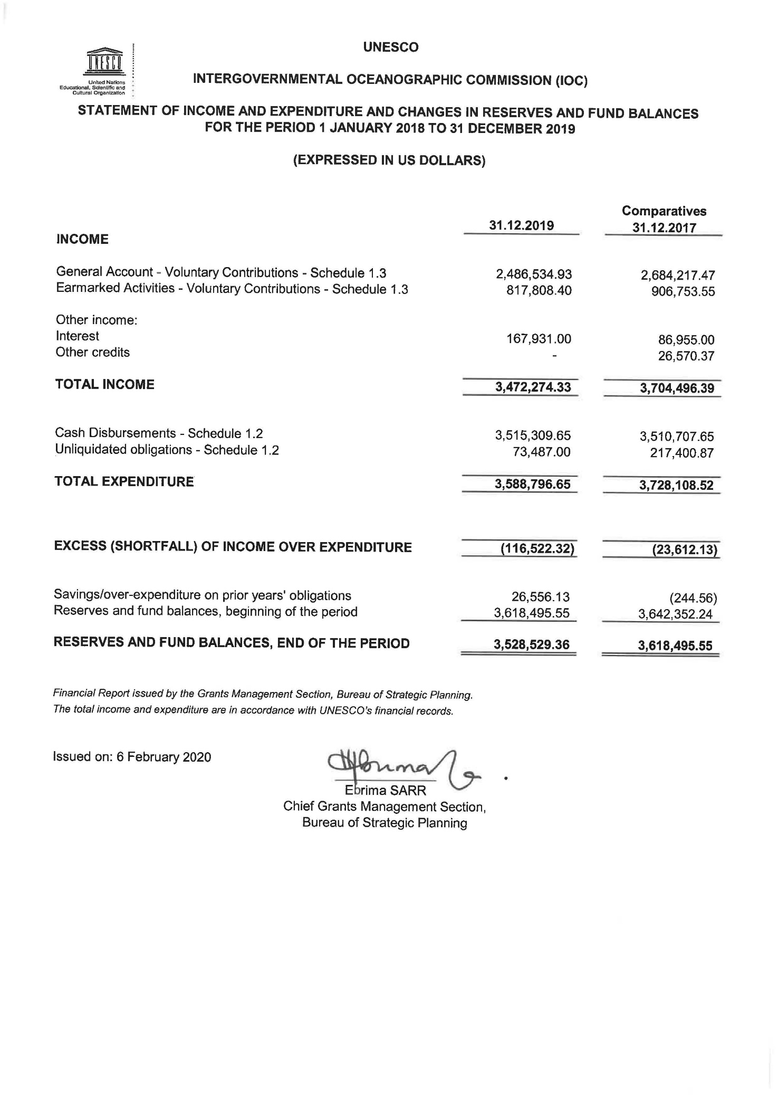

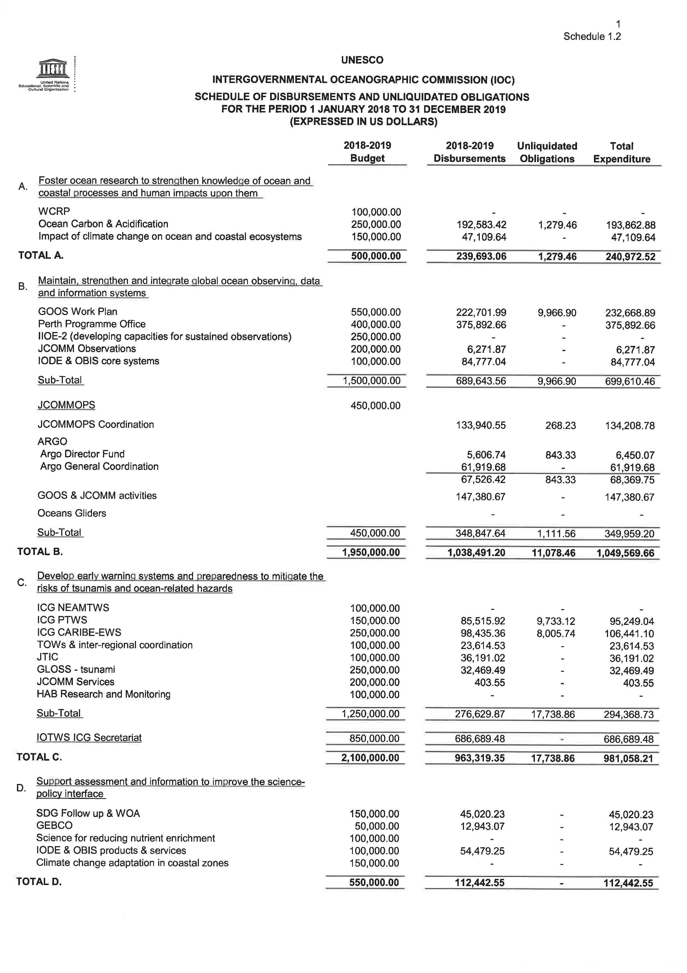

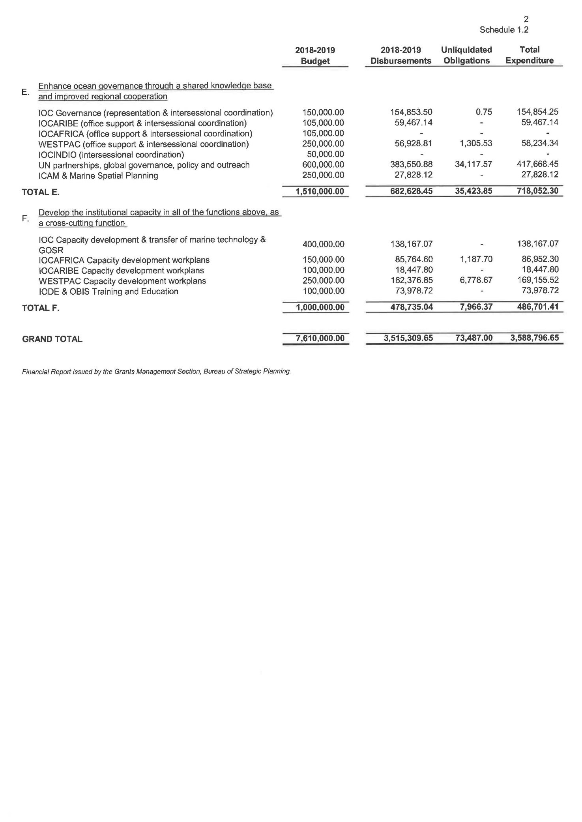

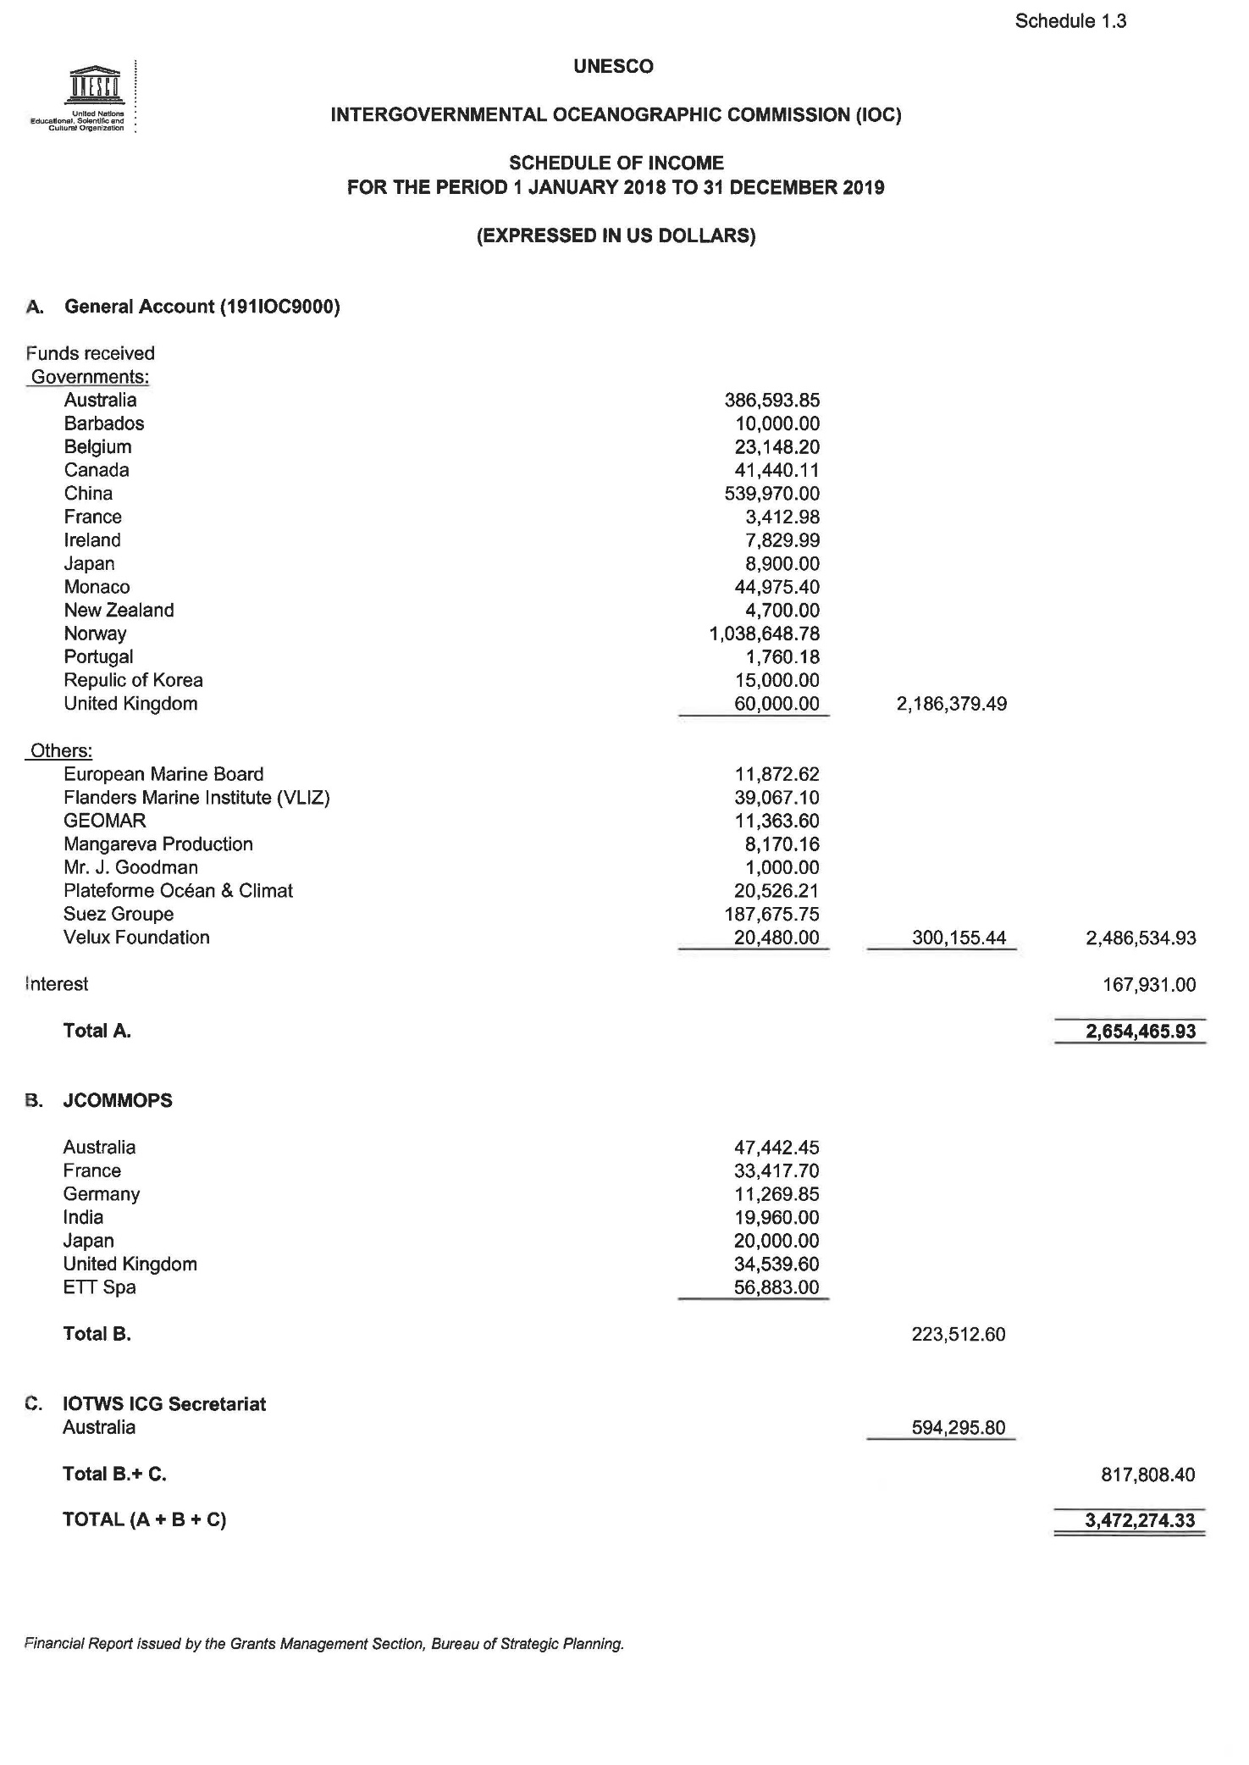

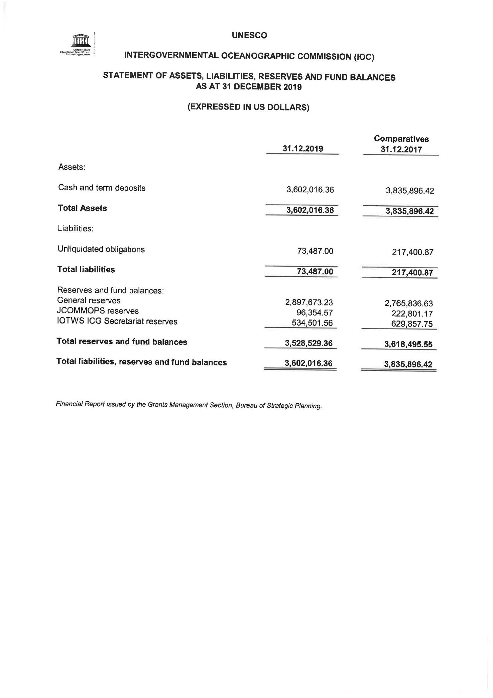

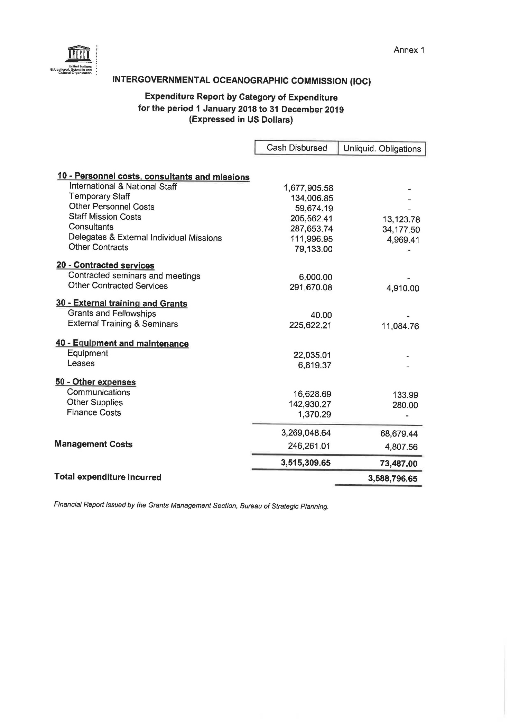

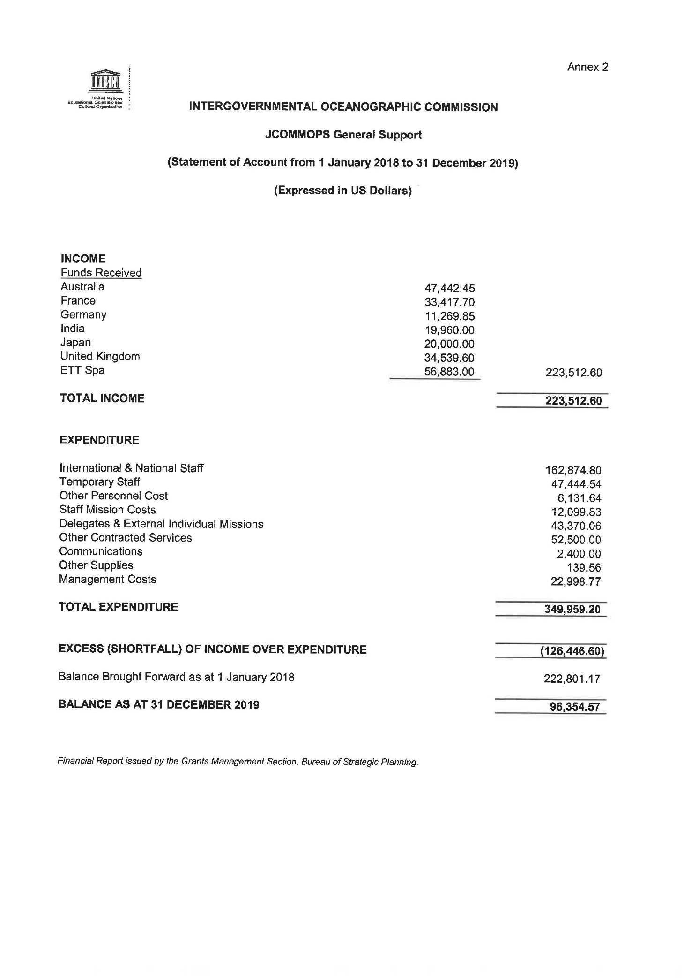

1. ‘Other’ groups individual contributions of less than US$ 90K.
2. These contributions are shown separately as they do not enter the UNESCO/IOC budgetary flow. Formal letters confirming the amounts reported were sent by the relevant partner institutions to the Executive Secretary for the purpose of inclusion in this report. The total of contributions of $ 2,788,733 for 2018 was reported to the UNESCO Executive Board in Annex III-b of document [206 EX/4.II.A.INF](https://unesdoc.unesco.org/ark:/48223/pf0000367527.locale=fr) and the total of contributions of US$ 7,411,518 for 2019 was reported to the UNESCO Executive Board in Table 3 of document 209 EX/4.II.INF.
3. Following the adoption by the 40th session of the General Conference of UNESCO of the budget scenario for 2020–2021 (40 C/5), based on the appropriated regular programme budget of US$ 534.6M (US$ 11,075,500 for the IOC), the Secretariat developed the work plans shown below consistent with [Resolution XXX-3](http://www.ioc-unesco.org/index.php?option=com_oe&task=viewDocumentRecord&docID=24888) and [IOC-XXX/2 Annex 9](http://www.ioc-unesco.org/index.php?option=com_oe&task=viewDocumentRecord&docID=24281).