|  |  |
| --- | --- |
| **World Meteorological Organization &**  **Intergovernmental Oceanographic Commission (of UNESCO)**  **Port Metereological Officers Training Workshop Sixth Session**,  Virtual Session, 16 and 18 March 2021 | Image result for ioc logo unesco  **PMO-6/Doc. 2.0** |
| Submitted by: Henry Kleta  26.02.2021  **DRAFT 1** |

**AGENDA ITEM 2: VOS Overview**

# SUMMARY

### Mr Henry Kleta (DWD, Germany, VOS Panel Chair) gave a short introduction on the Voluntary Observing Ship (VOS) Scheme.

The history and the current organisational framework were shown.

Details on the dataflows (real time - GTS - and delayed mode - MCDS) from VOS were shortly presented.

### Additionally some details on the PMO network were shown.

### B. ACTIONS/DECISIONS/Recommendations:

(a) Adopt draft Action/Decision/Recommendation*;*

* What, By who, Completion deadline
* Rational

# 

# C. BACKGROUND INFORMATION (not to be included in the session report):

### References (if any):

IMO MSC Circular 1293/Rev.1, 25 May 2018

"Participation in the WMO Voluntary Observing Ship Scheme"

IMO Draft MSC Circular 803

"Participation of NON-SOLAS Ships in the GMDSS"

2020 VOS data(map provided by OceanOPS)

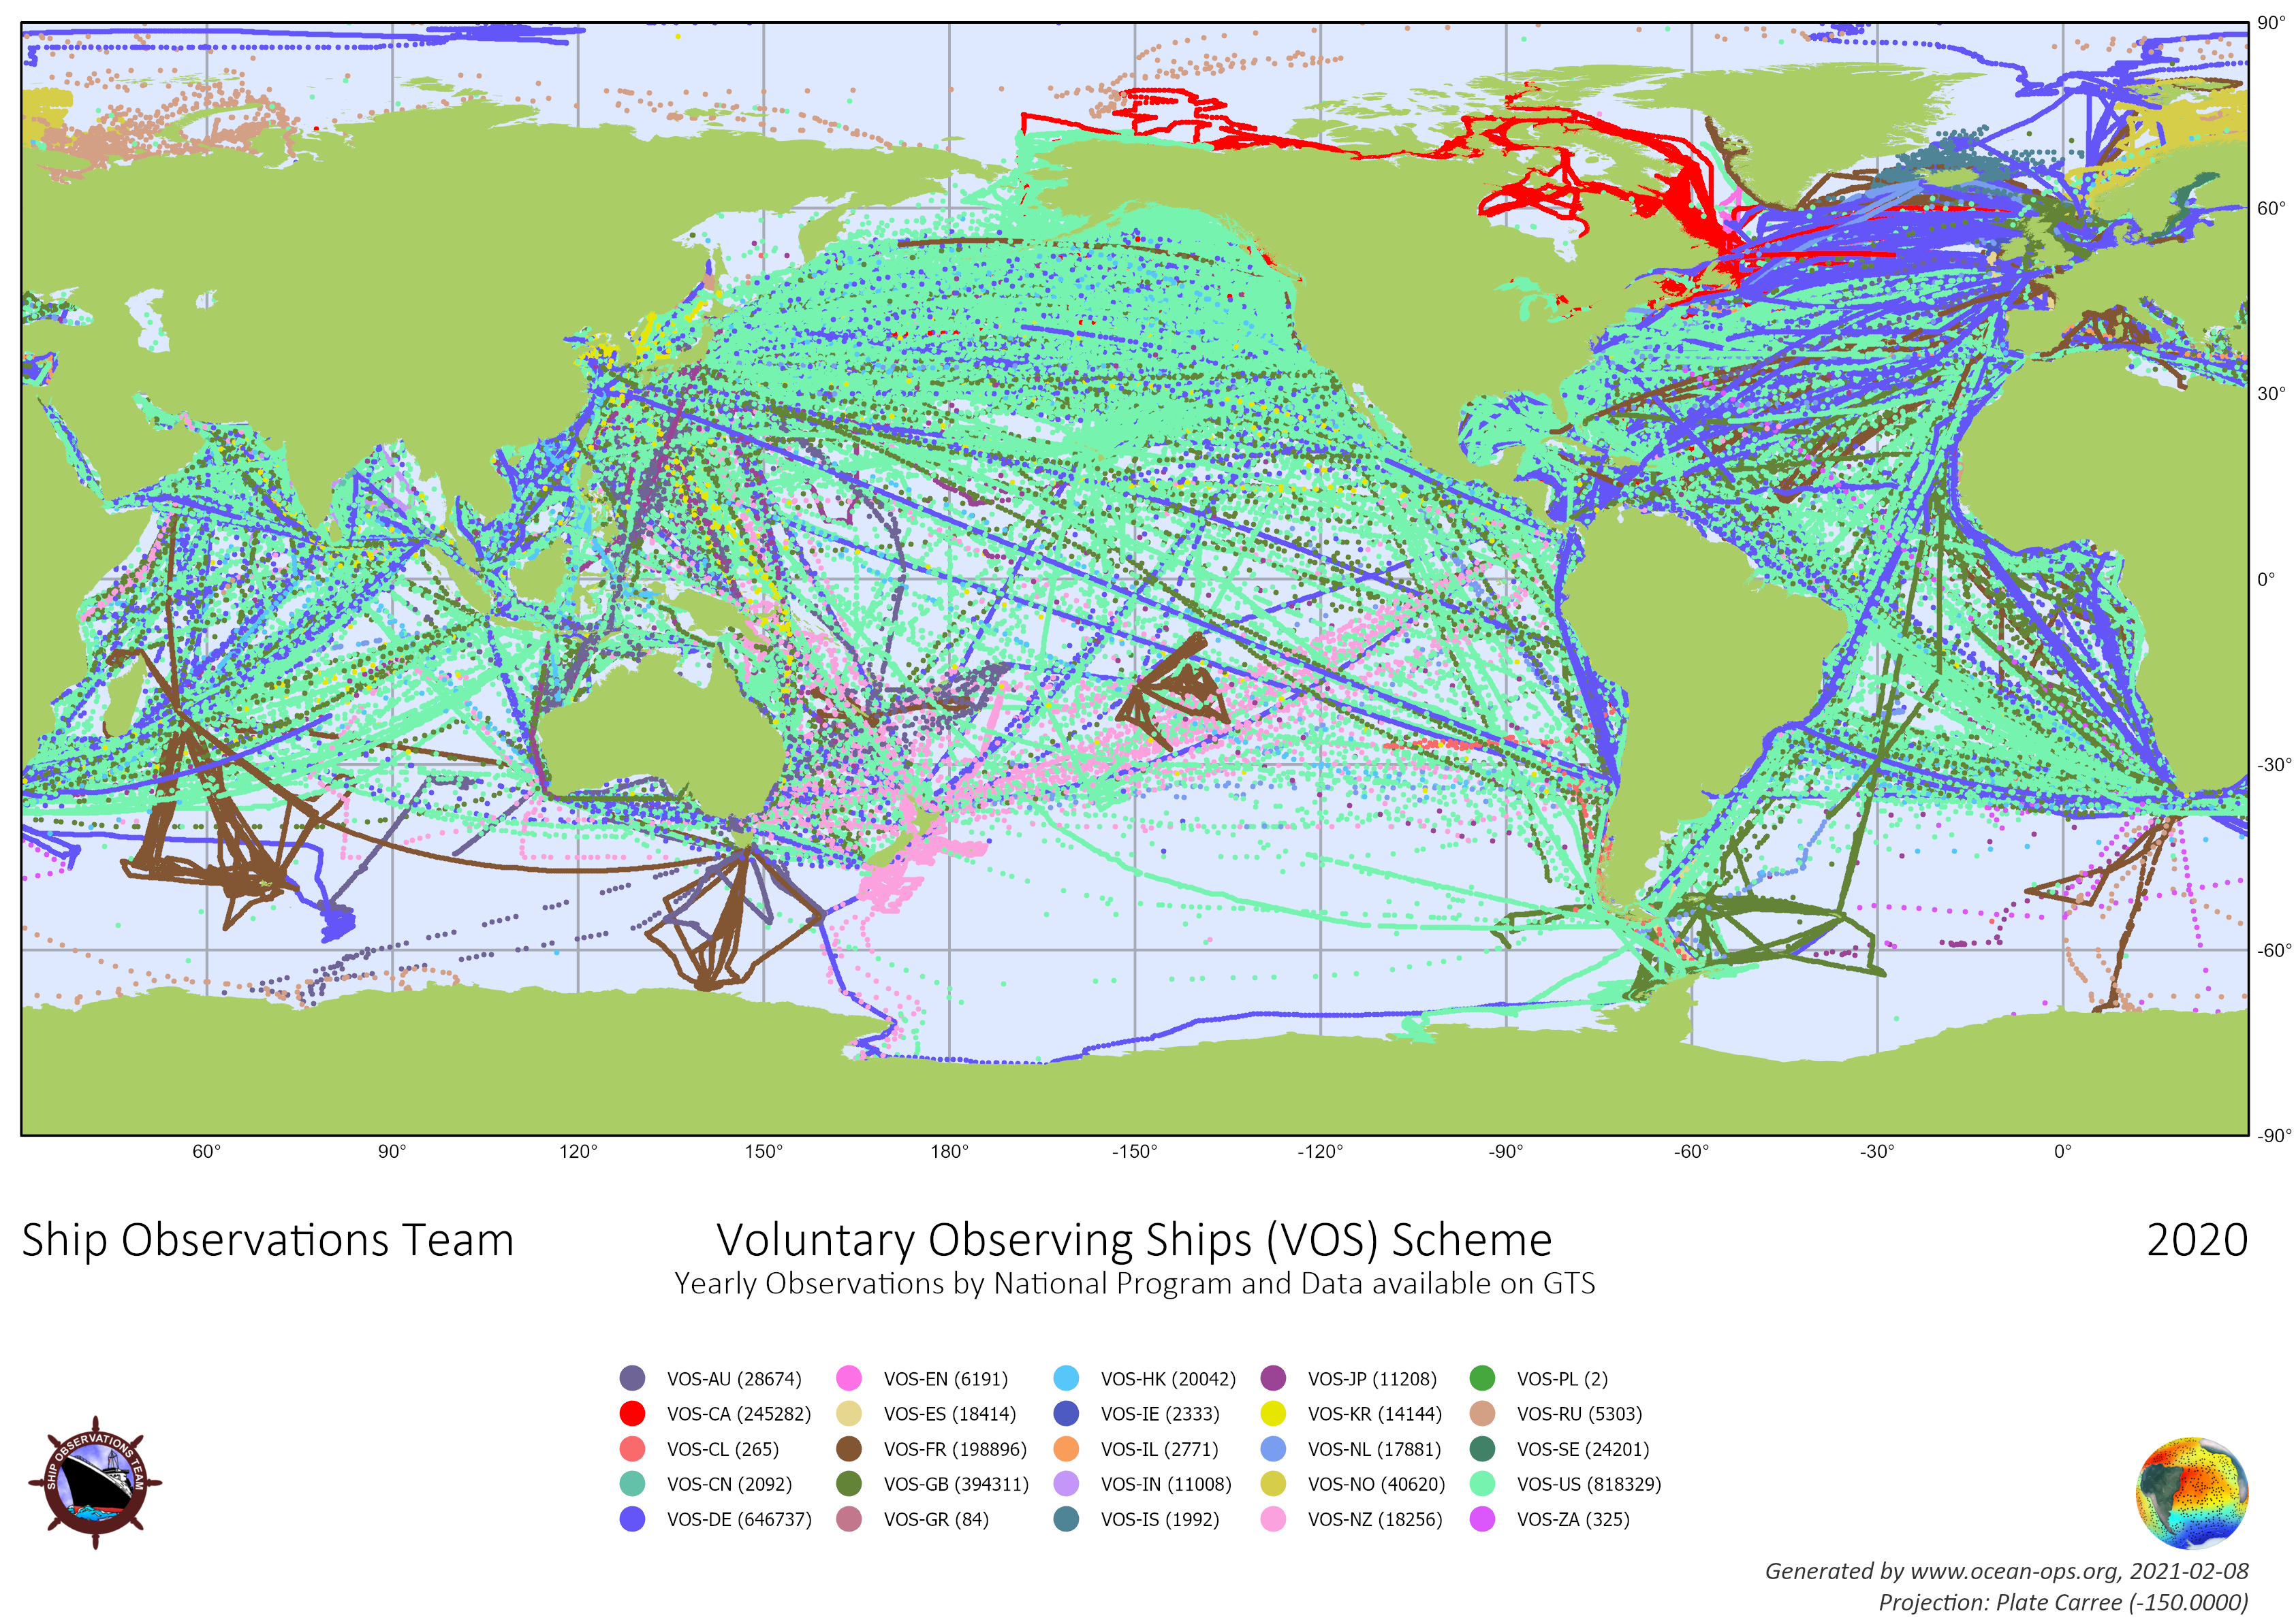

Data communications used by VOS (per VOS and per Obs, based on Pub47 Prst field)

