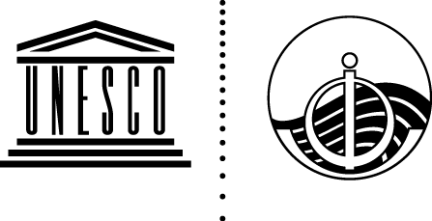
INTERGOVERNMENTAL OCEANOGRAPHIC COMMISSION
(of UNESCO)

Sixteenth Intergovernmental Session of the UNESCO-IOC Sub-Commission for the Caribbean and Adjacent Regions (IOCARIBE) – Virtual Meeting
(May 3 – 6, 2021)

TEMPLATE FOR SUBMISSION OF WRITTEN RECORDS
TO THE IOCARIBE SUMMARY REPORT
Member States that wish to provide a succinct written record of a particularly important aspect of their plenary intervention may do so in one of the four working languages of the Commission. Such statements will be annexed to the Sub-commission report in their original language. Statements should be sent using this template by email (p.wills-velez@unesco.org) to the IOCARIBE Secretariat.

Member State/Name of Delegation :
Agenda Item :
Date and Time of Intervention :
Name of Delegation Point of contact for this statement:
Title Agenda Item :
Statement:

