Summary
The IOC Assembly at its 30th session in 2019 adopted Resolution XXX-2 which, along with the parallel Resolution 9 (Cg-18) of the eighteenth session of the World Meteorological Congress, created the Joint WMO-IOC Collaborative Board. These resolutions asked the Collaborative Board to prepare a comprehensive and coordinated WMO-IOC Collaborative Strategy, based on existing sectoral strategies, and submit it in 2021 to the governing bodies of IOC and WMO for adoption.
Purpose of the document: The Assembly is invited to adopt this Collaborative Strategy, subject to its parallel adoption by the WMO Executive Council at its 73rd Session (also running 14–25 June 2021).
Financial and administrative implications: The financial and administrative implications of the activities fall within the parameters of the regular budget of IOC, and any extrabudgetary funds that can be raised.
The proposed decision is referenced Dec. A-31/3.5.5 in the Action Paper (document IOC/A-31/AP Rev.2)

Background
- In 2019, the eighteenth session of the World Meteorological Congress and the 30th session of UNESCO’s Intergovernmental Oceanographic Commission (IOC) Assembly mandated the creation of a Joint WMO-IOC Collaborative Board (JCB). The JCB is a guidance body, established to promote high-level collaboration and broad engagement of the relevant bodies of the IOC and World Meteorological Organization (WMO) with the intent to work together to advance all aspects of the value chain related to observations, prediction capabilities, data management/access, research, global and regional services and capacity building. On behalf of WMO and IOC, the JCB has developed this Collaborative Strategy to maintain, strengthen and promote links among the weather, water, climate and ocean communities in order to achieve the Visions of both IOC and WMO, building on a long history of cooperation.

Frameworks and collectively creating value
- Countries have made collective and synchronous commitments to disaster risk reduction, climate action and sustainable development through the United Nations. The individual and joint work of WMO and IOC advance this agenda “for people and planet” with essential technical, scientific, prediction and operational support.
- IOC and WMO are natural partners, and continued cooperation will maximize contributions to:
- Advance the 2030 Agenda for Sustainable Development and many Sustainable Development Goals (SDGs). Related to this, the United Nations Decade of Ocean Science for Sustainable Development 2021-2030 (Ocean Decade) will create transformative ocean science solutions to support the timely delivery of the data, information and knowledge needed to achieve a well-functioning ocean in support of SDGs.
- Keep people safe and prevent and reduce disaster risk, as identified in the Sendai Framework for Disaster Risk Reduction 2015-2030 and the International Convention for the Safety of Life at Sea, 1960 (SOLAS 1960).
- Prevent dangerous human-induced interference with the climate system, which is the objective of the United Nations Framework Convention on Climate Change (UNFCCC); reduce the risks and impacts of climate change through the Paris Agreement; and develop and incorporate science-based climate information and prediction into planning, policy and practice, which is the vision of the Global Framework for Climate Services (GFCS).
- Leave no one behind and support the unique challenges of least developed countries, landlocked developing States and small island developing States (SIDS), particularly through the SIDS Accelerated Modalities of Action (SAMOA) Pathway.
- WMO and IOC create societal benefit with value chains of observations, data management, forecasting systems and operational services, flowing from a common infrastructure through scientific research, assessments and policy influence. Collaboration, co-design and co-creation will support the action of WMO Members and IOC Member States, including through regional approaches and capacity development.

Vision
- The Vision in the WMO Strategic Plan 2020-2023 states that by 2030, a world will be seen “where all nations, especially the most vulnerable, are more resilient to the socioeconomic consequences of extreme weather, climate, water and other environmental events; and underpin their sustainable development through the best possible services, whether over land, at sea or in the air”.
- The Vision in the IOC Medium-Term Strategy 2022–2029 is to “bring together governments and the science community in achieving ‘The Science We Need for the Ocean We Want’” namely a clean, healthy and resilient, productive, predicted, safe, accessible, and inspiring and engaging ocean, where society understands and values the ocean in relation to human wellbeing and sustainable development.
- The two organizations complement the desire to strengthen Members/Member States in building their resilience and reducing risk, underpinning national and global sustainable development. Driven by the nature of each organization, WMO emphasizes the services and consequences linked to weather, climate and water, whereas IOC emphasizes scientific understanding and solutions for the entire ocean realm, including a healthy ocean. The differences are to be acknowledged but do not detract from the common elements of the visions between the two.

Mission and objectives
- IOC’s mission is to “promote international cooperation and to coordinate programmes in research, services and capacity-building, in order to learn more about the nature and resources of the ocean and coastal areas and to apply that knowledge for the improvement of management, sustainable development, the protection of the marine environment, and the decision-making processes of its Member States”. The IOC high-level objectives are:
- Healthy ocean and sustained ocean ecosystem services
- Effective warning systems and preparedness for tsunamis and other ocean-related hazards
- Resilience to climate change and contribution to its mitigation
- Scientifically-founded services for the sustainable ocean economy
- Foresight on emerging ocean science issues.
- The mission of the Ocean Decade, which IOC coordinates on behalf of the United Nations system, is “transformative ocean science solutions for sustainable development, connecting people and our ocean”.
- WMO’s mission is “to facilitate worldwide cooperation on monitoring and predicting changes in weather, climate, water and other environmental conditions through the exchange of data, information and services, standardization, application, research and training”. WMO is the authoritative voice on the state and behaviour of the Earth’s atmosphere, its interaction with the land and ocean, the weather and climate it produces, and the resulting distribution of water resources. WMO’s long-term goals and strategic objectives embrace a comprehensive Earth system approach, with a strong focus on water resources and the ocean. WMO long-term goals include to:
- Better serve societal needs
- Enhance Earth system observations and prediction
- Advance targeted research
- Close the capacity gap on weather, climate, hydrological and related environmental services
- Strategic realignment of WMO structure and programmes for effective policy and decision-making and implementation.
- The two organizations have a complementary mission in international cooperation, in closely allied areas. There is commonality in their objectives with both focused on early warning systems for hazards, understanding and monitoring parts of the Earth system, resilience to climate change and variability, observations, research and capacity development. Their divergences lie in the thematic scope. The overlapping ocean components between the two, with the ocean being integral to the Earth system, create the basis for a symbiotic partnership.

Key drivers
- WMO and IOC jointly recognize the following key societal drivers, linked to risk, economy and sustainable development:
- The skill of medium- and long-range weather forecasts is improved by the inclusion of ocean data in coupled ocean and atmospheric forecast models.
- High-impact weather, water and climate extremes have devastating consequences for the safety of people, national economies, urban and rural environments, and food and water security. According to the WMO-UNEP Intergovernmental Panel on Climate Change (IPCC), these extremes are expected to occur with greater frequency and/or intensity as greenhouse gas concentrations continue to rise.
- Climate variability and change impact many elements on which human well-being depends. They modify patterns of rainfall and drought, sea level, and coastal erosion. Temperature changes and ocean deoxygenation and acidification add stress to ecosystems and impact goods and services they provide.
- Coastal development continues at a rapid pace, increasing society’s exposure to and risk from ocean-related hazards.
- The OECD estimates that the ocean economy generated US$1.5 trillion in 2010 and, depending on climate change pathways, has the potential to outperform the growth rate of the global economy. Ocean, weather, climate and water knowledge and information are all essential for generating profits, jobs, protecting livelihoods and developing the ocean economy in a sustainable manner.
- The ocean is a potential source of solutions for climate change mitigation and for many dimensions of a sustainable ocean economy. Climate services can add significant value to the efficiency of integrated ocean management.

Overarching opportunities
- IOC and WMO already have a strong history in partnership. Building on this, there is opportunity to strengthen the partnership in existing and emerging activities and within the context of an Earth system approach, responding to societal drivers. Rapid progress in science and technology provides the opportunity for WMO and IOC to work collaboratively to improve interdisciplinary services and make them more accessible to developing countries. Advanced weather, water, ocean and climate services contribute to timely and effective planning and decision-making, resulting in greater socioeconomic benefits.
- Furthermore, as new forms of measurement and new uses for those measurements emerge, IOC Member States’ and WMO Members’ reliance on our organizations for this information will only increase. Jointly advancing the global observation and numerical weather, ocean and climate prediction systems, incorporating new technological developments, will provide a foundation for efficiently addressing the increasing requirements for impactful decisions related to a wide range of applications from public safety and transport to agriculture, energy, health and water resource management.

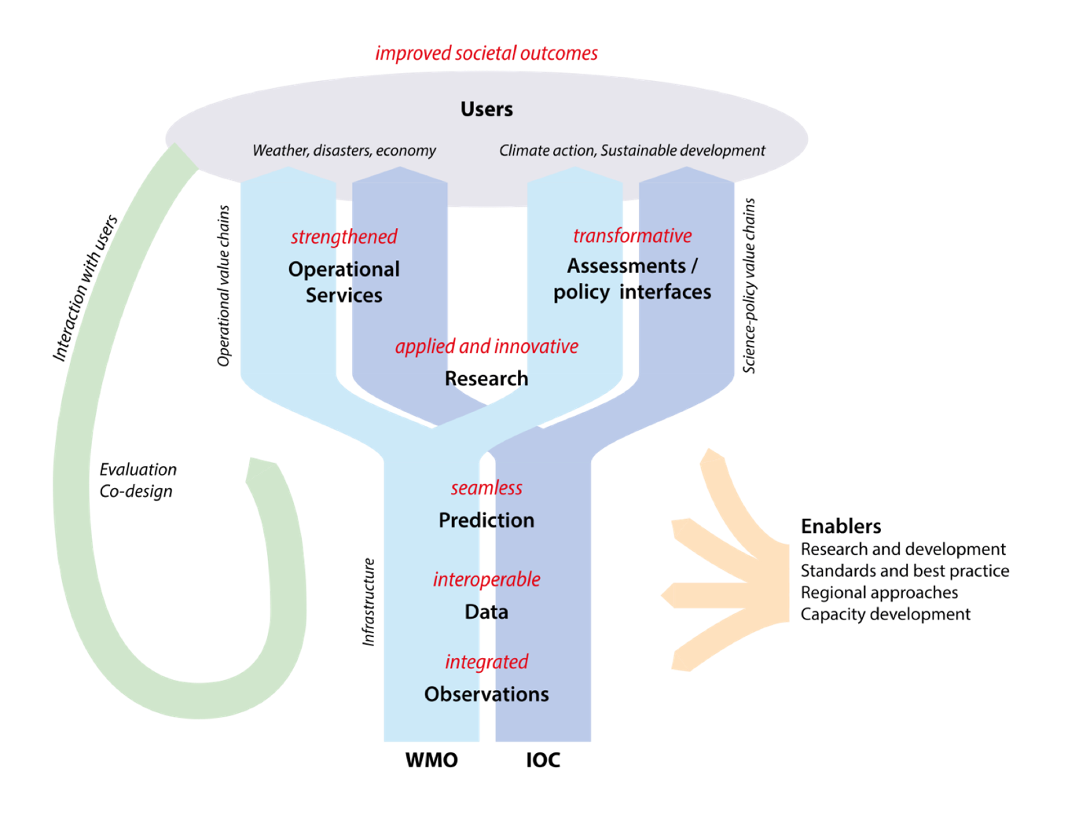

Figure: Value chains (blue), feedback cycles (green), and enablers (orange) across meteorological and oceanographic infrastructure, service delivery and science-policy interfaces covered in this collaborative strategy. Working strategically together can make the infrastructure more integrated, interoperable and seamless, strengthen operational services, promote innovative cross-disciplinary research and transform science-policy interfaces (red). Ultimately, they will improve societal outcomes related to weather, climate, disasters, the economy, climate action and sustainable development.
- The figure above depicts the two types of value chains from a common infrastructure of observations, data management and prediction, including a branch with operational service delivery and another branch addressing the science-policy interface. Reinforcing these value chains across WMO and IOC communities will lead to improved societal outcomes. This will depend as well on interaction with users, evaluating the value chains and co-designing responsive changes. Enablers across the meteorological and oceanographic spaces include research and development that leads to both operational and policy-relevant advances, the promotion of standards and best practice, taking appropriate regional approaches and building the capacity of all Members and Member States to engage for their own national and regional benefits.
- Through this WMO-IOC Collaborative Strategy, a strengthened partnership is envisaged, which would bring IOC and WMO closer together in delivering mutual benefits to both Members and Member States. This implies a greater Earth system approach, with integrated observing systems, interoperable data and information systems, seamless forecasting and prediction systems, strengthened operational services, innovative and cross-disciplinary research and transformative scientific input into policy processes.

Approaches
- WMO and IOC should collaborate on the following six approaches:
- Communicate and engage for mutual strategic reinforcement
- Acknowledging the common goals of the two agencies and the urgent need to raise the awareness of the scientific and technical approaches IOC and WMO can bring to solving societal challenges, including to national and global stakeholders, policy and decision makers and the broader public, WMO and IOC should strengthen collaboration in communication to common stakeholders. Fortifying the Earth system approaches already carried out in joint IOC and WMO representative agencies at the national level – emphasizing shared objectives – would be beneficial. Fostering internal communication amongst WMO and IOC expert networks is also important for improved collaboration and building a shared and engaged community. Where successes are observed, IOC and WMO together should create conditions to replicate these and scale them up. Providing advocacy for, and learning from, each other is also encouraged. Doing so would enable strategic and mutual reinforcement of the collaborative WMO and IOC activities and interests.
- Develop standards and best practices
- To ensure the maximum impact in delivering outcomes for societal benefit, IOC and WMO should create and maintain an approachable, robust and complementary set of standards and best practices. WMO and IOC should encourage the development and publication of best practices and the identification of gaps in this material, and take advantage of the mandatory WMO regulatory framework, where appropriate. Coordinating IOC and WMO data policies will bring mutual benefit.
- Meet service needs and respond to change
- Recognizing that both WMO and IOC are working to develop new and strengthen existing service delivery and skill, for multiple benefits across the value chain, both agencies should collaborate in identifying and monitoring the user requirements, to ensure relevance and response to change. Important components of this would include the co-design and building of sustained observing, data, and prediction infrastructures, research projects and services, promoting the transfer of technology and information. Conditions for innovative approaches should be fostered. Evaluating and monitoring improvements, while seeking regular feedback from users, is crucial.
- Support and leverage priority/complementary initiatives in the value chain
- At the core of the ocean collaboration between IOC and WMO, it is vital for both agencies to support and leverage priority and complementary initiatives along the value chain. In this regard, strengthened collaboration across the value chain will boost the intent for a seamless end-to-end research to operations system that delivers tangible and effective outcomes. In addition, closing the gap between the complementary work of the agencies would enhance benefits to users and stakeholders. Considering the full value chain, some key flagship initiatives for targeted focus include:
- Research: Foster collaborative innovation from both the WMO and IOC communities on ocean-atmosphere coupling and exchange to support advances across the broad range of weather, climate and ocean science for sustainable development.
- Observations: Collectively identify and support the observations (including both satellite and in-situ) with highest impact for mutually aligned service requirements and delivery, supporting optimal network design, while strengthening the international alliances to sustain ocean observing systems, linking in research and operational efforts.
- Data management: Coordinate outreach within IOC and WMO communities to identify requirements for use and provision of data and information around the delivery of tailored services and products of mutual concern. This would include identifying gaps, aligning data policies, building a common strategy, driving widespread provision and uptake of data across a broad sector of stakeholders, and engaging Members and Member States for developing joint data projects.
- Predictions: Identify priority Research to Operations and Operations to Research (R2O and O2R) actions as projects jointly agreed upon by the research and operational communities, focusing on thematic joint areas like high-impact marine weather, sub-seasonal to seasonal (S2S) and polar prediction projects, including their co-design, based on user needs and research advances.
- Services: Create a framework to globally address coastal inundation, marine environmental emergencies, and hazardous maritime and coastal weather events into a multi-hazard early warning system that enables users to access authoritative and accurate forecasts and early warnings at sea and along the coast. Enable better management of the risks of climate variability and change and adaptation to climate change through climate information, user interfaces and services.
- Regarding the existing formal co-sponsored initiatives of WMO and IOC: Global Ocean Observing System (GOOS), Global Climate Observing System (GCOS) and World Climate Research Programme (WCRP); it is important to continue strengthening them in the context of this strategy, in conjunction with the other co-sponsors.
- Monitoring and evaluating the availability of more and timely observations, data, forecasts, and services to both meteorological and ocean agencies would be important to measure the success of this approach.
- Motivated by the framework of the Ocean Decade, co-design and/or extend existing projects for high-value outcomes in weather, climate and disaster risk reduction (including with a focus on coastal zones and polar regions); responding to the research, observing and data infrastructure challenges; and when possible, exploring cross-cutting projects.
- Cooperate in capacity development where there is mutual benefit
- Capacity development, training and transfer of technology is a key element underpinning both WMO’s and IOC’s overlapping interests, output and beneficiaries. In areas of mutual interest, both Member and Member States would significantly benefit from joint capacity development and training initiatives. Particular attention should focus on joint IOC and WMO national agencies to reduce the number of duplicated activities. Closer cooperation between existing training and capacity development initiatives and infrastructure is needed – including, for example, between WMO Regional Training Centres and IODE Training Centres. Small island developing States (SIDS) and least developed countries with large coastal communities and a reliance on the marine economy should be prioritized.
- Take joint regional approaches
- Despite IOC and WMO regional structures not matching perfectly in a geographic sense, to strengthen partnerships between WMO and IOC and a broader community of stakeholders with a common interest, there is an advantage to addressing regional considerations. These can be met by the objectives within each component of the value chain, as well as in capacity development. Existing useful regional frameworks should also be utilized (e.g., Regional Climate Centres, Regional Climate Outlook Fora (RCOFs) and the GOOS Regional Alliances, among others) and regional bodies should work together to advance common objectives. Ideally, this would be synthesized into an overarching regional statement on working together, with references to specific regional priorities and strategies, as well as cooperation between regions with comparable characteristics. Coordination and follow-up between IOC and WMO regional offices intra-region is essential. Partnership could also be strengthened through WMO and IOC regional offices reaching between regions and providing regular feedback to IOC and WMO headquarters and technical bodies.
- Implementing these approaches will require targeted action, for which the JCB will play an overarching guidance and catalytic role.

ANNEX

List of Acronyms
GCOS | Global Climate Observing System
GOOS | Global Ocean Observing System
IOC | Intergovernmental Oceanographic Commission
IPCC | Intergovernmental Panel on Climate Change
JCB | Joint WMO-IOC Collaborative Board
O2R | Operations to Research
ODIS | Ocean Data and Information System
OECD | Organisation for Economic Co-operation and Development
R&D | Research and development
R2O | Research to Operations
S2S | Sub-seasonal to Seasonal Prediction Project
UNEP | United Nations Environment Programme
WCRP | World Climate Research Programme
WMO | World Meteorological Organization

