Summary
This note was received from the Secretariat of the World Climate Research Programme (WCRP) in response to a request from the IOC Secretariat in light of IOC’s capacity as one of the co-sponsors of WCRP.
The document illustrates recent developments related to WCRP that will elucidate alignment and synergies with relevant IOC programmes and activities and also with the UN Decade of Ocean Science for Sustainable Development, for the information of IOC Member States at the 31st session of the IOC Assembly.

Introduction
WCRP is sponsored by the World Meteorological Organization (WMO), the International Science Council (ISC), and the Intergovernmental Oceanographic Commission (IOC) of the United National Educational, Scientific, and Cultural Organisation (UNESCO). Scientific oversight and direction for WCRP is the responsibility of the Joint Scientific Committee, appointed by the three sponsors and currently chaired by Prof. Dr. D. Stammer (University of Hamburg). Day-to-day management of the Programme is carried out by Secretariat Staff at WMO in Geneva and by international project offices, which are supported primarily by generous national contributions.
The new WCRP
The World Climate Research Programme (WCRP) leads the way in addressing frontier scientific questions related to the coupled climate system — questions that are too large and too complex to be tackled by a single nation, agency or scientific discipline. In 2020 WCRP looked to the future, to move from strategies outlined in the WCRP Strategic Plan 2019-2028 to a structure and research priorities aimed at addressing the urgent challenges, and taking advantage of the opportunities, that society faces now and will face in the future.
After extensive groundwork, it was agreed in December 2020 that WCRP will establish two new Core Projects: Earth System Modelling and Observations and Regional Information for Society. These two projects will ensure that modelling and observational efforts are well integrated across WCRP and that the climate information from all WCRP activities is accessible, useful and useable by society at large. These two new Core Projects will augment and complement the work of our long-standing four Core Projects (CLIVAR, GEWEX, SPARC and CliC – see below), which will continue under the new WCRP.
The WCRP community also established five new Lighthouse Activities, which will tackle critical issues over the next decade. Although the science plans for these are still being developed the intention is that all these will include ocean components:
- Explaining and Predicting Earth System change: Developing capabilities for explaining, predicting, and gaining an early warning of changes in the Earth system (including the oceans), with a focus on the annual to decadal time-scales, regionally and globally;
- My Climate Risk: Assessing and explaining regional climate risk to deliver climate information that is meaningful at the local scale (intention is to have one ‘lab’ on the oceans and to connect to the Ocean Decade);
- Safe Landing Climates: Exploring the routes to climate-safe landing 'spaces’ for human and natural systems (will include a theme on the impacts of sea level rise on future habitability);
- Digital Earths: Creating digital and dynamic representations of the Earth system that can be openly explored and accessed in new and innovative ways (including the oceans e.g. linking to the DITTO – Digital Twins of the Ocean – project);
- WCRP Academy: Bringing together existing and facilitating new climate research and education opportunities to prepare for a new generation of climate scientists and leaders (including the oceans).
To ensure that communities around the world have a voice in shaping WCRP priorities, the Programme established a series of Climate Research Forums in 2020, with over 50 Regional Focal Points from around the world; we have delivered five of our planned Forums for 2020-21, reaching an audience of around 1000 of our broader community across Oceania, Asia, North America, Greenland and Europe. We envisage running the final three Forums in the last quarter of 2021, including one in South America that will have an Oceans focus. Building on these and the ongoing strategic development of WCRP, planning has started for a WCRP Open Science Conference in 2023, focusing on bridging climate science and society.

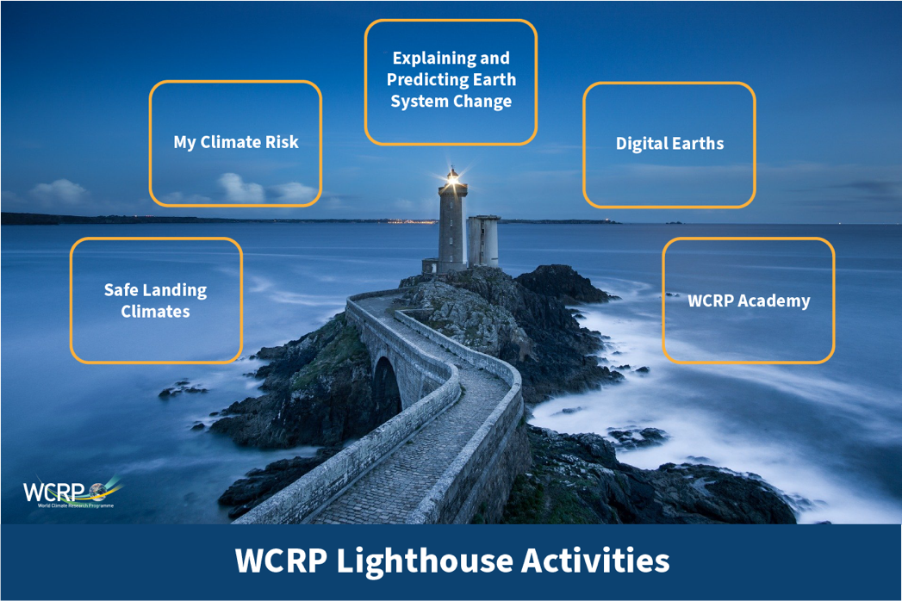

WCRP and the Ocean Science Community since the last IOC GA

The WCRP Grand Challenges
http://wcrp-climate.org/grand-challenges
The overarching WCRP Grand Science Challenges (GCs) represent major foci of scientific research, modelling, analysis and observations. Of the Grand Challenges, Regional Sea-Level Change and Coastal Impacts is of most direct relevance to IOC-UNESCO, though many others (e.g. on decadal climate, carbon feedbacks) have a significant ocean component. The Sea Level GC represents an integrated interdisciplinary program on sea level research reaching from the global to the regional and local scales. The 2019 meeting of the WCRP Grand Challenge on Regional Sea Level and Coastal Impacts was held from 12-15 October 2019 in Orléans, France, with the first two days focused on the links between science and coastal climate services. The workshop, which was organized in association with IOC/GLOSS, WMO and CLIVAR focused on stimulating the uptake of coastal climate services, how they support present days and future coastal resilience, and making recommendations as to the best way forward. A specific research topic on ‘Climate Services for Adaptation to Sea-Level Rise’ in Frontiers in Marine Science has been coordinated by the GC. The leadership of the GC has been updated by including the representativeness from user communities. A 2nd Sea Level Conference is planned to be held in July 2022 in Asia (Singapore), with a large representation from vulnerable Asian coastal areas, including top world stakeholders, city planners, coastal developers and managers and other relevant stakeholders to focus on the flow of knowledge from sea-level science to strengthen climate change adaptation and disaster resilience in coastal zones. As with all WCRP Grand Challenges, the Sea Level GC will come to an end after the 2nd Sea Level Conference. But sea level research will continue to take place within various elements of the new WCRP.
The WCRP Core Projects
WCRP carries out a major part of its activities through its four long-standing core projects, CLIVAR (oceans and climate - www.clivar.org), CliC (cryosphere and climate - www.climate-cryosphere.org), GEWEX (water and climate www.gewex.org) and SPARC (upper atmosphere and climate - http://www.sparc-climate.org). The two new Core Projects, whose science plans are still under development, will also have important ocean components as will the new Lighthouse Activities (see previous section). Of these Core Projects the work of CLIVAR is of particular relevance to IOC.
CLIVAR (Climate and Ocean: Variability, Predictability and Change) is one of the four original Core Projects of the WCRP, which aims to understand the dynamics, the interaction, and the predictability of the climate system with emphasis on ocean-atmosphere interactions. Many CLIVAR panel and Research Foci members are significantly involved in the design and planning of the new Lighthouse activities. Meanwhile, in response to the rapid pace of scientific advances and recognizing the need for the project to be flexible and responsive to new ideas and challenges, a new research foci on Tropical Basin Interactions has been approved. COVID-19 has hindered many activities organised by CLIVAR, however, the CLIVAR community is adapting to the new normality at a fast pace. The planned CLIVAR/FIO summer and ENSO summer schools are postponed to 2021. With the emphasis on connecting observation-modeling-prediction, a pan-CLIVAR workshop on ‘From global to coastal: Cultivating new solutions and partnerships for an enhanced Ocean Observing System in a decade of accelerating change’ will be organised in May 2021 at ICTP, Italy, in cooperation with IOC-UNESCO, GOOS, and other international partners. CLIVAR is also trying to increase its relevance and contribution to the UN Decade of Ocean Science for Sustainable Development, initiated by IOC-UNESCO.

Intergovernmental Oceanographic Commission (IOC)
United Nations Educational, Scientific and Cultural Organization
7 Place de Fontenoy
75 732 Paris Cedex 07, France
Tel.: +33 1 45 68 10 10
http://ioc.unesco.org

This will include existing modelling working groups and the Coupled Model Intercomparison Project (CMIP)
This will include the Coordinated Regional Climate Downscaling Experiment (CORDEX)

