Intergovernmental Oceanographic Commission
Reports of Meetings of Experts and Equivalent Bodies

OBIS Executive Committee (EC-OBIS) & OBIS Steering Group

Fourth Session EC-OBIS and Interim session SG-OBIS
Online
26-27 May 2021

UNESCO

Agenda

1. Opening and adoption of agenda 4
2. Status of the OBIS work plan 2021 4
2.1. OBIS Executive Committee report 5
2.1.1. Report on the IODE Committee Meeting 5
2.1.2. Report on other meetings 7
2.2. OBIS secretariat report 8
2.3. OBIS nodes report 10
2.4. OBIS Strategic Advisory Task Team report 12
2.5. OBIS Taxonomy Task Team report 13
2.6. OBIS Capacity Development Task Team report 13
2.7. OBIS Communications and Outreach Task Team report 14
2.8. OBIS Data Quality Assessment and Enhancement Project Team report 15
2.9. OBIS Vocabulary Infrastructure Project Team report 15
2.10. OBIS Genetic Data Project Team report 16
2.11. OBIS Project Team on the UN Ocean Decade 17
3. New planned activities 19
3.1. eDNA expeditions in MPAs 19
Annex 1. Agenda and Time Table 20
Annex 2. Results of a survey about collaboration between OBIS nodes and GBIF nodes, and data flows from GBIF nodes to OBIS 21
Annex 3. List of Participants 28

IOC/IODE-OBIS-EC-IV
Online, 26-27 May 2021
English only

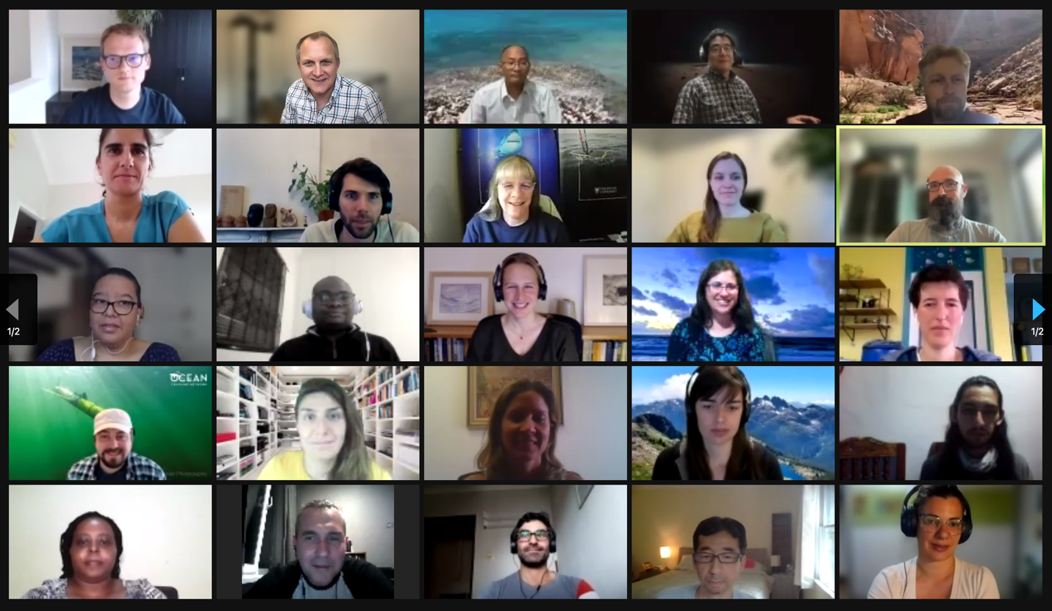

For bibliographic purposes, this document should be cited as follows: OBIS Executive Committee (OBIS-EC), Forth Session, 26-27 May 2021 Reports of Meetings of Experts and Equivalent Bodies, UNESCO 2020 (English), UNESCO, 19 pp. 3 annexes.

Executive Summary

On 26-27 May 2021, 35 participants from 20 countries representing 22 OBIS nodes participated in the 4th session of the OBIS Executive Committee, which was also held as an interim OBIS steering group meeting. The committee reviewed the status of the 2021 OBIS work plan and discussed new activities.

The OBIS steering group welcomed the new technical developments and capabilities in OBIS (new bioinformatics pipelines) leveraged through the Flanders’ government funded PacMAN project (Pacific Islands Marine Bioinvasions Alert Network). This will also allow OBIS to embark on new activities and transitioning OBIS into supporting operational activities, such as supporting local biodiversity monitoring and evaluation based on (e)DNA.

The collaboration with the GBIF network was briefly discussed and a follow-up meeting will further discuss and make recommendations on the data flow of marine data from GBIF nodes/publishers to OBIS.

The steering group agreed to hire a consultant to perform a review of the (increased) requirements from key stakeholders (e.g., GOOS, MBON, ODIS, and those identified through Ocean Decade Actions) and do a gap analysis or assessment of OBIS and its nodes’ capacity to support those needs including support for EOV data management. The steering group also agreed to contract a communication company to support the development of online video training tutorials.

The steering group endorsed the new terms of reference of the OBIS vocabulary project team. The OBIS vocab team is working on guidelines for mapping the most commonly used Measurement or Fact terms with the preferred BODC vocab and will propose a way forward to develop a mechanism or governance strategy to coordinate and build community consensus with regards to vocab mapping and priority setting of creating new vocab terms, including training.

The OBIS genetic data project team reported on the progress in developing guidelines using biodiversity data standards for sequence based data (in collaboration with TDWG and GBIF) and will illustrate this through a few use cases. The OBIS specific guidelines will be ready for presentation and adoption at the next OBIS steering group meeting (November 2021).

OBIS will be involved in several UN Ocean Decade programmes and IODE also requested OBIS to submit a standalone Decade Project proposal, which should present a vision and roadmap on what OBIS envisions to become by 2030, and how it can support the various Decade actions.

Opening and adoption of agenda

Martha Vides and Anton Van de Putte (SG-OBIS Co-Chairs) opened the meeting and welcomed all the participants.

Vides introduced the agenda and timetable. She explained that the meeting objective was to review and report on the status of the action items of the 2021 OBIS work plan and discuss any new activities. The participants were asked to raise hands (or add @h in the chat) if they wanted to speak. She mentioned that informal discussions in the chat box will not be recorded in the meeting report.

The meeting was split into 2 sessions of 3 hours maximum for each session. The first session was about reporting on the activities and proposed planned activities. The second session was spent on the adoption of the decisions and recommendations. The first session was recorded and shared with the entire steering group, and the participants were asked to provide feedback and input in the shared annotated agenda ahead of the second session, so we had all the information available for adoption before the meeting ended.

The meeting was attended by 35 participants from 20 countries representing 22 OBIS nodes, including the International Seabed Authority, who recently joined OBIS as new OBIS node.

Apologies were received from Izwandy Bin Idris (OBIS Malaysia), Maria Cornthwaite (OBIS Canada), Henrik Enevoldsen (HAB OBIS), Aidy M Muslim (OBIS Malaysia), Dave Watts (OBIS Australia).

The SG-OBIS welcomed the International Seabed Authority (ISA) as a new OBIS node. The ISA will publish the biodiversity data contained in ISA’s database, DeepData, through the OBIS platform, which will greatly enhance the global accessibility and visibility of deep-sea biodiversity data collected and submitted by contractors through their exploration activities in the past several decades.

Mirtha Lewis (OBIS Argentina) reported to us before the meeting that she will retire as the Argentinian OBIS node manager and be replaced by Marcos Zarate. Mirtha will still be involved and will assist Marcos in data quality tasks.

The SG-OBIS thanked Mirtha Lewis for her OBIS leadership in Argentina, which she executed since 2005 and welcomed Marcos Zarate as the new ArOBIS node manager.

Status of the OBIS work plan 2021

Anton Van de Putte (SG-OBIS Co-Chair) continued the meeting and invited the chairs of the various task teams and project teams to report on the activities, both completed, ongoing or planned. The meeting participants were asked to provide feedback and agree or disagree on any proposed changes to the work plan and budget.

OBIS Executive Committee report

Report on the IODE Committee Meeting

Martha Vides reported that several members of OBIS participated in several IODE inter-sessional working groups to prepare the 26th session of the IOC Committee on International Oceanographic Data and Information Exchange, which was held between 20-23 April 2021. Also, the OBIS secretariat supported all the IWGs. The following OBIS members were part of:

- GROUP 1: Review of NODC health status within the IODE network (only sec)
- GROUP 2: IODE Project and activity performance evaluation: status and way forward (M Muslim, Aidy)
- GROUP 3: Further development of ODIS (Van de Putte, Anton)
- GROUP 4: IODE contribution to the UN Decade of Ocean Science for Sustainable Development (Martha Patricia Vides; Van de Putte, Anton; Mazzuco, Ana Carolina; Mackay, Kevin; M Muslim, Aidy)
- GROUP 5: IOC Strategic Plan for Data and Information Management 2022-2026 (Van de Putte, Anton; Mazzuco, Ana Carolina; Muslim, Aidy; Bajona, Lenore; Nicholls, John)
- GROUP 6: Revision of the IOC Oceanographic Data Exchange Policy (Bajona, Lenore)
- GROUP 7: Draft Work Plan and Budget 2021-2022 (Van de Putte, Anton)
- GROUP 8: Future of the ODINs (Oleksandr Neprokin)

During the 26th session, the IODE committee noted with appreciation the OBIS 2019-2020 project progress report and approved the 2021 workplan, which were submitted to the IODE Management Group in December 2020.

A number of IODE-XXVI recommendations and decisions are important for OBIS, and the following members will represent OBIS in the various new IODE groups:

- Recommendation IODE-XXVI/6.1.1: Establishment of the IOC Ocean Data and Information System project (ODIS). Anton Van de Putte will represent OBIS in the SG-ODIS.
- Decision IODE-XXVI.6.2: Establishment of the IODE Intersessional Working Group (IWG) to identify the IODE contribution to the UN Decade of Ocean Science for Sustainable Development (2021-2030). Anton Van de Putte and Dan Lear will represent OBIS in this IWG.
- Recommendation IODE-XXVI.6.4: Establishment of new Intersessional working group (IWG-DATAPOLICY) on the revision of the IOC Oceanographic Data Exchange Policy (2003, 2019). OBIS will be represented by Ms Lenore Bajona.
- Decision IODE-XXVI.6.3: Establishment of new Intersessional working group to revise the IOC Strategic Plan for Oceanographic Data and Information Management. OBIS will be represented by Ms Lenore Bajona.
- Decision IODE-XXVI.4.1.2: Establishment of an inter-sessional working group to revise the terms of reference of IODE Ocean Data and Information Networks (ODINs). OBIS will be represented by Aidy M Muslim.
- Recommendation IODE-XXVI. 8.3: IODE Work Plan and Budget for 2021-2022. Total funds provided to IODE for 2020-2021 is $234,000 aiming to fulfill its functions on Observing systems & data, Assessments & info for Policy and Capacity development. An expected 35% funding cut from UNESCO regular programme will be made for the next biennium 2022-2023, adding to the critical situation of the insufficient staffing levels of the IODE including OBIS. A recommendation was made to allocate funds in the 2021 budget for the redesign of the IODE website. John Nicholls will be part of this working group. The IODE Committee allocated the following budget to OBIS:

- 15,000 USD for the International Ocean Data Conference in 2021 (new dates in 2022)
- 15,000 USD for the OBIS Genetic data workshop, September 2021
- 21,000 USD for OBIS meetings in 2022
- 22,000 USD for OBIS training and data mobilization event organized by ODINBlackSea, OBIS and OTGA, in Oostende, 2022.

The status of the IODE Network was assessed based on the report of the NODCs and ADUs survey, noting that no additional accreditation was submitted for the period. To review the health of the IODE Network, criteria were proposed, among which the contribution of data to OBIS was proposed. The IODE Committee highlighted the need to invite IOC members to expand the network in an outreach capacity, working with member states and seeking to participate through a partnership with other regions, including the OBIS network.
An invitation to expand and continue to work with other IOC programs and other partners and activities was made (HAB, Ocean Acidification portal, GOOS, EMODnet, SeaDataCloud, ICSU World Data System, Aquatic Sciences and Fisheries, Abstracts (ASFA); IAMSLIC, and others). Although the continued and expanding cooperation of IODE with the HAB program (Harmful Algal Information System – HAIS) was urged, the IODE Committee expressed concern about the limited human and financial resources. The FUST project: DIPS-4-Ocean Assessments included funding for OBIS to support HAIS (a new portal will be launched soon as part of the first Global HAB status report and shows the HAB data in OBIS combined with the HAB events from HAEDAT). However, the DIPS project is now ending and new funding to continue supporting the maintenance and development of HAIS needs to be found.
The IODE Committee honored our two past OBIS Co-Chairs Sky Bristol and Eduardo Klein with the IODE Achievement Award. Sky and Eduardo extended this recognition to the OBIS network and dedicated data managers, scientists, and colleagues from the Nodes. A news item on this has been posted online: https://obis.org/2021/04/22/iodeawards/.
More information on the 26th IODE Committee session is available at http://iode.org/iode26.

The SG-OBIS thanked the members from the OBIS network for actively participating in the IODE Committee meeting and reminded all members to express interest and participate in the many new IODE working groups.

Report on other meetings

Ward Appeltans (OBIS Project Manager) reported that GBIF will organise its first ever virtual global nodes meeting this year between 28 June - 2 July 2021. The meeting is targeted to the Nodes community (Node managers and Nodes staff). Recording of the sessions will be publicly available from a dedicated website that can be shared with the broader community. There will be a Marine data mobilization session organised by OBIS (Ward Appeltans, Abby Benson, Erika Montoya-Cadavid) and GBIF (Dag Endresen, Dairo Escobar) on 1 July 2021 between 16:00 - 17:30 UTC. We will highlight success stories of collaborations between OBIS nodes and GBIF nodes and illustrate how they work together, mentioning the commonalities, but also stress some challenges and differences between OBIS and GBIF. There will be a discussion at the end about how we can improve the collaboration at the nodes level. More about this will be discussed under agenda item 2.3.

He also said that the OBIS secretariat and EurOBIS will do a joint presentation on the collaboration between OBIS and EMODNet and provide an overview on the global connection at the EMODnet Open Conference 2021 (14-16 June 2021). More information on the event is available at www.emodnetconference2021.eu.

The “International Ocean Data Conference 2022 - The Data We Need for the Ocean We Want” will be held in Sopot, Poland between 14-16 February 2022. The IODE hopes this will be the first in a long series of conferences related to the “Global Ocean Data (and Information) Ecosystem”. During these conferences, IODE will discuss how evolving user needs will shape our national, regional and global data systems, what technologies are in place, and are expected to become available to further develop and improve its products and services for the scientific needs and societal benefits. The conference will also consider how IOC’s IODE is contributing to the UN Decade of Ocean Science for Sustainable Development (2021-2030) and how the Decade will contribute to IODE and its global network of data and information centres in reaching new user communities as well as data and information providers.”. The following OBIS members will participate in either the Conference Planning Committee: Maxime Sweetlove (AntOBIS), or the Conference Scientific Committee: Sky Bristol (OBIS-USA), Dan Lear (OBIS-UK) and Hannieh Saeedi (OBIS Deep-Sea).

Because the IODE budget allocated to OBIS in 2021 cannot be used for travel, due to the uncertainties related to the COVID-19 pandemic, the SG-OBIS proposed to use the 15,000 USD initially allocated to attend the IODE conference in 2021 to support activities of the Strategic Advisory Task Team and the Capacity Development Task Team, and the 15,000 USD initially allocated for the Genetic Data workshop to cover the salary of the OBIS Scientific Officer in 2021.

OBIS secretariat report

Ward Appeltans reported on the activities of the secretariat. The PacMAN project is currently one of the key projects of the secretariat involving Ward Appeltans, Saara Suominen and Pieter Provoost. Our main implementing partner is the University of the South Pacific (USP) in Suva (Fiji), with Gilianne Brodie, Joape Ginigni and Paayal Kumar as our main contacts. The secretariat has bi-weekly coordination team meetings with USP. A news item on the project was published on 19 April 2021 (https://obis.org/2021/04/19/PacMAN/).

The PacMAN national monitoring plan on marine invasive species in Fiji should be ready before the end of the first project year (by end of August 2021), before the first sampling campaigns can start. An online PacMAN Scientific Workshop was organized between 23 November - 01 December 2020, fostering discussions between 10 scientists who are experts in environmental DNA, marine biosecurity, and data management, as well as the PacMAN project team. Due to a lack of previous studies and incomplete reference databases in Fiji, the importance of baseline biodiversity surveys was highlighted. In addition, challenges in integrating genetic data to biosecurity management were identified, especially when it comes to providing rapid responses and reliable species identification. These issues will be considered when further discussing the project objectives with the key stakeholders at a national stakeholder meeting on 3 June 2021. This meeting will involve several national authorities responsible for the marine environment and biosecurity, as well as regional stakeholders (SPC, SPREP).

The OBIS secretariat also contributed to an important research paper providing recommendations for the standardisation of open taxonomic nomenclature, in the case of temporary names and as a way of indicating the level of certainty in an identification, by using the DwC term “identificationQualifer”. We highly recommend all OBIS nodes to carefully read this paper and use the guidelines when publishing new datasets.

On 27 April 2021, we launched a joint statement with VLIZ (EurOBIS and LifeWatch) on our contributions to the second UN World Ocean Assessment, and how our teams develop the statistics on the trends in marine biota (chapter 6) as well as the state of biodiversity in marine habitats (chapter 7).

The OBIS secretariat also submitted a new project proposal responding to the UNESCO/Flanders call for proposal. More information on this in agenda item 3.1.

The OBIS secretariat has also supported the various OBIS task teams and projects teams when requested, and as such supported the OBIS Vocab team with the organizations of monthly online meetings.

Members of the OBIS secretariat also participated and represented OBIS in several online meetings:

- Informal session in preparation for CBD-SBSTTA-24: 17-19 February and 24-26 February 2021
- UNESCO Forum on Biodiversity, 24 March 2021
- GBIF webinar on training, 28 April 2021
- EMODNet Biology end of phase 3 and start of phase 4 meetings (17, 18, 21 May 2021)
- Meetings of the TDWG IG on Genomic Biodiversity and DwC-MIxS TG
- Meetings of the C4IR-ESRI-NOAA-IODE WOD Cloud working group
- Meetings of the OceanInfoHub technical work package group

Pieter Provoost (OBIS data manager) reported on the status of some technical developments:
- The PostgreSQL database has been migrated to a fresh and larger database server. PostgreSQL was updated to version 13.2 which offers performance improvements and more efficient use of disk space.
- Several smaller changes have been implemented in the portal. The maps use the new vector tile API endpoint and offer finer resolution when zooming in. Links to NCBI and BOLD (based on WoRMS) have been added to the taxon pages. An overview of measurement types and an occurrence table has been added to the dataset pages. The dataset pages also include richer schema.org metadata for integration into the ODIS ecosystem.
- A report listing all MeasurementTypes in the OBIS database has been created to support the OBIS vocab team: https://mof.obis.org/.
- Ongoing: I'm refactoring the data pipeline software to allow indexing of additional Darwin Core extensions more easily, in particular the DNA derived data extension.
- Data filtering on WRiMS taxa has been added to the API and R package.

Planned activities:

- Integration of WoRMS traits and distributions into the database, this will support PacMAN and other use cases.
- Provide access to DNA derived data extension records and add information on sequences to the dataset pages.
- Tooling will be developed for PacMAN data management, from managing sample metadata to running bioinformatics workflows.
- I will start looking into the development of the PacMAN risk analysis and decision support tools.
- There has been some interest to access OBIS data via ERDDAP, this remains to be decided.
- The OBIS database exports (https://obis.org/manual/access/) will be improved by including MeasurementOrFact and absence Occurrence records in addition to the presence Occurrence records. DOIs will be added for citation and usage tracking.
- A GeoServer will be set up to provide better access to the spatial data for the OBIS areas, the shoreline distance calculations, and the environmental and depth layers.

The SG-OBIS appreciated the contribution from the Government of Flanders through PacMAN to leverage technical developments and capabilities to OBIS and its OBIS nodes

Provoost also reminded the OBIS nodes that they can make use of the IODE DataCite account to add DOI minting to their IPT. E.g., see Citation ID for this dataset: https://obis.org/dataset/995a6ef6-5c55-4b07-ad4e-d3fa29a2eb47

Sky Bristol (OBIS USA) raised a warning of caution indicating that IODE as the DOI minting authority here is taking on responsibility for the permanence of that resource, but it is also and foremost the OBIS Node who has obtained the DOI that is responsible for the long-term health of whatever the DOI points to. The OBIS Secretariat may want to put a safeguard in place like establishing an offline backup that can be brought online should the original source disappear. This would involve changing the dereferencing location for the DOI in DataCite, but the data will still be available. The OBIS secretariat agreed and will take this into account in the further development of the infrastructure and ensure cloud and cold storage is in place.

No further development has happened on the small data entry tool, but it's ready for use and adoption by OBIS nodes who are interested, see:

- https://smalldata.obis.org/
- https://github.com/iobis/smalldata

The SG-OBIS showed interest in the small data entry tool and requested the OBIS secretariat to organize a webinar to provide a demonstration of this tool.

Provoost also reported on the activities supporting other IOC programmes:

- Data analysis for the Global HAB Status Report, and further development of the HAB portal: https://data.hais.ioc-unesco.org/, Nature Communications paper coming out soon.
- Further development of the GOOS BioEco portal: https://bioeco-dev.obis.org/

OBIS nodes report

Ward Appeltans (OBIS project manager) reported that since 20 November 2020 (SG-OBIS-9), 413 new datasets have been published in OBIS and that OBIS now has a total of 78.5 million presence records of 155,000 marine species and a total of 163 million Measurement or Facts. The figure below shows the number of new datasets published per OBIS node. Despite this high number of new datasets, still 14 OBIS nodes did not publish new datasets in this reporting period, and if that situation doesn’t change then not less than eight OBIS nodes will be on the list of inactive OBIS nodes by the next SG-OBIS meeting. These are OBIS-OPI, ESP-OBIS, OBIS-Kenya, OBIS-CPPS, OBIS-Senegal, OBIS-OTN, Arctic-OBIS, AfrOBIS.

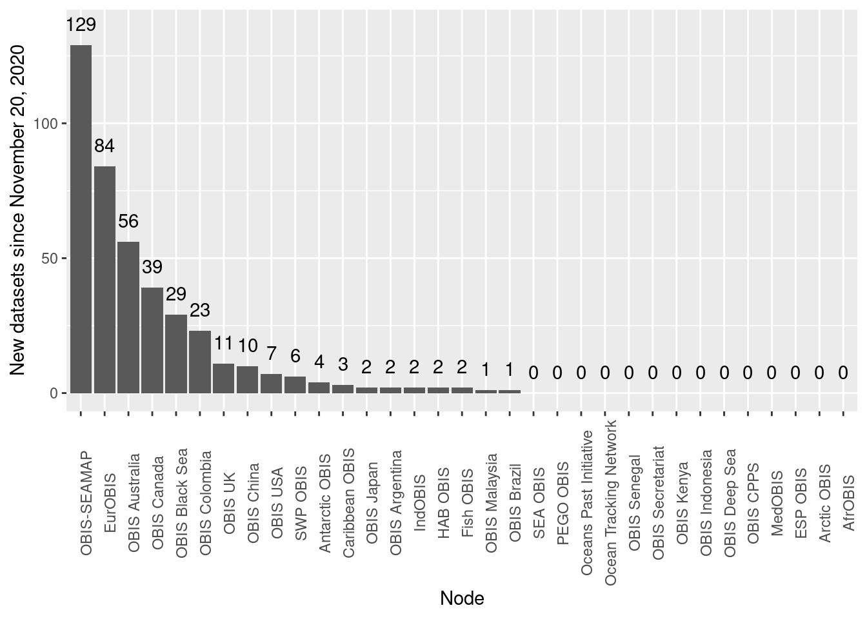
Figure: 413 new datasets have been published in OBIS in the past 6 months. Bringing the total to 4,059 datasets, +75 M presence records of 155,000 marine species and +160 M Measurements or sampling Facts.

At SG-OBIS-9, the OBIS steering group asked the OBIS nodes to work with GBIF nodes at the national level to define the nature and scope of interactions, identify potential for data duplication and share these experiences (illustrating opportunities and challenges) within the OBIS network for aggregation and integration. The outcomes of this mapping exercise will also be shown during the OBIS session at the GBIF Global Nodes meeting on 1 July 2021.

To prepare for this meeting, Abby Benson (OBIS USA) reported that she started drafting the Darwin Core guidelines for OBIS and GBIF nodes by illustrating the in-common as well as different requirements for both GBIF and OBIS. She also reported that GBIF requests assistance from OBIS to create a marine focused use case for the data mobilization workshops in Caribbean and Pacific and represents an opportunity to train GBIF data providers about OBIS specific requirements.

The OBIS secretariat has also prepared an online survey to collect the status of collaboration between GBIF and OBIS nodes, to hear from success stories and challenges encountered, and provide suggestions on improvements. All OBIS nodes were requested to fill in the survey. We received 25 responses. The results are available in annex 2.

The SG-OBIS requested the OBIS secretariat to organize an online meeting to review the results of the survey and discuss the data flow from GBIF nodes and publishers to OBIS. The following nodes expressed interest in joining this meeting: AntOBIS, OTN, EurOBIS, UK-OBIS, OBIS-USA, OBIS-Colombia, OBIS-OPI, Caribbean OBIS, Deep-sea OBIS, OBISAU.

The IODE Committee instructed OBIS to undertake a study to fit NODCs into the OBIS network construct and characterize the shared data management responsibility between NODCs, ADUs, and OBIS Nodes in fulfilling this mission for the biological data appropriate for OBIS. This activity has not been started yet.

OBIS Strategic Advisory Task Team report

Sky Bristol reported that the OBIS Strategic Advisory Task Team wants to organize several (online) meetings with stakeholders to better understand the expectations and hopes from OBIS, and perhaps revisit a number of those relationships. We are now at the stage where we have invested a lot in rebuilding the OBIS infrastructure and have been able to successfully sell OBIS, which is also illustrated by the growth of new data coming in. However, with the rise in expectations related to the UN Ocean Decade and initiatives under GOOS and MBON and others, we need to make sure OBIS and its network can meet those growing needs. Bristol has suggested that before we meet with our stakeholders, we do a baseline study of what we already know of those expectations and identify what we think needs to be done, so we have a basis for moving forward with those stakeholder consultations.

The SG-OBIS requested the strategic advisory task team to organize stakeholder consultations, but in preparing for those meetings they should perform a review of the requirements from key stakeholders (e.g., GOOS, MBON, ODIS, and those identified through Ocean Decade Actions) and do a gap analysis or assessment of OBIS nodes’ capacity to support those needs including support for EOV data management. The SG-OBIS proposed to set up a consultancy contract to support this activity and asked the task team to prepare a Terms of Reference within two weeks, so we can advertise the vacancy as soon as possible.

As an outcome of these stakeholder consultations, the SG-OBIS asked the Strategic Advisory Task Team, in cooperation with the Communication & Outreach Task Team, to develop a publication that explains the cooperation (or potential cooperation) between OBIS, GOOS and MBON and other stakeholders. The SG-OBIS asked the secretariat in collaboration with the SATT to organize webinars to communicate these partnerships.

Sky Bristol continued with a report on the status of the development of a roadmap and architectural plan for OBIS 3.0, the next generation of the International OBIS infrastructure. He said that he is just starting to explore what this roadmap may look like and reaching out to those who expressed interest initially to begin pulling together a small team to work on the activity. Our hope is to have a draft OBIS 3.0 roadmap completed by August 2021.

Bristol stated that the major development likely in the next few years across all infrastructures leveraging the Darwin Core will be a necessary evolution of the data model implementation of the standard. The main dynamic of this will be a recognition of multiple types of data structures beyond the “star schema” with an increased focus on semantics and explicit linkages in our data to controlled vocabularies and registries of various kinds. This should be well in keeping with the progression OBIS has been making through developments of measurement or fact data. Our roadmap activity will work to take these developments into account and best position OBIS to take advantage of new possibilities while maintaining its core capabilities.

OBIS Taxonomy Task Team report

Leen Vandepitte (Chair of the OBIS TaxTT) reported on the activities of the Taxonomy Task Team, which she said have been on a low level in the last period, as was also reported during the previous SG-OBIS meeting. Recently, it was agreed with the OBIS Secretariat that a vacancy for a summer student will be distributed through IODE and VLIZ, to provide content-support to the WoRMS Data Management Team in managing the non-matching names, during one month in July or August 2021. In addition, VLIZ/EurOBIS has also launched a student-vacancy for an IT-student to assist in the development of an online tool to deal with the OBIS-non-matching names. This tool will allow a more straightforward workflow concerning these names, both for the WoRMS Data Management Team and the OBIS Secretariat. It is important to note that launching these student vacancies does not guarantee that suitable candidates will be found, which might still have an implication on the progress of the non-matching process.

The SG-OBIS thanked all OBIS nodes that worked on matching the names with WoRMS, but also reminded us to look into the remaining taxonomic quality issues. The QC report is available at https://reports.obis.org/quality/.

OBIS Capacity Development Task Team report

Carolina Peralta (Chair of the CD-TT) reported on the training and workshop activities. The task team is working on:

- A general needs assessment for training or any help needed by the OBIS community (SG, OBIS data managers, etc.) in terms of refreshing or reviewing concepts and processes.
- A working strategy in collaboration with the CDTT and the INVEMAR/OceanTeacher Global Academy Regional Training Center to support an OBIS online training course to be developed in late 2021. The CDTT has been talking and sharing some thoughts with Martha Vides about training materials and course designs for a Latin American audience.

Ongoing cooperation and work with the Communication and Outreach Task Team resulted in preparation of our monthly SG calls with specific topics to be addressed. The next monthly meeting (June?) will cover information about Taxon Matching with WoRMS. For this the Taxonomy Task Team has offered support for presenting a short refreshment of the process.

The establishment of a Help Desk, the creation of new video tutorials and other training materials are still pending. Regarding the last two issues, some financial support may be needed to develop a few video tutorials, with professional design and format, using the OBIS logo and others (WoRMS, VLIZ, OTGA, etc.). A proposal made as a cooperation between the CDTT and the COTT was presented.

OTN expressed interest in contributing to developing this training material and raised a question regarding the copyright. The materials created for OBIS Canada earlier this year were meant to be held in right of the Queen but were, after an objection by OTN, amended to be CC-BY-4.0. OTN would like to volunteer these materials: (https://github.com/ocean-tracking-network/obis-workshop and https://github.com/otn-workshops/obis-workshop-fr) as a basis for future work, and to remain involved, if it would be useful, in crafting new material in any language.

Abby Benson (OBIS USA) reported that GBIF asked OBIS to provide a marine use case for the GBIF course and it would be worth considering reusing the training materials that GBIF has available.

The SG-OBIS proposed to set up a consultancy contract to develop video training material (including intro and outro). The SG-OBIS asked the CDTT to develop a Terms of Reference within two weeks, so we can advertise the vacancy as soon as possible.

OBIS Communications and Outreach Task Team report

John Nicholls (Chair of the OBIS COTT) reported on the engagement of the Communications and Outreach Task Team that has been relatively quiet over the last reporting period. Two SG Platform meetings were held (invitations were sent to all SG members) and current news, events and developments were discussed and shared. Ongoing cooperation and work with the Capacity Development Task Team will result in shared resources in terms of training materials for SG members, as well as broader training applications. The Taxonomy Task Team has also been active and are preparing training materials around taxonomy and related identification protocols to be applied by node managers.

Ward Appeltans reminded the group that outreach material is available via a shared dropbox folder, accessible at https://obis.org/outreach/.

The SG-OBIS welcomed the continuation of the monthly online SG-OBIS platform meetings as a way to provide short training modules, share new developments, challenges and concerns, as well as updates on progress at the OBIS nodes and secretariat level.

OBIS Data Quality Assessment and Enhancement Project Team report

Hanieh Saeedi (Chair of the OBIS QC PT) reported that OBIS data Quality Assessment and Enhancement Project Team was unfortunately not active as we did not have enough volunteers among the group to be able to run this task team. However, there are quite a lot of improvements within TDWG (see and ), which can be reviewed by the volunteers and some connections could be made by OBIS members with those task forces to make sure that OBIS quality control procedures are equivalent with other major players. To be able to run this task team, we need to have more members to be able to continuously map the quality control checks with TDWG and implement the advanced recommendations by those groups.

Maxime Sweetlove (AntOBIS) reported that they are currently doing an assessment of the data quality of Antarctic and Southern Ocean data and suggested to take over the leadership in this Task Team.

The SG-OBIS agreed with the proposal from AntOBIS and welcomed Maxime Sweetlove to take over the leadership in the OBIS Quality Assessment and Enhancement Project Team. The SG-OBIS thanked Hanieh Saeedi for her contributions thus far. SG members were asked to express interest in joining the Task Team.

OBIS Vocabulary Infrastructure Project Team report

Lenore Bajona (Chair OBIS VIP) reported that the project team has been meeting monthly, with much lively discussions. The project team welcomed new participants from BODC, TDWG and CIOOS. The NVS GitHub repository has been created for OBIS Vocabs (https://github.com/nvs-vocabs/OBISVocabs), and labels are setup/applied for 4 areas of focus (i) abundance/biomass, (ii) biometrics, (iii) habitats and (iv) life stages. The group is currently working on a GitHub issue Template and Joana Beja (EurOBIS) and Gwen Moncoiffe (BODC) are working on creating one or multiple decision tree(s) to help OBIS users find the best suited P01 codes for some of the most frequent or important parameter types.

Pieter Provoost (OBIS data manager) has further updated the online MoF statistics report: https://reports.obis.org/mof/ and created a more detailed filters’ report: https://mof.obis.org/.

Upon review of the Terms of Reference of the project team, it was determined an update was needed for clarity and the team suggested the following new OBIS Vocab Project Team Terms of Reference:

- Conduct its work within the context of the existing vocabulary-related activities of the Biodiversity Information Standards (TDWG) group.
- Produce guidelines for mapping the most commonly used Measurement or Fact terms in OBIS with the preferred BODC vocab.
- Propose a way forward to develop a mechanism or governance strategy to coordinate and build community consensus with regards to vocab mapping and priority setting of creating new vocab terms, including training.

The SG-OBIS welcomed and adopted the new Terms of Reference for the OBIS Vocabulary Infrastructure project team.

OBIS Genetic Data Project Team report

Saara Suominen (OBIS Scientific Officer, Chair of the OBIS Gen PT) reported on the activities of the Genetic data project team during the last reporting period. A GitHub repository (https://github.com/iobis/Project-team-Genetic-Data) was set-up for the team, where the guidelines for genetic data have been reviewed and discussed. In addition, the secretariat team has been in active discussion with the TDWG MixS-DwC interoperability task team led by Ms. Raissa Meyer, and independently also with GBIF.

On 17 March 2021, an online meeting was held with the project team to discuss the guidelines, and other concerns regarding the data standard. Issues decided on in the project team GitHub discussions include:

- Observations based on genetic data need to be clearly separated from traditional observations. This is most likely efficiently done by flagging all data originating from sequences.
- Sequence identifiers should be added to the DwC:taxonConceptID term, while retaining WoRMS as the taxonomic authority (DwC:scientificNameID)
- WoRMS will look into developing a matching tool to resolve NCBI taxonomy IDs to WoRMS LSIDs, which is now already possible through the WoRMS API.

The DNA-derived data extension will shortly be implemented in OBIS, with some minor differences to its implementation in GBIF. These differences will be discussed and exemplified in a dedicated section in the next version of the genetic data guidelines of GBIF.

Additionally, several bioinformatics pipelines and analysis parameters have been tested in connection with the PacMAN project, but there is still work to be done on the method for taxonomic assignment. A PacMAN/OBIS bioinformatic pipeline will be developed based on these tests. There has been little community engagement in the pipeline so far, however it will be open-access and available to the users, once finished. We noted that the biom-format for sequencing data was being used in many different ways, therefore it was not possible to automate the ingestion of the data as expected. Dedicated formatting of the output from the bioinformatics pipeline (be it in biom format or in separate tables) will be the first step for more automated eDNA data ingestion to OBIS.

The next steps of the genetic data project team will be to develop two use cases of genetic data, which will be added as examples to the github repository (https://github.com/iobis/dataset-edna). The biodiversity.aq/POLA3R portal (AntOBIS node) offered to provide one such use case. In addition, the project team will organise a virtual workshop for the users of the extension to finalise and get familiar with the formatting guidelines. Issues that still need to be discussed include, how to keep taxonomic classifications up to date and reliable, as well as the possibility to mine datasets from public genetic data repositories.

The SG-OBIS welcomed the progress made so far in the Genetic Data Project Team and is looking forward to the guidelines and use cases to be presented at the 10th SG-OBIS session.

OBIS Project Team on the UN Ocean Decade

Ward Appeltans reported that at the 26th session the IODE Committee requested OBIS and PacMAN to submit a Decade project proposal as a UN action for which no calls or deadlines are established. He also reported that OBIS is already a partner in three ocean Decade programme proposals:

A Global Integrated Marine Biodiversity Information Management and Forecasting System for Sustainable Development and Conservation (MarineLife 2030)
Marine Life 2030 will establish a globally coordinated system to deliver actionable, transdisciplinary knowledge of ocean life to those who need it, promoting human well-being, sustainable development, and ocean conservation. Within a decade, Marine Life 2030 will unite existing and frontier technologies and partners into a global, interoperable network and community of practice advancing observation and forecasting of marine life. This network of networks will link technical, management and policy stakeholders to build and exchange capacity for advancing society’s grand challenges of managing activities for a healthy and resilient ocean and the vibrant and healthy society that depends on it. Lead Institution: Smithsonian Institution.

Biomolecular Ocean Observing Network (BOON)
Ocean Life, from viruses to whales - is built from “biomolecules.” Biomolecules such as DNA infuse each drop of ocean water, grain of sediment, and breath of ocean air. The Biomolecular Ocean Observing Network (BOON) will develop a global system that will allow science and society to understand ocean life like never before. The programme will transform how we sense, harvest, protect, and manage ocean life, which faces multiple stresses including pollution, habitat loss, and climate change. It will also help communities detect biological hazards like harmful algal blooms and pathogens and be a key component of next-generation ocean observing systems. Lead Institution: The Partnership for Observation of the Global Ocean (POGO).

Ocean Observing Co-Design - Evolving ocean observing for a sustainable future.
This Programme will transform the ocean observing system through increased integration and innovation, creating a system co-designed with observing, modelling, and user stakeholders. This fit-for-purpose system will more effectively serve the expanding range of multidisciplinary societal needs and build essential infrastructure to demonstrate the ongoing societal value of the system. Lead Institution: the Global Ocean Observing System (GOOS) through lead sponsor IOC/UNESCO.

Anton Van de Putte reported that AntOBIS is also part of a regional Decade programme proposal. The Southern Ocean community of stakeholders is globally unique in its operation within an international framework (the Antarctic Treaty System) within which international collaboration, sharing of data, scientific understanding and environmental protection are fundamental. Through this framework, stakeholders have obligations relating to recording activities and monitoring impact. Utilising this strong spirit of cooperation, which is in keeping with the decade objectives, the Southern Ocean Programme will develop a collaborative framework where the full range of Southern Ocean stakeholders can engage to identify and address the major research challenges The Southern Ocean face. The scope and details of this Regional Programme are yet to be fully defined; however, it is envisioned that the community will be encouraged to identify collaborative Decade Projects and Actions that can be coordinated through the Regional Programme. Lead Institution: The Scientific Committee on Antarctic Research.

The ISA secretariat updated all members on the development of the plan to facilitate the implementation of the ISA Action Plan in support of the UN Decade of Ocean Science for Sustainable Development (ISA Action Plan), adopted by the ISA Assembly in December 2020. This includes several activities to be discussed with relevant OBIS nodes for strengthening and expanding the partnership with OBIS.

The SG-OBIS requested the OBIS Decade project team to develop and submit a project proposal for an OBIS Decade Project to the Decade coordination team preferably by the end of August 2021. The proposal should include (i) a vision and roadmap on what OBIS envisions to become by the end of the decade, (ii) how OBIS should be transformed to develop a more sustainable model, (iii) explain the value proposition of OBIS to the various Decade actions and Decade challenges, by building on its strengths, its world-wide network and established community of practice. This will also require a statement on the resource requirements vs the current capacity to meet the needs of the Ocean Decade including the needs for support from OBIS to the various Decade actions.

The SG-OBIS asked all members to share information on their involvement in Ocean Decade proposals (and in what capacity) in order to make sure that the OBIS Decade project team can make the relevant links in the OBIS Decade project proposal and strengthen collaboration between the different programmes and actions.

The following SG members expressed interest in joining the OBIS Ocean Decade project team:
Anton Van de Putte (AntOBIS), Hanieh Saeedi (OBIS Deep-Sea), Leen Vandepitte (EurOBIS), John Nicholls (OBIS-OPI), Sky Bristol (OBIS-USA), Dimitra Mavraki (MedOBIS), Luciana Genio (OBIS ISA) - TBC and Dan Lear (OBIS-UK).

New planned activities

eDNA expeditions in MPAs

In response to a call from UNESCO to submit proposals to the Flanders UNESCO Trust funds (this time collaboration between the Science and Cultural UNESCO sectors was highly encouraged), we jointly submitted a proposal with the secretariat of the World Heritage Convention, which is part of the UNESCO Cultural Sector. Together with the head of the marine World Heritage Programme, we have developed a proposal called: “eDNA Expeditions in marine World Heritage sites - Engaging citizen-scientists in revealing the richness and vulnerability of biodiversity for the conservation of UNESCO sites in a changing climate.”

The marine World Heritage site managers will be trained in eDNA sampling and organize citizen science sampling campaigns (eDNA expeditions). The DNA samples will be analyzed in a central lab and data will be made available through OBIS. A high-impact scientific report will be produced, comparable to the recently launched blue carbon report (https://whc.unesco.org/en/blue-carbon-report/). We will also develop a number of indicators including the Community Thermal Index to predict the sensitivity of the current species community to global warming. If target species for conservation move to colder waters, then this will become an issue for biodiversity conservation in those sites and will provide input into the discussion on the relevance of the currently fixed geographic boundaries of those sites.

The eDNA results will be combined with existing data in OBIS as well as any local (traditional) knowledge. The focus for this project will be on marine fish and vulnerable species on the IUCN Red List. The project will not be able to sample all 50 marine World Heritage sites, and a selection will be made. The proposal is currently under review, and we expect to hear back from Flanders before July 2021. If selected, the project will start in January 2022 and run for 2 years.

The SG-OBIS expressed its interest in this project, which if funded will give excellent visibility to OBIS. It also shows the potential of future operational activities, which OBIS can provide to partners such as the World Heritage Convention (e.g., supporting the monitoring and evaluation of marine areas of particular importance). If funded, OBIS nodes are asked to inform the OBIS secretariat if they have already established a collaboration with any of the 50 marine World Heritage sites and/or express interest in being involved in this eDNA expeditions project.

OBIS Japan expressed interest in collaborating in eDNA expeditions in MPAs.

The SG-OBIS requested all OBIS nodes to share information on planned activities and future projects at the next SG-OBIS meeting (30 Nov - 3 Dec 2021).

Annex 1. Agenda and Time Table

1. Opening and adoption of agenda
2. Status of the OBIS work plan 2021
2.1. OBIS Executive Committee report
2.1.1. Report on the IODE Committee Meeting
2.1.2. Report on other meetings
2.2. OBIS secretariat report
2.3. OBIS nodes report
2.4. OBIS Strategic Advisory Task Team report
2.5. OBIS Taxonomy Task Team report
2.6. OBIS Capacity Development Task Team report
2.7. OBIS Communications and Outreach Task Team report
2.8. OBIS Data Quality Assessment and Enhancement Project Team report
2.9. OBIS Vocabulary Infrastructure Project Team report
2.10. OBIS Genetic Data Project Team report
2.11. OBIS Project Team on the UN Ocean Decade
3. New planned activities
3.1. eDNA expeditions in MPAs

 | WED 26 May 2021 | THU 27 May 2021
8-11PM CET | 1/ Welcome and introduction  2/ Adoption of agenda  3/ Status of the OBIS work plan 2021  - OBIS Executive Committee report  - OBIS Secretariat report  - OBIS Nodes report  - OBIS Task Team Reports  - OBIS Project Team Reports  4/ New planned activities | 5/ Adoption of the decisions and recommendations.

Annex 2. Results of a survey about collaboration between OBIS nodes and GBIF nodes, and data flows from GBIF nodes to OBIS

OBIS nodes who filled in the Survey:
- AROBIS
- OPI-OBIS
- Arctic OBIS
- MedOBIS
- OBIS-SEAMAP
- OBISAU
- Caribbean OBIS
- OBIS Black Sea
- South Western Pacific Regional OBIS
- AntOBIS (twice, see Antarctica)
- EurOBIS
- OTN-OBIS
- OBIS Kenya
- OBIS Malaysia
- OBIS-UK
- ESPOBIS
- OBIS USA
- AFROBIS
- OBIS Colombia
- OBIS Brazil
- OBIS deep-sea
- SEAOBIS
- Antarctica OBIS
- OBIS Indonesia
- OBIS Japan

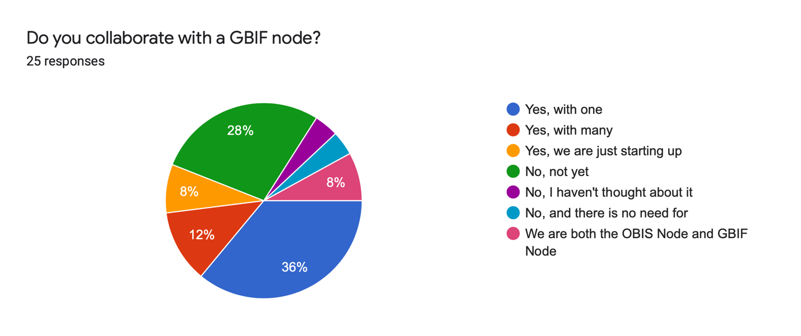
If you answered yes to the previous question, please list the GBIF node name(s)

- GBIF Argentina
- Nikolai Pertsov White Sea Biological Station
- Atlas of Living Australia
- Belgian Biodiversity platforms (formerly, others informally eg atlas of living Australia)
- Be-BIF, NL-BIF & GBIF France
- US Geological Survey Node
- Kenya GBIF Node based in the National Museums of Kenya
- UK National Biodiversity Network (NBN)
- SABIF
- SiB Colombia
- ASEAN Centre for Biodiversity
- JBIF (Japan Node of Global Biodiversity Information Facility)
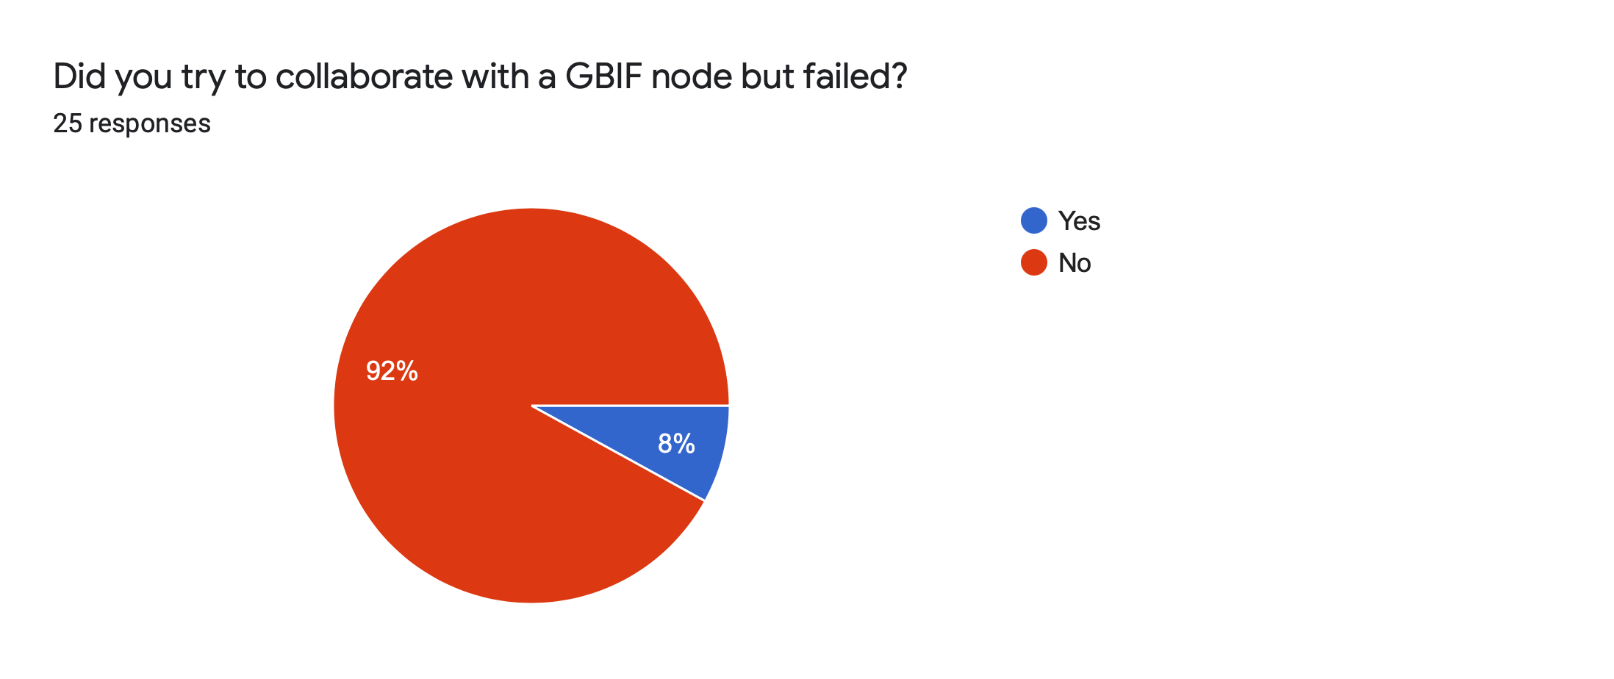
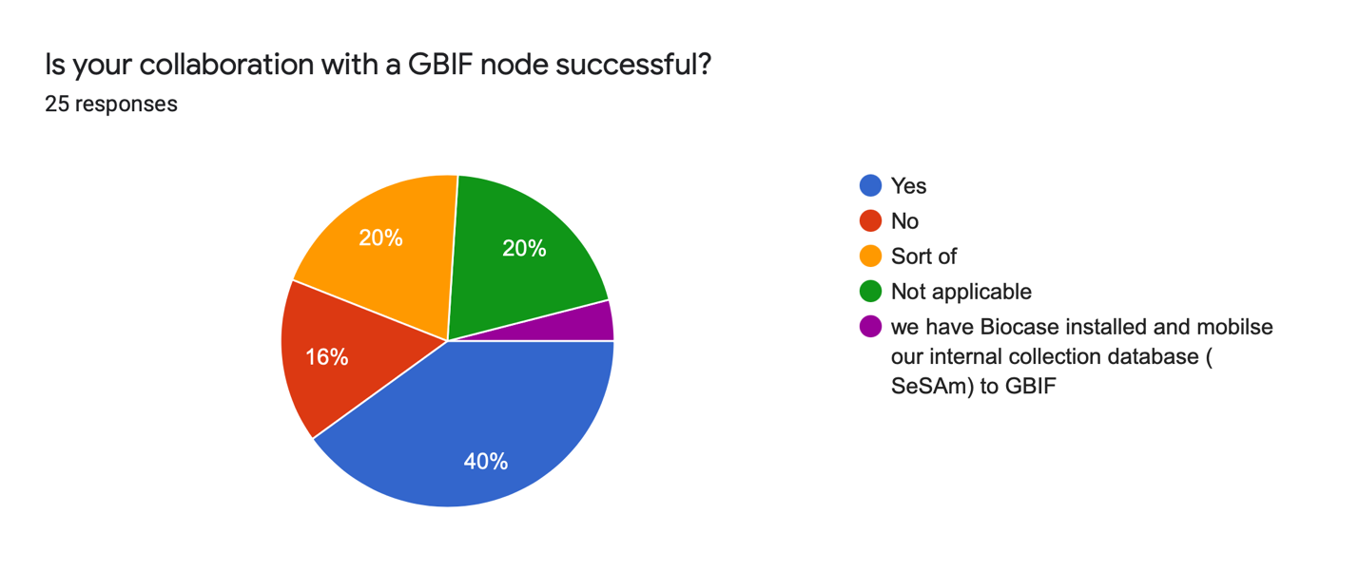

Please explain what the level of cooperation is?

- They use the OBIS IPT directly to publish marine datasets – 7 (28%)
- They allow us to republish marine datasets on our OBIS IPT – 7 (28%)
- They publish marine datasets directly to OBIS, and the datasets are listed as belonging to my OBIS node – 2 (8%)
- Collaboration in training – 7 (28%)
- Collaboration in tool development – 2 (8%)
- Collaboration in policy making – 3 (12%)
- Collaboration in communication & outreach – 7 (28%)
- None – 0 (32%)
- Other:
  - providing IT support for our activities, web hosting, IPT maintenance etc.
  - data standards development
  - Co-administration of the UK iNaturalist Node
  - Generation of national reports, Creation of joint proposals, collaboration with infrastructure support
  - In the Colombian context, both Nodes are part of an official national alliance so, we have a joint annual action plan to achieve goals.

If you republish marine datasets from GBIF nodes or publishers on your OBIS IPT, can you explain why OBIS should not (yet) harvest directly (note the publish once, harvest many times principle which we agreed on at the last SG meeting)?

- I wasn't aware this was an option for OBIS to harvest directly from IPTs already sharing to GBIF.
- We could harvest from GBIF, but we think we must work towards Event-eMoF datasets. Harvest must be carefully considered in terms of QC of the original data
- We do not republish datasets to OBIS to avoid duplication, our on portal does not republish data.
- To identify marine dataset/not and to run QC
- I still understand that OBIS will only harvest from its nodes unless there is no node available(?). As EurOBIS, we also want those datasets to appear through our own portal, so it can be included in our tools and functionalities. If OBIS would also harvest these datasets directly, the chances for duplication on OBIS-level will increase.
- Not applicable
- They haven't published any data yet
- I'm separating my datasets to be published both OBIS and GBIF. OBIS for aquatic datasets and GBIF for terrestrial.
- It does not apply in our case. We do not republish marine datasets. A dataset is published only once in our IPT and registered with GBIF. It is harvested directly from there by OBIS, and GBIF Node. We believe that is a good practice to avoid duplication.
- As a Tier 3 node there are additional publication steps (EurOBIS). Additionally, their data are not in OBIS-ENV format
- Our data system is in its final development stage
- GBIF is not using WoRMS as far as I know. I have not taken records from GBIF and put them into the OBISAU IPT. I have done so for ALA datasets once I know they are not already in OBIS and know that they contain marine records. I then filter out terrestrial records, apply WoRMS to it and publish to OBIS only (ie do not register with GBIF)
- I haven't rebuplished any GBIF marine datasets, but we are going to start harvesting in the next month. Do not intend to duplicate data.
- I think OBIS should
- We are starting the collaboration with Environmental Ministry where is hosted GBIF
- Not applicable because we haven't collaborate with any GBIF node so far.

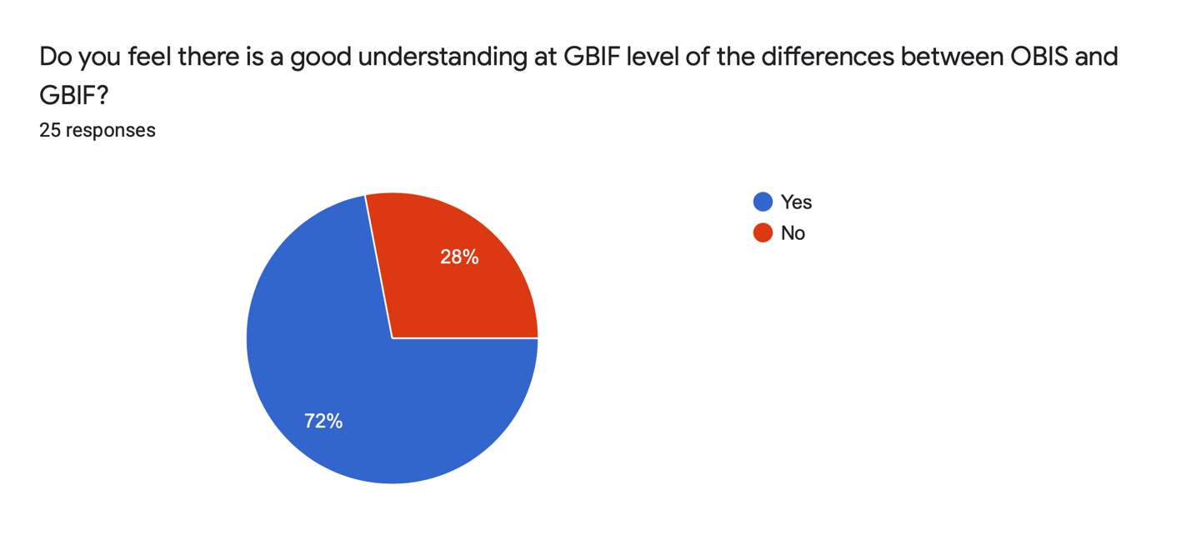

Are there any obstacles that prevent collaboration with GBIF nodes?

- The level of data QC is largely different, for example many data on land. Our node staff needs to check before republishing GBIF dataset
- Major obstacle in my eyes is communication and time. For neither the OBIS-node nor the GBIF-node (?), this is the highest priority (at least not for EurOBIS). And looking to harvest datasets from a GBIF-node (or GBIF directly) almost always leads to questions/doubts on the data, which need to be cleared out through email communication. As GBIF does not (yet) work with the eMoF, this means that EurOBIS would at least try to figure out whether the original provider would have more data than what is shared through GBIF, which also leads to more communication and follow-up.
- National bureaucracy
- Lack of communication and government approach to the university

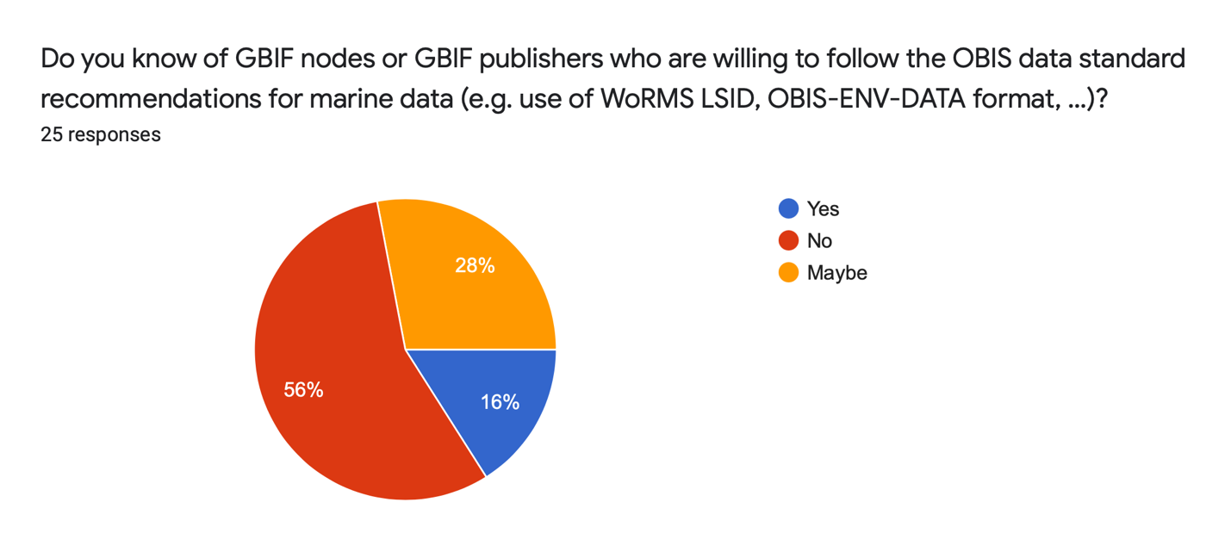

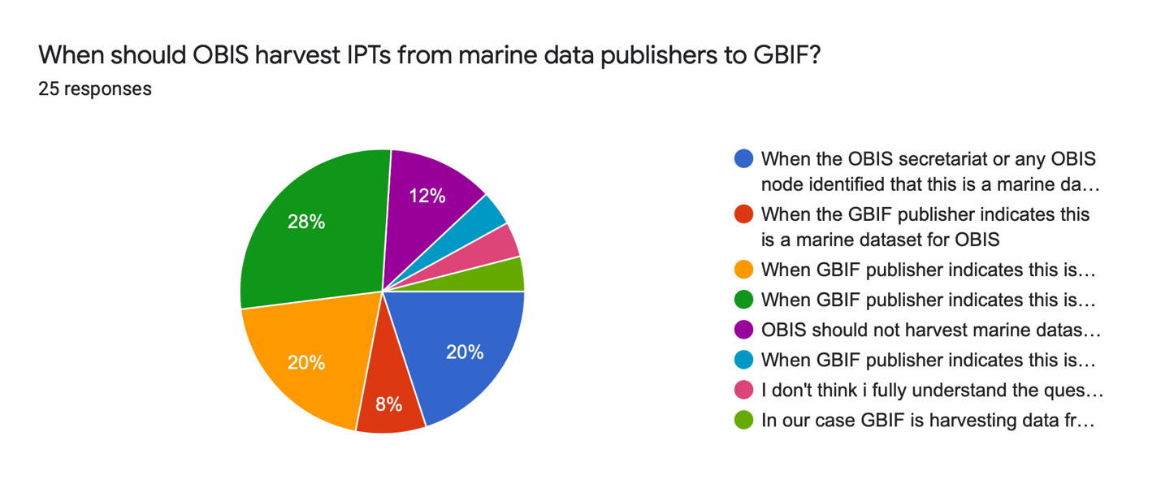
- When GBIF publisher indicates this is a marine dataset for OBIS and follow the OBIS data practices and are endorsed by an OBIS node (8)
- When GBIF publisher indicates this is a marine dataset for OBIS and follow the OBIS data practices (5)
- When the OBIS secretariat or any OBIS node identified that this is a marine dataset for OBIS (5)
- When the GBIF publisher indicates this is a marine dataset for OBIS (2)
- OBIS should not harvest marine datasets from GBIF publishers, they should become OBIS nodes first (3)

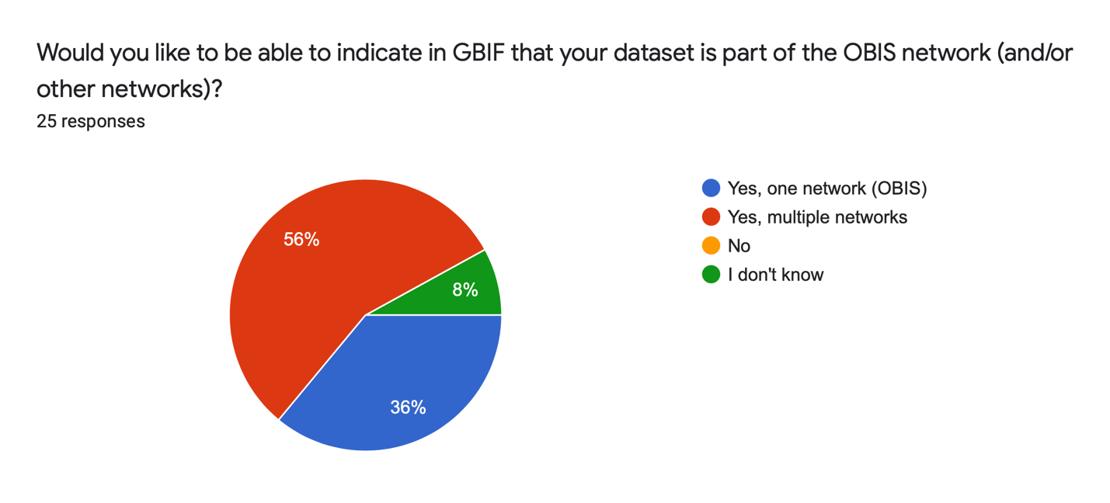

Is there anything else that should be changed to improve data flow from GBIF marine publishers to OBIS?

- Try to have the national GBIF nodes recognise the OBIS nodes nearby. Normally an institution as data providers will publish their data in one platform usually GBIF as it is country "official" repo for biodiversity. Encourage the communication between OBIS node and its near GBIF node will promote more mutual understanding and collaboration
- Harmonizing of occurrenceID, curation of Persistent Identifiers, Reduce Republishing of datasets
- Make sure it is easy to identify duplicate records from GBIF and OBIS downloads (e.g., must have same occurrenceID, or add a remark)
- Better communication with OBIS nodes
- Clear communication and demarcation of roles/remit
- Continues training and awareness - many node managers see this aspect as only a small part of a much larger and diverse workload.
- There are many marine data missing from GBIF on OBIS, this makes the life of people very hard in extracting the data from two sources and then removing's the duplicates, I hope that it could be somehow unified
- For me, it is the clear and simple identification of marine datasets in ALA (Atlas of Living Australia), the GBIF node we work with. Identifying marine data may become difficult as they wish to remove the "marine habitat" classification from their occurrence metadata.
- Awareness creation from nodes of OBIS and GBIF

What should be changed to improve collaboration with GBIF nodes?

- Be more specific on data flow
- You may better define a clear data flow that all OBIS nodes to follow
- more joint activities, e.g., training.
- Have a large-scale meeting with (all) OBIS- and GBIF-node managers/representatives. This way, all can be introduced to each other, the broader goals of both GBIF & OBIS can be explained and working strategies can be agreed upon, avoiding confusion on either side. This will probably improve future collaboration, and should also allow clearer, smoother, and faster data sharing.
- foster training on common practices
- It is important to identify the aspects that can be complementary on the part of GBIF nodes vs OBIS nodes, not only in a general way, but as a particular exercise in each country or area with OBIS nodes. This can help join efforts at different levels to strengthen the information to be made visible by both networks and offer more and better tools to users to take advantage of the data.
- Joint meetings, cross-organisation promotion/collaboration
- Training and awareness.
- Regular meetings among OBIS and GBIF nodes
- Comments specific to our collaboration with the ALA GBIF node: - ALA is revising data publishing to use OBISAU IPT and do a refresh just like OBIS. - Need to define a process for identifying growing datasets in ALA that can be updated for OBIS. - ALA is not yet using EMoF etc. - ALA have a new beta architecture (developed with GBIF) that is being tested and released soon. OBISAU team will be testing this architecture before release. The new architecture will not be integrating WoRMS or publishing OBIS-ENV-DATA etc. General comments for all GBIF nodes: - I still think OBIS nodes need to validate and check data before publication, given that there are more specific rules for creating suitable quality records in OBIS compared to GBIF.
- They should have joint meetings to understand each other
- To coordinate the definition of the databases working together without overlapping the bases. This is exclusive marine data in OBIS
- At the national level, have more meetings to establish collaboration criteria and promote funding so that institutions can publish their data sets on both networks.
- The current practice is sufficient, I think.
- Make GBIF nodes more aware of OBIS data practices

Annex 3. List of Participants

SG-OBIS Co-Chairs
Anton VAN DE PUTTE
Science Officer
OD Nature
Koninklijk Belgisch Instituut voor Natuurwetenschappen, Museum voor Natuurwetenschappen
Vautierstraat 29
1000 Brussel
Belgium
Email: avandeputte@naturalsciences.be
Martha VIDES CASADO
Investigador Científico
Biodiversidad y Ecosistemas Marinos
Instituto de Investigaciones Marinas y Costeras José Benito Vives de Andreis
Calle 25 No. 2-55, Playa Salguero, Rodadero
Santa Marta D.T.C.H., Magdalena,
Colombia
Tel: +57 4328600 Ext 283
Email: martha.vides@invemar.org.co
EC-OBIS member
Lenore BAJONA
Director of International Data Systems, Ocean Tracking Network
Ocean Tracking Network
Steele Ocean Sciences Building - Dalhousie University
Halifax Nova Scotia B3H4R2
Canada
Tel: 902-830-7657
Email: lenore.bajona@dal.ca
Patrick HALPIN
Professor
Nicholas School of the Environment / Duke University Marine Lab
Duke University, Nicholas School of the Environment
United States
Tel: 1.919.613.8062
Email: phalpin@duke.edu
John NICHOLLS
Researcher/Data Manager
History
Trinity College Dublin, Centre for Environmental Humanities
College Green
Dublin
2
Ireland
Tel: +353 1896-1663
Email: John.Nicholls@tcd.ie
Carolina PERALTA BRICHTOVA
Professor
Estudios Ambientales
Universidad Simon Bolivar, Laboratorio de Biología Marina
Departamento de Estudios Ambientales. Valle Sartenejas
Edif. Química y Procesos P.B. Ofic. 019. Valle de Sartenejas
Baruta 89000, Miranda
Venezuela
Email: anaperalta@usb.ve
Hanieh SAEEDI
Coordinator Biodiversity Information
Marine Zoology
Senckenberg Gesellschaft für Naturforschung
Senckenberganlage 25
60325 Frankfurt
Germany
Tel: 01746210915
Email: hanieh.saeedi@gmail.com
Leen VANDEPITTE
Senior scientist
Data Centre
Vlaams Instituut voor de Zee
Wandelaarkaai 7
8400 Oostende
Belgium
Email: leen.vandepitte@vliz.be
SG-OBIS member
Abby BENSON
Biologist
U.S. Geological Survey HQ
United States
Tel: 1-303-202-4087
Email: albenson@usgs.gov
Sky BRISTOL
Chief, Biogeographic Characterization
United States Geological Survey
United States
Tel: +1303.241.4122
Email: sbristol@usgs.gov
Sheldon CARTER
Database Manager
Office of Enivornmental Management and Mineral Resources
International Seabed Authority
14 - 20 Port Royal Street
Kingston
Jamaica
Tel: +1 876 470 9531
Email: scarter@isa.org.jm
Braulio FERNÁNDEZ
Universidad de Concepción, campus Concepción
CALLE VICTOR LAMAS 1290, CASILLA 160-C, CONCEPCION
CONCEPCION
Chile
Email: branferza@gmail.com
Katsunori FUJIKURA
Senior Scientist
Marine Biodiversity and Environmental Assessment Research Center
Japan Agency for Marine-Earth Science and Technology, Yokosuka
2-15 Natsushima
Yokosuka, Kanagawa
237-0061
Japan
Tel: 81-46-867-9555
Email: fujikura@jamstec.go.jp
Ei FUJIOKA
Duke University, Nicholas School of the Environment
Box 90328
Durham, North Carolina NC 27708
United States
Email: efujioka@duke.edu
Luciana GENIO
Environmental Analyst
Office of Environmental Management and Mineral Resources
International Seabed Authority
14 - 20 Port Royal Street
Kingston
Jamaica
Email: lgenio@isa.org.jm
Pamela HIDALGO
Professor
Departamento de Oceanografia
Universidad de Concepción, campus Concepción
CALLE VICTOR LAMAS 1290, CASILLA 160-C, CONCEPCION
CONCEPCION
Chile
Tel: + 56 41 22661175
Email: pamelahidalgodiaz@gmail.com
Takashi HOSONO
Senior engineer
Global Oceanographic Data Center
Japan Agency for Marine-Earth Science and Technology (JAMSTEC), Global Oceanographic Data Center (GODAC)
224-3 Toyohara
Global Oceanographic Data Center (GODAC)
Nago, Okinawa
905-2172
Japan
Tel: +81-90-2988-0269
Email: hosonot@jamstec.go.jp
Dan LEAR
Head of Data, Information & Technology
The Marine Biological Association of the United Kingdom
The LaboratoryCitadel Hill
Plymouth
PL1 2PB
United Kingdom
Tel: +44(0)1752633291
Email: dble@mba.ac.uk
Monica MACHUCA
Plan de Acción
Comisión Permanente para el Pacífico Sur
Centro Empresarial 'Las Cámaras", Torre B,officinas 1,2 y3
Av. Francisco de Orellana y Miguel H. Alcivar
090506
Guayaquil
Ecuador
Email: mmachuca@cpps-int.org
Dimitra MAVRAKI
Data manager MedOBIS
Hellenic Centre for Marine Research - Institute of Marine Biology, Biotechnology and Aquaculture
P.O.Box 2214
Former US Base at Gournes, P.C. 71500 municipality of Hersonissos
71003 Heraklion
Greece
Tel: +302810337740
Email: dmavraki@hcmr.gr
Ana Carolina MAZZUCO
Postdoc Researcher LTER / OBIS Brazil Data manager
Department of Oceanography
Universidade Federal do Espírito Santo
Av. Fernando Ferrari, 514,
Goiabeiras
Vitória-Espírito Santo
CEP 29075-910
Brazil
Tel: +5527992430004
Email: ac.mazzuco@me.com
Ismaïla NDOUR
Researcher
Centre de Recherches Océanographiques Dakar-Thiaroye
Institut Sénégalais de Recherches Agricoles
B.P.: 25275 Fann-Dakar
Rte des hydrocarbures
Dakar
Senegal
Tel: +221 77 6081 344
Email: ndismaila@gmail.com
Oleksandr NEPROKIN
Head of Information Support for the Scientific Researches Department / OBIS Black Sea node Manager
Information Support for the Scientific Researches
Ukrainian Scientific Centre of Ecology of the Sea
89, Frantsuzsky Blvd.
Odessa
Odessa oblast
65009
Ukraine
Tel: +380667532368
Email: o.neprokin@gmail.com
Zuleika PINZON
Comisión Permanente para el Pacífico Sur
Centro Empresarial 'Las Cámaras", Torre B,officinas 1,2 y3
Av. Francisco de Orellana y Miguel H. Alcivar
090506
Guayaquil
Ecuador
Email: zpinzon@cpps-int.org
Jonathan PYE
Director of Data Operations
Ocean Tracking Network
Steele Ocean Sciences Building - Dalhousie University
Halifax Nova Scotia B3H4R2
Canada
Tel: +1 9024 947 560
Email: jonpye@gmail.com
Tshikana RASEHLOMI
Marine Information Management System (MIMS) Manager
Oceans and Coasts Research Directorate
Department of Forestry, Fisheries and the Environment
P/Bag X2Rogger Bay
Cape Town
8012
South Africa
Tel: (+27) 711 758407
Email: Tshikana.deff@gmail.com
Maxime SWEETLOVE
Data officer
Antarctic group
Royal Belgian Institute of Natural Sciences, Operational Directorate Natural Environment, Belgian Marine Data Centre
rue Vautier 29
1000 Brussels
Belgium
Email: msweetlove@naturalsciences.be
Katherine TATTERSALL
Data Architect
Information and Data Centre
CSIRO National Collections and Marine Infrastructure
PO Box 1538
Hobart TAS 7001
Australia
Email: katherine.tattersall@csiro.au
Lennert TYBERGHEIN
Head of Data Centre
Data Centre
Vlaams Instituut voor de Zee
Wandelaarkaai 7
8400 Oostende
Belgium
Tel: +32 (0) 59 34 14 93
Email: lennert.tyberghein@vliz.be
Heidi VAN VLIET
Biologist
Stock and Assessment and Research Division
Pacific Biological Station (DFO – PBS), Fisheries and Oceans Canada
3190 Hammond Bay Rd.
Nanaimo BC V9T 6N7
Canada
Email: heidi.vanvliet@dfo-mpo.gc.ca
Nina WAMBIJI
Senior Research Officer
Fisheries
Kenya Marine and Fisheries Research Institute, Headquarter & Mombasa Station
PO Box 81651
Mombasa
080100
Kenya
Email: nwambiji@kmfri.co.ke
Marcos ZÁRATE
Postdoctoral research
CESIMAR
Centro para el Estudio de Sistemas Marinos, Centro Nacional Patagónico
Bv. Almirante Brown 2915
9120 Puerto Madryn
Chubut
Argentina
Tel: +54 2804 844 320
Email: zarate@cenpat-conicet.gob.ar
OBIS Secretariat
Ward APPELTANS
Project Manager OBIS, GOOS Biology & Ecosystems, IOC Capacity Development
UNESCO / IOC Project Office for IODE
Wandelaarkaai 7
Pakhuis 61
8400 Oostende
Belgium
Tel: +32 59 34 01 76
Email: w.appeltans@unesco.org
Pieter PROVOOST
OBIS Data Manager
UNESCO / IOC Project Office for IODE
Wandelaarkaai 7
Pakhuis 61
8400 Oostende
Belgium
Tel: +32 59 340161
Email: p.provoost@unesco.org
Saara SUOMINEN
Scientific Officer
OBIS
UNESCO / IOC Project Office for IODE
Wandelaarkaai 7
Pakhuis 61
8400 Oostende
Belgium
Email: s.suominen@unesco.org

https://iode.org/index.php?option=com_oe&task=viewDocumentRecord&docID=27701
https://data.hais.ioc-unesco.org
https://oceanexpert.org/event/2650
https://doi.org/10.3389/fmars.2021.620702
https://obis.org/2021/04/27/woa2/
https://docs.google.com/document/d/1s9_2uL9uX9swUDk9RX0i2sgORx0wAVwivnA2uYQtFe4/edit
https://drive.google.com/file/d/18PeAhRUre1OER4V6Wd-SH1QB5Ds3y0bA/view?usp=sharing
https://docs.gbif.org/course-data-mobilization/en/course-description.html
https://www.tdwg.org/standards/#current-standard
https://docs.google.com/spreadsheets/d/1uwnUtcMSe88AytUt_mSepeLTz54tMvV9llO2pBnObhE/edit#gid=1444049182
https://rs.gbif.org/sandbox/extension/dna_derived_data_2021-05-14.xml

