**Forecast Point analysis for the Task Team on Operations, regarding the homogenization of FP that TSPs are using for the Mediterranean:**

* IOC has 231 official Forecast Points
* CENALT, INGV & KOERI proposed another 185 FPs
* At 10 km distance, common FPs are:
  + *KOERI & CENALT - 1*
  + *KOERI & INGV - 28*
  + *INGV & CENALT – 7*
  + TOTAL common FPs 34
* New proposed FPs 151, at a distance greater than 10 km

Further analysis can be conducted upon co-chairs request…

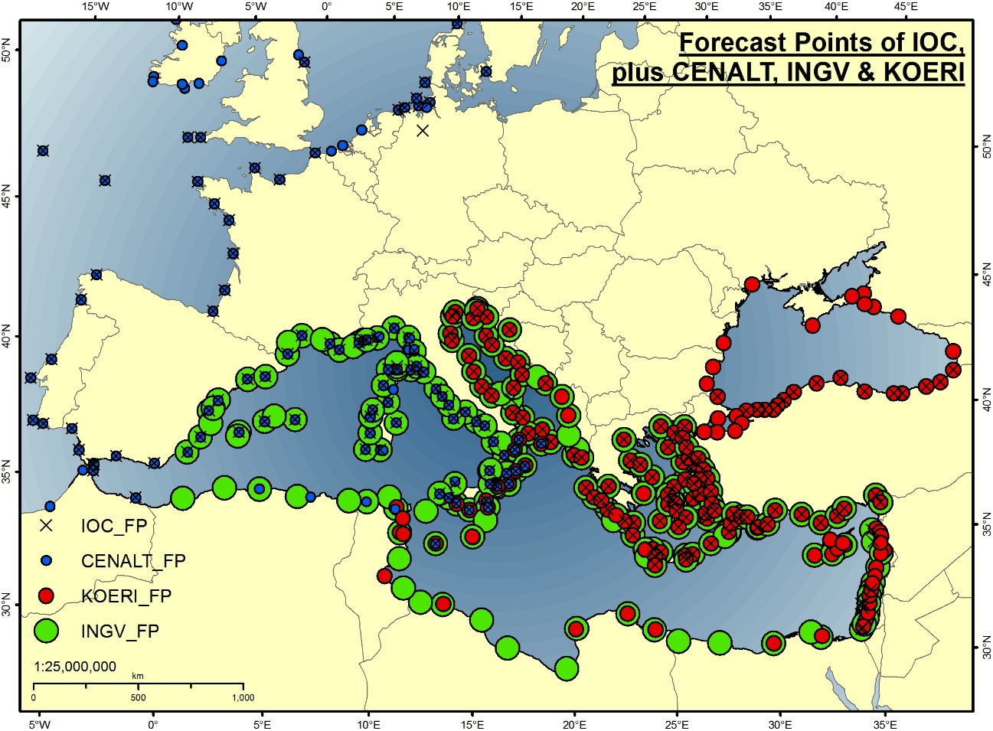

*Additional FPs that are used by TSPs (duplicates have been omitted)*

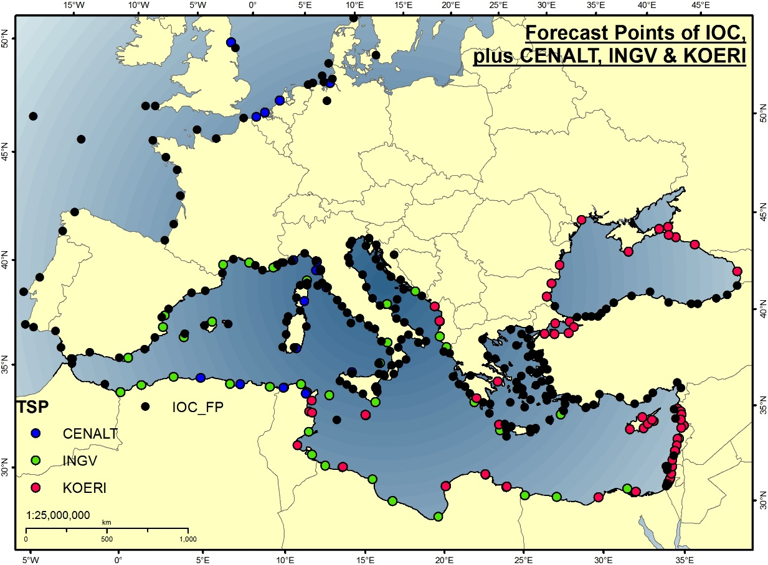

*Common FPs in light blue*

