

**Monitoring Plan**

**UNESCO**

Editors: Saara Suominen, Ward Appeltans, Pieter Provoost, Joape Ginigini, Gilianne Brodie, Paayal Kumar

Contributions received from: John Alonso, Nic Bax, Pier Luigi Buttigieg, Nitesh Datt, Neil Davies, John Deck, Chaminda Dissayanake, Riten Gosai, Pascal Hablützel, Kevin Mackay, Selai Manuel, Chris Meyer, Frank Muller-Karger, Shyama Pagad, Matthias Obst, Neomai Ravitu, Craig Sherman, Posa Skelton, Richard Willan

Citation:

UNESCO/IOC. 2021. *Pacific Islands Marine Bioinvasions Alert Network (PacMAN) Monitoring Plan.*S. Suominen et al. (eds), Paris, UNESCO. (IOC Technical Series, 168).

Funded by



**Table of Contents**

1. Statement of problem and management objectives 6

2. Target species 7

3. Sampling design 16

3.1. Advantages and disadvantages of monitoring with eDNA 17

3.2. Test Phase: Port Baseline Survey 19

3.3. Operational Phase: Monitoring 22

3.4. Timeline for sampling 22

4. Field Sampling Protocols 23

4.1. Sampling strategy at different project phases 24

4.1.1. Test phase, Port baseline survey 24

4.1.2. Operational phase, monitoring 24

4.2. Sampling protocols 25

4.2.1. Environmental measurement 25

4.2.2. Water sampling 25

4.2.3. Settlement plates 26

4.2.3.1. Deployment 26

4.2.3.2. Collection 27

4.2.4. Plankton sampling 28

4.3. Sample preparation and DNA extraction 29

4.3.1. Filtration of water samples 29

4.3.2. Settlement plates 30

4.3.3. Plankton samples 31

4.3.4. DNA extraction (all sample types) 31

4.4. Metabarcoding library preparation 32

4.4.1. Amplification of target gene region: 1st PCR 33

4.4.2. Add sample indeces and sequencing adapters: 2nd PCR 34

4.5. Species specific rapid detection 35

4.5.1. qPCR assay development 35

4.5.2. qPCR protocol 38

5. Data management plan 39

5.1. Data collection, storage, and preservation 41

5.2. Data analysis 42

5.3. Data sharing and re-use 43

5.4. Ethics, legal and security issues 44

6. Cost analysis 44

7. Monitoring outcomes and possible management actions 46

Annex 1. Introduced species detected in the Pacific Islands 54

Annex 2. Field sampling sheet: Environmental data 66

Annex 3. Field sampling sheet: Sampling data 67

Annex 4. Primers with nextera indices and sequence adapters 68

Annex 5. Total list of costs 72

Annex 6. NCBI SRA submission instructions for metabarcoding samples 74

Annex 7. Data submission spreadsheet templates 76

# Statement of problem and management objectives

Invasive species pose a major risk to marine biodiversity and ecosystem health (Bax et al. 2003, Molnar et al. 2008, Costello et al. 2010), and consequently to ecosystem services that are crucial for livelihoods and human well-being. The increasing movement of goods and services across the globe has enhanced the risk of invasive species throughout the world. Fiji is considered a hub of marine traffic among the Pacific Islands, and therefore is an entry point for high-risk invasive species in the area.

Currently, the information on local marine biodiversity, and consequently marine invasive alien species (MIAS) is lacking in the Pacific Islands at large. While the Government of Fiji is active in biodiversity monitoring through the Biosecurity Authority of Fiji (BAF), the Fiji Invasive Alien Species Task Force (FIST), the National Invasive Species Framework and Action Plan (NISFSAP) currently under construction through Fiji’s national invasive species project and the Early Detection and Rapid Response (EDRR) program, many of these initiatives are focused on terrestrial biosecurity and lack a robust approach to address the problem at the marine ecosystem level.

Consultation with local stakeholders revealed that increased efforts on marine biodiversity conservation should go hand in hand with increased efforts in MIAS management. National priorities for Fiji’s National Biodiversity Strategic Action Plan (NBSAP) addresses this link through its Focus Area 4: Management of Invasive Alien Species (IAS). Concerted efforts in this focus area are geared towards the establishment of an Invasive Species Database, the strengthening of the FIST, increased coordination between local and regional networks on IAS management and a renewed surge in national effort to raise the standard of biosecurity surveillance programs such as those found under the Early Detection and Rapid Response (EDRR) program for BAF. The successful development of these national programs, requires enhanced collection of information on marine biodiversity, knowledge on the existing presence of marine invasive species, and the development of routine monitoring to enable rapid responses to known highly invasive species.

Existing frameworks at BAF utilized for terrestrial IAS management will be used to guide the development of future management plans for MIAS. BAF is the lead implementing agency for a GEF 6 project “Building Capacities to Address Invasive Alien Species to Enhance the Chances of Long-term Survival of Terrestrial Endemic and Threatened Species on Taveuni Island and Surrounding Islets” aimed at establishing and enhancing national and local capacity to prevent, detect, control and manage invasive alien species. A key planned outcome of the project is development of a clearinghouse mechanism to collate and make accessible IAS information to all stakeholders. The PaCMAN project will partner with the GEF6 IAS project in this regard so that MIAS data generated from the PacMAN project is curated, verified, uploaded and available through this clearing house. Through PacMAN outcomes, the Ministry of Environment has indicated to initiate a management policy on marine invasive species as a by-product of the management recommendations from the project.

Technical capacity in molecular methods exists in pockets in Fiji, however further capacity development is necessary to ensure the effectiveness of eDNA in routine marine conservation efforts. BAF has been identified as a partner through local stakeholder consultations that will assist with technological gaps with its DNA analysis capacity through a recently acquired qPCR unit.

Considering marine invasive species, Fiji is also one of the Lead Partnering Countries (LPCs) in the GEF/UNDP-IMO project “Building Partnerships to Assist Developing Countries Minimize the Impacts from Aquatic Biofouling (GloFouling Partnerships (<https://www.glofouling.imo.org>), indicating its willingness to establish a national strategic action plan to manage biofouling. The Secretariat of the Pacific Regional Environment Programme (SPREP) which is the regional coordinator for the Glofouling partnerships is committed to develop a MIAS toolkit as well as conduct capacity building training for local MIAS managers as well as key technical working groups such as the FIST. SPREP has expressed a need for data on marine biodiversity, as well as monitoring guidelines that will be developed through PacMAN. The interest and involvement of SPREP shows that there is a need for MIAS monitoring also in other regional countries in the Pacific. Further linkages can be observed from SPREP’s increased efforts in building capacity on IAS management in the region through its GEF 6 project and its Managing Invasive Species for Climate Change Adaptation in the Pacific (MISCCAP).

# Target species

The PacMAN project will take a two-pronged approach to the monitoring of the marine environment. On the one hand metabarcoding of genetic markers with broad target communities will be used to describe the local marine biodiversity, enable identification of unexpected/novel MIAS and increase knowledge on the ecosystem state for environmental management. On the other hand, to ensure rapid detection and the possibility of early response, specific target species will be monitored using quantitative PCR (qPCR), allowing for specific and sensitive detections of the potentially most harmful invasive species for Fiji. Table 1 shows the preliminary priority MIAS list for targeted monitoring.

A survey of the species that are known to be the most invasive and harmful organisms in the world was collected from existing literature with an emphasis on those that have been found in the tropical South Pacific. A major source of information was the Australian list of priority species, which is the result of an extensive risk assessment procedure (MSPC 2018). Local aquaculture experts from the University of the South Pacific and SPC as well as local key agencies, such as the Ministry of Waterways and Environment, Biosecurity of Fiji, Fiji Ports Corporation Limited (FPCL), Maritime Safety Authority and Ministry of Fisheries as well regional partners at SPREP and global partners at the Global Invasive Species Database (GISD) were surveyed to decide on target species for high resolution monitoring with a qPCR approach. Further consultations were also conducted with former USP staff and affiliates who are knowledgeable to assist in the prioritization of the most relevant species.

**Table 1.** Priority marine alien invasive species watch list for the PacMAN project .

|  |  |  |  |
| --- | --- | --- | --- |
| **Scientific Name (Common name)** | **Description** | **Known spreading vectors** | **Reference** |
| *Eriocheir sinensis*  (Chinese mitten crab)    Photo: NHM Photographic Unit  Image source:<http://www.iucngisd.org/>    <https://obis.org/taxon/107451> | *E. sinensis* has had significant impacts in freshwater and brackish environments. Also impacts infrastructure and industry including blocking of cooling systems of power plants as well as damage to local fisheries. Has the potential to harm human health, as it is an intermediate host for lung fluke and can bioaccumulate toxins and heavy metals. Has wide temperature tolerances (reproductive temperature range is 9 to 30 °C). | Commercial shipping (ballast water) or intentional introduction | MSPC 2018 |
| *Rhithropanopeus harrisii*  (Harris’ mud crab)    Image source:<https://www.marinepests.gov.au/pests/identify/harris-mud-crab>    <https://obis.org/taxon/107414> | Is known to affect prey species richness and diversity negatively, altering prey population size and structure. *R. harrisii* is native to the Atlantic coast of the Americas from New Brunswick to northeast Brazil. It is a highly successful invader, having established in 20 countries across 45 degrees of latitude. Has wide temperature tolerances (optimum temperature range 15 to 25 °C) | Ballast water, aquaculture shipments and hull fouling | MSPC 2018 |
| *Hemigrapsus sanguineus*  (Asian shore crab)  <p>Two specimens of <em>Hemigrapsus sanguineus.</em></p>  Image source: Amy Benson, USGS,  <https://nimpis.marinepests.gov.au/species/species/25>    <https://obis.org/taxon/158417> | Is on priority list for tropical Queensland but not Darwin, some debate over if it is impacting native crabs by competition or disease transfer | Ballast water and biofouling | MSPC, 2018 |
| *Charybdis japonica*  (Asian paddle crab)    Image source: Colin McLay, University of Canterbury <http://www.marinelife.ac.nz/species/5409>    <https://obis.org/taxon/208836> | The Asian paddle crab Charybdis japonica is a portunid (swimming) crab native to marine environments of Central and South East Asia. It may impact native estuarine communities by competing for space and resources with native crabs. As it transmits disease and preys on native shellfish it is a potential threat to fisheries and traditional shell-fishing. Native to Central and South East Asia*.* Is on priority list for tropical Queensland | Ballast water, hull fouling, possible commercial interest | MSPC, 2018 |
| *Mytilopsis sallei*  (Black-striped false mussel)    Image source:<https://www.marinepests.gov.au/pests/identify/black-striped-mussel>    https://obis.org/taxon/397147 | *M. sallei* has serious impacts on biodiversity, by outcompeting and excluding native species and by modifying habitat through its dense settlement. Native to the tropical central Atlantic Ocean—the Caribbean Sea. It remains the only well-established MIAS to have been eradicated. | Hull fouling | MSPC 2018, Willan et al. 2000, Bax et al. 2002 |
| *Perna perna*  (Brown mussel)    Image source:<https://www.marinepests.gov.au/pests/identify/brown-mussel>    https://obis.org/taxon/140483 | *P. perna* forms dense aggregations, where densities of 27,200 individuals per square metre have been recorded. Native to tropical and subtropical waters of Africa. | Primarily hull fouling; but also ballast water and the translocation of fish and shellfish | MSPC 2018 |
| *Perna viridis*  (Asian green mussel)    Image source: Buck Albert, USGS, <http://www.iucngisd.org/gisd/speciesname/Perna+viridis>    <https://obis.org/taxon/367822> | Perna viridis is a bivalve mussel native to the Asia-Pacific region where it is widely distributed. It has been introduced elsewhere around the world through ship ballast, hull fouling and the experimental introduction for farming. Perna viridis can quickly form dense colonies in a range of environmental conditions. Detected in Singapore. | Hull fouling, ballast water,  Commercial use | Wells et al. 2019 |
| *Arcuatula senhousia*  (Asian bag mussel)    Image source: [Dr. Richard Willan https://www.marinepests.gov.au/pests/identify/asian-date-bag-mussel](https://www.marinepests.gov.au/pests/identify/asian-date-bag-mussel)    https://obis.org/taxon/505946 | Prefers intertidal to subtidal soft substrates (e.g. sediments). Tolerates wide variety of temperatures and salinities. Native to the waters of tropical and temperate Asia. (MSPC 2018) The impacts of this species decline over time (Dr. Richard Willan). | Biofouling on ships’ hulls and ballast water | MSPC 2018 |
| *Mytella strigata* (Handley 1843)  (Charru mussel)    Image source:<https://www.marinepests.gov.au/pests/identify/charru-mussel>    https://obis.org/taxon/1458663 | Brackish water mussel known to be problematic in India and Singapore. Easily mistaken by a non-specialist for the Fiji native species *Xenostrobus securis.* | Biofouling species | Jayachandran et al. 2019 Lim et al. 2018 |
| *Didemnum perlucidum*  (White colonial sea squirt)    Image source: Carolyn Trewin, Queensland Department of Agriculture and Fisheries  <https://nimpis.marinepests.gov.au/species/species/149>    https://obis.org/taxon/212506 | Potential to be highly invasive due to its rapid reproductive output. Fast growing and can occupy disturbed habitats. Can overgrow native species. Subtropical to tropical. Can be very difficult to identify from local species of *Didemnum.* | Biofouling species | MSPC 2018 |
| *Amathia verticillata*  (Spaghetti bryozoan)    Image source:Dan Minchin/Marine Organism Investigations <https://invasions.si.edu/nemesis/species_summary/155576>    https://obis.org/taxon/851581 | First described from the Mediterranean Sea and now widespread in tropical, subtropical, and warm-temperate waters. Established in Hawaii. Colonies of *A. verticillata* have had negative impacts by clogging shrimp fishing gear, fouling cultured pearl oysters, and overgrowing and killing eelgrass. | Biofouling species | e.g. Farrapeira 2011, Minchin et al. 2016 |
| *Batis maritima*  (Pickleweed)    Image source: Mary Keim,<https://www.inaturalist.org/guide_taxa/727487>    https://obis.org/taxon/418723 | Native to the Americas, invasive in Hawaii with mangroves, where they can destroy habitats of local species. | Biofouling species | Rauzon and Drigot 2003 |

In addition, a list of known introduced (not necessarily invasive) species from tropical regions especially in the Pacific was collected mainly from Campbell et al. (2016). This list will aid in classifying detected species based on previous experiences in adjacent areas. This list can be found in Annex 1.

Due to the absence of baseline data for MIAS in Fiji, the initial stages of the project will involve port surveys to capture the local marine biodiversity. This stage will allow the USP team to identify introduced species already present in these areas, and will support the prioritization of the MIAS species to focus efforts during the monitoring stage especially when using qPCR. Species of concern for the monitoring stage later in year 2 will be chosen here.

# Sampling design

Fiji is an island nation in the South Pacific, with more than 300 islands of which about 100 are permanently inhabited. Most of the population of about 880,000 lives in the two major islands Vanua Levu and Viti Levu. Fiji’s capital Suva on Viti Levu holds Fiji’s largest port, with extensive cargo and cruise traffic. The ports are managed by the [Fiji Ports Corporation Limited](https://www.fijiports.com.fj/). Fiji is considered a hub of marine traffic among the Pacific Islands.

This monitoring plan will begin with monitoring at Suva Harbour and surrounding lagoon, with local stakeholder involvement. In the future, it will be considered if sampling can be extended to the Lautoka international port and Denarau, as well as other ports which are frequented by tourist yachts.

## Advantages and disadvantages of monitoring with eDNA

Monitoring biodiversity has traditionally been achieved through time-consuming morphological assessments of organisms that require highly specialized taxonomic knowledge, which have led to some MIAS not being recognized for many years (e.g Northern Pacific Seastar in Australia). Advances in molecular biology have made it feasible to describe the biodiversity in the environment through the analysis of nucleic acids from environmental samples such as water, soil and even air (Zaiko et al. 2015, Bowers et al. 2021). Due to the simple and rapid sampling protocols of eDNA analyses, it is becoming possible to conduct large-scale surveys in the environment also in remote locations with limited time and access to resources. Specialized taxonomic knowledge is not required for getting an estimate on the organisms present, making it possible to conduct the sampling with less training. However, to ensure comparability of results over time it is important that sampling strategies are standardized. In addition, eDNA is highly useful for the detection of MIAS, as it can identify low-abundance organisms at many developmental stages, which might not be morphologically distinguishable or effectively sampled by the selected sampling device.

Despite the strong benefits related to incorporating eDNA to routine monitoring efforts, several challenges remain which may hinder its usefulness to environmental management. One of the most important pitfalls is the incompleteness of reference databases for metabarcoding approaches. Prior knowledge linking DNA sequences to taxonomically verified specimens is required for the reliable classification of sequences from eDNA analyses. However this information is lacking for a large portion of marine organisms. This is especially the case in tropical regions, which host highly diverse ecosystems and additionally remain understudied (Delrieu-Trottin et al. 2019, Pearmann et al. 2020 and references therein). Previously, the Moorea Biocode project (<http://biocode.berkeley.edu/>) has sequenced vouchered specimens from French Polynesia and these sequences will be queried for taxonomic classification of the PacMAN samples. The PacMAN project will also complement eDNA work with specimen collections, vouchering and sequencing to arrive at reliable and accurate species identifications for environmental monitoring and the MIAS watch list species. This data will be compared to and shared with existing initiatives like the eDNA barcode library program of the Australian Commonwealth Scientific and Industrial Research Organisation (CSIRO; <https://ecos.csiro.au/edna-barcode-library/>), as well as local and regional invasive species databases currently in development.

Other challenges related to eDNA work are the amount of time needed from sample collection to receiving the results, as well as the specialized laboratories and equipment needed for sample processing. Sampling is susceptible to contamination, and requires considerable care to prevent this from happening. Results may take months to receive, depending on the sample processing and available sequencing facility. While sequencing methods are rapidly developing, and may soon be ready for direct fieldwork, they are still not at the stage to directly adopt in a routine monitoring program like PacMAN. For more rapid detections, it is therefore necessary to amend eDNA metabarcoding analyses with species-targeted PCR methods, which can detect the most high risk species within a faster time frame. This is a cost-effective strategy especially suitable for development projects in small island developing states. PacMAN will utilise targeted qPCR assays, and will use these as the first detection level in the operational monitoring phase.

To gain a comprehensive understanding of the marine biodiversity at ports the baseline surveys should be as encompassing as possible. While eDNA samples of the water column alone can provide an abundance of information (Borrell et al. 2017), sampling of different materials at site is required for the full description of the local community (Koziol et al. 2019, Holman et al. 2019, Rey et al. 2020). One of the most important pathways for MIAS movement is biofouling on international vessels; it can be presumed that many of the sessile organisms would be found attached to surfaces at a certain stage in their life cycle and also during establishment in a new environment. On the other hand, water samples are easy to collect, and can be considered a composite sample with broad information of the environment. In addition, plankton net samples can help collect larval stages of organisms that are not yet established, but reproducing, and therefore enable the early detection of risk species in the area (Koziol et al. 2019). Following the examples of Rey et al. (2020) based on the HELCOM port survey protocol, during the PacMAN project different substrates will be sampled at port, namely settlement plates, plankton samples, and filtered water. Each of these sample types will be analyzed for community composition by eDNA metabarcoding.

In terms of the molecular work, it is important to choose the right region of DNA to enable the identification of target species efficiently. The most commonly used marker genes for metabarcoding studies that identify a broad range of species are the 18S ribosomal RNA gene, and the mitochondrial CO1 gene. There are however drawbacks associated with both of these markers and a considerable amount of care needs to be put into choosing the right assay for a metabarcoding study (van der Loos et al. 2020). The 18S gene region has the most taxonomic coverage, but is not considered specific enough to monitor invasive species that should not be confounded with closely related indigenous species. The mitochondrial CO1 gene has extensive records in genetic databases (e.g. BOLD), has a high specificity at the species level, but it’s taxonomic range is not as broad as the ribosomal genes. In addition there may be issues with nonspecific binding (Collins et al. 2019, Rey et al. 2020). To ensure the comparability of our initial surveys with other studies we will utilize the most common primers that have been used for surveying port biodiversity. These are the universal eukaryotic CO1 primers m1COIintF/jgHCO2198 (Leray et al. 2013, Geller et al. 2013), and the V9 region of the 18S rRNA gene with the primers 1389F/1510R (Amaral-Zettler et al. 2009).

Despite these challenges, detections from eDNA analyses have been found to be largely comparable to those made with traditional methods (Keck et al. 2021). However, the detections are still indirect, and require careful consideration from environmental managers before large management actions are taken. eDNA can be considered as an initial screening method that increases the information on local ecosystems and allows selecting for targeted visual detections, and proactive/preemptive management decisions.

## Test Phase: Port Baseline Survey

Due to the lack of information on local marine biodiversity and the presence of introduced or invasive marine species, it is necessary to conduct baseline surveys in Fiji. The baseline surveys will enable the Fijian stakeholders to gain an understanding of the state of local biodiversity, identify potentially MIAS already present and improve genetic reference databases on marine biodiversity. To achieve reliable results, and acquire the most comprehensive picture of biodiversity at risk sites, an initial port survey will be performed by USP incorporating both molecular and morphological methods. Specimens will be collected for morphological analysis with settlement plates, and bulk samples will be collected for simultaneous surveying using eDNA metabarcoding. Selected specimens will also be sequenced to enhance the genetic databases with local species. This will allow direct comparison of results from eDNA to morphological specimens, improving the taxonomic classification of results.

The port baseline survey will be conducted at Suva port roughly based on the HELCOM/OSPAR surveying guidelines. Four sites have been chosen within the Suva harbor, three of which are located at the wharf while a fourth site is located in the middle of the harbor. Site 1 will be between Princess wharf and South Kings wharf, and aimed to catch biofouling from both foreign fishing vessels using Princess Wharf and cruise vessels, tankers and bulk vessels using South Kings. The tidal flow sets northwards so that presence of biofouling at Princess Wharf will be transported towards the southern side at the Kings Wharf. Site 2 will be at Walu bay wharf, where bulk carriers from Asian & Australian Ports spend a considerable amount of time. The marine dolphin towards the floating dock at fishing vessel wharf at site 3 will be sampled in order to catch whatever comes out of the floating dock like material resulting from propeller and hull cleaning activities. Finally site 4 is at a navigation beacon directly across from the harbour, and will be monitored to consider species spread outside of the immediate marine traffic activities. A site removed from Suva port and located at the Pacific harbour is planned as a control site (outside of heavy international marine traffic), and will be evaluated for sampling in the monitoring phase of the project.

**Figure 1.** Sampling sites in Suva Harbour. Upper image: Broad overview of the localisation of sampling sites at Suva Harbour. Lower image: Detailed localisation of sampling sites 1-3.

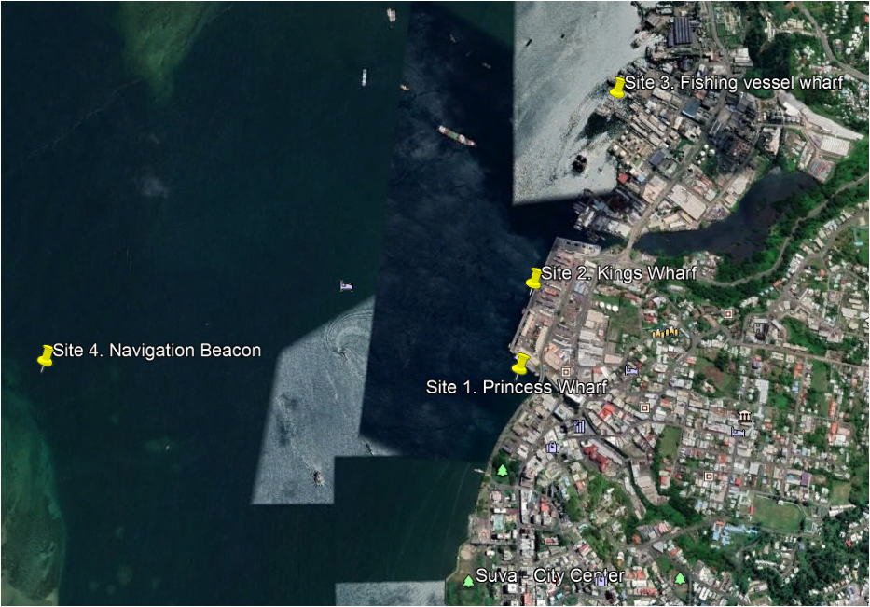

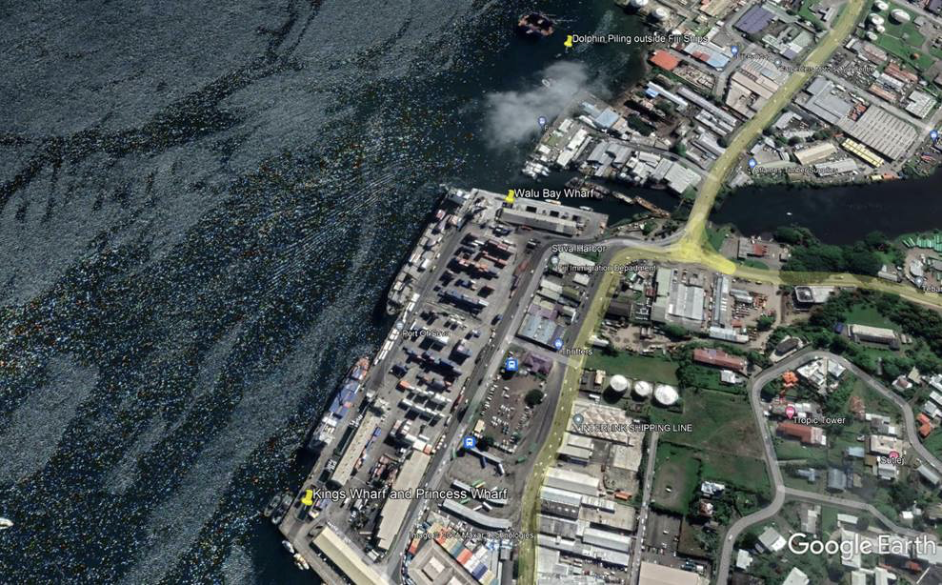

Sampling will be done four times during the trial phase (Yr 2). Initially in September 2021, settlement plates will be deployed at each of the four locations, and trial water samples will be collected to begin testing the sample processing workflow. Duplicate series of settlement plates (with 3 plates in each series) will be deployed at each site.

After an incubation period of two months in November 2021, the plates will be collected and replaced; one set of three will be preserved for molecular sampling, and another set of three plates will be used for the morphological sorting and taxonomic identification of species voucher samples. In addition, in the same sampling trips where settlement plates are replaced, water and plankton samples will be collected. At each location three replicate water samples and three replicate plankton samples will be collected from the water column, amounting to 24 samples in total (3 replicates x 2 sample types x 4 sample sites). All samples will be processed in the USP laboratory immediately after sampling, or on the following day, in which case, they will be stored at +4°C for no longer than 12 hours before sorting is conducted. Water filters and plankton samples will be processed for eDNA analysis in addition to one of the sediment plate series. DNA will be extracted for metabarcoding sample preparation, and stored at -20 °C before further processing. Mock community samples with known proportions of DNA from about 10 voucher specimens, will be used as positive controls for the metabarcoding analyses. Metabarcoding libraries will be prepared at the USP laboratory, from a subsample of the extracted DNA, while the remaining sample is kept for long-term storage and back-up. The libraries will then be sent for sequencing to Macrogen in South-Korea.

During the first sampling trip, settlement plates will be deployed and water samples will be collected to initiate laboratory trials. In total for each following sampling event 48 samples will be collected (12 water samples, 12 plankton samples, and 24 settlement plates). In addition a bottle of deioinized water, used in the laboratory for rinsing, will be processed as a blank control in parallel to samples. This full sampling strategy will be repeated twice more during the trial year (February and June 2022) and will allow for gross sorting and taxonomic identification of additional biofouling organisms as well as comparisons on seasonal fluctuations in the marine biodiversity at port. Detailed sampling and sample processing protocols can be found in the field sampling methods section (section 5).

The purpose of the trial period of one year is to allow the identification of invasive species diversity at the trial sites. In addition, during the trial phase existing qPCR assays will be tested for targeted risk species monitoring. Based on the results of the port survey, and local expertise, the USP team will select the main target species from this list to test species-specific primers. Primers will be tested in collaboration with the qPCR facilities hosted at BAF. Positive controls will be sourced from specimen collections of partnering laboratories, or synthetic double-stranded DNA with the target gene fragment will be ordered.

## Operational Phase: Monitoring

After the initial port survey is completed, in phase two of the project, PacMAN will move into the operational phase. This phase will specifically address the objective of early detection of invasive species, providing methods for the continuous monitoring of the hotspots of marine traffic in Fiji. Building on the initial port survey conducted in phase one, water and plankton samples for eDNA analysis will be collected from the identified sites at Suva port every month. During the cyclone season (November to April) sampling will be performed monthly when the conditions allow. In addition to the monthly eDNA samples, settlement plates will be collected every three months. The number of sampling stations and replicates will remain the same as in the trial phase.

As a first priority, qPCR analyses will be used to monitor specific target species from each sampling event. Following the collections, qPCR analysis of target MIAS will be conducted in collaboration with the BAF lab within a week of sample collection. To enable identification of novel or cryptic MIAS, and the long-term monitoring of ecosystem state, eDNA samples will also be sent for metabarcoding four times during the operational phase, from a selection of the collected samples. Metabarcoding libraries will be prepared at USP from the same DNA samples from the sampling events, and samples sent for sequencing to Macrogen in South Korea.

## Timeline for sampling

Here we present the organization of the work across the two project years from September 2021-August 2023.

**Figure 2**. Gantt chart timeline for sampling and related project activities

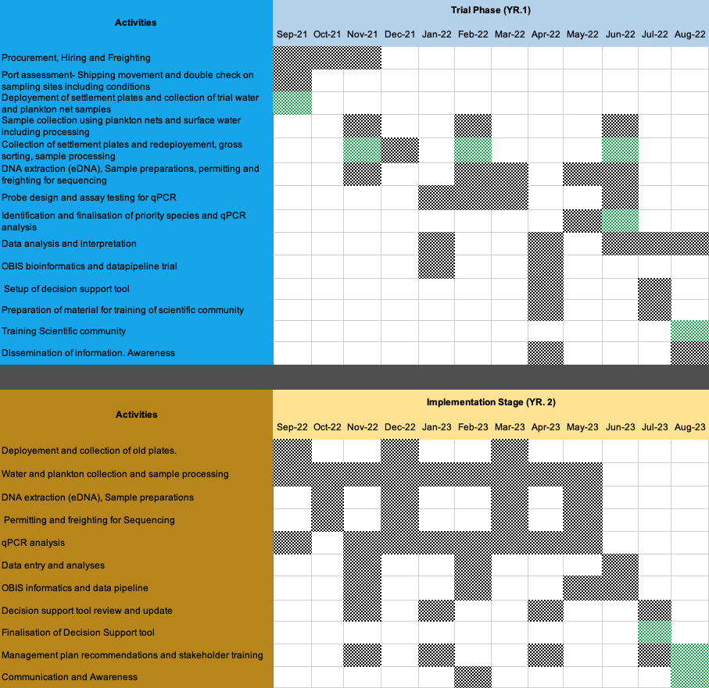

# Field Sampling Protocols

## Sampling strategy at different project phases

### Test phase, Port baseline survey

To perform a **full baseline survey** at a port location the following steps should be taken:

1. Sampling session 1
   1. Collect environmental and sampling information (protocol 4.2.1, Appendix 3/4)
   2. Take photographs of sampling locations when relevant
   3. **Deploy** settlement plates in duplicate (protocol 4.2.3.1) at each of the sampling sites and sample **water** and **plankton** in triplicate at each of the sampling sites (protocols 4.2.2 and 4.2.4.)
2. Sampling session 2
   1. Collect environmental data and sampling information (protocol 4.2.1, Appendix 3/4)
   2. Take photographs of sampling locations when relevant
   3. Sample **water, plankton** and **collect and replace settlement plates** (protocols 4.2.2.-4.2.4.)
3. Process samples in lab
   1. Morphological sorting and storage for samples collected for taxonomic specimens
   2. Data entry of samples (for taxonomic purposes for marine collection)
   3. Filter water samples (protocol 4.3.1.)
   4. Homogenize biomass samples (protocol 4.3.2-4.3.3)
   5. Store at -20 °C
4. Extract DNA (protocol 4.3.4.)
5. Prepare metabarcoding libraries (protocol 4.4)

### Operational phase, monitoring

For consistent monitoring, the strategy will be the following:

1. Sample for monitoring every month
   1. Collect environmental and sampling data (protocol 4.2.1, Appendix 3/4)
   2. Take photographs of sampling locations when relevant
   3. Collect water and plankton samples (protocols 4.2.2. and 4.2.4.)
   4. **Every three months:** Collect and replace settlement plates (protocol 4.2.3)
2. Process samples immediately after sampling in lab
   1. OR store at +4°C for no longer than 12 hours
3. Filter water samples (protocol 4.3.1)
4. Homogenize biomass samples (protocol 4.3.2-4.3.3)
5. Extract DNA (protocol 4.3.4)
6. **Test for target risk species with qPCR** (protocol 4.5.2)
7. Prepare samples for metabarcoding (protocol 4.4)

## 

## Sampling protocols

### Environmental measurement

Environmental measurements provide the context for ecological analyses, and long-term monitoring of ecosystem state, as well as ecological conditions for MIAS.

* Required Materials
  + Digital YSI logger
  + GPS logger
  + Secchi disc or turbidity meter
  + Digital camera
  + Field data sheet
  + Pen
* Protocol
  + For the three chosen sampling locations at port
    - Record GPS coordinates
    - Record water depth at location
    - Water salinity and temperature should be measured at least at 2.5 m intervals from surface water to bottom at each site.
    - Measure also pH, dissolved oxygen and turbidity if possible.
    - Fill in environmental data sheet
    - Take pictures of relevant conditions in the sampling locations (e.g. extensive biofouling)

### Water sampling

* **Required Materials**

1L sterilized water bottles (e.g. NalgeneTM), marked for exact 1 litre level. (4-5x for each site)

Sterile gloves

Thermal box and ice for cooling samples

Water-resistant marker/tape

* **Protocol**

**Preparation** before using/re-using sample bottles,

* + - Decontaminate by submerging in 10 percent bleach solution
    - Rinse thoroughly with distilled water (fill, cap, shake, and rinse; repeat at least three times), let dry.
    - At the sampling site, rinse again with sample water three times (cap and shake)

to remove any remaining bleach before collecting sample. This step requires a lot of care as any remaining bleach will degrade eDNA!

* + - Collect three replicate 1 L surface water samples at site
      * Label with: Date_Port_Location_SampleType_Depth_replicate
      * (e.g. 20211105_Suva_Site1_Water_0m_A)
    - Place in cooler for transport to lab
    - Fill in collection data sheet
    - At lab, either filter immediately (protocol 4.3.1) or place in +4 °C overnight for a maximum of 12 hours
    - Collect also an extra 1 litre of water at each site to be used in the processing of biomass samples.

### Settlement plates

#### Deployment

* **Required Materials**
  + 100mm diameter pipes x 4 lengths
  + Polypropylene rope (0.5 cm diameter), approx. 22 m
  + Short tubing (hard plastic, to place between PVC plates and rope)
  + Zip ties
  + Quarter inch rod
  + Bricks
  + In case of no suitable structure at the sampling sites, deploy on own buoys.
* **Preparation:**
  + Cut PVC pipe in half lengthwise, to get two half-circle shapes (~plates)
  + Sand both sides of each PVC pipe briefly (few seconds, sanding paper 80)
  + Drill hole in the in the center of each plate (~0.5 cm diameter)
  + Place short piece of tube at each hole on the PVC pipes (prevents breaking the rope due to movement of the setup in the water).
  + Secure PVC pipes with knots secured with zipties, so that there is 2m of rope between plates A and B, and 4 m between pipes B and C, and ample rope at each end.
    - This is depending on the depth of water at site, and the depth that the settlement plates will be deployed, the recommendation is at 1 m, 3 m and 7 m water depth.
  + Tie a brick at the end of the rope

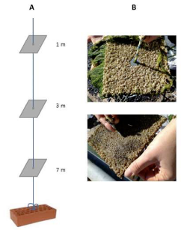

**Figure 3.** Suggested setup of settlement plates (Joint HELCOM/OSPAR guidelines). Plates will be replaced by PVC pipe segments cut in half

* **Deployment:**
  + Deploy duplicate setups at a location where they do not disturb port traffic
  + Check depth of water at site and adjust height of plates appropriately
  + Tie upper end of rope securely to a dock structure
  + Unit should remain upright and the rope should remain tight.

#### Collection

* **Required materials:**
  + Single-use (sterile) plastic bags (20x20 cm) labelled for collection (Ziplock bags)
  + Water-resistant marker
  + Sterile gloves
  + Cutters for the zipties
  + Thermal box and coolers for transportation
  + Digital camera
  + New prepared settlement plates (full setup) for replacement
* **Collection:**
  + Retrieve plates after 2-3 months soak time.
  + Retrieve all plates simultaneously.
  + Pull on the dock/boat as carefully as possible.
  + Place in individual plastic bags labelled with sample information
    - Date_Port_Location_SampleType_Depth_replicate
    - (e.g. 20211105_Suva_Site1_Plate_5m_A)
  + Photograph each plate
  + Place collected and labelled plastic bags in cooler for immediate transport to lab
  + In lab,
    - For one series of plates: scrape and homogenize the biomass immediately (protocol 4.3.2) or place in +4 °C overnight for a maximum of 12 hours
    - For the second series of plates: store in 95 % ethanol (not denatured) before specimen sorting.
  + Reminder: Collect additional water (approx. 1 litre) from each site (remember to label the bottle), to add volume to samples for the blending step.

### Plankton sampling

* **Required materials**
  + Plankton net with mesh sizes of 60 um and 280 um (what is available)
  + Sterile 250-500 ml collection bottles for samples
  + Marker
  + Squeeze bottle for rinsing
  + Sterile gloves
* **Protocol**
  + Tow Plankton net at 3 locations 10-15 m apart from each other at each site.
  + Drop net to 1 m from the bottom, and slowly bring back up (0.5-1 m/s)
    - Several tows may be needed to collect enough material for extraction at each site.
    - Collect each sample from the tow in a clean sample bottle. If multiple tows are required, the sample can be concentrated by using the codend of the plankton net.
    - If using different size classes these can also be combined if necessary
  + Pour collected material in collection bottle, marked with sample information
    - Date_Port_Location_SampleType_MeshSize_replicate
    - (e.g. 20211105_Suva_Site1_Plankton_200μm_A)
  + Place in cooler for transport to lab
  + Rinse codend of the plankton net three times with seawater at the collection site, and the next sampling site before new tow
  + In lab, centrifuge sample immediately (protocol 4.3.3), or place in +4 °C for a maximum of 12 hours.

## 

## Sample preparation and DNA extraction

All the following steps of the methods should be done in an area in the lab dedicated to eDNA work, to minimise contamination from other lab activities.

### Filtration of water samples

* **Required materials** 
  + Filtration setup 47 mm diameter (filtration cup, filter holder, collection Erlenmeyer)
  + Vacuum pump and connecting tubing
  + 0.45 μm filters 47 mm diameter (cellulose nitrate).
  + 1 L deioinized water in a clean Nalgene bottle for preparing control sample
  + 10 % bleach for cleaning
  + Sterilized tweezers
  + 15 ml falcon tubes for filter collection
  + Permanent marker
  + Sterile small metal scissors (for example nail scissors)
* **Protocol**
  + Clean bench with >70% ethanol and 10% bleach before work
  + Wear sterile gloves at all times and try to minimize contamination with careful working methods.
  + Clean filtration system by submerging in 10 % bleach and rinsing thoroughly with deionized water between samples
  + Setup filtration system, and condition the filter with a small amount of deionized water
  + Keep 1 l bottle of deionized water open during filtration to collect control sample
  + Record level of water in sample bottle, if not at 1 L mark
  + Pour sample water slowly on filter while keeping vacuum pump on.
  + If filter clogs, record amount of water remaining (total amount filtered)
  + Collect filter with sterile tweezers to falcon tube.
  + Label with the label on sample bottle
  + Freeze at -20 °C before DNA extraction
  + Clean filtration cup, and filter holder before the samples from the next site with bleach and deionized water (be very careful, as any remaining bleach will degrade eDNA!).
  + Change gloves between samples to minimize cross-contamination
  + When all samples have been filtered, filter the control sample, which was kept in an open bottle on the bench.
    - Label with Date_Port_control
    - (e.g. 20211105_Suva_control)
  + For DNA extraction, take about 100 mg of filter (for example half, measure approximate weight on the first trial processing round), return other half to freezer.
  + Cut filter piece into small pieces using sterilized tweezers and scissors, and add to extraction tube with beads.

### Settlement plates

* **Required materials:**
  + Sterile gloves
  + Sterilized tweezers
  + Sterilized razor blades
  + 50 ml sterile falcon tubes for sample collection
  + Tube holder for falcon tubes (cleaned by submerging into bleach and rinsing with water).
  + Mortar and pestle/homogenizer/blender for sample prep
    - E.g. kitchen blender
* **Protocol**
  + Take sample in plastic bag out of freezer
  + Wipe lab bench with >70% ethanol and 10% bleach
  + Set a sterilized kitchen foil on bench for any dropped material
    - Sterilize with ethanol and flame
  + With tweezers (or find another way here?), lift plate out of bag, and scrape biomass from both sides of the plate into falcon tube.
  + Homogenize biomass with additional site seawater on maximum speed in blender
  + Filter resulting slurry through a 40 𝝻m mesh for biomass samples
  + Return to falcon tube
  + Label with sample label
  + Freeze at -20°C before DNA extraction
  + For DNA extraction (protocol 4.3.4), measure 100 mg of homogenized and well-mixed biomass to a sample tube containing beads for bead beating.

### Plankton samples

* **Required materials:**
  + Sterile gloves
  + 50 ml sterile falcon tube
  + Tube holder for falcon tubes (cleaned by submerging into bleach and rinsing with water).
* **Protocol**
  + Pour biomass into Falcon tube
  + Centrifuge (cool if possible) to collect plankton pellet
  + Discard supernatant
  + Transfer pellet to 2 ml tube
  + Label with sample label
  + Freeze sample at -20 C
  + For DNA extraction, take 100 mg of biomass to a sample tube containing beads for bead beating.

### DNA extraction (all sample types)

* **Required materials**
  + Sterile gloves
  + DNA extraction kit (DNeasy Blood and Tissue Kit), containing extraction buffers and Proteinase K
    - Make sure that all preparation steps for the kit are done.
  + 0.5 mm and 0.1 mm glass beads (BioSpec Products), ashed or sterilized and cleaned
  + Sterile Eppendorf tubes (sterilized under UV if possible)
    - 2ml with screw cap and o-ring or suitable for bead beating
    - 1.5 ml eppendorfs
  + Bead-beater
  + DNAse free water
  + Biosafety Cabinet will be used to conduct extractions
  + Centrifuge (for Eppendorf tubes)
  + Vortex
  + Heat block/bath
  + Pipettes and DNAse free tips with filters (1000 ul, 200 ul, 100 ul, 10 ul)
  + 100% molecular grade ethanol
  + QBIT/Nanodrop
* **Protocol (**[**https://www.protocols.io/view/mbari-environmental-dna-edna-extraction-using-qiag-xjufknw?step=4**](https://www.protocols.io/view/mbari-environmental-dna-edna-extraction-using-qiag-xjufknw?step=4) **)**
  + Prior to extraction, 0.5 mm and 0.1 mm glass beads (BioSpec Products) need to be ashed at 500 °C for 5 hours OR soaked in 10% bleach for 20 min, rinsed at least 3x with milliQ water and dried.
  + Bead tubes: Distribute 0.25 g of each size glass bead into sterile 2.0-ml conical microcentrifuge tubes (with screw cap and o-ring). Autoclave tubes for 30 min.
  + Transfer sample (filter or biomass) to bead tubes with sterile forceps/spatula
    - 100 mg of tissue or filter
  + Add 720 μl Buffer ATL (Qiagen), and perform two bead-beating steps
    - Maximum speed for 45 sec, followed by incubation at 56 °C for 30 min
    - Repeat bead beating and incubation
  + Add 80 μl Proteinase K to each tube and incubate at 56 °C for a minimum of 2 hours, or overnight
  + After incubation, vortex tubes for 15 sec then centrifuge for 1 min at 4,000 x g.
  + Transfer 650 μl of supernatant to new 1.5-ml tubes then spin at 13,000 x g for 1 min.
  + After the final spin, transfer 600 μl of supernatant (avoiding any remaining glass beads) to a new 2-ml tube for the next steps.
  + For the remaining steps follow the manufacturer’s protocol for the Qiagen DNeasy Blood and Tissue Kit with the following modifications:
    - Use 600 μl of Buffer AL and 600 μl of 100% ethanol
    - Pipette 500 μl of lysate to spin column then centrifuge each time until the entire volume of lysate (1.8 mL) has passed through the spin column (can also be centrifuged)
    - Perform two 500-μl washes of Buffer AW1 and two 500-μl washes of Buffer AW2
    - Elute in two 50-μl steps for a total of 100 μl extracted DNA.
  + Process also the control water filter simultaneously with the all samples
  + Measure concentration and quality of the DNA extract with nanodrop and QBIT
  + Store at -20 °C

## Metabarcoding library preparation

The amplification for metabarcoding happens in two steps:

* Step 1: Amplification of the target region with universal indices (same for all samples)
* Step 2: Attachment of sample-indices and sequencing adapters to the amplicon of step 1

### Amplification of target gene region: 1st PCR

Primers will be ordered with overhangs, that are used for adding sample indices (barcodes) and sequencing adapters (Nextera).

**Table 2.** Universal primers commonly used for metabarcoding

|  |  |  |  |  |
| --- | --- | --- | --- | --- |
| Primer name | Sequence (overhang) | Target gene | Amplicon size (bp) | Reference |
| mlCOIintF | 5′-TCGTCGGCAGCGTCAGATGTGTTAAGAGACAGGGWACWGGWTGAACWGTWTAYCCYCC-3′ | COI | 313 | Leray et al. 2013 |
| jgHCO2198 | 5′-GTCTCGTGGGCTCGGAGATGTGTATAAGAGACAGTAIACYTCIGGRTGICCRAARAAYCA-3′ |  |  | Geller et al. 2013 |
| Uni18SF | ﻿5′-  TCGTCGGCAGCGTCAGATGTGTTAAGAGACAGAGGGCAAKYCTGGTGCCAGC-3′ | 18S-V4 | 400-600 | Zhan et al. 2013 |
| Uni18SR | ﻿5’-GTCTCGTGGGCTCGGAGATGTGTATAAGAGACAGGRCGGTATCTRATCGYCTT-3′ |  |  |  |

* Required materials
  + >70% ethanol, 10% bleach for cleaning
  + Sterile gloves
  + 0.2 ml strips of 8 + racks
  + Ice box + ice
  + PCR-grade water
  + Pipettes
  + Filter tips
  + Primers
  + Polymerase
    - KAPA Taq PCR kit
    - It is important that the polymerase does not have 3'->5' exonuclease activity, as these will not work with the inosine-containing degenerate COI primers.
* Protocol
  + Wear gloves at all times. Carefully clean the bench station(s) and pipettes.
  + Prepare calculations and sample map for location of samples in strips
  + Defrost reagents on ice, prepare mastermix for all samples, accounting for about 10% more volume, for pipetting error. One reaction in a total volume of 20 μl:
    - ﻿0.8 μl (5 nmol/ml) of forward and reverse primers
    - ﻿10 μl KAPA Taq 2X Readymix
    - 6.4 ul PCR-grade water
    - 2 μl DNA extract (5-10 ng, or undiluted)
  + Mix everything except DNA to prepare the mastermix
  + Aliquot 18 μl to 0.2 ml eppie strips
  + Finally add the 2 ul of DNA for each sample
    - 3 reactions for each sample and control
  + PCR protocol (based on Clarke et al. 2017):
    - 95 °C for 10 min;
    - 20 (or up to 35) cycles
      * COI: 95 °C for 30 s, 46 °C for 30 s, 72 °C for 1 min;
      * 18S: 95 °C for 30 s, 53 °C for 30 s, 72 °C for 1 min;
    - 72 °C for 10 min
  + Run PCR products on gel to check products: (for example like so):
    - 1.5 % agarose gel, stained with SybrSafe as a stain
    - With standard size ladder
  + Clean 20 ul of the PCR products with
    - QIAquick PCR Purification Kit (cut bands from gel and extract).
    - (Possible trial to be made for saving: is this first cleaning step strictly necessary?)
    - Quantify PCR products fluorometrically
  + Store products in fridge for short-term (<24 hours) or freezer for longer-term storage

### Add sample indeces and sequencing adapters: 2nd PCR

* Protocol:
  + Use (cleaned) PCR products from the first PCR reaction
  + Make map of samples and primers for each 0.2 ml tube before pipetting
  + PCR reaction (20 μl each). Pipette separately in each tube (or using multipipette, i.e. no preparation of mastermix, as each sample has different F/R primer combinations).
    - 10 μl KAPA Taq 2X Readymix
    - 4 μl of PCR-grade water
    - 0.5 μl (10 nmol/ml) of both F and R primer
    - 5 μl of cleaned PCR1 product
  + PCR conditions
    - initial denaturation step at 95 °C for 10 minutes
    - 15 cycles
      * 95 °C for 0:30, annealing at 55 °C for 0:30, and extension at 72 °C for 1:00.
    - A final extension at 72 °C for 10 minutes.
  + Clean PCR products using QIAquick PCR Purification Kit
  + Quantify fluorometrically.
  + Pool all samples at an equimolar concentration
    - Dilute samples to the same concentration using PCR-grade water, and combine the same volume of each sample
  + Concentrate sample using the QIAquick PCR purification kit.
  + Quantify DNA concentration of mixture
  + Run 1-5 μl on gel with standard ladder, and image
  + Send for sequencing

## Species specific rapid detection

### qPCR assay development

For species-specific detections, USP will test existing assays, or develop new assays for each of the chosen target risk species to ensure that the utilized primers do not have unspecific amplification of closely related local species. Some existing assays for the species in the target list are reviewed in table 3. These primers have been tested for qPCR functionality and have been found to be species-specific, and do not amplify a range of closely related species from the region of testing (not Fiji).

**Table 3.** Existing qPCR primers developed for the species in the PacMAN target list.

|  |  |  |  |  |  |  |  |  |
| --- | --- | --- | --- | --- | --- | --- | --- | --- |
| **Target Species** | **Primer name** | **Forward sequence** | **T (C)** | **Reverse sequence** | **T (C)** | **Length** | **Probe sequence** | **Reference** |
| *Eriochier sinensis* | Erisin_cytb_F02/R02 | ACCCCTCCTCATATCCAACCA | 62.7 | AAGAATGGCCACTGAAGCGG | 64.7 | 114 | FAM-TTTGCTTACGCTATTTTACGATCAATTCCT-BHQ1 | Andersen et al. 2018 |
| *Rhithropanopeus harrisii* | Rhihar_cytb_F03/R03 | GTCAACCTGGTACTCTCATTGGT | 63 | ACGAGGAAATGCTATATCAGGGG | 63 | 164 | FAM-TGTTGTAGTAACAGCTCACGCCTTTGT-BHQ1 | Andersen et al. 2018 |
| *Hemigrapsus sanguineus* |  |  |  |  |  |  |  |  |
| *Charybdis japonica* |  |  |  |  |  |  |  |  |
| *Mytilopsis sallei* | MytF, MytR | GYTAGTTCCRATGATGTTAGCTG |  | ACCTATTGAAACAGGCAACACTC |  |  | CCTCGGCTTAATAATGTTAGT | Bott et al. 2012 |
| *Perna perna\** | Fw A, Rev A | CTTAGTGGCATTAATTCGDAATCC | 59.2 | CAAAGTACCAATATCTTTATGATTRGTWGA | 57.5 | 281 | AACCATCGACTCAATTAA (lagging DNA strand) | Dias et al. 2013 |
| *Perna viridis\** | Fw A, Rev A | CTTAGTGGCATTAATTCGDAATCC | 59.2 | CAAAGTACCAATATCTTTATGATTRGTWGA | 57.5 | 281 | ACTCAAACAACAAAGTAAAC (lagging DNA strand) | Dias et al. 2013 |
| *Didemnum perlucidum* | Dper new F/R | AGCTCCTGATATAGCATTTCCTCGTTTAAA | 63.3 | AGATATTCCTGCTAAATGTAATGAAAAAATAGCTA | 61.2 |  | TAGCTCATTCAAATAGGGCAGTA | Simpson et al. 2017 |
| *Mytella strigata* | CO1mytellaFf/r | GGGTTAATAGGAAGAAGGTTGAGA | 50 used | ACAACCACCGATACA TAAAGG | 50 used | 196 | *Not developed* | Yip et al. 2021 |
| *Amathia verticillata* |  |  |  |  |  |  |  |  |
| *Batis maritima* |  |  |  |  |  |  |  |  |
| *Arcuatula senhousia* |  |  |  |  |  |  |  |  |

*These primers amplify also other invasive *Perna* species: *P. canaliculus*, species-specific probes were developed for species-specific detections.

Full validation of a new qPCR assay requires the following steps:

1. Design species-specific primers in silico (if available qPCR assays are reliable this step can be skipped).

* Collect reference sequences of target species and all available closely related (local) species from public genetic reference databases. Identify species-specific regions for primer selection by aligning the sequences and searching for regions that can differentiate the species by using the Geneious software, or if not available, free programs like Bioedit. Design primers with the help of primer-design software like <https://primer3.ut.ee/> or <https://eurofinsgenomics.com/en/resources/design-tools/pcr-primer-design/>
  + Choose amplicon length in between 75-200 bp
  + Avoid secondary structure if possible
  + Avoid templates with long (>4) repeats of single bases
  + Maintain a GC content of 50–60%
  + Maintain a melting temperature between 50ºC and 65ºC
    - Can be checked with oligocalc (<http://biotools.nubic.northwestern.edu/OligoCalc.html>)
  + Avoid repeats of Gs or Cs longer than three bases
  + Place Gs and Cs on ends of primers
  + Check sequence of forward and reverse primers to ensure no 3' complementarity (avoid primer-dimer formation)
  + Verify specificity using tools such as the Basic Local Alignment Search Tool (<http://www.ncbi.nlm.nih.gov/blast/>)

1. Test primers on tissue or DNA of the target species and closely related, local non-target species

* Source specimen samples or DNA from marine collections, by sampling the local environment, or by contacting partner laboratories

1. Test primers on environmental samples with known presence/absence of target species

* If there is no known presence of the species in the environmental samples, eDNA samples can be spiked with the DNA obtained from the target specimen at low concentrations to test the applicability of the assay for mixed environmental samples.

1. Define limit of detection

* The limit of detection can be defined by testing diluted target DNA to the concentration where a signal is no longer recorded.

### qPCR protocol

* Required materials:
* qPCR SYBR Green Mix (IQ™ SYBR® Green Supermix)
* DNA template - 10 ng to 100 ng gDNA
* Target species DNA diluted for a standard curve
* Forward and reverse primers diluted to working concentration (10µM working stocks are sufficient for most assays)
* Sterile filter pipette tips
* Sterile 1.5 mL screw-top microcentrifuge tubes
* PCR tubes, select tubes to match desired format and amount of samples:
  + - Individual thin-walled 200 µL PCR tubes
    - 96 well plates
* Plate seals
* ThermalSeal RTS™ Sealing Films
* ThermalSeal RT2RR™ film
* PCR grade water
* **Protocol**
  + Place all reaction components on ice.
  + Mix and then briefly centrifuge to collect contents at the bottom of the tube
  + Prepare enough master mix to run all samples in duplicate, and standard curve.
  + Be sure to include duplicate no template Negative Controls (NTC)
  + Calculate amount of reagents to mix. Add 10% volume to allow for pipetting error
  + Mix well, avoiding bubbles.
* Mastermix (for qPCR ready mixes)
  + For each reaction calculate the following reagents and combine:
    - 10 μl of 2X qPCR mix
    - 0.6 μl forward primer (10 μM concentration)
    - 0.6 μl reverse primer (10 μM concentration)
    - 4.8 μl PCR water
* Setup reactions:
  + For NTC reactions, add 4 μL of water to the empty reaction tube
  + For experimental reactions, add 4 μL of DNA solution to the empty reaction tubes.
  + Centrifuge all tubes briefly. Visually confirm that all tubes or wells contain sample at the bottom at the correct volume.
  + Carefully aliquot 16 μL of template master mix into each qPCR tube or plate well.
  + Mix reactions well and spin if needed.
  + Cap tubes or seal the PCR plate and label (according to instrument requirements). (Make sure the labelling does not obscure instrument excitation/detection light path.)
* Run samples as per instrument manufacturer recommendations. Examples of standard have been included below:
  + Standard cycling parameters:
    - Initial denaturation 94 °C for 2 min
    - 40 cycles:
      * Denaturation 94 °C for 15 sec
      * Annealing, extension, and read fluorescence 60 °C or 5 °C below lowest primer TM for 1 min
    - (Optional) Hold at 4 °C only if products will be run out on a gel
    - Add melting curve analysis to the end of the program

# Data management plan

The goal of this data management plan is to describe how data will be collected, used, preserved and shared within the project. The data management plan is drafted taking into account the FAIR Guiding Principles for scientific data management and stewardship[1] and the IOC Oceanographic Data Exchange Policy[2], in order to maximize the current and future value of the data and information generated by the project. We promote open science and try to make our research as transparent as possible. This is especially important as the information we create is likely to have policy and management consequences.

The project is expected to generate the data and information objects listed below throughout its data life cycle. All data objects will receive a unique identifier and will be published as open data as much as possible, taking into account that some data and information may be of a sensitive nature. Care will be taken to preserve provenance of all objects as well as relationships with other objects.

*Table 4. Overview of all data objects created by the project.*

|  |  |  |  |
| --- | --- | --- | --- |
| **Data object** | **Phase** | **Format** | **Preservation** |
| Field sampling sheets | Data collection | paper, PDF |  |
| Unprocessed sampling metadata, environmental measurements | Data collection | Excel |  |
| Species checklists | Data collection | Darwin Core Archive | PacMAN IPT |
| Images | Data collection | JPEG |  |
| Sequence reference database | Data collection |  |  |
| Raw sequence data | Data collection | fasta | NCBI |
| OTU tables | Data processing |  |  |
| Software | Data processing |  | GitHub |
| Specimen barcodes | Data dissemination |  | BOLD |
| Processed species occurrence data, environmental measurements, representative sequences, image metadata | Data dissemination | Darwin Core Archive | PacMAN IPT |
| Risk assessments | Data dissemination |  |  |
| Publications | Data dissemination | PDF | Publisher |

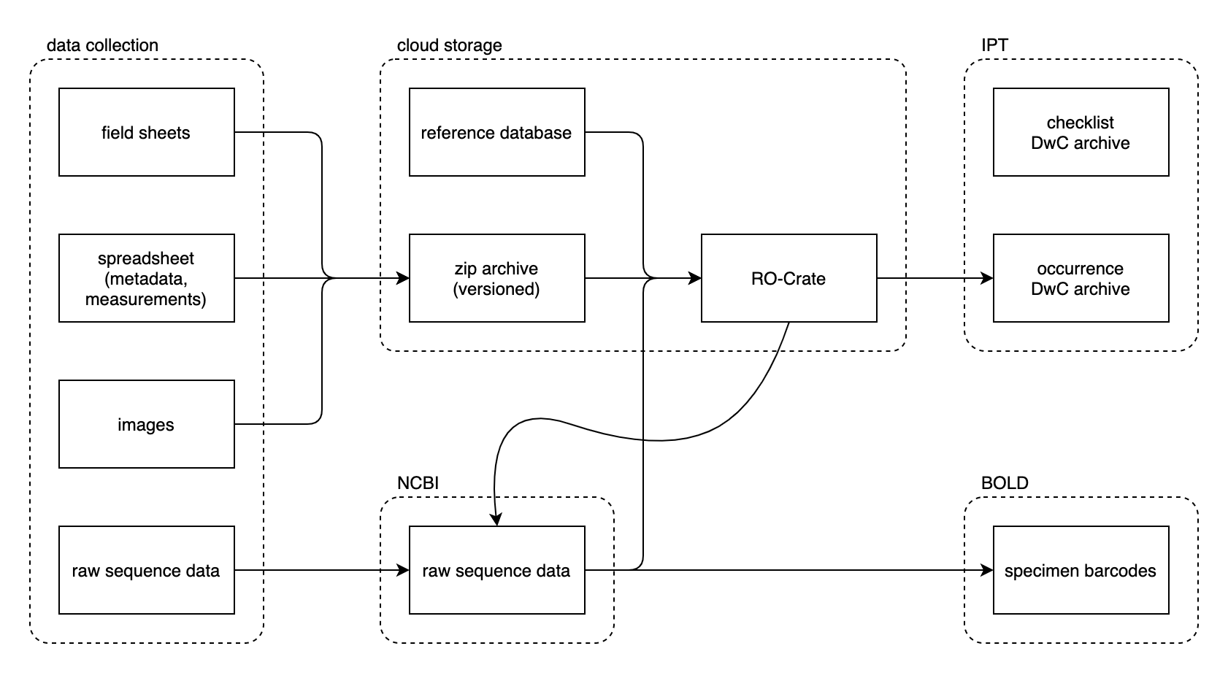

*Figure 4. Overview of all data objects created by the project and their relationships.*

## Data collection, storage, and preservation

During field sampling, sampling parameters, sample identifiers, and environmental measurements are written down on the field sampling sheets included in the PacMAN protocols. Excel templates will be provided to submit this information, together with images and links to externally hosted sequence data, to OBIS (see Annex 7, available for download [here](https://drive.google.com/drive/folders/1yaZr41gntigyLY3ncrxROdlxSPK-BaKM?usp=sharing)). A web interface will be developed to allow submission, and submitted datasets will be stored in cloud object storage with regular backups to another location.

Raw sequence data will be submitted to NCBI by the USP team. BioSample records are to be created under the PacMAN BioProject[3] (PRJNA741074) and accession numbers are added to the template spreadsheet. A bioinformatics pipeline is being developed and will be published as open source software (see section 5.2. Data analysis for more information).

OBIS will use this pipeline to process submitted metabarcoding sequence data, but an online computing environment, which will include the data processing pipeline as well as the sequence reference database, will be made available to all partners so they can run the analyses as well. Processed data, along with details about the workflow and links to externally hosted data such as the sequence data at NBCI, will be published as Research Object Crates (RO-Crate)[4]. RO-Crate is an open, community-driven, linked data based approach for packaging and sharing research objects. In addition to RO-Crate, Darwin Core archives are published on the project's IPT server with a Creative Commons CC BY 4.0 license.

The PacMAN project will build on publicly available checklists of species of interest, and will also generate its own checklists based on literature review and local knowledge. These checklists will be published as Darwin Core archives on the project's IPT server with a Creative Commons CC BY 4.0 license.

All software created by the project will be published openly on GitHub with a permissive license. The software will be versioned and include detailed documentation.

## Data analysis

The objective of the data analysis pipeline of PacMAN is to improve the availability of biodiversity and metabarcoding data to global data repositories. The aim is to automate the process from sequencing to data analysis and storage as much as possible, while ensuring data comparability and sustainability.

The bioinformatics pipeline of PacMAN (PacMAN - pipeline, <https://github.com/iobis/PacMAN-pipeline>) will be used to infer amplicon sequence variants (ASVs) from sequencing data. This will allow long-term comparability of results as no arbitrary thresholds for sequence clustering are used in the analysis step. The pipeline includes quality control, ASV inference, taxonomic assignment and data formatting for Darwin core archives. The pipeline has been developed by building on multiple open source metabarcoding pipelines, and after comparison of the results obtained from the existing pipelines. Briefly the pipeline utilises Trimmomatic (Bolger et al., 2014) and Cutadapt (Martin, 2011) for initial adapter and primer trimming as well as quality control. The dada2 pipeline is incorporated for further quality trimming, ASV inference through taking into account sequencing error profiles, sequence pairing, and finally chimera detection (Callahan et al. 2016). Taxonomic classification is done according to the ANACAPA pipeline (Curd et al. 2019) utilising alignment to the reference database with bowtie2 (Langmead et al. 2012) and inference of the lowest common ancestor in the chosen confidence threshold with Bayesian Lowest Common Ancestor (Gao et al. 2017). Finally the classified sequences are formatted to the Darwin core archive format, to ease their submission to global biodiversity databases like OBIS.

A very important part of the process will be to collect a sequence reference database that is comprehensive and reliable for the classification of ASVs to WoRMS scientific names. The reference database will be compiled by the OBIS data manager from public sources as well as from existing reference databases managed by project partners. The reference database will inform if and where sequencing of voucher specimens is required. The project team at the OBIS secretariat will develop the pipeline and compare and compile the reference database. The pipeline will be deployed on an online platform, with an easy to use interface for data submission. This will provide the USP team access to necessary computing power and ensure that the pipeline can easily be used in future applications of the project. When finished, the PacMAN pipeline will enable relatively automated and easy-to-use analysis of sequence data originating from metabarcoding studies. The pipeline will be fully open-access and the source code will be available online (<https://github.com/iobis/PacMAN-pipeline>).

Based on the species identified with the metabarcoding studies and the bioinformatic pipeline, the decision support tool will develop models to detect species that can cause specific risk to the local marine environment in Fiji. Invasive species lists presented in this document as well as consulted from Global Invasive Species Database (GISD) representative Shyama Pagad and a non-pacific MIAS species list from Pearman et al. (2020), will be used to aid in initial MIAS identifications. Then, models based on a combination of species distribution information, species trait information, and environmental data will be used to assess if an identified species has the potential to establish in the new environment. This data will be shown on a dashboard with a species watch list, enabling managers to identify species of concern, for dedicated monitoring efforts and full risk analyses.

## Data sharing and re-use

As per IOC-UNESCO’s data policy requirements data will be freely shared at the end of the project for the use of all stakeholders with the principle goals being to support knowledge distribution and to aid management decision making for the benefit of the people of Fiji and the region. Data will be accessible via the normal OBIS access methods. However, sensitive data such as the detailed location of rare or endemic species in need of conservation may be generalized (scientific name, location) where necessary as per current best practices (Chapman, 2020). Protocols will be further developed as to how, and to whom, sensitive data on invasive species e.g., identification of species that may have trade implications, will be released. These data and information release protocols will be approved by the PacMAN advisory board through the appointed focal point or through the CBD focal point.

An option for dealing with sensitive data:

Sensitive species list (i.e. sensitive endemic species) and/or algorithms are included in the data processing pipeline to ensure that sensitive information is not included in the public instantiations of the PacMAN datasets. Private dataset versions containing the sensitive information and/or reports on that information will be made available to the project partners including the Fijian authorities. Sensitive information will be released to the public after a moratorium period.

## Ethics, legal and security issues

The monitoring, and subsequent data acquisition, will be undertaken following research best practice access and benefit sharing guidelines and will meet the Republic of Fiji Islands current ad hoc arrangements as per the ministerial practices. These include:

1. Support letters from the relevant ministries have been obtained for the project activities.
2. Support letters from a local institute as a local partner to liaise with overseas partners has been received.
3. Any ethical issues of concern should be raised with the PacMAN project coordinator in the first instance, and before trial period starts (i.e. September 2021), and if not resolved be sent to the Advisory Board for further consideration.
4. The formalisation of an MoU with research partners with clear terms of reference on each partners contribution and duties to the research (e.g., BAF and USP).
5. In the event of the sample being transferred to a non-signatory of the MoU or an official project partner, a material transfer agreement (MTA) between the researcher (signatory) and the third party organisation shall be formalized and endorsed by a representative of each organisation with legal authority. The MTA shall be forwarded to Fiji government for endorsement by the Permanent Secretary for the Ministry of Fisheries.
6. The PacMAN monitoring activities will be executed in compliance with the Fiji ad hoc access and benefit sharing laws. Any issues will be resolved through the Advisory Board.
7. The use of Electronic sequence information for other research (outside of the PacMAN scope) must follow research best practices which acknowledges the source country including the PacMAN project and its partners as indicated in the CC-BY licence. A dataset citation will be added to the data.

# Cost analysis

The following table contains the estimated costs for sampling for the full processing of 4 sampling events in the trial year and 9 full sampling events in the operational phase. This includes sequencing of the samples three times in the trial phase and four times in the operational phase. Additionally, the costs for the extraction of DNA and processing of 100 voucher specimens has been added to this estimated cost list. Most prices have been confirmed from local suppliers of laboratory consumables. Costs that still need to be added are marked with ‘*TBA’*. The calculations for this table (costs by sample) calculations can be found in appendix 7, and a separate excel file.

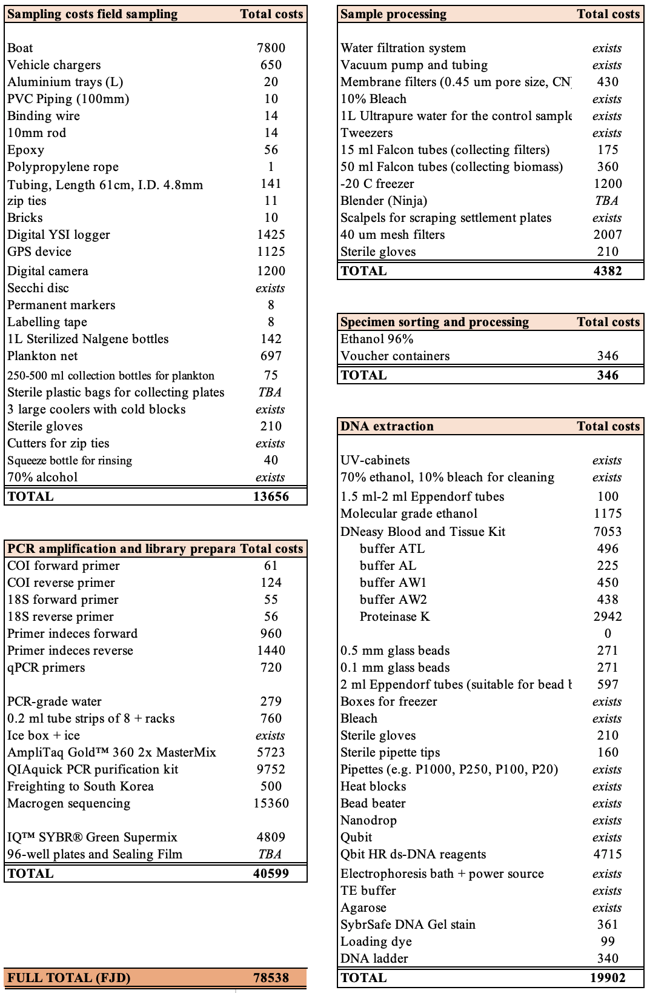

# Monitoring outcomes and possible management actions

In this section we identify a number of scenarios on the possible outcomes of the monitoring plan, and what types of management actions would be possible in terms of the information provided by monitoring under the PacMAN operational phase. The decision support tool will provide managers with a list of species detected in the molecular samples, and existing information on the species, e.g. knowledge on their distribution and preferred habitats, as well as if they are on the invasive species watch list. Different types of species detections, will mean different things, and required actions. Due to the lack of information on the current marine biodiversity in Fiji, it is likely that many species detections will be of species of which relatively little is known. Depending on the knowledge available for that species different management actions are needed. Most species detections will not require actions from environmental management, and can be used to help guide ecosystem assessments on longer time-frames. Those detections that can potentially be harmful, will be specifically flagged in the decision support tool, and can result in the following actions:

|  |  |  |
| --- | --- | --- |
| **Type of species detection** | **Knowledge on species** | **1st management action** |
| Known risk species detected | Existing comprehensive risk analysis | Initiate targeted survey (visual or molecular) |
| Unknown species detected | Distribution is not native, and according to habitat models, it could survive in Fiji | Initiate targeted survey and risk analysis |
| Unknown species detected | Not known if this species is native or not | Review information on this species |
| High abundance of new species detected | Distribution says it is likely not native, and according to habitat models it could survive in Fiji | Initiate risk analysis and consider rapid response |

Detections of high-risk species utilising the targeted species detection approach, can prompt more direct management actions. At first detection, it is recommended that if possible, a visual survey follows the detection, to understand the extent of incursion, and confirm the detection. This would then allow the initiation of eradication measures and management practices to enable the protection of the local ecosystem.

The mandate of the PacMAN project is limited to detection and sharing of data and information. We will provide training in the research methods and data analysis as well as interpretation. PacMAN will establish a list of contact points as first point of contact in case of positive detections. Needs for the decision support tool and possible management plans will be discussed with local stakeholders who have the mandate (e.g. the GEF6 coordinated by BAF). If additional surveys are required following a positive detection a contract will need to be established with the PacMAN team to carry this work out.

References

Amaral-Zettler, L. A., McCliment, E. A., Ducklow, H. W., & Huse, S. M. (2009). A method for studying protistan diversity using massively parallel sequencing of V9 hypervariable regions of small-subunit ribosomal RNA genes. PLoS ONE, 4(7), e6372. <https://doi.org/10.1371/journal.pone.0006372>

Andersen, J., Kallenbach, E., Thaulow, J., Hesselsoe, M., Bekkevold, D., Hansen, B. K., Jacobsen, L. M. W., Olesen, C. A., Moller, P. R., & Knudsen, S. W. (2018). *Development of species-specific eDNA-based test systems for monitoring of non-indigenous Decapoda in Danish marine waters*. NIVA Denmark Water Research. RAPPORT L.NR. 7204-2017

Australian Priority Marine Pest List: <https://www.marinepests.gov.au/what-we-do/apmpl>

Bolger, A. M., Lohse, M., & Usadel, B. (2014). Trimmomatic: A flexible trimmer for Illumina sequence data. *Bioinformatics*, *30*(15), 2114–2120. <https://doi.org/10.1093/bioinformatics/btu170>

Borrell, Y. J., Miralles, L., Do Huu, H., Mohammed-Geba, K., & Garcia-Vazquez, E. (2017). DNA in a bottle - Rapid metabarcoding survey for early alerts of invasive species in ports. *PLoS ONE*, *12*(9), 1–17. <https://doi.org/10.1371/journal.pone.0183347>

Bott, N. J., Giblot-Ducray, D., & Sierp, M. (2012). Development of a qPCR assay for the Black-striped Mussel, Mytilopsis sallei Report prepared for Commonwealth Department of Agriculture, Fisheries and Forestry & Biosecurity SA. *Marine Environment & Ecology*, *676*.

Bowers, H. A., Pochon, X., von Ammon, U., Gemmell, N., Stanton, J. A. L., Jeunen, G. J., Sherman, C. D. H., & Zaiko, A. (2021). Towards the optimization of edna/erna sampling technologies for marine biosecurity surveillance. *Water (Switzerland)*, *13*(8), 1–24. <https://doi.org/10.3390/w13081113>

Callahan, B. J., McMurdie, P. J., Rosen, M. J., Han, A. W., Johnson, A. J. A., & Holmes, S. P. (2016). DADA2: High-resolution sample inference from Illumina amplicon data. *Nature Methods*, *13*(7), 581–583. <https://doi.org/10.1038/nmeth.3869>

Campbell, M. L., Hewitt, C. L., & Miles, J. (2016). Marine pests in paradise: Capacity building, awareness raising and preliminary introduced species port survey results in the Republic of Palau. *Management of Biological Invasions*, *7*(4), 351–363. https://doi.org/10.3391/mbi.2016.7.4.05

Chapman AD (2020) Current Best Practices for Generalizing Sensitive Species Occurrence Data. Copenhagen: GBIF Secretariat. <https://doi.org/10.15468/doc-5jp4-5g10>

Clarke, L. J., Beard, J. M., Swadling, K. M., & Deagle, B. E. (2017). Effect of marker choice and thermal cycling protocol on zooplankton DNA metabarcoding studies. *Ecology and Evolution*, *7*(3), 873–883. <https://doi.org/10.1002/ece3.2667>

Collins, R. A., Bakker, J., Wangensteen, O. S., Soto, A. Z., Corrigan, L., Sims, D. W., Genner, M. J., & Mariani, S. (2019). Non-specific amplification compromises environmental DNA metabarcoding with COI. *Methods in Ecology and Evolution*, *10*(11), 1985–2001. <https://doi.org/10.1111/2041-210X.13276>

Curd, E. E., Gold, Z., Kandlikar, G. S., Gomer, J., Ogden, M., O’Connell, T., Pipes, L., Schweizer, T. M., Rabichow, L., Lin, M., Shi, B., Barber, P. H., Kraft, N., Wayne, R., & Meyer, R. S. (2019). Anacapa Toolkit: An environmental DNA toolkit for processing multilocus metabarcode datasets. *Methods in Ecology and Evolution*, *10*(9), 1469–1475. <https://doi.org/10.1111/2041-210X.13214>

Delrieu-Trottin, E., Williams, J. T., Pitassy, D., Driskell, A., Hubert, N., Viviani, J., Cribb, T. H., Espiau, B., Galzin, R., Kulbicki, M., Lison de Loma, T., Meyer, C., Mourier, J., Mou-Tham, G., Parravicini, V., Plantard, P., Sasal, P., Siu, G., Tolou, N., … Planes, S. (2019). A DNA barcode reference library of French Polynesian shore fishes. *Scientific Data*, *6*(1), 1–8. <https://doi.org/10.1038/s41597-019-0123-5>

Dias, P. J., Fotedar, S., Gardner, J. P. A., & Snow, M. (2013). Development of sensitive and specific molecular tools for the efficient detection and discrimination of potentially invasive mussel species of the genus Perna. *Management of Biological Invasions*, *4*(2), 155–165. <https://doi.org/10.3391/mbi.2013.4.2.09>

Duarte, S., Vieira, P. E., Lavrador, A. S., & Costa, F. O. (2021). Status and prospects of marine NIS detection and monitoring through (e)DNA metabarcoding. *Science of the Total Environment*, *751*, 1–39. <https://doi.org/10.1016/j.scitotenv.2020.141729>

Farrapeira, C.M.R. (2011) The introduction of the bryozoan Zoobotryon verticillatum (Della Chiaje, 1822) in northeast of Brazil: a cause for concern. Biol Invasions 13, 13–16 <https://doi.org/10.1007/s10530-010-9788-6>

Gao, X., Lin, H., Revanna, K., & Dong, Q. (2017). A Bayesian taxonomic classification method for 16S rRNA gene sequences with improved species-level accuracy. *BMC Bioinformatics*, *18*(1), 1–10. <https://doi.org/10.1186/s12859-017-1670-4>

Holman, L. E., de Bruyn, M., Creer, S., Carvalho, G., Robidart, J., & Rius, M. (2019). Detection of introduced and resident marine species using environmental DNA metabarcoding of sediment and water. *Scientific Reports*, *9*(1). <https://doi.org/10.1038/s41598-019-47899-7>

Keck, F., Blackman, R. C., Bossart, R., Brantschen, J., Couton, M., Hurlemann, S., Kirschner, D., Locher, N., Zhang, H., & Altermatt, F. (2021). Meta-analysis shows both congruence and complementarity of DNA metabarcoding to traditional methods for biological community assessment. *BioRXiv*. <https://doi.org/https://doi.org/10.1101/2021.06.29.450286>

Koziol, A., Stat, M., Simpson, T., Jarman, S., DiBattista, J. D., Harvey, E. S., Marnane, M., McDonald, J., & Bunce, M. (2019). Environmental DNA metabarcoding studies are critically affected by substrate selection. *Molecular Ecology Resources*, *19*(2), 366–376. <https://doi.org/10.1111/1755-0998.12971>

Langmead, B., Salzberg, S. (2012). Fast gapped-read alignment with Bowtie 2. *Nat Methods* 9, 357–359. [https://doi.org/10.1038/nmeth.192](https://doi.org/10.1038/nmeth.1923)3

Leray, M., Yang, J. Y., Meyer, C. P., Mills, S. C., Agudelo, N., Ranwez, V., Boehm, J. T., & Machida, R. J. (2013). *A new versatile primer set targeting a short fragment of the mitochondrial COI region for metabarcoding metazoan diversity : application for characterizing coral reef fish gut contents*. 1–14.

Marraffini, M. L., Ashton, G. V., Brown, C. W., Chang, A. L., & Ruiz, G. M. (2017). Settlement plates as monitoring devices for non-indigenous species in marine fouling communities. *Management of Biological Invasions*, *8*(4), 559–566. <https://doi.org/10.3391/mbi.2017.8.4.11>

Martin, M. (2011). Cutadapt removes adapter sequences from high-throughput sequencing reads. *EMBnet.Journal*, *17*(1), 10–12. <https://doi.org/10.14806/ej.17.1.200>

McDonald, J. I., Wellington, C. M., Coupland, G. T., Pedersen, D., Kitchen, B., Bridgwood, S. D., Hewitt, M., Duggan, R., & Abdo, D. A. (2020). A united front against marine invaders: Developing a cost-effective marine biosecurity surveillance partnership between government and industry. *Journal of Applied Ecology*, *57*(1), 77–84. <https://doi.org/10.1111/1365-2664.13557>

[Minchin](https://bioone.org/search?author=Dan_Minchin), D., [Liu](https://bioone.org/search?author=Ta-Kang_Liu), [T.-K.](https://bioone.org/search?author=Ta-Kang_Liu)  and [Cheng](https://bioone.org/search?author=Muhan_Cheng), M. (2016) "First Record of Bryozoan Amathia (= Zoobotryon) verticillata (Bryozoa: Vesiculariidae) from Taiwan," Pacific Science 70(4), 509-517 <https://doi.org/10.2984/70.4.9>

MPSC; Marine Pest Sectoral Committee Secretariat Department (2018), Australian Priority Marine Pest List: process and outcomes, prepared by ABARES, Canberra, May. CC BY 4.0. Available at: <https://www.marinepests.gov.au/sites/default/files/Documents/apmpl-process-outcomes.pdf>

Pearman, J. K., Ammon, U., Laroche, O., Zaiko, A., Wood, S. A., Zubia, M., Planes, S., & Pochon, X. (2020). Metabarcoding as a tool to enhance marine surveillance of nonindigenous species in tropical harbors: A case study in Tahiti. *Environmental DNA*, *September*, edn3.154. <https://doi.org/10.1002/edn3.154>

Pochon, X., Zaiko, A., Hopkins, G. A., Banks, J. C., & Wood, S. A. (2015). Early detection of eukaryotic communities from marine biofilm using high-throughput sequencing: an assessment of different sampling devices. *Biofouling*, *31*(3), 241–251. <https://doi.org/10.1080/08927014.2015.1028923>

[Rauzon MJ; Drigot DC, 2003. Red mangrove eradication and pickleweed control in a Hawaiian wetland, waterbird responses, and lessons learned. In: Turning the tide: the eradication of invasive species: Proceedings of the International Conference on eradication of island invasives [ed. by Veitch, C. R.\Clout, M. N.]. Gland, Switzerland: IUCN-The World Conservation Union, 240-248.](https://www.cabi.org/isc/abstract/20033127780)

Rey, A., Basurko, O. C., & Rodriguez-Ezpeleta, N. (2020). Considerations for metabarcoding-based port biological baseline surveys aimed at marine nonindigenous species monitoring and risk assessments. *Ecology and Evolution*, *10*(5), 2452–2465. <https://doi.org/10.1002/ece3.6071>

Simpson, T. J. S., Dias, P. J., Snow, M., Muñoz, J., & Berry, T. (2017). Real-time PCR detection of Didemnum perlucidum (Monniot, 1983) and Didemnum vexillum (Kott, 2002) in an applied routine marine biosecurity context. *Molecular Ecology Resources*, *17*(3), 443–453. <https://doi.org/10.1111/1755-0998.12581>

Tait, L., Inglis, G., & Seaward, K. (2018). Enhancing passive sampling tools for detecting marine bioinvasions. *Marine Pollution Bulletin*, *128*(January), 41–50. <https://doi.org/10.1016/j.marpolbul.2018.01.015>

van der Loos, L. M., & Nijland, R. (2020). Biases in bulk: DNA metabarcoding of marine communities and the methodology involved. *Molecular Ecology*, *March*, 1–19. <https://doi.org/10.1111/mec.15592>

von Ammon, U., Wood, S. A., Laroche, O., Zaiko, A., Tait, L., Lavery, S., Inglis, G., & Pochon, X. (2018). The impact of artificial surfaces on marine bacterial and eukaryotic biofouling assemblages: A high-throughput sequencing analysis. *Marine Environmental Research*, *133*(September 2017), 57–66. <https://doi.org/10.1016/j.marenvres.2017.12.003>

Wells, F. E., Tan, K. S., Todd, P. A., Jaafar, Z., & Yeo, D. C. J. (2019). A low number of introduced marine species in the tropics: A case study from Singapore. *Management of Biological Invasions*, *10*(1), 23–45. <https://doi.org/10.3391/MBI.2019.10.1.03>

Willan, R. C., Nenadic, N., Ramage, A., & McDougall, C. (2021). Detection and identification of the large, exotic, crassostreine oyster Magallana bilineata (Röding, 1798) in northern Queensland, Australia. *Molluscan Research*, *41*(1), 64–74. <https://doi.org/10.1080/13235818.2020.1865515>

Yip, Z. T., Lim, C. S., Tay, Y. C., How, Y., Tan, J., & Tun, K. (2021). Environmental DNA detection of the invasive mussel Mytella strigata as a surveillance tool. *Management of Biological Invasions*, *12*.

Zaiko, A., Samuiloviene, A., Ardura, A., & Garcia-Vazquez, E. (2015). Metabarcoding approach for nonindigenous species surveillance in marine coastal waters. *Marine Pollution Bulletin*, *100*(1), 53–59. <https://doi.org/10.1016/j.marpolbul.2015.09.030>

Zaiko, A., Schimanski, K., Pochon, X., Hopkins, G. A., Goldstien, S., Floerl, O., & Wood, S. A. (2016). Metabarcoding improves detection of eukaryotes from early biofouling communities: implications for pest monitoring and pathway management. *Biofouling*, *32*(6), 671–684. <https://doi.org/10.1080/08927014.2016.1186165>

# Annex 1. Introduced species detected in the Pacific Islands

Pre-existing knowledge of introduced and cryptogenic species (modified from Campell et al., 2016, references therein) in P: Palau, G: Guam, S: Western and American Samoa (P Skelton, pers comm.), H: Hawaii and tA: tropical Australia. I – Introduced, C – cryptogenic, N – Native. Please note that species are listed alphabetically within taxon group.

|  |  |  |  |  |  |  |  |
| --- | --- | --- | --- | --- | --- | --- | --- |
| **Phyla** | **Species** | **P** | **G** | **S** | **H** | **tA** | **Description** |
| Algae | *Caulerpa serruleta* |  |  | **C** |  |  |  |
|  | *Codium ovale* Zanardini, 1878  “Spongy ball alga” |  |  | **I** |  |  | Have been observed to be rapidly colonising disturbed areas with their tendency to form large clumps that potentially smother other native benthos. |
|  | *Codium arenicola* M.E.Chacana & P.C.Silva, 2014  “Dead man’s fingers” |  |  | **I** |  |  | Very little is known of this species or its impact on the marine environment. Similar species of *Codium* have been proven highly invasive, specifically *Codium tomentosoides* in New Zealand and South Australia. This alga is of concern, and effort should be made to monitor its spread. |
|  | *Halymenia durvillei* |  |  | **C** |  |  |  |
|  | *Spatoglossum macrodontum* J Agardh 1882 |  |  | **I** |  |  | Probably a recent introduction to Samoa, with invasive tendency. This Australian native has recently been collected from Samoa. It is found in Hawaii and French Polynesia, and could very well be recent introductions there. The degraded area where this alga is growing is a text-book habitat for invasive species. |
|  | *Valonia fastigiata* Harvey ex J Agardh 1887 |  |  | **I** |  |  | Coral reefs have been damaged by outbreaks of this species |
| Porifera | *Callyspongia aff. Fibrosa* (Ridley and Dendy 1886) |  | **C** |  |  |  |  |
|  | *Ianthella basta* (Pallas 1766) |  | **C** |  |  |  |  |
|  | *Mycale sp.*  *“orange sponge”* | **C** |  | **C** |  |  | Identified as a potential threat to coral reefs of Hawaii <http://hbs.bishopmuseum.org/invasives/reports/mycale.html> |
|  | *Mycale (Crambia) sp. 1* |  | **C** |  |  |  |  |
|  | *Niphates sp. 1* |  | **C** |  |  |  | One species currently spreading on the coast of Turkey:  <http://blackmeditjournal.org/volumes-archive/vol-26-2020/vol-26-2020-no-3-2/niphates-toxifera-porifera-demospongiae-a-possible-lessepsian-species-now-colonizing-the-coast-of-turkey/> |
|  | *Tedania cf. ignis* (Duchassaing and Michelotti 1864) |  | **I** |  |  |  | Native to eastern caribbean |
|  | *Haliclona caerulea* Hechtel 1965 | **C** | ? |  |  |  | Native to the Caribbean introduced in the central pacific [10.7717/peerj.1170](https://dx.doi.org/10.7717%2Fpeerj.1170) |
| Cnidaria Anthozoa | *Actiniaria sp. (1,2,3)* |  | **C** |  |  |  |  |
|  | *Aiptasia sp.* | **I** |  |  |  |  |  |
|  | *Carijoa riisei* (Duchassaing and Michelotti 1860) |  |  | **I** |  |  | According to the Australian risk assessment, not considered high risk |
|  | *Litophyton sp.* |  | **I** |  |  |  |  |
| Cnidaria - Hydroid | *Antennella secundaria* (Gmelin 1791) |  |  |  |  | **I** | According to the Australian risk assessment, not considered high risk |
|  | *Bouganvillea sp.* |  |  |  |  | **C** |  |
|  | *Bouganvillia muscus* |  |  |  | **I** |  |  |
|  | *Clytia hemisphaerica* (Linnaeus 1767) |  | **C** |  |  | **C** |  |
|  | *Clytia latitheca* Millard and Bouillon 1973 |  | **C** |  |  |  |  |
|  | *Clytia linearis* (Thorneley 1900) |  | **C** |  |  | **C** |  |
|  | *Clytia noliformis* (McCrady 1859) *sensu* Calder 1991 |  | **I** |  |  |  |  |
|  | *Corydendrium parasiticum* (Linnaeus 1767) |  | **C** |  |  |  |  |
|  | *Coryne eximia* (Allman 1859) |  |  |  |  | **C** |  |
|  | *Dynamena crisioides* |  |  | **C** |  |  |  |
|  | *Ectopleura viridis* Thorneley 1900 |  | **I** |  |  |  |  |
|  | *Eudendrium carneum* Clarke 1882 | **I** |  |  |  |  |  |
|  | Halopteris plagiocampa |  |  |  | **I** |  |  |
|  | Nemalecium lighti |  |  |  | **I** |  |  |
|  | Obelia bidentata |  |  |  | **I** |  |  |
|  | *Obelia dichotoma* (Linnaeus 1758) | **C** | **I** |  |  | **I** | According to the Australian risk assessment, not considered high risk |
|  | *Pennaria disticha* Goldfuss 1820 |  | **C** | **I** | **I** | **C** | Very common as a fouling organism on wharf pilings. Widespread throughout the Indo-Pacific. Its abundance and remarkable range is probably a result of historical movement of vessels, especially wooden vessels in the early days of sea-exploration. |
|  | *Plumularia strictocarpa* |  |  | **C** |  |  |  |
|  | *Sertularella diaphena* |  |  | **C** |  |  |  |
|  | *Turritopsis nutricula* McCrady 1857 |  | **C** | **I** | **I** |  | Widespread, originates from Caribbean? But probably no danger of invasiveness |
|  | *Thyroscyphus fruticosus* (Esper 1793) | **I** | **C** | **I** |  |  | Already in Fiji (most likely local?) |
| Polychaeta - Annelida | Chaetopterus variopedatus |  |  |  | **I** |  |  |
|  | Eulalia sanguinea |  |  |  | **I** |  |  |
|  | *Ficopomatus enigmaticus* (Fauvel 1923) |  |  |  |  | **I** |  |
|  | *Hydroides elegans* (Haswell 1883) |  |  |  | **I** | **I** | According to the Australian risk assessment, not considered high risk |
|  | *Hydroides sanctaecrucis* Krøyer 1863 |  |  |  |  | **I** |  |
|  | Pileolaria militaris |  |  |  | **I** |  |  |
|  | *Oenone fulgida* (Savigny in Lamarck 1818) |  | **I** |  |  |  |  |
|  | *Sabella spallanzanii* (Gmelin 1791) |  |  |  |  | **I** | According to the Australian risk assessment, not considered high risk |
|  | *Sabellastarte spectabilis* (Grube 1878) | **C** | **I** | **C** |  |  | Widespread throughout the Indo-Pacific, although considered an introduced species to the Hawaiian Islands. |
|  | *Salmacina dysteri* (Huxley 1855) |  | **C** | **I** |  |  | It is not clear where this species originated, but it is now found in warm waters globally. It was first seen in Hawaii in 1939, and it occurs there from the eulittoral zone down to around 600 m (2,000 ft).[2] It grows on solid structures such as on rocks, on seaweed on reef flats, on reef slopes and docks, especially in harbours and bays; it also grows on the hulls of ships and on top of other fouling organisms. In WriMS |
|  | *Thelepus setosus* (Quatrefages 1866) |  | **I** |  |  |  |  |
|  | *Timarete caribous* (Grube 1859) |  | **I** |  |  |  |  |
|  | Serpulididae |  |  |  | **I** |  |  |
|  | Serpula vermicularis |  |  |  | **I** |  |  |
|  | Spirobranchus kraussii |  |  |  | **I** |  |  |
| Mollusca - Gastropoda | *Bostrycapulus aculeatus* (Gmelin 1791) |  | **I** |  |  |  | I am not aware of any introductions of this cap snail to Pacific islands. [*Crepidula aculeata* is another name for the same species.] (Dr. Richard Willan) |
|  | *Cellana mazatlandica* (GB Sowerby I 1839) |  | **I** |  |  |  | urn:lsid:marinespecies.org:taxname:531786 |
|  | *Crepidula aculeata* |  | **I** |  |  |  |  |
|  | *Crucibulum spinosum* (GB Sowerby I 1824) |  | **I** |  |  |  |  |
|  | *Tathrella iredalei* Laseron 1959 |  | **I** |  |  |  | It would be very difficult to separate this particular species from native Fijian species.(Dr. Richard Willan) |
|  | *Rochia nilotica* (Linnaeus 1767) |  | **I** | **I** | **I** |  | Native to Fiji (Dr. Richard Willan) |
| Mollusca – Bivalvia | *Arcuatula senhousia* (Benson in Cantor 1842) |  |  |  |  | **I** | Dr Richard Willan not aware of any introductions of this mussel to Pacific islands. |
|  | *Chama asperella* Lamarck 1819 |  | **I** |  |  |  | Probably native to Fiji (Dr. Richard Willan) |
|  | *Chama macerophylla* Gmelin 1791 |  | **I** |  |  |  | Probably native to Fiji (Dr. Richard Willan) |
|  | *Chama pacifica* |  |  | **I** |  |  | Native to Fiji (Dr. Richard Willan) |
|  | Hiatella arctica |  |  |  | **I** |  | A complex of species, none of which is native to Fiji or has been introduced into Pacific islands to my knowledge. (Dr. Richard Willan) |
|  | *Isognomon ephippium* (Linnaeus 1758) |  | **C** |  |  |  | Native to Fiji (Dr. Richard Willan) |
|  | *Monia nobilis* (Reeve 1859) |  | **I** | **I** |  |  | urn:lsid:marinespecies.org:taxname:504268 |
|  | *Mytilopsis sallei* |  |  |  |  | **I** |  |
|  | *Neotrapezium sublaevigatum* (Lamarck 1819) |  | **C** |  |  |  |  |
|  | *Perna viridis* (Linnaeus 1758) |  |  |  |  | **I** |  |
|  | *Trapezium sublaevigatum* |  | **C** |  |  |  | Native to Fiji. [*Trapezium sublaevigatum* is another name for the same species] (Dr. Richard Willan) |
|  | *Tridacna derasa* (Röding 1798) |  | **I** |  |  |  | Native to Fiji (Dr. Richard Willan) |
|  | *Tridacna gigas* (Linnaeus 1758) |  | **I** |  |  |  | Native to Fiji (Dr. Richard Willan) |
| Arthropoda - Cirripedia | *Amphibalanus eburneus* (Gould 1841) |  | **I** |  | **I** | **I** |  |
|  | *Amphibalanus reticulatus* |  |  | **I** | **I** |  | Native to indo-pacific, introduced widely around the world. |
|  | *Chthamalus proteus* Dando and Southward 1980 |  | **I** |  |  |  |  |
|  | *Amphibalanus Amphitrite (Darwin 1854)* | **C** |  | **I** |  |  | This barnacle is considered an introduced and invasive in the Hawaiian Islands. Its native distribution is the Indo-Pacific. It is a serious fouling organism and its current widespread nature may have been aided by shipping activities dating back to early explorers. |
|  | *Chthalamus Proteus Dando and Southward 1980* | **I** |  |  |  |  | According to the Australian risk assessment, not considered high risk |
|  | *Tetraclita japonica Pilsbury 1916* |  |  | **I** |  |  | Common in the Western Pacific Ocean |
| Arthropoda - Isopoda | *Ligia exotica* Roux 1828 |  |  | **I** |  | **I** | Native to the Indo-Pacific. Although it is widely introduced, no economic or ecological impacts have been reported. |
|  | *Paracerceis sculpta* (Holmes 1904) |  |  |  |  | **I** | According to the Australian risk assessment, not considered high risk |
| Arthropoda - Malocostraca | *Bemlos virgus* |  |  | **C** |  |  |  |
|  | *Charybdis helleri* (Milne Edwards 1867) |  | **C** |  |  |  |  |
|  | *Corophium insidiosum* |  |  | **I** |  |  |  |
|  | Elasmopus rapax |  |  |  | **I** |  |  |
|  | Erichthonius punctatus |  |  |  | **I** |  |  |
|  | Erichthonius brasiliensis |  |  | **I** |  |  |  |
|  | Hemigrapsus takanoi |  |  |  |  |  | Not enough information |
|  | Laticorophium baconi |  |  |  | **I** |  | According to the Australian risk assessment not considered a high risk |
|  | Leucothoe micronesiae |  |  | **I** |  |  |  |
|  | *Metopograpsus oceanicus* (Hombron and Jacquinot 1846) |  | **C** |  | **I** |  |  |
|  | Monocorophium acherusicum |  |  |  | **I** |  | According to the Australian risk assessment, not considered high risk |
|  | Panopeus pacificus |  |  | **I** |  |  |  |
|  | *Penaeus monodon* Fabricius 1798 |  | **I** |  |  |  |  |
|  | *Penaeus stylirostris* Stimpson 1871 |  | **I** |  |  |  | Found to have natural breeding populations with little known negative effects (*comm*. Hewivatharane) |
|  | *Percnon guinotae Crosnier 1965* |  |  | **I** |  |  | Although the distribution of this species appears to be sporadic throughout the tropical seas (e.g. China, Indonesia, Australia, French Polynesia and Samoa), its presence in the Pacific Islands may be more recent. |
|  | *Penaeus vannamei* Boone 1931 |  | **I** |  |  |  | Found to have natural breeding populations with little known negative effects (*comm*. Hewivatharane) |
|  | *Caprella scaura* |  |  |  | **I** |  |  |
|  | Stenothoe gallensis |  |  |  | **I** |  |  |
|  | Stenothoe valida |  |  | **C** |  |  |  |
| Arthropoda- Pantopoda | Anoplodactylus callifornicus |  |  |  | **I** |  |  |
|  | Endeis nodosa |  |  |  | **I** |  |  |
| Bryozoa | *Aetea anguina* (Linnaeus 1758) |  |  |  |  | **I** |  |
|  | *Amathia distans* Busk 1886 | **I** | **I** |  | **I** |  | According to the Australian risk assessment, not considered high risk |
|  | *Amathia verticellatum* (delle Chiaje 1822) |  |  |  | **I** | **I** |  |
|  | *Bowerbankia sp* |  |  |  |  | **C** |  |
|  | *Bowerbankia cf. imbricata* |  |  |  | **I** |  |  |
|  | *Bryozoan sp. 1 (metallic)* |  | **C** |  |  |  |  |
|  | *Bugula neritina* (Linnaeus 1758) | **I** | **I** | **I** | **I** | **I** | According to the Australian risk assessment, not considered high risk.  Native to the Caribbean, believed to have been introduced to many areas, especially in Australia, Southeast Asia and the Red Sea, Indian Ocean and the Mediterranean. |
|  | *Bugula Dentata* |  |  | **I** |  |  |  |
|  | *Bugulina stolonifera* (Ryland 1960) |  |  |  | **I** | **I** |  |
|  | Caulibugula dendrograpta |  |  |  | **I** |  |  |
|  | Celleporaria brunnea |  |  |  | **I** |  |  |
|  | Celleporaria pilaefera |  |  |  | **I** |  |  |
|  | *Conopeum seurati* (Canu 1928) |  |  |  |  | **I** |  |
|  | Hippopodina tahitiensis |  |  |  | **I** |  |  |
|  | Poricella robusta |  |  | **C** |  |  |  |
|  | *Savignyella lafontii* (Audouin 1826) |  |  | **I** | **I** | **I** |  |
|  | *Schizoporella errata* (Waters 1878) |  |  | **I** | **I** | **I** |  |
|  | *Schizoporella pseudoerrata* |  |  |  | **I** |  |  |
|  | *Schizoporella pungens* |  |  |  | **I** |  |  |
|  | *Schizoporella serialis* (Heller 1867) |  | **I** |  |  |  |  |
|  | *Tricellaria inopinata* d’Hondt and Occhipinti Ambrogi 1985 | **I** |  |  |  | **I** |  |
|  | *Tricellaria occidentalis* (Trask 1857) | **I** |  |  |  | **I** |  |
|  | *Watersipora subtorquata* (d’Orbigny 1852) | **I** |  | **I** | **I** | **I** |  |
|  | *Virididentula dentata (Lamouroux, 1816)* | **I** |  |  |  |  |  |
| Echinodermata - Ophiuroid | *Ophiactis savignyi* (Müller and Troschel 1842) |  | **C** |  |  |  |  |
| Chordata - Ascidia | *Ascidia archaia* Sluiter 1890 | **C** |  |  | **I** |  |  |
|  | *Ascidia sp. B* |  | **C** |  |  |  |  |
|  | *Ascidia sydneiensis* Stimpson 1855 | **C** | **I** |  | **I** |  |  |
|  | *Ascidiacea sp. A* |  | **C** |  |  |  |  |
|  | *Botrylloides leachi* (Savigny 1816) |  |  |  |  | **I** | According to the Australian risk assessment, not considered high risk |
|  | *Botrylloides cf. simodensis* Saito and Watanabe 1981 |  | **C** |  |  |  |  |
|  | *Botrylloides niger* Herdman 1886 |  | **C** |  |  |  |  |
|  | *Botrylloides tyreus* (Herdman 1886) | **C** |  |  |  |  |  |
|  | *Botryllus sp. B* |  | **C** |  |  |  |  |
|  | *Botryllus sp. A* | **C** | **C** |  |  |  |  |
|  | *Cnemidocarpa irene* (Hartmeyer 1906) |  | **C** |  | **I** |  |  |
|  | *Didemnum perlucidum* Monniot F 1983 | **I** | **I** | **C** |  |  | On Australian pest priority list |
|  | *Didemnum psammatodes* (Sluiter 1895) |  | **C** |  |  |  |  |
|  | *Didemnum cf. spongioides Sluiter 1909* |  |  | **C** |  |  |  |
|  | *Diplosoma listerianum* (Milne Edwards 1841) | **I** | **I** |  | **I** |  |  |
|  | *Diplosoma sp. A* |  | **C** |  |  |  |  |
|  | *Ecteinascidia diaphanis* Sluiter 1886 | **C** |  |  |  |  |  |
|  | *Eusynstyela hartmeyeri* Michaelson 1904 | **C** |  |  | **I** |  |  |
|  | *Herdmania insolita* Monniot F and Monniot C 2001 |  | **C** |  |  |  |  |
|  | *Herdmania pallida* (Heller 1878) |  | **C** |  | **I** |  |  |
|  | *Herdmania mauritiana* (Drasche 1884) | **C** |  |  |  |  |  |
|  | *Herdmania momus* (Savigny 1816) | **C** |  |  |  |  |  |
|  | *Lissoclinum fragile* (Van Name 1902) | **I** | **I** |  |  |  |  |
|  | *Microcosmus exasperatus* Heller 1878 |  | **I** |  | **I** |  |  |
|  | *Microcosmus helleri* Herdman 1881 | **C** | **C** |  |  |  |  |
|  | *Microcosmus pupa* (Savigny 1816) | **C** | **C** |  |  |  |  |
|  | *Perophora multiclathrata* (Sluiter 1904) |  | **C** |  |  |  |  |
|  | *Perophora sagamiensis* Tokioka 1953 |  | **C** |  |  |  |  |
|  | *Phallusia nigra* Savigny 1816 | **I** | **I** | **I** |  |  |  |
|  | *Phallusia philippinensis* Millar 1975 | **C** |  |  | **I** |  |  |
|  | *Polyandrocarpa sagamiensis* Tokioka 1953 |  | **C** |  | **I** |  |  |
|  | *Polycarpa aurita* (Sluiter 1890) |  | **C** |  | **I** |  |  |
|  | *?Polycarpa nigricans Heller 1878* |  |  | **C** |  |  |  |
|  | *Polyclinum constellatum* Savigny 1816 |  | **I** |  | **I** |  |  |
|  | *Polyclinum nudum* Kott 1992 | **C** |  |  |  |  |  |
|  | *Pyura cf. robusta* Hartmeyer 1922 |  | **C** |  |  |  |  |
|  | *Pyura confragosa* Kott 1985 |  | **C** |  |  |  |  |
|  | *Pyura curvigona* Tokioka 1950 | **C** | **C** |  |  |  |  |
|  | *Pyura honu* Monniot C and Monniot F 1987 | **C** | **C** |  |  |  |  |
|  | *Pyura vittata* (Stimpson 1852) | **C** |  |  |  |  |  |
|  | *Rhodosoma turcicum* |  | **I** |  |  |  |  |
|  | *Styela canopus* (Savigny 1816) |  | **I** | **I** | **I** |  |  |
|  | *Styela clava* (Herdman, 1881) |  |  |  |  |  | Medium risk |
|  | *Styela plicata* (Lesueur 1823) | **N** | **N** |  |  | **I** | According to the Australian risk assessment, not considered high risk |
|  | *Symplegma brakenhielmi* (Michaelsen 1904) |  | **I** |  |  |  |  |
|  | *Symplegma oceania* |  |  |  | **I** |  |  |
|  | *Symplegma sp. A* |  | **C** |  |  |  |  |
| ChordataOsteichthyes | *Gambusia affinis* (Baird and Girard 1853) |  | **I** |  |  |  |  |
|  | *Mugil cephalus* Linnaeus 1758 |  | **I** |  |  |  |  |
|  | *Neopomacentrus violascens* (Bleeker 1848) |  | **I** |  |  |  |  |
|  | *Omobranchus elongates* (Peters 1855) |  | **I** |  |  |  |  |
|  | *Oreochromis mossambicus* (Peters 1852) |  | **I** |  |  |  |  |
|  | *Parioglossus philippinus* (Herre 1945) |  | **I** |  |  |  |  |
| Pisces | *Gobiidae sp.* | **C** |  |  |  |  |  |
|  | *Rhabdamia gracilis* |  | **I** |  |  |  |  |

Potential commercial species of caution

|  |  |  |
| --- | --- | --- |
| Scientific Name | Common name | Description |
| *Magallana bilineata* | Black scar oyster | An oyster now recorded in tropical Australia but assessed by Willian et al. (2021) as in need of further information to determine if invasive in tropical waters – i.e., no clear evidence of establishment or negative impacts |
| *Undaria pinnatifada* | Asian kelp | The species is edible so could be introduced by business for aquaculture in the future, this probably show be discouraged but unlikely to do well or establish in tropical waters |

# Annex 2. Field sampling sheet: Environmental data

|  |  |  |  |  |  |  |  |  |  |  |  |
| --- | --- | --- | --- | --- | --- | --- | --- | --- | --- | --- | --- |
| **Port** | **Site** | **Description of site** | **Coordinates** | **Date of sampling** | **Total water depth** | **Measurement depth (m from surface)** | **Salinity (ppt)** | **Temperature (°C)** | **Dissolved Oxygen (mg/l)** | **pH** | **Turbidity** |
|  |  |  |  |  |  | 0 |  |  |  |  |  |
| 2.5 |  |  |  |  |  |
| 5 |  |  |  |  |  |
| 7.5 |  |  |  |  |  |
|  |  |  |  |  |  | 0 |  |  |  |  |  |
| 2.5 |  |  |  |  |  |
| 5 |  |  |  |  |  |
| 7.5 |  |  |  |  |  |
|  |  |  |  |  |  | 0 |  |  |  |  |  |
| 2.5 |  |  |  |  |  |
| 5 |  |  |  |  |  |
| 7.5 |  |  |  |  |  |
|  |  |  |  |  |  | 0 |  |  |  |  |  |
| 2.5 |  |  |  |  |  |
| 5 |  |  |  |  |  |
| 7.5 |  |  |  |  |  |

# Annex 3. Field sampling sheet: Sampling data

|  |  |  |  |  |  |
| --- | --- | --- | --- | --- | --- |
| **Port** | **Site** | **Date of Sampling**  **(day, month, year)** | **Time ([hh]:[mm])** | **People sampling** | **Total water depth** |
|  |  |  |  |  |  |

|  |  |  |  |  |  |  |  |  |
| --- | --- | --- | --- | --- | --- | --- | --- | --- |
| **Sample Type** | **Water** | | | **Plankton** | | **Settlement plate** | | |
| **µm** | **µm** |
| **Collected?** |  |  |  |  |  |  |  |  |
| **Depth** |  |  |  |  |  |  |  |  |
| **Amount** |  |  |  |  |  |  |  |  |
| **Duration** |  |  |  |  |  |  |  |  |
| **Method** |  | | |  | |  | | |
| **Pretreatment** |  | | |  | |  | | |
| **Storage** |  | | |  | |  | | |
| **Replication** |  | | |  | |  | | |

|  |
| --- |
| **Comments** |

# 

# Annex 4. Primers with nextera indices and sequence adapters

|  |  |  |
| --- | --- | --- |
| **Forward**  **Primer Name** | **Sequence** | **Index name** |
| NGS_i5_S502 | 5′AATGATACGGCGACCACCGAGATCTACACCTCTCTATTCGTCGGCAGCGTC-3′ | S502 |
| NGS_i5_S503 | 5′AATGATACGGCGACCACCGAGATCTACACTATCCTCTTCGTCGGCAGCGTC-3′ | S503 |
| NGS_i5_S505 | 5′AATGATACGGCGACCACCGAGATCTACACGTAAGGAGTCGTCGGCAGCGTC-3′ | S505 |
| NGS_i5_S506 | 5′AATGATACGGCGACCACCGAGATCTACACACTGCATATCGTCGGCAGCGTC-3′ | S506 |
| NGS_i5_S507 | 5′AATGATACGGCGACCACCGAGATCTACACAAGGAGTATCGTCGGCAGCGTC-3′ | S507 |
| NGS_i5_S508 | 5’AATGATACGGCGACCACCGAGATCTACACCTAAGCCTTCGTCGGCAGCGTC-3′ | S508 |
| NGS_i5_S510 | 5′AATGATACGGCGACCACCGAGATCTACACCGTCTAATTCGTCGGCAGCGTC-3 | S510 |
| NGS_i5_S511 | 5′AATGATACGGCGACCACCGAGATCTACACTCTCTCCGTCGTCGGCAGCGTC-3′ | S511 |
| NGS_i5_S513 | 5′AATGATACGGCGACCACCGAGATCTACACTCGACTAGTCGTCGGCAGCGTC-3′ | S513 |
| NGS_i5_S515 | 5′AATGATACGGCGACCACCGAGATCTACACTTCTAGCTTCGTCGGCAGCGTC-3′ | S515 |
| NGS_i5_S516 | 5′AATGATACGGCGACCACCGAGATCTACACCCTAGAGTTCGTCGGCAGCGTC-3′ | S516 |
| NGS_i5_S517 | 5′AATGATACGGCGACCACCGAGATCTACACGCGTAAGATCGTCGGCAGCGTC-3′ | S517 |
| NGS_i5_S518 | 5′AATGATACGGCGACCACCGAGATCTACACCTATTAAGTCGTCGGCAGCGTC-3′ | S518 |
| NGS_i5_S520 | 5′AATGATACGGCGACCACCGAGATCTACACAAGGCTATTCGTCGGCAGCGTC-3′ | S520 |
| NGS_i5_S521 | 5′AATGATACGGCGACCACCGAGATCTACACGAGCCTTATCGTCGGCAGCGTC-3′ | S521 |
| NGS_i5_S522 | 5′AATGATACGGCGACCACCGAGATCTACACTTATGCGATCGTCGGCAGCGTC-3′ | S522 |

|  |  |  |
| --- | --- | --- |
| **Reverse Primer name** | **Sequence** | **Index name** |
| NGS_i7_N701 | 5′CAAGCAGAAGACGGCATACGAGATTCGCCTTAGTCTCGTGGGCTCGG-3′ | N701 |
| NGS_i7_N702 | 5′CAAGCAGAAGACGGCATACGAGATCTAGTACGGTCTCGTGGGCTCGG-3′ | N702 |
| NGS_i7_N703 | 5′CAAGCAGAAGACGGCATACGAGATTTCTGCCTGTCTCGTGGGCTCGG-3′ | N703 |
| NGS_i7_N704 | 5′CAAGCAGAAGACGGCATACGAGATGCTCAGGAGTCTCGTGGGCTCGG-3′ | N704 |
| NGS_i7_N705 | 5′CAAGCAGAAGACGGCATACGAGATAGGAGTCCGTCTCGTGGGCTCGG-3′ | N705 |
| NGS_i7_N706 | 5′CAAGCAGAAGACGGCATACGAGATCATGCCTAGTCTCGTGGGCTCGG-3′ | N706 |
| NGS_i7_N707 | 5′CAAGCAGAAGACGGCATACGAGATGTAGAGAGGTCTCGTGGGCTCGG-3′ | N707 |
| NGS_i7_N710 | 5′CAAGCAGAAGACGGCATACGAGATCAGCCTCGGTCTCGTGGGCTCGG-3′ | N710 |
| NGS_i7_N711 | 5′CAAGCAGAAGACGGCATACGAGATTGCCTCTTGTCTCGTGGGCTCGG-3′ | N711 |
| NGS_i7_N712 | 5′CAAGCAGAAGACGGCATACGAGATTCCTCTACGTCTCGTGGGCTCGG-3′ | N712 |
| NGS_i7_N714 | 5′CAAGCAGAAGACGGCATACGAGATTCATGAGCGTCTCGTGGGCTCGG-3′ | N714 |
| NGS_i7_N715 | 5′CAAGCAGAAGACGGCATACGAGATCCTGAGATGTCTCGTGGGCTCGG-3′ | N715 |
| NGS_i7_N716 | 5′CAAGCAGAAGACGGCATACGAGATTAGCGAGTGTCTCGTGGGCTCGG-3′ | N716 |
| NGS_i7_N718 | 5′CAAGCAGAAGACGGCATACGAGATGTAGCTCCGTCTCGTGGGCTCGG-3′ | N718 |
| NGS_i7_N719 | 5′CAAGCAGAAGACGGCATACGAGATTACTACGCGTCTCGTGGGCTCGG-3′ | N719 |
| NGS_i7_N720 | 5′CAAGCAGAAGACGGCATACGAGATAGGCTCCGGTCTCGTGGGCTCGG-3′ | N720 |
| NGS_i7_N721 | 5′CAAGCAGAAGACGGCATACGAGATGCAGCGTAGTCTCGTGGGCTCGG-3′ | N721 |
| NGS_i7_N722 | 5′CAAGCAGAAGACGGCATACGAGATCTGCGCATGTCTCGTGGGCTCGG-3′ | N722 |
| NGS_i7_N723 | 5′CAAGCAGAAGACGGCATACGAGATGAGCGCTAGTCTCGTGGGCTCGG-3′ | N723 |
| NGS_i7_N724 | 5′CAAGCAGAAGACGGCATACGAGATCGCTCAGTGTCTCGTGGGCTCGG-3′ | N724 |
| NGS_i7_N726 | 5′CAAGCAGAAGACGGCATACGAGATGTCTTAGGGTCTCGTGGGCTCGG-3′ | N726 |
| NGS_i7_N727 | 5′CAAGCAGAAGACGGCATACGAGATACTGATCGGTCTCGTGGGCTCGG-3′ | N727 |
| NGS_i7_N728 | 5′CAAGCAGAAGACGGCATACGAGATTAGCTGCAGTCTCGTGGGCTCGG-3′ | N728 |
| NGS_i7_N729 | 5′CAAGCAGAAGACGGCATACGAGATGACGTCGAGTCTCGTGGGCTCGG-3′ | N729 |

# Annex 5. Total list of costs

Table 1. Field Sampling

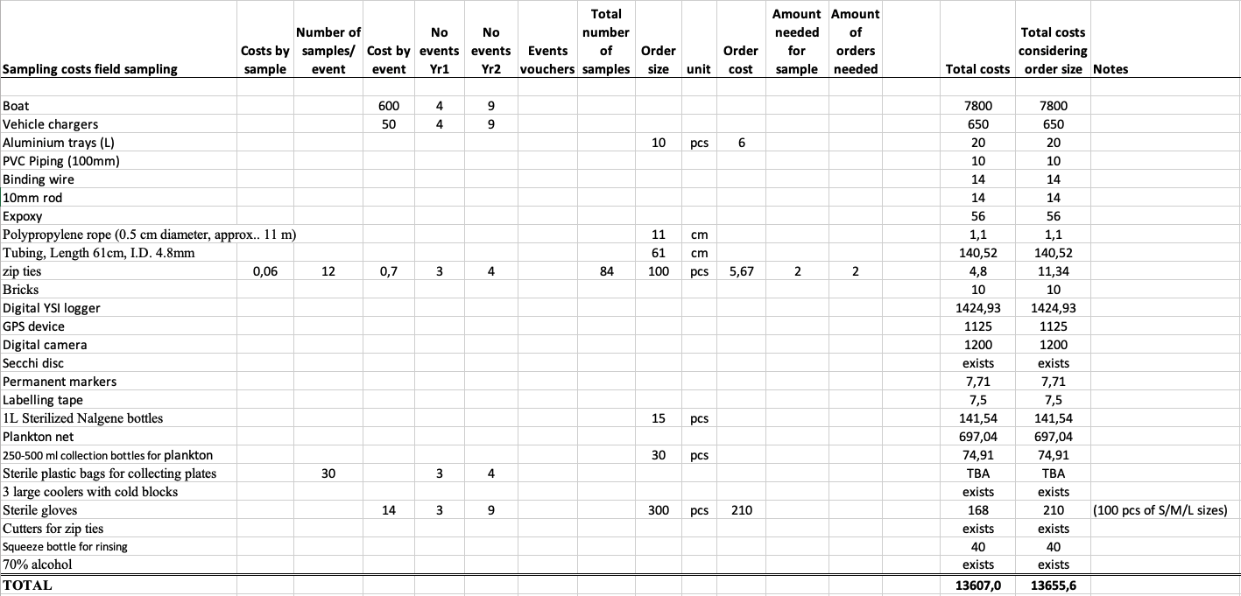

Table 2. Sample processing

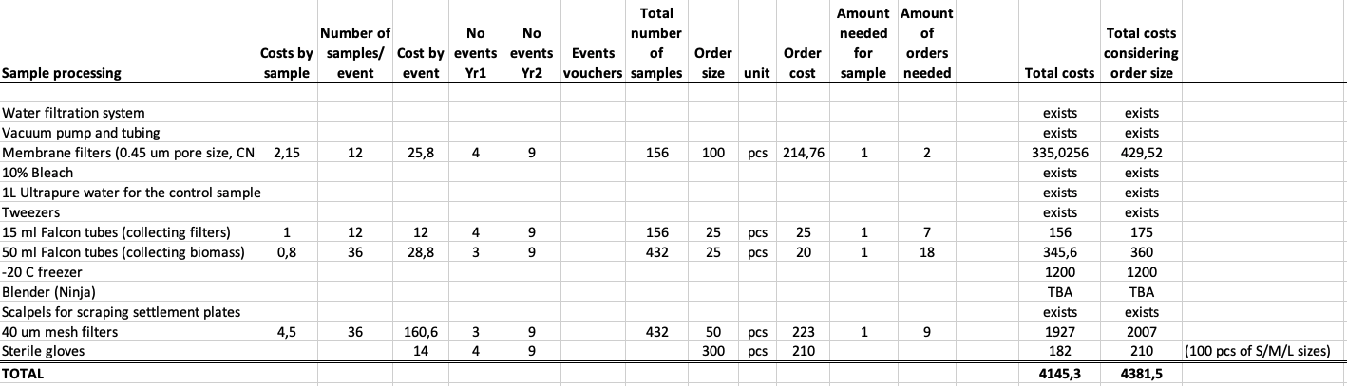

Table 3. DNA extraction reagents

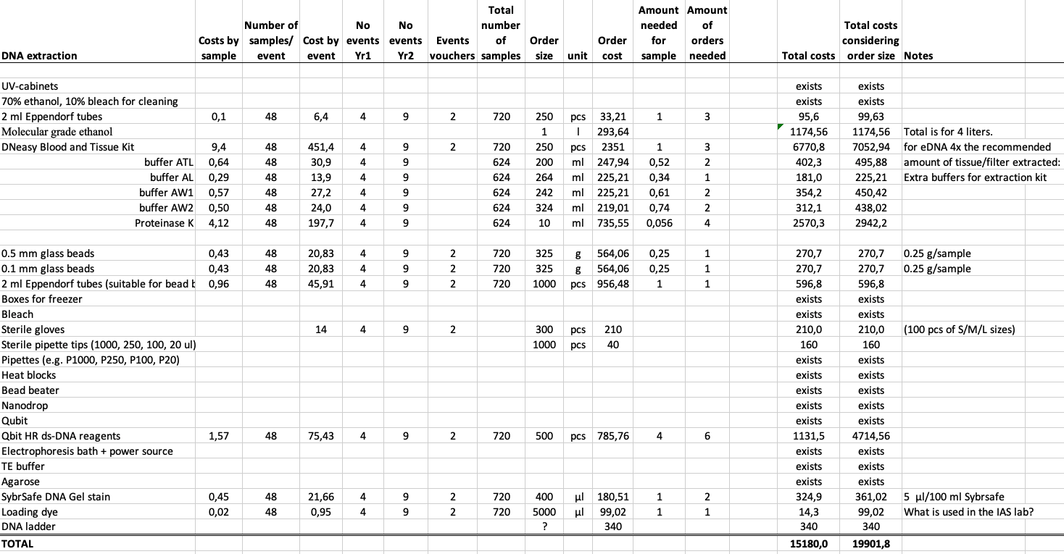

Table 4. PCR reagents

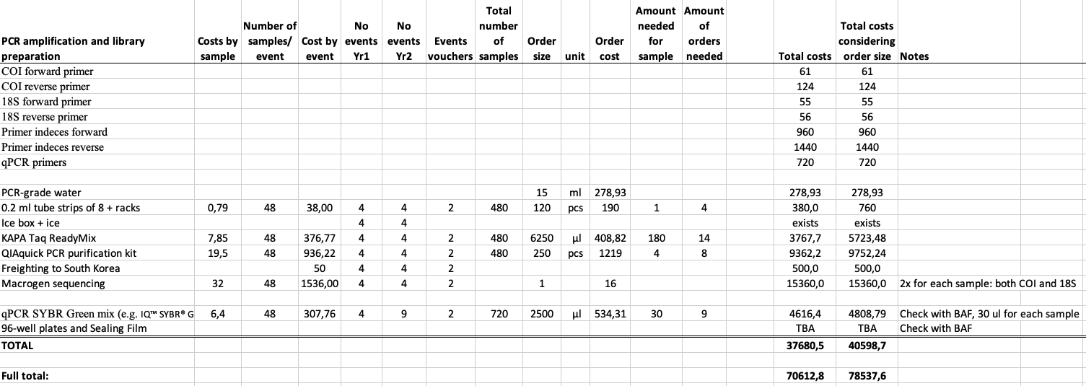

# Annex 6. NCBI SRA submission instructions for metabarcoding samples

1. Go to the NCBI SRA Submission Portal at <https://submit.ncbi.nlm.nih.gov/subs/sra/>.
2. Click "New submission".
3. Submitter panel: enter your personal details and continue.
4. General Info panel: in the BioProject section enter the PacMAN BioProject (PRJNA741074).
5. BioSample Type panel: under the GSC MIxS packages select MIMARKS Survey related and pick either sediment, water, or miscellaneous.
6. BioSample Attributes panel. Enter the following attributes:
   * Sample name: Date_Port_Location_SampleType_Depth_replicate_markerGene
     + 20211105_Suva_Site1_Plate_5m_A_CO1
   * Sample title: Settlement plate sample from Suva harbour site 1 replicate A
   * BioProject accession: PRJNA741074
   * Organism: pick seawater metagenome, sediment metagenome, or marine metagenome
   * Collection date (ISO 8601)
   * Depth
   * Elevation
   * Broad-scale environmental context: use ENVO vocabulary, for example:
     + <http://purl.obolibrary.org/obo/ENVO_00000447> for marine biome
   * Local-scale environmental context
   * Environmental medium: use ENVO vocabulary, for example:
     + <http://purl.obolibrary.org/obo/ENVO_03000033> for marine sediment
     + <http://purl.obolibrary.org/obo/ENVO_00002149> for seawater
     + <http://purl.obolibrary.org/obo/ENVO_06105023> for biofouling
   * Geographic location
   * Latitude and longitude: use decimal degrees
7. SRA Metadata panel. Enter the following attributes:
   * Sample_name: The exact same sample ID as BioSample Attributes
   * library_ID: ID from sequencing facility (e.g. ERR1234567)
   * Title: Short description of the sample
   * Library_strategy: AMPLICON
   * Library_source: METAGENOMIC
   * Library_selection: PCR
   * Library_layout: PAIRED
   * Platform: ILLUMINA
   * Instrument_model: MISEQ
   * Design_description: Amplicon sequencing of the CO1 gene with Leray/Geller primers
   * Filetype: fastq
   * Filename: Exact filename of forward reads submitted
   * Filename2: Exact filename of reverse reads submitted

# Annex 7. Data submission spreadsheet templates

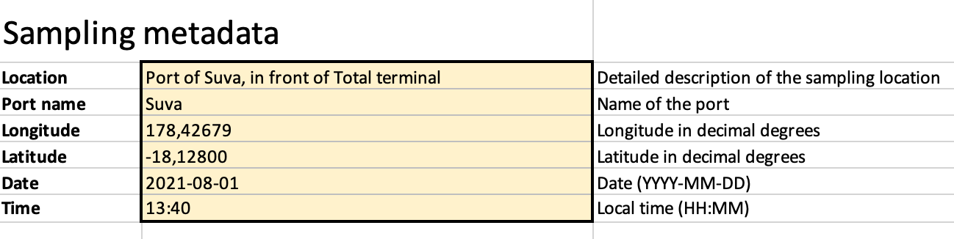

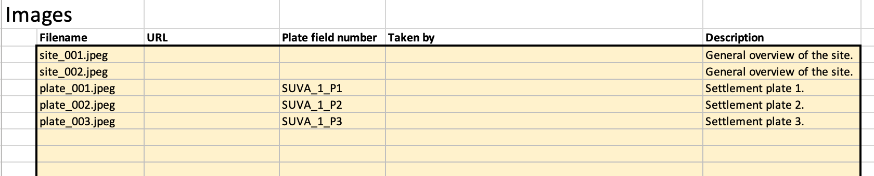

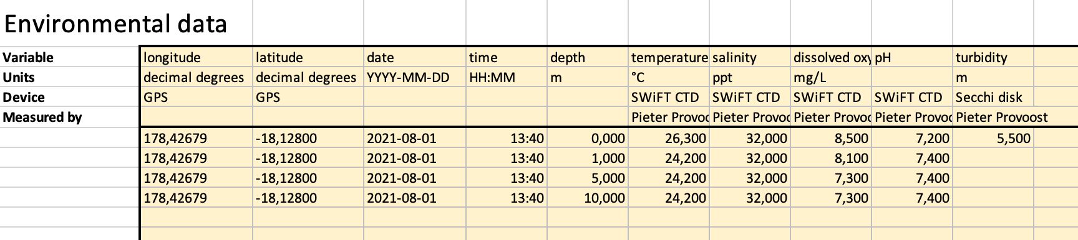

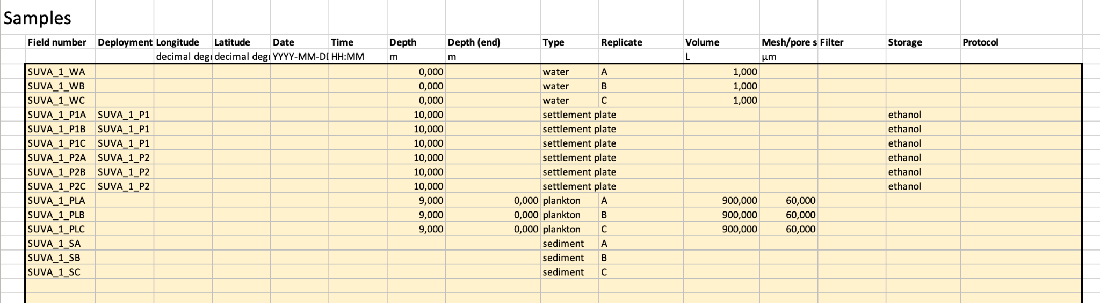



1. <https://www.go-fair.org/fair-principles/>
2. <https://iode.org/index.php?option=com_content&view=article&id=51&Itemid=95>
3. <https://www.ncbi.nlm.nih.gov/bioproject/PRJNA741074>
4. <https://www.researchobject.org/>