DATA BUOY CO-OPERATION PANEL (DBCP)

Format for National Reports on Current and
Planned BUOY Programmes

Country | FRANCE
Year | 2021 (1 July 2020- 30 June 2021)

1. CURRENT PROGRAMME:

Agency or programme | Météo-France
Number and type of buoys | (a) deployed during the year | - 92 SVP-B for E-SURFMAR (73 upgrades)  - 30 SVP-B (all upgrades) for IBPIO  - 46 SVP-BRST (TRUSTED project)
Number and type of buoys | (b) operational as of 31 August | - 5 moored buoys (2 in cooperation with UKMO)  - 209 SVP-B for E-SURFMAR (115 upgrades)  - 76 SVP-BRST (TRUSTED project)  - 61 SVP-B for MF IBPIO (all upgrades)  - 1 waveriders
Number and type of buoys | (c) reporting on GTS as  of 31 August | - 5 moored buoys (2 in cooperation with UKMO)  - 209 SVP-B for E-SURFMAR (115 upgrades)  - 76 SVP-BRST (TRUSTED project)  - 61 SVP-B for MF IBPIO (all upgrades)  - 1 waveriders
Purpose of programme | (a) operational | [x]
Purpose of programme | (b) met / ocean research | [_]
Purpose of programme | (c) developmental | [x]
Main deployment areas | Arctic, North Atlantic, Mediterranean Sea, Tropical Atlantic  Indian Ocean for drifters and moored buoys  Continental French coasts, French West Indies, Indian Ocean for waveriders
Vandalism incidents | 0

Agency or programme | Cerema (Center for studies and expertise on risks, environment, mobility, and urban and Country planning)
Number and type of buoys | (a) deployed during the year | 1 waverider
Number and type of buoys | (b) operational as of 31 August | 27 waveriders
Number and type of buoys | (c) reporting on GTS as of 31 August
Purpose of programme  (check/uncheck boxes using [_] or [x] as appropriate) | (a) operational | [x]
 | (b) met / ocean research | [x]
 | (c) developmental | []
Main deployment areas | Continental French coasts, Saint Pierre & Miquelon, French Guyana
Vandalism incidents | (a) Number of incidents  If vandalism incidents have occurred during the year, please provide the details using the form in the annex.

Agency or programme | IRD - French participation to PIRATA – (in cooperation with Meteo-France) and CLIVAR-Atlantic, + EU H2020 AtlantOS, TriATLAS and EuroSea programmes (international collaborations)
Number and type of buoys | (a) deployed during the year | Network of 6 meteo-oceanic buoys (All the buoys have been replaced in February-March 2021 during the PIRATA-FR31 cruise). 3 of them are classical ATLAS systems, 3 are new T-Flex systems (Iridium data transmission, potentially more sensors, etc.). Two buoys are equipped with a new CO2 sensor (10°W-6°S and 10°W-0°E).  Note that, due to 2 years at hand of vandalism at 8°E-6°S, this buoy has been replaced at 10°W-20°S with an ATLAS transmission system in 2020.  2 current meter moorings (ADCP) have been serviced (at 10°W-0°N and 23°W-0°N). The third equatorial current meter mooring initially located at 0°N-0°E has been recovered during PIRATA-FR31 and will be deployed westward at around 2.42°W-0°N next year due to an extension of the security area in the Gulf of Guinea.  During the PIRATA-FR31 cruise, 23 surface drifters have been deployed for Meteo-France in the eastern tropical Atlantic: 18 SVP-B-HRSST and 5 SVP-B.
Number and type of buoys | (b) operational as of 31 August | The 6 meteo-oceanic buoys were operational until 25 June 2021. 4 buoys are fully operational at 26 August 2021 and 2 buoys – 20°S-10°W and 10°S-10°W - moved adrift on June, 26th and July, 05th 2021 respectively certainly due to vandalism. The one from 20°S-10°W still transmitted meteo and oceanic data.
Number and type of buoys | (c) reporting on GTS as of 31 August | 6 buoys were reporting on GTS at 30 June 2021 (but ocean data at 10°W-20°S).
Purpose of programme  (check/uncheck boxes using [_] or [x] as appropriate) | (a) operational | [x]
 | (b) met / ocean research | [x]
 | (c) developmental | []
Main deployment areas | Eastern Tropical Atlantic Ocean and Gulf of Guinea
Vandalism incidents | (a) Number of incidents:  In total, 3 vandalism incidents occurred during this year :  - meteo-oceanic buoy at 10°S-10°W on March, 15th, 2021 (only 24h after been serviced during cruise PIRATA-FR31)  - meteo-oceanic buoy at 20°S-10°W went adrift on June, 26th 2021. It moves north-westward and its latest position was 19.53°S – 14.84°W (surface and sub-surface data are still transmitted)  - meteo-oceanic buoy at 10°S-10°W was vandalized by fishers a second time and went adrift on July, 5th 2021. Its latest position was 8.37°S and 11.90°W.  Our colleagues from GEOMAR are considering recovering these two buoys adrift in September during their cruise.  If vandalism incidents have occurred during the year, please provide the details using the form in the annex.

Agency or programme | IFREMER / SUMOS Cruise  (R/V Atalante, Bay of Biscay, PI P. Sutherland,  2021/02/10 → 2021/03/09)
Number and type of buoys | (a) deployed during the year | 20 x SOFAR Spotter. 5420 deployment hours in total.
Number and type of buoys | (b) operational as of 31 August | 0 (recovered at end of cruise)
Purpose of programme  (check/uncheck boxes using [_] or [x] as appropriate) | (a) operational | [ ]
 | (b) met / ocean research | [x]
 | (c) developmental | [ ]
Main deployment areas | Bay of Biscay
Vandalism incidents | 0

Agency or programme | IUEM/IFREMER/INSU/ILICO/SNO-COAST HF
Number and type of buoys | (a) deployed during the year | 1 “MAREL Iroise” buoy
Number and type of buoys | (b) operational as of 31 August
Number and type of buoys | (c) reporting on GTS as of 31 August
Purpose of programme  (check/uncheck boxes using [_] or [x] as appropriate) | (a) operational | [x]
 | (b) met / ocean research | COAST-HF-SNO programm for coastal high frequency long term monitoring
 | (c) developmental | [x]
Main deployment areas | French coast at the Brest-Bay outlet, at the interface with the Iroise sea (48°21’29’’ N, 4°33’05.48’’ W)
Vandalism incidents | No

Agency or programme | SHOM (Service Hydrographique et Océanographique de la marine)
Number and type of buoys | (a) deployed during the year | 21 drifting buoys owned by SHOM were deployed in last 12 months:  -3 code-i MetOcean,  -3 sc40i in surface,  -15 sc40i drogued at different depth: 200m*2, 15m*3, 50m*3, 100m*2, 75m*2, 7m*3
Number and type of buoys | (b) operational as of 31 August | 3 buoys were operational at 31 august 2021
Number and type of buoys | (c) reporting on GTS as of 31 August | All WOCE were reporting on GTS
Purpose of programme  (check/uncheck boxes using [_] or [x] as appropriate) | (a) operational | [x]
 | (b) met / ocean research | [x]
 | (c) developmental | [x]
Main deployment areas | Gibraltar / North Iceland
Vandalism incidents | (a) Number of incidents  If vandalism incidents have occurred during the year, please provide the details using the form in the annex.

2. PLANNED PROGRAMMES:

Agency or programme | Météo-France
Number and type of buoys | planned for deployment in the next 12 months | 100 SVP-B  2 waverider Guadeloupe
Purpose of programme  (check/uncheck boxes using [_] or [x] as appropriate) | (a) operational | [x]
 | (b) met / ocean research | [_]
 | (c) developmental | [_]
Main deployment areas | Arctic, North Atlantic, Tropical Atlantic, Indian Ocean

Agency or programme | Cerema (Center for studies and expertise on risks, environment, mobility, and urban and Country planning)
Number and type of buoys | planned for deployment in the next 12 months | From 4 to 5 waveriders
Purpose of programme  (check/uncheck boxes using [_] or [x] as appropriate) | (a) operational | [x]
 | (b) met / ocean research | [x]
 | (c) developmental | []
Main deployment areas | Corsica, French riviera, Baie de Somme, Noirmoutier, French Guayana

Agency or programme | IRD
Number and type of buoys | planned for deployment in the next 12 months | To maintain the 6 met-ocean PIRATA Network (3 Atlas, 3 T-Flex planed in 2022, and 2 currentmeter moorings at 23°W-0°N & 3°W-0°N).  Potential SVP / SVP-B / SVP-BRST deployments during the PIRATA FR32 cruise.
Purpose of programme  (check/uncheck boxes using [_] or [x] as appropriate) | (a) operational | [x]
 | (b) met / ocean research | [x]
 | (c) developmental | []
Main deployment areas | Tropical Atlantic

Agency or programme | IUEM/IFREMER/INSU/ILICO/SNO-COAST HF
Number and type of buoys | planned for deployment in the next 12 months | Continuous during the next 12 months
Purpose of programme  (check/uncheck boxes using [_] or [x] as appropriate) | (a) operational | [x]
 | (b) met / ocean research | [x] Long term observation
 | (c) developmental | [x] Seafet sensor validation
Main deployment areas

Agency or programme | SHOM (Service Hydrographique et Océanographique de la marine)
Number and type of buoys | planned for deployment in the next 12 months | 24
Purpose of programme  (check/uncheck boxes using [_] or [x] as appropriate) | (a) operational | [x]
 | (b) met / ocean research | [x]
 | (c) developmental | [x]
Main deployment areas

3. TECHNICAL DEVELOPMENTS:

(a) Buoy design | - Prototype “FLAME” (FLux Air/Mer par Eddy correlation) buoys comprising IRGASON High-speed Sonic anemometer / Gas analyzers are in development at IFREMER  - MAREL-technology with Coastoff2 interface
(b) Instrumentation | - NKE-MPx multiparameter probe  - Seafet sensor  - Carioca sensor  - Meteorological sensors Airmar 220WX
(c) Others

4. PUBLICATIONS (on programme plans, technical developments, QC reports, etc.):

Ref | Title | Type
1 | Assene, F., Y. Morel, A. Delpech, M. Aguedjou, J. Jouanno, S. Cravatte, F. Marin, C. Menesguen, A. Chaigneau, I. Dadou, G. Alory, R. Holmes, B. Bourlès, A. Koch-Larrouy. From mixing to the basin scale circulation: how the inverse cascade is involved in the formation of the subsurface currents in the Gulf of Guinea, Fluids, 5, 147, 2020, https://doi.org/10.3390/fluids5030147. | 7
2 | Burmeister K., Lübbecke J. F., Brandt P., Claus M., Hahn J. Fluctuations of the Atlantic North Equatorial Undercurrent and associated changes in oxygen transports. Geophysical Research Letters, 47(13), e2020GL088350 (9p.), 2020, https://doi.org/10.1029/2020GL088350. | 7
3 | Delpech, A., Conchon, A., Titaud, O., and Lehodey, P.: Influence of oceanic conditions in the energy transfer efficiency estimation of a micronekton model, Biogeosciences, 17, 833–850, 2020, https://doi.org/10.5194/bg-17-833-2020 | 7
4 | Lefèvre, N., P. Tyaquiçã, D. Veleda, C. Perruche and S. J. van Gennip, Amazon River propagation evidenced by a CO₂ decrease at 8°N, 38°W in September 2013, Journal of Marine Systems, 211, 2020, https://doi.org/10.1016/j.jmarsys.2020.103419. | 7
5 | Radenac, M.H., J. Jouanno, C. C. Tchamabi, M. Awo, B. Bourlès, S. Arnault, and O. Aumont, Physical drivers of the nitrate seasonal variability in the Atlantic cold tongue, Biogeosciences, 17, 529–545, 2020, https://doi.org/10.5194/bg-17-529-2020. | 7
6 | Vieira de Assunção, R., A. C. Silva, A. Roy, B. Bourlès, C. Henrique S. Silva, J.-F. Ternon, M. Araujo, and A. Bertrand, 3D characterisation of the thermohaline structure in the southwestern tropical Atlantic derived from functional data analyses, Progress in Oceanography, 187, 2020, https://doi.org/10.1016/j.pocean.2020.102399. | 7
7 | Bourlès Bernard, Herbert Gaëlle, Rousselot Pierre, Grelet Jacques, 2020. French PIRATA cruises: S-ADCP data. SEANOE. https://doi.org/10.17882/44635
8 | Bourlès Bernard, Llido Jerome, Rousselot Pierre, Habasque Jérémie, Grelet Jacques, Roubaud Fabrice, Bachelier Céline 2020. French PIRATA cruises: MOORING ADCP data. SEANOE. https://doi.org/10.17882/51557
9 | Habasque Jérémie, Bourlès Bernard, Bertrand Arnaud, Lebourges-Dhaussy Anne, Grelet Jacques, Rousselot Pierre, 2020. French PIRATA cruises: acoustic data. SEANOE. https://doi.org/10.17882/71379
10 | New Insights of the Sicily Channel and Southern Tyrrhenian Sea Variability, Water, (2019).  Menna M., Poulain P., Ciani D., Doglioli A., Notarstefano G.,  Gerin R., Rio M., Santoleri R., Gauci A., Drago A. doi:10.3390/w11071355. https://hal.archives-ouvertes.fr/hal-02169193/
11 | Foltz, G.R., P. Brandt, I. Richter, M. Rodriguez-Fonseca, F. Hernandez, M. Dengler, R.R.Rodrigues, J. Schmidt, L. Yu, N. Lefevre, L. Cotrim, M.J. McPhaden, M. Araujo, J.Karstensen, J. Hahn, M. Martin-Rey, C.M. Patricola, P. Poli, P. Zuidema, R. Hummels, R.C.Perez, V. Hatje, J.F. Lubbecke, I. Polo, R. Lumpkin, B. Bourlès, F.E. Asuquo, P. Lehodey, A.Conchon, P. Chang, P. Dandin, C. Schmid, A. Sutton, H. Giordani, Y. Xue, S. Illig, T.Losada, S.A. Grodsky, F. Gasparin, T. Lee, E. Mohino, P. Nobre, R. Wanninkhof, N.Keenlyside, V. Garcon, E. Sanchez-Gomez, H.C. Nnamchi, M. Drevillon, A. Storto, E. Remy, A. Lazar, S. Speich, M. Goes, T. Dorrington, W.E. Johns, J.N. Moum, C. Robinson, C.Perruche, R.B. de Souza, A. Gaye, J. Lopez-Parages, P.A. Monerie, P. Castellanos, N.U. Benson, M.N. Hounkonnou, J. Trotte-Duha, The Tropical Atlantic Observing System, Frontiers in Marine Science, https://doi.org/10.3389/fmars.2019.00206, 2019.
12 | Bourlès, B., M. Araujo, P. Brandt, M. Mc Phaden, N. Lefèvre, G. Foltz and L. Cotrim da Cunha, « Organization & sustainability of PIRATA network Report », Deliverable D.3.19 EU AtlantOS (H2020, Grant Agreement N°: 633211), 7pp., novembre 2018.
13 | Poli, P., B. Bourlès, S. Bond, S. Hafner, S. Klink and E. Petermann, « Drifter network improvement report », Deliverable D.3.20 EU AtlantOS (H2020, Grant Agreement N°: 633211), 7pp., décembre 2018.
14 | Maximilian Unterberger Guillaume Charria, Peggy Rimmelin-Maury, Eric Goberville, Paul Treguer, Nicolas Barrier, Emilie Grossteffan, Michel Repecaud, Loïc Quemener, Sebastien Theetten. « Extreme event occurrence linked with natural and anthropogenic climate variations in coastal waters of western Europe », Colloque IMBER, 15-21 juin 2019 - Brest.
15 | V. Rérolle1, D. Angelescu1, A. Hausot1, P. Ea1, N. Lefèvre2, C. Provost2, M. Labaste2 « Development of a novel hybrid pH sensor for deployment on autonomous profiling platforms » , Oceans2019, Marseille, 17-20 juin 2019
16 | Rimmelin-Maury Peggy, Charria Guillaume, Repecaud Michel, Quemener Loic, Beaumont Laurence, Guillot Antoine, Gautier Laurent, Prigent Sebastien,Le Becque Thierry, Bihannic Isabelle, Bonnat Armel, Le Roux Jean-Francois, Grossteffan Emilie, Devesa Jérémy, Bozec Yann (2020). Iroise buoy s data from Coriolis data center as core parameter support for Brest Bay and Iroise sea studies. SEANOE, 2020. https://doi.org/10.17882/74004
17 | Charria Guillaume, Theetten Sebastien, Ayouche Adam, Poppeschi Coline, Sudre Joël, Yahia Hussein, Garcon Véronique, Schmitt François (2020). Multi-scale coastal surface temperature in the Bay of Biscay and the English Channel . EGU 2020 General Assembly. 4–8 May 2020, Online .
18 | Charria G. et al., Temperature and Salinity Changes in Coastal Waters of Western Europe: Variability, Trends and Extreme Events. In: Ceccaldi HJ., Hénocque Y., Komatsu T., Prouzet P., Sautour B., Yoshida J. (eds) Evolution of Marine Coastal Ecosystems under the Pressure of Global Changes. Springer, Cham https://link.springer.com/chapter/10.1007/978-3-030-43484-7_15, 2020.
19 | Poppeschi Coline, Charria Guillaume, Unterberger Maximilian, Rimmelin-Maury Peggy, Goberville Eric, Barrier Nicolas, Petton Sebastien, Grossteffan Emilie, Repecaud Michel, Quemener Loic, Theetten Sebastien, Le Roux Jean-Francois, Treguer Paul (2020). Extreme coastal events linked with climate variation. Understanding low salinity episodes in the Bay of Brest, north-eastern Atlantic . EGU 2020 General Assembly. 4–8 May 2020, Online . https://archimer.ifremer.fr/doc/00631/74346/
20 | Farcy P, Durand D, Charria G, Painting D J, Tamminem T, Collingridge K, Grémare A J, Delauney L, Puillat I. Toward a European Coastal Observing Network to Provide Better Answers to Science and to Societal Challenges; The JERICO Research Infrastructure. Front. Mar. Sci., 6:529, 13p. doi: 10.3389/fmars.2019.00529, 2019.
21 | Repecaud Michel, Quemener Loic, Charria Guillaume, Pairaud Ivane, Rimmelin-Maury Peggy, Claquin Pascal, Jacqueline Franck, Lefebvre Alain, Facq Jean-Valery, Retho Michael, Verney Romaric (2019). National observation infrastructure: an example of a fixed-plateforms network along the French Coast: COAST HF . OCEANS 2019 - Marseille, Marseille, France, 2019. Electronic ISBN: 978-1-7281-1450-7 Print on Demand(PoD) ISBN: 978-1-7281-1451-4, pp. 1-6.
22 | Cocquempot Lucie, Delacourt Christophe, Paillet Jerome, Riou Philippe, Aucan Jérôme, Castelle Bruno, Charria Guillaume, Claudet Joachim, Conan Pascal, Coppola Laurent, Hocdé Régis, Planes Serge, Raimbault Patrick, Savoye Nicolas, Testut Laurent, Vuillemin Renaud (2019). Coastal Ocean and Nearshore Observation: A French Case Study. Frontiers In Marine Science, 6(324), 17p. Publisher's official version : https://doi.org/10.3389/fmars.2019.00324 , Open Access version : https://archimer.ifremer.fr/doc/00503/61489/
23 | Unterberger Maximilian, Charria Guillaume, Rimmelin-Maury Peggy, Goberville Eric, Treguer Paul, Barrier Nicolas, Grossteffan Emilie, Repecaud Michel, Quemener Loic, Theetten Sebastien (2019). Extreme event occurrence linked with natural and anthropogenic climate variations in coastal waters of western Europe . 2019 Future Oceans2 IMBeR Open Science Conference, 17-21 June 2019, Brest, France .
24 | Charria Guillaume, Schmitt François (2019). National observation infrastructures in a European framework: COAST-HF : An example of a fixed-platform network along French coasts . OceanPredict '19 - GODAE OceanView Symposium. May, 6-10, 2019 in Halifax, Nova Scotia, Canada .
25 | Unterberger M., Charria G., Rimmelin-Maury P., Goberville E., Tréguer P. Extreme event characterisation based on long-term in-situ high-frequency observations of coastal waters in western Europe. EMSO Third training school and conference on “Environmental Time Series Analysis” Tromsø, Norway, from 28th to 31st January 2019
26 | Poppeschi C, Charria G, Goberville E, Rimmelin-Maury P, Barrier N, Petton S, Unterberger M, Grossteffan E, Repecaud M, Quéméner L, Theetten S, Le Roux J-F and Tréguer P (2021) Unraveling Salinity Extreme Events in Coastal Environments: A Winter Focus on the Bay of Brest. Front. Mar. Sci. 8:705403. doi: 10.3389/fmars.2021.705403

5. SPECIAL COMMENTS (if any):

(a) Quality of buoy data | - The directional wave data of the SOFAR Spotter buoys seem of good quality.  - Automatic quality control Tool of Coriolis interface
(b) Communications | - Data transmission is performed via Iridium, no particular problems have been encountered.
(c) Buoy lifetimes | - No buoy lost over the (short) deployments.
(d) Other

Note: It is recommended that this form is filled in electronically and returned also electronically to the Secretariat. A template of the form can be downloaded from the following ftp site:

ftp://ftp.wmo.int/Documents/PublicWeb/amp/mmop/documents/dbcp/templates/Format-DBCP-National-Reports.doc

Annex - Form for reporting incidents of vandalism on data buoys

Country
Contact person e-mail
Year | Buoy Location |  | Type of Buoy  (e.g. Tsunami / Met -Ocean Buoy/Drifter/ARGO floats/ Other) | Type of damage to buoy | Buoy id/WMO id | Number of days of transmission lost | Cost of replacement | Remarks  (e.g. whether photos have been taken)
Year | Latitude | Longitude
2021 | 10°S | 10°W | Met-Ocean buoy (PIRATA T-Flex) | Lost all atmospheric sensors and aluminium buoy tower |  | 4 days (from March 15th to March 19th 2021) |  | Vandalized buoy retrieved with only ocean sensors.  See picture below.
2021 | 20°S | 10°W | Met-Ocean buoy (PIRATA ATLAS) | Buoy adrift (not yet retrieved) |  | From June 26th |  | Atmospheric and oceanic data are still transmitted as it moves north-westward – latest position : 19.53°S – 14.84°W
2021 | 10°S | 10°W | Met-Ocean buoy (PIRATA ATLAS) | Buoy adrift (not yet retrieved) |  | From July 5th |  | Only atmospheric data are still transmitted as it moves north-westward – latest position : 8.37°S and 11.90°W
Efforts taken against vandalism |  |  | Communication with the MICA center (https://www.mica-center.org/) dedicated to maritime security.
Awareness meeting Organised
Suggestions (if any)
Photos on Vandalism |  |  | (please include pictures if available; and email electronic versions to cgallage@wmo.int; support@jcommops.org)  Vandalized buoy at 10°S-10°W as found on March, 19th 2021 (only 4 days after maintenance)  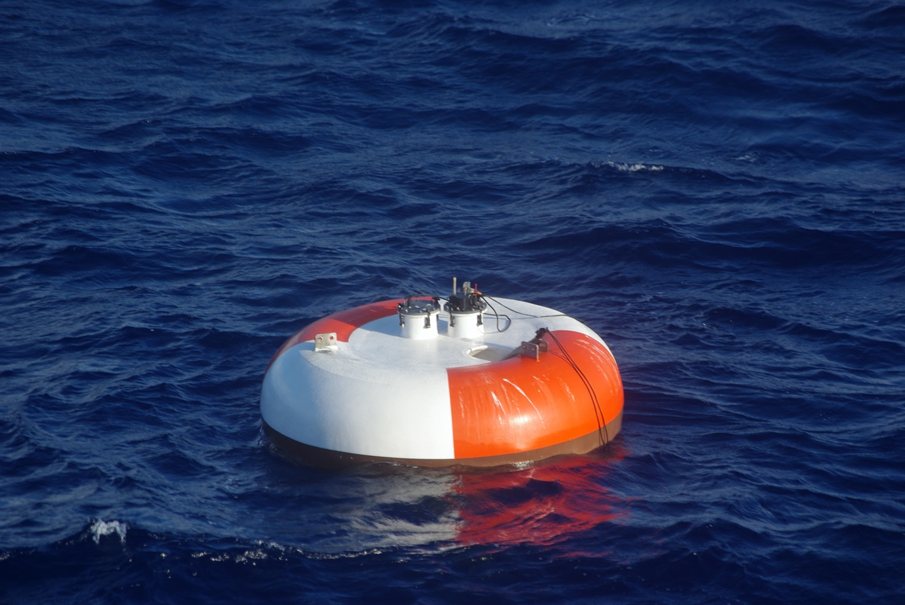  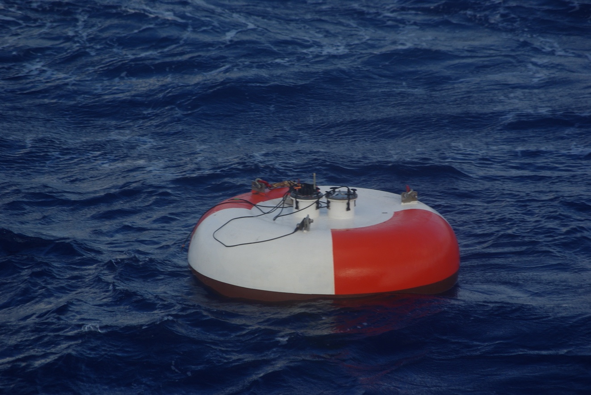  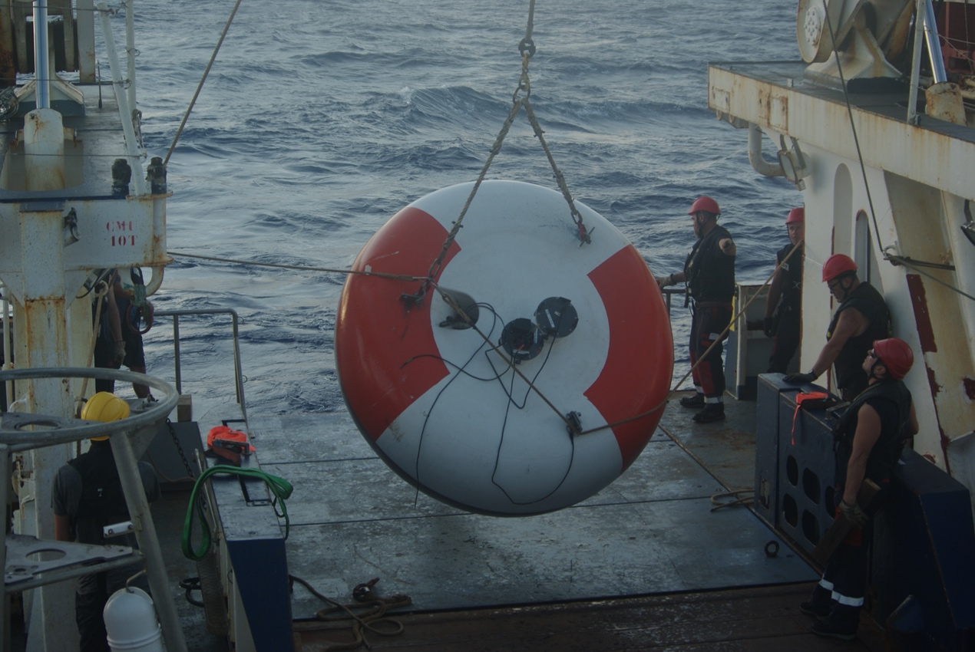

Note: It is recommended that this form is filled in electronically and returned electronically also to JCOMMOPS (cgallage@wmo.int; support@jcommops.org). A template of the form can be downloaded from the following ftp site: ftp://ftp.wmo.int/Documents/PublicWeb/amp/mmop/documents/dbcp/templates/Format-DBCP-Buoy-Vandalism-Reports.doc
______________

: Types of publications: (1) Implementation, (2) Operations, (3) Instrumentation, (4) Quality Management, (5) Data Management, (6) Data collection and/or location, (7) Data use, (8) Other

