**Intergovernmental Oceanographic Commission***Reports of Meetings of Experts and Equivalent Bodies*



**IODE Steering Group for the Ocean InfoHub Project**

**Annotated agenda**

**Second Session (Virtual)**5 October 2021

**UNESCO**

5 October 2021

English only

For bibliographic purposes this document should be cited as follows:

IODE Steering Group for the Ocean InfoHub Project (SG-OIH), Second Session, 5 October (virtual meeting) 10pp. & Annexes, 2021. (Reports of Meetings of Experts and Equivalent Bodies).

**TABLE OF CONTENTS**

page

1. Opening of the meeting 1

2. Administrative arrangements 1

3. Adoption of the Agenda 1

4. Overview of the OIH work plan and deliverables 1

4.1 Work package 1: Project management, coordination and evaluation 2

4.3 Work package 2: Technology development 4

4.4 Work package 3: Establishment and initial support of the global hub and regional nodes 9

4.5 Work package 4: Training and capacity development of the nodes 11

4.6 Work package 5: Communication, user marketing and feedback 13

5. Budget 15

6. Report on actions from SG-OIH-1 15

7. Election of the chair 16

8. Next meeting: Third Session of the SG-OIH 16

9. Close of the meeting 16

**ANNEXES**

ANNEX I: Provisional agenda

ANNEX II: Summary of Actions

ANNEX III: List of Participants

ANNEX IV: Reference documents shared in advance

# Opening of the meeting

Mr Vladimir Ryabinin, Executive Secretary of the IOC of UNESCO, welcomed participants to the meeting on behalf of the IOC.

Mr Gert Verreet, Policy Advisor in the Government of Flanders (Vlaamse Overheid - Departement Economie, Wetenschap & Innovatie, Afdeling Onderzoek), welcomed the participants on behalf of the Government of Flanders.

# Administrative arrangements

The Second Session of the IODE Steering Group for the Ocean InfoHub Project was convened on 5 October 2021. Due to the travel restrictions imposed by countries as a result of the COVID-19 pandemic, a face to face meeting was not possible. An alternative format was adopted involving the following elements:

* Background documents were prepared and circulated internally to core project team
* Background documents were sent to all Steering Group meeting participants in advance of the meeting.
* The meeting was held virtually in two sessions. Both sessions covered the entire agenda and the duplication was in order to allow for the Latin America and Caribbean region and the Pacific region to each meet at a reasonable hour. The meeting offered simultaneous English, Spanish and French translation in Session A, and simultaneous Spanish, English translation in Session B.

**Session A:**5 October 1PM-3PM UTC: <https://oceanexpert.org/event/3132>

**Session B:**5 October 7PM-9PM UTC: [https://oceanexpert.org/event/3158](https://aus01.safelinks.protection.outlook.com/?url=https%3A%2F%2Foceanexpert.org%2Fevent%2F3158&data=04%7C01%7CZulfikarB%40spc.int%7C9bb292ec0de24f3c1cc108d94c17eca5%7Cf721524dea604048bc46757d4b5f9fe8%7C0%7C0%7C637624487970595169%7CUnknown%7CTWFpbGZsb3d8eyJWIjoiMC4wLjAwMDAiLCJQIjoiV2luMzIiLCJBTiI6Ik1haWwiLCJXVCI6Mn0%3D%7C1000&sdata=Nze9HhbFr0y2%2Bcsrm%2BCZEgpb8h2FbuMAn1gvKIGj%2F0s%3D&reserved=0)

The purpose of the meeting was to provide a comprehensive overview of progress on the work plan over the past 12 months, and to get feedback on plans for the next year of the project.

# Adoption of the Agenda

Mr Nogueira (SG-OIH Chair) presented the draft agenda.

# Overview of the OIH work plan and deliverables

A presentation was made by Lucy Scott and the OIH team, covering the deliverables to date and the upcoming work plans for the five work packages. The work plan is on track with no major technical delays*.*

The OIH Project has 5 work packages:

**WP1:** Project management, coordination and evaluation

**WP2:** Technology development

**WP3:** Establishment and initial support the global hub and regional nodes

**WP4:** Training and capacity development of regional nodes

**WP5:** Communication, user marketing and feedback

## Work package 1: Project management, coordination and evaluation

This work package covers activities related to:

* overarching coordination and guidance
* planning and budget management
* monitoring and reporting
* risk and issue management
* project evaluation.

The role of the Steering Group is to:

* monitor and guide the implementation of the Ocean InfoHub
* propose remedial action where necessary
* advise the Project Manager
* ensure that the project serves user/region needs
* identify new opportunities and adjust the work plan according to changing needs and circumstances
* prepare annual progress reports

**Table 1. Work Package 1 overview of timeline**

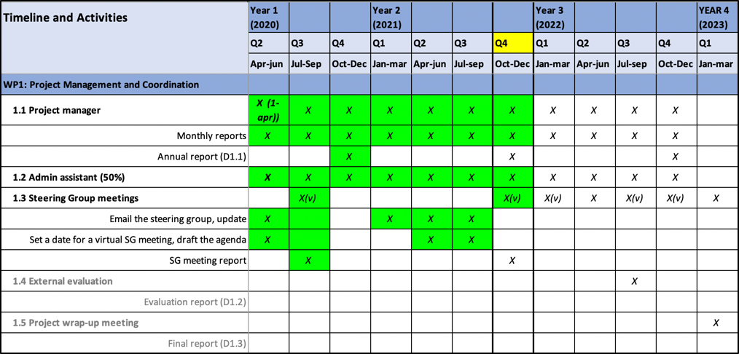

**4.2.1 Deliverables October 2020-September 2021**

1. Tracking sheet for all project deliverables maintained and monthly reports written. (Reference doc 1. OIH Project Timeline and Deliverables).

2. Steering Group meeting convened

3. General administration tasks (project management tools, calendars integrated, dropbox, Gdrive, regular IODE staff meetings and ad hoc UNESCO meetings).

**4.2.2 Objectives 2021-2022**

1. Tracking sheet for all project deliverables maintained and monthly reports written

2. Third session of the SG planned

3. General administration tasks continued

**Questions, discussion and contributions from the chat**

Session A

Session B

## 

## Work package 2: Technology development

This work package covers the technical developments needed to support the implementation of Ocean InfoHub nodes and the proof-of-concept ODIS reference architecture which will allow the nodes to interoperate with each other and external systems.

In terms of Ocean InfoHub development, this work includes:

● development of a Global Hub

● development of Regional/Thematic Node application (Virtual nodes part of the Global Hub or as separate regional/thematic nodes)

● continued populating of ODISCat

**Table 2. Work Package 2 overview of timeline**

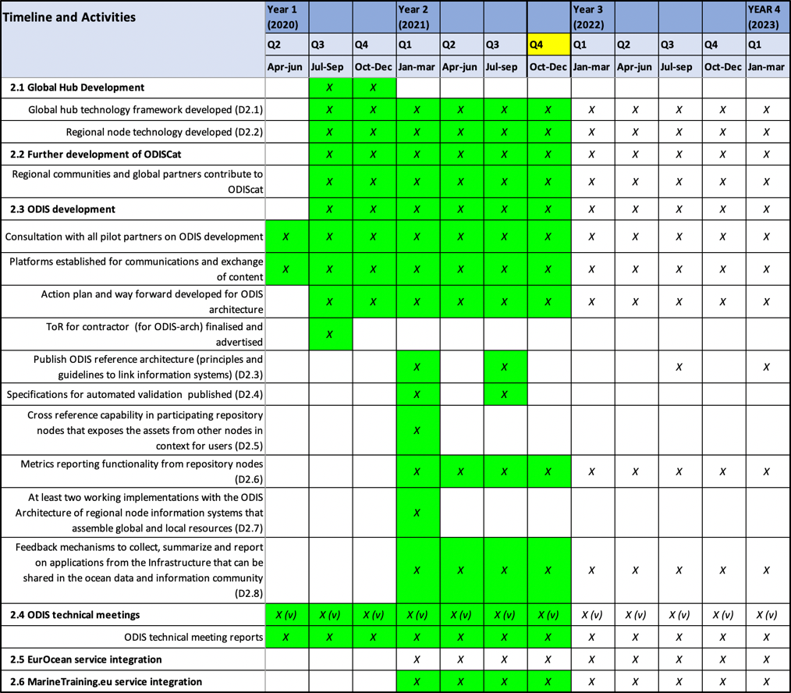

**4.3.1 Deliverables October 2020-September 2021**

**Global Hub Development**

**4.3.1.1 Global hub technology framework developed (D2.1)**

* We have the Ocean InfoHub website at https://oceaninfohub.org/
* We have developed and tested a reference implementation of the global hub server side architecture <https://oceans.collaborium.io/index.html> that demonstrates the facility to search across the existing seven working implementations. This is available online.
* We have a call open for the development of an OceanInfoHub Global Hub Search Portal as a demonstration of the ODIS. The contractor will be charged with developing a front-end web portal that dynamically builds content based on the (meta)data shared by early implementers of the ODIS-Architecture. This portal will have a high profile on the OIH web site home page.

**4.3.1.2 Regional node technology developed (D2.2)**

Regional nodes are currently online independently:

IOCAfrica: https://www.ioc-africa.org/

INVEMAR CHM-TMT: http://portete.invemar.org.co/chm#/

SPREP and SPC: <https://www.spc.int/>, https://www.sprep.org/

* We also do have regional data in the global OIH knowledge graph
* The global hub search portal will showcase the three regions.
* OIH-supported development work within each of the regions is actively bringing additional regional partners into the network.

**4.3.1.3 Further development of ODISCat**

**Regional communities and global partners contribute to ODIScat**

This is ongoing; at every new opportunity, organisations are asked to add records to ODIScat, and the projects have a close working partnership.

**ODIS development**

**4.3.1.4 Consultation with all pilot partners on ODIS development**

Regular WP2 core secretariat and partner meetings: 51 meetings over 12 months

GitHub repository:<https://github.com/iodepo/odis-arch>

Slack: >3,500 posts in XX channels. 50 Technical WG members.

**4.3.1.5 Platforms established for communications and exchange of content**

Completed

**4.3.1.6 Action plan and way forward developed for ODIS architecture**

Completed in the ToR for the ODIS-Arch contractor

**4.3.1.7 ToR for contractor (for ODIS-arch) finalised and advertised**

* Consultant hired and 8 month contract completed in September.
* New ToR is in process.
* ODIS specifications for six priority themes written and will be developed further on an ongoing basis.
* Documentation is available online at [https://book.oceaninfohub.org](https://book.oceaninfohub.org/?_ga=2.259810505.2141234701.1632318930-1206114531.1612510412)
* Documentation is under continuous revision and improvement.

**4.3.1.8 Publish ODIS reference architecture (principles and guidelines to link information systems) (D2.3**)

Documentation for the Ocean InfoHub is located at <https://book.oceaninfohub.org/>. This documentation is structured to address the three primary personas expected in the OIH community. Those being Publisher, Aggregator and User. An introduction to these personas is found at <https://book.oceaninfohub.org/personas/persona.html> which links out to more specific documentation for each.

**4.3.1.9 Specifications for automated validation published (D2.4)**

Ocean InfoHub is leveraging and documenting the use of the W3C SHACL (<https://www.w3.org/TR/shacl/>) recommendation to address the issue of validation. Shape graphs for the OIH thematic types can be leveraged through existing tools to automate validation. The OIH documentation provides a reference implementation of such a validation.

**4.3.1.10 Cross reference capability in participating repository nodes that exposes the assets from other nodes in context for users (D2.5)**

The Ocean InfoHub Source and Prov Approaches section (ref: <https://book.oceaninfohub.org/thematics/identifier/id.html>) describes some of the key approaches used to cross reference resources based on established identifiers. Specifically the documented identifier pattern (<https://book.oceaninfohub.org/thematics/identifier/id.html#identifier>) leverages an approach that allows both the expression of an ID value and the ID of the property itself. That is, the type of identifier it is, for example DOI and the value of that identifier.

Once encoded into the graph, the cross referencing capacity is expressed through the use of the SPARQL query language for RDF graphs. Itself documented at <https://book.oceaninfohub.org/users/query.html> and <https://book.oceaninfohub.org/users/sparql.html>.

**4.3.1.11 Metrics reporting functionality from repository nodes (D2.6)**

Reporting is supported both based directly on the graph generated by the providers and assembled into the Ocean InfoHub graph and by the supporting PROV (<https://www.w3.org/TR/prov-overview/>) based provenance data generated during the indexing processes.

This can then be used to support reporting functions as demonstrated at <https://book.oceaninfohub.org/tooling/notebooks/OIH_Queries.html>.

**4.3.1.12 At least two working implementations with the ODIS Architecture of regional node information systems that assemble global and local resources (D2.7)**

At present the following seven sources are being integrated into the Ocean InfoHub Knowledge Graph. Work is underway with several other partners to also bring their holdings into the graph.

AquaDocs; domain: <https://aquadocs.org>

Ocean Best Practices; domain: <https://oih.oceanbestpractices.org>

Marine Training EU; domain: <https://marinetraining.eu/>

Marine Institute Data Catalogue (1); domain: <http://data.marine.ie>

OceanExpert UNESCO/IOC Project Office for IODE; domain: <https://oceanexpert.org/>

Ocean Biodiversity Information System; domain: <https://obis.org>

Marine Spatial Atlas for the Western Indian Ocean (MASPAWIO) domain: <https://maspawio.net>

**ODIS-architecture implementation by partners**: proof of concept working spreadsheet.

<https://docs.google.com/spreadsheets/d/13bn9IPL8mYOwwoIKtTfx1XgW4FJsvofLSivevGTG7UE/edit?pli=1#gid=0>

In addition to the source list above it is useful to explore two efforts in particular.

* The MASPAWIO group is leveraging Geonode and can present on the net metadata in the Dublin Core mode encoded in XML. Code and workflows have been developed and documented in the Ocean InfoHub documentation to support the translation of this metadata into RDF for use in the Ocean InfoHub. This approach is being communicated back to MASPAWIO for them to implement locally. A locally generated graph has been included in the Ocean InfoHub but contains only a small test set of data.
* SPREP expresses data using the DCAT vocabulary and has also developed the capacity to express records in the native Ocean InfoHub schema.org patterns. These are only present on the development server for now which is not publicly available for indexing. Next steps with SPREP will be to move this to a publicly accessible service and then use the main Ocean InfoHub indexing used with other providers.

**4.3.1.13 Feedback mechanisms to collect, summarize and report on applications from the Infrastructure that can be shared in the ocean data and information community (D2.8)**

Ocean InfoHub has leveraged a range of approaches to collect feedback. These include the Slack channel (>3,500 posts in 25 channels. 50 Technical WG members), email, video conferencing and the GitHub repository. Results of these interactions are then documented in the ODIS OIH GitHub repository using the Jupyter Book package (<https://jupyterbook.org/intro.html>) which is what generates the resources at <https://book.oceaninfohub.org/index.html>. All documentation is done in Markdown to ensure easy re-use.

**4.3.1.14 ODIS technical meetings**

ODIS technical meeting reports

Regular WP2 core secretariat and partner meetings: 51 meetings over 12 months

All meetings are documented on the Project Google Drive and available to anyone interested.

**4.3.1.15 EurOcean service integration**

This is not complete, but we have a contract in place with EurOcean for the development work to commence this month, and to be completed within four months.

**4.3.1.16 MarineTraining.eu service integration**

Complete

Includes regional training course records from the CLME+ training portal

**4.3.2 Objectives 2021-2022**

**4.3.2.1 Global hub development**

* Work on the OIH website is ongoing
* A call is currently open for the development of the Global Search Hub.

**4.3.2.2 Regional node development**

We will continue to work closely with the regions on the three regional hubs and inclusion of additional partners.

**4.3.2.3 Development of ODIScat**

Continued work and SG meeting in 2021 Q4

**4.3.2.4 ODIS development**

Two further contracts are expected (one call open at the moment)

* A contract for the ongoing development of the ODIS-architecture and documentation.
* A second contract in support of the ODIS-architecture development (mainly to work with partners)

**4.3.2.5 ODIS meetings**

Regular meetings will be ongoing and partners are welcome to join.

Everything appears on the OIH google calendar which I can share with any interested SG members.

**Questions, discussion and contributions from the chat**

Session A

Session B

## 

## 4.4 Work package 3: Establishment and initial support of the global hub and regional nodes

This work package will enable the establishment of the global hub and three regional nodes covering Latin America - LAC (IOCARIBE+), Africa and Pacific SIDS at the operational level.

The technical aspects are covered by work package 2.

This work package will therefore focus on setting up procedures for the sourcing of content, submission of the content, developing of national and regional networking of content providers and users, and setting up of the matchmaking service to provide in-depth assistance to end users.

**Table 3. Work Package 3 overview of timeline**

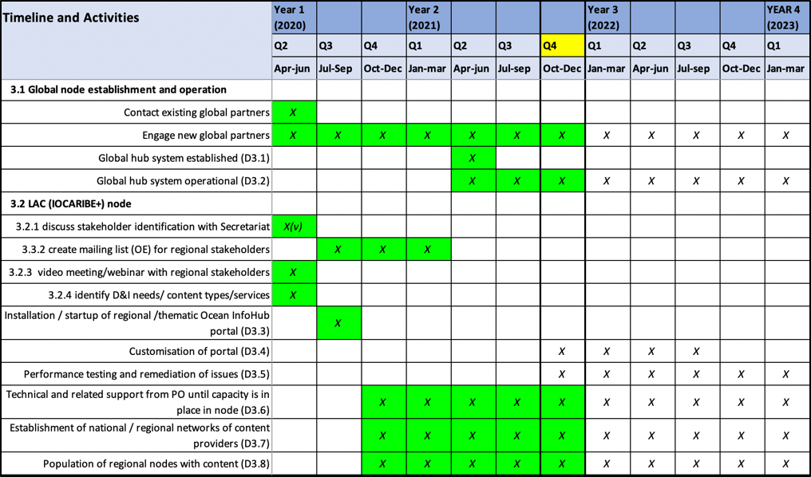

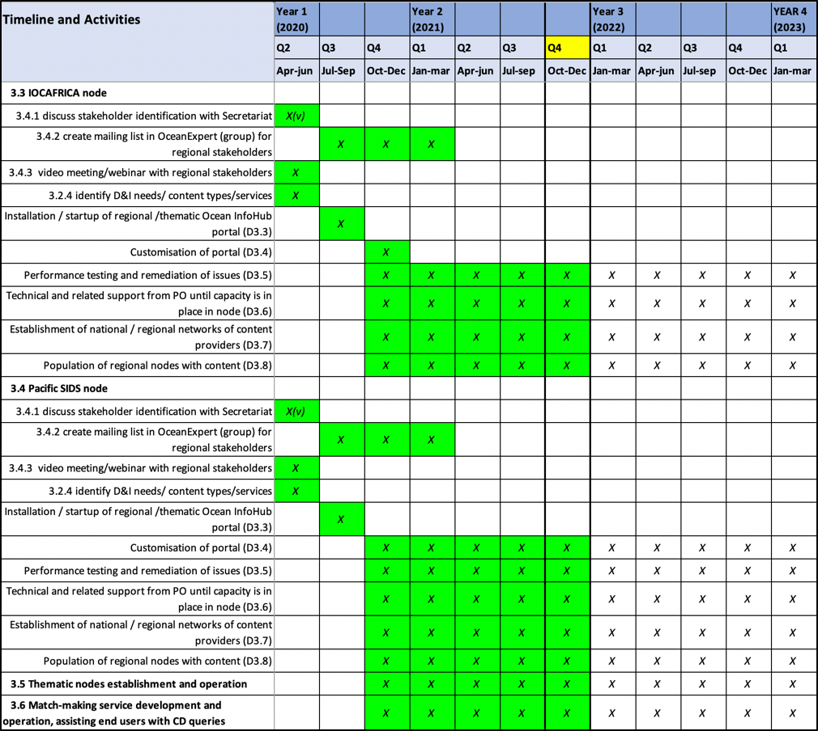

**4.4.1 Deliverables October 2020-September 2021**

**4.4.1.1 Global node establishment and operation**

Technical aspects were reported under WP2

The project held 77 meetings under WP3 across the three regions, as well as with global partners. Three dedicated OIH webinars were held and the project participated in numerous meetings and events (reported under WP5).

**4.4.1.2 Africa**

Supporting the improvement (QC and record entry) into OE and other regional databases

Ongoing work on the Africa Marine Training Database. (With thanks to NORAD)

Working with IOCAfrica and ICAN to revitalise the African Coastal and Marine Atlas and ODINAFRICA network

Ongoing working with implementation partners eg CORDO/maspawio

**4.4.1.3 LAC**

Working to develop the CHM_TMT to incorporate ODIS specifications and to include more partners (Such as the Sargassum Info Hub, CLME+ training, Caribbean Marine Atlas and others).

**4.4.1.4 PSIDS**

Working closely with SPC and SPREP to implement ODIS, and to develop use cases that are relevant to member states.

**4.4.2 Objectives 2021-2022**

**4.4.2.1 Global node establishment and operation**

Technical developments as reported under WP2

Ongoing work with regional and global partners.

**4.4.2.2 Africa**

Supporting the improvement (QC and record entry) into OE and other regional databases

Ongoing work on the Africa Marine Training Database. (With thanks to NORAD)

Working with IOCAfrica and ICAN to revitalise the African Coastal and Marine Atlas and ODINAFRICA network

Ongoing working with implementation partners eg CORDO/maspawio

**4.4.2.3 LAC**

Ongoing work to develop the CHM_TMT to incorporate ODIS specifications and to include more partners (Such as the Sargassum Info Hub, CLME+ training, Caribbean Marine Atlas and others).

**4.4.2.4 PSIDS**

Ongoing work with SPC and SPREP to implement ODIS, and to develop use cases that are relevant to member states.

**Questions, discussion and contributions from the chat**

Session A

Session B

## Work package 4: Training and capacity development of the nodes

This work package will focus on the development of a series of online training modules and tutorials as well as written documentation such as manuals. WP4 only commenced in 2021.

**Table 4. Work Package 4 overview of timeline**

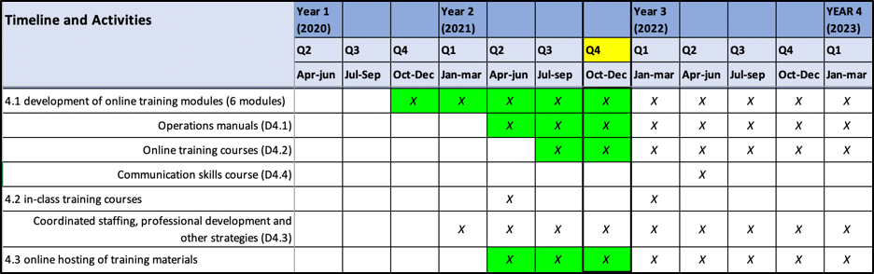

**4.5.1 Deliverables October 2020-September 2021**

**4.5.1.1 Development of online training modules**

* IOC/OTGA/OIH Training course: Implementing the Ocean Data and Information System (ODIS) architecture. 25-29 October 2021 [online]
* In development, on the OTGA e-learning platform.

**4.5.1.2 Operations Manuals**: ODIS-architecture documentation

[https://book.oceaninfohub.org](https://book.oceaninfohub.org/?_ga=2.259810505.2141234701.1632318930-1206114531.1612510412)

**Videos**: ODIS-architecture reference (walk-through) videos

https://drive.google.com/drive/folders/1JnfiXLwxYIc3Zx0WS5-6lyqDKahHfg8f?usp=sharing

**4.5.1.3 Online Training course:**

IOC/OTGA/OIH Training course: Implementing the Ocean Data and Information System (ODIS) architecture. 25-29 October 2021 [online]

* Event info on OE <https://oceanexpert.org/event/3256>
* Actual course (not yet public) <https://classroom.oceanteacher.org/course/view.php?id=722>

Training course materials also contributed to:

* ICAN9 Session III – Sharing your Atlas with the World (OceanInfoHub & [Schema.org](http://schema.org/))
* IOC/OTGA/RTC/Tianjin 2021 training course [Course: Ocean Data Stewardship in the Decade of Ocean Science for Sustainable Development (oceanteacher.org)](https://classroom.oceanteacher.org/course/view.php?id=708).

**4.5.1.4 Communication skills course**

Not yet addressed

**4.5.1.5 In-class training courses**

Not yet addressed, but will be considered in 2022.

**4.5.1.6 Online hosting of training materials**

IOC/OTGA/OIH Training course: Implementing the Ocean Data and Information System (ODIS) architecture. 25-29 October 2021 [online]

* Event info on OE <https://oceanexpert.org/event/3256>
* Actual course (not yet public) <https://classroom.oceanteacher.org/course/view.php?id=722>

**4.5.2 Objectives 2021-2022**

**4.5.2.1 Development of online training modules**

* Further development of the course IOC/OTGA/OIH Training course: Implementing the Ocean Data and Information System (ODIS) architecture. 25-29 October 2021 [online]
* Translation of training course materials to other languages

**4.5.2.2 Operations Manuals**: Further development of the ODIS-architecture documentation

[https://book.oceaninfohub.org](https://book.oceaninfohub.org/?_ga=2.259810505.2141234701.1632318930-1206114531.1612510412)

**4.5.2.3 Online Training course:**

IOC/OTGA/OIH Training course: Implementing the Ocean Data and Information System (ODIS) architecture. 25-29 October 2021 [online]

* Holding region-specific courses (language and time sensitive)

**4.5.2.4 Communication skills course**

**4.5.2.5 In-class training courses**

will be considered in 2022.

**4.5.2.6 Online hosting of training materials**

This is ongoing

**Questions, discussion and contributions from the chat**

Session A

Session B

## Work package 5: Communication, user marketing and feedback

This work package covers the communications and engagement activities needed to ensure the relevance and usefulness of the Ocean InfoHub global and regional/thematic nodes, to promote community participation in the Ocean InfoHub as contributors and users, and to solicit input needed to foster ongoing development of the Ocean InfoHub nodes.

**Table 5. Work Package 5 overview of timeline**

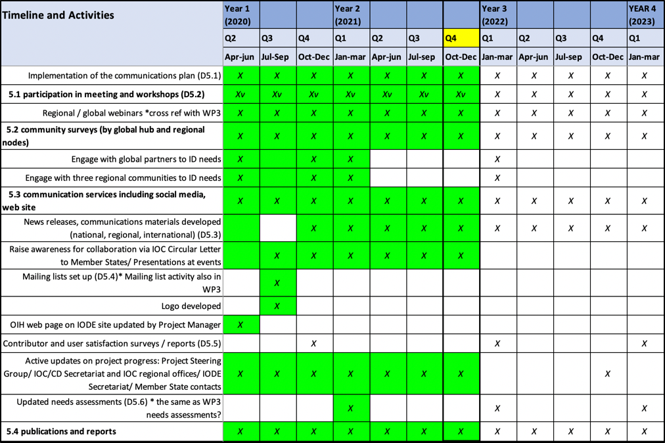

**4.6.1 Deliverables October 2020-September 2021**

**4.6.1.1 Participation in meetings and workshops**

* Altogether, the project has organised or participated in 189 documented virtual meetings, webinars or events (besides staff meetings) since the last Steering Group meeting.
* Many of these were internal WP2 or WP3 meetings, but many internal meetings include partners and can also be seen to contribute to WP5.
* At least 40 events contributed directly to awareness raising about OIH activities, objectives, and benefits of partnership.

**Selected examples (a full list is available)**

* International data sharing workshop for non-UN IGOs, Global and Regional organisations and projects, NGOs and private sector (12 October 2020)
* 2nd Session of the IOC Group of Experts on Capacity Development (26 October 2020)
* WMO data conference (16-19 November 2020)
* UN Decade planning meeting for Africa (3 November 2020)
* CLME+ training portal training (3 November 2020)
* GEBCO symposium (11 January 2021)
* Mapping the seafloor around Africa (2 webinars)
* VLIZ Marine Science Day (3 March 2021)
* IMDIS conference (12-14 April)
* IODE XXVI (20-23 April 2021)
* All-Atlantic Data and Policy Forum (31 May 2021)
* Towards an All-Atlantic Data Space workshop (3 June 2021)
* IUCN Regional Resource Hub Showcase (7 July 2021)
* Sargassum Webinar 5: The Sargassum Challenge: Opportunities for collaboration between West Africa and the Wider Caribbean Region (10 June 2021)
* International Coastal Atlas Network 9 (ICAN9) workshop Session III – Sharing your Atlas with the World (OceanInfoHub & Schema.org)

**4.6.1.2 Community surveys and needs assessments.**

The recent IOC-CD survey incorporated questions for and relevant to OIH; this will be repeated in 2022.

Many regional engagement, include the webinars, feed into identification of regional needs.

**4.6.1.3 Communication services (social media, website)**

The website is updated frequently and contains news items, media feeds.

We are currently using the IODE social media channels.

**4.6.1.4 Awareness raising through communications and events**

We use the mailing lists for important communications.

Regular communication uses Slack and email

Also see 4.6.1.1 above

**4.6.1.5 Active updates on project progress**

Through the website, Slack, Github and infrequent email updates.

**4.6.2 Objectives 2021-2022**

Questions, discussion and contributions from the chat

Session A

Session B

# 

# Budget

Significant cost savings were made during 2021 due to the travel restrictions imposed as a result of the global COVID-19 pandemic. Some meetings might still need to be held so a balance had to be found between additional spending (on consultancies, for example), while still retaining reserves to enable travel when permitted.

Costs to be spent for the remainder of 2021 and into 2022 include:

* Co-financing of activities at the IOC Sub-Commission for Africa
* Partial costs of AquaDocs maintenance supported.
* A contract for the ongoing development of the ODIS-architecture.
* A second contract in support of the ODIS-architecture development (mainly to work with partners)
* A contract for developing the Global Search Hub
* Co-financing of PSIDs regional activities
* A contract with INVEMAR for the further development of the CHM-TMT and the inclusion of additional regional partners through the implementation of ODIS.
* Meetings and online translation services
* Science communication services (including the development of a short video and graphics).

# Report on actions from SG-OIH-1

1. Continue the work in the three regions following the regional work plans (Q4)

**Report: this was continued as planned**

2. Review the applications and hire Sub-contractor for WP2 (1 October 2020)

**Report: This was done, a consultant (Doug) was hired and has completed his contract. A new ToR is in process.**

3. Continue the ODIS-architecture development as per the work plan and the proposed work of the sub-contractor on the schema.org (Q4).

**Report: This was completed.**

4. Convene regional meetings for each region and one for EU Partners (Q4), October 2020.

**Report: Four regional meetings were held before the close of 2020.**

5. Within WP2, focus on 5 thematic meetings for (i) people and institutions, (ii) Documents and best practices, (iii) Maps and spatial data, (iv) Training opportunities, (v) Vessels (Q4).

**Report: These five meetings were held, plus a sixth on Projects.**

6. Consider a global oceans meeting in the spirit of OceanObs, both within the OIH and also more broadly (2021).

**Report: the "International Ocean Data Conference- *The Data We Need for the Ocean We Want*" will be held in Sopot, Poland, between 14-16 February 2022 as a hybrid event.**

[**https://oceanexpert.org/event/3063**](https://oceanexpert.org/event/3063)

7. Facilitate an online voting process for the election of a Chair for the OIH Steering Group (15 October 2020).

**Report: This was completed and our current Chair, Frederico Nogueira, was elected.**

8. Continue to share SG reports in advance of the meetings, and allocate less time for reporting and more time for discussion (next SG meeting).

**Report: This has been done in 2021**

9. Focus on developing some tangible use-cases to demonstrate the OIH to end users (Q4) by the end of 2020.

**Report: The six thematic meetings towards the end of 2020 had a focus on use cases and implementation partners, and now the global search demonstration site can also be used as a demo for end users.**

# 7. Election of the chair

# 8. Next meeting: Third Session of the SG-OIH

# 9. Close of the meeting

**ANNEX 1**

**Second Session of the IODE Steering Group for the Ocean InfoHub Project**

|  |  |
| --- | --- |
|  |  |
|  |  |

**Provisional Agenda: 5 October 2021**

We are pleased to share session information and a provisional agenda for the meeting.

**Session A:** 5 October 1PM-3PM UTC

[https://oceanexpert.org/event/3132](https://aus01.safelinks.protection.outlook.com/?url=https%3A%2F%2Foceanexpert.org%2Fevent%2F3132&data=04%7C01%7CZulfikarB%40spc.int%7C9bb292ec0de24f3c1cc108d94c17eca5%7Cf721524dea604048bc46757d4b5f9fe8%7C0%7C0%7C637624487970595169%7CUnknown%7CTWFpbGZsb3d8eyJWIjoiMC4wLjAwMDAiLCJQIjoiV2luMzIiLCJBTiI6Ik1haWwiLCJXVCI6Mn0%3D%7C1000&sdata=Cf7wGRTvldZH0etCrbhs3tj5Ti3BDh%2FfzX2dMF1EXcQ%3D&reserved=0)

**Session B:** 5 October 7PM-9PM UTC

[https://oceanexpert.org/event/3158](https://aus01.safelinks.protection.outlook.com/?url=https%3A%2F%2Foceanexpert.org%2Fevent%2F3158&data=04%7C01%7CZulfikarB%40spc.int%7C9bb292ec0de24f3c1cc108d94c17eca5%7Cf721524dea604048bc46757d4b5f9fe8%7C0%7C0%7C637624487970595169%7CUnknown%7CTWFpbGZsb3d8eyJWIjoiMC4wLjAwMDAiLCJQIjoiV2luMzIiLCJBTiI6Ik1haWwiLCJXVCI6Mn0%3D%7C1000&sdata=Nze9HhbFr0y2%2Bcsrm%2BCZEgpb8h2FbuMAn1gvKIGj%2F0s%3D&reserved=0)

Both sessions will cover the entire agenda and the duplication is in order to allow for all regions to each meet at a reasonable hour.

These OceanExpert event links will be updated with background documents and the Zoom connection details.

***The meeting will open 20 minutes before the time; please connect early and keep your microphone on mute.***

Please confirm that you have the latest version 5.2.3 at:<https://zoom.us/download> in order to access the translation feature. Please note, the meeting will be recorded and made available online, together with all the presentations.

**Provisional Draft Agenda**

1 Opening of the meeting

2. Administrative arrangements

3. Adoption of the agenda

4. Overview of the OIH work plan and deliverables (Lucy Scott and OIH team).

5. Budget

6. Report on actions from SG-OIH-1

7. Election of the Chair

8. Next meeting: Third Session of the SG-OIH

9. Close of the meeting

**ANNEX II**

**Summary of Actions**

**ANNEX III**

**LIST OF PARTICIPANTS**

Total invited:

Total attended:

Attended session A:

Attended session B:

Attended both sessions:

|  |  |  |
| --- | --- | --- |
| **Name** | **Session** | **Email address** |

**ANNEX IV**

Reference Documents, shared in advance of the meeting

Available on the IODE Calendar [event page](https://www.iode.org/index.php?option=com_oe&task=viewEventRecord&eventID=2753):

1. OIH project timeline and deliverables
2. OIH Project summary English
3. OIH Project summary Spanish
4. OIH Project summary French
5. Recorded presentation: Overview of the OIH Project