**Template for the Report by the DBCP Action Groups to the**

**Thirty-SEVENth session of the DBCP (DBCP-37)**

*(Virtual session, 08-11 November 2021)*

**1) Summary**

|  |  |
| --- | --- |
| **Name of Action Group** | **International South Atlantic Buoy Program (ISABP)** |
| **Date of report** | 01 October 2021 |
| **Overview and main requirements addressed** | The main objective of ISABP is to continue establishing and maintaining a network of platforms in the Tropical and South Atlantic Ocean in order to provide meteorological and oceanographic data for both real-time and research purposes. The task includes support to the World Weather Watch Programme (WWW), the Global Climate Observing System, The world Climate Research Program and the Global ocean Observing System (GOOS), as well as to the research activities of participating institutions. |
| **Area of interest** | South Atlantic Ocean north of 55S plus Tropical Atlantic Ocean up to 20N (90 W to 30 E) |
| **Type of platform and variables measured** | Lagrangian drifters, with iridium transmitters, measuring sea level pressure, SST, salinity and sea-surface velocity. |
| **Targeted horizontal resolution** | 5x5 degrees and continuously filling areas where gaps exist. |
| **Chairperson/Managers** | Ms. Tania Daniels (nee Williams), South Africa Weather Service, SA. |
| **Coordinator** | Mr. Shaun Dolk, GDP, AOML, Miami, USA |
| **Participants** | Countries interested in the region (Brazil, US, France, South Africa, Tristan Is., Gabon, UK, Argentina) |
| **Data centre(s)** | Historical drifter data are assembled, quality controlled and interpolated at DAC, AOML, Miami, USA. GTS quality control is handled by AOML/GDP and disseminated to the GTS by SIO/GDP and Metocean Telematics. |
| **Website** | https://www.[ocean-ops.org/dbcp/isabp/](http://www.jcommops.org/dbcp/isabp/) (not updated)  Data also available through:www.aoml.noaa.gov/phod/gdp and osmc.noaa.gov/Monitor/OSMC/OSMC.html |
| **Meetings**  *(meetings held in 2020/2021; and planned in 2021/2022)* | ISABP meetings are held prior or during DBCP. A virtual meeting took place on September 2021 prior to DBCP-37. |
| **Current status summary** *(mid-2021)* | As of September 27, 2021, there were a total of 176 drifters transmitting good data in the ISABP region. (SVP:37, SVPB:139), all but one are iridium. Last year in September, there were a total of 212 drifters.  There are also 2 stationary drifters in the region, one on Tristan da Cunha and one on South Thule. |
| **Challenges/Opportunities/Risks** *(intersessional period- highlighting the impact of COVID19 and mitigation plans)* | The challenge continues to be to populate hard to reach areas and maintain coverage and attract new partners to help with the deployment of drifters.  COVID-19 continues to impact deployment opportunities and our ability to seed the region, as several cruises were delayed/cancelled. |
| **Summary of plans for 2022** | We will continue to address observational gap area. |

**2 Deployment plans for 2022**

Deployments during the intersessional period, (July 2020 through June 2021) are shown in Figure 1.

There were 101 drifters deployed in the area, a total of 112 less than last year during the same period. (11 SVP, 83 SVPB, and 7 wave drifters, only two failed on deployment.

The shortage of deployments were part due to COVID-19 related issues.

Deployments in the ISABP region were carried out by US vessels, French vessels, The Brazilian Navy, South Africa Weather Service (SAWS), Tristan da Cunha fisheries, University of Cape Town and South Thule Island fishing vessels, and UK. This year for the first time in more than 10 years, we partnered again with Argentina, through the University of Buenos Aires.

The GDP deployment plan from July 1, 2021 - June 30, 2022 is as follows:

Tropical Atlantic (20S - 30N): SVP=60 SVPB=40

Extra Tropical Atlantic (40S - 20S): SVP=15 SVPB=25

Southern Atlantic (60S - 40S): SVP=0 SVPB=40

**3 Data management**

3.1 Distribution of the data

Data are assembled and quality controlled at the AOML/GDP Drifter Data Assembly Centre, (DAC) in delayed mode. The historical interpolated data are available through the DAC web page http://www.aoml.noaa.gov/phod/gdp/index.php), These data is also archived at NCEI. The official dataset citation is:

Lumpkin, Rick; Centurioni, Luca (2019). Global Drifter Program quality-controlled 6-hour interpolated data from ocean surface drifting buoys. [indicate subset used]. NOAA National Centers for Environmental Information. Dataset. https://doi.org/10.25921/7ntx-z961. Accessed [date].

Real time and historical data are also available through the ERDDAP system http://osmc.noaa.gov//Monitor/OSMC/OSMC.html

Brazilian Buoy Program has its data available at http://www.goosbrasil.org/pnboia/dados/, for moored and drifting buoys.

3.1.1 Data policy

Details on data exchange policy.

Drifter data is open to the community and available in real time and delayed mode from websites mentioned above.

3.1.2 Real-time data exchange

Details on percentage of data distributed on GTS.

Details on data timeliness (i.e. reception time at operational meteorological services minus observation time), including known problems, possible solutions, statistics, etc.

All data from drifters are disseminated via GTS as soon as drifters are deployed and available through web sites (see above). These data are monitored and taken off GTS when sensors stop giving good quality data. As of September 27, 2021, there were a total of 176 surface drifters in the South Atlantic region, all transmitting good quality data on the GTS.

3.1.3 Delayed mode data exchange

Details on delayed mode data exchange, data centres, and archives.

Details on the collection and distribution of instrument/platform metadata

Details on the provision of discovery metadata about available data-sets using ISO 19115 standard.

Updates of the quality controlled and 6-hour interpolated data are performed at AOML every 2 -3 months. These quality controlled-interpolated data are available through the NOAA/AOML and NOAA/OSMC web sites, they are also archived at NCEI:

www.aoml.noaa.gov/phod/gdp/index.php and osmc.noaa.gov/Monitor/OSMC/OSMC.html

Metadata from GDP drifters are collected at the DAC directly from the manufacturers, archived and made available at the GDP web page and also at OceanOPS.

http://www.aoml.noaa.gov/phod/dac/deployed.html and also at:, http://www.aoml.noaa.gov/phod/dac/dirall.html

Metadata for drifter specifications, drogue specifications, and barometer metadata can be downloaded from this link: http://www.aoml.noaa.gov/phod/gdp/index.php under Metadata.

3.2 Data quality

Details on data quality, quality control procedures, including detected problems, correction of systematic errors and bias, reporting of data quality, feedback from data users, statistics, etc.

Data quality control and interpolation procedures were applied according to the peered review

paper by Hansen and Poulain. See Hansen, D.V. and Poulain, P.M., 1996, [[PDF]](http://www.aoml.noaa.gov/phod/gdp/papers/Hansen-Poulain_QC.pdf) for a complete description of the quality controlled and interpolation procedures applied to the drifter data in the database

**4) Instrument practices**

Details on instrument practices, followed standards and procedures, traceability to SI units, instrument inter-comparisons, etc.

**5) Details of Challenges/Opportunities/Risks**

Report details on the challenges, opportunities and risks for the task team during the intersessional period.

The challenge continues to be to populate hard to reach areas and maintain coverage and attract new partners to help with the deployment of drifters.

COVID-19 continues to impact deployment opportunities and our ability to seed the region, as several cruises were delayed/cancelled.

__________________

**Annex (optional)**

**Status maps and graphics**

**Drifters deployed in the South Atlantic Region during the intersessional period**

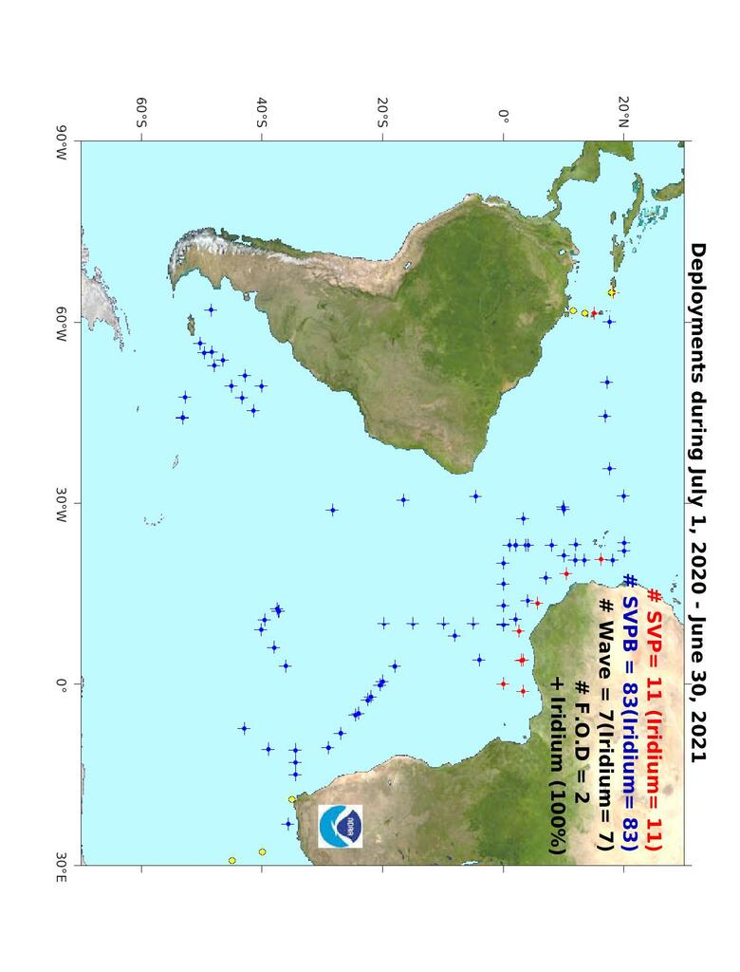

Figure 1. Deployment locations. A total of 101 drifters were deployed in the ISABP area.

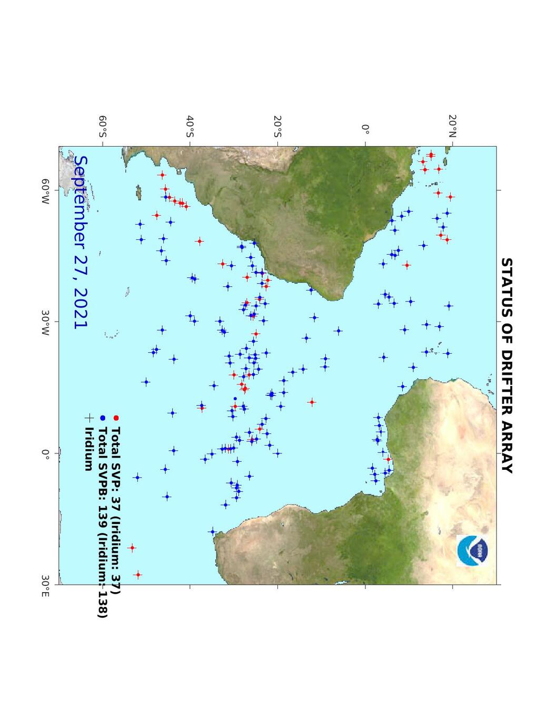

Figure 2. Status of the South Atlantic Array as of September 27, 2021. A total of 176 drifters are present in the region.

__________________