DATA BUOY COOPERATION PANEL (DBCP)

FORMAT FOR NATIONAL REPORTS ON CURRENT AND
PLANNED BUOY PROGRAMMES

Country | INDIA
Year | 2020-2021

Please Identify your Programme’s Major Opportunities and Challenges/Risks during the upcoming year and how DBCP can most effectively assist your Programme.

- CURRENT PROGRAMME:

Please Identify your Programme’s Major Opportunities and Challenges/Risks during the upcoming year and how DBCP may assist your Programme.

Agency or programme | National Institute of Ocean Technology,India
Number and type of buoys | (a) deployed during the year | 18
Number and type of buoys | (b) operational as of 31 August | 14
Number and type of buoys | (c) reporting on GTS as of 31 August | 12
Purpose of programme  (check/uncheck boxes using [_] or [x] as appropriate) | (a) operational | [x]
 | (b) met / ocean research | [x]
 | (c) developmental | [x]
Main deployment areas | Arabian Sea and Bay of Bengal
Vandalism incidents | (a) Number of incidents  If vandalism incidents have occurred during the year, please provide the details using the form in the annex.
(repeat table above as often as necessary)

2. PLANNED PROGRAMMES:

Agency or programme | National Institute of Ocean Technology,India
Number and type of buoys | planned for deployment in the next 12 months | 19 MOORED BUOYS
Purpose of programme  (check/uncheck boxes using [_] or [x] as appropriate) | (a) operational | [x]
 | (b) met / ocean research | [x]
 | (c) developmental | [x]
Main deployment areas | Arabian Sea and Bay of Bengal
(repeat table above as often as necessary)

3. TECHNICAL DEVELOPMENTS:

(a) Buoy design | - Indigenized OMNI 2.0
(b) Instrumentation | - Indigenized Data Acquisition Systems developed  - Indigenized Bottom pressure recorder developed (SAGAR BOOMI) compatible with DART format  - Subsurface Tsunami system developed (CHATUR)  - Technology transfer of met ocean, Tsunami buoy, RoboBoat Robo Coastal Observer

4. PUBLICATIONS (on programme plans, technical developments, QC reports, etc.):

Ref | Title | Type
1 | Venkatesan, R., Muthiah, M.A., Vedachalam, N., Thirumurugan, K., Senthilkumar, P., Vengatesan, G. and Sridharan, R., 2021. Can Submerged Buoys be Reliably Used for Monitoring Tsunamis in the Indian Ocean?. Marine Technology Society Journal, 55(1), pp.127-136. | 1
2 | Venkatesan, R., Ramesh, K., Muthiah, M.A., Vedachalam, N., Murugesh, P. and Atmanand, M.A., 2021. Estimation of Uncertainty in the Atmospheric Pressure Measurement From the Indian Ocean Moored Buoy Systems. Marine Technology Society Journal, 55(1), pp.137-146. | 7
3 | R.Venkatesan,N. Vedachalam, G. Vengatesan Quantification of ocean- atmosphere energy exchange during super cyclone Amphan in the Bay of Bengal using Indian Ocean moored observatories Dynamics of Atmospheres and Oceans,2021, 101210, ISSN 0377-0265, https://doi.org/10.1016/j.dynatmoce.2021 | 7
4 | P. Varalakshmi, N. Vasumathi, R.Venkatesan, Tropical Cyclone prediction based on multi-model fusion across Indian coastal region, Progress in Oceanography,2021 | 7
5 | Dr.R.Venkatesan ,K.Ramesh, Dr.N.Vedachalam, R.Sundar "Emerging Trends in Real Time Ocean Data Collection for Blue Economy in the Indian Context" Institution of Engineers India Annual Technical Volume of Marine Engineering Division Board, Volume III, 2020 PP 9-16 | 8
6 | Pearlman, Jay and Buttigieg, Pier Luigi and Bushnell, Mark and Delgado, Claudia and Hermes, Juliet and Heslop, Emma and Hörstmann, Cora and Isensee, Kirsten and Karstensen, Johannes and Lambert, Arno and Lara-Lopez, Ana and Muller-Karger, Frank and Munoz Mas, Cristian and Pearlman, Francoise and Pissierssens, Peter and Przeslawski, Rachel and Simpson, Pauline and van Stavel, Jordan and Venkatesan, Ramasamy. (2021). Evolving and Sustaining Ocean Best Practices to Enable Interoperability in the UN Decade of Ocean Science for Sustainable Development. Front. Mar. Sci. 8:458, doi:10.3389/fmars.2021.619685 | 8
7 | Venkatesan R. and K. Jossia Joseph, 2021. Rapid mode transmission in moored data buoys during cyclones, Breeze- IMS Chennai Chapter Newsletter. Vol.21, Issue No.1, May 2021 | 1
8 | Shroyer E, Tandon, A, Sengupta D, Fernando H. J, Lucas, A. J, Farrar, J. T, Chattopadhyay R, de Szoeke S, Flatau M, Rydbeck, A, Wijesekera, H, McPhaden M, Seo H, Subramanian, A, Venkatesan, R, Joseph, J, Ramsundaram, S, Gordon, A. L, Bohman, S. M, Pérez, J., Simoes-Sousa, I. T, Jayne, S. R., Todd, R. E, Bhat, G.S, Lankhorst, M, Schlosser, T, Adams, K, Jinadasa, S, Mathur, M., Mohapatra, M, Rao, E. P. R, Sahai, A. K, Sharma, R, Lee, C, Rainville, L, Cherian, D, Cullen, K, Centurioni, L. R, Hormann, V, MacKinnon, J, Send, U, Anutaliya, A, Waterhouse, A, Black, G. S, Dehart, J. A, Woods, K. M, Creegan, E, Levy, G, Kantha, L. H, Subrahmanyam, B. (2021). Bay of Bengal Intraseasonal Oscillations and the 2018 Monsoon Onset, Bulletin of the American Meteorological Society (published online ahead of print 2021). Retrieved May 29, 2021, from https://journals.ametsoc.org/view/journals/bams/aop/BAMS-D-20-0113.1/BAMS-D-20-0113.1.xml | 7
9 | Varalakshmi Perumal, Suresh Kumar Murugaiyan, Pavithran Ravichandran, R. Venkatesan, R. Sundar R Real Time Identification of Anomalous Event in Coastal Regions using Deep Learning techniques was published in Wiley online library Journal :Concurrency and Computation: Practice and Experience, on 15th June 2021 ; https://doi.org/10.1002/cpe.6421 | 8
10 | Venkatesan.R, Arul Muthiah M, Vedachalam N, Vengatesan, G, Ramesh, K, Kesavakumar B, Thirumurugan K, Technological Trends and Significance of the Essential Ocean Variables by the Indian Moored Observatories Relevance to UN Decade of Ocean Sciences in Marine Technology Society Journal,Volume 55, Number 3, May/June 2021, pp. 34-49(16) DOI : https :// doi.org /10.4031/ MTSJ.55.3.8 | 7
11 | Debi Prasad Bhuyan, Samiran Mandal, Arkaprava Ray, Sourav Sil, R. Venkatesan, Surface and Subsurface Signatures of Monsoon Intraseasonal Oscillations from Moored Buoys Observation in the Bay of Bengal, Dynamics of Atmospheres and Oceans, 2021, 101240,ISSN 0377-0265, https://doi.org/10.1016/j.dynatmoce.2021.101240 | 7
(repeat rows in the table above as necessary)

5. ADDITIONAL COMMENTS:

(a) Quality of buoy data | - Good. As per WMO standard  - Most publications using this data  - PAR with RAMA buoy data  - BUFR format validation completed and yet to implement for moored buoys.
(b) Communications | - Indian Satellites used for data telemetry  - GPRS/GSM Communication used for Coastal buoys  - INMARSAT Satellite telemetry used for Deep met ocean buoy  - Procurement of Iridium satellite telemetry work initiated
(c) Buoy lifetimes | - Two years (exclusive of sensor performance)
(d) Data Accessibility | - https://incois.gov.in/portal/datainfo/mb.jsp
(e) New Observations | - Upgradation of Indigenous Autonomous Rain Gauge (IARG)  - Rapid mode transmission during cyclone
(f) GFCS and WIGOS
(g) Additional Requirements | - OMNI RAMA web portal established to access moored buoy through https://incois.gov.in/portal/datainfo/buoys.jsp
(h) DBCP Linkages
(i) Contribution to UN Decade and UN SDGs | ●  ●  ●
(j) Other (i.e. Impact of COVID19 on observing systems and mitigation efforts) | - Planned to service the moored buoys in the Bay of Bengal and Arabian sea during March & April 2020 due to COVID 19 pandemic situation the cruises postponed to February and June 2021. Due to delay in service three surface lost and one buoy vandalized

Note: It is recommended that this form is filled in electronically and returned also electronically to the Secretariat. A template of the form can be downloaded from the following SharePoint site:

https://wmoomm.sharepoint.com/:w:/s/wmocpdb/EQ1z8KndbxREkzE6RH4NFkkBDdvOItne74OP8f4voMMSbg?e=pgru6r

National Report on Moored buoy network
India
(Report Period: July 2020- July 2021)

- Indian Mooring Buoy Network Support

The primary objective of Ocean Observation Network (OON) is to establish and maintain various in-situ ocean observation platforms to collect marine meteorological and oceanographic data both from the offshore and coastal region of the Indian Ocean to support various working system development (data assimilation in ocean general circulation model and Atmospheric General Circulation Models, validation of ocean hindcast/forecast model output, validation of satellite-derived parameter) and to facilitate research studies for better understanding and enhance our knowledge on the present climate. The Indian Ocean was under-sampled and poorly understood as recent as two decades ago compared to other tropical oceans. However, in the last two decades, there were systematic and focused efforts to monitor ocean state in the Indian Ocean region.
Considering the importance of ocean observations in terms of understanding the ocean environment and to utilize them for operational oceanography, a large number of observation platforms were deployed and maintained in the Indian Ocean coastal and open ocean waters during the last two decades, through the Ministry of Earth Sciences (MoES) funding under the project Ocean Observation Network (OON) through INCOIS, NIOT and NIO-Goa. These observational platforms facilitate to acquire real-time in-situ oceanographic and near-surface meteorological data. While designing it is also considered the existing Indian Ocean Observing System (IndOOS), which is a regional contribution to the Global Ocean Observing System (GOOS), an international collaborative effort led by the Intergovernmental Oceanographic Commission (UNESCO-IOC) to establish ocean observation and collect real-time oceanographic data of the world's oceans. The different platform under OON includes the moored met-ocean data buoys (RAMA-The Research Moored Array for African–Asian–Australian Monsoon Analysis and Prediction), expendable bathythermograph/expendable conductivity temperature depth (XBTs/XCTDs), drifters, Argo floats, ship-board Automated weather stations (AWSs), Acoustic Doppler Current Profiler (ADCP) network along Indian coast, current meter array in the equatorial Indian Ocean, wave rider buoys (WRBs), sea-level gauges (or Tide Gauges) along the coast of India, open ocean tsunami monitoring buoys (or Bottom Pressure Recorder (BPR)), OMNI mooring and HF Radar Network. The parameters being measured by various platforms are temperature, salinity, and current profiles, marine meteorological parameters, bio-geochemical parameters, sea-level, and waves, etc.
Indian National Centre for Ocean Information Services (INCOIS) deployed 494 ARGO floats and providing profile to INCOIS. During this period,18 floats were deployed (12 Argo floats with temperature and salinity, 6 Argo float with temperature, salinity, chlorophyll, dissolved oxygen and backscatter).
INCOIS planned to deploy 50 satellite-tracked surface drifters equipped with atmospheric pressure and sea surface temperature and procurement of the first batch of drifters is under progress. In collaboration with the National Institute of oceanography, INCOIS is maintaining 18 ADCP moorings along the Indian coast and 3 current meter mooring at the equator and 3 XBT/XCTD lines along Port Blair-Kolkata, Chennai-Port Blair and Kochi-Lakshadweep. Besides, INCOIS is maintaining 6 wave rider buoy, 35 tide gauge station along the Indian coast and 7 bottom pressure recorder (4 by INCOIS and 3 by NIOT) and 30 ship-based automatic weather station in the Indian Ocean.
To understand the air-sea interaction, upper ocean processes and dynamics of freshwater, INCOIS deployed a mooring (INCOIS-Flux mooring) on 23 May 2019 in the northern Bay of Bengal (17°48.26 N and 89°30.25 E) and retrieved the INCOIS-Flux mooring during September 2020. The system equipped with a direct covariance flux system (DCFS), a first of its kind in the Indian Ocean, along with near-surface met-ocean sensors and subsurface current, temperature and salinity sensors.
National Institute of Ocean Technology (NIOT) has established the moored buoy network in the Indian Seas. NIOT has been systematically maintaining the twelve deep-sea instrumented buoy systems with surface and subsurface sensors, three coastal buoys, one CALVAL Buoy, one Arctic mooring, one Indian tsunami buoy systems and data is being disseminated to INCOIS Hyderabad. NIOT developed the DART format and implemented for Indian Tsunami buoy system. The Indian Tsunami buoy data being shared to NDBC through INCOIS. NIOT and INCOIS jointly developed BUFR format for Arabian Sea OceanSites (AD07) and validated by JCOMMOPS. In future, all moored buoys data format converted to BUFR and plan to share in GTS. NIOT has been systematically carrying out preparations for executing these tasks despite the challenges faced such as ship time availability, adverse weather conditions, harsh marine environment, inaccessibility to visit the site in case of any eventualities, vandalism, procurement process and large inventory. The moored buoys are transmitting data in real time through the INMARSAT, INSAT and GPRS having a data return of 75%. Due to COVID-19, the moored buoy data return was diminution up to 20% when compared to 2018 -19.
Indian Observation Platforms | No of platforms in Ocean | Remarks
ARGO Floats | 494
ADCP Mooring | 18
Equatorial current meter array | 3
Drifter | -
Wave Rider buoy | 6
XBT/XCTD transects | 3
Tide Gauges | 35
Ship-based AWS | 30
HF Radar | -
ARCTIC Mooring | 1
Wave Height Meter | 1
Moored Buoys (Deep-ocean & Coastal) | 15
Tsunami Buoy | 7 (4 INCOIS and 3 NIOT)
Reference station | 1
ADCP subsurface mooring | 17
​INCOIS Flux mooring | ​0 | ​

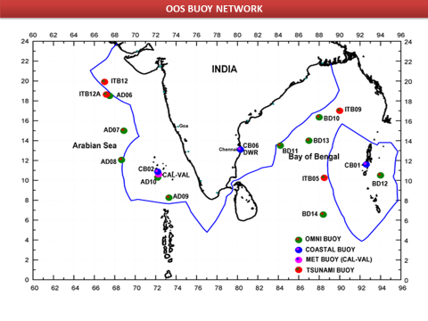

- Progress since last SAC meeting (February 2021)
OOS has been systematically maintaining the present buoy network and buoys are serviced periodically for real-time met ocean data collection and the collected data is being disseminated to INCOIS Hyderabad. Indian Tsunami Buoy System data is shared with NDBC through INCOIS. Metadata format updated till date for Deep Ocean and Coastal NIOT buoy systems. Buoy data sets are shared in GTS and made available in DBCP website for global community. OOS team is also periodically monitoring marine plastics in designated deep sea and coastal stations.
The functional status of buoy network during the period under consideration is given in below figure.
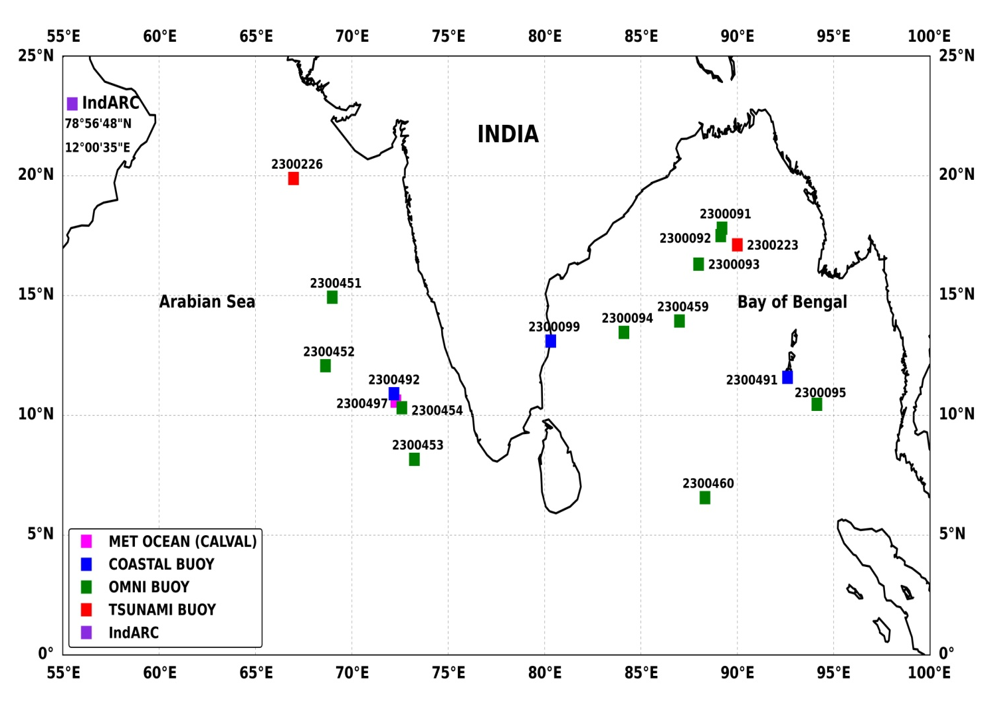 |  | 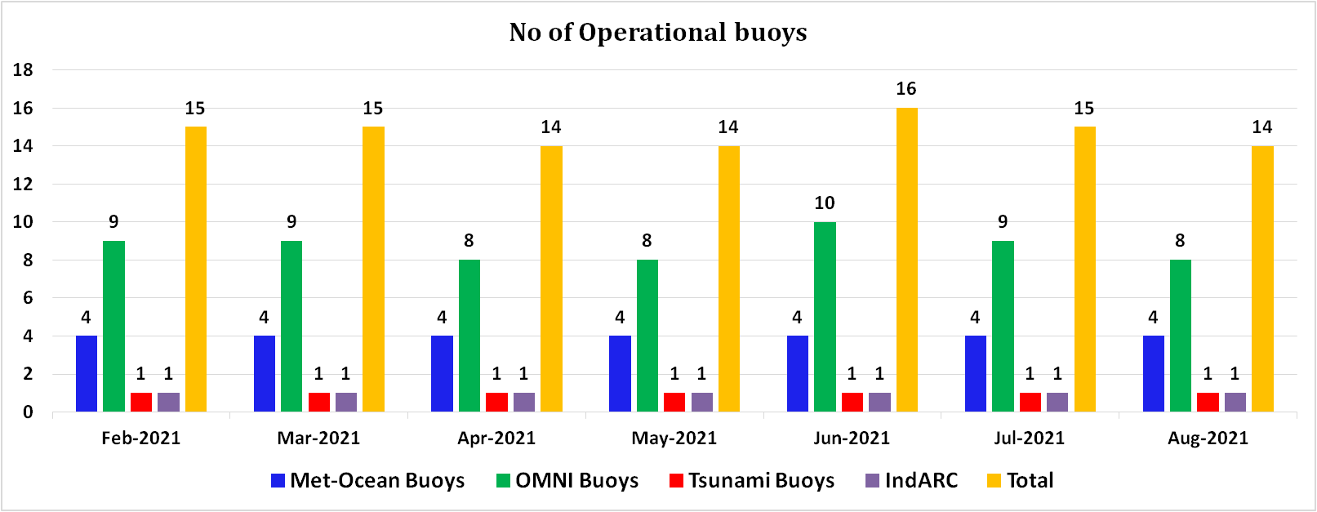
 | Figure :(a) Moored Buoy Network in the Northern Indian Ocean (b) Functional status of buoys during the assessment period.
An Indian patent has been granted for OOS for the invention titled ‘REAL TIME TSUNAMI MONITORING SYSTEM’, patent No. 369964 on 22nd June 2021. Inventors: Dr.R. Venkatesan, M.Arul Muthiah, R.Sundar & K.Ramesh. This invention has unique features such as hybrid telemetry & power, Smart Interface Module in dual mode and can communicate with the sea bed BPR unit from shore. Also, it can transmit Tsunami data to two warning centres simultaneously.
Six Indigenous Ocean observation technologies developed OOS team has been sucessfully transferred to M/s L&T for commercialisation and a meeting was conducted on 05th August 2021 with NRDC for technology transfer of Algorithm for rapid mode transmission during cylones.
An Indian patent is awarded to @MoesNIOT for the invention titled "A system and method for calibrating acoustic tide gauge", patent No. 371442 dt. 08th Jul 2021. Inventors: R. Sundar (from OOS), R. Srinivasan, Dr. G.A. Ramadass, Dr. M.A. Atmanand. This invention "A System and Method for Calibrating Acoustic Tide Gauge" uses a liquid level value computed from the pressure measured by the digital pressure sensor for calibrating the acoustic Tide Gauge. One of the paper submitted and presented by Mr.Biswajith Haldar of OOS titled” Effect of Mooring Motion on Temperature Profile Measurements in OMNI Buoy Systems: A Case Study” bagged the best paper award during the OSICON 21 conference.
Data from Indigenous Automatic Rain Guage installed at NIOT is shared with IMD every 15 mins interval through FTP.From Feburary 2021 to August 2021, two cruises and a coastal buoy field activity were undertaken by OOS department for the maintenance of OMNI, Tsunami and Coastal Buoy systems.During the first cruise,BOB OMNI buoy systems BD08, BD09, BD10, BD11, BD13 and two tsunami buoys were successfully serviced utilizing the services of ORV Sagar Nidhi during the period 6th Feb,2021 to 22nd Feb,2021and in the second cruise two BOB OMNI bouy systems BD14 and BD12 were successfully serviced, BD13 deep sea camera system retrieval and microplastic studies were carried out in 6 deep sea location during the cruise onboard Sagar Kanya during the period from 10th June,2021 to 03rd July,2021. Retrieval and deployment of coastal buoy CB01 was also carried out successfully during 08-13 March 2021 with the support of Andaman forest department. OOS team extended support to INCOIS in order to undertake emergency cruise onboard Sagar Kanya for the recovery of gliders. Twenty one papers were published in peer reviewed National & International jounals and conferences during this period.
OMNI-RAMA joint data Portal:
The signing ceremony of the Implementing Arrangement for Technical Cooperation in Development of the Research moored Array for African-Asian-Australian Monsoon Analysis and prediction (RAMA) and the Ocean Moored buoy Network in the northern Indian ocean (OMNI) for Improving Weather and Monsoon Forecasts between the National Oceanic and Atmospheric Administration (NOAA) Department of Commerce of the United States of America and the NIOT, Ministry of Earth Sciences (MoES) of the Government of India took place on 09th August 2021.
As part of the event, a data portal jointly developed by NIOT, INCOIS and PMEL-NOAA consisting data from NIOT-OMNI buoys and NOAA RAMA buoys in the Indian Ocean region was launched by Dr. Ashutosh Sharma, Secretary MoES. The portal provides details on deployment history, granular details of the buoy system like location, station depth, mooring type, buoy dimension, power source, Meteorological and Oceanographic sensor fit, method used by sensors for sampling, sampling intervals, measurement depths for underwater profile, power source, transmission interval and the mode of transmission.
The meta data provided in the site complies to WMO Integrated Global Observing System (WIGOS) format and also provides a comprehensive detail about the OMNI RAMA Program, technical details on mooring design, sampling description, specification of sensors, calibration of sensors, communication systems, quality control of Met-Ocean Parameters, a case study on Depth remapping for underwater measurements, list of publications using NIOT-OMNI buoy measurements and the abbreviations used in the metadata page. The portal facilitates download of data by Indian and global researchers from all OMNI and RAMA buoys in the Northern Indian Ocean.
IndARC-Indian Arctic mooring Activity : Due to present pandemic condition, the team could not travel to Kongsfjorden for retrieval of IndARC mooring . NCPOR has approached Italian Mooring team for retrieval of IndARC mooring. Subsequently, a detailed technical document describing the procedure to be followed during retrieval of the mooring was prepared and shared with Italian team. In connection with this activity, a joint meeting was held on 2nd Aug 2021 and members from NCPOR, NIOT and Italy were present for discussion. The plan for retrieval during September 2021 and logistics were discussed during the meeting.
Rapid mode transmission during Cyclones:
The rapid mode transmission facility incorporated in moored buoys provided realtime met-ocean data sets during Extremely Severe Cyclone Tauktae in May 2021. The low pressure system originated in the South-east Arabian Sea on 14 May 2021 intensified into a very severe cyclonic storm on 17 May 2021. Significant drop in SLP is observed in moored buoy network, which crossed the threshold for triggering rapid mode transmission. CALVAL buoy recorded minimum SLP of ~ 996 hPa and triggered in to cyclone mode. The refined algorithm enabled the high-frequency data transmission at every 30 minute interval, which was disseminated in realtime to various services providers for cyclone forecast.

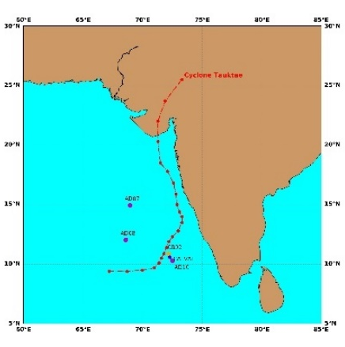 | 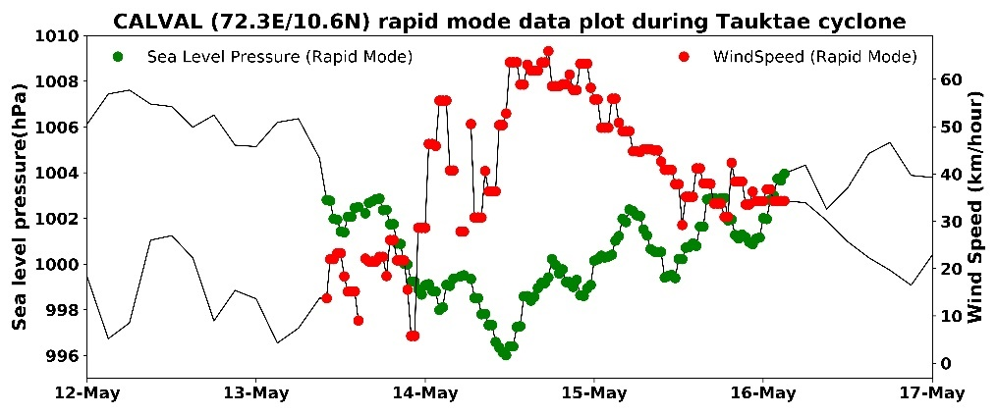
Figure: (a)Track of Tauktae, (b) Rapid mode data plot

- Technology Developments
Apart from undertaking year-round regular maintenance activities of buoys in both Bay of Bengal and Arabian Sea, OOS continuously strives to enhance the systems to a satisfactory level through its indigenization efforts. The development works carried out by the OOS team are detailed in the below sections.
  - Atmospheric Technologies Development - Jointly with IMD
2.1.1 Upgradation of Indigenous Autonomous Rain Gauge (IARG)
NIOT has setup IARG which collects the time series data from Rain gauge, Air temperature, Air pressure and Air humidity sensors at synoptic hours (and at programmed intervals) and transmits the information in GTS format in real time through INSAT/GPRS. IARG comprises of two weather proof compartments for the batteries, CPU and INSAT/GPRS transceiver. A suit of sensors fixed in a mast are interfaced to the CPU.The CPU activates the respective sensors at pre-determined time intervals to acquire data for a programmed period at configured frequency. Some sensors sampling may be done in parallel / concurrently. The acquired raw data is processed and the processed single value for each parameter in encrypted format is sent through INSAT/GPRS to Central Receiving Station (CRS). The system is now upgraded with air pressure sensor and the time interval of the CPU for the data transmission has been reduced to 15 minutes which was earlier 30 minutes. These data sets are sent to IMD.
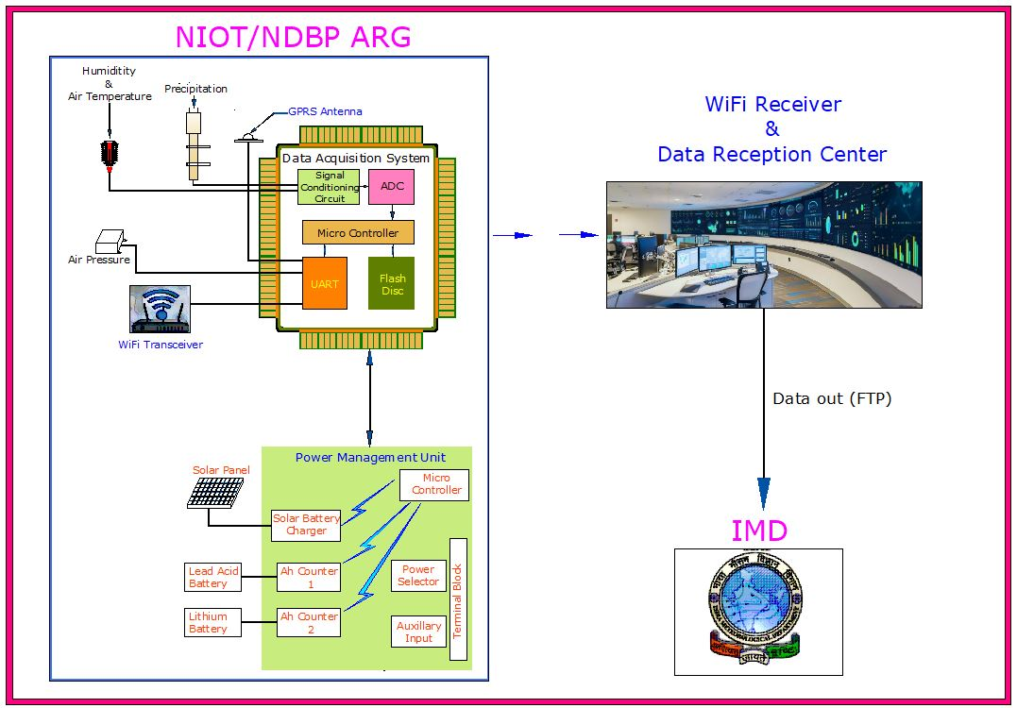
Figure: Schematic diagram of ARG System with Air temperature and Air pressure

2.1.2 Installation of AWS system at NIOT-Nellore campus
An AWS system with indigenous DAS was installed at NIOT campus at Chittedu Nellore on 11th August 2021.The system consists of an Indigenous CPU, Wind sensor mounted in a 10 m height tiltable mast, Humidity & Air temperature sensor, Air pressure sensor and Precipitation sensor. The transmission of real time data from Nellore to NIOT is using GPRS & INSAT and the received data is shared with IMD. The 10 m mast used is of tiltable type which can be easily handled by a single person using a winch, making it suitable for remote locations which are with limited man power for maintenance.
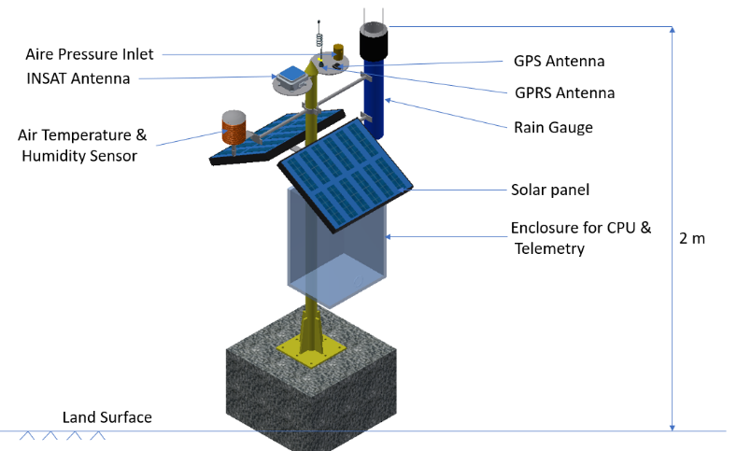
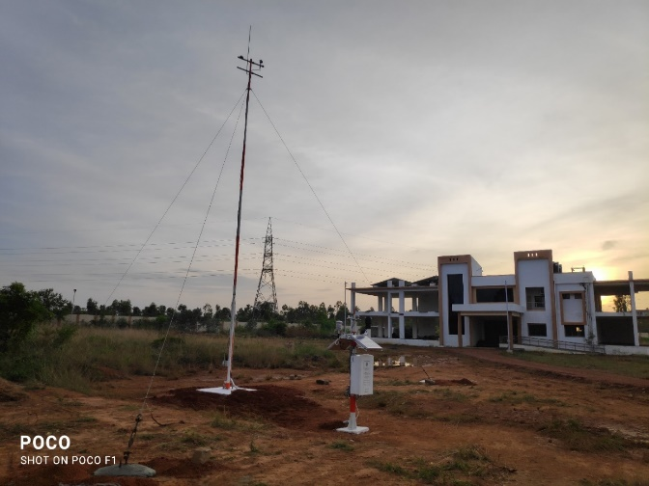
Figure: AWS system installed at Nellore NIOT campus

2.1.3 Development of Precipitation Sensor

OOS has successfully developed an Indigenous rain gauge working on capacitive principle for the measurement of rain in weather stations, moored buoy systems and also in the Automatic Rain Gauges. For floating platforms such as moored buoy systems, the capacitive based precipitation measurement with catchment funnel & measurement tube is suitable considering the floating and unstable nature of platform. This indigenously developed rain gauge is designed with a capacitive transducer which senses the water column height and a self-contained electronic circuit converts the capacitance value to a calibrated voltage output which is proportional to precipitation. Sensor has option for gain adjustment & offset correction through the variable potentiometer in the electronic circuit. The gauge has the automatic self-siphon facility for automatic draining of measuring chamber once the measuring chamber is filled by the accumulated rainfall. Periodic interrogation by a data logging system (sampling at 1Hz with interval of 2 minute) allows computation of the total precipitation and rate. Features like use of bird spike in the catchment area and installation of plastic guard inside the funnel filters the entry of foreign objects into the gauge and also ensures quality data & long term performance.
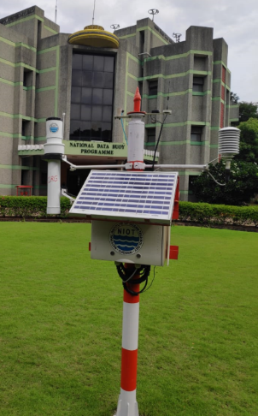
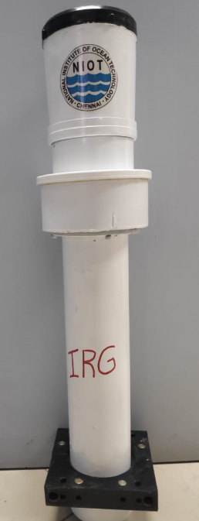

Figure : IRG installed at NIOT and IRG sensor.

  - Transfer of Technology(ToT) with M/s L&T

Below listed six Indigenous ocean observation technologies developed by OOS team has been successfully transferred to M/s L&T for commercialisation.

a. Robo Coastal Observer(RCO)
b. Robo Boat
c. Met Ocean Buoy System -Type-1
d. Met Ocean Buoy System-Type-2
e. Indian Tsunami Buoy System-Type-1
f. Indian Tsunami Buoy System-Type-2

The triparty agreement for technology transfer between NRDC, NIOT and L&T was signed on 20th August 2021 for further process.
- Data Buoy Observations during Cyclones
During this reporting period, the moored buoys deployed by the OOS captured the signals of two cyclones namely severe cyclone Yaas in the Bay of Bengal and extremely severe cyclone Tauktae in the Arabian Sea.
Four OMNI buoys namely BD08, BD09, BD10 and BD13 recorded the SLP drop during the cyclone Yaas. Maximum SLP drop was observed in BD08 and BD09 (~976 hPa). Wind speed of ~112 km/hr recorded in BD08. BD08 also recorded significant wave height (~8 m) and maximum wave height (~11.5 m)
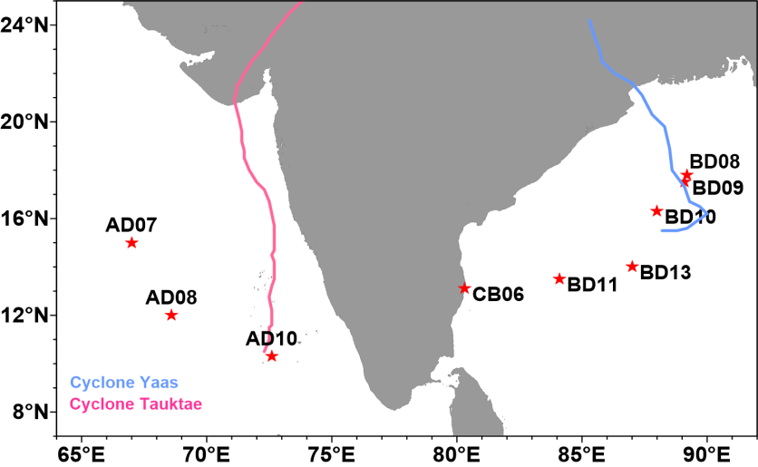
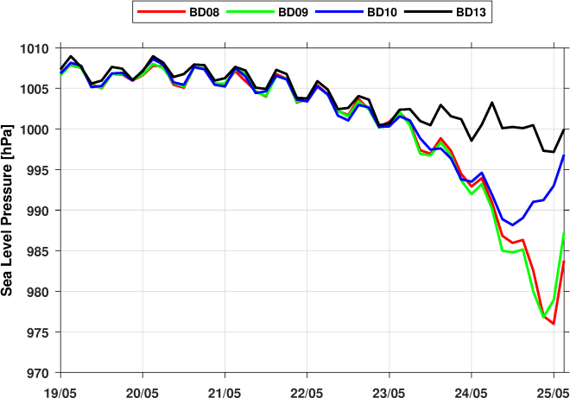 | 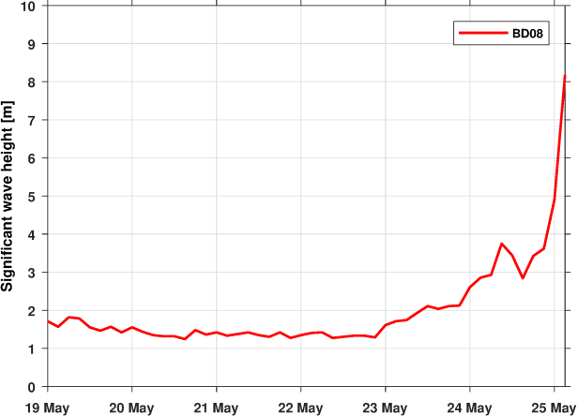
Figure: Track of cyclones Yaas, Tauktae and moored buoys, Sea Level Pressure and Significant wave height during Yaas cyclone
Extremely Severe Cyclone Tauktae originated as a low pressure area in the South-east Arabian Sea on 13 May 2021 and organized in to a deep depression on 14 May 2021. The signals of the depression was captured by three buoys, which were close to the weather system, namely CalVal [72.29E/10.60N], CB02 [72.20E/10.87N] and AD10 [72.50E/10.30N]. All the three buoys recorded SLP drop of ~ 8-10 hPa. The minimum SLP was observed in the CalVal buoy (996 hPa). The buoy also recorded maximum wind speed of ~ 70 km/hr. Significant wave height of ~ 3.2 m and maximum wave height of ~5.0 m have been recorded in the AD07 buoy situated at a distance of 489 km from the track. The buoy observations revealed that Sea Surface Temperature [SST] in the Arabian Sea was more than 30.5 °C. The SST dropped from ~ 31 deg. C to 28.5 deg. C in CB02. Also, the Tropical Cyclone Heat Potential [TCHP], which is define as measure of the integrated vertical temperature from the sea surface to the depth of the 26℃ isotherm, was quite high (~110-120 KJ/cm 2 ) in the Arabian Sea provided favorable environment for the intensification of the cyclonic storm.

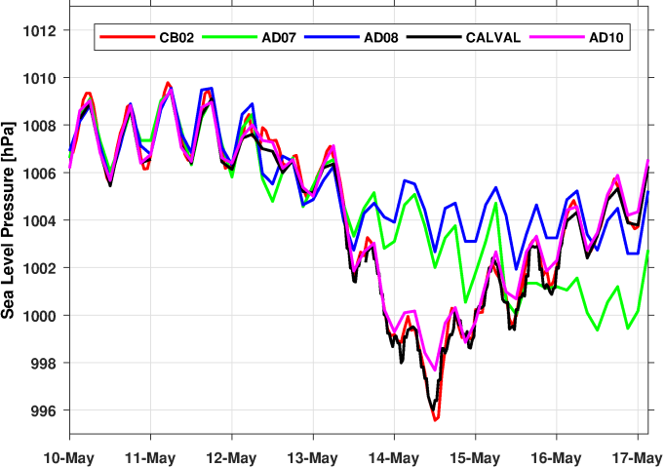 | 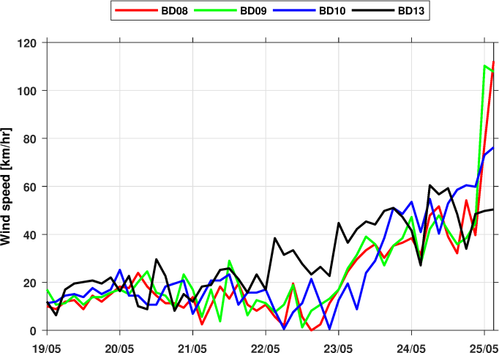
Figure: Sea Level Pressure and Wind speed at 10 m height during Tauktae cyclone in Arabian Sea

- Data Analysis & Results
The significant results from analysis of the in-situ OMNI observations are presented in this section. Three manuscripts were submitted and are under review in international journals. Annual report of moored buoy observations from 2010 to 2019 was prepared for all the OMNI buoys. The impact of warm water in western Bay of Bengal on intensification of Fani and Decadal variability of Stokes drift from OMNI buoy observations in the Bay of Bengal is in progress.
  - Sustenance of Moored Buoy Network during COVID pandemic:
The moored buoy network in Indian Ocean revolutionized the observational programs with systematic time series measurement of in-situ data sets from remote marine locations. The sustenance of the network requires persistent efforts to overcome the multitude of challenges such as vandalism, bio-fouling, rough weather, corrosion, ship time availability, telemetry issues etc, which got aggravated with the COVID-19 pandemic. However the improvements in the buoy system, indigenization of data acquisition system and efforts in ensuring the quality of measurements together with ‘best practice methods’ enabled the dissemination of valuable in-situ data sets particularly the rapid transmission during the during the Super cyclone Amphan in May 2020 amid the Covid lockdown. The manuscript detailing the reliability and enhanced utility of moored buoy observations particularly when other modes of measurements are limited is prepared for the Covid special issue of the journal ‘Frontiers in Marine Science’
  - Estimation of emissivity coefficients and offset correction of Long wave radiation measurements:
The analysis of LWR↓ measurements at the test station at NIOT and at the OMNI buoy BD09 in north BoB revealed significant offsets, which varied with each deployment. It necessitates the estimation of the offset during each deployment to correct the past data. In general, the LWR↓ values are overestimated and the study revealed an offset of 92.58 Wm-2 at test station whereas that of BD09 in north BoB is only 17.28 Wm-2. In both the experiments, the corrected values are in good agreement with that of the collocated WHOI measurements, which indicates the reliability of the method. It is observed that LWR↓cl strongly depends on the presence of integrated water vapor in the atmosphere. The study recommended the estimation of the emissivity coefficients from the measurements in the North Indian Ocean to provide better picture of the variability particularly during southwest monsoon season. The estimation of the emissivity coefficients during clear sky is under progress utilizing moored buoy observations.
  - Impact of Thick Warm Surface Layer in the Western Bay of Bengal on Sustaining High Turbulent Heat Flux during Cyclone Fani
We have examined the tropical cyclone Fani developed over the Bay of Bengal during April-May 2019. In-situ observations based on a network of moored buoys, remote sensing data, reanalysis products, and numerical modeling are utilized in the study. Prior to the formation of the cyclone, the western Bay of Bengal adjoining the Indian peninsula had a deep warm and salty surface layer with high tropical cyclone heat potential and low stability. A one-dimensional mixing experiment based on the PWP model revealed that the thick warm surface layer in the western Bay restricted SST cooling during the cyclone passage. The reduced cold wake along the cyclone track contributed to increasing in latent and sensible heat flux, which in turn caused intensification of the cyclone. The work is progressing in collaboration with Prof. Amit Tandon, UMass., and Dr. Robert Weller, WHOI.
  - Modulation of Intensity of Tropical Cyclones in the Bay of Bengal by oceanic eddies
The Bay of Bengal, rich in mesoscale oceanic eddies, is also home for devastating tropical cyclones. The intensity modulation of two intense TCs Phailin (2013) and Fani (2019) in the BoB by the oceanic eddies is studied. Phailin (Fani) weakened (intensified) over a cyclonic (anticyclonic) eddy. The reasons for the intensification and weakening of these cyclones over the eddies were analyzed using a synergy of remote sensing, modeling and insitu observations from moored buoys. The manuscript is under review in Oceanologia, Elsevier.
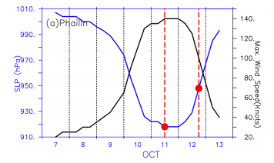
Figure: SLP and Wind speed from JTWC during Phailin

  - Characterizing near-surface salinity variability in the northern Bay of Bengal and its potential drivers during extreme freshening years of the 2011-2019 periods
The near-surface salinity (within 10 m from sea surface) variability are analyzed using observations from BD08 (18.0N/89.5E) in the northern BoB during 2011–2019 supplemented with satellite observations. The three years that exhibited drastic lowering of salinity are 2011, 2015 and 2017, among which 2017 was unique with prolonged freshening. The considerable variability in offshore advection of low salinity water during 2011, 2015 and 2017 was generally due to the variability in the weak wind driven surface circulation and existing mesoscale eddies. However, each freshening event was unique due to either the combined occurrence of mesoscale eddies and positive Indian Ocean Dipole as in 2011 or presence of mesoscale eddies and weak wind driven surface current as in 2017. (Under review in Dynamics of Atmospheres and Oceans, Elsevier).
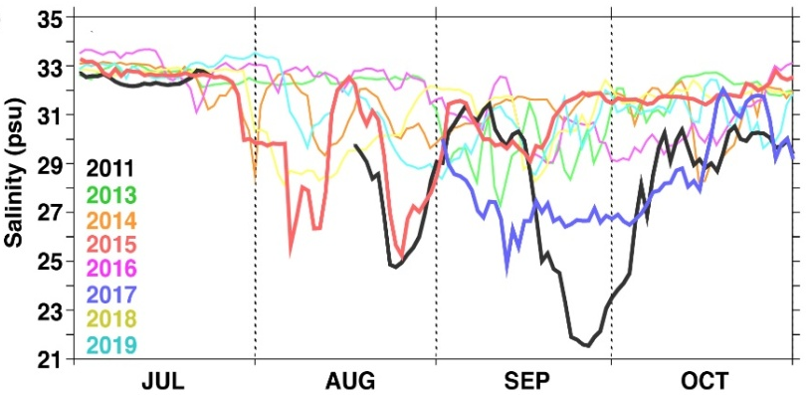
Figure: Salinity at 5 m during July-October of each year during 2011– 2019.

  - Decadal variability of Stokes drift from OMNI buoy observations in the Bay of Bengal
The moored buoy data obtained by OOS group of NIOT in deep as well as coastal waters have been analyzed to understand the dynamics of Stokes drift. A Data Product on Stokes Drift which serve as ready reckoners is prepared from the long term OMNI buoy observations (2011-2021) at 3 locations (BD08, BD11 & BD14) in deep waters of Bay of Bengal. The seasonal, inter-annual variability as well as rapid variation during 25 cyclones covering a decade have been analyzed. Stokes drift is evaluated from wave spectra obtained from the directional wave rider buoy observations in shallow waters (off Chennai &Agatti) and compared with ERA5 model estimates. The Stokes drift from real time observations from moored buoys during Yaas cyclone is being prepared. This work is under progress in collaboration with Prof. Amit Tandon, UMass.

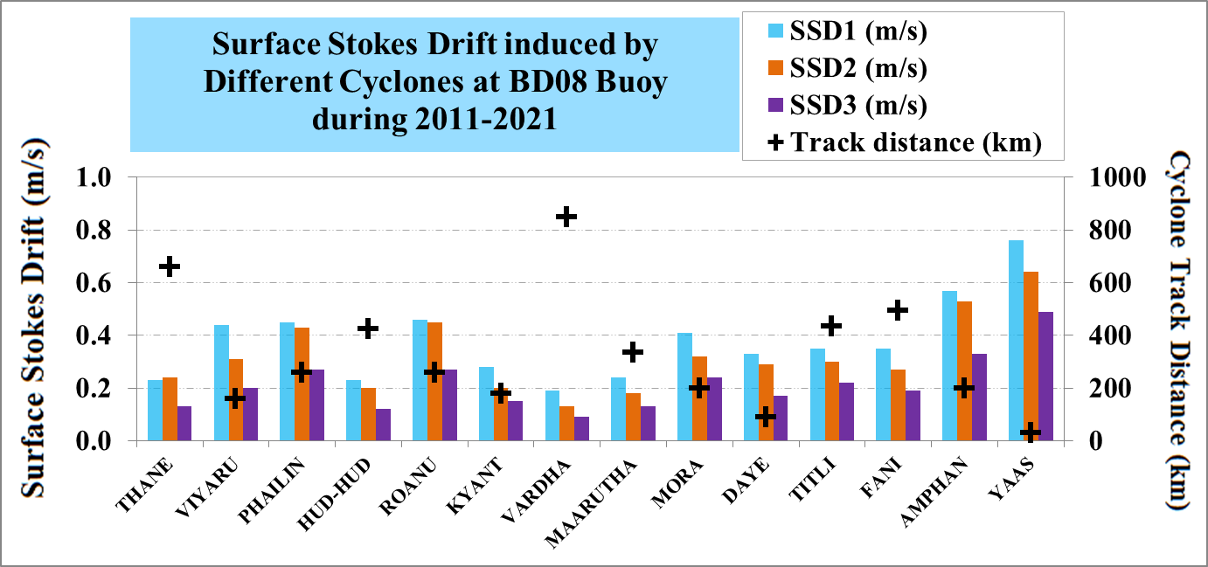

  - Decadal variability of wave power from OMNI buoy observations in the Bay of Bengal
The moored buoy data obtained by OOS group of NIOT in deep as well as coastal waters have been analyzed to understand the dynamics of Wave Power. A Data Products on Wave Power which serve as ready reckoners is prepared from the long term OMNI buoy observations (2011-2021) at 3 locations (BD08, BD11 & BD14) in deep waters of Bay of Bengal. The seasonal, inter-annual variability as well as rapid variation during 25 cyclones covering a decade have been analyzed.

5.0 Publications

5.1 Journal Publications

- Venkatesan, R., Muthiah, M.A., Vedachalam, N., Thirumurugan, K., Senthilkumar, P., Vengatesan, G. and Sridharan, R., 2021. Can Submerged Buoys be Reliably Used for Monitoring Tsunamis in the Indian Ocean?. Marine Technology Society Journal, 55(1), pp.127-136.
- Venkatesan, R., Ramesh, K., Muthiah, M.A., Vedachalam, N., Murugesh, P. and Atmanand, M.A., 2021. Estimation of Uncertainty in the Atmospheric Pressure Measurement From the Indian Ocean Moored Buoy Systems. Marine Technology Society Journal, 55(1), pp.137-146.
- R.Venkatesan,N. Vedachalam, G. Vengatesan Quantification of ocean- atmosphere energy exchange during super cyclone Amphan in the Bay of Bengal using Indian Ocean moored observatories Dynamics of Atmospheres and Oceans,2021, 101210, ISSN 0377-0265, https://doi.org/10.1016/j.dynatmoce.2021
- P. Varalakshmi, N. Vasumathi, R.Venkatesan, Tropical Cyclone prediction based on multi-model fusion across Indian coastal region, Progress in Oceanography,2021
- Dr.R.Venkatesan ,K.Ramesh, Dr.N.Vedachalam, R.Sundar "Emerging Trends in Real Time Ocean Data Collection for Blue Economy in the Indian Context" Institution of Engineers India Annual Technical Volume of Marine Engineering Division Board, Volume III, 2020 PP 9-16
- Pearlman, Jay and Buttigieg, Pier Luigi and Bushnell, Mark and Delgado, Claudia and Hermes, Juliet and Heslop, Emma and Hörstmann, Cora and Isensee, Kirsten and Karstensen, Johannes and Lambert, Arno and Lara-Lopez, Ana and Muller-Karger, Frank and Munoz Mas, Cristian and Pearlman, Francoise and Pissierssens, Peter and Przeslawski, Rachel and Simpson, Pauline and van Stavel, Jordan and Venkatesan, Ramasamy. (2021). Evolving and Sustaining Ocean Best Practices to Enable Interoperability in the UN Decade of Ocean Science for Sustainable Development. Front. Mar. Sci. 8:458, doi:10.3389/fmars.2021.619685
- Venkatesan R. and K. Jossia Joseph, 2021. Rapid mode transmission in moored data buoys during cyclones, Breeze- IMS Chennai Chapter Newsletter. Vol.21, Issue No.1, May 2021

- Shroyer E, Tandon, A, Sengupta D, Fernando H. J, Lucas, A. J, Farrar, J. T, Chattopadhyay R, de Szoeke S, Flatau M, Rydbeck, A, Wijesekera, H, McPhaden M, Seo H, Subramanian, A, Venkatesan, R, Joseph, J, Ramsundaram, S, Gordon, A. L, Bohman, S. M, Pérez, J., Simoes-Sousa, I. T, Jayne, S. R., Todd, R. E, Bhat, G.S, Lankhorst, M, Schlosser, T, Adams, K, Jinadasa, S, Mathur, M., Mohapatra, M, Rao, E. P. R, Sahai, A. K, Sharma, R, Lee, C, Rainville, L, Cherian, D, Cullen, K, Centurioni, L. R, Hormann, V, MacKinnon, J, Send, U, Anutaliya, A, Waterhouse, A, Black, G. S, Dehart, J. A, Woods, K. M, Creegan, E, Levy, G, Kantha, L. H, Subrahmanyam, B. (2021). Bay of Bengal Intraseasonal Oscillations and the 2018 Monsoon Onset, Bulletin of the American Meteorological Society (published online ahead of print 2021). Retrieved May 29, 2021, from https://journals.ametsoc.org/view/journals/bams/aop/BAMS-D-20-0113.1/BAMS-D-20-0113.1.xml
- Varalakshmi Perumal, Suresh Kumar Murugaiyan, Pavithran Ravichandran, R. Venkatesan, R. Sundar R Real Time Identification of Anomalous Event in Coastal Regions using Deep Learning techniques was published in Wiley online library Journal :Concurrency and Computation: Practice and Experience, on 15th June 2021 ; https://doi.org/10.1002/cpe.6421
- Venkatesan.R, Arul Muthiah M, Vedachalam N, Vengatesan, G, Ramesh, K, Kesavakumar B, Thirumurugan K, Technological Trends and Significance of the Essential Ocean Variables by the Indian Moored Observatories Relevance to UN Decade of Ocean Sciences in Marine Technology Society Journal,Volume 55, Number 3, May/June 2021, pp. 34-49(16) DOI : https :// doi.org /10.4031/ MTSJ.55.3.8
- Debi Prasad Bhuyan, Samiran Mandal, Arkaprava Ray, Sourav Sil, R. Venkatesan,
Surface and Subsurface Signatures of Monsoon Intraseasonal Oscillations from Moored Buoys Observation in the Bay of Bengal, Dynamics of Atmospheres and Oceans, 2021, 101240, ISSN 0377-0265, https://doi.org/10.1016/j.dynatmoce.2021.101240

5.2 Manuscripts Accepted / Under review
- R. Venkatesan, K. Jossia Joseph, C. Anoopa Prasad, M. Kalyani, M. Arul Muthiah, S. Ramasundaram, P. Murugesh, K. Thirumurugan, R. Sundar, B. Kesavakumar, G. Vengatesan, K. Ramesh, Martin V Mathew, K. N. Navaneeth, P. Senthilkumar, Biswajit Haldar, Abhishek Tandon, R. Sridharan, S. Sundar Jesuraj, C. Muthukumar, N. Sundaravadivelu and M. Saravanan, 2021. Sustenance of Moored Buoy Network during COVID pandemic –A Saga of Perseverance, Frontiers in Marine Science (Under Review).
- Navaneeth K.N., R. Venkatesan, M.V. Martin, Anoopa Prasad C., Ramesh K. and Jossia Joseph K, 2021. Field Validation method for drift correction in temperature and salinity measurements from moored buoys (Accepted in Marine Technology Society Journal)
- Biswajit Haldar, Abhishek Tandon, K.Jossia Joseph, M.Arul Muthiah, P.SenthilKumar, R.Venkatesan Remapping of temperature profile measurement in OMNI Buoy systems (submitted to journal of operational oceanography)
- Jossia Joseph K, A. Tandon, R. Venkatesan, T. J. Farrar and R. A. Weller, 2021. Long Wave Measurement Corrections for the OMNI Buoy Network, Journal of Atmospheric and Oceanic Technology(Under Review).
- Anoopa Prasad C, K Jossia Joseph, K. N Navaneeth, Martin V Mathew, Fabrice Papa, B Rohith, R Venkatesan and G Latha, 2021. Characterizing near-surface salinity variability in the northern Bay of Bengal and its potential drivers during extreme freshening years of the 2011-2019 period, Submitted to Dynamics of Atmospheres and Oceans (Under Review).
5.3 Conference
- B.Kesavakumar, M.Arul Muthiah, Dr.N.Vedachalam, Dr.R.Venkatesan “Machine Learning approach for prediction of status of rechargeable batteries used in deep ocean moored buoy system using in-situ parameters” in IEEE Madras Section International Conference (MASCON 21) – Accepted
- B.Kesavakumar, M.Arul Muthiah, G.Vengatesan, K.Ramesh, Biswajit Haldar, K.Thirumurugan,Dr.R.Venkatesan “Data Acquisition System for Deep Ocean Moored Buoy System – Development and Realisation” in IEEE Madras Section International Conference (MASCON 21) – Accepted
OSICON-2021 conference
- Study of wave spectral characteristics in deep water region in the southern Bay of Bengal R. Janani, G.Latha, M.Krishnaveni, and R.Venkatesan
- Wave spectral characteristics in shallow waters off Goa coast during pre and post-monsoon seasons Reddy Janakiram, G.Latha, R.Balamurugan, and R.Venkatesan
- Wave spectral characteristics of Two concurrent cyclone kyarr and maha in the Arabian sea R.Keerthivasan, G.Latha, R.Balamurugan, and R.Venkatesan
- Biswajit Haldar, Abhishek Tandon, K.Jossia Joseph, M.Arul Muthiah, P.SenthilKumar, R.Venkatesan Effect of Mooring Motion on Temperature Profile Measurements in OMNI Buoy Systems: A Case Study
- Intense upwelling in the southeastern Arabian Sea during the post-monsoon season Anoopa Prasad C., Martin V. Mathew, K. N. Navaneeth, K. Jossia Joseph and R. Venkatesan
- Air Quality Monitoring from Deep Ocean Moored buoy systems in the Indian Ocean B.Kesavakumar, G.Vengatesan, M. Arul Muthiah, R. Venkatesan
- Martin V. Mathew, K. N. Navaneeth, Anoopa Prasad C., K. Jossia Joseph and R. Venkatesan, 2021. Characteristics of Diurnal Sea Surface Temperature Variability in the North Indian Ocean and its Implications to Air-Sea fluxes OSICON-21, Goa, India, 12-14 August 2021.
- Five years of IndARC mooring– science and technology Divya David T, Subeesh M. P, Kesavakumar B,Archana Singh, Ravichandran M, Arul Muthiah , R Venkatesan
- Lectures/Presentations

- Dr.R.Venkatesan, Scientist-G, Head Ocean Observation Systems, gave a talk in Tamil on ‘Ocean Observations’ as part of the online webinar titled "Ariviyal Palagai" on 25th January 2021.
- Dr. R. Venkatesan, SC-G and Group Head-OOS delivered a talk on the virtual Meeting for discussing the proposed India-US joint program on Arabian Sea Boundary Layer Dynamics Studies on 22 Feb 2021
- Dr. K. Jossia Joseph, Sc-E participated and delivered a talk in the virtual discussion on ‘Girls Want to Explore STEM’, organized by US consulate-Chennai to commemorate Women History Month on 19 March 2021.
- Dr R Venkatesan delivered a talk on WMO REFORMS-Connecting the oceans climate and weather within the Earth system - Under the joint auspices of RMC Chennai and IMS Chennai chapter in a webinar on Review of Monsoons 2020 is being held on 23 March 2021 at 11:00 IST on World Meteorological Day 2021 in Webex
- Dr.R.Venkatesan delivered a lecture on Ocean Observation System- Present & Future Context Bay of Bengal on 17th June 2021 organized by National Oceanographic and Maritime Institute(NOAMI),Ministry of Science and Technology, Govt. of the people's republic of Bangladesh.
- Dr.R.Venkatesan delivered a lecture on Operational Oceanography in Africa-Role of Weather, Climate and Coastal Hazards Operational Oceanography. role of in-situ observations. GOOS AFRICA on 8th June 2021.
- Dr.R.Venkatesan, Scientist G and GH-OOS delivered a Tamil lecture on Plastic Pollution in Ocean as part of Swachhta Pakhwada through webinar and this talk was hosted by Ariviyal Palagai on 14th July 2021.

- Meeting/Workshops attended by staff members

- As nominated by DG IMD, Dr Venkatesan attended the meeting of WMO Commission For Observation, Infrastructure and Information Systems Infcom 1 (III) from 12 to 16 April 2021 through Virtual Session.
- NIOT-OOS group works undertaken on Marine Plastic studies is published in the newsletter of Ocean best practices work group of Global Ocean Observing System (GOOS) and the International Oceanographic Data and Information Exchange (IODE).Appreciation received for the Best practice developed by OOS team and for the activities undertaken in the last two years, even during Covid pandemic, 460 samples were collected from 106 sampling stations in 11 cruises.
- Workshop for training in Python programming is attended by B.Kesavakumar, Biswajit Haldar, G. Vengatesan, Abhishek Tandon

DATA BUOY CO-OPERATION PANEL (DBCP)
Annex- Form for reporting incidents of vandalism on data buoys

Country |  |  | INDIA
Contact person e-mail |  |  | venkat@niot.res.in
Year | Buoy Location |  | Type of Buoy  (e.g., Tsunami / Met -Ocean Buoy/Drifter/ARGO floats/ Other) | Type of damage to buoy | Buoy id / WMO id | Number of days of transmission lost | Cost of replacement | Remarks  (e.g., whether photos have been taken)
Year | Latitude | Longitude
2020 | 17°28’55" | 89°07’45" | Met Ocean Buoy  (Deep Ocean buoy) | Mast with sensor arm and Metrological sensor lost, Inmarsat Antenna | BD09  (23092) | 131 days |  | Enclosed
2020 | 18°38’9" | 67°11’34" | Tsunami Buoy | Inmarsat antenna and sensor arm lost | ITB12A  (23225) | 373 days |  | Enclosed
2020 | 19°53’43" | 66°59’52" | Tsunami Buoy | Transmission stopped | ITB12  (23226) | 279 days |  | Enclosed
2020 | 18°29’53" | 67° 27’ 19" | Met Ocean Buoy  (Deep Ocean buoy) | Metrological sensor lost; sub surface sensors lost | AD06  (23456) | 10 days |  | Enclosed
2021 | 16°21'37" | 87°59'25" | Met Ocean Buoy  (Deep Ocean buoy) | Surface buoy with metrological sensor lost, mooring cut observed | BD10  (23093) | 414 days |  | Enclosed
2021 | 13°59’15" | 86°58’55" | Met Ocean Buoy  (Deep Ocean buoy) | Surface buoy with metrological sensor lost, mooring cut observed | BD13  (23459) | 269 days |  | Enclosed
2021 | 10°31’15" | 94°05’09" | Met Ocean Buoy  (Deep Ocean buoy) | Surface buoy with metrological sensor lost, mooring cut observed | BD12  (23095) | 401 days |  | Enclosed
2021 | 13° 31'31" | 84° 10' 0" | Met Ocean Buoy  (Deep Ocean buoy) | Mast with sensor arm and Metrological sensor lost, Inmarsat Antenna | BD11  (23094) | 165 days |  | Enclosed
2021 | 06° 33' 56" | 88° 21' 18" | Met Ocean Buoy  (Deep Ocean buoy) | Mast with sensor arm and Metrological sensor lost, Inmarsat Antenna | BD14  (23460) | 266 days |  | Enclosed
2021 | 13°06’03" | 80°18’54" | Met Ocean Buoy  (Coastal buoy) | Mast with sensor arm and Metrological sensor lost, INSAT Antenna | CB06  (23099) | 48 days |  | Enclosed
2021 | 12° 04' 05" | 68° 37' 37" | Met Ocean Buoy  (Deep Ocean buoy) | Metrological sensors and mooring cut subsurface sensos lost | AD08  (23452) | 18 days |  | Enclosed
2021 | 18° 24’ 29" | 67° 28’ 10" | Met Ocean Buoy  (Deep Ocean buoy) | Metrological sensors and mooring cut subsurface sensos lost | AD06  (23456) | 260 days |  | Enclosed
2021 | 08° 10' 00" | 73° 15' 0" | Met Ocean Buoy  (Deep Ocean buoy) | Transmission Stopped | AD09  (23453) | 198 days* |  | Photos not available & not yet retrieved
2021 | 14° 56' 01" | 68° 59' 10" | Met Ocean Buoy  (Deep Ocean buoy) | Transmission Stopped | AD07  (23451) | 66 days* |  | Photos not available & not yet retrieved
Efforts taken against vandalism |  |  | i) Buoy safety sign information sticker is places on the Buoy to prevent vandalism  ii) Provided buoy locations information to Indian Navy/Coast Guard to enhance surveillance
Awareness meeting Organized |  |  | Vide publicity about importance of the buoys during trainings/workshops and public outreach activities
Suggestions (if any) |  |  | More intense and frequent awareness campaigns to be conducted for fishermen community
Photos on Vandalism |  |  | (Please include pictures if available; and email electronic versions to support@jcommops.org)

Note: It is recommended that this form is filled in electronically and returned electronically to JCOMMOPS (support@jcommops.org). A template of the form can be downloaded from the following ftp site: ftp://ftp.wmo.int/Documents/PublicWeb/amp/mmop/documents/dbcp/templates/Format-DBCP-Buoy-Vandalism-Reports.doc

VANDALISM PHOTOS

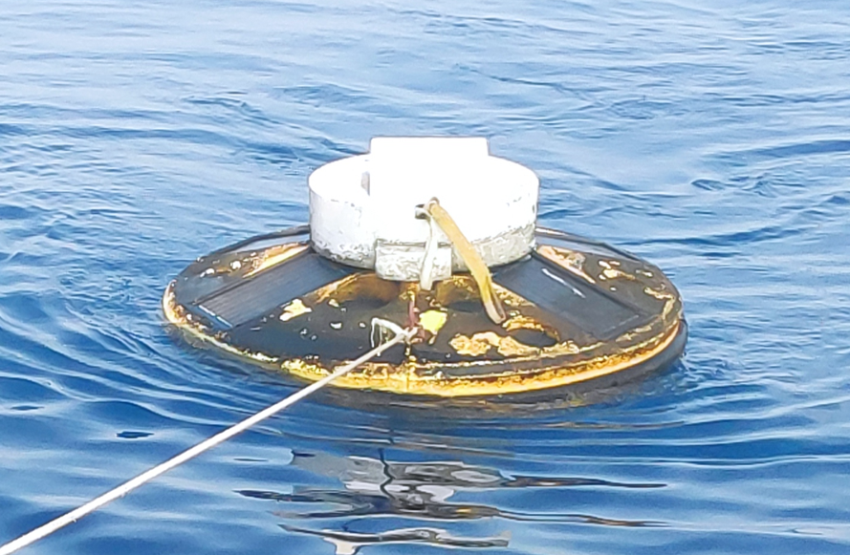  BD09 (23092) | 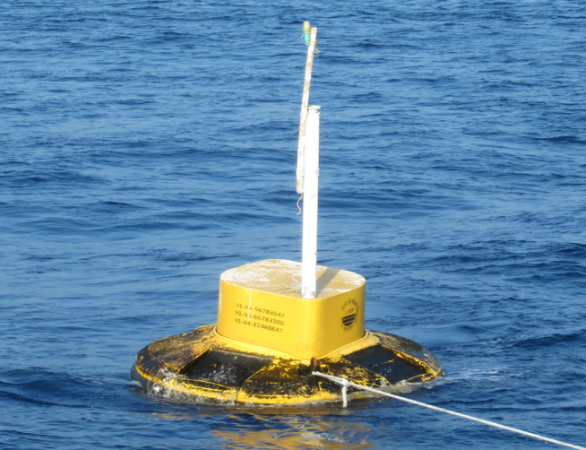  ITB12A (23225) | 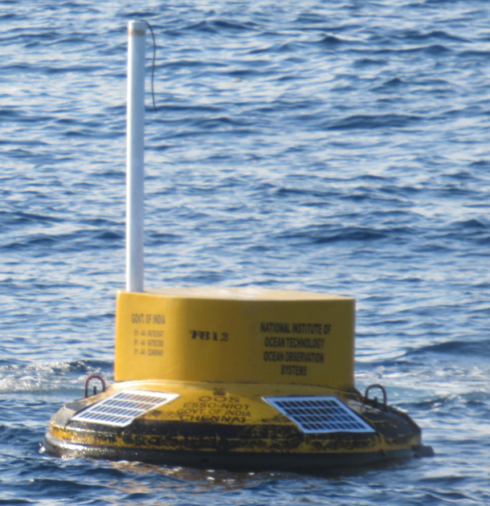  ITB12 (23226)
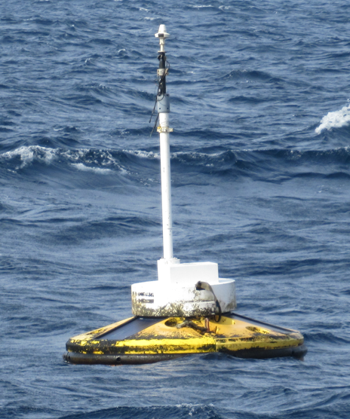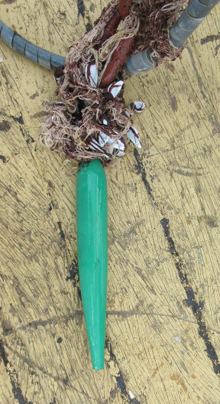  AD06 (23456) | 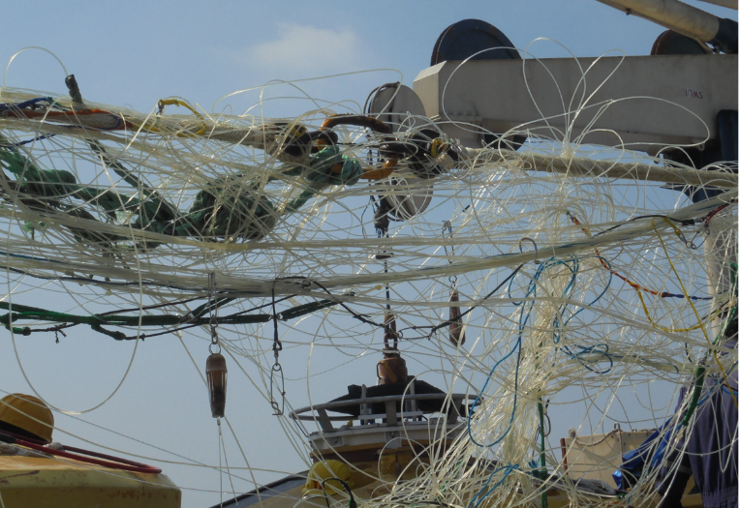  BD10 (23093) retrieved from seabed | 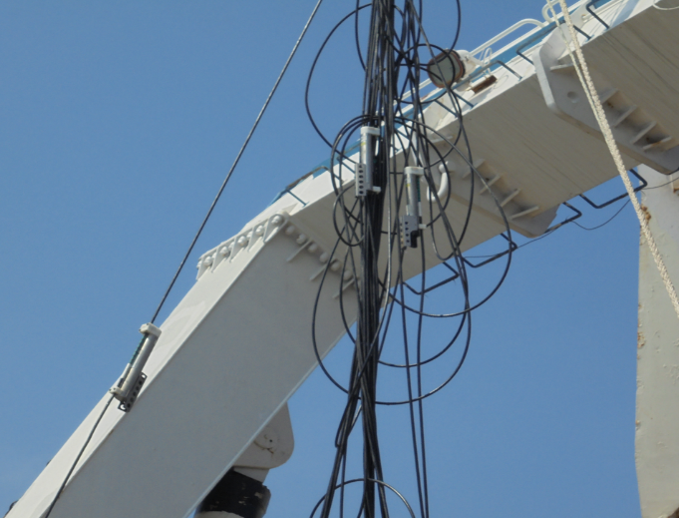  BD13 (23459) retrieved from seabed
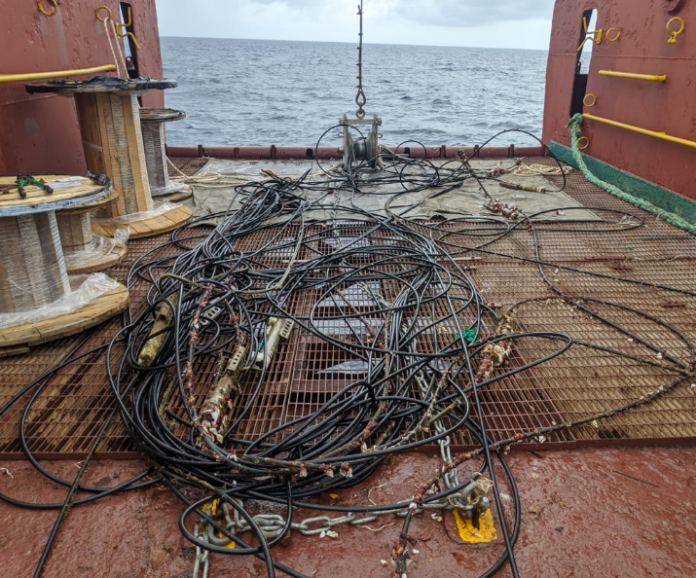  BD12 (23095) retrieved from seabed | 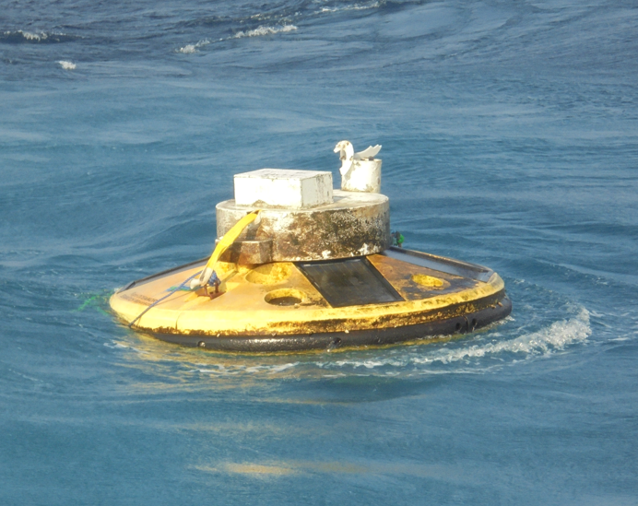  BD11 (23094) | 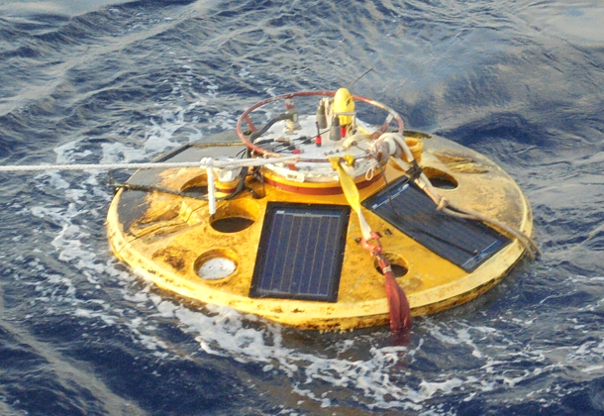  BD14 (23460)
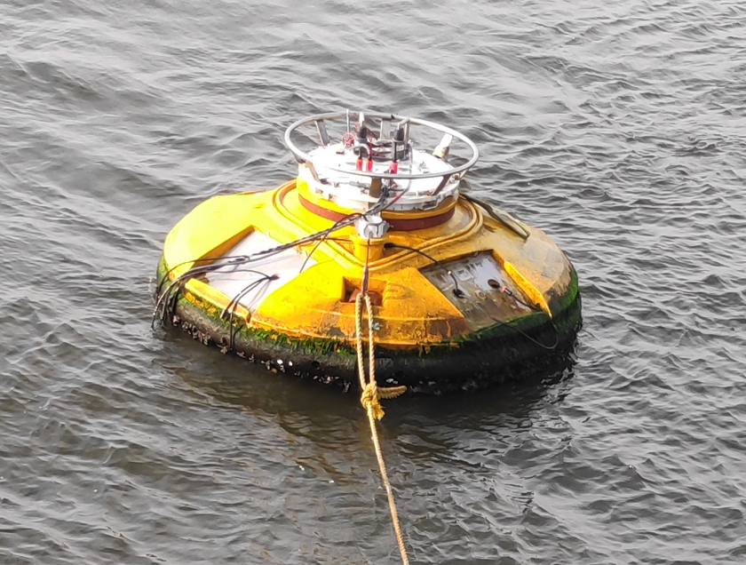  CB06 (23099) | 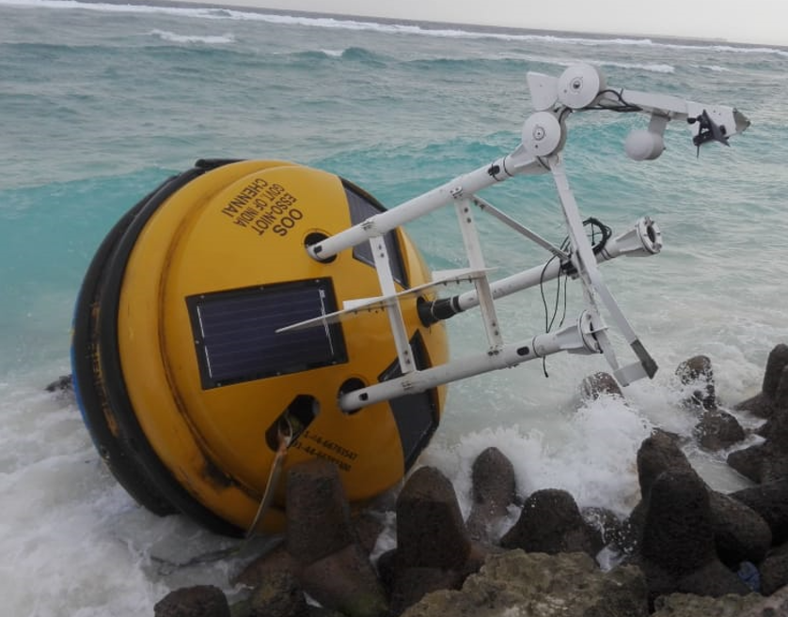  AD08 (23452) | 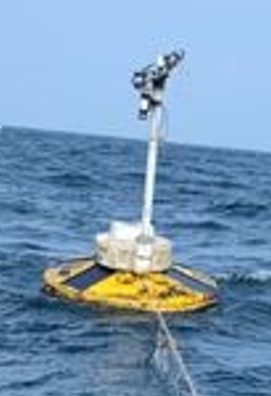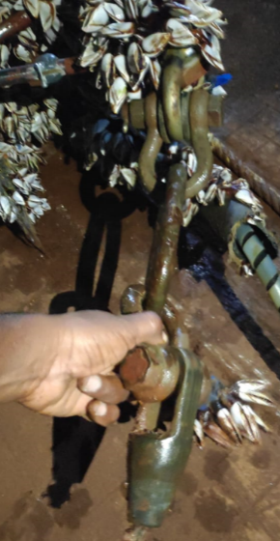  AD06 (23456)
____

Note: It is recommended that this form is filled in electronically and returned electronically also to OceanOPS (dbcp-tc@jcommops.org and karen.grissom@noaa.gov ). A template of the form can be downloaded from the following SharePoint site: https://wmoomm.sharepoint.com/:w:/s/wmocpdb/EXsq1FXv0vpHmOjQA-tTobwBMrNnjXnaQok3oudPhKIb3A?e=2IR9Wh
______________

: Types of publications: (1) Implementation, (2) Operations, (3) Instrumentation, (4) Quality Management, (5) Data Management, (6) Data collection and/or location, (7) Data use, (8) Other
How does the international community access the ocean observing data provided by your Organization
What new ocean observations does your Organization plan to make in the upcoming year (i.e. new parameters, expanding geographic scope, filling spatial or latency gaps)?
How do your Organization’s observations contribute to the WMO’s Integrated Global Observing System (WIGOS) and/or Global Framework for Climate Services (GFCS)?
What additional requirements (other than climate) does your organization have that are currently not adequately addressed by the DBCP?
How would your organization benefit from DBCP’s closer linkages to the Global Ocean Observing System(GOOS), Data Management and Modelling Communities?
How do your ocean observing networks contributing to the UN decade on Ocean Science and UN Sustainable Development Gloas .

