**DATA BUOY CO-OPERATION PANEL (DBCP)**

**Format for National Reports on Current and Planned Programmes**

**Country: United States of America**

**Year: 2021**

***CURRENT PROGRAMMES:***

|  |  |  |
| --- | --- | --- |
| **Agency or programme** | Global Drifter Program (GDP) | |
| Number and type of buoys | (a) deployed during the year | 896 |
| (b) operational as of 31 July | 1402 |
| (c) reporting on GTS as of 31 July | all |
| Purpose of programme  *(check/uncheck boxes using [_] or [x] as appropriate)* | (a) operational | [x] |
| (b) met / ocean research | [x] |
| (c) developmental | [x] |
| Main deployment areas | Global | |
| Vandalism incidents | (a) Number of incidents: NONE  If vandalism incidents have occurred during the year, please provide the details using the form in the annex. | |

The Global Drifter Program (GDP) is the principle component of the Global Surface Drifting Buoy Array, a branch of NOAA's Global Ocean Observing System (GOOS) and a scientific project of the DBCP. Its objectives are to (1) Maintain a global 5x5 degree array of ~1300 satellite-tracked surface drifting buoys to meet the need for an accurate and globally dense set of in-situ observations of mixed layer currents, sea surface temperature, atmospheric pressure, winds and salinity, and (2) provide a data processing system for scientific use of these data. These data support short-term (seasonal to interannual) climate predictions as well as climate research and monitoring. For more information, see <http://www.aoml.noaa.gov/phod/dac/gdp_objectives.php> and <http://gdp.ucsd.edu/ldl_drifter/index.html>.

Due to the impact of COVID-19 and an unexpected increase in Iridium transmission costs, a number of deployments were postponed or delayed. Other deployment opportunities were identified to continue deployments in high priority locations, including DART/TAO servicing cruises and Ships of Opportunity transects, that continued to operate during the pandemic.

|  |  |  |
| --- | --- | --- |
| **Agency or programme** | US Interagency Arctic Buoy Program (USIABP) | |
| Number and type of buoys | (a) deployed during the year | 10 Ice Trackers (IT)  6 IT-Barometer (ITB)  18 Ice Balls (IB, drogue-less SVP-Bs)  12 Ice Cadets  47 SVP-B Upgrades  14 Other |
| (b) operational as of 31 July | 179 |
| (c) reporting on GTS as of 31 July | 175 |
| Purpose of programme  *(check/uncheck boxes using [_] or [x] as appropriate)* | (a) operational | [x] |
| (b) met / ocean research | [x] |
| (c) developmental | [x] |
| Main deployment areas | Arctic Ocean, Bering and peripheral seas. | |
| Vandalism incidents | (a) Number of incidents NONE  If vandalism incidents have occurred during the year, please provide the details using the form in the annex. | |

The USIABP coordinates US contributions to the International Arctic Buoy Programme (IABP). Its objectives are to provide meteorological and oceanographic observations for real-time operational requirements and research purposes. For more information, see <http://iabp.apl.uw.edu>.

The US contributed many buoys deployed around the RV Polarstern and MOSAiC drift station.

COVID-19 cancelled all of our own field work, but we were still able to deploy most of our buoys using local collaborators, and by leveraging many of our other logistics-of-opportunity.

|  |  |  |
| --- | --- | --- |
| **Agency or programme** | National Oceanic and Atmospheric Administration (NOAA)/ National Weather Service (NWS)/ National Data Buoy Center (NDBC) **Coastal Weather Buoys (CWxB)** | |
| Number and type of buoys | (a) deployed during the year | 43 |
| (b) operational as of 31 July | 97 |
| (c) reporting on GTS as of 31 July | 97 |
| Purpose of programme  *(check/uncheck boxes using [_] or [x] as appropriate)* | (a) operational | [x] |
| (b) met / ocean research | [ ] |
| (c) developmental | [ ] |
| Main deployment areas | Atlantic and Pacific Oceans and Coastal Zone of the US, including the Bering Sea, Gulf of Mexico, and Great Lakes | |
| Vandalism incidents | (a) Number of incidents 31  (refer to vandalism report for details). | |

The National Data Buoy Center (NDBC) Coastal Weather Buoy network (CWxB) is a principle component of NOAA’s ocean observing system and a part of the Global Ocean Observing System (GOOS).The mission of NDBC’s Coastal Weather Buoy network is to provide quality observation to further the understanding and predictions to changes in weather, climate, and oceans. To support this mission NDBC's moored buoys measure and transmit barometric pressure, wind speed and direction, wind gust, air temperature, relative humidity, and sea surface temperature. In addition, all CWxB measure wave energy spectra from which significant wave height, dominant wave period, and average wave period are derived. Even the direction of wave propagation is measured on many moored buoys. For more information, see <http://www.ndbc.noaa.gov/mooredbuoy.shtml>.

The NDBC CWxB network has experienced no significant impact as a result of the COVID-19 pandemic.

|  |  |  |
| --- | --- | --- |
| **Agency or programme** | National Oceanic and Atmospheric Administration (NOAA)/ National Weather Service (NWS)/ National Data Buoy Center (NDBC) **Tsunameter Buoys** | |
| Number and type of buoys | (a) deployed during the year | 33 |
| (b) operational as of 31 July | 34 |
| (c) reporting on GTS as of 31 July | 34 |
| Purpose of programme  *(check/uncheck boxes using [_] or [x] as appropriate)* | (a) operational | [x] |
| (b) met / ocean research | [ ] |
| (c) developmental | [ ] |
| Main deployment areas | Atlantic and Pacific Oceans and Gulf of Mexico | |
| Vandalism incidents | (a) Number of incidents 2  (refer to vandalism report for details). | |

To ensure early detection of tsunamis and to acquire data critical to real-time forecasts, NOAA has placed Deep-ocean Assessment and Reporting of Tsunami (DART) buoys at sites in regions with a history of generating destructive tsunamis. Originally developed by NOAA, as part of the U.S. National Tsunami Hazard Mitigation Program (NTHMP), the DART Project was an effort to maintain and improve the capability for the early detection and real-time reporting of tsunamis in the open ocean. DART presently constitutes a critical element of the NOAA’s Tsunami Program. NOAA’s National Weather Service (NWS) is responsible for the overall execution of the Tsunami Program and NDBC is responsible for operating and maintaining the network of 39 tsunameter buoys. For more information on the NDBC tsunameter buoys see <http://www.ndbc.noaa.gov/dart/dart.shtml>.

The NDBC Tsunameter Buoy network has experienced no significant impact as a result of the COVID-19 pandemic.

|  |  |  |
| --- | --- | --- |
| **Agency or programme** | National Oceanic and Atmospheric Administration (NOAA)/ National Weather Service (NWS)/ National Data Buoy Center (NDBC) **Tropical Atmosphere Ocean (TAO) Arrray** | |
| Number and type of buoys | (a) deployed during the year | 28 |
| (b) operational as of 31 July | 39 |
| (c) reporting on GTS as of 31 July | 39 |
| Purpose of programme  *(check/uncheck boxes using [_] or [x] as appropriate)* | (a) operational | [x] |
| (b) met / ocean research | [x] |
| (c) developmental | [ ] |
| Main deployment areas | Equatorial Pacific Ocean | |
| Vandalism incidents | (a) Number of incidents 59  (refer to vandalism report for details). | |

The Tropical Atmosphere Ocean (TAO) array consists of approximately 55 moorings in the Tropical Pacific Ocean with real-time telemetry of oceanographic and meteorological observations. The array is a major component of the El Niño/Southern Oscillation (ENSO) Observing System, the Global Climate Observing System (GCOS) and the Global Ocean Observing System (GOOS). Support for the array is provided by the United States (National Oceanic and Atmospheric Administration). For more information see <http://tao.ndbc.noaa.gov/proj_overview/proj_overview_ndbc.shtml>

The TAO array has experienced minor impacts as a result of the COVID-19 pandemic. These small impacts are related to business closures and longer than normal lead times for sensor refurbishments.

|  |  |  |
| --- | --- | --- |
| **Agency or programme** | National Oceanic and Atmospheric Administration (NOAA)/ Pacific Marine Environmental Laboratory (PMEL) and Atlantic Oceanographic and Meteorological Agency (AOML)  **Prediction and Research moored Array in the Tropical Atlantic (PIRATA)** | |
| Number and type of buoys | (a) deployed during the year | 13 surface toroids |
| (b) operational as of 31 July | 15 surface toroids |
| (c) reporting on GTS as of 31 July | 15 surface toroids |
| Purpose of programme  *(check/uncheck boxes using [_] or [x] as appropriate)* | (a) operational | [ ] |
| (b) met / ocean research | [x] |
| (c) developmental | [x] |
| Main deployment areas | Tropical Atlantic Ocean | |
| Vandalism incidents | (a) Number of incidents 2  If vandalism incidents have occurred during the year, please provide the details using the form in the annex. | |

PIRATA is a multinational observation network, established to improve our knowledge and understanding of ocean-atmosphere variability in the tropical Atlantic. It is a joint project of Brazil, France and the United States of America. PIRATA is motivated by fundamental scientific issues and by societal needs for improved prediction of climate variability and its impact on the countries surrounding the tropical Atlantic basin. The overarching goals of the project are to (1) improve the description of the intra-seasonal to interannual variability in the atmospheric and oceanic boundary layers of the tropical Atlantic Ocean; (2) improve our understanding of the relative contributions of air-sea fluxes and ocean dynamics to variability in sea surface temperature and sub-surface heat content; (3) provide a set of data useful for developing and improving the predictive models of the ocean-atmosphere coupled system; (4) document interactions between tropical Atlantic climate and variability outside the region, such as ENSO and the North Atlantic Oscillation; and (5) design, deploy, and maintain an array of moored oceanic buoys and collect and transmit a set of oceanographic and atmospheric data, via satellite in near-real time, to monitor and study the upper ocean and lower atmosphere of the tropical Atlantic Ocean. For more information, see <http://www.pmel.noaa.gov/pirata/>.

The current array design for PIRATA calls for 18 surface buoys; this network is 100% completed. Future extensions and additions may be added, as demanded by research and operational needs.

Impacts from the COVID-19 Pandemic: Cruise delays, response and expected loss of data:

* 21 Oct - 6 Nov 2020 (diverted due to engine issues): *R/V Antares deployed* buoys at 8S_30W, 14S_32W and did a repair at 19S_34W). The buoy at 15N_38W was serviced on the PIRATA Northeast Extension (PNE) cruise by the NOAA Ship *Ronald H. Brown* in February of 2021. The Buoys at0_35W, 12N_38W, 8N_38W, 4N_38W have not been serviced. Cruise rescheduling is to be determined (TBD). It has been over 1000 days (2.7 years) since these 4 moorings were deployed and we have lost on average 500 days (1.37 years) of data. We expect an additional delay of approximately 6 months before these sites will be serviced. We expect an additional 6-month loss in T, S and surface met data and 6-month loss in near surface current data. Totally 2 years of data loss.
* Feb-March 2021 (completed): *Ronald H. Brown* (21N_23W, 12N_23W, 4N_23W, 15N_38W, 20N_38W). A tentative cruise is scheduled for Nov-Dec 2021 and will service (21N_23W, 12N_23W, 4N_23W, 20N_38W). We anticipate no gap in data. We expect no data loss.
* Feb/Mar 2022 (tentative): *Thalassa* (0_3W, 0_10W, 6S_10W, 10S_10W, 20S_10W, 0_23W). We anticipate to proceed on schedule (i.e., 0 month delay) to service the following: 0_3W, 0_10W, 6S_10W, 10S_10W, 20S_10W, 0_23W - These six moorings were deployed in Feb/Mar 2021.. The two moorings located at 10S_10W and 20S_10W experienced vandalism and went adrift in late June and early July 2021. These two drifting buoys were recovered 6 months after deployment by the German research vessel *Sonne*. We anticipate a 6 month gap in data before these two sites are re-deployed during the next French cruise. NOAA is extremely grateful for the R/V Sonne’s gracious support in recovering these two drifting buoys.

Loss of hardware:

We anticipate complete mooring losses at 0_35W, 12N_38W,4N_38W, 8N_38W and potentially others. The two buoys that went adrift at 10S_10W and 20S_10W were recovered with all but one sensor intact.

Project Deliverables and Education impacts:

PIRATA moorings have a 1-year (annual) service and maintenance design life. The delays in servicing these moorings will result in data losses due to battery failures and will increase the risk of equipment losses and high-resolution data losses due to extended deployment periods well in excess of the design life and impose additional risk by fishing activities and vandalism. These delays will therefore limit NOAA's capability to meet NOAA's mission.

We expect many educational aspects impacted since there are many students using these freely available PIRATA mooring data for research. PIRATA cruises provide training opportunities for students and early career scientists and engineers, and those opportunities will be greatly reduced this year and possibly next year.

|  |  |  |
| --- | --- | --- |
| **Agency or programme** | National Oceanic and Atmospheric Administration (NOAA)/ Pacific Marine Environmental Laboratory (PMEL)  **Research Moored Array for African-Asian-Australian Monsoon Analysis and prediction (RAMA)** | |
| Number and type of buoys | (a) deployed during the year | 0 surface toroids, 0 subsfc moorings |
| (b) operational as of 31 July | 10 surface toroids, 5 subsfc mooring |
| (c) reporting on GTS as of  31 July | 10 (9 moorings went adrift, 2 of these beached) |
| Purpose of programme  *(check/uncheck boxes using [_] or [x] as appropriate)* | (a) operational | [ ] |
| (b) met / ocean research | [x] |
| (c) developmental | [x] |
| Main deployment areas | Tropical Indian Ocean | |
| Vandalism incidents | (a) Number of incidents: 3 If vandalism incidents have occurred during the year, please provide the details using the form in the annex. | |

RAMA addresses the needs for comprehensive, long term, high quality real-time measurements in the Indian Ocean suitable for climate research and forecasting. RAMA is targeted at understanding and prediction of the east African, Asian and Australian monsoons, and benefits nations outside the Indian Ocean region due to atmospheric teleconnections which influence the far field. For more information, see <http://www.pmel.noaa.gov/tao/rama/>.

The current array design for RAMA calls for 25 moored buoy sites maintained by the US (NOAA/PMEL), of which 23 (92%) have been implemented and occupied for at least one year. Future additions may be added, as demanded by research and operational needs. Only five of these US RAMA mooring sites are actively transmitting from the moored position due to inability to maintain RAMA moorings during the COVID-10 pandemic.

Impacts from the COVID-19 pandemic: Cruise delays, response and expected loss of data:

* September 2021 (postponed): *Baruna Jaya (*15N_90E, 12N_90E, 8N_90E, 0_90E). Cruise rescheduling is TBD. These moorings have been deployed for > 650 days (1.78 years). Three of these moorings stopped transmitting, and two moorings beached. We expect an additonal > 6 months delay before these sites will be serviced. We expect a > 12-month loss in T, S and surface met data and > 12-month loss in near surface current data (U/V).
* September 2021 (postponed): *Sagar Nidhi* (0_81E, 2S_81E, 4S_81E, 8S_81E, 12S_81E). Cruise rescheduling is to be determined (TBD). These moorings have been deployed >750 days (>2 years). Three of these mooring have stopped transmitting and three moorings are adrift. We expect an additional > 6 months delay before these sites will be serviced. We expect a > 12-month loss in T, S and surface met data and > 12-month loss in near surface current data (U/V).
* Oct 2021 (postponed): *Sagar Nidhi* (15N_65E, 8N_67E, 4N_67E, 2N_67E, 0_67E, 2S_67E, 4S_67E, 8S_67E, 12S_67E). Cruise rescheduling is to be determined (TBD). These moorings have been deployed between 674-1515 days (1.8 - 4.15 yrs.). Two of these moorings have stopped transmitting and two are currently adrift. We expect an additional> 6 months delay before these sites will be serviced. We expect a > 12-month loss in T, S and surface met data and > 12-month loss in near surface current data (U/V).
* *Tethys Supporter* (4S_57E, 8S_55E). A cruise will NOT be scheduled. One mooring stopped transmitting and one mooring is adrift. We expect 100% loss at these sites.

Loss of hardware:

We anticipate complete mooring losses at 15N_90E; 0_81E, 2S_81E, 8S_81E, 12S_67E; 15N_65E; 4S_57E; 8S_55E. The moorings at 12N_90E and 0_90E went adrift and beached in Sir Lanka and Siberut island, Indonesia (respectively). Meteorological instrumentation were recovered from the 0_90E mooring, but all other mooring gear and instrumentation were lost. We anticipate other potential losses at sites that have been deployed > 1 year. However, we will not be able to confirm these as losses until we are able to access the sites during cruises.

Project Deliverables and Education impacts:

RAMA moorings have a 1-year (annual) service and maintenance design life. The delays in servicing these moorings will result in data losses due to battery failures and will increase the risk of equipment losses and high-resolution data losses due to extended deployment periods well in excess of the design life and impose additional risk by fishing activities and vandalism. These delays will therefore limit NOAA's capability to meet NOAA's mission.

We expect many educational aspects impacted since there are many students using these freely available RAMA mooring data for research.

|  |  |  |
| --- | --- | --- |
| **Agency or programme** | Coastal Data Information Program (CDIP) | |
| Number and type of buoys | (a) deployed during the year | ~40 |
| (b) operational as of 31 July | 73 |
| (c) reporting on GTS as of 31 July | All operational |
| Purpose of programme  *(check/uncheck boxes using [_] or [x] as appropriate)* | (a) operational | [x] |
| (b) met / ocean research | [x] |
| (c) developmental | [x] |
| Main deployment areas | US waters worldwide: Atlantic, Caribbean, Gulf of Mexico, Pacific, Alaska, Hawaii, Pacific Islands | |
| Vandalism incidents | (a) Number of incidents NONE  If vandalism incidents have occurred during the year, please provide the details using the form in the annex. | |

The Coastal Data Information Program (CDIP) is an extensive network for monitoring waves and beaches along the coastlines of the United States. Since its inception in 1975, the program has produced a vast database of publicly accessible environmental data for use by coastal engineers and planners, scientists, mariners, and marine enthusiasts. The program has also remained at the forefront of coastal monitoring, developing numerous innovations in instrumentation, system control and management, computer hardware and software, field equipment, and installation techniques. CDIP operates out of Scripps Institution of Oceanography, La Jolla, CA. For more information, see <http://cdip.ucsd.edu/>.

|  |  |  |
| --- | --- | --- |
| **Agency or programme** | Naval Oceanographic Office (NAVOCEANO) | |
| Number and type of buoys | (a) deployed during the year | 10 MetOcean iSLDMB drifters |
| (b) operational as of 31 July | 10 Iridium floats  7 iSVP drifters |
| (c) reporting on GTS as of  31 July | 10 Iridium floats  7 Iridium iSVP drifters |
| Purpose of programme  *(check/uncheck boxes using [_] or [x] as appropriate)* | (a) operational | [x] |
| (b) met / ocean research | [ ] |
| (c) developmental | [ ] |
| Main deployment areas | Global | |
| Vandalism incidents | (a) Number of incidents NONE  If vandalism incidents have occurred during the year, please provide the details using the form in the annex. | |

The purpose of NAVOCEANO deployments is to support US Navy operations globally. Deployment plans are dictated by operational needs.

Note: COVID-19 associated reduced manning and COVID-19 associated reduced deployment opportunities affected the number of instruments deployed.

***PLANNED PROGRAMMES:***

|  |  |  |
| --- | --- | --- |
| **Agency or programme** | Global Drifter Program (GDP) | |
| Number and type of buoys | planned for deployment in the next 12 months | 1000 drifters  (800 funded by NOAA;  200 by consortium partners) |
| Purpose of programme  *(check/uncheck boxes using [_] or [x] as appropriate)* | (a) operational | [x] |
| (b) met / ocean research | [x] |
| (c) developmental | [x] |
| Main deployment areas | global | |

|  |  |  |
| --- | --- | --- |
| **Agency or programme** | US Interagency Arctic Buoy Program (USIABP) | |
| Number and type of buoys | planned for deployment in the next 12 months | 20 SVP-B  30 Ice Balls (drogue-less SVP-Bs)  14 AXIB met. buoy  12 Ice Mass Balance (IMB) buoys  9 Ocean Profilers  80 Other (lots of iceberg tags) |
| Purpose of programme  *(check/uncheck boxes using [_] or [x] as appropriate)* | (a) operational | [x] |
| (b) met / ocean research | [x] |
| (c) developmental | [x] |
| Main deployment areas | Arctic | |

|  |  |  |
| --- | --- | --- |
| **Agency or programme** | National Oceanic and Atmospheric Administration (NOAA)/ National Weather Service (NWS)/ National Data Buoy Center (NDBC)  **Moored Buoys (MET/OCEAN)** | |
| Number and type of buoys | planned for deployment in the next 12 months | 72 |
| Purpose of programme  *(check/uncheck boxes using [_] or [x] as appropriate)* | (a) operational | [x] |
| (b) met / ocean research | [ ] |
| (c) developmental | [ ] |
| Main deployment areas | Atlantic and Pacific Oceans and Coastal Zone of the US, including the Bering Sea, Gulf of Mexico, and Great Lakes | |

|  |  |  |
| --- | --- | --- |
| **Agency or programme** | National Oceanic and Atmospheric Administration (NOAA)/ National Weather Service (NWS)/ National Data Buoy Center (NDBC)  **Tsunameter Stations** | |
| Number and type of buoys | planned for deployment in the next 12 months | 22 |
| Purpose of programme  *(check/uncheck boxes using [_] or [x] as appropriate)* | (a) operational | [x] |
| (b) met / ocean research | [ ] |
| (c) developmental | [ ] |
| Main deployment areas | Atlantic and Pacific Oceans and Gulf of Mexico | |

|  |  |  |
| --- | --- | --- |
| **Agency or programme** | National Oceanic and Atmospheric Administration (NOAA)/ National Weather Service (NWS)/ National Data Buoy Center (NDBC)  **Tropical Atmosphere Ocean (TAO) Project** | |
| Number and type of buoys | planned for deployment in the next 12 months | 37 toroids,  3 subsurface moorings |
| Purpose of programme  *(check/uncheck boxes using [_] or [x] as appropriate)* | (a) operational | [x] |
| (b) met / ocean research | [x] |
| (c) developmental | [ ] |
| Main deployment areas | Equatorial Pacific | |

|  |  |  |
| --- | --- | --- |
| **Agency or programme** | National Oceanic and Atmospheric Administration (NOAA)/ Pacific Marine Environmental Laboratory (PMEL) and Atlantic Oceanographic and Meteorological Agency (AOML)  **Prediction and Research moored Array in the Tropical Atlantic (PIRATA)** | |
| Number and type of buoys | planned for deployment in the next 12 months | 18 |
| Purpose of programme  *(check/uncheck boxes using [_] or [x] as appropriate)* | (a) operational | [ ] |
| (b) met / ocean research | [x] |
| (c) developmental | [x] |
| Main deployment areas | Tropical Atlantic | |

|  |  |  |
| --- | --- | --- |
| **Agency or programme** | National Oceanic and Atmospheric Administration (NOAA)/ Pacific Marine Environmental Laboratory (PMEL)  **Research Moored Array for African-Asian-Australian Monsoon Analysis and Prediction (RAMA)** | |
| Number and type of buoys | planned for deployment in the next 12 months | 18 surface toroids,  3 subsurface ADCP moorings |
| Purpose of programme  *(check/uncheck boxes using [_] or [x] as appropriate)* | (a) operational | [ ] |
| (b) met / ocean research | [x] |
| (c) developmental | [ ] |
| Main deployment areas | Tropical Indian Ocean | |

|  |  |  |
| --- | --- | --- |
| **Agency or programme** | Coastal Data Information Program (CDIP) | |
| Number and type of buoys | planned for deployment in the next 12 months | ~5 |
| Purpose of programme  *(check/uncheck boxes using [_] or [x] as appropriate)* | (a) operational | [x] |
| (b) met / ocean research | [x] |
| (c) developmental | [x] |
| Main deployment areas | Pacific Western, Atlantic, Gulf of Mexico,  Gulf of Alaska, Carribean | |

|  |  |  |
| --- | --- | --- |
| **Agency or programme** | Naval Oceanographic Office (NAVOCEANO) | |
| Number and type of buoys | planned for deployment in the next 12 months | ~15 floats  ~15 drifters |
| Purpose of programme  *(check/uncheck boxes using [_] or [x] as appropriate)* | (a) operational | [x] |
| (b) met / ocean research | [ ] |
| (c) developmental | [ ] |
| Main deployment areas | Global | |

***TECHNICAL DEVELOPMENTS:***

No new T-Flex systems were implemented in the past year and none are planned for the coming year. T-Flex data are reported on the GTS in BUFR format with Bulletin Header IOBX08 KPML. WMO numbers for T-Flex moorings take the 7-digit analog of the 5-digit code for the previous ATLAS system at the same site. For example, the WMO number for the first T-Flex mooring implemented (4°S 81°E in RAMA) will be 2300010 (vs 23010 for the previous ATLAS moorings at that site).

A new generation of mooring data acquisition system, named TELOS, is currently being tested with two prototype moorings deployed near Hawaii. These systems will offer increased flexibility for incorporating additional instrumentation and higher resolution real-time data transmissions.

A standard tropical mooring sensor suite includes sensors for measuring wind, air temperature, relative humidity, barometric pressure, longwave and shortwave solar radiation, precipitation, subsurface temperature, conductivity, pressure, and currents. In addition to the standard mooring observations, partner projects offer additional measurements including CO2, turbulence, and fish tracking. The Bay of Bengal Large Marine Ecosystem Project (BoBLME) supports a PMEL designed MapCO2 system for CO2 and ocean acidification observations at one RAMA site. Ancillary observations of turbulence are provided by Oregon State University employing thermal microstructure instruments (Chipods). GEOMAR provides sensors to measure subsurface dissolved oxygen (O2) in the Atlantic oxygen minimum zone. Two LOCEAN surface Carbon Dioxide (CO2) systems were deployed in FY 2020. Dalhousie University Ocean Tracking Network acoustic monitors are deployed on all RAMA and PIRATA surface moorings.

***SPECIAL COMMENTS (if any):*** None.

***PUBLICATIONS:***

**GDP:**

Duyck, E., & De Jong, M. F. (2021). Circulation over the south-east Greenland shelf and potential for liquid freshwater export: A drifter study. Geophysical Research Letters, 48, e2020JB020886. <https://doi.org/10.1029/2020GL091948>

Huang, B., Liu, C., Freeman, E., Graham, G., Smith, T., & Zhang, H. (2021). Assessment and Intercomparison of NOAA Daily Optimum Interpolation Sea Surface Temperature (DOISST) Version 2.1, Journal of Climate, 34(18), 7421-7441, <https://journals.ametsoc.org/view/journals/clim/34/18/JCLI-D-21-0001.1.xml>

Hsu, P.-C., Centurioni, L., Shao, H.-J., Zheng, Q., Lu, C.-Y., Hsu, T.-W., & Tseng, R.-S. (2021). Surface Current Variations and Oceanic Fronts in the Southern East China Sea: Drifter Experiments, Coastal Radar Applications, and Satellite Observations. Journal of Geophysical Research: Oceans, 126, e2021JC017373. <https://doi.org/10.1029/2021JC017373>

Lumpkin, R., R. Domingues, and G. Goni, 2021: Surface Currents [in “State of the Climate in 2020”]. *Bull. Amer. Meteor. Soc*., **102** (8), Chapter 3, [https://doi.org/10.1175/ BAMS-D-21-0083.1](https://doi.org/10.1175/%20BAMS-D-21-0083.1).

O’Malley, M., Sykulski, A. M., Laso-Jadart, R., & Madoui, M. (2021). Estimating the Travel Time and the Most Likely Path from Lagrangian Drifters, Journal of Atmospheric and Oceanic Technology, 38(5), 1059-1073, <https://journals.ametsoc.org/view/journals/atot/38/5/JTECH-D-20-0134.1.xml>

Paul, N., Sukhatme, J., Sengupta, D., & Gayen, B. (2021). Eddy induced trapping and homogenization of freshwater in the Bay of Bengal. Journal of Geophysical Research: Oceans, 126, e2021JC017180. <https://doi.org/10.1029/2021JC017180>

Peng, J., Dräger-Dietel, J., North, R. P., & Umlauf, L. (2021). Diurnal Variability of Frontal Dynamics, Instability, and Turbulence in a Submesoscale Upwelling Filament, Journal of Physical Oceanography, 51(9), 2825-2843, <https://journals.ametsoc.org/view/journals/phoc/51/9/JPO-D-21-0033.1.xml>

Phillipson, L., Li, Y., & Toumi, R. (2021). Strongly Coupled Assimilation of a Hypothetical Ocean Current Observing Network within a Regional Ocean–Atmosphere Coupled Model: An OSSE Case Study of Typhoon Hato, Monthly Weather Review, 149(5), 1317-1336, <https://journals.ametsoc.org/view/journals/mwre/149/5/MWR-D-20-0108.1.xml>

Sturges, W. (2021). On the Nongeostrophic Appearance of Some Mean Surface Velocity Observations in the Gulf of Mexico, Journal of Physical Oceanography, 51(6), 1829-1833, https://journals.ametsoc.org/view/journals/phoc/51/6/JPO-D-20-0232.1.xml.

van Sebille E, Zettler E, Wienders N, Amaral-Zettler L, Elipot S and Lumpkin R (2021) Dispersion of Surface Drifters in the Tropical Atlantic. Front. Mar. Sci. 7:607426. doi: 10.3389/fmars.2020.607426

Zaiss, J., Boyd, P. W., Doney, S. C., Havenhand, J. N., & Levine, N. M. (2021). Impact of Lagrangian sea surface temperature variability on Southern Ocean phytoplankton community growth rates. Global Biogeochemical Cycles, 35, e2020GB006880. <https://doi.org/10.1029/2020GB006880>

Zhang, H., Ignatov, A., & Hinshaw, D. (2021). Evaluation of the In Situ Sea Surface Temperature Quality Control in the NOAA In Situ SST Quality Monitor (iQuam) System, Journal of Atmospheric and Oceanic Technology, 38(7), 1249-1263, <https://journals.ametsoc.org/view/journals/atot/38/7/JTECH-D-20-0203.1.xml>

Zhao, M., R. M. Ponte, O. Wang, and R. Lumpkin, 2021: Using Drifter Velocity Measurements to Assess and Constrain Coarse-Resolution Ocean Models. *J. Atm. Ocean. Techn.*, 38(4), 909-919, <https://doi.org/10.1175/JTECH-D-20-0159.1>.

**CWxB:**

Kendall, M.S., B.L. Williams, A.J. Winship, M. Carson, K. Grissom,T.J. Rowell, J. Stanley, and K.W. Roberson, 2021: Winds, waves, warm waters, weekdays, and which ways boats are counted influence predicted visitor use at an offshore fishing destination. Fisheries Research, vol. 237, <https://doi.org/10.1016/j.fishres.2021.105879>

**PIRATA:**

Good, P., R. Chadwick, C. E. Holloway, J. Kennedy, J. A. Lowe, R. Roehrig, and S. S. Rushley, 2021: High sensitivity of tropical precipitation to local sea-surface temperature. Nature, 589, 408-414, <https://doi.org/10.1038/s41586-020-2887-3>.

Lefèvre, N., C. Mejia, D. Khvorostyanov, L. Beaumont, U. Koffi, 2021: Ocean circulation drives the variability of the carbon system in the Eastern Tropical Atlantic. Oceans, 2, 126– 148, <https://doi.org/10.3390/oceans2010008>.

Luo, B., P. J. Minnett, and N. R. Nalli, 2021: Infrared satellite-derived sea surface skin temperature sensitivity to aerosol vertical distribution ̶field data analysis and model simulations. Rem. Sens. Environ., 252, <https://doi.org/10.1016/j.rse.2020.112151>.

Alory, G., C. Y. Da-Allada, S. Djakouré, I. Dadou, J. Jouanno, and D. P. Loemba, 2021: Coastal upwelling limitation by onshore geostrophic flow in the Gulf of Guinea around the Niger River plume. Front. Mar. Sci., 7, 607216, <https://doi.org/10.3389/fmars.2020.607216>.

Burmeister, K., J. F. Luebbecke, P. Brandt, M. Claus, and J. Hahn, 2020: Fluctuations of the Atlantic North Equatorial Undercurrent and associated changes in oxygen transports. Geophys. Res. Lett., 47, e2020GL088350, <https://doi.org/10.1029/2020GL08835>.

Christophersen, J. A., G. Foltz, and R. C. Perez, 2020: Surface expressions of atmospheric thermal tides in the tropical Atlantic and their impact on open-ocean precipitation. J. Geophys. Res. Atmos., 125, e2019JD031997, <https://doi.org/10.1029/2019JD031997>.

Deppenmeier, A., R. J. Haarsma, C. van Heerwaarden, and W. Hazeleger, 2020: The Southeastern Tropical Atlantic SST bias investigated with a coupled atmosphere– ocean single-column model at a PIRATA mooring site. J. Climate, 33, 6255– 6271, <https://doi.org/10.1175/JCLI-D-19-0608.1>.

Delpech, A., A. Conchon, O. Titaud, and P. Lehodey, 2020: Influence of oceanic conditions in the energy transfer efficiency estimation of a micronekton model. Biogeosci., 17, 833–850, 2020, <https://doi.org/10.5194/bg-17-833-2020>.

Dominguez, C., J. M. Done, and C. L. Bruyère, 2020: Easterly wave contributions to seasonal rainfall over the tropical Americas in observations and a regional climate model. Clim. Dyn., 54, 191–209, <https://doi.org/10.1007/s00382-019-04996-7>.

Foltz, G. R., R. Hummels, M. Dengler, R. C. Perez, and M. Araujo, 2020: Vertical turbulent cooling of the mixed layer in the Atlantic ITCZ and trade wind regions. J. Geophys. Res. Oceans, 125, 2, <https://doi.org/10.1029/2019JC015529>.

Hackert, E., R. M. Kovach, A. Molod, G. Vernieres, A. Borovikov, J. Marshak, and Y. Chang, 2020: Satellite sea surface salinity observations impact on El Niño/Southern Oscillation predictions: Case studies from the NASA GEOS seasonal forecast system. J. Geophys. Res. Oceans, 125, <https://doi.org/10.1029/2019JC015788>.

Hummels, R., M. Dengler, W. Rath, G. R. Foltz, F. Schütte, T. Fischer, and P. Brandt, 2020: Surface cooling caused by rare but intense near-inertial wave induced mixing in the tropical Atlantic. Nature Comm., 11, <https://doi.org/10.1038/s41467-020-17601-x>.

Lefèvre, N., P. Tyaquiçã, D. Veleda, C. Perruche, S. Jan van Gennip, 2020: Amazon river propagation evidenced by a CO2 decrease at 8°N, 38°W in September 2013. J. Mar. Sys., 211, 103419, <https://doi.org/10.1016/j.jmarsys.2020.103419>.

Luo, B., P. J. Minnett, M. Szczodrak, N. R. Nalli, V. R. Morris, 2020: Accuracy Assessment of MERRA-2 and ERA-Interim Sea Surface Temperature, Air Temperature, and Humidity Profiles over the Atlantic Ocean Using AEROSE Measurements. J. Clim., 33, 16, 6889-6909, <https://doi.org/10.1175/JCLI-D-19-0955.1>.

Mallet, M., F. Solmon, P. Nabat, N. Elguindi, F. Waquet, D. Bouniol, A. M. Sayer, K. Meyer, R. Roehrig, M. Michou, P. Zuidema, C. Flamant, J. Redemann, and P. Formenti, 2020: Direct and semi-direct radiative forcing of biomass-burning aerosols over the southeast Atlantic (SEA) and its sensitivity to absorbing properties: a regional climate modeling study. Atmos. Chem. Phys., 20, 21, 13191- 13216, <https://doi.org/10.5194/acp-20-13191-2020>.

Radenac, M.-H., J. Jouanno, C. C. Tchamabi, M. Awo, B. Bourlès, S. Arnault, and O. Aumont, 2020: Physical drivers of the nitrate seasonal variability in the Atlantic cold tongue. Biogeosci., 17, 529-545, <https://doi.org/10.5194/bg-17-529-2020>.

Sun, Y., W. Perrie, F. Qiao, and G. Wang, 2020: Intercomparisons of high-resolution global ocean analyses: Evaluation of a new synthesis in Tropical Oceans. J. Geophys. Res. Oceans, 125, e2020JC016118, <https://doi.org/10.1029/2020JC016118>.

Yagi, M. and K. Kutsuwada, 2020: Validation of different global data sets for sea surface wind-stress. Inter. J. Rem. Sens., 41:15, 6022-6049, <https://doi.org/10.1080/01431161.2020.1714784>.

Zhou, X., P. Ray, B. S. Barrett, and P.-C. Hui, 2020: Understanding the bias in surface latent and sensible heat fluxes in contemporary AGCMs over tropical oceans. Clim. Dyn., 55, 2957–2978, https://doi.org/10.1007/s00382-020-05431-y.

**RAMA:**

Akhter, S., F. Qiao, K. Wu, X. Yin, K.M.A. Chowdhury, N.U.M.K. Chowdhury, 2021: Seasonal and long-term sea level variations and their forcing factors in the northern Bay of Bengal: a statistical analysis of temperature, salinity, wind stress curl, and regional climate index data. Dyn. Atmos. Oceans. <https://doi.org/10.1016/j.dynatmoce.2021.101239>.

Bingham, F.M., S. Brodnitz, and L. Yu, 2021: Sea Surface Salinity Seasonal Variability in the Tropics from Satellites, Gridded in Situ Products and Mooring Observations.  Remote Sens., 13, 110. <https://doi.org/10.3390/rs13010110>.

Chi, N.-H., R.-C. Lien, and E.A. D'Asaro, 2021: The mixed layer salinity budget in the central equatorial Indian ocean. J. Geophys. Res., 126. doi:10.1029/2021JC017280.

Jain, V., and P. Amol, S.G. Aparna, et al., 2021: Two decades of current observations in the equatorial Indian Ocean.  J. Earth Syst. Sci., 130, 75. <https://doi.org/10.1007/s12040-021-01568-4>.

Joseph, J., M.S. Girishkumar, H. Varikoden, et al., 2021: Observed sub-daily variability of latent and sensible heat fluxes in the Bay of Bengal during the summer.  Clim. Dyn., 56, 917-934. <https://doi.org/10.1007/s00382-020-05512-y>.

Leroy, E.C., J.Y. Royer, A.Alling, B. Maslen, and T.L. Rogers, 2021, 2021: Multiple pygmy blue whale acoustic populations in the Indian Ocean: whale song identifies a possible new population.  Sci. Repts., 11, 8762. <https://doi.org/10.1038/s41598-021-88062-5>.

Massich, J., W.S. Kessler, M.F. Cronin, and K.R. Grissom, 2021: Diurnal cycles of near-surface currents across the tropical Pacific. Journal of Geophysical Research 126(4). <https://doi.org/10.1029/2020JC016982>.

Modi, A., Munaka, S.K., Harikumar, R. et al., 2021: Evaluation of Winds from SCATSAT-1 and ASCAT Using Buoys in the Indian Ocean. J. Indian Soc. Remote Sens. <https://doi.org/10.1007/s12524-021-01335-4>.

Pradhan, M., A. Srivastava, S.A. Rao, et al., 2021: Are ocean-moored buoys redundant for prediction of Indian monsoon? Meteorol. Atmos. Phys. <https://doi.org/10.1007/s00703-021-00792-3>.

Pujiana, K., M.J. McPhaden, 2021: Biweekly mixed Rossby-gravity waves in the equatorial Indian Ocean., J. Geophys. Res., 126, e2020JC016840. <https://doi.org/10.1029/2020JC016840>.

Sabu, P., M.P. Subeesh, J.V. George et al., 2021: Enhanced subsurface mixing due to near-inertial waves: observation from Seychelles-Chagos Thermocline Ridge. Ocean Dynamics 71, 391-409. <https://doi.org/10.1007/s10236-020-01430-z>.

Sen, R., P.A. Francis, A. Chakraborty, et al., 2021: A numerical study on the mixed layer depth variability and its influence on the sea surface temperature during 2013-2014 in the Bay of Bengal and Equatorial Indian Ocean. Ocean Dynamics. <https://doi.org/10.1007/s10236-021-01452-1>.

Shroyer, E., et al., 2021: Bay of Benga Intraseasonal Oscillations and the 2018 Monsoon Onset. Bull. Am. Meteorol. Soc., <https://doi.org/10.1175/BAMS-D-20-0113.1>.

Vinu Valsala, M.G. Sreeush, M. Anju, Pentakota Sreenivas, Yogesh K. Tiwari, Kunal Chakraborty, S. Sijikumar, 2021: An observing system simulation experiment for Indian Ocean surface pCO2 measurements. Progress in Oceanography, 194, 102570. <https://doi.org/10.1016/j.pocean.2021.102570>.

Yu, J-Y., E. Campos, Y. Du, T. Eldevik, S.T. Gille, T. Losada, M.J. McPhaden, and L.H. Smedsrud, 2021: Variability of the Oceans. In: Interacting Climates of Ocean Basins (C.R. Mechoso, Ed.). Cambridge University Press, Cambridge, UK, 358pp.

Zeng, L., et al., 2021: A Decade of Eastern Tropical Indian Ocean Observation Network (TIOON), Bull. Am. Meteorol. Soc. [https://journals.ametsoc.org/view/journals/bams/aop/BAMS-D-19-0234.1/BAM...](https://journals.ametsoc.org/view/journals/bams/aop/BAMS-D-19-0234.1/BAMS-D-19-0234.1.xml).

**CDIP**

Rogowski P, Merrifield S, Collins C, Hesser T, Ho A, Bucciarelli R, Behrens J, Terrill E. Performance Assessments of Hurricane Wave Hindcasts. Journal of Marine Science and Engineering. 2021; 9(7):690. <https://doi.org/10.3390/jmse907069>.

James Behrens, Ross Timmerman, Eric Terrill, Sophia Merrifield, and Robert E. Jensen, 2021. “CDIP observations of recent extreme wave conditions on U.S. coasts”, Shore & Beach, 89(2), 41-45.

***SPECIAL COMMENTS (if any):*** None.

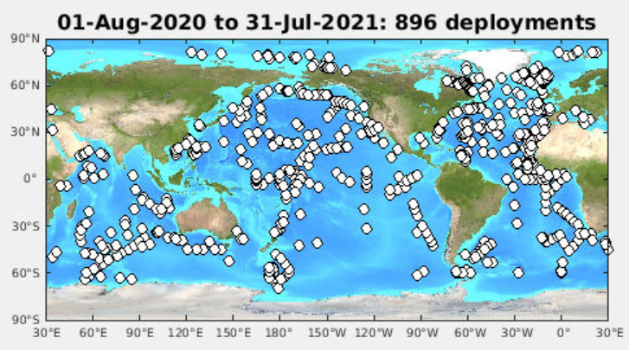

Fig. 1: Global Drifter Program deployment locations during the year.

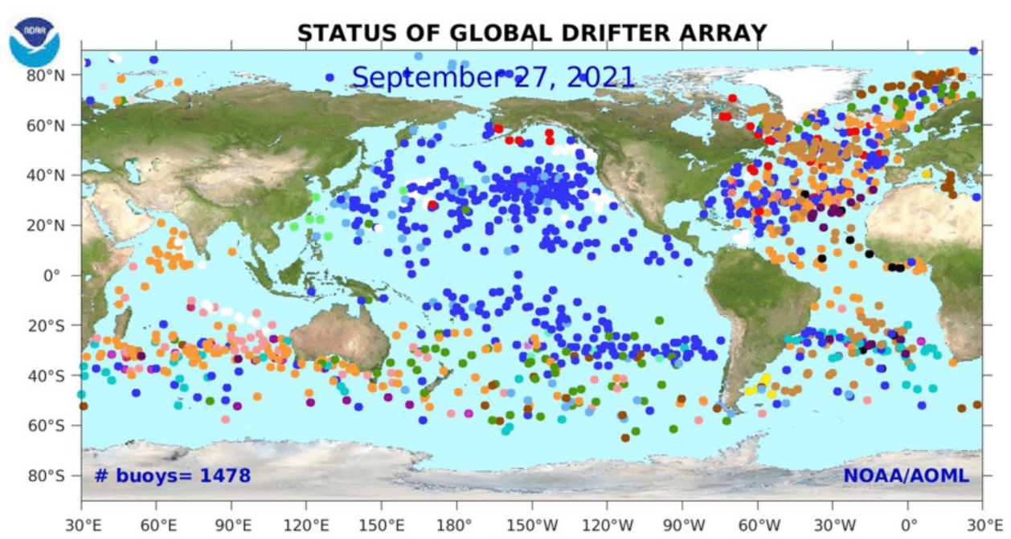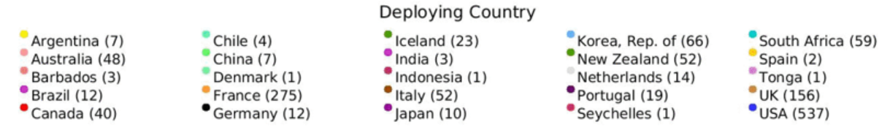

Fig. 2: Global drifter array status as of 27 September 2021. Figure from <http://www.aoml.noaa.gov/phod/gpd>.

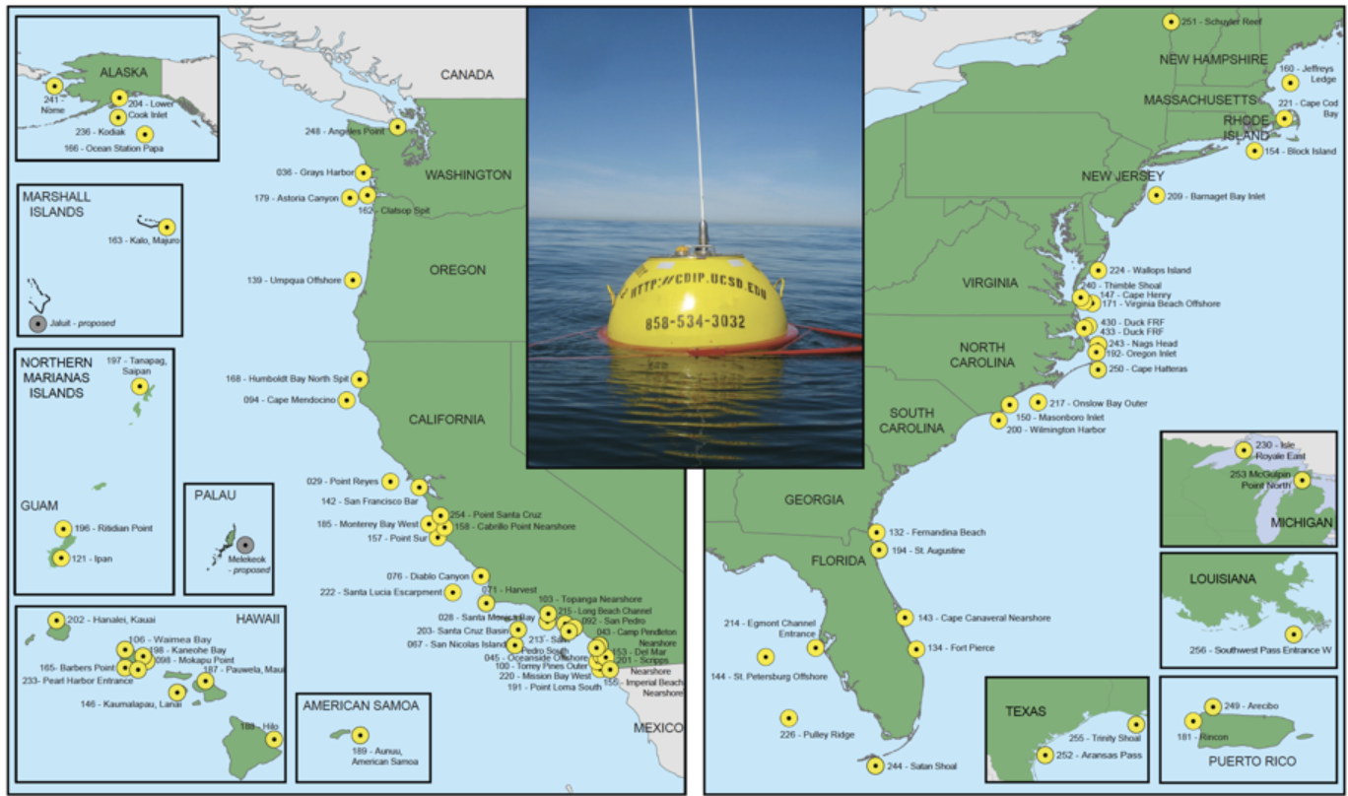

Fig. 3: Coastal Data Information Program (CDIP) monitoring locations.

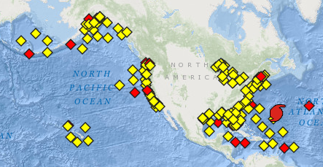

Fig. 4: NDBC Moored Buoys (MET/OCEAN), showing stations reporting in the last 8h (yellow) or not (red). Figure from <http://www.ndbc.noaa.gov/obs.shtml>. This image is for 1 October 2021.

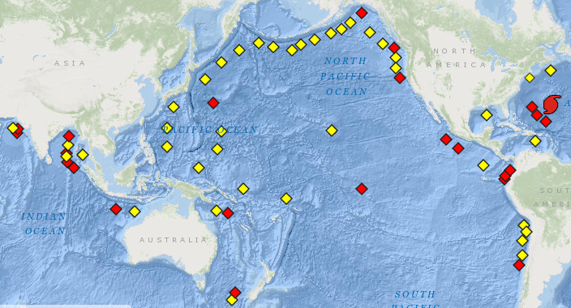

Fig 5: International Tsunami Network status, showing stations reporting in the last 24h (yellow) or not (red). Figure from <http://www.ndbc.noaa.gov/obs.shtml>. This image is for 1 October 2021.

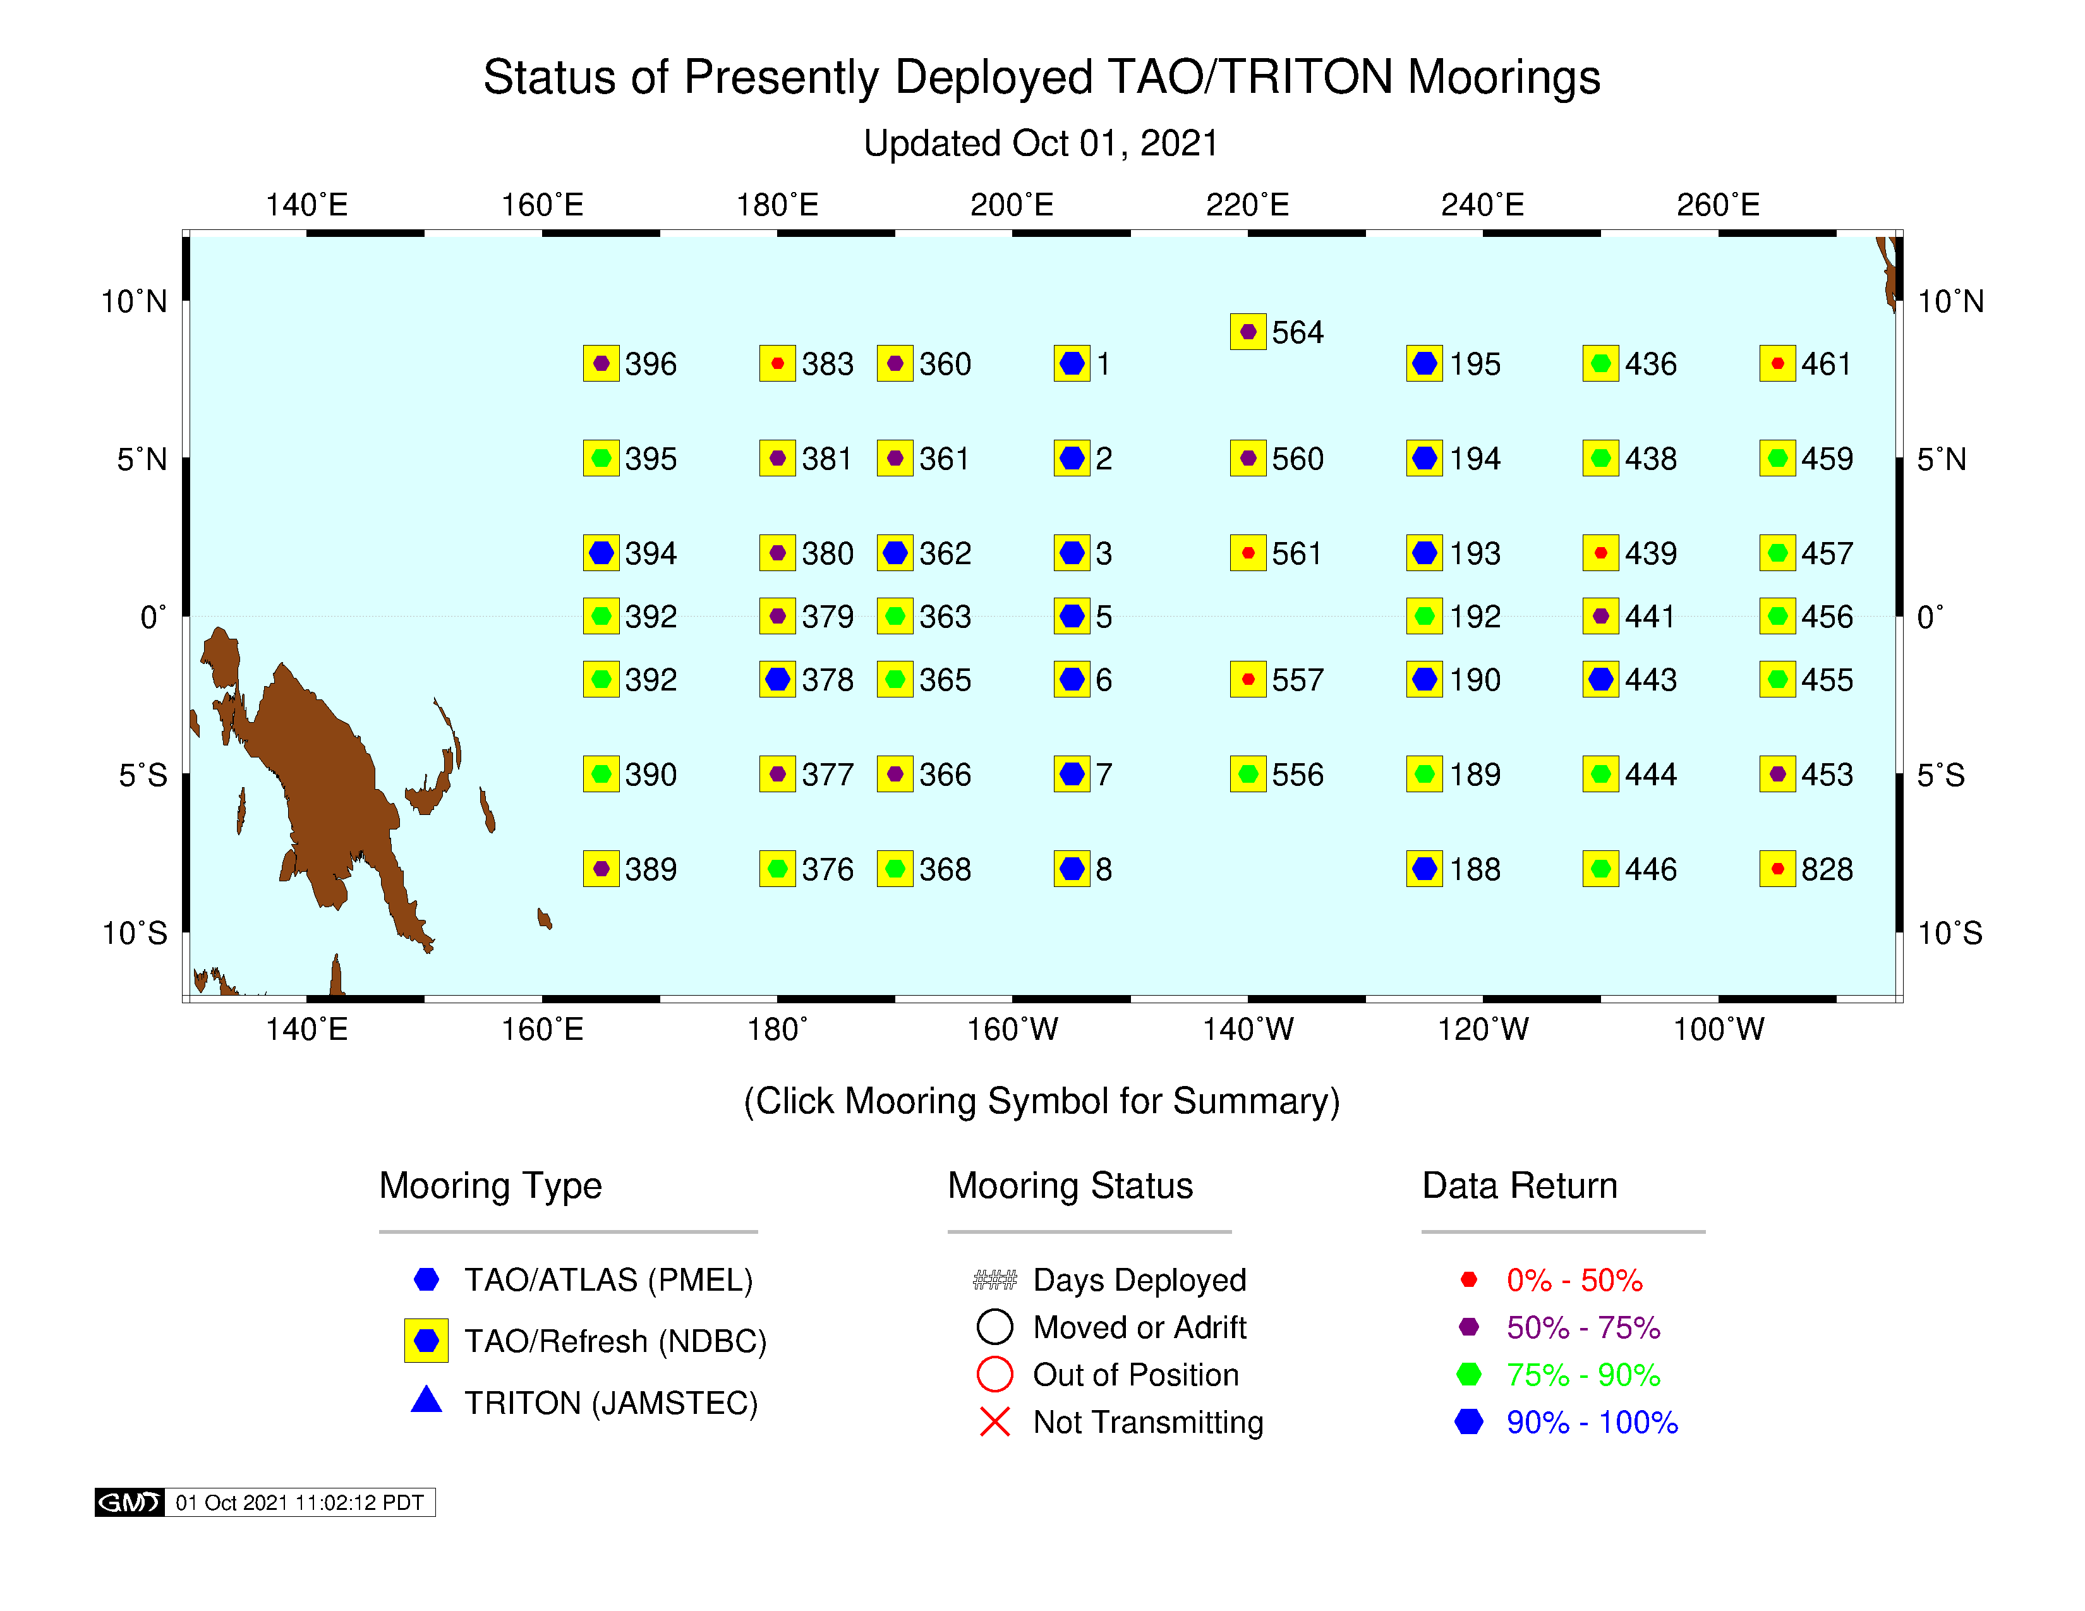

Fig. 6: NDBC Tropical Atmosphere Ocean (TAO) Array and TRITON Array status on 1 October 2021. The numbers indicate how many days have passed since last servicing (ideally <365). Figure from <http://www.pmel.noaa.gov/tao/global/status/>.

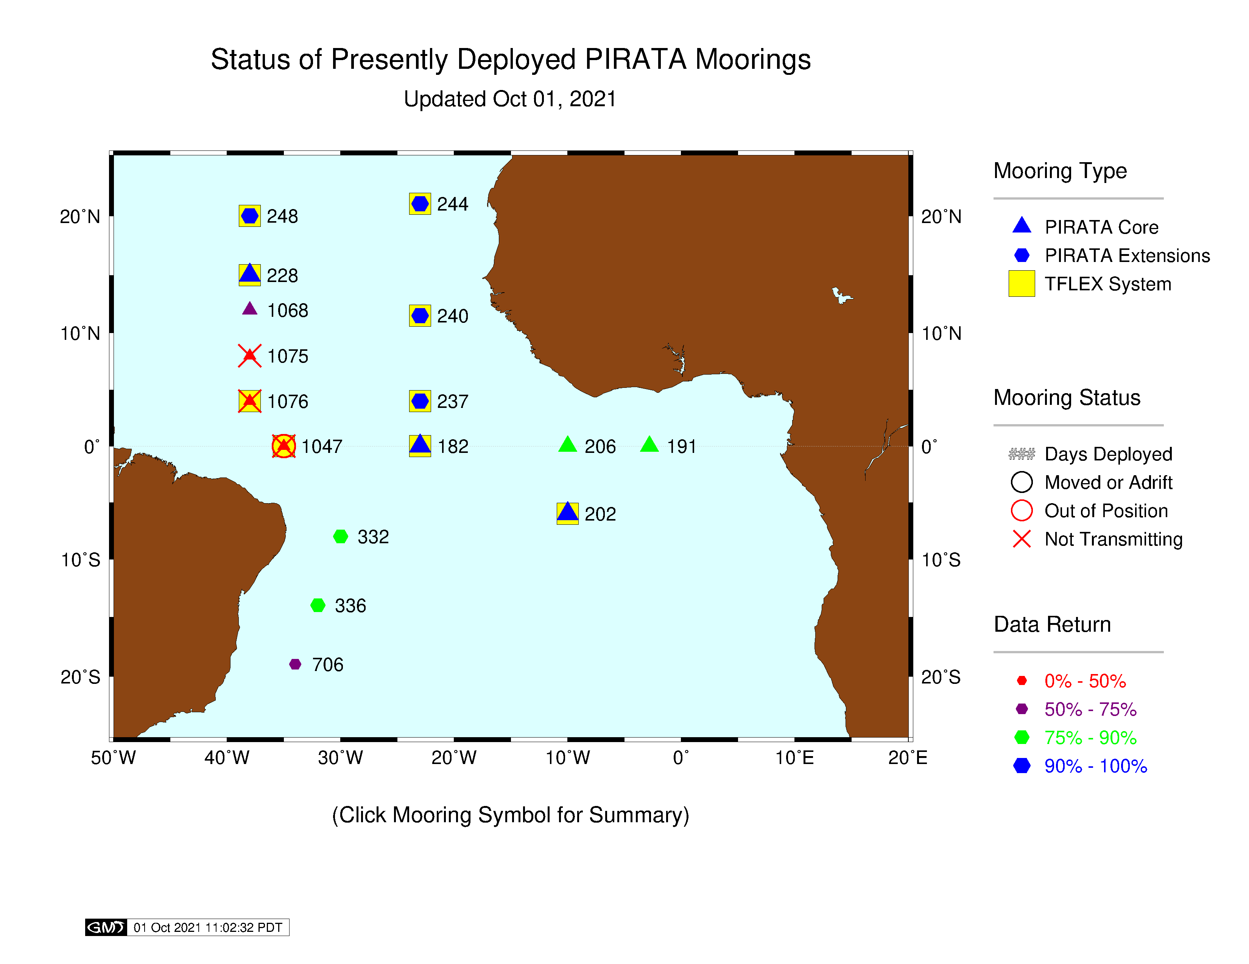

Fig. 7: PIRATA Array including PMEL/AOML Northeast Extension status on 1 October 2021. The numbers indicate how many days have passed since last servicing (ideally <365). ). Figure from <http://www.pmel.noaa.gov/tao/global/status/>.

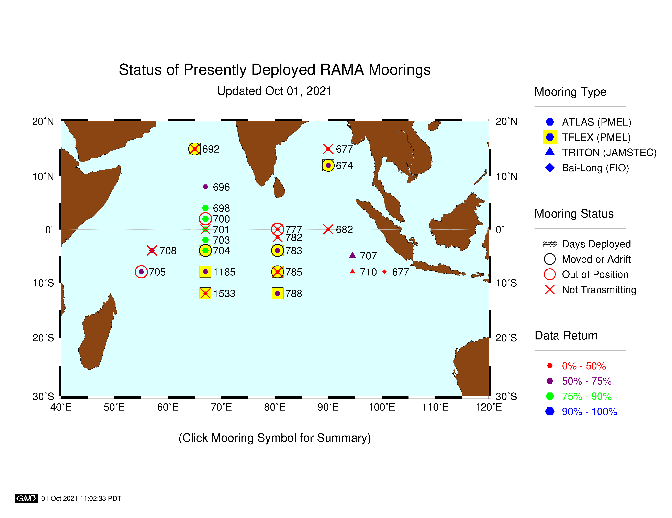

Fig. 8: International RAMA Array status on 1 October 2021. The numbers indicate how many days have passed since last servicing (ideally <365). Figure from <http://www.pmel.noaa.gov/tao/global/status/>.