Intergovernmental Oceanographic Commission
Reports of Meetings of Experts and Equivalent Bodies

IODE Steering Group for the OceanTeacher Global Academy project
(SG-OTGA-II)

Second Session (online)
16, 18, 19 November 2021

UNESCO 2021

IOC/IODE-SG-OTGA-II
Oostende, 20 November 2021
English

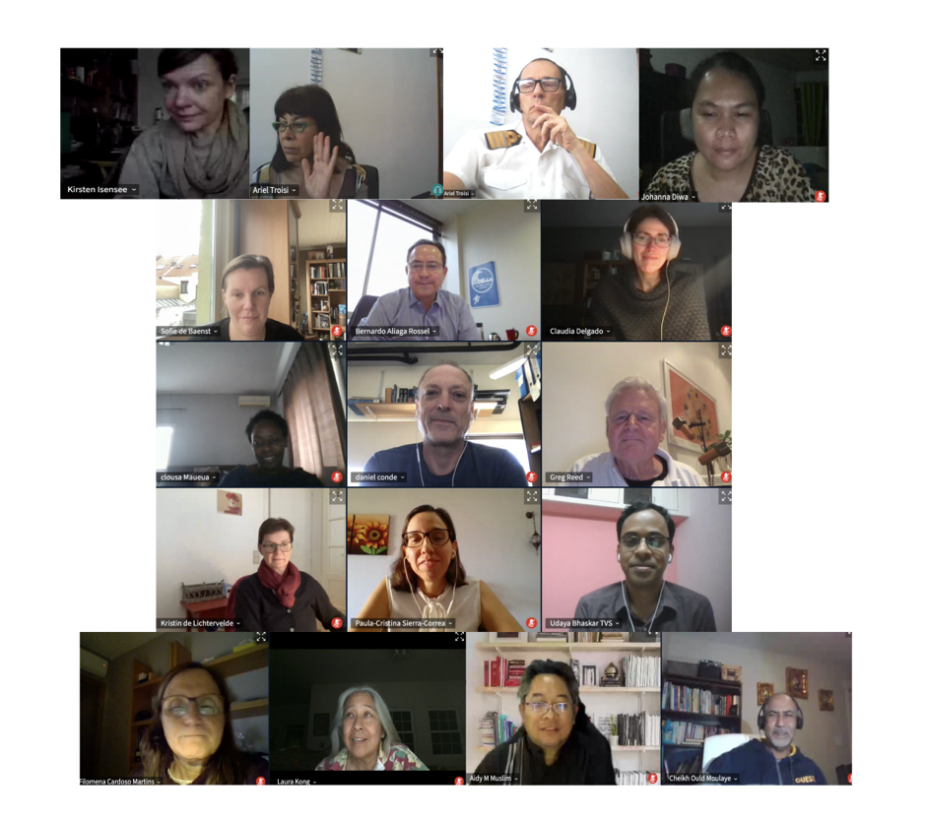

For bibliographic purposes this document should be cited as follows:
Second Session of the IODE Steering Group for the OceanTeacher Global Academy project (SG-OTGA-II), Online, 16, 18, 19 November 2021. Paris, UNESCO, 39 pp. 2021 (Reports of Meetings of Experts and Equivalent Bodies) (IOC/IODE-SG-OTGA-II) (English)
© UNESCO 2021

Table of Contents
1. OPENING OF THE MEETING 2
1.1 Welcome by the IOC representative 2
1.2 Address by the donor representative 3
1.3 Introduction of participants 3
1.4 Adoption of the Agenda and Timetable 3
2. OTGA PROJECT STATUS 4
2.1 Overview of Project Activities 4
3. REVIEW OF RTC/STC ACTIVITIES 2021 5
4. OTGA Operations and Work Packages 7
4.1 Review of OTGA Course Management Guidelines. 7
4.2 Facilitating online courses using the OTGA ELearning Platform 8
4.3 Process of online learning 10
4.4 IOC Capacity Development Needs Assessment Survey 12
4.5 Review of OTGA project work packages 13
5. OTGA WORK PLAN AND BUDGET 2022 14
5.1 Training needs identified by IOC Programmes and Regions 14
5.2 Other OTGA Activities 18
5.3 OTGA Project Budget 19
5.4 OTGA Workplan for 2022 19
6. SUMMARY AND DISCUSSION 20
6.1 Any other business 20
6.2 Review of the main decisions agreed during the meeting 20
6.3 Adoption of the work plan and summary report 20
6.4 Designation of SG Chair 21
6.5 Next OTGA SG session 21
7. CLOSING 21
Annex I. Agenda of the Meeting 22
Annex II. Results of Self-evaluation Instructor Survey 23
Annex III. Proposed Work Plan 2022 26
Annex IV. List of Participants 33

OPENING OF THE MEETING
The meeting was opened by Mr Udaya Bhaskar (RTC India), Chair of the Steering Group for the OceanTeacher Global Academy project. He welcomed participants to the second session of the Steering Group.
He informed the Group that the meeting would be held online only and, as Steering Group members are attending from countries across 22 time zones, it was not possible for everyone to meet in real time. As such, the meeting will be conducted over two plenary sessions of two and a half hours on each day of the meeting. Each agenda items will start with a pre-recorded presentations and then followed by online discussion. The online discussion fora will be used to discuss each agenda item and to ask questions and the discussion fora will remain open during the entire meeting.
The Chair outlined the objectives of the Steering Group meeting:
- To review the OTGA activities achieved in 2021
- To review the training courses delivered by the Regional and Specialized Training Centres in 2021
- To discuss the project work plan for 2022, including proposed courses and sharing of work package tasks
- Designate the SG Chair
The Chair informed the Group that nominations for Chair of the Steering Group for the next intersessional period will be accepted until the end of the meeting and should be sent to the OTGA Secretariat. RTC/STC coordinators can vote for the Chair (one vote per RTC/STC) and results will be announced on 26 November.

Welcome by the IOC representative
Mr Peter Pissierssens, IOC Capacity Building Coordinator and Head of the UNESCO/IOC Project Office for IODE, welcomed the meeting participants, and reflected on the history of OceanTeacher. IODE has a long tradition in short term technical training going back to the late 1980s with ad hoc training courses organized in various locations around the world. This model evolved into a more organized and standardized training course model with the opening of the IOC Project Office for IODE in 2005 and the first OceanTeacher Academy project that started in 2009 which developed a learning management system and teaching program benefiting over 1000 students from 120 countries between 2009 and 2013. The OceanTeacher Global Academy expanded into the development of regional training centres with attention to local requirements, language and culture. The OTGA approach is based on local ownership, with the regional training centres supported by the host countries.
The second OceanTeacher Global Academy Project started in April 2020 in the midst of the COVID-19 pandemic. However, OTGA and its Regional and Specialized Training Centres were able to quickly adapt to online training and delivered several online training courses and also hosted online courses for other organizations. In 2021 OTGA has successfully delivered over 30 online training courses across the network of regional and specialized training centres, and more than 700 participants have successfully completed training courses. During this year, OTGA has become a service provider, cutting across all IOC programmes with courses delivered or planned to support ocean acidification, ocean literacy, tsunami awareness, GOOS, IODE (including OBIS and ODIS), and the Harmful Algal Bloom programme. OTGA is also supporting the IOC regional sub-commissions and regional committees to ensure the capacity development needs of the regions are being met through the support of the regional and specialized training centres.
Mr Pissierssens recalled OTGA is developing collaborations beyond UNESCO IOC to position itself as the training hub for ocean sciences. OTGA is now an officially endorsed action project contributing to the United Nations Decade of Ocean Science for Sustainable Development that will contribute to fulfilling the ten Ocean Decade challenges and help deliver the ocean we want by 2030. This endorsement will encourage greater participation, collaboration and co-development in OTGA from around the world. Capacity development is not a short term activity with immediate results, but is the result of a long-term, sustained partnership, and Mr Pissierssens thanked the Government of Flanders as well as the 16 institutions that host the Regional and Specialized Training Centres for their continued support of the OceanTeacher Global Academy Project.

Address by the donor representative
Mr Gert Verreet, Policy Officer from the Flanders Department of Economy, Science and Innovation, Belgium addressed the meeting. Mr Verreet informed the Steering Group that the OceanTeacher Global Academy project is one of the flagships of UNESCO projects funded through the Flanders UNESCO Science Trust Fund (FUST) and has a long pedigree of developing IOC capability of capacity development. The current phase of OceanTeacher Global Academy has established a large number of Regional and Specialized Training Centres across the globe.
Mr Verreet was pleased to note that IOC has registered OceanTeacher Global Academy as an action under the UN Decade of Ocean Science and Sustainable Development (2021-2030). He noted the Ocean Decade is a great opportunity to reach out to new stakeholders, to new interested parties and to help them find training resources to achieve their own objectives. This second Steering Group meeting is an opportunity to address the question how OceanTeacher Global Academy can contribute the Ocean Decade to achieve additional impact across the globe. He explained Flanders is proud to host the UNESCO/IOC Project Office for IODE in Oostende as well as provide the resources through FUST for capacity development. Despite difficulties of time and distance he wished the online meeting all the success.

Introduction of participants
Participants provided video introductions which were uploaded to the meeting forum. The full list of participants is available as Annex IV.

Adoption of the Agenda and Timetable
The Steering Group adopted the agenda and timetable. All documents and pre-recorded presentations were made available online through the OceanTeacher meeting site https://classroom.oceanteacher.org/course/view.php?id=718. There were two plenary sessions of two and half hours on each day of the meeting at the following times: Session 1. UTC 0300-0530, Session 2. UTC 1300-1530
The agenda is attached as Annex I.

OTGA PROJECT STATUS

Overview of Project Activities
This agenda item was introduced by Ms Claudia Delgado, IODE Capacity Development Coordinator. She informed the Steering Group that the IODE Project Office is home to the OTGA Secretariat as well as representing RTC Belgium. The OTGA Secretariat is supported by several staff members from the IODE Project Office who meet regularly online to discuss ongoing activities and project implementation.
Ms Delgado explained that all training activities were delivered online in 2021, mainly as synchronous courses, due to the COVID-19 pandemic. OTGA successfully organised 32 online, synchronous courses, of which 6 were later adapted to self-paced mode. OTGA has also hosted another 5 courses with external partners. Over 3250 people applied to attend online training courses with 700 learners, out of the 1182 who started, successfully completing courses. Course languages included English, Spanish and Portuguese.
Ms Delgado emphasized the eLearning Platform is the backbone of OTGA as it facilitates face-to-face learning, blended and online learning. A major redesign of the platform took place in late 2020. It now runs on Moodle 3.11 version, including all the necessary upgrades. Several plugins were installed in order to improve the learning experience, namely the dedicated web conferencing tool BigBlueButton and others that enable the possibility of using external programming tools such as GitHub and Jupyter Notebooks and also the issuing of digital certificates. OTGA has engaged an eLearning designer to assist to improve the design and delivery of our training courses, especially the self-paced ones. This will be further discussed under agenda item 4.3.
Ms Delgado informed the Group that the OTGA Secretariat has successfully submitted a Small-Scale Activity for an OTGA Alumni System with funding from FUST. The aim of the Alumni System is to build an interaction between the OTGA administration and the learners to manage alumni data as well as to provide a single registration for learners who currently need to register on two disparate systems (OceanTeacher Moodle LMS and IOC OceanExpert). The system will also improve the overall IOC Capacity Development reporting requirements for UNESCO as well as individual Member States and donors.
Ms Delgado recalled in 2021 the OTGA Secretariat paid special attention to improve the project outreach and its presence on social media. Two outreach videos were produced, one on What is the OceanTeacher Global Academy and another one on Understand how the OTGA platform works . These have been published in October 2021 and are available on the OTGA YouTube channel . OceanTeacher is now regularly present on Facebook, LinkedIn and Twitter. As previously mentioned by Mr Pissierssens in his welcome speech, the OTGA Secretariat successfully submitted a proposal to become an endorsed Ocean Decade project. This should result in higher visibility globally for OTGA.
Finally, Ms Delgado recalled the ISO certification process for the IODE Project Office. Due to COVID-19 it was not possible to organize the mandatory face-to-face external audit. The external audit to confirm compliance with the new international standard ISO 29993 is now scheduled for 24-25 January 2022.

REVIEW OF RTC/STC ACTIVITIES 2021
Representatives of each RTC/STC provided a presentation focusing on:
- A description of the RTC or STC
- Summary of training courses delivered in 2021
- Issues encountered in delivering courses
All presentations have been uploaded to the meeting site.
Discussion.
Mr Mika Odido, IOC Coordinator in Africa, asked if RTC Belgium has considered converting to a fully-fledged UNESCO Category 1 Centre. The RTC Belgium coordinator advised she was unaware of the requirements for a UNESCO Category 1 but would investigate.
The Chair enquired if the training materials for the course delivered by China are available openly to all or only available to only those who attended the training. If openly available then the link for the same can be provided. RTC China responded training material are available on the OTGA website at https://classroom.oceanteacher.org/course/view.php?id=708.
The representative of STC ITIC asked if the presentations by the RTC/STCs could be made available as PDF or PPT. The OTGA Secretariat agreed to post PDF versions of all RTC/STC presentations to the meeting site.
Ms Delgado (OTGA Secretariat) commented on the eleven courses conducted by ITCOOcean in 2021 and noted that only one RTC India course is available through the OTGA. She enquired if the other courses could be made available through OTGA. The representative of RTC India advised that other courses could be made available to OTGA in the future.
The representative of STC ITIC enquired if the webinars from ITCOOcean are a learning experience or just a talk. She also noted that some courses are leading to a certificate and if there are plans to partner with a university. RTC India responded that the webinars are delivered on YouTube and available to anyone. The certificate courses are currently two week duration and ITCOOcean needs to ensure they can mobilise resources to deliver longer courses. Future plans are to deliver six month diploma courses and two year courses leading to master’s degree in the future.
The representative of RTC Belgium sought clarification from RTC Malaysia about UMT moving course online and if the courses are delivered through synchronous web conferencing or does UMT have a LMS. RTC Malaysia responded that UMT has a learning management system with some lectures online but some courses are also held face-to-face.
The representative of STC ITIC asked about experiences with completely online courses that do not require facilitator engagement. Many Training Centres are challenged on how to deliver these types of courses in an engaging manner. Ms Delgado (OTGA Secretariat) responded that an eLearning designer has been engaged to advise on structuring self-paced courses without a facilitator. RTC Belgium is planning to launch self-paced courses in 2022, however this is still a learning process for all of us.
The representative of RTC Belgium asked if the course on Sea-ice and Icebergs Observations delivered by STC Argentina could be offered in English. The representative from STC Argentina advised they are proposing to give the training in Spanish and then in English, once during the first semester 2022 and the other in the second semester.
The representative from RTC Colombia asked if there is a plan to translate the self-paced course on ocean acidification into Spanish. The OTGA Secretariat responded the ocean acidification course is currently only available in English but may be able to be translated into Spanish next year.
The representative from RTC Cono Sur asked if the Ocean Literacy courses were advertised. The OTGA Secretariat explained all OTGA courses are advertised through OceanExpert and communication is also widely done through social media of OTGA and IOC.
The representative from RTC Cono Sur congratulated RTC Colombia for successfully delivering 8 courses in 2021.
The representative from RTC Colombia asked how many courses from RTC India were held online and how many face-to-face. The representative from RTC India responded that all courses in 2021 were delivered online as it was not possible to have face-to-face courses. The representative from RTC Cono Sur enquired about the experience with webinars and the response from participants. The representative from RTC India explained that specialists were invited to deliver webinars which were streamed to YouTube. Questions were asked in the chat box and these were answered by the faculty expert.
STC Norway informed the group of the One Ocean Expedition which is a contribution to the UN Decade of Ocean Science for Sustainable Development. The OTGA Secretariat advised that OTGA will sponsor participants for the One Ocean expedition with priority to applicants from SIDS countries in the Pacific. The representative for RTC Pacific expressed support for the University of Bergen's One Ocean expedition to the South Pacific and will be happy to collaborate in planning and research which might be conducted during the voyage.
The representative from RTC Pacific mentioned a number of challenges faced by the RTC when providing training online. The representative of STC ITIC echoed the challenges for online learning. The OTGA Secretariat informed the Group that the identified challenges are being addressed and Mr Cheikh Moulaye (OTGA eLearning consultant) and advised templates for planning lessons which can be customised, will be available by the end of January.
The representative from STC ITIC: Internet stated that internet connection is a challenge for some Pacific Island countries. RTC Pacific agreed with this experience and asked about options to package courses that do not need internet connection. The OTGA Secretariat will investigate options for off-line courses for RTC/STCs with unstable internet connections.

OTGA Operations and Work Packages

Review of OTGA Course Management Guidelines.
This agenda item was introduced by Greg Reed who informed the Group that the OTGA Course Management Guidelines are intended to support the RTC/STC network by:
- Providing procedures on how to plan and design a course
- Providing recommendations on how to use the OceanTeacher Learning Management System
- Providing instruction on administrative procedures for organizing OTGA courses
Mr Reed outlined OTGA course planning and briefly discussed some of the aspects of course facilitation, course feedback and evaluation and quality management. He explained that course planning should begin a minimum sixteen weeks before the start of the course. The course planning timeline is used to show the steps to consider when preparing for a course and it is important that the timeline be followed, especially for face-to-face courses when travel is to be arranged. All proposals for training courses must be included the OTGA Course Proposal Form (Document No. IODE.F08). The Course Proposal Form will explain what will be gained from the course and should include the course objectives, learning outcomes, topics to be covered, the learning activities, target audience, facilitators, assessment process and learning resources. The OTGA Lesson/Module Plan form (Document No. IODE.F09) is used to describe each lesson or module to guide the learning activity and it includes the aims and objects of the lesson, the pedagogic approach to be used (such as group or individual learning, classroom or distance), the lesson format, how the lesson or module meets the expected learning outcomes of the course, and the way of measuring how well the goal was reached (learner assessment). Lesson plans should be provided for all course modules. Mr Reed further outlined the procedures for course announcements, facilitator assessment, participant application and selection.
Mr Reed explained that activities to be organized during a training course include recording attendance, issuing certificates and web conferencing. Attendance must be recorded for all face-to-face courses. For distance learning courses, Activity Completion is used to monitor progress through the course. Activity Completion must be enabled for all topics so attendance and participation can be monitored. OTGA course participants may receive either a Certificate of Participation for attended a course and this is monitored through online tracking tools or attendance records, and attain at least 90% attendance, or a Certificate of Completion can be awarded to participants who successfully complete the courses with well-structured activities, e.g., assignment, quiz, forum, etc., and with completion tracking enabled to monitor the learner progress through a sequence of learning activities. Certificates will be issued based on the template to be provided by the OTGA Secretariat.
Web conferencing can be used to deliver interactive visual solutions for OTGA distance learning courses by providing facilitators with tools to engage learners. BigBlueButton, is an activity module in Moodle, and is the preferred web conferencing solution for OTGA online learning. BigBlueButton supports real-time sharing of slides, webcams, whiteboard, chat and presenter's desktop. It also allows tracking attendance and can be used to pre-record lectures for learners to watch at their leisure. It is recommended hosting sessions be limited to 100 or less users as overall performance will degrade with more than 100 users. If recording a session, the recording will appear at the same location in the course. Other web conferencing tools can also be used.
Mr Reed underlined that the quality of learning services provided by OTGA is underpinned by the certification of the UNESCO/IOC Project Office for IODE as an ISO 29990 Learning Services Provider. This certification is a recognition of the quality of learning opportunities offered by OTGA through the Project Office and the high standard of quality learning services delivered. In 2022 the Project Office will be audited for certification using the international standard ISO 29993 as a Learning services outside formal education, which has replaced the ISO 29990 standard. As part of the certification, all OTGA courses including learning and assessment materials will be reviewed on an annual basis by the OTGA Secretariat. The OTGA Course Design Rubric will be used to evaluate and improve instructor led and self-paced OTGA courses. This rubric comprises a set of eight criteria used to evaluate courses and uses a scoring system to determine if a course meets the criteria. All courses will be reviewed against the criteria and should achieve an overall score of 80% of the possible points to attain endorsement as an OTGA course.
The OceanTeacher Global Academy Course Management Guidelines can be downloaded from the Steering Group meeting site.

Facilitating online courses using the OTGA ELearning Platform
This agenda item was introduced by Ms Claudia Delgado from the OTGA Secretariat who provided some advice on how to use the Moodle platform to improve courses and specifically on how to use its tools to facilitate online courses using the OTGA eLearning Platform. OceanTeacher uses the Moodle Learning Management System to provide a collaborative learning environment that can include resources such as course information, handouts presentations, videos and web links, and activities such as discussion for assignments, online tests, and quizzes, online submission of assignments by the learners, and subsequent online grading by the facilitators.
Ms Delgado defined eLearning as the use of computer and Internet technologies to deliver a broad array of solutions to enable learning. What eLearning is not is simply conducting classroom training using web conferencing tools; eLearning can offer effective instructional methods such as practicing with associated feedback, combining collaboration activities with self-paced study, personalizing learning paths based on learner needs, and using simulation and games. Due to the ongoing pandemic, the focus of OTGA is to deliver courses online with two main types of online courses: (i) self-paced which are limited in time or can be left open for an undetermined period of time, and (ii) facilitated online courses which can have both synchronous and asynchronous activities.
Synchronous courses. Consideration should be given to the estimated workload and spread of the course outline. For example, what was previously a 30 hour face-to-face course presented over five days should now become a minimum of a three week online course which implies an average of 10 hours workload per week. Since learners are likely working full time, she advised course could be extended up to 4 – 6 weeks long. The use of synchronous time should be limited to the absolutely necessary. This is because participants are often in different time zones and internet bandwidth can be a limiting factor both technically and financially. Synchronous sessions assumes that everyone is online at the same time despite the demands of work and private lives. Synchronous time should be used for discussion or group work and not to deliver lecture like content that can be easily delivered by a combination of reading assignments, recorded videos, tutorials, etc.
Ms Delgado explained the careful planning of a Moodle course is essential for creating a positive and effective learning experience for the learner. The OTGA Secretariat recommends the use of a course template to guide the design and delivery of courses. Th course template includes four main course blocks: (i) the course introduction, (ii) the course modules, (iii) course assessments, and (iv) course feedback and certificate.
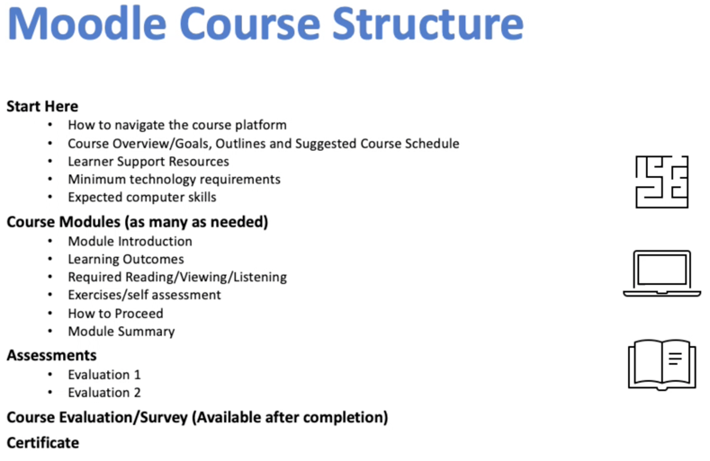
Ms Delgado then outlined some of the tools available on the OTGA eLearning platform that can be used to engage learners interactively during the course. Course material that a learner observes or reads, such as web or text pages, hyperlinks, and multimedia files, are known as Resources. Course material that a learner interacts with, or that enables interaction among learners and facilitators, are called Activities. Some Moodle Activities may be used as assessment tools.
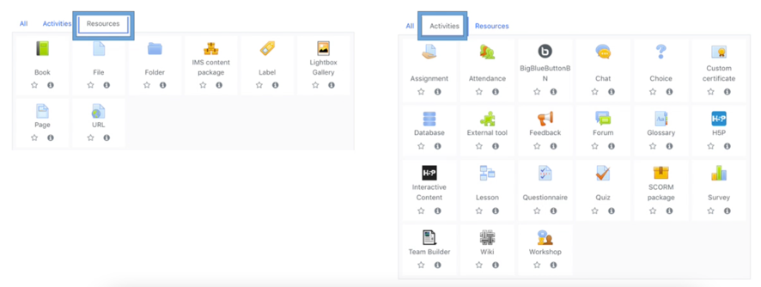
For more information about these Moodle tools, refer to the OceanTeacher Global Academy Course Management Guidelines.
Tracking activity completion and activity reports. All OTGA courses have activity completion enabled by default and the use of activity completion allows the facilitator to set the completion criteria for a specific activity. When editing a resource or an activity, the course editors can choose the level of completion that is mandatory or not, as well as a specific deadline for that. A learner can meet the criteria by viewing content, participating in a forum or completing a lesson, quiz, or assignment.
Activity reports. The activity report displays the different course elements, both resources and activities, with the names of the learners and their progress. These reports can be used to follow up on learner engagement and completeness of the course and if needed to contact specific students to provide extra support as needed.
Certificates. The Moodle custom certificate module is used to generate dynamic certificates and certificates are made available to participants who successfully meet the participation or completion criteria. Each certificate issued through the eLearning platform has a unique code that can be validated.
Ms Delgado concluded that the move to online learning is demanding and implies a considerable mind shift on how we deliver training. Blended learning formats, including the enhanced use of technology for training, are here to stay and should become the new normal.

Process of online learning
This agenda item was introduced by Mr Cheikh Ould Moulaye, the OTGA eLearning instructional designer consultant. He explained his main task is to assist developing and meeting learning outcomes for OTGA training activities. This includes (i) identifying knowledge gaps of RTC/STC instructors in the effective use of the learning management system, (ii) conducting training of trainers in designing and delivering online courses using the OTGA LMS and (iii) supporting subject matter experts in designing and creating quality instructional materials.
Consulting with RTC/STC administrators. Mr Moulaye conducted a comprehensive needs analysis by talking with administrators from eight RTC/STCs to gain feedback on how the move to online delivery had changed the way they were offering the courses and to discuss the following challenges:
- Move to online learning. One result of the move to online training has been an increase in enrollment but this came with lower quality participation, mainly due to the Internet connectivity and the challenge of synchronous sessions with different time zones. Some Training Centres also noticed that they needed more preparation for online courses and they receive less feedback from participants.
- Instructor challenges. Some challenges faced by instructors include the fact that online learning and creation of quality online material comes with high initial cost. It is a time consuming task and needs a specialized skill set that some instructors did not have at the beginning of the pandemic. Instructors also had difficulties to engage learners online and have challenges to work as a group and to make sure that the proposals are made on time, as it is more difficult to perform these activities online.
- Learner challenges. For learners, the variability and the cost of Internet quality connectivity was a challenge. Some learners had limited access to computers, some of them were attending online courses on their phones. Unlike face-to-face training where attendees leave behind their work and their families and focus on training, online training was done from home or from the workplace and there were distractions from their own family responsibilities or daily workload. Learners also expressed that they miss the hands-on training, field trips and so on, and they sometimes had difficulty to manage their time.
- OTGA support. Most Centres recognized that they need assistance to train subject matter experts on how to develop quality online courses. They also need access to templates that can be used for course development.
Instructor survey. Mr Moulaye conducted a survey of OTGA instructors to gain a better idea about their readiness for online training. He described the survey, created by Martin et al, used to evaluate the competencies of online instructors regarding course design, course communication, time management and technical competency. The self-evaluation survey was sent to all RTC/STCs and 27 answers to 22 questions were received. Mr Moulaye discussed the results of the survey which can be found in Annex II.
Evaluation of Sample course. The third source of data was the evaluation of sample courses and Mr Moulaye described the Quality Matters framework which incorporates best practices in the field of online learning, and the rubric which is designed to assess professional development activities. The rubric has eight general standards and 43 specific standards with each standard having a number of points. The specific standards with three points must be met for a course to be considered to be a quality course. This rubric was used to review some sample courses and most were not meeting the standards. For example, when checking the learning outcomes, most of them were not appropriately stated, because learning outcomes need to be (i) specific, (ii) measurable, (iii) stated from student perspective and not the activities that the instructor will do. Most of the examples reviewed were using verbs that are difficult to assess. Clear and measurable learning outcomes are needed to evaluate a course and are key.
Analyzing learner feedback. Mr Moulaye analyzed learner feedback from sample courses and found the feedback were not that helpful because most were overwhelmingly positive. It was suggested that this may be cultural as in some cultures it is not usual to give negative feedback. Following discussion with the OTGA Secretariat, a new set of feedback questions have been proposed.
Mr Moulaye concluded with some recommendations:
- Incorporate best practices and evidence-based strategies in eLearning.
- Develop training for subject matter experts and instructors on designing and delivering quality online courses using Moodle
- Develop and make available course templates for instructors to help them design online, blended and face-to-face courses.
- Better advertise for OTGA online courses and with their timeline and prerequisite.
- Assist RTCs and STCs to advertise their own courses.
He noted the OTGA secretariat has accepted these recommendations and will be working on implementing these.
Discussion.
The representatives for RTC Pacific and STC ITIC enquired when templates will be available. Mr Moulaye indicated that he is working on course “shell” templates which should be available by the end of January. The OTGA Secretariat will advise all RTC/STCs when the course templates are available (planned for January 2022).

IOC Capacity Development Needs Assessment Survey
Ms Johanna Diwa-Acallar, IOC Capacity Development consultant, presented a summary of the second IOC Capacity Development Needs Assessment Survey, including an extract of outcomes related to OTGA. The 2020 Capacity Development Needs Assessment Survey was conducted from September 2020 to February 2021 with 1005 responses received from 118 countries. About 63% of the respondents came from petitioner groups such as ocean researchers, academic staff from learning service providers, and students from higher education institutions.
Ms Diwa provided an overview of the general findings from the survey and then focussed on outcomes related to the OTGA. She provided a comparison of the responses of national authorities such as IOC focal points and CD focal points compared to practitioner groups. As shown, 100% of the student respondents indicated that they use OTGA in varying levels, with almost half indicating regular use of the platform, compared to half of the national authorities have never made use of OTGA.
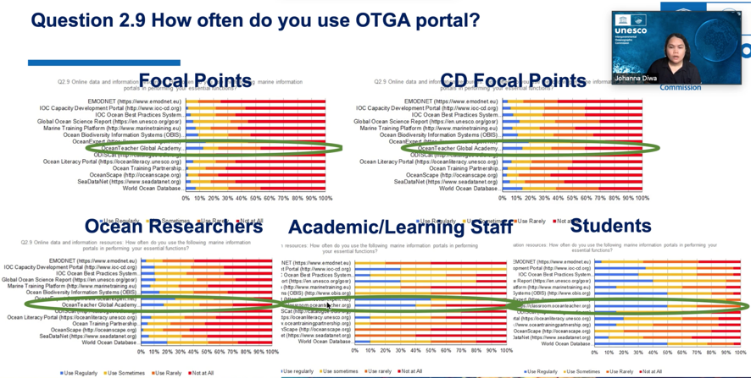
On the question of how IOC programmes can contribute to addressing your country's capacity development requirements, the majority of responses indicated OTGA can provide training courses to increase technical and professional skills, notably of young and early career ocean professionals.
Ms Diwa informed the Group that OTGA is in a position to contribute to the Ocean Decade objectives through its capacity development tools and resources as a platform and can provide training courses in collaboration with RTC/STCs and can serve as the training hub of specialized and high-quality learning services.
The full results of the survey are now available online at https://surveys.ioc-cd.org.

Review of OTGA project work packages
Ms Delgado, OTGA Secretariat, reviewed the project work package activities. She recalled the OTGA-2 project is structured around five interrelated work packages, as follows:
- WP1: Project Coordination. Monitoring the timely implementation of the project workplan and timely delivery of the project deliverables
- WP2: Project Technical Support. To improve the services supporting the delivery of the Learning Services, including the online application for courses, remote participation in courses and, above all, an up to date, fully functioning e-Learning Platform that can serve and assist with training 24/7, around the globe.
- WP3: Training course content creation. Designing and developing new course contents to address the capacity needs of the different IOC Programmes
- WP4: Training course activities. Provision of classroom and online training courses and support to users/learners during online courses
- WP5: Outreach, communication and project evaluation. Implement an effective communication and dissemination plan for the project by provide support towards the project evaluation and ensure the Steering Group provides guidance for the successful implementation of the Project
The OTGA Secretariat has taken on the responsibility for the work packages over the last year. It was agreed by the Group that more regular communication with WP leaders is needed and it was decided to hold regular meetings of WP leaders to discuss issues connected to each work package. It may not be necessary for all WP leaders to meet at the same time.

OTGA WORK PLAN AND BUDGET 2022

Training needs identified by IOC Programmes and Regions
Proposed OTGA training courses to support IOC Programmes and Regions were discussed. The following presentations were made:
- Ocean Biodiversity Information System. Mr Ward Appeltans, OBIS Project Manager, reported on the training and capacity development activities at OBIS. For 21 years OBIS has been building a central global platform to provide free access to ocean biodiversity and biographic data. OBIS training resources include the OBIS manual, GitHub repositories, OBIS tools for quality control, and training courses available on the OTGA eLearning platform, but there is a need to expand into more specific FAQs and to provide these as short public tutorials such as notebooks and videos. More information about OBIS training resources and alumni can be found on the OBIS website under the Training page. Mr Appeltans highlighted some new projects that OBIS is involved in that have a training component. Pacific islands Marine bioinvasions Alert Network (PacMAN) is a project funded by FUST to develop an end-to-end monitoring system to detect marine invasive species using rental eDNA and metabarcoding. A number of training courses will be organized with OTGA for sampling and for stakeholder engagement. Another project starting next year is organizing eDNA expeditions in World Heritage sites and there is a need to develop the training material to train citizen scientists to perform the sampling. Mr Appeltans outlined the OBIS nodes training plans for 2022 and 2023 and welcomed feedback, suggestions and questions on how to further develop OBIS capacity development activities.
- IOC Ocean InfoHub (OIH). Ms Lucy Scott, Ocean InfoHub Project Manager, introduced the InfoHub Project Training courses for 2022/3. She informed the Group that Ocean InfoHub Project is a three-year global initiative to improve access to marine and coastal data and information which commenced in April 2020 and is funded by the Government of Flanders Kingdom of Belgium. The objective of the project is to develop interoperability between existing information systems to improve the flow of information to end users. Ms Scott explained there are three closely related initiatives: the Ocean InfoHub Project, the Ocean and Data Information System Catalogue of data sources and the Ocean Data and Information System (ODIS). The Ocean InfoHub Project has developed the first phase of the architecture and is concerned with involving user communities and establishing proof of concept of ODIS. The project is working in three pilot regions: Africa, Latin America and Caribbean region, and the Pacific small island developing states. These three regions have participated in the development of the proposal for the project and will take a lead on pilot projects to test interoperability between hubs. In 2021, together with the OTGA and other partners, an online asynchronous training course, Implementing the Ocean Data and Information System Architecture, was held between from 25-29 October. The objectives of the course were (a) to equip participants with a conceptual understanding of what ODIS is, why it has been created and how it works, (b) to equip participants with conceptual and practical understandings of the technical components of ODIS, and (c) to provide participants with the tools they need to describe their metadata and publish it. In 2022, Ocean InfoHub plans to hold further courses on the same subject, but with improved and expanded content. In addition, the training materials will be translated into Spanish and French. A minimum of three courses are planned in 2022, the first course to be held in Spanish around April. These courses might be held asynchronously or pre-recorded to improve attendance and participation in that case.
- Ocean Best Practices System (OBPS). Ms Pauline Simpson, OBPS Project Manager, introduced the Ocean Best Practices System which is an IOC approved project co-sponsored by IODE and GOOS to support the ocean community to share methods and developing Best Practices. She explained the four main components to OBPS are (a) a permanent OBPS repository (currently storing 1445 best practices) using advanced technology to follow the FAIR principles, (b) a second publication channel through a peer-reviewed Research Topic section in Frontiers in Marine Science. (c) in collaboration with OTGA, a training and capacity development capability is being developed, and (d) a dynamic community outreach and engagement activity including an annual community workshop. Ms Simpson defined Best Practices using a two part definition: (a) a best practice is a methodology that has repeatedly produced superior results relative to other methodologies with the same objective, and (b) adoption by multiple organisations is an important part of Best Practices criteria, which supports the OBPS vision to have globally agreed and broadly adopted methods. Significantly for the OTGA Steering Group meeting, best practices are a permanent resource for training and capacity development. OBPS supports capacity development through collaboration with OTGA and the OBPS Project Manager is a member of the OTGA Steering Group and conversely OTGA is represented on the OBPS Steering Group. OBPS also supports OTGA and capacity development by providing a secure, sustainable repository and making methods and practices freely, findable and accessible by including courses, videos and documents in the OBPS repository. OBPS is proposing training courses to be included in the 2022 OTGA curriculum. One of these courses will build on the new OBPS infographic on developing a best practice. For more information see oceanbestpractices.org.
- Ocean Sciences: Harmful Algal Blooms (HAB). Mr Henrik Enevoldsen (IOC Science and Communication Centre on Harmful Algae), informed the Group of the following training courses planned for 2022:
  - Identification Qualification in Harmful Marine Microalgae (including optional workshops on enumeration and culture techniques) – Blended
  - International Phytoplankton Intercomparison (IPI) exercise - Blended.
- Ocean Sciences. Ms Kirsten Isensee (IOC Ocean Science Section) reviewed the main areas for collaboration between the Ocean Science Section and OTGA, including Harmful Algal Identification training, the International Phytoplankton Inter-calibration, ocean acidification, and coastal blue carbon ecosystems. The Ocean Acidification course focuses on IOC’s mandate for SDG reporting on ocean acidification indicator 14.3.1. The OTGA Ocean Acidification online course has been developed and will soon be launched. Further collaboration includes translation into other languages, tailor courses to specific regions, add new modules, and develop courses in the framework of the Ocean Decade. Another topic of interest is coastal blue carbon ecosystems. There is increased interest from partners such as the Blue Carbon Initiative and the International Partnership for Blue Carbon. It is expected the course will be online next year and there will be six modules. Other areas for future collaboration between OTGA and Ocean Science Sector include Deoxygenation. Summer schools are planned for next year and the year after and it is expected that some of the material can be integrated into an online course. There is also the Integrated Ocean Carbon Research Working Group which may want to give some introductory courses on the ocean carbon cycle, and finally there is multiple ocean stressors and the collaboration with SCOR.
- Ocean Literacy. Mrs Francesca Santoro (IOC, Ocean Literacy) informed the Group that a new ocean literacy training course for the finance sector is being planned (ideally launched in March 2022).
- IOC Tsunami Unit. Mr Bernardo Aliaga reported on the needs and priorities of the Tsunami Unit of IOC with respect to OTGA. He provided a brief recap on the Tsunami Group, the priorities of the Tsunami Unit in the context of OTGA, and some of the challenges in respect to staff competency training. He informed he Group there were four Intergovernmental Groups coordinating basin-based Tsunami early Warning and Mitigation Systems, with a strong technical component (observations, modelling, forecasting) and reinforced preparedness and awareness programmes. Regular full-scale or table-top drills and exercises are held in all basins: CARIBE WAVE 20 & 21, IOWave20, NEAMWave21 and PACWAVE20. The Tsunami Service Providers (TSP) covers all basins providing tsunami information (statements or threat information) to National Tsunami Warning Centres and/or Tsunami Warning Focal Points. TWS provides public awareness activities, including publishing papers and developing public awareness guidelines. In response to COVID-19 several guidelines have been developed for each of the regions with respect to how to face evacuation in presence of sanitary measures. Mr Aliaga outlined the training priorities for the Tsunami Group which focus on the STC ITIC and STC Indonesia. The Tsunami Ready course will be completed 2021 under the leadership of STC Indonesia and the Tsunami Awareness course is being developed by STC ITIC. It is hoped that the experience gained in developing these two courses will help streamline the development of the other courses. Support from OTGA is needed, particularly in developing the course on “Tsunami Warning Centre Staff Basic Competencies” which is a course requested by Small Island Developing States, in particular by the Pacific Island countries which are in urgent need of online hybrid training to ensure staff in the centres are properly trained and receive recognition certification for completing training.
- Ocean Decade. Ms Alison Clausen, IOC Program Specialist, working extensively on the Ocean Decade. Ms Clausen was pleased to note that OTGA is now a registered as a Decade Action which is an important step for future closer collaboration between OTGA and the Ocean Decade as all Decade programmes and projects address capacity development in some way or another. Either they have very strong capacity development needs or they're carrying out capacity development activities. Ms Clausen stated there are two programs that are strongly focused on capacity development at the global level. These are the Early Career Ocean Professional Programme and the global programme being led by the University of Michigan, the Global Ocean Core and Conveyor. These two programs are taking the lead in convening a community of practice in the Decade around capacity development and it is expected OTGA will have an active role in that community of practice. An inventory will be taken of existing programs and projects, including capacity development needs and what is offered or being planned in terms of capacity development, and this will be an important analysis to work with OTGA to identify future priorities and future needs. Ms Clausen informed the Group of the proposed training course on “Co-designing the science we need for the Ocean Decade” which is being developed in collaboration with the International Science Council to be hosted by OTGA and this course will be available in the next few months. Other potential training includes indigenous and local knowledge, potentially around observations as well as some regionally specific training courses. In conclusion, Ms Clausen welcomed OTGA as an endorsed Decade action and stressed the importance to align the priorities of OTGA with the Decade priorities to ensure OTGA can play a central role in the capacity development efforts of the Decade.
- IOC Sub Commission for Africa and the Adjacent Island States (IOCAFRICA). Mr Mika Odido, IOC Coordinator in Africa, presented the capacity development priorities for the IOC Sub Commission for African and Adjacent Island States. The priorities areas that have been identified by Member States include (i) understanding the ocean and coastal processes around Africa (ii) monitoring and early warning systems for coastal and natural hazards, (iii) understanding Africa's oceans, (iv) managing and mitigating the impacts of coastal areas impacted by changing climate, (v) strengthening of marine the impacts of coastal hazards and climate change, and (vi) the creation of a critical mass of marine science professionals. The last two priorities are especially relevant for the SG-OTGA. Mr Odido informed the Steering Group that the Sub Commission has developed a capacity development strategy with three pillars (i) basic training, (ii) continuous professional development, and (iii) partnerships with other IOC sub-commissions and other organizations such as WIOMSA and UNEP. The continuous professional development pillar focuses on strengthening, improving the skills of scientists and technical staff through regional training centres such as the OTGA Regional Training Centres. The designation of the regional training centres in Mozambique, Kenya and Ghana is an important step in developing infrastructure required for training and these Regional Training Centres have already organized training courses on a wide range of topics. Shipboard training on both South Africa and Kenya research vessels was also conducted. An oceanography training manual for the Western Indian Ocean is being developed and similar training manuals for other ocean basins around Africa will be developed. A regional consultation workshop on the UN Decade of Ocean Science of Sustainable Development, which met in January 2020 proposed five recommendations, each of which had elements of capacity development. These were (i) harnessing the demographic dividend by empowering the pool of youth population, (ii) catalyse research in ocean science through focused ocean literacy programs, (iii) improving the quality and quantity of research outputs and ensuring their outputs are used in transforming lives through innovation and robust application and ocean science, (iv) strengthening ocean research through integration of science, greater investment in ocean of serving systems and improved science policy interface., and (v) establishing a university-based ocean innovation Incubator hubs supported by the private sector. Some areas that were flooded that are important for capacity development was one national funding of Washington research and capacity development. Secondly, establishment of an exchange program. Thirdly, of course, the improvement of quality, equity of research output, assessments of cashiers of capacity in the region and schedule major clients for capacity development and how their requirements can be addressed. Mr Odido highlighted several areas that have been identified for capacity development. A regional gap analysis will develop a statement of priority needs for Africa under the Ocean Decade and identify the key barriers, opportunities and actions to meet these needs.
Discussion.
The representative of RTC Belgium noted that WIOMSA is quite active in training and asked how OTGA can collaborate with WIOMSA for training purposes. Mr Odido explained WIOMSA has a membership of over 500 scientists spread over western Indian Ocean and could be a key partner for OTGA. The representative of RTC Belgium / OTGA Secretariat also asked about some of the difficulties faced when delivering online training for African countries. Mr Odido noted many events, including workshops, are now conducted online and internet access is increasingly improving in Africa, though for some areas it may be a challenge. Access and cost via smart phones have improved and it is important to ensure OTGA training material is accessible on mobile devices.
All presentations submitted are available on the meeting site.

Other OTGA Activities
Ms Claudia Delgado informed the Group that OTGA collaborates with other partners by hosting or facilitating training courses. In addition to the courses organised by RTCs and STCs, OTGA has hosted courses in partnership with other stakeholders, including IMARPE/NOAA, VLIZ/EMODnet, AWI, BODC and POGO. In addition OTGA organised joint training courses with EUMETSAT and Mercator Ocean and is part of the stakeholder group of the All-Atlantic Ocean Research Alliance Project. Within IOC, OTGA is a member of the OceanBestPractices and the Ocean InfoHub Steering Groups works in close collaboration with the IOC Capacity Development Group of Experts. OTGA was represented at several international online meetings in 2021, namely IMDIS (12-14 April 2021), AANChOR SG Meetings (31 May/1 June 2021), All-Atlantic 2021 – All-Atlantic R&I for a Sustainable Ocean: Ministerial High-Level & Stakeholders Conference (2 - 4 June 2021), IOC Capacity Development Webinar (prep for the IOC Assembly 31st Session, 7 June 2021), UfM/WESTMED Webinar on Digitalization skills (9 June 2021), and BBNJ Intersessional Work: webinar on Clearing-House (14 October 2021).

OTGA Project Budget
This agenda item was introduced by Ms Kristin de Lichtervelde, Administrative Services Manager for the UNESCO/IOC Project Office for IODE. She informed the Group that when the OTGA II project was submitted and approved, its budget was mainly based on face-to-face training courses but immediately after the project was launched, the COVID pandemic hit and OTGA moved to online training. The OTGA budget can be used for both course development and face-to-face courses, however it is highly recommended that funds are used for course development as this is a more sustainable solution. Course development should be coordinated with IOC programmes and the OTGA secretariat are able to assist to establish contacts. Courses can also be developed through collaboration with other RTC/STCs. Ms de Lichtervelde explained there are rules which must be followed for organising face-to-face course which are documented in the OTGA Course Management Guidelines and the OTGA Course Planning timeline must be followed. Before a contract can be established for face-to-face courses, the course must be approved and a draft budget submitted and approved. UNESCO requires the organization's legal and banking information to establish a Vendor and every RTC/STC should have this vendor before referable submitting a budget. The creation of a vendor can easily take up to 4 weeks and without a vendor there can be no contract.
Ms de Lichtervelde noted that some costs are not eligible under the budget including promotion materials, visa costs, renting classrooms, internet and any COVID-19 related costs such as PCR test and quarantine hotels.

OTGA Workplan for 2022
All RTCs and STCs were requested to nominate training courses to be delivered in 2022 to be included in the project work plan. Given the ongoing travel restrictions due to COVID-19, the focus should be on developing and delivering online courses. A total of 72 courses have been proposed by the RTC/STCs to be delivered in 2022, as listed in Annex III. It was agreed the OTGA Secretariat will identify common/recurrent topics and will consult with the IOC Programmes and Regional sub commissions to identify priorities and define a shortlist of training courses to be organised across the network based on those priorities.
Ms Delgado (OTGA Secretariat) informed the Steering Group the focus should be on reducing the number of courses offered and developing quality flagship training courses. The possibility of co-designed courses between RTCs/STCs should also be explored. Mr Mika Odido (IOC Africa) suggested a core number of courses, possibly two or three, be organised on a regular basis at the same time every year so people can plan ahead. Ms Delgado noted work has commenced on developing a standard Ocean Data Management course which should be a first of a series to be developed by IODE.

SUMMARY AND DISCUSSION

Any other business
An application to host an OTGA Specialized Training Centre has been received from IOC Science and Communication Centre on Harmful Algae at University of Copenhagen. This centre has been delivering HAB Identification and Certification and the Intercalibration annual exercise (IPI) using of the OTGA eLearning Platform. The members of the Steering Group agreed that the addition of a Specialized Training Centre for Harmful Algal Bloom would be appropriate addition to the OTGA network of training centres and approved the application from the IOC Science and Communication Centre on Harmful Algae at University of Copenhagen to host a Specialize Training Centre for Harmful Algal Bloom.
The representative of RTC Malaysia requested that WESTPAC be informed of the decision to establish an OTGA Specialized Training Centre for Harmful Algal Bloom.

Review of the main decisions agreed during the meeting
The following decisions and actions were agreed by the Group:
- RTC Belgium to investigate requirements to become a UNESCO Category 1 Centre. (Action: RTC Belgium).
- All RTC/STC presentations to be uploaded to meeting site as PDF files (Action: OTGA Secretariat).
- Investigate options to provide courses off-line for learners with unstable internet connections. (Action: OTGA Secretariat, all RTC/STCs).
- Advise all RTC/STCs when the course templates are available (Action: OTGA Secretariat, expected January 2022).
- The Steering Group agreed to convene regular meetings between the Secretariat and WP leaders to discuss issues related to each work package (Action. WP leaders, Secretariat, starting in 2022)
- Training courses content to be made available to other RTC/STCs so they can share content and reduce overlap. (Action: OTGA Secretariat, all RTC/STCs).
- The Steering Group approved the application from the IOC Science and Communication Centre on Harmful Algae at University of Copenhagen to host a Specialized Training Centre for Harmful Algal Bloom.
- The OTGA Secretariat to consult with IOC programmes and regions to discuss priorities for 2022 training (Action: OTGA Secretariat).
- The OTGA Secretariat to identify common/recurrent topics and consult with the IOC Programmes and Regional sub commissions to identify priorities and define a shortlist of training courses to be organised in 2022 (Action: OTGA Secretariat, by end of 2021).
- Circulate the summary report to Steering Group for comment (Action: All RTC/STCs; OTGA Secretariat, by 29 November 2021).

Adoption of the work plan and summary report
The summary report will be circulated to the Steering Group for comment (Action: All RTC/STCs; OTGA Secretariat).

Designation of SG Chair
Nominations for Chair of the Steering Group for the next intersessional period were open until the end of the meeting and one nomination was received and accepted. The Group elected Mr Udaya Bhaskar (RTC-India) as SG Chair for the next intersessional period.

Next OTGA SG session
The next SG-OTGA session is planned to be held in October/November 2022. The meeting could be a virtual meeting or a face-to-face meeting depending on travel restrictions in place at the time.

CLOSING
The Chair thanked all participants for their active participation in the meeting. He also thanked the OTGA Secretariat for their assistance in organising the online meeting. He expressed optimism that the next meeting of the Steering Group can be held face-to-face to improve interventions and relationships.
The meeting closed on 19 November 2021.

Annex I. Agenda of the Meeting
- OPENING OF THE MEETING.
- OTGA PROJECT STATUS
- Review of RTC/sTC activities 2021
- OTGA Operations and Work Packages
- OTGA Work plan and budget 2022
- SUMMARY AND DISCUSSION
- CLOSING OF MEETING

Annex II. Results of Self-evaluation Instructor Survey
We sent a self-evaluation survey and got 27 answers to 22 questions, related to the following aspects, as suggested by Wang et al. (2019): course design; course communication; time management; technical competence.
“In this study, we examine four areas of online teaching competencies: course design, course communication, time management, and technical. We focused on these four competencies based our review of literature and existing readiness instruments.” (Wang et al., 2019)
Course Design/Summary
- I can write measurable learning objectives
- I can design assessment activities that are aligned with the learning outcomes and suitable for online delivery
- I can design online learning activities to help students meet the desired learning outcomes
- I can design teaching activities that provide students opportunities for interaction (e.g., discussion forums, wikis)
- I can organize instructional materials into weeks, modules or units
- I can create instructional videos (e.g., lecture video, demonstrations, video tutorials)
- I can use different teaching methods in the online environment (e.g., brainstorming, collaborative activities, discussions, presentations).
Possible answers:
I have never done this
I have done this and had limited success
I have done this successfully
I have done this and can teach others how to do it

Below we present the percent of respondents who said they have done the tasks successfully and those who said they have done them and can teach them to others.
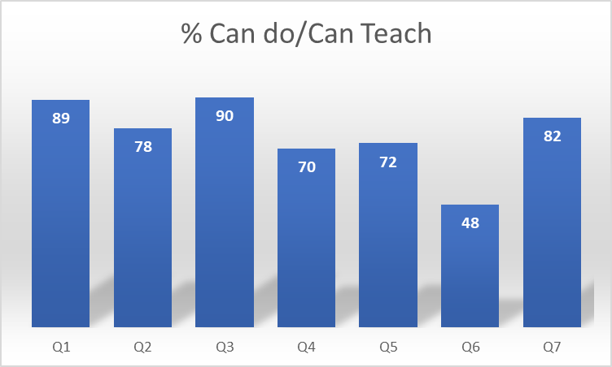

Course Communication Summary
- I can send announcements/email reminders to course participants
- I can create and moderate discussion forums
- I can use synchronous web-conferencing tools to interact with learners (e.g., Big Blue Button, Zoom, Skype)
- I can apply accessibility policies to accommodate learner needs

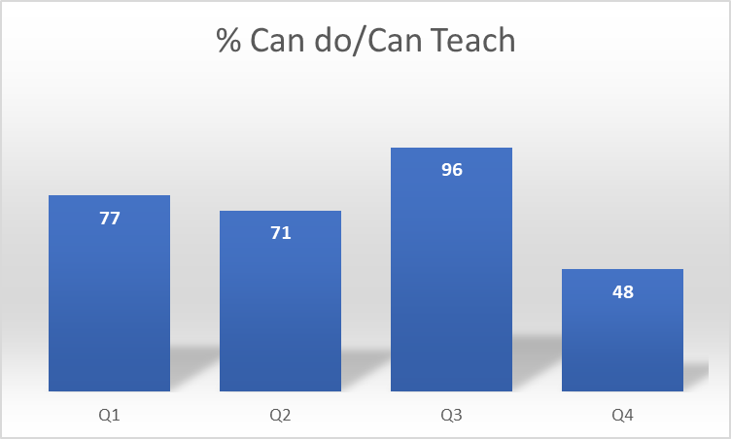

Time management Summary
- I can schedule weekly hours to facilitate the online course
- I can use features in learning management system in order to manage time (e.g., online
- I can use facilitation strategies to manage time spent on course (e.g., discussion board moderators, collective feedback, peer evaluation)

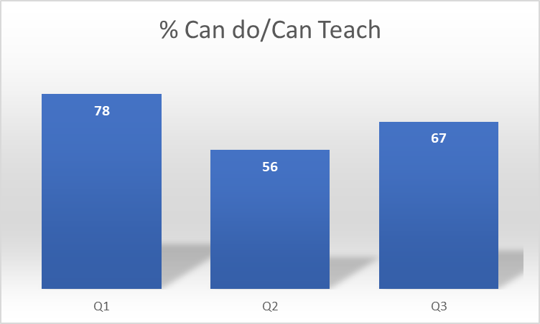

Technical competence Summary
- I can complete basic computer operations (e.g., creating and editing documents, managing files and folders)
- I can navigate within the course in the learning management system, Moodle
- I can create and manage course files and folders within Moodle
- I can create online quizzes, tests, and assignments
- I can set up the class gradebook and manage student grades in Moodle, such as set a grading scale, use points/percentages, and submit final grades.
- I can share open educational resources (e.g., learning websites, Web resources, games and simulations)
- I can use Moodle tools to record videos or audio messages
- I can use the Moodle reporting tools to follow up on student activities/completion

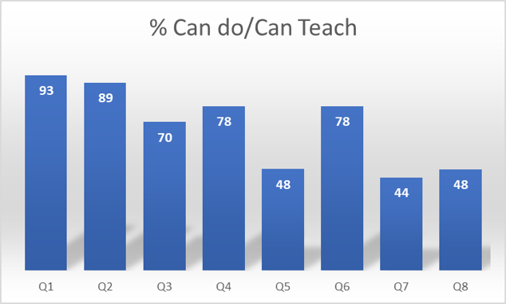

Annex III. Proposed Work Plan 2022
RTC/STC | Course name | Online/F2F | Date | Comments | IOC Programme | IOC Region | Priority
STC Argentina | Determinación del Límite Exterior de la Plataforma Continental | online | 2022 primer semestre |  | Law of the Sea | GLOBAL | High
 | Observador de Hielo Marino y Témpanos en español | online | 2022/05 |  | GOOS | GLOBAL | High
 | Oceanography Seminars | online | 2022 primer semestre | Course duration from March to June | other | GLOBAL | High
 | Gestión y publicación de datos de biodiversidad marina a través de OBIS | online | 2022 segundo semestre |  | IODE/OBIS | GLOBAL | Medium
 | Agua de lastre y bioincrustaciones: Evaluación, normativa y manejo de los vectores de introducción de especies exóticas marinas y de agua dulce | online | 2022/11 |  | IODE/OBIS | GLOBAL | Medim
 | Observador de Hielo Marino y Témpanos en inglés | online | 2022/10 |  | GOOS | GLOBAL | High
RTC Belgium | Ocean Data Management (self-paced) | online | ongoing |  | IODE | GLOBAL | High
 | Ocean Acidification (self-paced) | online | ongoing |  | OSS/Ocean Acidification | GLOBAL | High
 | Co-designing the science we need for the Ocean Decade | online | 2022 first quarter |  | Ocean Decade | GLOBAL | High
 | Ocean Literacy (self-paced) | online | ongoing |  | Ocean Literacy | GLOBAL | Medium
 | Ocean Best Practices (self-paced) | online | 2022 mid |  | GOOS+IODE | GLOBAL | Medium
RTC China | Qualiy control on ocean survey technology | online | 2022/10 | The course mainly based on ocean observation system, principle and technology of thermohaline depth measurement instrument. New techniques on quality control of ocean survey technology will be discussed during the training. | GOOS+IODE | WESTPAC
RTC Colombia | Tecnologías de Información (SIG) aplicado al Medio Marino y Costero. Caso de estudio: Determinación de zonas de conservación con ArcGIS | F2F | 2022/05/15-2022/05/20 | El curso proporciona conocimientos básicos acerca de los Sistemas de Información Geográfica (SIG) y su aplicación en temas marinos y costeros. Esto incluye temas como: métodos de adquisición de datos, técnicas de procesamiento, análisis espacial e interpretación de datos, creación de productos basados en los resultados de los análisis y métodos de publicación | IODE/OBIS | IOCARIBE | High
 | Comunicación de la Ciencia - Historias sobre el Océano | unsure | 2022/06/20-2022/06/24 | El curso proporciona conocimientos sobre la correcta divulgación de la ciencia, la importancia del uso de términos, de descubrir historias y de profundizar en las actividades que giran en torno a los mares y costas, en el marco del Decenio de las Ciencias Oceánicas para el Desarrollo Sostenible. Se abordan temáticas en torno a: Decenio de las Ciencias Oceánicas, el papel del periodismo ambiental, alfabetización oceánica, ocean literacy. | Ocean Literacy | IOCARIBE | Medium
 | Curso regional de capacitación y entrenamiento sobre determinación/cuantificación de microplásticos en ecosistemas costeros. | online | 2022/06 | Curso enfocado en determinación/cuantificación de microplásticos en ecosistemas costeros. Aporte al ODS 14.1. | OSS | IOCARIBE | Medium
 | Gestión y publicación de datos a través de la Red Global de Biodiversidad del Genoma (GGBN) | online | 2022/06 | Las muestras genómicas de organismos no modelo son cada vez más importantes en una amplia gama de estudios, desde la biología del desarrollo hasta los análisis de biodiversidad y su conservación. Toda esta información, asociada a las colecciones de tejido y/o ADN así como a las colecciones biológicas, debe digitalizarse y difundirse entre las comunidades científicas, así como entre las diferentes bases de datos. Con el fin de facilitar el intercambio de información sobre muestras genómicas y sus datos derivados, la GGBN, a través de su estándar de datos, proporciona lineamientos para promover el intercambio de información relacionado a la muestra genómica y su espécimen asociado, incluyendo datos sobre muestras de tejido, ADN, ADN ambiental y secuencias. A su vez provee una plataforma que facilita herramientas para la gestión, publicación y consulta de datos. La GGBN fomenta colaboraciones entre repositorios de biodiversidad con el fin de cumplir con estándares de calidad, mejores prácticas, interoperabilidad e intercambio de material de acuerdo con la legislación y convenciones nacionales e internacionales, beneficiando así a la sociedad a través de investigaciones que contribuyan al desarrollo y conservación de la biodiversidad. Específicamente para la biodiversidad marina, el desarrollo de este curso contribuirá al reto de lograr un océano transparente y accesible en el marco de la década de las Ciencias Oceánicas para el Desarrollo Sostenible (2020-2030). Actualmente este curso se está gestionando con la GGBN, esperamos terminar este proceso para su confirmación. | IODE/OBIS | IOCARIBE | High
 | Cambio climático: Carbono azul y adaptación basada en ecosistemas marinos y costeros | online | 2022/03 or 2022/07 | El curso busca sentar las bases respecto a los conceptos y prácticas relacionadas con carbono azul (mitigación – captura de CO2) y adaptación en ecosistemas marinos y costeros, en el marco de la convención de cambio climático, el plan estratégico Ramsar 2016 – 2024 y los objetivos de Desarrollo Sostenible 13 y 14. Busca también una retroalimentación e intercambio de experiencias por parte de todos los participantes de acuerdo a sus conocimientos y lecciones aprendidas en temas de conservación y manejo de ecosistemas marinos y costero o planificación de usos en el territorio. | IODE/OBIS | IOCARIBE | High
 | Curso regional de capacitación y entrenamiento sobre medición del sistema de carbonatos para la evaluación del indicador de acidez media (ODS 14.3.1). | online & F2F | 2022/08 | Curso enfocado en medición del sistema de carbonatos para la evaluación del indicador de acidez media (ODS 14.3.1). | OSS/Ocean Acidification | IOCARIBE | High
 | Curso regional de capacitación y entrenamiento sobre introducción a la eutrofización en ecosistemas costeros. | online | 2022/09 | Curso enfocado en eutrofización en ecosistemas costeros. Aporte al ODS 14.1. | OSS/HAB | IOCARIBE | Medium
 | Bases conceptuales y prácticas sobre la restauración en Manglares | online | 2022/10 | La degradación de ecosistemas marino costeros es una problemática ampliamente identificada frente a la cual se enfrentan los ecosistemas hoy por hoy, cuyo impacto se refleja directamente en los servicios ecosistémicos que proveen. Por ello, en el marco de la década de las Ciencias Oceánicas para el Desarrollo Sostenible y la Década de la Restauración de ecosistemas (2020-2030), declaradas por UNESCO, se presenta el curso; que busca presentar herramientas conceptuales y prácticas que permitan a profesionales, investigadores y técnicos, abordar la degradación de ecosistemas de manglar desde el enfoque de la restauración ecológica, considerando los aspectos biofísicos, socioeconómicos y de gobernanza, que faciliten la generación experiencias de restauración exitosas y sostenibles en el tiempo. | MPR | IOCARIBE | Medium
 | Curso - Taller REDCAM 2022 | online | 2022/10 | Curso enfocado en temáticas para la gestión sobre los recursos hídricos marinos y costeros | IODE/OBIS | IOCARIBE | High
 | Marine Proteted Areas | F2F | 2022/11 | El curso brinda un contexto sobre las Áreas Marinas Protegidas - AMP a nivel global,y para Latinoamérica y frente a amenazas como el cambio climático, en el marco del CDB, los objetivos de Desarrollo Sostenible 13 y 14 y el Decenio de las ciencias oceánicas. Abarca los temas de bases conceptuales sobre áreas marinas protegidas, monitoreo y herramientas, planeación, manejo, gobernanza y tematicas trasversales como cambio climático, pesquerías y otras actividades al interior de las AMP y en lo nacional. Busca también una retroalimentación por parte de todos los estudiantes de acuerdo a sus experiencias y entrenamiento adquirido en temas de conservación y manejo, para promover el desarrollo de metodologías que orienten hacia el manejo efectivo de las AMP. | MPR | IOCARIBE | High
RTC Cono Sur | Coastal/Marine Spatial Planning (2nd edition) | online | 2022/05-2022/06 |  | MPR
 | Integrated coastal management: lessons learned from local case studies in Iberoamerica | online | 2022/08-2022/09 |  | MPR
 | Oceans, climate and coastal risks | unsure | 2022/11 |  | MPR
RTC Ghana | Fishing vessel traffic data analyses for fisheries management | online | 2022/05/16-2022/05/27 | The course will be held online until it becomes conducive to conduct in the face-to-face mode |  | IOCAFRICA
 | Fisheries statistics and data collection | online | 2022/06/13-2022/06/24 | The course will be held online until it becomes conducive to conduct in the face-to-face mode |  | IOCAFRICA
 | Marine pollution monitoring and assessment | online | 2022/07/11-2022/07/22 | The course will be held online until it becomes conducive to conduct in the face-to-face mode |  | IOCAFRICA
 | Monitoring and detection of harmful algal blooms (HABs) in coastal systems | online | 2022/11/28-2022/12/9 | The course will be held online until it becomes conducive to conduct in the face-to-face mode | OSS/HAB | IOCAFRICA
STC HAB | Identification of Marine Harmful Algal Bloom Species | online | to be advised |  | OSS/HAB | GLOBAL | High
RTC India | Coastal Vulnerability Mapping and analysis using QGIS | unsure | 2022/04 | Exact dates will be finalized based on the closed holiday list for next year | MPR | IOCINDIO | Medium
 | Ocean Color Remote Sensing - Data, Processing and Analysis | unsure | 2022/06 | Exact dates will be finalized based on the closed holiday list for next year | IODE | IOCINDIO | High
 | Discovery and Use of Operational Ocean Data Products and Services. | unsure | 2022/09 | Exact dates will be finalized based on the closed holiday list for next year | IODE | IOCINDIO | Medium
STC Indonesia | Training on Advanced Ocean Forecast System | unsure | 2022/06 | This is a continuation of the basic OFS training held in August 2021 | GOOS | WESTPAC
 | Ocean literacy training for Fishermen | online & F2F | 2022/10 | Hopefully it could be F to F, since there are some simulations on operating meteorology instruments | Ocean Literacy | WESTPAC
RTC Kenya | Ocean Observations through Remote Sensing (OORS) – Sentinel-3 data products and services | ? | 2022/05/09-2022/05/13 |  | IODE | IOCAFRICA
RTC Malaysia | Introduction to Marine GIS using QGIS | unsure | 2022/06 |  | IODE | WESTPAC
 | Integrated Data Analysis for Upwelling Studies | unsure | 2022/03 | Part of Commitment with IOC WESTPAC | other | WESTPAC
RTC Mozambique | Oceanographic data collection techniques (CTD, ADCP, Tide gauges, wave gauges, Moored Current meter, drifters) | online | 2022/02/21-2022/02/25 |  | IODE | IOCAFRICA
 | Accessing free oceanographic programs and data | online | 2022/06/06-2022/06/10 |  | IODE | IOCAFRICA
 | Introduction to Ocean Data View (uploading data, bathymetry, contours, plotting diagrams and profiles) | face-to-face | 2022/10/03-2022/10/07 |  | IODE | IOCAFRICA
RTC Portugal | Deep Sea Mineral Resources | online | 2022/11/22-2022/11/30 | The course will focus on the formation and distribution of deep sea mineral resources, their exploration and possible future exploitation. The issues related with the protection and conservation of the marine environment will be also discussed as well as the role of the deep sea mineral resources to accomplish the Sustainable Development Goals envisaged by the United Nations to be achieved by 2030 | other | GLOBAL
 | Deep Sea Natural Resources in the Framework of The United Nations Convention on The Law of The Sea | online | 2022/11/14-2022/11/21 | The course will focus on the biological and geological deep sea natural resources, their importance for society and the legal regimes applied to the relevant maritime zones | Law of the Sea
 | Biomonitoring of hazardous substances in coastal ecosystems | online & F2F | 2022/01 | The aim of the course is to provide practical understanding and tools to carry out expeditious biomonitoring of coastal ecosystems. | IODE/OBIS | GLOBAL
 | Harmful Algal Blooms: environmental drivers, impacts, and prediction | online | 2022/02/01-2022/02/15 | This course aims to provide in-depth knowledge on the organisms forming harmful algal blooms, their life traits, environmental drivers, distribution patterns and trends over different types ofaquatic ecosystems. | OSS/HAB | GLOBAL
 | Applications of Ocean Colour Remote Sensing | online | to be confirm | to enable the trainees to understand the OCRS based applications to the study and management of marine processes and ecosystems. | IODE | GLOBAL
 | Observational oceanography and online resources for marine ecosystem analysis | face-to-face | to be confirm | To provide a brief overview on instruments employed on ocean observations; To provide an introduction on the use of free software for synthesis of ocean data and analyses; To discover and use of multi-parameter ocean data collections; To develop ocean data and products from multiple sources using selected software programs | GOOS | GLOBAL
 | The change we need for the ocean we want - Ocean Literacy with schools | online | 2022/01 | Empower teachers with more tools, critical thinking and understanding about the ocean and increase awareness about their daily relationship with it and how their behaviours can impact Ocean sustainability. It is intended that the trainees' learning is transferred and adapted to formal educational contexts. | Ocean Literacy | GLOBAL
 | Marine Biopolymers: extraction, processing and applications | online | to be confirm | to know the different biopolymers of marine origin, the procedures to isolate them, the techniques used for their characterization and exemplify research strategies for the development of biomaterials based on biopolymers of marine origin for application in the biomedical field. | IODE/OBIS | GLOBAL
 | Observing the Physical Properties of the Ocean | online & F2F | Spring_Summer | The course aims an introduction to observational oceanography and its importance for ocean and coastal monitoring. Students will learn where to acquire online, freely available in situ and remote oceanographic data and exploring open-source software tools to develop ocean data and products | GOOS | GLOBAL
 | Marine Biogeochemistry: Biogeochemical and ecological dimensions of a changing ocean | online | 2022/06 | To provide PhD students and young Researchers with an exceptional opportunity to gain a better understanding of the marine biogeochemical cycles and large-scale distribution of biological utilized elements and/ or tracers of oceanographic processes and their isotopes. | OSS | GLOBAL
 | Mud volcanism, migration and seepage of fluids in continental margins | online | to be confirm | To recognise and characterize the indicators of fluids migration and fluids seepage in the geological records, and evaluate their significance to the architecture and evolution of continental margins. | other | GLOBAL
 | Capacity building for ocean governance – participatory methodologies for collaborative management of the commons | online | 2022/02-2022/03 | Learn about ocean governance namely how to promote new forms of collaborative management, by actively engaging the multiplicity of entities operating in a multiscale level for jointly build strategies for ocean management, building up models of collaborative governance | other | GLOBAL
 | Marine Litter: monitoring, awareness and waste management | F2F preferred; if not online or blended | 2022/03 | Learn about one of the most worrisome threats to the integrity of marine ecosystems, what are the sources and sinks and what can be done to prevent and reduce its impacts with a focus on public awareness, waste management and circular economy | IODE/OBIS | GLOBAL
 | Climate change, ecosystems-based management and green Infrastructures towards a blue sustainable community- based development | online or blended | 2022/06-2022/07 | The main objective of this course is to understand how the paradigm shift provided by the “Working with nature” approach is essential to increase the resilience of coastal communities to climate change. | other | GLOBAL
 | Marine Social Sciences – a pluriverse perspective | online | to be confirm | To introduce the perspective of social sciences in societal development; To provide a systemic view on marine social sciences; To sensitize to the human dimension in marine policies, economics, and management; To raise awareness of critical citizenship in sustainable marine development; To provide tools to contribute to the building of sustainable and resilient marine communities; To develop critical sensitivity to the common ground between the agendas for sustainable marine development and socio-economic development; To empower for the understanding of social actors dynamics in marine communities; To foster an innovation that feeds back with the participation of the marine communities’ members in the production of knowledge and in decision-making. | other | GLOBAL
 | Coastal Ecosystems Restoration and Community- based Management | F2F preferred; if not online or blended | 2022/04-2022/05 | to provide participants with the main instruments for the restoration/rehabilitation of degraded coastal ecosystems, according to the state of the art and best practices for the requalification of coastal territories in the North Atlantic; Provide the participants with the skills to restore degraded ecosystems, according to state-of-the-art practices, to achieve a sustainable and a requalified environment; Elaborate plans/projects for ecosystems restoration and to monitor the success of those plans/projects for the sustainable management of the territory; Intertwine theory and practice, through field evaluation of implemented techniques in ongoing projects or using case studies. Develop a strategy for the active integration of coastal communities in the restoration process. | MPR | GLOBAL
 | Risk modelling in urban coastal areas to support an early warning, emergency planning and risk management system in extreme weather events | online | 2022/01-2022/02 | Understanding the nature and approaches to coastal risk phenomena in vulnerable urban areas or under anthropogenic pressure; Introduction to the most recent methodologies and techniques for Risk modeling and early warning for emergency planning; The discussion of good practices in the assessment of coastal risk, from the perspective of risk management and decision support; and the importance of risk literacy and the active involvement of coastal communities | MPR | GLOBAL
 | Microalgae Production | face-to-face | 2022/06-2022/07 | Knowledge and the practical tools to produce and to maintain cultures of microalgae. The methods to modulate the biochemical characteristics of microalgae strains | IODE/OBIS | GLOBAL
 | Conservation physiology, trophic ecology and tracking of marine top predators | online | 2022/01 | To learn modern tools for the study and use of marine top predators as ecological indicators | IODE/OBIS | GLOBAL
 | Management and mitigation of coastal erosion | online | 2022/01/07-2022/02/04 | This course aims to address the causes of coastal erosion and discuss measures for their mitigation, mapping the risk of erosion, presenting study examples, assessing the costs and benefits of coastal defense interventions, and discussing planning and monitoring policies. | MPR | GLOBAL | 1
RTC Pacific | Ocean Science to Services: Introduction to the Pacific Ocean Portal (5 day course) |  | 2022/04-2022/06 | Scientific Knowledge & Research; Ocean Data Management; Disaster Risk Reduction; Marine & Coastal Ecosystems; Australian BOM, USP, PCCOS; Ocean Science to Service 8 module course materials and training exercises; Consultancy underway to transfer courses for online delivery. | GOOS+IODE | WESTPAC
 | Pacific Islands Marine Bioinvasions Alert Network (PACMAN) monitoring and awareness courses |  | 2022/07-2022/09 | Biological monitoring; maritime safety, customs and biosecurity USP, SPREP, IODE, PCCOS; OTGA delivery required. Some courses to be delivered in person, others online; Support required for online course development. | IODE/OBIS | WESTPAC
 | QGIS for Coastal Fisheries (5 day course) |  | 2022/04-2022/06 | Ocean Data Management; Sustainable Use of Marine Resources PEUMP, PCCOS; 1st module is fully developed for Moodle; 2 months development required for additional modules, prior to upload and delivery via OTGA. | IODE | WESTPAC
 | Oceanographic Instrument Deployment, Maintenance and Return to Service |  | 2022/10-2022/12 | Ocean Scientific Knowledge; Ocean Data Management Australian BOM, PCCOS; Return-to-Service manuals, checklists, and SOPs; Development of presentations/videos, phased course materials. | GOOS+IODE | WESTPAC
STC ITIC and STC Indonesia | 1. Tsunami Awareness - overview covering hazard assessment, warning, preparedness, mitigation, response - 4-8 hrs content | online | 2022 | English, Spanish, Standard content with options for regional customization. Audience: All levels, no background necessary. Interest by other RTCs | Tsunami | GLOBAL
 | 5. Tsunami Ready (IOC MG 74) - Overview of guidelines, process for establishing Tsunami Ready Programmes and recognizing Tsunami Ready communities - 4-6 hrs content | online | 2022 1st Quarter | English, Spanish, Standard content with options for regional customization. Audience: government and non-government officials responsible or interested in tsunami preparedness, and in establishing programme | Tsunami | GLOBAL
 | 2. Tsunami Early Warning Systems - components of, and requirements for a robust, reliable, and effective tsunami warning system - 40 hrs content | online & F2F | 2022 2nd Quarter | English, Spanish, Standard content with options for regional customization. Audience: staff of agencies responsible for tsunami warning and mitigation in a country. Potential interest by other RTCs | Tsunami | GLOBAL
 | 3. TEMPP (Community Tsunami Evacuation Maps, Plans, and Procedures, IOC MG 82) - 4 modules, each 40 hrs content (160 hrs total): 1. Identifying Tsunami Inundation Areas, 2. Developing Tsunami Evacuation Maps, 3. Developing Tsunami Response Plans and Standard Operating Procedures, 4. Tsunami Exercising | online & F2F | 2022 to 2023 (4-modules) | English. Sequential training (40-hr content/module) and tsunami product development with outcome that community can be recognized as UNESCO IOC Tsunami Ready. Audience: scientists, government officials, and non-government organizations involved in tsunami preparedness. Potential interest by other RTCs | Tsunami | GLOBAL
 | 4. Tsunami Warning and Emergency Response Standard Operating Procedures (IOC MG 76) - procedures and protocols used successful tsunami warning | online & F2F | 2022 3rd Quarter | English, Standard content. Audience: staff of agencies involved in tsunami warning and emergency response in a country. Potential interest by other RTCs | Tsunami | GLOBAL
 | 6. Tsunami Warning Center Staff Basic Competencies - Information and skill requirements for tsunami warning center staff. Topics cover science of earthquakes and tsunamis, analysis methods, tools and techniques for monitoring, assessing the tsunami threat, issuing alerts, and cancelling tsunami warnings - 120 hrs content | online & F2F | 2023 | English, Spanish, Standard content with options for regional customization. Audience: staff of tsunami warning centers. Potential interest by other RTCs | Tsunami | GLOBAL
 | 7. Tsunami Hazard and Risk Assessment (IOC MG 49 Japan example, IOC MG 52 Indian Ocean) - 40 hrs content | online & F2F | 2022 | English, Spanish, Standard content with options for regional customization. Audience: scientists, universities, and staff of agencies responsible for tsunami warning mitigation in a country. Potential interest by other RTCs | Tsunami | GLOBAL

Annex IV. List of Participants

OTGA RTC/STC Representative
Mr. Benjamin BOTWE
Lecurer
Department of Marine and Fisheries Science
University of Ghana
Department of Marine & Fisheries Sciences
University of Ghana
Legon, Accra
Ghana
Email: boseibotwe@yahoo.co.uk
Mr. Jonathan CEDEÑO
Oceanographer
Facultad de Ingeniería Marítima y Ciencias del Mar
Escuela Superior Politecnica del Litoral
Km. 30.5 Via Perimetral
Guayaquil
Ecuador
Email: jcedeno@espol.edu.ec
Ms. Fangfang CHEN
Engineering
Business Planning Department
National Centre of Ocean Standard and Metrology
No.219, the Western Jieyuan Road
Nankai District
Tianjin 300112
China
Email: chenfangfang@ncosm.org.cn
Mr. Daniel CONDE
Professor
Facultad de Ciencias
Universidad de la República
Av. 18 de Julio 1968
Montevideo
Uruguay
Email: vladddcc@gmail.com
Ms. Nancy CORREA
Scientist
Oceanografía
Servício de Hídrografia Naval
Avda. Montes de Oca 2124
C1270ABV Buenos Aires
Argentina
Email: ncorrea59@gmail.com
Ms. Laura KONG
Director ITIC
UNESCO IOC NOAA International Tsunami Information Centre
1845 Wasp Blvd, Bldg 176
Honolulu, Hawaii 96818 USA
United States
Email: laura.kong@noaa.gov
Mr. Aidy M MUSLIM
Professor
Institute of Oceanography and Environment (INOS)
Institute of Oceanography and Environment
Universiti Malaysia Terengganu (UMT),Mengabang Telipot
21030 Kuala Terengganu
Terengganu
Malaysia
Email: aidy@umt.edu.my
Ms. Filomena MARTINS
Associate Professor
Department of Environment and Planning and GOVCOPP
Universidade de Aveiro, Departamento de Ambiente e Ordenamento, Unidade de Investigação em Governança, Competitividade e Políticas Públicas
Campus Universitário de Santiago
Departamento de Ambiente e Ordenamento
3810-193 Aveiro
Portugal
Email: filomena@ua.pt
Ms. Noer NURHAYATI
Director, Climate, Agroclimate and Marine Climate Center
Badan Meteorologi, Klimatologi, dan Geofisika
JI. Angkasa I No. 2 Kemayoran
Jakarta Pusat
Indonesia
Email: noerha04@gmail.com
Mr. Harrison ONGANDA
Research Officer
Research
Kenya Marine and Fisheries Research Institute, Headquarter & Mombasa Station
PO Box 81651
Mombasa 080100
Kenya
Email: honganda@kmfri.go.ke
Ms Lise Øvreås
STC Norway
Bergen
Norway
Email: lise.ovreas@uib.no
Ms. Molly POWERS
Team Leader, Ocean Literacy and Maritime Capacity
Oceans & Maritime Programme
Secretariat of the Pacific Community - Regional Office
Ratu Mara Road
Private Mail Bag
Suva
Fiji
Email: mollyp@spc.int
Ms. Marinez SCHERER
Professor
Oceanography
Universidade Federal de Santa Catarina
Caixa Postal: 246 Campus Reitor João David Ferreira Lima Trindade
Florianópolis-Santa Catarina
CEP 88040-970
Brazil
Email: marinezscherer@gmail.com
Ms. Paula SIERRA-CORREA
Research and Information Coordinator
Research and Information for Coastal Zone Management
Instituto de Investigaciones Marinas y Costeras José Benito Vives de Andreis
Calle 25 No. 2-55, Playa Salguero, Rodadero
Santa Marta D.T.C.H., Magdalena,
Colombia
Email: paula.sierra@invemar.org.co
Mr. Ariel TROISI
Technical Secretary
Servício de Hídrografia Naval
Avda. Montes de Oca 2124
C1270ABV Buenos Aires
Argentina
Email: atroisi@hidro.gov.ar
Mr. Tata VS UDAYA BHASKAR
Head, Ocean Data Management Division,
Additional Charge Program Planning Coordination Group (PPG)
Indian National Centre for Ocean Information Services
INCOIS, Ocean Valley, Pragathinagar (BO), Nizampet (SO)
Hyderabad 500090
Telangana
India
Email: uday@incois.gov.in
Ms. Ting YU
Associate Researcher
Division of Science and Technology Planning and Management
National Marine Data and Information Service(NMDIS)/SOA
93 Liuwei Road, Hedong District
Tianjin 300171
China
Tel: +86-22-24010768
Email: julia_yu_nmdis@yahoo.com
IOC Secretariat
Mr. Bernardo ALIAGA ROSSEL
Programme Specialist
Intergovernmental Oceanographic Commission of UNESCO
7, place de Fontenoy
75732 Paris cedex 07
France
Email: b.aliaga@unesco.org
Ms. Sofie DE BAENST
Administrative Assistant
UNESCO / IOC Project Office for IODE
Wandelaarkaai 7
Pakhuis 61
8400 Oostende
Belgium
Email: s.de-baenst@unesco.org
Ms. Kristin DE LICHTERVELDE
Administrative Services Manager
UNESCO / IOC Project Office for IODE
Wandelaarkaai 7
Pakhuis 61
8400 Oostende
Belgium
Email: k.de-lichtervelde@unesco.org
Ms. Cláudia DELGADO
OTGA Project Manager, IODE Training Coordinator
UNESCO / IOC Project Office for IODE
Wandelaarkaai 7
Pakhuis 61
8400 Oostende
Belgium
Email: c.delgado@unesco.org
Ms. Johanna DIWA
IOC Consultant
Capacity Development
UNESCO / IOC Project Office for IODE
Wandelaarkaai 7
Pakhuis 61
8400 Oostende
Belgium
Email: jp.diwa@unesco.org
Mr. Henrik ENEVOLDSEN
Head of Centre, IOC UNESCO Programme Coordinator, Technical Secretary IPHAB
IOC Science and Communication Centre on Harmful Algae
Universitetsparken 4
University of Copenhagen, Dept of Biology, Marine Biological Section
2100 Ø Copenhagen
Denmark
Email: h.enevoldsen@unesco.org
Ms. Kirsten ISENSEE
Programme Specialist - Ocean Carbon Sources and Sinks
Ocean Science Section
Intergovernmental Oceanographic Commission of UNESCO
7, place de Fontenoy
75732 Paris cedex 07
France
Email: k.isensee@unesco.org
Mr. Mika ODIDO
IOC Coordinator in Africa
UNESCO/IOC Sub Commission for Africa and the Adjacent Island States
UNESCO Nairobi Office
UN Gigiri Complex Block C
P.O. Box 30592
Nairobi 00100
Kenya
Email: m.odido@unesco.org
Mr. Peter PISSIERSSENS
Head, IOC Project Office for IODE, Oostende, Belgium and IOC capacity development coordinator
UNESCO / IOC Project Office for IODE
Wandelaarkaai 7
Pakhuis 61
8400 Oostende
Belgium
Email: p.pissierssens@unesco.org
Mr. Greg REED
IOC consultant
UNESCO / IOC Project Office for IODE
UNESCO / IOC Project Office for IODE
Wandelaarkaai 7
Pakhuis 61
8400 Oostende Belgium
Email: g.reed@unesco.org
Ms. Katherina SCHOO
Consultant - Ocean Acidification
Ocean Science Section
Intergovernmental Oceanographic Commission of UNESCO
7, place de Fontenoy
75732 Paris cedex 07
France
Email: k.schoo@unesco.org
Ms. Lucy SCOTT
Ocean InfoHub Project Manager; Marine Scientist
UNESCO / IOC Project Office for IODE
Wandelaarkaai 7
Pakhuis 61
8400 Oostende
Belgium
Email: l.scott@unesco.org
Ms. Pauline SIMPSON
IOC Consultant
UNESCO / IOC Project Office for IODE
Wandelaarkaai 7
Pakhuis 61
8400 Oostende
Belgium
Email: p.simpson@unesco.org
FUST Representative
Ms. Ann-Katrien LESCRAUWAET
Director International Relations
International Relations
Vlaams Instituut voor de Zee
Wandelaarkaai 7
8400 Oostende
Belgium
Email: annkatrien.lescrauwaet@vliz.be
Mr. Gert VERREET
Policy Advisor
Vlaamse Overheid - Departement Economie, Wetenschap & Innovatie, Afdeling Onderzoek
Koning Albert II-laan 35 bus 10
1030 Brussel
Belgium
Email: gert.verreet@vlaanderen.be
IODE
Mr. Sergey BELOV
deputy director
All-Russian Research Institute Hydrometeorological Information - World Data Center, Obninsk
6, Korolev St.,Obninsk,
Obninsk Kaluga region 249035
Russia
Email: belov@meteo.ru
OBSERVERS
Adityawarman Adityawarman
STC Indonesia
Jakarta Pusat
Indonesia
Madona Madona
STC Indonesia
Jakarta Pusat
Indonesia
Ratih Prasetya
STC Indonesia
Jakarta Pusat
Indonesia
Yuliana Purwanti
STC Indonesia
Jakarta Pusat
Indonesia
Katy Soapi
RTC Pacific
Suva
Fiji

[end of document]

https://www.youtube.com/watch?v=jGRMXTis-lA
https://www.youtube.com/watch?v=BpDvuqT2E2U
https://www.youtube.com/channel/UCI9bCuLFiDJ6fb7tCCW4ElQ
https://classroom.oceanteacher.org/pluginfile.php/49104/mod_label/intro/OTGA_Course_Management_Guidelines_v3.1.pdf
Martin, F., Budhrani, K., & Wang, C. (2019). Examining faculty perception of their readiness to teach online. Online Learning, 23(3), 97-119. doi:10.24059/olj.v23i3.1555

