Intergovernmental Oceanographic Commission
Reports of Meetings of Experts and Equivalent Bodies

IODE Steering Group for the OceanExpert project
(SG-OE-I)

First Session (online)
24 November 2021

UNESCO 2021

IOC/IODE-SG-OE-I
Ostend, 9 December 2021
English

GROUP PHOTO

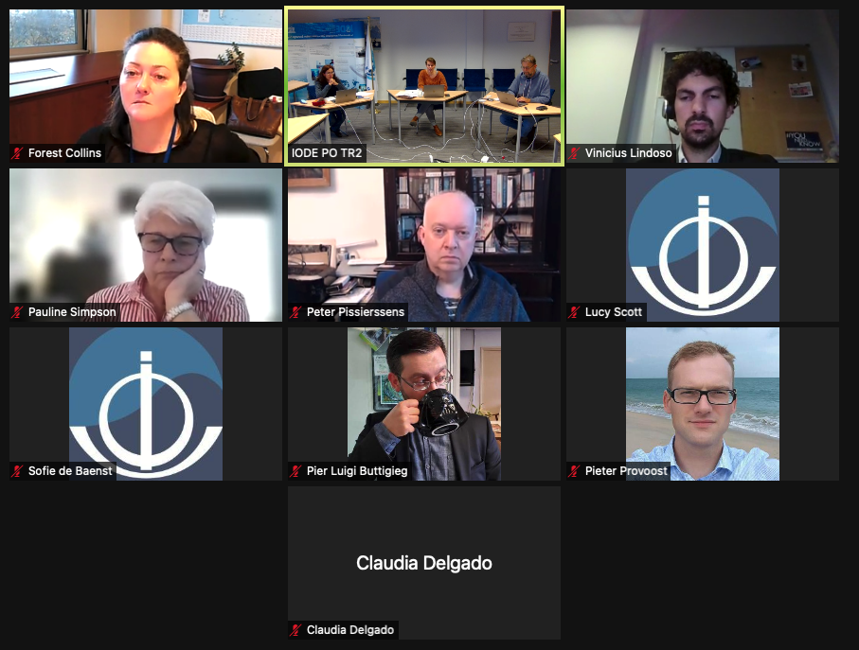

For bibliographic purposes this document should be cited as follows:
First Session of the IODE Steering Group for the OceanExpert project (SG-OE-I) Online, 24 November 2021. Paris, UNESCO, 5 p. 2021 (Reports of Meetings of Experts and Equivalent Bodies) (IOC/IODE-SG-OE-I) (English)
© UNESCO 2021

Table of Contents
1. opening of the meeting 1
1.1 introduction of participants 1
1.2 Adoption of the Agenda and Timetable 1
2. history of oceanexpert and statistics 1
3. oceanexpert vs competitors 2
4. strenghts and weaknesses of oceanexpert 2
4.1 strenghts 2
4.2 weaknesses 3
5. recommendations for the future oceanexpert 3
5.1 oceanexpert as a directory of ocean professionals contributing to ioc programmes and activities 3
5.2 optimization of the oceanexpert document repository 4
5.3 other suggestions for the future oceanexpert 4
6. Job descriptions 5
7. conclusion and way forward 5
8. closing of the meeting 5

Annex

Annex I: agenda
Annex II: diagram
Annex III: list of participants

opening of the meeting
The meeting was opened by Ms Sofie de Baenst, (UNESCO/IOC Project office for IODE) project manager of the OceanExpert project. The meeting was held as a hybrid event.

introduction of participants
The participants were requested to introduce themselves.

Adoption of the Agenda and Timetable
The Steering Group adopted the agenda and timetable. All documents were made available online on the OceanExpert website:
https://oceanexpert.org/event/3263
One additional agenda item was added as requested by Ms Sofie de Baenst. Agenda item 6: job description of the Content Manager and Technical Manager
The agenda is attached as Annex I.

history of oceanexpert and statistics
Based on the document prepared by Mr Peter Pissierssens, and other authors, Ms Sofie de Baenst explained that it all started with the creation of GLODIR (Global directory of Marine (and Freshwater) Professionals). That was set up in 1997 by the Group of Experts on Marine Information Management (GE-MIM). In 2002 GLODIR was renamed to OceanExpert to create more possibilities such as search options, send out mails, etc.
As from 2007, several IOC websites started to use “Paperclip” to connect to the OceanExpert database. This interface was a tool for creating/managing events and people, and to extract usage statistics. As Paperclip had a lot of security issues and considering that different versions were used for the different IOC sites, it was decided in 2021 to end the use of Paperclip to edit information in OceanExpert. Since then, the only interface to make changes in the database became https://oceanexpert.org.
Statistics show us that the number of entries in the OE database is increasing every year. At this moment there are more than 19,000 active users from all over the world registered (mainly based in USA, India and France).
Mr Vinicius Lindoso informed the Group that he uses OceanExpert also as a document repository, but that this feature is not as well developed in OE as it was in Paperclip. He informed us that using OceanExpert for documents has many advantages compared to Dropbox, Google, etc. to share documents with people all over the world. (there are no government restrictions on OE access, contrary to Google, Dropbox and others which cannot be used in a number of countries).

oceanexpert vs competitors
It was reported that there are several OceanExpert competitors such as LinkedIn, ORCID, ResearchGate and some others. The Steering Group agreed that many of these have their own limitations but that it can be an added value if a close link could be made between them and OE. This is especially the case for ORCID, being a platform by and for researchers and providing a unique ID for each expert. In this case, people could create and maintain their personal profile in one place (being ORCID), while that info can be used and displayed (with their permission) in OE. The unique ORCID profile, is easy to update on name, email addresses, institute information, …
Ms Lucy Scott pointed out that she also used OceanExpert to get in contact with regional experts before she started working at IOC.

strenghts and weaknesses of oceanexpert
This agenda item was introduced by Ms Sofie de Baenst who informed the Group on the strengths and weaknesses of the OceanExpert directory.

strenghts
- OceanExpert has become an integrated information management tool that is plugged into a number of IOC websites.

- Experts associated with IOC activities have become familiar with OceanExpert.

- IOC staff have become familiar with OceanExpert: for every event organized by the participating IOC programmes (IODE, GOOS, HAB, Tsunami, …) OceanExpert is used to prepare and display the list of participants, set up agenda items, link documents... This has resulted in substantial increases in records within the OE database.

- OceanExpert remains an easy to use and “free and open” source of contact information on experts and their institutions which enables experts to easily contact each other.

- OceanExpert is maintained by a UN agency and does not depend on revenue sourced from commercial activities. As such it can profile itself as a neutral, unbiased, advertisement free and totally free service. In addition, OceanExpert does not have geographic limitations due to political issues (in as far as UN decisions are respected).

- Through OIH/ODIS, OceanExpert has the opportunity to become a more key “connector” between individuals and their scientific output. Also, for regions without the capacity to set up their own data sharing forum, OceanExpert could be an entry point to participate in systems like ODIS, until national capacity is available in their region.

weaknesses

- A major weakness of OE today is that experts do not update their records on a regular basis. (This problem is not limited to OE) During the past years the IODE Secretariat therefore sent out an email to all experts in OE once a year inviting them to update their information. The annual mailing for 2021 is not done yet.

- The management of institutions in OE is not easy to use : due to the lack of a parent-child/hierarchy relation the number of institutions has become unmanageable and users often create duplicates which then need to be removed manually by the OE manager.

- While the inbuilt document management module is widely appreciated and used, its field structure does not comply with standards and the OE document repository is now competing with AquaDocs, ASFA and UNESDOC.

- The detailed information on expert activities is often incomplete and experts participating in IOC events often complain that entering that information takes too much time.

- OceanExpert has become more a Secretariat management tool rather than a tool that directly serves experts. Therefore, it is for the end user not always clear how to benefit from the system.

- While OceanExpert shows personal email addresses and physical addresses (institutional) to other members it is unclear whether this complies with the new GDPR regulations adopted by the European Union. Currently OE does not have a “switch” whereby experts can agree or disagree to make their email address visible. However, if we consider IOC activities, then lists of participants (including their email addresses) are always added to reports as an annex.

- OceanExpert does not keep individuals’ professional historical record. Once an individual changes job, all previous information is lost.

recommendations for the future oceanexpert

oceanexpert as a directory of ocean professionals contributing to ioc programmes and activities
The Steering Group agreed that the number of IOC websites that are now linked to OceanExpert through an API should be extended to other websites.
Good candidates are OBPS and the Alumni project of OTGA. OceanExpert will then be a a validator for multiple websites (once the expert profile is approved in OE, it doesn’t require an extra approval on the other websites). That kind of validation process is not offered by other platforms and will create an added value.
It is considered an option to limit the people who have full access to the OE data, to only those who are part of the IOC secretariat.
The Steering Group decided to investigate the possibility to create a distinction between people who only want to receive information (mailings) from IOC on its activities and people contributing to the IOC.
The Steering Group decided to consider setting up different classes of profiles in the system:
- people attending training courses
- people attending meetings
- contributors to documents
- participants in IOC assembly
The Steering Group further decided that, if the above-mentioned classes of profiles are created that this will not be implemented for historical IOC events and IOC documents. Most of the IOC documents are linked to IOC events. This new procedure would only apply for publications by experts and not for corporate authors (such as brochures).

optimization of the oceanexpert document repository
The Steering Group confirmed the advantage of a link with Aquadocs to improve the OceanExpert document repository functionality, as AquaDocs is harvested regularly by e.g. Google Scholar (thanks to the use of a standard field structure).
The link between OE and Aquadocs should be based on the correct metadata, which will enable search engines to find and understand the link.
The Steering Group also pointed out that authors of IOC documents (technical series, manuals and guides, working documents for meetings) are currently not mentioned as author on the document. Adding such reference would be an incentive for experts to use OceanExpert (and to keep their record up to date). This would also make an expert’s profile, more complete (expert/institute- event-document).
The Steering Group noted with regret that currently there is no possibility to set up a link between OE and UNESDOC

other suggestions for the future oceanexpert
It was suggested by Mr Lambert to make a distinction between technical and workflow/operational issues. Therefore, the creation of two working groups (useability and technical) would be an added value. It was not decided yet who should take part in these working groups.
Mr Pissierssens suggested to investigate the opportunity to contribute to the GOSR and STOR.
Ms Simpson suggested to investigate systems that OE could connect to. Mr Lambert replied that we will investigate the possibility for ORCID and AQUADOCS.

Job descriptions
The Steering Group agreed that Mr Arno Lambert will be Technical Manager and Ms Sofie de Baenst Content Manager for the OceanExpert project.

conclusion and way forward
The Group decided to have a stronger focus within OceanExpert on experts contributing to the work of IOC and to add new services (linking documents authors to OE records). The Group requested the Secretariat to discuss this at the level of the IOC’s MTM.
While taking into consideration the above decision on IOC focus, the Steering Group decided to study the possibility to let people decide on creating a profile for mailings or a more extensive profile as an IOC contributor.
The Steering Group decided to investigate ways to link OceanExpert with other online data and information systems (e.g. ORCID) in order to make sure the expert profiles remain up to date and for experts to keep their history on expertise in their record.
The Steering Group decided to investigate if there is an opportunity to get a focal point per institution that could confirm that the information and the linked experts are still correct and up to date. The Group also raised the question on how to enter, as well as quality control, experts not linked to an institution. External websites such as ResearchGate and ORCID could also contribute to this.
The Steering Group decided to check on current GDPR and UN regulations on storing personal data. This needs to be done on the level of IOC secretariat and UNESCO.
The Steering Group agreed that the creation of an Alumni system between OTGA and OE would be of benefit for ‘learners’ to be able to keep track of them and their professional career.

closing of the meeting
The meeting was closed by Ms de Baenst and it was agreed that a report of this meeting will be distributed to all participants by email. A workplan will be created and a next meeting will take place in 2022 (no date decided).
The meeting was closed on 24 November 2021 at17:00 CET .

Annex I.
Agenda of the meeting

- OPENING OF THE MEETING [10’]

  - Introduction of the participants
  - Agenda and timetable

- HISTORY OF OCEANEXPERT AND STATISTICS [10’]

- OCEANEXPERT VERSUS COMPETITORS [10’]

- STRENGHTS AND WEAKNESSES OF OCEANEXPERT [20’]

- RECOMMENDATIONS FOR THE FUTURE OCEANEXPERT [40’]

  - OceanExpert as a directory of Ocean professionals contributing to IOC programmes and activities
  - Optimization of the OceanExpert document repository
  - Other suggestions for the future OceanExpert

- JOB DESCRIPTIONS [5’]

- CONCLUSION AND WAY FORWARD [20’]

- CLOSING OF THE MEETING [5’]

Annex II.
Diagram of current/ future and possible linkages to OceanExpert

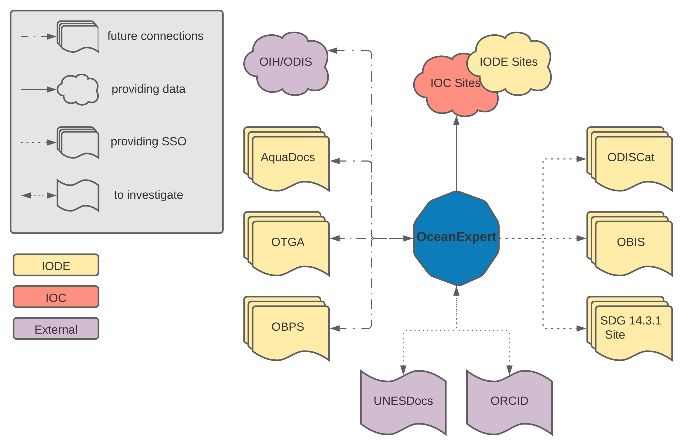
Annex III.
List of participants

Mr. Pier Luigi BUTTIGIEG
Data Scientist
Helmholtz Metadata Collaboration
GEOMAR | Helmholtz Centre for Ocean Research Kiel
Duesternbrooker Weg 20
24105 Kiel
Germany
Email: pier.buttigieg@awi.de
Ms. Forest COLLINS
Programme Assistant
Intergovernmental Oceanographic Commission of UNESCO
7, place de Fontenoy
75732 Paris cedex 07
France
Email: f.collins@unesco.org
Ms. Sofie DE BAENST
Administrative Assistant
UNESCO / IOC Project Office for IODE
Wandelaarkaai 7
Pakhuis 61
8400 Oostende
Belgium
Email: s.de-baenst@unesco.org
Ms. Cláudia DELGADO
OTGA Project Manager, IODE Training Coordinator
UNESCO / IOC Project Office for IODE
Wandelaarkaai 7
Pakhuis 61
8400 Oostende
Belgium
Email: c.delgado@unesco.org
Mr. Arno LAMBERT
IT Services Manager
UNESCO / IOC Project Office for IODE
Wandelaarkaai 7
Pakhuis 61
8400 Oostende
Belgium
Email: a.lambert@unesco.org
Mr. Vinicius LINDOSO
Digital Communications / Web Editor
Intergovernmental Oceanographic Commission of UNESCO
7, place de Fontenoy
75732 Paris cedex 07
France
Email: v.lindoso@unesco.org
Mr. Peter PISSIERSSENS
Head, IOC Project Office for IODE, Oostende, Belgium and IOC capacity development coordinator
UNESCO / IOC Project Office for IODE
Wandelaarkaai 7
Pakhuis 61
8400 Oostende
Belgium
Email: p.pissierssens@unesco.org
Ms. Lucy SCOTT
Ocean InfoHub Project Manager; Marine Scientist
UNESCO / IOC Project Office for IODE
Wandelaarkaai 7
Pakhuis 61
8400 Oostende
Belgium
Email: l.scott@unesco.org
Ms. Pauline SIMPSON
IOC Consultant
UNESCO / IOC Project Office for IODE
Wandelaarkaai 7
Pakhuis 61
8400 Oostende
Belgium
Email: p.simpson@unesco.org

