**INTERGOVERNMENTAL OCEANOGRAPHIC COMMISSION**

**of UNESCO**

**TWENTY-NINTH SESSION OF THE SESSION OF THE INTERGOVERNMENTAL COORDINATION GROUP FOR THE PACIFIC TSUNAMI WARNING AND MITIGATION SYSTEM (ICG/PTWS-XXIX)**

1-2 and 7-8 December 2021

Online

**WORKING DOCUMENT**

**PTWC PROPOSAL TO EXPAND THE EARTHQUAKE SOURCE ZONE OF THE**

**PTWS TO INCLUDE THE SOUTHERNMOST ATLANTIC**

This document has been prepared by Working Group 2 with the support of members of the PTWS Steering Committee and the Secretariat. It is presented to the ICG/PTWS-XXIX for discussion and ICG approval.

**PTWC PROPOSAL TO EXPAND THE EARTHQUAKE SOURCE ZONE OF THE PTWS TO INCLUDE THE SOUTHERNMOST ATLANTIC**

**WORKING DOCUMENT FOR ICG/PTWS-XXIX, 1-2 and 7-8 SEPTEMBER 2021**

**1. BACKGROUND**

The August 12, 2021, Mw 8.1 earthquake in the South Sandwich Islands demonstrated that the southern Atlantic seismic zone that encompasses the Scotia Arc Subduction Zone is a tsunami threat to PTWS coasts. Tsunami waves from this earthquake reached PTWS coasts within 4-6 hours (e.g., southernmost Chile and Chilean bases on the Antarctic Peninsula) and tsunami waves of more than 0.2 m amplitude were recorded in the Pacific as far away as French Polynesia, Hawaii, Alaska, and Japan (Table 1).

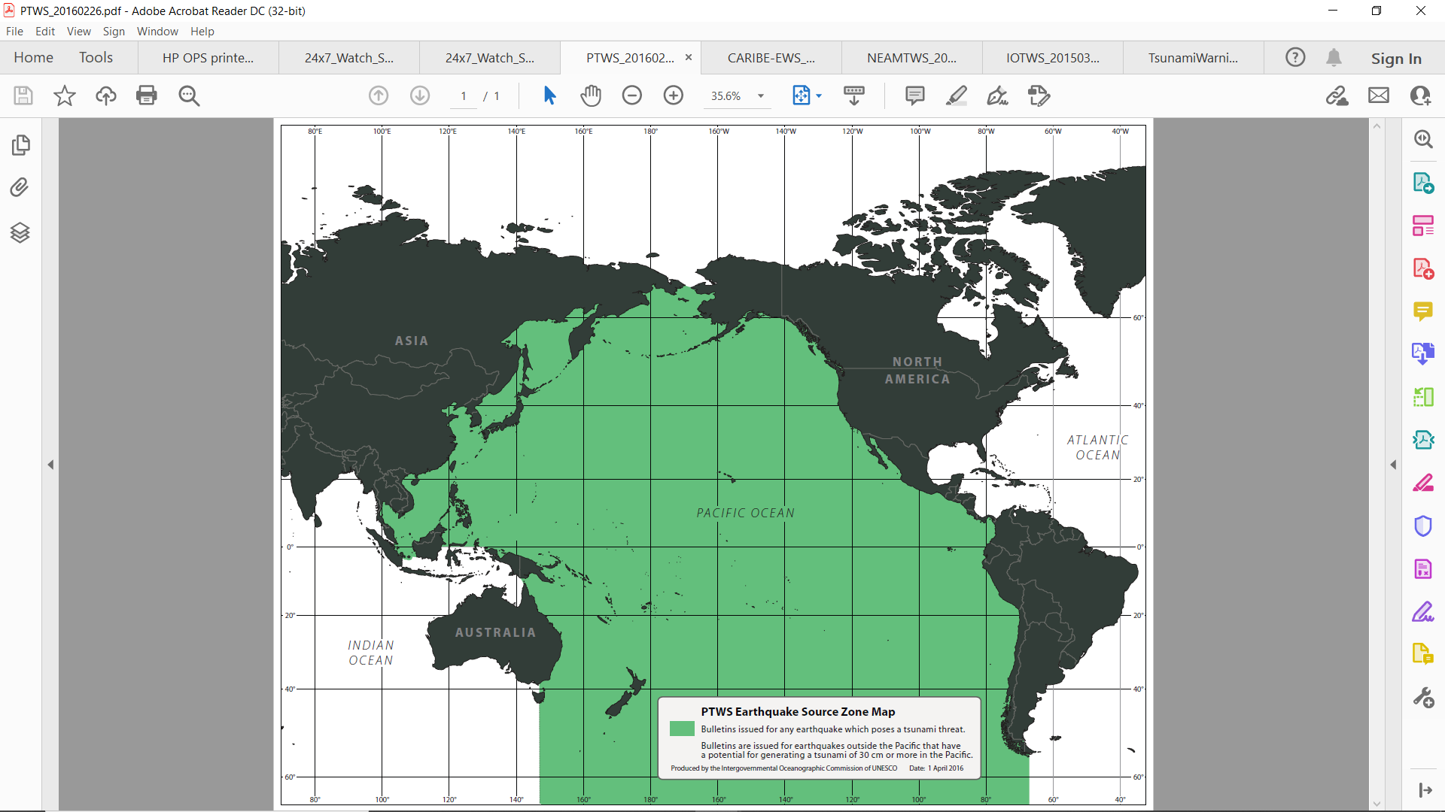

Figure 1. Current PTWS Earthquake Source Zone

|  |  |  |  |  |  |  |
| --- | --- | --- | --- | --- | --- | --- |
| **Location** | **Country or Territory** | **Lat** | **Lon** | **First Arrival (UTC)** | **Measurement (UTC)** | **Amplitude (meters)** |
| King_Edward_Point_UK | England | -54.28 | -36.50 | 8/12 20:32 | 8/12 21:54 | 0.641 |
| Port_Stanley_UK | United_Kingdom | -51.75 | -57.93 | 8/12 22:06 | 8/12 23:11 | 0.200 |
| Antarctica_Base_Prat_CL | Chile | -62.48 | -59.66 | 8/12 22:38 | 8/12 22:54 | 0.109 |
| Ohiggins_CL | Chile | -63.32 | -57.90 | 8/12 22:42 | 8/13 01:46 | 0.138 |
| Syowa_JP | Japan | -69.01 | 39.57 | 8/12 23:21 | 8/13 00:50 | 0.348 |
| Puerto_Williams_CL | Chile | -54.93 | -67.61 | 8/12 23:55 | 8/13 01:06 | 0.088 |
| Marion_Island_SA | South_Africa | 20.18 | -155.90 | 8/13 00:11 | 8/14 03:01 | 0.487 |
| Ushuaia_AR | Argentina | -54.81 | -68.29 | 8/13 00:19 | 8/13 01:27 | 0.076 |
| Imbituba_BR | Brasil | -28.23 | -48.65 | 8/13 01:01 | 8/13 06:49 | 0.203 |
| Simons_Town_SA | South_Africa | -34.19 | 18.44 | 8/13 01:10 | 8/13 02:01 | 0.240 |
| Port_Elizabeth_SA | South_Africa | -33.96 | 25.63 | 8/13 01:22 | 8/13 04:06 | 0.350 |
| Cape_Town_SA | South_Africa | -33.91 | 18.43 | 8/13 01:31 | 8/13 02:48 | 0.300 |
| Saint_Helena_UK | UK | -15.92 | -5.72 | 8/13 02:10 | 8/13 07:38 | 0.440 |
| Mossel_Bay_SA | South_Africa | -34.17 | 22.15 | 8/13 02:14 | 8/13 04:33 | 0.640 |
| Richards_Bay_SA | South_Africa | -28.80 | 32.08 | 8/13 03:03 | 8/13 10:10 | 0.260 |
| Kerguelen_FR | France | -49.35 | 70.02 | 8/13 03:55 | 8/13 05:14 | 0.102 |
| Rodrigue_MU | Mauritius | -19.68 | 63.42 | 8/13 04:49 | 8/13 07:34 | 0.245 |
| Tema_GH | Ghana | 5.64 | 5.64 | 8/13 04:52 | 8/13 11:06 | 0.199 |
| Takoradi_GH | Ghana | 4.88 | -1.74 | 8/13 05:08 | 8/13 15:57 | 0.349 |
| Reunion_FR | France | -20.94 | 55.28 | 8/13 05:22 | 8/13 06:11 | 0.205 |
| Toamasina_MG | Madagascar | -18.15 | 49.43 | 8/13 06:17 | 8/13 08:13 | 0.076 |
| Rikitea_PF | French_Polynesia | -23.12 | -134.97 | 8/13 07:38 | 8/13 08:17 | 0.056 |
| Palmeira_Cape_Verde | Cape_Verde | 16.75 | -22.98 | 8/13 08:40 | 8/13 08:42 | 0.064 |
| Cocos_Island_AU | Australia | -12.12 | 96.89 | 8/13 08:58 | 8/13 13:11 | 0.080 |
| Esperance_AU | Australia | -33.87 | 121.90 | 8/13 09:08 | 8/13 14:34 | 0.103 |
| Hillarys_Harbor_AU | Australia | -31.83 | 115.74 | 8/13 09:43 | 8/13 13:02 | 0.102 |
| Hiva_Oa_Marquesas | French_Polynesia | -9.80 | -139.03 | 8/13 09:55 | 8/13 10:20 | 0.193 |
| LaGomera_ES | Spain | 28.09 | -17.11 | 8/13 09:59 | 8/13 10:52 | 0.103 |
| Nuku_Hiva_Marquesas | France | -8.91 | -140.10 | 8/13 10:03 | 8/13 10:45 | 0.174 |
| La_Palma_ES | Spain | 28.68 | -17.77 | 8/13 10:11 | 8/13 16:33 | 0.051 |
| Ponta_Delgada_PT | Azores | 37.74 | -25.67 | 8/13 11:05 | 8/13 11:13 | 0.104 |
| Crescent_City_CA | USA-California | 41.75 | -124.18 | 8/13 14:30 | 8/13 21:31 | 0.203 |
| Honuapo_HI | USA-Hawaii | 19.08 | -155.55 | 8/13 14:35 | 8/13 16:30 | 0.016 |
| Haleiwa_HI | USA-Hawaii | 21.59 | -158.11 | 8/13 15:00 | 8/13 16:37 | 0.044 |
| Hilo_HI | USA-Hawaii | 19.73 | -155.06 | 8/13 15:02 | 8/13 15:18 | 0.170 |
| Honokohau_HI | USA-Hawaii | 19.67 | -156.02 | 8/13 15:02 | 8/13 15:32 | 0.060 |
| Kawaihae_HI | USA-Hawaii | 20.04 | -155.83 | 8/13 15:02 | 8/13 16:11 | 0.094 |
| Honolulu_Oahu | USA-Hawaii | 21.31 | -157.87 | 8/13 15:12 | 8/13 16:36 | 0.044 |
| Kahului_HI | USA-Hawaii | 20.90 | -156.48 | 8/13 15:23 | 8/13 15:31 | 0.172 |
| Nawiliwili_HI | USA-Hawaii | 21.95 | -159.36 | 8/13 15:32 | 8/13 15:50 | 0.060 |
| King_Cove_AK | USA-Alaska | 55.06 | -162.33 | 8/13 20:25 | 8/13 21:16 | 0.192 |
| Yakutat_AK | USA-Alaska | 59.55 | -139.73 | 8/13 20:47 | 8/13 21:14 | 0.106 |
| Kodiak_AK | USA-Alaska | 57.73 | -152.51 | 8/13 20:51 | 8/13 21:30 | 0.036 |
|  |  |  |  |  |  |  |

*Table 1. Maximum tsunami amplitudes recorded on coastal sea level gauges in the Atlantic, Pacific, and Indian Oceans.*

The southernmost Atlantic where this earthquake occurred is currently a part of the CARIBE-EWS Earthquake Source Zone (Fig. 2). Large earthquakes in this seismic zone occur frequently. Since the year 2000, 33 earthquakes of magnitude 6.5 or larger have occurred there -- appropriate for a Tsunami Information Statement for the CARIBE-EWS. Yet earthquakes from this region are less of a tsunami threat to CARIBE-EWS coasts than they are to PTWS coasts, as illustrated by the August 12, 2021, event. The east-west directionality of the main beams of energy as well as the South America land mass effectively limit tsunami energy going towards the Caribbean (Fig. 3). Aside from being more of a threat to the Pacific, such tsunamis are also more of a threat to IOTWMS coasts than to CARIBE-EWS coasts and they are obviously a threat to southern Atlantic coasts where there currently is no system. Six observations above the 0.3m threat level were recorded on gauges in the southern Atlantic (Table 1).

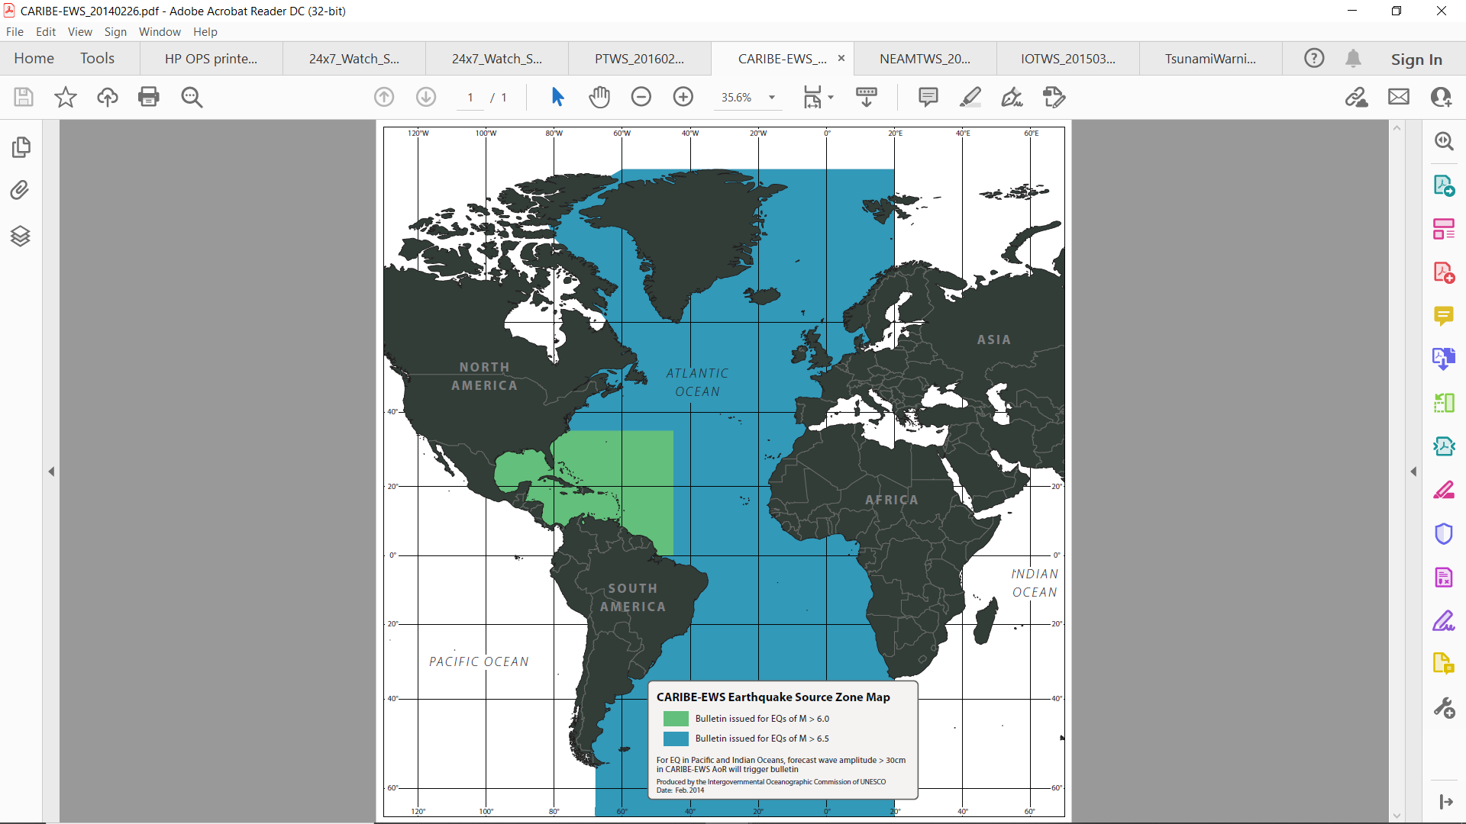

Figure 2. Current CARIBE-EWS Earthquake Source Zone

Figure 3. Example RIFT Deep Ocean Simulation of the August 12, 2021, tsunami based on an Mw of 8.0.

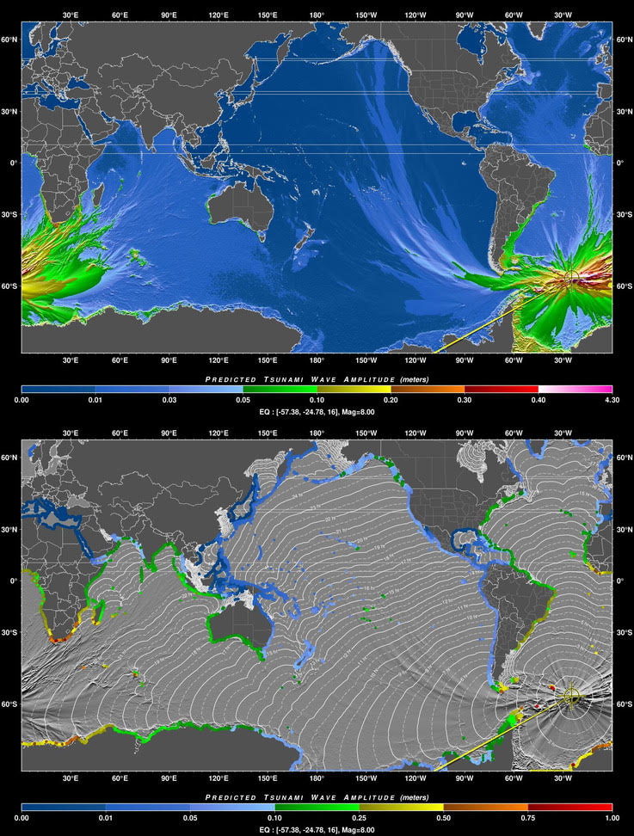

Current rules do allow TSPs to issue products for earthquakes outside their own system’s Earthquake Source Zone, either if they forecast or record tsunami amplitudes of 0.3m or more within their coastal service area, or if the earthquake might reasonably create concern about a tsunami threat even when there is not a threat. But those events should be an exception. For Scotia Arc events, the most concern is routinely within the Pacific coastal service area.

**2. PROPOSAL**

PTWC proposes to expand the PTWS Earthquake Source Zone to include part of the southern Atlantic Ocean that encompasses the Scotia Arc and its adjacent seismic zones. If the ICG/PTWS endorses this change it will be taken to the TOWS-WG Task Team on Tsunami Watch Operations for discussion. If they approve then a recommendation will be forwarded to the TOWS-WG. If they endorse the proposal then it will go the IOC General Assembly for final approval.

Potential related changes accompanying this proposed change could include the removal of this source region from the CARIBE-EWS Earthquake Source Zone (with ICG/CARIBE-EWS approval), and the addition of this source region to the IOTWMS Earthquake Source Zone (with ICG/IOTWMS approval).

The August 12, 2021 earthquake and tsunami might also motivate a reconsideration by South American and African countries bordering or within the South Atlantic regarding their inclusion in the IOC’s Tsunami Warning Programme.

**Working Group 2**

17/11/2021