Restricted distribution IOC/IODE-MG-2022-5.2
Oostende, 14 March 2022
English only

INTERGOVERNMENTAL OCEANOGRAPHIC COMMISSION
(of UNESCO)

2022 Meeting of the IODE Management Group

IOC Project Office for IODE, Oostende, Belgium (and online)
21-22 March 2022

Brief report on the results of the participants survey of the “International Ocean Data Conference 2022 - The Data We Need for the Ocean We Want”

In order to assess the experience of online and onsite participants of the conference a brief online survey was created. All participants were emailed and invited to fill the survey. 74 responses were received. This document summarizes the responses received.

- How did you perceive the programme?
(https://oceandataconference.org/programme/)
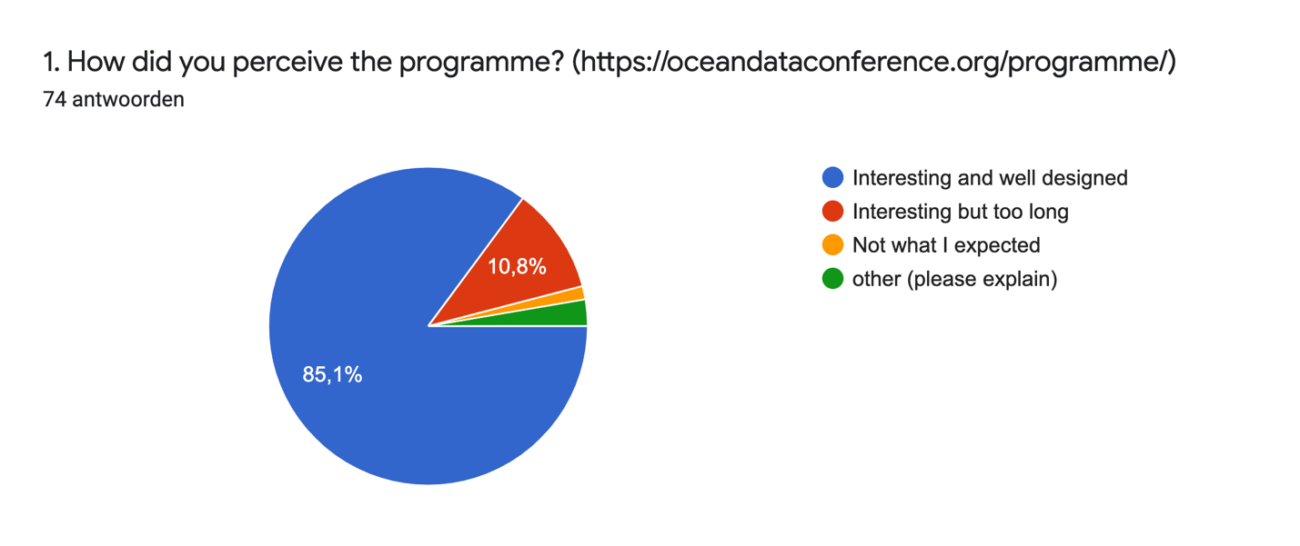
1a. If you have chosen 'not what I expected' or 'other' in the first question, please explain
- It was, indeed, interesting. Nevertheless, I think it would be better to have less oral presentations but longer in time. I missed more elaboration in some of the talks and others were explained too fast to have a good idea of what the speaker is trying to explain.
- I was expecting to be paid the visa and ticket to attend
- Interesting overview of the status of the art and ongoing initiatives but at the same time worrying the clear portals proliferation syndrome and the lack of status of the art studies before to create and launch new thematic portals

- Was the length of the presentations (8 minutes)…
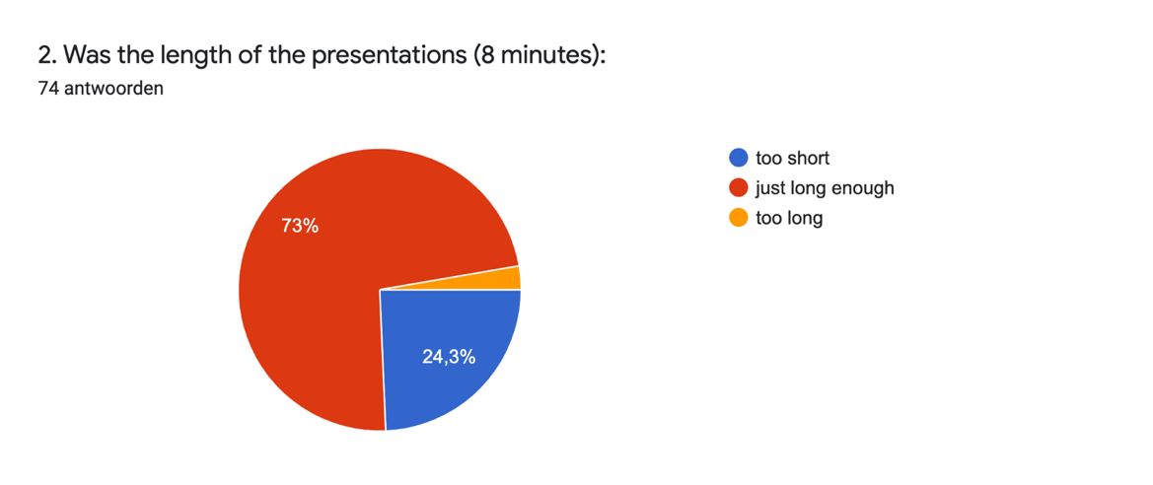
No additional remarks

- Was the overall quality of the presentations:
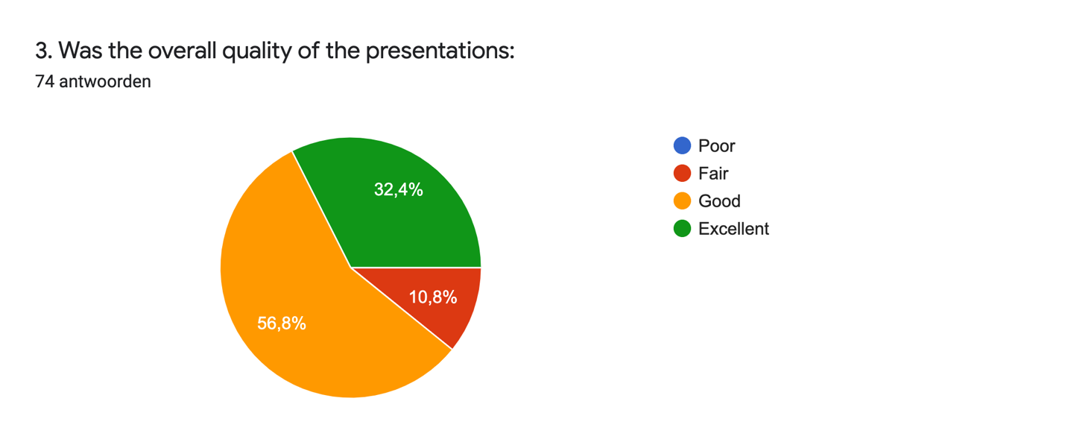
No additional remarks

- For participants on-line: did the hybrid form of the conference cause you any technical problems?
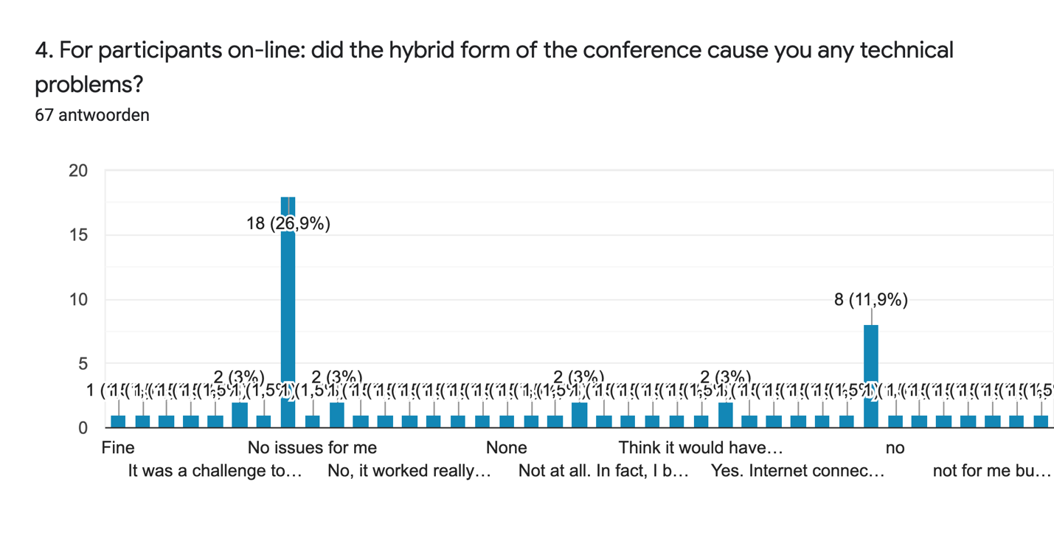
NO: 53 answers

YES: 14 answers (slow internet, didn’t understand the Padlet, sound in the beginning, network issues, not easy to connect with people in the meeting room)

- For participants on-site: what was your experience of the conference organised as a hybrid event?
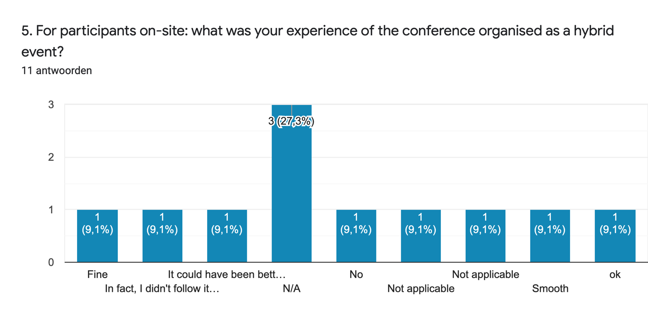
FINE/OK: 10
BETTER IN ONE WAY: 1

- For participants on-line: what was your experience of the conference organised as a hybrid event?

- Great - I took many "print screens" inserted in my notes of the meetings
- I appreciate that there were several ways (poster, pre-recorded with QA session and without QA real time, live, onsite) to join the conference.
- Would have been better with Q&A after each presentation
- Sometimes I got the impression that it was too much information in a short time, with very dense presentations. I think the time for the debate is scarce. Anyway it is a great idea to upload the recorded ppts and the use of the Padlet tool
- Great!
- Quite good
- I think It was great opportunity for who are unable to attend in person due to covid19 situation
- Fine. I would not participate in person. So for me to access in remote was a great opportunity
- Great. I wish future conferences may be organized as hybrid event.
- The conference can reach out more audience
- Excellent, there was not technical problems
- Superbly organised on the day. I had a little confusion ahead of the conference with regards to whether remote participants should be recorded or live but the organisers helped me very quickly.
- It was good for those participating over different time zones, while we could have very limited interactions among participants.
- At this moment, this is the best way for us to continue conduct this training however there are some issue that we face like technical issue and a lot more pressure because we do not have a chance to interact with other participants face to face and strengthen our relationship.
- For me, it was perfect since I wouldn't attend in person because of financial problems since I am doing my PhD
- It was not ideal, but understandably necessary. I also recognise that this may be a viable format for many future conferences and meetings even after the end of the pandemic issues.
- Excellent, there was not technical problems
- Day long events when one is attending online are quite difficult to follow. The schedule fits those present in the room, but not the online participants. Maybe this needs to be re-thought for future hybrid events
- Was able to catch up and select some recorded presentations
- One of the most efficient and effective hybrid events in which I participate online. I felt almost as if I was there in the room during the sessions. Use of Padlet very effective for interactive engaging of the online audience. Excellent time keeping. Great job!
- Satisfactory

- Do you have any suggestions for a possible next Ocean Data Conference?
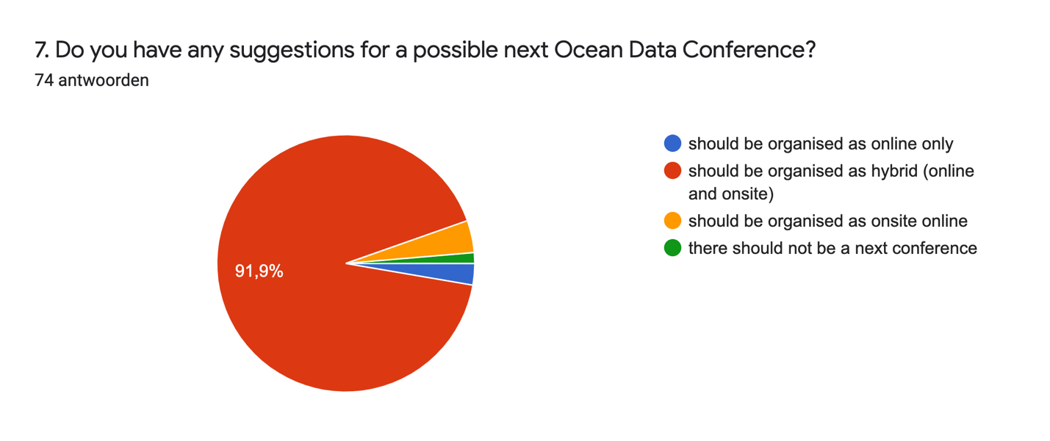

- Do you have any other suggestions or comments?

- Good day, I need the conference lack inclusiveness without involving Africans it was more of European event I will be glad to help and support to achieve this issue
- I would wish to contribute innovative ideologies research articles for the objective of the next conference
- The on-line training should be facilitated by data provision and DSA.
- There was lots of different interests and expectations, so everybody could be satisfied.
- I can't wait to participate in the next one! Thank you very much for the tremendous effort and the good organization.
- hybrid events permits a wider range of attendants
- Thank you to the convenors and hosts for an influential and useful conference that brought plenty of practical and thought provoking ideas.
- Improve the theme of the schedule regarding the site and online.
- More participants from the Global South should be given chance for scholarship
- invite more experts as resource person
- I would like to suggest a report of the conference with recommendations and list of participants may be provided to the participants . A certificate of participation may be issued on request basis.
- Please try to pay the visa and tickets for those in third world like Africa
- Workshop as a follow-up ?
- The Conference is a good meeting point to see what's going on, on the data management science. In addition, it allows to learn from the current initiatives. A point that has to be further developed is the federation of the existing and consolidated data management initiatives and promote the alignment of the new ones to the existing best practices, because my impression is that new initiatives try to re-invent the wheel, causing a massive proliferation of data portals and new management systems. In this sense, the conference contributes to the dissemination of the current best practices.
- The conference was held in English with the assumption that everyone can follow the different accents. I didn't see a translation service (presentations/panels), but even if an automated script could have been provided this would have improved inclusiveness (even if in only English). I also did not remember to add subtitles to my presentation, it was an after thought, but maybe the organisers can adopt/implement inclusiveness measures for future events, whether they are online, hybrid or in-presence.
- The hybrid event is a good idea because nowadays, at the pace of life we ​​lead, it is very difficult to have a week available for an event on site. I think that the fact that it was a hybrid ensured a higher participation. Thank you very much to all the organizers of the event. Best regards.
- I appreciate all the well prepared presentations, but there were many of them. I think more Q/A or discussion would be beneficial.
- As the activity conducted in Hybrid (online and onsite), suggest to host an event to invite all of the participants to do some learning and exchange activity in the same site.
- While I'm in favour of attending such large conference in-person where and when possible, I believe that organizing them in a hybrid format with zero or significantly reduced registration fees greatly expands the participation and impact of the event. I really enjoyed this event. In addition to my comments above, unlike on many other online or hybrid events, this time I was able to see the names of other online participants which helped me reach out to them to discuss the contents. Added benefit of online networking.
- I found the event very useful in providing the state of art in ocean observation
- For the most part the chairing was excellent, which meant that everything went very smoothly for a hybrid meeting. I was extremely impressed that a meeting of this size could be run effectively as a hybrid meeting. I have one suggestion regarding the panel discussions and one regarding the posters. As the time was quite short, the chairs needed to put the questions to the panel members efficiently. In one case, I felt that the chair of a panel discussion session could have made much more use of the panel rather than responding to questions themselves. I don't know whether there was an official poster session - apologies if I missed it. I did have a look at the posters and would have benefited from talking to the presenters. This could be an opportunity for better signposting of the session (or a request to have a specific poster session if there wasn't one).
- I think the best conference experience is always on site, but offering the possibility to join online could lead to larger participation

