**Working Group 1. Hazard Assessment and Modelling**

**PLAN OF ACTION DECEMBER 2021 – DECEMBER 2022**

**CO-CHAIRS :** Audrey Gailler (CEA, France), Mauricio Gonzalez (IH-Cantabria, Spain)

|  |  |  |  |  |  |
| --- | --- | --- | --- | --- | --- |
| ***Task/Action*** | ***Timeline*** | ***Responsibility*** | ***Time Frame*** | ***Status1*** | ***Priority*** |
| Update of WG1 TOR for a future Hazards and Risk WG | NEAMTWS-XVII | WG Chairs/ SC | All intersessional period | O | high |
| Discuss methodologies for defining the inundation maps (availablility and understanding for stakeholders) | NEAMTWS-XVII | WG1 + WG4 | All intersessional period | N | high |
| Elaborate on Cancellation policies and local vs. remote tsunami SOPs | NEAMTWS-XVII | WG1+TT OP + WG4 | All intersessional period | O | medium |
| Review on gaps for hazard and risk assessment | NEAMTWS-XVII | WG1 Chairs + Cost Action | All intersessional period | N | medium |
| Classical numerical benchmarking for the NEAM region (1969 Atlantic event and 2003 Algerian event) | NEAMTWS-XVII/XVIII | WG1 Participants + Cost Action | All intersessional period | N | medium |
| PTHA components benchmarking (comparison of results provided by different rapid forecasting approaches based on empirical amplification laws) | ? | WG 1 Participants + Cost Action | All intersessional period | N | low |
| Provision of data for benchmarking (seismic parameters, topo-bathymetry, sea level data, run-up....) of a Greek event | NEAMTWS-XVII/XVIII | Greece ? | All intersessional period | O | medium |

1 Notes: – Status: N – New, O – Ongoing

**WORKING GROUP II+III: Seismic, Geophysical & Sea Level Measurements: DRAFT PLAN OF ACTION for 2022**

**CO-CHAIRS :** Anna von Gyldenfeldt (Federal Maritime and Hydrographic Agency / Germany),

Musavver Didem Cambaz (Kandilli Observatory and Earthquake Research Institute / Turkey)

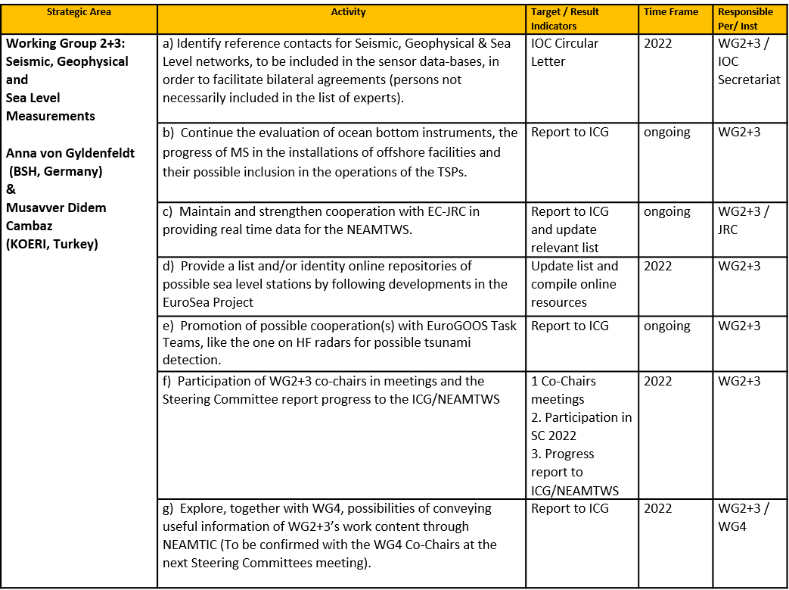

**ICG/NEAMTWS WORKING GROUP 4**

**PLAN OF ACTION   
FEBRUARY 2022 – FEBRUARY 2023**

**WORKING GROUP 4 : PUBLIC AWARENESS, PREPAREDNESS AND MITIGATION**

Chair: **Cecilia Valbonesi** (University of Florence, Italy)

| **Strategic Area** | **Objectives** | **Activity** | **Target / Result Indicators** | **Time Frame** | **Responsible Per/ Inst** |
| --- | --- | --- | --- | --- | --- |
| Working Group 4: Public Awareness, Preparedness and Mitigation | Promote community preparedness and initiatives at national level and in the framework of international projects, fostering synergies whenever possible and appropriate | Assessment of the tsunami risk perception in NEAM region | An online roundtable on ongoing stuidies in different Countries | All intersessional period | Cecilia Valbonesi  In cooperation with Secretariat |
| Interact with the TT on Tsunami Ready, with focus on: | - Participate in Tsunami Ready TT meetings  - Workshop on methodologies to define inundation areas and how to communicate to local stakeholders; in cooperation with WG1  - Promote discussion on alert dissemination methodologies;  -Webinar to enhance the development of TR in NEAM region and gain experience by interacting with experts from other ICGs | All intersessional period | Cecilia Valbonesi  In cooperation with  TT on Tsunami Ready  and  Secretariat |
| Encourage and support the development of the downstream (Preparedness and Response) component of the ICG/NEAMTWS programme | Evaluation of and discussion on legal implications of piloting Tsunami Ready-like initiatives in some test Countries of the NEAM region | Share the study on the impact of TR guidelines on the responsibilities of the local and the national TR board members.  Study on the UNESCO’s role in the recognition of a municipality as TR. | -All intersessional period | Cecilia Valbonesi  In cooperation with  TT on Tsunami Ready |
| Improving information and experience exchange on tsunami risk and disaster management within NEAM region | Involvment of TSPs and NTWCs in keeping the NEAMTIC website updated and to enriching its content. | Periodic contibutions from TSPs and NTWCs on recent events, historical anniversaries, published papers, drills, exercises, projects etc. | -All intersessional period | Cecilia Valbonesi  with the support of the Secretariat |
| Enhancing interdisciplinarity in tsunami risk and disaster management | To explore contributions and views of social scientists on tsunami threat levels. | - A report that will focus on the review of research literature and operational reports to address strength, weakness, opportunities and problemsì of threat level based EWS systems within the NEAMTWS context, as a base for further empirical research. | -All intersessional period | Andrea Cerase (University of Rome "La Sapienza") and Lorenzo Cugliari (INGV) |
| Represent WG4 in ICG/NEAMTWS and in INTER-ICG TOWS TASK TEAM on DMP (Disaster Management and Preparedness) | -Represent WG4 at the online and in person meeting of the inter-ICG Task Team on “Disaster management and preparedness”  -According to Secretariat, share with the WG4 the information about INTER-ICG TOWS TASK TEAM on DMP  Prepare a WG4 annual PoA  Report progress to Steering Committee and to ICG | -Report to the ICG  -Participation to the SC meeting/WG4 presentation  -Draft PoA for WG4 | -All intersessional period | Cecilia Valbonesi  Secretariat |
| Cooperation with other Working Groups and Task Teams as needed and requested | Support when needed and provide feedbacks | Participation to online and in person meetings, input/provide feedbacks to reference documents upon request | -All intersessional period | Cecilia Valbonesi |

**Task Team on Documentation: Plan of Action for 2022**

Co-chairs: **Stefano Lorito** (Instituto Nazionale di Geofisica e Vulcanologia, Italy) & **Nikos Kalligeris** (National Observatory of Athens, Greece)

| **Strategic Area** | **Objectives** | **Activity** | **Target / Result Indicators** | **Time Frame** | **Responsible Per/ Inst** |
| --- | --- | --- | --- | --- | --- |
| Task Team on Documentation | Revise Operational Users Guide | Prepare a draft of selected sections of the revised Operational Users Guide | Draft of selected sections of the revised Operational Users Guide | January 2022 – March 2022 | TT-Docs co-chairs |
| Share draft of the revised Operational Users Guide with TT-Docs/TT-OP members | Receive feedback from TT-Docs/TT-OP members | March 2022 | TT-Docs co-chairs / members/TT-OP members |
| Implement feedback from TT-Docs/TT-OP members | Revised draft of selected sections of the Operational Users Guide | March 2022-SC2022 | TT-Docs co-chairs |
| Present progress at the Steering Committee | Receive feedback from SC | SC2022 | TT-Docs co-chairs/SC members |
| Continue revising Operational Users Guide | 2nd draft of revised Operational Users Guide | SC2022-June 2022 | TT-Docs co-chairs |
| Share 2nd draft of the revised Operational Users Guide with TT-Docs/TT-OP members | Receive feedback from TT-Docs/TT-OP members | June 2022-September 2022 | TT-Docs co-chairs / members/TT-OP members |
| Implement feedback from TT-Docs/TT-OP members and finalize revision | Revised Operational Users Guide | September 2022-November 2022 | TT-Docs co-chairs |
| Present revised Operational Users Guide to ICG |  | November 2022 | TT-Docs co-chairs |

**Task Team on Operations: Draft Plan of Action for the period December 2021 – November 2022**

Co-chairs: **Fernando Carrilho** (Instituto Português do Mar e da Atmosfera, Portugal) & **Alessio Piatanesi** (Istituto Nazionale di Geofisica e Vulcanologia, Italy)

| **Strategic Area** | **Activity** | **Target / Result Indicators** | **Time Frame** | **Responsible Per/ Inst** |
| --- | --- | --- | --- | --- |
| Task Team on Operations | Evaluate the recommendations made by inter-ICG/TOWS working group on Tsunami Operation for possible implementation by ICG/NEAMTWS; specifically continue the assessment of the Global Service Definition Document (GSDD) and investigate its adaptability by the NEAMTWS. | Report to SC and ICG | February 2022-October 2022 | TTO co-chairs |
| Conduct a TT meeting in the 1st quarter of 2022 in coordination with the meetings of Steering Committee and other Task Teams. | Report to SC and ICG | March 2022-April 2022 | TTO co-chairs and members |
| Coordinate with TSP's the development of sea-level reading procedures for NEAMTWS purposes and the formalization of which and how non-instrumental information/observations can be included in the ONGOING messages. | Report to SC and ICG | March 2022-May 2022 | TTO co-chairs/ TSPs |
| Coordinate with TSP's the definition of a common  TSU-CAP template to issue tsunami messages that may serve both NEAMTWS and national needs at the same time. | Report to SC and ICG | March 2022-June 2022 | TTO co-chairs/ TSPs |
| Advice on the modalities of operation, interoperability, methods and standards for the development and issuance of  warnings, such as methods and reporting of magnitudes, and requirements in terms of coordination and operation of NEAMTWS. | Report to SC and ICG | All intersessional period | TTO co-chairs/ TSPs |
| Foster the development of the Tsunami Service Provider Inter-Operability Tool (TSP-IOT) | Report to SC and ICG | All intersessional period | TTO co-chairs/ TSPs |
| Continue to improve the Performance Monitoring Framework for  NEAMTWS upstream components, based on the functions-requirements defined in the approved accreditation procedure and performance indicators developed for Communication Test Exercises. | Report to SC and ICG | All intersessional period | TTO co-chairs |
| Support the Task Team on Documentation by reviewing the Interim Operational User’s Guide to identify sections that require corrections, modifications and/or updates according the progress made in NEAMTWS. | Revised Operational Users Guide | All intersessional period | TTO co-chairs/TT Documentation co-chairs |
| Support Task Team on Tsunami Exercises in the preparation of the NEAMWave23 Exercise. | Manual for the exercise | All intersessional period | TTO co-chairs/TT on Exercise |
| Report progress to ICG/NEAMTWS-XIX. | Report to ICG | November 2022 | TTO co-chairs |

**TASK TEAM ON TSUNAMI EXERCISE – PLAN OF ACTION 2022**

**CO-CHAIR:** Ceren Ozer Sozdinler (Gebze Technical University Department of Civil Engineering, Turkey), Marinos Charalampakis (National Observatory of Athens/ Greece)

| **Strategic Area** | **Activity** | **Time Frame** | **Responsible Per/ Inst** |
| --- | --- | --- | --- |
| **Task Team on Tsunami Exercise** | Submission of the final version of the Evaluation Report of NEAMWave21 | February 2022 | TT-TE co-chairs, exercise team & IOC Secretariat |
| Planning of NEAMWave23 (proposal to the TSPs) | Whole intersessional period | TT-TE co-chairs, exercise team & IOC Secretariat |
| Having online meetings with DG-ECHO and CPA representatives | March - April 2022 | TT-TE co-chairs, WG-04 & IOC Secretariat |
| Request Civil Protection Authorities with exercises experience to prepare a one-page guiding document to share with other non-experienced CPAs, describing their experience in implementing Phase B of NEAMWave Exercises | April - May 2022 | TT-TE co-chairs, exercise team & IOC Secretariat |
| Work together with the Secretariat to prepare a concept information paper to inform CPAs about the general concept of NEAMWave | May 2022 | TT-TE co-chairs, exercise team & IOC Secretariat |
| Revision of online tools (subscription & evaluation) | September – October 2022 | TT-TE co-chairs, exercise team & IOC Secretariat |
| Having online meetings with DG-ECHO and CPA representatives | October - November 2022 | TT-TE co-chairs, WG4 & IOC Secretariat |

**Task Team on Tsunami Ready: Plan of Action for 2022**

Co-chairs: **Ignacio Aguirre Ayerbe** (Instituto de Hidráulica Ambiental de Cantabria, Spain) & **Elena Daskalaki** (National Observatory of Athens, Greece)

| **Strategic Area** | **Objectives** | **Activity** | **Target / Result Indicators** | **Time Frame** | **Responsible Per/ Inst** |
| --- | --- | --- | --- | --- | --- |
| Task Team on Tsunami Ready | Membership of Tsunami Ready Task Team. | Confirm membership of the Task Team by former members of TR Group. | Official list of active TR-TT members. | April 2022 | Secretariat with the support of TR-TT co-chairs |
| Promote community preparedness.  Support and promote Tsunami Ready programme in the NEAM region. | Monitoring of TR pilot projects in NEAM area. | Report to ICG through WG4:   * on TR initiatives already in place in NEAM region (TR indicators achievement). * on new TR candidates. | All intersessional period | TR-TT co-chairs / members, in cooperation with WG 4 co-chairs and Secretariat |
| Interact with the WG4 group and foster its activities. | Online meetings with WG4 co-chairs. | All intersessional period | TR-TT co-chairs / members in cooperation with WG 4 co-chairs |
| Encourage and support approval of NEAMTWS TR guidelines, as part of the downstream component of the ICG/NEAMTWS programme. | Establish communication with other ICGs TTs and WGs related to Tsunami Ready, to share/discuss knowledge, experiences and challenges. | Propose online meeting, face-to-face meeting, webinar, etc. | All intersessional period | TR-TT co-chairs and members  WG 4 co-chairs  Secretariat |
| Identify critical points (and promote solutions to address them) of TR guidelines. This includes:  Identify methodologies followed by each TR community to promote discussion on them (e.g., to define inundation areas, to generate adequate maps addressing local particularities, to communicate to local stakeholders, on alert dissemination methodologies). | Online communications.  Summary report. | All intersessional period | TR-TT and WG 4 co-chairs and Secretariat with the support of WG 1. |
| Represent Tsunami Ready TT in ICG/NEAMTWS. | Represent TR-TT at meetings scheduled throughout the year 2022. | Participation to the SC meeting/TR-TT. presentation | All intersessional period | TR-TT co-chairs |
| Cooperation with other Working Groups and Task Teams. | Supporting where appropriate and providing feedback. | Participating in meetings and commenting on background documents as requested. | All intersessional period | TR-TT co-chairs |