Intergovernmental Oceanographic Commission
technical series | 151



EXERCISE CARIBE WAVE 22
A Caribbean and Adjacent Regions Tsunami Warning Exercise
10 March 2022
(Western Muertos Trough and Northern Panama)
Volume 2 Draft Summary Report

UNESCO

Intergovernmental Oceanographic Commission
technical series | 151

EXERCISE CARIBE WAVE 22
A Caribbean and Adjacent Regions Tsunami Warning Exercise
10 March 2022
(Western Muertos Trough and Northern Panama)
Volume 2 Summary Report

UNESCO 2022
IOC Technical Series, 151 (volume 2)
Paris, June 2022
English only

The designations employed and the presentation of the material in this publication do not imply the expression of any opinion whatsoever on the part of the Secretariats of UNESCO and IOC concerning the legal status of any country or territory, or its authorities, or concerning the delimitation of the frontiers of any country or territory.

NOTE: The United Nations Educational, Scientific and Cultural Organization (UNESCO) and the Intergovernmental Oceanographic Commission (IOC) pattern the contents of this handbook after the CARIBE WAVE 2011, 2013, 2014, 2015, 2016, 2017, 2018 and 2019 Exercises. Each of these exercises has a handbook published as IOC Technical Series. These CARIBE WAVE exercises followed the Pacific Wave exercises which commenced in 2008 with manual published by the Intergovernmental Oceanographic Commission (Exercise Pacific Wave 08: A Pacific-wide Tsunami Warning and Communication Exercise, 28–30 October 2008, IOC Technical Series, 82, Paris, UNESCO 2008). The UNESCO How to Plan, Conduct and Evaluate Tsunami Wave Exercises, IOC Manuals and Guides, 58 rev., Paris, UNESCO 2013 (English and Spanish) is another important reference.
For bibliographic purposes, this document should be cited as follows:
UNESCO/IOC. 2022. Exercise CARIBE WAVE 2022. A Caribbean and Adjacent Region Tsunami Warning Exercise, 10 March 2022 (Western Muertos Trough and Northern Panama). Volume 2: Summary Report. Paris, UNESCO, IOC Technical Series No 151, Vol. 2. (English only)
Report prepared by: Intergovernmental Coordination Group for the Tsunami and other Coastal Hazards Warning System for the Caribbean and Adjacent Regions (ICG/CARIBE-EWS)
Authors: Stephanie Soto, Elizabeth Vanacore, and Christa von Hillebrandt-Andrade

Published in 2020
by United Nations Educational, Scientific and Cultural Organization
7, Place de Fontenoy, 75352 Paris 07 SP
(IOC/2019/TS/151 Vol.2)
TABLE OF CONTENTS

Summary 7
1. BACKGROUND 8
2. EXERCISE CONCEPT 10
2.1 PURPOSE 10
2.2 OBJECTIVES AND GOALS 10
2.3 TYPE OF EXERCISES 11
3. EXERCISE OUTLINE 12
3.1 GENERAL 12
3.2 MASTER SCHEDULE (EXERCISE SCRIPT) 14
3.3 ACTIONS IN THE CASE OF A REAL EVENT AND FALSE ALARMS 14
3.4 REGISTRATION PROCEDURE 14
3.5 STATUS OF SEA LEVEL STATIONS DURING EXERCISE 18
3.6 RESOURCES 20
3.7 MEDIA ARRANGEMENTS 22
3.8 POST-EXERCISE EVALUATION 23
4. REFERENCES 30
ANNEX I. CATAC Dummy (Start of Exercise) Message 31
ANNEX II. CATAC Exercise Messages 32
ANNEX III. List Of Acronyms 42

Summary
The CARIBE WAVE exercise is conducted within the framework of the UNESCO IOC Intergovernmental Coordination Group for Tsunamis and other Coastal Hazards for the Caribbean and Adjacent Regions (CARIBE-EWS). The 2022 annual tsunami exercise took place on March 10 to test Tsunami Warning Systems and promote tsunami preparedness in the Caribbean and adjacent regions. The exercise was coordinated by the CARIBE WAVE task team, the NOAA International Tsunami Information Center Caribbean Office, and supported by the Caribbean Tsunami Information Center and Pacific Tsunami Warning Center. It was left up for Member States and Territories to choose between the Western Muertos Through and Northern Panama scenarios and to decide the level of participation and activity to be held in their country.
CARIBE WAVE exercises focus on communications and evaluating procedures and programs within Member States and Territories. The Pacific Tsunami Warning Center (PTWC), the Regional Tsunami Service Provider, issued a “Dummy” message through the different warning systems at 1400 UTC to test communications with Tsunami Warning Focal Points (TWFP) and National Tsunami Warning Centers (NTWC). Different methods of communications were used to test and disseminate the message: The World Meteorological Organization (WMO), Advanced Weather Interactive Processing System (AWIPS), Aeronautical Information Replacement System (AIRS), NOAA Weather Wire, GEONETCast Americas, Fax, Email, and Social Media. According to feedback as well as social media and web posts, the dummy message was successfully received. The Central America Tsunami Advisory Center (CATAC) also disseminated simulated products for the Northern Panama scenario to its stakeholders.

When PTWC issued its simulated “end of threat” messages for the exercise, over 406,000 people from across the entire Caribbean basin had registered on the Tsunami Zone website (tsunamizone.org). The majority of the participants were from K-12 Schools. Local governments, universities and preparedness organizations also had a high level of participation. According to the 48 Member States and Territories feedback, 413,285 people were directly engaged in the exercise. Social media platforms, which has become the primary source for communicating tsunami awareness, reached over 402 K people worldwide during the exercise.

Sea level data availability is important to forecast and confirm a real tsunami event. If a tsunami had occurred during the day of the exercise, data of 34 of the 64 sea-level stations in the region would have been available for event analysis. Only two of the Deep Ocean Assessment and Reporting on Tsunamis (DARTs) were operational during the exercise. CARIBE WAVE has been improving and validating tsunami preparedness since 2011, which is why tsunami exercises are crucial to maintain readiness in case of a real tsunami event.

1. BACKGROUND
The UNESCO IOC Intergovernmental Coordination Group for the Tsunami and Other Coastal Hazards Warning System for the Caribbean and Adjacent Regions at its Eighth session (ICG/CARIBE-EWS-VIII, Port of Spain, Trinidad and Tobago, 29 April – 1 May 2013), decided to conduct exercises named CARIBE WAVE on an annual basis leaving each Member State to define its level of participation. At an 15th session (online, 27-29 April), the ICG/CARIBE-EWS recommended that Exercise CARIBE WAVE 22 take place on 10 March 2022, with two hypothetical tsunami scenarios. The first scenario simulates a tsunami generated by a magnitude 8.0 earthquake located on the Western Muertos Trough and the second scenario is generated by an 8.3 magnitude earthquake located along North Panama Deformed Belt (NPDB).
Historical tsunami records from sources such as the National Oceanic and Atmospheric Administration’s (NOAA) Centers for Environmental Information (NCEI) show that from 1530 to 2020 tsunamis from earthquake, landslide, and volcanic sources have affected the region. According to NCEI, in the past 500 years, at least 83 tsunamis have been observed and approximately 4,500 people have lost their lives from tsunamis in the Caribbean and adjacent regions. Since the most recent devastating tsunami of 1946, there has been an explosive population growth and influx of tourists along the Caribbean and Western Atlantic coasts increasing the tsunami vulnerability of the region (von Hillebrandt-Andrade, 2013).
Recognizing the need for an early warning system, especially after the lessons learned from the 2004 Indian Ocean tsunami, the Intergovernmental Coordination Group for the Tsunami and other Coastal Hazards Warning System for the Caribbean and Adjacent Regions (ICG/CARIBE-EWS) was established in 2005 as a subsidiary body of the IOC/UNESCO with the purpose of providing assistance to all Member States of the region to establish their own early tsunami warning system. The main objective of the CARIBE-EWS is to identify and mitigate the hazards posed by local, regional and distant tsunamis. The ultimate goal is to create a fully integrated end-to-end warning system comprising four key components: monitoring and detection systems, hazard assessment, tsunami related services (dissemination), and community preparedness, readiness and resilience.
The CARIBE WAVE 22 exercise provided simulated threat tsunami messages from the PTWC triggered by two hypothetical earthquakes: (1) 8.0 Mw with an epicenter at 17.5ºN, 69.5ºW located at the Western Muertos Trough (Figure 1) and (2) 8.3 Mw with an epicenter at 9.3ºN, 80.3ºW located in Northern Panama (Figure 2).
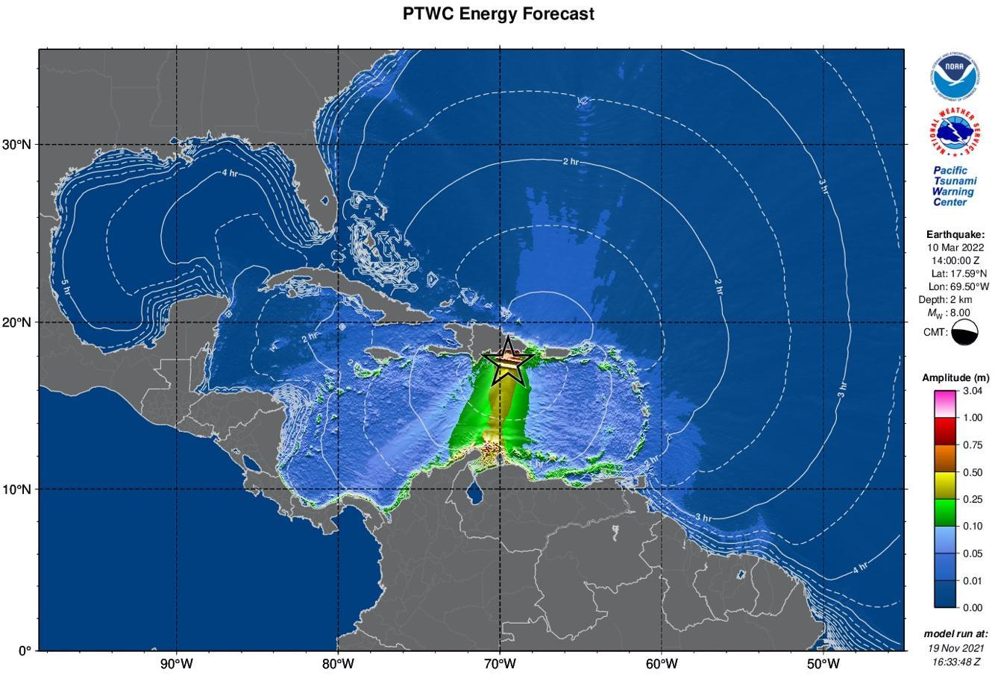
Figure 1. PTWC maximum deep-ocean amplitude map generated using RIFT
for Western Muertos Trough scenario.

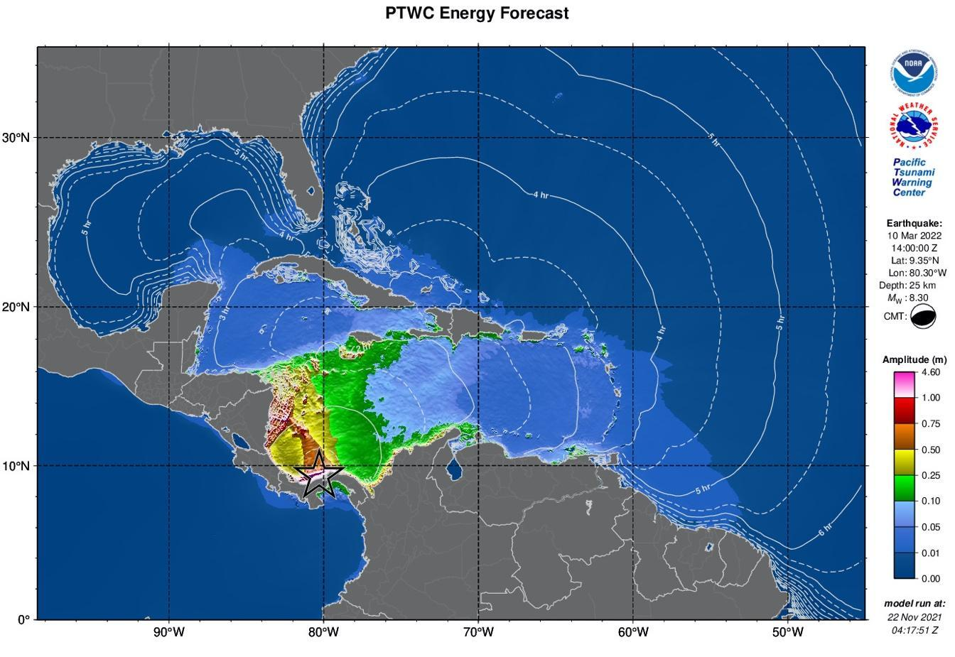

Figure 2. PTWC maximum deep-ocean amplitude map generated using RIFT
for Northern Panama scenario.

2. EXERCISE CONCEPT

2.1 PURPOSE
The purpose of the exercise was to improve Tsunami Warning System effectiveness in the Caribbean and adjacent regions. The exercise provided an opportunity for emergency management organizations throughout the region to exercise their operational lines of communications, review their tsunami response procedures, and promote tsunami preparedness. Regular exercising of response plans is critical to maintain readiness in case of an emergency. This is particularly true for the Caribbean and adjacent regions, where tsunamis are infrequent but can be of very high impact. Every emergency management organization (EMO) was encouraged to participate.

2.2 OBJECTIVES AND GOALS

Each organization developed its objectives for the exercise depending on its level of involvement in the scenario. There were two principal overarching objectives for the exercise.
- Exercise and evaluate communications between Regional Tsunami Service Provider and Members States/Territories.
  - Validate the issuance of tsunami products from the PTWC.
  - Validate receipts of tsunami products by CARIBE-EWS Tsunami Warning Focal Points (TWFPs) and/or National Tsunami Warning Centers (NTWCs).
- Evaluate the tsunami procedures and programs within Members States/Territories.
  - Validate readiness to respond to a tsunami.
  - Validate the operational readiness of the TWFPs/NTWCs and/or the National Disaster Management Office (NDMO).
  - Improve operational readiness. Before the exercise, ensure appropriate tools and response plan(s) have been developed, including public education materials.
  - Validate that the dissemination of warnings and information/advice by TWFPs and NTWCs, to relevant in-country agencies and the public is accurate and timely.
  - Evaluate the status of the implementation of the pilot CARIBE-EWS Tsunami Ready recognition programme.
ICG/CARIBE-EWS has established metrics to evaluate the goals of the exercise (Table 1). 100% of MS and Territories submitted the Post-Exercise Survey, with 88% being satisfied with the exercise.

Goals | 2016  Results | 2017  Results | 2018  Results | 2019  Results | 2020  Results | 2021  Metrics | 2021  Results | 2022  Metrics | 2022  Results
TWFP receive the dummy message | 84% | 95% | 100% | 89% | 97% | 100% | 97% | 100% | 91%
Participation of Member States of ICG/CARIBE-EWS with designated focal warning point | 100% | 100% | 97% | 100% | 92% | 100% | 98% | 100% | 100%
Community involvement (including agencies beyond TWFP) | 73% | 82% | 77% | 66% | 38% | 95% | 56% | 95% | 43%
Number of participants* | 332,812 | 679,985 | 643,403 | 793,353 | 4,622 | +10% | 333,518 | +10% | 413,281
Countries who participate submit exercise questionnaire | 100% | 100% | 91% | 82% | 92% | 100% | 95% | 100% | 100%
Members State and territories are satisfied with exercise |  |  |  | 82% | 76% | 100% | 96% | 100% | 88%
Table 1. Goals and Metrics. * As reported by Member States and Territories.

2.3 TYPE OF EXERCISES

The CARIBE WAVE 22 was planned for Caribbean countries to carry exercises at various scales of magnitudes and sophistication. It was up for Member States and territories to decide the type of exercise that would be carried out. The CARIBE WAVE Task Team recommended countries to plan and execute the exercise accordingly by taking into consideration the CARIBE EWS COVID-19 guidelines. Communication tests were carried out to validate the issuance and receipt of the messages distributed by the Pacific Tsunami Warning Center (PTWC), the Regional Tsunami Service Provider, and evaluations of the tsunami procedures and programs within Member States and Territories. The Central America Tsunami Advisory Center (CATAC) also distributed messages during the exercise. Several of the National and local Offices of Emergency Management (OEM) were able to extend the exercise down to the level of testing local notification systems such as the Emergency Alert System (EAS), sirens and loudspeakers.
According to the Member States, the number of participants in the exercise was 413,281 people throughout the Caribbean and adjacent regions. The participants in the eleventh annual regional tsunami exercise hailed from forty-eight Member States and territories. It represented a participation rate of 100% of all the Member States of the UNESCO Intergovernmental Coordination Group for Tsunamis and other Coastal Hazards for the Caribbean and Adjacent Regions (CARIBE-EWS). This level of participation represents the high enthusiasm from the CARIBE-EWS Members States to participate despite the trying situation of the COVID-19 pandemic.
Exercises were conducted at various scales of magnitude and sophistication. Exercises simulated the development, training, testing, and evaluation of Disaster Plans and Standard Operating Procedures (SOPs). The reported exercises included a variety of activities including testing communication systems, performing tabletop exercises, conducting seminars and drills (Figure 3). Additionally, the Task Team organized a post-exercise “hot wash” webinar to permit Member States and Territories to discuss and provide feedback on the exercise in an open forum.
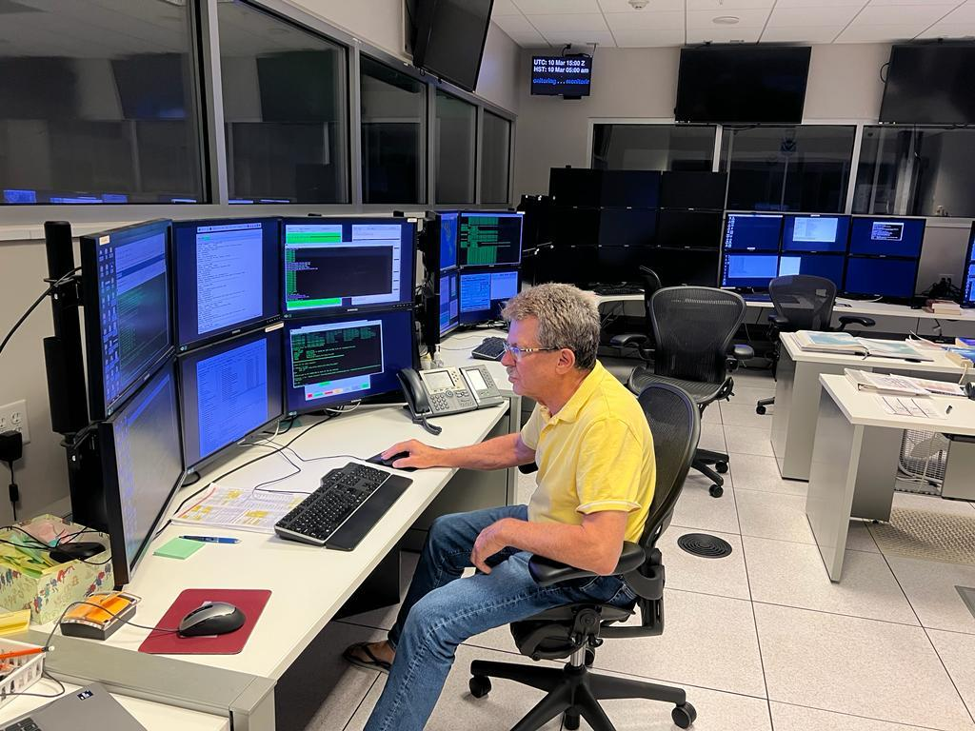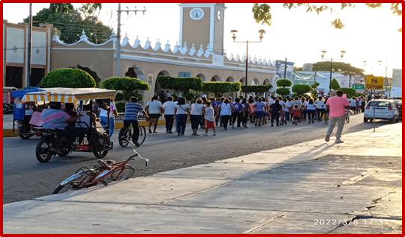
a
b

Figure 3. Participation of the exercise, CARIBE WAVE 22: PTWC (a), and Mexico (b).

3. EXERCISE OUTLINE

3.1 GENERAL

The tsunami messages that were issued for this exercise by the PTWC were based on two hypothetical earthquakes (Figure 4) with the following hypocenter parameters:
Western Muertos Trough Earthquake Scenario:
Origin Time 14:00:00 UTC March 10, 2022
Latitude 17.58ºN
Longitude 69.50ºW
Magnitude 8.0 – M_{w}
Depth 2.5 km
Northern Panama Earthquake Scenario:
Origin Time 14:00:00 UTC March 10, 2022
Latitude 9.35ºN
Longitude 80.30ºW
Magnitude 8.3 – M_{w}
Depth 25 km

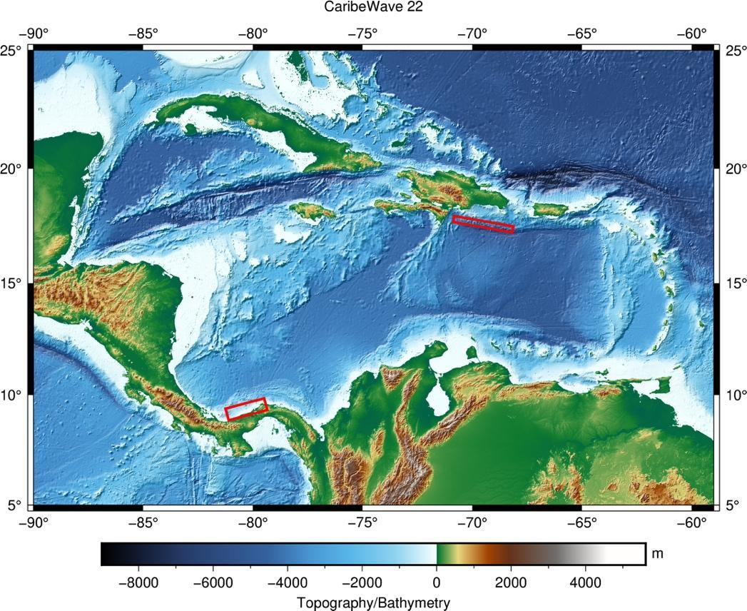
Figure 4. Map of the CARIBE WAVE 22 scenarios. Red boxes indicate the map view of the ruptured fault segments. This figure was generated using PyGMT (Uieda et al., 2021) and GEBCO 2021 background model (GEBCO, 2021).

Messages Issued by the PTWC
The PTWC issued (16) international simulated messages for CARIBE WAVE 22. The first tsunami threat message for the Western Muertos Trough and Northern Panama scenarios was based on the earthquake magnitude and location, and the tsunami travel times. While as of the third messages were based on simulated tsunami wave forecast, rather than seismic information. Tsunami threat forecast indicated the levels of threat that have been forecast and to which the countries or places they apply. The levels are tsunami heights of 0.3-1 meters, 1-3 meters, and greater than 3 meters above the normal tide levels are determined. The threats were updated usually within an hour.
Member States were required to select one scenario by February 25 for the 2022 exercise. Those who did not select a scenario, the organizers decided for which scenario the PTWC would send the products. All simulated products (text and graphical) were disseminated through email to the corresponding TWFPs and NTWCs and were made available in the Exercise Handbook. Any further dissemination was the responsibility of the corresponding national and local authorities.
The PTWC also issued live over all standard broadcast channels (WMO/AWIPS IDs WECA41 PHEB/TSUCAX) the initial dummy message to start the exercise at 1400 UTC on 10 March 2022.
Messages Issued by CATAC
CATAC issued (5) simulated messages in Spanish for CARIBE WAVE 22, with a similar format as the PTWC products. The first tsunami threat message was based on the earthquake magnitude and location. The third message included the simulated tsunami wave forecast and graphical products with predicted amplitudes at sea gauges and coastal zones. The messages were only disseminated for the Northern Panama scenario to Central American countries. All simulated products (text and graphical) were disseminated by email and telegram.
The initial dummy message was also issued through email to start the exercise at 1400 UTC on 10 March 2022. According to the Member States and Territories feedback, the message was successfully received by five countries in Central America. The content of the Dummy message as well as the tsunami simulated messages is given in Annex I.

3.2 MASTER SCHEDULE (EXERCISE SCRIPT)

CARIBE-EWS Tsunami Service Provider (PTWC) issued the initial dummy message for the two scenarios on March 10, 2022 at 1400 UTC. This message was used to test communications with TWFPs and NTWCs, and to start the exercise. The transmission methods used to send the dummy message were GTS - WIS (WMO Information System), EMWIN, AISR, NWWS, GNC-A, Email, Fax, and AWIPS (Advanced Weather Interactive Processing System), using header IDs WECA41 PHEB/TSUCAX. All simulated products (text and graphical) were disseminated only thru email to TWFPs and NTWCs. Eight (8) threat messages were issued for the Western Muertos Trough scenario, and eight (8) for the Northern Panama scenario. The graphical enhanced products were included in the third threat message for both Western Muertos Trough and Northern Panama scenario. As in past years, the most common methods to receive the Dummy messages were Email and Fax. WMO Information System (GTS) was also a method where several countries received the message (Figure 5).
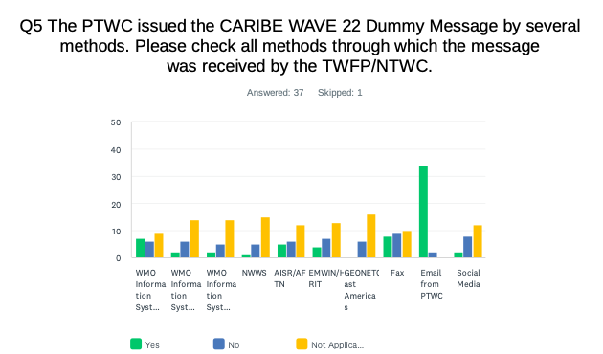
Figure 5. Methods that the CARIBE-EWS TWFPs/NTWCs used to receive the Dummy message by the PTWC.

3.3 ACTIONS IN THE CASE OF A REAL EVENT AND FALSE ALARMS
No significant real events and false alarms were reported by the Member States and Territories during the exercise. No actions were thus required.

3.4 REGISTRATION PROCEDURE
As for past exercises, the CARIBE-EWS teamed up with TsunamiZone.org for online registration (Figure 6). The link used for the registration was http://www.tsunamizone.org/register/. Under the “Register Here” Tab, participants were able to sign up and choose among the three major categories:
- Myself and/or my family,
- My school, district, college/university, or childcare center, and
- My organization, department, or agency (including TNCs. TWFPs and NTWCs). EMOs were encouraged to promote this registration system.
Most people registered directly on the TsunamiZone.org which is an open registration system available during the whole year. As of 29 April 2022, 409,667 people had registered (Table 2). Nevertheless, according to Member States who answered the post-exercise survey the estimated number of people actually participating were approximately 413,285 (Table 3).
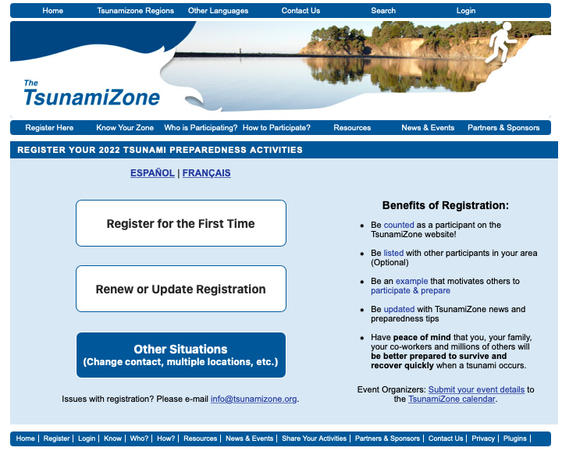
Figure 6. Registration by categories and Country for the CARIBE WAVE 22 Regional Tsunami Exercise.

Category | Number of Participants
Individuals/Families | 1,424
Childcare and Pre-Schools | 3,915
K-12 Schools and Districts | 253,827
Colleges and Universities | 32,581
Local Government | 38,968
State Government | 21,686
Federal/National Government∗ | 16,962
Businesses | 1,780
Hotels and Other Lodgings | 663
Healthcare | 12,022
Senior Facilities/Communities | 395
Disability/AFN Organizations | 198
Non-Profit Organizations | 2,856
Neighborhood Groups | 1,065
Preparedness Organizations | 18,008
Faith-based Organizations | 210
Museums, Libraries, Parks, etc. | 109
Volunteer/Service Clubs | 45
Youth Organizations | 225
Agriculture/Livestock | 182
Volunteer Radio Groups | 699
Science/Engineering Organizations | 609
Media Organizations | 37
Other | 1,201
Total | 409,667
Table 2. List of registrants and participants by Categories on TsunamiZone.org in the Caribbean
(as of 04/29/2022)

Country |  | Participants according to Member States | Participants according to Tsunami Zone
Antigua and Barbuda |  | 5,454 | 0
Aruba |  | 11,960 | 11,960
Bahamas |  | 1 | 3
Barbados |  | 70 | 102
Belize |  | 1 | 0
Brazil |  | 10 | 9
Colombia |  | 49 | 39
Costa Rica |  | 45 | 62
Cuba |  | 350 | 0
Curacao |  | 50 | 3
Dominica |  | 100 | 5
Dominican Republic |  | 400 | 374
France  (Martinique, Guadeloupe, Guyane, St. Barthelemy, St. Martin) |  | 196,400 | 196,393
Grenada |  | 2,000 | 6,464
Guatemala |  | 50 | 0
Guyana |  | 6 | 0
Haiti |  | 958* | 958
Honduras |  | 1 | 0
Jamaica |  | 253* | 253
Mexico |  | 6,000 | 357
Netherlands  (Bonaire, Saba, Sint Eustatius) |  | 26 | 37
Nicaragua |  | 300 | 320
Panama |  | 7 | 838
Saint Kitts and Nevis |  | 5,000 | 5,000
Saint Lucia |  | 884* | 884
Sint Maarten |  | 5 | 2
Saint Vincent and the Grenadines |  | 45 | 101
Suriname |  | 1 | 0
Trinidad and Tobago |  | 50 | 265
United Kingdom | Anguilla | 1,250* | 1,250
United Kingdom | Bermuda | 100 | 328
United Kingdom | British Virgin Islands | 4,755 | 4,802
United Kingdom | Cayman Islands | 1,000 | 3,250
United Kingdom | Montserrat | 0* | 0
United Kingdom | Turks and Caicos | 200 | 27
United States | Puerto Rico | 117,696 | 117,773
United States | US Virgin Island | 12,351 | 12,351
Venezuela |  | 45,457 | 45,457
TOTAL |  | 413,285 | 409,667
Table 3. List of participants by Country/Territory (as of 04/29/2022)
*Number taken from TsunamiZone.org for cases where countries did not report number of participants in survey.

3.5 STATUS OF SEA LEVEL STATIONS DURING EXERCISE
An analysis of sea level stations status was carried out by the International Tsunami Information Center Caribbean Office (ITIC-CAR) as part of the CARIBE WAVE 22 Regional Tsunami Exercise. This allowed ITIC-CAR to analyze the availability of sea level data. The PTWC provided simulated forecasted maximum wave heights for 64 CARIBE-EWS stations in the simulated bulletins. Only about 53% of these sea level stations were online on the IOC Sea Level facility during the exercise period (Fig. 7 and 8). Similarly, the Tide Tool system used by many Tsunami Warning Centers had around 50% of stations operational, this is a slight increase over the 46% data availability in 2021 and much less than the 76% data availability in CARIBE WAVE 2020 (Figure 10 and 11). Only 2 of the 8 reported DART stations were streaming data in the Caribbean/Gulf and Atlantic thru the National Buoy Center during the day of the exercise (Figure 12).
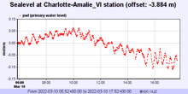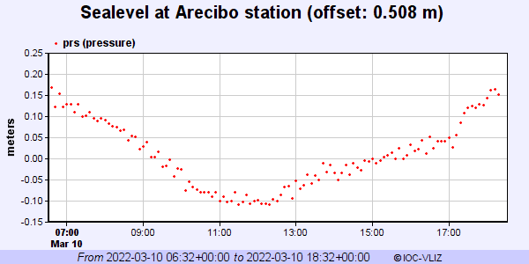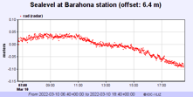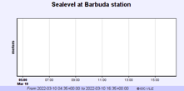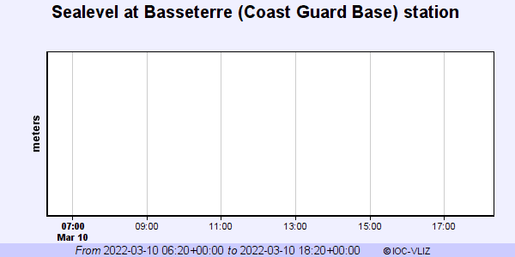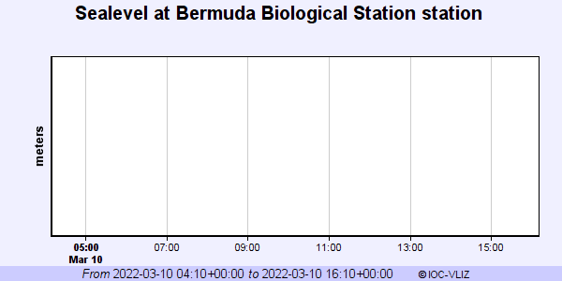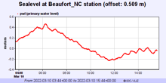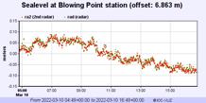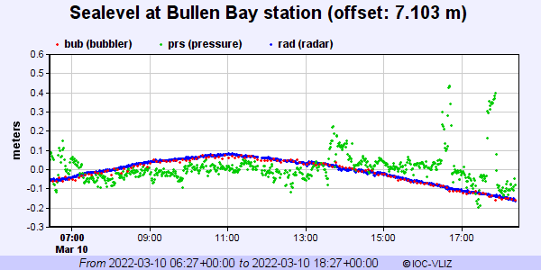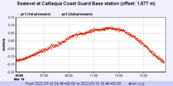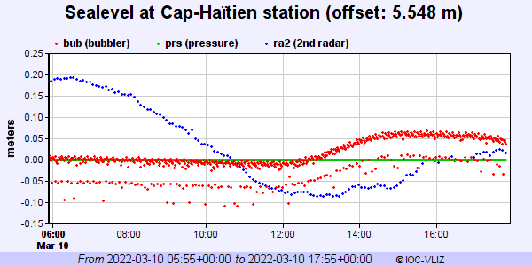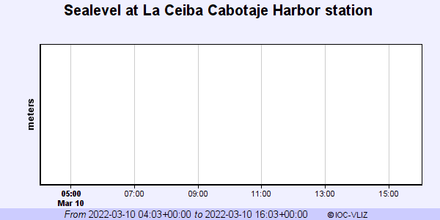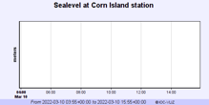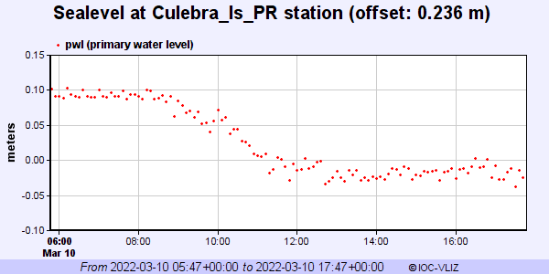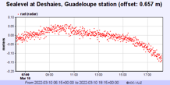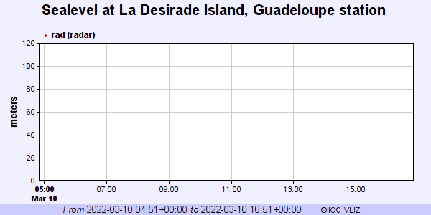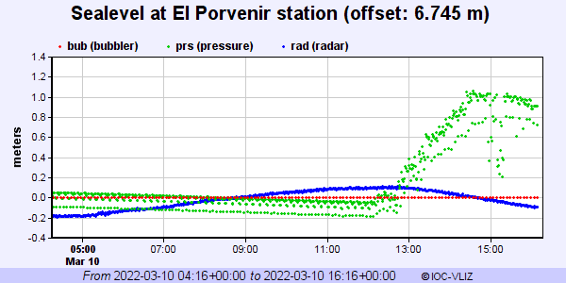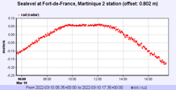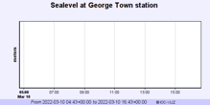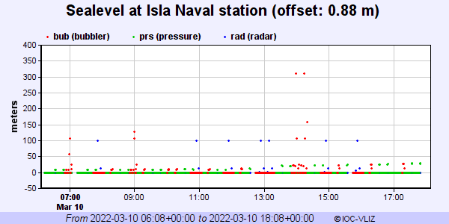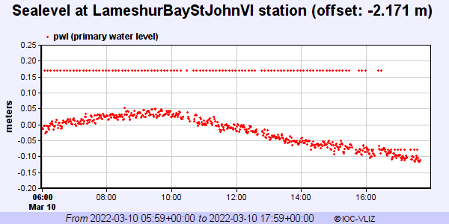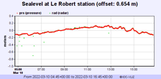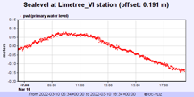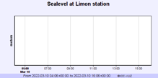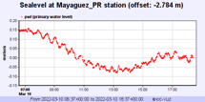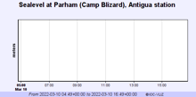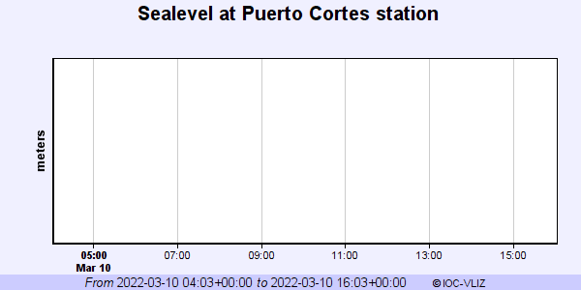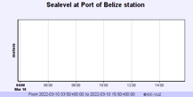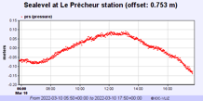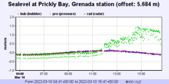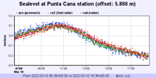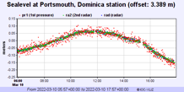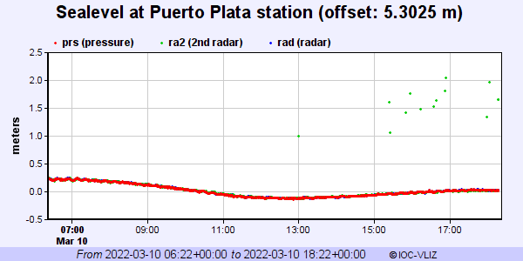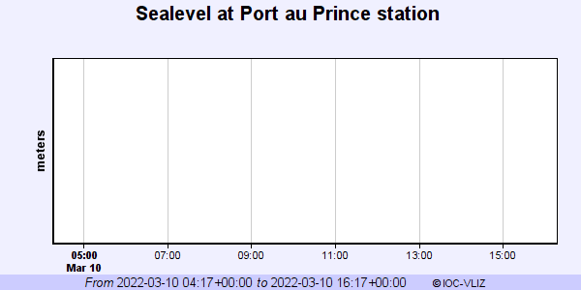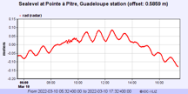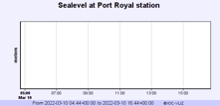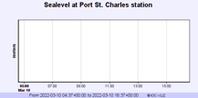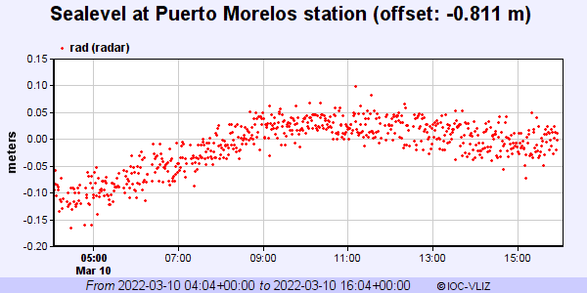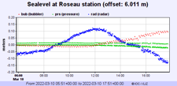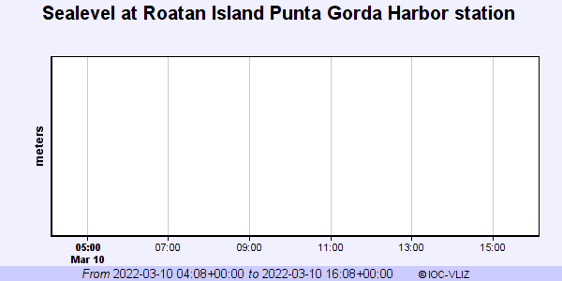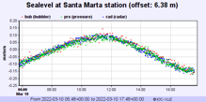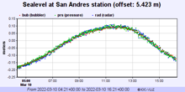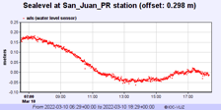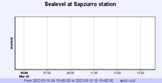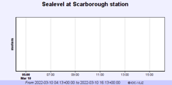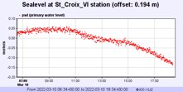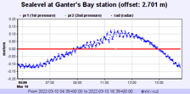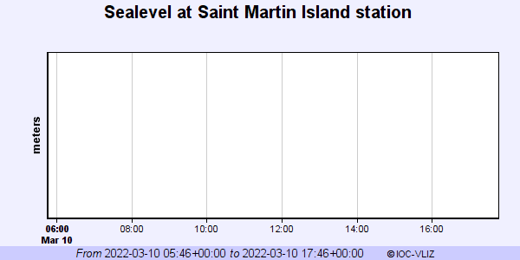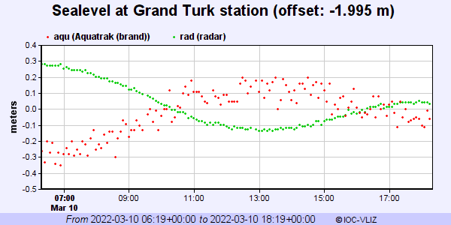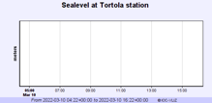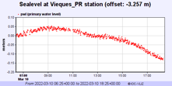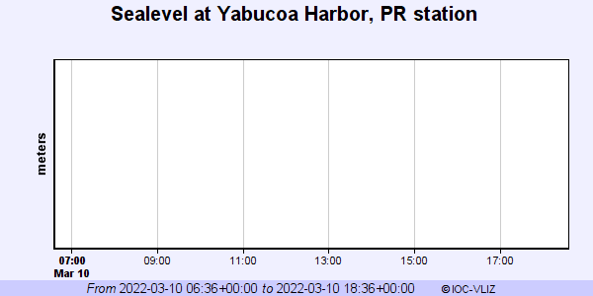

Barbuda
Basseterre
Bermuda
La Ceiba
Cabotaje Harbor
Corn Island
La Desirade Island, Guadeloupe
George Town
Limon
Parham, Antigua
Puerto Cortes
Port of Belize
Port au Prince
Port Royal
Port St. Charles
Roatan Island Punta Gorda Harbor
Sapzurro
Scarborough
Tortola
Saint Martin Island
Yabucoa Harbor, PR
Figure 7. Forecast of maximum wave heights for the Western Muertos Trough scenario from 52 CARIBE-EWS coastal sea level stations during the CARIBE WAVE exercise. Stations for which the name of the station is provided, and not the wave form, are stations that had no data on the IOC Sea Level Monitoring Facility.

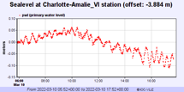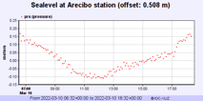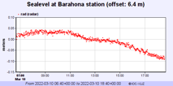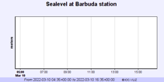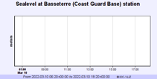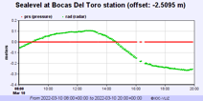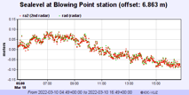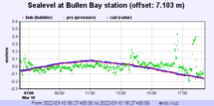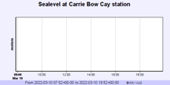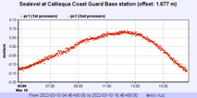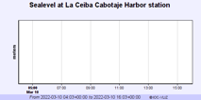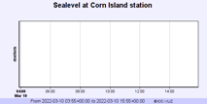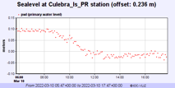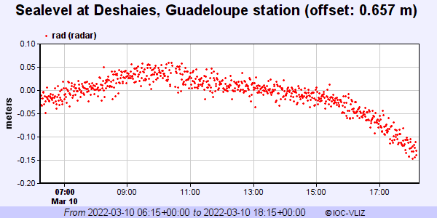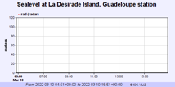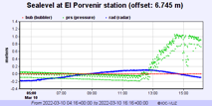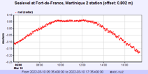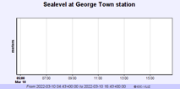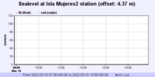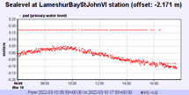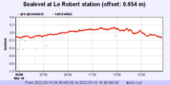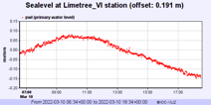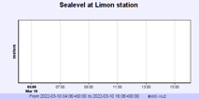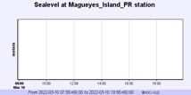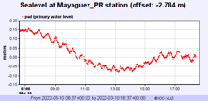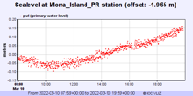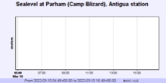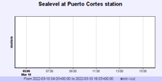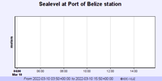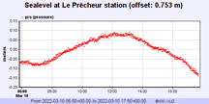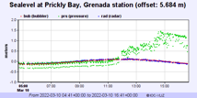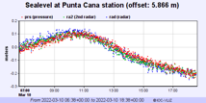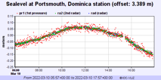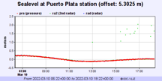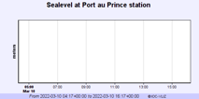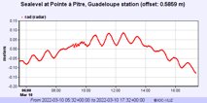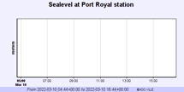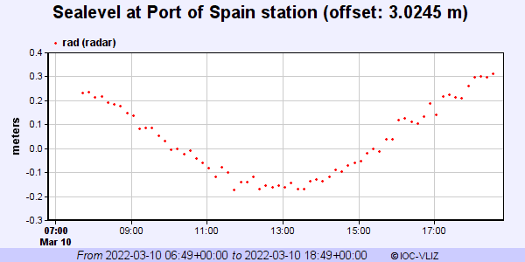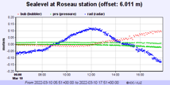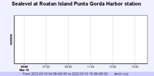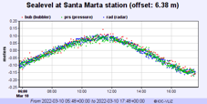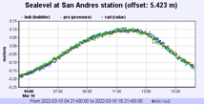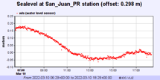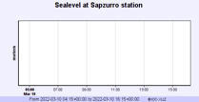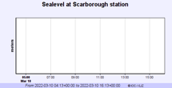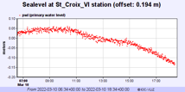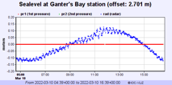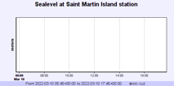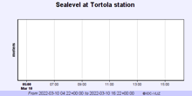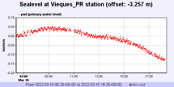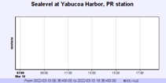
Parham (Camp Blizard), Antigua
Carrie Bow Cay
La Ceiba Cabotaje Harbor
Sapzurro
Tortola
Isla Mujeres2
La Desirade Island, Guadeloupe
Barbuda
Basseterre
Puerto Cortes
Port Royal
Scarborough
Yabucoa Harbor, PR
Saint Martin Island
Roatan Island Punta Gorda Harbor
Port au Prince
Port of Belize
Limon
George Town
Corn Island
Magueyes
Island PR

Figure 8. Forecast of maximum wave heights for the Northern Panama scenario from 54 CARIBE-EWS coastal sea level stations during the CARIBE WAVE exercise. Stations for which the name of the station is provided, and not the wave form, are stations that had no data on the IOC Sea Level Monitoring Facility.

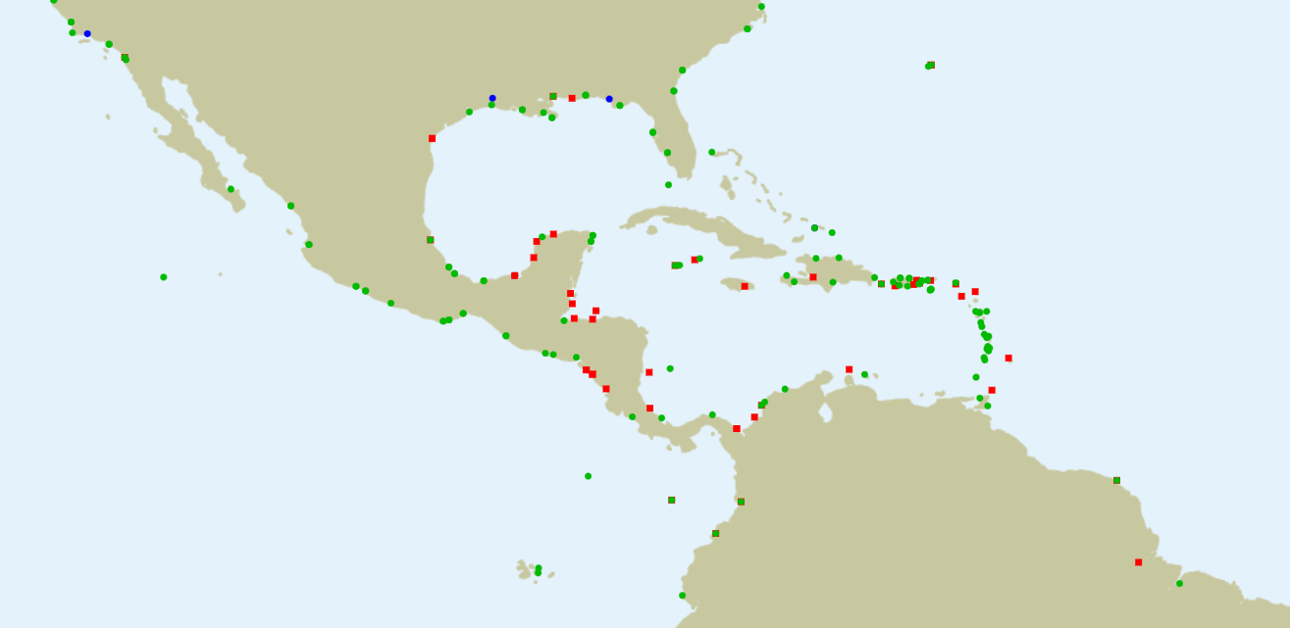
Figure 9. Screenshot showing IOC Sea Level facilities operating during the CARIBE WAVE 22 exercise. In green are stations for which data were available, red dots are for station for which there were no data.

3.6 RESOURCES
Although Emergency Management Organizations (EMOs) had advance notice of the exercise and some elected to set up a special dedicated shift to allow normal core business to continue uninterrupted, it was suggested that realistic resource levels be deployed in order to reflect some of the issues that are likely to be faced in a real event. Considering the pandemic, agencies were requested to adjust the exercise to their best convenience.
This year Elizabeth Vanacore was the Exercise Chair; while Alberto Lopez was the scientific experts that helped in the determination of the Western Muertos Trough scenario; Natalia Zamora was the scientific expert for the Northern Panama scenario which was based upon the outcome of a recent experts meeting in the region. ITIC-CAR coordinated the exercise for CARIBE-EWS.
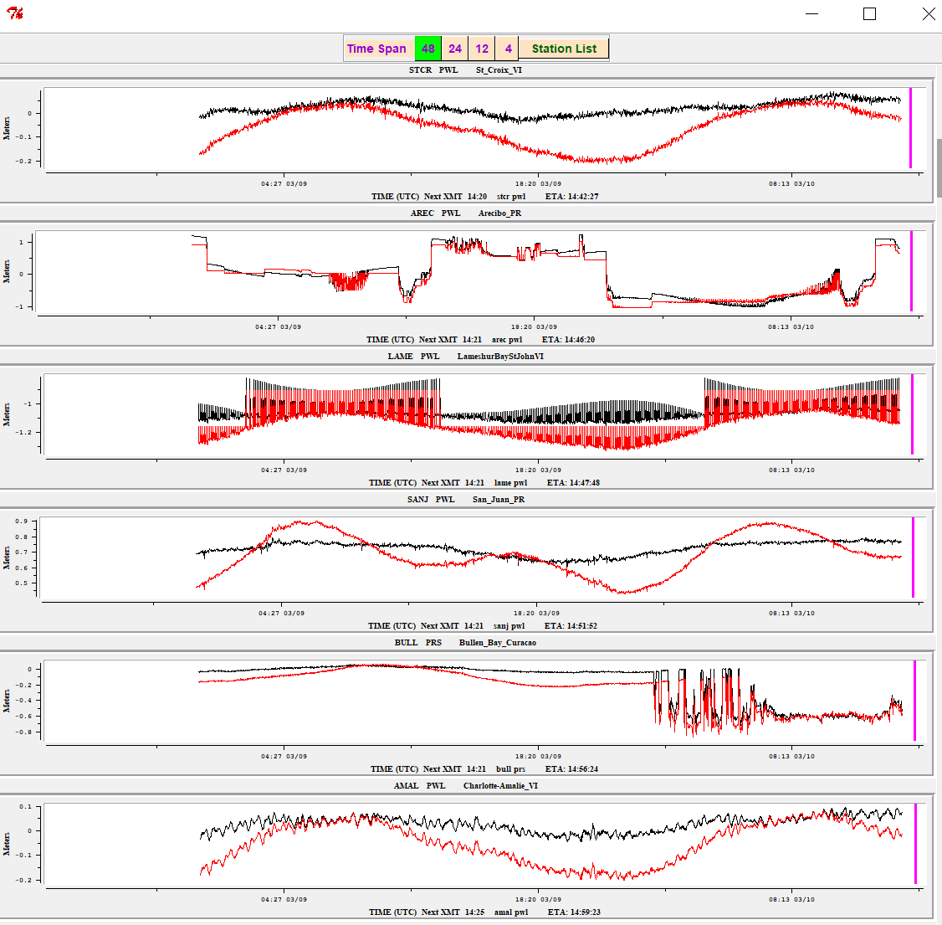
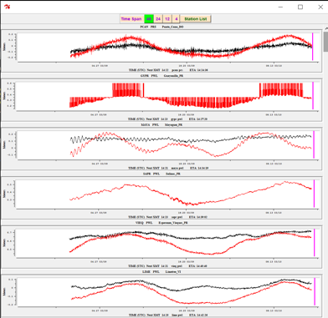
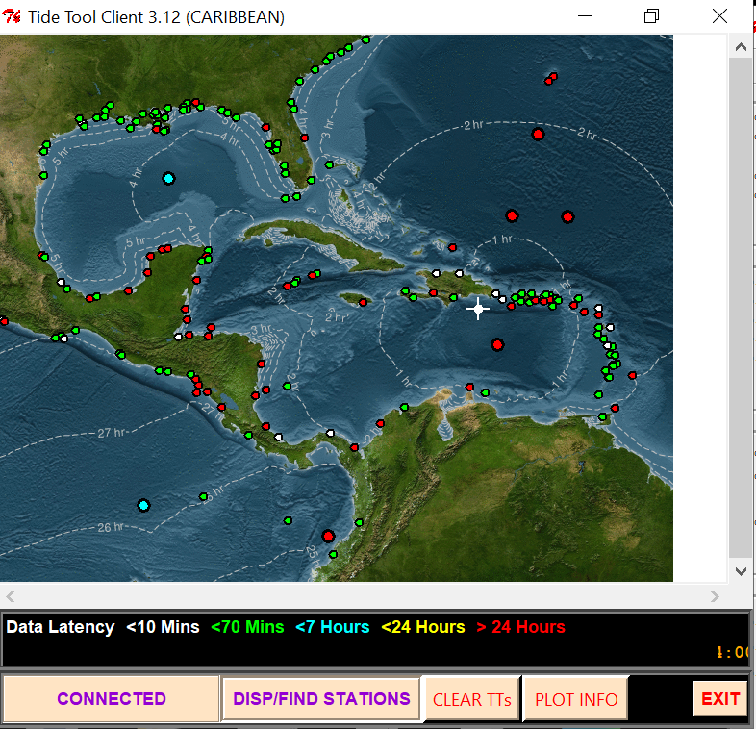

Figure 10. Screenshot from Tide Tool for the CARIBE WAVE 22 Western Muertos Trough scenarios. Tide Tool includes both coastal gauges and DARTs. In White and Green are operational stations, in red are stations with no data over the past 24 hours (non-operational). The Isochrons represent the travel time from the source of the simulated tsunami from. The Strip Chart to the left includes the marigrams from the closest 12 stations. The magenta stripe marks the estimated time of arrival.

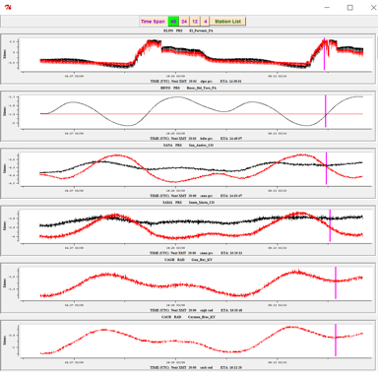
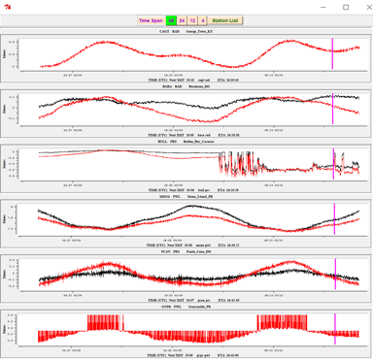
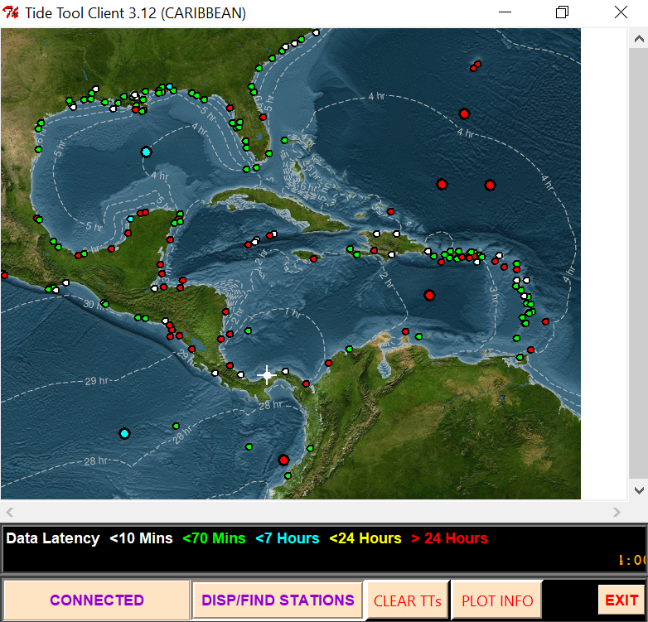

Figure 11. Screenshot from Tide Tool for the CARIBE WAVE 22 Northern Panama Scenario. Tide Tool includes both coastal gauges and DARTs. In White and Green are operational stations, in red are stations with no data over the past 24 hours (non-operational). The Isochrons represent the travel time from the source of the simulated tsunami from. The Strip Chart to the left includes the marigrams from the closest 12 stations. The magenta stripe marks the estimated time of arrival.

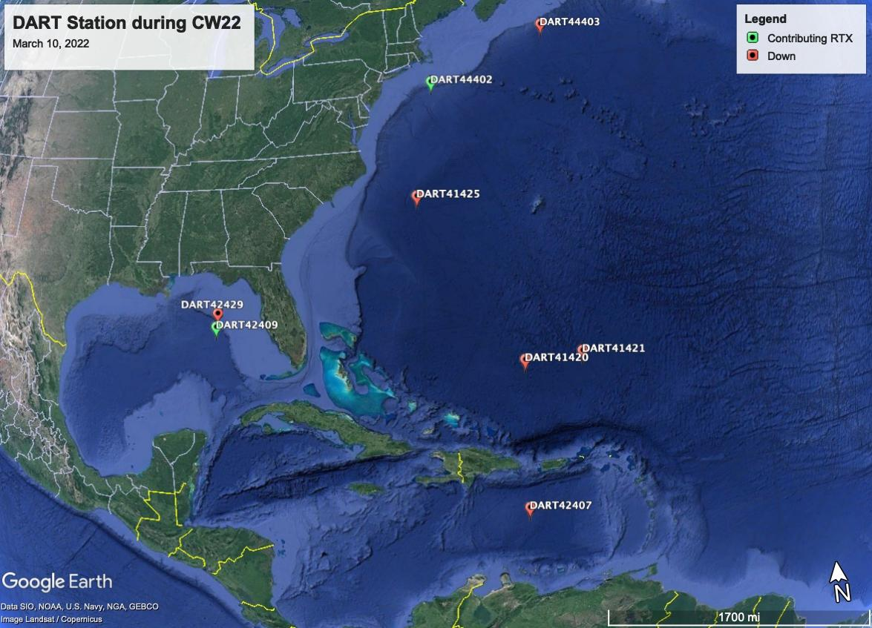
Figure 12. Map of operational and non-operational status of the DART’s on March 10, 2022.

3.7 MEDIA ARRANGEMENTS
One advantage in conducting exercises is that it provides a venue to promote tsunami awareness. The exercise offers an opportunity to collaborate with the media and disseminate more broadly information on the warning system. The CARIBE-EWS Member States and Territories indicated that about 43% of the news media participated and covered the exercise. The hashtag tracker Brand24 was used to monitor #CaribeWave and #CaribeWave22 from February 14 to March 16. Its data resulted in over 300 mentions on social media outlets and posts reaching over 1.7 million people worldwide (Figure 13). Emergency management agencies from countries such as Antigua and Barbuda, Barbados, Grenada, St. Kitts and Nevis, and others informed citizens through online article publications and social media posts that their country would participate in the exercise on March 10. The International Tsunami Information Center Caribbean Office, as well as the Puerto Rico Seismic Network also published informative posts related to tsunami awareness in preparation for CARIBE WAVE.
During the exercise, text messages and tweets about the start of the exercise were displayed on the PTWC account (Figure 14).
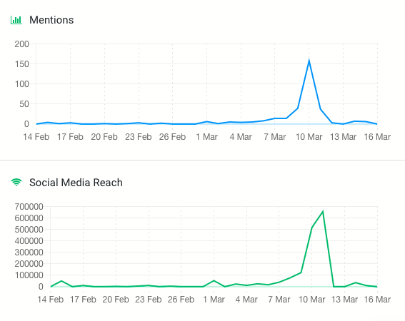

Figure 13. Graphs showing the #CaribeWave and #CaribeWave22 trending between
the 14th of February and 16th of March 2022.

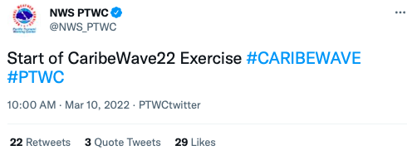
Figure 14. Twitter post about the CARIBE WAVE 22 exercise from NWS PTWC’s account.

Additionally, for CARIBE WAVE 22 a promotional video was produced in English, Spanish and French encouraging participants to act, prepare, and register for the exercise. The video was shared through social media and with the Member States and Territories through email.

EN - UNESCO/IOC Caribe Wave Exercise | https://vimeo.com/684809796
SP - Ejercicio Caribe Wave UNESCO/COI | https://vimeo.com/684839860
FR - UNESCO/COI Exercise Caribe Wave | https://vimeo.com/68484154

3.8 POST-EXERCISE EVALUATION
All participating countries were requested to provide feedback on the exercise through an online questionnaire. This feedback assists the ICG/CARIBE-EWS in the evaluation of CARIBE WAVE 22 and the development of subsequent exercises. It also helps response agencies document lessons learned and lead to improvements of the national systems. The survey contained 35 questions and was conducted by the IOC UNESCO using the Survey Monkey service. 38 surveys were completed representing the feedback from 100% of the MS and Territories.∗
The survey was available from the start of the exercise on March 10 and extended through March 31. Overall, the results indicated that the Dummy (Start of Exercise) message was received by 34 Member States, representing 91% of the CARIBE-EWS Member States and Territories. There was a strong dependency on email for the reception of products from the PTWC. The message was received by most countries within the first 1-2 minutes, and few countries reported delays. Despite COVID-19, 59% of the MS indicated that the TWFP/NTWC issued messages to relevant in country agencies. The exercise planning went well under extenuating circumstances, resulting in a 88% of satisfaction of MS and territories, and a total participation of 413,285 people from the Caribbean. The questions as well as the answers and comments are contained in the Supplement.
This evaluation contains valuable information and gives to the ICG/CARIBE-EWS group insights to address the objectives of the exercise. The results for the status of the implementation of the pilot CARIBE-EWS Tsunami Ready recognition project indicated that 93% of the countries are interested in implementing the program and 55% of these are already implementing it with 304 as total number of target communities to be recognized as Tsunami Ready (Table 4).
In addition, the survey provided the MS an opportunity to provide additional feedback on the exercise (Table 5).

Country | Already Implementing | Interested in Implementing | TsunamiReady® or Tsunami Ready Communities (as reported by Member States) | TsunamiReady® or Tsunami Ready Communities (IOC Records For CARIBE EWS) | Target Number
Antigua and Barbuda | Yes | - | 1 | 1 | 5
Aruba | No | Yes | 0 | 0 | 8
Bahamas | Yes | - | 2 | 0 | 22
Barbados | Yes | - | 8 | 1 | 50
Belize | No | Yes | 0 | 0 | 2
Brazil | No | Yes | - | 0 | -
Colombia | No | Yes | 0 | 0 | 5
Costa Rica | Yes | - | 5 | 0 | 4
Cuba | Yes | - | 0 | 0 | 4
Curacao | No | Yes | - | 0 | 5
Dominica | - | Yes | - | 0 | -
Dominican Republic | No | Yes | 0 | 1 | 4
France | Yes | - | 0 | 0 | 4
Grenada | Yes | - | 2 | 2 | 7
Guatemala | No | Yes | 0 | 0 | 2
Guyana | No | - | - | 0 | -
Haiti | Yes | - | 1 | 1 | 20
Honduras | Yes | - | 4 | 2 | 10
Jamaica | - | Yes | 10 | 1 | 5
Mexico | Yes | - | 0 | 0 | 21
NL- Bonaire, Saba, and Sint Eustatius | No | - | - | 0 | -
Nicaragua | Yes | - | 3 | 2 | 6
Panama | Yes | Yes | 0 | 0 | 9
Saint Kitts and Nevis | Yes | - | - | 1 | -
Saint Lucia | No | Yes | - | 0 | -
Saint Vincent and the Grenadines | Yes | - | 0 | 1 | 40
Sint Maarten | Yes | - | 0 | 0 | 1
Suriname | No | Yes | 0 | 0 | 2
Trinidad and Tobago | Yes | - | 1 | 1 | -
UK- Anguilla | Yes | - | - | 1 | -
UK- Bermuda | No | - | - | 0 | -
UK- British Virgin Islands | Yes | - | 4 | 1 | 4
UK- Cayman Islands | No | Yes | 0 | 0 | -
UK- Montserrat | - | - | - | 0 | -
UK- Turks and Caicos | No | Yes | 0 | 0 | 15
USA- Puerto Rico | Yes | - | 46 | 46 | 46
USA- US Virgin Islands | Yes | - | - | 3 | 3
Venezuela | No | Yes | 0 | 0 | 0
TOTAL | 20 YES | 15 INTERESTED | 87 | 65 | 304

Table 4. Status of Implementation of the Pilot CARIBE EWS Tsunami Ready Recognition Program.

Country | Exercise Caribe Wave 22  General Statements
Aruba | Very useful and forms part of yearly full-scale program.
Antigua and Barbuda | Over 5400 persons who took part in the exercise country-wide.  • More than 35 primary and secondary schools participated  •Of the disaggregated data collected from 50% of participating bodies representing some 45% of total participants showed a participation ratio of o Females 45% to Males 55% Generally it was noted that there was a good overall awareness of the activity by teachers and students alike, with a high level of interest and enthusiasm expressed by students and many volunteers.  • It was noted that preschools did utilize ropes to guide small children and a significant number of schools that had to cross active streets used teachers and security personnel to help manage the traffic where students had to cross, Many Schools ranging from several dozen to several hundred students in St Johns area, St Peters and St Marys areas recorded times of 5 mins or less for evacuation.  • There were persons from communities joining student as they moved towards evacuation areas when final counts were made in assembly areas.  The National time spread from the time from the initial message was received at the NTWC to receipt of disseminated message (of Early Warning via the Common Alerting Protocol (CAP) app) by participants country wide was 11 minutes.
Barbados | There were three (3) separate and distinct aspects to the Caribe Wave 2022 Exercise:  (1) The virtual Table-Top Exercise, which prompted participants to respond to the Tsunami threat to Barbados in accordance with the Exercise CARIBEWAVE 2022 Scenario. (2) A Communications Exercise executed by the Department of Emergency Management (DEM) and Barbados Citizen Band Radio Association (BCBRA) technical teams. The communications aspect of the exercise facilitated the response and transmission of messages in accordance with the parameters of the exercise and lent support to the third facet of the exercise. (3) Two (2) small, scaled evacuation exercises which targeted the tourism community and the disabled community in conjunction with their month of activities.  From all accounts all three activities went well and there were no major disruptions besides the failure of the CAP CAP system which prompted the use of primarily Astro and VHF radio. The disabled community was very appreciative with being involved in the exercise as it was the 1st time being involved in the physical aspect of the exercise. This promoted knowledge of the evacuation routes and the maintenance and development of family plans to promote self-evacuation of the disabled and their caretakers.  With respect to the Island Inn Hotel evacuation exercise this was well received as even more hotel guests than anticipated participated in the exercise without incident. The tabletop exercise scenarios allowed for agencies to explore their actions when faced with peculiar but yet realistic circumstances and they were able to express their actions in conjunction with their Sops. In conclusion the exercise provided an experience on which to build on by enhancing the involvement of the disabled community in future physical exercises, development and hotel's EOPs and finetuning the communications of agencies of the National Emergency Management System.
Belize | Similar to the above, no action was taken but the exercise served to test the ability of the TWFP to receive the messages in a timely manner. There is the need for the use of another medium whether it be SMS or using a platform such as WhatsApp.
Brazil | The webinars are essential to get me involved and understand how the exercise works. For the first time it was possible to interact with the Brazilian Navy that also participated on the webinars. It was possible to verify that there was an error on the email server configuration and not all in the PTWC emailing list received the warnings. Also, the exercise is important as a mind change process, working on the "No Tsunami Risk" culture in Brazil.
Colombia | The Caribe Wave 22 exercise went well, the bulletins were received within the times established in the manual and the established script was complied with at the national level. The National Emergency Management Office (UNGRD) will ensure that future exercises include the participation of territorial entities.
Cuba | Use the Caribbean Wave exercise as an example for all the countries of the world since it allows strengthening the response capacity in the event of a sudden event like this. Also, to train all member states to protect the population and its economic assets.
Curacao | We have been participating for years in the Caribe Wave Exercise. At the beginning of this year, we were still in the middle of a pandemic, and this also had an impact on the number of people who could participate in the exercise this year. We hope that next year we can plan a bigger exercise regarding Caribe Wave 2023.
Dominica | The exercise was useful in promoting public awareness on Tsunami hazard and safety. The virtual presentation was well supported, and participants expressed their appreciation for the information provided. Participants also indicated interest in further engagement to increase awareness on tsunami safety as well as other hazards.
Dominican  Republic | The Western Muertos represents a threat due to its proximity to the Dominican Republic.  On this occasion, a simulation exercise was carried out between the National Seismology Center, the Emergency Operations Center and the National Meteorology Office, which is the Focal Point for tsunamis.
France | In addition to territorial fragmentation, one of the difficulties encountered in FWI is the high turnover of managers (eg, DMO) in the public institutions. It is difficult to implement actions over time, including CW exercises. Individual who registered did not receive any message of the exercise.
Grenada | The annual exercise was an excellent opportunity for the country to test its Tsunami protocol. It also gave us an opportunity to measure the public's knowledge to adequately respond in times of need to the hazard. It has also given the Agency an opportunity to initiate the conversation of safety among the business community not just for Tsunami's but also hazards in general.
Guatemala | Although our country was not in the threat zone, we received all the PTWC messages. That is very useful to test our capabilities to respond in case of tsunami threat.
Haiti | That is a good exercise. It lets the focus group in Jeremie experiment the  tsunami messages from Codomar that is the National Tsunami Warning Center (NTWC). It lets also the focus group in Jeremie to start an experience of tsunami Early Warning System with CARIBE WAVE 2022 and understand better the Standard Operating Procedures (SOPs).
Honduras | It is important to have greater preparation, more exercises; however, they must be procedures that are socialized with greater anticipation and with greater commitment on the part of the pauses in participation. For this, face-to-face workshops must be held to define participation strategies.
Mexico | In a general way, we can cite that both in the reception and distribution of the different messages there were no major problems. However, there are small communities where there is no telephone and/or internet coverage, in these cases the notices were given through megaphones and in person. The general comments of the participants are in the areas of training, which are already considered. The percentage of participation was satisfactory.
Nicaragua | It provides us with better knowledge of the different activities that we must develop with the community, preparation and training of community personnel. As NTFP and NTC it allows us to improve the exchange of knowledge with the different response institutions and as CATAC it strengthens us to improve our Standard Operational Plans.
NL-Bonaire, Saba, and Sint Eustatius | Already discussed via email:  - We find that the modeling for computing the Forecasted Wave Heights takes a long time.  - We received the Graphical Forecast Products via email 10 minutes later than the 2nd warning message.  - We are interested in accessing the products, including more data formats, via an API or something similar.  Other remarks:  - Some internal stakeholders found the dummy message confusing because it states that it is the only message that they will receive. We will consider not forwarding it to them in next exercises.  - As in other years, we had problems with reaching some of the officials of the local government in a timely manner.
Panama | The exercises are very important to perform, to coordinate and compare actions in a real event and not to forget the procedures.  The CARIBE WAVE 22 Tsunami Exercise always provide important procedures (in this case, communication procedures), which have to follow in case of a real scenario (local, regional and distant).
Saint Kitts and Nevis | CARIBE WAVE exercise has strengthened the relationship between the various emergency agencies within the Caribbean region and the partner agencies around the world. CARIBE WAVE 22 Tsunami Exercise has shown that many people hesitate to respond to exercises but will respond when immediate danger is present.  The education process is very good and will continue to ensure that another evacuation exercise will receive excellent response from residents in the targeted areas.
Saint Vincent and the Grenadines | The exercise was extremely timely and useful. The following are some of the main takeaways from the exercise.  1. There is a need for some small-scale exercise to improve NEOC response and management (can be in the form of table-top exercises).  2. Refresher training exercise needed to prepare threats messages that will be disseminated to the public  3. Frequent simulations are necessary to increase familiarity with local and organizational SOPs.
Sint Maarten | Due to our current workload, we were not able to actively participate. We hope to join again in 2023.
Suriname | Due to an emergency situation in Suriname, we could not participate in the CARIBE WAVE 22 Tsunami Exercise.
Trinidad and Tobago | The exercise gave us the opportunity to test the SOPs outlined in Trinidad and Tobago Tsunami Warning Information Dissemination Protocol and Standard Operating Procedures (SOPs). In addition, it involved working through the process from receipt of the initial threat message to discontinuation. It has certainly provided the context for identifying the areas in our tsunami response that require development and/or strengthening.
UK- Bermuda | Bandwidth for this has been limited in Bermuda, but we're starting to see more interest tsunami preparedness (and in DRR in general). DRRM did a good job in coordinating agency attendance and asking some pointed questions that get people thinking about action plans. Still much work to do about tsunami awareness, but recent volcanic and seismic activity (Tonga, St. Vincent & the Grenadines, Canary Islands) have helped to focus attention on the risk.
UK- Cayman Islands | Can we have a meeting to discuss risk analysis? Thank you for all your hard work on the exercise and it is useful.
USA- Puerto Rico | During the CARIBE WAVE 2022 Exercise, the Puerto Rico Seismic Network (PRSN) tested multiple communication methods with emergency management agencies in our area of responsibility (Puerto Rico and Virgin Islands Region). The agencies within the (seismic) area of responsibility of the Puerto Rico Seismic Network are: Puerto Rico Emergency Management Bureau (PREMB, Puerto Rico), National Weather Service San Juan Forecast Office (NWS-SJ, Puerto Rico), Department of Disaster Management (DDM, British Virgin Islands), Virgin Islands Territorial Emergency Management Agency (VITEMA, US Virgin Islands), Oficina Nacional de Meteorología (ONAMET, Dominican Republic) y el Instituto Sismológico Universitario (ISU, Dominican Republic). Among the PRSN communication methods tested are the Broadcast System (System to Disseminate Information on Earthquakes and Tsunamis), dedicated telephones (ring downs and private telephone line), the PREMB radio frequency, RSS (PRSN), text message (Tsunami Warning Focal Points [TWFP] and some primary agencies), e-mail lists (emergency management list), automatic phone calls (TWFP), fax (TWFP), PRSN official web page and social media (Facebook and Twitter). Communication tests were conducted by ham radio with radio amateur volunteers between the PRSN (Mayagüez) and the rest of the region. PRSN updated the official web page for the CARIBE WAVE 2022 Communication Exercise (http://caribewave.uprm.edu/) for Puerto Rico and the Virgin Islands. This web page contains all the materials and guidelines developed by the PRSN for this year’s exercise, the EAS activation announcement for Puerto Rico and the promotion to complete the Official Registry of the Exercise (at tsunamizone.org), a description of the Western Muertos Trough Scenario, information in How to participate, among other materials. Starting on February 10, 2022, pre-exercise communication tests were conducted to promote Caribe Wave Exercise in the Puerto Rico and Virgin Islands Region among emergency managers and the public. These tests were issued on February 10, February 28, March 3, and March 9, by all communication lines available in PRSN (dedicated telephones, emails, fax, text message, RSS, and social media). PRSN issued 14 messages during the exercise. The 46 TsunamiReady communities participate in a different level including communication test, sirens activation and full-scale evacuation exercise. For this exercise, (only for Puerto Rico) the EAS system was activated in coordination with the Puerto Rico Emergency Management Bureau, National Weather Service (San Juan), Puerto Rico Broadcast Association, and Puerto Rico EAS Committee, through the following communication means: radio, T.V., cable TV, and NOAA weather radio. The real alert code of tsunamis (TWS) was issued during the exercise at 10:07 AM on March 10, 2022, by the National Weather Service (San Juan Forecast Office) to announce the Tsunami Warning for Puerto Rico, according to the Western Muertos Trough Scenario choose for Puerto Rico and the Virgin Islands. At the PRSN we monitored the activation of EMWIN, the NOAA radios, as well as the Puerto Rico EAS and WEA (as scheduled for the exercise). At PRSN we received the PTWC Dummy Message at 10:00 AM (14:00 GMT) through the EMWIN System and email. Puerto Rico Broadcaster Association will prepare a final report about the activation of the EAS System for Puerto Rico. Puerto Rico Emergency Management Bureau emits the WEA for Puerto Rico at 10:07 AM (14:07 GMT) to announce the Tsunami Warning for Puerto Rico, according to the Western Muertos Trough Scenario choose for Puerto Rico. The PRSN conducted Amateur Radio communication exercise with local volunteers.
USA-US Virgin Islands | Exercise was great, we need to just engage more agencies to exercise their plans and understand the importance of participating, as well as placing more educational staple signage in the community so that it can be seen in highly populated areas.
Venezuela | The CARIBE WAVE exercises have shown us the capacity that regional and local communities and authorities have to manage the tsunami emergency, I have seen local reports that estimate material damage and the number of people affected, injured, deceased, etc., they have created good databases with the inventories of hospital facilities and equipment necessary for handling the emergency, coordination has improved notably, despite the uncertainty when there is a change of authority, the response personnel continue to lead the exercise and with more and more enthusiasm and responsibility. All response personnel are observed assuming their role in accordance with the provisions of the laws, we hope to improve our economy to promote and evaluate the coastal areas that could be candidates for the Tsunami Ready program. I congratulate the programmers of the Caribbean Wave and the supports of the COI/Caribbean.
Table 5. General statements on CARIBE WAVE 22 Tsunami Exercise experience from countries
that participated.

REFERENCES

GEBCO Compilation Group (2021) GEBCO 2021 Grid (doi:10.5285/c6612cbe-50b3-0cff-
e053-6c86abc09f8f)

Uieda, L., Tian, D., Leong, W. J., Jones, M., Schlitzer, W., Toney, L., Grund, M., Yao, J.,
Magen, Y., Materna, K., Newton, T, Anant, A., Ziebarth, M., Wessel, P., & Quinn, J.
(2021). PyGMT: A Python interface for the Generic Mapping Tools (v0.5.0). Zenodo.
https://doi.org/10.5281/zenodo.5607255
von Hillebrandt-Andrade, Christa, 2013, Minimizing Caribbean Tsunami Risk: Science, Vol. 341, p. 966-968.

ANNEX I. CATAC Dummy (Start of Exercise) Message

¡Este es sólo un mensaje de prueba enviado por CATAC en apoyyo al Ejercicio CaribeWave 22!
***************************************************************************

Centro de Asesoramiento de Tsunami para América Centra (CATAC)

XXXXXXX ESTE ES UN EJERCICIO XXXXXXXXXX ESTE ES UN EJERCICIO XXXXXXXXXXX

Aviso: Este es un mensaje de inicio del ejercicio Caribe Wave 2022 para los países de América Central, como apoyo a la Comisión Oceanográfica Intergubernamental (COI), de la UNESCO y al ICG/CARIBE-EWS

Emisión: 2020-03-10 14:00 Hora (UTC)
2020-03-10 08:00 Hora de Centroamérica
2020-03-10 09:00 Hora de Panamá

Este mensaje se está utilizando para iniciar el ejercicio de tsunami Caribe Wave 2022, con origen en las costas del norte de Panamá.

El manual está disponible en el sitio web http://catac.ineter.gob.ni/
El propósito del ejercicio es proporcionar asesoría a la gestión de emergencias.
Es un escenario para poner a prueba los planes de respuesta ante tsunamis en los países de América Central

XXXXXXX ESTE ES UN EJERCICIO XXXXXXXXXX ESTE ES UN EJERCICIO XXXXXXXXXXX

ANNEX II. CATAC Exercise Messages

The following messages created for the CARIBE WAVE 22 tsunami exercise were issued by the Central American Tsunami Advisory Center for a magnitude 8.3 earthquake and subsequent tsunami originating in Northern Panama. Only Central American countries and regions by agreement with the center received the messages.

CATAC Message #1

¡Este es sólo un mensaje de prueba enviado por CATAC en apoyyo al Ejercicio CaribeWave 22!
******************************************************************************

Centro de Asesoramiento de Tsunami para América Central - CATAC

XXXXXXX ESTE ES SOLO UN EJERCICIO XXXXXXXXXXXXXXXXXXXXXXXXXXXXXXXXXXXXXXXXXXXXXXXXXXXXXXXXXXXXXXXXXXXXX

AVISO : Este mensaje se publica únicamente a título informativo como apoyo a los países de América Central. Las autoridades nacionales son responsables de determinar el nivel de alerta y efectuar las medidas
adecuadas para su país.

Boletín sobre tsunami N° 01

Publicado: 2022-03-10 14:03 Hora UTC
2022-03-10 08:03 Hora de Centroamérica
2022-03-10 09:03 Hora de Panamá

Un terremoto ha ocurrido con los siguientes estos parámetros preliminares:

Magnitud : 7.5
Fecha : 10/03/2022
Hora : 08:00 Hora Centroamérica, 09:00 Hora Panamá, 14:00 Hora UTC
Latitud : 09.40 Norte
Longitud : 80.30 Oeste
Profundidad : 25 Km
Ubicación : Norte de Panamá

Evaluación:
Considerando magnitud, profundidad del hipocentro, y ubicación del terremoto existe posibilidad de un tsunami destructivo para las zonas cercanas al epicentro, es decir Norte de Panamá y Costa Rica.

Acciones recomendadas:
Se urge tomar acciones inmediatas para la protección de la población en las costas del Caribe de América Central
Se proveerá mayor información en los próximos minutos.
******************************************************************************

XXXXXXX ESTE SOLO ES UN EJERCICIO XXXXXXXXXXXXXXXXXXXXXXXXXXXXXXXXXXXXXXXXXXXXX

CATAC Message #2

¡Este es sólo un mensaje de prueba enviado por CATAC en apoyyo al Ejercicio CaribeWave 22!
******************************************************************************

Centro de Asesoramiento de Tsunami para América Central - CATAC

XXXXXXX ESTE ES SOLO UN EJERCICIO XXXXXXXXXXXXXXXXXXXXXXXXXXXXXXXXXXXXXXXXXXXXXXXXXXXXXXXXXXXXXXXXXXXXX

AVISO : Este mensaje se publica únicamente a título informativo como apoyo a los países de América Central. Las autoridades nacionales son responsables de determinar el nivel de alerta y efectuar las medidas
adecuadas para su país.

Boletín sobre tsunami N° 02

Publicado: 2022-03-10 14:09 Hora UTC
2022-03-10 08:09 Hora de Centroamérica
2022-03-10 09:09 Hora de Panamá

Una advertencia de tsunami destructivo está en efecto para las zonas costeras del Mar Caribe de los países de América Central.

Un terremoto ha ocurrido con los siguientes estos parámetros:

Magnitud : 8.3
Fecha : 10/03/2022
Hora : 08:00 Hora Centroamérica, 09:00 Hora Panamá, 14:00 Hora UTC
Latitud : 09.40 Norte
Longitud : 80.30 Oeste
Profundidad : 25 Km
Ubicación : Norte de Panamá

Evaluación:

Por magnitud, profundidad y ubicación del terremoto existe la posibilidad de que se haya producido un tsunami destructivo
que afectaría con gran intensidad a las costas más cercanas, hasta unos cien kilómetros del epicentro del terremoto.
A mayores distancias también puede causar estragos en dependencia de las condiciones locales.
Las autoridades deben tomar acciones correspondientes a sus planes de respuestas.
Resultados de la simulación de tsunami:

Estimados de Tiempos de Arribo (ETA) en hora local y Altura Máxima (AM) de olas del tsunami, en diferentes puntos de pronóstico:

Sitio País ETA AM(m)
Colon Panamá 2022/03/10 09:00 8.84 Turtle Island Panamá 2022/03/10 09:00 2.17
Veraguas-Carbe Panamá 2022/03/10 09:07 7.71
San Blas Panamá 2022/03/10 09:14 2.27
Bocas del Toro Panamá 2022/03/10 09:26 4.10
Limón Costa Rica 2022/03/10 08:27 4.58
Corn Island Nicaragua 2022/03/10 08:59 2.68
San Juan de Nicaragua Nicaragua 2022/03/10 09:03 2.86
Little Corn Island Nicaragua 2022/03/10 09:10 2.51
Cayos Miskitos Nicaragua 2022/03/10 11:16 1.89
Cayos de Honduras Honduras 2022/03/10 12:08 1.60

Resultado gráfico:

Revise en el archivo adjunto a este mensaje, las zonas de pronóstico codificados con colores según el peligro,
para las zonas costeras del Mar Caribe de América Central y la propagación de energía.

Actualizaciones:

Se proveerá más información en los próximos minutos.

Los países podrán recibir adicionalmente, mensajes del Centro de Alerta de Tsunami para el Pacífico (PTWC). En caso de diferencias entre los resultados de CATAC y del PTWC, recomendamos preferir de manera conservativa,
las estimaciones que corresponden a un mayor peligro.

Información adicional:

Información detallada del sismo y tsunami se encuentra en el sitio web http://catac.ineter.gob.ni/

*******************************************************************************************************

XXXXXXX ESTE ES SOLO UN EJERCICIO XXXXXXXXXXXXXXXXXXXXXXXXXXXXXXXXXXXXXXXXXXXXXXXXXXXXXXXXXXXXX

CATAC Message #3

¡Este es sólo un mensaje de prueba enviado por CATAC en apoyyo al Ejercicio CaribeWave 22!
******************************************************************************

Centro de Asesoramiento de Tsunami para América Central - CATAC

XXXXXXX ESTE ES SOLO UN EJERCICIO XXXXXXXXXXXXXXXXXXXXXXXXXXXXXXXXXXXXXXXXXXXXX

AVISO : Este mensaje se publica únicamente a título informativo como apoyo a los países de América Central. Las autoridades nacionales son responsables de determinar el nivel de alerta y efectuar las medidas
adecuadas para su país.

Boletín sobre tsunami N° 03

Publicado: 2022-03-10 14:30 Hora UTC
2022-03-10 08:30 Hora de Centroamérica
2022-03-10 09:30 Hora de Panamá

Una advertencia de tsunami está en efecto para las zonas costeras de los países de América Central

Un terremoto ha ocurrido con los siguientes estos parámetros:

Magnitud : 8.3
Fecha : 10/03/2022
Hora : 08:00 Hora Centroamérica, 09:00 Hora Panamá, 14:00 Hora UTC
Latitud : 09.40 Norte
Longitud : 80.30 Oeste
Profundidad : 25 Km
Ubicación : Norte de Panamá

Evaluación:

Se ha producido un tsunami que afecta con mayor intensidad a las costas más cercanas al epicentro.
Existe afectación severa para las zonas costeras de Panamá, Costa Rica, Nicaragua..

Las autoridades deben tomar acciones correspondientes a sus planes de respuestas.
Resultados de la simulación de tsunami:

Estimados de Tiempos de Arribo (ETA), en hora local y Altura Máxima (AM) de olas del tsunami, en diferentes puntos de pronóstico:

Hora Centroamérica
ZONAS PAÍS ETA AM(m)
Colon Panamá 2022/03/10 09:00 8.84
Turtle Island Panamá 2022/03/10 09:00 2.17
Veraguas-Carbe Panamá 2022/03/10 09:07 7.71
San Blas Panamá 2022/03/10 09:14 2.27
Bocas dek Toro Panamá 2022/03/10 09:26 4.10
Limón Costa Rica 2022/03/10 08:27 4.58
Corn Island Nicaragua 2022/03/10 08:59 2.68
San Juan de Nicaragua Nicaragua 2022/03/10 09:03 2.86
Little Corn Island Nicaragua 2022/03/10 09:10 2.51
Cayos Miskitos Nicaragua 2022/03/10 11:16 1.89
Cayos de Honduras Honduras 2022/03/10 12:08 1.60

Resultado gráfico:

Revise en el archivo adjunto a este mensaje, las zonas de pronóstico codificados con colores según el peligro,
ara las zonas costeras del Océano Pacífico de América Central.

Mediciones en estaciones del nivel del mar:

Código Coordenadas País Hora Amax
VZ.LIMON 9.98N 83.02O Costa Rica 10/3/2022 08:14:10 3.96
VZ.BDTO 9.35N 82.25O Panamá 10/3/2022 09:00:00 2.34
VZ.COIS 12.32N 83.06O Nicaragua 10/3/2022 08:17:55 1.94
VZ.ELPO 9.55N 78.94O Panamá 10/3/2022 09:00:00 1.86
VZ.TELA 15.78N 87.45O Honduras 10/3/2022 11:31:43 0.37
VZ.CEIB 15.79N 86.76O Honduras 10/3/2022 11:13:40 0.33
VZ.RTAS 16.34N 86.54O Honduras 10/3/2022 10:33:40 0.21

Actualizaciones:

Se proveerá más información en los próximos minutos.

Mensajes del PTWC:
Los países podrán recibir adicionalmente, mensajes del Centro de Alerta de Tsunami para el Pacífico (PTWC). En caso de diferencias entre los resultados de CATAC y del PTWC, recomendamos preferir de manera conservativa,
las estimaciones que corresponden a un mayor peligro.

Información adicional:

Información detallada del sismo y tsunami se encuentra en el sitio web http://catac.ineter.gob.ni/

******************************************************************************

XXXXXXX ESTE ES SOLO UN EJERCICIO XXXXXXXXXXXXXXXXXXXXXXXXXXXXXXXXXXXXXXXXXXXXX

CATAC Message #4

¡Este es sólo un mensaje de prueba enviado por CATAC en apoyyo al Ejercicio CaribeWave 22!
******************************************************************************

Centro de Asesoramiento de Tsunami para América Central - CATAC

XXXXXXX ESTE ES SOLO UN EJERCICIO XXXXXXXXXXXXXXXXXXXXXXXXXXXXXXXXXXXXXXXXXXXXX

AVISO : Este mensaje se publica únicamente a título informativo como apoyo a los países de América Central. Las autoridades nacionales son responsables de determinar el nivel de alerta y efectuar las medidas
adecuadas para su país.

Boletín sobre tsunami N° 04

Publicado: 2022-03-10 15:00 Hora UTC
2022-03-10 09:00 Hora de Centroamérica
2022-03-10 10:00 Hora de Panamá

Se ha detectado un tsunami que está afectando a las zonas costeras de los países de América Central

Magnitud : 8.3
Fecha : 10/03/2022
Hora : 08:00 Hora Centroamérica, 09:00 Hora Panamá, 14:00 Hora UTC
Latitud : 09.40 Norte
Longitud : 80.30 Oeste
Profundidad : 25 Km
Ubicación : Norte de Panamá

Evaluación:

De acuerdo a informaciones recibidas y datos obtenidos, se confirma la generación de olas de tsunami,
que están afectando las zonas costeras del Mar Caribe de América Central.

Se hace hincapié a alturas de olas con amplitudes significativas que pueden ocurrir horas después del terremoto, inclusive en Guatemala.

Resultados de la simulación de tsunami:

Mediciones en estaciones del nivel del mar:

Código Coordenadas País Hora Amax
VZ.LIMON 9.98N 83.02O Costa Rica 10/3/2022 08:14:10 3.96
VZ.BDTO 9.35N 82.25O Panamá 10/3/2022 09:00:00 2.34
VZ.COIS 12.32N 83.06O Nicaragua 10/3/2022 08:17:55 1.94
VZ.ELPO 9 .55N 78.94O Panamá 10/3/2022 09:00:00 1.86
VZ.TELA 15.78N 87.45O Honduras 10/3/2022 11:31:43 0.37
VZ.CEIB 15.79N 86.76O Honduras 10/3/2022 11:13:40 0.33
VZ.RTAS 16.34N 86.54O Honduras 10/3/2022 10:33:40 0.21

Actualizaciones:
Se proveerá más información en los próximos minutos

Mensajes del PTWC:

Los países podrán recibir adicionalmente, mensajes del Centro de Alerta de Tsunami para el Pacífico (PTWC). En caso de diferencias entre los resultados de CATAC y del PTWC, recomendamos preferir de manera conservativa,
las estimaciones que corresponden a un mayor peligro.

Información adicional:

Información detallada del sismo y tsunami se encuentra en el sitio web http://catac.ineter.gob.ni/

******************************************************************************

XXXXXXX ESTE ES SOLO UN EJERCICIO XXXXXXXXXXXXXXXXXXXXXXXXXXXXXXXXXXXXXXXXXXXX

CATAC Message #5

¡Este es sólo un mensaje de prueba enviado por CATAC en apoyyo al Ejercicio CaribeWave 22!
******************************************************************************

Centro de Asesoramiento de Tsunami para América Central - CATAC

XXXXXXX ESTE ES SOLO UN EJERCICIO XXXXXXXXXXXXXXXXXXXXXXXXXXXXXXXXXXXXXXXXXXXXX

AVISO : Este mensaje se publica únicamente a título informativo como apoyo a los países de América Central. Las autoridades nacionales son responsables de determinar el nivel de alerta y efectuar las medidas
adecuadas para su país.

Boletín sobre tsunami N° 05

Publicado: 2022-03-10 16:00 Hora UTC
2022-03-10 10:00 Hora de Centroamérica
2022-03-10 11:00 Hora de Panamá

Un potente tsunami está afectando las costas del Pacifico de todos los países de América Central.

Se hace hincapié a alturas de olas con amplitudes significativas que pueden ocurrir horas después del terremoto, inclusive en Panamá. Se sugiere a las autoridades tomar las medidas pertinentes tomando en cuenta la magnitud del evento,
por lo que se pordrían generar olas con amplitudes signifiativas en el trancurso de las próximas horas.

Resultados de la simulación de tsunami:

Mediciones en estaciones del nivel del mar, en hora local y altura máxima en metros:

Código Coordenadas País Hora Amax
VZ.LIMON 9.98N 83.02O Costa Rica 10/3/2022 08:14:10 3.96
VZ.BDTO 9.35N 82.25O Panamá 10/3/2022 09:00:00 2.34
VZ.COIS 12.32N 83.06O Nicaragua 10/3/2022 08:17:55 1.94
VZ.ELPO 9.55N 78.94O Panamá 10/3/2022 09:00:00 1.86
VZ.TELA 15.78N 87.45O Honduras 10/3/2022 11:31:43 0.37
VZ.CEIB 15.79N 86.76O Honduras 10/3/2022 11:13:40 0.33
VZ.RTAS 16.34N 86.54O Honduras 10/3/2022 10:33:40 0.21

Evaluación:
Según nuestras simulaciones, amplitudes considerablemente mayores pueden ocurrir en las próximas horas.
las autoraidades nacionales de los diferentes países debern tomar las decisiones adecuadas,
de acuerdo a sus planes de respuesta.

Mensajes del PTWC:

Los países podrán recibir adicionalmente, mensajes del Centro de Alerta de Tsunami para el Pacífico (PTWC). En caso de diferencias entre los resultados de CATAC y del PTWC, recomendamos preferir de manera conservativa,
las estimaciones que corresponden a un mayor peligro.

Información detallada del sismo y tsunami se encuentra en el sitio web www.catac.ineter.gob.ni

******************************************************************************
XXXXXXX ESTE ES SOLO UN EJERCICIO XXXXXXXXXXXXXXXXXXXXXXXXXXXXXXXXXXXXXXXXXXXXX

XXXXXXX Este el el último mensaje, en el marco del ejercicio CaribeWave 22, enitido por CATAC XXXXXXXXX

ANNEX III. List Of Acronym
AWIPS | Advanced Weather Interactive Processing System
CATAC | Central American Tsunami Advisory Centre
EAS | Emergency Alert System
EMO | Emergency Management Organization
EMWIN | Emergency Management Weather Information Network
GTS | Global Telecommunication System
ICG/CARIBE-EWS | Intergovernmental Coordination Group for the Tsunamis and Other Coastal Hazards Warning System for the Caribbean and Adjacent Regions
INETER | Instituto Nicaragüense de Estudios Territoriales
IOC  ITIC-CAR | Intergovernmental Oceanographic Commission of UNESCO  International Tsunami Information Center Caribbean Office
NCEI  NDMO  NPDB  NOAA | National Centers for Environmental Information  National Disaster Management Office  North Panama Deformed Belt  National Oceanic and Atmospheric Administration
NTWC | National Tsunami Warning Centre
NWS | National Weather Service
PRSN | Puerto Rico Seismic Network
PTWC | Pacific Tsunami Warning Center
RIFT | Rapid Inundation and Forecasting of Tsunamis
TWFP | Tsunami Warning Focal Points
UNESCO | United National Educational, Scientific, and Cultural Organization
WMO | World Meteorological Organization

∗ Antigua and Barbuda, Aruba, Bahamas, Barbados, Belize, Brazil, Colombia, Costa Rica, Cuba, Curacao, Dominica, Dominican Republic, France (Martinique, Guadeloupe, Guyane, St. Barthelemy, St. Martin), Grenada, Guatemala, Guyana, Haiti, Honduras, Jamaica, Mexico, Netherlands (Bonaire, Saba and Sint Eustatius), Nicaragua, Panama, Saint Kitts and Nevis, Saint Lucia, Saint Vincent and the Grenadines, Sint Maarten, Suriname, Trinidad and Tobago, United Kingdom (Anguilla, Bermuda, British Virgin Islands, Cayman Islands, Montserrat, and Turks and Caicos), United States (Puerto Rico and the US Virgin Islands) and Venezuela (Bolivarian Republic of Venezuela).
∗ This includes TWFPs and TNCs
∗ Countries answering the post-exercise survey: Antigua and Barbuda, Aruba, Bahamas, Barbados, Belize, Brazil, Colombia, Costa Rica, Cuba, Curacao, Dominica, Dominican Republic, France (Martinique, Guadeloupe, Guyane, St. Barthelemy, St Martin), Grenada, Guatemala, Guyana, Haiti, Honduras, Jamaica, Mexico, Netherlands (Bonaire, Saba and Saint Eustatius), Nicaragua, Panama, Saint Kitts and Nevis, Saint Lucia, Saint Vincent and the Grenadines, Sint Maarten, Suriname, Trinidad and Tobago, United Kingdom (Anguilla, Bermuda, British Virgin Islands, Cayman Islands, Montserrat, Turks and Caicos), United States (Puerto Rico and the US Virgin Islands) and Venezuela.

