Department of Geology
University of Puerto Rico, Mayagüez and
NOAA’s National Weather Service

CARIBE WAVE 2022

Supplement Report

Stephanie Soto
Christa von Hillebrandt-Andrade
International Tsunami Information Center Caribbean Office
Elizabeth A. Vanacore
UPRM, Dept of Geology, Puerto Rico Seismic Network
May 2022

Summary of CARIBE WAVE

The CARIBE WAVE exercise is conducted within the framework of the UNESCO Intergovernmental Coordination Group for Tsunamis and other Coastal Hazards for the Caribbean and Adjacent Regions (CARIBE-EWS). The 2022 annual tsunami exercise took place on March 10 to test Tsunami Warning Systems and promote tsunami preparedness in the Caribbean and adjacent regions. The exercise was coordinated by the CARIBE WAVE task team, the NOAA International Tsunami Information Center Caribbean Office, and supported by the Caribbean Tsunami Information Center and Pacific Tsunami Warning Center. It was left up for Member States and Territories to choose between the Western Muertos Through and Northern Panama scenarios and to decide the level of participation and activity to be held in their country.
CARIBE WAVE exercises focus on communications and evaluating procedures and programs within Member States and Territories. The Pacific Tsunami Warning Center (PTWC), the Regional Tsunami Service Provider, issued a “Dummy” message through the different warning systems at 1400 UTC to test communications with Tsunami Warning Focal Points (TWFP) and National Tsunami Warning Centers (NTWC). Different methods of communications were used to test and disseminate the message: The World Meteorological Organization (WMO), Advanced Weather Interactive Processing System (AWIPS), Aeronautical Information Replacement System (AIRS), NOAA Weather Wire, GEONETCast Americas, Fax, Email, and Social Media. According to feedback as well as social media and web posts, the dummy message was successfully received. The Central America Tsunami Advisory Center also disseminated simulated products for the Northern Panama scenario to its stakeholders.

When PTWC issued its simulated “end of threat” messages for the exercise, over 406,000 people from across the entire Caribbean basin had registered on the Tsunami Zone website (tsunamizone.org). The majority of the participants were from K-12 Schools. Local governments, universities and preparedness organizations also had a high level of participation. Social media platforms, which has become the primary source for communicating tsunami awareness, reached over 402 K people worldwide during the exercise.

Sea level data availability is important to forecast and confirm a real tsunami event. If a tsunami had occurred during the day of the exercise, data of 34 of the 64 sea-level stations in the region would have been available for event analysis. Only two of the Deep Ocean Assessment and Reporting on Tsunamis (DARTs) were operational during the exercise. CARIBE WAVE has been improving and validating tsunami preparedness since 2011, which is why tsunami exercises are crucial to maintain readiness in case of a real tsunami event.

Supplement Survey Results

Caribe Wave 2022 Survey Report from TWFP/TNC

CARIBE WAVE 22 exercise was conducted at various levels and sophistications taking into consideration the implications due to the COVID-19 pandemic. The survey was available through the Survey Monkey services from the start of the exercise on March 10 and extended through March 31. The following Member States and Territories participated in the post-exercise evaluation:

- Antigua and Barbuda
- Aruba
- Bahamas
- Barbados
- Belize
- Brazil
- Colombia
- Costa Rica
- Cuba
- Curacao
- Dominica
- Dominican Republic
- France (Martinique, Guadeloupe, Guyane, St. Barthelemy, St. Martin)∗
- Grenada
- Guatemala
- Guyana
- Haiti
- Honduras
- Jamaica
- Mexico
- Netherlands (Bonaire, Saba and Sint Eustatius)∗
- Nicaragua
- Panama
- Saint Kitts and Nevis
- Saint Lucia
- Saint Vincent and the Grenadines
- Sint Maarten
- Suriname
- Trinidad and Tobago
- United Kingdom (Anguilla, Bermuda, British Virgin Islands, Cayman Islands, Montserrat, Turks and Caicos Islands)
- United States (Puerto Rico, US Virgin Islands)
- Venezuela (Bolivarian Republic of Venezuela)

Contact Information – Agency
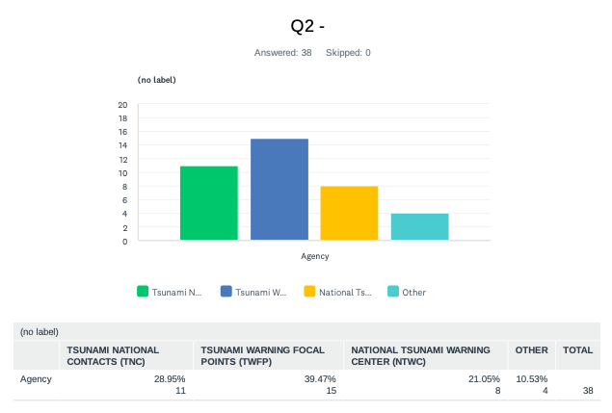

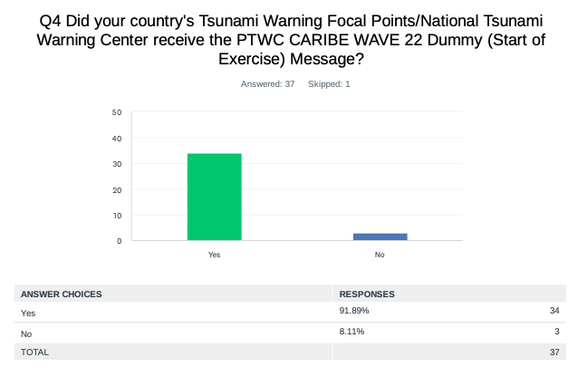
Comments:
Barbados: The dummy message was received from 10:00 LST to 10:05 LST.

Brazil: There are three email addresses registered at PTWC. All addressed to people. We are working on with the Secretariat to add the Situation Room address to the PTWC list. So that the Focal Point will have access to the warnings directly.

UK - Turks and Caicos: We did not receive any of the messages, this seems to be a situation we face every year.

US - US Virgin Islands: Fax received at EOC at 12:17 p.m.

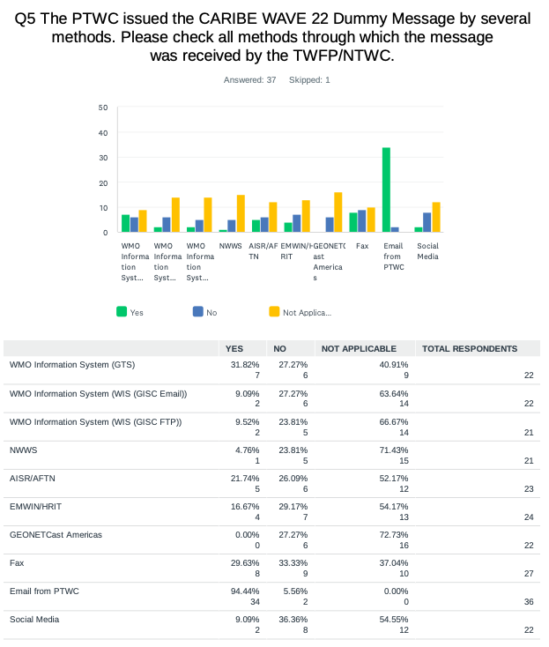
Comments:
Honduras: We believe there should be only one means of communication.

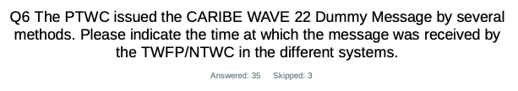

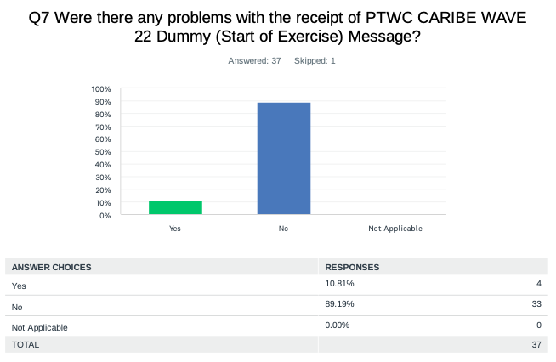
Comments:
Belize: Only emailed message was received. Social media specifically via WhatsApp would have been better.

Brazil: I was not informed by the Situation Room about CEMADEN has received the Dummy message. I did not receive any message due to a filter misconfigured at email server. We received messages from 1 to 7 though.

Honduras: We did not have a complete and complementary preparation; I consider more incidents in the Risk Management Institutions.

UK - Cayman Islands: Still quite concerned that email is not a suitable vehicle for critical alert messaging, especially outside normally working hours - a robo call system where phones ring would provide a higher probability that TNCs and TNFPs actually receive the messages in a timely manner in an actual event (especially at night and on weekends).

UK - Turks and Caicos: We did not receive any of the messages.

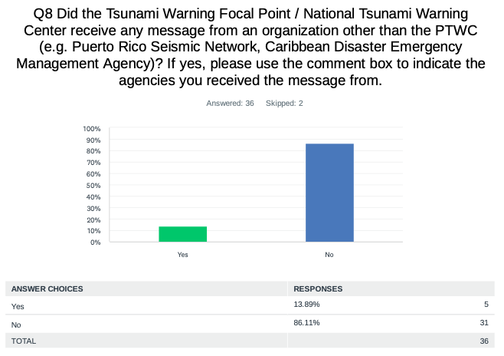

Comments:

Dominican Republic: Puerto Rico Seismic Network.

Nicaragua: CATAC sent dummy message in support of CARIBE WAVE 22 exercise to Central American member countries and local authorities in Nicaragua.

Panama: From CATAC.

Saint Kitts and Nevis: Currently we only receive messages from the PTWC.

UK - Anguilla: Puerto Rico Seismic Network.

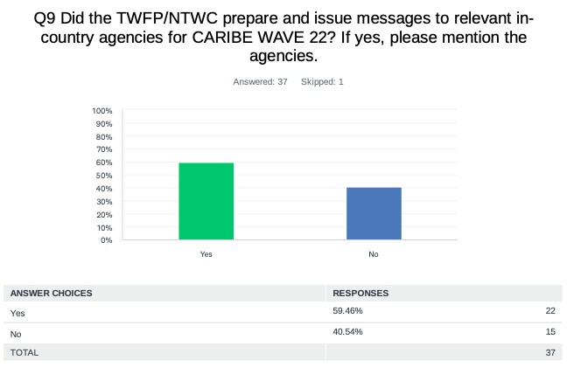
Comments:

Antigua and Barbuda: The messages were forwarded to the NTWFP – NODS.

Aruba: Buro Rampenbestrijding Aruba.

Barbados: Barbados Meteorological Services prepared local messages to the DEM and first responders. The messages were similar to the ones from the PTWC with a change in arrival time of the Tsunami.

Colombia: Colombian Geological Service National Unit for Disaster Risk Management Harbor Masters.

Cuba: National Civil Defense Staff sent to the Cuban Institute of Marine Sciences and the National Seismological Network.

Curacao: Disaster management Organization.

Costa Rica: A report was sent for the first bulletin via mail to CNE and contact list, in addition the app was used has a test mode.

Dominican Republic: Emergency Operation Center (COE).

France: Fire stations, municipalities, rectorate, regional health agency, airport and harbour authorities, medias, etc. Each island NTWC has a 300-cellphone number list of tsunami relevant services and stakeholders, to whom text messages are sent.

Grenada: National Disaster Management Agency and the Royal Grenada Police Force.

Haiti: Direction Generale de Protection Civile unite technique de sismologie Goal-Haiti and SARPT Jeremie. There was a table top exercise in Jeremie.

Honduras: Ideally, yes, but more work should be done to encourage participation.

Nicaragua: Civil Defense and SINAPRED.

NL - Bonaire, Saba, Sint Eustatius: Local governments of Saba, Bonaire and St Eustatius, including governors, disaster respondents, fire department, etc.. Departementaal Coördinatiecentrum Crisisbeheersing (Departmental Crisis Coordination Center) of national government. Rijksvertegenwoordiger (Kingdom Representative in the Caribbean).

Panama: Only to the national protection system. Sistema Nacional de Protección Civil (SINAPROC).

Saint Kitts and Nevis: The National Emergency Management Agency (NEMA) collaborated with telecommunications providers to broad cast a message.

Saint Vincent and the Grenadines: Although these messages were prepared, it may be useful to have a refresher course on the preparation and issuance of messages.

UK - Anguilla: We did not participate in this year's exercise, although we plan to do so later this year.

UK - Bermuda: Confirmation of receipt of messages during tabletop exercise: Bermuda Maritime Operations Centre Emergency Measures Organization Disaster Risk Reduction and Mitigation Team (Ministry of Nat'l Security).

UK - Cayman Islands: National Emergency Operations Centre.

USA - Puerto Rico: We received it from Puerto Rico Seismic Network.

Venezuela: The seismological service of Venezuela in Funvisis issued messages to the focal points and the communication center Ven-911 Vice Ministry of Risk Management and Civil Protection community leaders regional civil protection.

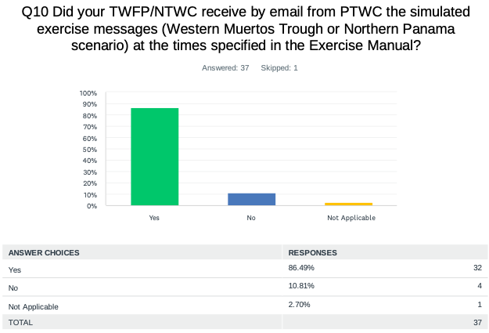
Comments:
Costa Rica: We received the Northern Panama scenario.
USA - Puerto Rico: WEA PR, EAS PR, and Interoperability (PREMB).

USA - US Virgin Islands: Agency also sent out IPAWS and Alert-VI messages, NOAA radio messages were not received though.

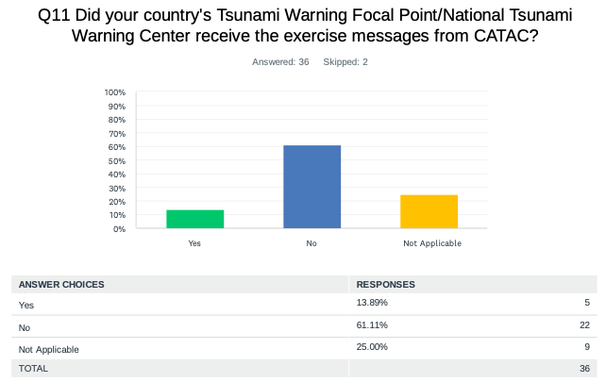

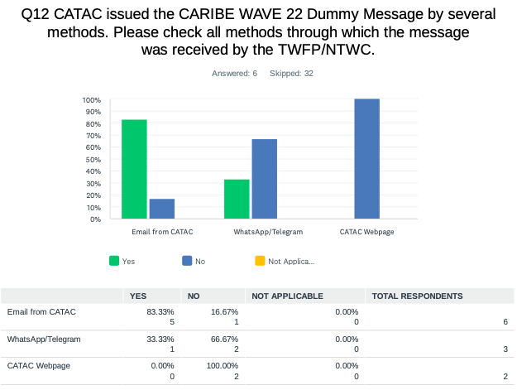
Comments:
Honduras: We did not verify in the third option.

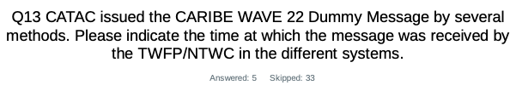

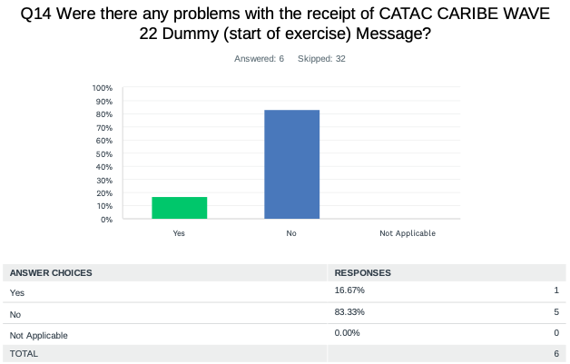
Comments:
Guatemala: The messages.

Panama: Apparently there was a problem receiving the notice message from CATAC. We missed some messages.

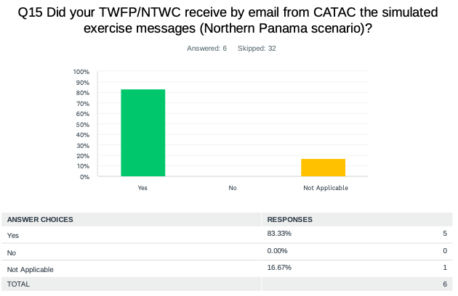

Comments:
Costa Rica: But some messages was mistaking bulletin number.

Nicaragua: In addition to the dummy message, CATAC sent five messages to Central American member countries and local authorities responding in Nicaragua: Civil Defense and SINAPRED.

Panama: Missing messages.

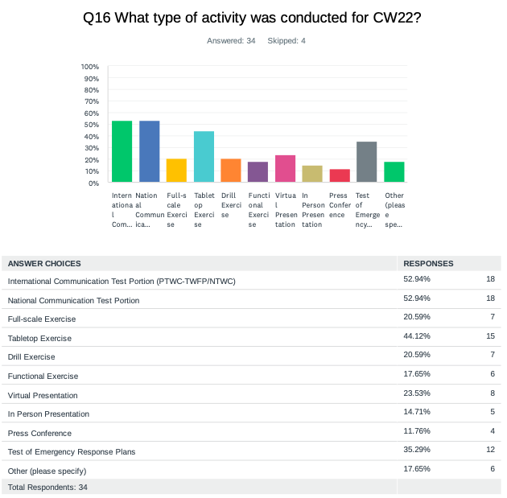

Comments:
Antigua and Barbuda: Evacuation of over 5,400 persons in Antigua including school, preschools, and some Government Departments. In Barbuda Education and Awareness Townhalls were conducted by disaster and response agencies.

Bahamas: Nothing was done.

Brazil: For the first time, CEMADEN and The Brazilian Navy was in contact to receive the test messages and communication between the two Centers were done at real time during the exercise.

Costa Rica: Evacuation
Dominican Republic: We carried out a tsunami simulation exercise between the COE Emergency Operations Center and the National Tsunami Contact.

Honduras: Communication was made with the COPECO authorities informing about the exercise.

Mexico: Evacuation of civilian population in different coastal town in the stated of Yucatan.

NL - Bonaire, Saba, Sint Eustatius: We know that local government of Saba did a Tabletop Exercise.

Panama: Broadcast by state television Channel 11.

Saint Lucia: We did not take part in CW22.

Suriname: We did not participate actively.

Trinidad and Tobago: A partial activation of the National Emergency Operations Centre was simulated. Tsunami threat messages were rapidly disseminated to key stakeholders in tsunami response. Each stakeholder provided feedback on their immediate actions taken.

UK - Anguilla: We did not participate at this time. We intend to use the scenario for an exercise later in the year.

UK - Bermuda: Tabletop exercise coordinated by Disaster Risk Reduction and Mitigation Team at Min. of Nat'l Security. Attendees - all EMO agencies. Verbal review of stakeholder plans.

USA - Puerto Rico: Everything was at different levels.

USA - US Virgin Islands: Next year we would like to ramp up to a press conference and possibly a functional exercise coordinated with all lifelines.

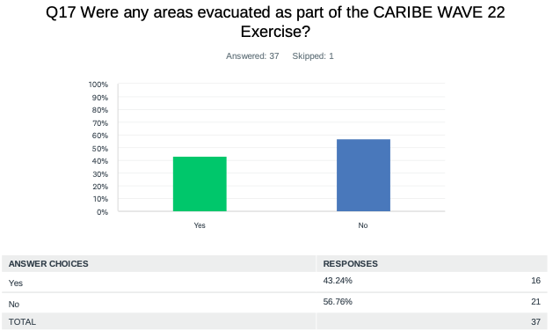

Comments:
Antigua and Barbuda: Evacuations were carried out island wide in Antigua in 13 of Antigua’s sixteen parishes, involving preschools, primary and secondary schools and the schools for differently abled an special needs. Education and awareness townhall presentations activities were conducted by the local Disaster Office and Fire Department in Codrington Barbuda involving schools and churches.

Barbados: The Island Inn Hotel was evacuated to their safe zone and 4 disabled persons from the Speightstown Community.

Costa Rica: School and wildlife refuge Manzanillo, Limon.

Cuba: According to the procedure to be followed, the population residing in areas of the eastern region was protected.

France: This year, evacuations were conducted on a local scale by some municipalities and/or schools in Martinique and Guadeloupe. No evacuations were conducted in Saint-Martin and Saint Barthelemy.

Guatemala: In our country, there was no tsunami threat.

Panama: Tabletop exercise.

Saint Kitts and Nevis: Majority of person did not respond positively, claiming that it is just an exercise, and they know what to do in a real event. However, the education process will continue.

Trinidad and Tobago: Tobago evacuated one school.

UK - Turks and Caicos: In country communications aspects.

USA - Puerto Rico: Some schools, city halls and public and private agencies.

USA - US Virgin Islands: Agency near the Christiansted town evacuated to 110 ft above sea level.

Venezuela: In Funvisis, the plan and protocols for earthquakes and tsunami were activated and in other coastal zone of Venezuela.

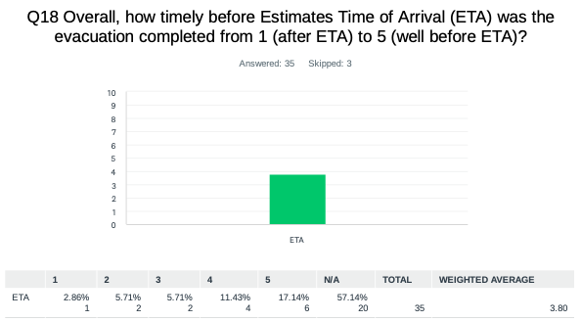

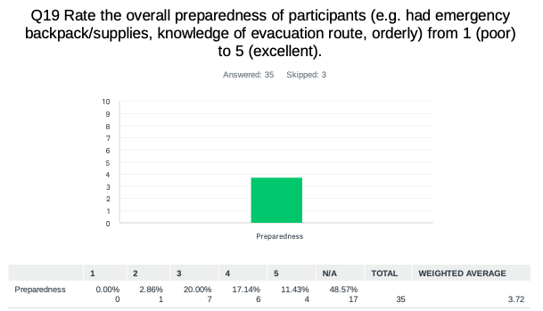

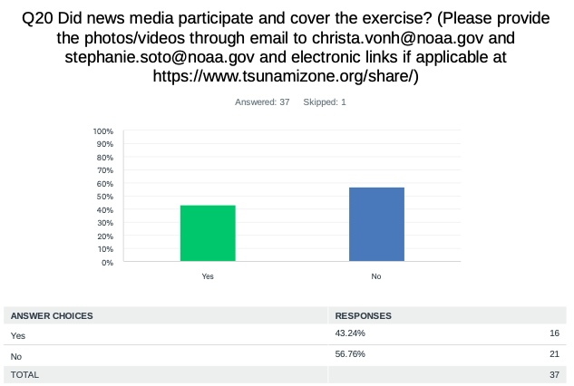

Comments:
Antigua and Barbuda: Local state media covered event as well as National Disaster office and some private media entities.

Aruba: Tele Aruba

Barbados: https://gisbarbados.gov.bb/blog/communications-test-tomorrow-thursday-march-10/

Cuba: The mass communication and dissemination media established to inform the population in disaster situations participated in the exercises.

France: https://la1ere.francetvinfo.fr/martinique/caribe-wave-la-martinique-participe-a-l-exercice-grandeur-nature-d-alerte-tsunami-ce-jeudi-10- mars-1251409.html

Panama: There were some interviews during the exercise.

Saint Vincent and the Grenadines: The local tv station tried to cover the event but were unaware of the different evacuation routes. They missed the actual evacuation but were able to conduct interviews with the participants at the end of the exercise.

UK - Bermuda: Via press release: https://bernews.com/2022/03/caribbean-tsunami-exercise-conducted/ https://www.royalgazette.com/environment/news/article/20220310/bermuda-to-join-caribbean-agencies-for-tsunami-exercise/
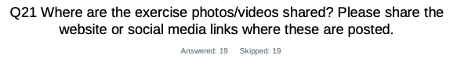
Comments:
Antigua and Barbuda: Videos/pictures to be uploaded to National Office of Disaster Services social platforms (Instagram, Facebook) and website.

Aruba: facebook/Bureau Rampenbestrijding Aruba

Barbados: https://www.instagram.com/p/Ca7ZJvgL_r1/?utm_medium=copy_link

Costa Rica: https://www.facebook.com/sinamot.cr/videos/650671992823804

Cuba: Pictures on the exercise are not published.

Dominican Republic: https://www.diariolibre.com/planeta/medioambiente/2022/03/03/tsunami-un-peligro-latente/1685418

France: https://www.youtube.com/watch?v=C-0Pd-7FXoE ; https://www.youtube.com/watch?v=XeNEKwmpJog

Mexico: https://twitter.com/SEMAR_mx/status/1501964523477127171/photo/1

UK – British Virgin Islands: bviddm Facebook

USA - Puerto Rico: Twitter and Facebook page PREMB and PRSN.

USA - US Virgin Islands: www.vitema.vi.gov and VITEMA social media pages

Venezuela: https://www.pcivil.gob.ve/2022/03/venezuela-participo-en-el-simulacro-internacional-caribe-wave-2022/ https://ultimasnoticias.com.ve/noticias/miranda/las-regiones-se-alistan-para-el-simulacro-caribe-wave-2022/ https://www.noticierovenevision.net/noticias/nacional/venezuela-participo-en-simulacro-caribe-wave-2022 https://laverdaddemonagas.com/2022/03/10/mas-de-280-efectivos-participaron-en-simulacro-caribe-wave-2022-en-monagas/ https://venezuela-news.com/caribe-wave-2022-venezuela-participo-en-simulacro-internacional-de-tsunamis/ https://twitter.com/MIJP_Vzla/status/1501954754146181120?ref_src=twsrc%5Etfw%7Ctwcamp%5Etweetembed%7Ctwterm%5E1501954754146181120%7Ctwgr%5E%7Ctwcon%5Es1_&ref_url=https%3A%2F%2Ftalcualdigital.com%2Ffuerzas-de-seguridad-del-estado-realizan-ejercicio-de-evacuacion-caribe-wave-2022%2F https://twitter.com/PCivil_Ve/status/1500524192697094149?ref_src=twsrc%5Etfw%7Ctwcamp%5Etweetembed%7Ctwterm%5E1500524192697094149%7Ctwgr%5E%7Ctwcon%5Es1_&ref_url=https%3A%2F%2Fultimasnoticias.com.ve%2Fnoticias%2Fmiranda%2Flas-regiones-se-alistan-para-el-simulacro-caribe-wave-2022%2F https://talcualdigital.com/fuerzas-de-seguridad-del-estado-realizan-ejercicio-de-evacuacion-caribe-wave-2022/

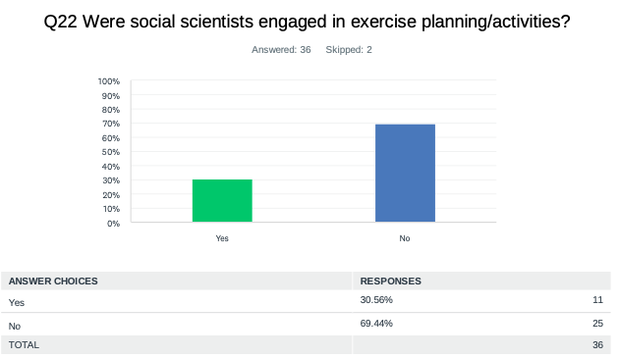

Comments:
Antigua and Barbuda: Not directly. It was done primarily through involvement of their partner agencies; National Office of Disaster Services- Ministry of Social Transformation, (NODS) and Ministry of Education, Fire Department. Social science students were also involved this time around in the assessment phase of the exercise.

Dominican Republic: National Seismology Center UASD.

France: The review of NTWC operational documents (SOPs) by some WG4 members has begun in preparation for this exercise. A reflection is also conducted for the drafting of alert messages and their understanding by the local population and tourists The audibility of sirens has been the subject of a participatory approach involving the population to map the effective range.

Mexico: Some participants consulted the National Center for Disaster Prevention and Oceanographic Research Institutes.

UK - British Virgin Islands: Guidance from the organizers and material that were available.

USA - Puerto Rico: Some social scientist used the amateur radio.

USA - US Virgin Islands: Somewhat but needs to be further developed going forward.

Venezuela: Researchers gave several workshops and seminars on the CARIBE WAVE 22 exercise, from the social dissemination department courses were prepared for Civil Protection and Disaster Management at the local and regional level.

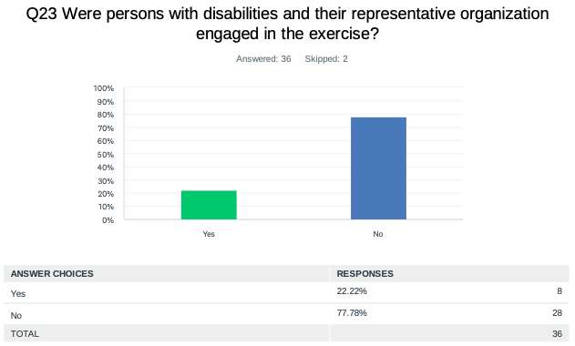

Comments:
Antigua and Barbuda: The main institutions that cater to differently abled children were actively involved.

Barbados: Four members from the disabled community as well as their caretakers participated in the exercise. These persons were primarily from the Speightstown Community. The National Disabilities Unit and the Barbados Council for the Disabled supported the evacuation.

USA - US Virgin Islands: ADA Coordinator participated.

Venezuela: In Funvisis a visually impaired person.

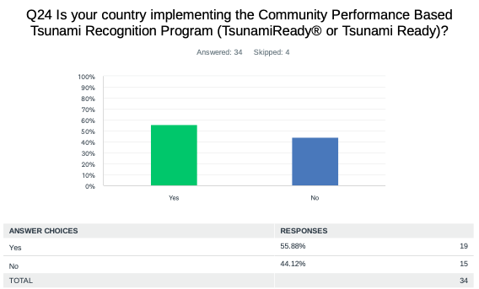

Comments:
Antigua and Barbuda: The Process had started in Antigua with several areas, the last to achieve recognition was St Johns City. Barbuda is the next area targeted.

Dominican Republic: We are still working on that.

France: Several communities are preparing for this request for recognition. Some municipalities are equipping themselves with signs to mark evacuation routes.

Mexico: This year is starting in Puerto Vallarta in the state of Jalisco, in Mexico, activities related to the tsunami ready program.

Nicaragua: Work is being done in the communities of Corn Island, Bluefield’s and Bluff.

Saint Lucia: Not at this time but expected to implement at a later date.

Sint Maarten: We are expected to work on the tsunami modeling soon.

Trinidad and Tobago: Trinidad already has one Tsunami Ready community and there are plans to have a second community that is Tsunami Ready.

UK - Anguilla: Anguilla obtained Tsunami Ready recognition in 2012. We are due for a review and re-recognition if applicable.

UK - Cayman Islands: Not at the moment. We really need improved risk analysis even if it is fairly basic. It is good know what you are preparing for - for example a school in Cayman Brac located on the coast, is considering building a set of stairs up a 70-foot-high bluff to create an evacuation route - the stairs probably present a greater threat than the possibility of a tsunami - can we spend some time working jointly on risk analysis? Many Islands like Cayman have very short shelf areas and very deep water close to the coast. Are these areas free from the tsunami threat?

Venezuela: Not yet, due to the health restrictions in the face of Covid 19 and the economic situation, transfer and coordination are difficult, despite having several coastal communities prepared for a tsunami.

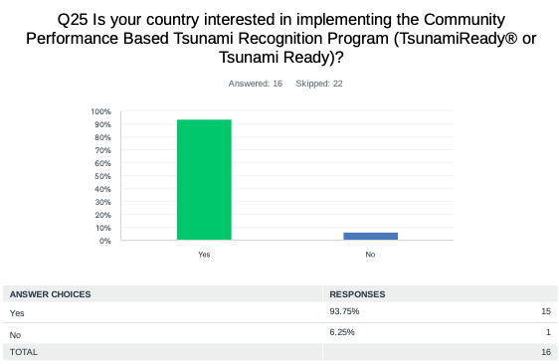

Comments:
Barbados: Holetown St James (From Porters Road to Holders Hill St. James).

Belize: Needs buy in from the National Emergency Management Organization.

NL - Bonaire, Saba, Sint Eustatius: That is up to the local governments to decide.

Suriname: We are interested but we don't have Tsunami's in our country.

UK - Bermuda: This isn't a question that's been asked, needs to come from Ministry of Nat'l Security, but the TWFP will encourage a decision.

UK - Cayman Islands: Possibly but as stated - tsunami threat and risk analysis is the logical starting point, and the Cayman Islands is mostly in the dark about the actual risk to the Cayman Islands from a tsunami.

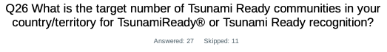
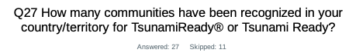

Country | Already Implementing | Interested in Implementing | TsunamiReady® or Tsunami Ready Communities (as reported by Member States) | TsunamiReady® or Tsunami Ready Communities (IOC Records For CARIBE EWS) | Target Number
Antigua and Barbuda | Yes | - | 1 | 1 | 5
Aruba | No | Yes | 0 | 0 | 8
Bahamas | Yes | - | 2 | 0 | 22
Barbados | Yes | - | 8 | 1 | 50
Belize | No | Yes | 0 | 0 | 2
Brazil | No | Yes | - | 0 | -
Colombia | No | Yes | 0 | 0 | 5
Costa Rica | Yes | - | 5 | 0 | 4
Cuba | Yes | - | 0 | 0 | 4
Curacao | No | Yes | - | 0 | 5
Dominica | - | Yes | - | 0 | -
Dominican Republic | No | Yes | 0 | 1 | 4
France | No | Yes | 0 | 0 | 1
Grenada | Yes | - | 2 | 2 | 7
Guatemala | No | Yes | 0 | 0 | 2
Guyana | No | - | - | 0 | -
Haiti | Yes | - | 1 | 1 | 20
Honduras | Yes | - | 4 | 2 | 10
Jamaica | - | Yes | 10 | 1 | 5
Mexico | Yes | - | 0 | 0 | 21
NL- Bonaire, Saba, and Sint Eustatius | No | - | - | 0 | -
Nicaragua | Yes | - | 3 | 2 | 6
Panama | Yes | - | 0 | 0 | 10
Saint Kitts and Nevis | Yes | - | - | 1 | -
Saint Lucia | No | Yes | - | 0 | -
Saint Vincent and the Grenadines | Yes | - | 0 | 1 | 40
Sint Maarten | Yes | - | 0 | 0 | 1
Suriname | No | Yes | 0 | 0 | 2
Trinidad and Tobago | Yes | - | 1 | 1 | -
UK- Anguilla | Yes | - | - | 1 | -
UK- Bermuda | No | - | - | 0 | -
UK- British Virgin Islands | Yes | - | 4 | 1 | 4
UK- Cayman Islands | No | Yes | 0 | 0 | -
UK- Montserrat | - | - | - | 0 | -
UK- Turks and Caicos | No | Yes | 0 | 0 | 15
USA- Puerto Rico | Yes | - | 46 | 46 | 46
USA- US Virgin Islands | Yes | - | - | 3 | 3
Venezuela | No | Yes | 0 | 0 | 0
TOTAL | 19 YES | 15 INTERESTED | 87 | 65 | 302

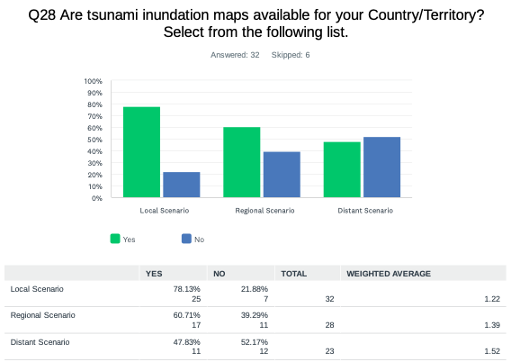

Comments:
Brazil: There is no research or studies with inundation mapping on Brazilian territory. We start simulating South Sandwich Islands 1929 Tsunami event and some preliminary studies are being done.

Dominican Republic: In San Felipe Puerto Plata in the north and Palenque, nigua y San Cristobal in the south.

Haiti: CAP-Haitien has inundation maps for local, reginal, distant scenarios.

Suriname: Only for Paramaribo, the capital city.

Trinidad and Tobago: We would like to have inundation maps developed.

UK - Anguilla: The map was developed under the original recognition process.

UK - Cayman Islands: Yes, this is the type of information we need - how do we go about getting this type of information. We recently secure LIDAR bathymetry of our inshore marine environment to a depth of 90 feet. Please let us know who can run the models...this is exactly the sort of assistance we need.

USA - US Virgin Islands: I am not sure for all three, but maps are being updated with new data.
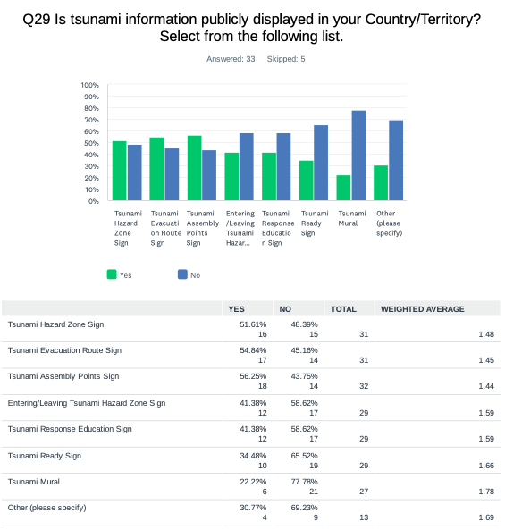

Comments:
Antigua and Barbuda: Billboards of Tsunami hazard zone and pictures of safe areas still to be created, posters and additional evacuation route signs too.

Barbados: Informational Billboards.

Brazil: There are nothing yet publicly about Tsunamis in Brazil. Is there a well consolidate culture that there is no Tsunami Risk in Brazil.

Costa Rica: But not in all coastal communities.

Dominican Republic: We have signals, but not are installed. We are traying to display in Puerto Plata, next month we have a meeting with local authorities.

France: While tsunami information publicity exists, it is a minority case.

Guyana: Tsunami is not considered as a local hazard.

Mexico: We have this sign only in one community, in Zihuatanejo, Guerrero.

Panama: Information by delivery of brochures.

Saint Vincent and the Grenadines: These will be installed soon for the communities in Union Island and St. George.

Suriname: No

UK - Cayman Islands: Tsunami Plan is on the Cayman Prepared website.

USA - US Virgin Islands: Maps are in the process of being installed this year because a lot are missing since Irma and Maria. Others can be incorporated as well.

Venezuela: It is planning with the competent authorities.

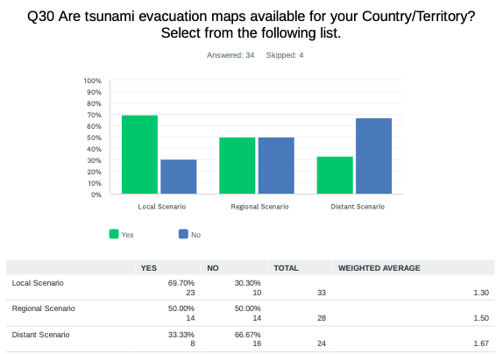
Comments:
France: cartography available on: https://exploit.univ-montp3.fr/

Mexico: Only exists this map for the community, in Zihuatenejo, Guerrero.

UK - Cayman Islands: We don't have run up models and could really use some support in this area to help identify the steps and process to produce the maps based on a scientific and evidence-based understanding of the tsunami risk in the Cayman context.

USA - US Virgin Islands: Needs to be developed.

Venezuela: Local capacities have been generated so that the municipal Civil Protection and communities prepare their own evacuation maps.

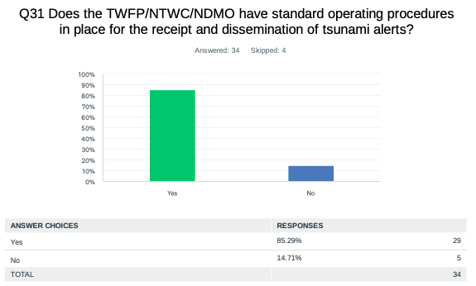
Comments:
NL - Bonaire, Saba, Sint Eustatius: Communication procedures between TWFP and local governments.

Panama: Yes, but right now it is under review for every 5 years.

Saint Vincent and the Grenadines: There is a document in draft for the parish of St. George, that will be extent to fit the national context.

Suriname: We work with other organizations like Red Cross if there is a need for that.

Trinidad and Tobago: The SOP document is in draft stage.

Venezuela: Yes, the Venezuelan seismological service has developed an action protocol for earthquake and tsunami events, and the VGRPC has created the Operational Action Plan for tsunami events.

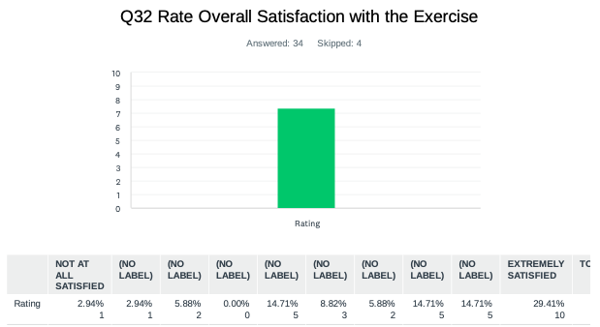
Comments:
Barbados: It went well from an exercise perspective highlighting possible areas for improvement.

France: A survey questionnaire was conducted with the main players of the exercise (33 responses): Without exception, they noted the importance of these exercises.

Haiti: That is the first tsunami exercise in Jeremie. Very satisfied.

Honduras: We did not have total participation.

Suriname: We haven't participated actively due to an emergency situation in our country.

UK - Bermuda: CARIBE WAVE continues to bring tsunami awareness to the forefront annually.

UK – Cayman Islands: I think the dissemination methodology should be tested at 3 am on a Sunday morning to see if it actually works…

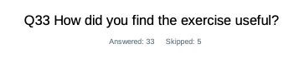
Country | Exercise Caribe Wave 22
Antigua and Barbuda | Identifying institutions with safe area challenges. establishing baseline times for evacuation areas, and identifying issues to address maintenance of evacuation trails at local district levels.
Aruba | Very useful.
Bahamas | Did not participate.
Barbados | It allowed for education, sensitization, inclusion of the disabled and identified areas for improvement.
Belize | No action was taken locally but the exercise served to highlight the need for another means of getting the Tsunami messages from PTWC. WhatsApp would help.
Brazil | It was possible to double check the email communication between PTWC and CEMADEN. We updated the email list at PTWC. And it was possible to interact with the Brazilian Navy and Rio de Janeiro State University.
Colombia | It was useful, the exercise made it possible to test the National Protocol between the entities of the National Tsunami Detection and Warning System and the internal procedures of the entities involved.
Costa Rica | Improve preparation from Caribbean, and making prepare capabilities in local people.
Cuba | We found the exercise useful because the modeled tsunami source represents a potential threat for the national territory and nearby countries, and we were able to evaluate the response capacities from a work on line table between several national institutions and the best location of the tide gauges to detect tsunami waves and the preparation of the young staff. It served to put into practice the operating procedure contemplated in the country for the response to the sudden event of the occurrence of Tsunami that could affect our country.
Curacao | Exercise is very useful for our department and community, especially when it comes to communication.
Dominican  Republic | Yes.
France | This annual exercise is highly useful for recently arrived/new DMOs, not only the day of the exercise, but mostly the preceding weeks during the preparation.
Grenada | It raises awareness on the hazard, also assist in preparedness for the hazard, if and or when it occurs
Guatemala | To prepare our country in case of emergency of tsunami threat.
Guyana | It allowed the office to exercise its plan with the actual products that would be received in the case of an actual tsunami.
Haiti | Very useful for Jeremie City that was experimenting a tsunami early warning system.
Mexico | Very useful. It is always good to establish and participate in this type of drill exercises, both in the organization and in the execution and response of the participants.
Nicaragua | Very good. It allows us to improve the preparedness of people located in coastal areas, as well as the preparation of trainers in integrated tsunami risk management.
NL-Bonaire, Saba, and Sint Eustatius | Yes, it is always good to exercise the communication procedures. This year the scenario was not the most interesting for us. However, it is always useful to follow it in order to remind stakeholders about the procedures and update communications channels (phone numbers, email addresses, etc.).
Panama | Quite useful, so as not to forget the procedures, but it is better to perform the exercises in the field.
Saint Kitts and Nevis | The exercise highlighted the strengths and weaknesses of the responses of residents in the area of the evacuation exercise and first responders, which is beneficial for building on the weak areas. Residents were aware of tsunami but were reluctant to participate because it was an exercise.
Saint Vincent and the Grenadines | It was very useful.
Sint Maarten | We did not actively participate.
Trinidad and Tobago | The exercise provided the opportunity for us to test our national system for disseminating tsunami warning information to key stakeholders and the public. Areas that require strengthening were identified.
UK- Bermuda | It was an opportunity to highlight the actual risk for the Atlantic and get agency heads thinking more proactively about simple action plans and messaging.
UK - British Virgin Island | It provided an opportunity to test plan and improve on areas that were highlighted.
UK- Cayman Islands | Yes, it was useful.
UK - Turks and Caicos | We did not receive the message.
USA- Puerto Rico | Was an opportunity to test the new RSS. Did the first promotional video with sign language and got more amateur radio involved in the exercise
USA-US Virgin Islands | Extremely helpful, community awareness is a gap we have to capitalize on and ensure the territory's readiness.
Venezuela | As a team, we had been carrying out a more active Caribe Wave until the beginning of the health emergency, it was necessary in this Caribe Wave 22 to think and discuss how to carry out the drill, coordination with the highest authorities, scientists and communities was important. Reconsidering the role of technologies and reviewing the way we communicate, and the virtual meeting was very important. With great enthusiasm, the state and municipal civil protections that have the drive and experience of the previous CWs created their own methodologies and adapted their participation taking into account security against Covid19, they informed the situational room of their interest, and we worked a lot with the situation reports, where the participation of radio amateurs in this exercise was further strengthened. We must rescue international communications with the other alert centers in the region, to obtain confirmation and exchange data, among others.

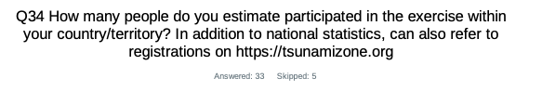
Country |  | Number of Participants according to Member States
Antigua and Barbuda |  | 5,454
Aruba |  | 11,960
Barbados |  | 70
Brazil |  | 10
Colombia |  | 49
Costa Rica |  | 45
Cuba |  | 350
Curaçao |  | 50
Dominica |  | 100
Dominican Republic |  | 400
France |  | 196,400
Grenada |  | 2,000
Guatemala |  | 50
Guyana |  | 6
Mexico |  | 6,000
Netherlands  Bonaire, Saba, Sint Eustatius |  | 26
Nicaragua |  | 300
Panama |  | 7
Sint Maarten |  | 5
Saint Vincent and the Grenadines |  | 45
Trinidad and Tobago |  | 50
United Kingdom | Bermuda | 100
United Kingdom | British Virgin Islands | 4,755
United Kingdom | Cayman Islands | 1,000
United Kingdom | Turks and Caicos | 200
U.S. | Puerto Rico | 117,696
U.S. | US Virgin Islands | 12,000
Venezuela |  | 45,457

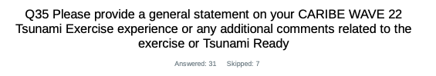
Country | Exercise Caribe Wave 22  General Statements
Aruba | Very useful and forms partly yearly full-scale program.
Antigua and Barbuda | Over 5400 persons who took part in the exercise country-wide.  • More than 35 primary and secondary schools participated  •Of the disaggregated data collected from 50% of participating bodies representing some 45% of total participants showed a participation ratio of o Females 45% to Males 55% Generally it was noted that there was a good overall awareness of the activity by teachers and students alike, with a high level of interest and enthusiasm expressed by students and many volunteers.  • It was noted that preschools did utilize ropes to guide small children and a significant number of schools that had to cross active streets used teachers and security personnel to help manage the traffic where students had to cross, Many Schools ranging from several dozen to several hundred students in St Johns area, St Peters and St Marys areas recorded times of 5 mins or less for evacuation.  • There were persons from communities joining student as they moved towards evacuation areas when final counts were made in assembly areas.  The National time spread from the time from the initial message was received at the NTWC to receipt of disseminated message (of Early Warning via the Common Alerting Protocol (CAP) app) by participants country wide was 11 minutes.
Barbados | There were three (3) separate and distinct aspects to the Caribe Wave 2022 Exercise:  (1) The virtual Table-Top Exercise, which prompted participants to respond to the Tsunami threat to Barbados in accordance with the Exercise CARIBEWAVE 2022 Scenario. (2) A Communications Exercise executed by the Department of Emergency Management (DEM) and Barbados Citizen Band Radio Association (BCBRA) technical teams. The communications aspect of the exercise facilitated the response and transmission of messages in accordance with the parameters of the exercise and lent support to the third facet of the exercise. (3) Two (2) small, scaled evacuation exercises which targeted the tourism community and the disabled community in conjunction with their month of activities.  From all accounts all three activities went well and there were no major disruptions besides the failure of the CAP CAP system which prompted the use of primarily Astro and VHF radio. The disabled community was very appreciative with being involved in the exercise as it was the 1st time being involved in the physical aspect of the exercise. This promoted knowledge of the evacuation routes and the maintenance and development of family plans to promote self-evacuation of the disabled and their caretakers.  With respect to the Island Inn Hotel evacuation exercise this was well received as even more hotel guests than anticipated participated in the exercise without incident. The tabletop exercise scenarios allowed for agencies to explore their actions when faced with peculiar but yet realistic circumstances and they were able to express their actions in conjunction with their Sops. In conclusion the exercise provided an experience on which to build on by enhancing the involvement of the disabled community in future physical exercises, development and hotel's EOPs and finetuning the communications of agencies of the National Emergency Management System.
Belize | Similar to the above, no action was taken but the exercise served to test the ability of the TWFP to receive the messages in a timely manner. There is the need for the use of another medium whether it be SMS or using a platform such as WhatsApp.
Brazil | The webinars are essential to get me involved and understand how the exercise works. For the first time it was possible to interact with the Brazilian Navy that also participated on the webinars. It was possible to verify that there was an error on the email server configuration and not all in the PTCW emailing list received the warnings. Also, the exercise is important as a mind change process, working on the "No Tsunami Risk" culture in Brazil.
Colombia | The Caribe Wave 22 exercise went well, the bulletins were received within the times established in the manual and the established script was complied with at the national level. The National Emergency Management Office (UNGRD) will ensure that future exercises include the participation of territorial entities.
Cuba | Thanks to the annual Caribe Wave exercises, we have been gaining experience and a level of high-quality information for warning of potential tsunami events in our country and also contributing from our geographical position to the security of the countries of the Greater Caribbean. Use the Caribbean Wave exercise as an example for all the countries of the world since it allows strengthening the response capacity in the event of a sudden event like this. Also, to train all member states to protect the population and its economic assets.
Curacao | We have been participating for years to the Caribe Wave Exercise. At the beginning of this year, we were still in the middle of a pandemic, and this also had an impact on the number of people who could participate in the exercise this year. We hope that next year we can plan a bigger exercise regarding Caribe Wave 2023.
Dominica | The exercise was useful in promoting public awareness on Tsunami hazard and safety. The virtual presentation was well supported, and participants expressed their appreciation for the information provided. Participants also indicated interest in further engagement to increase awareness on tsunami safety as well as other hazards.
Dominican  Republic | The Western Muertos represents a threat due to its proximity to the Dominican Republic. On this occasion, a simulation exercise was carried out between the National Seismology Center, the Emergency Operations Center and the National Meteorology Office, which is the Focal Point for tsunamis.
France | In addition to territorial fragmentation, one of the difficulties encountered in FWI is the high turnover of managers (eg, DMO) in the public institutions. It is difficult to implement actions over time, including CW exercises. Individual who registered did not receive any message of the exercise.
Grenada | The annual exercise was an excellent opportunity for the country to test its Tsunami protocol. It also gave us an opportunity to measure the public's knowledge to adequately respond in times of need to the hazard. It has also given the Agency an opportunity to initiate the conversation of safety among the business community not just for Tsunami's but also hazards in general.
Guatemala | Although our country was not in the threat zone, we received all the PTWC messages. That is very useful to test our capabilities to respond in case of tsunami threat.
Haiti | That is a good exercise. It lets the focus group in Jeremie experiment the  tsunami messages from Codomar that is the National Tsunami Warning Center (NTWC). It lets also the focus group in Jeremie to start an experience of tsunami Early Warning System with CARIBE WAVE 2022 and understand better the Standard Operating Procedures (SOPs).
Honduras | It is important to have greater preparation, more exercises; however, they must be procedures that are socialized with greater anticipation and with greater commitment on the part of the pauses in participation. For this, face-to-face workshops must be held to define participation strategies.
Mexico | In a general way, we can cite that both in the reception and distribution of the different messages there were no major problems. However, there are small communities where there is no telephone and/or internet coverage, in these cases the notices were given through megaphones and in person. The general comments of the participants are in the areas of training, which are already considered. The percentage of participation was satisfactory.
Nicaragua | It provides us with better knowledge of the different activities that we must develop with the community, preparation and training of community personnel. As NTFP and NTC it allows us to improve the exchange of knowledge with the different response institutions and as CATAC it strengthens us to improve our Standard Operational Plans.
NL-Bonaire, Saba, and Sint Eustatius | Already discussed via email:  - We find that the modeling for computing the Forecasted Wave Heights takes a long time.  - We received the Graphical Forecast Products via email 10 minutes later than the 2nd warning message.  - We are interested in accessing the products, including more data formats, via an API or something similar.  Other remarks:  - Some internal stakeholders found the dummy message confusing because it states that it is the only message that they will receive. We will consider not forwarding it to them in next exercises.  - As in other years, we had problems with reaching some of the officials of the local government in a timely manner.
Panama | The exercises are very important to perform, to coordinate and compare actions in a real event and not to forget the procedures. The CARIBE WAVE 22 Tsunami Exercise always provide important procedures (in this case, communication procedures), which have to follow in case of a real scenario (local, regional and distant).
Saint Kitts and Nevis | CARIBE WAVE exercise has strengthened the relationship between the various emergency agencies within the Caribbean region and the partner agencies around the world. CARIBE WAVE 22 Tsunami Exercise has shown that many people hesitate to respond to exercises but will respond when immediate danger is present. The education process is very good and will continue to ensure that another evacuation exercise will receive excellent response from residents in the targeted areas.
Saint Vincent and the Grenadines | The exercise was extremely timely and useful. The following are some of the main takeaways from the exercise.  1. There is a need for some small-scale exercise to improve NEOC response and management (can be in the form of table-top exercises).  2. Refresher training exercise needed to prepare threats messages that will be disseminated to the public  3. Frequent simulations are necessary to increase familiarity with local and organizational SOPs.
Sint Maarten | Due to our current workload, we were not able to actively participate. We hope to join again in 2023.
Suriname | Due to an emergency situation in Suriname, we could not participate in the CARIBE WAVE 22 Tsunami Exercise.
Trinidad and Tobago | The exercise gave us the opportunity to test the SOPs outlined in Trinidad and Tobago Tsunami Warning Information Dissemination Protocol and Standard Operating Procedures (SOPs). In addition, it involved working through the process from receipt of the initial threat message to discontinuation. It has certainly provided the context for identifying the areas in our tsunami response that require development and/or strengthening.
UK- Bermuda | Bandwidth for this has been limited in Bermuda, but we're starting to see more interest tsunami preparedness (and in DRR in general). DRRM did a good job in coordinating agency attendance and asking some pointed questions that get people thinking about action plans. Still much work to do about tsunami awareness, but recent volcanic and seismic activity (Tonga, St. Vincent & the Grenadines, Canary Islands) have helped to focus attention on the risk.
UK- Cayman Islands | Can we have a meeting to discuss risk analysis? Thank you for all your hard work on the exercise and it is useful.
USA- Puerto Rico | During the CARIBE WAVE 2022 Exercise, the Puerto Rico Seismic Network (PRSN) tested multiple communication methods with emergency management agencies in our area of responsibility (Puerto Rico and Virgin Islands Region). The agencies within the (seismic) area of responsibility of the Puerto Rico Seismic Network are: Puerto Rico Emergency Management Bureau (PREMB, Puerto Rico), National Weather Service San Juan Forecast Office (NWS-SJ, Puerto Rico), Department of Disaster Management (DDM, British Virgin Islands), Virgin Islands Territorial Emergency Management Agency (VITEMA, US Virgin Islands), Oficina Nacional de Meteorología (ONAMET, Dominican Republic) y el Instituto Sismológico Universitario (ISU, Dominican Republic). Among the PRSN communication methods tested are the Broadcast System (System to Disseminate Information on Earthquakes and Tsunamis), dedicated telephones (ring downs and private telephone line), the PREMB radio frequency, RSS (PRSN), text message (Tsunami Warning Focal Points [TWFP] and some primary agencies), e-mail lists (emergency management list), automatic phone calls (TWFP), fax (TWFP), PRSN official web page and social media (Facebook and Twitter). Communication tests were conducted by ham radio with radio amateur volunteers between the PRSN (Mayagüez) and the rest of the region. PRSN updated the official web page for the CARIBE WAVE 2022 Communication Exercise (http://caribewave.uprm.edu/) for Puerto Rico and the Virgin Islands. This web page contains all the materials and guidelines developed by the PRSN for this year’s exercise, the EAS activation announcement for Puerto Rico and the promotion to complete the Official Registry of the Exercise (at tsunamizone.org), a description of the Western Muertos Trough Scenario, information in How to participate, among other materials. Starting on February 10, 2022, pre-exercise communication tests were conducted to promote Caribe Wave Exercise in the Puerto Rico and Virgin Islands Region among emergency managers and the public. These tests were issued on February 10, February 28, March 3, and March 9, by all communication lines available in PRSN (dedicated telephones, emails, fax, text message, RSS, and social media). PRSN issued 14 messages during the exercise. The 46 TsunamiReady communities participate in a different level including communication test, sirens activation and full-scale evacuation exercise. For this exercise, (only for Puerto Rico) the EAS system was activated in coordination with the Puerto Rico Emergency Management Bureau, National Weather Service (San Juan), Puerto Rico Broadcast Association, and Puerto Rico EAS Committee, through the following communication means: radio, T.V., cable TV, and NOAA weather radio. The real alert code of tsunamis (TWS) was issued during the exercise at 10:07 AM on March 10, 2022, by the National Weather Service (San Juan Forecast Office) to announce the Tsunami Warning for Puerto Rico, according to the Western Muertos Trough Scenario choose for Puerto Rico and the Virgin Islands. At the PRSN we monitored the activation of EMWIN, the NOAA radios, as well as the Puerto Rico EAS and WEA (as scheduled for the exercise). At PRSN we received the PTWC Dummy Message at 10:00 AM (14:00 GMT) through the EMWIN System and email. Puerto Rico Broadcaster Association will prepare a final report about the activation of the EAS System for Puerto Rico. Puerto Rico Emergency Management Bureau emits the WEA for Puerto Rico at 10:07 AM (14:07 GMT) to announce the Tsunami Warning for Puerto Rico, according to the Western Muertos Trough Scenario choose for Puerto Rico. The PRSN conducted Amateur Radio communication exercise with local volunteers.
USA-US Virgin Islands | Exercise was great, we need to just engage more agencies to exercise their plans and understand the importance of participating, as well as placing more educational staple signage in the community so that it can be seen in highly populated areas.
Venezuela | The CARIBE WAVE exercises have shown us the capacity that regional and local communities and authorities have to manage the tsunami emergency, I have seen local reports that estimate material damage and the number of people affected, injured, deceased, etc., they have created good databases with the inventories of hospital facilities and equipment necessary for handling the emergency, coordination has improved notably, despite the uncertainty when there is a change of authority, the response personnel continue to lead the exercise and with more and more enthusiasm and responsibility. All response personnel are observed assuming their role in accordance with the provisions of the laws, we hope to improve our economy to promote and evaluate the coastal areas that could be candidates for the Tsunami Ready program. I congratulate the programmers of the Caribbean Wave and the supports of the COI/Caribbean.

∗ One survey submitted by the Member States for all constituents

