Department of Geology
University of Puerto Rico, Mayagüez and
NOAA’s National Weather Service

CARIBE WAVE 2022

Media Report

Stephanie Soto
Christa von Hillebrandt-Andrade
International Tsunami Information Center Caribbean Office
Elizabeth Vanacore
UPRM Puerto Rico Seismic Network
May 2022
Contents
UNESCO 4
PTWC 5
Antigua and Barbuda 6
Aruba 8
Barbados 9
Colombia 10
Costa Rica 12
Dominican Republic 17
France 19
Martinique 19
Guadeloupe 22
Grenada 23
Mexico 24
Saint Kitts and Nevis 25
Saint Vincent and the Grenadines 28
Trinidad and Tobago 29
United Kingdom 30
Bermuda 30
British Virgin Islands 33
Cayman Islands 41
United States 43
Puerto Rico 43
US Virgin Islands 51
Venezuela 53

CARIBE WAVE 2022
Regional Tsunami Exercise

The CARIBE WAVE exercise is conducted within the framework of the UNESCO Intergovernmental Coordination Group for Tsunamis and other Coastal Hazards for the Caribbean and Adjacent Regions (CARIBE-EWS). The 2022 annual tsunami exercise took place on March 10 to test Tsunami Warning Systems and promote tsunami preparedness in the Caribbean and adjacent regions. The exercise was coordinated by the CARIBE WAVE task team, the NOAA International Tsunami Information Center Caribbean Office, and supported by the Caribbean Tsunami Information Center and Pacific Tsunami Warning Center.

Over four hundred thousand people from the entire Caribbean basin participated in the exercise. Registered participants included designated Tsunami Warning Focal Points (TWFPs), National Tsunami Warning Center (NTWCs), as well as emergency and preparedness organizations, K-12 Schools, healthcare, businesses, among others. It was left up to the Member States and Territories to determine the level of participation and activity to be held in their country, and whether to use the simulated messages for one of the two tsunami scenarios: Western Muertos Trough and Northern Panama.

Most countries and territories publicized the exercise through social media to encourage the participation of the community. The hashtag tracker service Brand24 was used to monitor #CARIBEWAVE from February 14 to March 16. Its data resulted in over 300 mentions on social media outlets and posts reaching over 1.7 million people worldwide. Several Emergency Management agencies from countries such as Antigua and Barbuda, Barbados, Grenada, Saint Kitts and Nevis, and others informed citizens through online article publications and social media posts that their country would participate in the exercise on March 10. The International Tsunami Information Center Caribbean Office and the Puerto Rico Seismic Network also published informative posts related to tsunami awareness in preparation for CARIBE WAVE.

This report includes 62 associated publications accessed through the internet from 19 Member States and Territories in the Caribbean and Adjacent Regions, as well as international organizations. TV and radio broadcasts are not included.

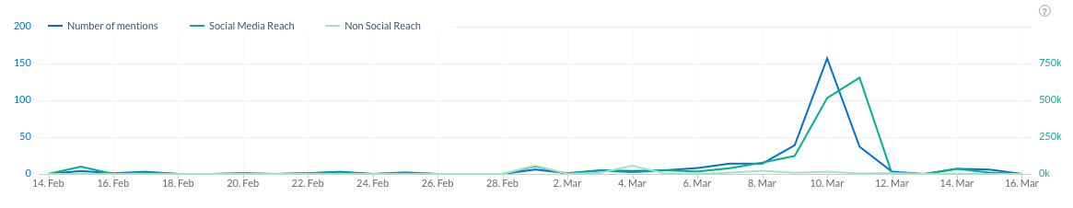

UNESCO

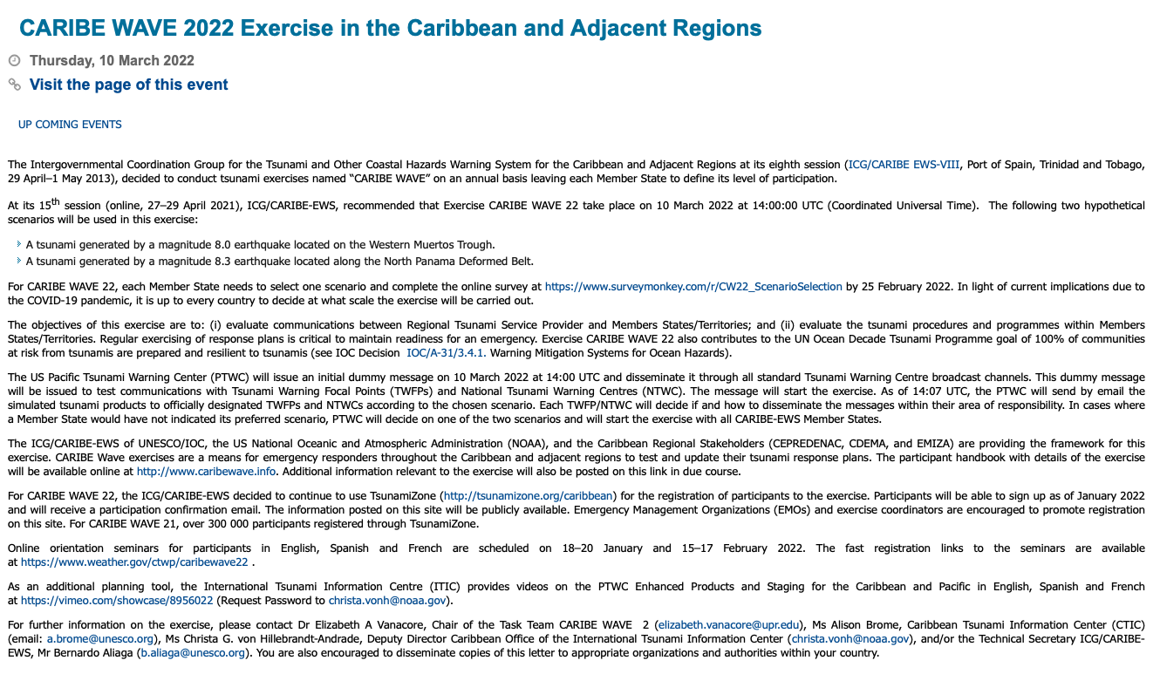

Retrieved from: http://iocaribe.ioc-unesco.org/component/djevents/details/2022-03-10/47-caribe-wave-2022-exercise-in-the-caribbean-and-adjacent-regions

PTWC

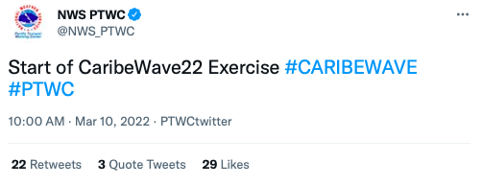

Retrieved from: https://twitter.com/NWS_PTWC/status/1501920826588741632

Antigua and Barbuda

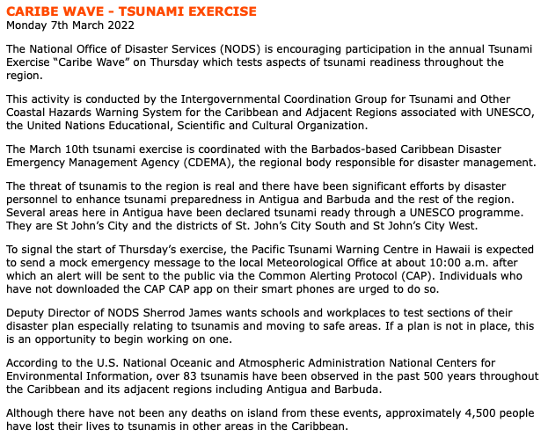

Retrieved from: https://www.antiguanice.com/v2/client.php?id=859&news=13885

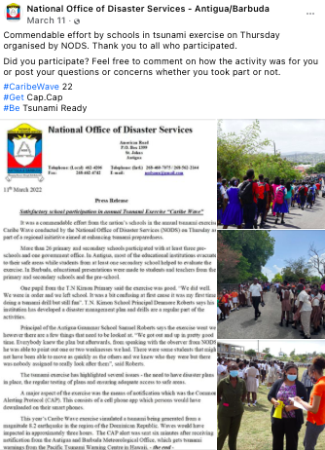
Retrieved from: https://www.facebook.com/NodsAntiguaAndBarbuda

Aruba
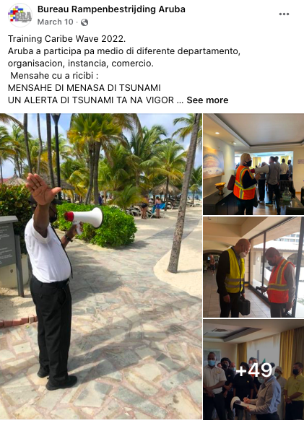
Retrieved from: https://www.facebook.com/Bureau-Rampenbestrijding-Aruba-381174835317318

Barbados

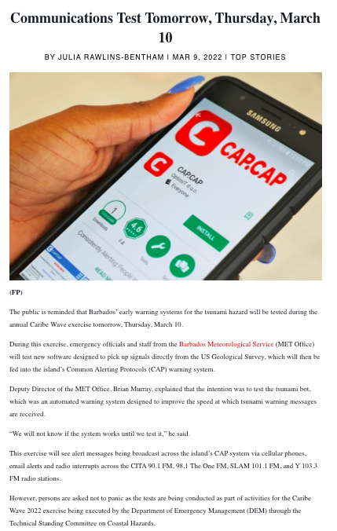
Retrieved from: https://gisbarbados.gov.bb/blog/communications-test-tomorrow-thursday-march-10/

Colombia

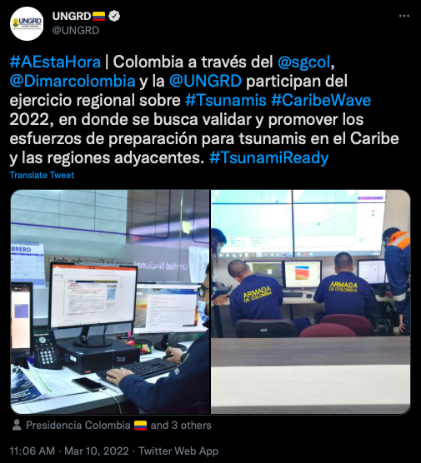

Retrieved from: https://twitter.com/UNGRD/status/1501937622205100052

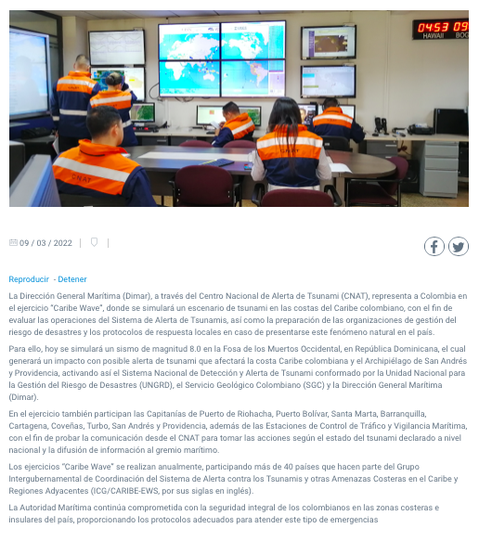
Retrieved from: https://www.dimar.mil.co/dimar-representa-colombia-en-el-ejercicio-internacional-de-tsunami-caribe-wave-2022

Costa Rica

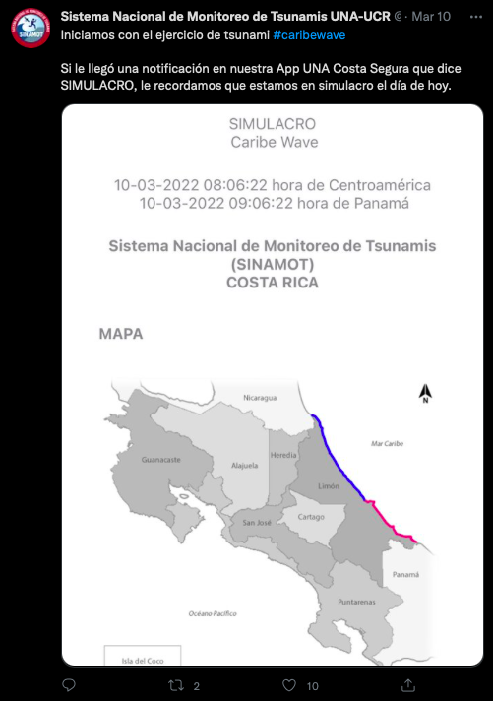

Retrieved from: https://twitter.com/SINAMOT_CR/status/1501925144721301505

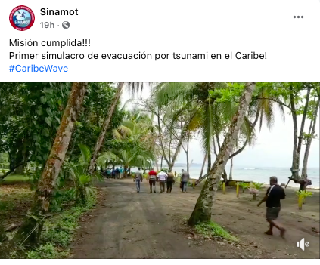

Retrieved from: https://www.facebook.com/sinamot.cr/

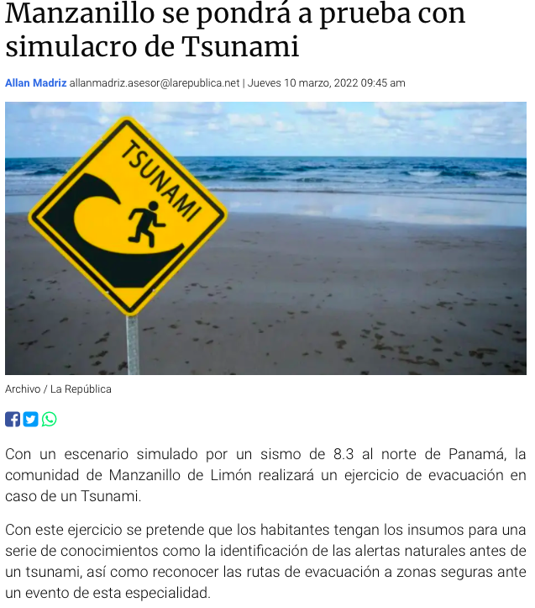
Retrieved from: https://www.larepublica.net/noticia/manzanillo-se-pondra-a-prueba-con-simulacro-de-tsunami

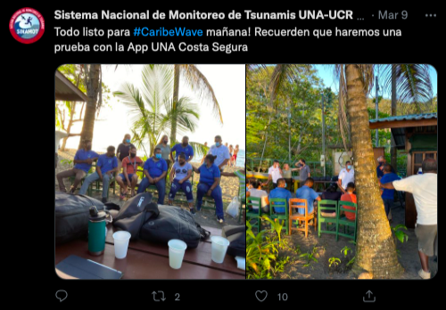

Retrieved from: https://twitter.com/SINAMOT_CR/status/1501729649088417800

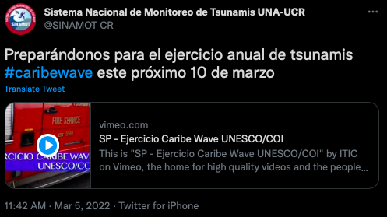

Retrieved from: https://twitter.com/SINAMOT_CR/status/1500134675301421066

Dominican Republic

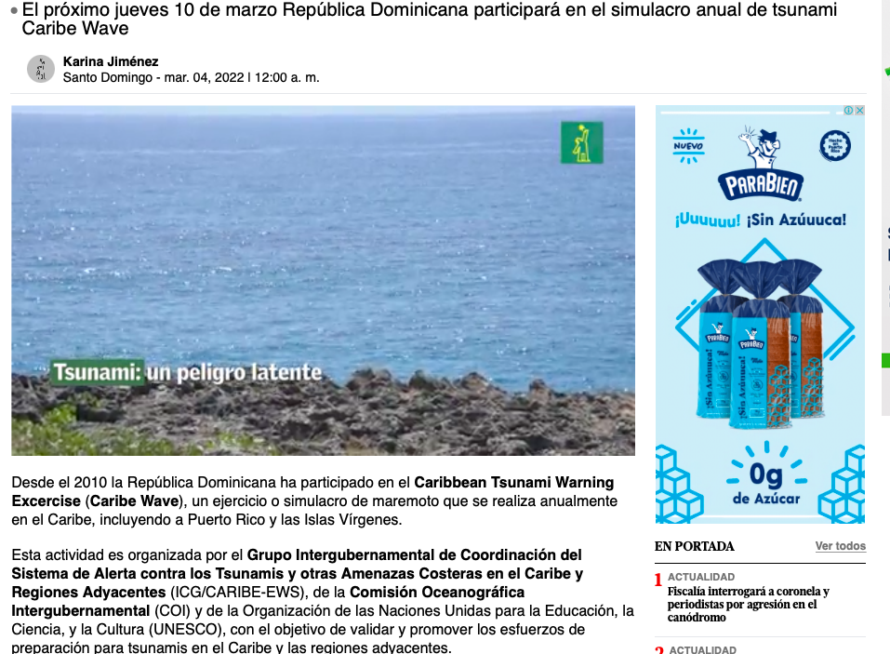

Retrieved from: https://www.diariolibre.com/planeta/medioambiente/2022/03/03/tsunami-un-peligro-latente/1685418

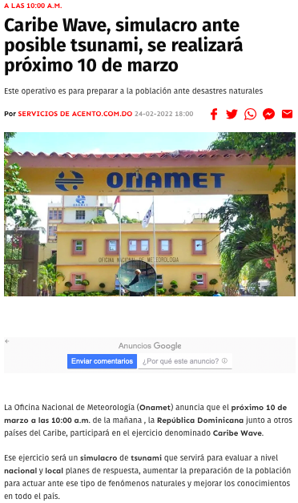

Retrieved from: https://acento.com.do/actualidad/caribe-wave-simulacro-ante-posible-tsunami-se-realizara-proximo-10-de-marzo-9035838.html

France

Martinique

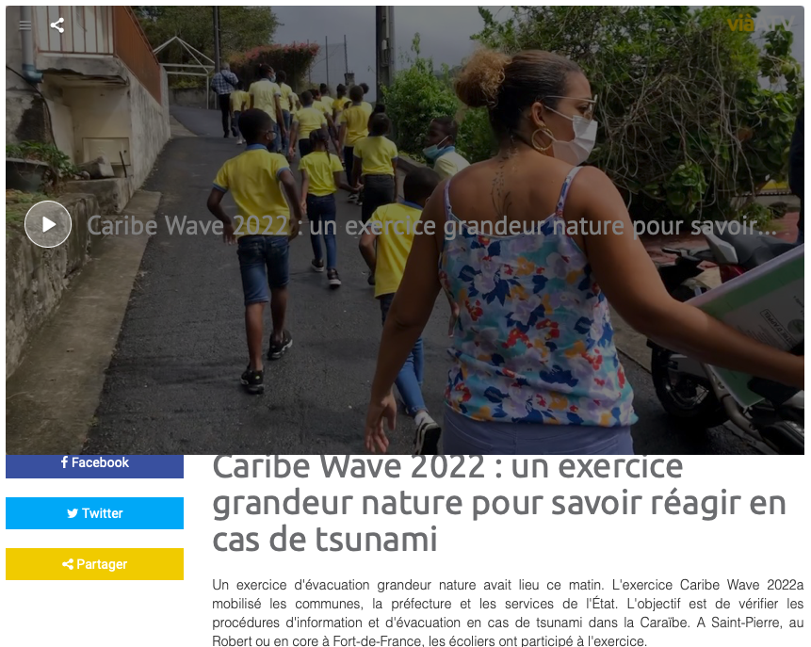
Retrieved from: https://viaatv.tv/caribe-wave-2022-un-exercice-grandeur-nature-pour-savoir-reagir-en-cas-de-tsunami/

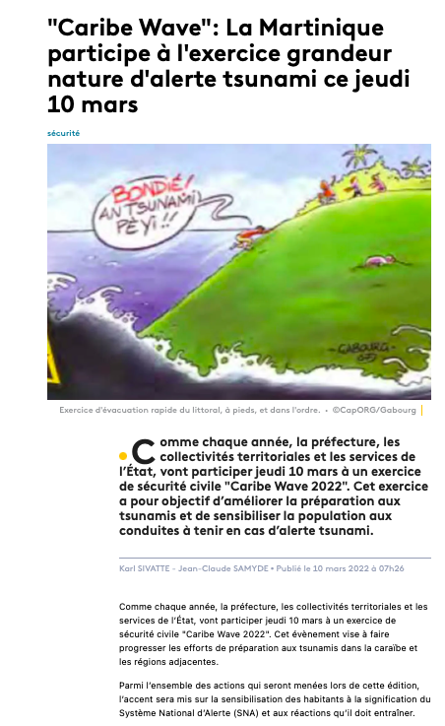
Retrieved from: https://la1ere.francetvinfo.fr/martinique/caribe-wave-la-martinique-participe-a-l-exercice-grandeur-nature-d-alerte-tsunami-ce-jeudi-10-mars-1251409.html
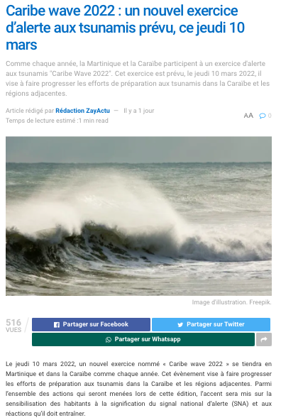

Retrieved from: https://www.zayactu.org/2022/03/caribe-wave-2022-un-nouvel-exercice-dalerte-aux-tsunamis-prevu-ce-jeudi-10-mars

Guadeloupe

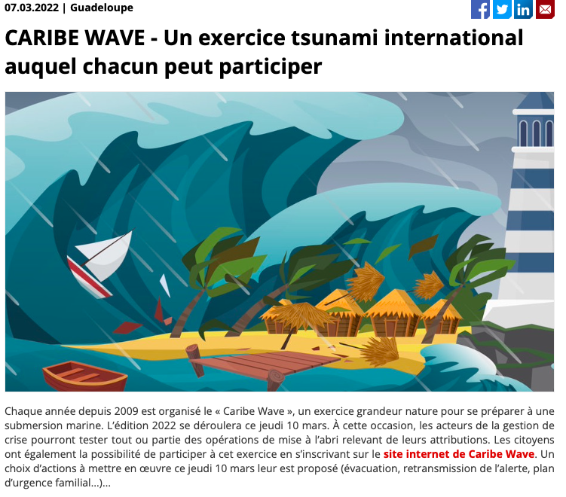

Retrieved from: https://www.memento.fr/article_07-03-2022-caribe-wave-un-exercice-tsunami-international-auquel-chacun-peut-participer

Grenada
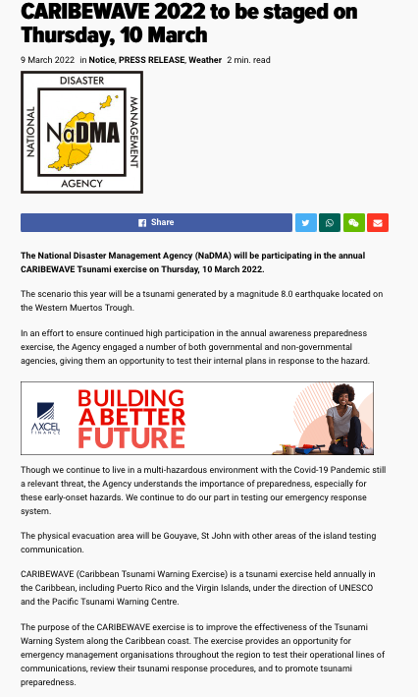
Retrieved from: https://www.nowgrenada.com/2022/03/caribewave-2022-to-be-staged-on-thursday-10-march/

Mexico
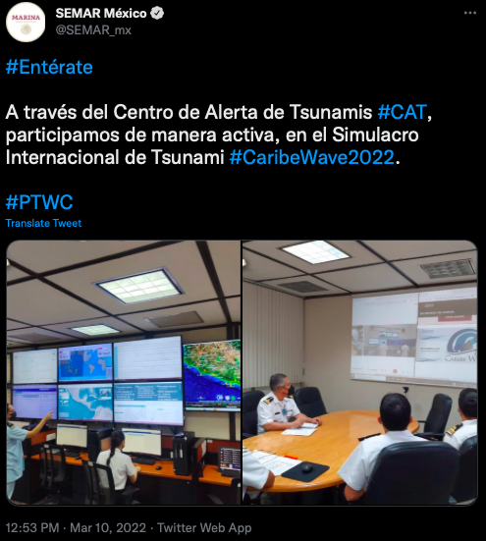
Retrieved from: https://twitter.com/SEMAR_mx/status/1501964523477127171 https://www.nowgrenada.com/2022/03/caribewave-2022-to-be-staged-on-thursday-10-march/

Saint Kitts and Nevis
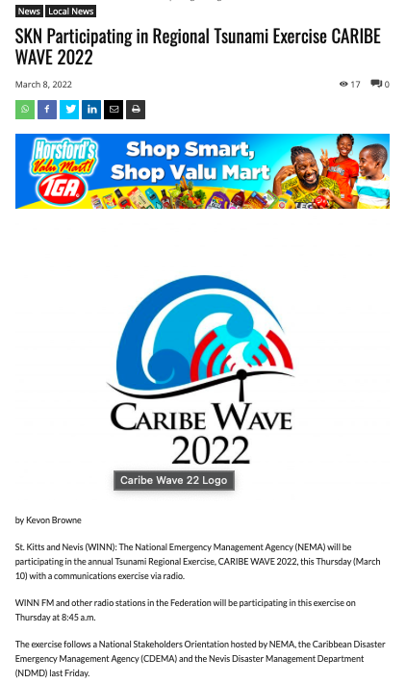
Retrieved from: https://www.winnmediaskn.com/skn-participating-in-regional-tsunami-exercise-caribe-wave-2022/
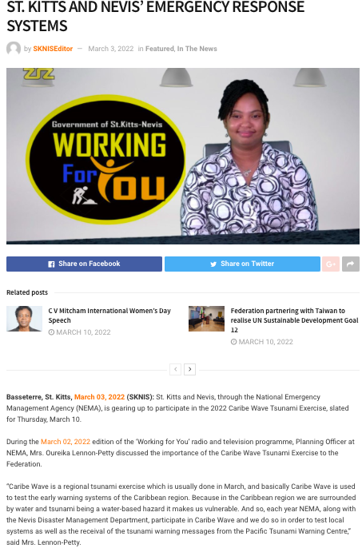
Retrieved from: https://www.sknis.gov.kn/2022/03/03/2022-caribe-wave-exercise-to-help-strengthen-st-kitts-and-nevis-emergency-response-systems/
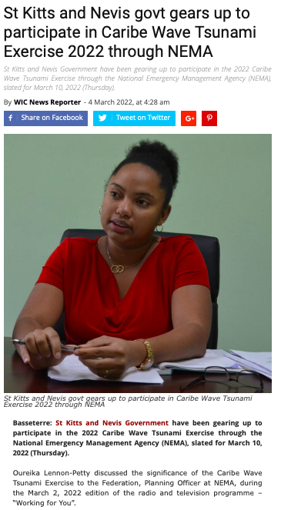
Retrieved from: https://wicnews.com/caribbean/st-kitts-and-nevis-govt-gears-up-to-participate-in-caribe-wave-tsunami-exercise-2022-through-nema-282740947/

Saint Vincent and the Grenadines

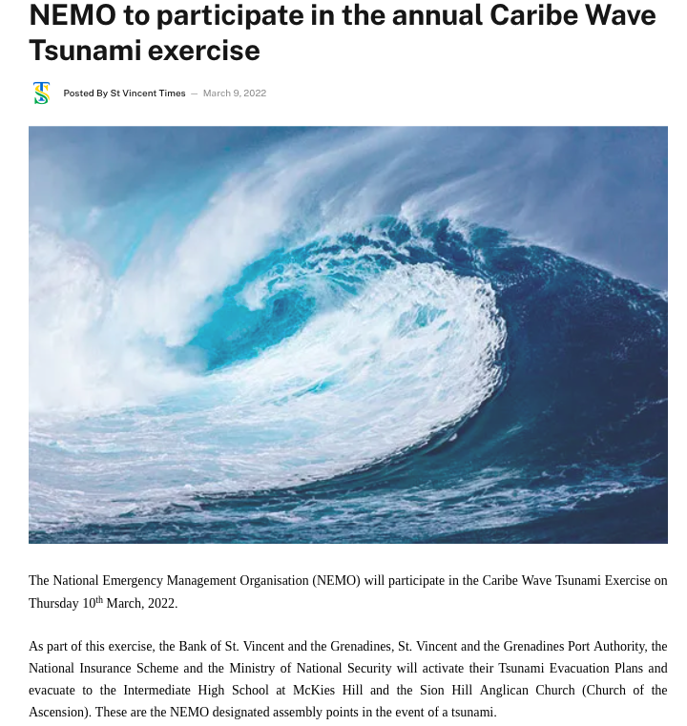

Retrieved from: https://www.stvincenttimes.com/nemo-to-participate-in-the-annual-caribe-wave-tsunami-exercise/

Trinidad and Tobago

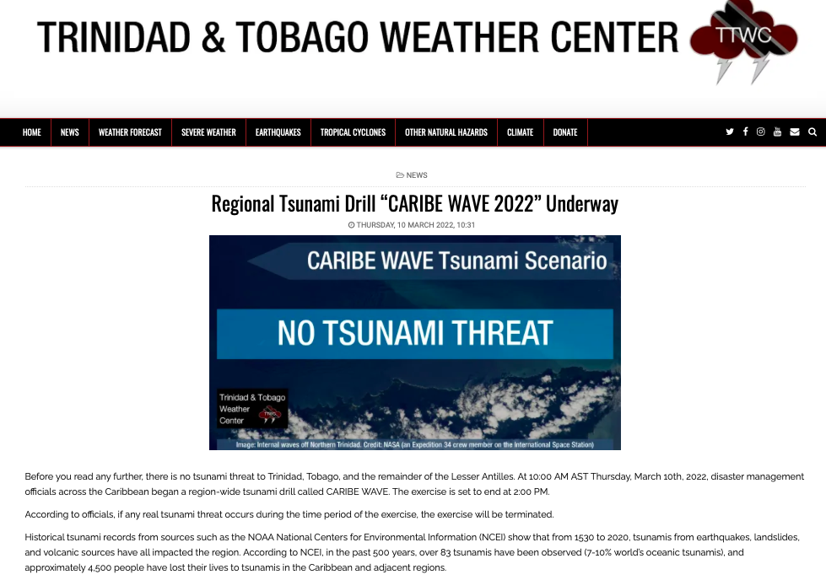

Retrieved from: https://ttweathercenter.com/2022/03/10/regional-tsunami-drill-caribe-wave-2022-underway/

United Kingdom

Bermuda

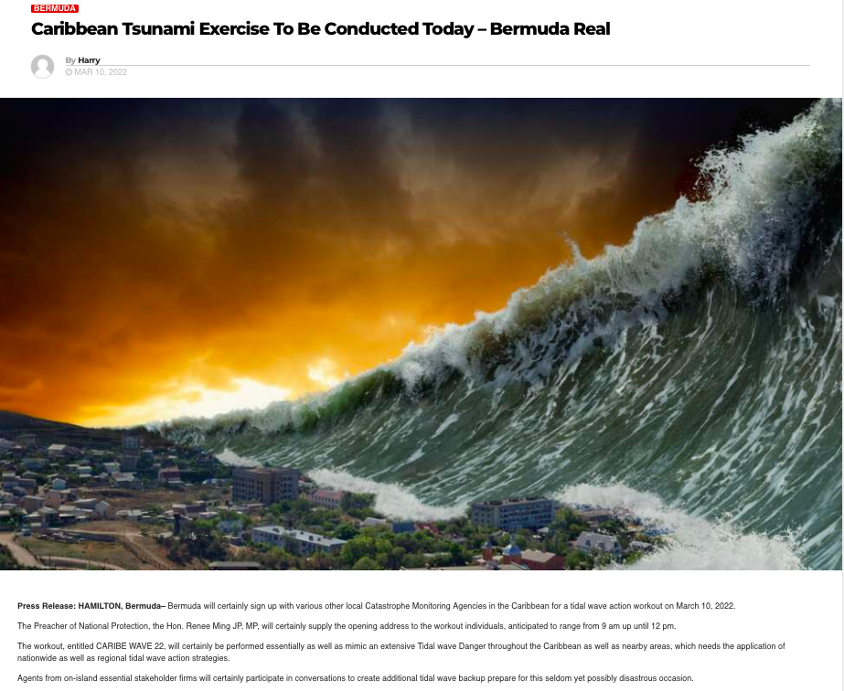

Retrieved from: https://www.newspostalk.com/caribbean-tsunami-exercise-to-be-conducted-today-bermuda-real/

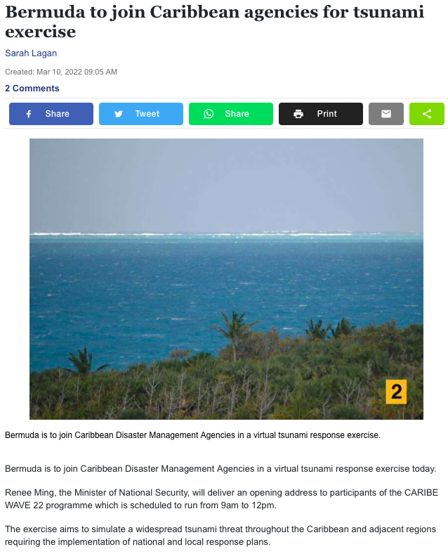
Retrieved from: https://www.royalgazette.com/environment/news/article/20220310/bermuda-to-join-caribbean-agencies-for-tsunami-exercise/

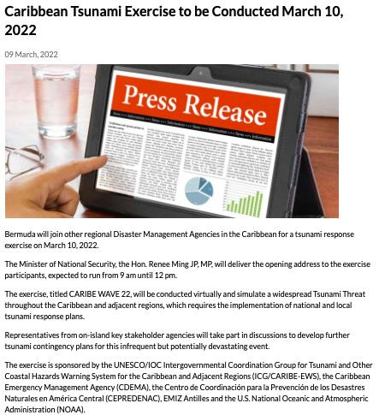

Retrieved from: https://www.gov.bm/articles/caribbean-tsunami-exercise-be-conducted-march-10-2022

British Virgin Islands

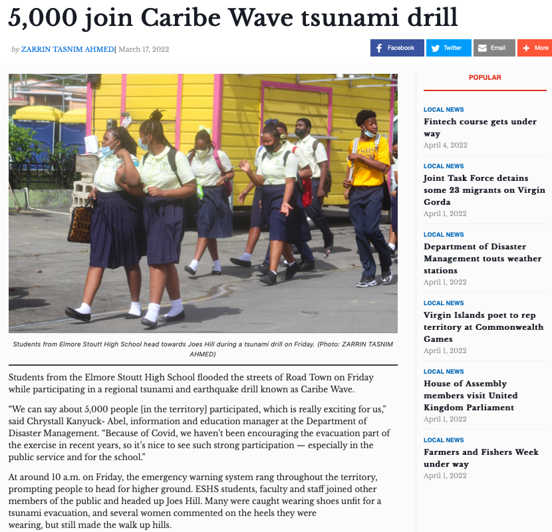

Retrieved from: https://www.bvibeacon.com/5000-join-caribe-wave-tsunami-drill/

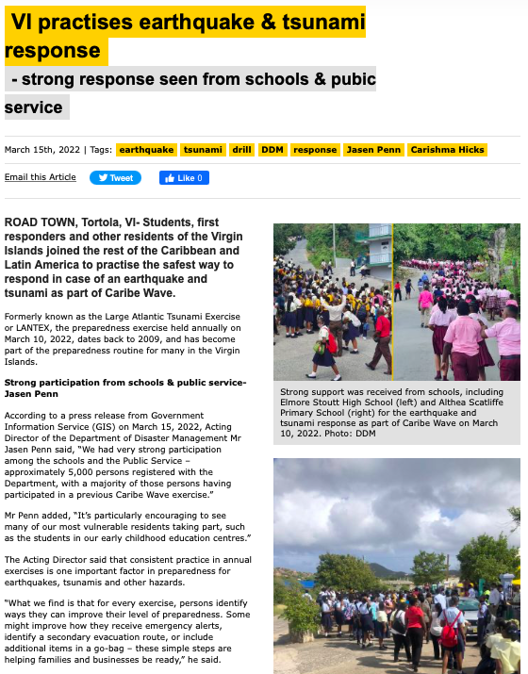
Retrieved from: https://www.virginislandsnewsonline.com/en/news/vi-practises-earthquake-tsunami-response

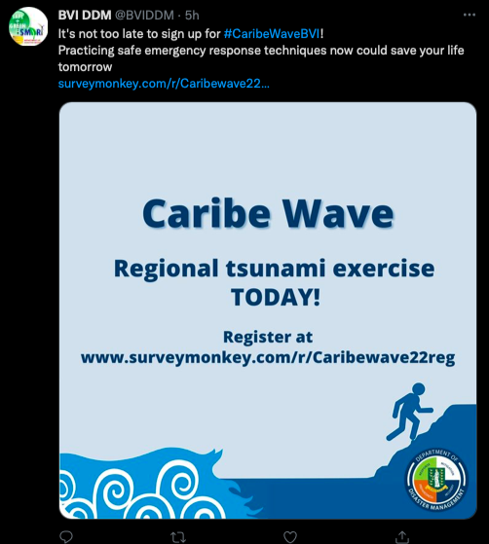
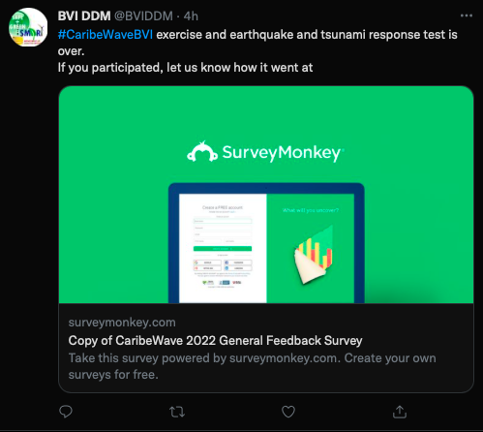

Retrieved from: https://twitter.com/BVIDDM/status/1501928698257174535

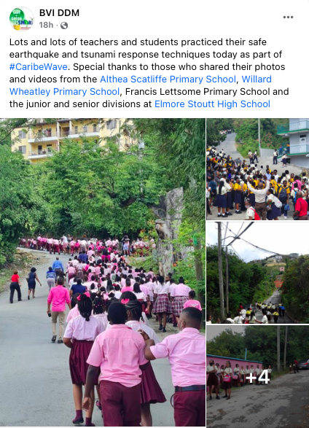

Retrieved from: https://www.facebook.com/bvi.ddm/

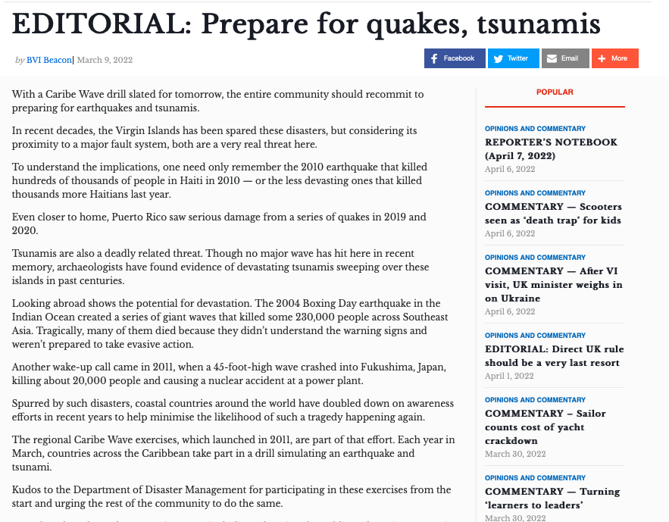

Retrieved from: https://www.bvibeacon.com/editorial-prepare-for-quakes-tsunamis/

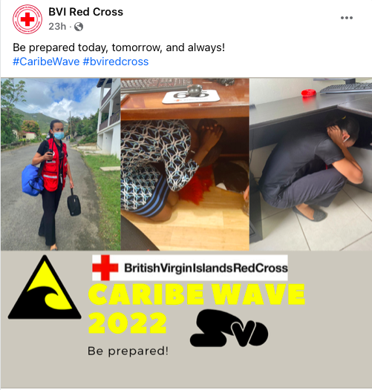

Retrieved from: https://www.facebook.com/bviredcross/

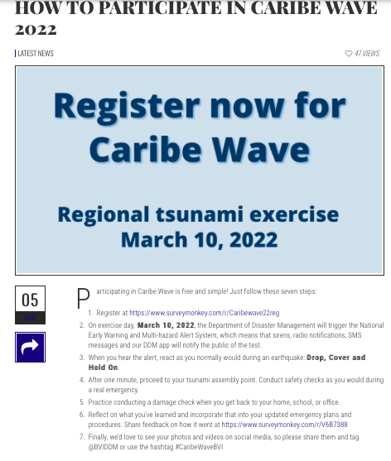

Retrieved from: https://www.bviddm.com/how-to-participate-in-caribe-wave-2022-in-7-steps/

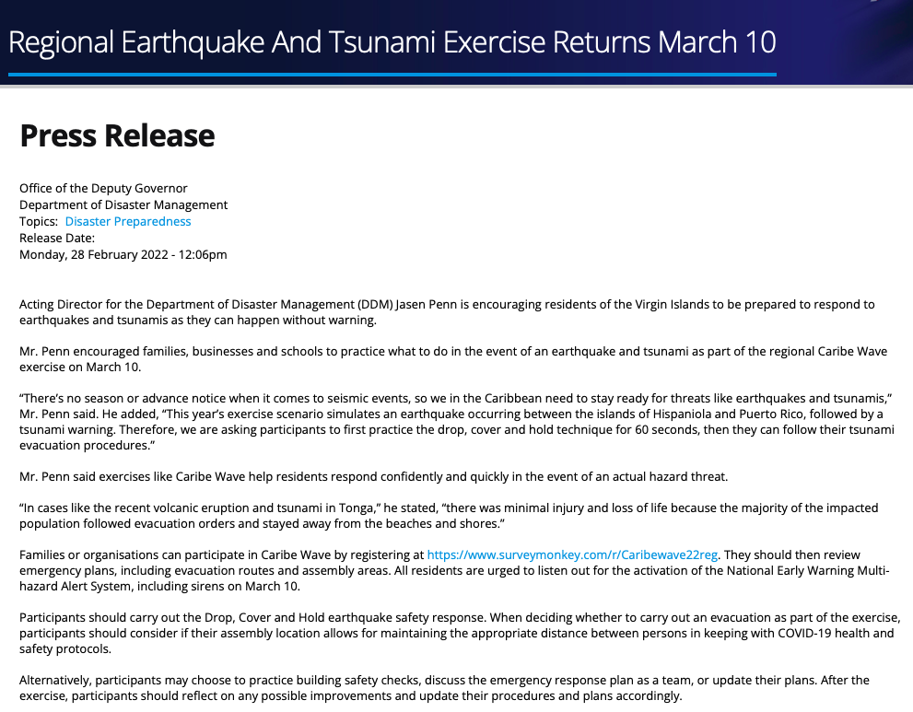

Retrieved from: http://www.bvi.gov.vg/media-centre/regional-earthquake-and-tsunami-exercise-returns-march-10

Cayman Islands

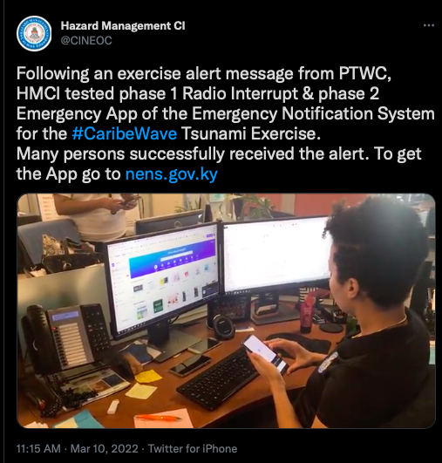

Retrieved from: https://twitter.com/CINEOC/status/1501939795823530000

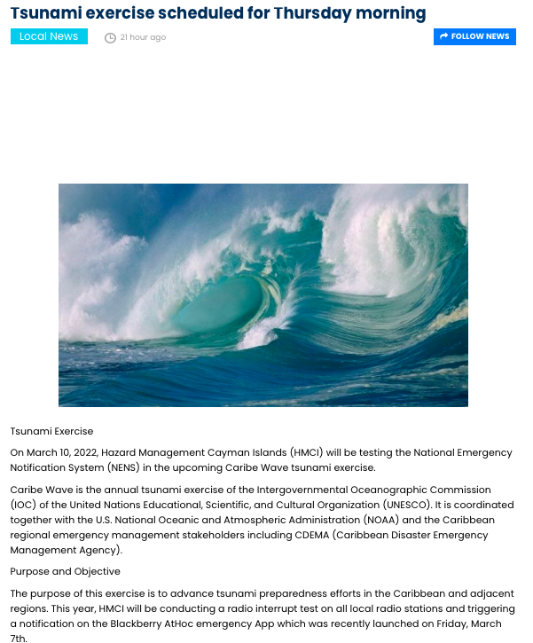

Retrieved from: https://www.caymaniantimes.ky/news/tsunami-exercise-scheduled-for-thursday-morning

United States

Puerto Rico

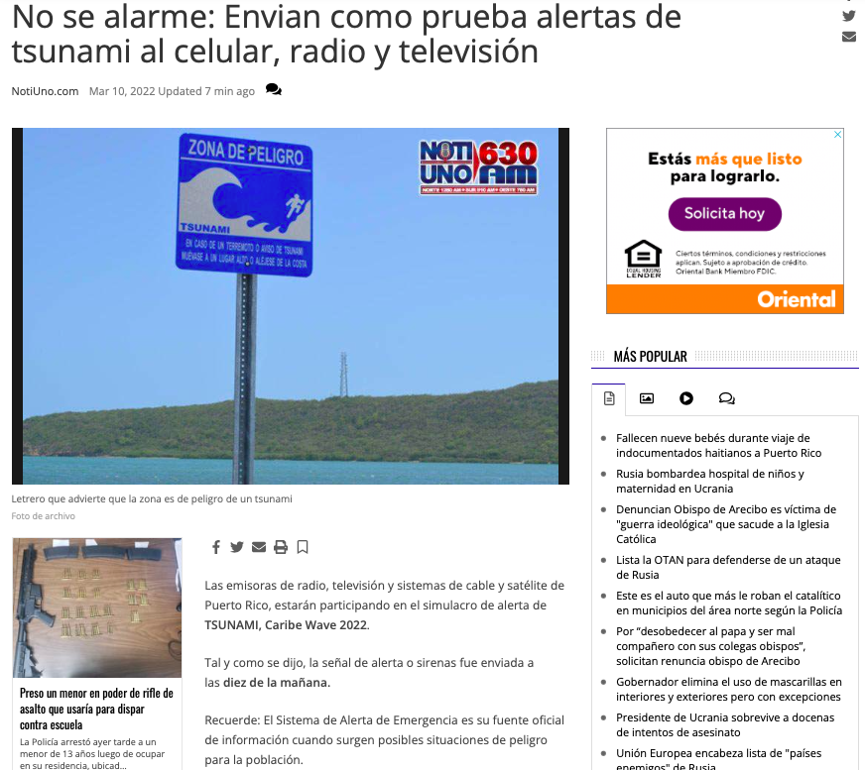

Retrieved from: https://www.notiuno.com/noticias/seguridad-y-justicia/no-se-alarme-enviar-n-como-prueba-alertas-de-tsunami-al-celular-radio-y-televisi/article_550a855e-a06a-11ec-89e0-6bc1ec394ec1.html

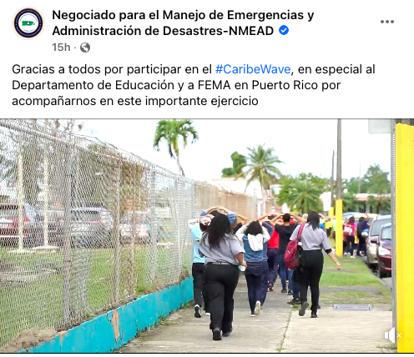

Retrieved from: https://www.facebook.com/NMEADpr/

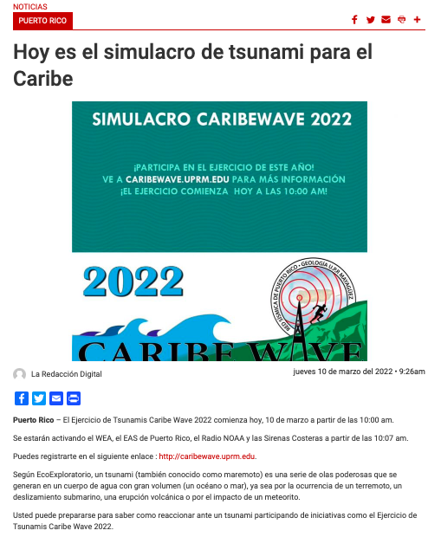

Retrieved from: https://www.periodicolaperla.com/hoy-es-el-simulacro-de-tsunami-para-el-caribe/

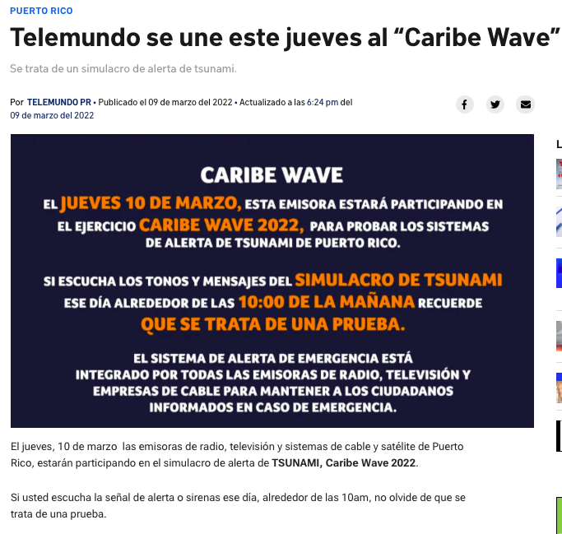

Retrieved from: https://www.telemundopr.com/noticias/puerto-rico/telemundo-se-une-este-jueves-al-caribe-wave/2314599/

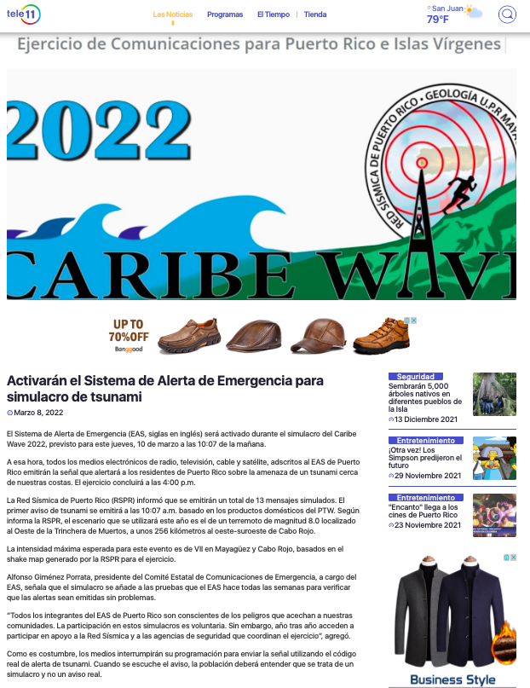
Retrieved from: https://teleonce.com/noticias/locales/activaran-el-sistema-de-alerta-de-emergencia-para-simulacro-de-tsunami/

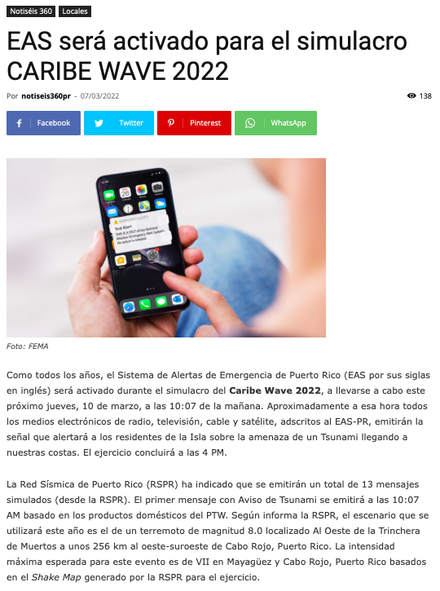

Retrieved from: https://wipr.pr/eas-sera-activado-para-el-simulacro-caribe-wave-2022/

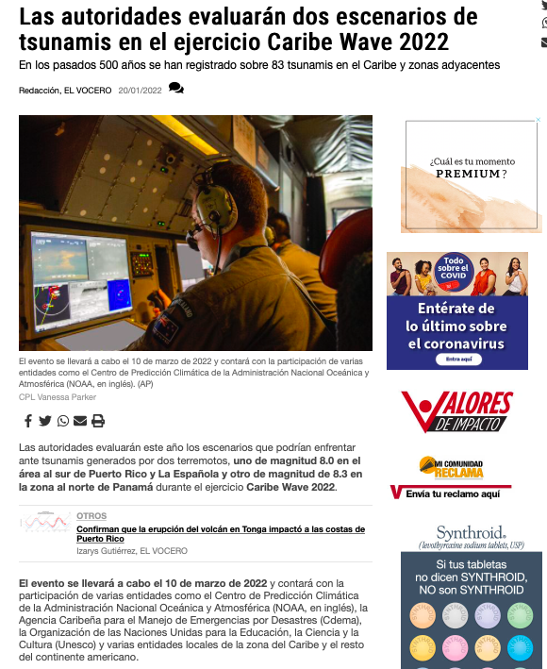

Retrieved from: https://www.elvocero.com/actualidad/otros/las-autoridades-evaluar-n-dos-escenarios-de-tsunamis-en-el-ejercicio-caribe-wave-2022/article_2f62c69a-7a0e-11ec-8418-1fd286eb5262.html

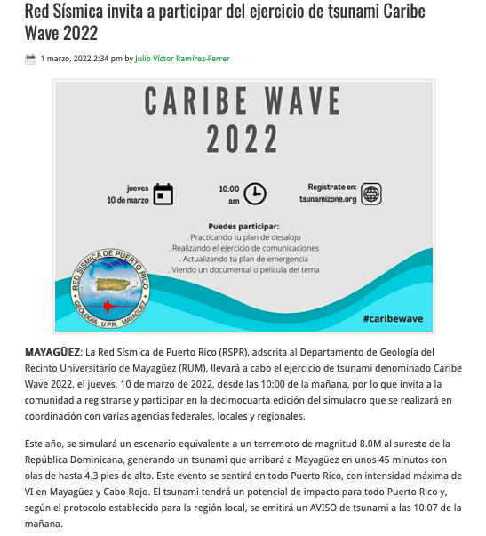

Retrieved from: https://lacallerevista.com/portada/red-sismica-invita-a-participar-del-ejercicio-de-tsunami-caribe-wave-2022/63984

US Virgin Islands

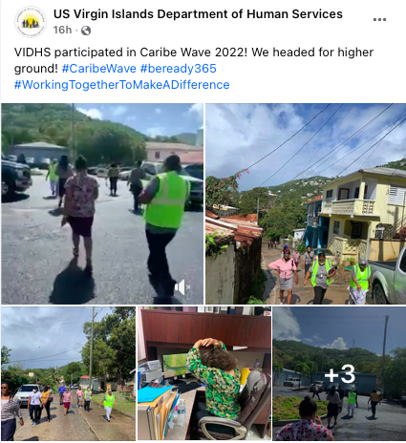

Retrieved from: https://www.facebook.com/usvidhs

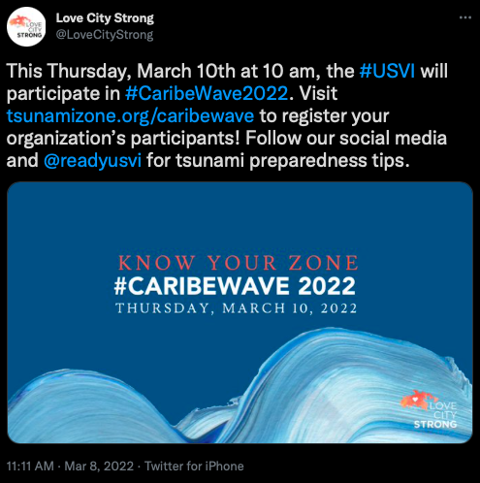

Retrieved from: https://twitter.com/LoveCityStrong/status/1501214140408471552

Venezuela

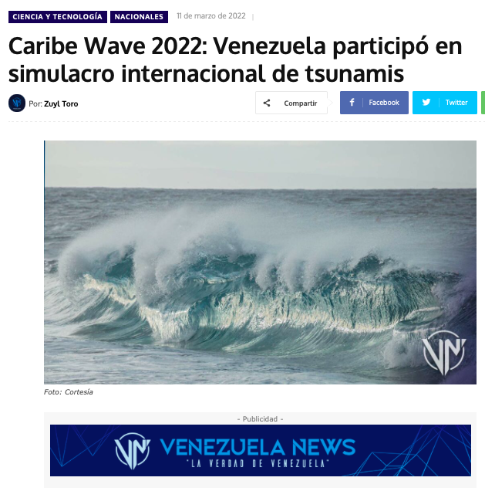
Retrieved from: https://venezuela-news.com/caribe-wave-2022-venezuela-participo-en-simulacro-internacional-de-tsunamis/
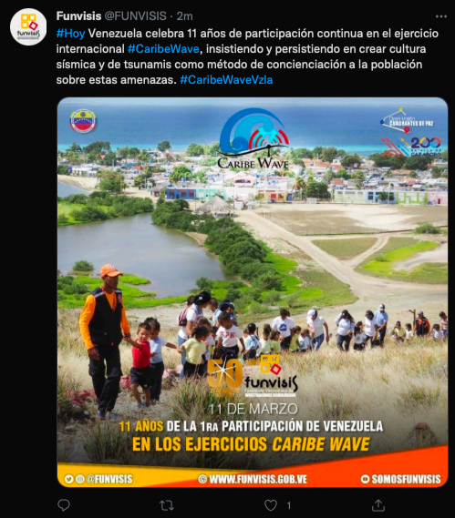

Retrieved from: https://twitter.com/FUNVISIS/status/1502292258296635392

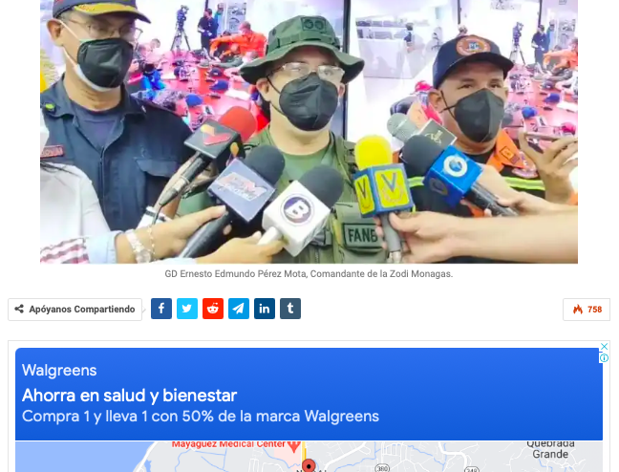

Retrieved from: https://laverdaddemonagas.com/2022/03/10/mas-de-280-efectivos-participaron-en-simulacro-caribe-wave-2022-en-monagas/

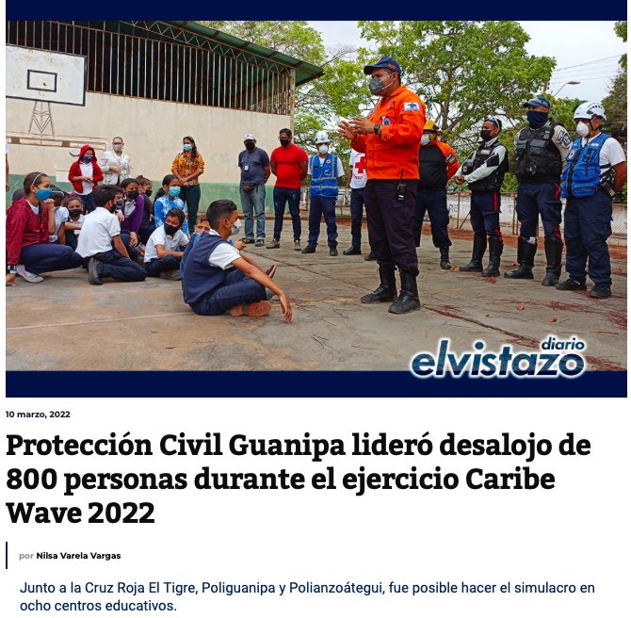

Retrieved from: https://diarioelvistazo.com/proteccion-civil-guanipa-lidero-desalojo-de-800-personas-durante-el-ejercicio-caribe-wave-2022/

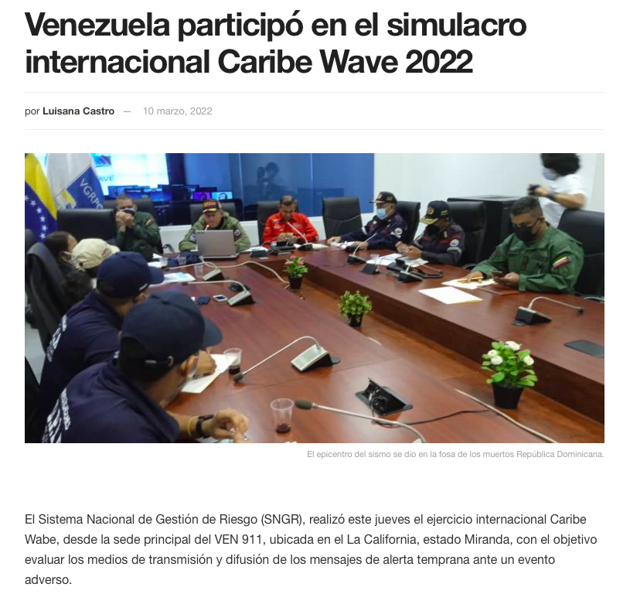

Retrieved from: https://www.pcivil.gob.ve/2022/03/venezuela-participo-en-el-simulacro-internacional-caribe-wave-2022/

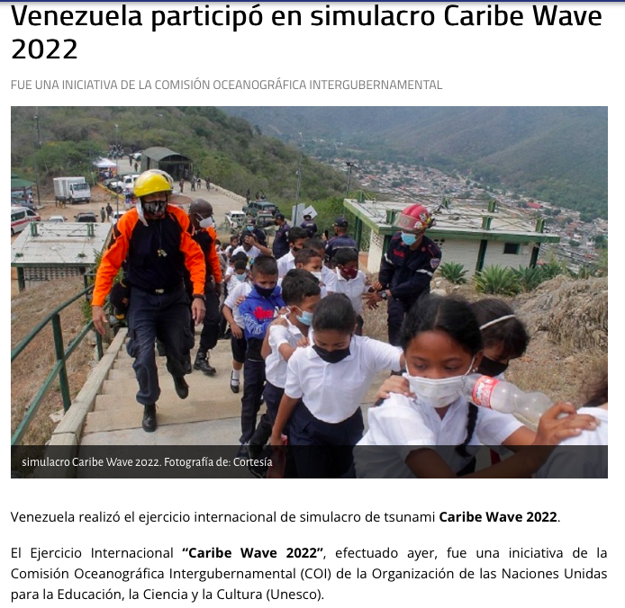

Retrieved from: https://www.noticierovenevision.net/noticias/nacional/venezuela-participo-en-simulacro-caribe-wave-2022

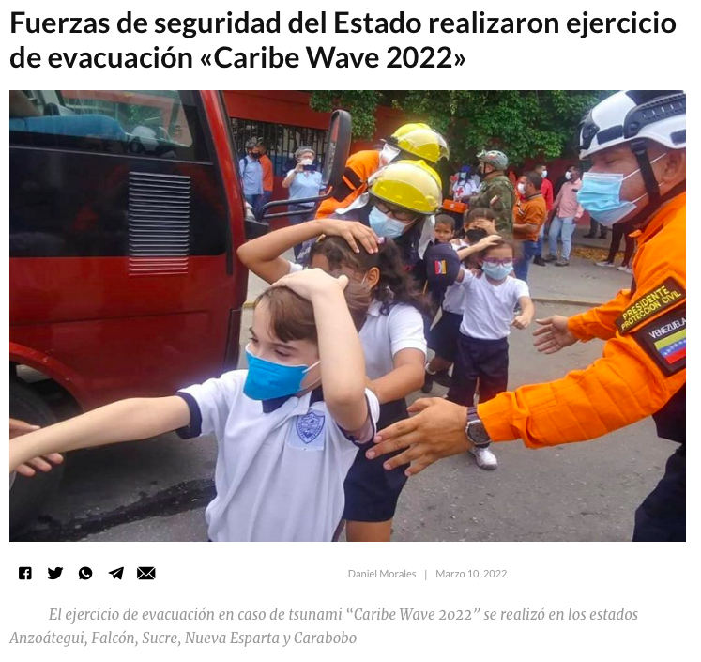

Retrieved from: https://talcualdigital.com/fuerzas-de-seguridad-del-estado-realizan-ejercicio-de-evacuacion-caribe-wave-2022/
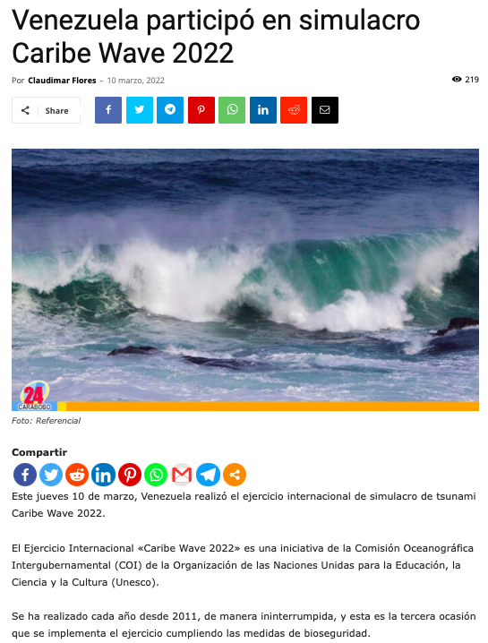

Retrieved from: https://noticias24carabobo.com/venezuela-simulacro-caribe-wave-2022/?utm_source=rss&utm_medium=rss&utm_campaign=venezuela-simulacro-caribe-wave-2022

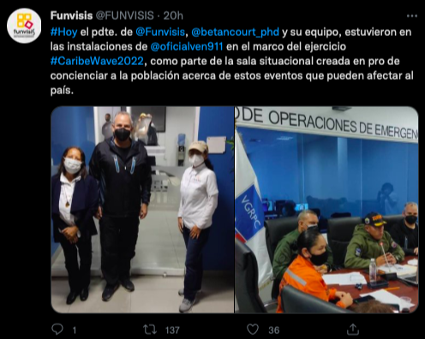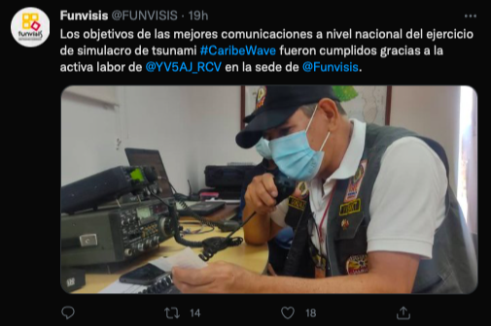

Retrieved from: https://twitter.com/FUNVISIS/status/1502002843082964993
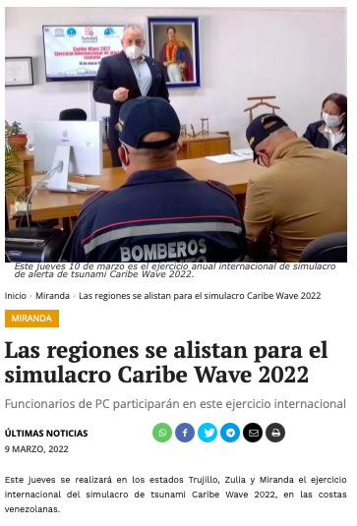
Retrieved from: https://ultimasnoticias.com.ve/noticias/miranda/las-regiones-se-alistan-para-el-simulacro-caribe-wave-2022/

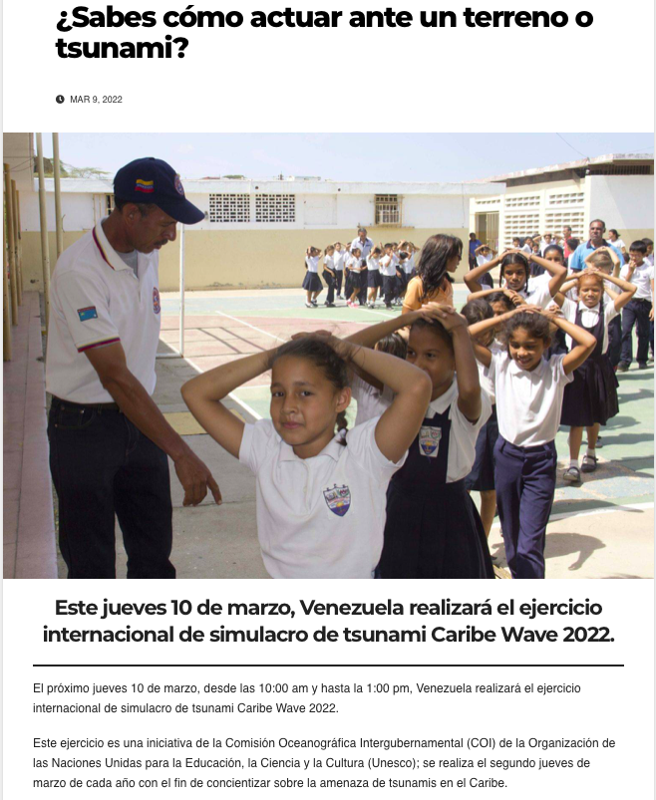

Retrieved from: https://nuevodia.com.ve/2022/03/09/caribe-wave-sabes-como-actuar-ante-un-terreno-o-tsunami/

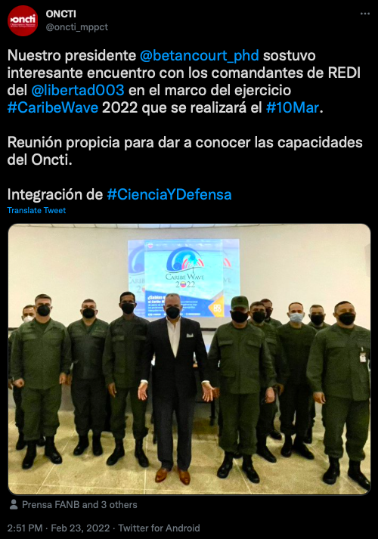

Retrieved from: https://twitter.com/oncti_mppct/status/1496558406035025928

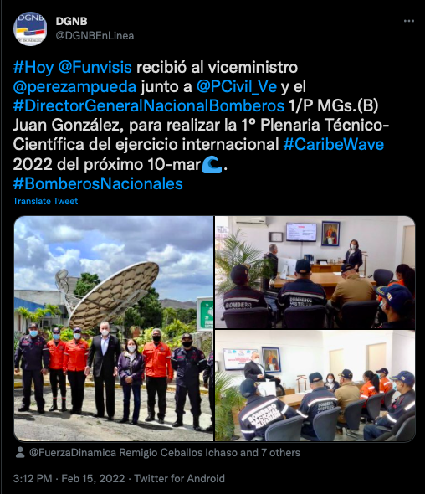

Retrieved from: https://twitter.com/DGNBEnLinea/status/1493664576595968000

