Summary
This document provides an overview of the status of decentralized Decade coordinating mechanisms that are envisaged in the Ocean Decade Implementation Plan including Decade Coordination Offices (DCOs), Decade Collaborative Centres (DCCs), Decade Implementing Partners (DIPs) and National Decade Committees (NDCs). It concludes with a discussion on the needs and perspectives of the Ocean Decade in relation to these mechanisms.

- Overview of Categories of Decade Coordinating Mechanisms
The Ocean Decade Implementation Plan defines the different types of structures that will support the Decade Coordination Unit in the coordination and implementation of the Ocean Decade. Further details on these structures are provided in the following documents: Decade Collaborative Centres and Decade Implementing Partners: Operational Guidelines, and National Decade Committees – Operational Guidelines.
Decade Coordination Offices (DCOs): may be hosted by UN entities or UN Member States. These Offices will act as ‘decentralized’ Ocean Decade Coordination Units, being organically attached to the central Decade Coordination Unit and will be responsible for a regional portfolio of Ocean Decade Actions and/or specific thematic initiatives focusing on one or more of the Ocean Decade Challenges. Initial guidance for the establishment of IOC/UNESCO-based Ocean Decade Coordination Offices is provided through IOC Circular Letter 2785 of 2019.The main functions of Ocean Decade Coordination Offices include, but are not limited to:
- Coordinate, monitor and report on specific Ocean Decade programmes or regional portfolios of actions.
- Review requests for endorsement of Ocean Decade Actions falling under their mandate and provide recommendations to the Ocean Decade Coordination Unit.
- Organize and participate in Ocean Decade implementation review meetings and other relevant meetings and discussions linked to the Decade implementation.
- Promote cooperation with relevant IOC programmes, related projects, other relevant UN entities and stakeholder groups in order to advance the implementation of the Ocean Decade.
- Raise awareness and visibility of the Ocean Decade amongst diverse stakeholder groups and coordinate targeted communications activities in line with branding and messaging guidelines provided by the Ocean Decade Coordination Unit.
- Seek partnerships and potential voluntary commitments to strengthen implementation and impact of the Ocean Decade.
Decade Collaborative Centres (DCCs): are proposed by Member States, or international or major regional non-UN organizations. They will play a similar decentralized coordination role as DCOs and will provide support to the Decade Coordination Unit and to Decade Coordination Offices by catalysing and coordinating Decade Actions at the regional or thematic level. The DCCs will be instrumental in facilitating coordination via Communities of Practice for endorsed Decade Actions, including via the Global Stakeholder Forum. They will provide technical, logistical, and financial support for: (i) scientific coordination and planning; (ii) the identification of collaboration and resource mobilisation opportunities; (iii) awareness raising and stakeholder engagement; and (iv) technical and scientific capacities to support Decade Actions. They will also provide advice to the Decade Coordination Unit on the scoping of Calls for Decade Actions and requests for endorsement of Decade Actions that fall within their purview. Decade Collaborative Centres will be legally separate from the IOC or the UN agency under which they are established and operate under the complete responsibility of the establishing entity(ies). The scope and mandate of Decade Collaborative Centres is expected to address one or more Ocean Decade Challenges (i.e., thematically focused Centres) or one or more ocean basins (i.e., geographically focused Centres).
Decade Implementing Partners (DIPs): are non-UN regional or international stakeholder organisations that provide targeted support to the Decade Coordination Unit and decentralized coordination structures, including both Decade Coordination Offices and Decade Collaborative Centres, in relation to different facets of Decade implementation. This can be either through alignment of partners’ strategic priorities and work programs, to Decade priorities and/or through the provision of support to implementation of one or more targeted elements of the Decade.
National Decade Committees (NDCs): are voluntary multi-agency and multi-stakeholder national platforms, which support the formal governance and coordination structures of the Ocean Decade. National Decade Committees can be existing or new structures specifically tailored to coordinate a wide variety of stakeholders at the national level. They facilitate the co-design and co-delivery of Decade Actions (at a national level) and facilitate access to benefits derived from the Decade such as data, products, science-policy advice and capacity development. The primary role of a National Decade Committee is to serve as a central hub which links and engages national level actors participating in the Ocean Decade. Unlike the more formal governance and coordination structures of the Ocean Decade, National Decade Committees are voluntary in nature. The Implementation Plan sets out the broad expectations for National Decade Committees which are described and expanded upon below. Within this framework, detailed mandates can be tailored according to national circumstances, and are at the discretion of the Committee and its members. Individual Committees are encouraged to learn from, and where appropriate, align efforts with those operating in other countries. National Decade Committees must be registered with the Decade Coordination Unit by the IOC-UNESCO national focal point.
- Status of DCOs
To date three DCOs are proposed.
Decade Coordination Office for the Western Pacific: Hosted within the IOC Sub-Commission for Western Pacific and supported by Thailand, the WESTPAC Decade Coordination Office will coordinate Decade Actions across all Ocean Decade Challenges in the Western Pacific region and its adjacent areas. It will assure the creation of synergies and links between existing Decade Actions, catalyse new Decade Actions, assist in resource mobilisation and outreach, and coordinate monitoring and evaluation of Decade progress in the region. The DCO will ensure close interactions with the South Pacific DCC hosted in PCCOS (refer below) to avoid overlap and maximize the Decade benefits to SIDS in the South Pacific region. The Terms of Reference for this DCO and the support letter from Thailand are included in INF/IOC-1418.
Decade Coordination Office for Ocean Observing: Numerous programmes and projects related to ocean observing have already been endorsed as part of the Ocean Decade. The core focus of the Decade Coordination Office (DCO) for Ocean Observing, which will be hosted within the GOOS Secretariat, will be on supporting the Ocean Decade Challenge 7, which specifically identifies the need to ensure a sustainable ocean observing system across all ocean basins that delivers accessible, timely and actionable data and information to all users. Sustained and fit for purpose ocean observations will also be key to the fulfilment of most of the remaining challenges, including for example those related to the ocean climate nexus, ecosystem management, marine pollution and resilience. The role of the DCO for Ocean Observing is to coordinate synergistic efforts among the diverse stakeholders that contribute to the Ocean Decade, to ensure efforts are not duplicated and opportunities are maximised and leveraged appropriately across the actions aimed at lifting GOOS and global and the Ocean Decade. The DCO will provide a focal point for liaising across the Ocean Decade on ocean observing related issues and undertaking communications to a broad range of stakeholders regarding the need for ocean observing to deliver the Ocean we want. The DCO will liaise with the Decade Coordination Unit for reporting, fundraising efforts and identifying needs or gaps to meet Challenge 7, helping scope future Ocean Decade Calls to support this.
Additional in-kind or financial resources in the order of USD 780,000 per year will be required to support the establishment and operation of this DCO within the GOOS Secretariat. Further details on resource needs and the Terms of Reference of the DCO are provided in IOC/INF-1418.
Decade Coordination Office for Ocean Data Sharing: The core focus of the DCO for Ocean Data Sharing, which will be housed within the IODE Programme of IOC-UNESCO, will be on supporting the Ocean Decade Challenge 8, supporting the development of the capacity, functionality and interoperability of the management of and accessibility to ocean data, information and knowledge. The DCO aims to drive the Data Management component of the digital data ecosystem needed for the Ocean Decade to be successful. The activities of this DCO will promote sustained digital interoperability between the data, information, and digital knowledge generated through Decade Actions.
It will bring together digital stakeholders - across regions, organizational scales, and capacity levels – to negotiate and establish clear agreements on their co-development of the Decade’s digital ecosystem. Building on the Ocean Decade’s implementation vision and in line with the considerations of the Ocean Decade Data Coordination Group, the DCO’s activities will ensure that well-defined, transparent and functional digital value chains are maintained and inclusively interlink the Decade’s stakeholders in a robust, interoperable digital commons. To achieve this, the DCO will assess and strengthen links between the observations, operations and modelling communities, digital twin initiatives, and other key stakeholders such as local communities and indigenous data stewards. In addition, the DCO will work towards equitable participation of all IOC Member States (and related regional organizations) in the Decade data activities to drive capacity development through its OceanTeacher Global Academy, Ocean InfoHub and other related IODE projects.
Additional in-kind or financial resources in the order of USD 670,000 per year will be required to support the establishment and operation of this DCO within the IODE programme. Further details on resource needs and the Terms of Reference of the DCO are provided in IOC/INF-1418.
- Status of DCCs
To date, two DCCs have been endorsed as Decade Contributions and a further five have been proposed and are currently being evaluated. The DCCs that have been endorsed as contributions to the Decade are as follow:
The Decade Collaborative Centre for the Northeast Pacific Ocean (DCC NEPO) is a regional DCC spanning the west coast and offshore regions of North America, hosted by the Tula Foundation in British Columbia, Canada. The Tula Foundation has a strong network of research and observing partners working throughout this highly productive ocean basin and has actively been building relationships with Indigenous peoples and local communities, industries, and governments. Stakeholders in this region are becoming very engaged in the Ocean Decade and a DCC will be critical to supporting and promoting co-designed ocean science for sustainable development. The DCC will have a specific focus on Indigenous and Local Knowledge Issues. The mandate for this DCC is included in Annex 1.
The Ocean Visions – UN Ocean Decade Collaborative Centre for Ocean-Climate Solutions (DCC OCS) is hosted by a partnership between Ocean Visions, Georgia Tech, and the Georgia Aquarium, and will be housed within the Georgia Aquarium in the United States. Ocean Visions is leading the way in the co-design of ocean-based solutions to climate change, spanning from carbon dioxide removal and sequestration to ocean alkalinity enhancement. This DCC will support endorsed and emerging programmes working within the ocean-climate nexus that have an interest in developing, testing, and eventually scaling these solutions to mitigate the worst effects of climate change. The mandate for this DCC is included in Annex 2.
The five DCCs that are undergoing evaluation are as follows:
- Decade Collaborative Centre for Coastal Resilience: This DCC will be hosted by the University of Bologna, Italy. The primary purpose of the DCC will be to contribute to Ocean Decade Challenge No. 6 – Coastal and community resilience and would work with the existing coastal resilience Community of Practice plus an international range of other key stakeholders. The DCC CR will be broad-based across a range of disciplines, fully addressing at least six of the ten Decade Challenges, and covering many aspects of the other four.
- Decade Collaborative Centre for the Indian Ocean: Hosted by the Indian National Centre for Ocean Information Services (INCOIS), this DCC will focus on all ten Ocean Decade Challenges in the Indian Ocean Region. It will draw on expertise and resources within INCOIS as well as from other Government and partner institutes within the region.
- Decade Collaborative Centre for Ocean-Climate Nexus and Coordination of Chinese Decade Implementing Partners: Hosted by the First Institute of Oceanography in the Ministry of Natural Resources, China this DCC will have two main objectives. It will focus on coordination of Decade Actions working on Ocean Decade Challenge No. 5: Ocean – Climate Nexus and will coordinate and synergize the work of a number of Decade Implementing Partners in China. This DCC will work in close collaboration with the DCC OCS proposed by Ocean Visions.
- Decade Collaborative Centre for Ocean Prediction: Hosted by Mercator Ocean International this DCC will focus on coordination, knowledge generation and dissemination of applications and services related to ocean prediction. It will work closely with the DCOs proposed for observations and data management as an integral part of the observations to applications value chain.
- Decade Collaborative Centre for the South Pacific: Hosted by the Pacific Community Centre for Ocean Science (PCCOS) of The Pacific Community (SPC), this DCC would address all Ocean Decade Challenges and would have a regional focus across 22 Pacific Island countries and territories.
Endorsement decisions on the first four of these five DCCs are expected in coming weeks. The evaluation process for the DCC for the South Pacific has just commenced and a decision is expected later in 2022.
- Status of DIPs
To date, in addition to the two DIPs endorsed in 2021 (European Marine Board and JPI Oceans) three additional proposals have been recently endorsed, as follows:
- Heirs to Our Oceans: Heirs to Our Oceans (H2OO) is a US based charity with a mission to help youth understand the role they can play in creating a healthier, safer world for all. As a DIP, H2OO would act as a consulting body for National Decade Committees to use as a resource as they set up their own Youth Advisory Councils. Additionally, H2OO serves as a mechanism through which to engage a broad audience of youth, amplify the voices of youth in the context of the Decade, and offer capacity development in areas crucial to movement building, such as public speaking training, leadership skills workshops, and providing organisational support for youth summits.
- EurOcean: As a Decade Implementing Partner, EurOcean will provide: (i) networking events, conferences, workshops, and webinars with relevant stakeholders in the European marine science arena; (ii) communication and dissemination of marine science activities to reach not only some of the most influential stakeholders but also the general public in European countries; (iii) ocean literacy activities; (iv) timely and reliable data, information, and knowledge, through our databases, awareness activities, studies, and reports; and (v) open databases which keeps data relevant to the marine scientific community in Europe. Additionally, they will support communications through their extensive network, on behalf of the Decade. Many of EurOcean’s activities are already aligned with the Ocean Decade. They will continue this alignment and direct implementation of Ocean Decade activities through a dedicated human resource.
- National Institute of Oceanography and Fisheries, Egypt: NIOF as a Decade Implementing Partner will support the fulfillment of the latter’s responsibilities and obligations in relation to capacity-building, marine scientific research, and international cooperation for the development of marine technology, as well as the implementation of the strategic directions identified in the Decade of Ocean Science for Sustainable Development (2021-2030). The NIOF DIP will coordinate the planning and implementation of the training activities in such a way as to stimulate and advance the conduct of marine scientific research by, and for the benefit of, IOC-Africa member states and to foster cooperation in marine scientific research and technological development.
In addition, three other proposals for Decade Implementing Partners from the University of Peking, the Administrative Centre for China’s Agenda 21, and EMODNet the are being reviewed with decisions expected in coming weeks.
- Status of NDCs
To date 28 National Decade Committees have been formally established (refer Figure 1). The Decade Coordination Unit has been advised by Member States that six others are in the latter stages of development (refer Table 1).
Figure 1: National Decade Committees established (as of 7 June 2022)

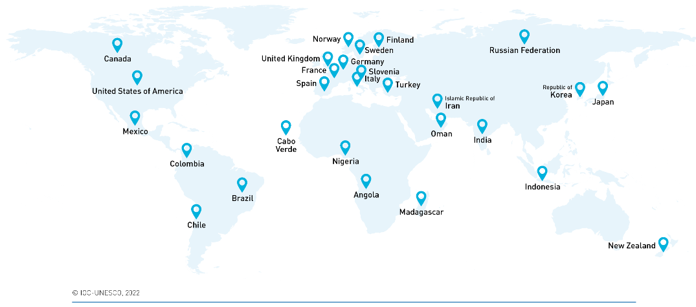

Table 1: National Decade Committees being established
- China  - Ghana  - Ireland | - Portugal  - Seychelles  - Venezuela

- Needs and Perspectives
The following priorities will be pursued in relation to decentralized Decade coordination structures over the next period:
- Resource mobilization for DCOs: A key priority will be to secure in-kind and financial resources to support the operationalization of the observations and data management DCOs that are proposed to be hosted within the GOOS Secretariat and IODE Programmes respectively. As described in IOC/INF-1418, Member States are encouraged to support these fundamental decentralized coordination structures that are essential for the success of the Decade and which will create a significant opportunity for the strengthening and positioning of IOC programmes during and beyond the life of the Decade.

- Soliciting new DCOs, DCCs and/or DIPs to fill critical gaps: It is envisaged that over the life of the Ocean Decade, a full matrix of decentralized coordination structures will emerge to cover all Ocean Decade Challenges and all major ocean basins. With the establishment of the first group of DCOs, DCCs and DIPs, a mapping will be undertaken to prioritize critical gaps in this matrix and actively solicit partners to fill these gaps.

- Encouraging establishment of new National Decade Committees: To date less than 20 percent of Member States have established National Decade Committees and there are major gaps in Least Developed Countries and Small Island Developing States. With the addition of human resources in the Decade Coordination Unit dedicated to supporting National Decade Committees, additional efforts will be made to increase the number of National Decade Committees, including encouraging existing Committees to mentor and support emerging Committees. Regular information and exchange sessions will be held with National Decade Committees to ensure sharing of information on status of existing and emerging Committees and opportunities for cross-Committee discussion and collaboration. The Global Stakeholder Forum will provide an online platform to facilitate such exchanges and coordination.

- Establishing reporting and coordination mechanisms with and amongst DCOs, DCCs and DIPs: Each DCO, DCC, and DIP will prepare an annual workplan that will be discussed and refined on a quarterly basis with the Decade Coordination Unit to ensure that its activities align with the priorities of the Decade. In addition to these regular bilateral coordination meetings, in recognition of the interactions between the foci of the various structures, the Decade Coordination Unit will synergize and encourage regular discussions between decentralized coordination structures working on similar themes or geographies. The Global Stakeholder Forum will provide an online platform to facilitate such exchanges and coordination.

ANNEX 1

MANDATE OF THE OCEAN DECADE COLLABORATIVE CENTRE
FOR THE NORTHEAST PACIFIC OCEAN
The following document details the agreed mandate and functions for the Decade Collaborative Centre for the Northeast Pacific Ocean (DCC NEPO) that will be hosted by the Tula Foundation.

Introduction to the Ocean Decade
The United Nations (UN) Decade of Ocean Science for Sustainable Development 2021-2030 (referred to as ‘the Ocean Decade’) was proclaimed by the 72nd Session of UN General Assembly (UNGA) in December, 2017. The Ocean Decade is being coordinated by the Intergovernmental Oceanographic Commission of UNESCO (IOC-UNESCO) in an effort to promote transformational, large-scale change and advance urgent action to move from the ‘ocean we have’ to the ‘ocean we want’. It includes a focus on least developed countries (LDCs), Small Island Developing States (SIDS) and land-locked developing countries (LLDCs).
The Ocean Decade will be implemented in accordance with the Implementation Plan and will be supported by contributions from Member States, specialized agencies, funds, programmes and bodies of the United Nations, as well as other intergovernmental organizations, non-governmental organizations and relevant stakeholders. The Decade Action Framework is built on ten Ocean Decade Challenges and three objectives that will contribute to creating the “ocean we want”. This includes a series of Decade Actions categorised as (i) “Decade Programmes”, long-term regional or global actions towards one or more challenges, (ii) “Decade Projects”, discrete and focused undertaking at regional, national or subnational scales, that typically contribute to a Decade Programme, (iii) “Decade Contributions”, financial or in-kind resources to support Decade Actions or coordination costs, and (iv) “Decade Activities”, on-off standalone initiatives that contribute to a Project or Programme.
Decade Collaborative Centres (DCCs) are one form of Decade Contribution. DCCs are hosted by institutions engaged in Decade initiatives that are well established and have a global or regional reach. DCCs are legally separate from IOC-UNESCO and operate under the complete responsibility of the establishing entity(ies) subject to the roles and functions identified in a mandate which is jointly agreed with IOC-UNESCO.
DCCs provide support to the Decade Coordination Unit within the IOC-UNESCO Secretariat by catalyzing and coordinating Decade Actions thematically (i.e. Ocean Decade Challenges) or geographically (ocean basins or land-based regions), as established in their endorsed scope. DCCs play a coordination and catalysis role for Decade Programmes, and related Decade Actions. At the regional or thematic level they will provide technical, logistical, and financial support for: (i) stakeholder engagement; (ii) catalyzing new Decade Actions; (iii) communications, awareness-raising and outreach; (iv) resource mobilization, and (v) monitoring and reporting. They will be equipped with a small team of dedicated staff, premises, and operational resources. The ultimate aim of the Ocean Decade is to have a full and coordinated matrix of partner-led DCCs covering all major themes and geographies and operating in a way that enhances collaboration and avoids overlap.

Rationale and Scope of the Northeast Pacific Ocean Decade Collaborative Centre
The Northeast Pacific Ocean Basin is an ideal region for an active DCC. Within the Northeast Pacific region there are important domains that cross US and Canadian National borders. This region is one of the most productive regions on earth, hosting rich biodiversity from the coastline, to the open ocean, to the deep sea. and supporting human communities for millennia. There are many active existing networks of research and observing organizations, industries, government entities, and coastal communities that are working to inform sustainable development related to the oceans. In addition, there is increased recognition of the importance of elevating Indigenous and other under-served communities in co-developing and mobilizing ocean knowledge for sustainable development. Improved coordination of these diverse programs and partners is needed to launch new initiatives and support implementation of the Ocean Decade. An active DCC in this region can help support coordination as well identify best practices, principles, and lessons that can be applied in other regions around the globe.
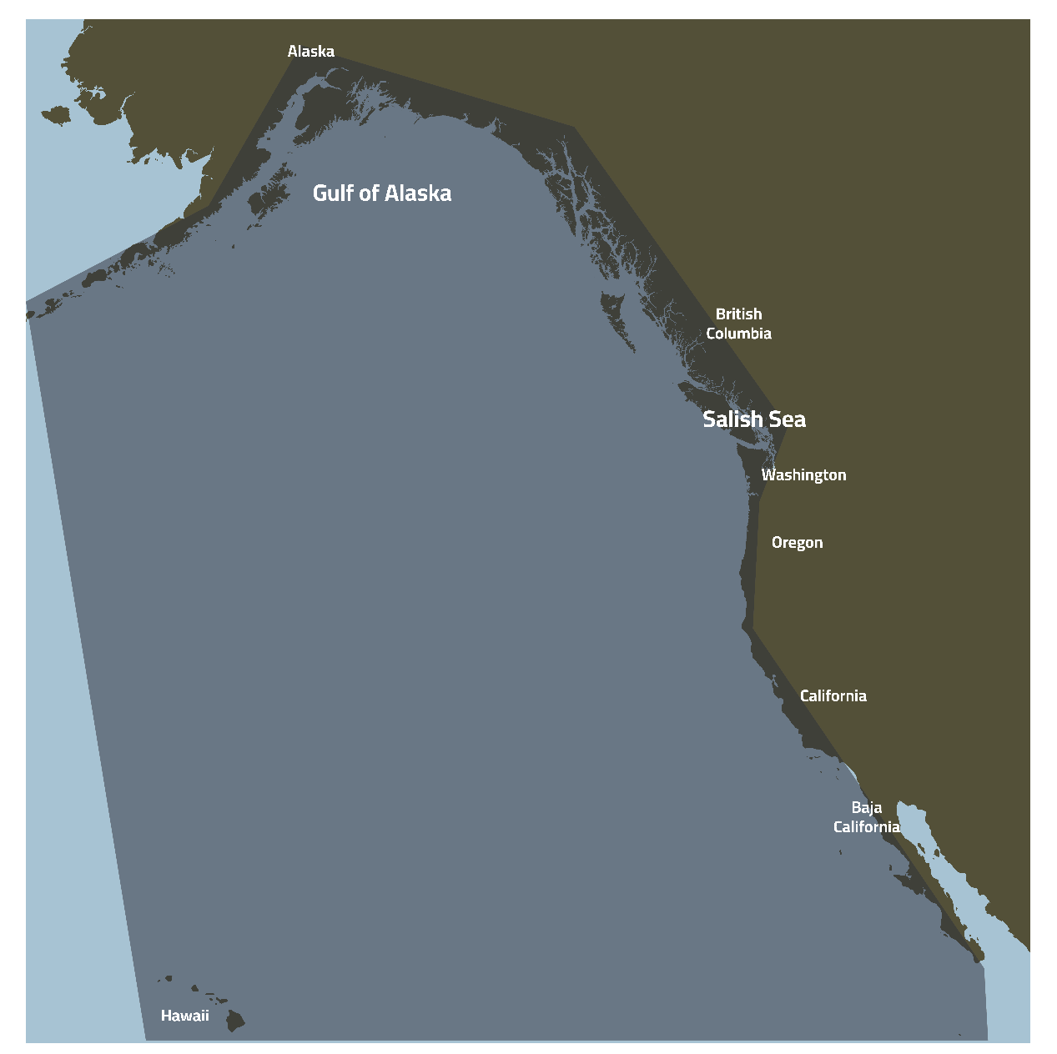
Figure 1. Illustrative boundaries of the Northeast Pacific Region for the Decade Regional Collaborative Center

The Decade Collaborative Centre for the Northeast Pacific Ocean (referred to as the DCC NEPO) will work across all ten Ocean Decade Challenges in the Northeast Pacific region. The boundaries of this region for the purposes of the Decade Collaborative Centre are shown in Figure 1. In addition to its regional focus that will encompass all Ocean Decade Challenges, the DCC NEPO will have a particular focus on supporting and mobilizing participation by Indigenous peoples and local communities and the development of Indigenous-led Decade Actions.

Functions and Responsibilities
A description of the functions and responsibilities of the DCC NEPO can be found below. These functions and responsibilities build on the general functions and responsibilities described in the Operational Guidelines for the Establishment of Decade Collaborative Centres and Implementing Partners and the Decade Implementation Plan.
- Supporting Endorsed Decade Actions
The DCC NEPO will have a first set of Decade Actions (Programmes - including their associated Projects, and Contributions) which have a primary attachment to the DCC, and a second set of Decade Actions that have a secondary attachment to the DCC. Decade Actions that have a primary attachment will be the main focus of the DCC. The DCC will have a lighter touch approach to Decade Actions that have a secondary attachment that will focus on communications and exchange of information. The DCC NEPO will not be responsible for coordination of the programmes or projects themselves, but rather provide coordination between and across Decade Actions.
The DCC NEPO will use the below criteria to conduct an initial stakeholder mapping exercise to propose which existing programmes and contributions should have either a primary or secondary attachment within three months of the formal endorsement of the Collaborative Centre. The DCU will review the outcome of this exercise and consider this in the broader context of endorsed Decade Actions, and other Collaborative Centres, to finalize those that will be under the purview of this Collaborative Centre. This exercise will be repeated following the outcome of each Call for Decade Actions based on a timeline to be agreed with the DCU.
The criteria are as follows and are not exhaustive nor are they all compulsory: They will be used as a guide during the mapping exercise described above:
Decade Actions with a likely primary attachment to the DCC NEPO:
- The Northeast Pacific is the key region of focus of the endorsed Decade Action
- The Decade Action’s regional focus on the North East Pacific is stronger than its thematic focus
Decade Actions with a likely secondary attachment to the DCC NEPO:
- The Northeast Pacific is one of the regions of focus of the endorsed Decade Action but not its primary focus
- The endorsed Decade Action is focused on a theme/Decade Challenge in which another DCC specializes in, and this thematic focus is stronger than its focus on the Northeast Pacific
- The Decade Action already has a primary attachment to another DCC but its regional focus is on the NE Pacific (once several DCCs are operating)
- Given the DCC’s strong expertise in working with Indigenous communities, Decade Actions without regional focus on the NE Pacific but which are working with Indigenous communities or on initiatives related to Indigenous and local knowledge.
- The endorsed Programme has multiple projects that are focused in the NE Pacific even though the Programme itself may not have this regional focus
DCC NEPO will track and maintain a global vision and database of the implementation of all Decade Programmes - including their Decade Projects, and Decade Contributions that fall within its scope of work. As far as possible, this database will be maintained in a form that is compatible with the overall DCU Decade Action database.
The DCC NEPO will plan and implement initiatives to convene and coordinate Decade Actions under its purview. The objective of this work is to enhance collaboration, promote synergies in implementation, and avoid duplication of efforts. It will actively seek and promote commonalities and potential for joint activities, learning and exchanges amongst endorsed Decade Actions in the aim of ensuring collective action and impact. The Annual Workplan prepared by the DCC will highlight the specific activities that will be implemented to achieve this objective but it is expected that it will include mapping of proposed workplans and initiatives of endorsed Decade Actions to proactively identify synergies and a mix of online and in-person meetings (depending on available resources) to facilitate discussions.
The Collaborative Centre will proactively facilitate the structuring, membership and activity of the North East Pacific Regional Community of Practice on the Global Stakeholder Forum. The DCC NEPO will lead coordination of the Community of Practice and use the Global Stakeholder Forum, in-person meetings, online meetings and other mechanisms for convening and exchanging information among relevant stakeholder engagement networks, and to play an active and leading role in facilitating dialogue and exchange between endorsed Decade Actions and other Decade stakeholders.
- Stakeholder Engagement
The DCC NEPO will interact with diverse stakeholders with the aim of providing information about the Ocean Decade and advising of opportunities to engage in the Decade. This includes government, UN, philanthropic, industry, NGOs and scientific stakeholders. Initiatives will be detailed in the Annual Workplan and could include regular webinars and technical meetings or side events at conferences and convenings. This work will be done in direct collaboration with the DCU, other relevant Decade Collaborative Centres, relevant National Decade Committees, relevant Decade Implementing Partners, and United Nations partners.
The NEP DCC will interact regularly with the US and Canadian National Decade Committees and organise regular meetings to share information, identify challenges and opportunities for increased engagement by national actors, and explore opportunities for joint initiatives to foster increased engagement in the Decade.
- Catalyzing new Decade Actions
The NEP DCC shall assist and advise the DCU to scope, promote and review Calls for Decade Actions for programmes and contributions within its scope of work. It will also support the DCU in the process of integrating endorsed Decade programmes who want to solicit projects into the relevant Calls for Decade Actions. This includes facilitating inputs from endorsed Decade Actions, partners and relevant experts (including via the Ocean Decade Expert Roster) to contribute to the scoping of Calls for Decade Actions through gap analyses and priority setting. In the lead up to the Calls and during the submission period, the Collaborative Centre will widely share information on the Call for Decade Actions, facilitate coordination of stakeholders looking for partners, and will facilitate collaboration and synergies between initiatives under development. The DCC NEPO will provide technical support and explore opportunities to raise financial resources to support co-design processes for Decade Actions.
Once programme and contribution submissions to Calls for Decade Actions are received by the DCU, the Collaborative Centre will work with partners and relevant experts (including via the Ocean Decade Expert Roster) to review and provide advice to the DCU on endorsement decisions as per the processes contained in the Ocean Decade Implementation Plan.
- Communications, Awareness Raising and Outreach
As part of its Annual Work Plan, the DCC NEPO will identify specific communications activities on the basis of its communications strategy. Specifically, the Collaborative Centre will contribute to diffusing content and assets created by the DCU and will create content tailored to the interests of the general audience within their scope of work. All communications activities will be carried out in accordance with the Ocean Decade Branding Guidelines and in close collaboration with the DCU communications team.

- Mobilization of Resources
The Collaborative Centre will contribute to the identification of potential partners that could mobilise resources for the Decade coordination or Action costs and where appropriate will develop relationships with these institutions to catalyse resource mobilisation for the Decade. It will provide regular information to the DCU on such efforts to ensure strong alignment with the resource mobilisation approach and mechanisms of the Decade and will create connections between potential partners and the DCU as appropriate. The Collaborative Centre will assist the DCU to collect regular information from Decade Actions on their resource needs to inform resource mobilisation efforts.
- Monitoring & Evaluation
Based on the requirements of the Ocean Decade monitoring and evaluation framework, the Collaborative Centre will provide advice to the Decade Coordination Unit on the most appropriate means of collecting monitoring and evaluation data for its scope of work. The DCC NEPO will support Decade Programmes, including their associated Projects, and Contributions that have a primary attachment to the DCC to collect and submit required monitoring data.
Following requests from the DCU, the Collaborative Centre will contribute to Decade annual reporting, including for example the preparation of programmatic/geographic summaries of Decade Actions under their scope of work. It will also provide specific inputs to the triennial State of the Decade Report such as case studies, or more in depth thematic or geographic analyses.

Organizational structure
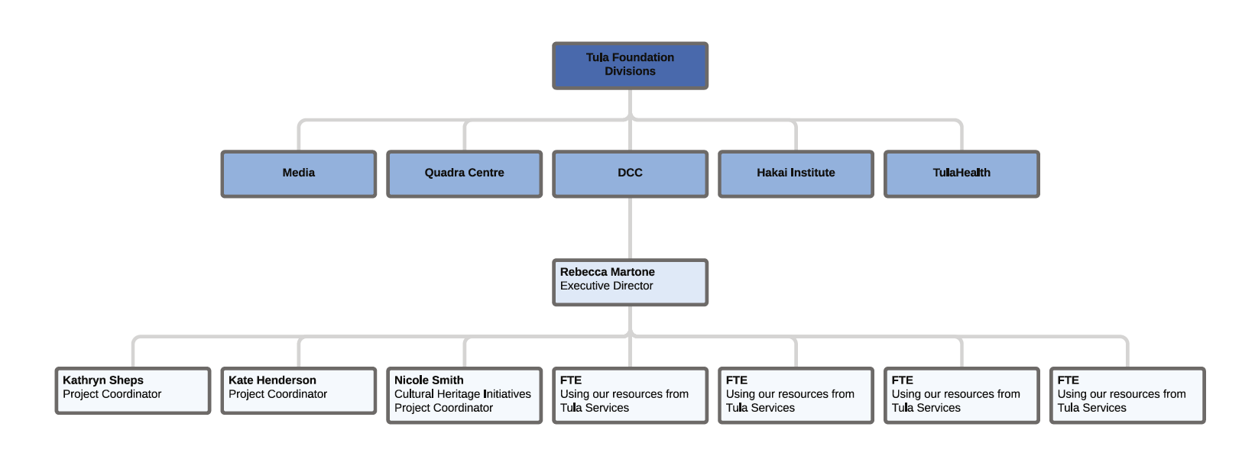
The DCC NEPO’s full-time team will include an Executive Director (100% FTE); a Project Coordinator who will provide overall coordination support and M&E (100% FTE); another Project Coordinator who will provide overall coordination support and communications/outreach focus (100% FTE); a Coastal Heritage Initiatives Project Coordinator (50% FTE), and a Project Coordinator with an ocean observations focus (10% FTE). The position descriptions for some key staff have been provided to the DCU and updated versions will be provided if significant changes are made. For more detail, please refer to the organizational chart below.

The Collaborative Centre will establish an Advisory Committee, which will be appointed by the Tula Foundation Board of Trustees and will be supported by the Executive Director and broader administrative team of the DCC NEPO. Members of the Advisory Committee will be selected to represent a diversity of sectors including organizations, scientists, community members, industry representatives, government representatives, and coastal and ocean practitioners. Membership will be on a voluntary basis for two-year terms. The role of the Advisory Committee is to provide guidance, technical knowledge and strategic judgment necessary to assist the DCC NEPO with meeting its objectives for the Ocean Decade. Advisory Committee members will provide advice to the Executive Director in fulfilling the responsibilities of the DCC NEPO, including, but not limited to, reviewing and advising on development and implementation of the strategic plan and key tasks of the DCC. Further, this Committee will promote the work of the DCC and Ocean Decade partners across the region. The Terms of Reference (TOR) for the Advisory Committee has been provided to the DCU. Any changes to the TOR or membership of the Committee will be discussed with the DCU during the regular coordination meetings.

5. Annual Workplan and Reporting of DCC Activities
The NEP DCC will prepare an Annual Work Plan for the period July to June each year, which will be discussed in an annual review meeting with the DCU and jointly agreed with the DCU across the following areas of work. The NEP DCC and DCU will meet at least quarterly to review plans and priorities and re-adjust the workplan as necessary throughout the year. Any proposed changes to this mandate will be discussed during the annual meeting. The DCC NEPO will provide a short Annual Report to the DCU by mid-May each year based on a template that the DCU will provide.
The DCC NEPO will participate in regular meetings with other DCCs that will be convened by the DCU as a means of sharing experiences and advice and coordinating actions.

6. Resource commitments
The Collaborative Centre shall finance its operation as per the budget outlined in Table 1. Any changes to the available budget need shall be communicated to the DCU.
Table 1. Committed Budget for Decade Collaborative Centre Activities and Operation

Resources | 2022 | 2023 | 2024 | 2025 | 2026 | 2027 | 2028 | 2029 | 2030 | Total
Human Resources | 416,427 | 428,920 | 441,788 | 455,041 | 468,692 | 482,753 | 497,236 | 512,153 | 527,517 | 4,230,527
Workspaces | 898 | 898 | 898 | 898 | 898 | 898 | 898 | 898 | 898 | 8,080
Equipment | 4,040 | 4,040 | 4,040 | 4,040 | 4,040 | 4,040 | 4,040 | 4,040 | 4,040 | 36,360
Vehicles | - | - | - | - | - | - | - | - | - | -
Communications | 122,400 | 122,400 | 122,400 | 122,400 | 122,400 | 122,400 | 122,400 | 122,400 | 122,400 | 1,101,600
Operational Costs | 39,419 | 39,419 | 39,419 | 39,419 | 39,419 | 39,419 | 39,419 | 39,419 | 39,419 | 354,774
Other | - | - | - | - | - | - | - | - | - | -
 | 583,184 | 595,677 | 608,545 | 621,798 | 635,450 | 649,510 | 663,993 | 678,910 | 694,275 | 5,731,342

7. Use of the Ocean Decade Logo
The Decade Collaborative Centre will be able to use the logo of the Ocean Decade in accordance with the Ocean Decade Brand Guidelines. The use of the logo will be allowed uniquely in the context of its agreed mandate as a Decade Collaborative Centre (e.g. to communicate or raise awareness about its role as part of the Ocean Decade) but the DCC cannot approve or delegate use of the logo to other parties for any purpose.

ANNEX 2
MANDATE OF THE OCEAN VISIONS – U.N. DECADE COLLABORATIVE CENTER FOR OCEAN–CLIMATE SOLUTIONS
The following document details the agreed mandate and functions for the Ocean Visions – U.N. Decade Collaborative Centre for Climate Solutions (DCC OCS) proposed by Ocean Visions in partnership with Georgia Tech and Georgia Aquarium.
- Introduction to the Ocean Decade
The United Nations (UN) Decade of Ocean Science for Sustainable Development 2021-2030 (referred to as ‘the Ocean Decade’) was proclaimed by the 72nd Session of UN General Assembly (UNGA) in December 2017. The Ocean Decade is being coordinated by the Intergovernmental Oceanographic Commission of UNESCO (IOC-UNESCO) to promote transformational, large-scale change and advance urgent action to move from the ‘ocean we have’ to the ‘ocean we want’. It includes a focus on least developed countries (LDCs), Small Island Developing States (SIDS) and land-locked developing countries (LLDCs).
The Ocean Decade will be implemented in accordance with the Implementation Plan and will be supported by contributions from Member States, specialized agencies, funds, programmes and bodies of the United Nations, as well as other intergovernmental organizations, non-governmental organizations and relevant stakeholders. The Decade Action Framework is built on ten Ocean Decade Challenges and three objectives that will contribute to creating the “ocean we want”. This includes a series of Decade Actions categorised as (i) “Decade Programmes”, long-term regional or global actions towards one or more challenges, (ii) “Decade Projects”, discrete and focused undertaking at regional, national or subnational scales, that typically contribute to a Decade Programme, (iii) “Decade Contributions”, financial or in-kind resources to support Decade Actions or coordination costs, and (iv) “Decade Activities”, on-off standalone initiatives that contribute to a Project or Programme.
Decade Collaborative Centres (DCCs) are one form of Decade Contribution. DCCs are hosted by one or more countries in an international or regional organisation engaged in Decade initiatives. DCCs are legally separate from IOC-UNESCO and operate under the complete responsibility of the establishing entity(ies) subject to the roles and functions identified in a mandate which is jointly agreed with IOC-UNESCO.

DCCs provide support to the Decade Coordination Unit (DCU) within the IOC-UNESCO Secretariat by catalyzing and coordinating Decade Actions thematically (i.e., Ocean Decade Challenges) or geographically (ocean basins or land-based regions), as established in their endorsed scope. DCCs play a coordination and catalysis role for Decade Programmes, and related Decade Actions. At the regional or thematic level they will provide technical, logistical, and financial support for: (i) stakeholder engagement; (ii) catalyzing new Decade Actions; (iii) communications, awareness-raising and outreach; (iv) resource mobilization, and (v) monitoring and reporting. They will be equipped with a small team of dedicated staff, premises, and operational resources. The aim of the Ocean Decade is to have a full and coordinated matrix of partner led DCCs covering all major themes and geographies and operating in a way that enhances collaboration and avoids overlap.

- Rationale and Scope for the Ocean Visions – U.N. Decade Collaborative Centre for Ocean-Climate Solutions
Understanding the nexus of the ocean and climate crises and developing ocean-based solutions are critical to the Ocean Decade. The primary focus of the proposed DCC OCS is on leading and supporting processes to co-design, develop, test, and ultimately deploy scalable, equitable ocean-based solutions to mitigate and reverse the effects of climate change (Challenge 5). To advance this mission, DCC OCS will engage with a global set of stakeholders and institutions to connect those with the capacity for generating new science and engineering knowledge to those with capacity to develop and test innovations and solutions (Challenge 4). Among the system-level challenges targeted by the DCC OCS are ocean-based solutions to ameliorating climate change, enhancing food security (Challenge 3), and building the climate resiliency of critical marine ecosystems and coastal communities (Challenge 1 and 2).

The DCC OCS will coordinate Decade Actions focused on solutions at the ocean-climate nexus across all regions and ocean basins. It will work in close collaboration with other Decade coordination structures focusing on different aspects of the ocean-climate nexus, including eventually the proposed DCCs focusing on coastal resilience (led by the University of Bologna, Italy) and the ocean-climate nexus (led by the First Institute of Oceanography, Ministry of Natural Resources, China).
- Functions and Responsibilities
A description of the functions and responsibilities of the DCC OCS can be found below. These functions and responsibilities build on the general functions and responsibilities described in the Operational Guidelines for the Establishment of Decade Collaborative Centres and Implementing Partners and the Decade Implementation Plan.
- Coordinating Endorsed Decade Actions
The DCC OCS will have a first set of Decade Actions (Decade Programmes - including their associated Projects, and Decade Contributions) which have a primary attachment to the DCC, and a second set of Decade Actions that have a secondary attachment to the DCC. Decade Actions that have a primary attachment will be the main focus of the DCC. The DCC will have a lighter touch approach to Decade Actions that have a secondary attachment that will focus on communications, ad-hoc support, and exchange of information.
The DCC OCS will use the below criteria to conduct an initial stakeholder mapping exercise to propose which existing programmes and contributions should have either a primary or secondary attachment within three months of the formal endorsement of the Collaborative Centre. This mapping exercise will also analyse and document the priority support needs of the Decade Actions to inform the annual Work Plan of the DCC.
The DCU will review the outcome of this exercise and consider this in the broader context of endorsed Decade Actions, and other Collaborative Centres, to finalize those that will be under the purview of this Collaborative Centre. This exercise will be repeated following the outcome of each Call for Decade Actions based on a timeline to be agreed with the DCU.
The criteria are as follows and are not exhaustive nor are they all compulsory. They will be used as a guide during the mapping exercise described above:
Decade Actions with a likely primary attachment to the DCC OCS:
- Solutions at the ocean-climate nexus are the key theme of focus of the endorsed Decade Action
- There is no DCC specializing in the geographical region in which the Decade Action evolves and/or the thematic focus on solutions at the ocean-climate nexus is stronger than its geographic focus
- The Decade Action doesn’t already have a primary attachment to another DCC (once several DCCs are operating)
Decade Actions with a likely secondary attachment to the DCC OCS:
- Solutions at the ocean-climate nexus are one of the topics of focus of the endorsed Decade Action but not its primary focus
- The endorsed Decade Action is focused on a region in which another DCC specializes in, and this regional focus is stronger than its focus on solutions at the ocean-climate nexus
- The Decade Action already has a primary attachment to another DCC but its thematic focus is on solutions at the ocean-climate nexus (once several DCCs are operating)
The DCC OCS will track and maintain a global vision and database of the implementation of all Decade Programmes - including their Decade Projects, and Decade Contributions that fall within its scope of work. As far as possible, this database will be maintained in a form that is compatible with the overall DCU Decade Action database and the Global Stakeholder Forum.
The DCC OCS will plan and implement initiatives to convene and coordinate Decade Actions under its purview. The objective of this work is to enhance collaboration, promote synergies in implementation, and avoid duplication of efforts. It will actively seek and promote commonalities and potential for joint activities, learning and exchanges amongst endorsed Decade Actions in the aim of ensuring collective action and impact. The Annual Work Plan prepared by the DCC will highlight the specific activities that will be implemented to achieve this objective, but it is expected that it will include mapping of proposed workplans and initiatives of endorsed Decade Actions to proactively identify synergies and a mix of online and in-person meetings (depending on available resources) to facilitate discussions. The DCC OCS will provide specialized support to relevant Decade Actions to identify the knowledge gaps and stakeholder mapping processes that will be critical to the successful co-design of ocean-climate solutions using their innovative “solutions roadmaps”.
The Collaborative Centre will proactively facilitate the structuring, membership and activity of the Ocean-Climate Solutions and Innovation Community of Practice via the Global Stakeholder Forum, which the DCC OCS will explore ways to expand functionality with users. The DCC OCS will lead coordination of the Community of Practice and use the Global Stakeholder Forum, in-person meetings, online meetings and other mechanisms for convening and exchanging information among relevant stakeholder engagement networks, and to play an active and leading role in facilitating dialogue and exchange between endorsed Decade Actions and other Decade stakeholders. This Community of Practice will serve as a primary mechanism to support endorsed Decade Actions through the co-design process for new and ongoing projects and activities, while the DCC OCS can also reach out to stakeholders interested in co-designing and developing new Decade Actions. This Community of Practice will also have strong links and interactions with several other emerging Communities of Practice and the DCC OCS will ensure fluid exchange of information and collaboration with the leaders of the other Communities of Practice.
- Stakeholder Engagement
The DCC OCS will interact with diverse stakeholders with the aim of providing information about the Ocean Decade and advising of opportunities to engage in the Decade. This includes government, UN, philanthropic, industry, NGOs and scientific stakeholders. Initiatives will be detailed in the Annual Work Plan and could include regular webinars and technical meetings or side events at conferences and convenings. This work will be done in direct collaboration with the DCU, other relevant Decade Collaborative Centres, relevant National Decade Committees, relevant Decade Implementing Partners, and United Nations partners.
The DCC OCS will interact regularly with relevant regional taskforces and National Decade Committees Committee and organise regular meetings to share information, identify challenges and opportunities for increased engagement, and explore opportunities for joint initiatives to foster increased engagement in the Decade. Due to its location it will exchange information regularly with the US National Decade Committee but will maintain a strong global focus.

- Catalyzing new Decade Actions
The DCC OCS will work with endorsed Decade Actions and new partners to develop solutions roadmaps that can be used as the basis to co-design, co-deliver and resource new Decade Actions. The solutions roadmaps are intended to help develop and test strategies, and ultimately scale innovative solutions within the ocean-climate nexus.
Below are examples of potential solutions roadmaps that will be co-hosted through the center but developed by different lead organizations, programs, and in coordination with other relevant DCCs. The center plans to build a digital interface and a process for developing and maintaining the roadmaps:

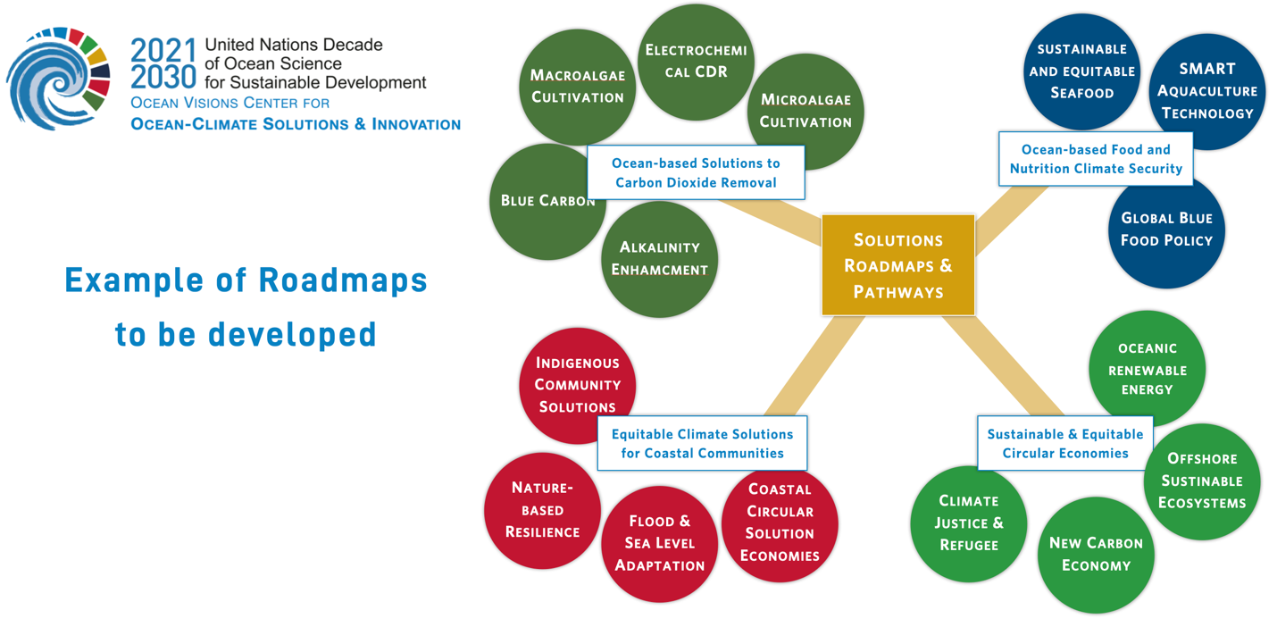

Preliminary conversations with various organizations that are leading endorsed Decade programmes or projects have already expressed interest in taking a leadership role the co-development of solutions roadmaps under certain themes (e.g. GEOS and MarineLife2030).
To advance and coordinate the work on the roadmaps, the COSCI executive council is seeking additional funding to support ECOP Fellows (e.g., through support from the US National Decade Committee and the National Academies of Science’s Ocean Studies Board to potentially host a Knauss Fellow through the National Sea Grant Program at the center).
The DCC OCS shall assist and advise the DCU to scope, promote and review Calls for Decade Actions for programmes and contributions within its scope of work. It will also support the DCU in the process of integrating endorsed Decade programmes who want to solicit projects into the relevant Calls for Decade Actions. This includes facilitating inputs from endorsed Decade Actions, partners and relevant experts (including via the Ocean Decade Expert Roster) to contribute to the scoping of Calls for Decade Actions through gap analyses and priority setting. In the lead up to the Calls and during the submission period, the Collaborative Centre will widely share information on the Call for Decade Actions, facilitate coordination of stakeholders looking for partners, and will facilitate collaboration and synergies between initiatives under development. DCC OCS will provide technical support and explore opportunities to raise financial resources to support co-design processes for Decade Actions.
Once programme and contribution submissions to Calls for Decade Actions are received by the DCU, the Collaborative Centre will work with partners and relevant experts (including via the Ocean Decade Expert Roster) to review and provide advice to the DCU on endorsement decisions as per the processes contained in the Ocean Decade Implementation Plan.
- Communications, Awareness Raising, and Outreach
As part of its Annual Work Plan, the DCC OCS will identify specific communications activities based on its communications strategy. Specifically, the Collaborative Centre will contribute to diffusing content and assets created by the DCU and will create content tailored to the interests of the general audience within their scope of work. All communications activities will be carried out in accordance with the Ocean Decade Branding Guidelines and in close collaboration with the DCU communications team.
- Mobilization of Resources
The Collaborative Centre will contribute to the identification of potential partners that could mobilise resources for the Decade coordination or Action costs and where appropriate will develop relationships with these institutions to catalyse resource mobilisation for the Decade. It will provide regular information to the DCU on such efforts to ensure strong alignment with the resource mobilisation approach and mechanisms of the Decade and will create connections between potential partners and the DCU as appropriate. The Collaborative Centre will assist the DCU to collect regular information from Decade Actions on their resource needs to inform resource mobilisation efforts.
The roadmaps for solutions at the ocean-climate nexus that DCC OCS will help co-create, will provide a framework for prioritizing and mobilizing funding to advance solution strategies that have been identified through a co-design process with diverse stakeholders.
- Monitoring & Evaluation
Based on the requirements of the Ocean Decade monitoring and evaluation framework, the Collaborative Centre will provide advice to the Decade Coordination Unit on the most appropriate means of collecting monitoring and evaluation data for its scope of work. DCC OCS will support Decade Programmes, including their associated Projects, and Contributions that have a primary attachment to the DCC to collect and submit required monitoring data.
Following requests from the DCU, the Collaborative Centre will contribute to Decade annual reporting, including for example the preparation of programmatic/geographic summaries of Decade Actions under their scope of work. It will also provide specific inputs to the triennial State of the Decade Report such as case studies, or more in depth thematic or geographic analyses.
- Organizational structure
The Collaborative Centre’s core team includes a full-time Program Director and a Communications and Program Manager of whose time 70% will be dedicated to the DCC OCS. Other supporting staff and experts include 30% of FTE of Ocean Visions’ Executive Director, 30% of FTE of Georgia Tech’s DCC OCS Executive Council member as well as 10% of FTE of OV’s Science Director, and 10% of FTE of Ocean Visions’ Communications Director, as well as ad hoc in-kind staffing support from Georgia Aquarium will further strengthen institutional capacity and viability. The Advisory Board primary function is to provide feedback on the center’s annual strategic plan, review its activities, help mobilize new resources to advance the center’s mission, and provide additional networking. Members of Advisory Board will be selected for this function by the partner institutions of the center Ocean Visions, Georgia Tech and Georgia Aquarium. The initial members represent the US National Oceanographic and Atmospheric Administration, Association of Zoos and Aquariums, and IOC-UNESCO in its role as the coordinating agency of the Ocean Decade. The Decade Programme Committee will include representatives from the endorsed Programme that are affiliated with the DCC OCS and its primary goal is to identify shared visions and synergies across the endorsed actions and maintain an open communication channels to ensure the center’s support for the Programmes meets current needs.
For more detail, please refer to the organizational chart below.
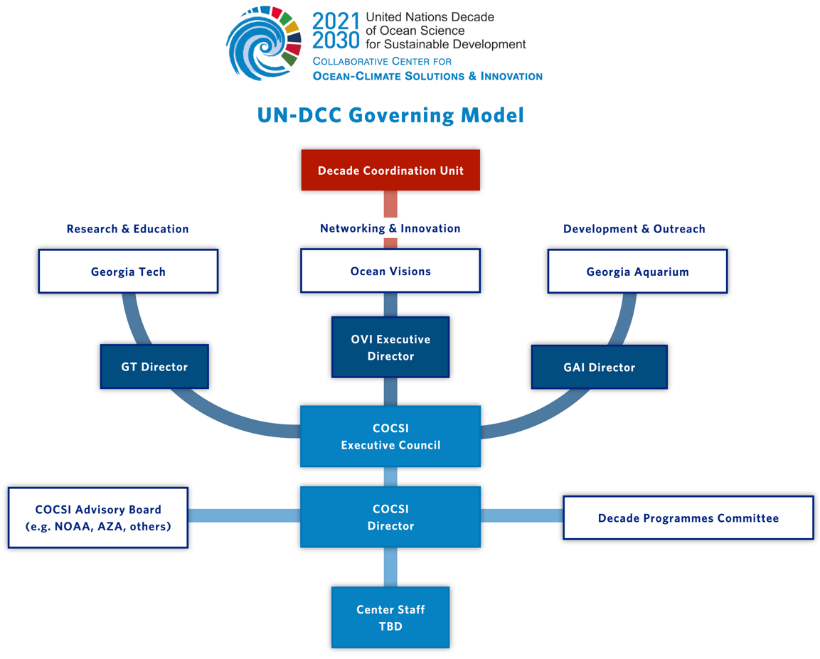

- Annual Work Plan and Reporting of DCC Activities
The DCC OCS will prepare an Annual Work Plan for the period July to June each year, which will be discussed in an annual review meeting with the DCU and jointly agreed with the DCU across the following areas of work. DCC OCS and the DCU will meet at least quarterly to review plans and priorities and re-adjust the workplan as necessary throughout the year. Any proposed changes to this mandate will be discussed during the annual meeting. DCC OCS will provide a short Annual Report to the DCU by mid-May each year based on a template that the DCU will provide.
The DCC OCS will participate in regular meetings with other DCCs that will be convened by the DCU as a means of sharing experiences and advice and coordinating actions.
- Resource commitments
The Collaborative Centre shall finance its operation as per the budget outlined in Table 1.

Table 1. Committed Budget for Decade Collaborative Centre Activities and Operation

 | Estimated amount in US$
Resources | 2022 | 2023 | 2024 | 2025 | 2026 | 2027 | 2028 | 2029 | 2030 | Total
Human Resources | 290,000 | 304500 | 319725 | 335,711 | 352,496 | 370,121 | 388,627 | 408,059 | 428,462 | 3197701
Equipment & Vehicles | 10,000 | 5,000 | 5,000 | 5,000 | 5,000 | 7,500 | 10,000 | 5000 | 5000 | 57500
Communications | 20,000 | 30,000 | 35,000 | 35,000 | 40,000 | 45,000 | 50,000 | 50,000 | 50,000 | 355000
Operational Costs | 30,000 | 35,000 | 40,000 | 40,000 | 45,000 | 45,000 | 50,000 | 50,000 | 50,000 | 385000
Other | 30000 | 35000 | 40,000 | 45,000 | 45,000 | 50,000 | 55,000 | 55,000 | 60,000 | 415000
Total yearly | 380000 | 409500 | 439725 | 460711 | 487496 | 517621 | 553627 | 568059 | 593462 | 4410201

- Use of the Ocean Decade Logo
The Decade Collaborative Centre will be able to use the logo of the Ocean Decade in accordance with the Ocean Decade Branding Guidelines. The use of the logo will be allowed uniquely in the context of its agreed mandate as a Decade Collaborative Centre (e.g., to communicate or raise awareness about its role as part of the Ocean Decade) but cannot approve or delegate use of the logo to other parties for any purpose.

Intergovernmental Oceanographic Commission (IOC)
United Nations Educational, Scientific and Cultural Organization
7, Place de Fontenoy
75 732 Paris 07 SP, France
Tel.: +33 1 45 68 03 18
http://ioc.unesco.org

