Summary

This document presents an overview of the financial situation of the IOC Special Account at year-end 2021, the proposal for revised budgetary allocations 2022–2023 and the forecast for the biennium 2022–2023. The Financial Report for the period 1 January 2020 to 31 December 2021 is provided in Annex I,
Decision proposed: After a brief introduction and discussion in plenary under item 3.1, the Executive Council is invited to take note of this report and consider the draft decision referenced as Dec. EC-55/3.1 in the Provisional Action Paper (document IOC/EC-55/AP). The document will then be subject to an in-depth review by the sessional statutory open-ended Financial Committee and the decision reflected in the Draft Resolution that the Financial Committee will be submitting to the Executive Council for adoption under item 5.2 in accordance with paragraph 15 of the Draft Revised Guidelines for the Preparation and Consideration of Draft Resolutions (IOC/INF-1315).

overview of the financial situation of the ioc special account

as at year end 2021 (in US dollars)

In accordance with the Financial Report for the period 1 January 2020 to 31 December 2021 presented further down in this document, the total income amounted to $6,093,445.76 (comparative 31.12.2019 – $3,472,274.33, while total expenditure for the same period amounted to $3,365,010.89 (comparative 31.12.2019 – $3,588,796.65).
The increase is largely due to the contribution by the Norwegian Agency for Development Cooperation (NORAD) in the amount of NOK 10 million to the General Account (191IOC9000) and NOK 10 million to the sub-account dedicated to the UN Decade of Ocean Science for Sustainable Development (193UND2040).
At the end of year 2021, only $259,234 were firmly committed by donors.
At the end of year 2021, the Fund balance amounted to $6,282,617.86 (comparative 31.12.2019 – $3,528,529.36), with the following breakdown:
- General reserves: $ 4,042,690.37 (comparative 31.12.2019 – $ 2,897,673.23)
- JCOMMOPS: $ 190,381.05 (comparative 31.12.2019 – $ 96,354.57)
- IOTWMS ICG Secretariat: $ 654,379.08 (comparative 31.12.2019 – $ 534,501.56)
- UN Decade of Ocean
Science for Sustainable
Development: $ 1,395,167.36
In accordance with Articles 8.2 and 8.3 of the Financial Regulations for the IOC Special Account, the above-mentioned balance is carried over to year 2022 for the implementation of the budget approved by the IOC Governing Bodies. In this context, the proposal for a revision of budgetary allocations adopted by the Assembly through IOC Resolution A-31/2 is submitted for the approval by the Executive Council in Table 1.
Table 2 provides the forecast for 2022–2023 as at year end 2021.

table 1. proposed revised budgetary allocations for 2022–2023

TITLE | Budget code | Approved budget | Requested change | Revised budget
IOC Function A |  | 450,000.00 | 0.00 | 450,000.00
 | 191ORS2041 | 450,000.00 | 0.00 | 450,000.00
WCRP | 191ORS2041.1 | 50,000.00 |  | 50,000.00
Ocean Carbon & Acidification | 191ORS2041.2 | 250,000.00 |  | 250,000.00
Impact of climate change on ocean and coastal ecosystems | 191ORS2041.3 | 150,000.00 |  | 150,000.00
IOC Function B |  | 1,750,000.00 | 0.00 | 1,750,000.00
 | 191OSD2044 | 1,300,000.00 | 0.00 | 1,300,000.00
GOOS design, dev't, engagement & impact | 191OSD2041.1 | 400,000.00 |  | 400,000.00
Observing system integration & delivery | 191OSD2041.3 | 400,000.00 |  | 400,000.00
Ocean forecast services & applications | 191OSD2041.4 | 200,000.00 |  | 200,000.00
IODE & OBIS | 191OSD2041.5 | 300,000.00 |  | 300,000.00
OceanOPS | 193JCS2041 | 450,000.00 |  | 450,000.00
IOC Function C |  | 1,900,000.00 | 150,000.00 | 2,050,000.00
 | 191EWS2041 | 1,050,000.00 | 150,000.00 | 1,200,000.00
ICG NEAMTWS | 191EWS2041.1 | 100,000.00 |  | 100,000.00
ICG PTWS | 191EWS2041.2 | 150,000.00 | 50000 | 200,000.00
ICG CARIBE-EWS | 191EWS2041.3 | 250,000.00 | 50000 | 300,000.00
TOWS & inter-regional coordination | 191EWS2041.4 | 100,000.00 |  | 100,000.00
IOTIC | 191EWS2041.5 | 100,000.00 |  | 100,000.00
GLOSS - tsunami | 191EWS2041.6 | 250,000.00 | 50000 | 300,000.00
HAB & NIS Research & Monitoring | 191EWS2041.7 | 100,000.00 |  | 100,000.00
ICG-IOTWMS Secretariat | 193EWS2041 | 850,000.00 |  | 850,000.00
IOC Function D |  | 450,000.00 | 0.00 | 450,000.00
 | 191AIP2041 | 450,000.00 | 0.00 | 450,000.00
Follow-up to SDGs, WOA & State of the ocean reporting | 191AIP2041.1 | 150,000.00 |  | 150,000.00
GEBCO | 191AIP2041.2 | 50,000.00 |  | 50,000.00
Science for reducing nutrient enrichment | 191AIP2041.3 | 100,000.00 |  | 100,000.00
Climate change adaptation in coastal zones | 191AIP2041.4 | 150,000.00 |  | 150,000.00
IOC Function E |  | 2,850,000.00 | 500,000.00 | 3,350,000.00
 | 191RCG2041 | 1,350,000.00 | 0.00 | 1,350,000.00
IOC Governance (representation & intersessional coordination) | 191RCG2041.1 | 150,000.00 |  | 150,000.00
IOCARIBE (office support & intersessional coordination) | 191RCG2041.2 | 100,000.00 |  | 100,000.00
IOCAFRICA (office support & intersessional coordination) | 191RCG2041.3 | 100,000.00 |  | 100,000.00
WESTPAC (office support & intersessional coordination) | 191RCG2041.4 | 250,000.00 |  | 250,000.00
IOCINDIO (intersessional coordination) | 191RCG2041.5 | 100,000.00 |  | 100,000.00
UN partnerships, global governance, policy and outreach | 191RCG2041.6 | 400,000.00 |  | 400,000.00
ICAM & Marine Spatial Planning | 191RCG2041.7 | 250,000.00 |  | 250,000.00
UN Decade of Ocean Science for Sustainable Development | 193UND2041 | 1,500,000.00 | 500,000.00 | 2,000,000.00
IOC Function F |  | 1,350,000.00 | 0.00 | 1,350,000.00
 | 191ICD2041 | 1,350,000.00 | 0.00 | 1,350,000.00
CD coordination (incl. TMT) | 191ICD2041.1 | 200,000.00 |  | 200,000.00
GOSR | 191ICD2041.2 | 150,000.00 |  | 150,000.00
Ocean Literacy | 191ICD2041.3 | 300,000.00 |  | 300,000.00
IOCAFRICA Capacity development workplans | 191ICD2041.4 | 250,000.00 |  | 250,000.00
IOCARIBE Capacity development workplans | 191ICD2041.5 | 100,000.00 |  | 100,000.00
WESTPAC Capacity development workplans | 191ICD2041.6 | 250,000.00 |  | 250,000.00
IOCINDIO Capacity development workplans | 191ICD2041.7 | 100,000.00 |  | 100,000.00
TOTAL BUDGETARY ALLOCATIONS 2022–2023 |  | 8,750,000.00 | 650,000.00 | 9,400,000.00

table 2. FORECAST 2022–2023

IOC Special Account
Forecast 2022–2023
(expressed in US Dollars)
 | Year 2022 |  |  | Year 2023
Opening balance: |  | 6,282,618 |  | 2,441,852
Working Capital Fund: |  | 1,000,000
Opening balance available: |  | 5,282,618 |  | 2,441,852
Signed commitments from donors:
 | United Kingdom (UK MetOffice) | 11,351
 | Société des Explorations de Monaco | 79,455
 | RevOcean | 165,000
 | EthicOcean | 3,428
 |  | 259,234 |  | 0
Sub-total Funds available or signed commitments: |  | 5,541,852 |  | 2,441,852
Income forecast based on previous years |  | 1,600,000 |  | 1,600,000
Sub-total Funds Expected: |  | 7,141,852 |  | 4,041,852
Planned Expenditure*: |  | 4,700,000 |  | 4,700,000
Estimated Closing balance /Funding gap: |  | 2,441,852 |  | -658,148
*Based on revised proposed budget 2022–2023 - ref. Table 1

ANNEX I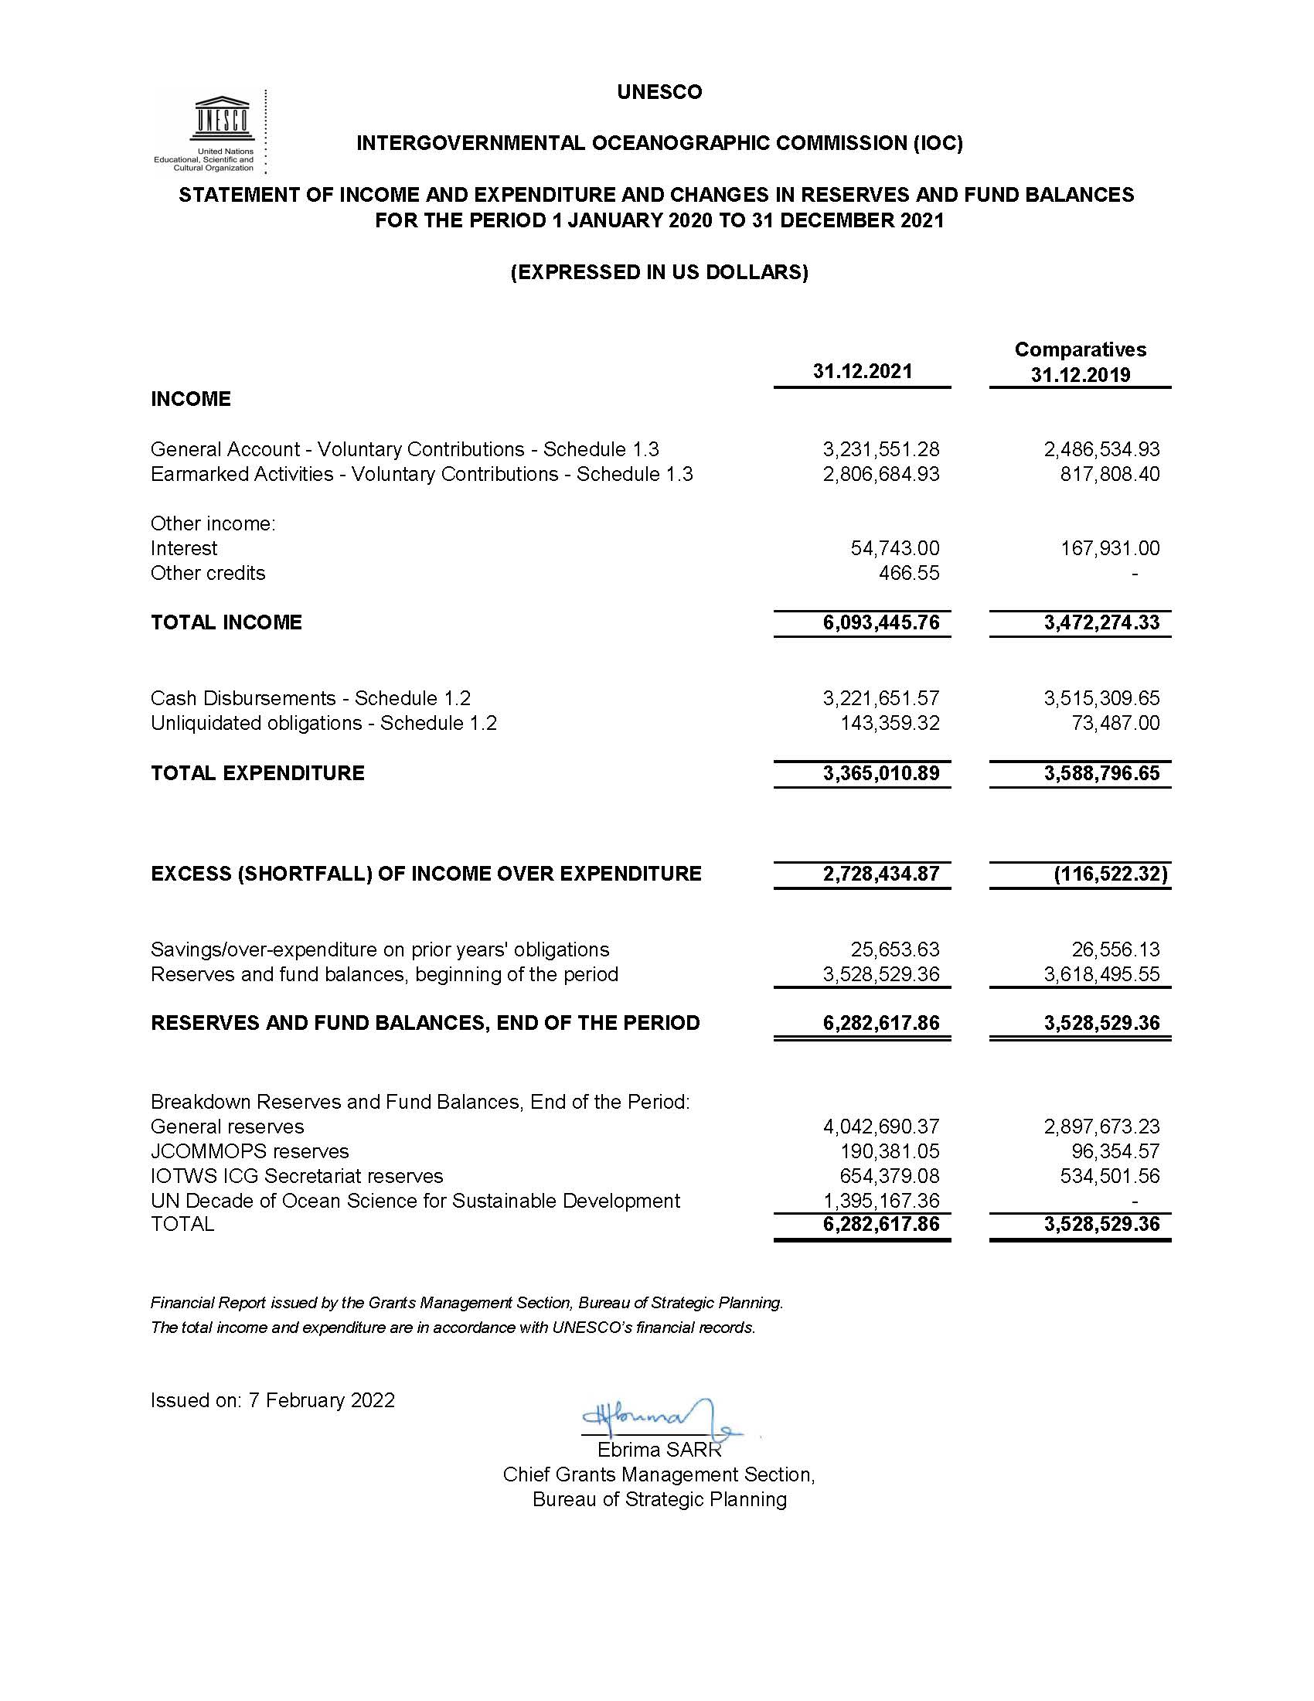

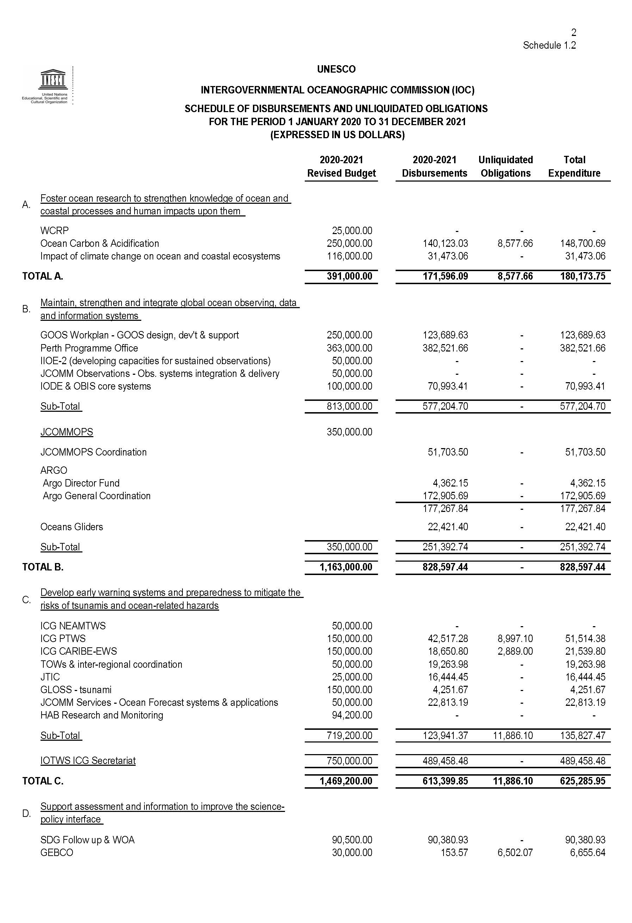
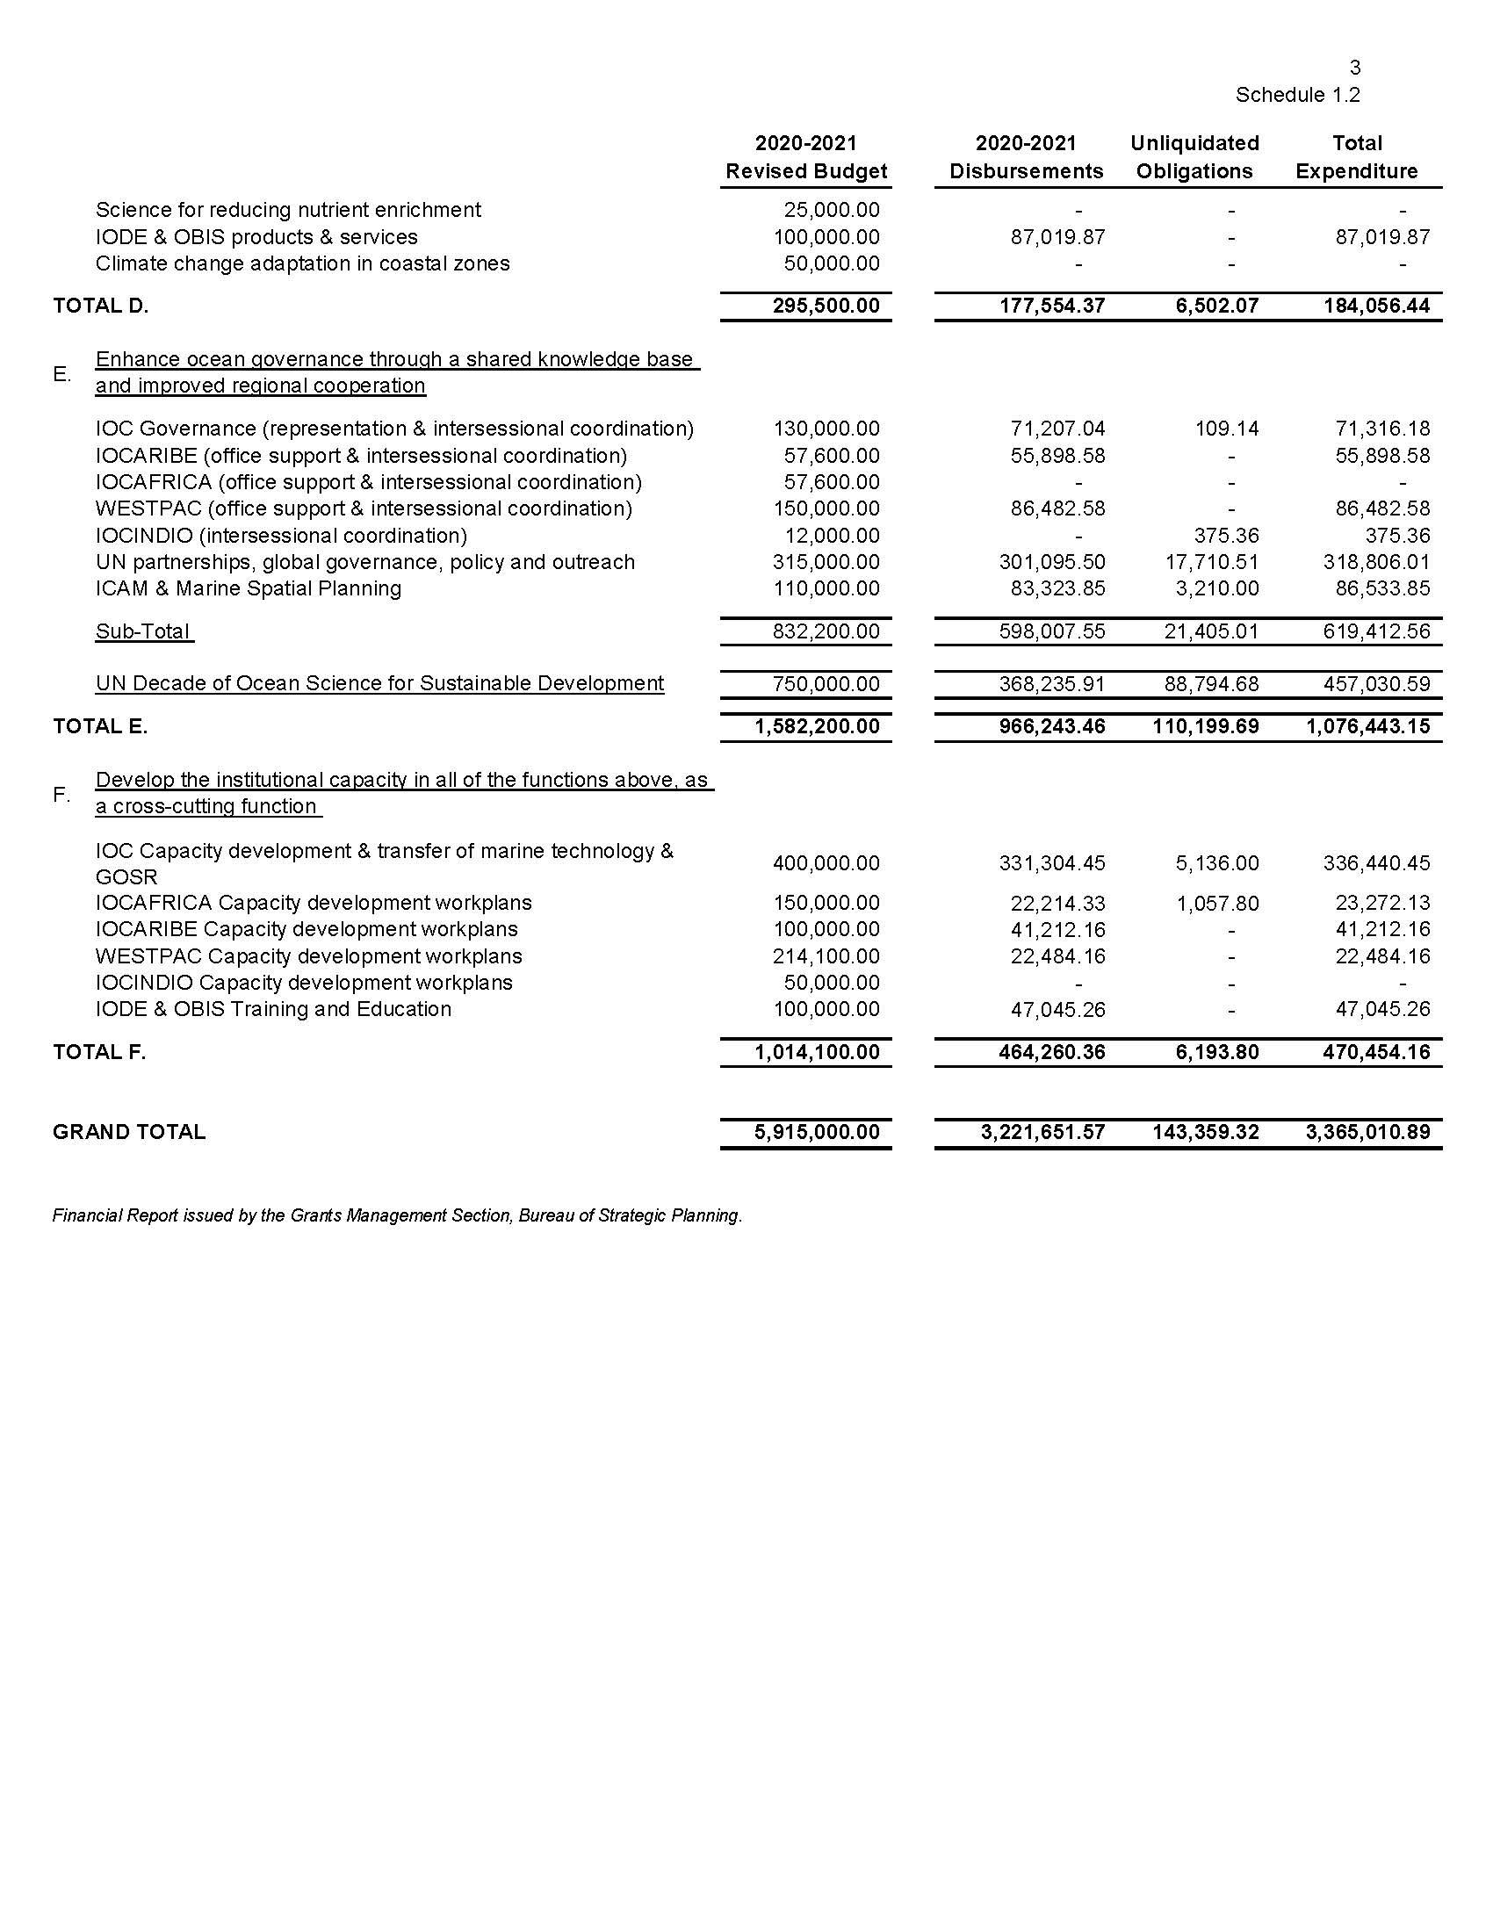

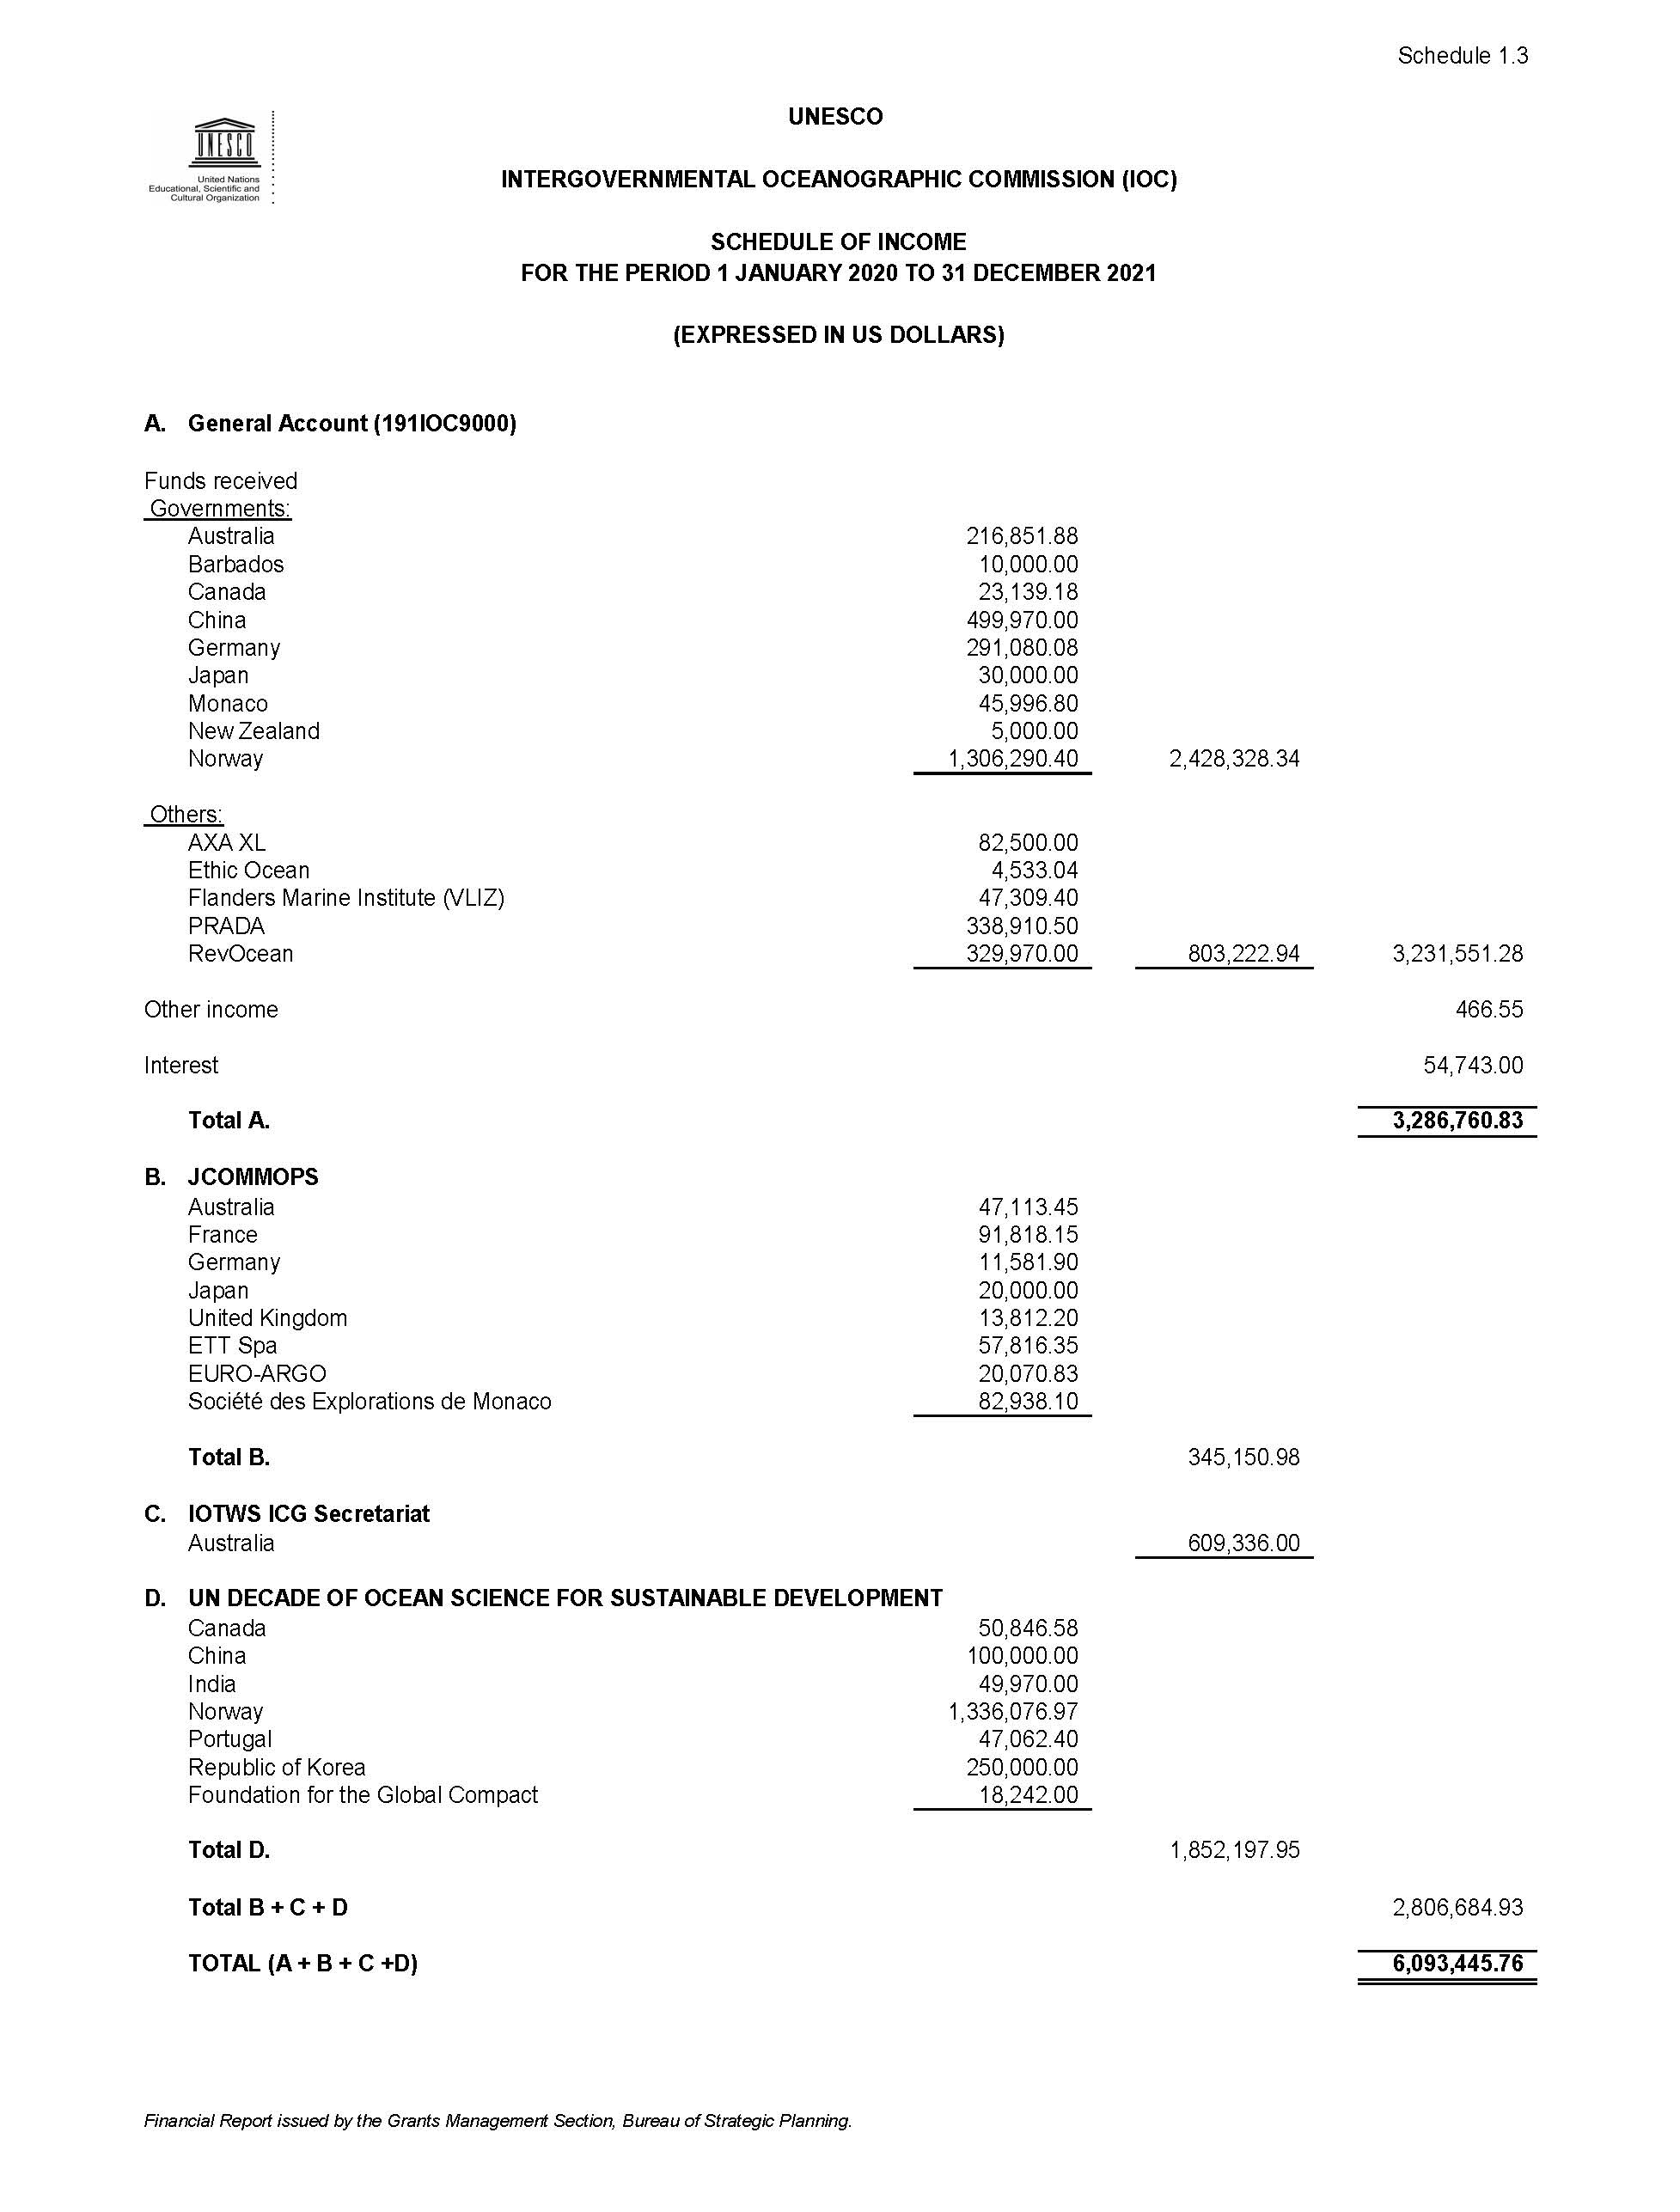

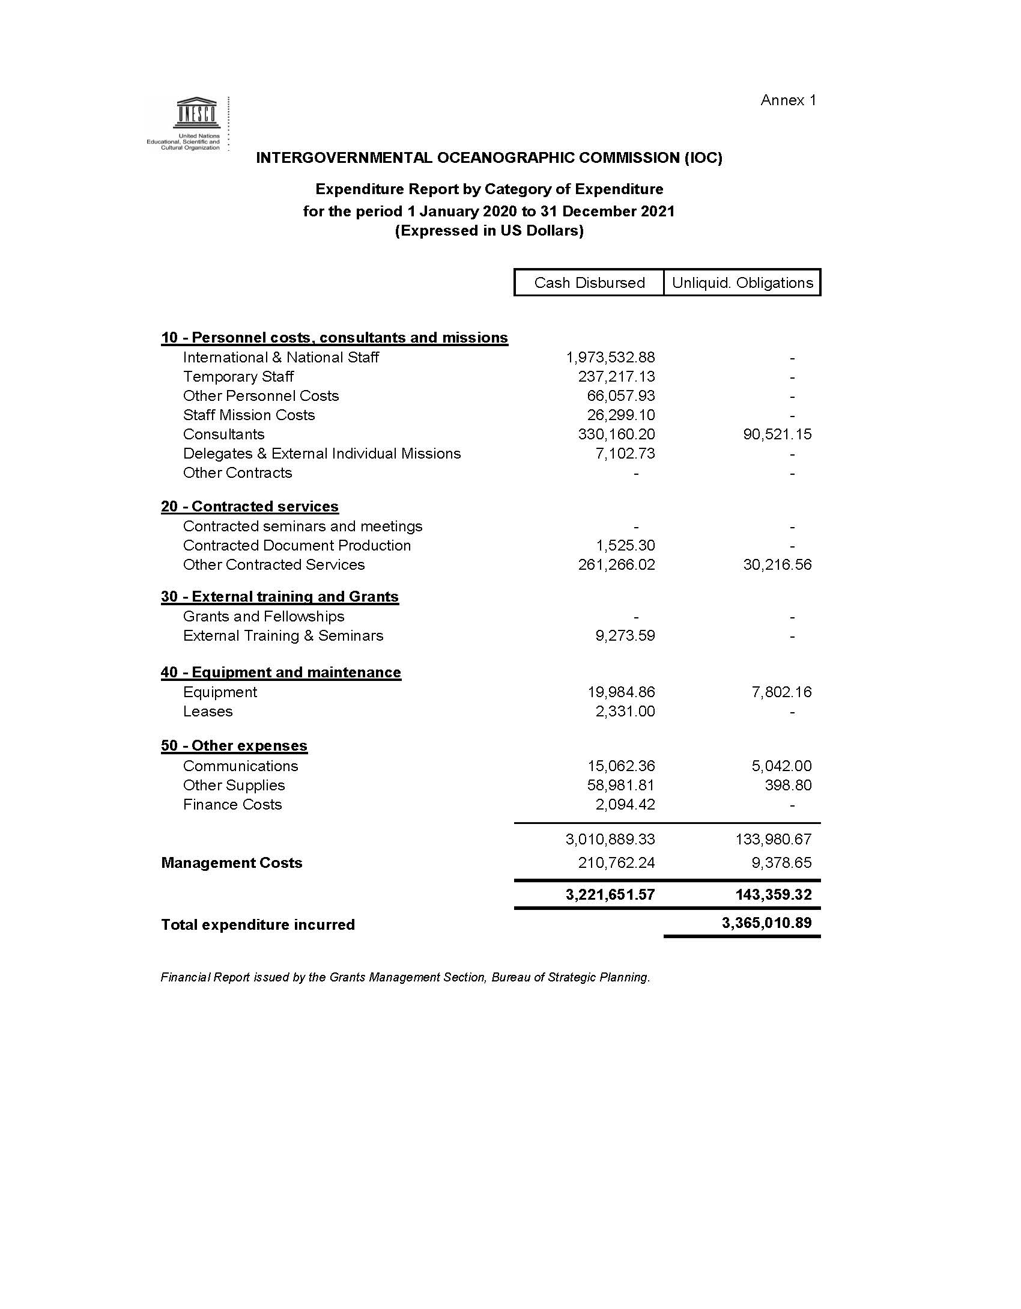
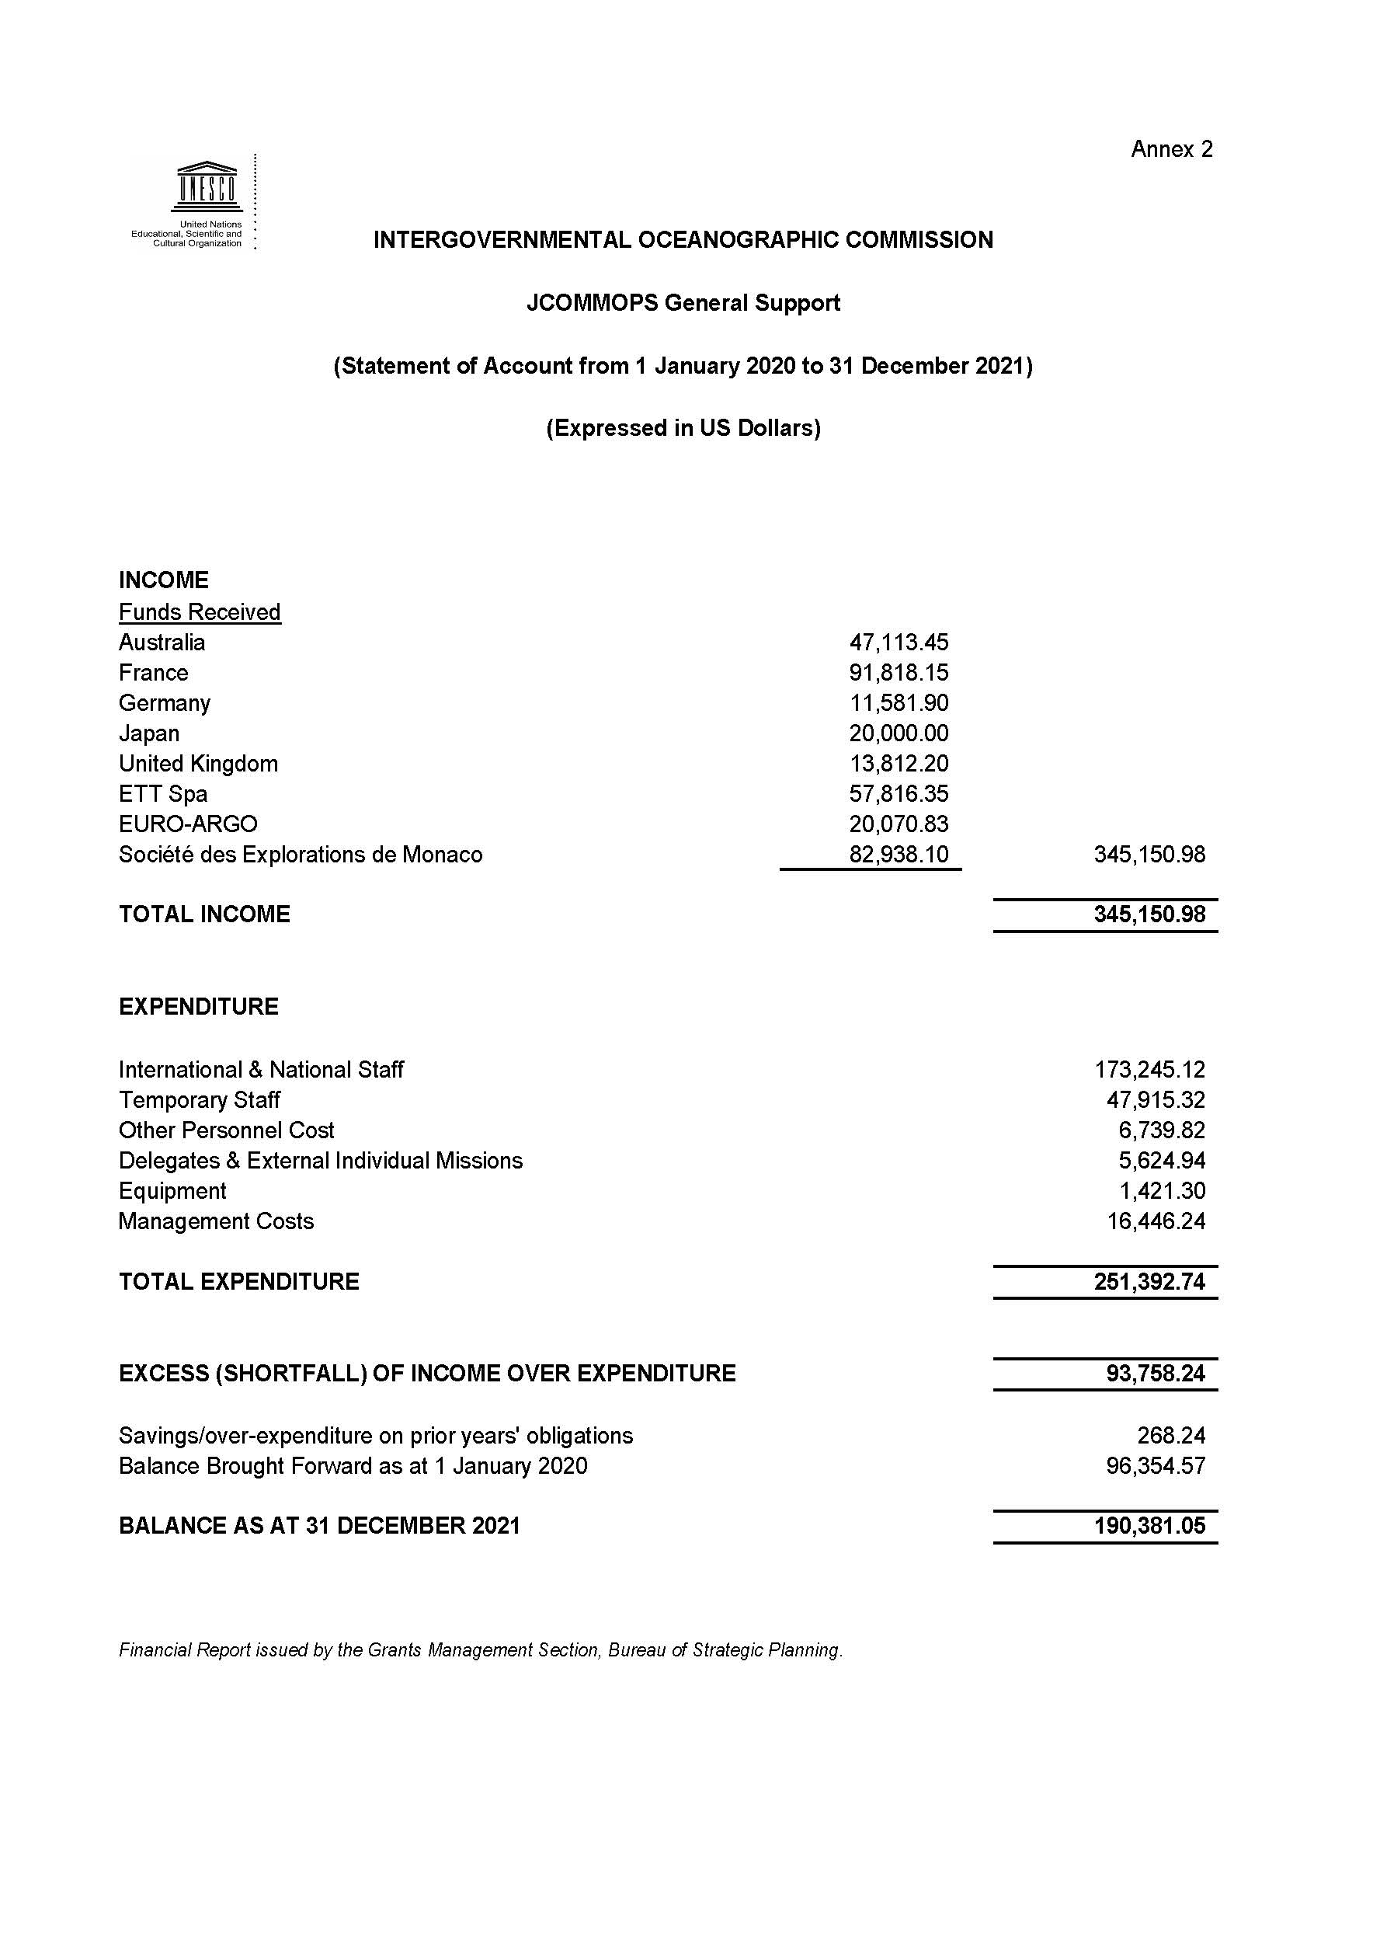

As approved through IOC Resolution A-31/2

