Summary
This document presents a set of rules of procedures developed by the Secretariat on the basis of the Decade Advisory Board Terms of Reference adopted by the 31st IOC Assembly, and general practice relevant to the conduct of business of subsidiary bodies/ expert groups.

Introduction
At the 31st session of the IOC Assembly (UNESCO, 14–15 June 2021), IOC Member States, UN agencies and partners expressed strong support for the UN Decade of Ocean Science for Sustainable Development and to the IOC in its role as coordinator of the implementation phase of the Decade. The Assembly inter alia approved the Terms of Reference for the Decade Advisory Board (DAB) on the basis of Document IOC-31/3.7.Doc(1), including the selection process of its members.
The Decade Advisory Board is a multi-stakeholder advisory body that assists the IOC Secretariat in performing its function as coordinator of the Decade. The Board reports both to the IOC Governing Bodies and the IOC Executive Secretary. The Board’s advice to the IOC Governing Bodies will concern strategic elements of the Decade implementation, such as reviews of the Decade progress in moving towards the Decade societal outcomes and on the research work in the domains of Decade challenges, identifying gaps and opportunities, advising on data stewardship strategies, the development of resource mobilisation strategies, and supporting the development of a monitoring and evaluation framework of the Decade.The Board also provide advice and operational support to the IOC Executive Secretary to facilitate the endorsement process of Decade Actions, specifically at the programme level.
As per the Terms of Reference, the Decade Advisory Board is comprised of up to 15 expert members drawn from government, private sector, philanthropy, civil society, and the scientific community and serving in their individual capacity. In addition to the 15 expert members, UN Legal Counsel- DOALOS, which is the Secretariat and focal point of UN-Oceans and the United Nations Convention on the Law of the Sea, has one permanent seat on the Decade Advisory Board. The IOC Secretariat as coordinator of the Decade also has a permanent seat on the Board. Three more seats are reserved for UN Agencies and will be identified through consultations via UN-Oceans. The process for selecting members of the Decade Advisory Board (2022-2023) was reported to IOC-UNESCO Member States through IOC Circular Letter 2871.
  - Selection of Expert Board Members
The Decade Advisory Board will comprise up to 15 expert members serving in their individual capacity drawn from government, private sector, philanthropy, civil society, and the scientific community. Expert members will be nominated through open calls for nominations. The calls will be circulated through the following means:
- IOC Member States via IOC Circular Letters;
- Relevant UN bodies via UN-Oceans;
- Scientific networks using formal and informal communication mechanisms;
- Dedicated ocean policy, business, and sustainable development networks through announcements; and;
- The Ocean Decade and IOC website.
Proposals for nominations can be made by IOC-UNESCO and United Nations Member States or United Nations entities, as well as intergovernmental organizations. Self-nomination will also be possible to encourage nominations from non-governmental entities.
Expert members will be selected with due consideration to expertise, geographic, generational, and gender balance and will serve on a voluntary basis in their personal capacities. Decade Advisory Board members do not represent their institutions or countries. They should be able to commit sufficient time to the work of the Decade Advisory Board and will take the responsibility to request the authorization of their employer to participate in this process.
The selection process in the Terms of Reference will be used to select Expert Board Members.
1.2 Duration of appointment and process for staggering of Board Expert Members’ Terms
Membership of Expert Members on the Decade Advisory Board will be for a two-year term, renewable for a second mandate. Members' terms will be staggered to ensure there is information exchange and mentoring between current and new Board members.
Starting in July 2023 and then 6 months before the end of the term of the mandate of each group of Expert Members, a new call for nominations will be opened.
Calls for nomination will follow the calendar presented below and will take place in 2023, 2025, 2027, and 2029.
 | 2022 |  | 2023 |  | 2024 |  | 2025 |  | 2026 |  | 2027 |  | 2028 |  | 2029 |  | 2030
Term Expert Members
Call for Nominations
Term Expert Members (inc. renewed members)
Call for Nominations
Term Expert Members (inc. renewed members)
Call for Nominations
Term Expert Members (inc. renewed members)
Call for Nominations
Term Expert Members (inc. renewed members)
1.3 Re- Appointment of Expert Members
Expert Members that wish to apply for a second term will submit a nomination form during the open call for nominations and will be considered within the overall pool of new candidatures generated by the regular call for nomination. IOC Officers leading the selection process will take these candidatures into account with due consideration to the need for expertise, geographic, generational, and gender balance across the membership of the DAB. The aim will be to maintain at least 5 of the serving Members at each rotation for a second consecutive term to ensure mentoring and continuity.
1.4 Co-Chairs of the Board
The Executive Secretary will appoint two Co-chairs from the Expert Members, ideally one representing the science fields and another one representing the societal end-users of the Decade. The Co-chairs will be appointed for one year with the possibility of a second one-year term in accordance with the provision of article 1.3.
1.5 Attendance at Meetings by Expert Members
Expert Members of the Decade Advisory Board cannot be represented at the Board meetings. In the event that an Expert Member cannot attend a meeting, he/she can send written comments in advance of the meeting that will be relayed during the discussions. Members are expected to attend every meeting of the Board. Unless exceptional circumstances apply, Members who are absent for two consecutive meetings and do not provide inputs to the work of the Board, will normally be considered to have resigned and new nominations will be sought. This decision will be at the discretion of the IOC Executive Secretary.
1.6 UN Agency Representation on the Board
UN Legal Counsel/DOALOS, which is the Secretariat and focal point of UN-Oceans and the United Nations Convention on the Laws of the Sea, has one permanent seat on the Decade Advisory Board. The IOC Secretariat as coordinator of the Decade also has a permanent seat on the Board. Three more non-permanent seats will be reserved for UN Agencies. The following modality will be used to fill the three non-permanent UN seats.
- Planning of meetings including thematic focus: At the beginning of each year, the Decade Coordination Unit (DCU) will communicate through UN-Oceans the general planning of the meetings and as far as possible, the main themes to be addressed at each meeting for at least the upcoming period of 6 months, but ideally for the upcoming 12 months. The themes to be addressed will be linked to the scope of the 6-monthly Calls for Decade Actions (cf. the Ocean Decade Challenges) as well as strategic issues of relevance to Decade implementation.
- Nomination of non-permanent members: On the basis of this planning, the Secretariat of UN-Oceans will request self-nomination by UN entities to be represented on the Board for the upcoming 12 month period. If there are more than three requests for membership, discussions will be held amongst interested entities to reach consensus with consideration given to the alignment between the issues to be treated and the mandate of the interested entities. This may include the possibility of different members having terms of less than a year (e.g. different members for different meetings during the year). Consideration will also be given to ensuring that the seats rotate amongst all interested UN entities.
- Registration of observers: Throughout the year the meeting agendas will be circulated via UN-Oceans in advance of the meetings. All other UN entities that wish to attend a particular meeting (including the possibility to intervene in the discussions as an observer) will be asked to register their interest via UN-Oceans to be an observer at a particular meeting.

  - Observers of Board Meetings
In accordance with Article 1.6 iii) Staff of UN agencies may attend meetings of the Board as Observers. Observers can intervene in meetings – comments will be recorded as coming from observer.

1.8 Experts and Task Teams

The Decade Advisory Board may invite external experts as individuals or in groups as needed to address specific issues or tasks. The decision to invite these external experts would be a decision of the Board.

1.9 Agendas of Board Meetings

The Co-chairs of the Decade Advisory Board will be primarily responsible for the development of the Board Meeting Agenda with the support of the Decade Coordination Unit (DCU). All Decade Advisory Board Members can recommend agenda items.

2.0 Decision Making
The Decade Advisory Board will strive for consensus on all issues in providing recommendations and advice to the IOC Executive Secretary. The minutes of the meeting will record any instances when consensus was not reached. No voting procedure will be adopted.
2.1 Secretariat of the Board
The Decade Coordination Unit (DCU) located within the IOC Secretariat will be the Secretariat for the Decade Advisory Board. The DCU will provide support to the Co-Chairs for the development of the agenda, reporting from the meeting and for logistical and practical aspects of meeting organization.
2.2 Annual Schedule of Board Meetings
The Decade Advisory Board shall meet four (4) times per year, with at least one (1) in presentia meeting annually when possible. Additional in-person or virtual meetings will be held as inter-sessional meetings as necessary.
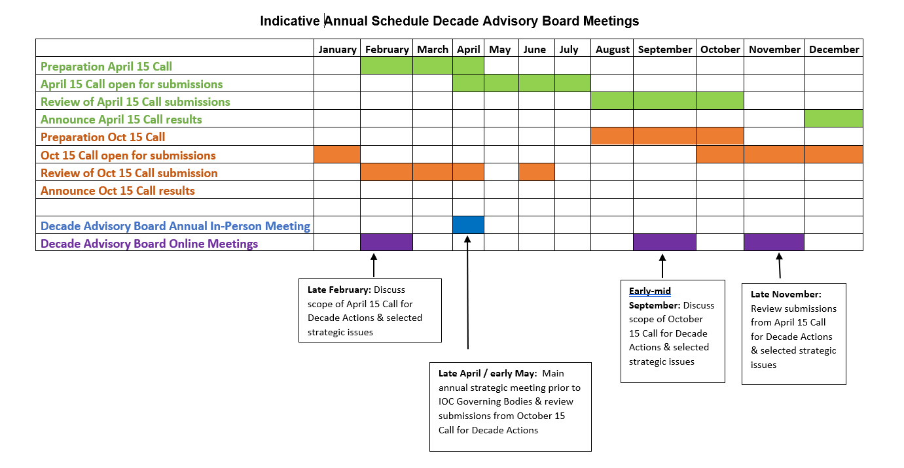

2.3 Reporting from Board Meetings
A report of the Board meetings will be developed and distributed by the Secretariat for the Decade Advisory Board. Following review by Board members, these reports will be made public on the Ocean Decade website.
2.4 Working Language

The working language of the Board will be English. No interpretation will be provided.
2.5 Amendments to Board Terms of Reference or Rules of Procedure
Any amendments to the Board’s Rules of Procedure should be considered by an IOC Major Governing Bodies (Assembly or Executive Council)

Intergovernmental Oceanographic Commission (IOC)
United Nations Educational, Scientific and Cultural Organization
7, Place de Fontenoy
75 732 Paris 07 SP, France
Tel.: +33 1 45 68 03 18
http://ioc.unesco.org

