IOC Roger Revelle Lecture, 2022
UNESCO, 16 June 2022

Climate change is ocean change: a physiologist's view

by Prof. Dr Hans-Otto Pörtner,
Alfred Wegener Institute, 27570 Bremerhaven, Germany
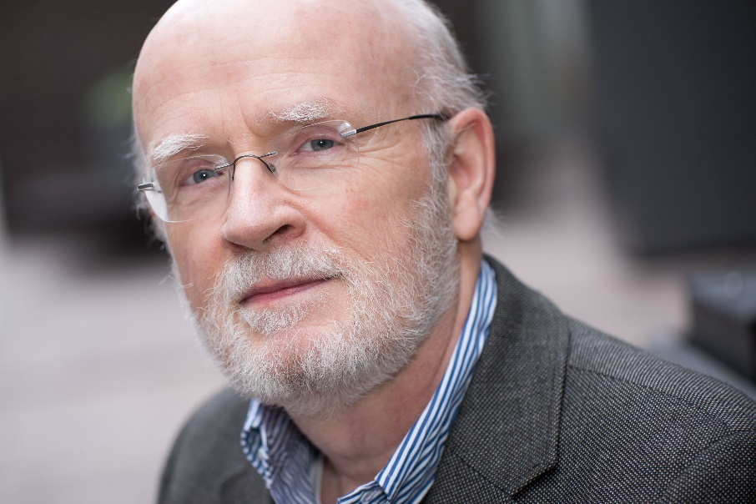

Abstract
Climate change drivers in the ocean entail ocean warming, acidification and loss of oxygen due to warming and enhanced stratification. These drivers individually and together affect ocean life. While some approaches compare the effect size of these individual drivers, other approaches strive to develop an integrative view. Based on principle considerations temperature emerges as a master variable shaping the functioning of all life forms in the ocean. Such functioning depends on the thermal performance curve as a reaction norm characterizing individual species and their life stages. Unifying principles around the thermal performance curve of species emerge and explain species vulnerability to climate change. Overlapping thermal performance curves characterize the temperature range at which species can co-exist at ecosystem level. The talk puts each of the drivers into context and puts an emphasis on how the interaction of drivers plays a role in the thermal tolerance and performance of marine animal species. It also addresses the ecosystem implications of such findings.
IPCC-5 WG II Co-Chair Prof. Dr Hans-Otto Pörtner (Germany)
Hans-Otto Pörtner is a physiologist and marine biologist performing research at the Alfred Wegener Institute Helmholtz Centre for Polar and Marine Research (AWI) in Bremerhaven, where he heads the Integrative Ecophysiology Section. During his scientific career Hans-Otto Pörtner has developed ground-breaking theories on the impacts of ocean warming, ocean acidification and hypoxia on marine organisms and ecosystems, and has validated these in numerous studies. Two of his seminal topics involve the molecular, biochemical and physiological mechanisms that determine the tolerance, performance and adaptive capacity of marine animals, and whether and how these mechanisms apply universally to all animals, including humans. He is a Web of Science/Clarivate Analytics highly cited researcher (top 1% Cross-Field) 2018 onward.
Hans-Otto Pörtner was Coordinating Lead Author of Chapter 6 (Ocean Systems) of the Working Group II contribution to the IPCC Fifth Assessment Report, published in 2014, and was elected Co-Chair of Working Group II in 2015. Under his co-leadership Working Group II published the IPCC Special Report on Ocean and the Cryosphere in a Changing Climate (SROCC) in 2019 and contributed to the Special Reports on “Climate Change and Land” and “Global warming of 1.5°C”. In addition, he co-led the Scientific steering committee for the IPCC-IPBES co-sponsored workshop and report 2021 on “Biodiversity and Climate Change” and was a member of the Scientific Steering Committees of the IPCC-ICOMOS- UNESCO international co-sponsored meeting on Culture, Heritage and Climate Change, held in 2021.
Hans-Otto Pörtner is an elected member of the European Academy of Sciences and was appointed by the German government to its Advisory Council on Global Change (WBGU) in 2020.

