ICG/PTWS HTHH Interim Procedures and PTWS Products Informational Webinar
6 September 2022, 2200-2320 UTC
organized by ITIC and PTWS WG 2 Task Team on Hunga-Tonga Hunga-Ha’apai (HTHH) Volcano Tsunami Hazard Response

Participant List and Webinar Photos

Participant List

Number of Attendees 54 persons or groups of persons
20 PTWS Member States, 1 CARIBE-EWS Member State

Country | Name
CHILE, SHOA | CHILE Arturo Oxley - SHOA Director
 | Carlos Zúñiga - Chile
 | Jorge Matus (SHOA - Chile)
CHINA, HONG KONG OBSERVATORY | Queeie Lam [Kwai Chung]
CHINA, NMEFC | Zhiguo XU - China
COLOMBIA, DIMAR | COLOMBIA - Carlos Buritica
 | Mary Rengifo B. (COLOMBI-DIMAR)
COLOMBIA | William Chaparro [Bogotá]
COOK ISLANDS, MET SVC | Arona Ngari - Cook Islands
ECUADOR, INOCAR | admin [Guayaquil]
 | Diana Salazar [Guayaquil]
 | INOCAR-ECUADOR TNFG LINTHON MICHAEL
 | Patricia Arreaga
ECUADOR | Freddy Yandún
 | Mariana Quispillo [Quito]
EL SALVADOR, MARN | El Salvador_MARN_Shigeo MORI [Tokyo]
FIJI, MRD | Raymond Mohammed (Fiji)
 | Katarina Rayawa
FRANCE, CENALT | François SCHINDELE
FRANCE, FRENCH POLYNESIA, CPPT | French-Polynesia - Anthony Jamelot (CPPT)
 | Olivier HYVERNAUD
GUATEMALA, INSIVUMEH | Luis Arriola
GUATEMALA | Jose Tojil [Guatemala City (Zona Diez)]
JAPAN, JMA | Nishimae Japan
 | Yutaro Taira, JMA [Shinjuku]
MALAYSIA, MET DEPT | MET Malaysia
 | Zaidi Bin Zainal Abidin
MEXICO, CAT-SEMAR | CAT México
 | CAT-Alterno Mx
NEW ZEALAND, GNS | Jen Andrews (GNS) [Lower Hutt (Avalon)]
 | ShengLin Lin
PERU, DIHIDRONAV | AUDITORIO [Lima]
 | Carol Estrada DIHIDRONAV_Perú [Carmen De La Legua Reynoso]
 | PERÚ - A. de F. Granda
PERU | Anónimo [La Victoria (Santa Catalina)]
 | MUNOZ VALQUI HENRY ALBERTO [Lima]
PHILIPPINES, PHIVOLCS | PHIVOLCS
SINGAPORE, MET SVC | Lesley [Singapore]
SOUTH KOREA, KMA | eq_mon10 [Yongsan-dong (Hangang-daero)]
 | Hye Won LEE(KMA)
 | KMA
 | You Seol-Han
TONGA, MET SVC | Laitia Fifita, ‘Ofa Fa’anunu
 | Gary Vite / Tonga Met
TRINIDAD & TOBAGO | Carol Subrath-Ali
USA, GUAM, WFO | Landon Aydlett
VANUATU, VMGD | Conference User [VMGD]
 | rv [VMGD], Dan Tari
PTWC | cmccreery
ITIC | Laura Kong
 | Christa Von Hillebrandt-Andrade
 | Carolina Hincapie-Cardenas
 | Tammy Fukuji
IOC, SUVA | Jiuta Korovulavula-IOC

Webinar Photos (screenshot)

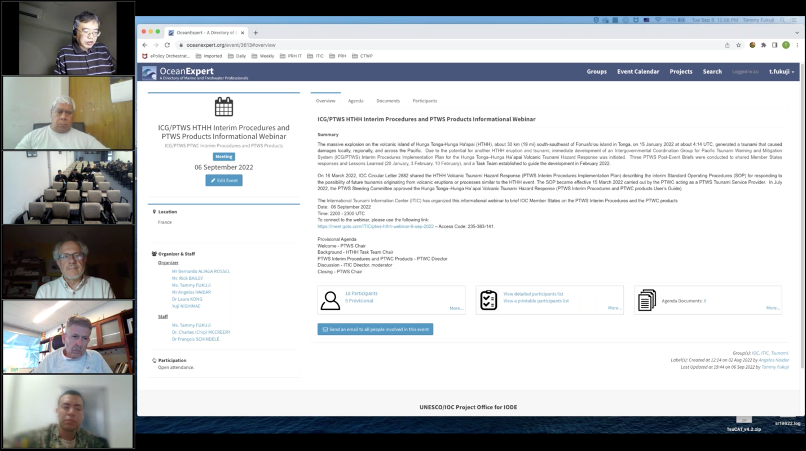

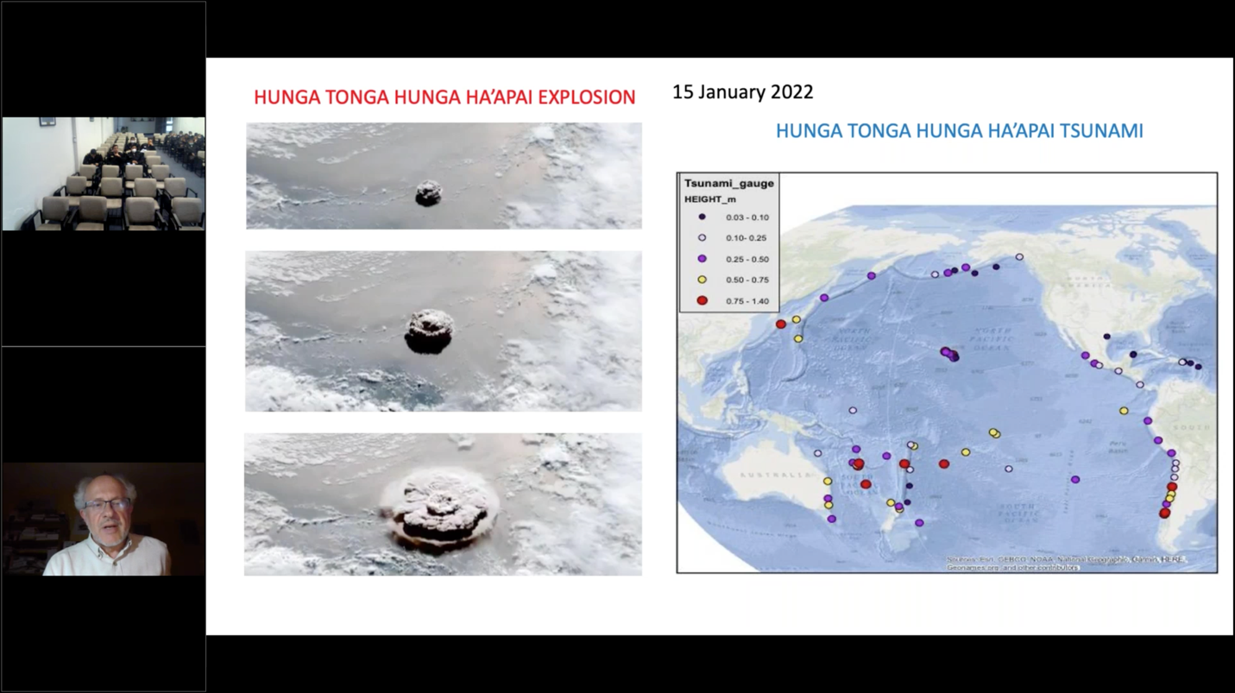

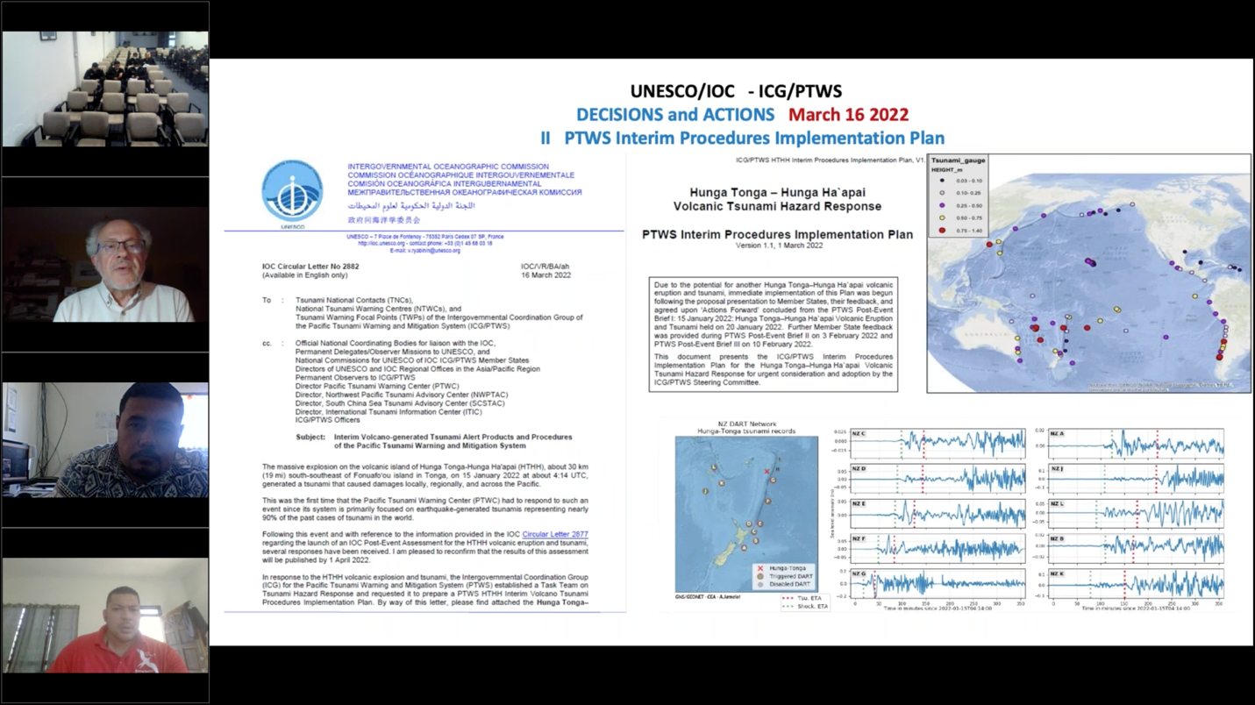

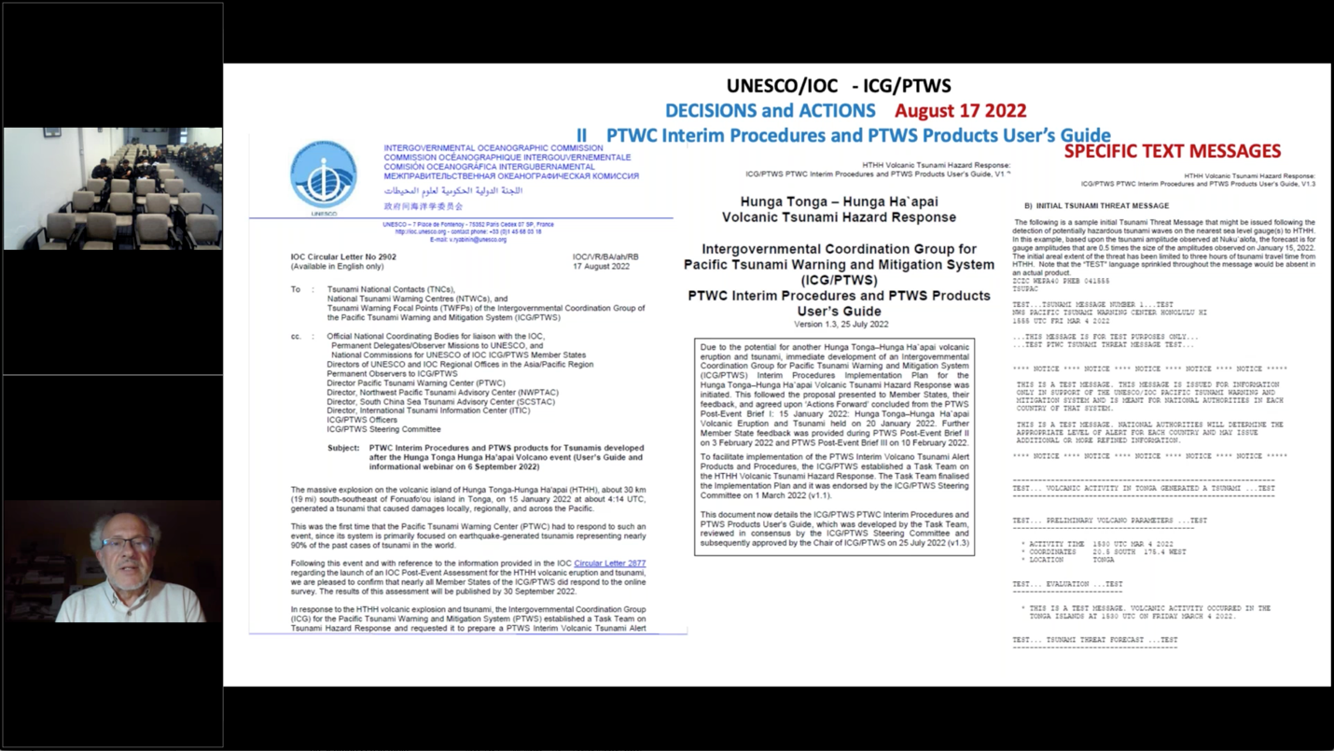

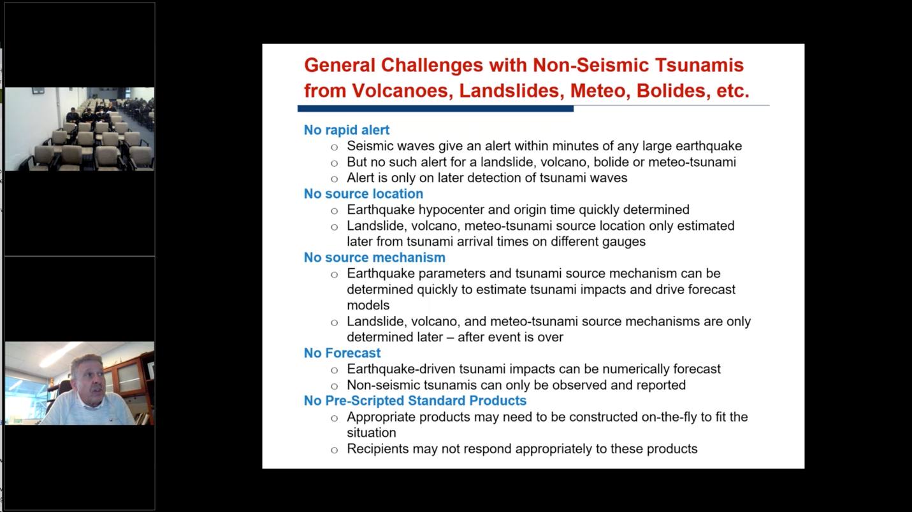

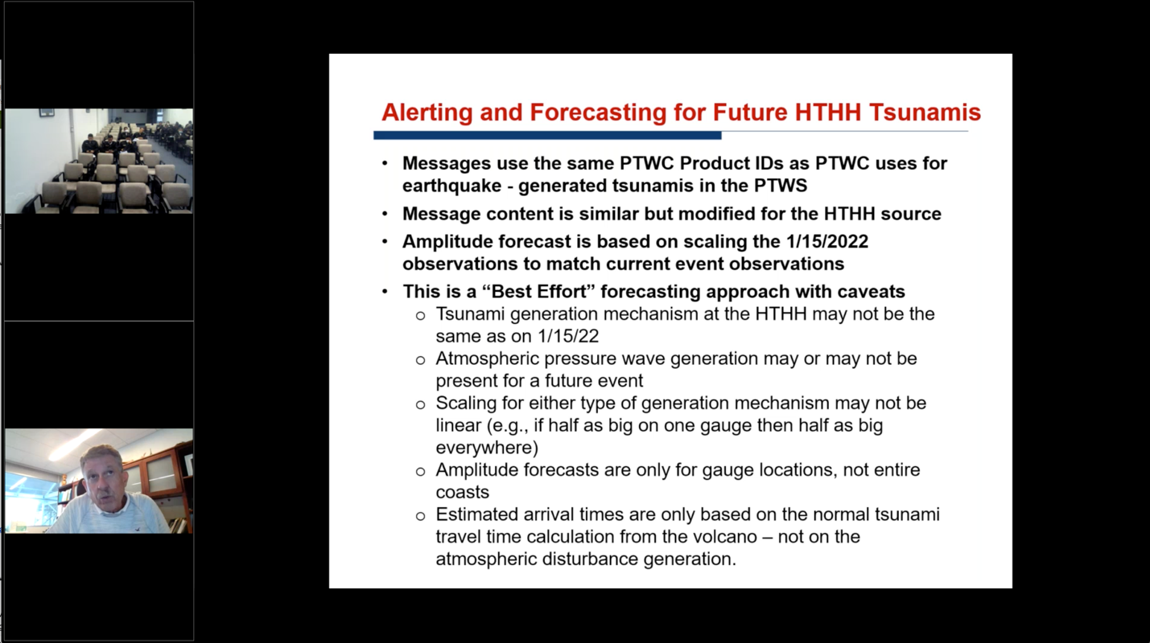

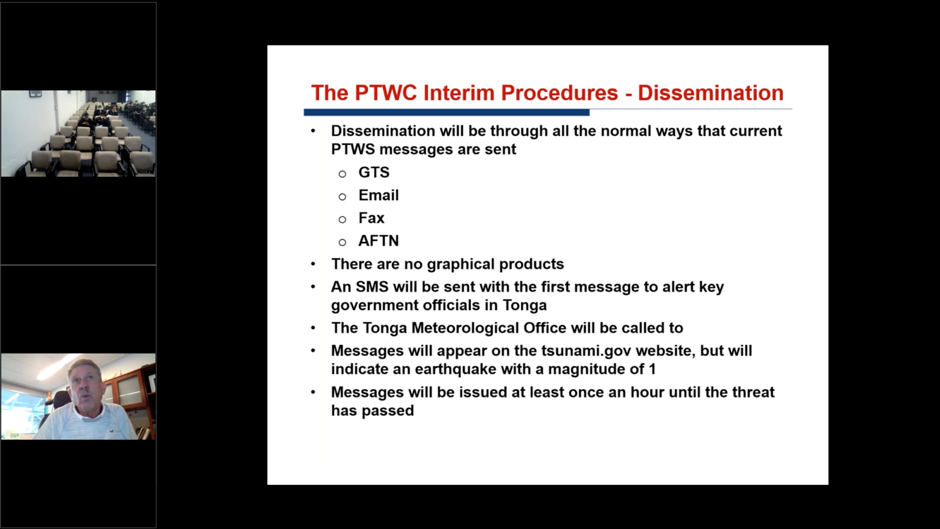

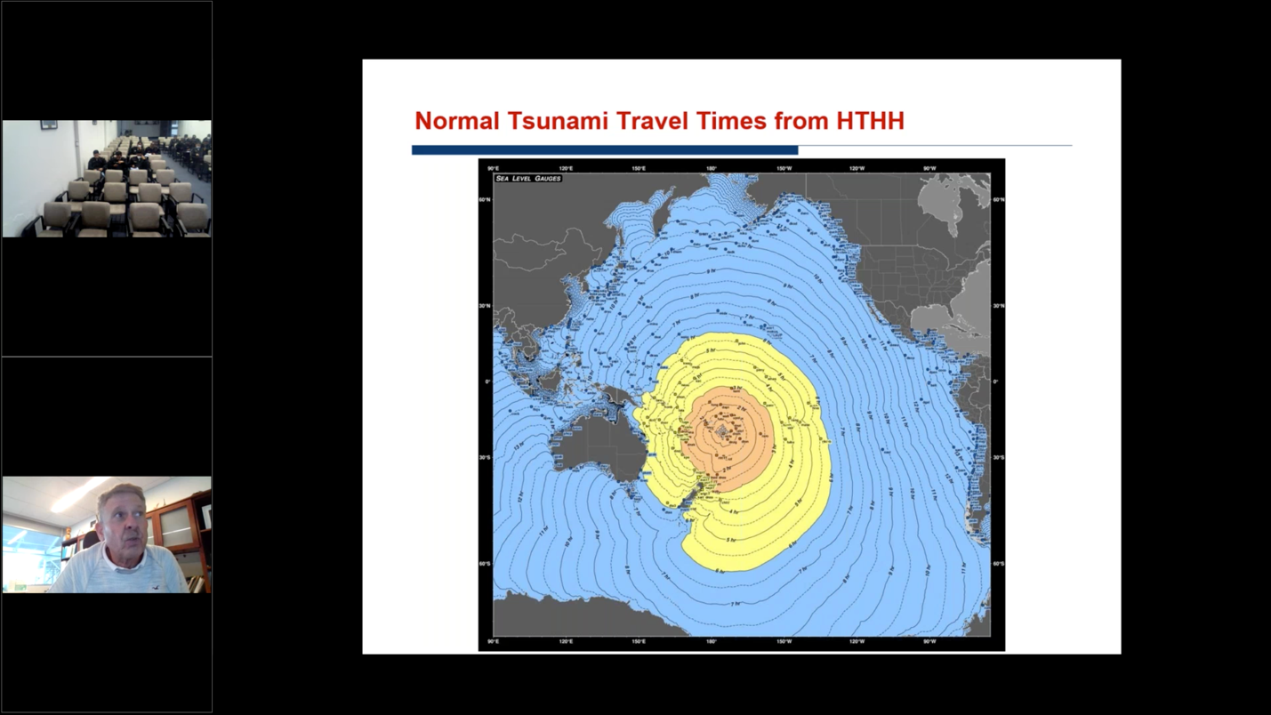

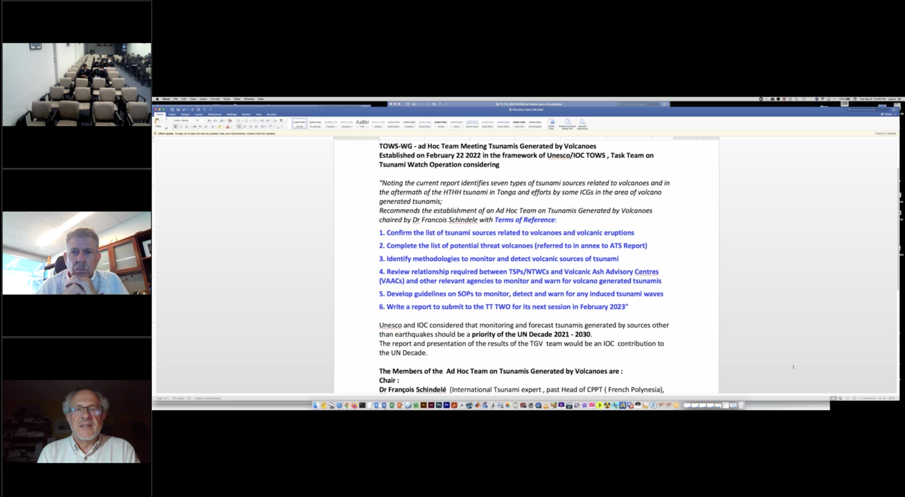

Group Photo (taken at end of webinar)

