**El Salvador National Report**

**DBCP– 38, Hybrid meeting, Geneva, Switzerland, 1-4 November 2022**

Francisco José Gavidia Medina. Oceanography Specialist.

Natural Hazards and Resources Observatory. Environment Ministry.

**Description of your observations network (buoy types, areas of deployment, et cetera - a map is preferred)**

Our oceanographic observations network include: cameras (2); tide gauges (3); buoys (2).

Those are located at three of four harbours we have: Acajutla; la Libertad; la Unión.

**Purpose of the programme (research, operations, forecasting etc.)**

Our oceanographic observations network has the purpose to warning the population for potential impacts associated to marine hazards. For that we monitoring (measuring and forecasting) marine conditions (wind waves, currents and tsunamis) and do case studies as applied research.

**Key successes/highlights**

The key successes we have is that we process the measurements obtained for the buoys component of our oceanographic observations network to generate measuring and forecasting reports of the current profiles, wind waves, spring tides and tsunamis which are disseminated on maritime economic sectors like fishery, tourism and transportation.

**Key issues and risks**

The key risk we have is the maintenance cost. The buoys component of our oceanographic observations network are installed at shallow water (20 m of depth) in front of two harbours: Acajutla; La Unión. The maintenance cost include the use of ship and divers with equipment to take off the sensors (NORTEK-AWAC), the data cable and anchor elements for maintenance aboard. Also we need a stock materials that cost approximately the 10% of the total cost. The maintenance timeline consider to do this once a year.

**Demonstrate how our buoy ocean observing network: 1) delivers data to impact/benefit research and/or operational communities and 2) will contribute to the emerging GOOS Co-Design structure (the societal benefits).**

We use our oceanographic observations network for monitoring marine hazards like: extreme events of swell; spring tides; wind storm surges; tsunami waves. Then when we process the measuring and forecasting we can warning the population for potential impacts (coastal inundations, drag by currents).

**¿What assistance or advice would you like from the DBCP? and/or ¿what suggestions do you have for the DBCP?**

Integrate the buoys component of our oceanographic observations network to international observations network like the National Data Buoy Center.

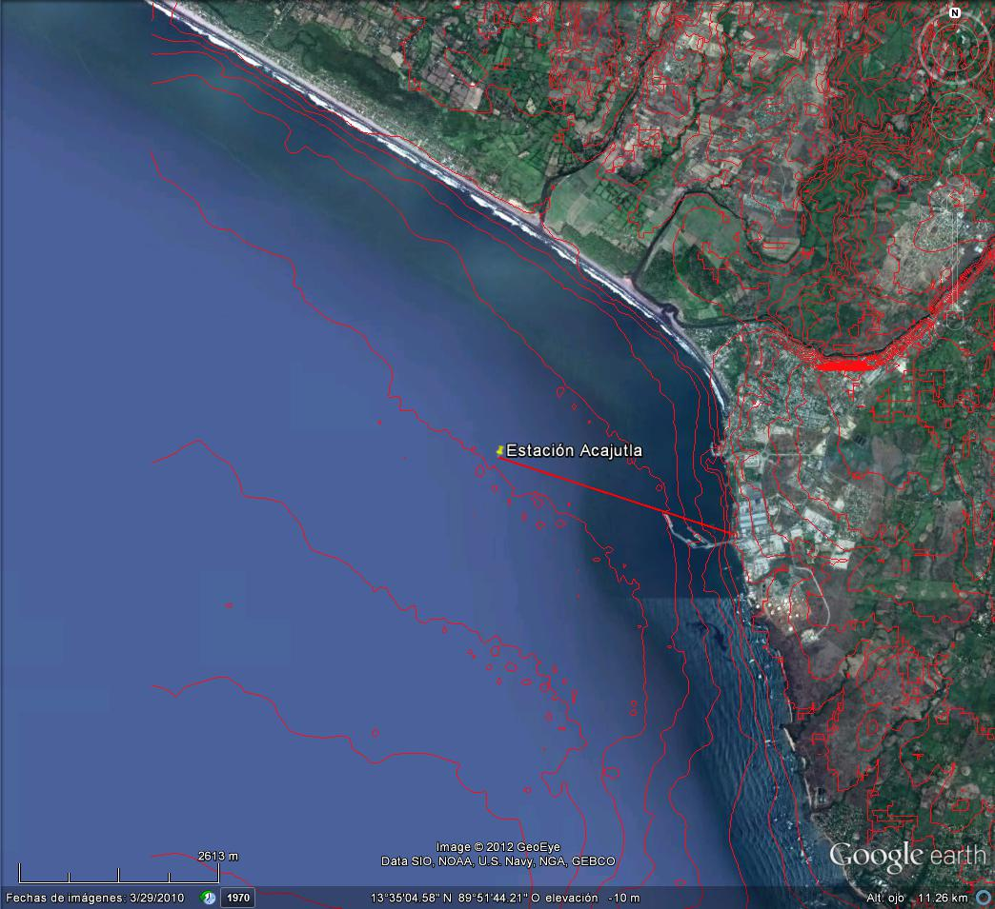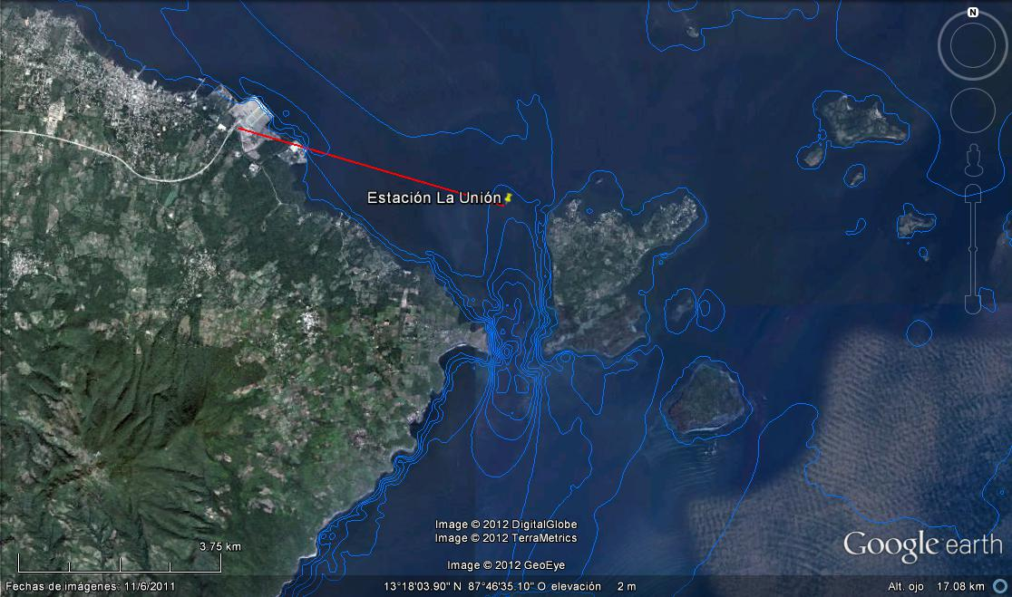

Location of the deployment areas. The NORTEK/AWAC sensor is at 20 m of depth. Is connected via data cable to the buoy. At the buoy there is a modem/antenna for the transmission of the data to the coast.

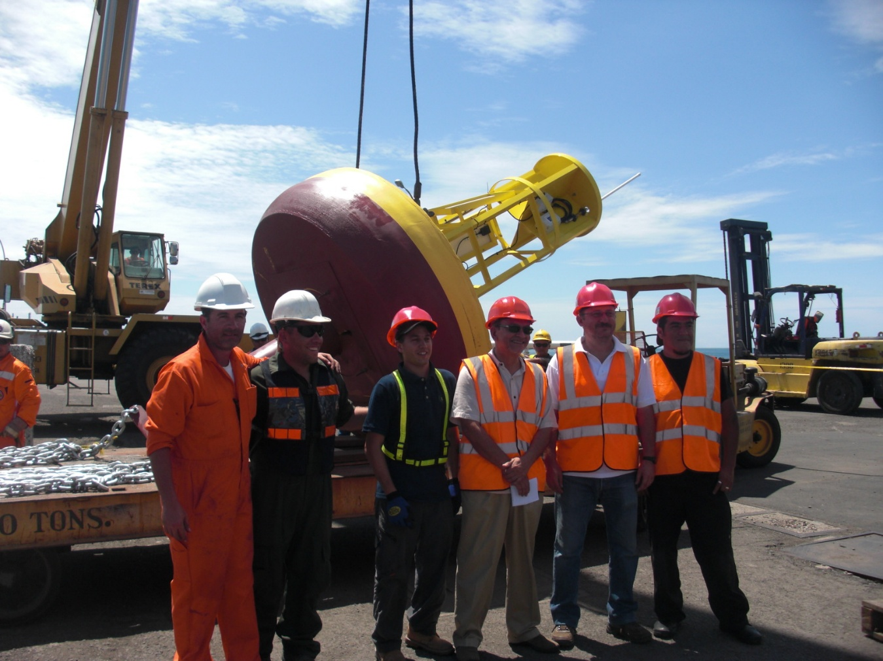

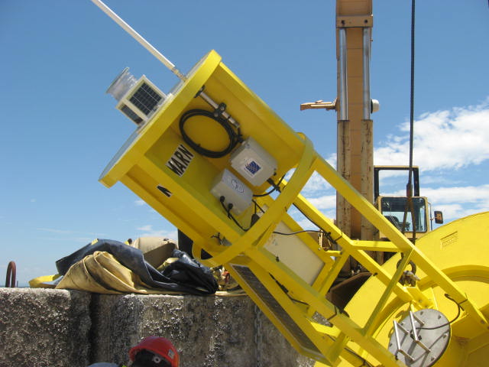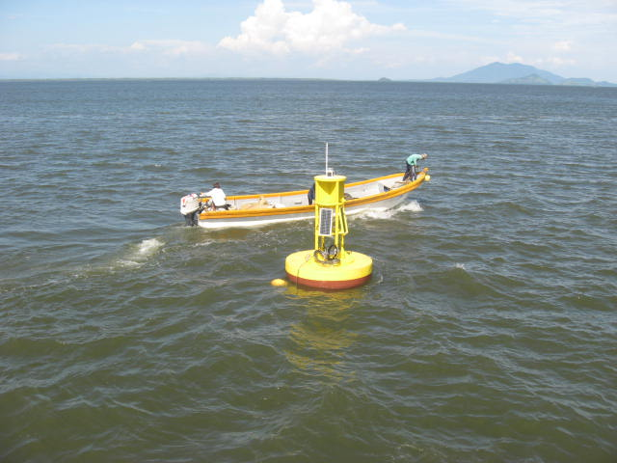

Installation of the buoys component of our oceanographic observations network on September, 2012.