DATA BUOY CO-OPERATION PANEL (DBCP)

Format for National Reports on Current and Planned Programmes

Country: United States of America

Year: 2022

CURRENT PROGRAMMES:

Agency or programme | Global Drifter Program (GDP)
Number and type of buoys | (a) deployed during the year | 862
 | (b) operational as of 31 July | 1249
 | (c) reporting on GTS as of 31 July | all
Purpose of programme  (check/uncheck boxes using [_] or [x] as appropriate) | (a) operational | [x]
 | (b) met / ocean research | [x]
 | (c) developmental | [x]
Main deployment areas | Global
Vandalism incidents | (a) Number of incidents: NONE  If vandalism incidents have occurred during the year, please provide the details using the form in the annex.

The Global Drifter Program (GDP) is the principle component of the Global Surface Drifting Buoy Array, a branch of NOAA's Global Ocean Observing System (GOOS) and a scientific project of the DBCP. Its objectives are to (1) Maintain a global 5x5 degree array of ~1300 satellite-tracked surface drifting buoys to meet the need for an accurate and globally dense set of in-situ observations of mixed layer currents, sea surface temperature, atmospheric pressure, winds and salinity, and (2) provide a data processing system for scientific use of these data. These data support short-term (seasonal to interannual) climate predictions as well as climate research and monitoring. For more information, see http://www.aoml.noaa.gov/phod/dac/gdp_objectives.php and http://gdp.ucsd.edu/ldl_drifter/index.html.

Pandemic-related deployment constraints were relaxed through the year.

Agency or programme | US Interagency Arctic Buoy Program (USIABP)
Number and type of buoys | (a) deployed during the year | 122
 | (b) operational as of 31 July | 200
 | (c) reporting on GTS as of 31 July | 57
Purpose of programme  (check/uncheck boxes using [_] or [x] as appropriate) | (a) operational | [x]
 | (b) met / ocean research | [x]
 | (c) developmental | [x]
Main deployment areas | Arctic Ocean, Bering and peripheral seas.
Vandalism incidents | (a) Number of incidents NONE  If vandalism incidents have occurred during the year, please provide the details using the form in the annex.

The USIABP coordinates US contributions to the International Arctic Buoy Programme (IABP). Its objectives are to provide meteorological and oceanographic observations for real-time operational requirements and research purposes. For more information, see http://iabp.apl.uw.edu.

COVID-19 cancelled some of our own field work in 2021-2022, but we were still able to deploy most of our buoys using local collaborators, and by leveraging many of our other logistics-of-opportunity.

We also deployed 65 GPS trackers on ice bergs north of Alaska, and around Greenland. These comprise most of the buoys that were not posted on the GTS.

As of June 2022, there were 200 buoys reporting in the IABP array (Figs. 3 and 4). The USIABP either purchased, deployed, or covers satellite telemetry for 155. The next largest contributor the IABP buoy network is the NOAA Global Drifter Program which owns and coordinated the deployment of 71 buoys reporting on the GTS in the North Atlantic sector of the Arctic Ocean, and Baffin Bay.

Agency or programme | National Oceanic and Atmospheric Administration (NOAA)/ National Weather Service (NWS)/ National Data Buoy Center (NDBC) Coastal Weather Buoys (CWxB)
Number and type of buoys | (a) deployed during the year | 20
 | (b) operational as of 31 July | 94
 | (c) reporting on GTS as of 31 July | 94
Purpose of programme  (check/uncheck boxes using [_] or [x] as appropriate) | (a) operational | [x]
 | (b) met / ocean research | [ ]
 | (c) developmental | [ ]
Main deployment areas | Atlantic and Pacific Oceans and Coastal Zone of the US, including the Bering Sea, Gulf of Mexico, and Great Lakes
Vandalism incidents | (a) Number of incidents 56  (refer to vandalism report for details).

The National Data Buoy Center (NDBC) Coastal Weather Buoy network (CWxB) is a principle component of NOAA’s ocean observing system and a part of the Global Ocean Observing System (GOOS).The mission of NDBC’s Coastal Weather Buoy network is to provide quality observation to further the understanding and predictions to changes in weather, climate, and oceans. To support this mission NDBC's moored buoys measure and transmit barometric pressure, wind speed and direction, wind gust, air temperature, relative humidity, and sea surface temperature. In addition, all CWxB measure wave energy spectra from which significant wave height, dominant wave period, and average wave period are derived. Even the direction of wave propagation is measured on many moored buoys. For more information, see http://www.ndbc.noaa.gov/mooredbuoy.shtml.

The NDBC CWxB network has experienced no significant impact as a result of the COVID-19 pandemic.

Agency or programme | National Oceanic and Atmospheric Administration (NOAA)/ National Weather Service (NWS)/ National Data Buoy Center (NDBC) Tsunameter Buoys
Number and type of buoys | (a) deployed during the year | 27
 | (b) operational as of 31 July | 32
 | (c) reporting on GTS as of 31 July | 32
Purpose of programme  (check/uncheck boxes using [_] or [x] as appropriate) | (a) operational | [x]
 | (b) met / ocean research | [ ]
 | (c) developmental | [ ]
Main deployment areas | Atlantic and Pacific Oceans and Gulf of Mexico
Vandalism incidents | (a) Number of incidents 1  (refer to vandalism report for details).

To ensure early detection of tsunamis and to acquire data critical to real-time forecasts, NOAA has placed Deep-ocean Assessment and Reporting of Tsunami (DART) buoys at sites in regions with a history of generating destructive tsunamis. Originally developed by NOAA, as part of the U.S. National Tsunami Hazard Mitigation Program (NTHMP), the DART Project was an effort to maintain and improve the capability for the early detection and real-time reporting of tsunamis in the open ocean. DART presently constitutes a critical element of the NOAA’s Tsunami Program. NOAA’s National Weather Service (NWS) is responsible for the overall execution of the Tsunami Program and NDBC is responsible for operating and maintaining the network of 39 tsunameter buoys. For more information on the NDBC tsunameter buoys see http://www.ndbc.noaa.gov/dart/dart.shtml.

The NDBC Tsunameter Buoy network has experienced no significant impact as a result of the COVID-19 pandemic.

Agency or programme | National Oceanic and Atmospheric Administration (NOAA)/ National Weather Service (NWS)/ National Data Buoy Center (NDBC) Tropical Atmosphere Ocean (TAO) Arrray
Number and type of buoys | (a) deployed during the year | 24
 | (b) operational as of 31 July | 40
 | (c) reporting on GTS as of 31 July | 40
Purpose of programme  (check/uncheck boxes using [_] or [x] as appropriate) | (a) operational | [x]
 | (b) met / ocean research | [x]
 | (c) developmental | [ ]
Main deployment areas | Equatorial Pacific Ocean
Vandalism incidents | (a) Number of incidents 52  (refer to vandalism report for details).

The Tropical Atmosphere Ocean (TAO) array consists of approximately 55 moorings in the Tropical Pacific Ocean with real-time telemetry of oceanographic and meteorological observations. The array is a major component of the El Niño/Southern Oscillation (ENSO) Observing System, the Global Climate Observing System (GCOS) and the Global Ocean Observing System (GOOS). Support for the array is provided by the United States (National Oceanic and Atmospheric Administration). For more information see http://tao.ndbc.noaa.gov/proj_overview/proj_overview_ndbc.shtml

The TAO array has experienced minor impacts as a result of the COVID-19 pandemic. These small impacts are related to business closures and longer than normal lead times for sensor refurbishments.

Agency or programme | National Oceanic and Atmospheric Administration (NOAA)/ Pacific Marine Environmental Laboratory (PMEL) and Atlantic Oceanographic and Meteorological Agency (AOML)  Prediction and Research moored Array in the Tropical Atlantic (PIRATA)
Number and type of buoys | (a) deployed during the year | 17 surface toroids
 | (b) operational as of 31 July | 17 surface toroids
 | (c) reporting on GTS as of 31 July | 17 surface toroids
Purpose of programme  (check/uncheck boxes using [_] or [x] as appropriate) | (a) operational | [ ]
 | (b) met / ocean research | [x]
 | (c) developmental | [x]
Main deployment areas | Tropical Atlantic Ocean
Vandalism incidents | (a) Number of incidents: unknown  If vandalism incidents have occurred during the year, please provide the details using the form in the annex.

PIRATA is a multinational observation network, established to improve our knowledge and understanding of ocean-atmosphere variability in the tropical Atlantic. It is a joint project of Brazil, France and the United States of America. PIRATA is motivated by fundamental scientific issues and by societal needs for improved prediction of climate variability and its impact on the countries surrounding the tropical Atlantic basin. The overarching goals of the project are to (1) improve the description of the intra-seasonal to interannual variability in the atmospheric and oceanic boundary layers of the tropical Atlantic Ocean; (2) improve our understanding of the relative contributions of air-sea fluxes and ocean dynamics to variability in sea surface temperature and sub-surface heat content; (3) provide a set of data useful for developing and improving the predictive models of the ocean-atmosphere coupled system; (4) document interactions between tropical Atlantic climate and variability outside the region, such as ENSO and the North Atlantic Oscillation; and (5) design, deploy, and maintain an array of moored oceanic buoys and collect and transmit a set of oceanographic and atmospheric data, via satellite in near-real time, to monitor and study the upper ocean and lower atmosphere of the tropical Atlantic Ocean. For more information, see http://www.pmel.noaa.gov/pirata/.

The current array design for PIRATA calls for 18 surface buoys; this network is 100% completed. Future extensions and additions may be added, as demanded by research and operational needs.

Impacts from the COVID-19 Pandemic: Cruise delays, response and expected loss of data:
- Nov–Dec 2021 (completed): Ronald H. Brown (21°N 23°W, 12°N 23°W, 4°N 23°W, 20°N 38°W). The mooring at 12°N 38°W was recovered on this cruise to avoid complete loss as it was deployed in Oct 2018 and stopped transmitting data in Nov 2020. A cruise is scheduled for Nov–Dec 2022 and will service (21°N 23°W, 12°N 23°W, 4°N 23°W, 20°N 38°W and 4°N 38°W). We anticipate no gap in data. We expect no data loss.
- Feb–April 2022 (completed): Thalassa (0° 3°W, 0° 10°W, 6°S 10°W, 10°S 10°W, 20°S 10°W, 0° 23°W). These six moorings were deployed in Feb–April 2022. We anticipate no gap in data. We expect no data loss
- May–June 2022 (completed): Antares (19°S 34°W, 14°S 32°W, 8°S 30°W, 0° 35°W, 4°N 38°W, 8°N 38°W, 12°N 38°W, 15°N 38°W). Seven out of the eight moorings were deployed in May–June 2022. The 4°N 38°W was not serviced due to loss of equipment. This mooring will be serviced by the Ronald H. Brown in Nov–Dec 2022. There will be a 6 month delay in data from this site.
Loss of hardware:
There was complete mooring losses at 0° 35°W, 4°N 38°W, 8°N 38°W due to the long 3.5 year period between servicing and a partial mooring loss at 15°N_38°W due to nylon break caused by high tensions during recovery and 19°S 34°W due to wire breakage.
Project Deliverables and Education impacts:
PIRATA moorings have a 1-year (annual) service and maintenance design life. The delays in servicing these moorings will result in data losses due to battery failures and will increase the risk of equipment losses and high-resolution data losses due to extended deployment periods well in excess of the design life and impose additional risk by fishing activities and vandalism. These delays will therefore limit NOAA's capability to meet NOAA's mission.

Agency or programme | National Oceanic and Atmospheric Administration (NOAA)/ Pacific Marine Environmental Laboratory (PMEL)  Research Moored Array for African-Asian-Australian Monsoon Analysis and prediction (RAMA)
Number and type of buoys | (a) deployed during the year | 3 surface toroids, 1 subsfc moorings
 | (b) operational as of 31 July | 5 surface toroids, 5 subsfc mooring
 | (c) reporting on GTS as of  31 July | 2 (2 moorings went adrift)
Purpose of programme  (check/uncheck boxes using [_] or [x] as appropriate) | (a) operational | [ ]
 | (b) met / ocean research | [x]
 | (c) developmental | [x]
Main deployment areas | Tropical Indian Ocean
Vandalism incidents | (a) Number of incidents: unknown due to mooring loss and deployment times that have exceeded lifetime design.  If vandalism incidents have occurred during the year, please provide the details using the form in the annex.

RAMA addresses the needs for comprehensive, long term, high quality real-time measurements in the Indian Ocean suitable for climate research and forecasting. RAMA is targeted at understanding and prediction of the east African, Asian and Australian monsoons, and benefits nations outside the Indian Ocean region due to atmospheric teleconnections which influence the far field. For more information, see http://www.pmel.noaa.gov/tao/rama/.

The current array design for RAMA calls for 25 moored buoy sites maintained by the US (NOAA/PMEL), of which 23 (92%) have been implemented and occupied for at least one year. Future additions may be added, as demanded by research and operational needs. Only five of these US RAMA mooring sites are actively transmitting from the moored position due to inability to maintain RAMA moorings during the COVID-10 pandemic.

Impacts from the COVID-19 pandemic: Cruise delays, response and expected loss of data:
- December 2021 (completed): Isabu (4°S_67°E, 8°S_67°E, 12°S_67°E). Three moorings were deployed. Two of these moorings went adrift. 4°S 67°E went adrift Dec 2021 about 30 hours after deployment during IO4-21-IS. Isabu would not turn back. Drifted near Diego Garcia, but intercepted and recovered by M/V Grampian Frontier on 19 Jan 2022. All subsurface recovered (except for release). 8°S 67°E went adrift on September 18, 2022.
- No cruises onboard the Sagar Nidhi were scheduled to service the following sites: (15°N 65°E, 8°N 67°E, 4°N 67°E, 2°N 67°E, 0° 67°E, 2°S 67°E, 0° 81°E, 2°S 81°E, 4°S 81°E, 8°S 81°E, 12°S 81°E). These moorings have been deployed between 1050–1150 days (2.9–3.15 yrs.). We expect full mooring loss at 15°N_65°E, 2N_67°E, 0°_67°E, 2°S_67°E, 0°_81°E, 2°S_81°E, 4°S 81°E, 8°S 81°E. We expect an additional > 6 months delay before these sites will be serviced. We expect a > 12-month loss in T, S and surface met data and > 12-month loss in near surface current data (U/V).
- September 2022 (postponed): Baruna Jaya (15°N 90°E, 12°N 90°E, 8°N 90°E, 0° 90°E). Cruise rescheduling is TBD. None of these moorings are transmitting. These moorings have been deployed for >1030 days (2.84 years). We expect an additional >6 months delay before these sites will be serviced. We expect a >12-month loss in T, S and surface met data and >12-month loss in near surface current data (U/V).
- Tethys Supporter (4°S 57°E, 8°S 55°E). A cruise will NOT be scheduled.
Loss of hardware:
We anticipate complete mooring losses at 15°N 90°E; 0° 81°E, 2°S 81°E, 4°S 81°E 8°S 81°E, 15°N 65°E; 2°N 67°E; 0° 67°E; 2°S 67°E; 4°S 57°E; 8°S 55°E. We anticipate other potential losses at sites that have been deployed >1 year. However, we will not be able to confirm these as losses until we are able to access the sites during cruises.
Project Deliverables and Education impacts:
RAMA moorings have a 1-year (annual) service and maintenance design life. The delays in servicing these moorings will result in data losses due to battery failures and will increase the risk of equipment losses and high-resolution data losses due to extended deployment periods well in excess of the design life and impose additional risk by fishing activities and vandalism. These delays will therefore limit NOAA's capability to meet NOAA's mission. We expect many educational aspects impacted since there are many students using these freely available RAMA mooring data for research.

Agency or programme | Coastal Data Information Program (CDIP)
Number and type of buoys | (a) deployed during the year | ~40
 | (b) operational as of 31 July | ~80
 | (c) reporting on GTS as of 31 July | All operational
Purpose of programme  (check/uncheck boxes using [_] or [x] as appropriate) | (a) operational | [x]
 | (b) met / ocean research | [x]
 | (c) developmental | [x]
Main deployment areas | US waters worldwide: Atlantic, Caribbean, Gulf of Mexico, Pacific, Alaska, Hawaii, Pacific Islands
Vandalism incidents | (a) Number of incidents NONE  If vandalism incidents have occurred during the year, please provide the details using the form in the annex.

The Coastal Data Information Program (CDIP) is an extensive network for monitoring waves and beaches along the coastlines of the United States. Since its inception in 1975, the program has produced a vast database of publicly accessible environmental data for use by coastal engineers and planners, scientists, mariners, and marine enthusiasts. The program has also remained at the forefront of coastal monitoring, developing numerous innovations in instrumentation, system control and management, computer hardware and software, field equipment, and installation techniques. CDIP operates out of Scripps Institution of Oceanography, La Jolla, CA. For more information, see http://cdip.ucsd.edu/.

Agency or programme | Naval Oceanographic Office (NAVOCEANO)
Number and type of buoys | (a) deployed during the year | 2 Iridium ALAMO floats, 6 MetOcean iSLDMB drifters
 | (b) operational as of 31 July | 0 Iridium ALAMO floats, 0 MetOcean iSLDMB drifters
 | (c) reporting on GTS as of  31 July | 0 Iridium ALAMO floats, 0 MetOcean iSLDMB drifters
Purpose of programme  (check/uncheck boxes using [_] or [x] as appropriate) | (a) operational | [x]
 | (b) met / ocean research | [ ]
 | (c) developmental | [ ]
Main deployment areas | Global
Vandalism incidents | (a) Number of incidents NONE  If vandalism incidents have occurred during the year, please provide the details using the form in the annex.

The purpose of NAVOCEANO deployments is to support US Navy operations globally. Deployment plans are dictated by operational needs.

Note: COVID-19 associated reduced manning, COVID-19 associated reduced deployment opportunities, and evolving operational needs affected the number of instruments deployed for the current reporting period. All instruments are listed as no longer/not currently sending data to GTS because they were deployed nearly a year ago, and have expended their operational lifetime.

PLANNED PROGRAMMES:

Agency or programme | Global Drifter Program (GDP)
Number and type of buoys | planned for deployment in the next 12 months | 1000 drifters  (800 funded by NOAA;  200 by consortium partners)
Purpose of programme  (check/uncheck boxes using [_] or [x] as appropriate) | (a) operational | [x]
 | (b) met / ocean research | [x]
 | (c) developmental | [x]
Main deployment areas | global

Agency or programme | US Interagency Arctic Buoy Program (USIABP)
Number and type of buoys | planned for deployment in the next 12 months | 20 SVP-B  30 Ice Balls (drogue-less SVP-Bs)  14 AXIB met. buoy  12 Ice Mass Balance (IMB) buoys  9 Ocean Profilers  80 Other (lots of iceberg tags)
Purpose of programme  (check/uncheck boxes using [_] or [x] as appropriate) | (a) operational | [x]
 | (b) met / ocean research | [x]
 | (c) developmental | [x]
Main deployment areas | Arctic

Agency or programme | National Oceanic and Atmospheric Administration (NOAA)/ National Weather Service (NWS)/ National Data Buoy Center (NDBC)  Moored Buoys (MET/OCEAN)
Number and type of buoys | planned for deployment in the next 12 months | 41
Purpose of programme  (check/uncheck boxes using [_] or [x] as appropriate) | (a) operational | [x]
 | (b) met / ocean research | [ ]
 | (c) developmental | [ ]
Main deployment areas | Atlantic and Pacific Oceans and Coastal Zone of the US, including the Bering Sea, Gulf of Mexico, and Great Lakes

Agency or programme | National Oceanic and Atmospheric Administration (NOAA)/ National Weather Service (NWS)/ National Data Buoy Center (NDBC)  Tsunameter Stations
Number and type of buoys | planned for deployment in the next 12 months | 37
Purpose of programme  (check/uncheck boxes using [_] or [x] as appropriate) | (a) operational | [x]
 | (b) met / ocean research | [ ]
 | (c) developmental | [ ]
Main deployment areas | Atlantic and Pacific Oceans and Gulf of Mexico

Agency or programme | National Oceanic and Atmospheric Administration (NOAA)/ National Weather Service (NWS)/ National Data Buoy Center (NDBC)  Tropical Atmosphere Ocean (TAO) Project
Number and type of buoys | planned for deployment in the next 12 months | 37,  3 subsurface moorings
Purpose of programme  (check/uncheck boxes using [_] or [x] as appropriate) | (a) operational | [x]
 | (b) met / ocean research | [x]
 | (c) developmental | [ ]
Main deployment areas | Equatorial Pacific

Agency or programme | National Oceanic and Atmospheric Administration (NOAA)/ Pacific Marine Environmental Laboratory (PMEL) and Atlantic Oceanographic and Meteorological Agency (AOML)  Prediction and Research moored Array in the Tropical Atlantic (PIRATA)
Number and type of buoys | planned for deployment in the next 12 months | 18
Purpose of programme  (check/uncheck boxes using [_] or [x] as appropriate) | (a) operational | [ ]
 | (b) met / ocean research | [x]
 | (c) developmental | [x]
Main deployment areas | Tropical Atlantic

Agency or programme | National Oceanic and Atmospheric Administration (NOAA)/ Pacific Marine Environmental Laboratory (PMEL)  Research Moored Array for African-Asian-Australian Monsoon Analysis and Prediction (RAMA)
Number and type of buoys | planned for deployment in the next 12 months | 17 surface toroids,  4 subsurface ADCP moorings
Purpose of programme  (check/uncheck boxes using [_] or [x] as appropriate) | (a) operational | [ ]
 | (b) met / ocean research | [x]
 | (c) developmental | [ ]
Main deployment areas | Tropical Indian Ocean

Agency or programme | Coastal Data Information Program (CDIP)
Number and type of buoys | planned for deployment in the next 12 months | ~5
Purpose of programme  (check/uncheck boxes using [_] or [x] as appropriate) | (a) operational | [x]
 | (b) met / ocean research | [x]
 | (c) developmental | [x]
Main deployment areas | Pacific Western, Atlantic, Gulf of Mexico,  Gulf of Alaska, Carribean

Agency or programme | Naval Oceanographic Office (NAVOCEANO)
Number and type of buoys | planned for deployment in the next 12 months | ~10 floats  ~10 drifters
Purpose of programme  (check/uncheck boxes using [_] or [x] as appropriate) | (a) operational | [x]
 | (b) met / ocean research | [ ]
 | (c) developmental | [ ]
Main deployment areas | Global

TECHNICAL DEVELOPMENTS:

No new T-Flex systems were implemented in the past year and none are planned for the coming year. T-Flex data are reported on the GTS in BUFR format with Bulletin Header IOBX08 KPML. WMO numbers for T-Flex moorings take the 7-digit analog of the 5-digit code for the previous ATLAS system at the same site. For example, the WMO number for the first T-Flex mooring implemented (4°S 81°E in RAMA) will be 2300010 (vs 23010 for the previous ATLAS moorings at that site).

A new generation of mooring data acquisition system, named TELOS, is currently being teested. These systems will offer increased flexibility for incorporating additional instrumentation and higher resolution real-time data transmissions.

A standard tropical mooring sensor suite includes sensors for measuring wind, air temperature, relative humidity, barometric pressure, longwave and shortwave solar radiation, precipitation, subsurface temperature, conductivity, pressure, and currents. In addition to the standard mooring observations, partner projects offer additional measurements including CO2, turbulence, and fish tracking. The Bay of Bengal Large Marine Ecosystem Project (BoBLME) supports a PMEL designed MapCO2 system for CO2 and ocean acidification observations at one RAMA site. Ancillary observations of turbulence are provided by Oregon State University employing thermal microstructure instruments (Chipods). GEOMAR provides sensors to measure subsurface dissolved oxygen (O2) in the Atlantic oxygen minimum zone. Two LOCEAN surface Carbon Dioxide (CO2) systems were deployed in FY 2022. Dalhousie University Ocean Tracking Network acoustic monitors are deployed on all RAMA and PIRATA surface moorings.

The next generation of the TAO buoy, referred to as a TAO Recap station, is currently being tested in the TAO array. To date there have been three successful field tests of the new technology, the first deployed at 5°N 125°W, the second at 0° 165°E, and the last at 0° 170°W. Each deployment is more complex than the previous. The new TAO Recap buoys once operational will offer value added capability such as additional mixed-layer observations and air-sea flux instruments along with higher resolution real-time data transmissions. The new TAO Recap array is being co-designed under the international collaborative Tropical Pacific Observing System (TPOS).

SPECIAL COMMENTS (if any): None.

PUBLICATIONS:
CDIP:
https://cdip.ucsd.edu/themes/cdip?d2=p51&u2=d:list:src:publications_references

CWxB:
Hall, C., R.E. Jensen, and D.W. Wang, 2022: Performance Evaluation of the Newly Operational NDBC 2.1-m Hull. J. Atmos. and Oceanic Tech., 39, 861-880, https://doi.org/10.1175/JTECH-D-21-0172.1
Jiang, H., 2022: Wind speed and direction estimation from wave spectra using deep learning. Atmos. Meas. Tech., 15, 1-9, https://doi.org/10.5194/amt-15-1-2022
Kendall, M.S., B.L. Williams, A.J. Winship, M. Carson, K. Grissom, T.J. Rowell, J. Stanley, and K.W. Roberson, 2021: Winds, waves, warm waters, weekdays, and which ways boats are counted influence predicted visitor use at an offshore fishing destination. Fisheries Research, 237, https://doi.org/10.1016/j.fishres.2021.105879

Global Drifter Program:
Androulidakis, Y., V. Kourafalou, M Olascoaga, F. Beron-Vera, M. Le Henaff, H. Kang, and N. Ntaganou, Nektaria. (2021). Impact of Caribbean Anticyclones on Loop Current variability. Ocean Dynamics. 71. https://doi.org/10.1007/s10236-021-01474-9
Arbic, B. K., Elipot, S., Brasch, J. M., Menemenlis, D., Ponte, A. L., Shriver, J. F., et al. (2022). Near-surface oceanic kinetic energy distributions from drifter observations and numerical models. Journal of Geophysical Research: Oceans, 127, e2022JC018551. https://doi.org/10.1029/2022JC018551
Cardoso, Cláudio & Caldeira, Rui. (2021). Modeling the Exposure of the Macaronesia Islands (NE Atlantic) to Marine Plastic Pollution. Frontiers in Marine Science. 8. https://doi.org/10.3389/fmars.2021.653502.
Caspar-Cohen, Z., Ponte, A., Lahaye, N., Carton, X., Yu, X., & Gentil, S. L. (2022). Characterization of Internal Tide Incoherence: Eulerian versus Lagrangian Perspectives, Journal of Physical Oceanography, 52(6), 1245-1259. https://doi.org/10.1175/JPO-D-21-0088.1
Chan, D., & Huybers, P. (2021). Correcting Observational Biases in Sea Surface Temperature Observations Removes Anomalous Warmth during World War II, Journal of Climate, 34(11), 4585-4602. https://doi.org/10.1175/JCLI-D-20-0907.1
Devana, Manish S., William E. Johns, Adam Houk, and Sijia Zou (2021), Rapid Freshening of Iceland Scotland Overflow Water Driven by Entrainment of Major Upper Ocean Salinity Anomaly, Geophysical Research Letters, 8, Issue 22, https://doi.org/10.1029/2021GL094396
Dukhovskoy, D. S., Yashayaev, I., Chassignet, E. P., Myers, P. G., Platov, G., & Proshutinsky, A. (2021). Time Scales of the Greenland Freshwater Anomaly in the Subpolar North Atlantic, Journal of Climate, 34(22), 8971-8987. https://doi.org/10.1175/JCLI-D-20-0610.1
Duyck, E., & De Jong, M. F. (2021). Circulation over the south-east Greenland shelf and potential for liquid freshwater export: A drifter study. Geophysical Research Letters, 48, e2020JB020886. https://doi.org/10.1029/2020GL091948
Eddebbar, Y. A., Subramanian, A. C., Whitt, D. B., Long, M. C., Verdy, A., Mazloff, M. R., & Merrifield, M. A. (2021). Seasonal modulation of dissolved oxygen in the equatorial Pacific by tropical instability vortices. Journal of Geophysical Research: Oceans, 126, e2021JC017567. https://doi.org/10.1029/2021JC017567
Elipot, S., Sykulski, A., Lumpkin, R. et al. A dataset of hourly sea surface temperature from drifting buoys. Sci Data 9, 567 (2022). https://doi.org/10.1038/s41597-022-01670-2
Essink, S., Hormann, V., Centurioni, L. R., & Mahadevan, A. (2022). On Characterizing Ocean Kinematics from Surface Drifters, Journal of Atmospheric and Oceanic Technology, 39(8), 1183-1198. https://doi.org/10.1175/JTECH-D-21-0068.1
Fan, S., Zhang, B., Perrie, W., Mouche, A., Liu, G., Li, H., et al. (2022). Observed ocean surface winds and mixed layer currents under tropical cyclones: Asymmetric characteristics. Journal of Geophysical Research: Oceans, 127, e2021JC017991. https://doi.org/10.1029/2021JC017991
Hui, Z., Li, Y., Sun, J. et al. (2022). Validation and error analysis of wave-modified ocean surface currents in the northwestern Pacific Ocean. J. Ocean. Limnol. 40, 1289–1303. https://doi.org/10.1007/s00343-021-1182-y
Huang, B., Liu, C., Freeman, E., Graham, G., Smith, T., & Zhang, H. (2021). Assessment and Intercomparison of NOAA Daily Optimum Interpolation Sea Surface Temperature (DOISST) Version 2.1, Journal of Climate, 34(18), 7421-7441. https://doi.org/10.1175/JCLI-D-21-0001.1
Huang, G., H. Zhan, Q. He, X. Wei, B. Li (2021). A Lagrangian study of the near-surface intrusion of Pacific water into the South China Sea[J]. Acta Oceanologica Sinica, 40(7): 15-30. http://doi.org/10.1007/s13131-021-1766-6
Jiang, X., Dong, C., Ji, Y., Wang, C., Shu, Y., Liu, L., & Ji, J. (2021). Influences of deep-water seamounts on the hydrodynamic environment in the Northwestern Pacific Ocean. Journal of Geophysical Research: Oceans, 126, e2021JC017396. https://doi.org/10.1029/2021JC017396
Johns, W., et al. (2021). Tropical Atlantic Observing System (TAOS) Review Report.
Le Goff, C., Boussidi, B., Mironov, A., Guichoux, Y., Zhen, Y., Tandeo, P., et al. (2021). Monitoring the greater Agulhas Current with AIS data information. Journal of Geophysical Research: Oceans, 126, e2021JC017228. https://doi.org/10.1029/2021JC017228
Li, D., Chang, P., Yeager, S. G., Danabasoglu, G., Castruccio, F. S., Small, J., et al. (2022). The impact of horizontal resolution on projected sea-level rise along US east continental shelf with the Community Earth System Model. Journal of Advances in Modeling Earth Systems, 14, e2021MS002868. https://doi.org/10.1029/2021MS0028681
Lilly, J. and P. Pérez-Brunius. (2021). A gridded surface current product for the Gulf of Mexico from consolidated drifter measurements. Earth System Science Data. 13. 645-669. https://doi.org/10.5194/essd-13-645-2021.
Lilly, J. & P. Pérez-Brunius. (2021). Extracting statistically significant eddy signals from large Lagrangian datasets using wavelet ridge analysis, with application to the Gulf of Mexico. Nonlinear Processes in Geophysics. 28. 181-212. https://doi.org/10.5194/npg-28-181-2021.
Lumpkin, R., F. Bringas, and G. Goni, 2022: Surface Currents [in “State of the Climate in 2020”]. Bull. Amer. Meteor. Soc., 103 (8), S180–S183, https://doi.org/10.1175/BAMS-D-22-0072.1.
Maillard, L., Boucharel, J., & Renault, L. (2022). Direct and Rectified Effects of Tropical Instability Waves on the Eastern Tropical Pacific Mean State in a Regional Ocean Model, Journal of Physical Oceanography, 52(8), 1817-1834. https://doi.org/10.1175/JPO-D-21-0300.1
Martínez, Justino, Emilio García-Ladona, Joaquim Ballabrera-Poy, Jordi Isern-Fontanet, Sergio González-Motos, José Manuel Allegue & Cristina González-Haro (2022). Atlas of surface currents in the Mediterranean and Canary–Iberian–Biscay waters, Journal of Operational Oceanography. https://doi.org/10.1080/1755876X.2022.2102357
Peter, B.N., Sreejith, M. & Siswanto, E. Variability of Arabian Sea surface circulation and chlorophyll distribution: a remote sensing estimation. TAO 33, 22 (2022). https://doi.org/10.1007/s44195-022-00024-0.
Philips, H. E., et al. (2021). Progress in understanding of Indian Ocean circulation, variability, air–sea exchange, and impacts on biogeochemistry. Ocean Sci., 17, 1677–1751, https://doi.org/10.5194/os-17-1677-2021.
Prend, C. J., Gray, A. R., Talley, L. D., Gille, S. T., Haumann, F. A., Johnson, K. S., et al. (2022). Indo-Pacific sector dominates Southern Ocean carbon outgassing. Global Biogeochemical Cycles, 36, e2021GB007226. https://doi.org/10.1029/2021GB007226
Prend, C. J., Keerthi, M. G., Lévy, M., Aumont, O., Gille, S. T., & Talley, L. D. (2022). Sub-seasonal forcing drives year-to-year variations of Southern Ocean primary productivity. Global Biogeochemical Cycles, 36, e2022GB007329. https://doi.org/10.1029/2022GB007329
Qiu, B., Nakano, T., Chen, S., & Klein, P. (2022). Bi-directional energy cascades in the Pacific Ocean from Equator to Subarctic Gyre. Geophysical Research Letters, 49, e2022GL097713. https://doi.org/10.1029/2022GL097713
Schallenberg, C., Strzepek, R. F., Bestley, S., Wojtasiewicz, B., & Trull, T. W. (2022). Iron limitation drives the globally extreme fluorescence/chlorophyll ratios of the Southern Ocean. Geophysical Research Letters, 49, e2021GL097616. https://doi.org/10.1029/2021GL097616
Seidov, D., Mishonov, A. and Parsons, R. (2021), Recent warming and decadal variability of Gulf of Maine and Slope Water. Limnol Oceanogr, 66: 3472-3488. https://doi.org/10.1002/lno.11892
Semper, S., Våge, K., Pickart, R. S., Jónsson, S., & Valdimarsson, H. (2022). Evolution and transformation of the North Icelandic Irminger Current along the North Iceland shelf. Journal of Geophysical Research: Oceans, 127, e2021JC017700. https://doi.org/10.1029/2021JC017700
Shroyer, E., et al. (2021). Bay of Bengal Intraseasonal Oscillations and the 2018 Monsoon Onset, Bulletin of the American Meteorological Society, 102(10), E1936-E1951. https://doi.org/10.1175/BAMS-D-20-0113.1
Srinivasan, A., Chin, T. M., Chassignet, E. P., Iskandarani, M., & Groves, N. (2022). A Statistical Interpolation Code for Ocean Analysis and Forecasting, Journal of Atmospheric and Oceanic Technology, 39(3), 367-386. https://doi.org/10.1175/JTECH-D-21-0033.1
Tarry, D. R., Ruiz, S., Johnston, T. M. S., Poulain, P.-M., Özgökmen, T., Centurioni, L. R., et al. (2022). Drifter observations reveal intense vertical velocity in a surface ocean front. Geophysical Research Letters, 49, e2022GL098969. https://doi.org/10.1029/2022GL098969
Tarry, D. R., Essink, S., Pascual, A., Ruiz, S., Poulain, P.-M., Özgökmen, T., et al. (2021). Frontal convergence and vertical velocity measured by drifters in the Alboran Sea. Journal of Geophysical Research: Oceans, 126, e2020JC016614. https://doi.org/10.1029/2020JC016614
Treguier, A. M., Mathiot, P., Graham, T., Copsey, D., Lique, C., & Sterlin, J. (2021). Heat Balance in the Nordic Seas in a Global 1/12° Coupled Model, Journal of Climate, 34(1), 89-106. https://doi.org/10.1175/JCLI-D-20-0063.1
Tuchen, F. P., Brandt, P., Lübbecke, J. F., & Hummels, R. (2022). Transports and pathways of the tropical AMOC return flow from Argo data and shipboard velocity measurements. Journal of Geophysical Research: Oceans, 127, e2021JC018115. https://doi.org/10.1029/2021JC018115
Vic, Clément & Hascoet, Solenne & Gula, Jonathan & Huck, Thierry & Maes, Christophe. (2022). Oceanic mesoscale cyclones cluster surface Lagrangian material. Geophysical Research Letters. 49. https://doi.org/10.1029/2021GL097488.
Wu, W., Du, Y., Qian, Y.-K., Chen, J., & Jiang, X. (2022). Large South Equatorial Current meander in the southeastern tropical Indian Ocean captured by surface drifters deployed in 2019. Geophysical Research Letters, 49, e2021GL095124. https://doi.org/10.1029/2021GL095124
Xia, Q., Dong, C., He, Y., Li, G., & Dong, J. (2022). Lagrangian Study of Several Long-Lived Agulhas Rings, Journal of Physical Oceanography, 52(6), 1049-1072. https://doi.org/10.1175/JPO-D-21-0079.1
Xia, Q., Li, G., & Dong, C. (2022). Global Oceanic Mass Transport by Coherent Eddies, Journal of Physical Oceanography, 52(6), 1111-1132. https://doi.org/10.1175/JPO-D-21-0103.1
Zeiden, K. L., Rudnick, D. L., MacKinnon, J. A., Hormann, V., & Centurioni, L. (2022). Vorticity in the Wake of Palau from Lagrangian Surface Drifters, Journal of Physical Oceanography, 52(9), 2237-2255. https://doi.org/10.1175/JPO-D-21-0252.1
Zhu, K. L. Mu, and X. Xia. (2021). An ensemble trajectory prediction model for maritime search and rescue and oil spill based on sub-grid velocity model, Ocean Engineering, 236, 109513, https://doi.org/10.1016/j.oceaneng.2021.109513.

PIRATA:

Aguiar, A. L., M. Marta-Almeida, L. O. Cruz, J. Pereira, M. Cirano, 2022: Forcing mechanisms of the circulation on the Brazilian Equatorial Shelf. Cont. Shelf Res., 247, 104811, https://doi.org/10.1016/j.csr.2022.104811.
Asharaf, S., D. J. Posselt, F. Said, and C. S. Ruf, 2022: Updates on CYGNSS Ocean Surface Wind Validation in the Tropics. J. Atmos. Oc. Tech., https://doi.org/10.1175/JTECH-D-21-0168.1.
Bingham, F. M. and S. Brodnitz, 2021: Sea surface salinity short-term variability in the tropics. Ocean Sci., 17, 1437–1447, https://doi.org/10.5194/os-17-1437-2021.
Bingham, F. M., S. Brodnitz, and L. Yu, 2021: Sea surface salinity seasonal variability in the tropics from satellites, gridded in situ products and mooring observations. Remote Sens., 13, 110, https://doi.org/10.3390/rs13010110.
Bonou, F., Medeiros, C., Noriega, C., et al. 2022: A comparative study of total alkalinity and total inorganic carbon near tropical Atlantic coastal regions. J Coast Conserv, 26, 31, https://doi.org/10.1007/s11852-022-00872-5.
Brandt, P., J. Hahn, S. Schmidtko, F. P. Tuchen, R. Kopte, R. Kiko, B. Bourlès, R. Czeschel, M. Dengler, 2021: Atlantic Equatorial Undercurrent intensification counteracts warming-induced deoxygenation. Nature Geoscience, 14, 5, 278-282, https://doi.org/10.1038/s41561-021-00716-1.
Castelão, G. P., 2021: A machine learning approach to quality control oceanographic data. Computers & Geosciences, 155, (104803), https://doi.org/10.1016/j.cageo.2021.104803.
Körner, M., M. Claus, P. Brandt, and F. P. Tuchen, 2022: Sources and Pathways of Intraseasonal Meridional Kinetic Energy in the Equatorial Atlantic Ocean. Journal of Physical Oceanography, doi: 10.1175/JPO-D-21-0315.1.
Foli, B.A.K., K. Appeaning Addo, J. K. Ansong, et al., 2022: Evaluation of ECMWF and NCEP Reanalysis Wind Fields for Long-Term Historical Analysis and Ocean Wave Modelling in West Africa. Remote Sens Earth Syst Sci, 5, 26–45, https://doi.org/10.1007/s41976-021-00052-3.
Fu, Y., Brandt, P., Tuchen, F. P., Lübbecke, J. F., & Wang, C. (2022): Representation of the Mean Atlantic Subtropical Cells in CMIP6 Models. Journal of Geophysical Research: Oceans, 127(3), e2021JC018191, doi: 10.1029/2021JC018191.
Giordani, H. and Peyrillé, P., 2022: Dynamics of the Atlantic Marine Intertropical Convergence Zone. J. Geophys. Res. Atmos., 127, e2021JD036392. https://doi.org/10.1029/2021JD036392.
Good, P., R. Chadwick, C. E. Holloway, J. Kennedy, J. A. Lowe, R. Roehrig, and S. S. Rushley, 2021: High sensitivity of tropical precipitation to local sea-surface temperature. Nature, 589, 408-414, https://doi.org/10.1038/s41586-020-2887-3.
Heukamp, F.O., P. Brandt, M. Dengler, F.P. Tuchen, M.J. McPhaden, and J.N. Moum, 2022: Tropical instability waves and wind-forced cross-equatorial flow in the central Atlantic Ocean. Geophys. Res. Lett., https://doi.org/10.1029/2022GL099325.
Houndegnonto, O. J., N. Kolodziejczyk, C. Maes, B. Bourlès, C. Y. Da‐Allada, N. Reul, 2021: Seasonal variability of freshwater plumes in the eastern Gulf of Guinea as inferred from satellite measurements. J. Geophys. Res. Oceans, 126, 5, https://doi.org/10.1029/2020JC017041.
Imbol Koungue, R. A., and P. Brandt, 2021: Impact of Intraseasonal Waves on Angolan Warm and Cold Events. J. Geophys. Res. Oceans, 126, 4, https://doi.org/10.1029/2020JC017088.
Liang, H., B. Jiang, S. Liang, et al., 2022: A global long-term ocean surface daily/0.05° net radiation product from 1983–2020. Sci Data, 9, 337, https://doi.org/10.1038/s41597-022-01419-x.
Lefèvre, N., C. Mejia, D. Khvorostyanov, L. Beaumont, U. Koffi, 2021: Ocean circulation drives the variability of the carbon system in the Eastern Tropical Atlantic. Oceans, 2, 126–148, https://doi.org/10.3390/oceans2010008.
Luko, C. D., I. C. A. da Silveira, I. T. Simoes-Sousa, J. M. Araujo, and A. Tandon, 2021: Revisiting the Atlantic South Equatorial Current, J. Geophys. Res. Oceans, 126, e2021JC017387, https://doi.org/10.1029/2021JC017387.
Luo, B., P. J. Minnett, and N. R. Nalli, 2021: Infrared satellite-derived sea surface skin temperature sensitivity to aerosol vertical distribution ̶ field data analysis and model simulations. Rem. Sens. Environ., 252, https://doi.org/10.1016/j.rse.2020.112151.
Moum, J. M., K. G. Hughes, E. L. Shroyer, W. D. Smyth, D. Cherian, S. J. Warner, B. Bourlès, P. Brandt and M. Dengler, 2022: Deep cycle turbulence in the Atlantic and Pacific cold tongues. Geophys. Res. Lett, 49, e2021GL097345, https://doi.org/10.1029/2021GL097345.
Reverdin, G., C. Waelbroeck, C. Pierre, C. Akhoudas, G. Aloisi, M. Benetti, B. Bourlès et al., 2022: The CISE-LOCEAN sea water isotopic database (1998-2021). Earth Sys. Sci. Data Disc., https://doi.org/10.5194/essd-2022-34.
Richter, I., H. Tokinaga, and Y. M. Okumura, 2022. The extraordinary equatorial Atlantic warming in late 2019. Geophys. Res. Lett, 49, e2021GL095918. https://doi.org/10.1029/2021GL095918.
Specht, M. S., J. Jungclaus, and J. Bader, 2021: Identifying and characterizing subsurface tropical instability waves in the Atlantic Ocean in simulations and observations. J. Geophys. Res. Oceans, 126, e2020JC017013. https://doi.org/10.1029/2020JC017013.
Thandlam, V., 2022: Quantifying uncertainties in CERES/MODIS downwelling radiation fluxes in the global tropical oceans. Research Square, https://doi.org/10.21203/rs.3.rs-1458712/v1.
Tuchen, F. P., P. Brandt, J. Hahn, R. Hummels, G. Krahmann, B. Bourlès, C. Provost, M. J. McPhaden, and J. M. Toole, 2022: Two decades of full-depth current velocity observations from a moored observatory in the central equatorial Atlantic at 0°N, 23°W. Front. Mar. Sci., 9, 910979, https://doi.org/10.3389/fmars.2022.910979.
Tuchen, F. P., P. Brandt, J. F. Lübbecke, and R. Hummels, 2022: Transports and Pathways of the Tropical AMOC Return Flow from Argo Data and Shipboard Velocity Measurements. J. Geophys. Res.: Oc., 127(2), e2021JC018115, https://doi.org/10.1029/2021JC018115.
Vallès‐Casanova, I., E. Fraile‐Nuez, M. Martín‐Rey, E. van Sebille, A. Cabré, A. Olivé‐Abelló, and J. L. Pelegrí, 2022: Water Mass Transports and Pathways in the North Brazil‐Equatorial Undercurrent Retroflection. J. Geophys. Res.: Oc, 127, 5, https://doi.org/10.1029/2021JC018150.

Varona, H. L., and M. Araujo, 2022: Hydro-thermodynamic dataset of the Amazon River Plume and North Brazil Current retroflection. Data in Brief, 40, 107705, https://doi.org/10.1016/j.dib.2021.107705.

Vieira, R. E., L. Cotrim da Cunha, L. K. Pinho, A. M. Fernandes, R. Avelina, R. de Almeida Keim, C. Musetti de Assis, T. Veloso Franklin, and J. da Silva Nogueira, 2022: Biogeochemical Characteristics of Western Tropical Atlantic Ocean Water Masses. Anuario do Instituto de Geociencias, 45, 45732, https://doi.org/10.11137/1982-3908_45_45732.

Yan, Y., L. Zhang, X. Song, G. Wang, and C. Chen, 2021: Diurnal variation in surface latent heat flux and the effect of diurnal variability on the climatological latent heat flux over the tropical oceans. J. Phys. Oceanogr., 51, 3401-3415, https://doi.org/10.1175/JPO-D-21-0128.1.

RAMA:
Aparna, A.R. and M.S. Girishkumar, 2022: Mixed layer heat budget in the eastern equatorial Indian Ocean during the two consecutive positive Indian Ocean dipole events in 2018 and 2019. Clim Dyn. https://doi.org/10.1007/s00382-021-06099-8.
Bhattacharya, B., S. Mohanty, and C. Singh, 2022: Assessment of the potential of CMIP6 models in simulating the sea surface temperature variability over the tropical Indian Ocean. Theor. Appl. Climatol. https://doi.org/10.1007/s00704-022-03952-6.
Chowdhury K.M.A., J. Wensheng, L. Guimei, A.M. Kawser, and A. Shaila, 2022: Spatiotemporal variation and mechanisms of temperature inversion in the Bay of Bengal and the eastern equatorial Indian Ocean. Acta Oceanologica Sinica, 41(4), 1-17. doi:10.1007/s13131-021-1873-4.
Dandapat, S., Chakraborty, J. Kuttippurath, et al., 2021: A numerical study on the role of atmospheric forcing on mixed layer depth variability in the Bay of Bengal using a regional ocean model. Ocean Dynamics. https://doi.org/10.1007/s10236-021-01475-8.
Girishkumar, M.S., J. Joseph, M.J. McPhaden, and E. Pattabhi Rama Rao, 2021: Atmospheric Cold Pools and Their Influence on Sea Surface Temperature in the Bay of Bengal. J. Geophys. Res., 126, e2021JC017297. https://doi.org/10.1029/2021JC017297.
Iskandar, I., M. Nagura, and M.J. McPhaden, 2021: Role of the eastern boundary-generated waves on the termination of 1997 Indian Ocean Dipole event. Geosci. Lett. 8, 35 (2021). https://doi.org/10.1186/s40562-021-00205-8.
Joshi, A.P. and H.V. Warrior, 2022: Comprehending the role of different mechanisms and drivers affecting the sea-surface pCO2 and the air-sea CO2 fluxes in the Bay of Bengal: A modeling study. Marine Chemistry, 243, 104120. https://doi.org/10.1016/j.marchem.2022.104120.
Liu, Y., L. Cheng, Y. Pan, J. Abraham, B. Zhang, J. Zhu, and J. Song, 2021: Climatological seasonal variation of the upper ocean salinity. Intl. J. Climatol., 1-22. https://doi.org/10.1002/joc.7428.
Ningsih, N.S., S.L. Sakina, R. D. Susanto, and F. Hanifah, 2021: Simulated zonal current characteristics in the southeastern tropical Indian Ocean (SETIO). Ocean Sci., 17, 1115-1140. https://doi.org/10.5194/os-17-1115-2021.
Panchang, R., and M. Ambokar, 2021: Ocean acidification in the Northern Indian ocean: A review. Journal of Asian Earth Sciences, 219, 104904. https://doi.org/10.1016/j.jseaes.2021.104904.
Phillips, H.E., et al, 2021: Progress in understanding of Indian Ocean circulation, variability, air-sea exchange, and impacts on biogeochemistry. Ocean Sci., 17, 1677-1751. https://doi.org/10.5194/os-17-1677-2021.
Tiwari, P., A.P. Dimri, S.C. Shenoi, P.A. Francis, A.K. Jithin, 2021: Indian Ocean - A study using Regional Ocean Modeling System (ROMS). Dyn. Atmos. Oceans. doi: https://doi.org/10.1016/j.dynatmoce.2021.101243.
Venkatesan, R., 2021: Sustenance of Indian Moored Buoy Network During COVID-19 Pandemic - A Saga of Perseverance. Front. Mar. Sci. 8, 718909. doi:10.3389/fmars.2021.718909.
Wijesekera, H.W., W.J. Teague, D.W. Wang, Z.R. Hallock, C.A. Luecke, E. Jarosz, H.J.S. Fernando, S. Jinadasa, T.G. Jensen, A. Rydbeck, and M. Flatau, 2021: Intraseasonal Variability of Upper Ocean Heat Fluxes in the Central Bay of Bengal, J. Phys. Oceanogr. https://doi.org/10.1175/JPO-D-21-0161.1.
Yan, Y., L. Zhang, X. Song, G. Wang, and C. Chen, 2031: Diurnal viariation in surface latent heat flux and the effect of diurnal variability on the climatological latent heat flux over the tropical oceans. J. Phys. Oceanogr. https://doi.org/10.1175/JPO-D-21-0128.1
Zhang, Y. and Y. Du, 2022: Oceanic Rossby waves induced two types of ocean-atmosphere response and opposite Indian Ocean Dipole phases. J Climate, 35, 3927-3945.

TAO:
Bingham, F.M., S. Brodnitz, and L. Yu, 2021: Sea surface salinity seasonal variability in the tropics from satellites, gridded in situ products and mooring observations. Remote Sens., 13, 110. https://doi.org/10.3390/rs13010110.
Bingham, F.M. and S. Brodnitz, 2021: Sea surface salinity short-term variability in the tropics, Ocean Sci., 17, 1437-1447, https://doi.org/10.5194/os-17-1437-2021.
De Rovere, F., D. Zanchettin, M.J. McPhaden, and A. Rubino, 2022: Assessment of radiative heating errors in Tropical Atmosphere Ocean Array marine air temperature measurements. Environ. Res. Lett., 17. 014040, https://iopscience.iop.org/article/10.1088/1748-9326/ac42fc.
Deppenmeier, A., F.O. Bryan, W. Kessler, and L. Thompson, 2021: Modulation of cross-isothermal velocities with ENSO in the tropical Pacific cold tongue. J. Phys. Oceanogr. https://journals.ametsoc.org/view/journals/phoc/aop/JPO-D-20-0217.1/JPO-....
Hu, S., S. Li, Y. Zhang, C. Guan, Y. Du, M. Feng, K. Ando, F. Wang, A. Schiller, and D. Hu, 2021:Observed strong subsurface marine heatwaves in the tropical western Pacific Ocean, Environmental Research Letters, 16(10), 104024, https://doi.org/10.1088/1748-9326/ac26f2.
Liu, Y., L. Cheng, Y. Pan, J. Abraham, B. Zhang, J. Zhu, and J. Song, 2021: Climatological seasonal variation of the upper ocean salinity. Intl. J. Climatol., 1-22. https://doi.org/10.1002/joc.7428.
Masich, J., W. S. Kessler, M.F. Cronin, and K.R. Grissom, 2021: Diurnal cycles of near-surface currents across the tropical Pacific. J. Geophys. Res., 126, e2020JC016982.
McPhaden, M.J., T. Lee, S. Fournier, and M.A. Balmaseda, 2021: ENSO Observations. In El Niño Southern Oscillation in a Changing Climate (eds M.J. McPhaden, A. Santoso and W. Cai). AGU Monograph, https://doi.org/10.1002/9781119548164.ch3.
Pradhan, M., Srivastava, S.A. Rao, et al., 2021: Are ocean-moored buoys redundant for prediction of Indian monsoon? Meteorol. Atmos. Phys. https://doi.org/10.1007/s00703-021-00792-3.
Shi, W. and M. Wang, 2021: Tropical instability wave modulation of chlorophyll-a in the Equatorial Pacific. Sci. Repts., 11, 22517. https://doi.org/10.1038/s41598-021-01880-5.
Smyth, W.D., S.J. Warner, J.N. Moum, H. Pham, and S. Sarkar, 2021: What controls the deep cycle? Proxies for equatorial turbulence., J. Phys. Oceanogr. 51. https://journals.ametsoc.org/view/journals/phoc/aop/JPO-D-20-0236.1/JPO-....
Whitt, D.B., 2022: Rain impacts on the surface atmosphere and upper ocean in the central equatorial Pacific. J. Phys. Oceanogr., 52. https://doi.org/10.1175/JPO-D-22-0033.1
Whitt, D.B., D.A., Cherian, R.M. Holmes, S.D. Bachman, R.-C. Lien, W.G. Large, and J.N. Moum, 2022: Simulation and Scaling of the Turbulent Vertical Heat Transport and Deep-Cycle Turbulence across the Equatorial Pacific Cold Tongue, Journal of Physical Oceanography, 52, 981-1014. https//journals.ametsoc.org/view/journals/phoc/52/5/JPO-D-21-0153.1.xml.
Yan, Y., L. Zhang, X. Song, G. Wang, and C. Chen, 2021:Diurnal variation in surface latent heat flux and the effect of diurnal variability on the climatological latent heat flux over the tropical oceans. J. Phys. Oceanogr. https://journals.ametsoc.org/view/journals/phoc/aop/JPO-D-21-0128.1/JPO-...
Yang Y.L. Kuiping, W. Yu, Y. Zu, and L. Liu, 2021: Modulation of observed sea surface temperature variation by the quasi-biweekly oscillation in the tropical western Pacific during boreal summer. https://doi.org/10.1002/joc.7413.
Yu, J-Y., E. Campos, Y. Du, T. Eldevik, S.T. Gille, T. Losada, M.J. McPhaden, and L.H. Smedsrud, 2021: Variability of the Oceans. In: Interacting Climates of Ocean Basins (C.R. Mechoso, Ed.). Cambridge University Press, Cambridge, UK, 358pp.
Zhang, X., J. Sprintall, and L. Zeng, 2021: What role does the barrier layer play during Extreme El Niño Events? J. Geophys. Res., 126, https://doi.org/10.1029/2020JC017001.
Zheng, Y., Y. Du, J. Chi, and S.-P. Xie, 2021: Rapid changes in northeastern tropical Pacific Ocean surface salinity due to trans-basin moisture transport in recent decades. Clim. Dyn. https://doi.org/10.1007/s00382-020-05585-9.
Zhu, J., G. Vernieres, T. Sluka, S. Flampouris, A. Kumar, A. Mehra, M.F. Cronin, D. Zhang, S. Wills, J. Wang, and W. Wang, 2021: Roles of TAO/TRITON and Argo in Tropical Pacific Observing Systems: An OSSE Study for Multiple Time Scale Variability, J. Climate, 34, 6797-6817.
Zou, Y. and X. Xi, 2021: Unveiling the mysteries of SST evolutions in the equatorial Pacific at the onset of El Niño events. J. Phys. Oceanogr., 51, 2303-2313. https://doi.org/10.1175/JPO-D-19-0323.1.

SPECIAL COMMENTS (if any): None.

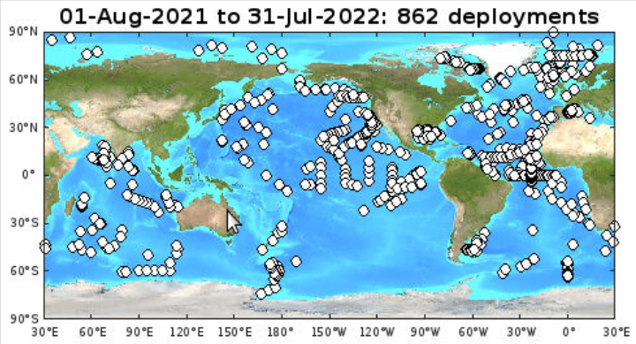

Fig. 1: Global Drifter Program deployment locations during the year.

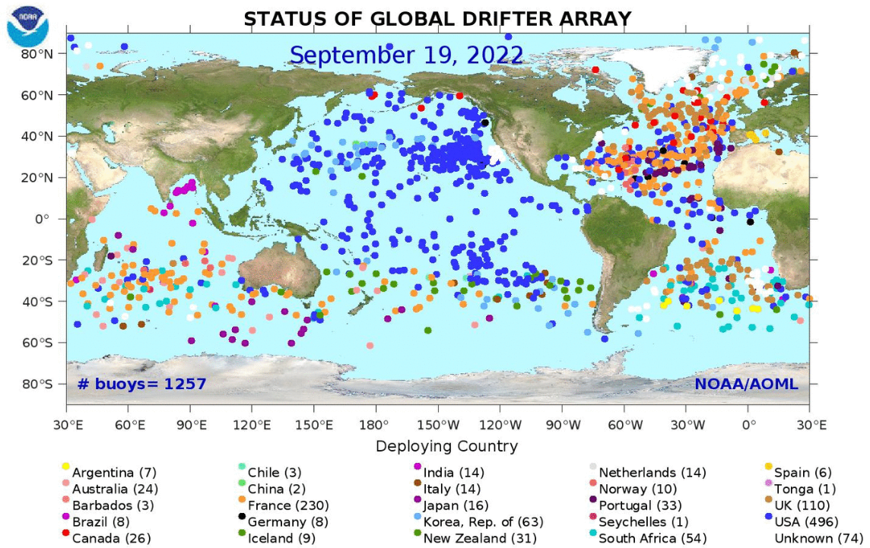

Fig. 2: Global drifter array status as of 19 September 2022. Figure from http://www.aoml.noaa.gov/phod/gpd.

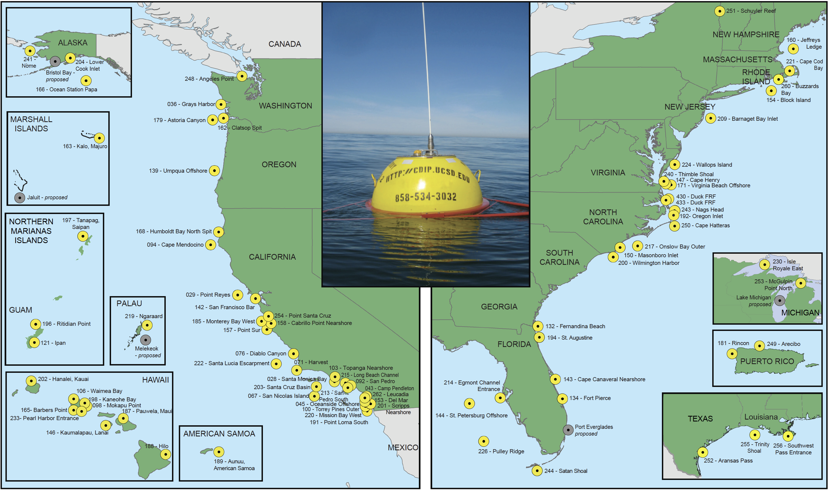
Fig. 3: Coastal Data Information Program (CDIP) monitoring locations.

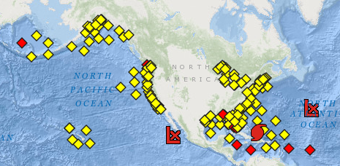

Fig. 4: NDBC Moored Buoys (MET/OCEAN), showing stations reporting in the last 8h (yellow) or not (red). Figure from http://www.ndbc.noaa.gov/obs.shtml. This image is for 20 September 2022.

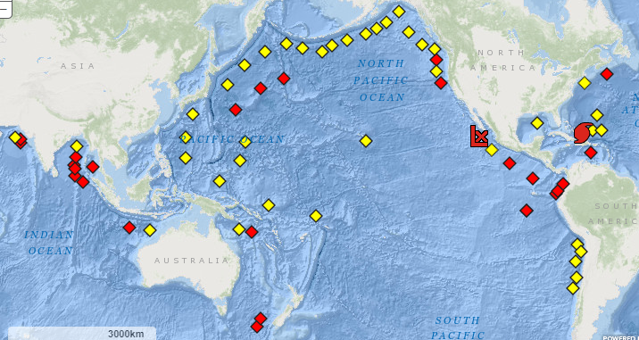

Fig 5: International Tsunami Network status, showing stations reporting in the last 24h (yellow) or not (red). Figure from http://www.ndbc.noaa.gov/obs.shtml. This image is for 20 September 2022.

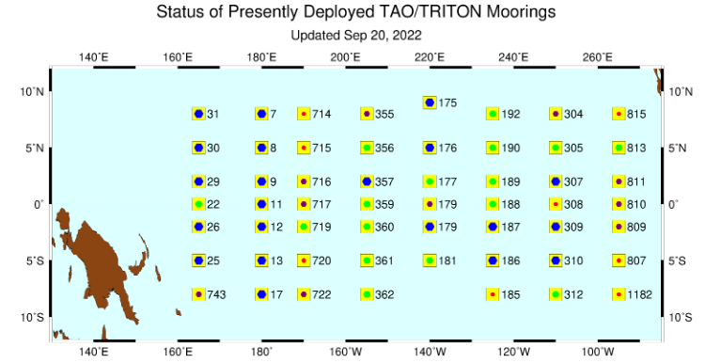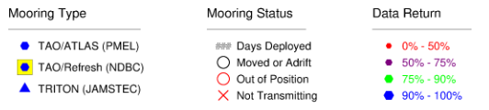

Fig. 6: NDBC Tropical Atmosphere Ocean (TAO) Array and TRITON Array status on 20 September 2022. The numbers indicate how many days have passed since last servicing (ideally <365). Figure from http://www.pmel.noaa.gov/tao/global/status/.

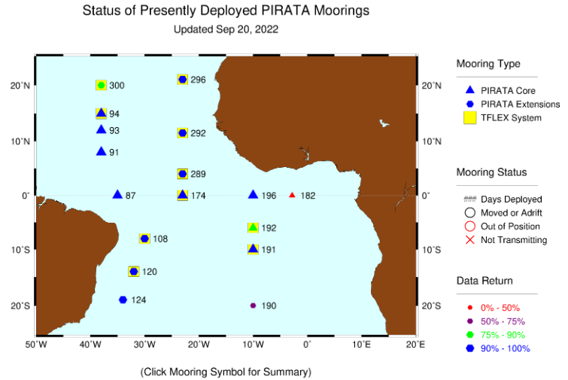
Fig. 7: PIRATA Array including PMEL/AOML Northeast Extension status on 20 September 2022. The numbers indicate how many days have passed since last servicing (ideally <365). Figure from http://www.pmel.noaa.gov/tao/global/status/.

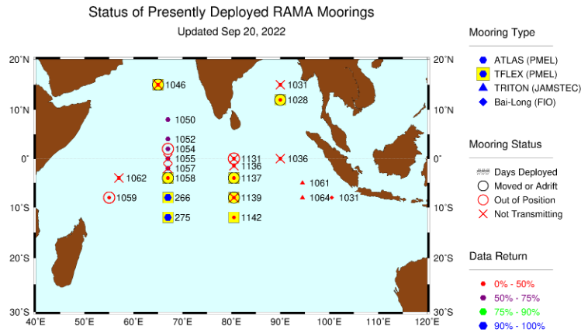

Fig. 8: International RAMA Array status on 20 September 2022. The numbers indicate how many days have passed since last servicing (ideally <365). Figure from http://www.pmel.noaa.gov/tao/global/status/.

