Report by the DBCP Action Groups to the
THIRTY-SEVENTH session of the DBCP
(Virtual; 8-12 November 2021)

1) Summary

Name of Action Group | Global Drifter Program
Date of report | 20 October 2022
Overview and main requirements addressed | Global Drifter Program (GDP). Goals: 1. Maintain a global 5x5° array of ~1300 satellite-tracked surface drifting buoys to meet the need for an accurate and globally dense set of in-situ observations of mixed layer currents, sea surface temperature, atmospheric pressure, winds, salinity, and waves; and 2. Provide a data processing system for scientific use of these data. These data support weather forecasting and ocean state estimation, short-term (seasonal to interannual) climate predictions as well as climate research and monitoring.
Area of interest | Global ocean
Type of platform and variables measured | Lagrangian drifters measuring surface velocity, SST; some drifters also measure sea level pressure, wind, salinity, and/or sub-surface temperature profiles as well as waves
Targeted horizontal resolution | 5 degree x 5 degree (~1300 units)
Chairperson/Managers | Dr Rick Lumpkin, NOAA/AOML, USA  Dr Luca Centurioni, SIO/LDL, USA
Coordinator | Operations Manager: Mr Shaun Dolk, NOAA/AOML, USA  Operations Manager at the Lagrangian Drifter Laboratory (LDL) of SIO: Mrs Lucia Bertero
Participants | Numerous national and international institutions
Data centre(s) | GDP Data Processing Center (DPC) – Manager: Mr Lance Braasch, SIO/LDL, USA  GDP Data Assembly Center (DAC) – Manager: Mr Shaun Dolk, NOAA/AOML, USA
Website | http://www.aoml.noaa.gov/phod/gdp  http://gdp.ucsd.edu/
Meetings  (meetings held in 2020/2021; and planned in 2021/2022) | Weekly Extreme Events and Ocean Observations (EEOO) telecons; biweekly GDP telecons
Current status summary | Annual size of array was 1363 drifters. Current size as of 17 October 2022 is 1263 drifters.
Summary of plans for next year | Maintain array at ~1300 drifters

2 Deployment plans for 2022-2023

Deployments in the period 1 August 2021 to 31 July 2022 are shown in Fig. 1. A total of 862 drifters were deployed during this period, compared to 896 drifters last year and 1100 drifters the year before.

In the coming year, the GDP Deployment Plan is:

Operational Buoy Deployments 800
Consortium Research Buoy Deployments 200

Total Deployments in 2018-2019 1000

More deployments may be needed to fill gaps in the global array as they develop, and will be conducted if more drifters are available for deployment.

3 Data management

3.1.1 Data policy

The GDP Data Assembly Center (DAC), located at NOAA’s Atlantic Oceanographic and Meteorological Laboratory (AOML), was recognized as an official DAC for Drifting Buoys in the Marine Climate Data System by the World Meteorological Organization during the Joint Technical Commission Session in Geneva, Switzerland, in November 2020. The drifter DAC provides access to drifters from GDP partners that have given Service Argos permission to make these data available to the DAC, and to Iridium drifters deployed under several VARs. In return, the partners have access to all quality controlled and interpolated data available in the database via the World Wide Web. The GDP DAC monitors data on the GTS for drifters managed by the GDP and advises LDL/SIO (Iridium drifters) or CLS (Argos drifters) to take sensor data and/or positions off GTS once their data becomes unreliable. Drifters managed by other centers, or upgraded drifters, should be monitored and their data also removed from the GTS when their sensors fail.

3.1.2 Real-time data exchange

The GDP Data Processing Center (DPC), located at the Scripps Institution of Oceanography’s (SIO) Lagrangian Drifter Laboratory (LDL), receives all drifter data from the Iridium satellite gateway, decodes their payload according to metadata and then archives, and relays these data onward to the DAC at AOML. The DPC also handles data insertion onto the GTS of all the GDP drifters, including the drifters with barometer upgrades.

All data from drifters in the GDP’s programs are disseminated via GTS as soon as drifters are deployed. The GDP monitors data going out on the GTS, and transmissions of sensors producing bad data or transmissions such as from grounded drifters are removed from the GTS data stream.

As of 10 October 2022, there were 1292 GDP drifters (including international partners such as ESURFMAR) transmitting good quality data on the GTS. Most of these drifters, using the Iridium Satellite System, were posted onto the GTS by the DPC at LDL/SIO. Other GDP partners are expected to distribute their drifter data on the GTS as soon as deployments have occurred. The GTS data timeliness is monitored by operational centers such as the DPC at SIO and other GDP collaborators, who report on these issues.

Access to real-time data can be obtained in several ways. One is described at http://www.aoml.noaa.gov/phod/gdp/real-time_data.php and is obtained via NOAA’s Observing System Monitoring Center (OSMC) site at https://www.osmc.noaa.gov/. Users can request data from a particular area, for particular days, and from individual or batches of drifters, as needed, in many formats including but not limited to NetCDF, ASCII, Matlab, and Excel.

The GDP LDL at SIO provides real-time data service/relay infrastructure. Users can request graphical websites with interactive plotting in addition to a URL-based query interface for downloading drifter data. This data may be downloaded in a number of formats including but not limited to HTML, ASCII, Matlab, and Excel. These services are available on request and have been provided to scientific collaborators on an as requested basis.

3.1.3 Delayed mode data distribution and exchange

The DAC assembles, quality controls, and interpolates data from approximately 1300 drifters per month from all GDP national and international partners, from all oceans of the world. These data are made available through the web with a delayed time of 2—3 months. As of late October 2022, quality-controlled data are available through 31 July 2022. These data can be accessed at http://www.aoml.noaa.gov/phod/gdp and also archived at NOAA/NCEI. The six-hourly data can be referenced as:
Lumpkin, Rick; Centurioni, Luca (2019). Global Drifter Program quality-controlled 6-hour interpolated data from ocean surface drifting buoys. [indicate subset used]. NOAA National Centers for Environmental Information. Dataset. https://doi.org/10.25921/7ntx-z961. Accessed [date].
The hourly dataset version 2.00 is officially available from NOAA NCEI at https://doi.org/10.25921/x46c-3620.

Drifter manufacturers send standardized specification sheets for all drifters with drogues centered at 15 meters. Along with metadata pertaining to the deployment process, sensor lifetimes, death date, mode of failure, and end location, metadata from these drifter specifications are archived at AOML and made available at www.aoml.noaa.gov/phod/gdp. Metadata provided by AOML are interrogated by JCOMMOPS and incorporated into their metadata systems.

Instructions to interpolate quality-controlled, interpolated data are given at http://www.aoml.noaa.gov/phod/gdp/images/ERDDAP_Interpolated_Data.pdf. The data are served by NOAA’s OSMC site. Users can request data from a particular area, for a particular time period, and from individual or batches of drifters, as needed, in many formats including NetCDF, ASCII, Matlab, and Excel.

3.2 Data quality

No new developments in the intersessional period.

4) Instrument practices

Technical supervision and developments related to the design of the Surface Velocity Program (SVP) drifter are led by the SIO/LDL component of the GDP. These developments aim to standardize and improve the drifter design. In previous years, this has included:
- Ruggedized tether attachment for strength and water infiltration implemented across the drifter fleet;
- Recommendation for high-quality batteries issued to manufacturers and implemented;
- Design of ruggedized battery packs;
- Recommendation for more accurate SST (0.05°C) issued to manufacturers and implemented by the SIO/LDL;
- Recommendation for ruggedized drogue design issued to manufacturers and implemented;
- New tether material (synthetic rope) is currently under evaluation
- Recommendation for usage of post-consumer recycled plastics where feasible
- Recommendations for issues related to real-time GPS management and patches for WRNO

5) Evolution of the Global Drifter array

The growth of the array through October 2022 is shown in Fig. 2. During the last year, the array had an average size of 1363 drifters. This period began with the array at 1402 drifters and concluded with the array at 1244 drifters.
Annex (optional)

Status maps and graphics

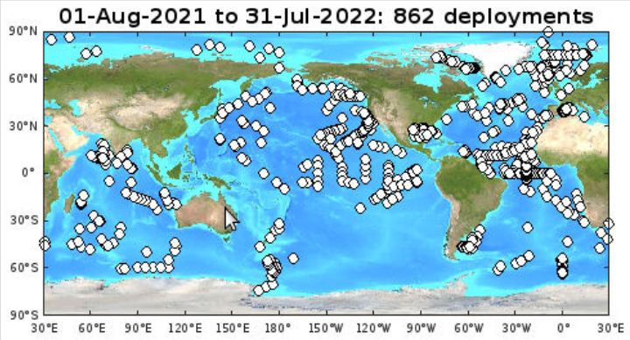

Fig. 1: Global Drifter Program deployment locations during the year

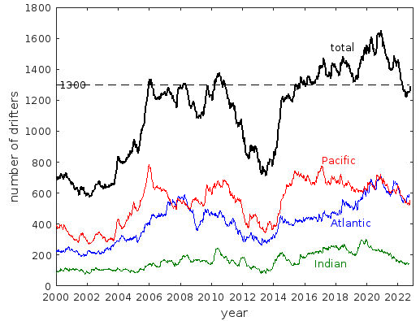

Fig. 2: Size of global drifter array, total (black) and in various subregions (color). Atlantic/Indian divided at 25°E in the Southern Ocean, Atlantic/Pacific at 70°W in the Southern Ocean, Indian/Pacific at 125°E south of Timor.

__________________

