DATA BUOY COOPERATION PANEL (DBCP)

FORMAT FOR NATIONAL REPORTS ON CURRENT AND
PLANNED BUOY PROGRAMMES

Country | China
Year | 2021.07 - 2022.08

- CURRENT PROGRAMME:

Please Identify your Programme’s Major Opportunities and Challenges/Risks during the upcoming year and how DBCP may assist your Programme.
(1) Buoy observation equipment is difficult to maintain
Buoy deployment is difficult and dangerous, which means the deployment method need to be improved, and there should be more protection methods. In addition, the marine forecast should be more accuracy to make sure the offshore operation is safe.
(2) More professionals are needed
The professionals for buoy maintenance are not enough, the personnel structure need to be improved to meet the requirement of high strength offshore operation.
Agency or programme | Ministry of Natural Resources
Number and type of buoys | (a) deployed during the year | 8 moored buoys, including 3m, 6m, 10m diameter moored buoys and, 15 Argo floats
Number and type of buoys | (b) operational as of 31 August | 31 moored buoys  58Argo floats  3 environmental buoys
Number and type of buoys | (c) reporting on GTS as of 31 August | 60
Purpose of programme  (check/uncheck boxes using [_] or [x] as appropriate) | (a) operational | [-]
 | (b) met / ocean research | [-]
 | (c) developmental | [-]
Main deployment areas | China Seas and adjacent waters, Tropical Western Pacific，Tropical Indian Ocean, the Arctic Ocean
Vandalism incidents | 6

Agency or programme | China Meteorological Administration
Number and type of buoys | (a) deployed during the year | 0
Number and type of buoys | (b) operational as of 31 August | 17 moored buoys, including 3m,6m,10m diameter moored buoys
Number and type of buoys | (c) reporting on GTS as of 31 August | 0
Purpose of programme  (check/uncheck boxes using [_] or [x] as appropriate) | (a) operational | [-]
 | (b) met / ocean research | [x]
 | (c) developmental | [x]
Main deployment areas | China Seas and adjacent waters
Vandalism incidents | 0

Agency or programme | Chinese Academy of Sciences
Number and type of buoys | (a) deployed during the year | 2
Number and type of buoys | (b) operational as of 31 August | 8 moored buoys, including 3m,6m,10m diameter moored buoys
Number and type of buoys | (c) reporting on GTS as of 31 August | 0
Purpose of programme  (check/uncheck boxes using [_] or [x] as appropriate) | (a) operational | [-]
 | (b) met / ocean research | [-]
 | (c) developmental | [-]
Main deployment areas | China Seas and adjacent waters
Vandalism incidents | 2

2. PLANNED PROGRAMMES:

Agency or programme | Ministry of Natural Resources
Number and type of buoys | planned for deployment in the next 12 months | 6 moored buoys
Purpose of programme  (check/uncheck boxes using [_] or [x] as appropriate) | (a) operational | [-]
 | (b) met / ocean research | [-]
 | (c) developmental | [-]
Main deployment areas | China Seas and adjacent waters, Indian Ocean, the Arctic Ocean

3. TECHNICAL DEVELOPMENTS:

(a) Buoy design | - After 30 years of development, the buoys in China has been continuously improved and the solar power supply system operates steadily and reliably.  - The wave sensors have been tested in practice for decades, and their reliability has been steadily improved and the data quality is good.  - In recent years, the buoy has adopted modern sensor technology, automatic control technology, special data analysis software and communication network. It can carry a variety of sensors involving water quality, hydrology, meteorology and other elements, and has excellent observation and monitoring capabilities to deal with complex marine environments. It is possible to collect high-quality ocean observation and monitoring data all day.  - The sensors on Ice stations are able to meet the requirement of the low temperature environment, and the data quality is good and reliable.
(b) Instrumentation | - Beidou satellite communication technology is becoming more and more mature, CDMA and dual Beidou transmission mode are gradually implemented in Chinese operational buoy, which is safe and reliable.

4. PUBLICATIONS (on programme plans, technical developments, QC reports, etc.):

Ref | Title | Type
1 | Solution of Bailong buoy data sharing through GTS. | Technical developments
2 | A configurable data receiving controller for ocean buoys and its configuration method. | Technical developments

5. ADDITIONAL COMMENTS:

(a) Quality of buoy data
(b) Communications
(c) Buoy lifetimes
(d) Data Accessibility
(e) New Observations
(f) GFCS and WIGOS
(g) Additional Requirements
(h) DBCP Linkages
(i) Contribution to UN Decade and UN SDGs | ●
(j) Other (i.e. Impact of COVID19 on observing systems and mitigation efforts) | - At present, the COVID-19 outbreak is under control in China, and the buoy observation network is less affected by the pandemic. Various tasks are progressing steadily, and offshore buoys are operating normally.  - The international cooperation is stagnated due to COVID-19, and the maintenance of oversea buoys is difficult.
Note: It is recommended that this form is filled in electronically and returned also electronically to the Secretariat. A template of the form can be downloaded from the following SharePoint site:

https://wmoomm.sharepoint.com/:w:/s/wmocpdb/EQ1z8KndbxREkzE6RH4NFkkBDdvOItne74OP8f4voMMSbg?e=pgru6r

Annex - Form for reporting incidents of vandalism on data buoys
Country |  |  | China
Contact person e-mail |  |  | Yue Xinyang, National Marine Data and Information Service, email: yue_xin_yang@outlook.com
Year | Buoy Location |  | Type of Buoy  (e.g. Tsunami / Met -Ocean Buoy/Drifter/ARGO floats/ Other) | Type of damage to buoy | Buoy id/WMO id | Number of days of transmission lost | Cost of replacement | Remarks  (e.g. whether photos have been taken)
Year | Latitude | Longitude
2021.7 | / | / | Met-ocean buoy | Malfunction | / | 15 | 0.27 | Yes(Fig.1)
2021.9 | / | / | Met-ocean buoy | Malfunction | / | 30 | 0.09 | Yes(Fig.2)
2022.7 | / | / | Met-ocean buoy | Typhoon damage | / | 0 | 16.29 | No
2022.4 | / | / | Met-ocean buoy | Destroy | / | 0 | 25.71 | Yes(Fig.3)
2022.6 | / | / | Met-ocean buoy | Drifting | / | 0 | 7.14 | No
2021.9 | / | / | Ice station | Malfunction | / | / | / | No
2021.11 | / | / | Other | Malfunction | / | / | / | No
2022.3 | / | / | Other | Malfunction | / | / | / | No
Efforts taken against vandalism |  |  | - Real-time buoy monitoring system is installed.  - Improve the remote monitoring of buoy, such as install video camera and alarm system, AIS system installed to prevent collision, etc.  - To strengthen the security capabilities of fasteners, such as increasing anti-theft bolts.  - To strengthen the running state monitoring and control of the buoy.  - Paste water proof warning notice, program label and multiple languages introduction of buoy and contact information on buoys. |  |  |  |  |  |  |  |  | /
Awareness meeting Organized |  |  | At 12 May 2022, SOA organized a publicity activity to publicize the importance of buoys for public services, disaster prevention and mitigation. Meanwhile SOA used its WeChat account to publish articles to publicize the destruction of the buoy and call for protection of the buoy.
Suggestions (if any) |  |  | - To establish the monitoring system of buoy operation.  - To establish a coordination operation with the China Coast Guard to establish and improve the regular inspections and maintenance of buoys  - To strengthen buoy management after deployed.  - To establish maintenance system of buoy operation.  - To strengthen the education, improve the senses of people in protecting scientific equipment.
Photos on Vandalism
Note: It is recommended that this form is filled in electronically and returned electronically also to OceanOPS(dbcp-tc@jcommops.org and karen.grissom@noaa.gov ). A template of the form can be downloaded from the following SharePoint site: https://wmoomm.sharepoint.com/:w:/s/wmocpdb/EXsq1FXv0vpHmOjQA-tTobwBMrNnjXnaQok3oudPhKIb3A?e=2IR9Wh

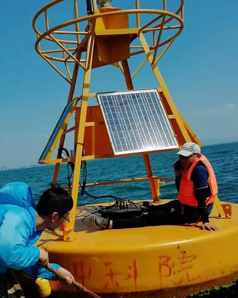
Fig.1 Malfunction

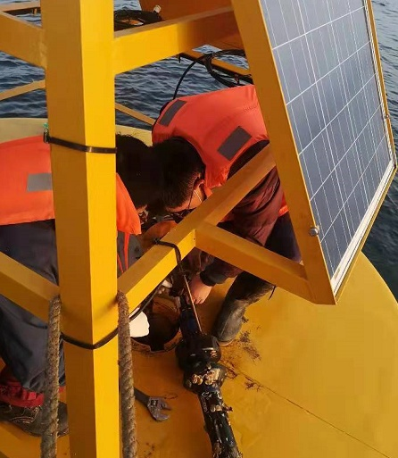
Fig.2 Malfunction

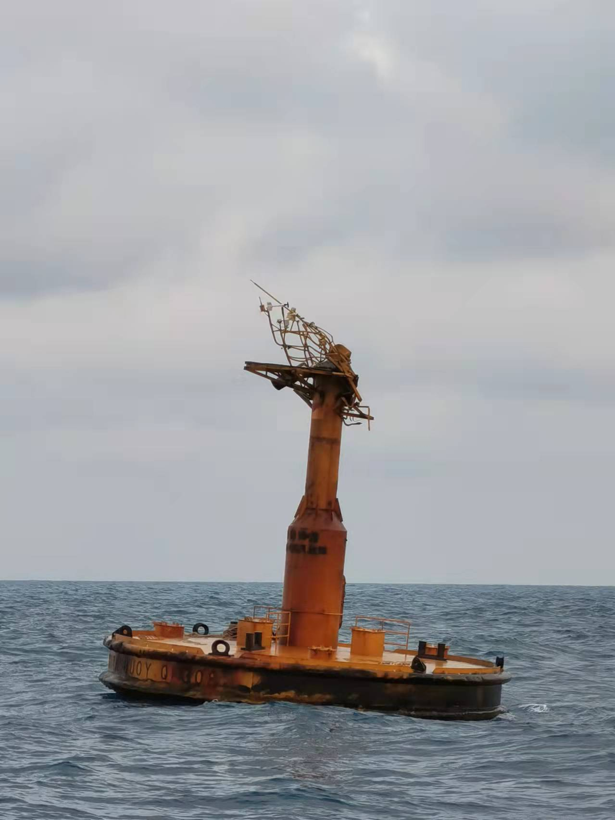
Fig.3 Destroy
Inputs to ITP report
China
Tsunami buoys are mainly located in South China sea and East China sea. In South China sea, the tsunami buoys and coastal seismic stations have been deployed by SOA to detect earthquakes that may trigger local tsunamis. These buoys have been damaged many times since they were deployed, and have stopped data transmission. At present, SOA has completed the repair of one tsunami buoy by cooperating with the buoy manufacture by integrating the existing tsunami buoy hardware, and cooperate with relative departments to carry out the site selection work for new stations.
In East China sea, the surface hydrology and metrology observations are normal, but there has been a malfunction for the sub-surface tsunami warning and mitigation system. The buoy manufacture had carried out the maintenance this year, but not finished yet due to the sea condition. The re-maintenance work is in preparation and will be implemented soon.

: Types of publications: (1) Implementation, (2) Operations, (3) Instrumentation, (4) Quality Management, (5) Data Management, (6) Data collection and/or location, (7) Data use, (8) Other
¹: Types of publications: (1) Implementation, (2) Operations, (3) Instrumentation, (4) Quality Management, (5) Data Management, (6) Data collection and/or location, (7) Data use, (8) Other ?How does the international community access the ocean observing data provided by your Organization
What new ocean observations does your Organization plan to make in the upcoming year (i.e. new parameters, expanding geographic scope, filling spatial or latency gaps)?
How do your Organization’s observations contribute to the WMO’s Integrated Global Observing System (WIGOS) and/or Global Framework for Climate Services (GFCS)?
What additional requirements (other than climate) does your organization have that are currently not adequately addressed by the DBCP?
How would your organization benefit from DBCP’s closer linkages to the Global Ocean Observing System(GOOS), Data Management and Modelling Communities?
How do your ocean observing networks contributing to the UN decade on Ocean Science and UN Sustainable Development Gloats .

