Report by the DBCP Action Groups to the
Thirty-EIGHth session of the DBCP (DBCP-38)
(Hybrid session, 1-4 November 2022)

1) Summary

Name of Action Group | International Programme for Antarctic Buoys (IPAB)
Date of report | 31 October 2022
Overview and main requirements addressed | The Participants of the WCRP/SCAR International Programme for Antarctic Buoys (IPAB) work together to maintain a network of drifting buoys in the Southern Ocean, in particular over sea ice, to provide meteorological and oceanographic data for real-time operational requirements and research purposes.
Area of interest | South of 55°S and that region of the Southern Ocean and Antarctic marginal seas within the maximum seasonal sea-ice extent.
Type of platform and variables measured | Ice buoys measuring the following:  Minimum variables: Buoy position  Basic variables: Buoy position, atmospheric pressure and SST  Other variables: Air temperature, ice and/or snow temperature, atmospheric pressure tendency, wind speed and direction, snow accumulation, other sea-ice properties and oceanographic variables
Targeted horizontal resolution | 500 km x 500 km
Chairperson/Managers | Dr Petra Heil, Australian Antarctic Division and Australian Antarctic Program Partnership, Hobart, Australia
Coordinator | Dr. Christian Haas, York University, Toronto, Canada; and: Alfred Wegener Institute for Polar and Marine Research, Bremerhaven, Germany  Dr. Ignatius Rigor, University of Washington, Seattle, USA
Participants | - Alfred Wegener Institute, Germany  - Australian Antarctic Division, Australia  - Bureau of Meteorology, Australia  - British Antarctic Survey, UK  - Finnish Institute for Marine Research, Finland  - GI, University of Alaska Fairbanks, USA  - IARC, University of Alaska Fairbanks, USA  - National Ice Center, USA  - National Snow and Ice Data Center NSIDC, USA  - ISDM/MEDS, Dept. of Fisheries and Ocean, Canada  - Meteorological Service NZ LTD, New Zealand  - Norwegian Polar Institute, Norway  - Polar Science Center, Univ. of Washington, USA  - National Institute of Polar Research, Japan  - JAMSTEC, Japan  - Programma Nazionale di Ricerche in Antartide, Italy  - DAMTP, UK  - SAMS, UK  - York University, Toronto, Canada  - CLS/Service Argos, France  - South African Weather Service, South Africa- Meteorological Office, UK  - CRREL, USA
Data centre(s) | Alfred Wegener Institute for Polar and Marine Research, Germany:  http://www.pangaea.de/search?q=ipab  http://data.meereisportal.de/gallery/index_new.php?lang=en_US&active-tab1=method&active-tab2=buoy  National Snow and Ice Data Center NSIDC, USA:  http://nsidc.org/data/docs/daac/nsidc0084_ipab_antarctic_buoys.gd.html
Website | http://www.ipab.aq/
Meetings  (meetings held in 2019/2020; and planned in 2020/2021) | IPAB Participants last held their annual meeting on June 15, 2018, and had a joint meeting with IABP on June 17, 2018 in Davos Switzerland.
Current status summary (mid-2022) | - Only 20 buoys reporting in the area south of 55S.  - Buoys primarily provided by NOAA Global Drifter Program, and AWI.  - Logistics primarily provided by AWI, BOM, KOPRI, NIPR, NIWA, NZ Navy, SAWS, USAP  - Most of the Southern Ocean remains sparse, especially in areas of sea ice and along the Antarctic Coast.
Challenges/Opportunities/Risks (intersessional period- highlighting the impact of COVID19 and mitigation plans) | - Small number of buoys and short survival times remain important challenges.  - Need boost.
Summary of plans for 2023 | GDP has been deploying SVPs in collaboration with Japan’s National Institute of Polar Research (NIPR) which has been deploying ~10 drifters/yr, at roughly 60S, 85E-110E.  New Zealand Navy has also been deploying SVP buoys north of the ice, they facilitate NZ Met Service activities.  RV Polarstern plans to sail to the Southern Ocean Winter 2022-2023.

3 Data management

3.1 Distribution of the data

3.1.1 Data policy

Data are generally freely distributed among IPAB participants as part of general scientific collaboration. Participants are encouraged to submit their data to the IPAB coordinator upon completion of their own scientific analyses.

3.1.2 Real-time data exchange

Participants are encouraged to transmit their data to the GTS. Most of the buoys deployed by the USIPAB program transmitted to the GTS. Other participants are overwhelmed by new requirements due to increased usage of Iridium transmission.

3.1.3 Delayed mode data exchange

We work closely with the Integrated Science Data Management Service (ISDM) of the Department of Fisheries and Ocean (DFO), Canada on the reception, archiving, and posting of IPAB GTS data.

3.2 Data quality

Data quality is an ongoing issue. QC is performed by the individual science groups, or by some national data centres and the DBCP when data are transmitted to the GTS.

5) Details of Challenges/Opportunities/Risks

- Small number of buoys and short survival times remain important challenges.
- Need more buoys and ships to deploy within the targeted network grid of 500 km x 500 km
__________________

Partnerships

All SVP-B drifters deployed as part of the IPAB were supplied by the NOAA GDP and AAD.
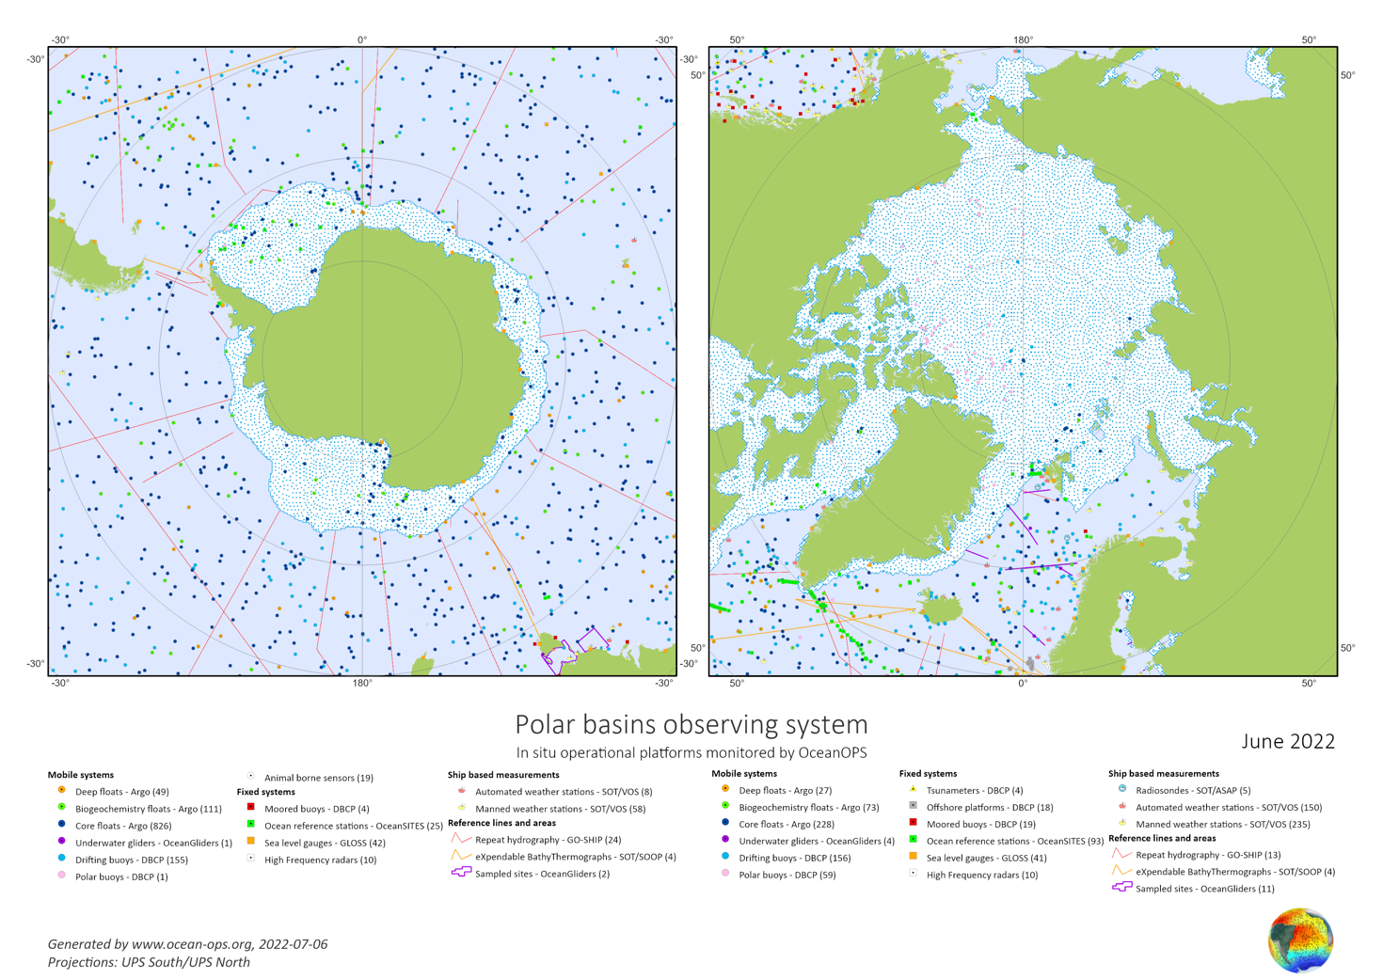
Figure 1: Status of Southern Ocean (left; and Arctic, right) GTS buoy network, June 2022.

