Report by the DBCP Action Groups to the
Thirty-EIGHth session of the DBCP (DBCP-38)
(Hybrid session, 1-4 November 2022)

1) Summary

Name of Action Group | International Arctic Buoy Programme (IABP)
Date of report | 31 October 2022
Overview and main requirements addressed | Participants of the IABP continue to work together to maintain a network of drifting buoys on the ice of the Arctic Basin to provide meteorological and oceanographic data for real-time operational requirements and research purposes including support to the World Climate Research Programme (WCRP) and the World Weather Watch (WWW) Programme.
Area of interest | Arctic Ocean and its marginal seas, excepting Exclusive Economic Zones, where agreements of the Coastal States have not been obtained.
Type of platform and variables measured | Buoys on ice and/or in water measuring basic meteorological variables such as atmospheric air pressure and surface temperature. Other variables such as: atmospheric pressure tendency, air chemistry (e.g. ozone), snow and sea-ice properties, as well as sub-surface oceanographic characteristics (e.g. temperature and salinity)
Targeted horizontal resolution | 250 km x 250 km
Chairperson/Managers | Chairperson: Dr Christian Haas, Alfred Wegener Institut (AWI) for Polar and Marine Research, Bremerhaven, Germany  Vice Chairperson: Dr. Takashi Kikuchi, Japan Agency for Marine-Earth Science and Technology (JAMSTEC)
Coordinator | Dr. Ignatius Rigor, Polar Science Center, University of Washington, Seattle, WA, USA
Participants | Participants range from Science Institutions to Universities to Government Agencies.  http://iabp.apl.uw.edu/overview_participants.html.  Participant contributions are shown on this site http://iabp.apl.uw.edu/overview_contributions.html.
Data centre(s) | http://iabp.apl.uw.edu/
Website | http://iabp.apl.uw.edu/
Meetings  (meetings held in 2019/2020; and planned in 2020/2021) | IABP Participants cancelled their annual meetings for 2020–2022 due to COVID-19, and held their last annual meeting on 21-31 May, 2019 in Seattle, USA.
Current status summary (mid-2020) | As of June 2022, 200 buoys were reporting.
Challenges/Opportunities/Risks (intersessional period- highlighting the impact of COVID19 and mitigation plans) | The primary challenge for the IABP is maintain the network in the Eurasian Basin of the Arctic Ocean (Fig. 1). Collaboration with the Arctic and Antarctic Research Institute (AARI) in St. Petersburg, Russia, and other Russian Agencies has been ceased due to the Russian/Ukrainian War.
Summary of plans for 2023 | Summer is the primary deployment season in the Arctic.  Participants will deploy over 150 buoys ranging from: Ice Trackers which simply provide GPS positions of the drifting sea ice, SVP’s providing surface air pressure, buoys providing air pressure and air temperature, Ice Mass Balance buoys, Oceanographic Profiling buoys measuring temperature and salinity down to 800m.  A broad overview map of our deployments plans is shown in Fig. 2. Details may be viewed at http://iabp.apl.washington.edu/overview_deploymentplans.html.  Plans for future years will be similar.

2 Deployment plans for 2022 - 2023

3 Data management

3.1 Distribution of the data
Most of the meteorological and oceanographic data is posted on the GTS. Much of the ice data and atmospheric chemistry data are available from Participants’ web pages. Efforts continue to have those using Iridium communication to find means to post data to the GTS.

3.1.1 Data policy
Data exchange policies of the Participants for that data not getting onto the GTS has not been catalogued. However, most Participants have web sites that display data and/or graphs of the data.

3.1.2 Real-time data exchange
Participants are encouraged to transmit their data to the GTS. Most of the buoys deployed by the USIABP transmit to the GTS. Other participants are overwhelmed by new requirements due to increased usage of Iridium transmission.

3.1.3 Delayed mode data exchange
We work closely with the Integrated Science Data Management Service (ISDM) of the Department of Fisheries and Ocean (DFO), Canada on the reception, archiving, and posting of IABP GTS data.

3.2 Data quality
Feedback is ad hoc. Data is suppressed when noted to be questionable. The IABP Coordinator participates in the buoy QC forums of the DBCP and JCOMM, and performs day-to-day QC of the data. More thorough QC of the data is performed during the analysis and production of the research data bases.

4) Instrument practices

We are currently in the midst of a sensor intercomparison for the various buoys/instruments that we use to observe polar meteorology and oceanography at the Arctic Observing Experiment (AOX) test site in Utqiaġvik, Alaska.

Data analyses procedures for the Arctic are documented in journal papers. As part of our efforts to collect and provide the metadata, details on instruments and other procedures will be provided through our web pages.

5)Details of Challenges/Opportunities/Risks

Our challenges remain the same, i.e. maintaining the network of buoys in an ocean of increasingly dynamic sea ice, and deploying buoys in the Eurasian Arctic. As shown in Fig. 1, the need to find ways to deploy buoys in the Eurasian Arctic has been exacerbated by the Russian/Ukrainian war.
__________________
Annex (optional)

Status maps and graphics

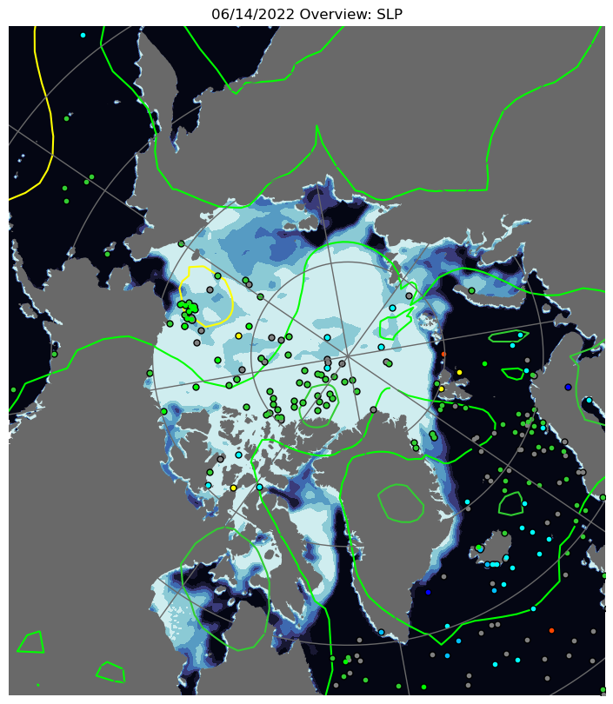

Figure 1. Map of buoy positions on 15 June 2022 from IABP.apl.uw.edu There are currently 200 buoys reporting in the IABP observing network (buoys north of 60N). Note gap in Eurasian sector of the Arctic Ocean (upper half of map).

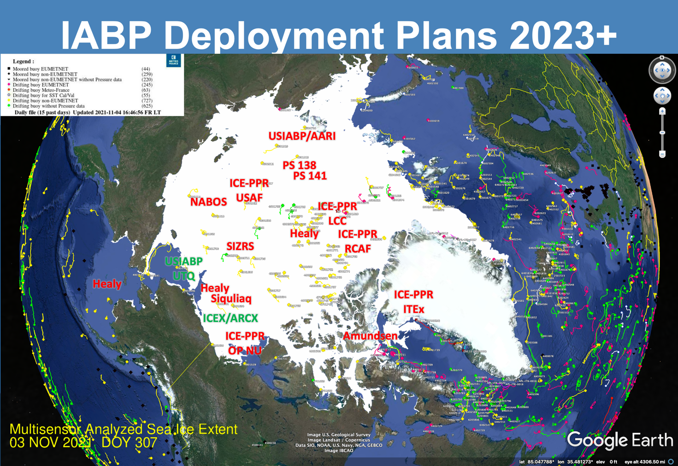

Figure 2. Broad overview of IABP deployment plans. The IABP and Collaborators planned to deploy over 150 buoys during the Spring (green), and Summer (red) of 2022.

Details may be found at http://iabp.apl.uw.edu/overview_deploymentplans.html

__________________

