TOWS TT DMP Meeting online
17 November 2022
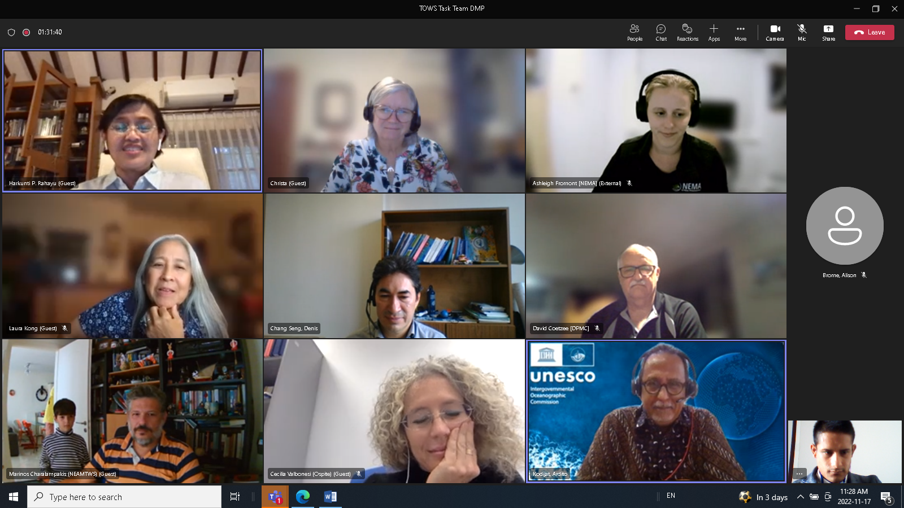
- Wave Exercises
PacWAVE
- PacWAVE was organised between September – November 2022.
- Emphasis on Regional Cooperation: South America, South China Sea, and the Pacific Islands (9 Nov). Expect preliminary results for the TOWS 2023 meeting.
IOWAVE
- It will be conducted in 2023. Currently under preparation.
CARIBE WAVE
- The exercise is held every year (March) by decision of the Member States.
- The CARIBE WAVE dedicated website with information on past and present exercises is transitioning from NOAA to the ITIC UNESCO IOC international exercise section of website.
- CARIBE WAVE 22 report is available on exercise website, over 410,000 people participated in 47 of the 48 Member States and Territories.
- CARIBE WAVE 23 will take place on 23 March 2023.
- There will be two scenarios, one based on an earthquake off Honduras and second, for testing of volcano EWS, an eruption and flank collapse of Mount Pelée, Martinique.
- Article accepted for publication on the Bulletin of Seismological Society of America, which will summarize over 10 years of exercises in the Caribbean.
NEAMWave:
- Exercises are conducted, under normal conditions, every two years, traditionally in November.
- During the last exercises joint scenarios are conducted between two message providers. An effort for 3 providers issuing messages for the same scenario is under discussion.
- Discussion about aligning the NEMAWave23 exercise with the exercises foreseen in the CoastWAVE project. If this is decided, the scenarios and dates of the exercise must be selected accordingly, covering the needs of 7 different coastal communities all around the North-eastern Atlantic and the Mediterranean. However, it is recognized by everyone that this would be a very demanding and complicated task.
- An objective is to have more inclusion of the Civil Protection Agencies by providing orientation information and workshops.
- Dates to conduct the exercise will be confirmed during the ICG/NEAMTWS XVIII Session in March/April 2023.

- State of Tsunami Ready Implementation / Internal Workflow
NEAMTWS:
- Target is to have 7 Tsunami Ready recognized communities from the CoastWAVE project and 3 communities from traditional country funding by the end of 2023. Tsunami Ready implementation is slow but progressing.
- Exercise carried out for the first time in Istanbul with participation of children in the CoastWAVE project community.
IOTWMS:
- Target is to have 9 communities recognized by early 2023.
- An Indian Ocean tsunami ready hybrid workshop will be held on the 22-26 November 2022.
CARIBE-EWS
- A total of 15 communities have been recognized in 12 countries.
- Target is to have another 9 communities recognized by the end of 2023.
- Finalized renewals of two communities and two more in pending status.
Pacific EWs
- Twelve communities in five countries have been recognized, but they were all done under the pilot programme. Another five communities are very close to becoming Tsunami Ready recognized.
General Discussion
- Some communities are proactive in TEWS implementation/preparedness under their own terms. How to allow these communities to become involved in the IOC UNESCO Tsunami Ready programme while they continue their own implementation process (an issue for some bigger member states such as the USA, China, Chile, and Japan).
- New Zealand used some of the TR indicators to develop their own tsunami regional plan. A template will be drafted to use KPI's in a wider hazard context (liaise with WMO who may be interested to know this) – to be reported in TOWS.
- Further discussed, how do we continue working with partners as there is continuous progress in tsunami ready implementation globally – specifically on reaching the target of protecting 100 % of communities at risk.
- Global coordination of Tsunami Ready and Internal workflow, common repository of templates is being finalized by TICs and Tsunami Unit.
- Tools have been developed to scale up tsunami ready:
- ITIC is hosting Tsunami Ready website: communities that become recognized officially, they will have their own web page.
- Tsunami Ready map viewer: is live and can also be accessed through the ITIC Tsunami Ready website, it highlights recognized communities, countries where TR is being implemented and communities where TR recognition is in progress. It is still a work in progress.
- Recommended a TICs meeting around TOWS 2023.
- What kind of templates would be good to have that will help countries express interest and implement Tsunami Ready.
- Tsunami Information Centres (TICs) and Updated Terms of Reference (ToRs)

- The ICG/PTWS Steering Committee has agreed on new TIC ToRs. They will be discussed in the next ICG/PTWS meeting from 28 November to 3 December 2022.
- The ICG/NEAMTWS will consider the PTWS/IOTWMS versions and discuss the item in the NEAMTWS expert meeting (28-30 November 2022 and the ICG Session in March/April 2023).

- Tsunami Symposium

- No updated information on Tsunami Symposium.
- To be discussed at the expert NEAMTWS meeting in Nov 2022, Naples, Italy.
- The Chair of TOWS TT DMP is also chair of symposium.
- To organise a meeting to focus on next tsunami symposium.

- Global NTWC Competency Framework

- The ICG/PTWS has created a draft to be reported during the next TOWS meeting.

- Check Status of Tsunami Glossary Version 2022 (Quick review)

- Laura Kong, can volunteer to take the lead and try to compile content/information from various stakeholders.
- How much and what needs to be added/updated to the glossary? Terms? Pictures/Images?
- Need to discuss if this is a Secretariat or TOWS matter and real budget needs
- The tsunami Glossary 2019 version is uploaded under the OTGA platform.

KEY FOLLOW UP ACTIONS
Action: Recommended a TICs meeting around TOWS 2023.
Action: To organise a meeting to focus on the next tsunami symposium.
Action: On the Tsunami Glossary Version 2022, Laura Kong, to (volunteer), take the lead and compile content/information from various stakeholders.
Action: On the Tsunami Glossary Version 2022, check if there are any terms and figures to be clarified. Discuss budget needs.
Action: Define templates that will help countries express interest and implement Tsunami Ready.
Action: Discuss partnership / synergies development as there is continuous progress in tsunami ready implementation globally – specifically on reaching the target of protecting 100 % of communities at risk.
Action: Discuss how communities that follow their own tsunami prepared programmes e.g. New Zealand) can link to the IOC UNESCO Tsunami Ready Recognition Programme.
Action: To discuss in the next TTDMP meeting about tsunami guidance for critical infrastructure, multi hazard framework in WTAD activities, and school programme.

