PTWC Proposal to Expand the Earthquake Source Zone of the PTWS to Include the Southernmost Atlantic.
Background
The August 12, 2021, Mw 8.1 earthquake in the South Sandwich Islands demonstrated that the southern Atlantic seismic zone that encompasses the Scotia Arc Subduction Zone is a tsunami threat to PTWS coasts. Tsunami waves from this earthquake reached PTWS coasts within 4-6 hours (e.g., southernmost Chile and bases on the Antarctic Peninsula) and tsunami waves of more than 0.2 m amplitude were recorded in the Pacific as far away as French Polynesia, Hawaii, and Alaska (Figure 1).
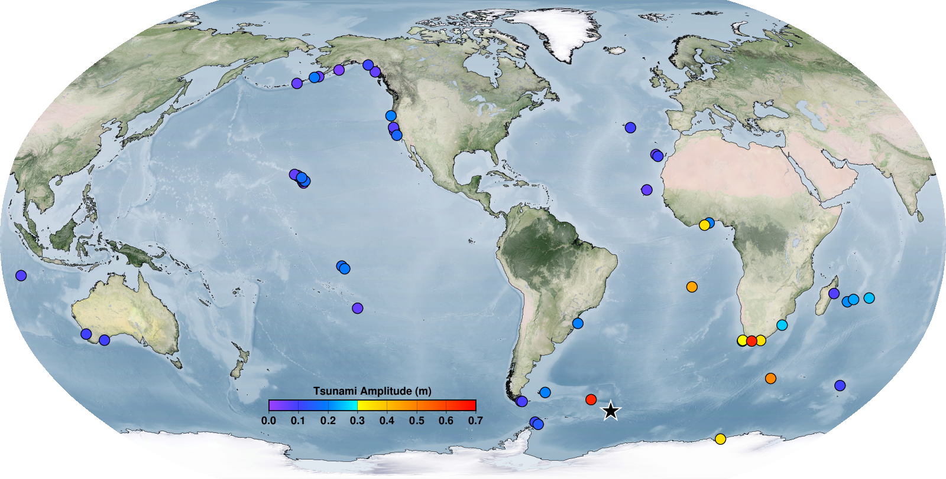
Figure 1. Tsunami amplitudes from the August 12, 2021 magnitude 8.1 earthquake in the South Sandwich Islands (black star) recorded on coastal sea-level gauges in the Atlantic Ocean, Pacific Ocean, Indian Ocean, and Antarctica. Each dot represents a gauge, and the color of the gauge indicates the tsunami amplitude in meters as shown in the color-bar legend.
The southernmost Atlantic where this earthquake occurred is currently a part of the CARIBE-EWS Earthquake Source Zone (Figure 2). Large earthquakes in this seismic zone occur frequently. Since the year 2000, 33 earthquakes of magnitude 6.5 or larger have occurred there -- appropriate for a Tsunami Information Statement for the CARIBE-EWS. Yet earthquakes from this region are less of a tsunami threat to CARIBE-EWS coasts than they are to PTWS coasts, as illustrated by the August 12, 2021, event. The east-west directionality of the main beams of energy as well as the South America land mass effectively limit tsunami energy going towards the Caribbean (Figure 3). Aside from being more of a threat to the Pacific, such tsunamis are also more of a threat to IOTWMS coasts than to CARIBE-EWS coasts and they are obviously a threat to southern Atlantic coasts where there currently is no system. Six observations above the 0.3m threat level were recorded on gauges in the southern Atlantic (Figure 1).
Figure 2. The current CARIBE-EWS Earthquake Source Zone.
Current rules allow the Tsunami Service Providers of one system to issue products for earthquakes outside of their own system’s Earthquake Source Zone, either if they forecast or record tsunami amplitudes of 0.3m or more within their own coastal service area, or if the earthquake might reasonably create concern about a tsunami threat in their area even when there is not a threat. But those events should be an exception. For Scotia Arc events, the most concern is routinely within the PTWS coastal service area. Yet those events are not part of the PTWS Earthquake Source Zone (Figure 4).
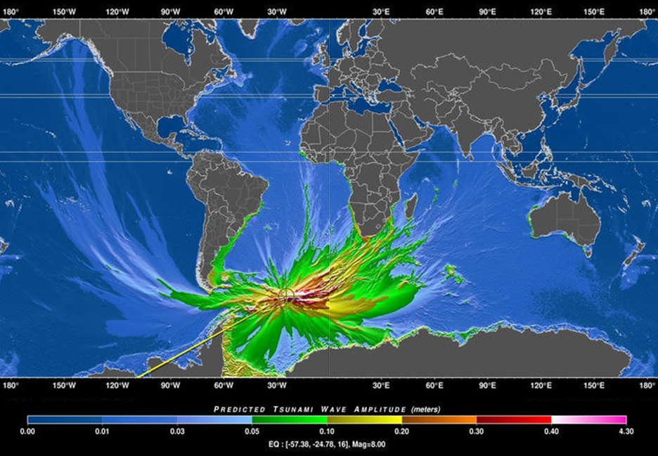
Figure 3 Numerical simulation of the tsunami produced by the August 12, 2021 magnitude 8.1 earthquake in the South Sandwich Islands. The maximum deep-ocean amplitudes of the tsunami are indicated by the color scale at the bottom. The complex directional pattern of tsunami energy is due to the shape and amount of seafloor deformation as well as refraction by bathymetry.
Proposal
PTWC proposes to expand the PTWS Earthquake Source Zone to include part of the southern Atlantic Ocean that encompasses the Scotia Arc and its adjacent seismic zones (Figure 4). If the ICG/PTWS endorses this change it will be taken to the TOWS-WG Task Team on Tsunami Watch Operations for discussion. If they approve then a recommendation will be forwarded to the TOWS-WG. If they endorse the proposal then it will go the IOC General Assembly for final approval.
Potential related changes accompanying this proposed change could include the removal of this source region from the CARIBE-EWS Earthquake Source Zone (with ICG/CARIBE-EWS approval), and the addition of this source region to the IOTWMS Earthquake Source Zone (with ICG/IOTWMS approval).
The August 12, 2021 earthquake and tsunami might also motivate a reconsideration by South American and African countries bordering or within the South Atlantic regarding their inclusion in the IOC’s Tsunami Warning Programme.
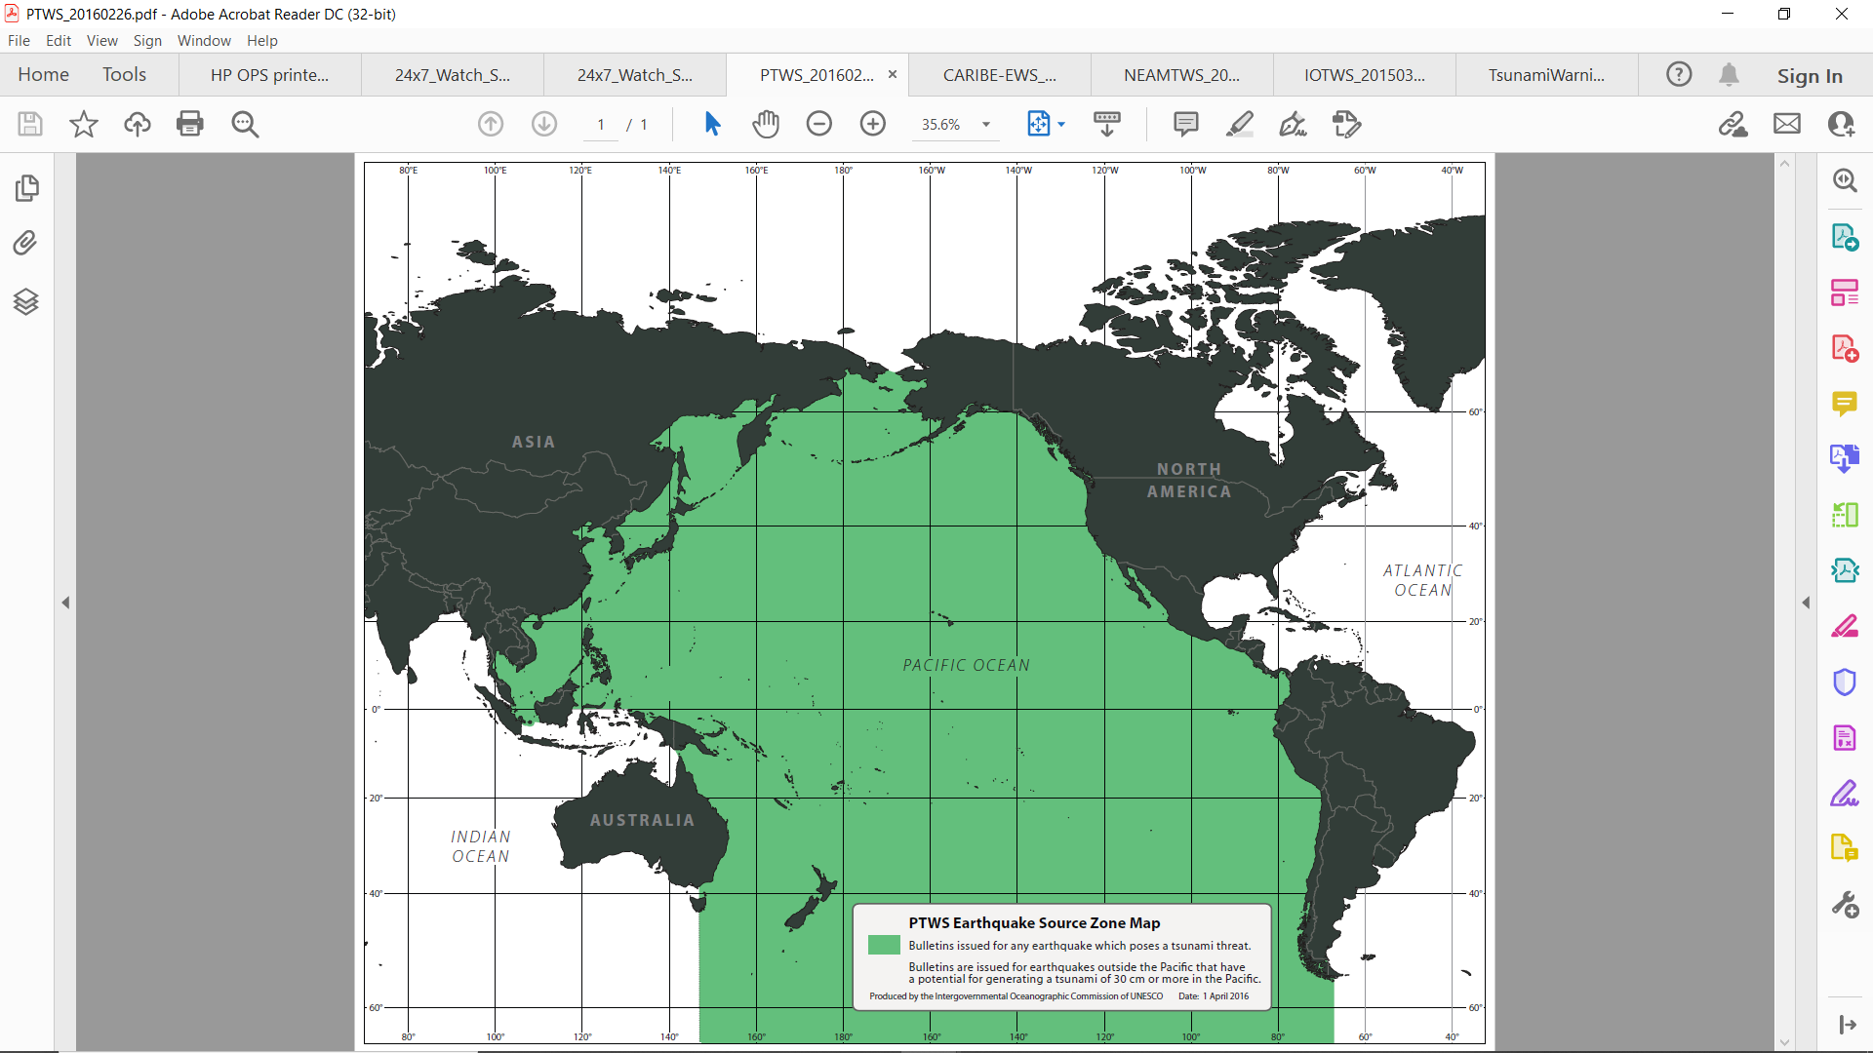
Proposed Addition
Figure 4. The current PTWS Earthquake Source Zone is indicated in green. The gray box at the lower right indicates the approximate proposed addition to the PTWS ESZ that would include the seismic zone associated with the Scotia Arc and South Sandwich Islands.

