The Fourteenth session of the Observations Coordination Group (OCG-14)
Cape Town, South Africa
6-8 June 2023

INFORMATION NOTE FOR IN-PERSON PARTICIPANTS

VENUE OF THE MEETING
OCG-14 will be held from 6 to 8 June 2023 at the Peter Stoker Centre, Department of Forestry, Fisheries and the Environment (DFFE) East Pier Building, V+A Waterfront, Cape Town, South Africa.

The meeting will be preceded by a number of side events as listed below (all at the same venue):

- GOOS Co-Design Boundary Current Exemplar session on 5 June 2023 (tbc)
- Low-cost sensor workshop, 2 June 2023 [Ann-Christine Zinkann, Juliet Hermes]
- Group building activity, 5 June 2023 (tbc)
- GOOS Co-Design Boundary Current Exemplar session, 5 June 2023 [Tammy Morris, Ann-Christine Zinkann]
- Capacity Development in high schools, 9 June 2023 [CD Team]

ARRIVAL AT MEETING
Check in for the Workshop and the OCG-14 session will take place at the registration desk in the venue on 6 June 2023 from 8.30 to 9.00 a.m. Participants are encouraged to bring a name tag at the time of registration [you are encouraged to use a prior name tag to reuse and recycle].

WORKING LANGUAGE
The working language will be English only.

ENTRY VISA REQUIREMENTS
A List of countries exempt from requiring a visa to enter South Africa is available here: http://www.dha.gov.za/index.php/immigration-services/exempt-countries
There are currently no COVID protocols in South Africa, however please continue to confirm with your travel agent/relevant authority.
For attendees that require an invitation letter from the local organizers to apply for a visa, please request this letter directly from Prof Juliet Hermes (jc.hermes@saeon.nrf.ac.za)

HOTEL RESERVATION
Participants are advised to make their own accommodation bookings well in advance. Appendix A contains a list of some recommended hotels within the Waterfront in Cape Town, located close to the meeting venue. There are hundreds of hotels and airbnbs in Cape Town and the surrounds and more within the Waterfront. If you are not sure please get in touch!

LOCAL TRANSPORTATION
Participants shall arrange their local transportation between the airport and the hotel and between the hotel and the venue. The hotels listed below are within walking distance of the venue.

Some hotels can provide the shuttle between the airport and the hotel, and / or the hotel and the venue. We can recommend DMC couriers (mention you are here for the OCG meeting with Juliet Hermes) davidlee.dmc@gmail.com, there are many other shuttles such as EZ shuttle, Cape Town airport shuttle etc. If you are not sure

Uber and similar e-hailing services are also available, as well as the MyCiti Bus service. A map showing their V+A Waterfront route is shown below should your hotel be located further away from the V+A Waterfront.

Depending on the weather and spread of participants, we may consider organising a shuttle from hotel to the venue if needed, hence the local organising committee will need your hotel information

LIFE AND HEALTH INSURANCE
Life/major health insurance for each participant is necessary and is the responsibility of participant’s institution or Government. The Local Organizing Committee will not assume any responsibility for life and major health insurance, nor for expenses related to medical treatment or accidents.

CURRENCY EXCHANGE
The local currency is the South African Rand. There are currency exchange offices at the Cape Town International Airport as well as most banks. Credit cards are also readily accepted at all hotels, shops and facilities. For updated exchange rates, please consult the XE website.

LOCAL CLIMATE IN JUNE
The mean weather conditions in Cape Town in June are as follows:

Extreme max temperature: 29.9° C
Extreme min temperature: 5.9° C
Average max temperature: 18.3° C
Average min temperature: 11.8° C
Average rainfall for June: 117.5 mm, with an average of 13 rain days for month expected.

INTERNET ACCESS AND COMMUNICATIONS
Wireless internet connectivity will be freely available to the participants, at the meeting’s venue.

The Local Organizing Committee can facilitate participants to purchase local SIM cards for mobile phones, if required. This service should also be available on arrival at the Cape Town International Airport.

ELECTRICITY VOLTAGE
The voltage in South Africa is 220-240 Volts. Primary socket types in South Africa use the type D and M Plugs (see image below). At the venue, there will be extension leads and multiplugs available. Some of these are fitted with the standard two-prong (European) plug type, but please consider purchasing an adaptor for visiting South Africa. If you have a European plug it is easy to purchase an additional local adaptor within SA if needed. These should also be available at electronics shops on arrival at Cape Town International Airport.

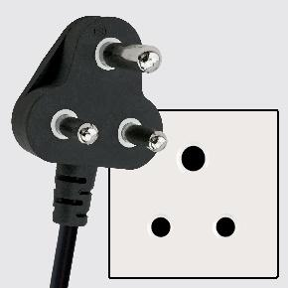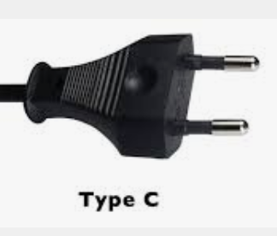

LOCAL ORGANIZING COMMITTEE
For any further information please contact the Local Organizing Committee at the following address:

Prof. Juliet Hermes
Egagasini Node, South African Environmental Observation Network (SAEON)
Cell: +27 83 472 9159
Email: jc.hermes@saeon.nrf.ac.za

Dr. Tamaryn Morris
Marine Unit, South African Weather Service (SAWS)
Cell: +27 82 509 1713
Email: tamaryn.morris@weathersa.co.za

APPENDIX A
LIST OF RECOMMENDED HOTELS
No | Accommodation in Cape Town | Address | Rate of the Room/Night
H1 | Atlantic Marina | V&A Marina Residential, West Quary Roa, V&A Waterfront, 8001, Cape Town, South Africa  Tel: +27 21 418 0128  Email: enquiries@atlanticmarina.com  https://www.atlanticmarina.com/ | Standard Room  R 3700 / approx. USD 202
H2 | AC By Marriott Cape Town Waterfront | Dockrail Road, Foreshore, 8001, Cape Town, South Africa  Tel: +27 21 1371 100  https://www.marriott.com/en-us/hotels/cptar-ac-hotel-cape-town-waterfront/overview/ | Standard Room  R 2360 / approx. USD 138
H3 | Radisson RED V&A Waterfront | Silo 6, Silo Square, V&A Waterfront, Cape Town, 8001, South Africa  Tel: +27 87 086 1578  Email: baxter@radissonred.com  https://www.radissonhotels.com/en-us/ | Standard Room  R 2271 / approx. USD 134  --  Superior Room  R 2877 / approx. USD 168
H4 | The Commodore Hotel | Portswood Rd, Victoria & Alfred Waterfront, Cape Town, 8002  Tel: +27 21 415 1000  Email: commodore@legacyhotels.com  https://www.legacyhotels.co.za/hotels/commodore-hotel | Standard Room  R 3159 / approx. USD 184  --  Deluxe Room  R 3627 /approx. USD 211
H5 | Southern Sun Waterfront | 1 Lower Buitengracht, Cape Town, Western Cape, South Africa  Tel: +27 21 409 4000  Email: sswaterfront.reservations@southernsun.com  https://southernsun.com | Standard Room  R 2696 / approx. USD 157  --  Executive Room  R 3850 / approx. USD 224
H6 | Capetonian Hotel | Pier Place, Heerengracht Street, Cape Town, 8001, South Africa  Tel: +27 21 405 5670  Email: enquiries@capetonian.co.za https://capetonian.co.za | Superior Room  R 1080 / approx. USD 63  –  Deluxe Room  R 1350 /approx. USD 79
H7 | Protea Hotel Cape Town Waterfront Breakwater Lodge | Portswood Road, V & A Waterfront, Cape Town, South Africa, 8001  Tel: +27 21 406 1911  https://www.marriott.com | Standard Room  R 2017 / approx. 117 USD  --  Deluxe Room  R 2276 / approx.  132 USD

Notes:

AIRPORT
V&A WATERFRONT
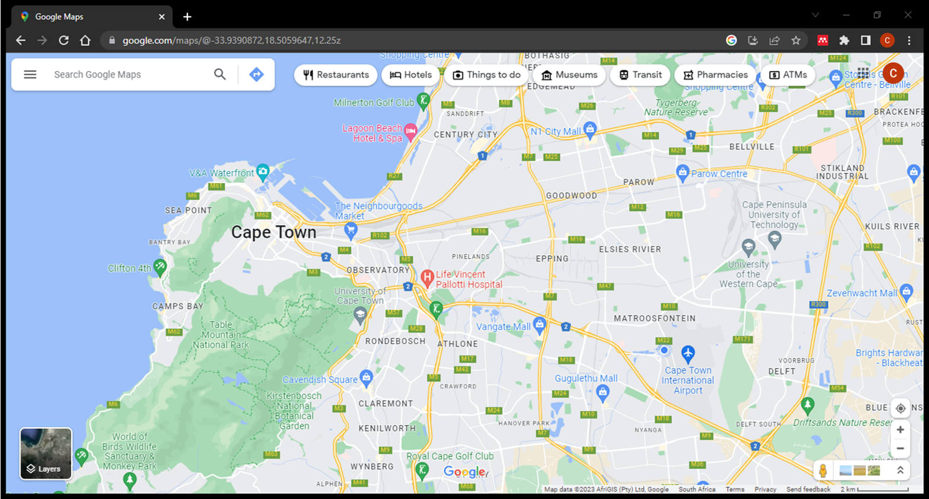

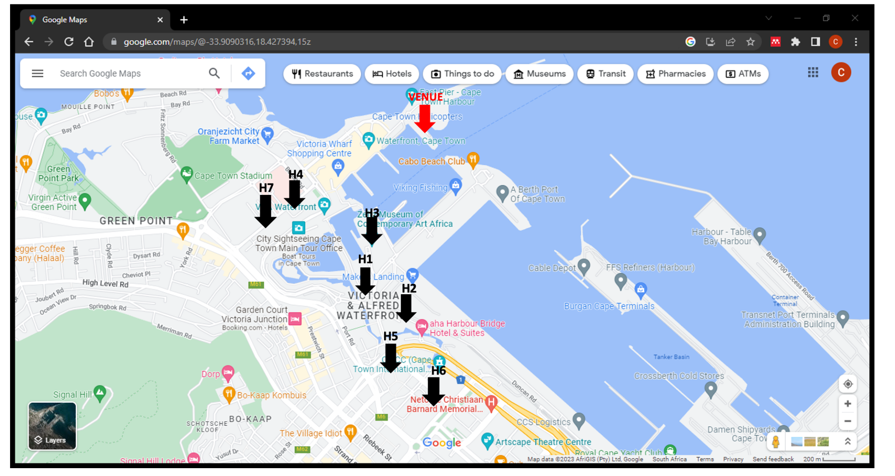
VENUE
H6
H5
H2
H1
H3
H4

