Restricted distribution IOC-FAO/IPHAB-XVI/Inf.6
Paris, 14 March 2023
English only

Sixteenth Session of the IOC-FAO Intergovernmental Panel

on Harmful Algal Blooms

Rome, 27-29 March 2023

Item 4.6.1 of the Provisional Agenda

PROGRESS REPORT OF THE IOC REGIONAL WORKING GROUP ON HARMFUL ALGAL BLOOMS IN THE CARIBBEAN AND ADJACENT REGIONS (IOCARIBE-ANCA)

Gustavo Arencibia Carballo - Cuba
J. Ernesto Mancera Pineda - Colombia
Maribelle Vargas Montero – Costa Rica
Carlos Seixas - Panamá
Oscar Armando Amaya Monterrosa – El Salvador
Karla Evelyn Paz Cordón - Guatemala

Introduction
During the 2021-2023 intersessional period, the IOCARIBE-ANCA working group achieved the goals proposed in March 2021 during the VIII ANCA-virtual workshop: 1) Increased visibility among the different social stakeholders in the Caribbean region; 2) Identify and characterize the microalgae responsible for the intoxications (PSP, DSP, ASP, NSP, Ciguatera), as well as the toxins vector species in the Caribbean and adjacent areas; Strengthening of research on epiphytic toxic dinoflagellates; 3) Progress in initiatives on HAB early warning systems.
Since there are not focal points in all the Caribbean countries, work continues to add more members to the current group.
Ciguatera food poisoning continues to be a problem that affects public health in the Caribbean region, as well as the notable and manifest incidence of harmful algal blooms, as reported by different countries.

- Activities to increase visibility among stakeholders.
As a visibility and positioning strategy for the HAB theme, the ANCA group, with the financial support of IOCARIBE and the universities and research centers of different Caribbean countries, developed five types of products aimed at different audiences: Research papers, informative book on ciguatera, posters and brochures, participation in seminars, congress, courses, and a virtual reality HAB course.
The information is summarized in the following table.
Type of Product | Description | Audience | Supported by
Research papers | Arteaga-Sogamoso, E., Rodríguez, F., Amato, A., Begoña Ben-Gigirey, Fraga, S., Mafra Jr. L.L., Fernandes, L.F., de Azevedo Tibiriç, C.E., Chomérat, N., Nishimura, T., Homma, C., Adachi, M., Mancera-Pineda, J.E. 2023. Morphology and phylogeny of Prorocentrum porosum sp. nov. (Dinophyceae): A new benthic toxic dinoflagellate from the Atlantic and Pacific Oceans. Harmful Algae 121:102356. https://doi.org/10.1016/j.hal.2022.102356  Arteaga-Sogamoso, E., Riobo, P., Rodríguez, F., Mancera-Pineda, J.E., Franco-Angulo, J. 2022. First record of the dinoflagellate Prorocentrum borbonicum in the continental coast of Colombian Caribbean: A new 42 hydroxi-palytoxin producer.  Morales- Benavides, D., Rodríguez- Rodríguez, P., Valerio- González, Lorelys. 2022. Prorocentrales epifitos de Thalassia testudinum K.D. Koenig, 1805 durante la época de surgencia y relajación, en playa La Maceta Boca del Río, estado Nueva Esparta, Venezuela. Bol. Inst. Oceanog. Venez. 61(02).  Arteaga-Sogamoso, E., F. Rodríguez, J.E. Mancera-Pineda. 2021. Morphological and molecular characterization of Gambierdiscus caribaeus (Dinophyceae), with a confirmation of its occurrence in the Colombian Caribbean Tayrona National Natural Park. Botanica Marina. https://doi.org/10.1515/bot-2020-0070.  Arencibia-Carballo, G. Franco Mendoza, L.R., Aguilar Ríos, A., Tello Cetina. J.A. 2002. Toxicidad por ciguatera en consumo de Barracuda (Sphyraena barracuda) en la costa norte de La Habana, Cuba. Brazilian Journal of Animal and Environment Research. 5(2): 2454-2473. https://brazilianjournals.com/ojs/index.php/BJAER/issue/view/170  DOI: https://doi.org/10.34188/bjaerv5n2-082 | Academic sector | Universities  Research Institutes
Informative book on ciguatera  Catalog of harmful microalgae of the Cienfuegos province | Third edition of: LA CIGUATERA UN RIESGO POTENCIAL PARA LA SALUD HUMANA: Preguntas frecuentes.  Arencibia Carballo, G., Mancera Pineda, J.E., Delgado Miranda, G., Díaz Asencio, L. 2022. (1200 copies).  Quick identification of 24 species and 2 genera that cause HAB events, information on harmful and/or toxic effects, distribution, habitat, local occurrence. | Environmental authorities and decision makers | IOCARIBE  Cienfuegos
Posters and brochures | Series of 4 informative posters about the ciguatera, in Spanish and English, as an informative advertising campaign “Let's learn from Ciguatera”. The print run was over 1,200 copies for each type of poster and language (Appendix 1).  Informative posters for the technical team of the National Red Tide Commission of Guatemala (NRTC), to attend to poisoning during May 2022 (Appendix 2). | Fishing communities | IOCARIBE, CIP – La Habana  Guatemala NRTC
Seminars, Congress, Courses | • Regional Training Course HAIS-HAEDAT, ANCA-IOCARIBE, 22-23 November and 6 December, 2021.  • Regional Training Course on Nuclear Techniques (Radio-ligand Receptor Binding Assay-RBA) for the Analysis of Toxins in Marine Organisms, Monaco. September 2022.  • IV Congreso Universitario de Investigaciones Científicas de la Secretaria de Investigaciones Científicas de la UES. Ponencia “Floraciones Algales Nocivas en cuerpos de agua dulce de El Salvador”. 26 al 28 de octubre de 2021.  • VIII Taller de Trabajo Grupo “Algas Nocivas del Caribe y regiones adyacentes” y la Comisión Oceanográfica Gubernamental (IOC-CARIBE). 3 al 5 de marzo de 2021.  • Curso de Posgrado “Ecología Funcional de Fitoplancton” con un total de 80 virtuales durante la Escuela de Verano - La Paloma “Ciencias del Mar y Ecología Funcional Acuática” entre el 10 y 16 de marzo de 2021, organizador por la Universidad de la República, Uruguay.  • Semana del Océano de Mónaco, en el marco de la ponencia “The Latinoamerican and Caribbean Network for Research in Coastal and Marine Stressors. – REMARCO, a cooperation strategy to facilitate decision-making in the face of common challenges and vulnerabilities in marine de 2021.  • Congreso Nacional Marino Costero de Guatemala. Conference: Marea Roja en Guatemala. 25 al 28 Octubre 2022.  • Congreso Mexicano de Florecimientos Algales Nocivos. Conference: FAN en el Pacífico Central de Guatemala. 3 al 7 Octubre 2022.  • Aniversario de la Escuela Naval de Guatemala. Conference: Importancia del Monitoreo de Plancton en Guatemala. 18 de octubre 2022.  • Taller Regional sobre el Índice de Eutrofización Potencial Costera (ICEP) y Floraciones Algales Nocivas (FANs). Modalidad Virtual desde Trinidad y Tobago, 25 y 26 julio 2022, 8h.  • Curso teórico-práctico “Fitoplancton, florecimientos algales y Ficotoxinas. Modalidad virtual México, 16-27 enero 2023.  • Reunión del grupo ANCA-IOCARIBE sobre los a avances en el estudio de las floraciones algales nocivas en Venezuela, 2021.  • XIX Internacional Harmful Algae (virtual). Octubre 10-15- 2021. La Paz, Baja California Sur, México:  - Distribution of potencially toxic epibenthic dinoflagellates in Venezuela.  - Blooms of the cyanobacteria Limnoraphis cf. birgei in a volcanic lake of El Salvador  - Harmful algal blooms along central Guatemalan Pacific coast.  - Influence of resources and regulators on potentially toxic benthic dinoflagellates abundance: evidence from different coastal systems of the Colombian Caribbean.  • Reunión de lanzamiento del proyecto CARMINA (Caribbean Micro-algae responsible for ciguatera poisoning: diversity, toxicity and toxin production). Modalidad virtual. 8 al 13 de mayo de 2022. | Academic sector and other sectors
Free virtual reality course of HAB | Free virtual reality course: Introduction to HABs | Young people, adolescents, and children | IOCARIBE, Universidad Nacional de Colombia, INVEMAR
 | https://play.google.com/store/apps/details?id=com.nova.florecimientosAlgalesNocivos

- Identify and characterize the microalgae responsible for the intoxications (PSP, DSP, ASP, NSP, Ciguatera, Cyanotoxins)
To achieve this objective, different projects, thesis, and monitoring programs, are being carried out both nationally and regionally, among others:
Projects financed by the International Atomic Energy Agency (IAEA):
- RLA 7020 Establishing the Caribbean Observing Network for Ocean Acidification and its impact on Harmful Algal Blooms, using nuclear and isotopic techniques.
- RLA 7026 Supporting the use of receptor binding assay (RBA) to reduce the adverse impacts of harmful algal toxins on seafood safety.
- RL 7022 Fortalecimiento al Monitoreo y Respuesta Regional para Entornos Marinos y Costeros Sostenibles.
- RLA 7014 Latin American regional proficiency test on the determination of trace elements and radionuclides in algae, soil and spiked water.
- RLA-7025: "Fortalecimiento de las capacidades en ambientes marinos costeros usando técnicas nucleares e isotópicas" (2020-2023).
Doctoral Thesis:
- Abundancia y distribución de dinoflagelados bentónicos potencialmente tóxicos y concentraciones de ciguatoxinas en organismos marinos de la región centro sur de Cuba. June 2022.
- Influencia de Recursos y Reguladores en la Abundancia Poblacional de Dinoflagelados Bentónicos del Caribe Sur-Occidental en Escalas Diarias. Universidad Nacional de Colombia, Sede Caribe. Edgar Arteaga. Doctorado en Ciencias, línea Biología Marina. In progress.
- Microalgas tóxicas en el Pacífico de Guatemala. Doctorado en Ciencias Agrícolas y medioambientales de la Universidad de Santiago de Compostela, España. Karla Evelyn Paz Cordón. In progess.

Master Thesis:
- Sistema de Vigilancia y Gestión de las Floraciones Algales Nocivas (SVG-FANs) para las zonas costeras de la provincia de Cienfuegos. June 2022.
- Herramienta para el pronóstico de riesgo de mortandad masiva de peces asociada a florecimientos algales nocivos en estuarios tropicales. Universidad Nacional de Colombia, Sede Bogotá. Luis Felipe Santos. Maestria en Ciencias, línea Biología. In progress.

- Progress in initiatives on HAB early warning systems.
As a result of the efforts of the ANCA-IOCARIBE network, some countries have initiated an initiative aimed at managing the risk of HABs. Since it is essential to collect information on the appearance of toxic microalgae and to describe their temporal variability, different monitoring programs are carried out in the Caribbean region.
Considering the vulnerability to HABs, it is important to design and apply an early warning system (EWS) for risk reduction. This EWS must include an effective monitoring plan with strategic actions to face and mitigate the challenges of intoxications transmitted by organisms. An important factor for EWS effectiveness lies in the level of citizen participation. The communities at risk must be an active part of the system, receiving timely information, training, and exchanging knowledge with other stakeholders. For this reason, one of ANCA's priority activities has been the dissemination of actions and results with different social sectors (See section I of this report).
EWSs must integrate monitoring data, which in the case of HAB events, correspond to the presence of species, oceanographic and atmospheric variables, and toxicity levels. Comprehensive analysis of these data should lead to the generation of information on risk forecasting and prediction. The specific risk assessment is the basic input for the authorities to make decisions and to communicate them to the community and other potentially affected organizations in a timely manner. EWSs, then, must prevent, prepare for, and address the negative impacts generated by HABs. Considering this, it was carried out a training on HAIS-HAEDAT from 22/11/2021 to 6/12/2021, using zoom platform.
The objective of the course was to train researchers from the Caribbean in the registration of HAB events in the region. The course was attended by 93 participants from 19 Caribbean countries and 11 countries from other regions.
As a result of the training, the ANCA region has 16 editors responsible for updating the HAIS-HAEDAT system. These editors are from Venezuela, Mexico, Panama, Jamaica, Guatemala, El Salvador, Cuba, Costa Rica and Colombia (Appendix 3). The editors received a guide for the use of the HAIS-HAEDAT prepared by the IOC. As of the date of this report, the editors of Cuba, Colombia, Guatemala and Venezuela reported being up to date with the uploading of data in HAIS-HAEDAT.
Until now, countries like Colombia and Cuba are working on indices as tools with predictive potential.
- IRMA: An index to predict mass fish mortality during harmful algal blooms in tropical estuaries

In the Ciénaga Grande de Santa Marta (CGSM), the largest and most productive estuarine system in Colombia, HAB events are frequent. This led to the development of a mass fish kill indicator for integration into an early warning system. The indicator, named IRMA, was based on the HAB conceptual model mechanism described for CGSM. According to this model, the increase in PO4 stimulates the massive growth of microalgae, mainly atmospheric nitrogen-fixing cyanobacteria. After overproduction, the cyanobacteria collapse, producing hypoxia/anoxia. To calculate the IRMA, algorithms were built based on values measured in the monitoring program over the past 30 years and over 4,000 records, to rate the risk of fish mortality based on PO4, chlorophyll, and dissolved oxygen concentrations. The IRMA was calibrated using fish kill events recorded in CGSM and fitting a statistical model to validate the indicator with other physical and chemical variables. Considering the high predictive value of IRMA on CGSM, this index has great potential to be explored as a tool to manage eutrophication in tropical estuaries.

- IRCIGUA: Risk index for Ciguatera
The Fisheries Research Center (CIP) of Havana is developing the risk index for Ciguatera (IRCIGUA), as a tool for the Early Warning System. Likewise, it is establishing criteria for ecosystem monitoring to assess risks due to ciguatera. The design of the surveys and the free access EPIINFO portal for the application of the surveys are already available. So far, 44 surveys have been carried out and additional information was obtained on knowledge and control of ciguatera in health centers.
On the other hand, the HAB Event Surveillance and Management System for the province of Cienfuegos emphasizes the integrating nature that the management of these phenomena demands in coastal areas. It is a cyclical process that includes five stages: Surveillance, Communication, Activation of the System, Direct management of the event and impact evaluation.

- Needs identified in the ANCA group.

- Establish in the remaining countries, the national HAB monitoring plan.
- Provide inputs for early warning systems on harmful algal blooms.
- Strengthen the training of personnel at different levels.
- Generate mechanisms that facilitate the acquisition of certified patterns for toxin analysis.
- Expand dissemination, dissemination, and education strategies on HABs to all social sectors, with special emphasis on the tourism sector.
- Improve infrastructure for research and monitoring.
- Maintain constant effective communication between the different projects under development.

- Appendix
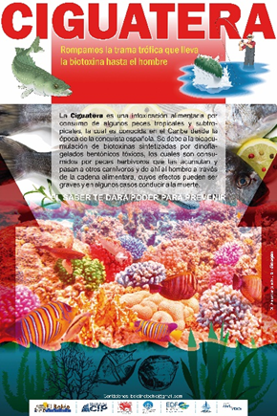 | 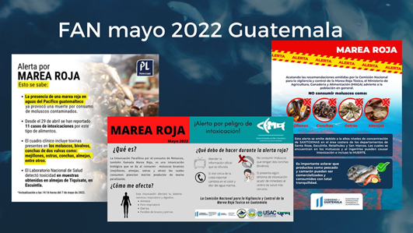
Appendix 1. Dissemination campaign “Let's learn from Ciguatera” | Appendix 2. Information about toxic event in Guatemala
Appendix 3. ANCA editors to HAIS – HAEDAT

Country | Editors | Contact
Venezuela | Lorelys Valerio and Soraya Silva | lorelysvalerio@gmail.com soraya.j.silva@gmail.com
Mexico | Rosalba Alonso and José Luis Peña | rosalba@ola.icmyl.unam.mx jopema@cetmar11.edu.mx
Panamá | Carlos Seixas and Kathia Broce | kathia.broce@utp.ac.pa carlosseix@hotmail.com
Jamaica | Azra Blythe-Mallett | azra.blythemallett@moa.gov.jm
Guatemala | Leonel Carillo | leocarri1@yahoo.com
El Salvador | Oscar Amaya and Rebeca Quintanilla | cesiah.quintanilla@ues.edu.sv
Cuba | Gustavo Arencibia, Ruby Thomas and Dayana Dellundé | ddellunde22@gmail.com rubyts2016@gmail.com
Costa Rica | Maribell Vargas | mvmontero@gmail.com
Colombia | Julian Franco and Edgar Arteaga | julian.franco@invemar.org.co edgar.arteaga@invemar.org.co

Appendix 4. Additional Information provided by the Countries.

COSTA RICA - From 1999 to date, it has been confirmed that the main problem associated with harmful algal blooms in Costa Rica are the intoxication episodes caused by PSP mainly associated with the dinoflagellates Pyrodinium bahamense var. compressum and to a lesser but equally important extent with Gymnodinium catenatum. Available data on poisoning by ingestion of contaminated mollusks in recent years indicate that to date there are no official reports of fatalities and epidemiological pictures have only been observed in some areas of the Costa Rican Pacific. Since 2008, we have observed episodes of mortality producing HABs in corals on the north coast of the Costa Rican Pacific, produced mainly by the dinoflagellate Margalefidinium polikrykoides as well as by cyanobacteria. In this same area, we have observed an increase in blooms of the dinoflagellate Lingulodinium polyedrum and various species of Dinophysis spp. However, we have not been able to corroborate their toxicity due to lack of support for toxin analysis. Likewise, episodes of mass fish mortality are observed every year in the Pacific coast of the country, where the main causal species is Margalefidinium polikrykoides.
The Pacific Ocean of Costa Rica is the main fishing area of the country, but despite this, the monitoring of microalgae is very limited and restricted to specific areas of oyster farms or areas of artisanal mollusk extraction, these areas of exploitation of the Japanese oyster Magallana gigas are more concentrated in the Gulf of Nicoya since monitoring depends on the operational capabilities of public universities that are involved in the issue.
At present the Inter-institutional Commission for the Prevention and Control of Red Tide since December 2021, has decreed partial and total bans on the extraction and marketing of bivalve mollusks, whether naturally extracted or cultured, due to the lack of controls necessary to ensure a toxin-free product, and the sanitary measure is extended until the results of the analysis conducted by the National Laboratory of Veterinary Services of SENASA (LANASEVE), confirm that the products are suitable for human consumption. The mollusks involved in the ban have been, among others, the Anadara tuberculosa known as piangua, mussels and the Japanese oyster Magallana gigas.

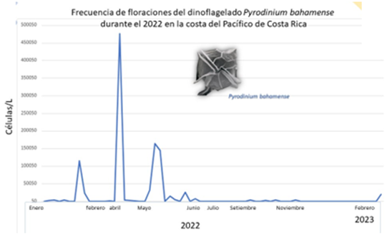 | Distribution of the dinoflagellate Pyrodinium bahamense in the Pacific coast of our country during the year 2022.

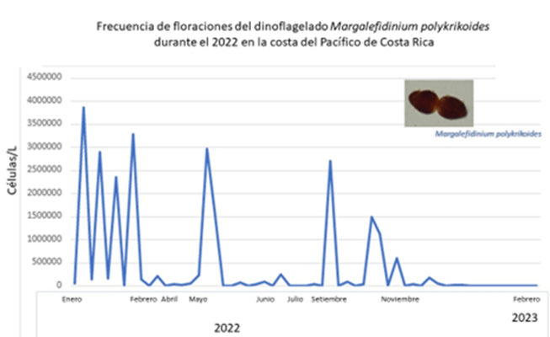 |  | Distribution of the dinoflagellate Margalefidinium polykrikoides in the Pacific coast of our country during the year 2022
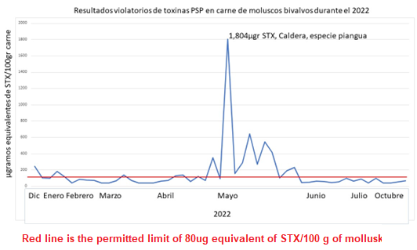 | Distribution of saxitoxin levels reported in mouse bioassay samples for mollusks (Data taken from SENASA reports for the Interinstitutional Commission for the Prevention and Control of Red Tide).

SENASA (National Animal Health Service) resolutions are always supported by the recommendations of the Commission for the Epidemiological Surveillance of Red Tide, to which several state institutions and public universities belong.
Water samples for analysis of harmful/toxic phytoplankton from oyster farms are collected by previously trained oyster farm personnel and delivered to university personnel for morphological analysis and species identification, which is why there is a constant sampling schedule for bivalve mollusks and water samples.
On the Caribbean coast of our country, the presence of species potentially producing ciguatoxins has been detected; however, there is no information on ciguatera events in our Caribbean sector, mainly due to the lack of knowledge of the disease on the part of the health sector. In this zone, monitoring is very limited and restricted to specific areas.
PANAMA - Algae blooms and mortality of marine organisms are phenomena that occur occasionally in the Pacific of Panama. The Aquatic Resources Authority, the Ministry of the Environment and the University of Panama have participated at different times in aspects related to the preventive management of these blooms, from the implementation of fishing bans to the identification of the causative organisms. Despite the fact that, occasionally, deaths of fish and other marine organisms are recorded in Panama, there is very little documentary evidence that relates this phenomenon to the presence of harmful organisms. There is only one published case of a coral die-off caused by Cochlodinium catenatum and Gonyaulax monilata that occurred simultaneously on Isla Uvas in the western Pacific of Panama and Isla El Caño in the southern Pacific of Costa Rica. In the months of September, October, and November 2022, about 160 dead turtles and in an advanced state of decomposition arrived on the coast of Panama, mainly green turtles. Initially, an algae bloom was thought, but there was no evidence to support it.

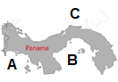

HABs risk zones in Panama. A- Risk of neurotoxic blooms, B- Risk of harmful blooms, C- Risk of ciguatera. | Areas where monitoring is carried out or has been carried out in recent years in Panama.

CUBA - The first laboratory in Latin America and the Caribbean capable of detecting ciguatoxins in marine organisms recently became fully operational in Cuba, as a result of close cooperation with the IAEA. Ciguatoxins are responsible for the main non-bacterial poisoning, due to the consumption of marine organisms. These toxins cause multiple cases of ciguatera each year. To address the problem of ciguatoxins, the IAEA has been building capacity to monitor ciguatera in the region using nuclear and isotope techniques.
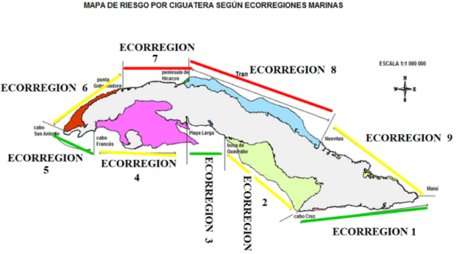

Marine areas and ciguatera risk assessment in Cuba

VENEZUELA - The first events of algae blooms in Venezuela date back to 1977, affecting 257 people who suffered severe paralyzing intoxication and 10 deaths from consuming mussels (Perna perna). More recently (2014-2015) there were cases of massive poisoning in the marine and coastal zone on the central coast of Venezuela, due to outcrops of benthic microalgae of the species Ostreopsis cf. siamensis, Rhizosolenia setigera, and Eutreptiella gymnastica. In Venezuela there is a regulation of the National Bivalve Mollusc Health Program that establishes a concentration of 80 µg STX/100 g tissue as the maximum permissible level to be able to market bivalve molluscs. The program indicates that it is mandatory to carry out the diagnosis of PSP toxins in bivalve molluscs prior to commercialization. There is no legislation in the case of DSP, ASP, and ciguatera.

COLOMBIA - The study of potentially toxic epiphytic and benthic dinoflagellates is relatively recent in Colombia. The toxic events of tourists and some residents on the island of San Andrés in 2007 stimulated research on ciguatera in Colombia.
To date, eleven species of dinoflagellates associated with macroalgae and seagrass have been identified (Dinophysis acuminata, Gambierdiscus toxicus, Ostreopsis ovata, Prorcentrum arenarium, P.belizeanum, P. emarginatum, P. hoffmannianum, P. lima, P. maculosum, P. . mexicanum) on San Andrés island. Likewise, twelve species of dinoflagellates were found associated with five drifting substrates, two species of marine phanerogams and three of macroalgae, concluding that drift is a very important substrate for potentially toxic dinoflagellates and considering its floating nature, it may represent one of the main dispersal vectors of these species in the Caribbean.
During 2015, an ENSO-Niño year, the composition and abundance of dinoflagellates associated with seagrasses in Barú, an island near Cartagena de Indias, was examined, found three genera of dinoflagellates, Prorocentrum, Ostreopsis, and Gambierdiscus, which include toxigenic species related to ciguatera and diarrheal shellfish poisoning. Prorocentrum lima was the most abundant dinoflagellate.
The seagrass beds of the Tayrona National Natural Park (TNNP) Colombian Caribbean have also been studied to understand the composition and structure of dinoflagellate assemblages. Between January 2014 and December 2015, fourteen species of potentially toxic epiphytic dinoflagellate belonging to four genera (Prorocentrum, Ostreopsis, Coolia, and Gambierdiscus) were identified. On the other hand, using morphological (light and scanning electron microscopy), and molecular techniques, the presence of Gambierdiscus caribaeus was confirmed in the same place, Prorocentrum borbonicum and P. porosum sp. nov. were collected.

