Kenson Stoddard

NAtional EMergency management Organization | Old montrose, Svg

**National Tsunami Report for St. Vincent and the Grenadines 2023**

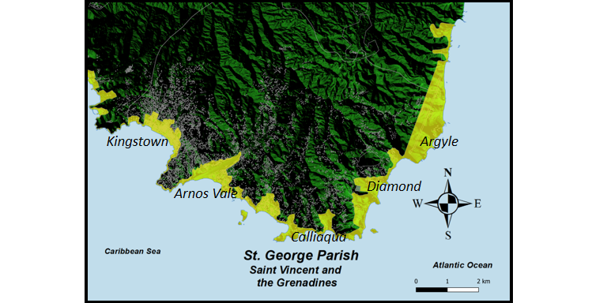

**NATIONAL REPORT**

**Submitted by St. Vincent and the Grenadines**

**BASIC INFORMATION**

1. **ICG/CARIBE EWS Tsunami National Contact (TNC)**

Name: Michelle Forbes

Title: Director

Organization: National Emergency Management Organization

Postal Address: National Emergency Management Organization, Old Montrose Kingstown, St. Vincent and the Grenadines

Email Address: [nemosvg@gmail.com](mailto:nemosvg@gmail.com), [nemosvg@gov.vc](mailto:nemosvg@gov.vc), [nemosvgeoc@gmail.com](mailto:nemosvgeoc@gmail.com)

Telephone Number: 784-456-2975

Fax Number: 784-457-1691

Cellular Telephone Number: 784-531-6108

1. **ICG/CARIBE EWS Tsunami Warning Focal Point (TWFP)**

Name: Michelle Forbes

Title: Director

Responsible Organization: National Emergency Management Organization

Postal Address: National Emergency Management Organization, Ministry of National Security, Old Montrose Kingstown, St. Vincent and the Grenadines

Emergency Telephone Number:

Emergency Fax Number: 784-457-1691

Emergency Cellular Telephone Number: 784-531-6108

**National Tsunami Warning Centre (If different from the above)**

Person in Charge: Billy Jeffers

Title: Manager

Responsible Organization: St. Vincent and the Grenadines Meteorological Services

Postal Address: St. Vincent and the Grenadines Meteorological Services, Civil Aviation Compound, Argyle International Airport, Argyle

Email Address: svgmet@gmail.com

Emergency Telephone Number: 784-458-4477

Emergency Fax Number: 784-458-0868

Emergency Cellular Telephone Number: 784-491-3026

1. **Tsunami Advisor (s), If applicable**

Name: Michelle Forbes

Title: Director

Responsible Organization: National Emergency Management Organization

Postal Address: National Emergency Management Organization, Old Montrose Kingstown, St. Vincent and the Grenadines

Emergency Telephone Number:

Emergency Fax Number: 784-457-1691

Emergency Cellular Telephone Number: 784-531-6108

1. **Tsunami Standard Operating Procedures for a Local Tsunami (when a local tsunami threat exists, less than 1 hour travel time).**

The National Emergency Management Organization (NEMO) has been assigned the responsibility to identify and characterize tsunamigenic events as stipulated in the draft National Tsunami Standard Operating Procedures (SOPs). The functions of NEMO for tsunamigenic events are supported by the St. Vincent and the Grenadines Meteorological Services (SVG Met. Services) as the alternate Tsunami Warning Focal Point and the Royal St. Vincent and the Grenadines Police Force (RSVGPF).

As described in the draft SOP the SVG Met. Services will provide support to monitor and alert national agencies and stakeholders for tsunamigenic activities during the hours of 6 am to 9 pm while the Royal St. Vincent and the Grenadines Police Force will perform similar functions during the hours of 9 pm to 6 am.

**Threshold or Criteria for declaring a potential tsunami emergency**

For localized tsunami threats, the threshold or criteria for declaring a potential tsunami emergency will vary. In the first instance, the draft SOP states that residents and visitors to St. Vincent and the Grenadines should be guided by the natural Tsunami signs to trigger the relevant Tsunami response actions. As stated in the Tsunami SOP document once residents and visitors experience the following phenomena all persons occupying low-lying areas should make their way to higher ground (30m in elevation):

1. A significantly strong earthquake is felt,
2. The unusual recession of the nearshore coastal waters
3. A strange rumble coming from the sea in the aftermath of an Earthquake

NEMO also recognizes that the islands of St. Vincent and the Grenadines are exposed to the possibility of several geophysical hazardous events that are related to the island’s geography and near source-related tectonic and volcanic (submarine and surface) activity. For these events, the thresholds or criteria for declaring a potential local tsunami threat are:

* the natural signs observed from a largescale earthquake (greater than 6 in magnitude) e.g., on the Caribbean plate
* Signals received by the existing marine and terrestrial network of seismic and tidal monitoring instruments from
  + a violent eruption of a submarine volcano e.g., kick em, Jenny
  + an explosive eruption of a volcano e.g., La Soufriere, SVG, or Mt. Pelee, Martinique.
  + Collapse of a coastal or submarine mountain
  + Meteorite impact

**Organization’s response to the information received by the agency responsible for characterizing the potential tsunami threat**

The National Emergency Management Organization is designated as the Organization responsible for characterizing the potential tsunami threat from a local tsunami. Upon receipt of a tsunami threat message from the Pacific Tsunami Warning Centre (PTWC) the Tsunami Service provider for St. Vincent and the Grenadines, NEMO will also be responsible for coordinating actions such as disseminating a Tsunami threat message to all national stakeholders.

**Dissemination of Tsunami Information in St. Vincent and the Grenadines**

Subsequent to this initial alert message from the PTWC, a set of cascading alerts will be disseminated to all tsunami warning focal points i.e., leaders or other senior contact persons of Government Ministries and Departments, State Agencies, Private Sector Organizations, chairpersons of the 22 District Disaster Committees (DDCs) and other community leaders.

Tsunami warning focal points will in turn support NEMO with the dissemination of the Tsunami threat message to employees and community members. This information flow is captured in the national tsunami call-out tree. In a parallel process, once tsunami waves are detected and the PTWC determines that SVG will be impacted (in less than an hour), the NEMO will change the Tsunami Alert Level to RED which indicates a tsunami warning is in effect. A Tsunami warning indicates that there will be imminent danger of coastal flooding from a tsunami.

Tsunami information is disseminated through multiple forms of media. For St. Vincent and the Grenadines, Tsunami information messages once received are disseminated by NEMO via electronic mail (E-mail), SMS messages, VHF radios, and telephone calls to all tsunami focal points in the first instance. The information will also be sent by way of email and telephone calls to the national and private radio stations across the island. It must be noted that three (3) radio stations are outfitted with emergency interrupt devices and as such their regular programme will be interrupted on receipt of a tsunami threat message. Concurrently information will also be sent via the Common Alerting Protocol (CAP) application, District Disaster Committee WhatsApp groups, Instagram, and the NEMO and SVG Met. Services website and Facebook pages.

At the community level, a Tsunami threat message from NEMO is expected to trigger the Community Early Warning System that is in place for a tsunami event. Community members have crafted a local system of alerts that primarily relies on a combination of modern and traditional methods of warning. For instance, they have agreed to use instruments such as Bullhorns (megaphones), church bells, conch shells, town criers or wailers, and other musical instruments. This system is augmented by several key community contacts that are responsible for raising the alert using a uniquely recognizable pattern of alarm or sound. Information will also be relayed through typical forms of media (WhatsApp, email, telephone and other social media platforms).

The draft SOP also includes contingencies for alerting vulnerable groups e.g., the elderly, women, pregnant women, children, and persons with disabilities. Community groups and family members are expected to assist their dependents in the event of an evacuation

**Termination of a Tsunami Emergency Situation**

The termination of a tsunami emergency is initiated by an end-of-threat message from the Pacific Tsunami Warning Centre, NEMO will then issue a local TSUNAMI WARNING CANCELLATION message on all media platforms and communication channels to all tsunami focal points.

The Hon. Prime Minister who is the chair of the National Emergency Council upon the advice of the Director of NEMO will determine the status and safety of all coastal zone areas across SVG. If it has been determined that the tsunami threat to all coastal zone have passed and the coastal areas are deemed safe, NEMO will issue an ALL-CLEAR message which indicates that it is safe to return to the beach, docks and other nearshore areas.

1. **Tsunami Standard Operating Procedures for a Regional Tsunami (when a regional tsunami threat exists, less than 1–3-hour travel time)**

The National Emergency Management Organization (NEMO) has been assigned the responsibility to identify and characterize tsunamigenic events as stipulated in the draft National Tsunami Standard Operating Procedures (SOPs). The functions of NEMO for tsunamigenic events are supported by the St. Vincent and the Grenadines Meteorological Services (SVG Met. Services) as the alternate Tsunami Warning Focal Point and the Royal St. Vincent and the Grenadines Police Force (RSVGPF).

As is the case for local tsunami threats the SVG Met. Services will also provide monitoring and alerting support to all government ministries, community organizations and other state and non-state agencies for tsunamigenic activities during the hours of 6 am to 9 pm while the Royal St. Vincent and the Grenadines Police Force will perform similar functions during the hours of 9 pm to 6 am.

**Threshold or Criteria for declaring a potential tsunami emergency for a Regional Tsunami**

For regional tsunami threats, the threshold or criteria for declaring a potential tsunami emergency will be guided by the information received from the PTWC. Unlike local tsunamis, the people of St. Vincent and the Grenadines may not observe all of the natural signs associated with tsunamis generated by near-source earthquakes. Consequently, the threshold criteria will be a regional earthquake with a magnitude greater than 6.

These events will trigger Tsunami alert messages from the PTWC. Regional Tsunamis generated by a seismic event associated with e.g., a volcanic eruption will trigger the network of seismic and tidal gauge equipment. Sea surface-level readings of over a few metres in the aftermath of these seismic or tectonic events will be flagged as a possible tsunami threat event and an alarm will be issued by the PTWC to NEMO (the TWFP) in SVG.

Tsunamis generated by regional events may exhibit some of the characteristic natural signs typically associated with a local threat as they approach the nearshore areas of islands. For these events, the natural signs criteria for declaring a potential local tsunami threat may still be applicable.

**Organizations’ response to the information received by the agency responsible for characterizing the potential tsunami threat from a regional tsunami**

The National Emergency Management Organization is designated as the Organization responsible for characterizing the potential tsunami threat from a regional tsunami. Upon receipt of a tsunami threat message for a regional tsunami threat from the Pacific Tsunami Warning Centre, NEMO will also be responsible for disseminating a Tsunami threat message to all national stakeholders.

**Dissemination of Tsunami Information in St. Vincent and the Grenadines**

Subsequent to this initial alert message a set of cascading alerts will be disseminated to all tsunami warning focal points i.e., leaders or other senior contact persons of Government Ministries, Departments, State and Non-State Agencies, Private Sector Organizations, chairpersons of the 22 District Disaster Committees, and other community leaders. The designated Tsunami warning focal points will in turn support NEMO with the dissemination of the Tsunami threat message to their colleagues, employees and members of the various communities. This information flow is captured in the national tsunami call-out tree.

In instances where a regional tsunami threat is identified the Tsunami Alert Level will be raised to YELLOW (Tsunami Watch) if it is determined that the detected waves are more than 2 hours away. As the wave arrival time goes below two (2) and one (1) hour(s) the tsunami Alert Level will move to an ORANGE (Tsunami Advisory) and RED level (Tsunami Warning) respectively. An ORANGE alert level is issued when there is an imminent possibility of dangerous currents from tsunamis (no flooding) whilst a RED alert indicates there is imminent danger of coastal flooding from tsunamis.

Tsunami information is disseminated through multiple forms of media. The Tsunami information message once received, is disseminated by NEMO via electronic mail (E-mail), SMS messages, VHF radios, and telephone calls to all tsunami focal points in the first instance. The information will also be sent by way of email and telephone calls to the national and private radio stations across the island. Concurrently information will also be sent to the public via the Common Alerting Protocol (CAP) application, District Disaster Committee WhatsApp groups, Instagram, and the NEMO and SVG Met. Services website and Facebook pages.

At the community level, a Tsunami threat message from NEMO is expected to trigger the Community Early Warning System that is in place for a tsunami event. Community members have crafted a local system of alerts that primarily relies on a combination of modern and traditional methods of warning. For instance, they have agreed to use instruments such as Bullhorns (megaphones), church bells, conch shells, town criers or wailers, and other musical instruments. This system is augmented by several key community contacts that is responsible for raising the alert using a uniquely recognizable pattern of alarm or sound. Information will also be relayed through typical forms of media (WhatsApp, email, telephone and other social media platforms).

The draft SOP also includes contingencies for alerting vulnerable groups e.g., the elderly, women, pregnant women, children, and persons with disabilities. Community groups and family members are expected to assist their dependents in the event of an evacuation.

**Termination of a Tsunami Emergency Situation for a regional tsunami threat**

The termination of a tsunami emergency is initiated by an end-of-threat message from the PTWC, NEMO will then issue a TSUNAMI WARNING CANCELLATION message on all media platforms, and communication channels to all tsunami focal points.

The Hon. Prime Minister who is the chair of the National Emergency Council upon the advice of the Director of NEMO will determine the status and safety of all coastal zone areas across SVG. If it has been determined that the tsunami threat to all coastal zone have passed and the coastal areas are deemed safe, NEMO will issue an ALL-CLEAR message which indicates that it is safe to return to the beach, docks and other nearshore areas.

1. **Tsunami Standard Operating Procedures for Distant Tsunami (when a distant tsunami threat exists, more than 3 hours travel time)**

The National Emergency Management Organization (NEMO) has been assigned the responsibility to identify and characterize tsunamigenic events as stipulated in the draft National Tsunami Standard Operating Procedures (SOPs). The functions of NEMO for tsunamigenic events are supported by the St. Vincent and the Grenadines Meteorological Services (SVG Met. Services) as the alternate Tsunami Warning Focal Point and the Royal St. Vincent and the Grenadines Police Force (RSVGPF).

As described in the draft SOP the SVG Met. Services will provide support to monitor and alert national agencies and stakeholders for tsunamigenic activities during the hours of 6 am to 9 pm while the Royal St. Vincent and the Grenadines Police Force will perform similar functions during the hours of 9 pm to 6 am.

**Threshold or Criteria for declaring a potential tsunami emergency for a Distant Tsunami**

For Distant tsunami threats, the network of global instruments is expected to recognise the causal tsunami events and determine whether waves have been generated. The Threshold or Criteria for declaring a potential tsunami event from a distant tsunami will be an earthquake of magnitude greater than 6 that has occurred on the sea floor. In addition, Sea surface-level readings of over a few metres in the aftermath of these seismic or tectonic events will be flagged as a possible tsunami threat event and an alarm will be issued by the PTWC to NEMO (TWFP) for SVG.

**Organizations’ response to the information received by the agency responsible for characterizing the potential tsunami threat**

The National Emergency Management Organization is designated as the Organization responsible for characterizing the potential tsunami threat for a distant tsunami event. Upon receipt of a tsunami threat message from the Pacific Tsunami Warning Centre, NEMO will also be responsible coordinate actions such as disseminating a Tsunami threat message to all national stakeholders.

**Dissemination of Tsunami Information in St. Vincent and the Grenadines**

Subsequent to this initial alert message, a set of cascading alerts will be disseminated to all tsunami warning focal points i.e., leaders or other senior contact persons of Government Ministries and Departments, State Agencies, Private Sector Organizations, chairpersons of the 22 District Disaster Committees and other community leaders. Tsunami warning focal points will in turn support NEMO with the dissemination of the Tsunami threat message to employees and community members. This information flow is captured in the national tsunami call-out tree.

In instances where a distant tsunami threat is identified the Tsunami Alert Level will be raised to YELLOW (Tsunami Watch) if it is determined that the detected waves are more than 2 hours away. As the wave arrival time goes below two (2) and one (1) hour(s) the tsunami Alert Level will move to an ORANGE (Tsunami Advisory) and RED level (Tsunami Warning) respectively. An ORANGE alert level is issued when there is an imminent possibility of dangerous currents from tsunamis (no flooding) whilst a RED alert indicates there is imminent danger of coastal flooding from tsunamis.

Tsunami information is disseminated through multiple forms of media. The Tsunami information message once received is disseminated by NEMO via electronic mail (E-mail), SMS messages, VHF radios, and telephone calls to all tsunami focal points in the first instance. The information will also be sent by way of email and telephone calls to the national and private radio stations across the island. Concurrently information will also be sent via the Common Alerting Protocol (CAP) application, District Disaster Committee WhatsApp groups, Instagram, and the NEMO and SVG Met. Services website and Facebook pages.

At the community level, a Tsunami threat message from NEMO is expected to trigger the Community Early Warning System that is in place for a tsunami event. Community members have crafted a local system of alerts that primarily relies on a combination of modern and traditional methods of warning. For instance, they have agreed to use instruments such as Bullhorns (megaphones), church bells, conch shells, town criers or wailers, and other musical instruments. This system is augmented by several key community contacts that are responsible for raising the alert using a uniquely recognizable pattern of alarm or sound. Information will also be relayed through typical forms of media (WhatsApp, email, telephone and other social media platforms).

The draft SOP also includes contingencies for alerting vulnerable groups e.g., the elderly, women, pregnant women, children, and persons with disabilities. Community groups and family members are expected to assist their dependents in the event of an evacuation

**Termination of a Tsunami Emergency Situation from distant tsunami events**

The termination of a tsunami emergency is initiated by an end-of-threat message from the Pacific Tsunami Warning Centre, NEMO will then issue a TSUNAMI WARNING CANCELLATION message on all media platforms, communication channels and to all tsunami focal points.

The Hon. Prime Minister who is the chair of the National Emergency Council upon the advice of the Director of NEMO will determine the status and safety of all coastal zone areas across SVG. If it has been determined that the tsunami threat to all coastal zone have passed and the coastal areas are deemed safe, NEMO will issue an ALL-CLEAR message which indicates that it is safe to return to the beach, docks and other nearshore areas.

1. **National Sea Level Network**

|  |  |  |
| --- | --- | --- |
| Location | Position | Description of Instruments |
| Calliaqua (RSVGPF Coastguard Base) | Latitude:13.129912  Longitude: -61.1955 | A Sea level station comprised of Two (2) Pressure Sensors |
| Chateaubelair | Latitude: 13.2911  Longitude: -61.2406 | Two (2) Sea level stations:  i. Sea level station with a Radar Sensor  ii. Sea level station with a Battery Sensor |

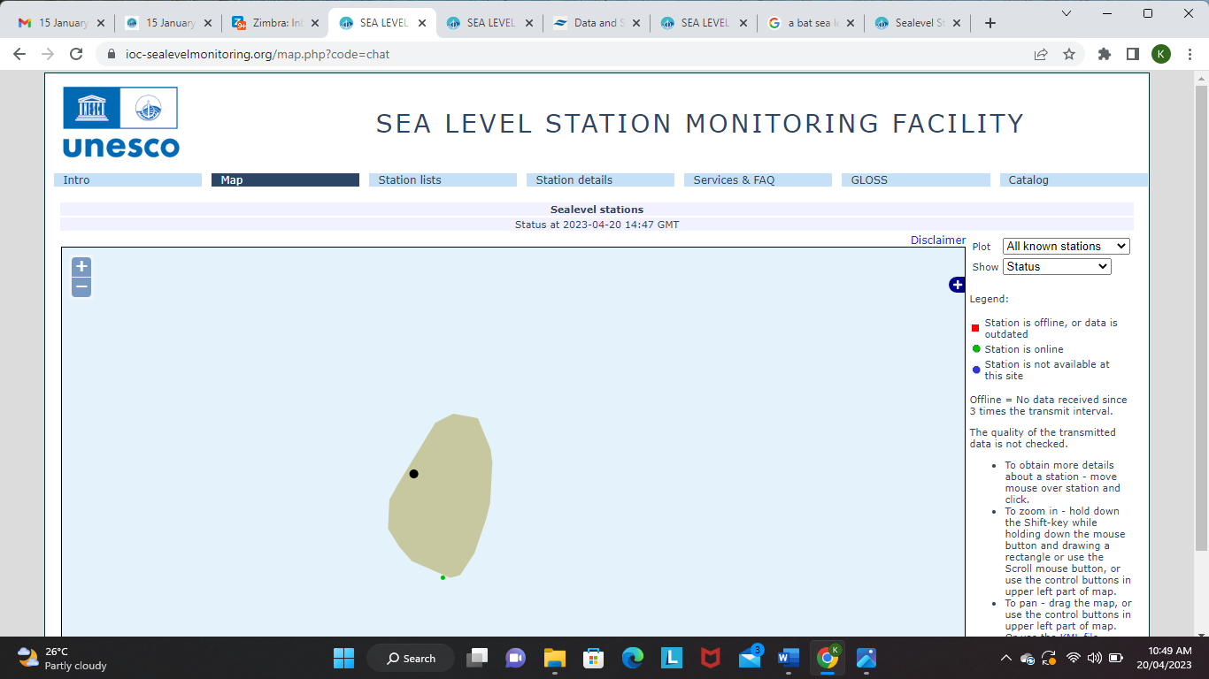

Figure 1. Black dot showing the location of the sea level station (radar) in Chateaubelair

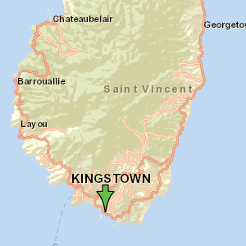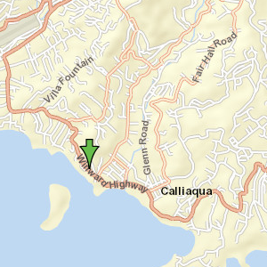

Figure 2. Maps showing the location of the sea level pressure sensors at Calliaqua, St. Vincent and the Grenadines.

1. **Information on Tsunami Occurrences/Tsunami Exercises**

St. Vincent and the Grenadines has experienced the effects of five (5) significant tsunami events in recorded history. The recorded description of the data on each event is provided in Table 1 below. According to the recorded history, the islands have been affected by tsunami waves in 1844, 1867, 1868, 1902 and 1939 with varying scales of impact.

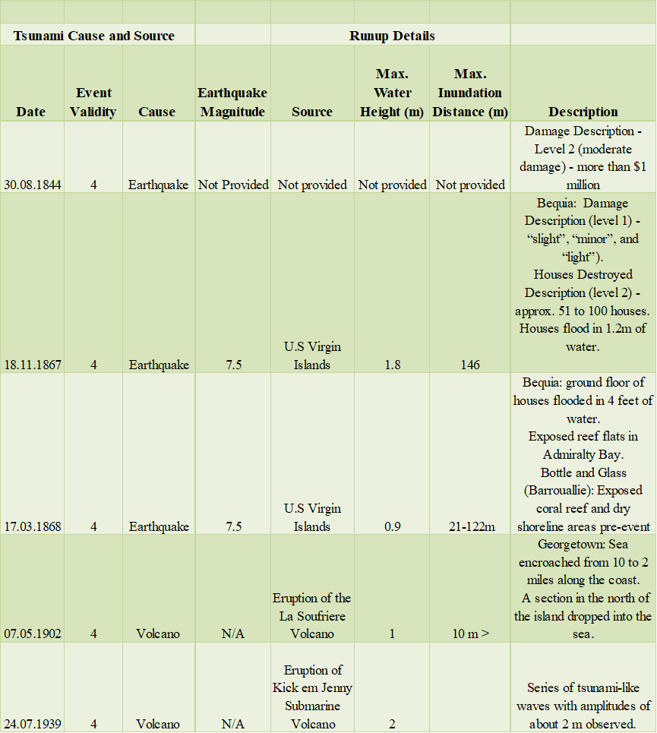

*Table 1. Recorded tsunami events for St. Vincent and the Grenadines from 1530 to 2020.*

Evidence also suggests that the islands have been impacted by other small-scale events that may have gone unnoticed. For instance, at around 12:14 am/ 4 UTC on January 15, 2022, the Hunga-Tonga Hunga Ha'apai volcanic eruption produced a tsunami whose waves and effects were detected in ocean basins as far as the Caribbean and adjacent regions.

An analysis of the Marigram collected from the Calliaqua Coastguard Base Sea Level station located at the southern tip of the island revealed that a 0.175m wave was detected and attributed to the Hunga- Tonga tsunami. The marigram information revealed that the tsunami waves were detected at around 4:31 pm/20:31 UTC, Sunday, January 16, 2022. There were no public warnings or tsunami alert messages generated for this event as the impacts were negligible. The sea level observations at the Calliaqua sea level station are captured in the figure that follows.

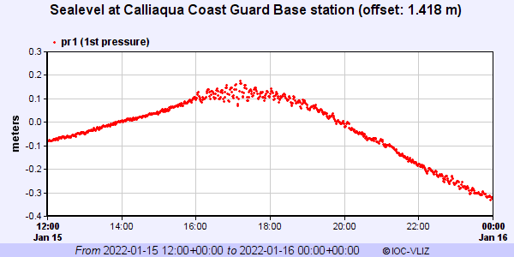

1. **Websites (URLs) of the national tsunami–related website**

The national tsunami-related websites and URLs are those of the National Emergency Management Organization and the St. Vincent and the Grenadines Meteorological Services.

* **National Emergency Management Organization**

<http://www.nemo.gov.vc/>

<http://www.nemo.gov.vc/nemo/>

* **St. Vincent and the Grenadines Meteorological Services.**

<http://meteo.gov.vc/>

<http://meteo.gov.vc/meteo/>

1. **Summary of plans for the improvement of future tsunami warning and mitigation systems.**

In 2008 the National Emergency Management Organization launched a national programme towards significantly improving its human, technical, technological and legislative capacity to prepare, respond and mitigate against the possible hazards associated with a tsunami. One of the principal focus areas identified for improvements is the national system to deliver tsunami warnings and mitigation to the general public.

The future strategy for the improvement of tsunami warnings and mitigation includes approaches to improve the broad areas of, Knowledge Management, Institutional Capacity Building, Community Resilience, Sectoral Integration and Operational Readiness. A summary of the tsunami-specific plans and actions will be outlined for all programming areas in the following subsection

**Institutional Arrangements**

* Finalization of the draft National Tsunami Standard Operating Procedures as an annex to the updated National Emergency Management Plan 2006
* Revision of the National Emergency Management plan to include provisions that will mandate radio and television stations to broadcast emergency information when required.
* Upgrade the National Emergency Management Act or the National Telecommunication Regulation Commission NTRC legislation to include a clause that will ensure that all media agencies mandatorily broadcast all emergency messages whenever there is an imminent threat.
* Develop a crisis communication policy and strategic implementation plan for St. Vincent and the Grenadines.

**Knowledge Management**

* Collaborate with the Ministry of Education to incorporate tsunami science information in the primary and secondary school DRR curriculum.
* Support the Safe School Programme of the Ministry of Education to develop DRR educational material for tsunamis and all other hazards. These include educational products and tools that are gender-specific and tailored to the needs of other vulnerable groups.
* Ensure tsunami-related data is integrated into the proposed NEMO Management Information System (MIS).
* Explore opportunities to promote tsunami scenario planning, modelling and research at the post-secondary level.
* Work alongside all private radio stations to develop an emergency public education programme and materials which will include tsunamis
* Provide emergency communications training for media personnel and social media influencers.

**Sectoral Integration**

* Support ministries, sectors, departments of government and other organizations to develop Standard Operating Procedures for tsunamis as part of the overarching sectoral/ministerial/ organization DRR plans.
* Support training opportunities in DRR and business continuity plan development for tsunamis and other hazards.
* Support sectors in developing strategies to ensure the workplace is tsunami-proof as is practicable.

**Operational Readiness**

* Support ministries, sectors, departments of government and other organizations to develop plans and tools that will enable them to participate in the annual tsunami exercise and drills such as exercise CaribeWave.
* Conduct a multi-agency national-scale tsunami exercise triennially.
* Train members of the NEMO mechanism to establish Emergency Operation Centre (EOC) to support tsunami emergencies.
* Explore opportunities to increase the capacity for search and rescue teams and emergency medical teams to operate effectively in the aftermath of a tsunami.
* Explore opportunities to procure emergency safety, search and rescue equipment that will support tsunami rescue and response activities.
* Training for the staff at NEMO, SVG Met Services and the Royal SVG Police in preparing tsunami messages for public consumption and interpreting the message from the PTWC to determine the localised region-specific forecast.
* Training on the use of the National Emergency Communication Network e.g., the use of emergency communications radios

**Community Resilience**

* Plan and execute bi-annual Community Emergency Response Teams training for members of all coastal communities across SVG.
* Provide District Disaster Groups with search and rescue equipment that can promote their effective functioning after the passage of a tsunami.
* Collaborate with District Disaster committees and community groups to execute frequent tsunami exercises and evacuation drills.
* Enhance the national community public education programme to increase tsunami awareness, knowledge and safety at the community level.
* Develop a programme to increase tsunami information and knowledge among sectors and other stakeholders that occupy and whose livelihoods depend on coastal zone areas.
* Collaborate with District Disaster Committees to develop a DRR public education strategy to support trainer of trainer workshops for warning and mitigation information for tsunamis at the community level. The strategy intends to empower community members and groups to support tsunami public awareness throughout communities across SVG.
* Plan and execute future iterations of the Tsunami Ready Recognition Programme.

1. **EXECUTIVE SUMMARY**

The National Tsunami Programme for St. Vincent and the Grenadines which was birth out of the devastating impact of the 2004 Indonesian Tsunami began in 2008. In the formative years of the programme, tsunami management was not formalised and structured. Tsunami management in St. Vincent and the Grenadines has benefited from the structure provided through the CDEMA Comprehensive Disaster Management (CDM) Strategy. Consequently, tsunamis are managed through the five (5) broad programming areas of Institutional Capacity Building, Knowledge Management, Sectoral Integration, Operational Readiness and Community Resilience outlined in the Country Work Programme document for St. Vincent and the Grenadines.

Since then, the tsunami programme has undergone several iterations and at each stage, significant advancements have been achieved. Some of the advancements include the development of a National Tsunami Standard Operating Procedure (SOPs) in 2016 and an upgraded document in 2019. The 2019 tsunami readiness pilot programme formed the catalyst for increased tsunami resilience approaches in St. Vincent and the Grenadines. Some of the benefits of the programme thus far are:

1. Tsunami signage such as evacuation maps and those identifying assembly points and tsunami hazard zones.
2. Increased public education and awareness for public and private sector stakeholders as well as at the community level.
3. Tsunami public education material for print, electronic and social media
4. Tsunami Early Warning Systems (EWS)
5. Tsunami information flow chart or call-out tree.

Collaborative work with the Pacific Tsunami Warning Centre (PTWC) proved valuable in establishing a TWFP (NEMO) and an NTWC (SVG Met. Services). Communications with these two institutions are continuously tested annually during the CaribeWave tsunami exercises. Caribewave exercises also present opportunities to test national, community and organizational SOPs. In recent years three large-scale evacuation drills were executed and those communities are in a better position to manage the expected threats and impacts posed by tsunamis.

1. **NARRATIVE**

The National Tsunami Programme for St. Vincent and the Grenadines commenced in 2008 as the threat and damage posed by tsunami waves were brought into focus after the devastation caused by the 2004 Indonesian tsunami. Since then, the NEMO mechanism sought to institute a national framework to manage tsunami-related risks. As part of the government’s plan of action, the NEMO secretariat was identified as the most appropriate institution to manage tsunami-related risks and thus it was formally designated as the National Tsunami Warning Focal Point for St. Vincent and the Grenadines.

Following on from its designation, NEMO has continuously sought opportunities to develop strategies and approaches to enhance the resilience of the general public and more specifically vulnerable coastal communities to tsunami hazards.

The introduction and adoption of the Country Work Programme in 2007/2008 complemented by the CDEMA Comprehensive Disaster Management (CDM) Strategy (2014) were major game changers for disaster management in SVG. Both Initiatives (CWP and CDM strategy) provided a structured framework that enabled a holistic, inclusive, proactive, evidence-based approach to Disaster Risk Management and Disaster Risk Reduction. This broad-based framework (CDM) emphasizes focus actions on all hazards and people at all disaster management continuum phases.

The specific tsunami-related plans and activities are further articulated in the five-year Country Work Programme (CWP) document which serves as the roadmap for DRR actions in SVG. Broadly, the national tsunami programme is executed through several iterations subsumed under the envelope of the tsunami-smart or the more recently renamed tsunami-ready programme. Several schools, government ministries, departments, businesses and local communities have benefited from various tsunami-specific plans and activities since the programme was launched.

To date, the National Tsunami Programme has delivered a suite of tsunami-related resources, products and activities to the general public. These include but are not limited to tsunami-related public education and information materials in multi-media forms as well as for multi-media platforms. The programme also encapsulates the development of tsunami evacuation maps, signage, evacuation drills and exercises, Vulnerability and Capacity Assessments (VCAs), Emergency Operation Centre training, Public Consultations and Standard Operating Procedures (SOPs).

**Innovations or modifications to the National tsunami warnings and operations**

The tsunami SOP (2016) serves as the first tsunami-specific planning document for the island and thus is fundamental to effecting a paradigm shift in perception, situational awareness, understanding and approaches to the management of tsunami emergencies.

The draft SOP document establishes the enabling environment for the following.

* The methods for receiving and disseminating tsunami threat messages at the national and community level.
* An Early Warning System (EWS) for tsunami emergencies at the national and community level.
* The agency responsible for the management of tsunamis
* A tsunami services provider (PTWC)
* The National Tsunami Warning Focal Point (NEMO)
* A National Tsunami Warning Centre (SVG Met. Services)
* National and community information flow chart (Tsunami call-out tree)
* Roles and responsibilities for state agencies, district disaster committee and community members for an impending tsunami event
* A description and colour code for tsunami alert levels
* Standardized tsunami signage

The execution of the tsunami readiness communities programme began in 2015 with the initial Tsunami Ready Programme for the community of Rose Place Kingstown. The initial 2015 programme was then enhanced to allow new communities to become tsunami ready. Subsequently, the enhanced Tsunami ready programme (second iteration) focused on delivering tsunami readiness plans and actions for the southernmost parish of St. George on the main island of St. Vincent as well as for Union Island the most southern of the Grenadine islands. This programme afforded NEMO the opportunity to test and distil the various components of the SOP to determine its fit for purpose. The findings generated from different tsunami exercises have prompted considerations for modification of the tsunami SOP. Some of the modifications include:

* Community-specific Tsunami EWSs that are nuanced and thus capture and reflect the differences within community systems, and available resources e.g., human (skilled and technical residents), institutional (presence of police station, community health centre etc. and technological (school bells, megaphones, church bells, available emergency equipment).
* Agreements at the community and organizational level to include an evacuation support mechanism to assist persons with disabilities whose mobility is restricted in cases where a tsunami evacuation is required.
* A temporary alteration to the NTWC and its warning procedures. The tsunami SOP has identified the SVG Met. Services as the NTWC. However, one of the conditions that are fundamental to the designation of a NTWC is the requirement for the agency to be in a full 24-hour operation.

At present the SVG Met. Services have not transitioned to a 24-hour daily operational schedule and as such a temporary system of operation has been crafted where NEMO, the SVG police and the SVG Met. Services will provide shared tsunami warning focal point support in the interim. The warning centre will shift depending on the time of day a tsunami threat is issued. That is, the SVG Met. Services will provide its typical NTWC duties with support from NEMO by day (6 am to 9 pm) while, the Royal St. Vincent and the Grenadines Police Force will perform NTWC duties at night (9 pm to 6 am).

* At the community level DDCs have recognised the need for an agile EOC in response to a tsunami threat. As a consequence, communities have explored conducting EOC operations from a mobile unit or tent location in designated highland areas.
* A unique modification at the organisational level is a contingency design to increase exit points and escape routes at the workplace. Typically, as a security measure, most organizations often employ a single access point to their buildings and compounds although multiple access exists. To improve access during emergencies several organizations have agreed to place the keys in specific locations and assign duty officers the responsibility of opening all other access points to the building and compound. This initiative is designed to promote easy escape routes during tsunami emergencies.

**Tsunami Mitigation Activities in St. Vincent and the Grenadines**

Tsunami mitigation for St. Vincent and the Grenadines is primarily focused along the key priority areas of the Country Work Programmes of building institutional capacity, knowledge management, operational readiness and community resilience. The specific actions are mainly soft engineering approaches that are reflected through the creation and revision of existing legislation, policy and planning documents and their related activities to promote tsunami resilience. Although necessary, limited financial endowment and access to financial resources are challenges to the adoption of hard engineering approaches.

**The National Tsunami Public Education Programme for** **St. Vincent and the Grenadines**

The tsunami mitigation activities for St. Vincent and the Grenadines are predicated on a comprehensive public education and awareness strategy. The general aim of the public education and awareness strategy is to significantly ramp up public education on tsunami science i.e., information on the genesis, nature or characteristics, and expected impacts of tsunamis.

The public education strategy also includes increasing awareness and familiarity in communities to

1. SOPs for tsunami warning and messaging,
2. Existing tsunami alert system,
3. components of the tsunami information flow charts at the national and community levels
4. key points of contact at the national, community and organizational levels.
5. Tsunami signage that includes, evacuation maps and the standard signs for assembly points, evacuation routes, and identification of hazard zone.
6. The natural signs of an impending tsunami.
7. The national and community EWSs.

The NEMO public education strategy is delivered through frequent public consultation/meetings, PowerPoint presentations and consultatory sessions with public and private sector organizations as well as multi-media communication material that can be accessed through the printing press and on all electronic and social media platforms.

NEMO has made several presentations to primary and secondary schools located in the evacuation areas on Union Island and in the coastal communities of the parish of St. George as part of the 2nd phase of the tsunami readiness programme. Schools will be outfitted with tsunami evacuation maps which contain tsunami signage, assembly points, evacuation routes and tsunami inundation areas for a worst-case tsunami scenario.

Tsunami evacuation maps will also be strategically placed in high-access buildings throughout tsunami-ready communities. Some of these buildings include the main hospital and other health centres, the main ports of entry, ministerial buildings and police stations. Billboards displaying evacuation maps and other tsunami signs will be installed in all tsunami-ready communities to promote awareness of inundation areas, evacuation routes and assembly points for each map area.

**Tsunami exercises in St. Vincent and the Grenadines**

NEMO coordinates annual tsunami exercises and activities twice per year. Tsunami exercises are concentrated around Exercise Caribewave activities and World Tsunami Day activities. For the past few years, Exercise Caribewave took the form of large-scale tsunami evacuation drills for schools, ministries, financial institutions and other state-owned agencies in the capital Kingstown and on the islands of Bequia and Union Island.

To execute these activities members of the NEMO staff worked assiduously with the participating agencies to develop SOP templates that provide employees (exercise evacuees) with a basic understanding of the established evacuation procedures for each participating agency. Subsequent to the formulation of the organizational SOP templates, public education consultatory sessions were convened with participating agencies to build awareness of tsunami science information, communication information and expectation for the Caribewave exercise. In addition, members of the Bequia district disaster committee received training on the use of emergency communication radios and basic instruction and guidelines on EOC management. The estimated number of participants for the evacuation drill exercises is as follows

* Union Island tsunami emergency evacuation drill (2019) – 150 persons
* Tsunami evacuation drill in Kingstown (2022) – 95 persons
* Bequia tsunami evacuation drill (2023) – 200 persons

Exercise Caribewave 2020 and 2021 were significantly restricted by the debilitating effects of the Covid-19 pandemic (2020) and preparatory plans for the explosive eruption of the La Soufriere Volcano (2021). During those years NEMO use the exercises to examine the efficiency of the communication between the tsunami service provider PTWC and the communication team of the NTFP and the NTWC.

**Enhancing awareness of tsunamis in St. Vincent at the Grenadines**

Significant work has been done to heighten public education and awareness of tsunami hazards. Notwithstanding the many successes of existing public education strategies, there are some gaps and possible areas for improvement. Two major gaps that exist are the absence of a national crisis communication strategy and implementation plan. The National Emergency Management Organization has taken bold steps to address these gaps by developing Terms of Reference and procuring the services of a consultant to develop the aforementioned strategy and implementation plan.

A separate consultancy was responsible for recording and creating new hazard-specific jingles taking into consideration the country context. Plans have been tabled to review the social media strategy and to develop a suite of public education infomercials, videos, reels and animations for all emergencies including tsunamis. NEMO is expected to increase staff through the addition of a media/communications officer that will be responsible for the review and development of future media and communication products and programmes for the organization.

In conclusion, tsunami readiness plans and procedures in SVG have been enhanced by the Tsunami Ready Recognition programme with the signage as is reflected in the initiatives outlined throughout this document. The momentum built through the tsunami programme requires further investment in order to keep pace with the tsunami resilience agenda. Ultimately, the government of St. Vincent and the Grenadines is committed to achieving its overarching goal for the National Tsunami Programme viz ensuring all coastal communities across St. Vincent and the Grenadines are in a position to respond to tsunami threats preserving lives, livelihood and property.