Intergovernmental Oceanographic Commission
technical series | 151



EXERCISE CARIBE WAVE 23
A Caribbean and Adjacent Regions Tsunami Warning Exercise
23 March 2023
(Gulf of Honduras and Mount Pelée)
Volume 2 Draft Summary Report

UNESCO

Intergovernmental Oceanographic Commission
technical series | 151

EXERCISE CARIBE WAVE 23
A Caribbean and Adjacent Regions Tsunami Warning Exercise
23 March 2023
(Gulf of Honduras and Mount Pelée)
Volume 2 Summary Report

UNESCO 2023
IOC Technical Series, 151 (volume 2)
Paris, June 2022
English only

The designations employed and the presentation of the material in this publication do not imply the expression of any opinion whatsoever on the part of the Secretariats of UNESCO and IOC concerning the legal status of any country or territory, or its authorities, or concerning the delimitation of the frontiers of any country or territory.

NOTE: The United Nations Educational, Scientific and Cultural Organization (UNESCO) and the Intergovernmental Oceanographic Commission (IOC) pattern the contents of this handbook after the CARIBE WAVE 2011, 2013, 2014, 2015, 2016, 2017, 2018 and 2019 Exercises. Each of these exercises has a handbook published as IOC Technical Series. These CARIBE WAVE exercises followed the Pacific Wave exercises which commenced in 2008 with manual published by the Intergovernmental Oceanographic Commission (Exercise Pacific Wave 08: A Pacific-wide Tsunami Warning and Communication Exercise, 28–30 October 2008, IOC Technical Series, 82, Paris, UNESCO 2008). The UNESCO How to Plan, Conduct and Evaluate Tsunami Wave Exercises, IOC Manuals and Guides, 58 rev., Paris, UNESCO 2013 (English and Spanish) is another important reference.
For bibliographic purposes, this document should be cited as follows:
UNESCO/IOC. 2022. Exercise CARIBE WAVE 2022. A Caribbean and Adjacent Region Tsunami Warning Exercise, 10 March 2022 (Western Muertos Trough and Northern Panama). Volume 2: Summary Report. Paris, UNESCO, IOC Technical Series No 151, Vol. 2. (English only)
Report prepared by: Intergovernmental Coordination Group for the Tsunami and other Coastal Hazards Warning System for the Caribbean and Adjacent Regions (ICG/CARIBE-EWS)
Authors: Stephanie Soto, Elizabeth Vanacore, and Christa von Hillebrandt-Andrade, Jelis Sostre, and Desiree Bayouth

Published in 2020
by United Nations Educational, Scientific and Cultural Organization
7, Place de Fontenoy, 75352 Paris 07 SP
(IOC/2019/TS/151 Vol.2)
TABLE OF CONTENTS

Summary 7
1. BACKGROUND 8
2. EXERCISE CONCEPT 9
2.1 PURPOSE 9
2.2 OBJECTIVES AND GOALS 9
2.3 TYPE OF EXERCISES 11
3. EXERCISE OUTLINE 12
3.1 GENERAL 12
3.2 MASTER SCHEDULE (EXERCISE SCRIPT) 14
3.3 ACTIONS IN THE CASE OF A REAL EVENT AND FALSE ALARMS 14
3.4 REGISTRATION PROCEDURE 14
3.5 STATUS OF SEA LEVEL STATIONS DURING EXERCISE 18
3.6 RESOURCES 20
3.7 MEDIA ARRANGEMENTS 22
3.8 POST-EXERCISE EVALUATION 23
4. REFERENCES 29
ANNEX I. CATAC Dummy (Start of Exercise) Message 30
ANNEX II. CATAC Exercise Messages 31
ANNEX III. List Of Acronym 42

Summary
The CARIBE WAVE exercise is conducted within the framework of the UNESCO Intergovernmental Coordination Group for Tsunamis and other Coastal Hazards for the Caribbean and Adjacent Regions (CARIBE-EWS). The 2023 annual tsunami exercise took place on March 23 to test Tsunami Warning Systems and promote tsunami preparedness in the Caribbean and adjacent regions. The exercise was coordinated by the CARIBE WAVE task team, the NOAA International Tsunami Information Center Caribbean Office, and supported by the Caribbean Tsunami Information Center and Pacific Tsunami Warning Center. It was left up for Member States and Territories to choose between the Gulf of Honduras and Mount Pelée scenarios and to decide the level of participation and activity to be held in their country.
CARIBE WAVE exercises focus on communications and evaluating procedures and programs within Member States and Territories. The Pacific Tsunami Warning Center (PTWC), the Regional Tsunami Service Provider, issued a “Dummy” message through the different warning systems at 1400 UTC to test communications with Tsunami Warning Focal Points (TWFP) and National Tsunami Warning Centers (NTWC). Different methods of communications were used to test and disseminate the message: The World Meteorological Organization (WMO), Advanced Weather Interactive Processing System (AWIPS), Aeronautical Information Replacement System (AIRS), NOAA Weather Wire, GEONETCast Americas, Fax, Email, and social media. According to feedback as well as social media and web posts, the dummy message was successfully received. The Central America Tsunami Advisory Center (CATAC) also disseminated simulated products for the Gulf of Honduras scenario to its stakeholders.

When PTWC issued its simulated “end of threat” messages for the exercise, over 420,000 people from across the entire Caribbean basin had registered on the Tsunami Zone website (tsunamizone.org). The majority of the participants were from K-12 Schools. State governments, universities and preparedness organizations also had a high level of participation. According to the Member States and Territories feedback, 432,244 people were directly engaged in the exercise. Social media platforms, which has become the primary source for communicating tsunami awareness, reached over 1.8 M people worldwide during the exercise.

Sea level data availability is important to forecast and confirm a real tsunami event. If a tsunami had occurred during the day of the exercise, data of 44 of the 65 sea-level stations in the region would have been available for event analysis. Only two of the Deep Ocean Assessment and Reporting on Tsunamis (DARTs) were operational during the exercise. CARIBE WAVE has been improving and validating tsunami preparedness since 2011, which is why tsunami exercises are crucial to maintain readiness in case of a real tsunami event.

1. BACKGROUND
The UNESCO IOC Intergovernmental Coordination Group for the Tsunami and Other Coastal Hazards Warning System for the Caribbean and Adjacent Regions at its Eighth session (ICG/CARIBE-EWS-VIII, Port of Spain, Trinidad and Tobago, 29 April – 1 May 2013), decided to conduct exercises named CARIBE WAVE on an annual basis leaving each Member State to define its level of participation. At its Officers Meeting (virtual, 7-9 June 2022), the ICG/CARIBE-EWS recommended that Exercise CARIBE WAVE 23 take place on 23 March 2023, with two hypothetical tsunami scenarios. The first scenario simulates a tsunami generated by a magnitude 7.6 earthquake located in the Gulf of Honduras and the second scenario is generated by a flank collapse in Mount Pelée volcano, Martinique
Historical tsunami records from sources such as the National Oceanic and Atmospheric Administration’s (NOAA) Centers for Environmental Information (NCEI) show that from 1530 to 2020 tsunamis from earthquake, landslide, and volcanic sources have affected the region. According to NCEI, in the past 500 years, at least 65 confirmed tsunamis of validity 3+ have been observed and approximately 4,500 people have lost their lives from tsunamis in the Caribbean and adjacent regions. Since the most recent devastating tsunami of 1946, there has been an explosive population growth and influx of tourists along the Caribbean and Western Atlantic coasts increasing the tsunami vulnerability of the region (von Hillebrandt-Andrade, 2013).
Recognizing the need for an early warning system, especially after the lessons learned from the 2004 Indian Ocean tsunami, the Intergovernmental Coordination Group for the Tsunami and other Coastal Hazards Warning System for the Caribbean and Adjacent Regions (ICG/CARIBE-EWS) was established in 2005 as a subsidiary body of the IOC/UNESCO with the purpose of providing assistance to all Member States of the region to establish their own early tsunami warning system. The main objective of the CARIBE-EWS is to identify and mitigate the hazards posed by local, regional and distant tsunamis. The ultimate goal is to create a fully integrated end-to-end warning system comprising four key components: monitoring and detection systems, hazard assessment, tsunami related services (dissemination), and community preparedness, readiness and resilience.

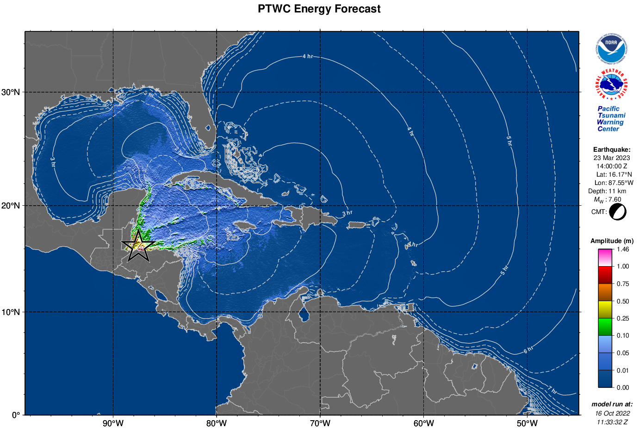
Figure 1. PTWC maximum deep-ocean amplitude map generated using RIFT
for Gulf of Honduras scenario.

2. EXERCISE CONCEPT

2.1 PURPOSE
The purpose of the exercise was to improve Tsunami Warning System effectiveness in the Caribbean and adjacent regions. The exercise provided an opportunity for emergency management organizations throughout the region to exercise their operational lines of communications, review their tsunami response procedures, and promote tsunami preparedness. Regular exercising of response plans is critical to maintain readiness in case of an emergency. This is particularly true for the Caribbean and adjacent regions, where tsunamis are infrequent but can be of very high impact. Every emergency management organization (EMO) was encouraged to participate.

2.2 OBJECTIVES AND GOALS

Each organization developed its objectives for the exercise depending on its level of involvement in the scenario. There were three principal overarching objectives for the exercise.
- Exercise and evaluate communications between Regional Tsunami Service Provider and Members States/Territories.
  - Validate the issuance of tsunami products from the PTWC.
  - Validate receipts of tsunami products by CARIBE-EWS Tsunami Warning Focal Points (TWFPs) and/or National Tsunami Warning Centers (NTWCs).
- Evaluate the tsunami procedures and programs within Members States/Territories.
  - Validate readiness to respond to a tsunami.
  - Validate the operational readiness of the TWFPs/NTWCs and/or the National Disaster Management Office (NDMO).
  - Improve operational readiness. Before the exercise, ensure appropriate tools and response plan(s) have been developed, including public education materials.
  - Validate that the dissemination of warnings and information/advice by TWFPs and NTWCs, to relevant in-country agencies and the public is accurate and timely.
  - Evaluate the status of the implementation of the UNESCO/IOC Tsunami Ready programme.
- Evaluate volcanic procedures
  - Evaluate proposed PTWC CARIBE-EWS procedures and products for volcanic events.
  - Evaluate input and procedures from agencies responsible for volcano monitoring.
  - Evaluate Member States and Territories response plans for tsunamis from volcanoes.
ICG/CARIBE-EWS has established metrics to evaluate the goals of the exercise (Table 1). 90% of MS and Territories submitted the Post-Exercise Survey, with 97% being satisfied with the exercise.

Goals | 2016  Results | 2017  Results | 2018  Results | 2019  Results | 2020  Results | 2021  Results | 2022  Results | 2023  Metrics | 2023  Results
TWFP receive the dummy message | 84% | 95% | 100% | 89% | 97% | 97% | 91% | 100% | 97%
Participation of Member States of ICG/CARIBE-EWS with designated focal warning point | 100% | 100% | 97% | 100% | 92% | 98% | 100% | 100% | 61%
Community involvement (including agencies beyond TWFP) | 73% | 82% | 77% | 66% | 38% | 56% | 43% | 95% | 44%
Number of participants* | 332,812 | 679,985 | 643,403 | 793,353 | 4,622* | 333,518 | 413,281 | +10% | 432,244
Countries who participate submit exercise questionnaire | 100% | 100% | 91% | 82% | 92% | 95% | 100% | 100% | 90%
Members State and territories are satisfied with exercise |  |  |  | 82% | 76% | 96% | 88% | 100% | 97%
Table 1. Goals and Metrics. * As reported by Member States and Territories.

2.3 TYPE OF EXERCISES

The CARIBE WAVE 23 was planned for Caribbean countries to carry exercises at various scales of magnitudes and sophistication. It was up for Member States and territories to decide the type of exercise that would be carried out. The CARIBE WAVE Task Team recommended countries to plan and execute the exercise accordingly by taking into consideration the CARIBE EWS COVID-19 guidelines. Communication tests were carried out to validate the issuance and receipt of the messages distributed by the Pacific Tsunami Warning Center (PTWC), the Regional Tsunami Service Provider, and evaluations of the tsunami procedures and programs within Member States and Territories. The Central America Tsunami Advisory Center (CATAC) also distributed messages during the exercise. Several of the National and local Offices of Emergency Management (OEM) were able to extend the exercise down to the level of testing local notification systems such as the Emergency Alert System (EAS), sirens and loudspeakers.
According to the Member States, the number of participants in the exercise was 432,244 people throughout the Caribbean and adjacent regions. The participants in the twelfth annual regional tsunami exercise hailed from forty-three out of the forty-eight Member States and territories. It represented a participation rate of 90% of all the Member States of the UNESCO Intergovernmental Coordination Group for Tsunamis and other Coastal Hazards for the Caribbean and Adjacent Regions (CARIBE-EWS). This level of participation represents the high enthusiasm from the CARIBE-EWS Members States to participate despite the continuos situation of the COVID-19 pandemic.
Exercises were conducted at various scales of magnitude and sophistication. Exercises simulated the development, training, testing, and evaluation of Disaster Plans and Standard Operating Procedures (SOPs). The reported exercises included a variety of activities including testing communication systems, performing tabletop exercises, conducting seminars and drills (Figure 2). Additionally, the Task Team organized a post-exercise “hot wash” webinar to permit Member States and Territories to discuss and provide feedback on the exercise in an open forum. Discussions on what was the overall impression towards the exercise, unique successes and lessons learned, as well as strength and gaps on the exercise was shared. Some of the Member States feedback were on the successful execution of tsunami evacuations in schools and business. The exercise also helped Emergency Managers identify the need for redundant communication and to adjust their Standard Operating Procedures. Future CARIBE WAVE exercise scenarios was discussed during the webinar, some countries suggested the use of other volcano generated tsunamis, as well as historical tsunamis such as the Jamaica 1692 Port Royal earthquake, and other earthquake scenarios from the Northwest Caribbean.
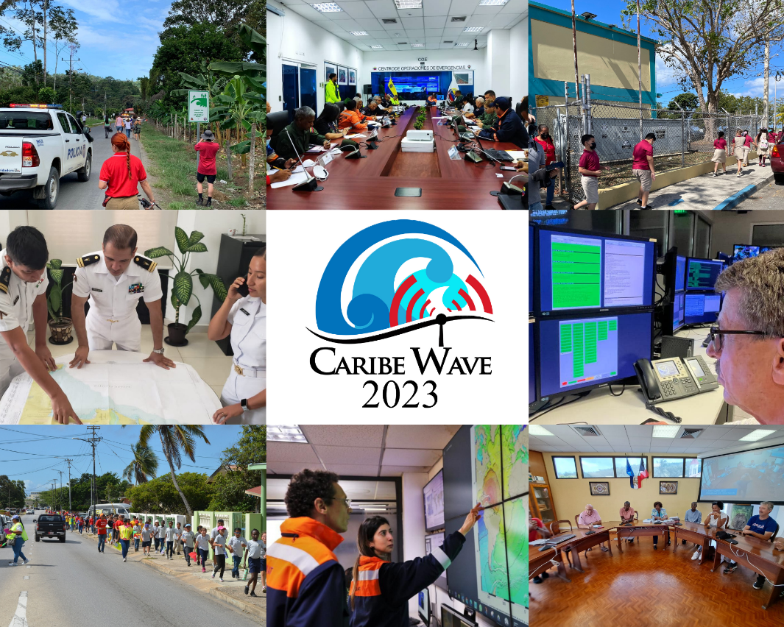
a
b

Figure 2. Participation of the exercise, CARIBE WAVE 23. From top left to right; Costa Rica, Venezuela, Puerto Rico, Mexico, Pacific Tsunami Warning Center, Aruba, Colombia, and Guadeloupe.

3. EXERCISE OUTLINE

3.1 GENERAL

The tsunami messages that were issued for this exercise by the PTWC were based a hypothetical earthquake with the following hypocenter parameter for the Gulf of Honduras and VONUT messages and sea level observations for Mount Pelée (Figure 4):
Gulf of Honduras Scenario:
Origin Time 14:00:00 UTC March 23, 2023
Latitude 16.07ºN
Longitude 87.54ºW
Magnitude 7.6 – M_{w}
Depth 11 km
Mount Pelée Scenario:
Origin Time 14:00:00 UTC March 23, 2023
Latitude 14.48ºN
Longitude 61.10ºW

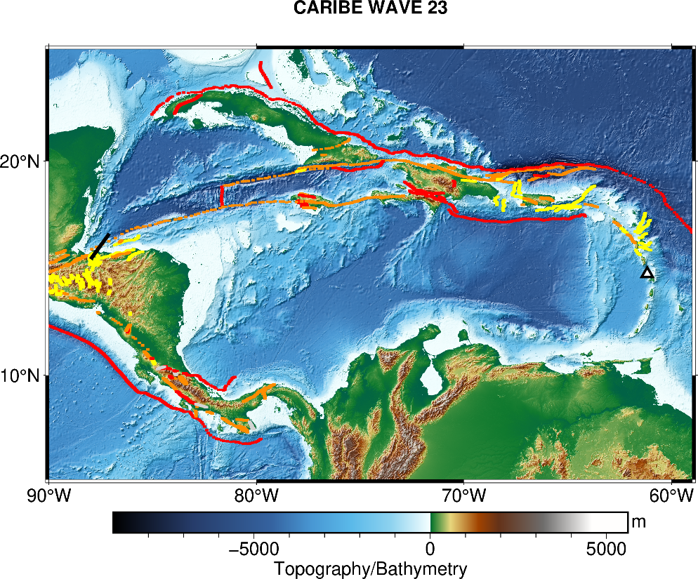
Figure 3. Map of the CARIBE WAVE 23 scenarios. The black rectangle indicates the map view of the ruptured fault segments and the black outlines triangle indicates the volcano location. This figure was generated using PyGMT (Uieda et al., 2021) and GEBCO 2021 background model (GEBCO, 2021).

Messages Issued by the PTWC
The PTWC issued (13) international simulated messages for CARIBE WAVE 23. The first tsunami threat message for the Gulf of Honduras and Mount Pelée scenarios was based on the tsunami earthquake and source event parameters, and the estimated tsunami travel times. While as of the third messages were based on simulated tsunami wave forecast, rather than seismic information. Tsunami threat forecast indicated the levels of threat that have been forecast and to which the countries or places they apply. The levels are tsunami heights of 0.3-1 meters, 1-3 meters, and greater than 3 meters above the normal tide levels are determined. The threats were updated usually within half-hour to an hour.
Member States were required to select one scenario by March 10 for the 2023 exercise. Those who did not select a scenario, the organizers decided for which scenario the PTWC would send the products. All simulated products (text and graphical) were disseminated through email to the corresponding TWFPs and NTWCs and were made available in the Exercise Handbook. Any further dissemination was the responsibility of the corresponding national and local authorities.
The PTWC also issued live over all standard broadcast channels (WMO/AWIPS IDs WECA41 PHEB/TSUCAX) the initial dummy message to start the exercise at 1400 UTC on 23 March 2023.
Messages Issued by CATAC
CATAC issued (5) simulated messages in English and Spanish for CARIBE WAVE 23, with a similar format as the PTWC products. The first tsunami threat message was based on the earthquake magnitude and location. The third message included the simulated tsunami wave forecast and graphical products with predicted amplitudes at sea gauges and coastal zones. The messages were only disseminated for the Gulf of Honduras scenario to Central American countries. All simulated products (text and graphical) were disseminated by email. To note is that their products 2-5 indicated that there was an “Advertencia de Tsunami” in Spanish bulleting and Tsunami Warning in the English bulleting. No end of threat message was received.
The initial dummy message was also issued through email to start the exercise at 1400 UTC on 23 March 2023. According to the Member States and Territories feedback, the message was successfully received by six countries in Central America. The content of the Dummy message as well as the tsunami simulated messages is given in Annex I.

3.2 MASTER SCHEDULE (EXERCISE SCRIPT)

CARIBE-EWS Tsunami Service Provider (PTWC) issued the initial dummy message for the two scenarios on March 23, 2023 at 1400 UTC. This message was used to test communications with TWFPs and NTWCs, and to start the exercise. The transmission methods used to send the dummy message were GTS - WIS (WMO Information System), EMWIN, AISR, NWWS, GNC-A, Email, Fax, and AWIPS (Advanced Weather Interactive Processing System), using header IDs WECA41 PHEB/TSUCAX. All simulated products (text and graphical) were disseminated only thru email to TWFPs and NTWCs. Seven (7) threat messages were issued for the Gulf of Honduras scenario, and six (6) for the Mount Pelée scenario. The graphical enhanced products were included in the third threat message for the Gulf of Honduras scenario. As in past years, the most common methods to receive the Dummy messages were Email and Fax. WMO Information System (GTS) was also a method where several countries received the message (Figure 4).
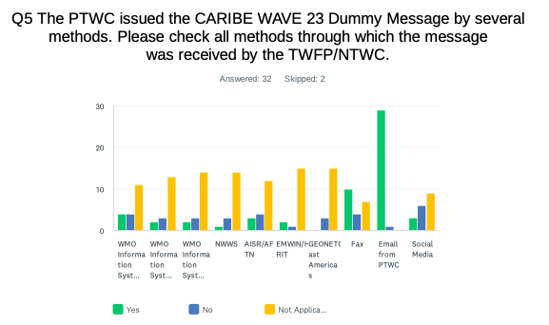
Figure 4. Methods that the CARIBE-EWS TWFPs/NTWCs used to receive the Dummy message by the PTWC.

3.3 ACTIONS IN THE CASE OF A REAL EVENT AND FALSE ALARMS
No significant real events and false alarms were reported by the Member States and Territories during the exercise. No actions were thus required.

3.4 REGISTRATION PROCEDURE
As for past exercises, the CARIBE-EWS teamed up with TsunamiZone.org for online registration (Figure 6). The link used for the registration was http://www.tsunamizone.org/register/. Under the “Register Here” Tab, participants were able to sign up and choose among the three major categories:
- Myself and/or my family,
- My school, district, college/university, or childcare center, and
- My organization, department, or agency (including TNCs. TWFPs and NTWCs). EMOs were encouraged to promote this registration system.
Most people registered directly on the TsunamiZone.org which is an open registration system available during the whole year. As of 19 April 2023, 421,486 people had registered (Table 2). For the first time there were people from every category participating. Nevertheless, according to Member States who answered the post-exercise survey the estimated number of people actually participating were approximately 432,244 (Table 3).
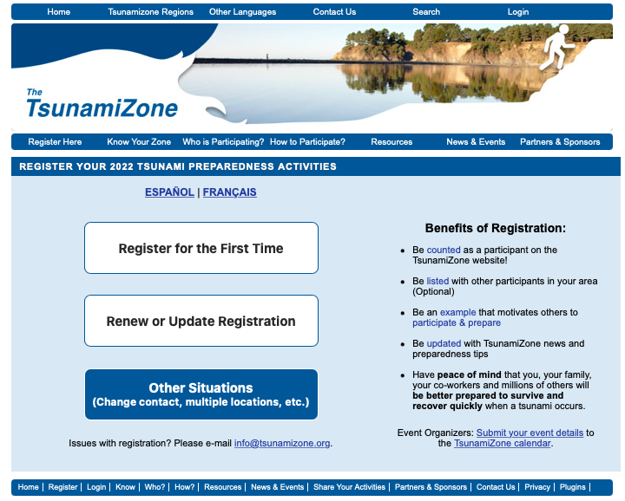
Figure 5. Registration by categories and Country for the CARIBE WAVE 23 Regional Tsunami Exercise.

Category | Number of Participants
Individuals/Families | 2,214
Childcare and Pre-Schools | 5,959
K-12 Schools and Districts | 264,367
Colleges and Universities | 26,353
Local Government | 25,858
State Government | 32,266
Federal/National Government∗ | 15,766
Tribes/Indigenous Peoples | 15
Businesses | 3,609
Hotels and Other Lodgings | 596
Healthcare | 15,977
Senior Facilities/Communities | 650
Disability/AFN Organizations | 225
Non-Profit Organizations | 3,848
Neighborhood Groups | 1,747
Preparedness Organizations | 16,460
Faith-based Organizations | 162
Museums, Libraries, Parks, etc. | 230
Volunteer/Service Clubs | 132
Youth Organizations | 395
Animal Shelter/Service Providers | 14
Agriculture/Livestock | 277
Volunteer Radio Groups | 823
Science/Engineering Organizations | 519
Media Organizations | 667
Other | 2,357
Total | 421,486
Table 2. List of registrants and participants by Categories on TsunamiZone.org in the Caribbean
(as of 04/19/2023)

Country |  | Participants according to Member States | Participants according to Tsunami Zone
Antigua and Barbuda |  | 6,020* | 6,020
Aruba |  | 3,700 | 2,897
Bahamas |  | 0* | 0
Barbados |  | 200 | 344
Belize |  | 2* | 2
Brazil |  | 15 | 14
Colombia |  | 97 | 253
Costa Rica |  | 70 | 54
Cuba |  | 150 | 0
Curacao |  | 165* | 165
Dominica |  | 300 | 4
Dominican Republic |  | 350 | 165
France  (Martinique, Guadeloupe, Guyane, St. Barthelemy, St. Martin) |  | 175,209* | 175,209
Grenada |  | 10,769* | 10,769
Guatemala |  | 25 | 30
Guyana |  | 6 | 10
Haiti |  | 150 | 454
Honduras |  | 0* | 0
Jamaica |  | 341* | 341
Mexico |  | 14,500 | 823
Netherlands  (Bonaire, Saba, Sint Eustatius) |  | 34 | 34
Nicaragua |  | 90 | 20
Panama |  | 3,000 | 9,354
Saint Kitts and Nevis |  | 2,500 | 2,300
Saint Lucia |  | 300 | 254
Sint Maarten |  | 1 | 75
Saint Vincent and the Grenadines |  | 200 | 101
Suriname |  | 0* | 0
Trinidad and Tobago |  | 500 | 480
United Kingdom | Anguilla | 500* | 500
 | Bermuda | 233 | 233
 | British Virgin Islands | 3,000 | 14
 | Cayman Islands | 7,225 | 7,329
 | Montserrat | 0* | 0
 | Turks and Caicos | 500* | 500
United States | Puerto Rico | 129,189 | 129,844
 | US Virgin Island | 17,904 | 17,904
Venezuela |  | 54,999 | 54,999
TOTAL |  | 432,244 | 421,486
Table 3. List of participants by Country/Territory (as of 04/19/2023)
*Number taken from TsunamiZone.org for cases where countries did not report number of participants in survey.

3.5 STATUS OF SEA LEVEL STATIONS DURING EXERCISE
An analysis of sea level stations status was carried out by the International Tsunami Information Center Caribbean Office (ITIC-CAR) as part of the CARIBE WAVE 23 Regional Tsunami Exercise. This allowed ITIC-CAR to analyze the availability of sea level data. The PTWC provided simulated forecasted maximum wave heights for 65 CARIBE-EWS stations in the simulated bulletins. Only about 61% of these sea level stations were online on the IOC Sea Level facility during the exercise period (Fig. 6 and 7). Similarly, the Tide Tool system used by many Tsunami Warning Centers had around 68% of stations operational, this is a slight increase over the 50% data availability in 2022. Only 2 of the 7 reported DART stations were streaming data in the Caribbean/Gulf and Atlantic thru the National Buoy Center during the day of the exercise (Figure 10).
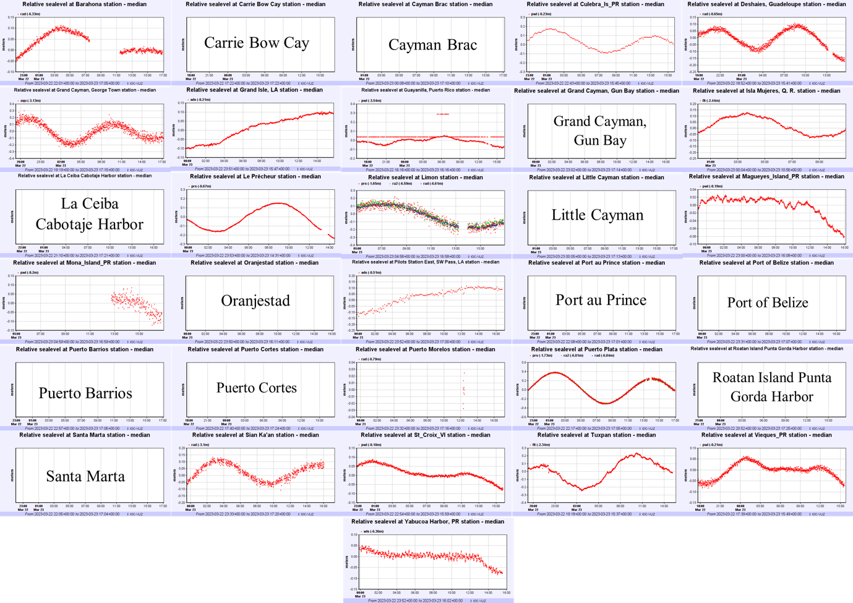Figure 6. Forecast of maximum wave heights for the Gulf of Honduras scenario from 31 CARIBE-EWS coastal sea level stations during the CARIBE WAVE exercise. Stations for which the name of the station is provided, and not the wave form, are stations that had no data on the IOC Sea Level Monitoring Facility.

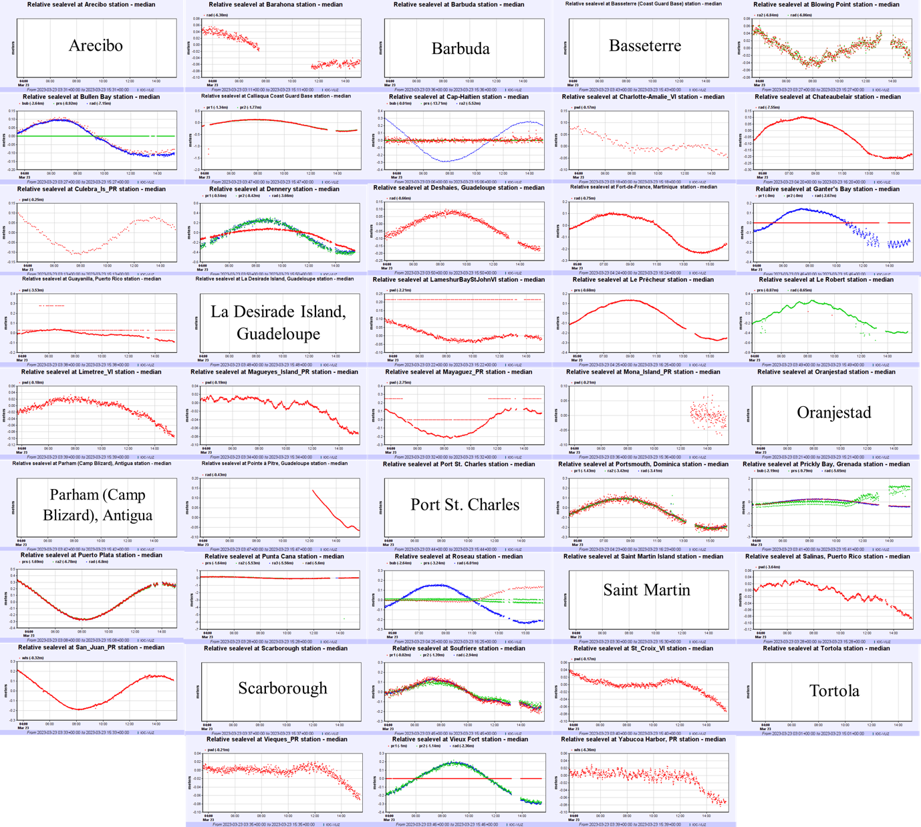
Figure 7. Forecast of maximum wave heights for the Mount Pelée scenario from 43 CARIBE-EWS coastal sea level stations during the CARIBE WAVE exercise. 10 stations for which the name of the station is provided, and not the wave form, are stations that had no data on the IOC Sea Level Monitoring Facility.

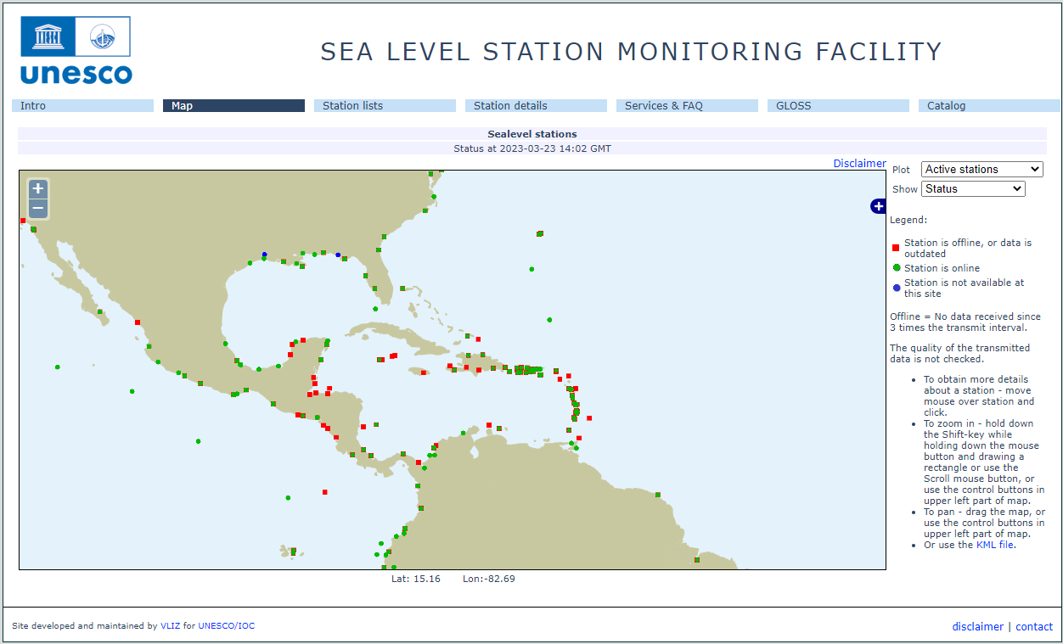
Figure 8. Screenshot showing IOC Sea Level facilities operating during the CARIBE WAVE 23 exercise. In green are stations for which data were available, red dots are for station for which there were no data.

3.6 RESOURCES
Although Emergency Management Organizations (EMOs) had advance notice of the exercise and some elected to set up a special dedicated shift to allow normal core business to continue uninterrupted, it was suggested that realistic resource levels be deployed in order to reflect some of the issues that are likely to be faced in a real event. Considering the pandemic, agencies were requested to adjust the exercise to their best convenience.
This year Elizabeth Vanacore was the Exercise Chair; while Silvia Chacón-Barrantes was the scientific experts that helped in the determination of the Gulf of Honduras scenario; Valerie Clouard and Fabrice Fontaine were the scientific expert for the Mount Pelée scenario. ITIC-CAR coordinated the exercise for CARIBE-EWS.
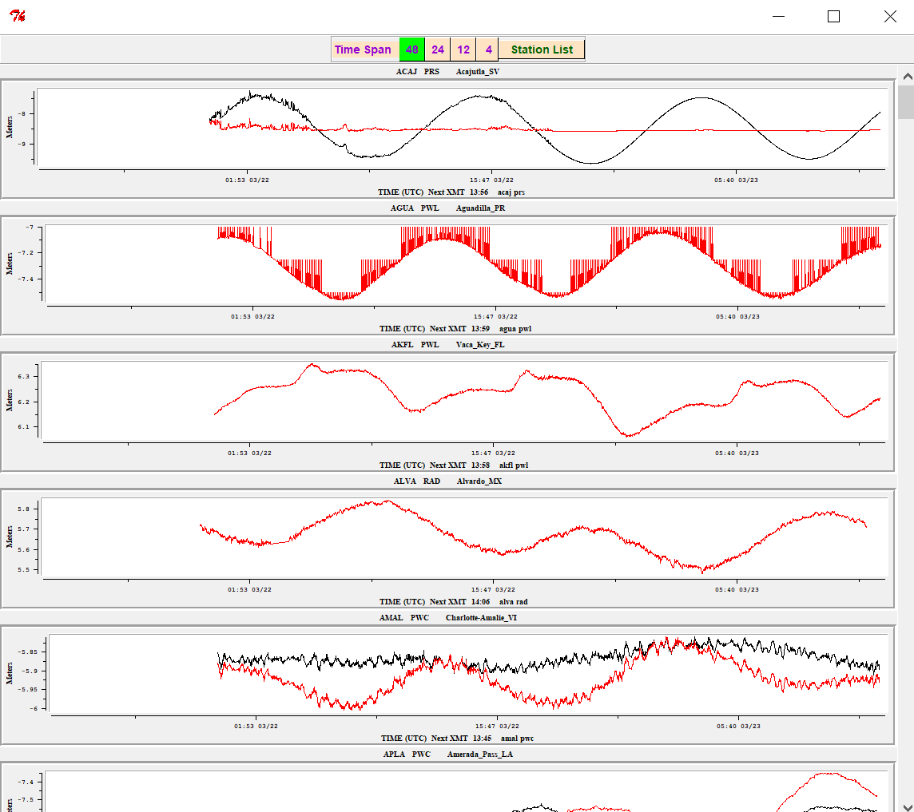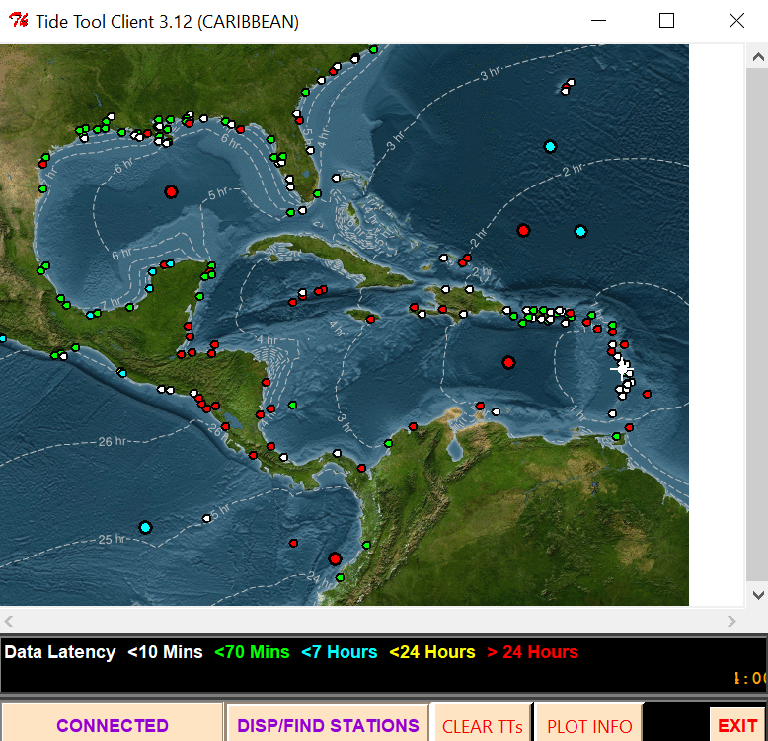
Figure 9. Screenshot from Tide Tool for the CARIBE WAVE 23 Mount Pelé Scenario. Tide Tool includes both coastal gauges and DARTs. In White and Green are operational stations, in red are stations with no data over the past 24 hours (non-operational). The Isochrons represent the travel time from the source of the simulated tsunami from. The Strip Chart to the left includes the marigrams from the closest 5 stations. The magenta stripe marks the estimated time of arrival.

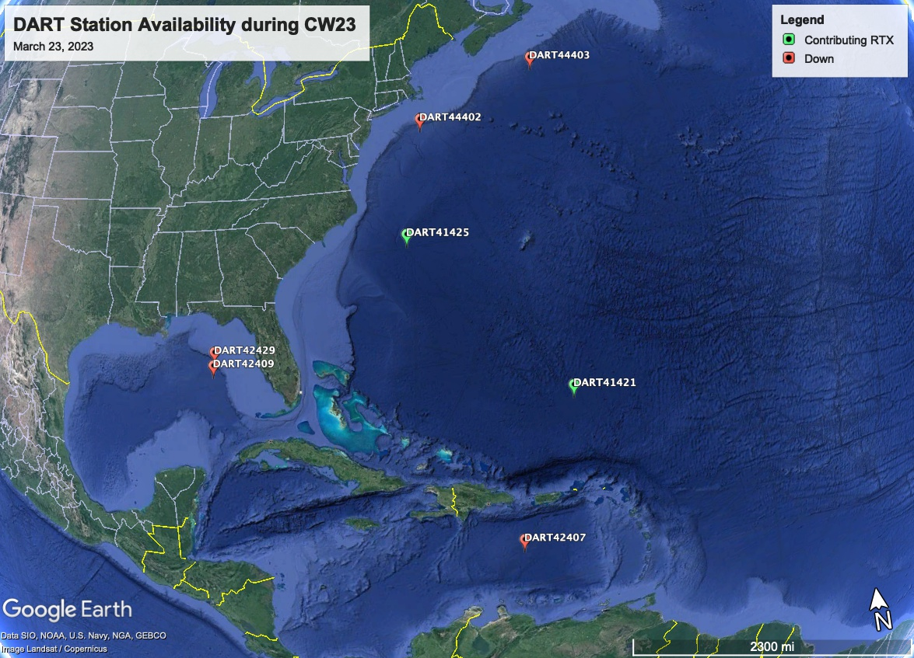
Figure 10. Map of operational and non-operational status of the DART’s on March 23, 2023.

3.7 MEDIA ARRANGEMENTS
One advantage in conducting exercises is that it provides a venue to promote tsunami awareness. The exercise offers an opportunity to collaborate with the media and disseminate more broadly information on the warning system. The CARIBE-EWS Member States and Territories indicated that about 36% of the news media participated and covered the exercise. The hashtag tracker Brand24 was used to monitor #CaribeWave and #CaribeWave23 from February 28 to March 30. Its data resulted in over 250 mentions on social media outlets and posts reaching over 1.8 million people worldwide (Figure 11). Emergency management agencies from countries such as Barbados, British Virgin Islands, Saint Lucia, Trinidad and Tobago, and others informed citizens through online article publications and social media posts that their country would participate in the exercise on March 23. The International Tsunami Information Center Caribbean Office, as well as the Puerto Rico Seismic Network also published informative posts related to tsunami awareness in preparation for CARIBE WAVE.
During the exercise, text messages and tweets about the start of the exercise were displayed on the PTWC account (Figure 12).

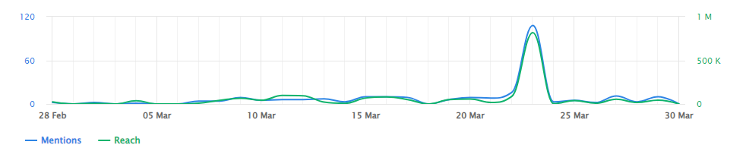

Figure 11. Graphs showing the #CaribeWave and #CaribeWave23 trending Mentions and Social Media Reach between the 28th of February and 30th of March 2023.

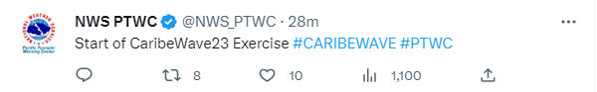
Figure 12. Twitter post about the CARIBE WAVE 23 exercise from NWS PTWC’s account.

3.8 POST-EXERCISE EVALUATION
All participating countries were requested to provide feedback on the exercise through an online questionnaire. This feedback assists the ICG/CARIBE-EWS in the evaluation of CARIBE WAVE 23 and the development of subsequent exercises. It also helps response agencies document lessons learned and lead to improvements of the national systems. The survey contained 45 questions and was conducted by the IOC UNESCO using the Survey Monkey service. 33 surveys were completed representing the feedback from 90% of the MS and Territories.∗
The survey was available from a week prior to the exercise on March 23 and extended through April 14. Overall, the results indicated that the Dummy (Start of Exercise) message was received by 31 Member States, representing 94% of the CARIBE-EWS Member States and Territories. There was a strong dependency on email for the reception of products from the PTWC. The message was received by most countries within the first 1-3 minutes, and few countries reported delays. Despite COVID-19, 61% of the MS indicated that the TWFP/NTWC issued messages to relevant in country agencies. The exercise planning went well under extenuating circumstances, resulting in a 90% of satisfaction of MS and territories, and a total participation of 432,244 people from the Caribbean. The questions as well as the answers and comments are contained in the Supplement.
This evaluation contains valuable information and gives to the ICG/CARIBE-EWS group insights to address the objectives of the exercise. The results for the status of the implementation of the UNESCO/IOC Tsunami Ready Recognition Programme indicated that 71% of the countries are interested in implementing the program and 75% of these are already implementing it with 87 as total number of target communities to be recognized as Tsunami Ready (Table 4), this number is a lot smaller than indicated in previous years..
In addition, the survey provided the MS an opportunity to provide additional feedback on the exercise (Table 5).

Country | Already Implementing | Interested in Implementing | TsunamiReady® or Tsunami Ready Communities (as reported by Member States) | TsunamiReady® or Tsunami Ready Communities (IOC Records For CARIBE EWS) | Target Number
Antigua and Barbuda | - | - | - | 1 | -
Aruba | No | Yes | 0 | 0 | 8
Bahamas | Yes | - | - | 0 | -
Barbados | Yes | - | 1 | 1 | 1
Belize | Yes | - | 0 | 0 | -
Brazil | No | No | - | 0 | -
Colombia | No | Yes | 0 | 0 | -
Costa Rica | Yes | - | 0 | 0 | -
Cuba | No | Yes | 0 | 0 | 2
Curacao | - | - | - | 0 | -
Dominica | Yes | - | - | 0 | -
Dominican Republic | Yes | - | 2 | 1 | 2
France | Yes | - | 0 | 0 | -
Grenada | Yes | - | 3 | 2 | 3
Guatemala | Yes | - | 0 | 0 | -
Guyana | No | - | - | 0 | -
Haiti | Yes | - | 2 | 2 | 2
Honduras | No | Yes | - | 2 | -
Jamaica | - | - | - | 1 | -
Mexico | Yes | - | 0 | 0 | -
NL- Bonaire, Saba, and Sint Eustatius | No | No | - | 0 | -
Nicaragua | Yes | - | 2 | 2 | 2
Panama | Yes | - | 0 | 0 | 1
Saint Kitts and Nevis | Yes | - | 1 | 1 | 1
Saint Lucia | Yes | - | 1 | 0 | 1
Saint Vincent and the Grenadines | Yes | - | 0 | 1 | -
Sint Maarten | No | Yes | 0 | 0 | 1
Suriname | - | - | - | 0 | -
Trinidad and Tobago | Yes | - | 1 | 1 | 12
UK- Anguilla | Yes | - | - | 1 | 4
UK- Bermuda | Yes | - | - | 0 | -
UK- British Virgin Islands | Yes | - | 1 | 1 | 1
UK- Cayman Islands | Yes | - | 0 | 0 | -
UK- Montserrat | Yes | - | - | 0 | -
UK- Turks and Caicos | - | - | - | 0 | -
USA- Puerto Rico | Yes | - | 46 | 46 | 46
USA- US Virgin Islands | Yes | - | - | 3 | -
Venezuela | Yes | - | 0 | 0 | -
TOTAL | 25 YES | 5 INTERESTED | 60 | 66 | 87

Table 4. Status of Implementation of the Pilot CARIBE EWS Tsunami Ready Recognition Program.

Country | Exercise Caribe Wave 23  General Statements
Aruba | Evaluating adapt and adjust for CARIBE WAVE 2024.
Barbados | From the communications end, the Barbados Meteorological Services (BMS) did a good gob in sending out the appropriate warning and discontinuation messages. The only issues that occurred was the delay in the distribution of the CAP messages, which was beyond the scope of the BMS.
Brazil | After a sequence of participation, I could note more willingness from the Operations Chief in the Situation room, even with lots of warnings being sent due to raining season in our country. I hope to keep increasing the participation on the operational 24/7 sector of our institute.
Colombia | It was an interesting exercise which allowed the National Detection and Warning System to apply the protocol update and to identify improvement actions.
Cuba | CARIBE WAVE Tsunami Exercises are perhaps, without fear of being mistaken, one of the best examples of a systematic effort and activity in order to continuously improve a warning system for the common well-being of all the inhabitants of the Caribbean region, taking into account that it is a relatively small basin where a tsunami could put its precious coastal settlements in great danger.
Dominica | The public interaction was very informative and interactive. Schools are always very receptive to the public outreach activities
Dominican  Republic | In general, the exercise is fine. It is important to continue raising awareness about these issues among the population, especially the rulers of the countries that make decisions.
Guatemala | This kind of exercise is very good for testing our preparedness in case of a real event. As INSIVUMEH, we are in charge of processing the information from PTWC emails and translating to more convenient bulletins for national agencies and people in general. So in this exercise we test the system doing this kind of processing, our system of dissemination of messages (telegram and email).
Haiti | It's very difficult to provide a general statement about the CARIBE WAVE 23 tsunami exercise because of the bad socio-political situation in Haiti. We couldn't organize a very good exercise because communication and moving across the country are very difficult. We couldn't use EMWIN because its installation is in not safe area. I wish that the political situation will be improved in order to realize a better exercise next year.
Mexico | The exercise was communicated one month in advance, for a greater participation of the coastal population. The PTWC products were received at the times scheduled for the exercise. However, there was a delay in the distribution of a monitoring bulleting, due inconsistencies in the email system. The participation of the civilian population was obtain, carrying out evaluations and response activities by the emergency managers.
Nicaragua | Excellent work.
Panama | In the case of Panama, greater coordination is required between the responsible agencies to advance in the development of the alert system. The training prior to the exercise is very good, many students are trained, we must internally improve the participation of all levels that have to do with Risk Management, a fund must be designated to meet all the logistics and preparation needs in time for the exercise, related to the making of signs, tubes for its installation in PVC, stickers, making maps and their printing on durable material, talk with the Authorities so that they allow their officials involved in this issue to be able to attend and participate, this means designating them their per diem to cover their mobilization, food and lodging, allow those in charge of Tsunami to be able to provide statements, participate in televised programs to speak and educate on the subject.My experience was pleasant to see that the E-MAIL system worked well and that the objective of the Institute of Meteorology and Hydrology of Panama, in issuing a Test Notice, in almost real time, at the moment the Tsunami warning was activated, was achieved.
Saint Kitts and Nevis | The exercise has proven to be instrumental for the response to any real event. The NEMA and the other government agencies, private sector, and NGOs are more informed of their responsibilities and roles. The majority residents have shown that they are knowledgeable of the tsunamis and know what to do in the event of a tsunami. The country has been certified as Tsunami Ready, and this exercise will continue to provide the necessary incites to improve.  The Nevis Disaster Management highlighted the Tsunami Hazard as part of its Public Awareness and Education Multi Hazards Campaign for the Month of March. As part of the campaign the Department executed a Mass Evacuation Exercise with over 2,500 persons on Thursday 23rd March 2023 @ 10 a.m. as part of the 12th annual Regional Caribe Wave Tsunami Exercise. The CARIBE WAVE Tsunami exercise was important to validate and advance end-to-end tsunami preparedness. It provided an opportunity to test International, Regional and Local operational lines of communications, tsunami response and evacuation procedures and evaluate our readiness in communities at risk on the island of Nevis.  The hybrid approach lends to greater participation that will being more interest from the private sector. I encourage us to look at this moving forward.
Saint Vincent and the Grenadines | The SVG CARIBE WAVE 23 was a resounding success. We were able to mobilize plan action in the community of port Elizabeth and successfully evacuate 200 persons for several institutions in less than 15 to 20 minutes. The communication process requires some additional training and work.
UK - Anguilla | Being Tsunami ready is and will continue to be an important element within our annual planning.
UK- British Virgin Islands | Overall, the exercise went very well with the activation of the National Early Warning Multi-hazard Alert System, which includes public notifications via emergency siren, radio, the DDM app, social media and other tools.  We had support from local broadcasters airing messages to make sure that persons were aware of the exercise and what to do in case of a real threat.  There was great support from the public and private sector took especially the primary schools and early childhood education centres, doing full drop, cover and hold drills in addition to evacuation inland or to high ground as well as participation from the BVI Autism Centre and BVI Services.
UK- Cayman Islands | This was a really positive exercise experience for the Cayman Islands. The involvement of all schools has resulted in improvement in the school hazard plans for tsunami threats. It has built awareness and familiarization in the education system as well as more generally in the community. The exercise also provided an opportunity for us to test the emergency notification system and as a result of the publicity surrounding the exercise an additional 800 persons signed up for the Emergency App bringing the total to nearly 7,000 (so more than 10 percent growth from a single event - CARIBE WAVE 23) We feel grateful. This exercise improved our overall preparedness and level of readiness for a tsunami.
USA- Puerto Rico | CARIBE WAVE 23 was an excellent opportunity to practice tsunami response plans at state, municipalities, public and private agencies, schools, families and TsunamiReady Supporter agencies. The scenario was ideal to activate our critical thinking about how to react if a tsunami is generated do a volcanic eruption and not an earthquake as we are used to. It was also an opportunity to foment the participation in exercise and foment the preparedness after all these years that we had to deal with the pandemic and people avoided contact. This interaction is ideal for communities, so their plans are more solid and realistic in case they have to confront a real tsunami.
USA-US Virgin Islands | Adequate time for the agency (VITEMA) to prepare and conduct outreach. Ability conduct evacuation drills and sound Tsunami Warning Sirens. Anticipate including VITEMA EOC Tabletop Exercise in 2024.
Venezuela | This CARIBE WAVE 23 was more active than the previous two years in the face of the health emergency, contacts with the highest authorities were resumed and the new authorities were convinced of the importance of the CARIBE WAVE 23 exercise, coordination with scientists and communities was very important. With great enthusiasm, the state and municipal civil protections, given their experience in previous exercises, assumed the participation with their own methodologies and adapted their participation taking into account the security against COVID-19, they informed the situation room and a lot of work was done with the documents prepared by the Vice Ministry of Risk Management and Civil Protection and its team called "Operations Order for the Caribbean Wave", with the participation of radio amateurs, in this exercise communications were strengthened. We must rescue international communications with the other alert centers in the region, to obtain confirmation and data exchange, among others. An evaluation will be made to the coastal zones that can be prepared for the tsunami ready program in the near future.
Table 5. General statements on CARIBE WAVE 23 Tsunami Exercise experience from countries
that participated.

REFERENCES

GEBCO Compilation Group (2021) GEBCO 2021 Grid (doi:10.5285/c6612cbe-50b3-0cff-
e053-6c86abc09f8f)

Uieda, L., Tian, D., Leong, W. J., Jones, M., Schlitzer, W., Toney, L., Grund, M., Yao, J.,
Magen, Y., Materna, K., Newton, T, Anant, A., Ziebarth, M., Wessel, P., & Quinn, J.
(2021). PyGMT: A Python interface for the Generic Mapping Tools (v0.5.0). Zenodo.
https://doi.org/10.5281/zenodo.5607255
von Hillebrandt-Andrade, Christa, 2013, Minimizing Caribbean Tsunami Risk: Science, Vol. 341, p. 966-968.

ANNEX I. CATAC Dummy (Start of Exercise) Message

Â¡This is just a test message sent by CATAC in support of Exercise CaribeWave 23!
***************************************************************************
Central America Tsunami Advisory Center (CATAC)
XXXXXXX THIS IS AN EXERCISE XXXXXXXXXXXX THIS IS AN EXERCISE XXXXXXXXXXXXXXXX
Notice : This is a kick-off message for exercise Caribe Wave 2023 for Central
American countries, such as for Central American countries in support of the
Intergovernmental Oceanographic Commission (IOC), of UNESCO and the
ICG/CARIBE-EWS.
Isuued : 2023-03-23 14:00 Time (UTC)
2023-03-23 08:00 Central American Time
2023-03-23 09:00 Panama Time
This message is being used to initiate the Caribe Wave 2023 tsunami exercise, originating off the northern coast of Honduras.
The exercise messages are available on the web site http://catac.ineter.gob.ni/.
The purpose of the exercise is to provide emergency management advice.
It is a scenario to test tsunami response plans in Central American countries.
XXXXXXX THIS IS AN EXERCISE XXXXXXXX THIS IS AN EXERCISE XXXXXXXXXXXX THIS IS AN EXERCISE XXXXXXXXXXXX
...

ANNEX II. CATAC Exercise Messages

The following messages created for the CARIBE WAVE 23 tsunami exercise were issued by the Central American Tsunami Advisory Center for a magnitude 7.6 earthquake and subsequent tsunami originating in the Gulf of Honduras. Only Central American countries and regions by agreement with the center received the messages.

CATAC Message #1

Â¡This is just a test message sent by CATAC in support of Exercise CaribeWave 23!
***************************************************************************
Central America Tsunami Advisory Center - CATAC
XXXXXXX THIS IS JUST AN EXERCISE XXXXXXXXXXXXXXXXXXXXXXXXXX
NOTICE : This message is published for information purposes only in support
of Central American countries. National authorities are responsible
for determining the level of alert and for taking appropriate measures for their
country.
Tsunami Bulletin NÂ° 01
Issued : 2023-03-23 08:03 Central American Time
2023-03-23 09:03 Panama Time
2023-03-23 14:03 UTC Time
An earthquake has occurred with the following these preliminary parameters:
Magnitude : 7.6
Date : 23/03/2023
Time : 08:00 Central American Time, 09:00 Panama Time, 14:00 UTC Time
Latitude : 16.1 N
Longitude : 87.5 W
Depth : 11 Km
Location : Northern Honduras
Assessment:
There is a very high possibility of tsunami considering the magnitude, depth of the hypocenter, and the location of the earthquake.
Recommended Actions:
Immediate actions are urgently needed for the protection of the population on the Caribbean coasts of Central America.
More information will be provided in the next few minutes.
*************************************************************************************
XXXXXXX THIS IS JUST AN EXERCISE XXXXXXXXXXXXXXXXXXXXXXXXXX

CATAC Message #2

Â¡This is just a test message sent by CATAC in support of Exercise CaribeWave 23!
***************************************************************************
Central America Tsunami Advisory Center - CATAC
XXXXXXX THIS IS JUST AN EXERCISE XXXXXXXXXXXXXXXXXXXXXXXXXX
NOTICE : This message is published for information purposes only in support of
Central American countries. National authorities are responsible for
determining the level of alert and for taking appropriate measures for their
country.
Tsunami Bulletin NÂ° 02
Issued: 2023-03-23 08:09 Central American Time
2023-03-23 09:09 Panama Time
2023-03-23 14:09 UTC Time
A tsunami warning is in effect for the coastal areas of Central American countries.
An earthquake has occurred with the following parameters:
Magnitude : 7.6
Date : 23/03/2023
Time : 08:00 Central America Time, 09:00 Panama Time, 14:00 UTC Time
Latitude : 16.1 N
Longitude : 87.5 W
Depth : 11 Km
Location : Northern Honduras
Evaluation:
Due to magnitude, depth and location of the earthquake there is a possibility that a tsunami may have been produced which would affect with greater intensity the nearest coasts, about 100 km from the epicenter of the earthquake.
Authorities should take actions corresponding to their response plans.
Tsunami simulation results:
Estimated Time of Arrival (ETA) in local time and Maximum Height (AM) of tsunami waves,at different forecast points:
Site Country ETA AM(m)
Utila Honduras 2023-03-13 08:16:30 5.29
Atlantida Honduras 2023-03-13 08:38:30 3.61
Puerto CortÃ©s Honduras 2023-03-13 08:25:30 3.11
Chichino Grande Honduras 2023-03-13 08:26:30 2.38
ColÃ³n Honduras 2023-03-13 08:55:30 1.75
Isla de la Bahia Honduras 2023-03-13 08:24:30 1.54
Izabal Guatemala 2023-03-13 08:35:00 1.37
Guanaja Sur Honduras 2023-03-13 08:19:00 1.26
Isla del Cisne Honduras 2023-03-13 09:29:00 0.58
Graphical result:
Review in the attachment to this message, the color-coded forecast zones according to hazard, for the Caribbean Sea coastal areas of Central America.
Updates:
More information will be provided in the next few minutes.
Countries may additionally receive messages from the Pacific Tsunami Warning Center (PTWC).
In case of differences between CATAC and PTWC results, we recommend to prefer conservatively, the estimates that correspond to a higher hazard.
Additional information:
Detailed earthquake and tsunami information can be found at the website.
www.catac.ineter.gob.ni
***************************************************************************
XXXXXXX THIS IS JUST AN EXERCISE XXXXXXXXXXXXXXXXXXXXXXXXXX

CATAC Message #3

Â¡This is just a test message sent by CATAC in support of Exercise CaribeWave 23!
***************************************************************************
Central America Tsunami Advisory Center - CATAC
XXXXXXX THIS IS JUST AN EXERCISE XXXXXXXXXXXXXXXXXXXXXXXXXX
NOTICE : This message is published for information purposes only in support of
Central American countries. National authorities are responsible for
determining the level of alert and for taking appropriate measures for their
country.
Tsunami Bulletin NÂ° 03
Issued: 2023-03-23 08:30 Central American Time
2023-03-23 09:30 Panama Time
2023-03-23 14:30 UTC Time
A tsunami warning is in effect for the coastal areas of Central American countries.
An earthquake has occurred with the following parameters:
Magnitude : 7.6
Date : 23/03/2023
Time : 08:00 Central American Time, 09:00 Panama Time, 14:00 UTC Time
Latitude : 16.1 N
Longitude : 87.5 W
Depth : 11 Km
Location : North of Honduras
Evaluation:
Due to magnitude, depth and location of the earthquake there is a possibility that a tsunami may have been produced which would affect with greater intensity the closest coasts, about 100 km from the epicenter of the earthquake.
Authorities should take actions corresponding to their response plans.
Tsunami simulation results:
Estimated Time of Arrival (ETA) in local time and Maximum Height (AM) of tsunami waves, at different forecast points:
Site Country ETA AM(m)
Utila Honduras 2023-03-13 08:16:30 5.29
AtlÃ¡ntida Honduras 2023-03-13 08:38:30 3.61
Puerto CortÃ©s Honduras 2023-03-13 08:25:30 3.11
Chichino Grande Honduras 2023-03-13 08:26:30 2.38
ColÃ³n Honduras 2023-03-13 08:55:30 1.75
Isla de la Bahia Honduras 2023-03-13 08:24:30 1.54
Izabal Guatemala 2023-03-13 08:35:00 1.37
Guanaja Sur Honduras 2023-03-13 08:19:00 1.26
Isla del Cisne Honduras 2023-03-13 09:29:00 0.58
Graphical result:
Review in the attachment to this message, the color-coded forecast zones according to hazard, and wave heights, for the Caribbean Sea coastal areas of Central America.
Sea level station measurements:
Code Coordinates Country ETA AM(m)
VZ..CABC 16.803N 88.082W Belize 2023-03-23 08:12:34 6.67
VZ..TELA 15.784N 87.453W Honduras 2023-03-23 08:00:00 4.08
VZ..PCOR 15.843N 87.959W Honduras 2023-03-23 08:00:00 3.73
VZ..CEIB 15.790N 86.760W Honduras 2023-03-23 08:17:00 3.17
VZ..RTAS 16.346N 86.540W Honduras 2023-03-23 08:00:54 2.00
VZ..PRBA 15.695N 88.622W Guatemala 2023-03-23 08:19:54 1.56
VZ..POBE 17.474N 88.201W Belize 2023-03-23 08:55:10 1.05
Updates:
More information will be provided in the next few minutes.
Countries may additionally receive messages from the Pacific Tsunami Warning Center (PTWC).
In case of differences between CATAC and PTWC results, we recommend to prefer conservatively, the estimates that correspond to a higher hazard.
Additional information:
Detailed earthquake and tsunami information can be found at the website.
http://catac.ineter.gob.ni/
***************************************************************************
XXXXXXX THIS IS ONLY AN EXERCISE XXXXXXXXXXXXXXXXXXXXXXXXXX

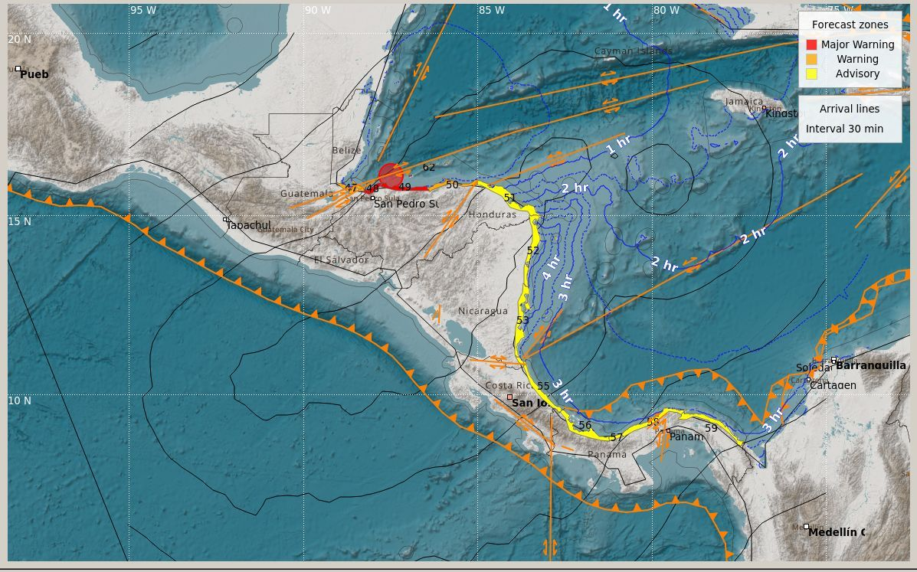

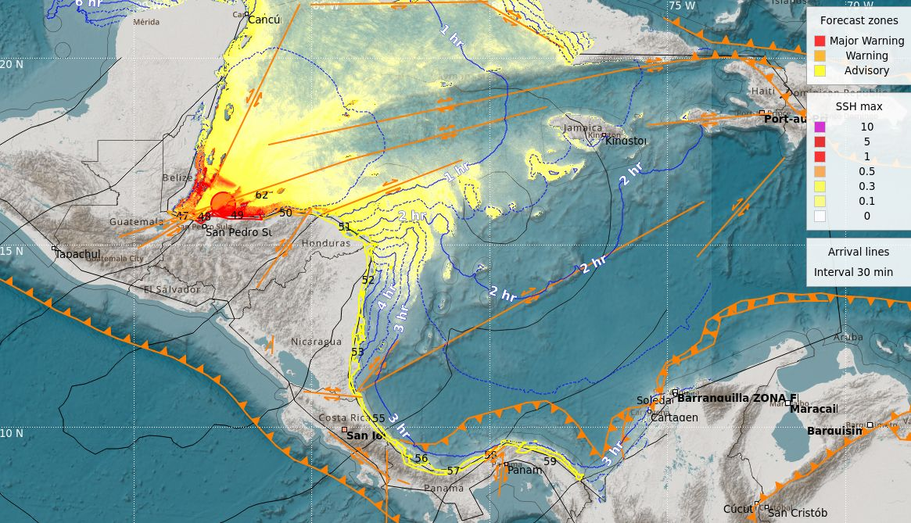

CATAC Message #4

Â¡This is just a test message sent by CATAC in support of Exercise CaribeWave 23!
***************************************************************************
Central America Tsunami Advisory Center - CATAC
XXXXXXX THIS IS JUST AN EXERCISE XXXXXXXXXXXXXXXXXXXXXXXXXX
NOTICE : This message is published for information purposes only in support of
Central American countries. National authorities are responsible for
determining the level of alert and for taking appropriate measures for their
country.
Tsunami Bulletin NÂ° 04
Issued : 2023-03-23 09:00 Central American Time
2023-03-23 10:00 Panama Time
2023-03-23 15:00 UTC Time
A tsunami warning is in effect for the coastal areas of Central American countries.
An earthquake has occurred with the following parameters:
Magnitude : 7.6
Date : 23/03/2023
Time : 08:00 Central American Time, 09:00 Panama Time, 14:00 UTC Time
Latitude : 16.1 N
Longitude : 87.5 W
Depth : 11 Km
Location : North of Honduras
Evaluation:
Due to magnitude, depth and location of the earthquake there is a possibility that a tsunami may have been produced which would affect with greater intensity the closest coasts, about 100 km from the epicenter of the earthquake.
Authorities should take actions corresponding to their response plans. No incidents are reported in the countries south of Honduras.
Tsunami simulation results:
Estimated Time of Arrival (ETA) in local time and Maximum Height (AM) of tsunami waves, at different forecast points:
Site Country ETA AM(m)
Isla del Cisne Honduras 2023-03-13 09:29:00 0.58
Sea level station measurements:
Code Coordinates Country ETA AM(m)
VZ..CABC 16.803N 88.082W Belize 2023-03-23 08:12:34 6.67
VZ..TELA 15.784N 87.453W Honduras 2023-03-23 08:00:00 4.08
VZ..PCOR 15.843N 87.959W Honduras 2023-03-23 08:00:00 3.73
VZ..CEIB 15.790N 86.760W Honduras 2023-03-23 08:17:00 3.17
VZ..RTAS 16.346N 86.540W Honduras 2023-03-23 08:00:54 2.00
VZ..PRBA 15.695N 88.622W Guatemala 2023-03-23 08:19:54 1.56
VZ..POBE 17.474N 88.201W Belize 2023-03-23 08:55:10 1.05
Updates:
More information will be provided in the next few minutes.
Countries may additionally receive messages from the Pacific Tsunami Warning Center (PTWC).
In case of differences between CATAC and PTWC results, we recommend to prefer conservatively, the estimates that correspond to a higher hazard.
Additional information:
Detailed earthquake and tsunami information can be found at the website.
http://catac.ineter.gob.ni/
***************************************************************************
XXXXXXX THIS IS ONLY AN EXERCISE XXXXXXXXXXXXXXXXXXXXXXXXXX

CATAC Message #5

Â¡This is just a test message sent by CATAC in support of Exercise CaribeWave 23!
***************************************************************************
Central America Tsunami Advisory Center - CATAC
XXXXXXX THIS IS JUST AN EXERCISE XXXXXXXXXXXXXXXXXXXXXXXXXX
NOTICE : This message is published for information purposes only in support of
Central American countries. National authorities are responsible for
determining the level of alert and for taking appropriate measures for their
country.
Tsunami Bulletin NÂ° 05
Issued : 2023-03-23 10:00 Central American Time
2023-03-23 11:00 Panama Time
2023-03-23 16:00 UTC Time
A tsunami warning is in effect for the coastal areas of Central American countries.
An earthquake has occurred with the following parameters:
Magnitude : 7.6
Date : 23/03/2023
Time : 08:00 Central American Time, 09:00 Panama Time, 14:00 UTC Time
Latitude : 16.1 N
Longitude : 87.5 W
Depth : 11 Km
Location : North of Honduras
Sea level station measurements:
Estimated Time of Arrival (ETA) in local time and Maximum Height (AM) of tsunami waves.
Code Coordinates Country ETA AM(m)
VZ..CABC 16.803N 88.082W Belize 2023-03-23 08:12:34 6.67
VZ..TELA 15.784N 87.453O Honduras 2023-03-23 08:00:00 4.08
VZ..PCOR 15.843N 87.959O Honduras 2023-03-23 08:00:00 3.73
VZ..CEIB 15.790N 86.760O Honduras 2023-03-23 08:17:00 3.17
VZ..RTAS 16.346N 86.540O Honduras 2023-03-23 08:00:54 2.00
VZ..PRBA 15.695N 88.622O Guatemala 2023-03-23 08:19:54 1.56
VZ..POBE 17.474N 88.201O Belize 2023-03-23 08:55:10 1.05
Assessment:
According to our simulations, considerably higher amplitudes could occur in the next few hours.
The national authorities of the different countries should make the appropriate decisions,
according to their response plans.
PTWC messages:
Countries may additionally receive messages from the Pacific Tsunami Warning Center (PTWC).
In case of differences between CATAC and PTWC results, we recommend preferring conservatively, the estimates that correspond to a higher hazard.
Additional information:
Detailed earthquake and tsunami information can be found at the website.
http://catac.ineter.gob.ni/
***************************************************************************
XXXXXXX THIS IS ONLY AN EXERCISE XXXXXXXXXXXXXXXXXXXXXXXXXX
XXXXXXX This is the last message, in the frame of the exercise CaribeWave 23, sent by CATAC XXXXXXXXXXX

ANNEX III. List Of Acronym
AWIPS | Advanced Weather Interactive Processing System
CATAC | Central American Tsunami Advisory Centre
EAS | Emergency Alert System
EMO | Emergency Management Organization
EMWIN | Emergency Management Weather Information Network
GTS | Global Telecommunication System
ICG/CARIBE-EWS | Intergovernmental Coordination Group for the Tsunamis and Other Coastal Hazards Warning System for the Caribbean and Adjacent Regions
INETER | Instituto Nicaragüense de Estudios Territoriales
IOC  ITIC-CAR | Intergovernmental Oceanographic Commission of UNESCO  International Tsunami Information Center Caribbean Office
NCEI  NDMO  NOAA | National Centers for Environmental Information  National Disaster Management Office  National Oceanic and Atmospheric Administration
NTWC | National Tsunami Warning Centre
NWS | National Weather Service
PTWC | Pacific Tsunami Warning Center
RIFT | Rapid Inundation and Forecasting of Tsunamis
TWFP | Tsunami Warning Focal Points
UNESCO | United National Educational, Scientific, and Cultural Organization
WMO | World Meteorological Organization

∗ Antigua and Barbuda, Aruba, Bahamas, Barbados, Belize, Brazil, Colombia, Costa Rica, Cuba, Curacao, Dominica, Dominican Republic, France (Martinique, Guadeloupe, Guyane, St. Barthelemy, St. Martin), Grenada, Guatemala, Guyana, Haiti, Honduras, Jamaica, Mexico, Netherlands (Bonaire, Saba and Sint Eustatius), Nicaragua, Panama, Saint Kitts and Nevis, Saint Lucia, Saint Vincent and the Grenadines, Sint Maarten, Suriname, Trinidad and Tobago, United Kingdom (Anguilla, Bermuda, British Virgin Islands, Cayman Islands, Montserrat, and Turks and Caicos), United States (Puerto Rico and the US Virgin Islands) and Venezuela (Bolivarian Republic of Venezuela).
∗ This includes TWFPs and TNCs
∗ Countries answering the post-exercise survey: Aruba, Bahamas, Barbados, Belize, Brazil, Colombia, Costa Rica, Cuba, Dominica, Dominican Republic, France (Martinique, Guadeloupe, Guyane, St. Barthelemy, St Martin), Grenada, Guatemala, Guyana, Haiti, Honduras, Mexico, Netherlands (Bonaire, Saba and Saint Eustatius), Nicaragua, Panama, Saint Kitts and Nevis, Saint Lucia, Saint Vincent and the Grenadines, Sint Maarten, Trinidad and Tobago, United Kingdom (Anguilla, Bermuda, British Virgin Islands, Cayman Islands, Montserrat), United States (Puerto Rico and the US Virgin Islands) and Venezuela.

